POLAND

In 2014 the number of new complaints made against Poland fell slightly from 2013’s peak. New EU Pilot files opened against Poland remained stable after the sharp fall recorded in 2012. The overall number of pending infringement cases increased for the first time since 2011, while new infringement cases for late transposition were broadly stable at the much lower level registered in 2012.
- COMPLAINTS
- New complaints made against Poland by members of the public (2011-14)
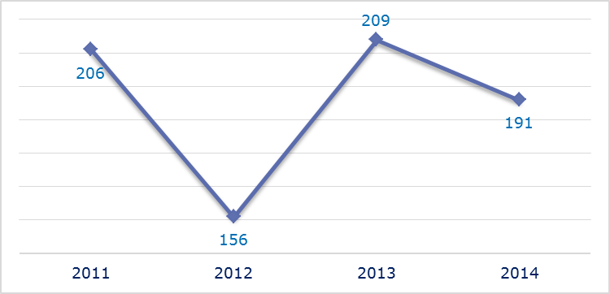
- Evolution of complaints against Poland
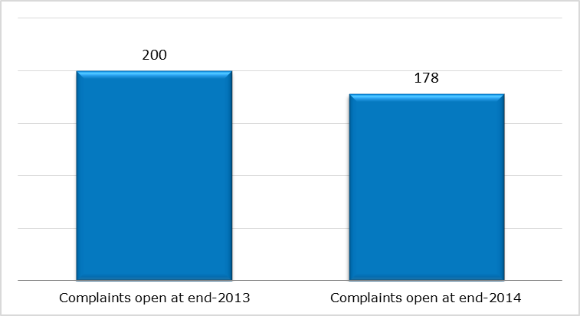
- New complaints registered in 2014: main policy areas
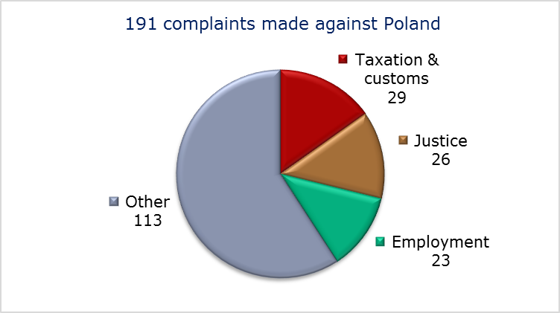
- EU PILOT
- New EU Pilot files opened against Poland (2011-14)
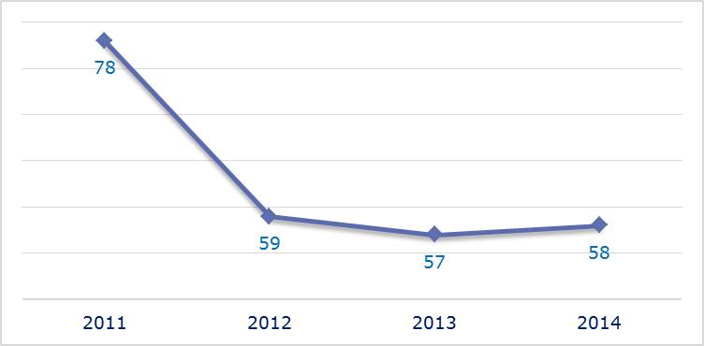
- Evolution of files relating to Poland open in EU Pilot
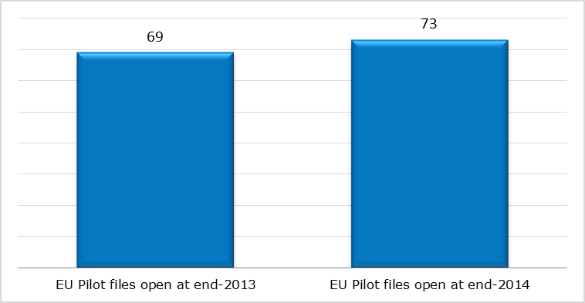
- New EU Pilot files opened in 2014: main policy areas
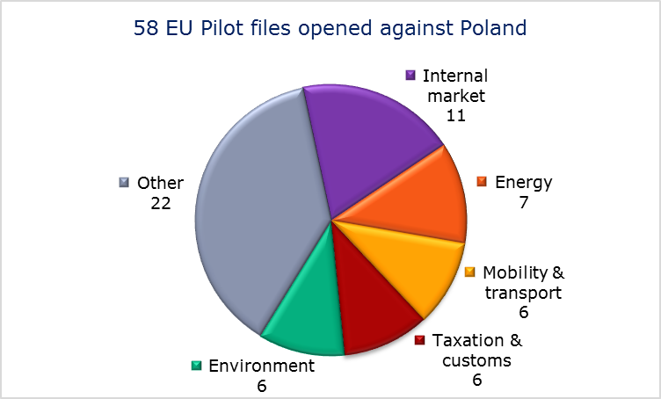
- EU Pilot files: average response time in days (2011-14)
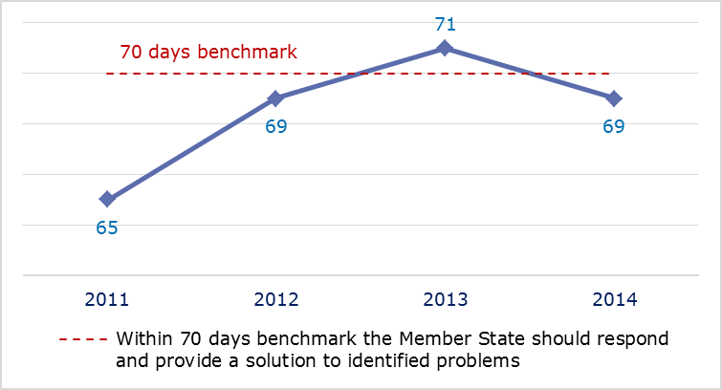
- EU Pilot files: evolution of the resolution rate by Poland (2011-14)
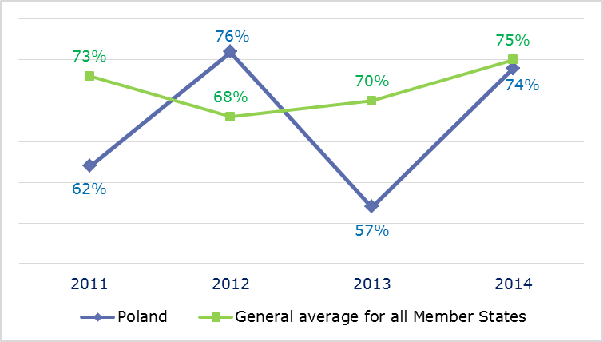
- INFRINGEMENT CASES
- Infringement cases against Poland open on 31 December (2010-14)
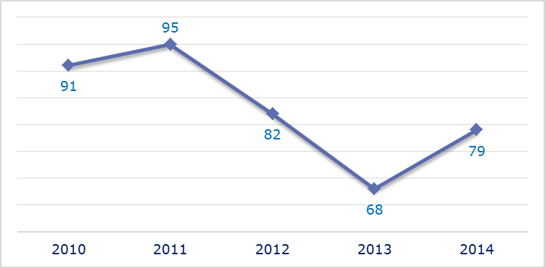
- New infringement cases opened in 2014: main policy areas
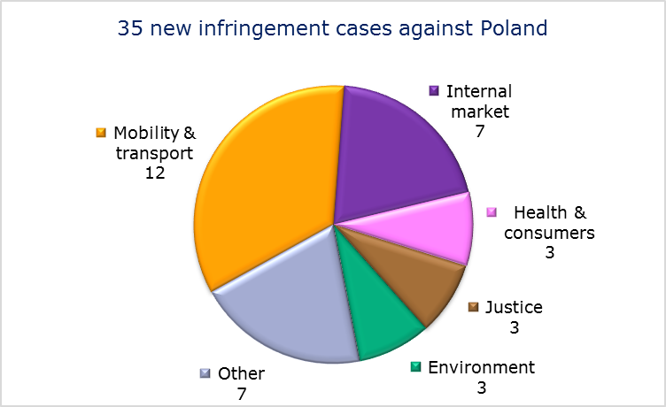
- Key infringement cases and referrals to the Court
- The Commission opened 35 new infringement cases against Poland in 2014. These, and other major ongoing infringement cases, concern:
- nonconformity of national rules with the Fixed-Term Work Directive;
- exclusion of certain biofuels(HVO) from the Polish biofuels market and counting towards the national target in violation of the Renewable Energy Directive;
- granting of a building permit for two new units of a coal-fired power station without having carried out the assessment for retrofitting of CO₂ capture prescribed by the Large Combustion Plants Directive;
- inadequate river basin management plans, which are required under the Water Framework Directive;
- incorrect transposition of the Environmental Impact Assessment Directive with regard to mining activities;
- incorrect transposition of the right to appeal against decisions refusing, annulling or revoking visas;
- the right of EU nationals to become members of a political party or to found one in the Member State of residence;
- incomplete transposition of the Free Movement Directive;
- failure to notify measures transposing the Capital Requirements Directive;
- failure to efficiently implement functional airspace blocks. Under the Single European Sky legislation, national air traffic control organisations should work together in regional airspace blocks to gain efficiency, cut costs and reduce emissions. The set-up of these common airspace blocks is arranged around traffic flows rather than state boundaries, which leads to performance improvements
- award of land lease contracts in the Port of Gdansk in breach of the principle of freedom of establishment;
- non-implementation of an earlier Court ruling on the First Railway Package;
- lack of a national enforcement body, of sanctions and of designated bus terminals for disabled bus and coach passengers;
- late notification of measures transposing the Cross-border Healthcare Directive;
- The Commission pursued before the Court four cases under Article 258 TFEU. They concern:
- failure to notify the Commission of the penalties put in place to deal with cases where the EU rules for companies and personnel working with fluorinated gases are not followed;
- national legislation specifying grounds for exclusion from tenders that differ from those provided for by the Public Procurement Directive. The exclusion concerned cases in which economic operators who had been awarded a contract had failed to perform it correctly and in which the contract had terminated due to circumstances for which they were responsible;
- failure to comply with EU legislation on the quality and safety of human tissues and cells;
- Poland’s system of regulated gas prices for non-household customers in violation of the Gas Directive.

- The Commission did not refer any cases to the Court under Article 260(2) TFEU.
- TRANSPOSITION OF DIRECTIVES
- New late transposition infringement cases against Poland (2010-14)
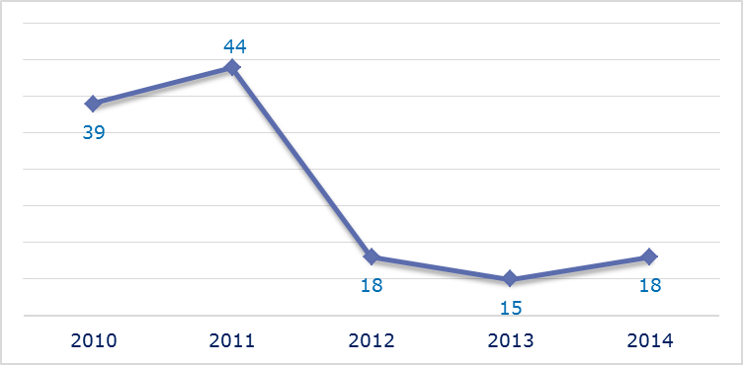
- New late transposition infringement cases opened in 2014: main policy areas
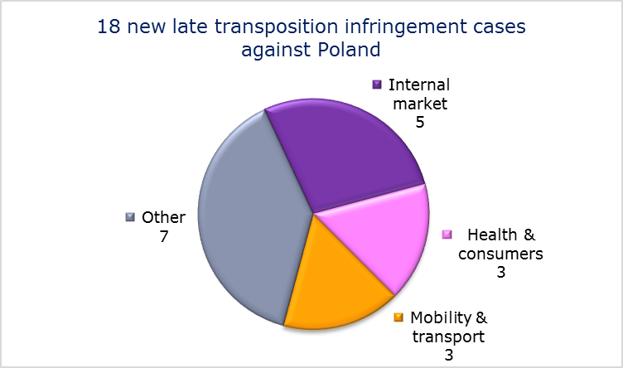
- Referrals to the Court
The Commission did not refer any cases to the Court under Articles 258 and 260(3) TFEU.
- EARLY RESOLUTION OF INFRINGEMENT CASES

Major cases closed without a Court judgment in 2014
These concerned:
- transposition of the Mining Waste Directive; Poland is now in compliance;
- the award of land lease contracts in the Port of Gdansk in breach of the principle of freedom of establishment.
- IMPORTANT JUDGMENTS
- Court rulings
The Court ruled that:
- the Polish requirement that the steering wheel of right-hand drive vehicles must be moved to the left-hand side for road safety reasons infringes Union law since this cannot be considered necessary to achieve the stated goal;
- Poland was in breach of the directive on the deliberate release of GMOs into the environment because producers were not legally obliged to inform the authorities if they cultivated genetically modified crops and no register was set up to list the locations where such crops were grown;
- Poland’s designation of nitrate vulnerable zones was insufficient and so were the measures contained in the action programmes;
- Poland failed to adequately implement the Nitrates Directive.
- Preliminary rulings
In preliminary rulings addressed to the Polish judiciary, the Court ruled that:
- the non-discrimination rule in the Fixed-Term Work Directive also applies to notice periods;
- the taxation of non-EU investment funds receiving dividends from Polish companies must be the same as that of similar domestic funds, provided that the fund’s State of residence is bound by an obligation under a convention on mutual administrative assistance. This convention must enable the Polish tax authorities to verify any information which may be provided by the investment fund.

PORTUGAL

The number of new complaints made against Portugal continued to increase and reached in 2014 the highest level in the last four years. The number of new EU Pilot files opened against Portugal fluctuated over the last years. In 2014, this number was higher than in 2013, but nonetheless lower than in 2012. As regards the overall number of pending infringements, the descending trend registered over the last years was discontinued in 2014, when the number of cases very slightly increased as compared to the previous year. In the area of transposition of directives, the positive trend noted in the last years continued in 2014. The number of new late transposition infringement cases against Portugal was in 2014 the smallest over the last five years.
- COMPLAINTS
- New complaints made against Portugal by members of the public (2011 -14)
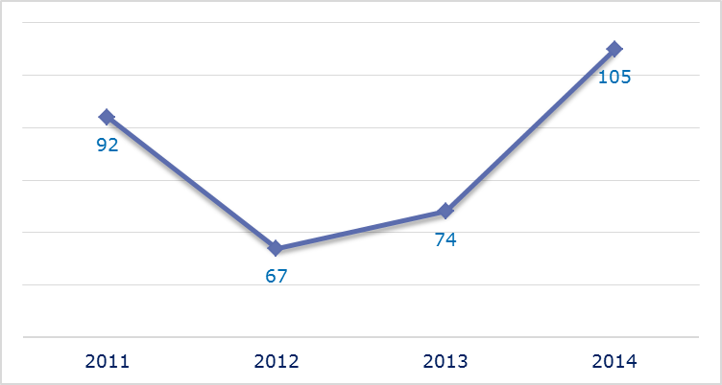
- Evolution of complaints against Portugal
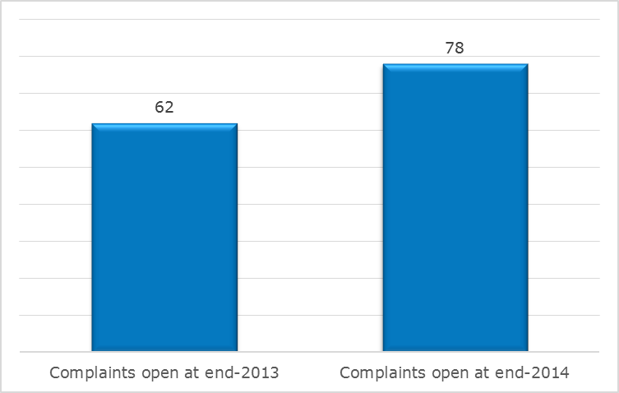
- New complaints registered in 2014: main policy areas
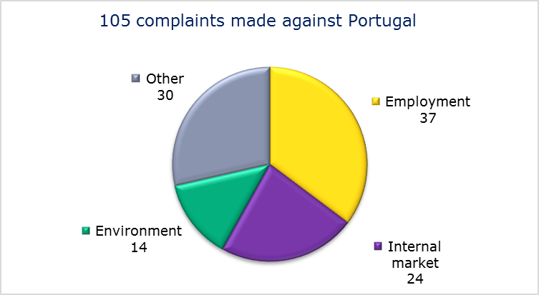
- EU PILOT
- New EU Pilot files opened against Portugal (2011-14)
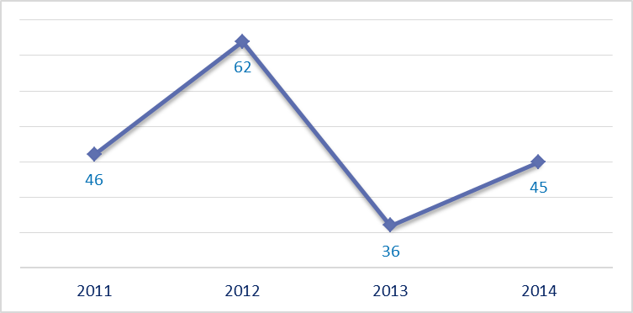
- Evolution of files relating to Portugal open in EU Pilot
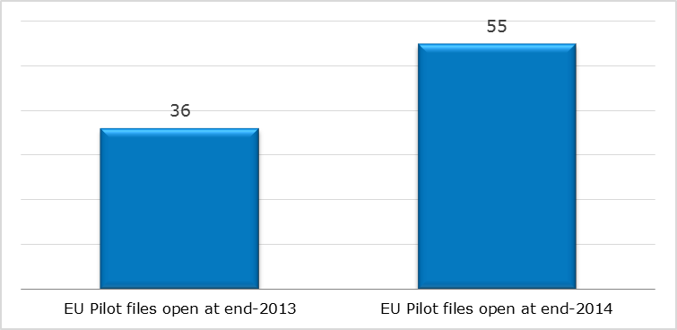
- New EU Pilot files opened in 2014: main policy areas
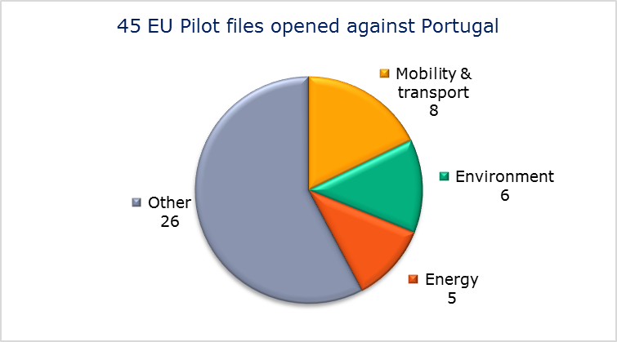
- EU Pilot files: average response time in days (2011-14)
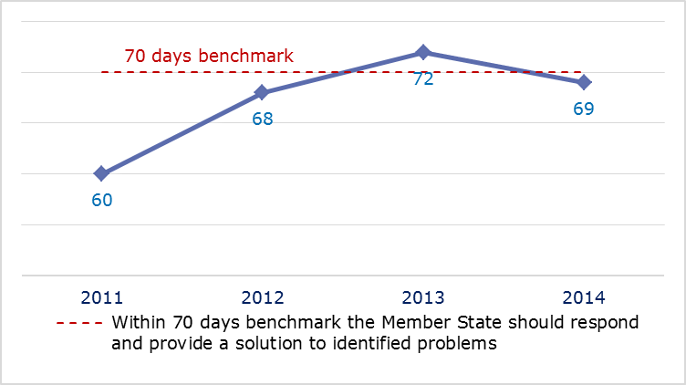
- EU Pilot files: evolution of the resolution rate by Portugal (2011-14)
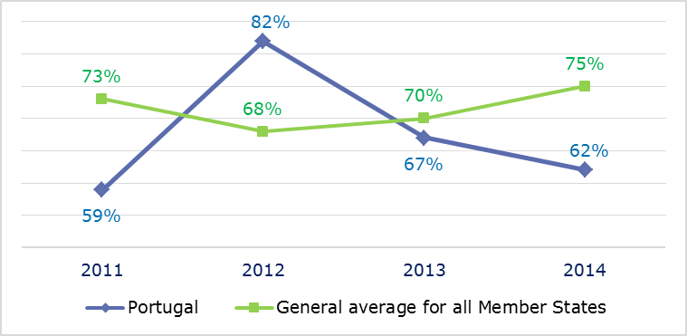
- INFRINGEMENT CASES
- Infringement cases against Portugal open on 31 December (2010-14)
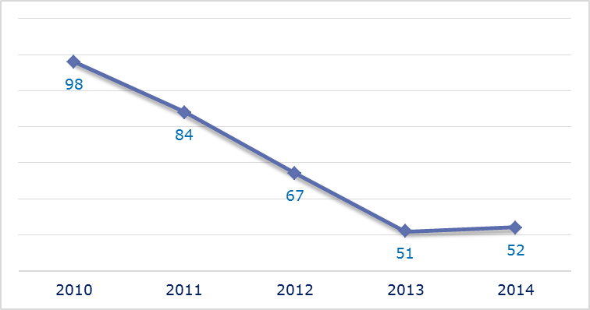
- New infringement cases opened in 2014: main policy areas
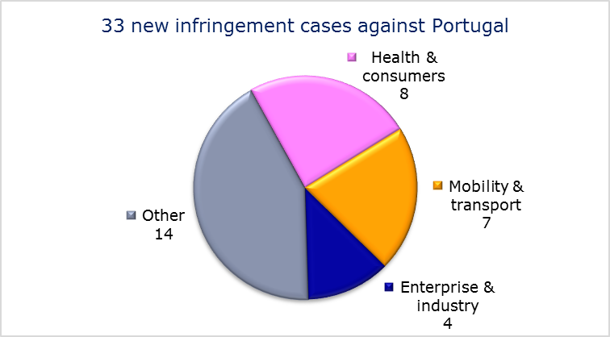
- Key infringement cases and referrals to the Court
- The Commission opened 33 new infringement cases against Portugal in 2014. These, and other major ongoing infringement cases, concern:
- discriminatory treatment of HVO and biofuels in violation of the Renewable Energy Directive;
- failure to communicate to the Commission its long-term strategy for mobilising investment in renovating the national stock of residential and commercial buildings as required under Energy Efficiency Directive;
- incorrect transposition of the Late Payment Directive;
- non-respect of EU air quality standards (PM₁₀ limit values) in several agglomerations;
- failure to comply with a Court judgment that Portugal has not ensured adequate urban waste water treatment in sensitive areas;
- failure to ratify the International Convention on Civil Liability for Bunker Oil Pollution Damage 2001 (the Bunkers Convention);
- non-communication of measures transposing the Capital Requirements Directive;
- failure to efficiently implement functional airspace blocks. Under the Single European Sky legislation, national air traffic control organisations should work together in regional airspace blocks to gain efficiency, cut costs and reduce emissions. The set-up of these common airspace blocks is arranged around traffic flows rather than state boundaries, which leads to performance improvements;
- incorrect application of the regulation on the rights of passengers travelling by train;
- incorrect application of the regulation on the rights of passengers travelling by bus and coach;
- late transposition of the Cross-border Healthcare Directive.
- The Commission referred three cases to the Court under Article 258 TFEU. They concern:
- failure to establish guidelines for assessing infrastructure safety for road infrastructure in the trans-European network (TEN-T);
- failure to guarantee the independence of the airport slot coordinator;
- discrimination against taxpayers who cease to be tax-resident in Portugal.
- The Commission referred one case to the Court under Article 260(2) TFEU. This concerns:
- failure to implement a judgment of the Court of Justice finding that Portugal was failing in its obligation to collect, treat and dispose of urban waste water adequately since seven agglomerations across the country with populations of more than 15 000 lacked the necessary collection systems and 15 lacked adequate treatment systems. The Commission proposed a lump sum of EUR 4 458 828 and a daily penalty of EUR 20 196 until the obligations are met.

- TRANSPOSITION OF DIRECTIVES
- New late transposition infringement cases against Portugal (2010-14)
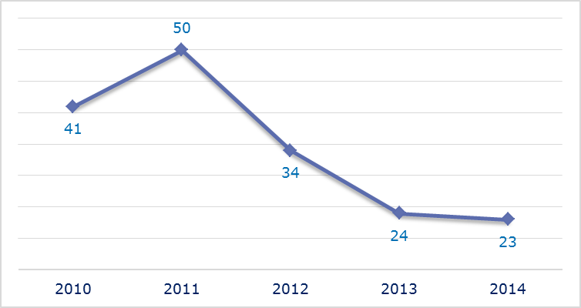
- New late transposition infringement cases opened in 2014: main policy areas
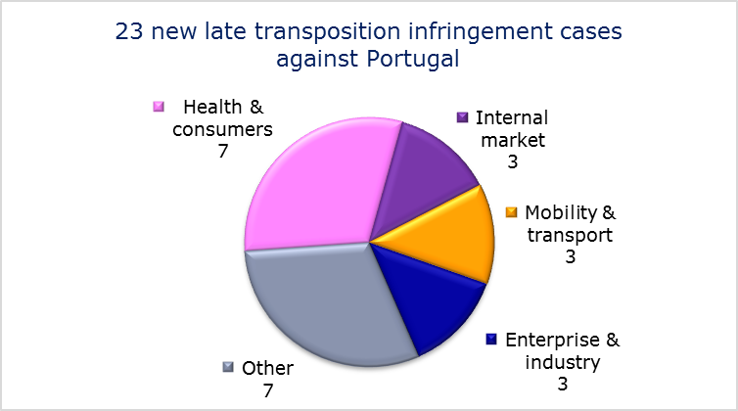
- Referrals to the Court
The Commission did not refer any cases to the Court under Articles 258 and 260(3) TFEU.
- EARLY RESOLUTION OF INFRINGEMENT CASES

Major cases closed without a Court judgment in 2014
These concerned:
- incorrect transposition of the Mining Waste Directive;
- incorrect transposition of the directive on public participation in the drawing up of certain plans and programmes relating to the environment;
- designation of national bodies and sanctions for protecting passenger rights when travelling by sea and inland waterway.
- IMPORTANT JUDGMENTS
- Court rulings
The Court ruled that:
- Portugal was still failing to correctly transpose the provisions of the Universal Service Directive despite the Court’s earlier judgment. Since the Court found that Portugal had not designated the companies responsible for providing the universal service by using a procedure that is consistent with the directive, and in the end had not provided the requested proof of the termination of the designated provider, it ordered Portugal to pay a lump sum of EUR 3 million, plus a daily penalty of EUR 10 000 until it complies with the first judgment;
- Portugal failed to organise a procedure for selecting suppliers to provide ground-handling services for baggage handling, ‘ramp handling’ and freight and mail handling at Lisbon, Porto and Faro airports.
- Preliminary rulings
In a preliminary ruling addressed to the Portuguese judiciary, the Court ruled that:
- the in-house exemption (which makes it possible to not apply the public procurement directives) requires, amongst other conditions, that the contracting authority exercises over the contractor a control similar to the control that it exercises over its own departments. This condition is not met if a private undertaking or a non-profit entity makes any investment in the capital of a company of which the awarding authority is also part.

ROMANIA

The number of new complaints made against Romania fell in 2014 but remains relatively high. New EU Pilot files opened against Romania declined for the third consecutive year. However, the number of pending infringements increased considerably after three years of stability. New infringement cases for late transposition also rose for the first time since 2011.
- COMPLAINTS
- New complaints made against Romania by members of the public (2011-14)
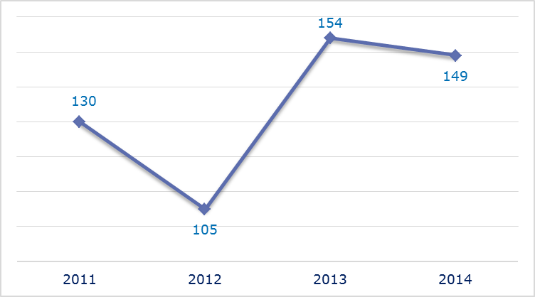
- Evolution of complaints against Romania
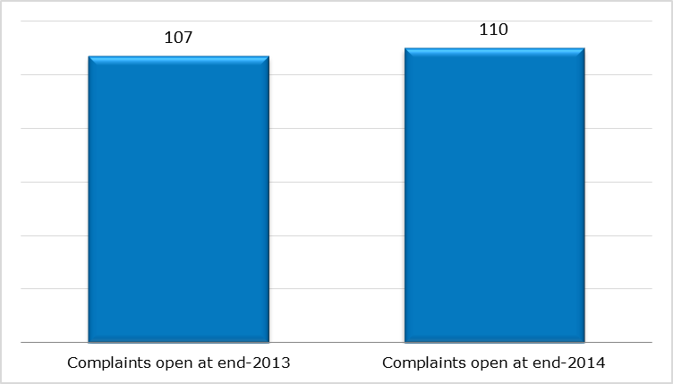
- New complaints registered in 2014: main policy areas
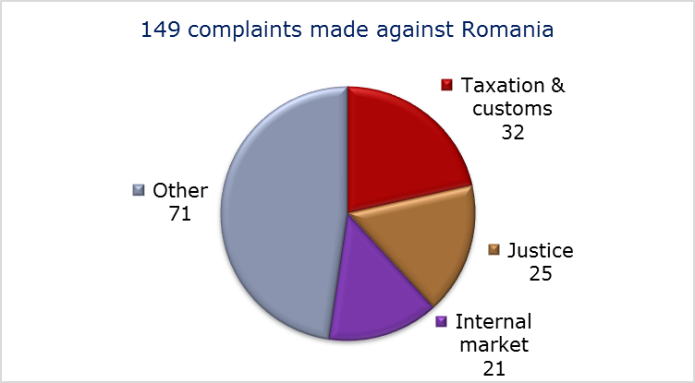
- EU PILOT
- New EU Pilot files opened against Romania (2011-14)
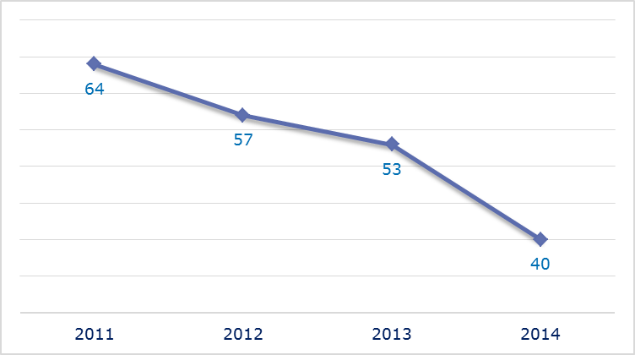
- Evolution of files relating to Romania open in EU Pilot
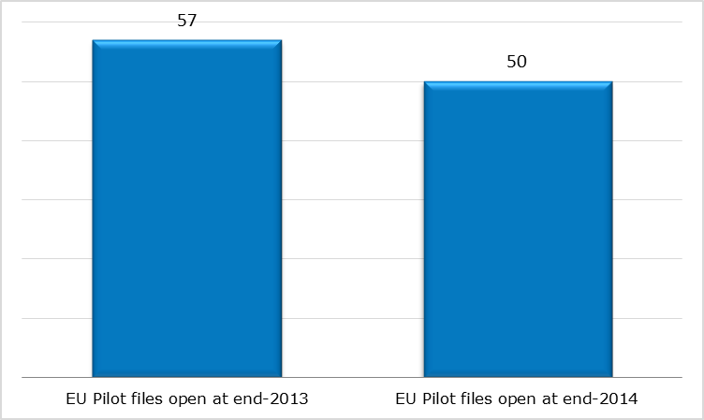
- New EU Pilot files opened in 2014: main policy areas
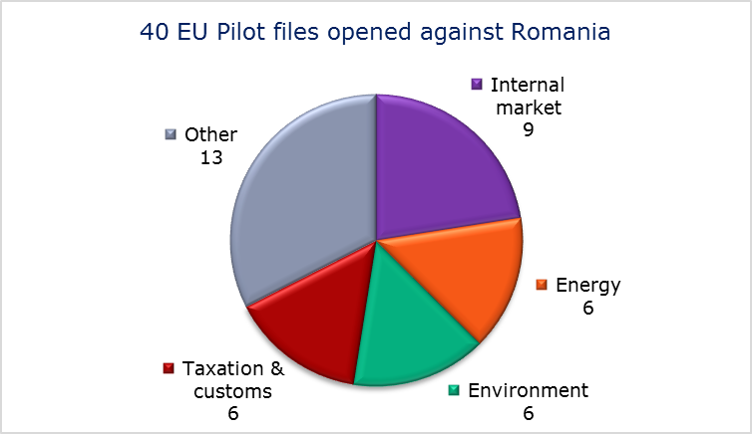
- EU Pilot files: average response time in days (2011-14)
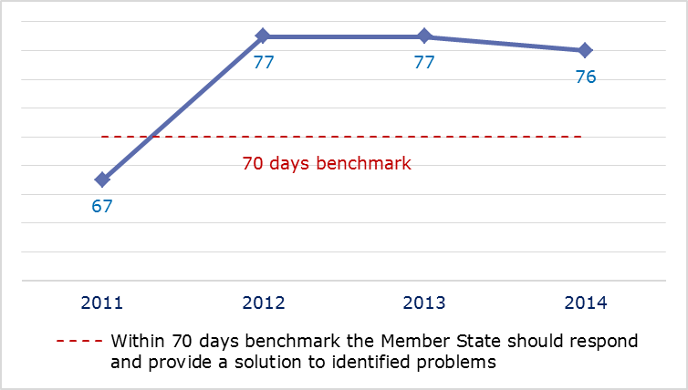
- EU Pilot files: evolution of the resolution rate by Romania (2011-14)
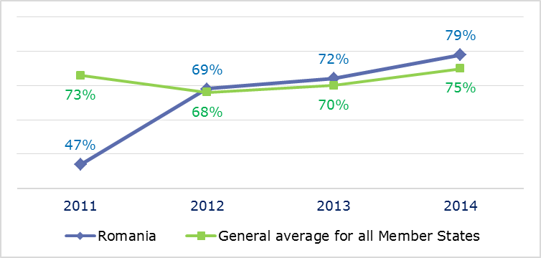
- INFRINGEMENT CASES
- Infringement cases against Romania open on 31 December (2010-14)
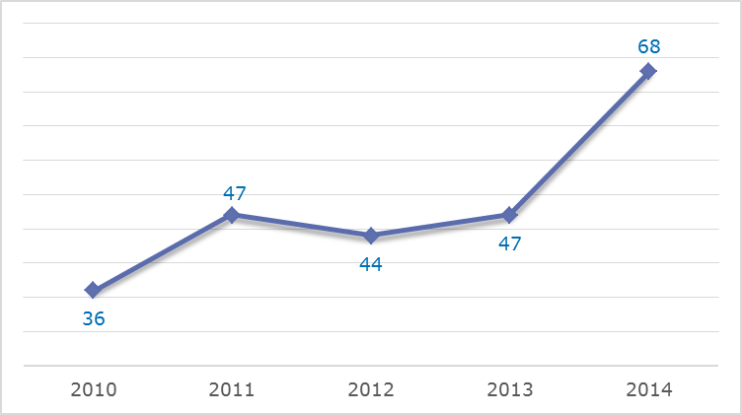
- New infringement cases opened in 2014: main policy areas
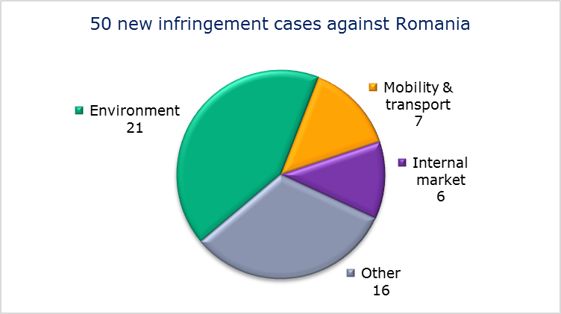
- Key infringement cases and referrals to the Court
- The Commission opened 50 new infringement cases against Romania in 2014. These, and other major ongoing infringement cases, concern:
- nonconformity with the Working Time Directive of the national legislation on annual leave for government employees;
- barriers to exports of natural gas by, inter alia, requiring gas transactions to undergo prior checks and approval;
- failure to communicate to the Commission its national energy efficiency action plan as required under the Energy Efficiency Directive;

- non-respect of EU air quality standards (PM₁₀ limit values) in several zones and agglomerations;
- failure to operate waste landfills in accordance with the provisions of the Landfill Directive;
- incorrect application of the Environmental Impact Assessment Directive in relation to lignite quarries in the Gorj Region;
- non-compliance in waters and resources under Romanian jurisdiction with the principle of equal access rights for vessels flying the flag of other Member States;
- non-communication of measures transposing the Capital Requirements Directive and the Cross-border Healthcare Directive;
- failure to efficiently implement functional airspace blocks. Under the Single European Sky legislation, national air traffic control organisations should work together in regional airspace blocks to gain efficiency, cut costs and reduce emissions. The set-up of these common airspace blocks is arranged around traffic flows rather than state boundaries, which leads to performance improvements;
- incorrect award of public passenger transport services in the Bucharest area;
- nonconformity of the national transposition measures with the Railway Safety Directive.
- The Commission did not refer any cases to the Court under Article 258 TFEU.
- The Commission did not refer any cases to the Court under Article 260(2) TFEU.
- TRANSPOSITION OF DIRECTIVES
- New late transposition infringement cases against Romania (2010-14)
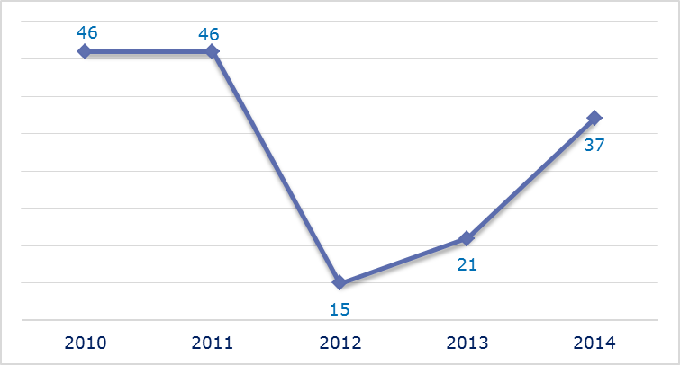
- New late transposition infringement cases opened in 2014: main policy areas
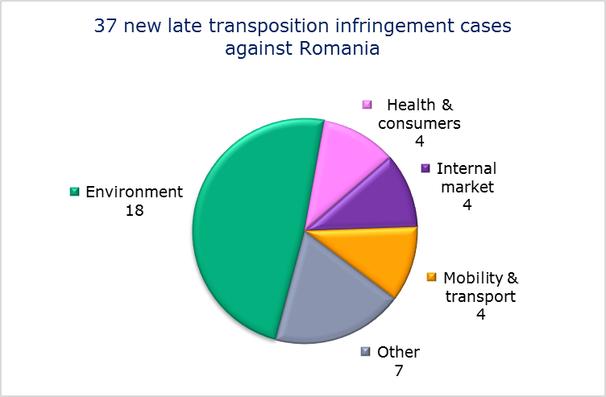
- Referrals to the Court
The Commission did not refer any cases to the Court under Articles 258 and 260(3) TFEU.
- EARLY RESOLUTION OF INFRINGEMENT CASES

Major cases closed without a Court judgment in 2014
These concerned:
- failure to fully transpose the Electricity and Gas Directives;
- non-communication of national measures transposing the Industrial Emissions Directive;
- incorrect application of the regulation on the rights of bus and coach passengers by not designating a national enforcement body nor setting up a penalty system for infringements of the regulation;
- nonconformity of national legislation with the directive on the separation of accounts in the rail sector;
- incorrect application of the directive on veterinary checks in intra-EU trade by confiscating meat originating from Denmark;
- incorrect application of the VAT Directive regarding the treatment of non-recovered leased goods.
- IMPORTANT JUDGMENTS
- Court rulings
There were no major Court rulings in 2014.
- Preliminary rulings
In preliminary rulings addressed to the Romanian judiciary, the Court ruled that:
- national provisions which exclude producers from the benefit of agriculture aids because of their debts to national or local budgets are incompatible with the regulation establishing common rules for direct support schemes under the Common Agricultural Policy and certain support schemes for farmers;
- prior medical authorisation under the regulation on the coordination of social security systems cannot be refused because the hospital concerned cannot provide medication and basic medical supplies and infrastructure in good time in the insured person’s Member State of residence.

SLOVAKIA

The number of new complaints made against Slovakia fell slightly in 2014, the third consecutive decline. New EU Pilot files opened against Slovakia and the overall number of pending infringement cases have not changed much over the last five years. New infringement cases for late transposition showed a small fall but were above the low reached in 2012.
- COMPLAINTS
- New complaints made against Slovakia by members of the public (2011-14)
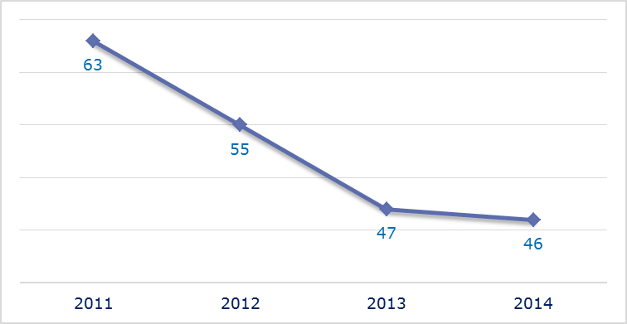
- Evolution of complaints against Slovakia
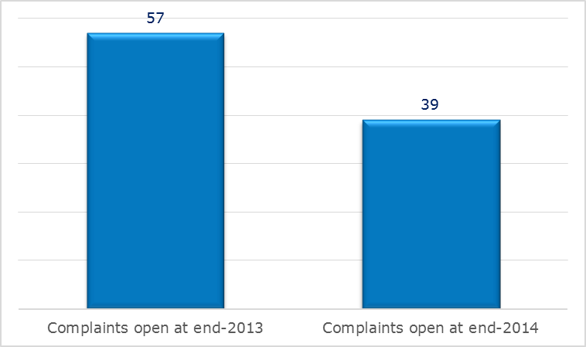
- New complaints registered in 2014: main policy areas
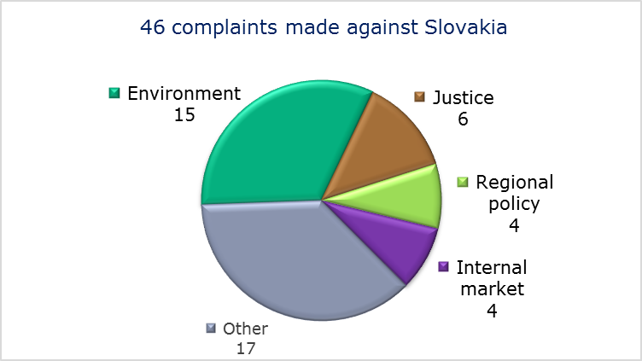
- EU PILOT
- New EU Pilot files opened against Slovakia (2011-14)
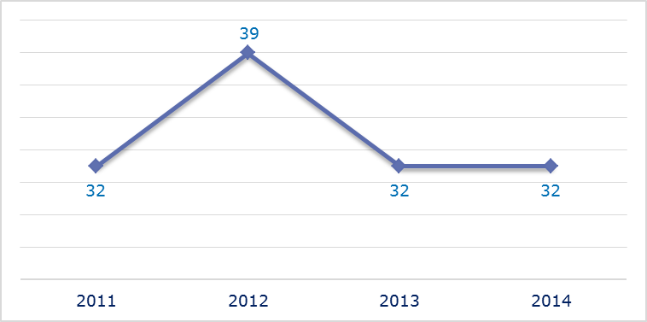
- Evolution of files relating to Slovakia open in EU Pilot
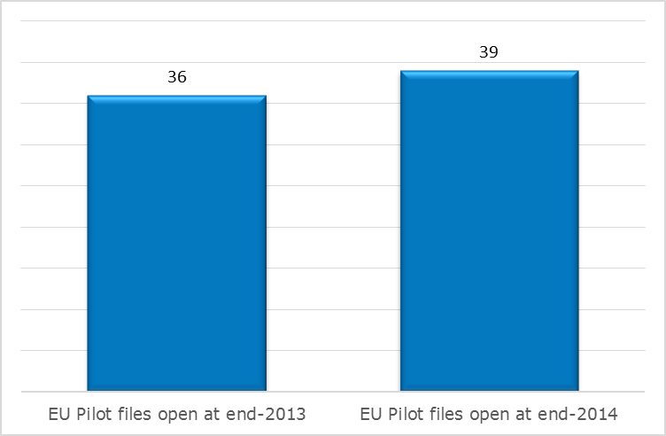
- New EU Pilot files opened in 2014: main policy areas
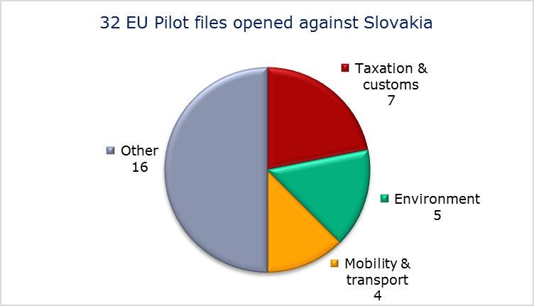
- EU Pilot files: average response time in days (2011-14)
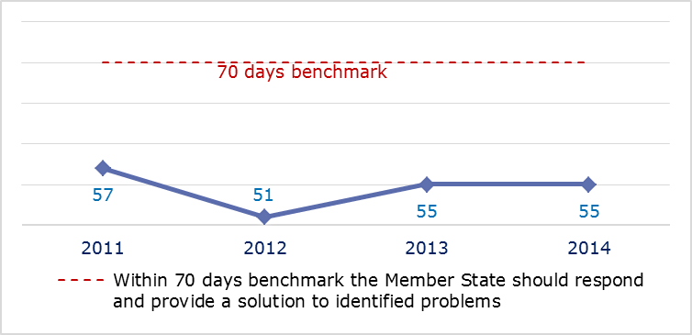
- EU Pilot files: evolution of the resolution rate by Slovakia (2011-14)
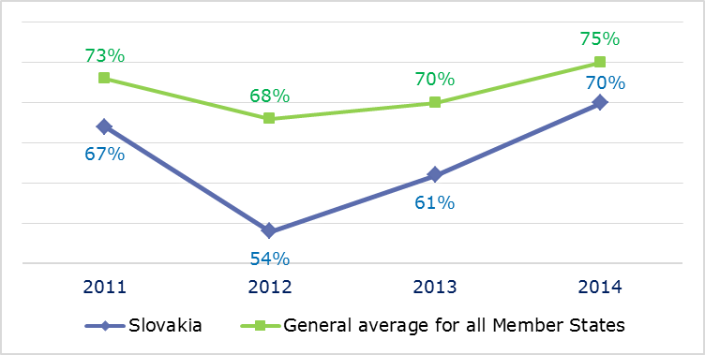
- INFRINGEMENT CASES
- Infringement cases against Slovakia open on 31 December (2010-14)
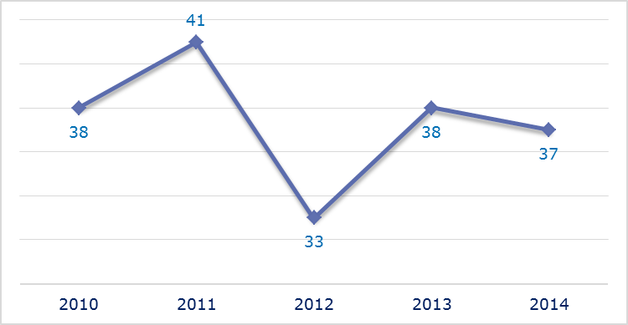
- New infringement cases opened in 2014: main policy areas
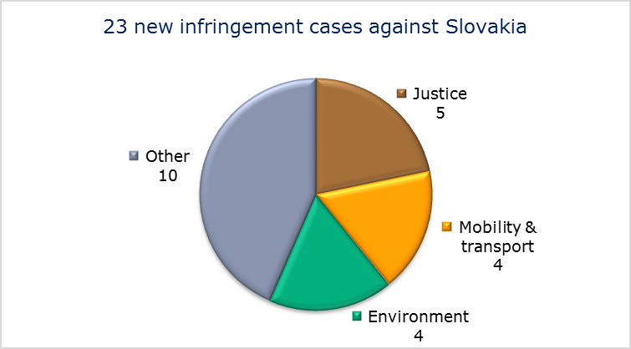
- Key infringement cases and referrals to the Court
- The Commission opened 23 new infringement cases against Slovakia in 2014. These, and other major ongoing infringement cases, concern:
- incorrect implementation of the Late Payment Directive;
- non-compliant transposition of the Floods Directive;
- exclusion of workers in areas deemed not dangerous from the right to health surveillance;
- non-respect of EU air quality standards (PM₁₀ limit values) in several zones and agglomerations;
- lack of effective judicial remedy against the refusal, annulment or revocation of a visa, in breach of the provisions of the Visa Code;
- violation of the right of EU nationals to become members of a political party or to found one in the Member State of residence;
- non-communication of measures transposing the Capital Requirements Directive;
- failure to efficiently implement functional airspace blocks. Under the Single European Sky legislation, national air traffic control organisations should work together in regional airspace blocks to gain efficiency, cut costs and reduce emissions. The set-up of these common airspace blocks is arranged around traffic flows rather than state boundaries, which leads to performance improvements;
- nonconformity of national legislation with the Railway Interoperability Directive;
- failure to connect to the EU driving licence network, RESPER;
- lack of effective control by the judiciary in cases where traders seek enforcement, outside ordinary court procedures, of claims that are based on unfair contract terms or violate the rules on consumer credit. This includes recourse to commercial arbitration bodies which do not apply consumer law.
- The Commission did not refer any cases to the Court under Article 258 TFEU.
- The Commission did not refer any cases to the Court under Article 260(2) TFEU.
- TRANSPOSITION OF DIRECTIVES
- New late transposition infringement cases against Slovakia (2010-14)
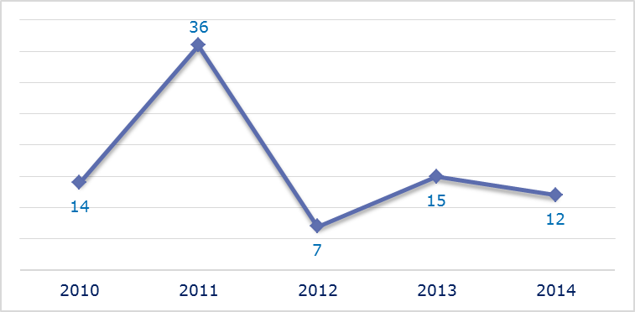
- New late transposition infringement cases opened in 2014: main policy areas
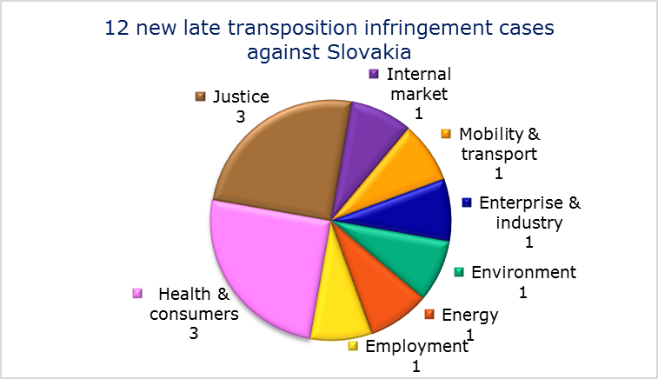
- Referrals to the Court
The Commission did not refer any cases to the Court under Articles 258 and 260(3) TFEU.
- EARLY RESOLUTION OF INFRINGEMENT CASES

Major cases closed without a Court judgment in 2014
These concerned:
- exclusion of workers in areas deemed not dangerous from the right to health surveillance;
- breach of the principle of free movement of goods regarding the requirements for type approval of car rugs and the presence of a representative of the manufacturer;
- non-compliant transposition of the Bathing Water Directive;
- non-compliance of national legislation with the Railway Safety Directive.
- IMPORTANT JUDGMENTS
- Court rulings
There were no major Court rulings in 2014.
- Preliminary rulings
In preliminary rulings addressed to the Slovakian judiciary, the Court ruled that:
- the directive on control of the acquisition and possession of weapons must be interpreted as not precluding national legislation which authorises the issue of a European firearms pass only to holders of weapons used for hunting and target-shooting.

The number of files open at the end of 2013 given in the 2013 annual report is different from the current figure. This is because some files were registered late and others have been closed.
Directive 1999/70/EC.
Directive 2009/28/EC.
Directive 2001/80/EC.
Directive 2000/60/EC.
Directive 85/337/EEC.
MEMO/14/589.
MEMO/14/293.
Directive 2004/38/EC.
Directive 2013/36/EU.
Regulation (EC) No 550/2004.
IP/14/818.
MEMO/14/470.
Directive 2011/24/EU and MEMO/14/470.
Commission v Poland, C-303/14, IP/14/449.
Directive 2004/18/EC.
The Commission decided on 17 October 2013 to refer the case to the Court; the application was filed on 4 April 2014, Commission v Poland, C-162/14, IP/13/965.
The Commission decided on 26 September 2013 to refer the case to the Court; the application was filed on 21 January 2014, Commission v Poland, C-29/14, IP/13/873.
Directive 2006/21/EC.
Commission v Poland, C-639/11 and Commission v Lithuania, C-61/12, CJE/14/37.
Commission v Poland, C-478/13 and Directive 2001/18/EC.
Commission v Poland, C-356/13.
Directive 91/676/EEC, Commission v France, C-237/12 and Commission v Poland, C-356/13.
Nierodzik, C-38/13.
Emerging Markets, C-190/12.
The number of files open at the end of 2013 given in the 2013 annual report is different from the current figure. This is because some files were registered late and others have been closed.
Directive 2009/28/EC.
Directive 2012/27/EU.
Directive 2011/7/EU.
PM₁₀ is an air pollutant consisting of small particles with an aerodynamic diameter less than or equal to a nominal 10 micrometers. The particles’ small size allows them to penetrate deep into the lungs where they may be deposited and cause adverse health effects. (Source: European Environment Agency).
MEMO/14/537.
MEMO/14/36.
Directive 2013/36/EU, MEMO/14/589.
Regulation (EC) No 550/2004.
IP/14/818.
Regulation (EC) No 1371/2007, MEMO/14/2130.
Regulation (EU) No 181/2011, MEMO/14/241.
Directive 2011/24/EU, MEMO/14/2130.
Commission v Portugal, C-116/14, IP/14/49 The case was subsequently withdrawn from the Court due to Portugal’s compliance.
The Commission decided on 20 November 2013 to refer the case to the Court; the application was filed on 24 April 2014, Commission v Portugal, C-205/14, IP/13/1100.
Commission v Portugal, C-503/14, IP/14/50.
Commission v Portugal, C-557/14, IP/14/1142.
Directive 2006/21/EC.
Directive 2003/35/EC.
Regulation (EU) No 1177/2010.
Directive 2002/22/EC.
Commission v Portugal, C-76/13 and Court press release No 89/14.
Commission v Portugal, C-277/13.
Centro Hospitalar de Setúbal and SUCH, C-574/12.
Directive 2003/88/EC.
MEMO/14/470.
Directive 2012/27/EU.
PM₁₀ is an air pollutant consisting of small particles with an aerodynamic diameter less than or equal to a nominal 10 micrometers. The particles’ small size allows them to penetrate deep into the lungs where they may be deposited and cause adverse health effects. (Source: European Environment Agency).
Directive 1999/31/EC.
Directive 2011/92/EU.
Directive 2013/36/EU.
Directive 2011/24/EU; MEMO/14/537.
Regulation (EC) No 550/2004.
IP/14/818.
Directive 2004/49/EC MEMO/14/589.
Directives 2009/72/EC and 2009/73/EC.
Directive 2010/75/EU.
Regulation (EU) No 181/2011.
Directive 91/440/EEC.
Directive 89/662/EEC.
Directive 112/2006/EC.
Regulation (EC) No 1782/2003, Agenţia de Plăţi şi Intervenţie pentru Agricultură (APIA), C-304/13.
Regulation (EC) No 883/2004.
Elena Petru, C-268/13, CJE/134/14.
Directive 2011/7/EU, IP/14/689.
Directive 2007/60/EC.
Directive 89/391/EEC.
PM₁₀ is an air pollutant consisting of small particles with an aerodynamic diameter less than or equal to a nominal 10 micrometers. The particles’ small size allows them to penetrate deep into the lungs where they may be deposited and cause adverse health effects. (Source: European Environment Agency).
MEMO/14/470.
MEMO/14/589.
Directive 2013/36/EU.
Regulation (EC) No 550/2004.
IP/14/818.
Directive 2008/57/EC.
Directive 2006/126/EC.
Directive 89/391/EEC.
Directive 2006/7/EC.
Directive 2004/49/EC.
Directive 91/477/EEC, Michal Zeman, C-543/12.

