SLOVENIA

The number of new complaints made against Slovenia has increased marginally over recent years, while new EU Pilot files have remained stable since 2012. The overall number of pending infringement cases against Slovenia was unchanged in 2014 but still at its highest level for five years. New infringement cases for late transposition increased further but remain well below the rather high 2011 level.
- COMPLAINTS
- New complaints made against Slovenia by members of the public (2011-14)
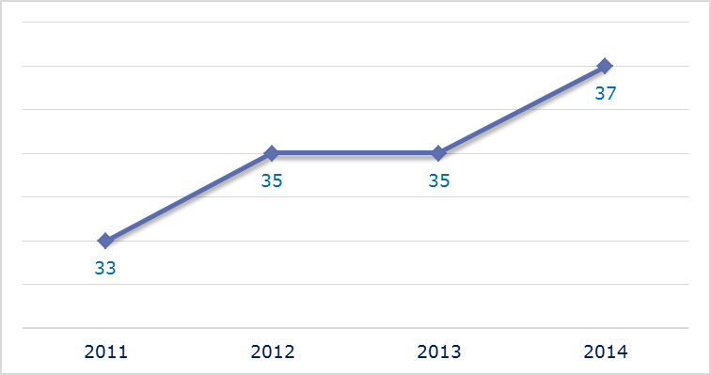
- Evolution of complaints against Slovenia
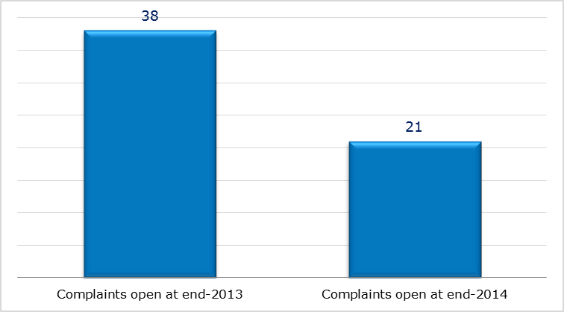
- New complaints registered in 2014: main policy areas
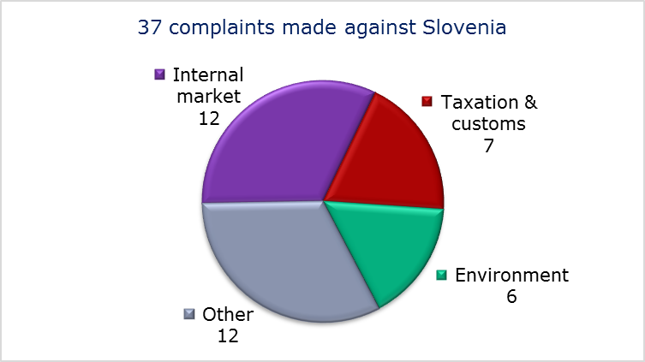
- EU PILOT
- New EU Pilot files opened against Slovenia (2011-14)
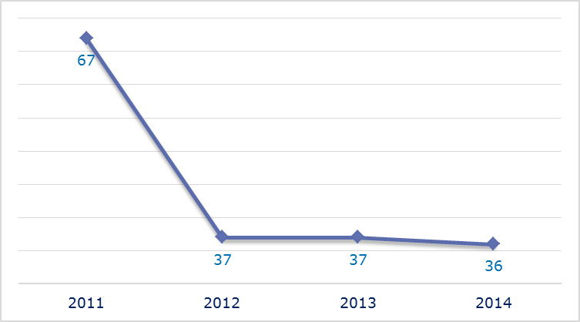
- Evolution of files relating to Slovenia open in EU Pilot
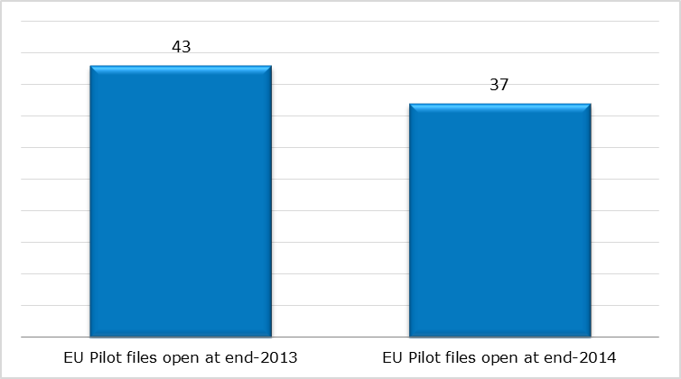
- New EU Pilot files opened in 2014: main policy areas
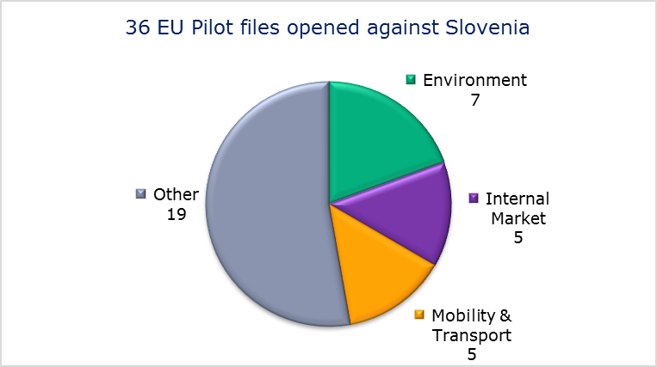
- EU Pilot files: average response time in days (2011-14)
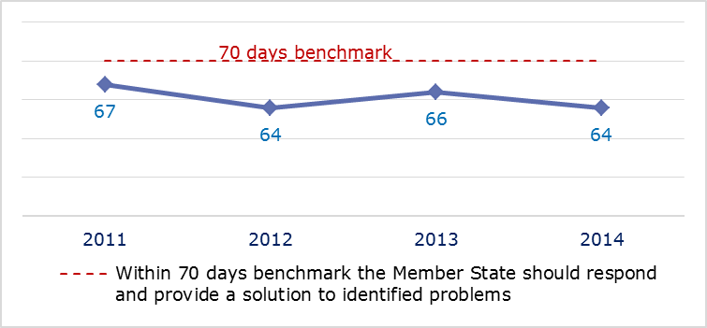
- EU Pilot files: evolution of the resolution rate by Slovenia (2011-14)
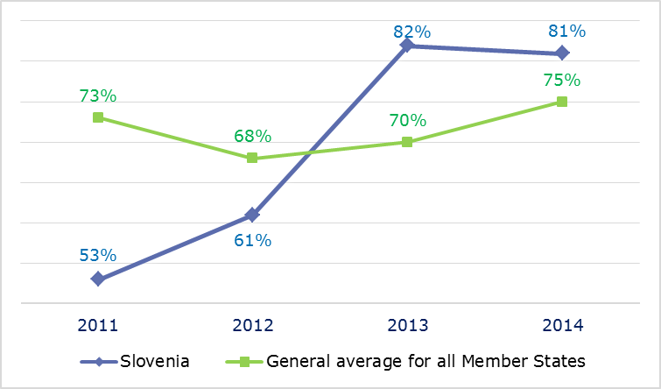
- INFRINGEMENT CASES
- Infringement cases against Slovenia open on 31 December (2010-14)
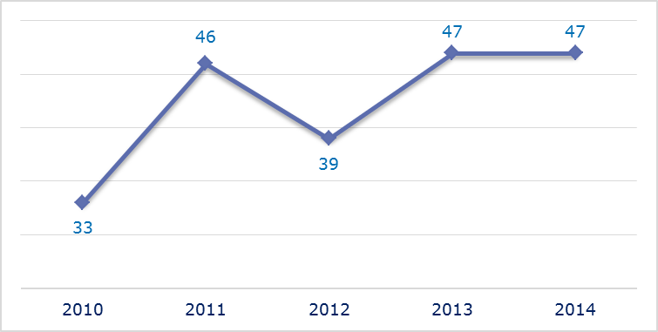
- New infringement cases opened in 2014: main policy areas
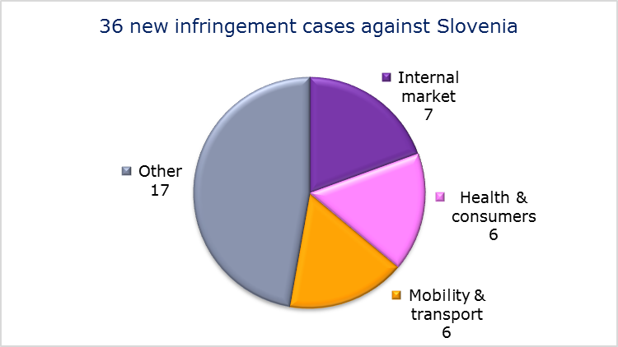
- Key infringement cases and referrals to the Court
- The Commission opened 36 new infringement cases against Slovenia in 2014. These, and other major ongoing infringement cases, concern:
- failure to comply with obligations under the Regulation on security of gas supply;
- failure to communicate to the Commission its long-term strategy for mobilising investment in renovating the national stock of residential and commercial buildings and its national energy efficiency action plan, as required under Energy Efficiency Directive;
- failure to provide for public participation in environmental decision-making procedures;
- failure to efficiently implement functional airspace blocks. Under the Single European Sky legislation, national air traffic control organisations should work together in regional airspace blocks to gain efficiency, cut costs and reduce emissions. The set-up of these common airspace blocks is arranged around traffic flows rather than state boundaries, which leads to performance improvements;
- failure to correctly apply European rules on the separation of accounts between infrastructure managers and railway operators;
- failure to connect to the EU driving licence network, RESPER;
- nonconformity of national legislation with EU legislation as regards the national equality body;
- non-communication of measures transposing the Capital Requirements Directive;
- incorrect implementation of the directive laying down minimum standards for the protection of pigs, which requires that sows are kept in groups during part of their pregnancy;
- failure to notify full transposition of the Cross-border Healthcare Directive.
- The Commission referred one case to the Court under Article 258 TFEU. This concerns:
- breach of EU waste legislation by operating two illegal landfill sites.
- The Commission did not refer any cases to the Court under Article 260(2) TFEU.
- TRANSPOSITION OF DIRECTIVES
- New late transposition infringement cases against Slovenia (2010-14)
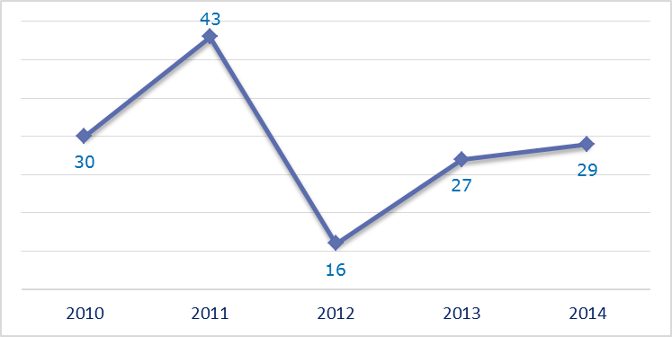
- New late transposition infringement cases opened in 2014: main policy areas
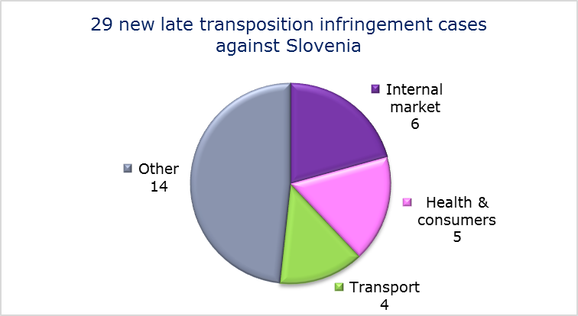
- Referrals to the Court
The Commission did not refer any cases to the Court under Articles 258 and 260(3) TFEU.
- EARLY RESOLUTION OF INFRINGEMENT CASES

Major cases closed without a Court judgment in 2014
These concerned:
- failure to fully transpose the Electricity and Gas Directives;
- non-communication of national measures transposing the Pyrotechnics Directive;
- incomplete transposition of the directive improving and extending the EU greenhouse gas emission allowance trading scheme and the directive on the geological storage of carbon dioxide;
- incorrect application of the Environmental Impact Assessment Directive in relation to a waste treatment facility in Ljubljana;
- nonconformity of national legislation with the Habitats Directive as regards the legal regime for densely constructed settlement areas inside Natura 2000 sites;
- nonconformity of national legislation with the Railway Safety Directive;
- discriminatory taxation of non-resident self-employed individuals;
- discriminatory taxation of pension insurance contributions by non-resident individuals.
- IMPORTANT JUDGMENTS
- Court rulings
There were no major Court rulings in 2014.
- Preliminary rulings
No major preliminary rulings were addressed to the Slovenian judiciary in 2014.

SPAIN

In 2014 the number of new complaints made against Spain increased by over 100 for the second year running, but new EU Pilot files pursued the decline seen over recent years. The number of pending infringement cases also remained on the downward trend started in 2011. New infringement cases for late transposition rose but were still well below the 2010 and 2011 levels.
- COMPLAINTS
- New complaints made against Spain by members of the public (2011-14)
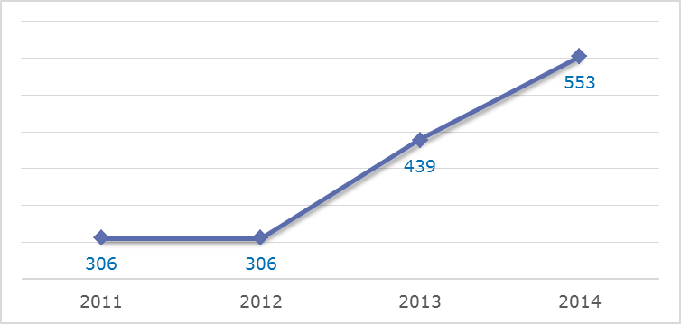
- Evolution of complaints against Spain
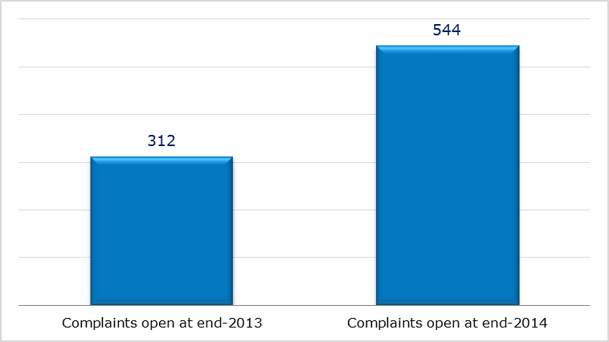
- New complaints registered in 2014: main policy areas
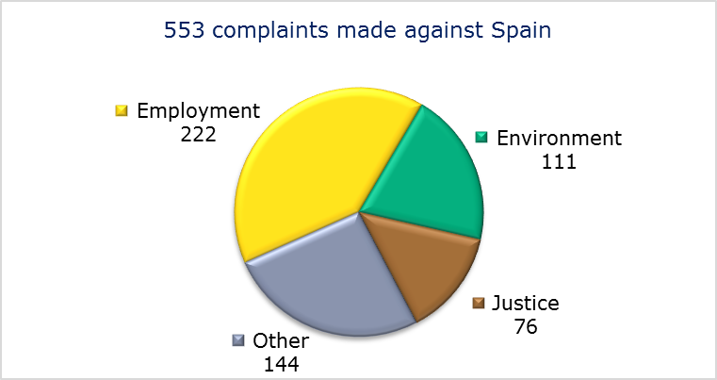
- EU PILOT
- New EU Pilot files opened against Spain (2011-14)
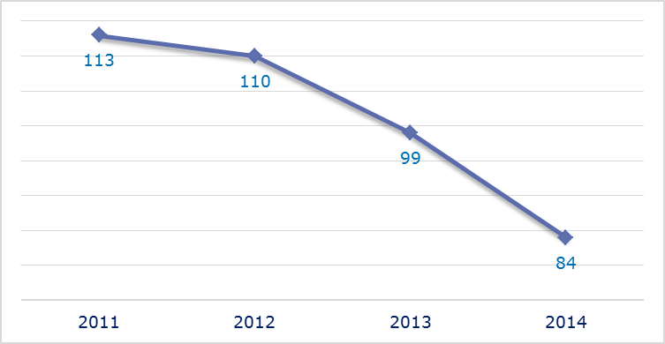
- Evolution of files relating to Spain open in EU Pilot
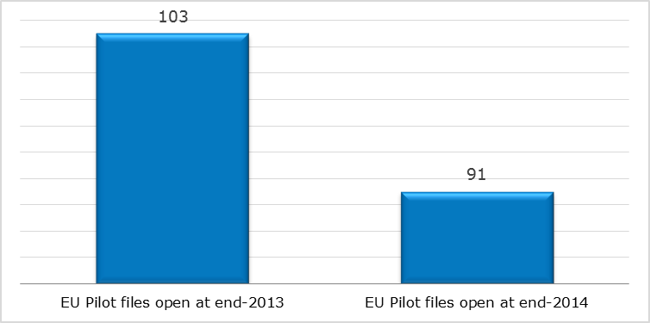
- New EU Pilot files opened in 2014: main policy areas
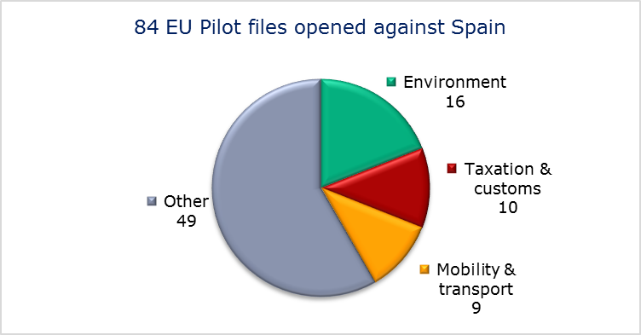
- EU Pilot files: average response time in days (2011-14)
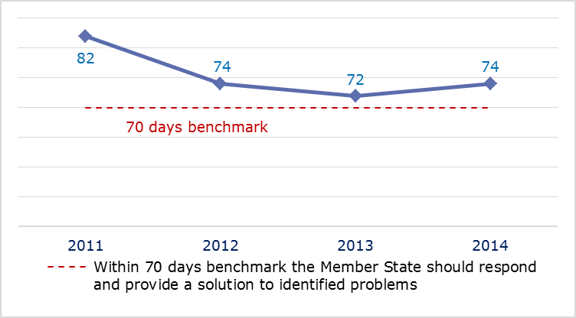
- EU Pilot files: evolution of the resolution rate by Spain (2011-14)
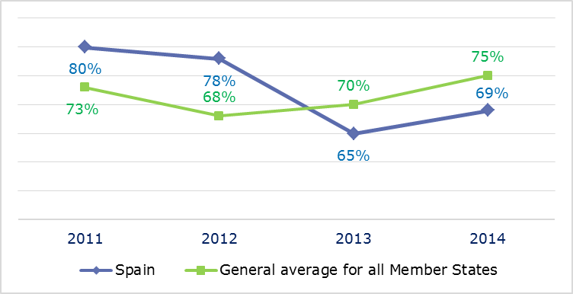
- INFRINGEMENT CASES
- Infringement cases against Spain open on 31 December (2010-14)
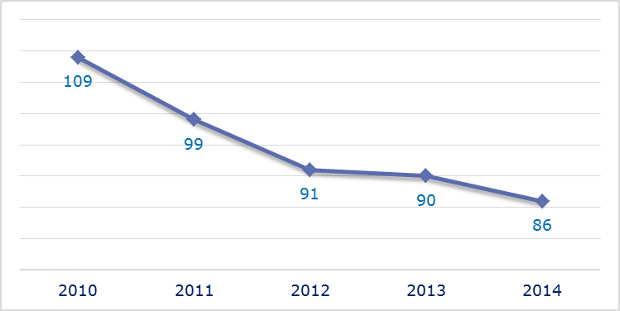
- New infringement cases opened in 2014: main policy areas
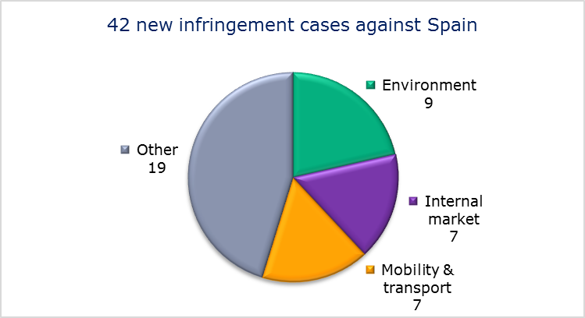
- Key infringement cases and referrals to the Court
- The Commission opened 42 new infringement cases against Spain in 2014. These, and other major ongoing infringement cases, concern:
- nonconformity with the Working Time Directive regarding the conditions applied to Civil Guard employees;
- nonconformity with the Working Time Directive of the national provisions and practices on annual leave for public sector staff;
- working conditions in the national police force, which are incompatible with the Working Time Directive;
- rules on the marking of historic firearms in Spain, which restrict the free movement of goods;
- obstacles to the manufacture import, export, sale, installation and operation of gambling machines without prizes;
- nonconformity with the biofuels sustainability criteria under the Renewable Energy Directive;
- uncontrolled landfill sites still awaiting closure, sealing and restoration;
- non-respect of EU air quality standards (PM₁₀ limit values) in several zones and agglomerations;
- the deterioration of the habitats of the Doñana wetlands in Andalusia;
- inadequate management of saline waste from potash extraction in central Catalonia;
- non-communication of measures transposing the directive on the right to interpretation and translation in criminal proceedings;
- non-communication of measures transposing the Capital Requirements Directive;
- failure to efficiently implement functional airspace blocks. Under the Single European Sky legislation, national air traffic control organisations should work together in regional airspace blocks to gain efficiency, cut costs and reduce emissions. The set-up of these common airspace blocks is arranged around traffic flows rather than state boundaries, which leads to performance improvements;
- discriminatory airport charges;
- failure to comply with a Court judgment finding that Spain has not correctly transposed the directives of the First Railway Package;
- higher taxation of income of non-profit entities located outside Spain and/or of the taxpayers making contributions to the aforementioned entities.

- The Commission referred two cases to the Court under Article 258 TFEU. They concern:
- numerous landfills which are operating in breach of the Landfill Directive;
- the planned rail link between Seville and Almería, for which no adequate environmental impact assessment has been carried out.
- The Commission did not refer any cases to the Court under Article 260(2) TFEU.
- TRANSPOSITION OF DIRECTIVES
- New late transposition infringement cases against Spain (2010-14)
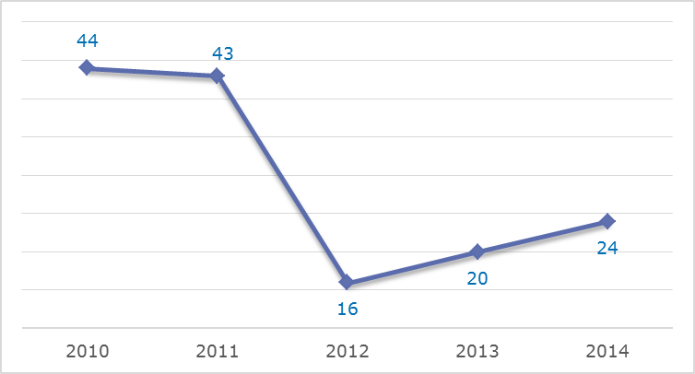
- New late transposition infringement cases opened in 2014: main policy areas
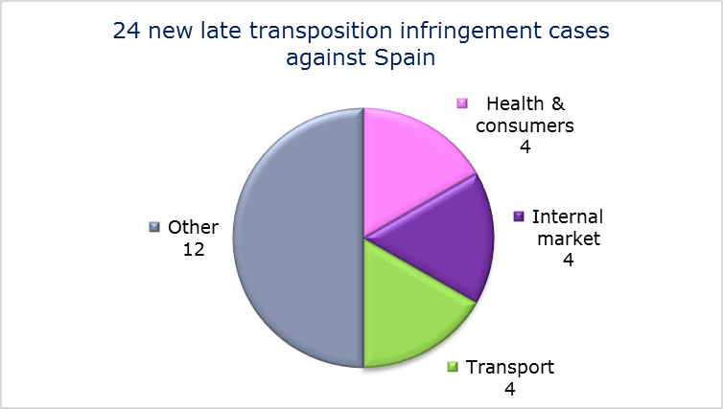
- Referrals to the Court
The Commission did not refer any cases to the Court under Articles 258 and 260(3) TFEU.
- EARLY RESOLUTION OF INFRINGEMENT CASES

Major cases closed without a Court judgment in 2014
These concerned:
- rules on the composition of teams in basketball competitions organised by the Spanish Basketball Federation and the Spanish federation of basketball clubs, requiring a minimum number of locally trained players;
- failure to apply the provisions of the Framework Directive on health and safety at work correctly to Civil Guard employees;
- the incompatibility of Spain’s provisions on the working hours of forensic doctors with the Working Time Directive;
- nonconformity with the Working Time Directive of the provisions laying down a limit to the carry-over period for annual leave applying to members of the autonomous police force of the Basque Country (Ertzaintza);
- nonconformity of the Canary Islands’ new catalogue of endangered species with the Habitats Directive;
- restrictions on inspection bodies in Catalonia (limited number of inspection bodies, minimum number of offices and sectors, minimum share capital, separate authorisation for Catalonia);
- restrictions on the profession of technical designer;
- lack of independence of the airport slot coordinator;
- restriction on the freedom to provide services, in the form of a requirement that registration tax must be paid in full before a company car can be used on Spanish roads;
- incorrect application of the VAT Directive: in certain cases Spain does not allow the taxable person to amend an invoice in which VAT was erroneously not charged to allow for it to be charged to the client.
- IMPORTANT JUDGMENTS
- Court rulings
The Court ruled that:
- Spain failed to fulfil its obligation to comply with a judgment under Article 108(2) requiring it to comply with six Commission State aid recovery decisions concerning Basque fiscal schemes. Spain having recovered the pending amounts before the date of the judgment in the Court case, the Commission did not impose daily penalty payments. The Court ordered Spain to pay a lump sum of EUR 30 million;
- experience cannot be regarded as an award criterion in public procurement procedures (confirmation of established case law);
- the Commission had not adopted the financial correction decisions within the deadline indicated in the regulation on the European Regional Development Fund, the European Social Fund and the Cohesion Fund. The Court of Justice considered that the Commission infringed essential procedural requirements by adopting these decisions after the regulation’s six-month deadline had expired, which was not compatible with the general principle of sound administration. The Court of Justice ruled in favour of Spain by annulling the General Court’s judgement and overturning previous case law, which considered that the regulatory deadlines for adopting financial correction decisions were indicative and the the Commission had to adopt them in a “reasonable time”;
- Spain’s rules for authorising road transport companies breach Article 34 TFEU concerning free movement of goods due to the obligation that a company’s first vehicle must have been registered for the first time at least five months earlier;
- Spanish legislation that provides a monopoly for the recruitment of dockers violates Article 49 TFEU;
- EU law precludes both (i) the Spanish law granting regions the competence to adopt and apply different tax treatment for residents, thus treating purely internal and cross-border situations differently and (ii) the obligation imposed on foreign pension funds and insurance companies to designate a tax representative in Spain.
- Preliminary rulings
In preliminary rulings addressed to the Spanish judiciary, the Court ruled that:
- a project which relates only to the extension of an electrical voltage transformer substation is not covered by the Environmental Impact Assessment Directive, unless the extension is part of the construction of overhead electrical power lines;
- compensation for the loss of remuneration due the length of judicial procedures declaring a dismissal unfair (salarios de tramitación) is more favourable treatment than is required by the directive on the protection of employees in the event of the insolvency of their employer and thus not fall under its scope. In insolvency cases, compensation may therefore be granted only to employees who are unfairly dismissed and not to those whose dismissal was declared null and void;
- under the Data Protection Directive, following a search made on the basis of a person’s name the operator of a search engine is obliged to remove from the list of results displayed links to web pages published by third parties and containing information relating to that person. Before removing the links the operator has to examine whether the subject of the data has the right to demand that the information in question relating to him personally should no longer be linked to his name. This is the case when the information about him appears to be inadequate, irrelevant or no longer relevant, or excessive in relation to the purposes for which it was processed. However, a right to erasure is denied when the subject of the data played a role in public life: here the public’s interest in accessing all the information available about the subject prevails over the latter’s right to erasure;
- a system of enforcement which provides that mortgage enforcement proceedings may not be stayed by the court of first instance but also precludes the debtor from bringing an appeal in the enforcement proceedings breaches the directive on unfair terms and Article 47 of the Charter of Fundamental Rights.

SWEDEN

In 2014 the number of new complaints made against Sweden fell from 2012’s level for the second year running. New EU Pilot files opened against Sweden declined considerably from their 2013 peak. The number of pending infringement cases was unchanged from 2013 at just over half 2011’s level. New infringement cases for late transposition remained in single figures.
- COMPLAINTS
- New complaints made against Sweden by members of the public (2011-14)
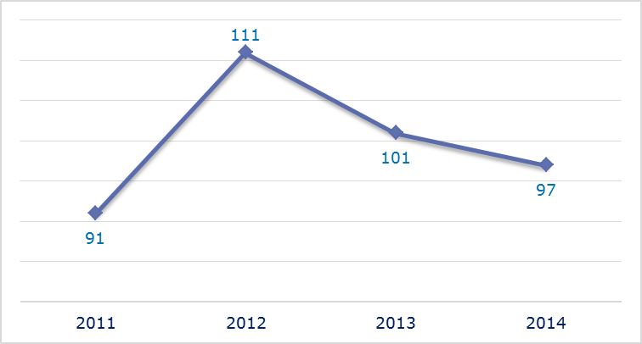
- Evolution of complaints against Sweden
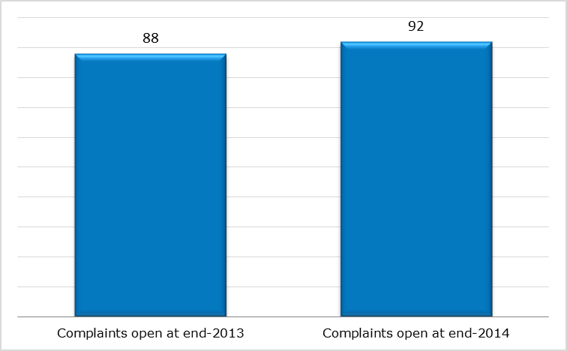
- New complaints registered in 2014: main policy areas
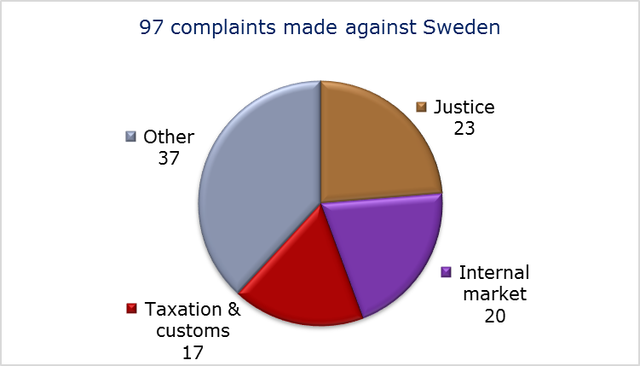
- EU PILOT
- New EU Pilot files opened against Sweden (2011-14)
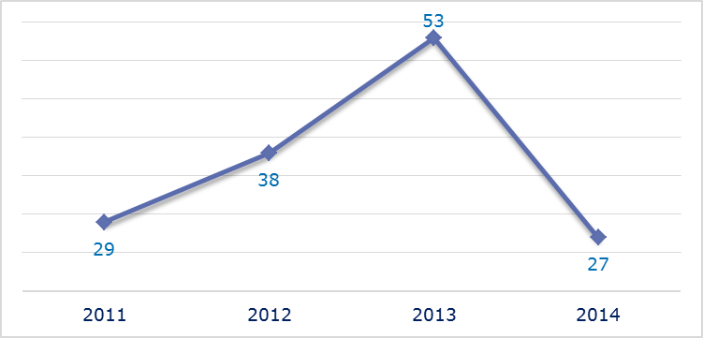
- Evolution of files relating to Sweden open in EU Pilot
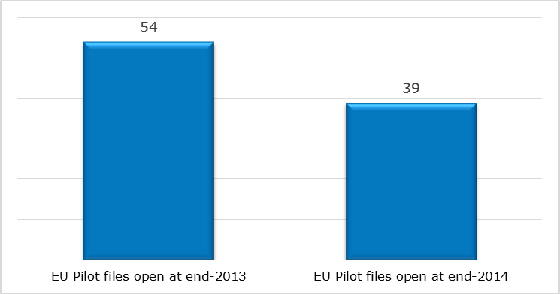
- New EU Pilot files opened in 2014: main policy areas
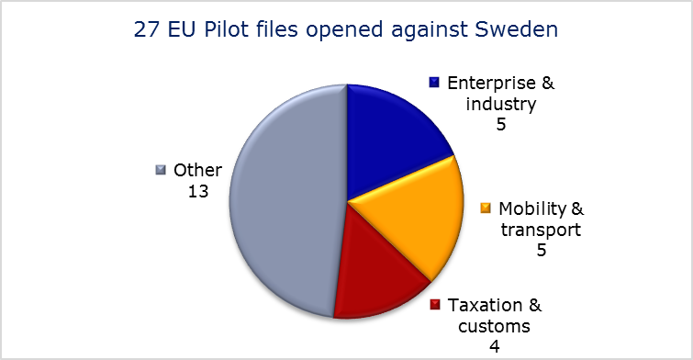
- EU Pilot files: average response time in days (2011-14)
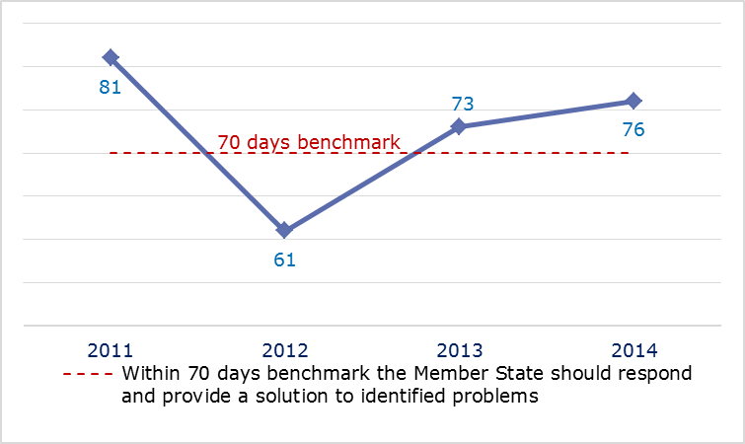
- EU Pilot files: evolution of the resolution rate by Sweden (2011-14)
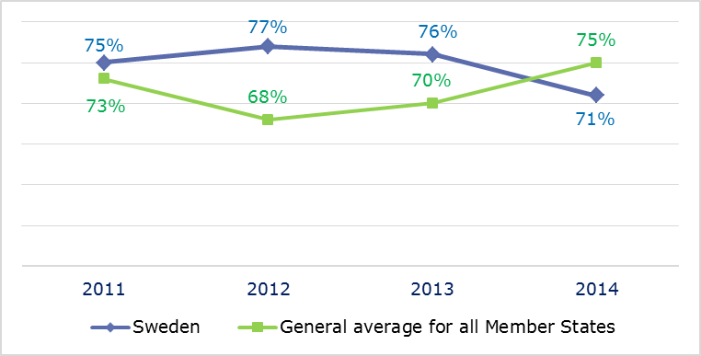
- INFRINGEMENT CASES
- Infringement cases against Sweden open on 31 December (2010-14)
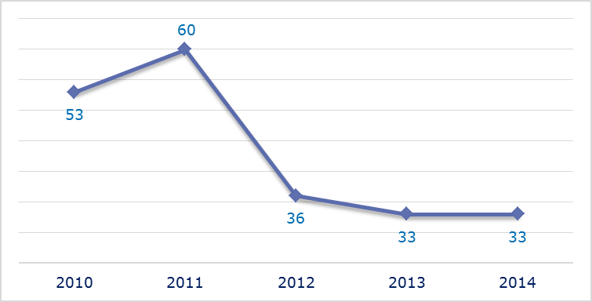
- New infringement cases opened in 2014: main policy areas
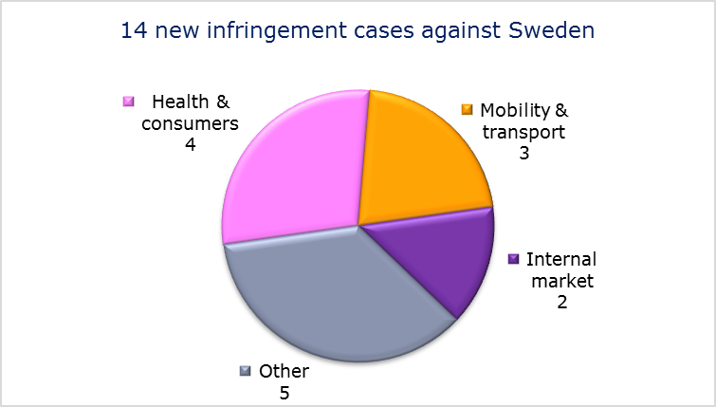
- Key infringement cases and referrals to the Court
- The Commission opened 14 new infringement cases against Sweden in 2014. These, and other major ongoing infringement cases, concern:
- failure to pay parental allowance where Sweden is the competent Member State to pay family benefits under the regulation on the coordination of social security systems. Under Sweden’s legislation, parental allowance is classified as a maternity and equivalent paternity benefit, and not as a family benefit as prescribed by the regulation;
- failure to provide for protection against abusive successive fixed-term employment contracts, in breach of the Fixed-Term Work Directive;
- lack of a judicial procedure to appeal against hunting decisions taken by the County Administrative Boards;
- nonconformity of national legislation with the provisions of the directive on free movement of EU citizens and their family members;
- non-communication of national measures transposing the Capital Requirements Directive;
- incorrect application of the regulation concerning the rights of bus and coach passengers due to the lack of designated bus terminals for disabled passengers and of sanctions for violations of the regulation;
- incorrect transposition of the Airport Charges Directive due to the lack of consultation of airport users and discriminatory charges;
- mandatory quarantine and testing to detect certain diseases, in particular paratuberculosis in cattle, before these animals can be sent to Sweden;
- discriminatory limit on the deductibility of cross-border intra-group interest payments.
- The Commission referred one case to the Court under Article 258 TFEU. This concerns:
- the exemption provided for in the VAT Directive, which states that services supplied by public postal services and the sale of stamps should be exempt from VAT. In Sweden the supply of services whose terms have been individually negotiated are not allowed to benefit from the VAT exemption.
- The Commission did not refer any cases to the Court under Article 260(2) TFEU.
- TRANSPOSITION OF DIRECTIVES
- New late transposition infringement cases against Sweden (2010-14)
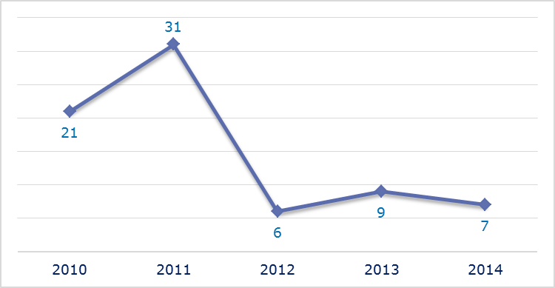
- New late transposition infringement cases opened in 2014: main policy areas
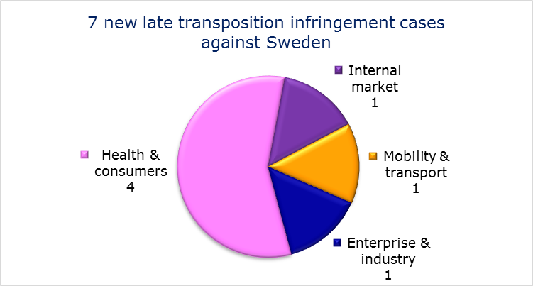
- Referrals to the Court
The Commission did not refer any cases to the Court under Articles 258 and 260(3) TFEU.
- EARLY RESOLUTION OF INFRINGEMENT CASES

Major cases closed without a Court judgment in 2014
These concerned:
- nonconformity of the national implementing legislation with the requirements of the Mining Waste Directive;
- the Swedish rules on taxation of alcohol, which impose payment of excise duties on alcohol products that have been seized by customs authorities and thus have not been brought into Sweden.
- IMPORTANT JUDGMENTS
- Court rulings
The Court ruled that:
- Sweden did not implement a judgment of the Court of Justice finding that it had incorrectly transposed the directive on integrated pollution prevention and control incorrectly. The Court ordered Sweden to pay a lump sum of EUR 2 million and a daily penalty of EUR 4 000 for each day it delayed implementing the measures necessary to comply with the first judgment.
- Preliminary rulings
In preliminary rulings addressed to the Swedish judiciary, the Court ruled that:
- the Renewable Energy Directive does not require Member States to open their support schemes for renewable electricity to producers established in other Member States. The Swedish scheme promoting domestic green energy production is therefore compatible with EU law;
- the exclusivity clause contained in Fishing Partnership Agreements concluded between the Union and third countries excludes any possibility for Union vessels to carry out fishing activities on the basis of a licence issued by those third countries without the intervention of the competent EU authorities;
- for a direct descendant of an EU national to be regarded as dependent and thus come within the definition of a ‘family member’ of an EU citizen, a Member State cannot require him to prove that he has tried unsuccessfully to find work or to obtain a subsistence allowance in his country of origin.

UNITED KINGDOM

In 2014 the number of new complaints made against the UK fell by 17 % from the previous year’s peak. New EU Pilot files opened also declined for the third year running. The number of pending infringement cases was broadly similar to 2013 and remained well below the 2011 level. New infringement cases for late transposition were unchanged at their lowest level since 2010.
- COMPLAINTS
- New complaints made against the United Kingdom by members of the public (2011-14)
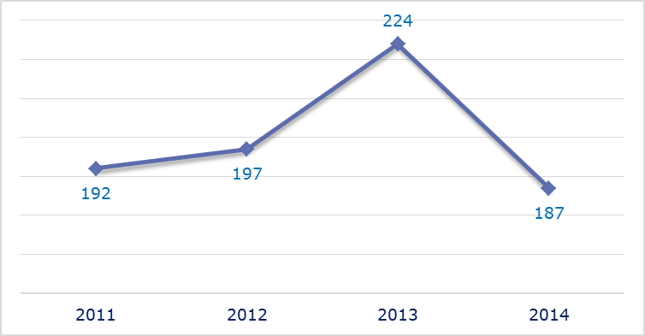
- Evolution of complaints against the United Kingdom
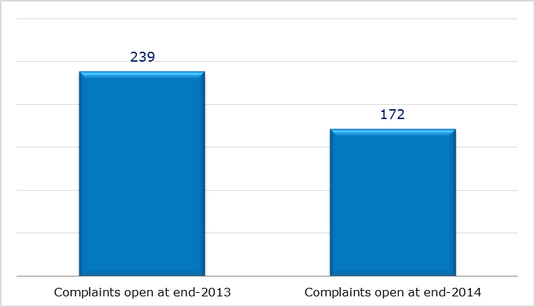
- New complaints registered in 2014: main policy areas
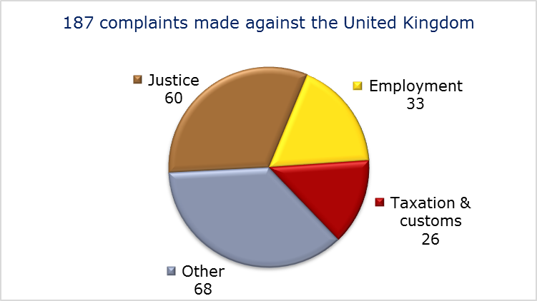
- EU PILOT
- New EU Pilot files opened against the United Kingdom (2011-14)
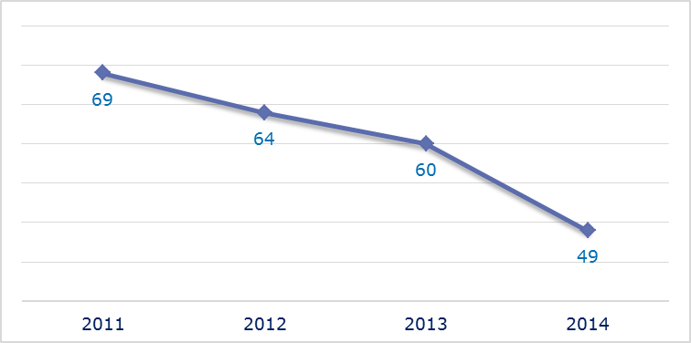
- Evolution of files relating to the United Kingdom open in EU Pilot
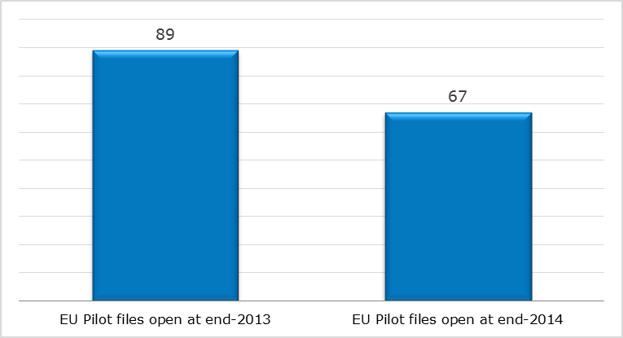
- New EU Pilot files opened in 2014: main policy areas
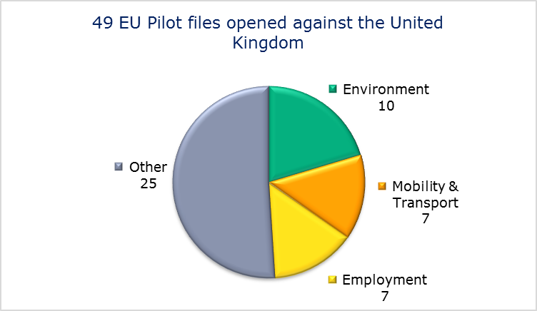
- EU Pilot files: average response time in days (2011-14)
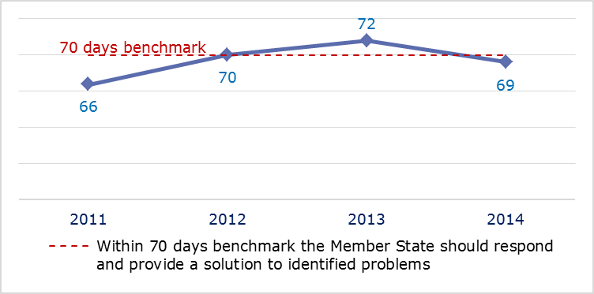
- EU Pilot files: evolution of the resolution rate by the United Kingdom (2011-14)
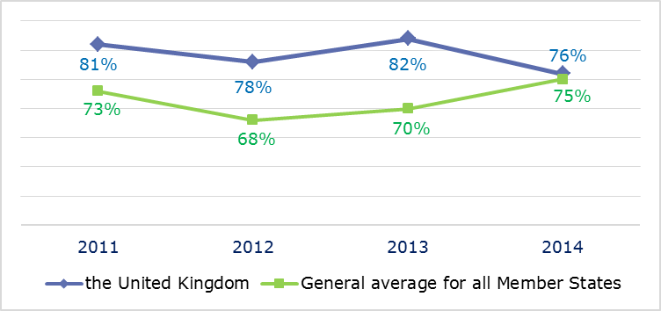
- INFRINGEMENT CASES
- Infringement cases against the United Kingdom open on 31 December (2010-14)
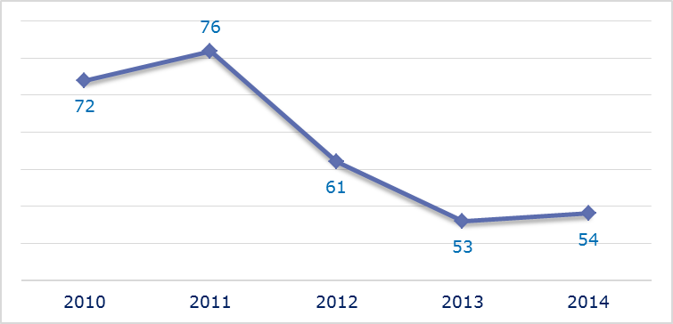
- New infringement cases opened in 2014: main policy areas
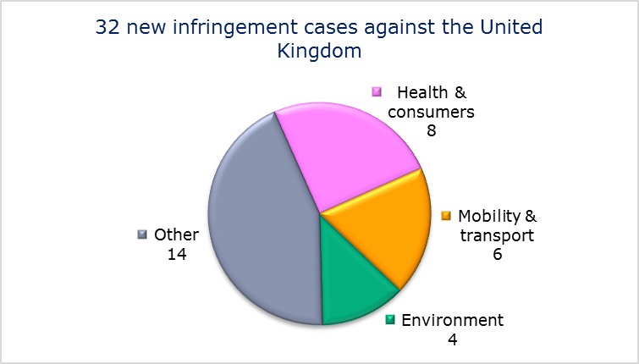
- Key infringement cases and referrals to the Court
- The Commission opened 32 new infringement cases against the United Kingdom in 2014. These, and other major ongoing infringement cases, concern:
- the nonconformity of national law with the Working Time Directive regarding annual leave entitlements for overtime and sick leave;
- the issuing and the display of energy performance certificates in public buildings under the Energy Performance of Buildings Directive;
- the ‘front–of-pack’ food labelling scheme, which colour-codes certain nutrients using a traffic-light-system. The scheme may make the marketing of some products more difficult and thus hinder or impede trade between Member States;
- non-respect of EU air quality standards (nitrogen dioxide limit values);
- incorrect application of the Environmental Impact Assessment Directive and the Habitats Directive regarding the Pembrokeshire Power Station cooling system;
- failure to correctly apply judgments of the Court of Justice on the rights of EU nationals who return to the Member State of their nationality after living in another Member State;
- incorrect application of the directive on driving licences;
- incomplete transposition of the directive amending several directives on two- or three-wheel motor vehicles, the Capital Requirements Directive and the Cross-border Healthcare Directive;
- failure to efficiently implement functional airspace blocks. Under the Single European Sky legislation, national air traffic control organisations should work together in regional airspace blocks to gain efficiency, cut costs and reduce emissions. The set-up of these common airspace blocks is arranged around traffic flows rather than state boundaries, which leads to performance improvements;
- incomplete transposition of the First Railway Package;
- failure to comply with EU rules on excessive track access charges for passenger and freight trains using the Channel Tunnel.
- The Commission referred three cases to the Court under Article 258 TFEU. They concern:
- the application of a discriminatory ’right to reside’ condition for EU nationals to be granted social security benefits (such as child benefit or a state pension credit);
- breach of EU rules on fiscal marking of fuels: under the rules fuel distributors should be required to have two separate fuel tanks to distinguish between the lower tax marked fuel for fishing vessels and the fuel subject to the standard rate for private leisure boats;
- the taxation regime for transfers of assets abroad. The UK legislation seems to treat domestic and cross-border transactions differently
- the reduced VAT rate on the supply and installation of energy-saving materials, which goes beyond what is allowed under the VAT Directive.
- The Commission did not refer any cases to the Court under Article 260(2) TFEU.
- TRANSPOSITION OF DIRECTIVES
- New late transposition infringement cases against the United Kingdom (2010-14)
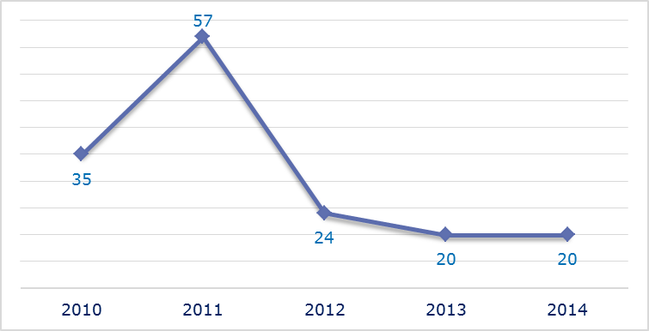
- New late transposition infringement cases opened in 2014: main policy areas
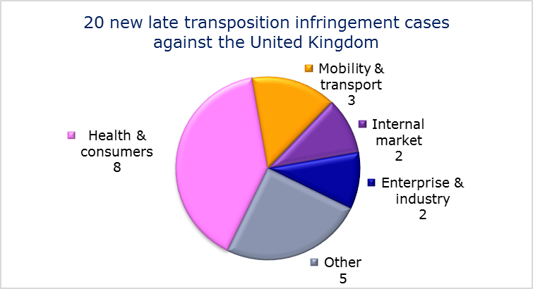
- Referrals to the Court
The Commission did not refer any cases to the Court under Articles 258 and 260(3) TFEU.
- EARLY RESOLUTION OF INFRINGEMENT CASES

Major cases closed without a Court judgment in 2014
They concerned:
- incorrect transposition of the Wild Birds Directive;
- incorrect application of the Environmental Impact Assessment Directive regarding risk assessment of the liquefied natural gas terminal and tankers in Milford Haven, Wales;
- incorrect application of the regulation concerning the rights of bus and coach passengers by not designating bus terminals where disabled people are entitled to receive assistance, not designating a national enforcement body and not setting up a penalty system for infringements of the regulation;
- incorrect application of the VAT Directive by not allowing a manufacturer to reduce the taxable amount of his supplies if the purchase is cancelled or he gives a price reduction due to a fault or damage to the goods purchased.
- IMPORTANT JUDGMENTS
- Court rulings
The Court ruled that:
The UK controlled foreign company rule for capital gains is not compatible with the Treaty because it levied corporation tax on the UK parent company when its non-UK subsidiary realised capital gains by disposing of an asset. The tax was levied even if the UK parent company could prove that the transaction was carried out for valid commercial reasons and did not involve tax avoidance;
- the UK cannot abolish taxpayers’ remedies for the repayment of taxes levied in breach of EU law without proper transitional arrangements;
- the UK was financially responsible for its refusal to pay to the EU Budget £ 15 million plus interest due from the import of fresh garlic under incorrect authorising documents;
- the UK’s system of costs for environmental plaintiffs bringing a case to court was excessive.
- Preliminary rulings
In preliminary rulings addressed to the UK judiciary, the Court ruled that:
- Member States are not required to grant maternity leave or adoption leave to a female worker who as a commissioning mother had a baby through a surrogacy arrangement;
- a woman who gives up work, or is seeking work, because of the physical constraints of the late stage of pregnancy and the aftermath of childbirth can retain the status of ‘worker’ for the purpose of the rules on free movement of workers. To do so, she must return to work or find another job within a reasonable period after the birth of her child;Article 7 of the Working Time Directive must be interpreted as a salesperson’s holiday pay cannot be limited to their basic salary. Where such a worker is paid commission calculated on the basis of the sales that they make, that commission must also be included in the calculation of the holiday pay;
- the ambient air quality standard for nitrogen dioxide under the Air Quality Directive is binding and the national court has to take the necessary measures to ensure the competent authority establishes the required air quality plans;
- when a non-EU national holds a residence card as a family member of an EU national, a Member State cannot make their right of entry subject to the requirement that they must first obtain a visa;
- periods in prison cannot be taken into account for the purposes of acquiring a permanent resident permit or being granted enhanced protection against expulsion;
- the unfertilised human ova whose division and further development have been stimulated by parthenogenesis does not constitute a ‘human embryo’ within the meaning of Article 6(2)(c) of the directive on the legal protection of biotechnological inventions if, in the light of current scientific knowledge, it is not capable of developing into a human being;
- on the concept of certain meat processing techniques, in particular whether they should qualify as ‘mechanically separated meat’ or ‘meat preparation’ in terms of the regulation on hygiene rules for food of animal origin;
- a consortium group relief from taxes must be granted to a consortium with member companies and an ultimate parent company in non-EU countries as long as the link company is an EU or EEA company.

Regulation (EU) No 994/2010.
Directive 2012/27/EU.
Directive 2003/35/EC.
Regulation (EC) No 550/2004.
IP/14/818.
Directive 2012/34/EU, MEMO/14/293.
Directive 2006/126/EC.
Directives 2000/43/EC, 2004/113/EC and 2006/54/EC.
Directive 2013/36/EU.
Directive 2008/120/EC.
MEMO/14/36.
Directive 2011/24/EU, MEMO/14/470.
Commission v Slovenia, C-140/14, IP/14/51.
Directives 2009/72/EC and 2009/73/EC.
Directive 2013/29/EU.
Directives 2009/29/EC and 2009/31/EC.
Directive 92/43/EEC.
Directive 2004/49/EC.
The number of files open at the end of 2013 given in the 2013 annual report is different from the current figure. This is because some files were registered late and others have been closed.
Directive 2003/88/EC.
MEMO/14/36.
Directive 2009/28/EC.
MEMO/14/537.
PM₁₀ is an air pollutant consisting of small particles with an aerodynamic diameter less than or equal to a nominal 10 micrometers. The particles’ small size allows them to penetrate deep into the lungs where they may be deposited and cause adverse health effects. (Source: European Environment Agency).
Directive 2008/50/EC, MEMO/14/589.
Directive 2010/64/EU, MEMO/14/470.
Directive 2013/36/EU.
Regulation (EC) No 550/2004.
IP/14/818.
Commission v Spain, C-454/14, IP/14/814.
Commission v Spain, C-461/14, IP/14/814.
Directive 89/391/EEC.
Directive 92/43/EEC.
Regulation (EC) No 765/2008.
Directive 2006/112/EC.
Commission v Spain, C-184/11 and Court press release No 71/14.
Spain v Commission, C-641/13 P.
Regulation (EC) No 1083/2006.
Spain v Commission, C-197/13P; Spain v Commission, C-192/13P; Spain v Commission, C-429/13 P and Spain v Commission, C-513/13P.
Commission v Spain, C-428/12.
Commission v Spain, C-576/13.
Commission v Spain, C-127/12 and IP/11/1278 on the earlier referral decision.
Commission v Spain, C-678/11 and IP/10/1569 on the earlier referral decision.
Directive 85/337/EEC, as amended by Directive 97/11/EC.
Consejería de Infraestructuras y Transporte de la Generalitat Valenciana and Iberdrola Distribución Eléctrica, C-300/13.
Directive 2008/94/EC.
Hernández, C-198/13.
Directive 95/46/EC.
Google Spain and Google, C-131/12 and Court press release No 70/14.
Directive 93/13/EEC.
Sanchez Morcillo and Abril Garcia, C-169/14.
The number of files open at the end of 2013 given in the 2013 annual report is different from the current figure. This is because some files were registered late and others have been closed.
Regulation (EC) No 883/2004.
Directive 1999/70/EC.
Directive 2004/38/EC.
Directive 2013/36/EU.
Regulation (EU) No 181/2011.
Directive 2009/12/EC.
MEMO/14/470.
The Commission decided on 20 November 2013 to refer the case to the Court; the application was filed on 10 March 2014. Commission v Sweden C-114/14; IP/13/1111.
Directive 2006/21/EC.
Directive 2008/1/EC.
Commission v Sweden, C-243/13 and Court press release No 166/14.
Ålands Vindkraft AB v. Energimyndigheten, C-573/12, press release of the Court No 90/14.
Ahlström and Others, C-565/13.
Reyes, C-423/12, CJE/6/14.
Directive 2003/88/EC.
Directive 2010/31/EU.
Directive 2008/50/EC , IP/14/154.
Directive 2011/92/EU.
Directive 92/43/EEC.
The Queen v Immigration Appeal Tribunal and Surinder Singh, ex parte Secretary of State for the Home Department, C-370/90 and Eind, C-291/05.
Directive 2006/126/EC.
Council Directive 2013/60/EU.
Directive 2013/36/EU.
Directive 2011/24/EU.
Regulation (EC) No 550/2004.
IP/14/818.
First Railway Package (Directives 91/440/EEC and 2001/14/EC, replaced by the Rail Recast Directive 2012/34/EU).
Commission v United Kingdom, C-308/14.
Directive 95/60/EC.
IP/14/810.
The Commission decided on 24 October 2012 to refer the case to the Court; the application was filed on 7 March 2014, Commission v United Kingdom, C-112/14, IP/12/1147.
Directive 2006/112/EC. The Commission decided on 21 February 2013 to refer the case to the Court; the application was filed on 4 April 2014, Commission v United Kingdom, C-161/14, IP/13/139.
Directive 2009/147/EC.
Directive 85/337/EEC as amended by Directives 97/11/EC and 2003/35/EC.
Regulation (EU) No 181/2011.
MEMO/14/537.
Council Directive 2006/112/EC.
Commission v United Kingdom, C-112/14 and IP/12/1146 on the earlier referral decision.
Commission v United Kingdom, C-640/13 and IP/12/64 on the earlier referral decision.
Commission v United Kingdom, C-60/13.
Commission v United Kingdom, C-530/11.
D., C-167/12 and Court Press Release No 36/14.
Saint Prix, C-507/12 and Court Press Release No 86/14.
Directive 2003/88/EC, Lock, C-539/12.
ClientEarth, C-404/13.
McCarthy and Others, C-202/13 and Court Press Release No 182/14.
Onuekwere, C-378/12 and G, C-400/12 and Court Press Release No 4/14.
Directive 98/44/EC.
International Stem Cell Corporation, C-364/13.
Regulation (EC) No 853/2004 and Newby Foods, C-453/13.
Felixstowe Dock and Railway Company and Others, C-80/12 and Court Press Release No 46/14.

