TABLE OF CONTENTS

Contents
1. Executive Summary Sheet 4
2. Introduction 6
3. Procedural issues and consultation of interested parties 7
3.1. Impact Assessment Steering Group 7
3.2. Impact Assessment Board 7
3.3. Use of Expertise and Consultation of interested parties 8
3.3.1. External expertise 8
3.3.2. Consultation of interested parties 8
4. Review of the current policy and problem definition 9
4.1. The problem 9
4.1.1. The basic problem 9
4.1.2. The current problem 9
4.1.3. Relationship with other energy efficiency and climate policies 11
4.2. Evaluation of the current policy framework 12
4.2.1. Scope of the evaluation 12
4.2.2. Achievements of the legislative framework 13
4.2.3. Problems with the current legislation and implementation 18
4.3. The baseline: How will the problem evolve? 23
4.4. Who is affected and how? 25
4.5. Justification of EU action 26
5. Objectives 27
6. Policy options 28
6.1. Measures to address the problems 28
6.1.1. Measures to address problems related to Energy Labelling 28
6.1.2. Measures to address problems related to both Energy Labelling and Ecodesign 31
6.1.3. Measures to address problems related to (predominantly) Ecodesign 36
6.2. Policy options 38
6.2.1. Option 0: no changes, baseline 38
6.2.2. Option 1: Improvements within the existing regulatory framework 39
6.2.3. Option 1+: Option 1 combined with some improvements in the legal framework, notably for energy labelling 39
6.2.4. Option 2: Significant reform of both ecodesign and energy labelling 40
6.2.5. Option 3: Comprehensive reform of ecodesign and energy labelling extending the scope to non-energy related products and to centralise market surveillance 41
6.2.6. Suboption to Options 1+, 2 and 3: merge ecodesign and energy labelling into one legal instrument 42
7. Analysis of impacts 43
7.1. Approach 43
7.2. Impacts of options 45
7.2.1. Environmental impact 45
7.2.2. Economic impact 49
7.2.3. Social impact 54
7.2.4. Impacts of merging ecodesign and energy labelling 56
8. Comparing the options 58
9. Monitoring and evaluation 63
Annex 1 – Use of expertise and consultation of interested parties 64
Annex 2 – Detailed presentation of the Ecodesign and Energy Labelling Directive and their implementation 90
Annex 3 – Analysis of market surveillance by member states 97
Annex 4 – The 2012 review of the Ecodesign Directive 100
Annex 5 – Description of the model and modelling assumptions 102
Annex 6 – The baseline – product sectors and consumer expenditure 106
Annex 7 – Product registration database: practical details 109
Annex 8 – Transition between different labels – practical details 110
Annex 9 – Administrative burden calculation 112
Annex 10 – Ambition level of measures 118

1. Executive Summary Sheet
Impact assessment on Review of the Energy Labelling Directive and the Ecodesign Directive
A. Need for action
Why? What is the problem being addressed? Maximum 11 lines
The basic problem that products can have a negative impact on the environment depending on how they are made, used and disposed is addressed by the Ecodesign and Energy Labelling Directives. However, problems have arisen in the implementation of the Directives. Most products are now in the top classes of the energy label making it more difficult for consumers to distinguish between models. Moreover, the "A+", "A++" and "A+++" classes introduced during the previous revision of the Energy Labelling Directive have shown to be less effective in persuading consumers to buy more efficient products than the A to G scale. Further, there is non-compliance with ecodesign and labelling requirements leading to a loss of about 10% of envisaged energy savings, in part related to weak enforcement by national market surveillance authorities. Evaluation also revealed further problems with the current policy framework and implementation. These problems do not only affects the potential energy and environmental savings targeted by the policy, but also affect consumers as their energy bills are not reduced by as much as is envisaged.

What is this initiative expected to achieve? Maximum 8 lines
The main objective is to reduce energy consumption (and associated energy bills) and other significant environmental impacts of products by ensuring consumers are informed in a relevant and easy-to-understand way and allowing industry to transform environmental challenges into economic opportunities. In terms of energy savings the current 10% loss of savings due to non-compliance is a specific target, but also potential further savings through other improvements are to be explored. In addition, a main objective is to provide a simplified policy framework that is apt for purpose and robust to future developments.

What is the value added of action at the EU level? Maximum 7 lines
The objective of reducing negative environmental impacts of products, in particular energy use, cannot be sufficiently achieved by the Member States, because this would lead to divergent national provisions and procedures (while having similar objectives) that would generate undue costs for industry (and eventually consumers) and constitute obstacles to the free movement of goods within the EU. Acting at the EU level is the only way to ensure that requirements and labels for products placed on the market are equal in all Member States, thereby ensuring the functioning of the Internal Market underpinned by Article 26 of the Treaty on the Functioning of the European Union.

B. Solutions
What legislative and non-legislative policy options have been considered? Is there a preferred choice or not? Why? Maximum 14 lines
One non-legislative option and three legislative options representing varying degrees of the extent of reform of the Directives have been formulated. The non-legislative option ("1") includes improvements within the existing regulatory framework. The first legislative option ("1+") combines the non-legislative measures with changes to the Energy Labelling Directive to address the layout of the label and requiring registration prior to placing labels on the market. The second legislative option ("2") adds to the first one also registration of products covered by ecodesign and requires product to be third-party tested (instead of in-house). The third legislative option ("3") is a complete overhaul of the framework extending the scope of the Directive to all products, not just energy-related products; in order to better address non-energy environmental impacts. For the legislative options separate sub-options are defined concerning the layout of the label, with energy efficiency scale ratings of respectively A+++ to D (baseline), A-G, 0-100 and 9-3. The preferred option is option 1+ combined with the sub-option of the A-G scale for the label. This option achieves significantly better impacts than Options 0 and 1. While options 2 and 3 achieve even better results, they are questionable with regard to international obligations and for option 3 also for the principle of proportionality. The A-G label, shows the best results and its additional administrative costs are more than offset by its superior effect on consumers related monetary benefits.

Who supports which option? Maximum 7 lines
Option 1 has little support from stakeholders, while Option 1+ has significant support from stakeholders: the vast majority is of the view that the Energy Labelling Directive needs to be changed to achieve energy savings closer to the full economic technical potential. Option 2, revising also the Ecodesign Directive, is supported by a smaller share of stakeholders. In particular industry interest groups are not convinced about the need for change of the Ecodesign Directive. Green NGOs support option 3. The A+++ to D and the 9-3 label do not have much support from stakeholders. The vast majority supports an A-G label, though not all manufacturers and retailers do. The 0-100 label is supported by some industry interest groups.

C. Impacts of the preferred option
What are the benefits of the preferred option (if any, otherwise main ones)? Maximum 12 lines
Approximate yearly impact, 2030:
Energy savings: 552 TWh primary energy
Consumer savings € 10-30 billion
Additional commercial revenue € 34 billion

What are the costs of the preferred option (if any, otherwise main ones)? Maximum 12 lines
Administrative and compliance costs are approximately:
€ 7-12 million per year for manufacturers
€ 3-4 million per year for dealers
€ 3 million per year for the Commission
Given that compliance is mandatory, manufacturers and dealers should be able to pass these costs on to consumers, for whom they would be more than offset against their monetary benefits. There are no other negative impacts.
How will businesses, SMEs and micro-enterprises be affected? Maximum 8 lines
The positive impact on revenues affects larger businesses and SMEs and micro sized enterprises in the same way. A different regime for micros/SMEs cannot be justified. All retailers should be subject to the same rules as energy labels are only useful for consumers if all products are labelled in all retail outlets. There are few SMEs manufacturers and no micros. The same rules should apply to all to ensure fair competition in the single market.
Will there be significant impacts on national budgets and administrations? Maximum 4 lines
There are no additional impacts on national budgets/administrations.
Will there be other significant impacts? Max 6 lines
In case of revision of Energy Labelling and/or Ecodesign, a revision from Directive to Regulation and removing overlap with the Market Surveillance Regulation would lead to simplification.
D. Follow up
When will the policy be reviewed? Maximum 4 lines
A review clause 5-10 years after adoption would be included.

2. Introduction
The Energy Labelling Directive requires the Commission to review the effectiveness of the Directive and its delegated acts by 31 December 2014.
The Ecodesign Directive required the Commission to review the effectiveness of the Directive and its implementing measures by 2012. That review concluded that no immediate revision was necessary, but that the Directive could be reviewed again along with the review of the Energy Labelling Directive, since the effects of ecodesign implementing regulations and energy labelling delegated regulations applicable to the same energy-related products are often linked and complementary.
This impact assessment comprises the outcome of the review of the Energy Labelling Directive and the Ecodesign Directive. It focusses on the framework Directives and not on the individual implementing regulations or any new energy-related products that may in future be addressed under this framework through the Ecodesign Working Plan. Chapter 3 summarises the procedural issues and the consultation of interested parties. Chapter 4 sets out the problem definition, the conclusions of the evaluation of existing policy, and the outstanding problems and their underlying drivers. Chapter 5 describes the policy objectives. Chapters 6, 7 and 8 present the options, impact analysis, and comparison of options, respectively. Monitoring and evaluation issues are considered in Chapter 9.
This impact assessment supports a new legislative proposal on Energy Labelling. It does not support a revision of the Ecodesign Directive.
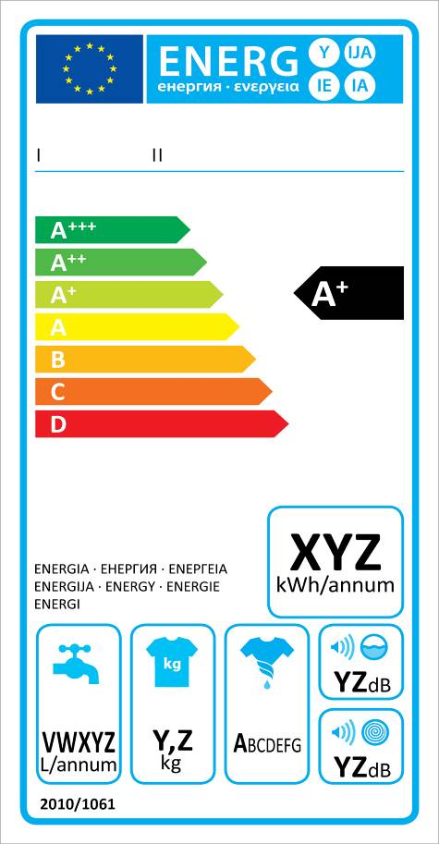
Figure 1: The energy label for washing machines

3. Procedural issues and consultation of interested parties

3.1. Impact Assessment Steering Group
Lead DGs: DG Energy, DG Enterprise and Industry
Agenda planning /WP reference: 2013/ENER+/036
Impact assessment steering group (IASG): The impact assessment work was followed by the Inter-Service Steering Group (ISG) on energy efficiency which met 3 times in February -November 2014. The Steering Group consisted of: DG Agriculture, DG Budget, DG Climate Action, DG Competition, DG Connect, DG Economic and Financial Affairs, DG Employment, Social Affairs and Inclusion, DG Environment, Eurostat, the Executive Agency for Small and Medium-sized Enterprises, DG Health and Consumers, Infrastructure and logistics in Brussels, DG Internal Market and Services, the Joint Research Centre, DG Justice, the Legal Service, DG Mobility and Transport, DG Regional Policy, DG Research and Innovation, the Secretariat General, DG Taxation and Customs Union, and DG Trade.

3.2. Impact Assessment Board
The Impact Assessment Board of the European Commission assessed a draft version of the present impact assessment report and issued its opinions on 5 and 16 June 2015. The Impact Assessment Board made several recommendations and, in the light of the latter, the final impact assessment report inter alia:
- clarifies the scope of the review and this impact assessment;
- explains the relationship with the Energy Efficiency Directive, the Emission Trading System and the Effort Sharing in the non-ETS sectors;
- provides information on expected energy savings and their cost-effectiveness for existing product-specific measures and for potential additional product groups;
- explains where there are differences for different products groups with regard to the effect of the legislation;
- clarifies that the lifetime of products that is used in the analysis is the economic lifetime, which takes into account consumer behaviour on discarding certain products before the end of their technical lifetime;
- elaborates on the role of the market surveillance regulation and why it is not expected that the proposal for a new market surveillance regulation will lead to much additional market surveillance effort on ecodesign and energy labelling;
- highlights the difficulty in establishing performance benchmarks for market surveillance, even for long-established sectors such as consumer product safety;
- elaborates on the effectiveness and practical operation of the product registration database;
- analyses the option of merging the energy labelling and ecodesign frameworks;
- provides more (qualitative) explanation of the modelling results and corrects an error in the impacts in terms of jobs for the different label layouts;
- elaborates in more detail the monitoring arrangements for future evaluation.

3.3. Use of Expertise and Consultation of interested parties

3.3.1. External expertise
Two studies were specifically commissioned to prepare the review, one general evaluation study (further referred to as the 'evaluation study') and one specific study focussing on consumer understanding and behaviour related to different types of energy labels (further referred to as the 'consumer behaviour study'). In addition, an impact assessment study provided specific analysis for the options set out in this impact assessment. Further studies requested by the Commission during 2011-2014 also provided relevant input. Details are provided in Annex 1.

3.3.2. Consultation of interested parties
Stakeholders were consulted through the following means:
- Three stakeholder meetings organised by the contractor of the evaluation study.
- A public consultation on the ‘Your voice in Europe’ web page.
- A stakeholder meeting on selecting the energy label designs to be tested in the second phase of the 'consumer behaviour study'.
- An international conference on products policy.
- An Ecodesign Consultation Forum meeting.
Further detail on stakeholder consultation can be found in Annex 1.

4. Review of the current policy and problem definition

4.1. The problem
Since this impact assessment concerns a review of existing Directives, the problem is described in two steps in the following sections: firstly the basic problem that created the need for the Directives, and secondly the problems that have arisen in the course of the application and implementation of the Directives.

4.1.1. The basic problem
The basic problem is that products can have a negative impact on the environment depending on how they are made, used and disposed. As set out in previous impact assessments on sustainable product policy the most important market failures and imperfections that prevent the achievement of greater energy and environmental efficiency are:
- Prices that do not reflect the negative environmental impacts of the production or consumption of products;
- Difficulties for consumers to tell whether one product is more resource efficient during its use phase than another;
- Higher upfront costs when buying a more performing product, while the benefits accrue over a longer period of time (i.e. during its use-phase). Consumers may not take into account the use cost of a product but focus on the initial purchase price only;
- Measures on efficiency of products taken by Member States create barriers to the free movement of goods in the EU and unnecessary burden for industry to comply with different sets of rules in each Member State.

4.1.2. The current problem
The above problems have been addressed by the current policy framework through a two-pronged approach:
- Banning the least energy and environmentally efficient products from the EU market through ecodesign requirements for manufacturers, which are EU-harmonised (thus, Member States cannot set different requirements) ensuring the free movement of energy-related products and eliminating unnecessary regulatory burden for companies. The aim of the Ecodesign Directive is to address both energy consumption and other significant environmental impacts of production, use and end-of-life treatment of energy-related products;
- Encouraging consumers to buy more energy efficient products by informing them about the energy use of products through a mandatory harmonised EU energy label (see figure 1) provided by manufacturers and displayed by dealers. The aim of the Energy Labelling Directive is to address specifically energy consumption during the use phase and, where relevant, other consumption of resources during use of energy-related products.
The two approaches are complementary, with ecodesign 'pushing' the market and energy labels 'pulling' it, as illustrated in figure 2. Energy labels are only introduced for products where an information failure for the user exists, which is not always the case for professional products. A detailed presentation of the Ecodesign and Energy Labelling Directive and their implementation is provided in Annex 2.
Problems have arisen, in particular:
- Energy labels have proved successful in encouraging consumers to buy more energy efficient models and manufacturers have responded by producing ever more energy efficient products. As a result most products are now in the top classes, which have become overpopulated, making it more difficult to distinguish between models. Thus, rescaling may be necessary, in which the required efficiency for each label class is redefined and a product model that now is in class A++ will be 'rescaled' to e.g. class B. This has not yet been undertaken for specific products; when this was proposed to stakeholders for televisions in 2012, this was considered premature without clear provisions for this in the Energy Labelling Directive. Moreover, the "A+", "A++" and "A+++" classes introduced during the previous revision of the labelling Directive have shown to be less effective in persuading consumers to buy more efficient products than the A to G scale.
- Non-compliance with ecodesign and labelling requirements, in part related to weak enforcement by national market surveillance authorities.
Evaluation also revealed further problems, described in section 4.2.3, with the current policy framework and implementation.
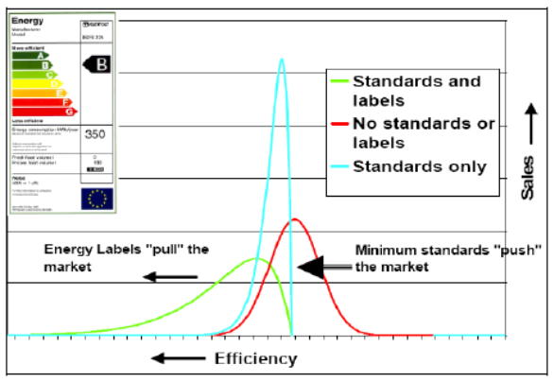
Figure 2: The combined effect of ecodesign ('minimum standards') and energy labels

4.1.3. Relationship with other energy efficiency and climate policies
The Energy Labelling Directive and the Ecodesign Directive contribute to the Energy Efficiency Directive's target (Article 3) to ensure that the Union's 2020 energy consumption is not more than 1483 mtoe of primary energy or not more than 1086 mtoe of final energy consumption. The Energy Labelling Directive and the Ecodesign Directive are complementary to the measures Member States are required to take by the Energy Efficiency Directive. In order to prevent double counting, it is specified in the Energy Efficiency Directive that for energy savings obligations of Member States (Article 7), only savings exceeding those achieved by ecodesign can be counted towards those obligations.
There is no direct relation between the Energy Labelling and the Ecodesign Directives and the EU's main policy instruments to reduce greenhouse gas emissions, i.e. the Emission Trading System (ETS) and the Effort Sharing by Member States in the non-ETS sectors. Energy efficiency policy is a policy in its own right for the objectives of competitiveness, security of supply and sustainability. Energy efficiency measures are complementary to ETS because they address non-price barriers such as lack of information, bounded rationality and high behavioural discount rates. In the case of products, the incentive generated by the ETS could in theory prompt companies exposed to the ETS price to pressure appliance manufacturers to reduce this consumption, but in practice this incentive is too indirect, diffuse and economically insignificant to make a real difference. By contrast, energy labelling provides consumers with information so that they can make more informed decisions precisely in the situations where it is relevant, namely when new products are purchased. Ecodesign removes all products from the market that would be more costly than the product that would have the least cost during its lifetime (purchase costs plus operating costs), because not all consumers make "rational" decisions and they discount future cost savings more than what is rational (and certainly more than what is socio-economically optimal).
By reducing electricity consumption of products, ecodesign and energy labelling have a direct effect on the demand for electricity, which is part of the ETS sector. Because ecodesign and energy labelling reduce the demand for electricity, less effort is needed under the ETS. As a result, the price of allowances is lower than it would otherwise be. However, so far Commission assessments have not found evidence of this in the current framework, as the decrease in the prices of allowances was primarily driven by lower economic activity and other factors. In the future this might change, although the proposed Market Stability Reserve, by reducing the surplus, would counteract this effect and stabilise the level of emission allowance prices. In the sectors not covered by ETS, EU action on ecodesign and energy labelling brings down the cost of national action to achieve greenhouse gas emission saving targets. Reducing energy use of products cannot be sufficiently achieved by the Member States, because this would lead to divergent national provisions and procedures (while having similar objectives) that would generate undue costs for industry (and eventually consumers) and constitute obstacles to the free movement of goods within the EU.

4.2. Evaluation of the current policy framework

4.2.1. Scope of the evaluation
The scope of the evaluation concerns energy-related products and it does not go into the question of whether energy savings are more or less cost-effectively achieved in other sectors. The PRIMES reference and policy scenario 2013 show that in order to achieve our decarbonisation and energy targets, all policy measures are necessary for delivering energy savings. Further, given that the Ecodesign Directive applies the principle of setting requirements at the least life cycle cost level (explained further on in this impact assessment) and given that the Energy Labelling Directive requires that each step on the label corresponds to significant cost savings to the user, the costs to achieve the energy savings through these Directives are equal to or less than zero (further detail at the end of section 4.2.2).
The Energy Labelling and Ecodesign Directives are both framework Directives that lay down the conditions under which requirements can be set for specific energy-related products (such as washing machines or electric motors) through delegated acts (for energy labelling) and implementing acts (for ecodesign). The evaluation and this impact assessment focus on the framework Directives and not on the individual implementing regulations, which are subject to their own consultation and impact assessment process (see also process chart in Annex 2). Therefore, the evaluation examined the implementation of the Directives for the product groups covered by the first Ecodesign Directive (article 16, which contained a list of priority products) and the two subsequent working plans. Any new products that may in future be addressed under this framework will be identified in the 2015-2017 Working Plan, which the Commission plans to adopt as part of the Circular Economy package later in 2015. Any identified product groups would be subject to preparatory studies that investigate in more detail the potential for environmental improvement and provide the elements for the identification of policy options in the subsequent impact assessments.
There are potentially other policy measures than Energy Labelling and Ecodesign that could increase the efficiency of energy-related products, such as fiscal measures, incentive schemes, voluntary schemes etc. However, this evaluation focusses on the specific problems that have arisen in the implementation of the Energy Labelling and Ecodesign, such as effectiveness of energy labels and enforcement. In wider context, energy labelling and ecodesign policies have shown to work well across the world. The Energy Labelling and Ecodesign policies have been an example for other jurisdictions outside the EU, thus driving significantly more energy savings, contributing to a more uniform global playing field and creating opportunities for European business abroad. The setting of minimum efficiency and labelling requirements is recognised globally as one of the most effective policy tools in the area of energy efficiency. A recent study for the Commission shows that out of 59 non-EU countries that have adopted equipment energy labelling schemes, half of them (53%) have adopted designs that have fully or partially emulated the EU energy label (including major economies such as Brazil, China, Korea, Russia and South Africa). At least 45 countries outside the European Union have adopted minimum energy efficiency requirements for products, some of them in fact implementing ecodesign regulations in the context of association agreements or EU membership negotiations. The EU and the US are the world leaders in the development of minimum energy efficiency requirements and energy labelling.

4.2.2. Achievements of the legislative framework
To date 24 ecodesign implementing regulations have been put in place, some of which have been subsequently updated through amendment, and two ecodesign voluntary agreements are in place. Products covered range from household products, such as fridges, lamps and boilers, to professional and industrial products, such as electric motors and fans. In addition, 12 delegated regulations on energy labelling now ensure that a range of products must be sold with an EU energy label attached. The effectiveness of the policy is illustrated by the transformation of the market for fridges and washing machines shown in figure 3a and 3b.
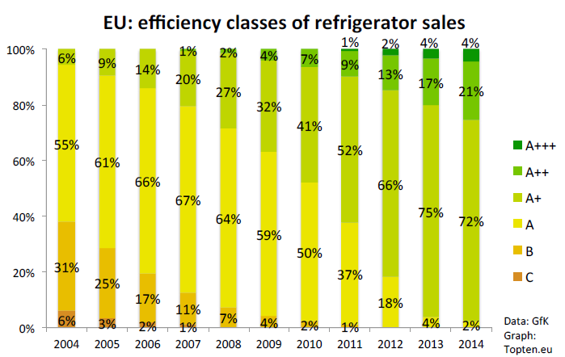
Figure 3a: Transformation of the EU Market for refrigerators
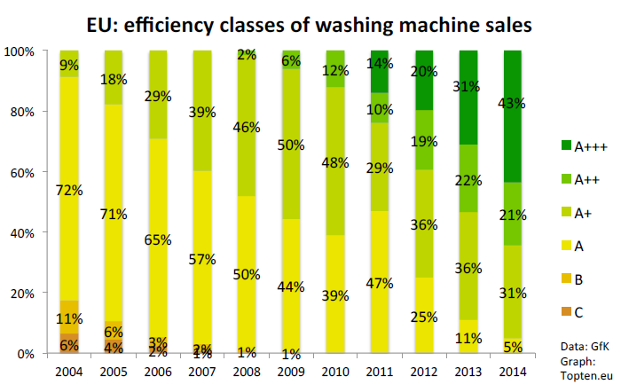Figure 3b: Transformation of the EU Market for washing machines
It is possible that the energy efficiency improvement is in part due to other factors such as ongoing market trends independently of the policy. No ex-post counterfactual data is available to assess this, because it is difficult to quantitatively assess what would have happened in the absence of the policy. In any case, energy efficiency improvements do not necessarily occur spontaneously. On the contrary, for example in the case of vacuum cleaners, a product that was until recently not regulated by ecodesign or energy labelling, energy use per product was, in absence of regulation, increasing rather than decreasing, with no parallel improvement in functionality. By contrast, the various consumer studies show a high impact of the energy label on consumer choice. In addition, the sheer existence of the energy label for a product group triggers a competition towards more energy efficiency among the manufacturers. Therefore, at least a significant part of the observed energy efficiency improvement can be attributed to the Directives.
Based on modelling, in which energy use developments in the different sectors affected by ecodesign and energy labelling until 2010 were corroborated with Eurostat data, the ecodesign and energy labelling measures in place to date (see Annex 2 for a full list) are estimated to save 175 mtoe primary energy per year in 2020. This estimate takes into accounts 'rebound' effects, i.e. behavioural responses to the use of more efficient products (e.g. using them more than was previously the case for the less efficient product) and the trend towards ever more and bigger appliances (computers, displays, etc.) per household. The estimate does not take into account any non-compliance with the legislation, of which section 4.2.3 indicates currently to be about 10% of expected energy savings. Taking this into account means that ecodesign and energy labelling measures contribute to about two fifths of the EU 2020 target of 20% energy savings by 2020.Energy savings from considering new product groups within the scope of the Directives show a significantly lower cost-effective energy savings potential of around 6 mtoe per year in 2030.
Consumers trust the energy label and usually take it into account when they buy appliances. The label achieves its intended effect in slightly different ways for different types of products. For appliances such as fridges and washing machines, for which many consumers are aware that these can significantly affect their household bills, the label provides easily accessible and standardised information to help consumers take this into account in their choice. For other types of appliances where many consumers are less aware of the significance on their household energy bills, such as televisions, the label first of all raises their awareness on this and then secondly serves in a similar way as for fridges and washing machines. This is evidenced by the results of the consumer behaviour study which found that the choice between one and another label design has a greater difference in impact on behaviour when consumers rank energy efficiency of low importance in their purchasing decision. This observation was particularly strong in the case of televisions.
The Directives have helped consumers to lower their utility bills, as the least efficient products are taken off the market through ecodesign and the choice of more efficient products is facilitated through energy labelling. For example, for fridges the average difference in energy consumption between A+++ and class B appliances is around 160 kWh per year representing about €600 over the appliance's lifetime. In total, the ecodesign and energy labelling measures in place to date are estimated to save end-users of products (household, commercial and industry) 110 billion euro net (higher acquisition costs counterbalanced by lower running costs) per year: composed of ca. € 170 billion saving on energy bills and € 60 billion extra acquisition costs. The net savings are€ 100 billion when taking into account current non-compliance levels. This is equivalent to 465 euros per household per year. By 2030, the net savings achieved by ecodesign and energy labelling measures in the different sectors will have grown to almost € 300 billion, saving the EU consumers almost 17% on total costs versus the situation without measures (see Figure 3c).
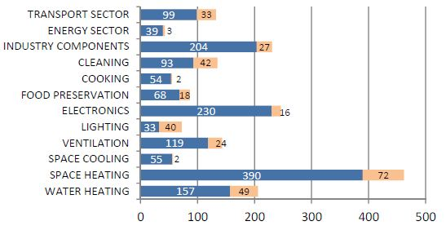
Figure 3c: Consumer total expenditure (running costs + acquisition costs) EU 2030 in billion euro with current ecodesign and energy labelling measures (blue) compared to absence of policy (blue plus pink), assuming energy price escalation rate of 4%. The graph includes the impact of tyre labelling (transport sector) which is not the subject of this impact assessment.
For environmental aspects other than energy consumption there has been less impact so far, because most of such ecodesign requirements were introduced more recently and do not yet apply. The exception is water consumption, which has been addressed by the energy label for washing machines since 1996, by the energy label for dishwashers since 1999, and by ecodesign requirement for washing machines since 2011. For both washing machines and dishwashers the water consumption per cycle more than halved over the last ten years. These regulations have thus also contributed to the strategy for a resource-efficient Europe.
Apart from environmental and monetary benefits to end-users, the setting of requirements at EU level also benefits industry. A common and predictable regulatory framework brings down costs for manufacturers, because rules are harmonised across the EU. It reduces the commercial and financial risks of innovation and allows European industry to compete with lower cost countries on higher value added products. The increase in acquisition costs for the consumers translates into higher business revenue for all market actors (plus taxes). For measures existing and in the pipeline today, it is calculated that by 2020, the extra revenue will be € 55 bln, growing to € 75 bln by 2030, compared to a situation without measures. Some 43% will go to industry, 11-12% to wholesale and 45% to retail, subdivided into 13-16% to retail and (because there is a large share of installed products) 30-33% to installers. While there is some administrative burden involved for business with the redesign and testing of the products, as well as the provision of technical documentation and of the energy label, these costs are orders of magnitude lower than the additional revenue generated by the higher acquisition costs of the products.
All in all, it can be stated with confidence that the existing measures under the two framework directives achieve energy savings at financial costs which are negative for all actors involved (they are gains), or, at most, are zero. The net consumer cost savings of the measures in the different sectors are illustrated in Figure 3c above. The reason for this is that the Ecodesign Directive requires the minimum requirements on product energy efficiency to be established at the level of Least Life Cycle Cost (LLCC) from the point of view of the end-user, meaning the level at which the combined purchase and running costs (energy, maintenance, disposal etc.) of a product are the lowest. Less efficient products would be cheaper to buy, but that advantage would be outweighed by the higher running costs. More efficient products would have lower running costs, but the advantage would be outweighed by the higher purchase cost. Thus the LLCC level achieves the highest cost savings compared to the base case, meaning the ecodesign measures are cost-savers by definition. The Energy Labelling Directive requires that each step in the label corresponds to significant cost savings to the user. As a result, all the classes in the label have to include products whose combined running and purchase costs are lower than that of the base-case non-efficient product (below the "break-even point" in Figure 3d), ensuring that energy labelling promotes, also by definition, products that bring absolute cost savings over the life cycle.
Figure 3d. Typical Life Cycle Cost curve. I = Basecase, II = Least Life Cycle Cost, III = No financial loss (break even point), IV = Best Available Technology

4.2.3. Problems with the current legislation and implementation
The evaluation study identified the following problems with the current framework:
Problems related to Energy Labelling
- 'Reduced effectiveness of labels following the introduction of A+ and up classes': In the recast of the Energy Labelling Directive in 2010 three classes (A+++, A++, A+) were added on top of the existing labelling A (best) - G (worst) scale of the EU energy label. These new classes have reduced the effect of the label on consumers to purchase more efficient products. While consumer research shows that the new label scale is understandable for consumers, it has reduced their willingness to pay more for more efficient products, because they are less motivated by a difference between A+ and A+++ than by a difference between C and A.
The scale of this problem can be illustrated by the difference in energy consumption between A+++ and A+ washing machines (with 7 kg load) which is 50 kWh/year. At sales of more than 15 million washing machines a year, this difference means after a period of fifteen years more than 11 TWh/year electricity use (1 mtoe primary energy) for all washing machines bought in that period. Given that washing machines present only a fraction of the savings of all labelled products, the scale of this problem is significant. At the same time, the addition of A+ and up classes meant that the scale remains of a closed type. Thus, a rescaling of the label classes is necessary when a large share of the market reaches class A+++. Rescaling has not yet been undertaken, as no agreed method exists and the possibility to add + classes has so far undermined any compromise for such rescaling.
For several product groups, products populate mainly the highest classes leaving the lowest classes unpopulated, which is not known to consumers. This is in part because of the success of the scheme, as manufacturers have responded to the challenge of producing more energy efficient products, but also because of incoherence between energy labelling and ecodesign regulations. For a number of product groups, the ecodesign and energy labelling regulations have in the course of time become incoherent, because further steps of staged bans by ecodesign were put into place while energy labels were unchanged. This means that a number of classes shown on the energy label are unpopulated because of ecodesign legislation having banned products of that efficiency. In the most extreme cases of washing machines, fridges and dishwashers, the energy label currently displays A+++ to D classes, but only A+++, A++ and A+ appliances can still be placed on the market.
- 'Increase in size of appliances': There is a trend towards larger products in particular product groups, i.e. refrigerators, washing machines and TV’s. For example, the average viewable surface area of TV's grew from 10 dm² (19 inches diagonal) in 1990 to 28 dm² (32 inches) in 2010 and is projected to rise to an average 71 dm² (51 inch) in 2030. As a result, overall efficiency improvements for these products may not result in absolute energy savings. It is unclear if this trend is solely in response to consumer demand or whether this is in part a development driven by the label since it is normally easier to make larger appliances more efficient and thus obtain higher label classes: the rating scale of the label rewards energy efficiency, i.e. energy use related to a function such as the screen size of a TV. Although the label provides consumers also with the absolute energy consumption, some consumers do not understand this and a significant share of consumers thinks the rating scale itself represents energy consumption, rather than efficiency.
Problems related to both Energy Labelling and Ecodesign
- 'Long rulemaking processes, leading to outdated technical and preparatory work': While the entire process from the start of the preparatory study to the publication of the regulation should be possible within 41 months, until 2012 the average was 49 months. This leads to lost savings as measures enter into force later and are based on outdated market data. After the preparatory study, the process takes approximately 20 months (see for further detail Annex 2). Thus, even if the 41-month schedule could be followed, the market data from the preparatory study will be outdated by the time of the decision on the regulation. The lack of availability and access to recent market data is a problem for the preparatory study and for the regulatory process if there is a need to update such data.
Another aspect related to the rule-making process is that the Energy Labelling Directive lacks a working plan and a formalised stakeholder forum such as the Consultation Forum under the Ecodesign Directive, although in practice ecodesign and energy labelling regulations have always been developed together using the Ecodesign Directive's working plan and stakeholder forum as a basis. So far only in one case was only an energy labelling regulation developed (for updating all energy labelling regulations with regard to the display of the label on the internet), for which the same consultation procedure was applied as for ecodesign.
- 'Too low level of ambition for a number of product regulations': The evaluation study found that while for some product groups ecodesign regulations and labels have shown the right ambition level, for many other product groups the level of ambition is too low compared to what is technically and economically feasible (see Annex 10 for details). The evaluation highlighted this is often related to the problem of limited and outdated data. In addition, also the requirement in the Ecodesign Directive of aiming to set requirements at the least life cycle cost poses problems. This criterion assumes that more efficient products have increased investment cost and decreased cost of operation (namely energy cost). On the basis of product-specific conditions (taking e.g. into consumer behaviour and durability of the product that determine its lifetime) the level of the requirement for the least life cycle cost should be established. However, for e.g. electronic products there is not always a clear relationship between purchase price and efficiency. In addition the evaluation study indicates that two existing voluntary agreements have an ambition level that is too low compared to what is technically and economically feasible.
- Non-compliance due to 'weak enforcement': The expert estimate from the evaluation study is that yearly around 0.6% of the market is surveyed. The indication is that 10-25% of products on the market are non-compliant with ecodesign requirements. Some 20% of products are estimated to be offered for sale without the energy labels displayed and another 15% have the label displayed in an insufficient way (e.g. wrong placement, retailer made label, label hidden or covered). On the basis of these figures, the average level of non-compliance with ecodesign and energy labelling regulation is estimated at 20%.
The share of non-compliance itself does not provide a clear indication of what the scale of the problem is with regard to loss of envisaged energy savings: some non-compliant products may be only a little less efficient than required or indicated on the label, while others may be much less efficient. Based on expert estimates, the evaluation study indicates that around 10% of envisaged energy savings are being lost due to non-compliance. In addition to the findings of the evaluation study, further analysis of market surveillance performance by Member States based on collection of data by the Commission is provided in Annex 3.
There is a general agreement that the level of market surveillance is too low and should be increased as it is economically beneficial for society (current investments in enforcement are estimated to be 0.05% of the value of lost energy savings). Non-compliance also affects consumers, who may have bought an appliance with a different performance than what they were informed of, and the competitiveness of many manufacturers as it undermines a level playing field. There are a number of different drivers behind the weak enforcement:
- 80% of the respondents to the public consultation think that not enough resources are given to market surveillance authorities.
- The evaluation also highlighted unclear provisions in the legal texts, notably an overlap of requirements between the Energy Labelling Directive and its delegated acts, which leads to questions of interpretation and makes analysis of suspected non-compliance cases more difficult. In addition, there is an overlap of provisions between the Directives and the market surveillance regulation. The market surveillance regulation sets out the general requirements and procedures for Members States to enforce EU-harmonised product legislation, while product-specific legislation such as the ecodesign and energy labelling include the requirements for economic operators that Member States need to enforce. However, the Ecodesign and Energy Labelling Directives currently also include a number of provisions on procedures for enforcement. This overlap is less likely to lead to interpretation questions, as the provisions in the Ecodesign and Energy labelling Directive should take precedence over those in the market surveillance regulation. Nevertheless, different procedures for market surveillance for Ecodesign and Energy Labelling than for safety legislation (even though the products concerned may be the same ones) sectors creates additional burden for Member States authorities, making market surveillance less efficient.
- A specific obstacle for authorities concerns the timely access to technical documentation and the ability to contact foreign entities, including the identification of the manufacturer. More importantly, even in the common case where the manufacturer is known and contacted, obtaining the technical documentation for individual products often takes several weeks, even though the legislation requires that this should be made available within 10 days. Furthermore, manufacturers use the same energy label and/or ecodesign declarations for a range of “product family” models ("equivalent models") that have the same performance, but this information is only available once the technical information file is received and since it is not available in readily shareable electronic format market surveillance authorities are often not aware that other authorities may have already tested an equivalent model. As 10 market surveillance authorities (MSAs) indicate in the Ecopliant project "The different trademarks and different model identification for equivalent products is often a problem for MSAs controlling the national markets, and this is especially a barrier for increased coordination of market surveillance activities across the EU."
- Cooperation between market surveillance authorities is considered limited and better coordination is a way in which the impact of market surveillance can be increased without significantly increasing the resources used for enforcement authorities at national level.
Problem related to (predominantly) Ecodesign
- 'Other environmental impacts could receive more attention': the evaluation study found that regulations to date have mainly addressed the use-phase energy consumption, as this represents the most important contribution to the environmental impacts of the energy-related products. There is potential for reduction of other environmental impacts of energy-related products, e.g. through increased durability. The evaluation study indicates that for properly including non-energy aspects modifications to the MEErP methodology used for preparatory studies would be necessary. To address other environmental impacts of products more widely, an extension of the scope of the Directives to product groups other than energy-related products would be necessary, since for other types of products, environmental impacts other than use-phase energy usually dominate. However, the environmental impacts of products other than energy-related products is a wider problem than the Ecodesign Directive and there may be other ways to address it than to extend the scope of the Directive. Therefore, the assessment of measures related to the Ecodesign Directive to address this problem should take into account other policy instruments that can address the underlying problem for these products.
Thus, the following six problems are identified, along with their underlying drivers:
- Reduced effectiveness of labels following the introduction of A+ and up classes
- Label layout laid down in recast Energy Labelling Directive
- Increase in size of appliances
- Consumer demand for bigger products
- A share of consumers interpret the label rating as absolute consumption
- Easier for larger appliances to be made more efficient and achieve higher label classes
- Long rulemaking processes
- Proper consultation, consideration and assessment requires time
- Limited and outdated data
- Too low level of ambition for a number of product measures
- Limited and outdated data
- Least life cycle cost criterion is poor guidance
- The criteria for requirements of self-regulation are not sufficiently detailed
- Weak enforcement
- Insufficient national resources made available
- Overlap of legal provisions
- Difficult access to technical documentation
- Insufficient cross-border cooperation
- Little reduction of non-energy environmental impacts
- MEErP does not sufficiently capture some impacts
- Scope of the Directives excludes non-energy related products
These six problems diminish the ability of the legislation to reduce negative impacts of products on the environment. They lead to a loss of potential energy savings, unnecessary extra cost for consumers, not satisfactorily informing them, and low savings impact on environmental issues other than energy. The problems identified include the problems that were not fully addressed by the non-legislative actions initiated after the 2012 review of the Ecodesign Directive.

4.3. The baseline: How will the problem evolve?
The purpose of the baseline is to identify what would happen in the absence of new policy. The baseline is quantified so that the analysis of the policy options formulated and analysed in the next chapters can be compared to it. The quantification of the baseline is done on the basis of the 'ecodesign impact accounting' model, of which further detail is provided in Annex 5.
In the absence of any changes to the Ecodesign and Energy Labelling Directives and any changes to the way they are implemented, there will continue to be further energy and other environmental savings. First and foremost because the existing ecodesign and energy labelling product regulations will continue to have effect: more stringent requirements already laid down in the ecodesign regulations will start apply at their scheduled dates and the product labels for categories of products that are not yet populating the highest label classes will drive industry to make more efficient products. Secondly, since the Directives would stay in place as they are, also new ecodesign and energy labelling product regulations for new product categories would still be developed (if product categories could deliver significant savings) and existing product ecodesign and energy labelling product regulations would be reviewed and updated if there are significant potential further savings in energy and other environmental impacts.
However, in absence of any changes non-compliance will remain a problem and is expected to remain at the same level (see Annex 3). The new regulation on market surveillance proposed by the Commission is likely to improve the framework for market surveillance. A key aspect of the proposal is that it removes overlaps of enforcement provisions between the market surveillance regulation, the general product safety legislation and the sector-specific product legislation. However, it does not remove the overlap for ecodesign and energy labelling, because the general product safety legislation is not applicable to ecodesign and energy labelling and it was considered not appropriate at the time of the market surveillance regulation proposal to amend the Ecodesign and Energy Labelling, since they were undergoing their own review and stakeholder consultation. Therefore, by itself the new regulation on market surveillance is unlikely to lead to additional market surveillance effort on ecodesign and energy labelling by Member States, and it is assumed in the baseline that there is no improvement with regard to energy savings being lost due to non-compliance. This non-compliance not only affects the potential energy and environmental savings targeted by the policy, but, at least where it concerns labelled products, would also undermine consumer confidence in the energy label: the more reports are published on non-compliance, the less consumers will trust the EU energy label.
Further, the energy label will be running into its limits: the labelling scheme will lose its impact once all or most models correspond to the A+++ rating. The current approach of introducing an A-G label for a newly regulated appliance and then adding A+ and up classes to allow for technological progress would continue to apply. However, once the A+++ to D label would be in place for a specific product no further revision of the delegated act would be undertaken, because this requires rescaling, which has been rejected for the A+++ to D label when this was proposed for televisions. Thus, the energy labels were a large share of models would be in the highest classes would lose their meaning and effect on consumers.
There may also be other missed potential in the absence of any changes to the Ecodesign and Energy Labelling Directives or the way they are implemented. As pointed out, the evaluation study indicated that higher ambition levels on energy efficiency are possible, which are not achieved in the current implementation. The same applies to non-energy environmental impacts of energy-related products. Further, other types of products will remain outside the scope of the Ecodesign and Energy Labelling Directives.
Figure 4 shows the resulting baseline trend in energy consumption of energy-related products in absence of any changes in the policy or its implementation, taking into account non-compliances and the limitations of the energy label. Detail on the development for specific product sectors as well as on consumer expenditure trends is provided in Annex 6.
Figure 4 also provides a comparison with what would have happened in absence of energy efficiency legislation for products. This is to illustrate the significant energy savings gained from regulating energy efficiency of products, even if there is also an autonomous trend to improve energy efficiency for most types of energy-related products in absence of policy (not depicted, but taken into account in the 'ecodesign impact accounting' model).
6000
6500
7000
7500
8000
8500
9000
9500
10000
10500
1990
2010
2015
2020
2025
2030
Year
Energy of Entire Installed Stock (TWh/a)
No ecodesign/energy labelling policy
Baseline
Figure 4: Energy use of all energy-related products for the baseline compared to no ecodesign and energy labelling policy

4.4. Who is affected and how?
Consumers are affected, because the policies should lower their utility bills and the overall life cycle cost of buying and using appliances. The energy label provides them with objective information on use of energy and other resources.
Retailers are affected, because they have to ensure proper display of the label. In addition, the shift towards more efficient appliances which usually have higher costs means higher turn-over and likely also higher profits. The affected retailers include micro-enterprises, which should be subject to the same rules as energy labels are only useful for consumers if all products are labelled in all retail outlets.
Manufacturers, both in the EU and those exporting to the EU are affected, because they have to take the requirements of the regulations into account when designing new products. Further, the label presents them with opportunity to compete on a second objective factor, energy efficiency, in addition to price. The affected manufacturers would include any micro-enterprises for the same reason as given for retailers and to ensure fair competition in the single market where it concerns ecodesign requirements. The sectors concerned include few or no micro-enterprises manufacturers.
Society at large is affected, because of the environmental benefits of the policy.
Member States are affected, because they have to ensure compliance through market surveillance and inform consumers about the label.
Third countries are affected, because the A-G energy labelling scheme has been followed as a model in many different countries around the world and some countries have also implemented EU ecodesign regulations. They are also affected through the Agreement on Technical Barriers to Trade which is to ensure that regulations, standards, testing and certification procedures do not create unnecessary obstacles, while also providing the right to implement measures to achieve legitimate policy objectives.
Standardisation organisations are affected, because they need to develop the detailed testing and measurement methods.

4.5. Justification of EU action
The Energy Labelling Directive is based on Article 194(2) of the Treaty on the Functioning of the European Union, which provides a legal base for measures to promote energy efficiency. The Ecodesign Directive is based on Article 114 of the Treaty on the Functioning of the European Union, the legal base for measures for the functioning of the internal market.
The objective of reducing negative environmental impacts of products, in particular energy use, cannot be sufficiently achieved by the Member States, because this would lead to divergent national provisions and procedures (while having similar objectives) that would generate undue costs for industry (and eventually consumers) and constitute obstacles to the free movement of goods within the EU. Only through harmonised EU rules on energy labelling and underlying measurements and testing can it be ensured that the same model of a product has the same published energy class throughout the EU.
In the absence of EU legislation, it is likely that all Member States would introduce energy efficiency legislation for some product groups, because of consumer protection and because it is difficult to achieve the target of the Energy Efficiency Directive without addressing the energy use of products. Acting at the EU level is the only way to ensure that requirements and labels for products placed on the market are equal in all Member States, thereby ensuring the functioning of the Internal Market underpinned by Article 26 of the Treaty on the Functioning of the European Union. The principle of proportionality is examined in section 8.

5. Objectives
The general objective of the Treaty that the policy aims of the Energy Labelling and Ecodesign Directives contribute to is to ensure the functioning of the internal market through the free movement of goods that ensure a high level of environmental and consumer protection.
The specific objective of the Energy Labelling and Ecodesign Directives is to reduce energy consumption and other significant environmental impacts of products by ensuring consumers are informed in a relevant and easy-to-understand way and allowing industry to transform environmental challenges into economic opportunities.
The evaluation found that the objectives remain relevant and that increasing energy efficiency has in fact gained in relevance. Therefore, the operational objectives for the present review of Energy Labelling and Ecodesign Directives are directly derived from the above objectives and are to update the policy framework so that it continues to ensure the functioning of the internal market, a high reduction of energy consumption and other environmental impacts of products. In addition, in light of the problems identified further specifically objectives of this review are to ensure that an update of the policy framework is relevant, useful and easy-to-understand for consumers and can be enforced easily and appropriately. Further specific objectives reinforced by the Commission's drive for better regulation are to ensure that the policy is simple, apt for purpose and robust to future developments and cost-effective. Finally, in addition to the specific objectives a criterion for the assessment should be that the policy framework should remain in line with international obligations. The extent of achievement of reduction of energy consumption will be measured quantitatively, while other objectives can be assessed only qualitatively.

6. Policy options

6.1. Measures to address the problems
Reaching the objectives identified in Chapter 5 necessitates solutions to the outstanding problems and underlying drivers defined in section 4.2. On the basis of the evaluation study and consultation, a number of actions was identified which are referred to as measures. These measures are described below and in section 6.2 they are bundled in different ways to form policy options. These measures work equally well for all product groups, except where explicitly stated differently (provision of monetary information). Product-specific features (e.g. economic lifetime) are not different between the baseline and the measures with a few exceptions as described in Annex 5.

6.1.1. Measures to address problems related to Energy Labelling
For the problem of 'reduced effectiveness of labels following the introduction of A+ and up classes' the measure identified is to change the label scale layout. There are alternative layouts possible. A specific study tested the consumer understanding and the effect on their purchase decisions of a number of potential basic frames that could be used for a new energy label. On the basis of the results of this first phase of the study, potential future label scale designs were drawn up for further analysis. Stakeholders were consulted on the draft label designs and rejected the label design adding further + classes (for example A++++), requesting that it should not be among the label designs among to be tested on consumers in the second phase of the study. Further information on the study and stakeholder consultation is in Annex 1.
Measure 1A: Alphabetic A-G label
The Energy Labelling Directive would be amended so that an A-G label would be applied for products without ever adding any + classes. In order to keep promoting further efficiency improvements, this requires periodic rescaling in which the class-requirements would be made more stringent and a product model that is in class B will be 'rescaled' to e.g. class E. A vast majority of respondents supported this option. However, manufacturers and retailers (both interest groups and individual companies) did not hold a uniform view on the issue, their answers ranging from ‘strongly agree’ to ‘strongly disagree’.
The periodic rescaling means that there may be a transition period in which old (from before the scaling) and new labels (rescaled) would be present. Having an overlap in the market between old ‘A’ and new ‘A’ was seen as undesirable by respondents to the public consultation, in particular by industry and consumer interest groups. An overlap is likely to confuse consumers and lead to sales of less efficient appliances than otherwise, although it is impossible to quantify by how much. The solution is to shorten any overlap period, but that means a different approach in supplying and affixing labels is needed than the present one (at present from a certain date manufactures put a label in the box they ship to dealers; dealers affix the label supplied by manufactures; the label remains on the shop floor as long the specific appliance to which it is attached is not sold). Further detail on the transition period is provided in Annex 8. Periodic rescaling would take place every 5-10 years.
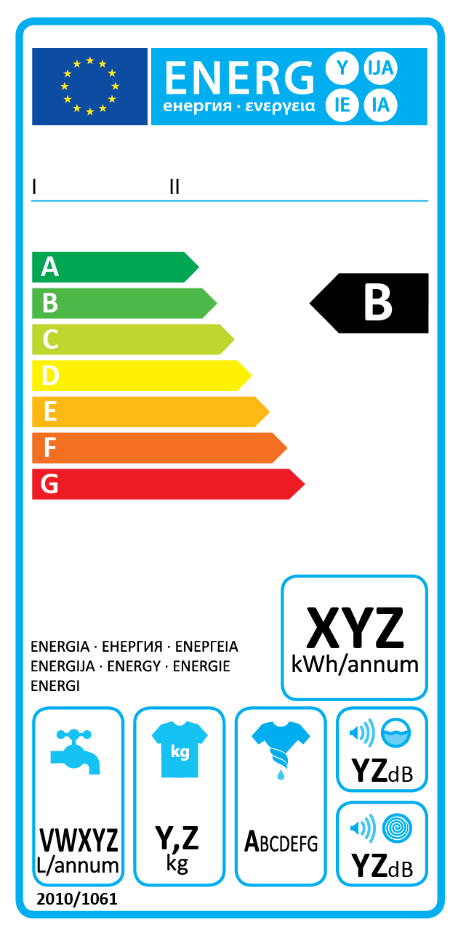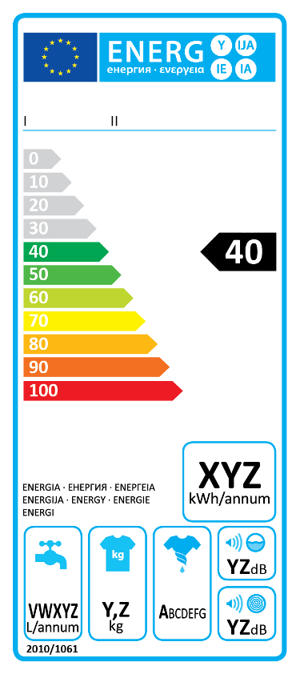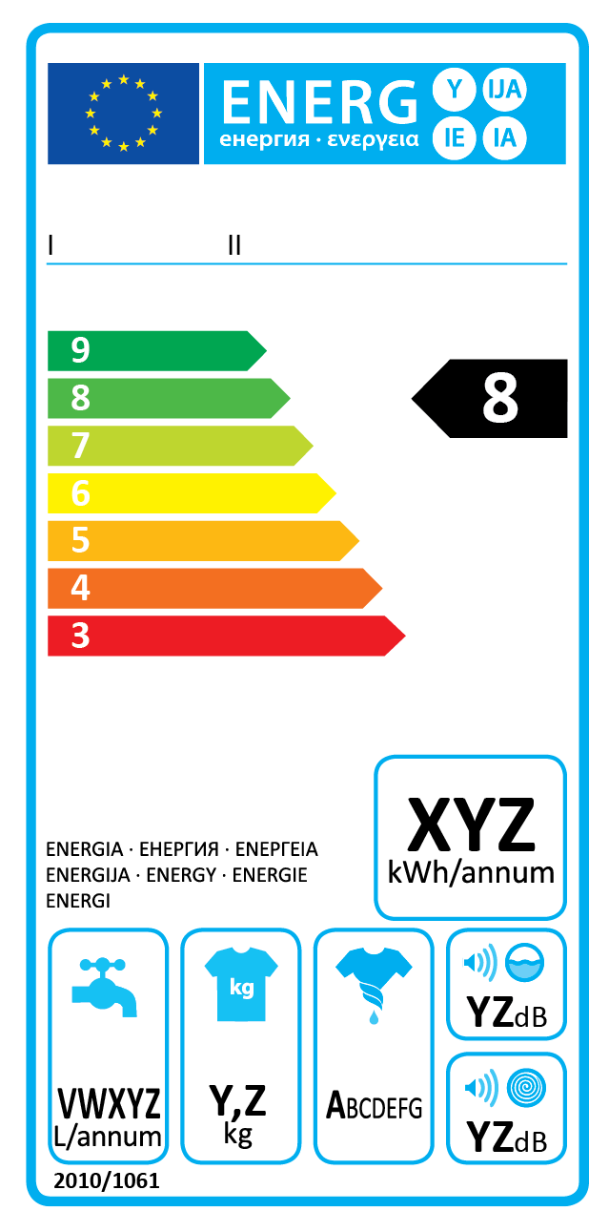
Figure 5 : A-G label (left), numeric label (middle) and reverse numeric label (right)
Measure 1B: Numeric label
The Energy Labelling Directive would be amended so that a numeric label (see figure 5) would be applied for all products. The classes in the initial label would be indicated by numbers ranging from zero on top to e.g. 100 at the bottom, the lower number the better the energy efficiency. At the introduction of the label the top classes would be indicated in grey and be unused so that the label allows room for technological improvement. The level of the zero class should be at or close to the theoretical best possible efficiency. In the case of technological improvement some or all of the grey classes would be made available and a number of classes at the bottom of the label would be removed; the colour scale would thus move up in the label. The normal transition phase after such an update of the label would be less confusing for consumers as each product remains in its existing class (although the assigned colour and the class position in the colour scale do change). Thus, no special transition period as in measure 1A is necessary. Stakeholders from industry and environmental NGOs suggested further exploring this option. In the public consultation stakeholders tended to disagree with moving to an open ended scale on the label such as in this option, except for respondents from industry interest groups who were more positive about it.
Measure 1C: Reverse numeric label
The Energy Labelling Directive would be amended so that a reverse numeric label (see figure 5) would be applied for all products. The classes in the label would be indicated by numbers ranging initially from seven on top to one at the bottom, the higher number the better the energy efficiency. In the case of technological improvement additional classes 8, 9, etc. would be added on top and an equivalent number of classes at the bottom of the label would be removed; the colour scale would remain to show its seven colours, with dark green for the (new) best class. The normal transition phase after such update of the label would be less confusing for consumers as each product remains in its existing class (although the assigned colour and the class position in the colour scale do change). Thus, no special transition period as in measure 1A is necessary. In the public consultation, most respondents across all groups disagreed to some extent with this option. However, in the consultation meeting of 19 February 2014 several stakeholders indicated this was an interesting option to explore further.
For the problem of 'Increase in size of appliances' three possible measures are identified on the basis of the evaluation study. Measures 2 and 3 presented below are alternatives, both addressing the feedback from the majority of respondents to the public consultation who would prefer to focus on both energy efficiency and energy consumption, but with a stronger focus on energy consumption than at present. Measure 2 attempts to improve the way absolute energy consumption of appliances is communicated through the label; measure 3 is more ambitious and uses the current strength of the label design and changes the mechanics behind it, i.e. which products are assigned to which classes. Measure 4 addresses the problem by providing extra information in addition to the label and is only useful in combination with one of the other measures since it has been found to work only for some products types and not for others, as explained below.
Measure 2: More emphasis on absolute energy consumption on the label
The label layout would be changed in order to put more emphasis on the indication of the absolute energy consumption, currently indicated in a box with the indication "XYZ kWh/annum" (see figure 1 or figure 5). Because of the limited space on the label this measure would at the same time limit the amount of non-energy information on the label.
Measure 3: Require for larger appliances a higher efficiency to reach a certain label class
The Energy Labelling Directive would specify that in the preparation of delegated acts it should be considered on a product by product basis whether for larger appliances a higher efficiency (energy use per amount of service, such as the screen size of a TV or the load capacity of a washing machine) is required to reach certain classes on the label. Although this approach could already be applied in the current implementation of the Directive, in the absence of a provision in the Energy Labelling Directive specifically addressing this, only for one product group has it been possible to agree on such approach.
Measure 4: Provide monetary information
Dealers would be required to display the cumulative annual running cost of the appliance due to energy and any other resource consumption either alongside the purchase cost or as part of the overall life cycle cost for consumers (purchase cost plus cumulative annual running cost). A standardised methodology to calculate the cumulative annual running cost would be defined at European level, while the input values for the specific parameters used in it would be different per Member State. The Commission would arrange a webtool, in which dealers can enter their geographic location and the specific energy consumption indicated on the label of the product. The webtool would then provide the dealer with the cumulative annual running cost. National parameters such electricity prices are available to the Commission and can be regularly updated. Consumer and environmental interest groups support this measure, while most manufacturers do not. Trials were done in Norway and the UK. They indicated that this measure only had effect for appliances with high energy consumption such as washer-driers and tumble driers. Therefore, this measure would apply only to product groups with high energy consumption.

6.1.2. Measures to address problems related to both Energy Labelling and Ecodesign
For the problems of 'Too low level of ambition for a number of product measures', 'Long rulemaking processes' and 'Weak enforcement' two measures have been identified that can address more than one of these problems at once. The evaluation study recommended establishing a mandatory product registration database, presented below as measure 5, of which the data can be used to address all three problems. An alternative is measure 6 which does not require changes in legislation and also provides data, but it addresses the problems to a lesser extent and cannot provide the type of data needed to address the problem of weak enforcement.
Measure 5: Mandatory product registration database
A database would be established at EU level, under the management of the Commission, in which manufacturers would have to register their models before placing them on the market. They would need to provide the technical documentation and indicate all equivalent models; the detail of what should be registered in the database is provided in Annex 7. This measure would not involve any additional generation by manufacturers of information or documentation, but only registering in the database information that they are already required to generate (and provide on request). The Commission and the national market surveillance authorities would have access to this database. This would allow the national market surveillance authorities quick access to the technical information necessary for their inspections. Thus, they could save the time that they are currently spending on contacting manufacturers for this information, and use it on core enforcement actions, including checking compliance of dealers with energy labelling. In the context of the revision of the Directive on harmonisation of requirements for radio equipment, which falls under the same market surveillance regime as ecodesign and energy labelling, it was estimated that a registration database could result in an estimated overall gain of up to 10-15% in time/resources for market surveillance authorities. Based on the experience of such a database in Australia, which has higher compliance rates for an otherwise similar policy, this measure is expected to improve compliance rates by 6%-point and reduce energy savings losses as a result of non-compliance by 3%-point (see Annex 5). The costs are estimated to be approximately € 3 million investment to establish the database, € 300.000 annual maintenance costs for the EU budget, and € 3 million per year for manufacturers for the clerical task of entering the information in the database (they already have the information, see further Annex 9).
Although the database is established at EU level, this measure does not lead to any changes in the competence of national authorities with regard to market surveillance. The Commission merely facilitates the establishment and maintenance of the database. If a market surveillance authority finds a product in a shop that is not registered in the database, that authority can immediately start a non-compliance case or take the product off the market in case the manufacturer cannot be contacted. This measure is expected to work well especially in combination with measure 9 on joint enforcement actions, as the latter is expected to increase the budget and level of enforcement activities and would allow to undertake joint action to address a potential situation in which a significant share of product models is not registered in the database. This measure can also be enhanced by developing a digital application for consumers to check the product registration database and report any absence of a product to the market surveillance authorities.
At the same time the product registration database provides the Commission with up to date information on the energy efficiency and other significant environmental impacts of new products, which can be used in the rulemaking process to establish the appropriate ambition level of requirements. Although the database does not include data on sales that preparatory studies usually include, the most important is the data on the efficiency levels that are economically feasible and already available for the products on the market. Such data is particularly important for energy labelling, where in the absence of such data the risk is that the level of ambition for the top classes is set at a too low level, and as a result energy labels will have to be revised early and thus frequently. The availability of up to date information prevents delays in the rulemaking process that are due to a need to procure third party data to update outdated data. A little more than half of the respondents to the public consultation supported this measure, consisting mainly of government and surveillance bodies, environmental interest groups and one quarter of industry interest groups that responded on this topic.
Similar databases exist in other EU harmonisation legislation (cosmetics, noise and radio equipment; for other sectors the Commission is also looking into this as part of its e-Compliance initiative) and in other jurisdictions.
Measure 6: Expand the database study
The existing project in which a contractor, for six product groups, establishes and manages an energy-related product database with energy and significant other environmental data on models available on the EU market would be replicated for all products covered by ecodesign and energy labelling regulations, at present more than 20. Since such data would be collected from publicly available sources, rather than through systematic information from manufacturers, it would not be comprehensive and less up to date than the data collected through a product registration database, but nevertheless of use to address the problem of ambition levels of measures. Since such study cannot collect the technical information necessary for inspections (notably test reports that are held by manufacturers), this measure cannot support market surveillance authorities in improving enforcement.
On the basis of the evaluation study, additional measures have been identified that specifically address the problem of 'Too low level of ambition for a number of product measures' The Ecodesign Directive contains a provision that specifies the level at which requirements should be set. The application of this provision could be refined or, more ambitiously addressing the problem, the provision could be changed. These are two alternative measures further described below.
Measure 7: Use learning curves for least life cycle cost
Annex II of the Ecodesign Directive contains a requirement to aim at setting the level of ecodesign requirements for energy efficiency at the life cost minimum for end-users. It requires adapting such level as a result of sensitivity analysis covering relevant factors. Under this measure in such sensitivity analysis the application of “learning curves”, i.e. the consideration of decreasing production costs over time, would be included. A majority of respondents to the public consultation supported this measure, though manufacturers and their interest groups were divided on it.
Measure 8: Change least life cycle cost requirement
The requirement in Annex II of the Ecodesign Directive to aim setting the ecodesign requirements for energy efficiency at the life cost minimum for end-users would be changed into setting the requirements at the break-even point, i.e. the point where the life-cycle costs of a more efficient product are equal to the life cycle costs of the least efficient product (see section 4.2.2 for more detail on life cycle cost). Respondents to the public consultation were divided: government bodies and environmental interest groups supported this measure; manufacturers are not in favour.
Further, five additional measures have been identified that specifically address the problem of 'Weak enforcement'. These measures can complement each other, except that measure 13, establishing an EU market surveillance authority changes the way market surveillance is organised for ecodesign and energy labelling to such extent that measures 9 and 10 are not applicable in such case. The potential measure for the Commission to enact infringement procedures against Member States that do not carry out sufficient market surveillance activity is not included. This is because this potential is limited, as it is not obvious how to establish a benchmark for a sufficient level of market surveillance. The Commission proposed as one of its 20 actions in its market surveillance action plan to develop key performance benchmarks for market surveillance, but even for the consumer products safety area where there is more experience in collecting data on market surveillance it is proving difficult to identify and agree with Member States relevant enforcement indicators, let alone benchmarks. More than two years after the adoption of the action plan the action is still on-going without a foreseeable indication of the outcome. Market surveillance is an area where Member States are keen to decide themselves how, where and how much effort to invest.
Measure 9: Support joint actions
Joint surveillance and enforcement actions by market surveillance authorities from across the EU would be supported under the Horizon2020 programme in which the national authorities would cooperate in joint testing and other cross-border activities. A little more than half of the respondents to the public consultation consider that the current mechanisms for cooperation in market surveillance between administrations are not effective and support further cooperation beyond the Administrative Cooperation (ADCO) meetings and the Intelligent Energy Europe Ecopliant project. These joint actions could address both non-compliance by suppliers and by dealers, although because of the cross-border dimension they are more likely to address supplier obligations.
Measure 10: Align with market surveillance regulation
The Directives would be aligned with the proposal for a new market surveillance regulation, which aims, inter alia, at eliminating overlaps between general legislation on market surveillance and sector-specific legislation. Article 3(2)-(4) and Article 7 of the Ecodesign Directive and Article 3(2)-(4) of the Energy Labelling Directive would be deleted and a specific article on enforcement would be inserted in both Directives stating that Member States shall ensure that the authorities responsible for market surveillance verify compliance according to the market surveillance regulation. Since the present overlaps concern enforcement of supplier and dealer obligations, such a measure could address non-compliance by both actors. Respondents to the public consultation indicated that it is necessary that the market surveillance regulation applies fully to ecodesign and energy labelling and double requirements should be avoided.
Measure 11: Streamline legal provisions
The requirements for suppliers and dealers in the Energy Labelling Directive would be less detailed in order to avoid overlap and/or contradiction with the delegated acts and the requirements for drafting delegated acts would explicitly specify that the necessary details have to be included in delegated regulations. In addition, the Directive would be changed to a Regulation, because transposition creates still a risk for further overlap and/or contradiction between the general framework and its delegated regulations. Removing and preventing such overlaps and contradictions improves enforcement, because it allows to pursue certain non-compliance cases that otherwise would not be considered worth pursuing due to legal uncertainty. The present overlaps in energy labelling provisions concern requirements for both suppliers and dealers and therefore this measure can address non-compliances by both actors. The instrument of a regulation seems in any case the better instrument since the main element of the policy that requires detailed implementation by Member States is enforcement of the delegated acts, for which requirements are detailed in those delegated acts and in the market surveillance regulation. In options that require revision of the Ecodesign Directive, also that Directive would be revised into a Regulation for the same reasons. Stakeholders pointed out unclear formulations in legal texts, notably the format of information to be provided to consumers and authorities.
Measure 12: Third party certification
The Energy Labelling and Ecodesign Directives would be amended so that for all products covered, a third party has to certify the compliance before a model is placed on the market (at present self-certification applies and third party certification is only an option in the Ecodesign Directive for products where it is duly justified and proportionate to the risk). This would only address non-compliance of suppliers, not for dealers. Not many stakeholders supported this option in the public consultation. In particular the heating industry supported it.
Measure 13: EU market surveillance authority
Instead of market surveillance by the Member States, it would be undertaken by an EU authority, to be newly set up. This measure was already analysed in the impact assessment for the product safety and market surveillance package, but not selected, because would entail significant costs due to the need for the establishment of coordination infrastructures and capacity, which currently do not exist at EU level. Moreover, in the current impact assessment this option includes expanding the scope of the Directives to all products (measure 14), which would likely lead to product-specific requirements that cannot be tested on the product in a laboratory, but instead requires paper trail evidence throughout the life-cycle of the product. This requires in any case new capacities to be developed. Therefore, the consideration to do this through an EU authority merits specific consideration in this context. A little more than half of the respondents to the public consultation across interest groups supported this measure specifically for ecodesign and energy labelling.

6.1.3. Measures to address problems related to (predominantly) Ecodesign
For the problem of 'Little reduction of non-energy environmental impacts' two alternative measures are identified. Measure 14 was recommended by the evaluation study, whereas the alternative, measure 15, is much more ambitious and also explored by the evaluation study.
Measure 14: The impact categories, the characterisation factors, the inventory database and the assumptions in the modelling of the Methodology for the Ecodesign of Energy-related Products (MEErP) and its Ecoreport tool would be reviewed and were necessary updated to better fit the analysis of material impacts.
Measure 15: The scope of both Directives would be extended to include further products beyond energy-related products. About one fifth of respondents to the public consultation supported this measure for Energy Labelling, while about two-thirds opposed it. For the Ecodesign Directive there was somewhat more support: one third of respondents supported it, while a little over half opposed it. The European Parliament has called on the Commission to propose such a scope extension for the Ecodesign Directive. In addition, the scope of the Energy Labelling Directive would be extended beyond the use phase to display life-cycle impacts on the label since the use phase of non-energy related products is usually the least important in terms of energy consumption. In the public consultation, government bodies and environmental interest groups favoured such additional information. Manufacturers, retailers and consumer interest groups did not support this. Rather than extending the scope of the Directives, there may be other policy instruments than Ecodesign and Energy Labelling that can address the underlying problem for these products. This will be taken into account in the assessment of the impacts.
The graph below provides an overview of how each of the measures described above links to the problem drivers.

Problems | Drivers for which measures are identified |  | Measures
Reduced effectiveness of labels following the introduction of A+ and up classes | Label layout laid down in recast Energy Labelling Directive |  | 1. Change the label scale layout
Increase in size of appliances | A share of consumers interpret the label rating as absolute consumption |  | 2. More emphasis on absolute energy consumption on the label
Increase in size of appliances |  |  | 3. Require for larger appliances a higher efficiency to reach a certain label class
Increase in size of appliances | Easier for larger appliances to be made more efficient and achieve higher label classes
Increase in size of appliances |  |  | 4. Provide monetary information
Long rulemaking processes | Limited and outdated data |  | 5. Mandatory product registration database
Too low level of ambition for a number of product measures | Limited and outdated data |  | 6. Expand the database study
Too low level of ambition for a number of product measures | Least life cycle cost criterion is poor guidance |  | 7. Use learning curves for least life cycle cost
Too low level of ambition for a number of product measures | Least life cycle cost criterion is poor guidance |  | 8. Change least life cycle cost requirement
Weak enforcement | Insufficient national resources made available |  | 9. Support joint actions
Weak enforcement | Overlap of legal provisions |  | 10. Align with market surveillance regulation
Weak enforcement | Difficult access to technical documentation |  | 11. Streamline legal provisions
Weak enforcement | Insufficient cross-border cooperation |  | 12. Third party certification
Weak enforcement | Insufficient cross-border cooperation |  | 13. EU market surveillance authority
Little reduction of non-energy environmental impacts | MEErP does not sufficiently capture some impacts |  | 14. Review MEErP
Little reduction of non-energy environmental impacts | Scope of the Directives excludes non-energy-related products |  | 15. Extension of the scope to product groups other than energy-related products

6.2. Policy options
Policy options were constructed combining different sets of measures. The policy options represent different degrees of change to the existing policy framework and ambition levels to address the problems. One option would not require changes to the existing legal framework and three others requiring changes to the legal framework in different degrees. In addition, the options changing the legal framework contain a suboption of merging the two legal frameworks into one instrument, which could address identified incoherencies between ecodesign and energy labelling. Box 1 gives an overview of the options, which are described in detail further below.
Box 1: Overview of the policy options
Option 0: No change ("baseline option")
Option 1: Improvements within the existing regulatory framework
Option 1+: Option 1 combined with some improvements in the legal framework, notably for energy labelling
Option 2: Significant reform of both ecodesign and energy labelling
Option 3: Comprehensive reform of ecodesign and energy labelling extending the scope to non-energy related products and to centralise market surveillance
Suboption to option 1+, 2 and 3: merge ecodesign and energy labelling into one legal instrument
The possibility to repeal one or both Directives and their implementing/delegated acts was discarded, because it would not solve the basic problem. In addition it would not be consistent with policy objectives and the target of the Energy Efficiency Directive, which is unlikely to be achievable without legislation on energy efficiency of products. In the absence of EU legislation, Member States would regulate leading to divergent national provisions and procedures, and thus undue costs for industry (and consumers) and obstacles to the free movement of goods within the EU. The vast majority of respondents to the public consultation, in particular consumers, agreed that minimum energy performance standards for products are necessary. An overwhelming majority of respondents to the public consultation across all groups strongly disagreed with the option of abolishing the label. Member States rejected the possibility to stop working on ecodesign and energy labelling when in the Energy Council in June 2014 the Commission raised this question in light of the criticism during the European Parliament election campaign.

6.2.1. Option 0: no changes, baseline
This option does not address the problems, but represents the baseline, as set out in section 4.3, with which other options can be compared. There is not much support from stakeholders for this option: the vast majority of stakeholders think that the Energy Labelling Directive needs to be changed and a large majority of respondents to the public consultation across all types of respondents agreed that A+++-D class is more difficult to understand than the previously used A-G scale.

6.2.2. Option 1: Improvements within the existing regulatory framework
Since for almost all problems there is one measure identified that could address the problem, at least in part, without making changes to the existing legal framework, this option was identified and constructed of those measures that require no changes to the Energy Labelling Directive or the Ecodesign Directive. The only problem this option cannot address is the one of reduced effectiveness of labels, which requires changes to the Energy Labelling Directive.
Problem category | Measure(s) addressing it
Reduced effectiveness of labels | none
Increase in size of appliances | 2. More emphasis on absolute energy consumption on the label
Long rulemaking processes | 6. Expand the database study (ecodesign and energy labelling)
Too low level of ambition of measures | 6. Expand the database study (ecodesign and energy labelling)  7. Use learning curves for least life cycle cost
Weak enforcement | 9. Support joint actions
Non-energy environmental impacts | 14. Review MEErP

6.2.3. Option 1+: Option 1 combined with some improvements in the legal framework, notably for energy labelling
This option was identified to address the problem of reduced effectiveness of labels, the only one that cannot be addressed by option 1. Since the measure addressing this problem requires changes to the Energy Labelling Directives, a number of other measures that require changes to the Energy Labelling Directive and that are expected to further or better address the problems compared to the measures in option 1 were also included in this option. For the problem of 'increase in size of appliances' the non-legal measure of putting more emphasis on absolute energy consumption on the label was left out as the alternative measure of requiring for larger appliances a higher efficiency to reach a certain label class is expected to address this problem better, because it uses the strength of the label (the green-to-red colour scale) to address the problem. The additional emphasis on absolute energy consumption on the label has a risk of diluting the effect of that very strength.
In this option the product registration database would only apply to products covered by energy labelling. For these products, the problem of weak enforcement that the registration database addresses is more prevalent. Energy labels cover consumer products for which the number of equivalent models is larger: in the consumer products sector there are "no-brand" manufacturers producing for third companies, which then put their own brand on the product and are responsible for placing it on the market. The "no-brand" manufacturer can supply the same ("equivalent") product to different suppliers who market it under their own brand. Further, models of different colours are usually also equivalent and more common for domestic appliances. Since the product registration database is included for labelled products in this option, the alternative measure (no 6) would only apply to products covered only by ecodesign.
This option includes one change to the Ecodesign Directive, i.e. aligning it with the proposal for the market surveillance regulation, which implies deleting several clauses from the Ecodesign Directive as they are already addressed by the proposal for the market surveillance regulation. Aligning only energy labelling and not ecodesign is not desirable, since market surveillance activities often address both at the same time.
Problem category | Measure(s) addressing it
Reduced effectiveness of labels | 1. Change the label scale layout to A) Alphabetic A-G label; B) Numeric label; or C) Reverse numeric label
Increase in size of appliances | 3. Require for larger appliances a higher efficiency to reach a certain label class  4. Provide monetary information
Long rulemaking processes | 5. Mandatory product registration database (labelling only)  6. Expand the database study (ecodesign only)
Too low level of ambition of measures | 5. Mandatory product registration database (labelling only)  7. Use learning curves for least life cycle cost
Weak enforcement | 5. Mandatory product registration database (labelling only)  9. Support joint actions  10. Align with market surveillance regulation  11. Streamline legal provisions
Non-energy environmental impacts | 14. Review MEErP

6.2.4. Option 2: Significant reform of both ecodesign and energy labelling
This option was identified aiming to address all problems in an ambitious way without a complete overhaul of the legislative framework such as would be caused e.g. by changes to the scope of the Directives or to the competences on market surveillance. Thus, this option includes the most ambitious measures, except for measures 8 (change least life cycle cost requirement), 13 (EU market surveillance authority) and 15 (extension of scope to non-energy related products).
Measure 8 of changing the least life cycle cost requirement to a break-even point requirement is not included in this option, because it is a radical change, as it will remove from the market products that are the least cost options with expected negative effects for in particular vulnerable consumers. It will also likely raises the ambition level for ecodesign to such extent that energy labels may not be useful anymore: if the requirement banning products from the market is set a high level, the differentiation in energy efficiency of the remaining products on the market is likely too small, which, given margins of error in testing products, does not allow to distinguish that differentiation through a label with classes (see section 4.2.2. for more details on life cycle cost).
In this option the product registration database would apply both to products covered by energy labelling and those covered only by ecodesign.
Problem category | Measure(s) addressing it
Reduced effectiveness of labels | 1. Change the label scale layout to A) Alphabetic A-G label; B) Numeric label; or C) Reverse numeric label
Increase in size of appliances | 3. Require for larger appliances a higher efficiency to reach a certain label class  4. Provide monetary information
Long rulemaking processes | 5. Mandatory product registration database
Too low level of ambition of measures | 5. Mandatory product registration database  7. Use learning curves for least life cycle cost
Weak enforcement | 5. Mandatory product registration database  9. Support joint actions  10. Align with market surveillance regulation  11. Streamline legal provisions  12. Third party certification
Non-energy environmental impacts | 14. Review MEErP

6.2.5. Option 3: Comprehensive reform of ecodesign and energy labelling extending the scope to non-energy related products and to centralise market surveillance
This option was identified aiming to address other environmental impacts than energy use in a comprehensive way. Under this option the framework Directives (which would be changed to Regulations) would be revised to extend their scope to product groups other than energy-related products, and for Energy Labelling (as already is the case for Ecodesign) to all life cycle phases and all environmental impacts. The product-specific requirements that would follow from such scope extension would be such that, for certain products and certain environmental impacts, they cannot be tested on the product in a laboratory, but instead require chain of custody evidence throughout the life-cycle. This requires a different approach to market surveillance than currently undertaken by the Member States under EU product harmonisation legislation. Therefore, this option includes centralising market surveillance at the EU level.

Problem category | Measure(s) addressing it
Reduced effectiveness of labels | 1. Change the label scale layout to A) Alphabetic A-G label; B) Numeric label; or C) Reverse numeric label
Increase in size of appliances | 3. Require for larger appliances a higher efficiency to reach a certain label class  4. Provide monetary information
Long rulemaking processes | 5. Mandatory product registration database
Too low level of ambition of measures | 5. Mandatory product registration database  8. Change least life cycle cost requirement
Weak enforcement | 5. Mandatory product registration database  11. Streamline legal provisions  12. Third party certification  13. EU market surveillance authority
Non-energy environmental impacts | 15. Extension of the scope to product groups other than energy-related products

6.2.6. Suboption to Options 1+, 2 and 3: merge ecodesign and energy labelling into one legal instrument
This option was identified aiming to simplify the legal framework and to address the incoherencies between ecodesign and energy labelling referred to in section 4.2.3: the empty classes on some energy labels due to ecodesign requirements and the lack of a working plan and a formalised stakeholder forum for Energy Labelling, while they exist under the Ecodesign Directive. Under this option, the framework Directives would be merged and revised into one Regulation. For product groups where there are currently both an implementing measure for ecodesign and for energy labelling, these would be merged into one implementing measure, thus reducing the number of implementing measures.

7. Analysis of impacts

7.1. Approach
The analysis of impacts was supported by modelling. The model used for the impact analysis study is the ecodesign impact accounting model developed by Van Holsteijn en Kemna B.V. (VHK), which incorporates the data from all preparatory studies and impact assessments done for ecodesign and energy labelling. The description of the model and how the measures are incorporate in the model is provided in Annex 5. The main model parameters identified to influence the results were the energy prices for which sensitivity analysis was applied by modelling and presenting results of two different assumptions as detailed in section 7.2.2. All cost and benefits are inflation-corrected and expressed in 'Euro 2010'.
A specific study tested the consumer understanding and the effect on their purchase decisions of the different label layouts presented in section 6.1. In terms of consumer understanding the study found that alphabetic labels scales (A+++ to D and A to G) are clearly better understood by consumers than (reverse) numeric labels, as shown in figure 6. This confirms the initial literature research by the study finding evidence that consumers do not understand numerical scales as well as alphabetical scales.
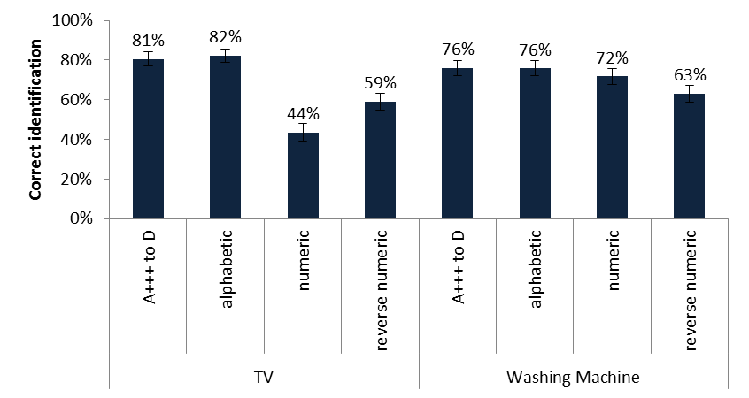
Figure 6: Percentage of respondents correctly identifying the most efficient of three models with an energy label. 'alphabetic' refers to the A-G label
In terms of effect on purchase decisions the testing of the four labels showed a slightly different trend: the ranking of the four labels was different for the test on televisions (figure 7) than for washing machines (Figure figure 8). The A-G label scored best for television, but came second for washing machines, where the reverse numeric label scored best. When the result for both products is combined, as shown in table 1, the A-G label scores the best, with the reverse numeric label second and the numeric label scores lowest. That pattern confirms the findings on consumer behaviour in the first phase of the study, in which consumers where asked how much of a premium they were prepared to pay for a more efficient product when shown the labels.
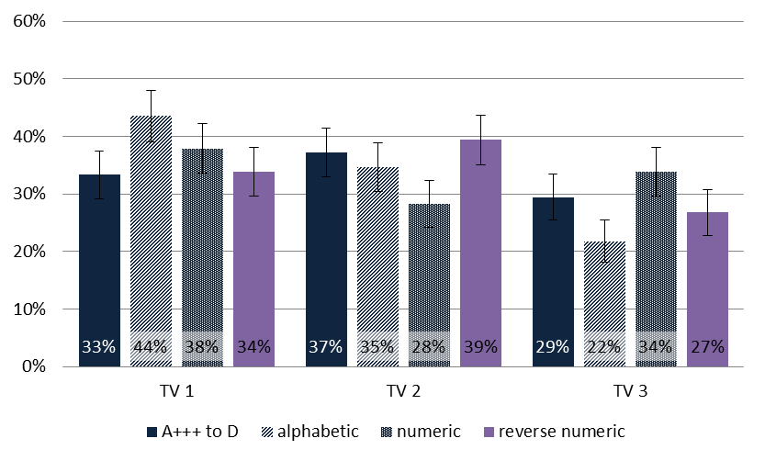
Figure 7: Proportion that choose the most (TV1), middle (TV2), and least energy efficient television (TV3) by energy label. 'alphabetic' refers to the A-G label
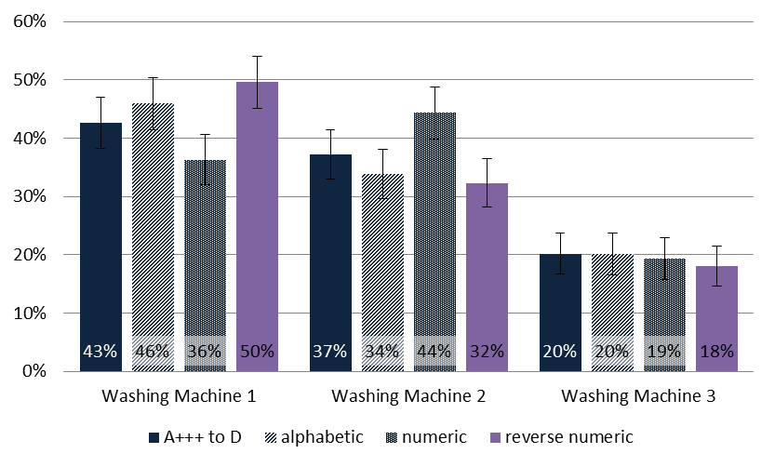
Figure 8: Proportion that choose the most (washing machine 1), middle (washing machine 2), and least energy efficient washing machine (3) by energy label. 'alphabetic' refers to the A-G label

Table 1: Consumer purchase choices for different label layouts (television and washing machines combined)
 | A+++ to D  (baseline) | A-G  (measure 1A) | Numeric  (measure 1B) | reverse numeric  (measure 1C)
Most efficient  (baseline class A+++ to A+) | 38% | 45% | 37% | 42%
Middle efficient  (baseline class A+ to A) | 37% | 34% | 36% | 36%
Least efficient  (baseline class A to B) | 25% | 21% | 27% | 22%
The results from the study with regard to purchase behaviour were fed into the model developed by VHK referred to above (detail on how the results were incorporated in the model is provided in Annex 5).

7.2. Impacts of options

7.2.1. Environmental impact
The energy consumption trend for the options and the baseline are shown in figure 9. The energy savings of the options in the year 2030 compared to the baseline are provided in table 2, broken down by product sector. These results only cover energy-related products; for other products that are also included in Option 3 additional analysis is provided further below. Further, for the sub-options concerning the layout of the label the additional impacts that have to be added for each of the suboptions to options 1+, 2 and 3 are provided in table 3.
As can be seen from the results, Option 1, containing only non-legislative measures, already provides significant energy savings compared to the baseline. All measures included in this option contribute significantly to this result, with the support of joint actions by Member States through EU projects estimated to have the highest impact.
Option 1+ provides further significant energy savings, mainly because the product registration database reduces non-compliance rates for labelled products and provides better up-to-date data to establish requirements. In addition, also the measure requiring higher energy label classes for larger appliances contributes for a significant part of the further savings. The measure requiring the provision of monetary information contributes to a lesser extent, because it only applies to some products, but is nevertheless of importance, because it applies to water heaters where significant further energy savings are achieved in this option.
The sub-option of the A-G label would provide further significant energy savings, whereas the reverse numeric label would do so to a much lesser extent. The numeric label would actually increase energy use compared to the baseline A+++ to D label, because the result of the consumer behaviour testing presented in section 7.1 showed that it was less effective than the current A+++ to D label. The impacts are directly related to the result of that behaviour testing presented in table 1 (further detail in Annex 5). The result of sub-option of the A-G label (minus 62 TWh/year in 2030; approximately 5 mtoe) is considerable and in the same order of magnitude, although less than either of the main measures to address non-compliance (the joint action and the product registration database). The impacts of these suboptions apply in the same way to Options 2 and 3.
Option 2 and Option 3 give higher energy savings than Option 1+, although the incremental savings are lower than the differences between the baseline, Option 1 and Option 1+. The additional savings in Option 2 mainly result from higher compliance rates of products, because of the measure requiring third party certification and because the product registration database applies in this option also to products only covered by ecodesign.
The additional savings for energy-related products in Option 3 are mainly the result of more ambitious ecodesign requirements, because the aim would be to set requirements at the so-called break-even point, rather than at the least life-cycle cost point. The somewhat unexpected result that this option only achieves modest additional energy savings compared to Option 2 can be explained by two factors. Firstly, the measure of applying learning curves in the least life cycle cost calculation in Options 1, 1+ and 2 already makes a significant step in the same direction as changing the requirement to break-even point. Secondly, the measure of applying learning curves combined with other measures in Option 2 already improve the average efficiency of certain product groups to such extent that limits of what is considered technologically possible are being reached in Option 2 for a number of product groups: electric motors, ventilation units, air heaters and certain types of local heaters. The additional measure of applying the break-even point requirement therefore does not lead to additional energy savings for these product groups.
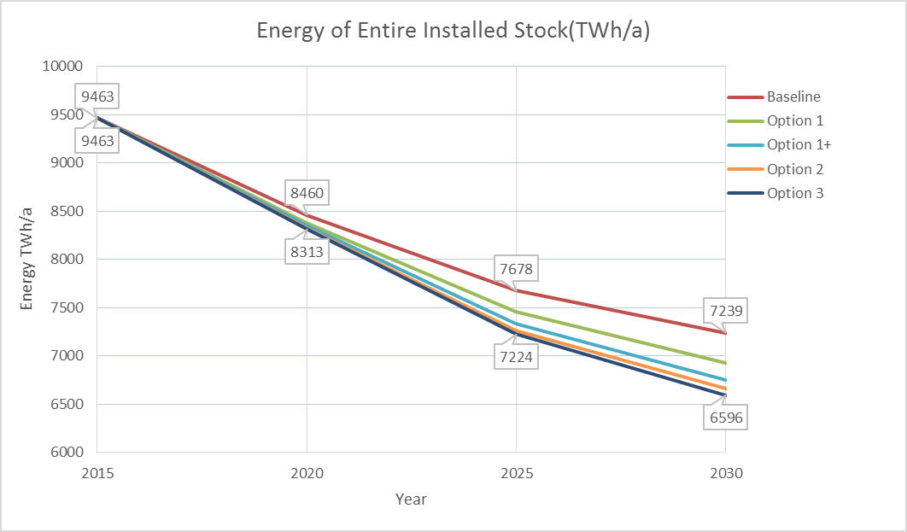
Figure 9: Primary energy of entire installed stock (TWh/a), total EU, years 2015-2030. Baseline and Options 1, 1+, 2 and 3 (excluding impact from any change in label layout). Results for option 3 do not take into account the extension of the scope to non-energy related products, see text

Table 2: Primary energy use compared to the baseline, EU totals for year 2030. Excluding effects from any change in label layout. Results for option 3 do not take into account the extension of the scope to non-energy related products, see text
Entire installed stock | Energy use, TWh/a, year 2030
 | Base | Opt1 | Opt1+ | Opt2 | Opt3
WATER HEATING | 0 | -54 | -122 | -129 | -135
SPACE HEATING | 0 | -64 | -116 | -134 | -144
SPACE COOLING | 0 | -7 | -12 | -14 | -16
VENTILATION | 0 | -37 | -38 | -55 | -71
LIGHTING | 0 | -26 | -47 | -54 | -56
ELECTRONICS | 0 | -9 | -15 | -20 | -22
FOOD PRESERVATION | 0 | -19 | -28 | -36 | -42
COOKING | 0 | -8 | -10 | -13 | -16
CLEANING | 0 | -13 | -26 | -29 | -31
INDUSTRY COMPONENTS | 0 | -70 | -71 | -87 | -102
ENERGY SECTOR | 0 | -4 | -4 | -8 | -9
TOTAL in TWh primary | 0 | -312 | -488 | -579 | -643
TOTAL (in PJ primary) | 0 | -1123 | -1759 | -2084 | -2316
TOTAL (in mtoe primary) | 0 | -27 | -42 | -50 | -55

Table 3: Environmental impacts in 2030 for the different label layouts compared to the baseline A+++ to D label
 | A-G | numeric | reverse numeric
Energy use (TWh primary) | -62 | +17 | -36
GHG (Mt CO₂-eq./y)  of which falling under the ETS | -9.6  -4.4 (46%) | +2.6  +1.2 (46%) | -5.5  -2.5 (45%)

Impacts of the options on the main environmental impacts other than energy are given in table 4 with additional impacts (applying to options 1+, 2 and 3) of greenhouse gas emissions of the sub-options concerning the layout of the label presented in table 3. As regards material efficiency, the review of the MEErP and implementing any updates as result of that review (included in Options 1, 1+ and 2) is likely to have limited impact, since the MEErP has recently been reviewed and updated to integrate some material efficiency parameters. Further, for a number of products some developments to reduce material use (and thus also waste) are already on-going, driven by cost reductions and technological change.
Table 4: Impacts in 2030 on greenhouse gas emissions, nitrogen oxide emissions and water use compared to the baseline, excluding impacts from any change in label layout.
 | Option 1 | Option 1+ | Option 2 | Option 3*
GHG (Mt CO₂-eq./y)  of which falling under the ETS | -45  -27 (60%) | -75  -41 (55%) | -87  -49 (56%) | -94  -55 (59%)
Direct NO_{x} (kt NO_{x}./y) | -18 | -27 | -28 | -29
Direct water use (million m³ /year) | -139 | -206 | -206 | -206
*Results for option 3 do not take into account the extension of the scope to non-energy related products, see text
The assessment of the impact for an extension of the scope in Option 3 to product groups other than energy-related products is complex, because of the variety and diversity of products and environmental impacts. A first assessment of the potential for reduction of environmental impacts can be made by comparing the estimated environmental impact of energy-related products with that of non-energy related products.
The use of energy-related products excluding transport equipment causes over 70% of EU energy consumption and approximately 50% of the emissions of regulated air-bound pollutants in the EU. The rest of energy use and air-bound emissions comes from transport, agriculture and direct process emissions (from industrial processes, solvents and waste. However, for some other environmental impacts such as water-bound emissions (heavy metals to water, eutrophication, etc.) the share for energy-related products is small and instead other sources are dominant (for water-bound emission agriculture and urban waste water). However, a considerable part of environmental impacts could not be addressed by extending the scope to all products as a significant share of the impacts is caused by services.
On the basis of the above, it is estimated that extending the scope of the Directives to cover all other product groups can potentially have twice as much environmental impact as at present. However, a range of environmental impacts of products other than energy-related products are already addressed through legislation. This is particularly the case for vehicles, for which CO₂ emissions, pollutant emissions, end of life and the use of certain refrigerants in air-conditioning systems are addressed through other EU legislation, although their production, also significant in environmental impacts, is regulated to a more limited extent. Environmental impacts of food and drink are addressed by existing EU legislation including through the Common Agricultural Policy's cross-compliance, water, nitrates, sewage sludge and fertiliser policy and the organic label, their transport, emissions and energy use from processing, retail, packaging, use and waste. Environmental impacts of non-energy related products are also addressed by the EU ecolabel and by green public procurement.
Due to the vast diversity of what falls under the term 'product' it is not possible to quantify the potential for reduction of environmental impacts through the expansion of the scope of the Directives. However, the examples provided above concerning the coverage of environmental impacts by existing legislation for the two main sectors of transport and food and drink that are not in the scope of the Directives show that the potential to address environmental impacts through expansion of the scope of the Ecodesign and Energy Labelling is relatively limited compared to what at first sight might be expected.
Further, in case of labelling there are only environmental benefits if it encourages consumers to buy products that are environmentally preferable. Testing of energy labels with environmental life-cycle parameters added showed a slight positive effect in this respect, but at the same time consumers had difficulty understanding aspects on the labels that did not relate to the use of the product.

7.2.2. Economic impact
The main economic impact is on consumer expenditure. Consumers include both private consumers and commercial and industrial consumers of end-products. The consumer expenditure is the combined expenditure of purchase of products, energy costs during usage, and for some products, water costs during usage and/or installation and maintenance costs. The main drivers for a change in consumer expenditure as result of the options are: 1) more efficient appliances usually have higher purchase cost; and 2) more efficient appliances cost less to operate. Overall consumer expenditure/savings compared to the baseline are calculated for two different assumptions for future energy price developments:
- An increase in energy prices of 4% per year, which has been the assumption in preparatory studies for ecodesign and energy labelling and in the published report 'ecodesign impact accounting'. Corresponding results are provided in figure 10 and table 5;
- An increase in energy prices of 4% per year up to 2020 and of 0.5% from 2020 onwards, which reflects price developments in the PRIMES model used for the Commission's 2014 Energy Efficiency Communication. Corresponding results are provided in figure 11 and table 6.
Under the first energy price trend assumption the consumer expenditure decreases continuously going from Option 1 to 1+ to 2 to 3, whereas under the second energy price trend consumer expenditure is approximately the same for all options. The figures presented cover only energy-related products; for other products analysis is provided further below. The overall trend that the options decrease consumer expenditure compared to the baseline is reflected also for individual product sectors, with exception notably for space heating and cooking.
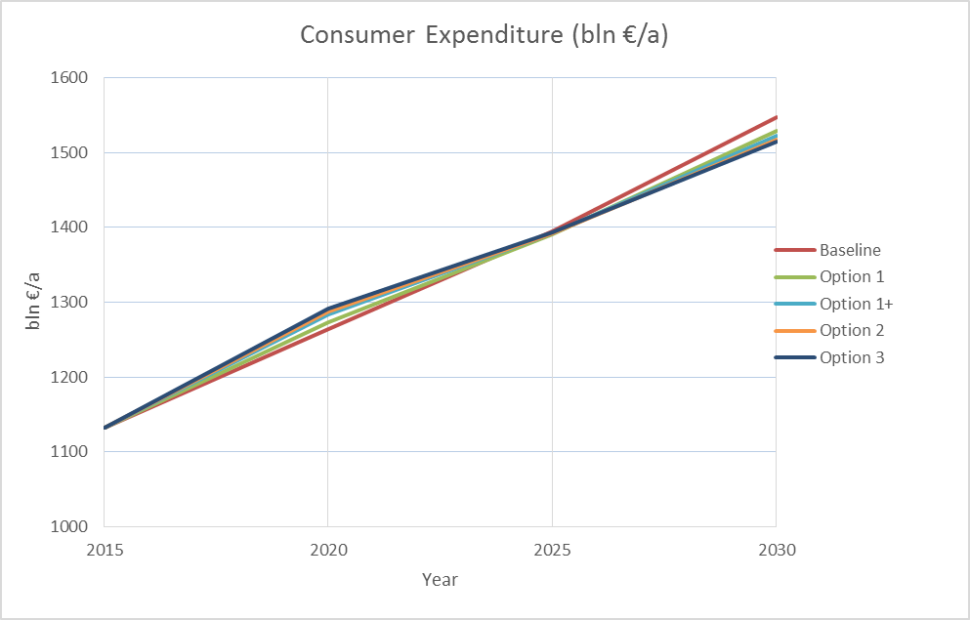
Figure 10: Consumer expenditure (billion €) for baseline and options, Total for the EU for a 4% escalation rate for energy prices (excluding impact from any change in label layout). Results for option 3 do not take into account the extension of the scope to non-energy related products, see text

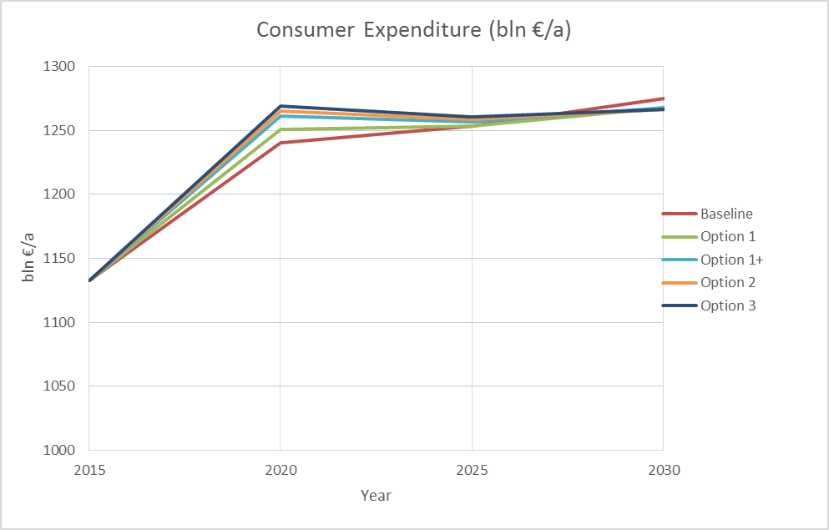
Figure 11: Consumer expenditure (billion €) for baseline and options, Total for the EU for a 4% escalation rate for energy prices until 2020 and 0.5% thereafter (excluding impact from any change in label layout). Results for option 3 do not take into account the extension of the scope to non-energy related products, see text

Table 5: Consumer expenditure savings in 2030 for the options compared to the baseline for a 4% escalation rate for energy prices (excluding impact from any change in label layout). Results for option 3 do not take into account the extension of the scope to non-energy related products, see text
 | Consumer Saving, year 2030
(bln €/a) | Base | Opt1 | Opt1+ | Opt2 | Opt3
WATER HEATING | 0 | -4.7 | -9.6 | -10.2 | -10.6
SPACE HEATING | 0 | 1.9 | 4.8 | 5.8 | 6.2
SPACE COOLING | 0 | 0.0 | 0.2 | 0.2 | 0.3
VENTILATION | 0 | -4.9 | -5.4 | -7.8 | -8.5
LIGHTING | 0 | -2.8 | -5.2 | -6.0 | -6.2
ELECTRONICS | 0 | -1.0 | -1.6 | -2.1 | -2.3
FOOD PRESERVATION | 0 | -1.4 | -1.8 | -2.4 | -2.9
COOKING | 0 | 1.6 | 1.5 | 2.3 | 3.3
CLEANING | 0 | -2.4 | -4.3 | -4.7 | -4.9
INDUSTRY COMPONENTS | 0 | -5.5 | -5.6 | -6.8 | -8.0
ENERGY SECTOR | 0 | -0.2 | -0.3 | -0.4 | -0.5
TOTAL in bln €/a | 0 | -19.5 | -27.2 | -32.1 | -34.1

Table 6: Consumer expenditure savings in 2030 for the options compared to the baseline for a 4% escalation rate for energy prices until 2020 and 0.5% thereafter (excluding impact from any change in label layout). Results for option 3 do not take into account the extension of the scope to non-energy related products, see text
 | Consumer Saving, year 2030
(bln €/a) | Base | Opt1 | Opt1+ | Opt2 | Opt3
WATER HEATING | 0 | -2.4 | -4.5 | -4.7 | -4.9
SPACE HEATING | 0 | 4.4 | 9.4 | 11.1 | 11.9
SPACE COOLING | 0 | 0.3 | 0.6 | 0.7 | 0.9
VENTILATION | 0 | -3.2 | -3.4 | -5.0 | -5.0
LIGHTING | 0 | -2.0 | -3.7 | -4.3 | -4.4
ELECTRONICS | 0 | -0.7 | -1.1 | -1.4 | -1.6
FOOD PRESERVATION | 0 | -0.8 | -1.1 | -1.4 | -1.7
COOKING | 0 | 1.9 | 2.0 | 2.9 | 4.0
CLEANING | 0 | -1.9 | -3.1 | -3.4 | -3.5
INDUSTRY COMPONENTS | 0 | -3.6 | -3.6 | -4.4 | -5.1
ENERGY SECTOR | 0 | -0.1 | -0.1 | -0.2 | -0.3
TOTAL in bln €/a | 0 | -8.1 | -8.6 | -10.2 | -9.8
The impact on commercial revenues of energy–related products is shown in table 7. The additional impacts (applying to options 1+, 2 and 3) of the sub-options concerning the layout of the label are presented in table 9. The impact on commercial revenues includes industry, wholesale, retail, and, for some products groups, installation and maintenance. The impact on revenues affects larger businesses and small and medium sized enterprises in the same way. While wholesale, retail, installation and maintenance are done almost completely in the EU; part of the manufacturing is not. It is estimated that approximately 80-85% of the total business revenues contribute to EU GDP. The increase in revenue in Option 3 of € 40 billion represents a 7% increase in 2030 compared to the baseline.
The trend for the revenues follows the same trend as for the energy savings. This is because, except for electronic products, more efficient products are more expensive. For lighting revenues decrease, because the shift in sales to higher efficiency lamp types means mainly LEDs, which also have longer economic lifetimes and consequently need less frequent substitution, leading to an overall decrease in sales volumes and consequently in revenue. The large increases in revenues for space heating and cooking are linked to their large increase in acquisition costs due to a shift to geo-thermal heat pumps and induction hobs. If unit prices for geo-thermal heat pumps and induction hobs would decrease further than now assumed in the model, revenues for all options might be over-estimated.
For Option 3, there are additional significant economic impacts, because of the extension of the scope to non-energy related products. For such products environmental impacts in the production phase are usually of greater impact than those in the use phase. Thus, regulation of such products would likely focus on the production phase, rather than the use phase. This means that the environmental benefits would not result in a reduction in cost for the consumer using the product; depending on the environmental impacts to be addressed it may increase the purchase costs for products for the consumer. There may be indirect cost reductions, such as reduction of costs of health care for EU tax-payers in case of reduced pollution in the EU. However, due to the vast diversity of what would fall under the scope of 'product', it is not possible to quantify the costs or cost reductions associated with the extension of the scope to non-energy related products.

Table 7: Revenue (sum of industry, retail, wholesale, installation and maintenance), total for EU in year 2030, for the options compared to the baseline (excluding impact from any change in label layout). Results for option 3 do not take into account the extension of the scope to non-energy related products, see text
 | Revenue Increase, 2030
(billion €/a) | Base | Opt1 | Opt1+ | Opt2 | Opt3*
WATER HEATING | 0 | 2.2 | 5.9 | 6.3 | 6.6
SPACE HEATING | 0 | 9.0 | 17.9 | 20.7 | 22.2
SPACE COOLING | 0 | 0.7 | 1.3 | 1.6 | 1.9
VENTILATION | 0 | 0.4 | 0.8 | 0.9 | 2.4
LIGHTING | 0 | -0.4 | -0.7 | -0.8 | -0.9
ELECTRONICS | 0 | 0.0 | 0.0 | 0.0 | 0.0
FOOD PRESERVATION | 0 | 0.3 | 0.6 | 0.6 | 0.7
COOKING | 0 | 2.2 | 2.5 | 3.4 | 4.6
CLEANING | 0 | 0.4 | 0.7 | 0.8 | 0.8
INDUSTRY COMPONENTS | 0 | 0.8 | 0.8 | 1.0 | 1.2
ENERGY SECTOR | 0 | 0.1 | 0.1 | 0.2 | 0.3
TOTAL in bln €/a | 0 | 16 | 30 | 35 | 40
The administrative burden for the options is provided in table 8 and table 9, with further detail provided in Annex 9. The main driver for the burden for the Member States (negative), the EU and the Commission is the EU market surveillance authority (in option 3).
The main drivers for the burden for manufacturers are third party certification (options 2 and 3) and the extension of the scope to non-energy related products (option 3). The measure of a product registration database does not lead to much additional administrative burden, because all the information manufacturers would have to register in the database is information they already have to produce under the current energy labelling and ecodesign directive and implementing measures before placing a product on the market. Therefore the only additional burden is the clerical task of entering the available information into the database. This amounts to 1.5 million euro per year for the entire industry in option 1+ and 3 million euro per year in options 2 and 3.
The main driver for the burden for dealers is the display of monetary information, which costs 2 million euro per year, (options 1+, 2 and 3) and the suboption (also in options 1+, 2 and 3) of the A-G label, which involves rescaling. For the rescaling suppliers would, for a period of several months after the date of application of the new label for them, supply both the new and the old label with their products. Dealers would display the models with the old label but keep the new label ready. On a specific date at the expiry of the transition period, dealers would be required to replace the old label with the new one on all products that are on display in the shops. For any products that were already in the shop before the transition period started, dealers would have to obtain a new label from the supplier (further practical and administrative details on rescaling are provided in Annex 8). This is estimated to cost 50 million euro for manufacturers and 10 million euro for dealers every 5-10 years.
Given that compliance is mandatory, manufacturers and dealers should be able to pass their costs on to consumers and thus they can be offset against the benefits for consumers. Comparison with the benefits in consumer expenditure and commercial revenues shown above reveals that the administrative costs are offset manifold by the monetary benefits.

Table 8: Total approximate additional administrative and compliance costs in EU per option compared to baseline (detail in Annex 9), excluding impact from any change in label layout
 | Option 1 | Option 1+ | Option 2 | Option 3
Manufacturers | none | € 1.5 million/year | € 140 million/year | € 500-1000 million/y
Dealers | none | € 2 million/year | € 2 million/year | € 2 million/year
Member States | none | none | none | minus € 10 million/y
EU/Commission | € 3.0 million/year | € 2.7 million/year | € 2.3 million/year | € 32 million/year
Total (rounded) | € 3 million/year | € 6 million/year | € 145 million/year | € 500-1000 million/y

Table 9: Economic impacts in 2030 for the different label layouts compared to the baseline A+++ to D label
 | A-G | numeric | reverse numeric
Consumer expenditure at 4% energy price escalation rate (billion € per year) | -3.7 | +1.0 | -2.2
Consumer expenditure at 0.5% energy price escalation rate from 2020 (billion € per year) | -1.2 | +0.3 | -0.8
Commercial revenues (billion € per year) | +3.7 | -1.0 | +2.1
Administrative burden for suppliers (million €) | 50  (every 5-10 years) | 50  (only once) | 50  (only once)
Administrative burden for dealers (million €) | 10  (every 5-10 years) | 10  (only once) | 10  (only once)

7.2.3. Social impact
The impact in 2030 on jobs in industry, retail, wholesale, installation and maintenance per option compared to the baseline is shown in table 10 and the additional impact (applying to options 1+, 2 and 3) of the sub-options concerning the layout of the label presented in table 11. It is estimated that industry jobs constitute 55% of total jobs and 70% of those are inside the EU. Estimating that wholesale, retail and installer jobs are almost completely inside the EU, this means that around 85% of the total direct jobs are created inside the EU. Job creation for wholesale, retail and installers is expected to be even across the EU. Job creation in industry will be to a different extent in different Member States, depending on the extent of their current manufacturing industry in these sectors. Given that the main product sector where the increase takes place is the heating sector, for which the jobs are mostly in industry and installation, based on current employment patterns in that sector, it is expected that the job creation is skewed towards men rather than women and towards low and medium-skilled workers, rather than high-skilled workers.
The trend for the options follows the same trend as for the commercial revenues as they are closely linked: in the model, the direct jobs are calculated from the increase in revenue and the average turnover per employee in the various sectors. This approach is generic for all products, whereas the employment effects are in fact, in part, expected to be related to the specific technology used for each specific product. As a general approach this may therefore overestimate the direct jobs. In addition, if the revenues for space heating and cooking are over-estimated by the model as hypothesized above, then also the increase in direct jobs for those products would be overestimated for all options; this effect alone could mean an overestimation by a factor two.
Table 10: Direct jobs increase (sum of industry, retail, wholesale, installation and maintenance), total for EU in year 2030, for the options compared to the baseline (excluding impact from any change in label layout). Results may be significantly overestimated, see text, and results for option 3 do not take into account the extension of the scope to non-energy related products, see text
 | Direct jobs increase, 2030
(in 1000 jobs) | Base | Opt1 | Opt1+ | Opt2 | Opt3
WATER HEATING | 0 | 32 | 83 | 89 | 94
SPACE HEATING | 0 | 128 | 254 | 295 | 316
SPACE COOLING | 0 | 11 | 18 | 23 | 27
VENTILATION | 0 | 6 | 12 | 13 | 32
LIGHTING | 0 | -7 | -13 | -15 | -15
ELECTRONICS | 0 | 0 | 0 | 0 | 0
FOOD PRESERVATION | 0 | 5 | 10 | 12 | 12
COOKING | 0 | 40 | 44 | 61 | 82
CLEANING | 0 | 6 | 12 | 14 | 15
INDUSTRY COMPONENTS | 0 | 10 | 10 | 13 | 16
ENERGY SECTOR | 0 | 2 | 2 | 4 | 5
TRANSPORT SECTOR | 0 | 0 | 0 | 0 | 0
TOTAL | 0 | 233 | 432 | 509 | 584

In terms of impacts on vulnerable consumers, the improvement of compliance in all options, ranging from some improvement in option 1 to a high improvement in option 3, benefits them in particular, reducing the risk that they unknowingly end up buying products that consume more energy than they intended and can afford. More generally, they benefit from lower costs over the life cycle of the product. For the product groups where there the costs over the life cycle could increase (space heating, space cooling and cooking) this increase is caused by particularly high upfront purchase costs of advanced technologies of which the sales is encouraged by a good energy label class. Because of the particularly high upfront cost, vulnerable consumers are unlikely to purchase these technologies. Alternative technologies are still available to them, except possibly in the case of option 3, where the measure of changing the least life cycle cost requirement under the ecodesign directive would remove the least life cycle cost technologies from the market. Thus, only in the case that option 3 would be selected, would mitigation measures for vulnerable consumers need to be foreseen.
The additional impact (applying to options 1+, 2 and 3) of the sub-options concerning the layout of the label presented in table 11. The trends follow the same trends as for energy savings.

Table 11: Social impacts in 2030 for the different label layouts compared to the baseline A+++ label. Results may be significantly overestimated, see text
 | A-G | numeric | reverse numeric
Direct jobs (1000 jobs) | +52.2 | -13.6 | +30.1
With regard to potential social impacts in the area of fundamental rights, in particular on the protection of personal data, the establishment of a mandatory product registration database (included in option 1+, 2 and 3) could have an impact as the concept of protection of data, generally limited to natural persons, can be extended to legal persons, but only in so far as the official title of the legal person identifies one or more natural persons. No such cases are known for the manufacturers of energy-related products. In any case, manufacturers are already required to put their name or trade mark on the energy label. For data that may be commercially sensitive (technical documentation and test reports) access would be restricted to the market surveillance authorities and the Commission, who are also today the only ones that have to be given access to them (on request).

7.2.4. Impacts of merging ecodesign and energy labelling
The suboption to Options 1+, 2 and 3 (merging ecodesign and energy labelling into one legal instrument) only has an impact on administrative burden. The suboption can also address the two issues of incoherence that were identified: the empty classes on some energy labels due to ecodesign requirements, and the lack of a working plan and a formalised stakeholder forum for Energy Labelling, while they exist under the Ecodesign Directive. Under this option, the framework Directives would be merged and revised into one Regulation. However, no impacts are assumed from addressing these problems through a merger of the frameworks, because the incoherencies can already be addressed in the Options 1+, 2 and 3 without such merger. The problem of the empty classes can be addressed through revising the energy label, which is done under all three options. The problem that there is no working plan and a formalised stakeholder forum for energy labelling, while there is for ecodesign, can already be addressed through energy labelling only.
The impacts in terms of administrative burden are the following:
- The Commission would have reduced work, because sections concerning definitions and measurement and calculation methods that are usually identical in both ecodesign and energy labelling regulations for a specific product group would have to be drafted and revised only once, instead of twice. However, it is still only a small reduction of burden, because other parts of ecodesign and energy labelling regulations, which are the majority, are different.
- Manufacturers would be able to find their obligations for energy labelling and ecodesign in one regulation rather than in two. However, the impact of this is small, since the number of requirements on manufacturers is unlikely to change as a result of the merger (and other requirements on the products, e.g. concerning safety, remain laid down in other legislation).
- Member States would have one less separate sector for their market surveillance of EU product legislation. However, most Member States have already combined the market surveillance for energy labelling and ecodesign in the same authority, and the number of requirements they have to enforce is unlikely to change as a result of the merger.
- As suboption under option 1+, Member States would have to delete their transposition law on ecodesign as a result of the merger of the Directives into one Regulation, while otherwise they would not need to do so because option 1+ does not imply changes to the Ecodesign Directive. This means a one-off slight increase in administrative burden.
The above impacts on administrative burden are small, because ecodesign and energy labelling regulations for specific products are currently already developed in parallel by the Commission, even though there is no legal provision that arranges this.
In order to merge the two frameworks a number of issues would have to be resolved. Firstly, the legal basis for the two frameworks is different. The Energy Labelling Directive is based on Article 194(2) of the Treaty on the Functioning of the European Union, the legal base for measures on energy. The Ecodesign Directive is based on Article 114 of the Treaty on the Functioning of the European Union, the legal base for measures for the functioning of the internal market. While it would seem possible to have a legal base of Article 114 of the Treaty on the Functioning of the European Union (the 1992 Energy Labelling Directive had, in absence of a provision for energy in the Treaty, such legal base), there is a risk that this could unintentionally limit Member States legislating on provision of information on energy-related products that may be complementary to the energy label. Secondly, for the suboption under options 1+ and 2, the issue of the different scope of ecodesign and energy labelling would have to be resolved. While option 3 foresees expansion and harmonisation of the scope, under options 1+ and 2, the scope of both frameworks remains as they currently are, which is different: ecodesign covers all life cycle phases and environmental impacts, while energy labelling is limited to energy and resources in the use phase of the product.

8. Comparing the options
This chapter summarises the pros and cons of the policy options in terms of their effectiveness in meeting the objectives (table 12) and their associated costs and benefits weighed against the baseline scenario (table 13Table). The comparison of the suboptions for the label layout is shown in table 14; these results add to options 1+, 2 and 3 in the same way.
Box 2: Overview of the policy options
Options
Option 0: No change ("baseline option")
Option 1: Improvements within the existing regulatory framework, notably funding EU joint market surveillance actions
Option 1+: Option 1 combined with some changes to the Energy Labelling Directive, notably requiring labelled products to be registered in a database and improving the legal structure by changing to a Regulation and aligning it the market surveillance regulation.
Option 2: Option 1+ combined with changes to the Ecodesign Directive, notably requiring ecodesign products to be registered in a database and requiring third party certification for all products under its scope.
Option 3: Changing the scope of both Directives to cover all products instead of only energy-related products, requiring products to be registered in a database, requiring third party certification for all products under its scope and market surveillance done by an EU authority.
Suboption to option 1+, 2 and 3: merge ecodesign and energy labelling into one legal instrument.
Suboptions for the label layout
Option 0 and 1 include: current A+++ to D and not updating the label
Other options can include alternative suboptions:
Alphabetic label: A to G with reclassification when updating the label
Numeric label: 0 to 100 with top classes in grey only becoming available when updating
Reverse numeric label: 7 to 1 with classes 8, 9 etc. being added on top when updating

Table 12: Qualitative comparison of the impact of the options with regard to the objectives,
 | Baseline | Option 1 | Option 1+ | Option 2 | Option 3
Functioning of the internal market
Reduce energy consumption of products
Reduce other environmental impacts
Simple, apt for purpose and future-proof
Cost-effective
Relevant and useful to consumers
Enforce easily and appropriately
In line with international obligations
Table legend:
Extent to which the objective is achieved | Little | Some | To significant extent | Thoroughly
Grey scale
How to interpret table 12
The baseline does not address the problems. It ensures functioning of the internal market and achieves energy savings in and a reasonably cost-effective way. However, it offers no solutions to the problems of non-compliance and reduced effectiveness of labels on consumers, nor does it offer simplifications.
Option 1 secures some progress towards further energy savings and reducing non-compliance, but cannot achieve all objectives satisfactorily, in particular non-legislative action cannot address the problem of the label layout.
Option 1+ achieves significant progress in further energy savings, reduction of non-compliance and better labels for consumers. This is achieved in a cost-effective way, saving consumer money. It simplifies legislation through coherence with the market surveillance regulation and revision of the Energy Labelling Directive. The choice of instrument for that revision, a Regulation, is appropriate for obligations that apply directly to economic operators and is in line with the EU's better regulation agenda.
Option 2 is with regard to the objectives different from option 1+ mainly with respect to international obligations, for which the measure requiring third party certification for all product covered by ecodesign could create disproportionate obstacles with regard to international trade . It is not obvious that the principle of proportionality is respected by introducing third party verification for all products regardless of it being duly justified and proportionate to the risk of non-compliance. Another difference is that would include a revision of the Ecodesign Directive simplifying it into a Regulation.
Option 3 achieves significant progress in reducing environmental impacts other than energy consumption. However, from the analysis it is not obvious whether this policy is the right instrument for that: for a number of product types it overlaps with other environmental policies. As such, it does not lead to simplification, nor is it particularly cost-effective. Unlike for the other options, it is not obvious that the principle of proportionality is respected for this option: it appears to go beyond what is necessary to achieve the identified objectives, at least for those non-energy related products that are covered to significant extent by existing legislation. In addition, like option 2 it could create disproportionate obstacles with regard to international trade and it is not obvious that the principle of proportionality is respected by introducing third party verification for all products regardless of it being duly justified and proportionate to the risk of non-compliance.

Table 13: Summary of the impacts estimates compared to the baseline, excluding impact from any change in label layout
 | Option 1 | Option 1+ | Option 2 | Option 3*
Environmental impacts
Energy use (TWh primary/year) | -310 | -490 | -580 | better than option 2
GHG (Mt CO₂-eq./y) | -45 | -75 | -87 | better than option 2
Economic impacts
Consumer expenditure at 4% energy price escalation rate (billion € per year) | -20 | -27 | -32 | at best similar to option 2
Consumer expenditure at 0.5% energy price escalation rate from 2020 (billion € per year) | -8 | -9 | -10 | at best similar to the other options
Commercial revenues (billion € per year) | +16 | +30 | +35 | not available
Social impact
Direct jobs (1000 jobs)** | +230 | +430 | +510 | not available
Administrative burden
Administrative burden (million € per year) | +3 | +6 | +145 | +500-1000
*Due to the inclusion of the extension of the scope to non-energy related products in this option, some quantifications for this option are not available and others not to the same extent as for the other options
**The direct jobs creation may be significantly overestimated, see explanation in section 7.2.3.

With regard to stakeholder views, Option 1 has little support from stakeholders, while Option 1+ has significant support from stakeholders: the vast majority is of the view that the Energy Labelling Directive needs to be changed to achieve energy savings closer to the full economic technical potential. Option 2, revising also the Ecodesign Directive, is supported by a smaller share of stakeholders. In particular industry interest groups are not convinced about the need for changes to the Ecodesign Directive. Green NGOs support option 3.
The suboption to merge the ecodesign and energy labelling has the additional effect of slightly reduced administrative burden for the Commission and manufacturers, although in the case of Option 1+ it also means a slight additional administrative burden for Member States. The suboption of merging is not proportionate in the case of Option 1+, because the measures in that option do not require a revision of ecodesign.
Table 14: Impacts in 2030 for the different label layouts compared to the baseline A+++ label
 | A-G | numeric | reverse numeric
Environmental impacts
Energy use (TWh primary/year) | -62 | +17 | -36
GHG (Mt CO₂-eq./y) | -9.6 | +2.6 | -5.5
Economic impacts
Consumer expenditure at 4% energy price escalation rate (billion € per year) | -3.7 | +1.0 | -2.2
Consumer expenditure at 0.5% energy price escalation rate from 2020 (billion € per year) | -1.2 | +0.3 | -0.8
Commercial revenues (billion € per year) | +3.7 | -1.0 | +2.1
Social impact
Direct jobs (1000 jobs)* | +52.2 | -13.6 | +30.1
Administrative burden
Administrative burden for business (million €) | 60  (every 5-10 years) | 60  (only once) | 60  (only once)
*The direct jobs creation may be significantly overestimated, see explanation in section 7.2.3.
With regard to the label layout, the A+++ to D and the reverse numeric label do not have much support from stakeholders. The vast majority supports an A-G label, though not all manufacturers and retailers do. The numeric label is supported by some industry interest groups.
The above comparison shows that of the options that have most support from stakeholders, option 1+ that revises the Energy Labelling Directive, but not the Ecodesign Directive, achieves significantly higher energy savings and positive economic and social impacts than Options 0 and 1. Option 2 and 3 achieve even better results in these categories, but they do not score as well in achieving the objective of being in line with international obligations and for option 3 it is not obvious that the principle of proportionality is respected.
The label layout that has most support from stakeholders, the A-G label, scores the best on all aspects, except administrative costs related to the rescaling of the label. Given that compliance is mandatory, suppliers and dealers should be able to pass these costs on to consumers. For consumers, these costs more than offset against their monetary benefits resulting from the A-G label's superior effect.

9. Monitoring and evaluation
The general objectives of the Energy Labelling and Ecodesign Directive are to ensure the functioning of the internal market and a high level of environmental and consumer protection. The functioning of the internal market is ensured under both frameworks by a requirement for Member States to allow the free movement of products compliant with the respective EU rules. Member States are required to notify to the Commission their (draft) legislation that could potentially be an obstacle to the free movement of goods. The indicator of success in this case is the number of national pieces of legislation concerning environmental impacts of energy-related products that are notified to the Commission (the lower the number, the better).
Environmental and consumer protection is ensured through the reduction of energy consumption and other significant environmental impacts. The indicator of success is the reduction in the product's impact in the categories regulated in the delegated acts. Progress is monitored product by product: under both the existing and the proposed framework, the product-specific delegated acts require reviews to be carried out some years after their entry into force. Such reviews gather information about the environmental performance of the products in scope that are sold and used in the EU. Thereby, progress is tracked compared to the situation before the adoption of the acts, and necessary adjustments can be made to the requirements, if there is technologically feasible and cost-effective further improvement potential. This also allows checking progress towards the operational objective of the present review, increasing the effectiveness of the labelling scheme by allowing a rescaling of those labels where only the top classes are populated today due to technological development. Results can be monitored in the context of subsequent reviews of the concerned delegated acts, which will be able to measure the acceleration of market transformation thanks to rescaling, compared to the current speed of transformation. The measures establishing an energy-related products database study and a mandatory product registration database would also provide the Commission with more solid data to monitor and evaluate progress towards meeting the objective of further energy savings.
Reporting by Member States on the result of market surveillance under the market surveillance regulation would provide the Commission with data on enforcement actions and compliance, allowing to verify whether compliance rates are increasing as a result of market surveillance enhanced through the use of the product database. The Administrative Cooperation ('ADCO', see Annex 3) group on market surveillance on ecodesign and energy labelling provides a platform in which the reports on of market surveillance activities can be jointly analysed with the Member States market surveillance authorities.
The next evaluation of the Energy Labelling framework is foreseen in 5-10 years. It should building on the ex-post evaluation of product-specific review studies, evaluate the effectiveness of the framework in ensuring the free movement of goods and the reduction of energy consumption and other significant environmental impacts of products, especially with regard to improvements achieved in the rate of market transformation by rescaled labels, and in the rate of market surveillance thanks to the product database.

Annex 1 – Use of expertise and consultation of interested parties

External expertise
Two studies were specifically commissioned to prepare the review:
- Ecofys, Waide Strategic Efficiency, University of Coimbra, SEVEn7, SoWatt & Öko-Institute, Evaluation of the Energy Labelling Directive and specific aspects of the Ecodesign Directive, 2014.
The study produced the following final reports:
- Literature review
- Survey results
- Assessment scope expansion
- Final technical report
- London Economics & Ipsos Mori, A study on the impact of the energy label – and of potential changes to it – on consumer understanding and on purchase decisions, 2014.
Further studies requested by the Commission during 2011-2014 also provided relevant input:
- VHK, Ecodesign impact accounting part 1, May 2014
- Ecofys, Impacts of the EU’s Ecodesign and Energy/Tyre labelling legislation on third jurisdictions, 30 April 2014
- Ecofys, Impact of Ecodesign and Energy/Tyre Labelling on R&D and Technological Innovation, 23 May 2014
- COWI & BIO Intelligence Service, Assessing the data collected in the framework of the Ecodesign and Labelling annual market surveillance data collection exercise run by the Commission, on-going
- CentERdata, Ecorys & GfK, Study on the effects on consumer behaviour of online sustainability information displays, 2014
- Ipsos MORI, London Economics & AEA, Research on EU product label options, 2012
- BIO Intelligence Service, Material-efficiency Ecodesign Report and Module to the Methodology for the Ecodesign of Energy-related Products (MEErP), 2013
- JRC-IES “Integration of resource efficiency and waste management criteria in European product policies – Second phase”, 2012.
A study by VHK "Assistance to the Impact Assessment for the Review of the Energy Labelling Directive and certain aspects of the Ecodesign Directive" provided specific analysis for the options set out in this impact assessment, notably through modelling, see Annex 5.

Consultation
Three stakeholder meetings were organised by the contractor of the evaluation study: on 27 June 2013, 14 October 2013 and 18 February 2014. A website was maintained where minutes and other documents related to these meetings were published. As the second meeting took place in the context of the public consultation it was chaired by the Commission.
The public consultation ran from 31 August to 30 November 2013 on the ‘Your voice in Europe’ web page. The consultation was separated in two different questionnaires targeting different actors: a survey with 47 questions targeted interest groups, government bodies and experts. A shorter survey with 20 questions targeted consumers and individual retailers and manufacturers and was translated into all EU official languages. 138 Responses were received to the longer survey, of which 58 from manufacturers and their interest groups, 20 from government bodies, 13 from environmental interest groups and 9 from consumer interest groups. 197 Responses were received to the shorter survey, of which 127 from consumers (from 18 EU Member States; almost one third from France), 40 from retailers (almost all from Germany) and 30 from manufacturers (half of which from Germany). A detailed summary of the respondents and responses was published in February 2014.
In conjunction with the contractors' meeting on 18 February, the Commission organised a stakeholder meeting on 19 February 2014 on the results from testing a preliminary set of energy label designs and the proposed energy label designs for further testing. The minutes of the meeting can be found further below in this Annex.
In the context of the review, the Commission organised on 20 and 21 February 2014 a Conference on Products Policy: International Trends in Ecodesign and Energy Labelling. More than 400 participants from approximately 50 different countries attended. The three plenary sessions and six workshops included 51 speakers, panellists and moderators, a majority of which came from the public sector (34%), followed by the private sector (32%), academics/researchers/consultants (21%) and NGOs (13%). 16% of the speakers/panellists came from outside the EU. Key outcomes of the conference were:
- As regards the review of the energy label, there is consensus that continuing with the A+++ label (i.e. arriving at 4, 5 or 6 plusses) is not sustainable and has to be addressed. Rescaling of the label (meaning that an A-labelled product today would become a C or D-labelled product tomorrow) is an option which has been implemented successfully in other jurisdictions (notably Australia).
- Further international cooperation was welcomed by everybody although it will not be easy as there are no obvious 'low hanging fruit'. The focus should be on convergence of standards and test methods.
- More effective market surveillance is crucial to ensure a level playing field for industry and to provide consumers with reliable information. More collaboration between Member State authorities and the establishment of obligatory product registration by manufacturers (as already happens in USA and Brazil) were seen as key areas for future work.
Further details of the conference, including all presentations, are available online.
The Commission organised an Ecodesign Consultation Forum on the review of the Directives on 11 June 2014. The minutes of the meeting can be found further below in this Annex.

Minutes of the consultation meeting organised by the services of the European Commission on the method to update existing energy label scales to reflect technological progress of the labelled products
Date: 19 February 2014, 9:00 – 13:00
Venue: Charlemagne building (Room De Gasperi) at 170, Rue de la Loi, Brussels.
1. Introduction by European Commission, DG Energy
The Chair (P. Hodson, Head of Unit for Energy Efficiency, DG Energy) welcomed participants and indicated that the on-going work on the review of the Energy Labelling Directive and Ecodesign Directive should make it possible for the new Commission to proceed with this towards the end of 2014. The work on the review started in May 2013 with a study led by Ecofys and one of the key topics is the label design for which a second study by London Economics and Ipsos tests consumer understanding and behaviour. The objective of this meeting is as much as possible to find consensus on which four label designs to test.
2. Findings from the Energy Labelling Directive's Evaluation Study on the method to update existing energy label scales to reflect technological progress of the labelled products (P. Waide on behalf of Ecofys and their consortium partners)
See presentation in Annex I
3. Results from testing a preliminary set of energy label designs (Ch. Duke on behalf of London Economics / IPSOS)
See presentation in Annex II
4. Questions of clarification
ECOS indicated that the energy label not only serves to compare specific products, but also to compare with the market as a whole, which was the objective of the idea of the benchmark marker and this second aspect should somehow be addressed.
CECED asked whether P.Waide had specific evidence for the statement that products are often designed to just meet the thresholds of label classes. P. Waide confirmed that there was research from early in the implementation of the energy label that indeed showed this. CECED further inquired about the confidence intervals for the first phase of the London Economics/IPSOS study. Ch. Duke did not have these intervals at hand but indicated that due to the large sample sizes (about 3000 for each label tested) confidence levels are relatively high. CECED also noted that the willingness of consumers to spend money is a complex matter with many factors whereas the experiments in the first phase of the London Economics/IPSOS study reflect an extreme simplification of reality and therefore one should be cautious on aspects related to money. Ch. Duke replied that the simulated environment is indeed simplified and that this has both benefits and weaknesses. A weakness is indeed that in reality many other things have an impact. A benefit is that the experiment allows comparison under the exact same conditions.
Italy indicated that the Australian approach on updating energy labels referred to by P. Waide no longer applies: today further stars ('superclasses') are added to the existing six. P. Waide indicated that this is true for some products, but that he understood consumers had difficulty understanding the superclasses. Italy further indicated that the difference in understanding between the A-G label and others in the first phase of the London Economics/IPSOS study is small given that the A-G labels are well-known and the others are not; thus any of the labels can be considered to be understandable. In the first instance, the rules on how to update existing energy label scales should be fixed and only after that should further consumer understanding testing be done.
The Netherlands responded to the remark by Italy, indicating that not only understanding is important, but also behaviour and if a label is less effective in that respect, manufacturers can ask less money for appliances in better classes. Moreover, the Netherlands indicated that the Ecofys study put too much emphasis on how consumers react to labels and too little on the position/role of suppliers and dealers. The study also sketches an ideal picture on changing labels whereas the reality is more complex: there are still old-style EU energy labels to be found in shops. The transition period should not be taken lightly; any continuous transition might create confusion.
BSH indicated that the Australian approach has led to classes that are unattainable with reasonable economic effort. P. Waide responded that that is a relevant issue, but separate from the one under discussion.
Francisco Zuloaga remarked that the comments on the Australian experience showed that good market data is the basis for a good discussion.
Electrolux stated that they were concerned about frequent changes to the label, which is a problem for innovation and for consumers. There could be scope for an A-G label under the right conditions.
5. Proposed energy label designs for further testing (European Commission, DG Energy)
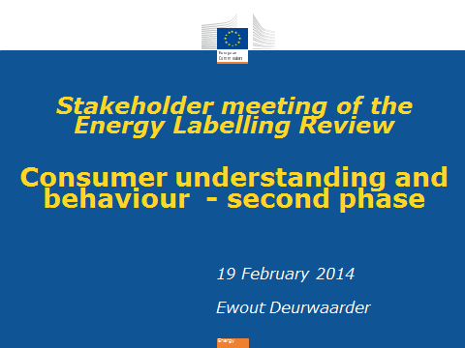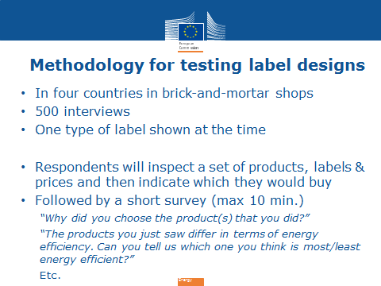
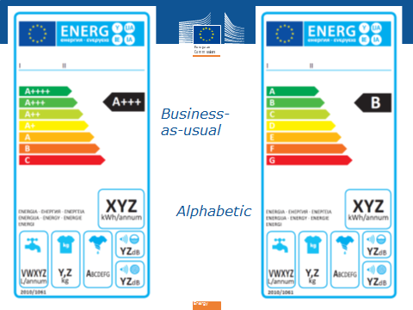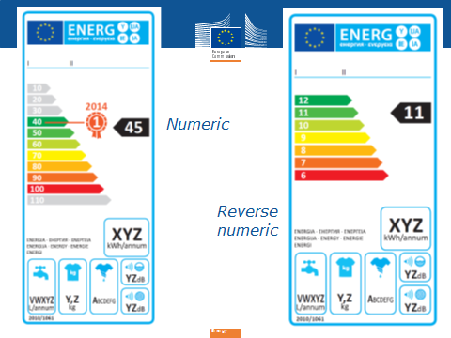
6. Public debate on the proposed energy label designs and on the method for testing them (moderated by the European Commission, DG Energy)
The Chair indicated that a maximum of four labels can be tested, but they do not have to be the four labels suggested. He invited participants to comment particularly on the labels they liked with the aim to improve them.
The Ökopol institute inquired why the benchmark marker was only included in label 3 and suggested it might better be left out, possibly to be tested in a later phase.
Denmark remarked that while the A-G label seems to them the best for consumers, for the testing their comments concerned labels 3 and 4. These should be combined, taking the best from each by introducing the benchmark and the top grey classes from label 3 in label 4. Further, concerning the testing methodology consumers should be given information on the labels in advance to avoid bias because some labels are close to the current one and others are not.
EHI pointed to the specificities for heating products as opposed to washing machines, televisions and lamps on which the to be tested labels are based. Heating products have different characteristics, e.g. lifetime, and are not yet labelled, only from 2015.
ECOS stated that label 1 should not be tested as no one is in favour of using that. Label 3 incorporates too many innovative elements at the same time, each of those should be tested separately; the benchmark marker could be left out. The methodology for testing should include assessing consumers' willingness to pay. Further, it is important to know whether consumers expect the label to be about energy efficiency or absolute energy consumption. Concerning the bottom part of the label something better than 'kWh/annum' is needed e.g. an extra horizontal scale.
Italy indicated that whatever methodology would be chosen, it would always have weaknesses, but this should not be used to reject the result. Italy indicated it preferred label 3, but the benchmark marker is a problem and also the number on the arrow does not correspond to the number on the class. Further, the transition period between two generations of labels, a weak point of label 2, should be tested. Italy further inquired how the countries in which the tests will take place were selected.
IKEA remarked that they would be interested to see more on pricing so that consumers can see what they will be saving on their energy bills. IKEA indicated that Label 1 is not an option whereas label 2 is. For label 3 the year number on the benchmark marker is confusing. The grey scales on that label are interesting though they add more information/complexity; they are not needed at the bottom.
The Rhineland-Palatinate Consumer Organisation suggested that for the methodology more than just 2-3 products in the shop should be labelled to get closer to real conditions. The interviews should include a question on why consumers choose a certain product. The test should include more complex products such as air conditioners. Label 1 should not be included. Label 2 should include a year number to distinguish the generation of the label. Label 3 and 4 should be made clearer; the numbers may not be understood by consumers.
ANEC/BEUC suggested that since it is well-known that label 2 works best, both in terms of understanding and behaviour, the focus should be on how to improve that label. The word 'annum' on the label is not understood by all consumers. The benchmark marker in label 3 could give the wrong impression that is also covers non-energy aspects. In the methodology for testing consumers should not be given prior information on the labels. Concerning transition periods between labels the current process does not seem the right process to look at this. The key issue for the current study is to make a better scale. The transition process is an issue that needs to be looked at separately to ensure that it will not confuse consumers.
CECED remarked that the label is a tool that should work on the market at all times. Therefore, there is a need to test transition scenarios, because two labels will co-exist on the market. This needs to be tested in brick-and-mortar stores. Some of the suggested label designs could be improved. The benchmark marker could be taken out and for label 4 the scale could run from 7 to 1 instead of 12 to 6. Concerning the methodology for testing it seems that the question 'Which appliance would you buy?' covers the entire evaluation process of which energy efficiency is only a part. Instead the question ' Which appliance is more efficient?' should be asked.
The German Retail Federation indicated that the benchmark marker should be left out of label 3. The question 'Which appliance would you buy?' would lead to skewed result if it is not actually bought. Any result on understanding would not be useful if not the question of rescaling is taken into account. Further, also the administrative burden of rescaling should be taken into account.
Sweden suggested an alternative label design with an A-G scale which has grey arrows added on the top. The benchmark marker is not needed, because the grey arrows already provide an indication of such information. However, the year of the label needs to be added. The labels should be tested not only on consumers, but also on manufacturers and retailers. QR codes on the label are very important and should therefore already now be included.
CLASP indicated that they missed a clear statement of the research question being asked. A clear rationale for the different label elements is missing. There should be a more methodological approach.
Consumers Futures UK stated that an inquiry among 4000 consumers showed that they were interested in running costs. However, introducing a second rating chart with running cost would be confusing. Further, not only do consumers have difficulty with the word 'annum' on the label, but also with 'kWh'. They suggested the potential for open data should be explored, although it is not clear whether this should be done through QR codes.
Francisco Zuloaga remarked that there is no need to test label 1. Further, since the first part of the study already tested understanding, the second part could instead focus on rescaling.
Belgium indicated that it fully supported that all the suggested four labels will be tested. The experiment should be as open as possible to new ideas at this stage. However, label 1 should have A+++ on top and not A++++. Such a label would also allow rescaling and the A+++ could be indicated in grey. Grey scales at the bottom do not seem useful, but at the top they are more interesting. For label 3 the benchmark marker is interesting and can be included as such. It is good to test in brick-and-mortar shops to understand the actions of consumers in an actual situation. All four labels offer the possibility or rescaling though this study should be about the layout. However, it is also necessary to take into account how manufactures and retailers react to the situation of rescaling. A questionnaire should be presented to the retailers participating in the experiment. Belgium asked whether it was possible to test a layout where the length of the bars represents the energy consumption. Belgium further inquired whether the black arrow should give alphabetic or numeric information and whether 0-100 scale in label 3 represents the energy efficiency index.
Germany indicated that label 1 is not an option and that instead the A+++ label should serve as the business as usual scenario. Label 2 should be tested with a rescaling scenario and include a validity year on the label. Label 3 should be tested without the benchmark marker as it has a key influence on the result. Such additional elements could be tested in a second phase. There should not be a number in the arrow on this label, but instead the arrow should be in the colour of the class. For label 4 they inquired why it runs from 12 to 6 and not from 7 to 1.
France remarked that testing label 1 is not a good idea. The current three plusses on the label is already a lot. Label 2 should be tested with a rescaling scenario. Label 3 should be tested without a benchmark and perhaps an A-G label with grey zones could be tested. Label 4 is not clearly understandable. Labels 2 and 3 are the most important to test as well as an A-G label with grey zones. The labels should also be tested with manufacturers and retailers.
The Netherlands stated that this study cannot and does not need to solve all issues; it should not try to solve the transition process. If there is a transition, this will apply to all label designs, not just for label 2. It is possible for label 2 to be used for 10 years without transition. The research of this study should be kept simple. Label 1 seems awkward for experts, but on second thought it is useful to test, because not all those involved are experts. The benchmark marker should be left out of label 3. Both understanding and effectiveness should be tested.
Orgalime remarked that it is necessary to make sure that the labels are comparable. They asked why the benchmark marker was only included in label 3. The transition process from the current to the new label should be tested as well as further updates of the label.
The United Kingdom remarked that it is necessary to test a business-as-usual label, but it seems this should be an A+++ label rather than label 1. There should not be a benchmark marker in label 3.
Austria suggested leaving out label 1 because it is not consistent, combining alphabetic with symbolic elements. Leaving it out increases the sample size for the testing of the other three labels. In label 3 there is no added value to include the benchmark marker. It is also better for the consumer not to include grey areas. Further, the question is which label both consumers and industry will accept.
The German Federal Environment Agency supplemented the German comments by remarking that also the absolute energy consumption is important and that it should be investigated whether for some appliances an indication 'per cycle' would be more motivating than 'per annum'.
BSH stated that the co-existence of different labels should be addressed and that it is possible to test this without making the experiment too complex. If needed, BSH is available to assist on this.
Ch. Duke responded to a number of methodological questions raised. Responding to CECED, she indicated that the experiment will ask consumers which product they would buy, but also why they would buy that one and which they think is more efficient. Responding to Italy she explained that for the selection of the countries for the testing in the second part of the study it was attempted to get a mix in geographic coverage while having a practical approach: testing in brick-and-mortar shops is not very common and agreements with retailers are key. Responding to the Rhineland-Palatinate Consumer Organisation she explained that only a limited number of products in the shops can be labelled for the experiment as it is using valuable store space and it is not practical to do it on the whole shop floor.
The Chair made the following points on the basis of the discussion:
- There is a need for a business-as-usual label, but it would indeed be better to use the A+++ label for that purpose than label 1.
- No one argued against label 2; there were only remarks on the transition phase. There is a trade-off on the understanding of the labels versus the transition and rescaling. If a transition would be tested it would have to be done for all four labels. This study is not necessarily the best tool to do this. The Commission will have to assess the transition in its impact assessment and will have to assess it separately from the current study.
- For label 3 it is necessary to make it as good as possible. With a few exceptions the inclusion of the benchmark marker is not supported. Other suggestions were to put the exact number of the class on the arrow, to change the colour of the arrow, to remove the grey bars at the bottom and to add a top class of zero. There is a need to look from the graphical perspective whether these can be done.
- Concerning label 4 it is a question whether to keep this label or not. If it is not kept the sample size for the other three labels can be increased or something else could be tested. Testing elements related to costs seems too complex in this study and on-going work in the UK on this can be used. Other options for testing are: label 3 with letters instead of numbers; per cycle versus per annum; and higher prominence of absolute energy consumption.
The German Retail Federation asked what the grey bars would stand for in a label 3 with letters instead of numbers. They suggested keeping label 4, but adding grey bars to it.
ECOS stated that testing a label 3 with letters instead of numbers is appropriate as this introduces an innovative element to an alphabetic label, whereas so far only innovative elements were included in numeric labels. Further the methodology should include a question on efficiency versus consumption.
Belgium indicated they would like to see label 4 maintained, but grey bars could be added on top.
Italy remarked that label 4 should be kept, but with all numbers, e.g. 15 to 1.
The Netherlands suggested keeping label 4 as it is good to have distinctive options, but they were not convinced about adding grey bars on top.
CECED stated that label 4 is a workable one, but it should be displayed as 7 to 1. In addition, testing transition needs to be kept as an option. CECED would be willing to explore how resources for this can be made available.
Portugal argued to keep label 4.
The Ökopol institute said that the question of testing transition was dismissed too quickly as there will be some products with the old label and others with the new label. Further, testing on how to improve communication on the absolute level of energy consumption is important.
Italy pointed out that on transition periods the impact assessment would need to say something substantial. There was a quick exercise in 2009 to test transition.
7. Wrap up by European Commission, DG Energy
The Chair concluded that there seemed more support for label 4 than for the new suggestion of label 3 with letters instead of numbers. Therefore, the labels to be tested would be changed as follows:
- A+++ to D label (instead of A++++ to C)
- unchanged (A-G as proposed)
- will remain numeric, but revised on the basis of a number of suggestions made
- will be made more attractive, but not be 7-1.
Separately from the study, the Commission will investigate the issue of transition. Any contributions in the forms of studies from stakeholders would be welcome, the latest by August. The Chair thanked all participants for their contribution to the discussion.
Annex I to the minutes of 19 February 2014 - presentation by P. Wade
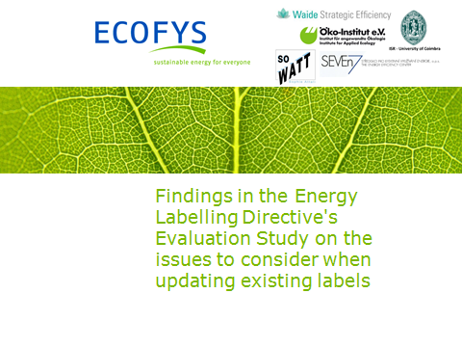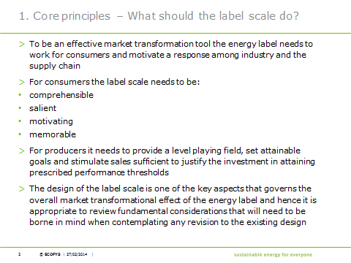
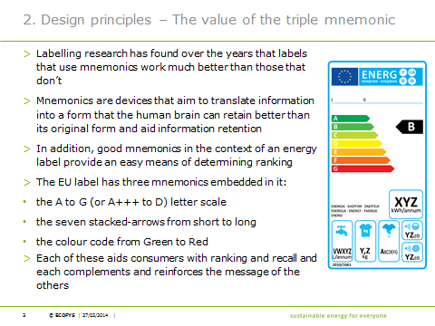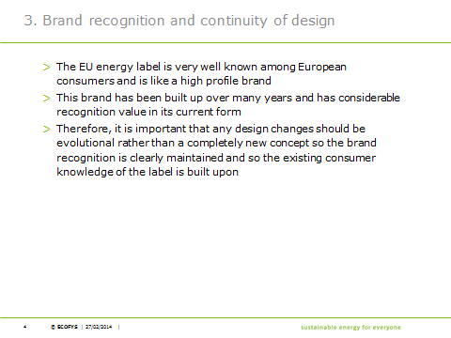
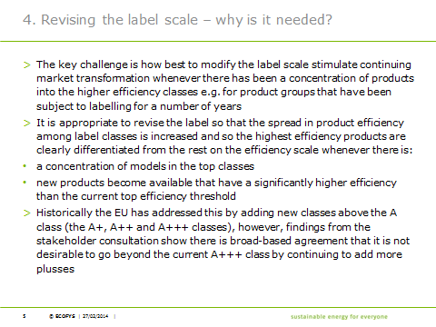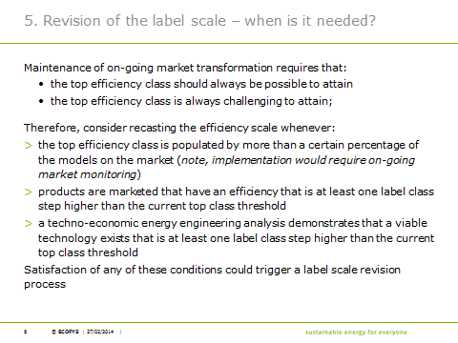
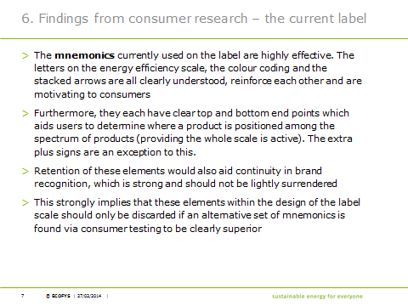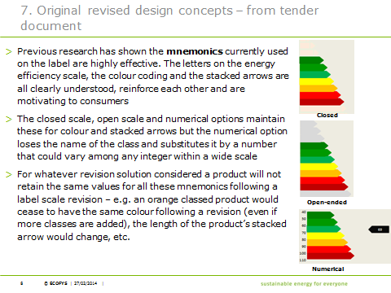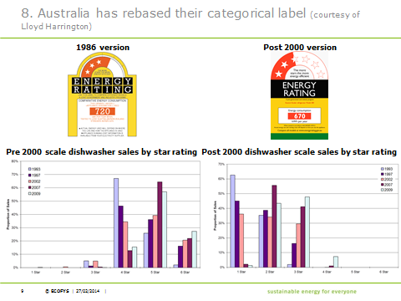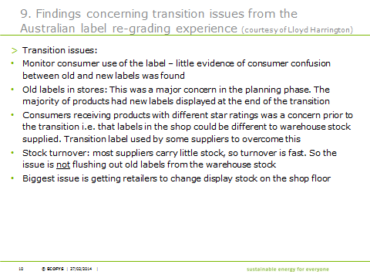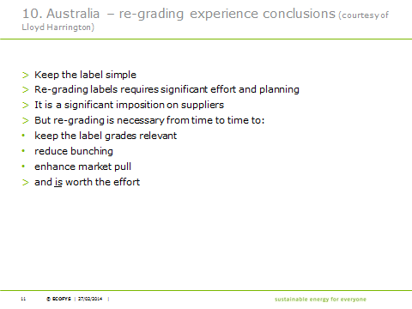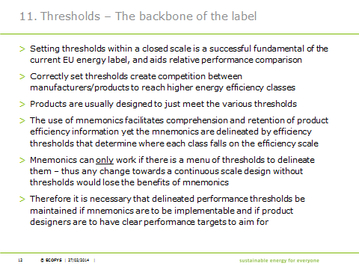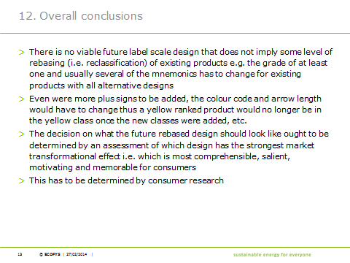

Annex II to the minutes of 19 February 2014 – presentation by Ch. Duke
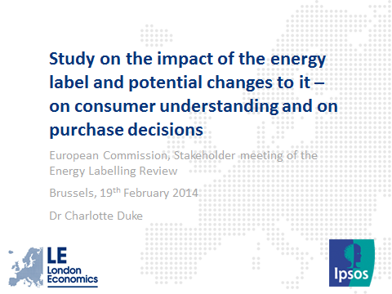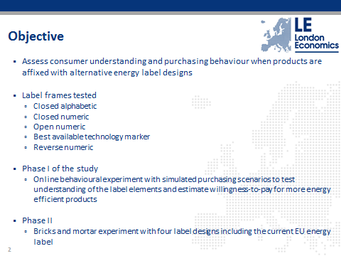
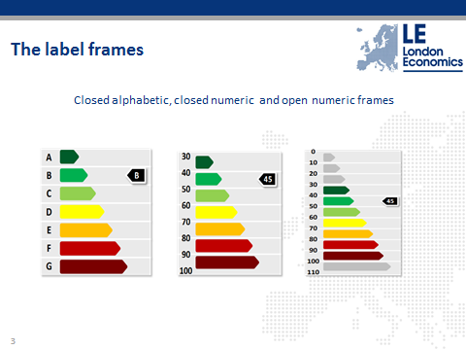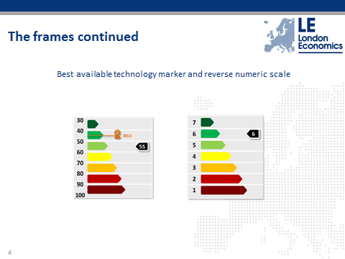
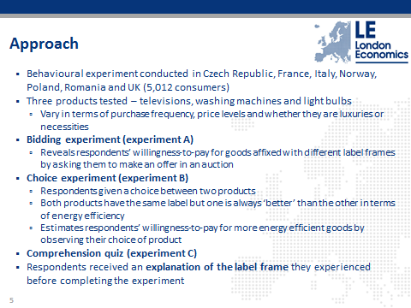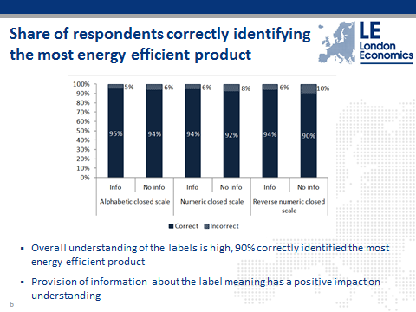
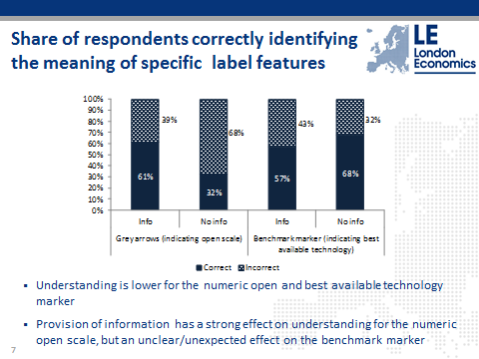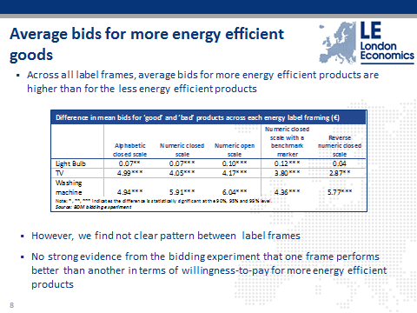
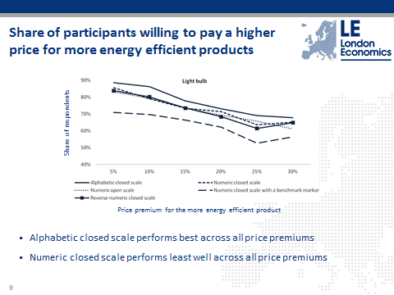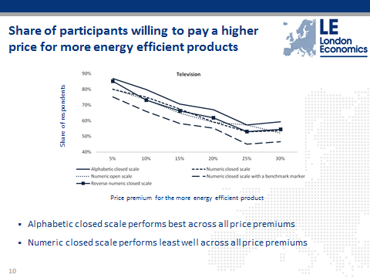
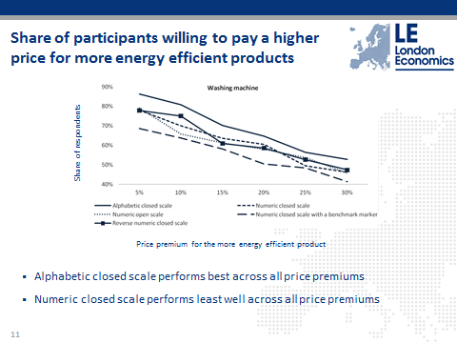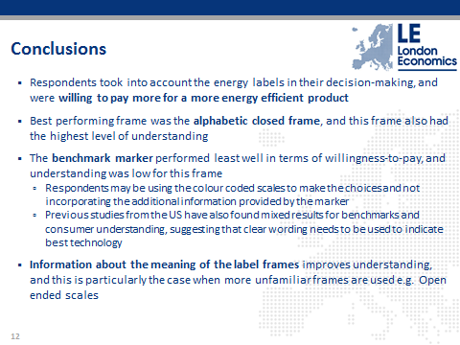

Minutes of the meeting of the Consulation Forum under Article 18 of Directive 2009/125/EC on energy-related products on "Review of the Ecodesign and Energy Labelling Directives "
Brussels, 11 June 2014 (14.00 - 18.00)
Participants: See Annex.
EC participants: Paul HODSON (Chairman - ENER), Robert NUIJ, Andras TOTH, Ewout DEURWAARDER (ENER), Marzena ROGALSKA, César SANTOS GIL, Michael BENNETT (ENTR), Ferenc PEKAR (ENV).
Documents: The Commission services circulated the evaluation study preparing the review on 4 June 2014.

1. Welcome and introduction

The Chair welcomed the participants to this meeting of the Consultation Forum, dedicated to the review of the energy labelling directive and certain aspects of the ecodesign directive. The Chair introduced the representatives of the Commission present in the room.

2. Adoption of the Agenda

The Chair presented the agenda and apologised that the minutes of the previous meeting were not yet ready for adoption. He asked for any other modifications or suggestions to the agenda.

The agenda was approved without further change.

3. Update on the review of the Ecodesign and Energy Labelling Directives – Discussion
The Chair explained that a review of the energy labelling directive is required by the end of 2014, and that it also includes a review of aspects of the ecodesign directive that could not be assessed during the 2012 review of that Directive. The evaluation study had been running since May 2013, accompanied by a public consultation from August to November 2013 and a stakeholder meeting on the first findings and recommendations report in February 2014. The final report of the study was published on 4 June 2014. The purpose of the meeting today is to discuss issues that were identified in the study and that the Commission services consider as particularly relevant for the development of the review package.
The Chair recalled that the review is taking place outside the familiar context in which the Consultation Forum works (implementing measures and delegated acts under two directives). The Commission's proposal for a review package will be discussed by Council and Parliament in ordinary legislative procedure, meaning that the Commission will not share drafts or conduct further consultations with stakeholders before the formal adoption of the proposal, at the earliest at the end of the year.
The Commission services started a debate with the meeting participants, based on a presentation formulating the main problems identified in the study.
Problem 1 - Long rulemaking process
1. How can we ensure that the availability of standards and certain steps of the adoption process do not delay the measures and their implementation?
IT: we cannot force European Standardisation Organisations (ESOs) to work faster, although delays can be frustrating - also to the ESOs themselves. Slowness is sometimes caused by real difficulties. The solution has already been found in transitional methods of measurement.
BE: we should simplify standards to focus on energy measurements; they also make it too difficult for Member States (MS) to carry out surveillance.
Orgalime: timely mandates to ESOs and constant exchange during standard development could speed up processes.
EEB: develop standard already when studying user patterns.
2. Should mandatory product registration be introduced in order to ensure the availability of sufficient and up-to-date data for rulemaking? (See also point 7)
BE: in favour of mandatory database, good for both recyclers and market surveillance. Consumers could have access to certain parts, as well as companies who could offer services to consumers. However, the database should be considered only as a means of assistance to market surveillance, rather than market surveillance per se.
DG ENTR: such a product database would have to be developed in cooperation with the internal market directorate in DG ENTR. A separate informal meeting with stakeholders might be organised. ANEC welcomes the suggestion, propose to bring an expert who set up a multilingual database in a third country.
UK: a different database is needed for rule-making than for market surveillance.
DE: it would be helpful, but only publicly available data should go in it, otherwise access problems will prevent large scale implementation. There should be no trade secrets in the database. There could be problems ensuring upload by solely the appropriate actors. Energy efficiency information can be made public. However, neither the associated detailed technical information on the technology, nor the information regarding quantities placed on the market should be made publicly available.
Digital Europe: several databases exist or are in development: Energy Star database, ICSMS, Ecopliant and one developed by Sogeti for the Commission, so would it be necessary to provide all these databases with information? The Commission responded that the Energy Star database serves a specific purpose and that the project executed by Sogeti is more to find out how data could be collected and maintained. The objective is not that industry would have to fill in multiple databases.
Orgalime: against product registration, because of confidentiality and intellectual property risks.
AT: the only way to increase surveillance is to decrease costs. A product database would reduce the cost of the first step, i.e., the documentary check of Regulation 765/2008.
SK: supports database. Industry wants to self-regulate but does not want to provide data, but we need data to see if e.g. voluntary agreements (VAs) are ambitious enough.
IT: if US/AUS style database (products to be registered when placed on the market), then technical documentation would have to be submitted, which contains sensitive information. If it is a public database, it should be different, in 24 languages, which brings additional difficulty compared to other markets. The Consultation Forum should discuss the database separately.
DK: database can save MS time; without it, they have to chase technical documentation, industry rarely respects 10-day deadline. A lot of time of market surveillance authorities is wasted on obtaining technical documentation from industry. Sometimes Danish authorities have to ask five times for it, meaning 50 days of waiting for the technical documentation instead of 10.
CECED: industry delivers data for preparatory studies. Products should be physically tested, market surveillance should get more budget, and the answer to surveillance problems should not be that additional burdens are imposed on manufacturers, which may not deliver expected results. Risks: who will compile registered data? What happens if free-riders do not register their products at all?
Lighting Europe: if products do not correspond to technical documentation, how can it be systematically identified? SMEs will have to implement it. There could be a large burden placed on industry for having a database, which we do not yet know if MS will be able to successfully use.
ECOS: modern IT systems can solve access problems. Public part is needed. Product information is difficult to collect today, standard format and platform for reporting is needed.
European Aluminium Association: database should be optional, cost for SMEs should be considered, and it should cover several regulations. It cannot be the only way for market surveillance. EAA is in favour of tighter market surveillance.
AT: reminds that doing only documentary checks is allowed by Art 19 of 765/2008.
Chair: The market surveillance package is going through legislative process now. Clarification: CECED did not ask to ignore the law regarding document checks; rather, they insisted on physical tests in addition.
BE: documentary checks were sufficient under 92/75/EEC, and they are the starting point. But doing them on the basis of the database is not OK. The database should be used only when dubious products are found on the market. There is already a database in BE of heating products which includes declarations of conformity. If products are found that are not in the database, producers are contacted. Unambiguous model identifiers can solve problems related to registration not corresponding to products on the market.
Problem 2 - Level of ambition
3. Should requirements aim at another level than Least Life Cycle Cost to increase their stringency?
IT: higher ambition leads to political problems, consensus is better, less ambition does not mean less success, we need to be closer to people.
EPEE, Orgalime, CECED: target values are averages, if we go for Break Even Point, in 50% of the cases there would be no return on investment over the lifetime, which cannot be accepted.
NL: Least Life Cycle Cost (LLCC) methodology could be improved by dynamic pricing, resulting in more stringent measures (BE: agree). Price / efficiency relation does not exist for e.g. electronic products, where some other methodology is needed to determine the level of requirements.
European Aluminium Association: LLCC is not possible for all products. Windows can be upgraded after installation by replacing glazing only.
Orgalime: it is of common interest to maintain the credibility of the instrument, and to keep key stakeholders aligned. Industry sectors have invested heavily. Criteria in the Directive such as significant potential for improvement should be respected.
DK: supports equal life cycle costs.
CECED: Long term targets and learning curves imply many assumptions on how the market will behave, they are very risky.
ECOS: LLCC has not been applied yet, because by the time adopted regulations started to apply, levels were already obsolete. At least the accuracy of the LLCC calculation should be improved. Product database would be helpful to see where market stands.
EEB: we cannot go too quickly, but we should go beyond least life-cycle costs, because we are not even reaching it currently.
4. Is there a need to stop prioritising voluntary agreements (over legislation) when they are available?
NL: voluntary agreements (VAs) are not a priority question; the criteria are so complex that only a few of them have been endorsed.
IT: in favour of having VAs as an alternative to the Commission deciding in the form of regulations. Orgalime supports: some implementing measures were even preceded by VAs.
DK: VAs are worth only if there are clear deadlines and ambition levels. The effects have been meagre so far, while development has been resource-intensive.
BE: we should carry on with caution. Priority-setting in VAs should not be steered by industry. VA market surveillance cannot be done by industry, as it would be contrary to new approach. For sectors with small numbers of products, VAs could be appropriate. Whether to opt for VAs versus Ecodesign energy efficiency mandatory requirements regarding new products could be judged on LLCC, on the basis of cost per kWh of energy saved, comparing it against the cost of upgrading the electricity grid.
ANEC/BEUC: VAs so far have proven to be neither faster nor less costly. Therefore,the two existing VAs do not fulfil the criteria in the Directive. Take also for example the proposal for a VA on game console proposal, which goes back to 2012 and still there is little progress. VAs should have surveillance and sanctions. Guidelines on VAs have to be finalized before any VA is endorsed or revised.
Chair: reminds that the question is not about stopping VAs, but whether we should continue prioritising them. ECOS: NGOs have strong reservations about VAs. What would it mean to stop prioritising VAs? There would not be a possibility to have a VA if Commission starts drafting legislation? Chair: With regard to the above, it depends on if, and how, we reformulate the text.
UK: In general we prefer self-regulation over regulation.
CECIMO: difficulties with the machine tools VA were caused by the fact that it is a complex product group. They had stated before that data was missing, and the consultant BIOIS came to the same conclusion.
SK: support VAs. For machine tools, the last 10 years should have been sufficient to gather the missing data.
Problem 3 - Weak enforcement
5. Should an EU market surveillance authority be set up, or should we have requirements on the minimum level of surveillance?
AT: Regarding considerations of whether present levels of market surveillance are “weak”, this term is relative. There is no discussion in the Ecofys report about what would be a realistic objective for surveillance. 100% is unrealistic. The reasons of perceived low surveillance levels are not analysed in the report, except for lack of resources. The cost imposed by EU legislation determines the way products are checked, but the study also failed to examine that issue. IT agrees; if the Commission thinks it can do better, then Italy wishes it good luck. The infringement procedures concerning lack of market surveillance are one more example of the dirigiste approach from “Brussels” that is presently being criticised.
NL, SK, EAA: in favour of an EU market surveillance authority, which could tackle existing interpretation problems across MS concerning products that can circulate freely around the EU. SK: calls for more information on an EU authority, yearly budget, will it be parallel to MS surveillance? Chair: The study and the current consultation will be followed by the drafting of an impact assessment, which will highlight the topics discussed today. But the details of any potential EU surveillance authority will have to be developed later.
NL: The Ecopliant workshop yesterday has shown that no single MS can perform effective surveillance for ecodesign and energy labelling. In any case, more thinking is needed on how to cooperate and specialise in surveillance (EPEE agree).
UK, FR, BE: there could be better coordination and information sharing, playing on the respective strengths of the various surveillance authorities. There is not much we can do in addition to current efforts (like coordination in ADCO) without infringing the subsidiarity principle. BE: We cannot define what minimum level of surveillance means. Instead, EU funding could be better oriented, there is less of a problem with products that are targeted by both labelling and ecodesign, as manufacturers will want to get rid of bad products anyway. For other appliances covered by only ecodesign, e.g. those that have to be tested on-site (transformers, large space heaters), targeted support for improving surveillance could make sense.
DK: EU authority would require such a change of competences that it is unrealistic in the current political context (EPEE agrees). Instead, an agency would make sense with an objective to help national surveillance with pan-European perspective.
SE: it should not be called an “authority”, but there is an increased role for the Commission: enhancing cooperation, formal technical support and information on companies. Nordic cooperation quoted as an example. Commission should set up an online ecodesign platform where everything is available together (prep studies, guidelines etc.). In order to determine a minimum level of surveillance, we would have to know what the metrics are (EPEE agrees).
ANEC: No one MS can possibly cover all the requirements with surveillance, so coordination is needed. A more legislative solution might be helpful, preventing complicated products from self-declaring, imposing different conformity rules on them, requiring more documentation, assistance from Notified Bodies and quality control.
Orgalime: there is room for more coordination, better use of ICSMS. There might not be an Ecodesign-specific solution to the general problems of market surveillance.
6. Should we align surveillance provisions between ecodesign, labelling and the market surveillance framework?
UK, BE, DK, NL, FR, SE: agree. BE sees even possible combination with surveillance under the Low Voltage Directive. NL questions how this objective can be achieved, perhaps through a merger of the directives? FR claims that it is doing this alignment already.
EAA: manufacturers need a single framework under which to comply with EU requirements.
7. Should mandatory product registration be introduced in order to ensure the availability of sufficient and up-to-date data for surveillance? (NB See also comments previously made re. the product registration database in Point 2.)
EEB: product database helpful for better enforcement, also good for up-to-date requirements.
SE: ICSMS should be the compliance database. Mandatory registration may have high costs, feasibility study is needed: using it with other policy areas, which product groups are suitable, who should maintain it.
EAA: highlights that SMEs would then need to invest more resources; this financial impact should be quantified, as part of overall considerations regarding the use of mandatory registration.
Problem 4 - Non-energy environmental impacts
8. Should the MEErP be further revised to better capture non-energy environmental impacts?
EEB: as long as there is no trade-off with energy efficiency, we should not shy away from resource efficiency requirements. It would not add too much further delay to adoption processes. This is particularly relevant for the revision of existing measures.
IT: Before deciding to further revise MEErP, we should ask ourselves what the important requirements are, and only those should be written into legislation. Market surveillance has proved that sometimes odd requirements end up in legislation.
BE, DE. DE: it is a major weak point that the labelling directive does not specify what should be assessed when preparing legislation, and unfortunately the Ecofys report is silent about this. The mandate to ESOs on material efficiency is well appreciated (BE agrees). It will be interesting to see if the material efficiency tool under MEErP will be successfully implemented.
NL: Point 8 is not a priority issue. MEErP is not perfect, but has already pointed to non-energy impacts. The question today is more regarding firstly, how might such impacts be regulated? And secondly, how would rules be enforced?
SE: Supports enhanced treatment of resource efficiency (in particular, repairability), but better coordination is needed between MS bodies covering different aspects (example: solid fuel boilers). It should also be explored how ecodesign/labelling can be used to enhance the implementation of other directives, e.g. REACH or legislation on hazardous substances. The real gap is that information on substances does not get from the producer to the end-of-life phase. Ecodesign could require that such information is gathered and communicated. While this might already be possible, the text of the directive could be complemented so that it is not forgotten in implementation. BE: agree with principle but it has to be cost-effective. Recycled products may be in breach of REACH, as they cannot provide full information on material content. This conflict would have to be resolved.
KREAB representing Emerson: in order to better exploit the existing potential, we should make use of the whole ecological profile in order to drive design, i.e., not solely energy efficiency, but also resource efficiency. As there is a lack of guidance/methods on such profiles, Emerson is prepared to work on a targeted EU methodology or standard.
9. Should the scope of the Directives be extended to cover non-energy-related products (non-ErPs)?
EEB, ANEC/BEUC: We could extend scope without starting to work on products such as T-shirts right away. If there is an a priori exclusion, we lose the benefit of anticipatory effect on industry. EEB: re-launching the review later to extend the scope would be a waste of money. Extended framework directive could even specify that e.g. the next two working plans will only cover ErPs.
IT, FR, SE, EAA: it is premature to extend to all products, we have not yet explored all possibilities under current scope, and we may lose out on energy efficiency in the process. SE: Does not want to exclude the possibility of extending the scope, but suggests to focus on the further possibilities that exist under the current scope, including on systems, other aspects than energy, harmonised building labelling.
UK: We should not divert efforts; we should focus on existing mandate. Methodologies are missing to support a scope extension.
BE: premature to extend, especially for labelling, too many problems even within current framework.
BE: DG ENV is working on Product Environmental Footprint (PEFp); the methodology to cover non-ErPs might be there for next revision. PEFp types of requirements are more suitable for these products than requirements on specific aspects. Extended producer responsibility such as for example a service based business model, inherently guaranteeing efficient use of resources and materials, could be a ground to be exempted from specific durability criteria.
DK: the previous extension (to non-energy related products) has not yet resulted in experience. In the current implementation, ecodesign should take more account of resource efficiency.
NL: Energy labelling is by definition restricted to energy. Under ecodesign, we cannot escape from a scope extension at one point. It is true we need vision, but we also need measurement methods and realistic enforcement (EPEE agrees). We do not need to wait for an extension; we can already practice covering other environmental aspects via the current scope.
EPEE: scope extension would put large additional burdens on industry. Scope extension also needs to be considered with regard to subsequent enforceability of mandatory requirements (CECED agrees.)
Orgalime: apart from enforceability issues, there are more question marks relating to other environmental aspects. For example, where is the significant environmental improvement related to dismantlability? Modern trends in the recycling industry lead to a future where dismantling a product might not be necessary any more. Products containing recycled materials tend to have quality issues.
CECED: industry already considers the reduction of material use in production as an opportunity. It happens anyway, rules would also be difficult to control, and presently there are no reproducible measurement methods. It could perhaps be the subject of some horizontal measure beyond ecodesign.
Problem 5 - Effectiveness of the energy label
The Commission services explained that they would not like to reopen the February discussion about the choice of labels to be tested. The consumer tests started at the end of May in FR, CZ, PT and SI (in the latter two, in place of the originally planned UK and BE). First results should be available in August, and the report will be made public.

10. Should the label scale layout be changed to tackle the issue of re-scaling?
BE, SE, DK, DE, ANEC/BEUC agree.
DK: we should be aware of rescaling need when the lowest available class is A+ as with cold appliances.
SE: the resilience of the label to changes over time should be tested.
European Heating Industry (EHI): the impact of the transition period should be assessed if rescaling is implemented.
11. Should absolute consumption be more emphasised in the label?
DK, UK, AT, NL, BE, DE, CECED: support emphasis on absolute consumption.
UK, SE: questions 11 and 13 should be considered together. BE: if either 11 or 13 is implemented, the other is not necessary.
NL: Framework directive could provide guidance on when to target absolute consumption in the regulations.
IT: It should be case by case, the functionality of the product should be considered. Consumer could select products that consumes less energy but do not fulfil the expected functionality. In future, revision or not, we should have a better analysis of consumer behaviour and real use of the product.
EAA: strongly against, the question makes sense for energy-using products only, not for ErPs, which do not consume themselves. The consumption totally depends on how the product is operated. SE: information should be provided on the impact of the product on energy use.
EEB: in favour of a case by case approach. If we address it in energy labelling, it should also be addressed in ecodesign.
EPEE: energy label methodology was developed for plug and play products. For more complex products, another approach is needed; large appliances are not necessarily bad.
ANEC/BEUC: it is a very useful feature in the label, but there are some issues with how it is indicated and how the consumers interpret it. What is better, yearly consumption or per cycle? “Annum” is not understood everywhere in the EU.
12. Should monetised information on life cycle costs be provided with the label or in the price tag?
UK: shop trials in the UK are still in process, initial results show some promise, but not uniformly across products. In any case, it should not be placed on the label itself; consumers do not get the notion that more efficient products can still consume more than less efficient ones. There should be clarity whether retailers are allowed to provide monetised information on their own initiative.
AT, NL, CECED: it may be counterproductive, since difference between highest classes may not lead to much money saving.
NL: Life Cycle Costs on an EU label do not make much sense – such considerations would have to be delegated to regional level. The scope of the energy label does not extend to the price tag, which is covered by other EU legislation.
BE: it does not make sense in the energy label itself; BE thinks that implementation elsewhere could be investigated.
IT, DE: monetised information would be impossible in practice, as energy mixes differ locally/nationally. IT: the cost may not reflect the quality of the energy consumed. DE: price information would become obsolete quickly.
DK: research shows that the label works because the message is clear, it would be a mistake to insert an extra parameter on it. The price information would be contradictory to the principle of the internal market.
SE: agree with the MS views above.
EAA: against - the idea does not make sense for ErPs.
EEB: in favour of providing LCC information to consumers. If it differs across the EU, QR codes could be used to give access to local information. If there is a normalised approach, EU-wide indication is possible.
CECED, NO: price indication in the label could be confusing.
13. Should the formula determining the class be changed to stop favouring large appliances?
IT: We have to carefully weigh pros and cons. What is better, consumer purchasing two smaller products or one larger? There might be other ways of discouraging from buying larger products.
EEB: even if label favours products with lower consumption, consumers are not forced to buy them. This is an issue only for ecodesign.
DK, SE: agree. DK: it is more complicated when different technologies are in the same group. SE: it should be logarithmic formula, based on use patterns.
EAA, CECED: disagree. EAA: A larger product does not always consume more energy. Depending on the context, with a large window, solar gains may be higher than heat losses.
ANEC/BEUC: the size of households is declining, so is there indeed a need for larger appliances?
Other questions

NO: Primary Energy Factor (PEFa) problem was not mentioned today. In the 2012 review, the consultant recommended a forum for discussion on this issue. In the current study, Ecofys recommended a more thorough review. Suggests dedicated formal meeting on the matter. CZ, BE agree. IT: absolute consumption solves the PEFa issue, as it would have to be indicated in secondary consumption on the label. Ecodesign also needs to be based on that, we need to keep the two pieces of legislation aligned, including the levels of the requirements.
SE: it is written in the space heater regulations that these factors have to be reviewed. Agree with NO; however, the question is relevant only for energy labelling. For ecodesign, tapping into the energy efficiency potential is still the key aspect. It could be considered to align the PEFa with the Renewable Energy Sources Directive.
Chair: we will consider whether or not to hold a meeting. Ecodesign is an internal market directive, whereas the PEFa is set in the Energy Efficiency Directive. The latter would be the place to discuss any changes to the PEFa value.
EPEE: The Ecofys study underlined need for policy coherence; this is relevant for products having different sets of requirements under ecodesign and under other policies. There should be a cost-benefit analysis of making changes to the LLCC approach.
IT: Can we go on having two legal procedures for adopting measures (delegated acts and implementing measures)? Chair: if we propose changes to the Ecodesign directive, then it will presumably have to be updated to the delegated acts procedure, as has already been the case with the Energy Labelling Directive.
BE: asks the Commission to take account of the wish from several MS to check whether the Energy Labelling Directive can be “de-Lisbonised”, in order to use implementing acts instead of delegated ones. AT: supports BE and reminds that Treaty Article 230 requires that it should be precisely defined what is delegated. Current scope of delegation is too large. Perhaps we should consider returning to co-decision.

4. AOB
The Commission services gave an update on planned next steps with different measures in the adoption procedure.
UK: What is the status of measures on ventilation products? Chair: the draft energy labelling regulation is waiting for approval to start the adoption process, and the ecodesign measure is in turn waiting for the energy labelling regulation.
NL: What is the status of the study on smart appliances? CECED: Are the consultants chosen?
Chair: we will try to ensure that the smart appliances study can start as soon as possible.

Annex II to the minutes of 11 June 2014 – Attendence list
Member States | Name
AT | LUDWAR | Gerhard
BE | SOENEN | Bram
BE | VERCKENS | Bram
BE | CREVECOEUR | Guibert
BE | SCHORPION | Hannelore
BG | BONTCHEV | Bontcho
CZ | HYKSA | Vlastimil
DE | AKKERMAN | Floris
DE | BERGER | Jan
DE | HINSCH | Thomas
DE | KÜPER | Arne
DE | OEHME | Ines
DK | NIELSEN | Peter
FI | WIIK | Carina
FI | HAKKARAINEN | Niina
FR | BISSON | Evelyne
HU | KARCZA FUNTEKNE | Beata
IE | SWEENEY | Mark
IT | BASILIO | Emanuele
IT | PRESUTTO | Milena
LU | BRAUN | Ricarda
LV | APSITE | Inga
LV | KAULINŠ | Dzintars
LV | MATULIS | Dainis
NL | SIDERIUS | Hans-Paul
NL | VAN DAM | Paul
NO | FAGERLUND | Kirsti Hind
NO | TONSBERG | Marianne Norman
SE | LOPES | Carlos
SI | BELAVIC BENEDIK | Andreja
SK | TOPOLSKY | Erik
UK | RIMMER | Edward Michael
UK | WALKER | Mike
Organisation
AEGPL | MAUBANC | Samuel
ANEC | EVANS | Chris
ANEC/BEUC | MALIZOU | Angeliki
CECED | RAMBALDI | Matteo
CECED | RICHAUD | Candice
CECED/ VORWERK | SCHIANSKY | Jethro
CECED/ VORWERK | CHALANÇON | Pierre
CECIMO | SLUPEK | Kamila
CEN/CENELEC | GINDROZ | Bernard
CEN/CENELEC/ EVA | IRVINE | David
COGEN EUROPE | TUDOROIU | Alexandra
DIGITAL EUROPE | FEINDT | Silvie
DIGITAL EUROPE / CISCO | VERSCHUERE | Klaus
DIGITAL EUROPE / DELL | MORIARTY | Tom
DIGITAL EUROPE / HP | ORD | Jason
DIGITAL EUROPE / INTEL | GIBSON | Peter
DIGITAL EUROPE / PANASONIC | DUBRAY | Marie-Helene
DIGITAL EUROPE / SAMSUNG | RANA | Sandeep
DIGITAL EUROPE / SHARP | GROEBLER | Thomas
EAA | VATAVALIS | Pavlos
ECOFYS | MOLENBROEK | Edith
ECOS | SPENGLER | Laura
ECOS | TOULOUSE | Edouard
EEB | ARDITI | Stephane
EEB | WACHHOLZ | Carsten
EFCEM | WARREN | Keith
EHI | RATEAU | Fanny
EPEE | VOIGT | Andrea
EPEE/ DAIKIN | BEELAERTS | Veerle
EPEE/ DAIKIN | OKI | Takahiro
EPEE/ EVIA | BONVILLAIN | Denis
EPTA | SCUDERI | Francesco
eu.bac | MELCHIOR | Frederic
EUROCOMMERCE | DAVIDSON | Christel
EUROVENT | VAN EYKEN | Felix
Glass for Europe | OGGIANU | Luca
KREAB consultant for EMERSON | GORKEM | Marie
Lighting Europe | PAGANO | Fabio
Lighting Europe | TIRONI | Fabrizio
Lighting Europe | BRIATORE | Chiara
Lighting Europe/ OSRAM | FRANZ | Otmar
OEKO INSTITUT | FISCHER | Corinna
ORGALIME | LINHER | Sigrid
ORGALIME | KOCH | Lars
ORGALIME / ZVEI | ELFERS | Christine
RREUSE | RIEDER | Daphne
UEAPME | LENA | Guido

Annex 2 – Detailed presentation of the Ecodesign and Energy Labelling Directive and their implementation
This Annex sets out the background to the Ecodesign and Energy Labelling Directives, summarises the process for developing implementing measures and the role of the different institutions, presents what has been achieved and describes the next steps in their implementation.

Summary
The Ecodesign Directive, adopted in 2005 and extended from energy-using to energy-related products in 2009, allows the Commission to prohibit the sale in the EU market of those models of energy-related products with the highest environmental impacts. Every three years an ecodesign working plan identifies the products to be studied in detail. After a preparatory study a product specific regulation is drafted detailing the EU-harmonised ecodesign criteria for that product group, which is adopted following the implementing act procedure. To date 24 ecodesign implementing regulations have been put in place, some of which have been subsequently updated through amendment, and two ecodesign voluntary agreements are in place. Products covered range from household products, such as fridges, lamps and boilers, to professional and industrial products, such as electric motors and fans. Further products groups are under study for potential regulation.
The Energy Labelling Directive, revised in 2010, allows the Commission to require energy labels to be displayed on energy-related products at point of sale. The label shows which energy class a product achieves, and this encourages the sale of more energy efficient and environmentally friendly models through the provision of comparable information on energy efficiency and consumption of key resources. After a preparatory study a product specific regulation is drafted detailing the energy label for that product group, which is adopted following the delegated act procedure. 13 delegated regulations now ensure that a range of products, all of which are also subject to Ecodesign regulations, must be sold with an EU energy label attached. All these measures were amended in 2014 so that the energy label will also be shown when selling the product via the internet.
The related Tyre Labelling Regulation is separate from the Energy Labelling Directive framework, but addresses the same issue for the specific sector of tyres. Its review is foreseen for March 2016, although the present review may have an impact on this regulation, because of its similarity to the Energy Labelling Directive's delegated regulations.
Ensuring compliance by manufacturers and retailers with the legislation is the responsibility of Member States through market surveillance (see Annex 3 for further information). To ensure a common interpretation in enforcing the requirements and to organise market surveillance efficiently across the EU, Member States' market surveillance authorities exchange information through Administrative Cooperation groups (ADCO). Furthermore, the Market Surveillance Regulation provides the framework for Members States to organise their market surveillance. The regulation specifies that its provisions apply to all Union harmonisation legislation on products, insofar as there are no specific provisions with the same objective in that legislation. The latter is at present the case for Articles 3(2)-(4) and Article 7 of the Ecodesign Directive and Article 3(2)-(4) of the Energy Labelling Directive. These articles take precedence over similar provisions in the market surveillance regulation. To further improve Member States' market surveillance the Commission proposed a new market surveillance regulation for products in February 2013.

Background energy labelling and ecodesign

Energy labelling
The second oil crisis in the early '80s led the Council in 1986 to set an objective to improve energy efficiency by 20% by 1995. The Gulf Crisis of 1990 reinforced doubts about the security of oil supplies. Furthermore, the Energy/Environment Council of 1990 set the objective to maintain CO₂ emissions at 1990 levels. While energy consumption in industry remained stable in the '80s, residential and transport consumption rose substantially. In this context, and in an effort to preserve the single market from fragmentation by similar national initiatives introduced at the time, a Community-wide energy labelling scheme (Council Directive 92/75/EC) was established, using the A-G scale with coloured arrows for the first time. The directive was supplemented by further, "implementing" Directives on household washing machines, washer-dryers, lamps, cold appliances, electric ovens and air-conditioners during the period 1995-2002.
In 2010, the Energy Labelling Directive 92/75/EC was replaced by Directive 2010/30/EU. Its main features were the introduction of A+, A++, and A+++ classes on top of the A-G scale, an almost language-free label used across the whole internal market, and distance and internet sales added into the scope. Previously existing labels have since been updated, and new labelling measures have been created for a number of additional product groups.

Ecodesign
In the course of the 1990's Council directives were adopted setting minimum energy efficiency requirements for boilers (1992), refrigerators and freezers (1996) and fluorescent lamp ballasts (2000). These aimed at avoiding the fragmentation of the internal market (Member States had initially introduced or expressed the desire to introduce national requirements) and at ensuring that the increased circulation of products on the internal market did not result in a proliferation of cheaper, low-efficiency appliances.
To set a framework for future work, in 2003 the Commission then proposed the Ecodesign of Energy-Using Products Directive (adopted in July 2005). The directive allowed for product specific implementing measures adopted in comitology, containing minimum requirements that would remove the worst performing products from the market. The rationale behind this approach was to allow for fast progress in highly technical matters, while maintaining legal soundness and cooperation among the institutions of the EU.
The Energy Labelling and Ecodesign Directives complement each other, as the former promotes the best products (exercising a "pull" towards more energy efficiency), while the latter removes the worst from the market ("push" effect).
In 2009, the Ecodesign Directive's scope was extended to cover also energy-related products, i.e. products that do not use energy themselves but have an influence on other products' energy use, such as building controls or thermal insulation.

Process and role of the Institutions
Both the Ecodesign and Energy Labelling Directives are framework directives. They require the Commission to come forward with implementing regulations laying down product-specific requirements, and set the conditions these regulations must meet. In turn, the regulations must be approved or not objected to by the European Parliament and Council. The below figure gives an overview of the legislative process.
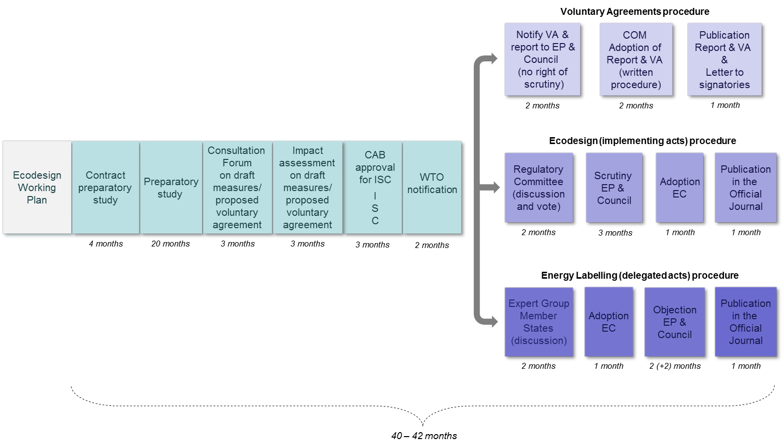
The process starts with establishing the priorities for Union action. Priority product groups are selected based on their potential for cost-effective reduction of energy consumption and following a transparent process culminating in working plans that outline the priorities.
A first list of priority product groups was provided in the Ecodesign Directive itself (2005/32/EC, Article 16). Subsequently, the first formal working plan (for 2009-2011) and the second (for 2012-2014) were adopted by the Commission after consultation of the Ecodesign Consultation Forum (composed of Member State and stakeholder experts).
The products listed in the two plans (1st working plan: 1-10; 2nd working plan: 11-18) are the following:
- Air-conditioning and ventilation systems (commercial and industrial) | - Window products
- Electric and fossil-fuelled heating equipment | - Steam boilers ( < 50MW)
- Food preparing equipment (including coffee machines) | - Power cables
- Industrial and laboratory furnaces and ovens | - Enterprises' servers, data storage and ancillary equipment
- Machine tools | - Smart appliances/meters
- Network, data processing and data storing equipment | - Lighting systems
- Refrigerating and freezing (professional) | - Wine storage appliances (c.f. Ecodesign regulation 643/2009)
- Sound and imaging equipment (incl. game consoles) | - Water-related products
- Transformers
- Water-using equipment

There were also a number of conditional products in the 2nd Working Plan that the Commission committed to study closer before deciding to launch full preparatory work (such as thermal insulation, power generating equipment).
Once the product group has been selected, a preparatory study is undertaken by an independent consultant, involving extensive technical discussions with interested stakeholders.
Next, the Commission's first drafts of ecodesign and energy labelling measures are submitted for discussion to the Consultation Forum, consisting of Member States' and other stakeholders' representatives. The Parliament, Member States and stakeholders are kept informed (by receiving copies of the evolving texts of the draft regulations) at each stage from there onwards.
After the Consultation Forum, the Commission drafts an impact assessment, which after approval of the IAB is taken forward to inter-service consultation together with draft implementing measures.
The next step is WTO notification. Following that, the two procedures follow different paths. The draft energy labelling delegated act is discussed in a Member State Expert Group where opinion(s) are expressed and consensus is sought but no vote is taken. The draft ecodesign measure is submitted for vote to the Regulatory Committee of Member State experts. Next, the Commission adopts the delegated act for energy labelling.
After this the European Parliament and Council have the right of scrutiny for each measure for which a period of three or four months is foreseen. Within this time the co-legislators can block the adoption process by the Commission. Parliament committees sometimes discuss proposals to object to measures (light bulbs and fridges in 2009) or go one step further and vote on such a proposal (vacuum cleaners and water heaters in 2013). On one occasion an objection was even adopted in plenary, blocking the measure for televisions in 2009.
Voluntary agreements
The Directive sets out in its Annex VIII in addition to the basic legal requirements indicative criteria for assessing whether proposed self-regulatory initiatives can be considered as an alternative to an implementing measure. The industry which submits a self-regulatory proposal in view of it being officially recognised by the Commission is expected to provide sufficient technical background to enable the Commission and the members of the Consultation Forum to assess the proposal, notably in terms of the added value as compared with business-as-usual.

The Commission assesses each self-regulatory initiative on a case by case basis after consulting the members of the Consultation Forum and taking into account the findings of the technical/economic preparatory study if available. The basis for the assessment whether a proposal goes beyond business-as-usual is the information provided by the industry and affected parties and, if available, the findings of the preparatory study. Voluntary agreements are expected to include quantified and staged objectives, starting from a well-defined baseline and measured through verifiable indicators. Voluntary agreements also need arrangements for independent verification as they are not necessarily subject to market surveillance by Member States.

The Commission is in the process of developing guidelines for voluntary agreements. The Consultation Forum endorsed on 12 June 2014 an approach that voluntary agreements should cover at least 80% of the market share of a product category and that at least 90% of all product models of each signatory of the voluntary agreement comply with its requirements.

Existing ecodesign, energy labelling and tyre labelling legislation

Framework legislation
- 2009/125/EC Ecodesign Framework Directive
- 2010/30/EU Energy labelling Framework Directive
- 1222/2009/EC Labelling of tyres with respect to fuel efficiency and other
essential parameters

24 Ecodesign implementing regulations
- 1275/2008 Electric power consumption standby and off mode
- 107/2009 Simple set-top boxes
- 244/2009 Non-directional household lamps (+amending regulation 859/2009)
- 245/2009 Fluorescent lamps without integrated ballast, for high intensity discharge lamps and for ballasts and luminaires (+ amending regulation 347/2010)
- 278/2009 External power supplies
- 640/2009 Electric motors (+ amending regulation 4/2014)
- 641/2009 Circulators (+ amending regulation 622/2012)
- 642/2009 Televisions
- 643/2009 Household refrigerating appliances
- 1015/2010 Household washing machines
- 1016/2010 Household dishwashers
- 327/2011 Industrial fans
- 206/2012 Air conditioning and comfort fans
- 547/2012 Water pumps
- 932/2012 Household tumble driers
- 1194/2012 Directional lamps, light emitting diode (LED) lamps and related equipment
- 617/2013 Computers and servers
- 666/2013 Vacuum cleaners
- 801/2013 Networked standby
- 813/2013 Heaters
- 814/2013 Water heaters
- 66/2014 Domestic cooking appliances
- 548/2014 Power transformers
- 1253/2014 Ventilation units
4 amending Ecodesign implementing regulations
- 859/2009 Ultraviolet radiation of non-directional household lamps (amending regulation 244/2009/EC)
- 347/2010 Fluorescent lamps without integrated ballast, for high intensity discharge lamps and for ballasts and luminaries (amending regulation 245/2009/EC)
- 622/2012 Circulators (amending regulation 641/2009)
- 4/2014 Industrial electric motors (amending regulation 640/2009)

3 Voluntary ecodesign agreements (Report to the EP & Council)
- COM (2012) 684 Complex set top boxes
- COM (2013) 23 Imaging equipment
- COM(2015) 178 Game Consoles

13 energy labelling supplementing regulations (of which 1 amending)
- 1059/2010 Household dishwashers
- 1060/2010 Household refrigerating appliances
- 1061/2010 Household washing machines
- 1062/2010 Televisions
- 626/2011 Air conditioners
- 392/2012 Household tumble driers
- 874/2012 Electrical lamps and luminaires
- 665/2013 Vacuum cleaners
- 811/2013 Heaters
- 812/2013 Water heaters
- 65/2014 Domestic cooking appliances
- 518/2014 Energy labelling on the internet (amending the above regulations)
- 1254//2014 Residential ventilation units

2 Product-specific Directives still in force
- 92/42/EEC Hot-water boilers efficiency Council Directive (D)
- 96/60/EC Household combined washer-driers (EL)

Annex 3 – Analysis of market surveillance by member states
The need for market surveillance
Both minimum efficiency requirements, set through ecodesign implementing measures, and energy labelling require effective market surveillance mechanisms to ensure a level playing field for businesses and reliable product information for consumers. Such mechanisms must deal with two different issues:
- Checking whether products on the market comply with EU requirements on energy efficiency.. Otherwise, high energy-consuming goods would still be purchased by consumers, and worse, consumers may pay higher prices for less energy efficiency products than for higher energy efficiency ones.
- Checking that the energy labelling is accurate and in accordance with the EU requirements, public institutions must check that the label is put on all appliances for sale. The label must be visible, printed in colour, and properly displayed. The need for a visible label is clear, as energy labelling can influence consumers' purchase decisions only if this is the case.
Organisation of market surveillance
Member States are required to establish a market surveillance authority for ecodesign and for energy labelling. In most Member States this is the same authority, although in some this responsibility is divided. In a number of Member States the authority is also responsible for market surveillance of other EU harmonisation legislation on products, such as the Low Voltage Directive. In Germany and Spain the market surveillance competence is devolved to the regional level and in the UK some of the energy labelling requirements are devolved to the local level.
Enforcement activities
Data collected since 2012 from Member States show a wide variety in enforcement activities for the years 2009-2013, including product documentation checks and product testing in laboratories. In the case of energy labelling, these also include inspection of display of labels in shops as well as in the case of distance selling (notably through the internet). Some Member States also inspect requirements for advertisement and promotional material to include the reference to the energy class. Member States use a range of corrective actions to deal with non-compliances, including administrative decisions, withdrawal of models, decisions by customs authorities to reject products at the border, voluntary measures taken by companies and financial penalties.
Almost all Member States perform product documentation checks and inspection of display of labels in shops. In certain years, a few Member States did not have any market surveillance activity. In some cases Member States only acted upon receipt of complaints, while others had an active programme involving random and/or targeted checks. The Commission has since early 2013 engaged with Member States that appeared to have no activity to ensure they started market surveillance activities on ecodesign and energy labelling. This engagement reduced the number of Member States without activity of 4-6 in the years 2009/2010 to none in 2013. In general, the combined market surveillance activities of the Member States increased significantly between 2009 and 2013. This may be due to increased attention to this topic from the Commission, industry and NGOs, as well as from those market surveillance authorities already playing an active role. However, it is also necessary since the level of market surveillance started from a low base and the number of ecodesign and energy labelling regulations increased during those years.
Almost half of the Member States also perform product testing in laboratories. Although product testing is only one way to check compliance, it is an essential instrument as it is ultimately the only way to establish whether a product meets the minimum ecodesign requirements and/or indicates the correct label class. The number of Member States that performs product testing is increasing since 2009/2010 when only a few Member States performed such tests. One reason that not all Member States are testing products in laboratories is that testing is expensive. This may also be the reason that a large share of tests reported by Member States are on smaller appliances such as external power supplies and lamps, and on compliance with standby and off-mode requirements.
Expenditure
No precise figures on total Member States expenditure on market surveillance are available, since only about half of the Member States share information of available budgets. In 2011 this was estimated at € 7-10 million. Based on (incomplete) data collected from Member States it is currently likely to be around € 10 million.
Administrative cooperation
Representatives of market surveillance authorities meet twice a year in the context of Administrative Cooperation ('ADCO') groups on ecodesign and on energy labelling. The meetings are chaired by a Member State. During 2012-2014 the Netherlands chaired the ecodesign ADCO group, since then taken over byd the UK who already chaired the energy labelling ADCO group. Meetings of the two groups are held jointly; in many Member States responsibility for market surveillance falls in the same authority. Participation in the meetings has increased since the establishment of the groups; almost all Member States present at the most recent meeting. In-between meetings market surveillance authorities have several means to exchange information. Authorities from ten Member States also cooperate in the Intelligence Energy Europe programme-supported project "Ecopliant" and its successor "EEpliant" examining and analysing the practices and tools of market surveillance authorities across the EU in order to identify best practices and produce guidelines and training seminars.
Level of compliance
The level of compliance found by market surveillance authorities varies widely from Member State to Member State, from product to product and from year to year.
While sometimes all tested products by an authority in a certain year are found to be compliant with ecodesign requirements, more typically 10-50% of products inspected and/or tested are found to be non-compliant, with several higher cases, even up to 90%. In the case of energy labelling requirements for dealers, non-compliance rates found by authorities are typically between 5% and 40%, in some cases up to 90%. On average, non-compliance rates found in market surveillance are about 15-35%. The share of non-compliant products and labels found in 2013 seems about 5-10%-point lower than in most of the years before, but preliminary data received for the year 2014 does not confirm such downward trend. No particular pattern can be identified that would suggest that compliance rates are consistently different in different geographical areas of the EU.
Non-compliance comes in different gradations. For example, a product may not be compliant with the energy efficiency requirement or other specific ecodesign requirements such as water consumption. However, non-compliance can also mean that requirements for the booklet of instructions are not followed. Another form of non-compliance with ecodesign is the absence of a declaration of conformity. While authorities have not provided details about the type of non-compliances found, the non-compliance rates found by market surveillance authorities are probably not representative for the entire market, because authorities often use targeted checks, including for example:
- Brands with a history of non-compliance
- Brands involved in international complaints
- Brands with a high market share
- Brands in low price segment of the market
Therefore, the levels of non-compliance found by market surveillance are likely to be significantly higher than the overall level of non-compliance on the market. Thus, the overall level of non-compliance of 20% estimated on the basis of the evaluation study is plausible.

Annex 4 – The 2012 review of the Ecodesign Directive
The Commission had to review the effectiveness of the Ecodesign Directive and its implementing measures by 2012. That review identified eight challenges for which the Commission announced a number of non-legislative actions to improve the application of the Directive and its implementing measures. The extent to which the actions announced in that review have already addressed the challenges varies as follows:
- 'Complex and lengthy preparatory procedure': the Commission's report did not identify a specific action to address this although in fact the time to adopt measures has reduced by 7 months.
- 'Limited data to inform policy decisions': in 2013 a three-year contract was signed to develop a database on energy efficiency and other environmental aspects of energy-related products placed on the market. However, the collection of data under the project was limited to six product categories to keep the scope of the study manageable.
- 'Insufficient coordination of ecodesign measures with other pieces of EU legislation': a pilot project was initiated in which the Commission's Joint Research Centre (JRC) provides technical support to the policy DGs for a number of products and investigates the possibilities for a more integrated process of developing product specific policy measures. The project is on-going and should be finalised in 2015.
- 'Insufficient resources to deal with the increasing amount of regulatory, communication and standardisation work': a significant part of non-regulatory work was delegated to external bodies and experts. As a result, the yearly number of ecodesign and energy labelling measures published increased to nine in 2013, against eight in 2012, two in 2011 and seven in 2010 (see Annex 2). In 2014 the number dropped to seven, but only because adoption and publication of several regulations encountered a short delay into 2015 due to the change of the Commission.
- 'Question on the level of ambition of some requirements': the Commission indicated it would continue reinforcing the use of the expertise of stakeholders. For the ecodesign regulations adopted in 2013 the evaluation study gives a mixed picture: the regulation for space heaters is viewed as having the correct ambition level, whereas the one for computers is seen as clearly too low while others are considered in-between.
- 'Remaining potential to further address non-energy-related issues of energy-related products': the Commission indicated it would continue reinforcing the use of the expertise of stakeholders. In 2013, durability and dust re-emission requirements were included in the ecodesign regulation for vacuum cleaners and nitrogen oxide emission requirements were included in ecodesign regulations for space heaters and water heaters. Noise was also addressed for these products. Design requirements for recycling were included in the voluntary ecodesign agreement for imaging equipment. Requirements for information provision relevant for disassembly, recycling and disposal at end-of-life were included in the regulations for space heaters, water heaters and vacuum cleaners.
- 'Delays in the elaboration of suitable harmonised standards': external experts were contracted and NGOs were provided with support to allow for their active involvement. This is likely to result in standards that are better fit for purpose, but the problem of delay remains.
- 'Insufficient and ineffective market surveillance': funding opportunities for joint action on market surveillance between national authorities were provided and the Commission collected data from Member States on their enforcement activities. While the data show an overall increase in market surveillance activities over the years, the level of market surveillance is still relatively low.

Annex 5 – Description of the model and modelling assumptions
The model used for the impact analysis study is the ecodesign impact accounting model developed by Van Holsteijn en Kemna B.V. (VHK), which incorporates the data from all preparatory studies and impact assessments done for ecodesign, energy labelling and tyre labelling legislation. The model provides results of a comprehensive accounting of the impacts of ecodesign and energy labelling measures on the energy consumption, the socio-economic situation (jobs), the industrial competitiveness (revenues) and the technology development, over the period 2010-2050. A detailed description of the model is provided in the report 'ecodesign impact accounting'. A limitation of this model is that to determine future product prices, the model applies a product-specific yearly price decrease representing the expectations at the time the preparatory study or impact assessment for a specific product group was drawn up; thus, it cannot apply more sophisticated approaches such as learning curves for product prices as a function of volume of sales. Product life is assumed to be the same for all scenarios. For most of the products, the product life is a fixed number. Different technologies within a product category can have different economic lifetimes, such as is particularly the case for light sources. Further, the economic lifetime of vacuum cleaners and electronic displays varies per year in order to ensure that the stock and sales data match with the real figures. The model addresses the EU as a whole and applies EU averages for parameters that vary across the EU (electricity prices, fuel, purchase prices etc.). The error margin of the model is estimated to be within 10%.
For the baseline scenario the 'ECO' scenario of the model was used and adjusted to take into account 10% of loss of projected energy savings due to non-compliance.
The model contains all product groups for which the regulations are listed in Annex 2 as well as a number of further products groups for which regulations have not yet been published. However, for a number of products no energy savings are included in the model, because at the time of finalising the product-specific input for the model (November 2013) there was not sufficient data available to generate their energy savings. Details on specific products groups are provided in the VHK study "Assistance to the Impact Assessment for the Review of the Energy Labelling Directive and certain aspects of the Ecodesign Directive".
To model the effect of the different measures, a number of assumptions were made for the measures concerned, as indicated below, subsequently transformed into modelling inputs, on which further detail is included in the VHK study. Measures related to market surveillance and non-compliance rates are assumed to take effect on new products gradually between 2016 and 2020. Other measures are assumed to take effect in 2020, except for measure 2, which can be effective as early as 2017.
Measure 1 (change the label scale layout)
In the second phase of the consumer understanding and behaviour study the four label layouts presented in this impact assessment were tested on consumers for televisions and washing machines. The result of the behaviour experiment are expressed as the proportion of consumers who choose the most, the middle and the least efficient model. These results are shown in table 15 averaged for televisions and washing machines. The differences in percentages can, taking into account the average class represented by respectively the most, middle and least efficient model be translated into a share of a class increase or decrease compared to the baseline: +0.14 class for the A-G label, -0.036 class for the numeric label and +0.08 class for the reverse numeric label.

Table 15: Consumer purchase choices for different label layouts (television and washing machines combined)
 | A+++ to D  (baseline) | A-G  (measure 1A) | Numeric  (measure 1B) | reverse numeric  (measure 1C)
Most efficient  (baseline class A+++ to A+) | 38% | 45% | 37% | 42%
Middle efficient  (baseline class A+ to A) | 37% | 34% | 36% | 36%
Least efficient  (baseline class A to B) | 25% | 21% | 27% | 22%

Measure 2 (more emphasis on absolute energy consumption on the label)
This measure affects labelled consumer products, including space and water heaters. Approximately 20% of consumers think the coloured arrows represent absolute energy consumption rather than energy efficiency. It is assumed that because of this measure half of those who currently misunderstand the label on this aspect would better understand it and buy appliances with lower absolute energy consumption, which is represented in the model as buying appliances of one class higher.
Measure 3 (require for larger appliances a higher efficiency to reach a certain label class)
This measure affects labelled consumer products, including space and water heaters. It is assumed that all consumers who currently misunderstand the label on absolute consumption versus efficiency (see measure 2) would buy appliances of one class higher.
Measure 4 (provide monetary information)
This measure affects appliances where there is a high life-cycle cost saving: tumble driers and water heaters. Also washer driers and space heaters have high energy use. However, washer-driers are a nice product not included in the modeling used for this impact assessment and for space heaters the model indicates that overall life cycle cost do not decrease for more efficient models. Appliances bought are 5% more efficient than otherwise.
Measure 5 (mandatory product registration database)
This measure is expected to increase compliance by 6%-point and thus reduce losses from non-compliance by 3%-point. For the rule-making process: at the time of decision making the data will be two years more recently than previously which on average is expected to lead to 4% (2 times 2%; for 2 years) more ambitious ecodesign and energy labelling classes requirements .
Measure 6 (expand the database study)
This measure addresses the problem for the long rule-making process: at the time of decision making the data will be two years more recent than previously which on average is expected to lead to 4% more ambitious ecodesign and energy labelling class requirements (see measure 5). However, on-going experience with the current project indicates that it is difficult to collect data without commitment for the industry. Therefore, it assumed that the effect is half of what it could be, 2%. For the same reason it is assumed that the effect on market surveillance is not significant.
Measure 7 (use learning curves for least life cycle cost)
For this measure that applies “learning curves” to the least life cycle cost requirement, the effects are assumed to be half of the effects of the measure of changing the requirement and applying instead the break-even point (see measure 8). Thus, ecodesign requirements are estimated to be 2.5% more ambitious requirements for products only covered by ecodesign and 1% more ambitious requirements for products that (also) have labels.
Measure 8 (change least life cycle cost requirement)
The change of the requirement to break-even point is expected to lead to 5% more ambitious requirements for ecodesign. For products with energy labels this effect is likely to be lower, because many models are, driven by the label, already more efficient than the ecodesign requirements. Instead of 5%, for products that have labels the effect is estimated at 2%.
Measure 9 (support joint actions)
This measure increases the expenditure on market surveillance in the EU by about 25% and addresses new cross-border cooperation. If done on long-term, this measure is expected to increase compliance by 6%-point and thus reduce losses from non-compliance by 3%-point (see footnote in measure 5).
Measure 10 (align with market surveillance regulation)
This measure is expected to increase compliance by 0.5%-point and thus reduce losses from non-compliance by 0.25%-point (see footnote in measure 5).
Measure 11 (streamline legal provisions)
This measure is expected to increase compliance by 0.5%-point and thus reduce losses from non-compliance by 0.25%-point (see footnote in measure 5).
Measure 12 (third party certification)
This measure is (in combination with measure 5) expected to increase compliance to 97% and thus reduce losses from non-compliance to 1.5%.
Measure 13 (EU market surveillance authority)
In this measure the expected compliance rates could be lower than for the combined measures of option 2, because fraud with paperwork is more difficult to detect when parameters cannot be verified with a laboratory test. However, energy efficiency requirements for energy-related products (the only products included in the model) can continue to be verified in a laboratory test and therefore the assumed compliance rate is 97%, reducing losses from non-compliance to 1.5% (see measure 12).

Annex 6 – The baseline – product sectors and consumer expenditure
Figure 12 and 13 show that the further energy savings referred to in section 4.3 apply to almost all product sectors, but notably to space heating and lighting. Nevertheless, consumer expenditure on energy-related products, i.e. acquisition cost plus running cost, will increase, whether energy prices will rise fast (figure 14Figure ) or slow (figure 15). This is particularly the case for electronics and industry components, and in case energy prices increase fast also space heating. It is however a significantly lower compared to the consumer expenditure in the absence of ecodesign and energy labelling policy, as shown in figure 16.
Figure 12: Baseline Primary Energy (TWh/a) per product sector, cumulative, Total for the EU for the Entire Installed Stock.
Figure 13: Baseline Primary Energy (TWh/a) per product sector, cumulative, Total for the EU for New Products Only.
Figure 14: Baseline Consumer Expenditure (billion €/a) per product sector, cumulative, Total for the EU, when assuming a constant energy price escalation rate of 4%.
Figure 15: Baseline Consumer Expenditure (billion €/a) per product sector, cumulative, Total for the EU, when assuming an energy price escalation rate of 4% up to year 2019 and an escalation rate of 0.5% from 2020 onwards.
Figure 16: Consumer expenditure EU 2030 in billion euro for the baseline (blue) compared to absence of policy (blue plus pink), assuming energy price escalation rate of 4%.

Annex 7 – Product registration database: practical details
Before placing a product on the market, the manufacturer provides the following information in the product registration database:
- suppliers name and/or trademark;
- model identifier;
- the model identifiers of equivalent models (where applicable);
- the label in electronic format;
- the class(es) and other parameters on the label;
- the fiche in electronic format;
- the user manual (in case of ecodesign);
- website-address(es) where required product information is made available (in case of ecodesign, where applicable);
- EC declaration of conformity (in case of ecodesign);
- the technical documentation specified in the applicable delegated act;
- test report or similar evidence that requirements are met and that the data and information on the label, in the fiche and in other required documentation is correct.
In addition, the EU legislation should require that the model identifier is printed on the product, on the packaging, or available electronically by scanning a code on the model or the packaging. That model identifier could consist of a (by the database) assigned code for the identification of the manufacturer plus a further code for the specific identification of the model (chosen by the manufacturer).
The information entered in the database shall be in one of the official languages of the European Union. Manufacturers may update their registration, e.g. by adding further model identifiers of equivalent models.
For products also covered by energy star, the database could be merged with the energy star database.

Annex 8 – Transition between different labels – practical details
When a different label than the A+++ to D label is introduced and when a label is updated through rescaling, there would normally be two generations of labels in stores, making it difficult for consumers to use the label to compare energy efficiency, whereas this is the main purpose of the energy label.
Today, labels are introduced in shops because from a certain date suppliers add the label in the packaging box and then the dealer affixes the label to the product. Thus, labels are not introduced for all products of a certain type on the shop floor at the same time. A legally introduced product without a label or with an old label can remain without/with that label until it has been sold. Dealers do not normally re-label products that are already in store unless the label is lost or stolen.
There can be four types of transitions where new labels are published by manufacturers:
- first labelling of a previously unlabelled product group
- updating the label of an already labelled product group with additional information or graphical design changes (not affecting the label class of particular models)
- reclassification of the A-G scale of the already existing label for a product group (changing the position of particular models on the scale)
- transition between one type of label to another due to the horizontal update of the common energy label design (e.g. following a revision of the framework directive)
To date, only the transitions referred to under a) and b) have been experienced. There have not been reports of a) being particularly problematic for either consumers, suppliers or dealers. In the case of b), the label itself did not change substantially, and the label class of a given model remained the same, so consumers were not puzzled by the coexistence of two generations of labels. The transitions under c) and d) have the potential to cause more confusion, as they involve a reclassification of products and the coexistence of possibly substantially different energy labels. If labels are not updated simultaneously after reclassification, models having the same energy efficiency risk being indicated as belonging to different classes in the shops, which would mislead consumers and would put certain suppliers at an undue disadvantage.
It is therefore necessary to improve the current approach so that consumers are not confronted with products that they cannot correctly compare because the label on one of them is of a previous label generation.
To achieve this, the following approach is envisaged:
- Suppliers would, for a period of several months (e.g. 6) after the date of application of the new label for them, supply both the new and the old label with their products. They would also be required to make the new label available for download on their websites.
- In this transition period, dealers would display the models with the old label but keep the new label ready.
- On a specific date at the expiry of the transition period, dealers would be required to replace the old label with the new one on all products that are on display in the shops. The date could be made to fall in a period when dealers review their stocks anyway (e.g. January or July). It could also be given as a time period, rather than a single date (e.g. no new labels are to be on display before 1 January, no old labels are to be on display after 15 January).
- For any products that were already in the shop before the transition period started, dealers would have to obtain a new label from the supplier (it could also be made available on-line for download on the suppliers' websites).
- Online and paper promotional material would also be required to display the new label classes of the products at the end of the transition period, but not before.
- Member States would be required to set up promotional information campaigns to prevent that consumers who have recently consulted energy labels get the impression that less-efficient products are being offered to them.

Note:
For lamps, where the label is printed directly on the packaging, a different solution is necessary, such as printing both the old and new label on the packaging for a specific period of time, or a switch to providing the label on the shop shelf instead of the packaging.

Annex 9 – Administrative burden calculation
Administrative and compliance costs have been analysed for each measure separately. Administrative costs are defined as “the costs incurred by enterprises, the voluntary sector, public authorities and citizens in meeting legal obligations to provide information on their action or production, either to public authorities or to private parties”. The Commission's in-house Administrative Burden Calculator was used to calculate administrative cost for businesses and public authorities for measures 1 and 3.
Measure 1A: Label transition for the A-G label
As indicated in annex 8, suppliers will have to supply two labels instead of one for a period of 6 months at a cost of € 0.3 to print a label. For an annual 300-400 million products sold with labels (excluding 500-2000 million lamps), this means a total of approximately € 50 million for suppliers to temporarily provide a second label for a transition of one label to another for all product groups combined. Furthermore, suppliers may have to supply some replacements labels on request of dealers depending on the delivery channel for replacement labels (see Annex 8).
Dealers have to re-label products. For the Australian re-labelling program in 2000 it was assumed that 10% of units sold during their 3-month transition period passed through showrooms and incurred label change costs, while 90% would be delivered direct from warehouse to buyer and needed no label change. Thus, based on annual sales, approximately 2.5% of products need re-labelling in brick-and-mortar shops or on the internet. Little effort is needed to re-label a product in the case of internet shops for which electronic labels are available and in the case where new labels had already been provided by suppliers in the period running up to the re-labelling date. In cases where the label has to be requested from the supplier, the effort will be slightly higher (see Annex 8). An average time of five minutes per product is assumed resulting in € 10 million costs for a transition of one label to another for all products groups combined.
These administrative costs are incurred every 5-10 years, meaning an annual cost of 5-10 million for suppliers and 1-2 million for dealers.
Measure 1B and 1C: Numeric / reverse numeric label
For the numeric and reverse numeric labels no label transition is necessary once those new labels design are in place. However, the transition from the current A+++ to D label to one of these two labels has administrative costs for dealers. These are the same cost as calculated for measure 1A, € 50 million for suppliers and € 10 million for dealers, but, as mentioned, they will only be incurred once.
Measure 2: More emphasis on absolute energy consumption on the label
This measure requires a consumer understanding and behaviour study to select the best solution for providing more emphasis on absolute energy consumption in the energy label layout, estimated at € 150.000-250.000. Applying the result of the study does not require additional effort compared to business-as-usual.
Measure 3: Require a higher efficiency for larger appliances to reach a certain label class
This measure does not require additional effort compared to business-as-usual: the practical effect is that those models that are affected will have a lower class on the energy label compared to what they would have if this measure does not apply. This does not affect design of a product, nor any of the administrative requirements that have to be met.
Measure 4: Provide monetary information
Dealers/installers of tumble driers and water heating equipment (the products to which this measure applies) will have to access a webtool for each model concerned and select their geographical location and the energy consumption indicated on the label of the product. The webtool provides them with the cumulative annual running cost that they will have to display near the price tag in their shop and/or catalogue. In addition, staff needs a brief training every 4-5 months. A trial in the UK estimated the cost for dealers for one product group (washer-driers) at £ 100.000 for the UK. When adjusted to the EU as a whole this amounts to approximately € 1 million per year per product group. For tumble driers and water heating equipment combined that results in a total additional administrative burden for this measure above business-as-usual of approximately € 2 million per year.
The development of the webtools for these products combined by a contractor on behalf of the Commission is estimated at € 100.000 with € 10.000 per year for maintenance..
Measure 5: Mandatory product registration database
The key burdens generated by this option are expected to be similar to those for the product registration database for radio equipment:
- Training staff to become acquainted with the system: this is a one-time investment and not considered significant.
- Depending on the design for the operation of the database, upload manufacturer information and obtain manufacturer code. This is again considered not significant.
- Upload product specific information: this implies selecting appropriate information, formatting, and actually uploading the information. This is considered to be significant.
However, because the model code would be determined by the manufacturer and not provided by a pre-registration, the system is less complex than that for radio equipment. On the other hand, the amount of data to be provided may be more than in the case of radio equipment. Manufacturers of radio equipment claimed high administrative costs. However, the study and impact assessment found that that perceived high additional burden seemed to arise mainly from the fact companies were not complying with their existing obligations: "Should the current obligation to establish a technical file prior to the placing of a product on the market be systematically fulfilled, additional costs would be limited." Also for the registration of energy–related products companies are already obliged to assemble all the required documents and information, and to make this information available to authorities on request. Thus, the only additional administrative burden is to register the information. For radio equipment the volume of registration was estimated at 5000 models per year. Such figure is likely to be representative also for lamps, but too high for other product groups covered by ecodesign and/or energy labelling and an average figure of 1500 models per year per product group would be a more appropriate estimate. Two hours of collection and registration time per model family is assumed, which corresponds with the estimated administrative costs borne by suppliers for Australia's product registration database. For the +/- 30 product groups covered, the total additional cost of registration is estimated at € 3 million per year, or € 1.5 million in case the registration only concerns products that have energy labels.
The burden for Member States' market surveillance authorities to obtain documents is significantly reduced by this measure. It is, however, assumed that they spend the freed-up time on other market surveillance activities instead thereby contributing to higher compliance rates.
The costs for the Commission to set up the database are likely to be similar to the product registration base for radio equipment, adjusted for the number of models to be registered and kept in the database. The cost for the product registration base for radio equipment was estimated at € 300.000 investment and € 30.000 annual maintenance costs for registration of 5000 models per year. Based on the above estimate of new models per year per product group of about 1500 for the +/- 30 product groups covered, this would imply approximately € 3 million investment and € 300.000 annual maintenance costs, or half of that in case the registration only concerns products that have energy labels.
Measure 6: Expand the database study
The budget for the current three-year study covering six products was € 500.000. The cost for the Commission to cover about 30 products would thus be approximately € 1 million per year. If only products that are covered by ecodesign only and not those (also) with labels need to covered by the study (as in the case of option 1+), then the costs would be halved.
Measure 7: Use learning curves for least life cycle cost
Applying “learning curves” as sensitivity analysis in determining the least life-cycle cost can be done as part of the work undertaken in the preparatory studies for product groups under study and therefore does not cause significant administrative costs.
Measure 8: Change 'least life cycle cost' requirement
This measure does not require administrative effort additional to business-as-usual. However, there are likely to be compliance costs for business in order to meet the more stringent requirements. Such compliance costs are likely to be negligible for product groups that have energy labels, where almost all businesses would, because of the energy label, in any case already go beyond the minimum ecodesign requirements. For product groups only covered by ecodesign requirements (and no energy labels) the compliance cost in terms of redesign may be significant for some businesses. A recent case study for laptops estimated that the total design costs for compliance with the seven applicable EU internal market directives and regulations, including ecodesign, is € 8 million per year. Assuming that: 1) one quarter of that cost is due to ecodesign ; 2) changing the least life-cycle cost requirement to break-even point may increase the design cost by half; and 3) laptops constitute about one third of the ecodesign regulation for computers, the total additional compliance cost above business-as-usual for the 15 regulations for product groups which have no energy label could be € 45 million per year.
Measure 9: Support joint surveillance actions
Joint surveillance actions fit the requirements and description of 2014 Horizon2020 call on the energy efficiency market uptake segment of "Ensuring effective implementation of EU product efficiency legislation" for which the indicative cost was 1.5-2 million euro for the EU budget. Such a call would be opened every year with the aim to support several joint actions per year.
Measure 10: Align with market surveillance regulation
This measure does not require additional effort compared to business-as-usual.
Measure 11: Streamline legal provisions
This measure does not require additional effort compared to business-as-usual, in particular if the Directive(s) would be changed to (a) Regulation(s).
Measure 12: Third party certification
Third party certification requires product testing to be done by a third party. Current ecodesign and energy labelling requirements already require businesses to test their products, but they can do so in in-house facilities. Thus, the extra cost are the fee for the third party and any logistics costs. These extra costs are estimated at, on average, € 3000 per model. Taking an average number of models tested per year per product group of 1500, the total additional cost of third party certification for the around 30 product groups covered is estimated at € 135 million per year.
Measure 13: EU market surveillance authority
The costs related to the establishment of an EU market surveillance authority would entail the building and maintenance of the necessary infrastructure, such as (i) establishment of a new EU Agency, (ii) hiring EU market surveillance inspectors, (iii) providing the new Agency with facilities necessary for performing its activities, etc. A precise estimate of these costs is not possible. However, the order of magnitude can be estimated by referring to existing agencies that carry out similar tasks, in particular the European Commission's Health and Consumers Directorate-General directorate known as the Food and Veterinary Office (FVO) which performs market surveillance. The budget of FVO is estimated at around € 30 million annually. In this respect, it can be reasonably envisaged that the annual budget needed for an EU Agency responsible for market surveillance of ecodesign and energy labelling would be € 30 million. At the same time, Member States would no longer perform market surveillance, spending an estimated € 10 million less per year (see Annex 3).
Measure 14: Review MEErP
This measure requires one expert study to review, and where necessary propose updates to, the MEErP, estimated at € 100.000-200.000.
Measure 15: Extension of the scope to non-energy related products
So far, the focus of implementing measures under ecodesign has been on requirements related, primarily, to the use phase. Conformity with any ecodesign requirements for non-energy-related products, such as food and drink products, would rely on the provision of information by suppliers to ensure that products comply with those requirements. Producers or importers of such products would have to certify that the inputs used in their products were produced by their supplier in certain ways so that the final product would meet the minimum requirements. For certain requirements they would also need to know the values of the relevant environmental impact indicators. Thus, unless there is direct control of the upstream production stages, it would require producing and exchanging more environmental information along the production chain. It would also require the use of declaration or certification schemes.
The cost of carrying out a life cycle assessment for one parameter for a specific model of an industrial or agricultural product typically costs between € 3.500-11.000, but can cost as much as € 50.000 or more. The costs of certification are estimated between € 1.500 and € 5.000 per product. Assuming the same amount of products groups as for energy-related products with the same average figure of 1500 models per year per product group (see above, measure 3), the total cost would in the range of € 225-720 million. In addition, there likely to be compliance cost for redesign of products. Based on the estimate of compliance cost for measure 8 (but applying to 30 instead of 15 product groups) these could be in order of € 100 million.
Further, market surveillance on such requirements would probably require considerable resources to be effective with a higher risk of non-compliance in comparison to current ecodesign requirements based on product testing. This is taken into account through measure 13 'EU market surveillance authority'.
Finally, a large majority of respondents to the public consultation across all stakeholder types expects an increase of administrative burden for the Commission from this measure. Assuming the Commission staff dealing with ecodesign and energy labelling would need to be doubled, about 15 additional posts are necessary at an average cost FTE of € 131.000.

Annex 10 – Ambition level of measures
The evaluation study provides the following analysis of the ambition level of ecodesign (ED) and energy labelling (ELD) regulations:
"The survey asked stakeholders for their opinion on the ambition of ED and ELD measures adopted to date [..]. Most stakeholder groups agree that, across product groups, the implementing measures and labels have shown ambition that was too low compared to what is technically and economically feasible. Government bodies were divided between assessing the level of ambition as too low and correct. Industry found the ambition of the measures to be about right. Ambition clearly varies by product group. The consultation pointed out the following broad perceptions by stakeholders on the energy saving ambition of ED measures:
- Correct ambition for all stakeholders: boilers, standby and off-mode losses, external power supplies, circulators in buildings, simple set-top boxes;
- Correct to too low for government bodies, mostly correct for other groups: electric motors, vacuum cleaners;
- Too high for industry, too low for environmental groups, correct for other groups: non-directional lighting;
- Correct or too high for industry, correct to too low for government bodies, too low for other groups: water heaters, directional lighting;
- Correct for industry, correct to too low for government bodies, too low for other groups: tertiary lighting, room air conditioning, fans, domestic refrigerators, washing machines, dishwashers, laundry driers, water pumps;
- Correct to too low for industry, correct to too low for government bodies, too low or much too low for other groups: PC’s and servers, complex set-top boxes, imaging equipment;
- Correct for industry, too low too much too low for other groups: televisions.
The study team has done its own investigation on the ambition of product groups. As already mentioned this analysis was limited in several ways. Nonetheless, we feel confident to say that the level of ambition on electric motors, standby and off-mode losses, external power supplies, circulators in buildings and non-directional lighting was correct. In addition, the level of ambition on domestic refrigerators, washing machines and dishwashers was too low and for televisions was much too low."

Directive 2010/30/EU, OJ L 153, 18.6.2010, p. 1
Directive 2009/125/EC, OJ L 285, 31.10.2009, p. 10
COM(2012) 765 final
SEC(2015) 323
SEC(2008)2110 for the 2008 Sustainable Consumption and Production and Sustainable Industrial Policy Action Plan, SEC(2008)2115 for the 2008 proposal for a recast of the Ecodesign Directive and SEC(2008)2862 for the 2008 proposal for a recast of the Energy Labelling Directive.
Directive 2012/27/EU
http://ec.europa.eu/clima/policies/ets/index_en.htm
http://ec.europa.eu/clima/policies/effort/index_en.htm
Impact Assessment accompanying Communication from the Commission to the European Parliament and the Council on Energy Efficiency and its contribution to energy security and the 2030 Framework for climate and energy policySWD(2014) 255
ibid
Ecofys, Impacts of the EU’s Ecodesign and Energy/Tyre labelling legislation on third jurisdictions, 30 April 2014
AEA Energy & Environment, Work on Preparatory Studies for Eco-Design Requirements of EuPs, Lot 17 Vacuum Cleaners, February 2009
See studies referred to on page 12/13 of London Economics & Ipsos Mori, A study on the impact of the energy label – and of potential changes to it – on consumer understanding and on purchase decisions, 2014;
Ecofys, Evaluation of the Energy Labelling Directive and specific aspects of the Ecodesign Directive: Final Report section 5.1.1.2. "Manufacturer response" p 76
This estimate includes the impact of all the measures adopted until March 2015, and that of measures at various stages of adoption. It does not include the impact of future measures covering those product groups where only preparatory studies are on-going or that are considered for the next Working Plan, or the impact of on-going and future revisions of existing measures.
Recent academic research found rebound effects between 10 and 30% for a broad range of energy conservation measures, and a lower estimate for lamps specifically (6%). Miklós Antal, Jeroen C.J.M. van den Bergh, Re-spending rebound: A macro-level assessment for OECD countries and emerging economies, Energy Policy 2014; Galvin, R., Estimating broad-brush rebound effects for household energy consumption in the EU28 countries and Norway: some policy implications of Odyssee data, Energy Policy 2014; Joachim Schleich et. al., A brighter future? Quantifying the rebound effect in energy efficient lighting, Energy Policy, 2014.
Ecofys, Evaluation of the Energy Labelling Directive and specific aspects of the Ecodesign Directive: Background report I: Literature review, December 2013.
London Economics & Ipsos Mori, A study on the impact of the energy label – and of potential changes to it – on consumer understanding and on purchase decisions, 2014
The actual bills may at present not be lower or not as much lower as expected as a result of the policy, because the cost savings due to energy efficiency are (at least in part) offset by use of more and bigger appliances and by inceasing energy prices.
VHK, Ecodesign impact accounting part 1, May 2014, p6 http://ec.europa.eu/energy/efficiency/studies/doc/2014_06_ecodesign_impact_accounting_part1.pdf
VHK, Ecodesign impact accounting part 1, May 2014, p44
VHK, "Omnibus" Review Study on Cold Appliances, Washing Machines, Dishwashers, Washer-Driers, Lighting, Set-top Boxes and Pumps, 12 March 2014.
COM(2011) 21
in theory; in practice this has been confirmed for some products sectors, but not for some others, see: Ecofys, Impact of Ecodesign and Energy/Tyre Labelling on R&D and Technological Innovation,, 23 May 2014
VHK, Ecodesign impact accounting part 1, May 2014, p44
For example, the compliance costs for the redesign of the products (which includes testing) covered by 15 ecodesign regulations are estimated at merely 45 million euros / year for the entire industry (see Annex 9 Measure 8). Other administrative costs (such as producing technical documentation and providing the label) tend to be much lower than this.
From:VHK, Methodology for Ecodesign of Energy-related Products (MEErP) 2011, Methodology Report Part 1 (Methods), 28 November 2011, page 136.
Ecofys, final technical report p.4
Ecofys, final technical report p.81 and London Economics & Ipsos Mori, A study on the impact of the energy label – and of potential changes to it – on consumer understanding and on purchase decisions, 2014
Confirmed also by a recent study finding that the A class is an anchor for consumers’ judgment of energy efficiency and that an extension with plusses weakens the label, resulting in consumers attaching less importance to energy efficiency when choosing appliances (Folke Ölander & John Thøgersen, Informing Versus Nudging in Environmental Policy, J Consum Policy, 8 March 2014)
VHK, "Omnibus" Review Study on Cold Appliances, Washing Machines, Dishwashers, Washer-Driers, Lighting, Set-top Boxes and Pumps, 12 March 2014.
VHK, "Omnibus" Review Study on Cold Appliances, Washing Machines, Dishwashers, Washer-Driers, Lighting, Set-top Boxes and Pumps, 12 March 2014.
When rescaling was proposed to stakeholders for televisions in 2012, this was considered premature without clear provisions for this in the Energy Labelling Directive.
Notably for washing machines: 43% of sales in 2014 were of class A+++ (topten.eu, Energy efficiency of White Goods in Europe: monitoring the market with sales data, 3 June 2015, http://www.topten.eu/uploads/File/WhiteGoods_in_Europe_June15.pdf)
VHK, Ecodesign impact accounting part 1, May 2014, p33
E.g. in Germany 2012 90% of TVs with a screen size of less than 80 cm had class A and B and hardly any class A+, whereas more than 50% of TVs a screen size of 140 cm or more had class A+; almost all washing machines of capacity 3-4.5 kg had class A or A+, whereas more than 80% of those with capacity of 8 kg had class A+++; Okopol, Beyond energy efficiency, May 2014, p.10
Ecofys final technical report p.80
Ecofys, Background report II: Survey results. p.47; Wade and Watson, The New European Energy Label: Assessing Consumer Comprehension and Effectiveness as a Market Transformation Tool, May 2013, p.92.
In point 1 of Annex II of the Ecodesign Directive
The life cycle cost is the combined cost of purchasing the appliance and the running cost (energy and any other resources) over its lifetime. Setting requirements at the least life cycle cost means that the level of the requirement is set as such that the cheap, inefficient appliances are banned, but not the ones that are cheapest in life cycle cost.
Hans-Paul Siderius, Setting MEPS for electronic products, Energy Policy 2014.
Ecofys, Background document II: Survey results. Annex I, p.112-113
Such estimates probably exclude so-called formal non-compliances such as incorrect documentation delivered with the product. As illustration of different levels of non-compliance, in the Atlete II project ( http://www.atlete.eu/2/ ) out of 50 washing machines, none were found non-compliant with the ecodesign requirement for energy efficiency, seven were found to be non-compliant with other specific ecodesign requirements (e.g. water consumption), but as many as 34 were found to be non-compliant with generic ecodesign requirements such as requirements for the booklet of instructions.
Ecofys, Evaluation of the Energy Labelling Directive and specific aspects of the Ecodesign Directive: Background report I: Literature review, December 2013, p.9.
Ecofys final technical report p.159 referring to P. Waide et al., Enforcement of energy efficiency regulations for energy consuming equipment: findings from a new European study, Proceedings of the 6th International Conference EEDAL'11 Energy Efficiency in Domestic Appliances and Lighting
Article 4, 5 and 6 of the Energy Labeling Directive contain requirements for Member States. These are effectively requirements for suppliers and dealers and are included as such also in the delegated acts, though with more precision, but the overlap of requirements leads to questions of interpretation.
Regulation (EC) No 765/2008, for which the Commission has proposed a revision (COM(2013)75)
Raised by authorities in interviews; cf. Ecofys final technical report, p.162
One Member State indicated that it can take their market surveillance authority sometimes up to 50 days to obtain technical documentation from manufacturers, because of lack of cooperation, even though the Directives oblige manufactures to supply it within 10 days; see Annex 1. Market surveillance inspectors also report that technical documentation and/or test reports received are sometimes dated after the date of their request, whereas manufacturers should have such information readily available.
As indicated in the Ecopliant ( http://www.ecopliant.eu/ ) Establish Best Practice interim report on the five stages of market surveillance studied: "The model numbers of certain products are inconsistent across the EU. For instance, the model number of a product in one MS may be different from the model number of the same product in a different MS."
Best Practice Guidelines, Ecopliant European Ecodesign Compliance Project (draft 19 December 2013)
While the Energy Labelling Directive could be changed to address this problem, it can be argued that it was never meant to address this given the clear focus of the scope on the energy in the use-phase.
Methodology for the Ecodesign of Energy-related Products: http://ec.europa.eu/enterprise/policies/sustainable-business/ecodesign/methodology/index_en.htm
Ecofys final technical report p.5, although on p.32 it adds that on-going studies aim to address this.
This driver is not further assessed in this impact assessment, because it is a driver external to the policy area concerned.
This driver is not further assessed in this impact assessment, because it relates to general procedures not specific to this policy area.
Annex VIII of the Ecodesign Directive contains indicative criteria that may be used to evaluate the admissibility of voluntary agreements as alternative to implementing meaures. On level of ambition, the criteria only indicate that there must be aaded value compared to business as usual, However, this driver is not further assessed in this impact assessment, because the Commission is in the process of developing guidelines for voluntary agreements, on which the Ecodesign Consultation Forum was consulted on 12 June 2014. These guidelines aim to cover, inter alia, the ambition level of voluntary agreements by specifying a minimum level of market share to be covered by such agreements.
The driver in the context of Ecodesign and Energy Labelling. There may be other drivers in the context (or absence) of other policy instruments.
Further detail on the 2012 review of the Ecodesign Directive is in Annex 4.
Minutes of the Ecodesign Consultation Forum meeting on Televisions (Lot 5) and Displays (Lot 3), 8 October 2012
This will soon be the cases for washing machines, for which in January and February 2013 44% of sales were of class A+++ or A++ (VHK, "Omnibus" Review Study).
The expenditure is the combined expenditure of purchase of products, energy costs during usage, and for some products, water costs during usage and/or installation and maintenance costs.
This illustration does not consider or address the issue whether regulating products should be addressed at Member State or EU level, which is addressed in section 4.5.
Including installers e.g. for products such as heaters
For definition of micro-enterprises see http://ec.europa.eu/enterprise/policies/sme/facts-figures-analysis/sme-definition/index_en.htm
This includes the EEA EFTA states Norway, Liechtenstein and Iceland who implement this EU policy as well as Turkey through the Customs Union, and the countries of the Energy Community where it concerns energy labelling.
Ecofys, Impacts of the EU’s Ecodesign and Energy/Tyre labelling legislation on third jurisdictions.
Economic lifetime includes consumer behaviour aspects such as replacing a product before the end of its technical lifetime
London Economics & Ipsos Mori, A study on the impact of the energy label – and of potential changes to it – on consumer understanding and on purchase decisions, 2014. First phase of the study
Cf. minutes of the stakeholder meeting on 19 February 2014, in Annex 2. Stakeholders also rejected this during the consultation, most of them strongly, cf. Ecofys, Background document II: Survey results. p.52 and Annex I, p.37
Ecofys, Background document II: Survey results. p.52
Ecofys, Background document II: Survey results. p.52
Arditi, Meli & Toulouse, Revising EU energy label: evolution or revolution?, ECEEE summer study proceedings 2013
Ecofys, Background document II: Survey results. Annex I, p.40
Ecofys, Background document II: Survey results. p.53
Ecofys, Background document II: Survey results. p.42
For lighting products predominantly used in household lighting (providing less than 1300 lumens of light), the energy label class is determined according to a formula which makes it more difficult for lamps with more lumens to obtain good classes.
Ecofys, Background document II: Survey results, p.57
http://www.greenudge.no/en/studier/artikkel-under-studier/
https://www.gov.uk/government/uploads/system/uploads/attachment_data/file/350282/John_Lewis_trial_report_010914FINAL.pdf
For the purposes of this impact assessment: tumble driers and water heating equipment. Washer-driers are a niche product not included in the modeling used for this impact assessment (see Annex 5). For space heaters, another product group with high energy consumption, the model indicates that overall life cycle cost do not decrease for more efficient models (further explanation is in section 7.2.2) and thus providing monetary information would not encourage purchase of more efficient products.
SWD(2012) 329
Ecofys, Background document II: Survey results, p.76 and 79
Regulation 1223/2009 requires prior to placing on the market the notification to the Commission of the category and name(s) of the product, contact details of responsible and physical person, country of placing on the market and country origin in case of import and presence of certain substances and any potentially necessary medical treatment.
Directive 2000/14/EC requires the collection of noise data for informed consumer choice and for the assessment of new technological development and the need for further legislative action. The data is collected through a requirement to send a copy of the EC declaration of conformity to the Commission. The database is maintained by the Commission: http://ec.europa.eu/enterprise/sectors/mechanical/noise-outdoor-equipment/database/index_en.htm
The proposal to revise Directive 1999/5/EC requires, for categories of equipment affected by a low level of compliance, that prior to their placing on the market, they are registered in a central system arranged by the Commission and that the allocated registration number is affixed to the product.
The Commission announced in the Communication on “A vision for the internal market for industrial products” of February 2013 that "It will [..] launch an initiative on e-Compliance whereby compliance with Union harmonisation legislation can be demonstrated electronically and in several languages, for example through e-labelling, digital market surveillance and electronic declarations of conformity in all official Union languages." Work on the e-Compliance initiative is on-going and in a less advance stage than that of this impact assessment.
Including Australia, Brazil, Canada, China, India, South Korea, USA and Vietnam; cf. Ecofys final technical report, p.184-185
http://ec.europa.eu/energy/intelligent/files/tender/doc/2013/tender_specifications_eaci_iee_2013_002.pdf
Ecofys, Background document II: Survey results, p.72
Ecofys, Background document II: Survey results. p.71-72
COM(2013)76
Ecofys, Background document II: Survey results. p.78-79
COM(2013) 75 final
Ecofys, Background document II: Survey results, p.78
The change to a Regulation is possible, because the main requirements of the Energy Labelling Directive (and the Ecodesign Directive) are on suppliers and dealers and even those are in fact set out in the necessary detail in the delegated (implementing in the case of ecodesign) acts. The main requirement for Member States concerns enforcement. The provisions for such enforcement are, however, set out in the market surveillance regulation. In the transposition of the Energy Labelling Directive in 2010-2011 most Member States simply copied the provision one-to-one in their national legislation.
An authority may find that a non-compliance is significant from the consumer and energy savings point of view, but nevertheless not pursue the case if there is some ambiguity in the legal framework and thus a significant chance that a Court would not uphold its non-compliance decision.
Ecofys final technical report, p.161
At present third party certification only applies for ecodesign of boilers, for which such requirements were also in Council Directive 92/42/EEC of 21 May 1992 on efficiency requirements for new hot-water boilers fired with liquid or gaseous fuels.
Ecofys, Background document II: Survey results, p.80
SWD(2013)33 final; option 3D
Ecofys, Background document II: Survey results. p.76
Methodology for the Ecodesign of Energy-related Products: http://ec.europa.eu/enterprise/policies/sustainable-business/ecodesign/methodology/index_en.htm
Ecofys, Background document II: Survey results. p.28-31
P7_TA(2012)0223
Ecofys, Background document II: Survey results. p.57
Ecofys, Background document II: Survey results. p.9 and 53
This measure is presented as being implemented through revision of the Ecodesign Directive, though it may also be possible to implement it through a stand-alone regulation.
London Economics & Ipsos Mori, A study on the impact of the energy label – and of potential changes to it – on consumer understanding and on purchase decisions, 2014. Second phase of the study.
These are simply the savings in the year 2030; they are not averaged over the entire modelling period nor cumulative over a multi-year period.
Except the measure of reviewing the MEErP, which only affects non-energy environmental impacts.
EU Emission Trading System
One example of this is that the total amount (in mass) of waste of display (screens) in 2012 was higher than the amount sold (typical ratio across EU: 1.3 with Sweden as high as 2.6). Source: Weeeforum, Key figures report 2010-2012, 28 March 2014
EU Emission Trading System. The GHG savings that fall under sectors of the ETS concern the savings in electricity consumption.
For dedicated water heaters, central heating combi's for water heating, and central heating boilers for space heating. Note that Ecodesign and Energy Labelling affects NOx emissions also indirectly: through energy saving for product groups without explicit direct NOx emission-limits and indirectly through electricity savings (NOx from power plants).
For washing machines and dishwashers.
Direct and indirect (through electricity generation) energy use.
Greenhouse gases (>60%), acidifying agents (NO_{x}, SO_{x}, NH₃), persistent organic pollutants (POPs, e.g. dioxins and furans) & polycyclic aromatic hydrocarbons (PAHs), air-bound heavy metals (Cd, Pb, As, etc.), non-methane volatile organic compounds (NMVOCs), particulate matter (PM). For an overview per category based on Eurostat and data from the European Energy Agency (EEA) see Kemna, R.B.J., MEErP-Part 2, VHK for the European Commission, 2011.
Regulation (EC) 443/2009, Regulation (EU) 510/2011 and Directive 1999/94/EC
Directive 2005/55/EC and Regulation (EC) No 715/2007
Directives 2000/53/EC and 2005/64/EC
Directive 2006/40/EC
Council Regulation (EC) No 73/2009
Directives 2000/60/EC and 91/676/EEC and Regulations 86/768/EEC and (EC) 2003/2003
Council Regulation (EC) No 834/2007
See legislation on vehicles referred to earlier in the paragraph
Directive 2010/75/EC
Energy use for refrigeration/cooking/baking, which is in the scope of ecodesign and energy labelling
Commercial refrigeration for which ecodesign and energy labelling regulation is under preparation
Directive 1994/62/EC
Refrigeration and cooking appliances covered by ecodesign and energy labelling
Directives 1999/31/EC and 2008/98/EC
Regulation (EC) No 66/2010, http://ec.europa.eu/environment/ecolabel/
http://ec.europa.eu/environment/gpp/index_en.htm
Parameters that indicate the impact of all phases in a products' life, including production, use and recycling/disposal.
Ipsos MORI, London Economics & AEA, Research on EU product label options, 2012
Consumer expenditure also increases, because consumers buy more appliances than they used to (e.g. having three televisions in a house rather than one), but this does not differ between the options.
Future water price developments are fixed at an increase of 3% per year.
http://ec.europa.eu/energy/efficiency/studies/doc/2014_06_ecodesign_impact_accounting_part1.pdf
http://ec.europa.eu/energy/efficiency/events/2014_energy_efficiency_communication_en.htm
For space heating this is because the additional energy savings as a result of the options in this impact assessment are achieved by a shift towards (currently) expensive geo-thermal heat pumps. The predicted increase in acquisition costs exceeds the predicted decrease in energy costs. However, the signaled shift will increase the sales quantities for these heat pumps and it is likely (mass production/installation) that this will lead to a further reduction of the prices per unit than those currently assumed in the model. This price development is difficult to assess, but it might well be that the estimated consumer expenses are too high. There is also a small such observed effect for space cooling, for which geo-thermal heat pumps can be applied as well. For cooking the same applies as for space heating: the increase in consumer expense derives mainly from electric hobs. In this case the increase in efficiency implies a shift to (currently) expensive induction hobs to which the same reasoning applies as for heat pumps.
These are simply the savings in the year 2030; they are not averaged over the entire modelling period nor cumulative over a multi-year period.
SMEs affected can be found mostly in the retail and installation/maintenance sector.
VHK, Assistance to the Impact Assessment for the Review of the Energy Labelling Directive and certain aspects of the Ecodesign Directive, 2014
It is possible that the registration database de facto leads to further actual additional administrative burden. This would be the case for manufacturers that currently do not comply with the requirements to produce technical documentation before placing a product on the market. However, this non-compliance is one of the reasons for the problem that market surveillance authorities are facing: obtaining technical documentation often takes several weeks, in part because the manufacturers only start producing it after the request. The requirement to register technical documentation would not only solve the problem for market surveillance authorities, but also correct this de facto non-level playing field between manufacturers.
Note that these are direct jobs, i.e. in the production and trade column of the products; indirect jobs, i.e. those jobs created by the spending power of the direct employees, may be three to five times higher, but VHK notes in their report on ecodesign impact accounting that "no consensus agreed factor is available".
VHK, Assistance to the Impact Assessment for the Review of the Energy Labelling Directive and certain aspects of the Ecodesign Directive, 2014
Enshrined in Article 2 of Directive 95/46/EC
C-92/09, point 53
Council Directive 92/75/EC
E.g. France's consumer protection law on the provision of information on availability of spare parts
Ecofys, Background document II: Survey results. p.7
Although the difference in economic impacts between options 1+ and 2 is close to the margin of error of the analysis.
https://ec.europa.eu/energy/sites/ener/files/documents/Background_document_I_-_Literature_report.pdf
https://ec.europa.eu/energy/sites/ener/files/documents/Background_document_III_-_assessment_scope_expansion_-_final.pdf
https://ec.europa.eu/energy/sites/ener/files/documents/Background_document_III_-_assessment_scope_expansion_-_final.pdf
https://ec.europa.eu/energy/sites/ener/files/documents/Final_technical_report-Evaluation_ELD_ED_June_2014.pdf
https://ec.europa.eu/energy/sites/ener/files/documents/Background_document_III_-_assessment_scope_expansion_-_final.pdf
http://ec.europa.eu/energy/efficiency/studies/doc/2014_06_ecodesign_impact_accounting_part1.pdf
http://ec.europa.eu/energy/efficiency/studies/doc/201404_ieel_third_jurisdictions.pdf
http://ec.europa.eu/energy/efficiency/studies/doc/201405_ieel_product_innovation.pdf
http://ec.europa.eu/digital-agenda/en/news/effects-consumer-behaviour-online-sustainability-information-displays-study-report
http://ec.europa.eu/energy/efficiency/studies/doc/2012-12-research-eu-product-label-options.pdf
http://www.energylabelevaluation.eu/
http://www.energylabelevaluation.eu/tmce/BUINL13345_Survey_Report_def.pdf
http://www.amiando.com/PolicyProductsConference2014.html
http://ec.europa.eu/consumers/archive/safety/psmsp/index_en.htm
The 1st Working Plan was a Commission Report addressed to the EP and Council, the 2nd Working Plan - on advice of SG - was a Staff Working Document.
The vacuum cleaner objection was defeated in the ENVI committee by 43 votes against and 4 in favour. The water heater objection was defeated in the ENVI committee by 51 votes against and 1 in favour.
The motivation of the objection was that the EP wanted to delay the discussion of the draft labelling measure so that it would have to become a delegated act under the recast post-Lisbon Energy Labelling Directive in 2010. The measure was indeed subsequently adopted as a delegated act
With an incentive to increase this to 100% in which case no sensitive market data has to be submitted to the independent inspector
ED = Ecodesign requirements
EL = Energy labelling
Directive 2006/95/EC
COWI & BIO Intelligence Service, Assessing the data collected in the framework of the Ecodesign and Labelling annual market surveillance data collection exercise run by the Commission, on-going.
One Member State has not yet submitted its report required by Article 3(3) of the Energy Labelling Directive, but its general market surveillance report submitted in accordance with Article 18(6) of the Market Surveillance Regulation indicates that it is active in the area of energy labelling.
P. Waide et al., Enforcement of energy efficiency regulations for energy consuming equipment: findings from a new European study, Proceedings of the 6th International Conference EEDAL'11 Energy Efficiency in Domestic Appliances and Lighting
E.g. the Information and Communication System on Market Surveillance (ICSMS) and dedicated sections of the Commission's Communication and Information Resource Centre for Administrations, Businesses and Citizens (CIRCABC)
http://www.ecopliant.eu/
http://www.prosafe.org/images/Documents/EEPLIANT/EEPPLIANT_Press_release_v2.pdf
Only for six Member States the reported data allowed to calculate non-compliance rates for all years (2009-2013) and for both ecodesign and energy labelling. For other Member States there are gaps in the data. Therefore, statements concerning trends for the EU as a whole need to be expressed with caution.
Best Practice Guidelines, Ecopliant European Ecodesign Compliance Project (draft 19 December 2013)
COM(2012) 765 final
http://ted.europa.eu/udl?uri=TED:NOTICE:52785-2013:TEXT:EN:HTML&tabId=1
Tyres, vacuum cleaners, lighting, air conditioners, computers and electric motors
Showers and taps, commercial refrigeration, professional refrigeration, space heaters and water heaters
EuropeDirect, EASME and New Approach consultants
Ecofys final technical report p.21-22
Under the Intelligent Energy Europe (IEE) Work Programme 2013 and Horizon 2020 call for 2014 and 2015
http://ec.europa.eu/energy/efficiency/studies/doc/2014_06_ecodesign_impact_accounting_part1.pdf
There are indications that product lifetime of a number of appliances may be decreasing: preliminary results of a German study show that the average first useful service life of large household appliances decreased from 14.1 to 13 years between 2004 and 2012/2013 in Germany (Umwelt Bundesamt, Einfluss der Nutzungs-dauer von Produkten auf ihre Umweltwirkung: Schaffung einer Informa-tionsgrundlage und Ent-wicklung von Strategien gegen „Obsoleszenz“ Zwischenbericht, February 2015), but such indications are too preliminary to take into account and would not mean different assumption on product lifetime for different options.
Commercial refrigeration, solid fuel boilers, local space heaters and air heating and cooling products
London Economics & Ipsos Mori, A study on the impact of the energy label – and of potential changes to it – on consumer understanding and on purchase decisions, 2014.
London Economics & Ipsos Mori, A study on the impact of the energy label – and of potential changes to it – on consumer understanding and on purchase decisions, 2014.
4.9% was found for tumble driers if in combination with staff training (Kallbekken et al., Bridging the Energy Efficiency Gap: A Field Experiment on Lifetime Energy Costs and Household Appliances, 2012)
Overall compliance rates in Australia are estimated to be at least 93%: labelling compliance is 89-98% depending on appliance type and risk-based testing points to non-compliance rates under 8% (Mark Ellis & Associates, Survey of Market Compliance Mechanisms for Energy Efficiency Programs in APEC economies, 2012), likely due to more effort on market surveillance compared to the EU average (BIO intelligence service, 2013) and due to a product registration database. Both are assumed to contribute to a similar extent. Better legal provisions might also contribute somewhat to the difference in compliance between Australia and the EU. Therefore, the 13%-point difference in compliance rates between Australia and the EU is attributed to 6% for measure 5, 6% for measure 9, 0.5% for measure 10 and 0.5% for measure 11 (no equivalent of measure 12, third party certification, exists in Australia).
The relationship between level of compliance and lost energy savings is based on the figures reported in section 4.2.3, which indicate that currently 10-25% of products are non-compliant with ecodesign requirements and 20% sold without labels (and another 15% displayed in insufficient way) , while 10% of envisaged energy savings are being lost due to non-compliance. The average non-compliance figure assumed for this purpose on the basis of these figures is 20%.
Energy use of dishwashers improved from 1.4 to 0.9 kWh per cycle between 1993 and 2013, which means an average 2.2% improvement per year; for washing machines 1.27 to 0.57 kWh per cycle in the same period which means an average 3.9% improvement per year (VHK, "Omnibus" Review Study on Cold Appliances, Washing Machines, Dishwashers, Washer-Driers, Lighting, Set-top Boxes and Pumps, 12 March 2014).
The data in the ecodesign preparatory study for fridge-freezers pointed to a least life cycle cost point of 246 kWh/year and a break-even point of 232 kWh/year, thus 5.7% lower (Edouard Toulouse, Fine-tuning the ecodesign engine: improving on the least life cycle cost criterion for a doubling of energy savings, 2013)
For refrigerators/freezers it was found that roughly two thirds of the savings were a consequence of energy labelling and rebate/promotion measures by Member States (which would not have been possible without the methodological framework and reference values of the label) and one third was due to the minimum standard (CECED lecture by prof. Stamminger at Energy Plus workshop, HomeTech, Berlin, 2001, cited in Second ECCP Progress Report Can we meet our Kyoto targets?, Commission, 2003)
The main APEC economies with both third party certification and product registration that report compliance rates (Canada, China, Mexico and Thailand), have such rates of 95-100% (Mark Ellis & Associates, Survey of Market Compliance Mechanisms for Energy Efficiency Programs in APEC economies, 2012). This corresponds with figures found in the EU for safety legislation: Testing of consumer electrical equipment with EU safety legislation showed 18% compliance for products without third party certification and 75% with third party certification. When adjusting these numbers for slight non-compliances they are 65% and 95%, respectively (International Federation of Inspection Agencies, Consumer Product Safety in Europe: Results from the 2013 market study, November 2013)
The energy savings for the transport sector in figure 12 and 13 reflect the impacts of the labelling of tyres, see Annex 2.
Instead of being chosen entirely by the manufacturer, this could be a code of fixed length composed of a part identifying the manufacturer that is allocated to him and a part identifying the model chosen by the manufacturer.
The database would provide specific entry fields for this for each regulation.
In the case of lamps suppliers print the label on the packaging. In the case of luminaries and certain types of air conditioners suppliers can alternatively make the label available electronically.
At the energy labelling conference of the German Energy Agency on 7 July 2014 dealers indicated that the energy label is the single most common stolen item in German shops. Consumers remove the energy label from products to compare products, remember it for future shopping or online shopping. This creates problems for retailers as they need to obtain a new copy of the label, which they claim is hard to get from suppliers (although the Energy Labelling Directive requires suppliers to deliver labels promptly on request for dealers - Article 5(d)).
Commission impact assessment Guidelines
Estimated at 0.50 Australian dollar (exchange rate at the time approximately 0.6 €/Australian dollar) by George Wilkenfeld and Associates Pty Ltd, Regulatory Impact Statement, Energy Labelling and Minimum Energy Performance Standards for Household Electrical Appliances in Australia, February 1999, p. 40
Of which approximately 100 million vacuum cleaners, 100 million displays, 50 million consumer white goods, 40 million cooking appliances, 10 million room air conditioners and 60 million heating products
George Wilkenfeld and Associates Pty Ltd, Regulatory Impact Statement Energy Labelling and Minimum Energy Performance Standards for Household Electrical Appliances in Australia: Supplementary Cost-Benefit Analysis on Transition to a Revised Energy Label, November 1999, p. 19
10% of sales during three months equal 2.5% of sales during one year.
In the UK between 11% and 24% of energy-related products were bought online in the period 2010-2012, with the exception of computers for which this figure was already more than 80% (Consumer Focus 'Under the influence? Consumer attitudes to buying appliances', 21 December 2012)
Cf. Commission Delegated Regulation (EU) 518/2004 with regard to labelling of energy-related products on the internet; and SWD(2014) 57 final
At an employee tariff of € 14.30 per hour representative for shop sales workers
"When the training is not refreshed, the effect declines sharply after 4–5 months, implying a need for reminders of the training to maintain the effect over time" (Kallbekken et al., Bridging the Energy Efficiency Gap: A Field Experiment on Lifetime Energy Costs and Household Appliances, 2012)
The UK has approximately 64 million inhabitants; the EU approximately 506 million.
At an employee tariff of € 41.50 per hour representative for managers and € 14.30 per hour representative for shop sales workers
SWD(2012) 329 final, p.31
Technopolis Group report "Impact Assessment concerning a proposed mandatory registration system in the scope of directive 1999/5/EC, 5.10.2009.
Equivalent models (i.e. models that are exactly the same with regard to energy efficiency, but sold under different model codes or even brand names) can be registered through a single registration and therefore count here as one model.
For electronic products 2500-3000 per product group based on Energy Star registrations, for many domestic appliances such as washing machines, dishwashers, tumble driers vacuum cleaners it is likely to be much lower, possibly as low as 500. Industry databases for other domestic appliances such refrigeration and cooking points to about 1500-2000. For heating/cooling equipment it is estimated to be lower, in the range of 250-1000 depending on the specific product group. For commercial and industrial products it would be in the range of 2000-3000 for motors and fans, but as low as 50 for power transformers (VHK)
At an employee tariff of € 32.10 per hour representative for professionals
100 Australian dollar per model (exchange rate at the time approximately 0.6 €/Australian dollar). In addition, Australia charges a registration fee of 150 Australian dollar per model (George Wilkenfeld and Associates Pty Ltd, Regulatory Impact Statement Energy Labelling and Minimum Energy Performance Standards for Household Electrical Appliances in Australia: Supplementary Cost-Benefit Analysis on Transition to a Revised Energy Label, November 1999, p. 18)
SWD(2012) 329 final, Annex X
http://ec.europa.eu/energy/intelligent/files/tender/doc/2013/tender_specifications_eaci_iee_2013_002.pdf
SWD(2014) 23 final part 2, p. 52 and 54
Although there were seven applicable EU internal market directives that caused the total cost, not all of those impacted design significantly and thus the weight of ecodesign among the seven is estimated to be higher than one seventh: at one fourth.
€ 8 million divided by 4 (estimated share of impact of ecodesign in EU internal market directives applicable to laptops) multiplied by 0.5 (50% extra design costs on top of business-as-usual due to the change of least life cycle cost requirement to break-even point requirement) multiplied by 45 (to account for all 15 product groups, because laptops only constitute 1/3 of a product group).
http://ec.europa.eu/research/participants/portal/desktop/en/opportunities/h2020/topics/2362-ee-15-2014.html
VHK
See analysis of administrative burden of measure 3
SWD(2013) 33 final, section 5.2.1.3
CSES, Evaluation of the Ecodesign Directive (2009/125/EC) Final report, March 2012
OECD, Global Forum on Trade and Climate Change, Paris, 9 and 10 June 2009, Counting Carbon in the Market Place, p.16
CSES, Evaluation of the Ecodesign Directive (2009/125/EC) Final report, March 2012
Ecofys, Background document II: Survey results. p.69
Current Commission staff for ecodesign and energy labelling is estimated at 11 posts in DG Energy, 3 in DG Enterprise and Industry and 1 in other DGs combined.
COM(2013) 75/3, p59
It should be noted that the government bodies' original opinion of the measures ambition level, expressed through qualified majority voting in the regulatory committee, is "correct" by default. It could be that (1) the survey responses do not represent the opinion of the Member States as a whole, (2) additional evidence has come forth that made Member States change their opinion.

