

Contents

Introduction 3

Relevance 5

*Energy efficiency and protection of the environment* 5

*Consumers* 6

*Free movement* 7

Effectiveness 8

*The energy label* 11

*Product-specific regulations and voluntary agreements* 13

*Compliance and enforcement* 14

*Non-energy environmental impacts* 15

*Free movement* 16

*Other effects* 17

Efficiency 17

*Regulatory process* 19

EU-added value 21

Coherence 23

*Coherence between Ecodesign and Energy Labelling* 23

*Coherence with other EU policy* 24

*Coherence with international approaches* 25

Robustness of the evaluation 33

Conclusions 34

*Relevance* 34

*Effectiveness* 34

*Efficiency* 35

*EU-added value* 35

*Coherence* 35

Annex – Detailed presentation of the Ecodesign and Energy Labelling Directive and their implementation 37

Introduction

1. The Energy Labelling[1] and Ecodesign Directives[2] were adopted to address the basic problem that products can have a negative impact on the environment depending on how they are made, used and disposed of. The Eco-design Directive addresses this problem by 'pushing' the market towards greener (in particular, more energy efficient) products by banning the worst performing ones. The Energy Labelling Directive addresses this problem by 'pulling' the market towards more energy efficient products by informing consumers about the energy efficiency and other resources use of products through an energy label (see figure 1), thereby encouraging them to buy more energy efficient ones. The Directives provide the framework. The specific requirements for each product group are, after a preparatory study and extensive stakeholder consultation, set out in product specific regulations (delegated acts for energy labelling; implementing acts for ecodesign).
2. The Eco-design Directive contains a list of products which have been identified by the Council and the European Parliament as priorities for implementation by the Commission. The Eco-design Directive further requires the Commission regularly to adopt working plans that set out further indicative lists of product groups to be considered as priorities for the adoption of specific regulations. The initial list of priority products in the Eco-design Directive is based on the European Climate Change Programme which identified products offering a high potential for cost-effective improvements of energy performance and CO2 emissions reductions. The two Commission working plans adopted so far were based on studies screening all energy-related products for their savings potential and suitability for regulation, and were consulted on extensively with stakeholders. Regulations for specific products are developed on the basis of a preparatory study, which follows the comprehensive methodology laid down in the "Methodology for the Eco-design of Energy-related Products" ("MEErP"). Detailed background on the Directives and their implementation is provided in the annex.

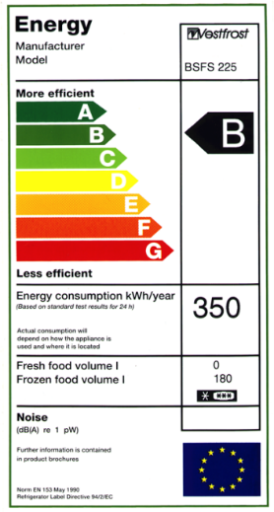 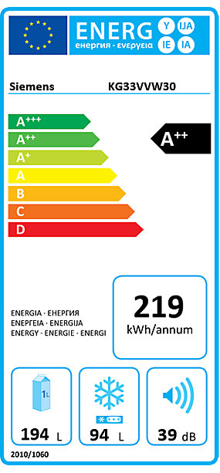

*Figure 1: EU energy label for fridges 1995-2011 (left) and from 2011 (right)*

1. The Ecodesign Directive required the Commission to review its effectiveness and that of its implementing measures by 2012. That review[3] concluded that no immediate revision was necessary and that there was no need for the extension of the scope of the Directive to non-energy related products. The Commission's review proposed that specific aspects of the Ecodesign Directive could be reassessed during the review of the Energy Labelling Directive due in 2014. The 2012 review concluded that special attention should be paid to those aspects that could not be fully assessed such as the efficiency of implementing measures and harmonised standards, and a more close coordination between the implementation of the two Directives.
2. The Energy Labelling Directive requires the Commission to review its effectiveness and that of its delegated acts by 2014. In addition, it also requires the Commission to assess the contribution of the requirement to show the energy class in advertisements to the aim of the Directive, the effectiveness of the public procurement provisions of the Directive[4] and the need for amending the design and content of the label in the light of technical evolution and the understanding by consumers of the label layout. In addition, the Commission decided to examine whether the current modalities need to be adapted to deliver its objectives in a less intrusive way[5].
3. A joint ex-post evaluation addressing all key aspects of the two Directives makes sense as the effects of ecodesign implementing regulations and energy labelling delegated regulations applicable to the same energy-related products are often linked and complementary.

Relevance

1. The objectives of the Energy Labelling and Ecodesign Directives are threefold:

* Increasing energy efficiency and the level of protection of the environment
* Providing consumers with information that allows them to choose more efficient products
* Ensuring the free movement of energy-related products in the European Union

1. These objectives remain as relevant as they were more than 20 years ago. In the context of establishing the Single Market by 1992, a common energy labelling scheme was agreed in that year. From 1995 onwards the energy label was implemented for washing machines, tumble driers, washer-driers, dishwashers, refrigerators and freezers, electric ovens, air conditioners and lamps. Minimum energy efficiency requirements for new boilers were introduced in 1992. This was followed in subsequent years by requirements for refrigerators and freezers and for ballasts for fluorescent lighting. The adoption of the Eco-design Directive in 2005 provided the framework to ensure EU harmonised energy efficiency requirements for a broad range of product groups; at present more than 20. In addition, along with the implementation of the Ecodesign Directive, energy labels were developed for additional products such as televisions and heating equipment.

## *Energy efficiency and protection of the environment*

1. Increasing energy efficiency is even more relevant than it was 20 years ago. The European Union is facing unprecedented challenges resulting from increased dependence on energy imports and scarce energy resources, and the need to limit climate change and to overcome the economic crisis. Energy efficiency plays an important role in addressing these challenges. It improves the European Union’s security of supply by reducing primary energy consumption and decreasing energy imports. It helps to reduce greenhouse gas emissions in a cost-effective way, thereby mitigating climate change. Shifting to a more energy-efficient economy should also accelerate the spread of innovative technological solutions and improve the competitiveness of industry in the European Union, boosting economic growth and creating high quality jobs in several sectors related to energy efficiency.
2. In 2007, the European Council made energy efficiency a core part of its 2020 strategy[6] with a 20% energy efficiency target by 2020, the achievement of which was the key driver for the establishment of the Energy Efficiency Directive[7]. The Juncker Commission has made a resilient Energy Union with a forward-looking climate change policy one of its ten priorities, which includes significantly enhancing energy efficiency beyond the 2020 objective[8]. In October 2014 the European Council set an indicative target at the EU level of at least 27% for improving energy efficiency in 2030. This will be reviewed by 2020, having in mind an EU level of 30%[9]. The Commission's vision for an Energy Union recognises that the EU has put in place the world's leading set of measures to become more efficient in our energy consumption through energy labelling and ecodesign legislation[10].
3. The objective to address other environmental aspects of products has gained in relevance compared to 20 years ago. Eco-industries and eco-innovation currently supply a third of the global market for green technologies, worth a trillion euros and expected to double by 2020. The Juncker Commission made a commitment to a revised proposal for the circular economy that will reinforce this trend thus contributing to green growth.

## *Consumers*

1. Providing consumers with information that allows them to choose more efficient products remains relevant. Four out of 10 people say that the environmental impact of a product or service influences their purchasing decision[11]. Energy-related performance is a top level concern for consumers, often the most frequently mentioned purchasing consideration (along with price) more than twice as frequently as appliance brand[12]. European consumers trust the energy label and usually take it into account when they buy electrical household appliances[13].
2. The media through which consumers search for information has changed over the last 20 years. There is an overall trend towards buying products, including energy-related appliances, on the internet. In addition, increasing proportions of purchasers seek information online before they buy a product in a shop. The opposite phenomenon also exists i.e. purchasers browsing in the physical world but buying online, still relatively marginal in the European Union, though more pronounced in the US[14]. The Ecodesign and Energy Labelling frameworks have the necessary flexibility to be able to adapt to such developments: the energy labelling regulations have recently been adapted to ensure that the energy label is shown on the internet[15].

## *Free movement*

1. The principle of free movement of goods is one of the cornerstones of the European Union. The Juncker Commission made it one of its ten priorities to complete the internal market in products and services and make it the launch pad for our companies and industry to thrive in the global economy[16]. The free movement of goods is the most highly developed of the four ‘freedoms’ that make up the single market[17]. Around 75% of intra-EU trade is in goods. In today’s single market for goods, it is easy to buy and sell products in 28 Member States with a total population of more than 500 million. Consumers have a wide choice and are able to shop around for the best offers. The free movement of goods is also vital to the success of thousands of EU businesses[18]. The GDP increase that can be attributed to the Single Market equates to almost €1200 extra yearly income per EU household[19].
2. There is free movement of goods in the European Union because, for most products, the European Union has managed to agree on the extent to which we should protect at European Union level various public interests that could otherwise be invoked by Member States to justify barriers to goods entering (or leaving) their territories. So-called ‘harmonisation legislation’ such as Ecodesign and Energy Labelling specifies requirements that products must meet to benefit from free movement.

Effectiveness

1. The evaluation of the effectiveness of the policy framework has revealed that its objectives have been achieved. Nevertheless, the introduction of A+ and higher classes on the energy label during the last review of the Directive in 2010 have reduced the effectiveness of the label for consumers and there is untapped potential for energy savings and reducing other environmental impacts[20].
2. To date 24 ecodesign implementing regulations have been put in place. Products covered range from household appliances, such as fridges, lamps and vacuum cleaners, to professional and industrial equipment, such as electric motors, power transformers and fans. Two further products groups, i.e. imaging equipment and complex set-top boxes, are covered by voluntary industry agreements endorsed by the Commission. In addition, 13 delegated regulations on energy labelling now ensure that a range of mostly consumer products must be sold with an EU energy label attached. For the majority of product groups there is a strong consensus on the appropriateness of the measures.[21]
3. The energy efficiency of the regulated products has increased. The effectiveness of the policy is illustrated by the transformation of the market shown for a number of product groups in figure 2 and 3 below. It is possible that the energy efficiency improvement is in part due to other factors such as ongoing market trends in energy efficiency improvement independently of the policy. No ex-post counterfactual data is available to assess this. It is likely, however, that a significant part of the energy efficiency improvement is due to the Directives: e.g. for vacuum cleaners, a product that was until recently not regulated by ecodesign or energy labelling, energy use was, in absence of regulation, increasing rather than decreasing[22].

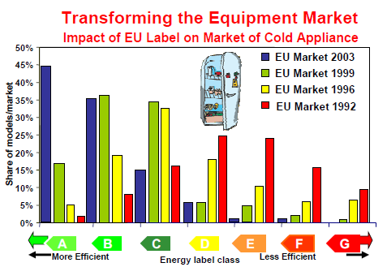

*Figure 2: Transformation of the EU Market for refrigerators and freezers 1992-2003[23]*

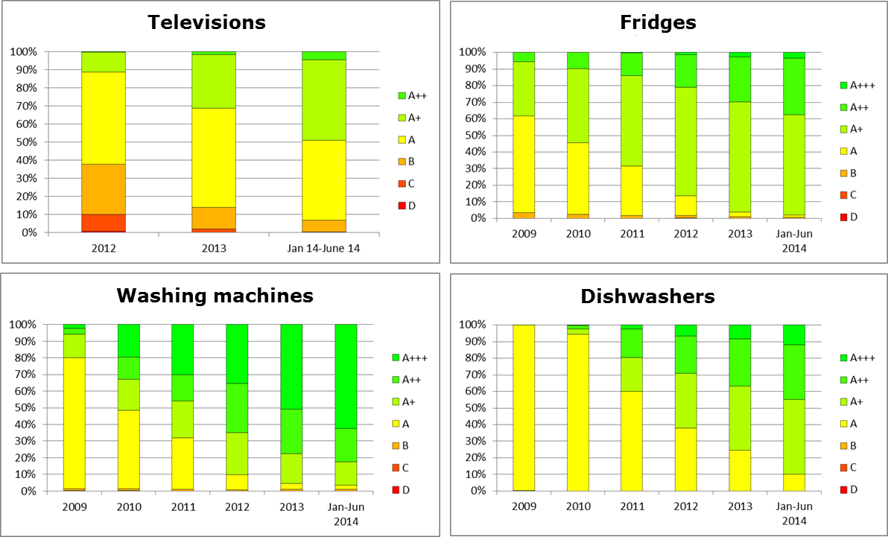

*Figure 3: Transformation of the market for selected appliances (2009-2014, for Belgium)[24]*

1. In terms of energy savings, the ecodesign and energy labelling measures in place to date and soon to be adopted are estimated to save 175 Mtoe primary energy per year by 2020[25]. This corresponds to 19% savings with respect to business-as-usual energy use scenario for those products. As such, these policies will deliver almost half of the 20% energy efficiency target by 2020.
2. The Directives have helped consumers to lower their utility bills compared to what they would have been in their absence. The number of household appliances in the EU has risen by a quarter in the past ten years, but household electricity use has been flat[26]. In total, the ecodesign and energy labelling measures in place to date are estimated to save end-users of products 100 billion euro per year in 2020[27], which is approximately 465 euro per household per year. Reinvesting these savings in other sectors of the economy would result in the creation of a significant number of jobs. Dependency on imports of energy would be reduced by 23% and 37% for natural gas and coal, respectively[28].
3. There is still untapped potential from regulating further product groups[29] and from revising existing measures[30], although 80-90% of final energy consumption in the form of electricity and heat (excluding transport) comes from products already dealt with by ecodesign and energy labelling regulations or covered by preparatory studies for such regulations[31].
4. The achievement of the full savings potential of this policy has been reduced because of several factors. Firstly, following the introduction of A+ and higher classes, labels have become less effective in persuading consumers to buy more efficient products. Secondly, non-compliance with ecodesign and labelling requirements, in part related to weak enforcement by national market surveillance authorities, is estimated to reduce the energy savings by 10%. Thirdly, while for some product groups the minimum requirements and labels have shown the right level of ambition, for other product groups the ambition levels are lower than what is technically and economically feasible. Fourth, the rulemaking process is long, sometimes resulting in outdated technical and preparatory work at the time of policy decisions; and finally there is a trend towards larger products, which tend to be relatively more efficient than smaller products and thus achieve a high energy class, but nevertheless have a higher absolute consumption than smaller appliances of the same type.

## *The energy label*

1. There is strong evidence that consumers respond positively to informative energy labels using a comparative scale with multiple performance thresholds showing that, for the same level of service, certain products consume more energy than others. The majority of consumers recognise, understand and use the energy label in their purchasing decisions[32]. The EU energy label has raised the profile and importance of energy efficiency as a product feature and through successfully overcoming information barriers has made energy efficiency matter to consumers for the majority of labelled products. In so doing it has also become a widely recognised brand for energy efficiency. The recipe for this success has been the universal application of a label design that is easy to understand at a glance, presents information that is salient to and trusted by consumers and can be retained throughout the purchasing process so that it actively affects product purchase decisions.
2. One of the key reasons for the success of the EU energy label is that it uses mnemonics[33] to convey and reinforce the energy efficiency ranking of labelled products. The most obvious mnemonic used is the letter to indicate the energy efficiency class but this is reinforced by the colour scale of the classes in the efficiency scale. Lastly, the arrows in the efficiency scale itself, which are stacked in order of length from short (denoting low energy consumption) to long (denoting high energy consumption) constitute a third and more subtle set of reinforcing mnemonics. Thus, the A to G of the letter scale reinforces the green to red colour scale that is reinforced by the length of the stacked arrows. Collectively, this set of reinforcing mnemonics enables the easy visual identification of the efficiency of the product in question and contextualises it against a broader efficiency scale, so it is clear where the highest and lowest part of the scale are and where the efficiency of the specific labelled product is positioned on the scale. Lastly, the mnemonics are essential in aiding memory so that consumers are readily able to remember the efficiency of products they have previously seen and keep that information in mind as they consider which product to purchase.[34]
3. After 20 years of energy labelling in Europe the energy label still functions broadly as originally intended. However, the design amendment that uses additional plusses to indicate higher efficiency classes beyond the A class is less effective in motivating the purchase of higher efficiency products than the original A to G scale. While consumer research shows that the new label scale is understandable for consumers, it has reduced their willingness to purchase more for more efficient products, because they are less motivated by a difference between A+ and A+++ than by a difference between C and A[35].
4. A key challenge is how best to address the need to modify the label to take account of the concentration of products into the higher efficiency classes of the product groups that have been subject to labelling for a number of years. Whenever concentration in the top classes occurs or new products are available that have a significantly higher efficiency than the current top efficiency threshold, it is appropriate to revise the label to increase the spread in product efficiency among label classes to ensure that the most efficient products are clearly differentiated from other products on the label. Since the 2010 review of the energy labelling Directive, this issue has been addressed by adding new classes above the A class (the A+, A++ and A+++ classes). However, these new classes have been contentious due to concerns that they weaken the label’s effectiveness and there is general agreement among all stakeholders that for this reason it is not desirable to add further + classes on top of the current A+++ class[36].
5. The EU energy label is well known among European consumers and as such can be considered a high profile brand. This brand has been built up over many years and has considerable recognition value in its current form. Therefore, it is important for any design changes to be incremental rather than introduce a completely new concept. With regard to concepts using numeric scales, there is evidence such labels lead to more consumers choosing less energy efficient products than with alphabetic scales[37]. Further, the effect of the requirement for advertisements to contain a reference to the energy class could not be quantified[38], but it does address an information failure in the market[39].
6. Beyond consumers' understanding of the label layout, other issues have been noted by stakeholders as potentially weakening the label's impact. One of them is the technical complexity that underpins the label and notably the calculation of the energy efficiency index. The current use of linear formulae for most labels may favour large appliances resulting in better energy efficiency classifications than for smaller products despite a higher absolute energy consumption. Many consumers also have difficulty understanding the meaning of certain icons present in the label giving information on other aspects of the product, for example the 'switch logo' on the television label and the drying efficiency on the dishwasher label[40].

## *Product-specific regulations and voluntary agreements*

1. For a number of product groups the ambition level of the regulations is considered appropriate compared to what is technically and economically feasible. This is the case e.g. for boilers, standby and off-mode requirements, external power supplies, circulators in buildings and simple set-top boxes. For a number of other product groups there is disagreement among stakeholders and experts on whether the ambition level of the regulations is appropriate or too low. At least for computers and televisions, it seems clear that the level of ambition of the regulations is too low compared to what is technically and economically feasible. It was found that a low level of ambition is often related to the problem of limited and outdated data. The requirement in the Ecodesign Directive of aiming to set requirements at the least life cycle cost[41] also poses problems in some cases. This criterion assumes that more efficient products have increased investment cost and decreased cost of operation (namely energy cost). However, for e.g. electronic products there is not always a clear relationship between purchase price and efficiency.
2. The two existing voluntary agreements, for imaging equipment and for complex set-top boxes, are considered to have an ambition level that is too low compared to what is technically and economically feasible. For voluntary agreements, the Ecodesign Directive does not prescribe a reference level for requirements, but merely indicates that they need to have added value compared to business as usual. However, the low level of ambition in the voluntary agreement does not necessarily mean that a regulation for these specific product groups would have achieved higher energy savings. The features and performance of these products change so fast that regulation could have difficulties to follow these fast technological trends. Further, the voluntary agreement on complex set-top boxes is not restricted to manufacturers, but other important market players such as service providers, component manufacturers and software providers can subscribe as well. This is a different approach than in most product legislation and is an important feature of this voluntary agreement, as software is an influential factor in the energy consumption of a complex set-top box and service providers determine the software on the box. Energy savings in software may, therefore, have offset the low level of ambition in relation to hardware.
3. Experience to date with voluntary agreements has shown that they can work effectively when "inclusion" of a broad part of the market sector is possible, whilst "non-inclusion" of certain industry actors or groups has been the cause of opposition by stakeholders because of market distortion, unfair competition or missing out on the full savings potential. In addition, openness and transparency is crucial: citing company confidentiality as an argument for not disclosing information such as sales numbers can make it impossible for independent entities to monitor the agreement. The Commission is in the process of developing guidelines for voluntary agreements. The Ecodesign Consultation Forum endorsed in June 2014 an approach that voluntary agreements should cover at least 80% of the market share of a product category and that at least 90% of all product models of each signatory of the voluntary agreement comply with its requirements, with an incentive to increase this to 100%[42].

## *Compliance and enforcement*

1. It is estimated that 10-25% of products on the market are non-compliant with ecodesign and energy labelling requirements and that around 10% of envisaged energy savings are being lost due to non-compliance[43]. In absolute terms, this means about 17 Mtoe primary energy per year.
2. Kitchen specialist shops, furniture shops and large supermarkets are among the shop types with the lowest level of proper label display. Furthermore, internet shops, whose market shares are increasing, often do not display some of the required information. As for product types, wine storage appliances, air-conditioners, and electric ovens have the lowest degree of proper label display.
3. Expenditure by Member States on market surveillance is estimated to be around € 10 million per year. Almost all Member States perform product documentation checks and inspection of display of labels in shops. Nevertheless, for some years, a few Member States reported that they had no market surveillance activity. The number of Member States without activity decreased from 4-5 in the years 2009/2010 to none in 2013. In some cases Member States only acted upon receipt of complaints, while others had an active programme involving random and/or targeted checks. In general, the combined market surveillance activities of the Member States increased significantly between 2009 and 2013. However, the level of market surveillance started from a low base and the number of ecodesign and energy labelling regulations increased during those years[44].
4. Industry has contributed to market surveillance, notably through participation in projects funded by the Commission, such as 'Athlete'[45]. This has contributed to improved capacities of market surveillance authorities with regard to testing procedures for ecodesign and energy labelling. The capacity needs of market surveillance authorities have now shifted to better cooperation between authorities and exchanging good practices, such as explored in the 'Ecopliant' project[46].
5. There are administrative and legal barriers for market surveillance of ecodesign and energy labelling. Firstly, lack of staff is a consequence of the lack of financial resources and different policy priorities. Secondly, unclear formulations in legal texts (e.g. apparent differences between the Energy Labelling Directive and its delegated acts concerning the way the product fiche has to be made available). Thirdly, there is no benchmark on what is considered appropriate market surveillance. Fourth, a specific obstacle concerns the ability to contact foreign entities, including the identification of the manufacturer placing the products on the EU market. Finally, there is no independent evaluation of manufacturer claims about products as exists in some other sectors where manufacturers are required to do a third party certification on their products.

## *Non-energy environmental impacts*

1. For environmental aspects other than energy consumption there has been less impact so far, because most of such ecodesign requirements were introduced more recently and do not yet apply and such requirements have not been introduced as systematically as energy efficiency requirements. The exception is water consumption, which has been addressed by the energy label for washing machines since 1996, by the energy label for dishwashers since 1999, and by an ecodesign requirement for washing machines since 2011. For both washing machines and dishwashers the water consumption per cycle more than halved over the last ten years[47].
2. Regulations to date have mainly addressed the energy consumption in the use-phase, as this represents, to varying degrees, the most important contribution to the environmental impacts of energy-related products. Nevertheless, there is a potential for further reduction of other environmental impacts in energy-related products, which has been identified in several studies, e.g. on aspects of reusability, recyclability, recycled content, hazardous substances, emissions in use, and durability/reparability. Some product-specific ecodesign regulations contain requirements on such aspects, such as emission requirements for solid fuel boilers and solid fuel local space heaters and durability requirements for lamps and vacuum cleaners.[48]
3. An additional reason why other environmental impacts of products have been addressed to a lesser extent than energy impacts is because the Ecodesign Directive covers only energy-related products. For other products, non-energy environmental impacts are more dominant. Due to the nature of the current scope of products covered, the MEErP methodology focuses mainly on technological aspects of the product itself, which in the case of non-energy-related products are often not the cause for environmental impact or a basis for improvement, since impacts occur at the stage of resource extraction, during production or at the end-of-life stage. Since these impacts are not measurable on the product itself, conformity with any ecodesign requirements would have to rely on the provision of information by suppliers to ensure that products comply with set specifications. The information (and certification) requirements would have to be based on environmental impact analysis and assessment, continuous measurement, targets, and monitoring procedures for each step in the supply chain. The on-going EU Product Environmental Footprint pilot phase[49] is currently testing verification approaches for embedded impacts to identify a method that balances reliability and feasibility. The testing should be finalised in 2016 after which the Commission will evaluate progress before deciding on the way forward[50].

## *Free movement*

1. Ensuring free movement is one of the two objectives of the Ecodesign Directive (alongside environmental protection). It is also manifest from its internal market harmonisation legal basis and its specific provisions to Member States with regard to free movement.
2. Since 2010, the Energy Labelling Directive has energy rather than internal market harmonisation as legal basis. Nevertheless, it harmonises energy labels and their application across the EU through its delegated regulations. Only complementary policies such as information campaigns to inform consumers about new labels and additional incentives for energy-related products are implemented differently from Member State to Member State.
3. None of the two Directives has caused any obstacles to the free movement of energy-related products in the European Union.

## *Other effects*

1. In the course of 2014, ecodesign became the subject of a certain amount of negative media attention, notably in the United Kingdom, Germany and Austria, which led to a negative perception of the policy by a certain share of the public and some policymakers[51]. By its very nature the energy label is intended to attract consumers and guide their decision making. It is in fact appreciated as such by the large majority of consumers who recognise and use it for their purchasing decisions. With regard to ecodesign, the media have claimed that it limits consumer choice and regulates energy consumption at the expense of performance of appliances.
2. However, as intended, the Energy Labelling and Ecodesign have had little perceived or real impact on overall market sizes, overall market structure, or overall product choices. Although ecodesign bans the least efficient products from the EU market, this has not had a negative effect on the availability of a wide range of products across different price ranges. Even the higher purchase prices (which are offset by savings on the energy bill) are hardly noticeable to consumers: the impact of Energy Labelling and Ecodesign on prices is understood to be low and they have not affected the long-term downward trend of prices, with the exception of lighting and circulators.[52]
3. The perceived trade-off between energy efficiency and performance reported by some media is not based on facts. Only in the case of the ban of certain light bulbs in the early years of the policy could the speed of the implementation of the bans (as a result of political demand from the Member States) have (temporarily) affected performance since alternative technologies were not yet fully mature. This perceived trade-off was raised again by some media in the case of regulations for vacuum cleaners and ovens[53] even though industry and other experts claim that such trade-offs are non-existent or minimal. In the case of vacuum cleaners functionality is explicitly addressed through minimum performance requirements in the legislation. This has also made it clear that the benefits of the policy have not been sufficiently communicated.

Efficiency

1. In general, the benefits from Energy Labelling and Ecodesign outweigh costs, both for businesses and for society as a whole. While the cost of requirements and labelling will fall on manufacturers in the first instance, these are then passed on to end-users (households and other businesses) who benefit from cost savings that considerably outweigh the upfront costs. In total, the ecodesign and energy labelling measures in place to date are estimated to save end-users of products 100 billion euro per year in 2020[54].
2. Regarding the level of production costs and the improvement of profit margins for manufacturers the evidence is inconclusive. For energy labels, however, it is important to appreciate that the response of manufacturers is as important as the response of consumers. Although the application of the label is mandatory there is no obligation for manufacturers to improve the efficiency of their products in response to this requirement. However, there is strong evidence that manufacturers have reacted positively to the EU energy labels and have voluntary embraced them as an important feature which can differentiate their products. This suggests that the extra investment needed to achieve higher efficiency levels has generally been outweighed by the benefits.[55]
3. Actual data for the EU as a whole are not available, but for the UK the benefit to cost ratio was estimated at 3.8 (compared to an average of 3.0 for a range of 17 environmental policies)[56] for the regulations in place in 2012 and there are no indications why the benefit to cost ratio would be substantially different in other Member States. The ratio includes the costs for manufacturers of producing labels and meeting the requirements, the costs for enforcement and the financial savings to final consumers from reduced energy consumption. It does not include benefits that are hard to quantify, such as the higher profit margins on more expensive efficient products, the stimulation of innovation, the contribution to energy security, and removing competition from poor quality cheap products from the market through a level playing field.
4. Ecodesign and Energy Labelling have an impact on innovation, but this it difficult to attribute and quantify, as it does not show up clearly in patent statistics and firms do not strongly attribute their innovation activities to the legislation[57]. What is clear is that the regulations are one of the main drivers for innovation, alongside consumer demand and competitive position. The balance between requirements being set at an ambitious but not over ambitious level is important to stretch but not overstretch firms. SMEs may benefit from new niche markets, e.g. for LEDs, although the opposite is also true for SMEs, in cases where lower capacities and resources for innovation see them left behind. SMEs typically have more limited technical and financial capacity to comply with the regulations, which is a risk, and some evidence of market concentration suggests that in some product groups these constraints are adversely affecting SMEs.
5. Ecodesign and Energy Labelling apply also to micro-enterprises. For energy labelling, the affected retailers (that have to ensure the label is applied to the product) include micro-enterprises, which cannot be exempted as energy labels are only useful for consumers if all products are labelled in all retail outlets. The sectors concerned include few or no micro-enterprises manufacturers, but those that do exist need to be treated in the same way as other manufactures for the same reason as given for retailers and to ensure fair competition in the single market where it concerns ecodesign requirements.
6. The position of SMEs and microenterprises is considered in the legislation, but in different ways than through exemptions based on company sizes. Firstly, the Ecodesign Directive mainly considers as candidates for potential regulation products that are usually mass-manufactured: this follows from its requirement that the products to be regulated should represent a significant volume of sales, indicatively 200.000 units per year within the European Union. In addition, a number of regulations also make exceptions for subcategories of products that have low sale volumes, where such exceptions are not expected to be exploited as loopholes to the regulations. Furthermore, as required by the Ecodesign Directive, implementing dates for regulations take into account possible impacts on SMEs.
7. For voluntary agreements, one advantage that is generally emphasised is that such agreements are likely to deliver the policy objectives in a less costly manner than mandatory requirements. However, no systematic data is available on their benefit to cost ratio. Nevertheless, their benefits are expected to be less than for regulations, based on the fact that, as referred to earlier, the two existing voluntary agreements are considered to have an ambition level that is too low compared to what is technically and economically feasible. The costs are also expected to be less that for regulations given that administrative and procedural requirements are less. However, there are additional costs for industry compared to regulation in terms of having to arrange independent verification of compliance, whereas regulations are subject to market surveillance by the Member States, who usually bear the cost for that.

## *Regulatory process*

1. The entire ecodesign/energy labelling regulatory process should normally take 41 months from the start of the preparatory study to the publication of the implementing measures in the Official Journal (see annex for details on the process). In practice though, the regulatory process took on average 49 months until 2012, with a number of regulations that had been in the process for years not yet being finished. The number of regulations adopted each year has increased in recent years and included a few difficult ones such as those on space and water heaters or on directional lamps and luminaires.
2. Delays in the process have been connected with several issues. Firstly, the quality of the preparatory study and availability of sufficient quality data. Secondly, a gap of, on average, 10 months between the publication of the preparatory study and the Consultation Forum meeting. Thirdly, the technical complexity of some of the products. Fourth, contentiousness for some of the products for which stakeholder involvement can lead to conflicts that practically grind the process to a halt. The last steps before adoption are straightforward, and should be fairly quick compared to the preparatory phase. However, experience shows that the adoption of a measure can sometimes take a long time.
3. Harmonised standards play a key role in the process. Due to the so-called 'New Approach' for EU product legislation applied from 1986, under EU Ecodesign and Energy Labelling the development of test procedures is mandated to the European standardisation organisations resulting in harmonized European Standards. Where they exist, standards make an important contribution to the success of the regulations. Problems tend to arise when they do not exist or are still under development, in which case this is an important obstacle to the smooth drafting and adoption of regulations.[58]
4. For voluntary agreements, one advantage that is generally emphasised is that such agreements are likely to deliver the policy objectives faster than the mandatory requirements. Voluntary agreements tend to be proposed for complex products with fast technological development, so that the technology and market change can be reflected in an updated version of the voluntary agreement. However, in practice, voluntary agreement processes are not necessarily fast: they also require an impact assessment, inter-service consultation and a formal decision from the Commission, which puts the presumption of a more efficient process into question.
5. Stakeholder input and involvement is considered to be of great value to the process, for information, discussion and creation of a broad base of support for a measure. There is a trade-off: the transparency and inclusiveness of the process also contributes to its length. Official stakeholder involvement is scheduled to take place multiple times and in practice there are many more moments of stakeholder involvement, such as through bilateral discussions between stakeholders or between stakeholders and the Commission or consultant, and through position papers from stakeholders. A significant majority of non-governmental stakeholders (industry, retailers/ distributors, environmental and consumer organisations) in the Ecodesign and Energy Labelling process see no need for changing stakeholder involvement in the process. The main reason for dissatisfaction with the energy labelling regulations process for Member State is that they do not have a formal vote in the adoption process, as they currently still have for ecodesign regulations. This is a consequence of the provisions of the Lisbon Treaty on delegated and implementing acts.
6. Another factor relevant to assess the efficiency of the regulatory process is that for the size of its economy the EU commits substantially less resources to support its programme than other economies, as shown in figure 4. It is interesting to note that the US expenditure is roughly 10 times that of the EU despite both having similar sized economies and similar magnitudes of benefits to achieve from optimising their equipment energy efficiency programmes. The estimated person-hours per year for development of the Chinese programme are over twice those of the EUʼs. The Japanese and Australian programmes have the lowest person hours committed for administration. However, the total Australian effort when consultants are added is roughly equivalent to that in the EU despite having a population of only 1/25th of the EUʼs and a much smaller economy. The total Japanese effort is not available.[59]

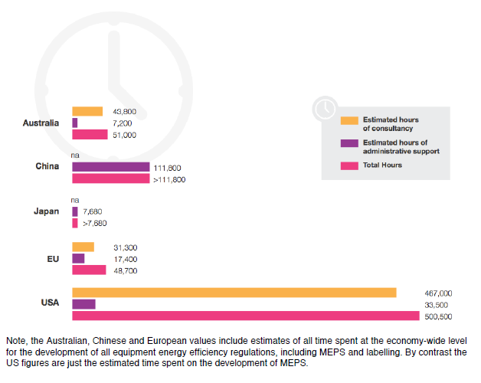

*Figure 4: Administrative and technical support for the development and administration of equipment energy efficiency regulations by peer economy–estimated hours per year. 'na' refers to 'not available', 'MEPS' refers to minimum efficiency requirements [60]*

EU-added value

1. An EU harmonised regulatory framework rather than having rules at Member State level brings down costs for manufacturers. Regulating at EU level has ensured energy efficiency of products, while preventing that this could otherwise be invoked by Member States to justify barriers to goods entering (or leaving) their territories. Since the Single Market became a reality in 1993, intra-EU trade in goods has grown as a share of GDP by around 5 percentage points. Intra-EU trade represented around 17% of EU GDP in 1999 and close to 22% in 2011. Furthermore, intra-EU trade represents a very high percentage of GDP in most Member States. Better access to the internal market and global markets has led to greater economies of scale and scope and thus enhanced firm-level competitiveness and cost efficiencies through regulatory and product convergence at European level and, to some extent, also globally.[61] Consumers also benefit from lower prices due to EU-wide competition. The GDP increase that can be attributed to the Single Market equates to almost €1200 extra yearly income per EU household.[62]
2. Prior to the establishment of certain ecodesign and energy labelling regulations at EU level, Member States imposed national obligations on business in the interests of energy efficiency and consumer protection. For example, in 1990, 9 of the 12 Member States of the EU had diverging mandatory minimum requirements in place for the efficiency of hot-water boilers for central heating[63]. This meant that there were considerable regulatory barriers to trade for those products because of the different rules and requirements, meaning that businesses had to treat each EU Member State as a separate market and offer different products. Doing business on a cross-border basis in this environment imposed considerable regulatory compliance costs on businesses. The adoption of the first ecodesign-type measure on boiler efficiency in 1992 therefore directly addressed the needs of European industry.
3. Also in 1990, Germany, the Netherlands and the United Kingdom had voluntary energy labelling schemes in place, and Denmark was about to introduce a mandatory one. The Commission decided that that was likely to hinder trade between Member States, asked Denmark to defer its proposal and announced its intention to propose what became the EU's energy labelling directive in 1992[64]. The intention of the Netherlands to introduce minimum energy efficiency requirements on refrigerators in 1992 was similarly deferred by the Commission and led to the EU-wide ecodesign-like regulation for fridges and freezers[65]. French, Italian, Irish and British measures intending to ban incandescent bulbs, as well as a specific request that the European Council addressed to the European Commission[66] (on the initiative of Germany[67], holding the Presidency of the EU at the time), led to the introduction of such a ban at EU level.
4. For other types of energy-related products, no national rules were in place prior to the adoption of ecodesign and energy labelling legislation that addressed regulatory gaps. In these sectors, ecodesign and energy labelling preceded the possible development of national legislation thus preventing the emergence of different national regulations which would otherwise have led to market fragmentation, obstacles to the free movement of products and to higher costs for regulatory compliance. Thereby, they enabled businesses to tap into a larger market for their products, while ensuring high levels of environmental protection. The approximation of product legislation through internal market legislation has been relevant in promoting industrial competitiveness because regulatory convergence at EU level supported by voluntary technical standards, has promoted access to new markets within the internal market and led to fairer competition and a level playing field among economic operators.[68]
5. Union harmonisation legislation also strengthens competitiveness in other ways, e.g. through effects on global regulatory and product convergence, enhanced take-up of innovation and RTD results (through a technology-neutral approach), the promotion of industry consolidation leading to even greater economies of scale with manufacturing firms capable of operating across the internal market and beyond.[69]

Coherence

## *Coherence between Ecodesign and Energy Labelling*

1. The two Directives are complementary and their implementation is largely done in a coherent way. While the Energy Labelling Directive lacks a working plan and a formalised stakeholder forum such as the Consultation Forum under the Ecodesign Directive, in practice ecodesign and energy labelling regulations have always been developed together using the Ecodesign Directive's working plan and stakeholder forum as a basis. So far only in one case was only an energy labelling regulation developed (for updating all energy labelling regulations with regard to the display of the label on the internet), for which the same consultation procedure was applied as for ecodesign. Further, for a number of product groups the ecodesign and energy labelling regulations have in the course of time become incoherent, because further steps of staged bans by ecodesign were put into place while energy labels were unchanged. This means that a number of classes shown on the energy label are unpopulated because of ecodesign legislation; a state of affairs often not known to consumers. In the most extreme cases of washing machines, fridges and dishwashers the energy label currently displays A+++ to D classes, but only A+++, A++ and A+ appliances can still be placed on the market. This is undermining the consumer relevance of the label.
2. In theory, ecodesign and energy labelling could be merged on the grounds that they are thematically closely related and complement each other. This would ensure that definitions, measurement methods, etc. are exactly the same, and would lead to leaner and more transparent decision processes. Also, the labelling of tyres could be integrated into energy labelling, because its aim and appearance of the label are similar. However, such mergers are not so self-evident. Although Ecodesign and Energy Labelling are at first sight quite similar, they partly follow different logics. For example, the Ecodesign Directive includes a conformity assessment and CE marking procedure while the Energy Labelling Directive does not. In addition, the scope is not identical with respect to life cycle phases and environmental aspects. In the end, the question of mergers does not turn out to be decisive. What is important is that existing policies should be coherent, mutually supportive, streamline procedures and methods, and represent a clear task sharing.

## *Coherence with other EU policy*

1. The overall policy framework is coherent and mutually supportive. In general, different policies complement each other by addressing different life cycle stages, impacts, actors, or employing different mechanisms. Still, there can be a lack of policy coherence for specific products or issues, and there may be inefficiencies due to double work in misaligned procedures. In particular, the criteria and requirement levels of different pieces of product legislation (Green Public Procurement, Ecodesign, Energy Labelling, Ecolabel, Energy Star for office equipment) are not fully aligned.
2. Notably there is lack of synergy in measurement methods for certain products. While ecodesign and energy labelling rely on the same measurement methods, other instruments such as green public procurement or the EU Ecolabel, use different methods for some products and parameters. Further, there are possibilities for a more integrated process of developing product specific policy measures. Following the conclusions of the review of the Ecodesign Directive in 2012[70] a pilot project was initiated in which the Commission's Joint Research Centre provides technical support to the policy DG's for a number of products and investigates the possibilities for a more integrated process of developing product specific policy measures. The project's results are not yet available, but it is possible that the conclusions will point to some trade-off: on the one hand developing the preparatory work for all product instruments at the same time could guarantee alignment of measurement methods, save duplicate technical work and reduce the number of consultations and meetings of stakeholders; on the other hand the increased number of variables and dimensions of four or five rather than two policy instruments could lead to longer preparatory and policy processes, leading to lower cumulative energy savings[71].

## *Coherence with international approaches*

1. At least 45 countries outside the European Union have adopted minimum energy efficiency requirements for products and at least 59 non-EU countries use energy labels, as shown in figures 5 and 6. Lighting, heating, air conditioning and refrigeration are the product groups most regulated through such policies around the world. The EU regulations are influential internationally and the EU has an important role in international standardisation and harmonisation efforts. Some countries follow the EU's ecodesign and energy labelling regulations while others use different requirements, testing methods and/or labels. Norway, Iceland and Liechtenstein, as part of the European Economic Area, implement both the EU's ecodesign and energy labelling regulations. Turkey does the same as part of the Customs Union with the European Union. The contracting parties of the Energy Community (Albania, Bosnia and Herzegovina, FYR of Macedonia, Moldova, Montenegro, Serbia and Ukraine; Georgia is candidate member) implement the EU's energy labelling regulations. Some of them also implement ecodesign regulations in the context of association agreements or EU membership negotiations. Further countries implement some or all energy labelling and/or ecodesign regulations, because of their close relationship with the EU market for energy-related products (e.g. Jordan, Switzerland and South Africa).
2. 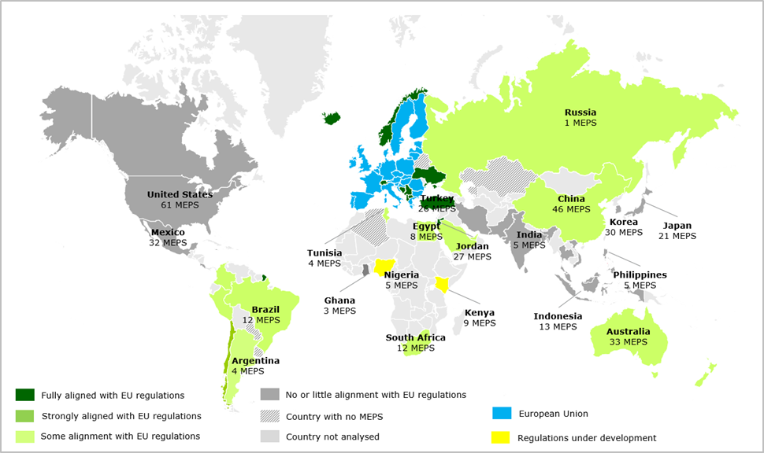

*Figure 5: Countries with minimum efficiency requirements and the degree of alignment with the European Union[72]*

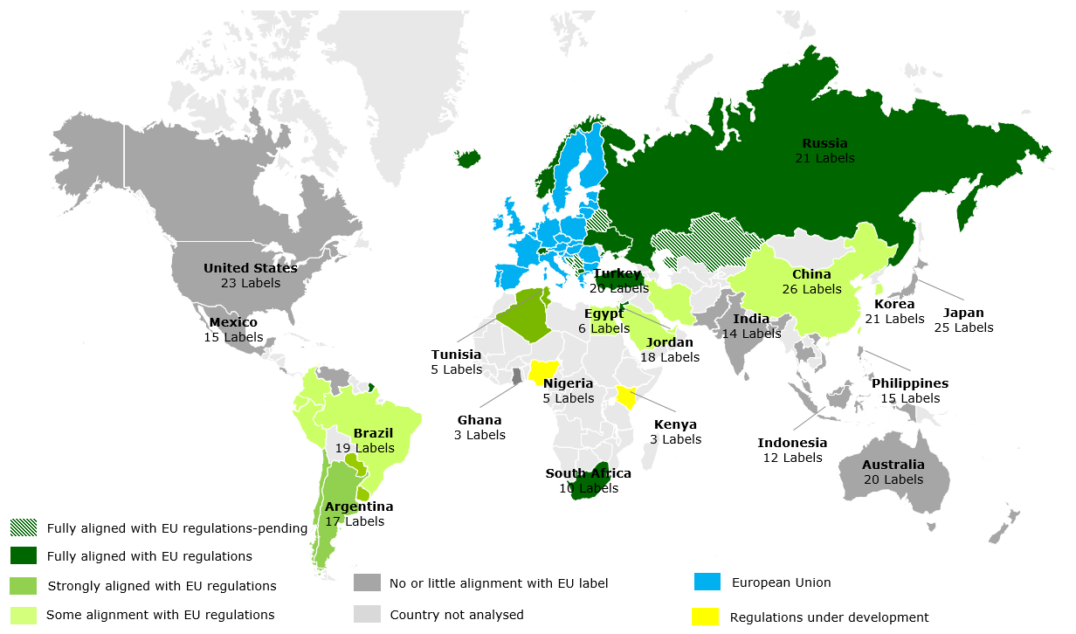

*Figure 6: Countries with energy labels and degree of alignment with the EU label[73]*

1. The system of minimum energy efficiency requirements works in most countries in the same way as in the European Union: if a product does not meet the minimum requirements it cannot be placed on that country's market. The main difference between the EU's ecodesign and other countries' requirements is that in other countries the requirements are normally limited to energy efficiency, whereas ecodesign can also address other significant environmental impacts. The only approach that is distinctively different is that of Japan's Top Runner scheme, which imposes mandatory minimum fleet-average efficiency requirements that producers or importers have to satisfy for regulated products. What this means is that instead of each product having to meet a minimum energy efficiency threshold, the sales-weighted sum of all products that a producer sells in a specific target year has to meet the specified Top Runner minimum energy efficiency threshold. The threshold is in principle set at the most efficient product at the time of market analysis, though products with particularly high price or using patented technology are excluded from that analysis. The target year is set 3 to 10 years ahead. In practice, the rate of improvement of products in terms of energy efficiency due to Top Runner is in the same range as for ecodesign. Regarding the interest of some European stakeholders in a Top Runner scheme it seems that the appeal of the Top Runner approach is to a large degree conceptual and to a certain extent even more based on an ideal picture than on facts. Most of the 'top runner' characteristics can also be found in the Ecodesign Directive.[74]
2. The system of energy labels works in most countries in the same way as in the European Union: all products offered for sale have to bear an energy label that includes a comparative scale allowing consumers to choose more efficient products. More than 30 countries have adopted energy labels that fully or partially emulate the EU label design. The alphabetic label layout with coloured arrows is followed in Algeria, Argentina, Brazil, Chile, Colombia, Egypt, Iran, Israel, Jordan, Norway, Peru, Russia, South Africa, Switzerland, Turkey, Ukraine and Uruguay though without the A+ classes. Other jurisdictions use numbers (China, Taiwan, Thailand, Tunisia and South Korea), star ratings (Australia, Bangladesh, Costa Rica, Ghana, India, Indonesia, Japan, Kenya, Malaysia, New Zealand, Saudi Arabia, Sri Lanka, United Arab Emirates and Vietnam), or indicate on a horizontal scale the estimated yearly energy or operating cost (Canada, Mexico and the US)[75]. Some jurisdictions also apply endorsement labels that can be used on a voluntary basis for the best-performing products. An example is the US Energy Star label, which is also used in the European Union for office equipment based on an agreement between the EU and the US government[76].

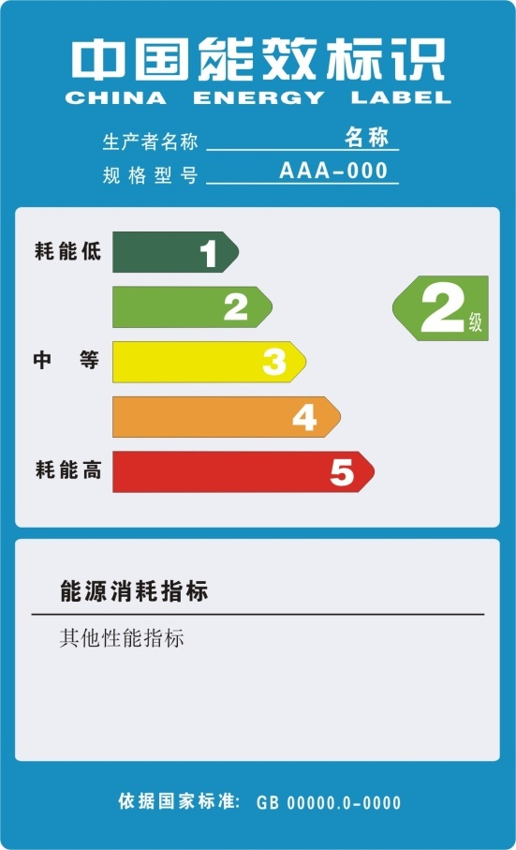 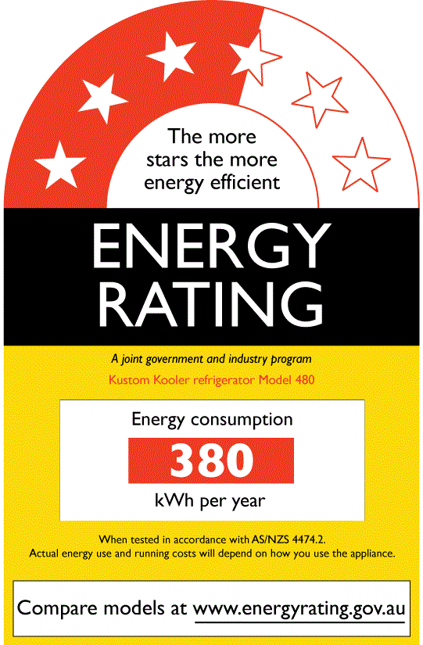

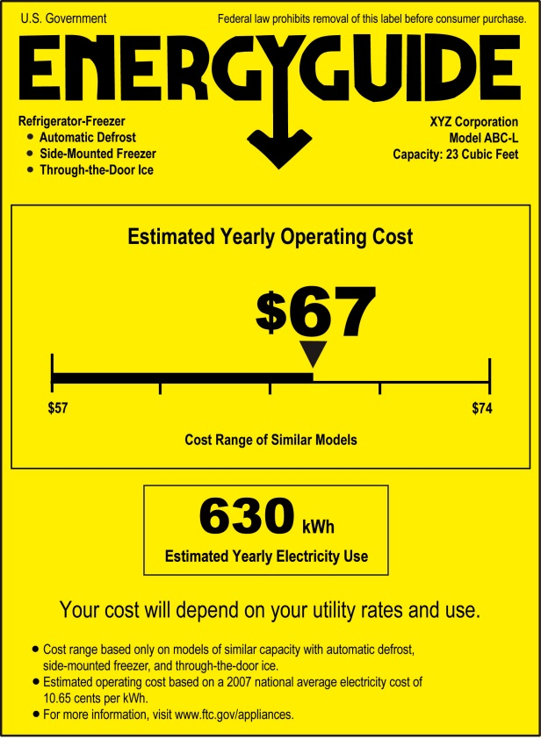 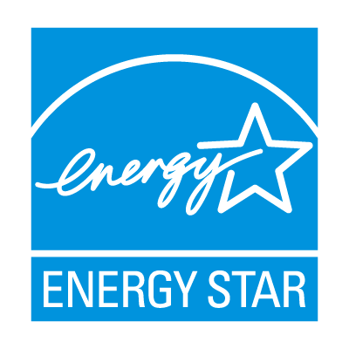

*Figure 7: Chinese label (top, left), Australian label (top, right), US comparative label (bottom, left) and US Energy Star label (bottom, right). The EU Energy Label is shown in figure 1.*

1. The EU and the US are the world leaders in the development of minimum energy efficiency requirements and energy labelling. Perhaps surprisingly, the EU leads in the number of minimum energy efficiency requirements, whereas the US has more energy labels than the EU, see figure 8. This is a reversal of earlier years in which the EU relied more on energy labels and the US relied more on minimum energy efficiency requirements. It should be noted however that most US labels are voluntary Energy Star endorsement labels, whereas most EU labels are mandatory comparative energy labels. The EU regulations tend to be more ambitious (see figure 9). The EU typically tackles products that have not previously been regulated elsewhere, thus setting an international benchmark for testing and evaluating efficiency for those products, which is later adopted by other economies. A similar process applies to the US, although probably limited to ICT products, for which US Energy Star specifications seem to set the example for how to measure and rank energy performance.[77]

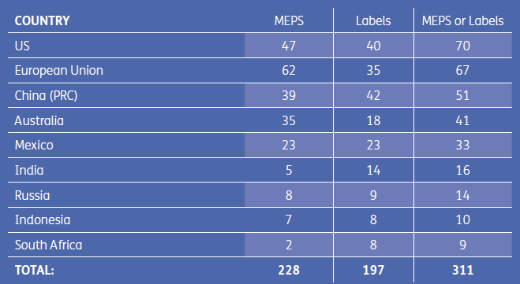

*Figure 8: Number of product groups regulated by minimum energy efficiency requirements ("MEPS") and/or labels. Note that the EU numbers do not correspond to number of regulations, because product groups were categorised differently for the purpose of international comparison.[78]*

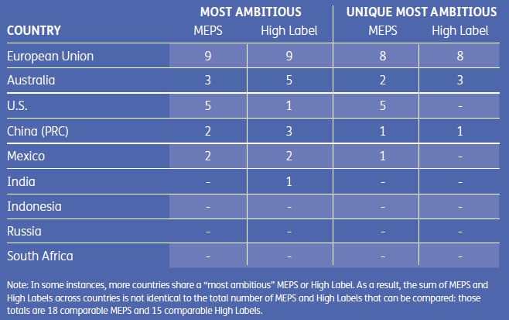

*Figure 9: Most ambitious minimum energy efficiency requirements ("MEPS") and/or labels for each product group categorised by country.[79]*

1. The alignment of test procedures in the world is greater than that of the minimum requirement and the labels themselves, as shown in figure 10. Test procedures describe how the energy consumption/efficiency of a product should be determined. For a number of products test procedures are well-aligned world-wide, with the highest alignment for lighting, consumer electronics/ICT products and motors/pumps/fans. Standard 60034-2-1 of the International Electrotechnical Commission concerning test procedures for motors is an example of a successful, though slow and resource intensive process, to align testing procedures across the globe[80]. The European Union scores high on alignment of test procedures with other economies, as shown in figure 11. This is because test procedures for ecodesign and energy labelling usually rely on international standards, where available.

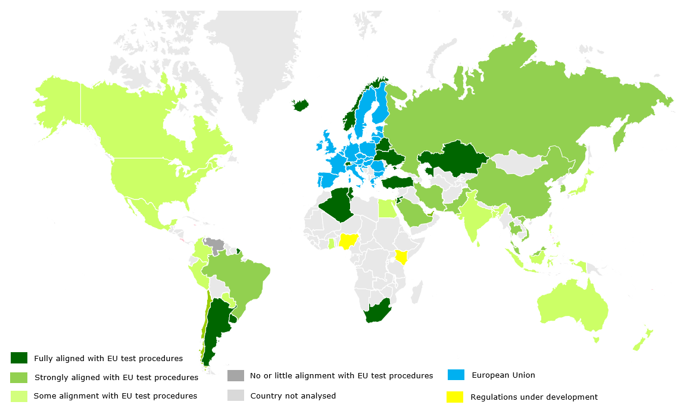

*Figure 10: Similarities with EU test procedures[81]*

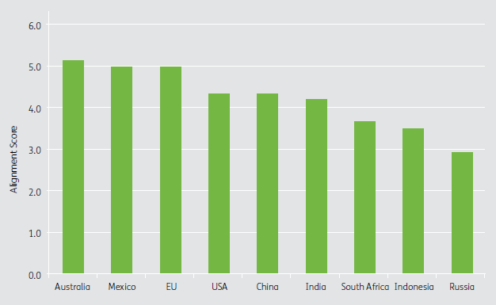

*Figure 11: CLASP alignment score for test procedures and energy efficiency metrics (higher score is more alignment with other economies)[82]*

1. The EU's approach of relying on international standards for testing methods does mean that policy makers give up a certain degree of administrative control over test procedures. Moreover, due to the so-called 'New Approach' for EU product legislation applied from 1986, under EU Ecodesign and Energy Labelling, the development of test procedures is mandated to the European standardisation organisations through harmonized European Standards (which can be identical or similar to international standards). By contrast, US policy makers have a full mandate to set the test procedures used in all US regulations. In Australia, policy makers have a large degree of influence over the test procedures used in the regulations via the consultants that they hire to represent their interests in the test procedure development process and via direct liaison with the standardisation body directly responsible for establishing test procedures. A similar situation exists in Japan where the policy makers have a close working relationship with the national standardisation body and in China where agencies designated by the policy makers have direct input into the national test procedure standardisation process.[83]
2. In terms of monitoring and enforcement, other countries also have market surveillance through checking and testing of random and targeted samples, similar to the EU. Many countries accompany this by requiring information on performance and compliance of products to be registered in a central registration database to which market surveillance authorities have access (e.g. Australia, Brazil, Canada, China, India, South Korea, US and Vietnam). In the EU, Member States' market surveillance authorities instead have to request such information from manufacturers each time they inspect a product. A number of countries also require a third party to certify that the product model is compliant before any units are placed on the market (e.g. Canada, China, Mexico and Thailand). The Japanese Top Runner scheme has a distinctly different approach and requires manufacturers and importers to provide both energy and sales data for all products covered by the scheme in the target year. Because in the Top Runner scheme not the individual models, but the fleet average needs to comply with the target requirement, data from individual products cannot be conclusive regarding whether a manufacturer complies with the target for a certain product category. This means that the Top Runner scheme regarding monitoring and enforcement is highly dependent on co-operation from manufacturers and on confidential data. In practice this means that independent enforcement is not possible. Furthermore, it requires a stable market situation in which manufacturers or importers do not change quickly. It also means that consumer purchasing behaviour is still important: the fleet average approach goes wrong if too many consumers buy products with low efficiency, which are then not compensated for by products bought with a high efficiency.[84]

Robustness of the evaluation

1. This report was drafted on the basis on a combination of evaluation tools and inputs. The main input was an evaluation study by an external contractor[85]. This study generated as its first input a literature review, including academic literature. The second source of input was that of stakeholders. The study took into account the responses of a public consultation on the ‘Your voice in Europe’ web page. Further, the study contacted selected stakeholders directly on specific topics in order to appropriately capture the end-user perspectives. In addition, stakeholders were consulted on the progress of the study through three dedicated stakeholder meetings, ensuring a balanced representation of stakeholders by relying on the members of the Ecodesign Consultation Forum. This allowed double–checking and provided confirmation of the results.
2. A third source of input for this evaluation was further research, notably studies not yet available at the time of the literature review[86] and studies looking at international comparisons of energy efficiency policy for products[87]. Availability of quantitative data was limited for this part of the evaluation. An important quantitative input is the benefit to cost ratio. The source used[88] applied a reliability rating to qualify it and considered that the costs were well understood and that the estimates relied largely on expert judgement informed by some real-world data.
3. Since a number of different sources and evaluation techniques were used by external contractors and these were themselves complemented and corroborated with other evidence, the evaluation presented in this report can be considered robust and fact-based.

Conclusions

## *Relevance*

1. In summary, the evaluation has shown that the three objectives of the Energy Labelling and Ecodesign Directives (increasing energy efficiency and the level of protection of the environment; providing consumers with information that allows them to choose more efficient products; and ensuring the free movement of energy-related products in the European Union) remain as relevant as they were more than 20 years ago. In particular, increasing energy efficiency has in fact gained in relevance.

## *Effectiveness*

1. The evaluation has shown that the legislative framework governing the energy efficiency of energy-related products is effective, delivering almost half of the 20% energy efficiency target by 2020. At the same time, the policy has provided significant benefits to consumers in terms of monetary savings, to industry in terms of lowering compliance costs by ensuring a level playing field in the internal market and to the environment in terms of reduced impacts.
2. Nevertheless, the evaluation found that the full savings potential of this policy has been reduced because of several factors. In particular, the introduction of the A+++, A++ and A+ classes on the label following the 2010 revision, by reducing simplicity, has reduced the effectiveness of the instrument in encouraging consumers to buy more efficient products. Ensuring a clear legal framework to address this reduced effectiveness requires a revision of the Energy Labelling Directive.
3. In addition, non-compliance with product-specific requirements, in part related to weak enforcement by national market surveillance authorities, was identified as the cause of a reduction in energy savings, estimated to be around 10%. While some remedies to address this could be introduced without a revision of the Directives (e.g. making more resources available for enforcement at Member State level), others would require a change at least to the Energy Labelling Directive (e.g. introducing a central product registration database that a number of other jurisdictions have in place for similar policies).
4. Further factors limiting energy savings (problems with the right level of ambition for some product groups; long rulemaking process; trend towards larger products not addressed in most energy labels) and other identified problems (e.g. certain icons on labels not understood by consumers) can be addressed in the implementation of the Directives and do not require revision. Thus, as regards ecodesign, while the evaluation has indicated some areas where further improvements could be made (including also a more systematic inclusion of other significant environmental impacts beyond energy), the Directive can still be considered broadly fit for purpose. Further improvements to implementation would not require a revision of the Ecodesign Directive.
5. For electronic products, of which some are covered by ecodesign and energy labelling regulations and others by voluntary agreements, the evaluation found challenges related to the fast development of the market and the absence of clear relationship between purchase price and efficiency. This may merit a specific in-depth review, which would fit in the context of the upcoming evaluation of the EU Energy Star label, which also addresses electronic (office) equipment.
6. The evaluation found no evidence of intrusiveness of the policy, with an exception of the speed of the implementation of the ban of certain light bulbs in the early years of the policy (as a result of political demand from the Member States). The perceived trade-off between energy efficiency and performance reported by some media is not based on facts. It is clear, however, that the benefits of the policy should be better communicated to citizens.

## *Efficiency*

1. The evaluation has shown that the ecodesign and energy labelling policy is efficient. The benefits outweigh costs, both for businesses and for society as a whole. The benefit to cost ratio was estimated at 3.8, compared to an average of 3.0 for a range of environmental policies.
2. The regulatory process is efficient compared to other jurisdictions in terms of the resources used. However, the rulemaking process is too long. New ways to reduce the length of the process and prevent delays should be explored.

## *EU-added value*

1. An EU harmonised regulatory framework for energy efficiency of products provides a clear EU-added value. It brings down cost for manufacturers compared to different rules and requirements in each Member State (as was the situation in 1990 for efficiency of central heating boilers). It enables businesses to tap into a larger market for their products, while ensuring high levels of environmental protection.
2. An EU harmonised framework also strengthens competitiveness in other ways, notably through effects on global convergence and the promotion of industry consolidation leading to greater economies of scale with manufacturing firms capable of operating on a global scale.

## *Coherence*

1. The overall policy framework is coherent and mutually supportive. The main incoherence between ecodesign and energy labelling is found between certain ecodesign and energy labelling regulations targeting the same product groups: further steps of staged bans by ecodesign were put into place while energy labels were unchanged, which meant that a number of classes shown on the energy label are unpopulated because of ecodesign legislation while this is often not known to consumers. To prevent this problem in future the Energy Labelling Directive would need to be revised so that energy labels can be further updated once too many classes on the label are unpopulated.
2. As regard coherence with other EU product policies, there could be synergy in measurement methods where this is not yet the case. Ecodesign and Energy Labelling rely on the same measurement methods, but the EU Ecolabel uses different methods for some products and parameters. A fitness check of the EU Ecolabel is on-going.
3. The EU is, along with the US, the world leader in the development of minimum energy efficiency requirements and energy labelling. Many other countries follow similar approaches: at least 45 countries outside the European Union have adopted minimum energy efficiency requirements for products and at least 59 non-EU countries use energy labels. The EU regulations and the A-G label layout (other countries have not added the plusses) are influential internationally and the EU has an important role in international standardisation and harmonisation efforts. In terms of monitoring and enforcement, a number of other countries complement market surveillance by requiring information on performance and compliance of products to be registered in a central registration database and/or require a third party to certify that the product model is compliant.
4. Only Japan's Top Runner scheme works distinctively different: it does not impose minimum energy efficiency requirements on individual units of products, but on the average of the products (of a certain type) that the company sells. It is equally effective to ecodesign, but more suitable for a homogeneous national market, such as Japan. As compliance cannot be verified on individual products, enforcement is highly dependent on cooperation by manufacturers. It could also be less effective for products groups, where the share of imports is high.

Annex – Detailed presentation of the Ecodesign and Energy Labelling Directive and their implementation

This Annex sets out the background to the Ecodesign and Energy Labelling Directives, summarises the process for developing implementing measures and the role of the different institutions, presents what has been achieved and describes the next steps in their implementation.

Summary

The Ecodesign Directive, adopted in 2005 and extended from energy-using to energy-related products in 2009, allows the Commission to prohibit the sale in the EU market of those models of energy-related products with the highest environmental impacts. Every three years an ecodesign working plan identifies the products to be studied in detail. After a preparatory study a product specific regulation is drafted detailing the EU-harmonised ecodesign criteria for that product group, which is adopted following the implementing act procedure. To date 24 ecodesign implementing regulations have been put in place, some of which have been subsequently updated through amendment, and two ecodesign voluntary agreements are in place. Products covered range from household products, such as fridges, lamps and boilers, to professional and industrial products, such as electric motors and fans. Further products groups are under study for potential regulation.

The Energy Labelling Directive, revised in 2010, allows the Commission to require energy labels to be displayed on energy-related products at point of sale. The label shows which energy class a product achieves, and this encourages the sale of more energy efficient and environmentally friendly models through the provision of comparable information on energy efficiency and consumption of key resources. After a preparatory study a product specific regulation is drafted detailing the energy label for that product group, which is adopted following the delegated act procedure. 13 delegated regulations now ensure that a range of products, all of which are also subject to Ecodesign regulations, must be sold with an EU energy label attached. All these measures were amended in 2014 so that the energy label will also be shown when selling the product via the internet.

The related Tyre Labelling Regulation is separate from the Energy Labelling Directive framework, but addresses the same issue for the specific sector of tyres. Its review is foreseen for March 2016, although the present review may have an impact on this regulation, because of its similarity to the Energy Labelling Directive's delegated regulations.

Ensuring compliance by manufacturers and retailers with the legislation is the responsibility of Member States through market surveillance. To ensure a common interpretation in enforcing the requirements and to organise market surveillance efficiently across the EU, Member States' market surveillance authorities exchange information through Administrative Cooperation groups (ADCO). Furthermore, the Market Surveillance Regulation provides the framework for Members States to organise their market surveillance. The regulation specifies that its provisions apply to all Union harmonisation legislation on products, insofar as there are no specific provisions with the same objective in that legislation. The latter is at present the case for Articles 3(2)-(4) and Article 7 of the Ecodesign Directive and Article 3(2)-(4) of the Energy Labelling Directive. These articles take precedence over similar provisions in the market surveillance regulation. To further improve Member States' market surveillance the surveillance the Commission proposed a new market surveillance regulation for products in February 2013[89].

Background energy labelling and ecodesign

*Energy labelling*

The second oil crisis in the early '80s led the Council in 1986 to set an objective to improve energy efficiency by 20% by 1995. The Gulf Crisis of 1990 reinforced doubts about the security of oil supplies. Furthermore, the Energy/Environment Council of 1990 set the objective to maintain CO2 emissions at 1990 levels. While energy consumption in industry remained stable in the '80s, residential and transport consumption rose substantially. In this context, and in an effort to preserve the single market from fragmentation by similar national initiatives introduced at the time, a Community-wide energy labelling scheme (Council Directive 92/75/EC) was established, using the A-G scale with coloured arrows for the first time. The directive was supplemented by further, "implementing" Directives on household washing machines, washer-dryers, lamps, cold appliances, electric ovens and air-conditioners during the period 1995-2002.

In 2010, the Energy Labelling Directive 92/75/EC was replaced by Directive 2010/30/EU. Its main features were the introduction of A+, A++, and A+++ classes on top of the A-G scale, an almost language-free label used across the whole internal market, and distance and internet sales added into the scope. Previously existing labels have since been updated, and new labelling measures have been created for a number of additional product groups.

*Ecodesign*

In the course of the 1990's Council directives were adopted setting minimum energy efficiency requirements for boilers (1992), refrigerators and freezers (1996) and fluorescent lamp ballasts (2000). These aimed at avoiding the fragmentation of the internal market (Member States had initially introduced or expressed the desire to introduce national requirements) and at ensuring that the increased circulation of products on the internal market did not result in a proliferation of cheaper, low-efficiency appliances.

To set a framework for future work, in 2003 the Commission then proposed the Ecodesign of Energy-Using Products Directive (adopted in July 2005). The directive allowed for product specific implementing measures adopted in comitology, containing minimum requirements that would remove the worst performing products from the market. The rationale behind this approach was to allow for fast progress in highly technical matters, while maintaining legal soundness and cooperation among the institutions of the EU.

The Energy Labelling and Ecodesign Directives complement each other, as the former promotes the best products (exercising a "pull" towards more energy efficiency), while the latter removes the worst from the market ("push" effect).

In 2009, the Ecodesign Directive's scope was extended to cover also energy-related products, i.e. products that do not use energy themselves but have an influence on other products' energy use, such as building controls or thermal insulation.

Process and role of the Institutions

Both the Ecodesign and Energy Labelling Directives are framework directives. They require the Commission to come forward with implementing regulations laying down product-specific requirements, and set the conditions these regulations must meet. In turn, the regulations must be approved or not objected to by the European Parliament and Council. The below figure gives an overview of the legislative process.

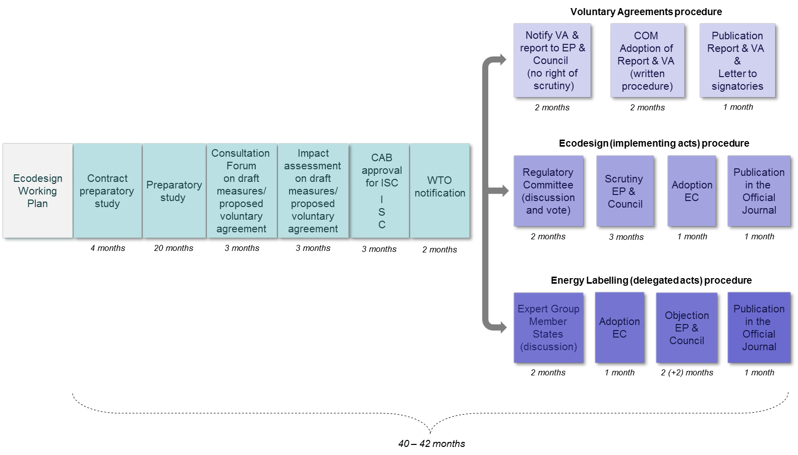

The process starts with establishing the priorities for Union action. Priority product groups are selected based on their potential for cost-effective reduction of energy consumption and following a transparent process culminating in working plans that outline the priorities.

A first list of priority product groups was provided in the Ecodesign Directive itself (2005/32/EC, Article 16). Subsequently, the first formal working plan (for 2009-2011) and the second (for 2012-2014) were adopted by the Commission[90] after consultation of the Ecodesign Consultation Forum (composed of Member State and stakeholder experts).

The products listed in the two plans (1st working plan: 1-10; 2nd working plan: 11-18) are the following:

|  |  |
| --- | --- |
| 1. Air-conditioning and ventilation systems (commercial and industrial) | 1. Window products |
| 1. Electric and fossil-fuelled heating equipment | 1. Steam boilers ( < 50MW) |
| 1. Food preparing equipment (including coffee machines) | 1. Power cables |
| 1. Industrial and laboratory furnaces and ovens | 1. Enterprises' servers, data storage and ancillary equipment |
| 1. Machine tools | 1. Smart appliances/meters |
| 1. Network, data processing and data storing equipment | 1. Lighting systems |
| 1. Refrigerating and freezing (professional) | 1. Wine storage appliances (c.f. Ecodesign regulation 643/2009) |
| 1. Sound and imaging equipment (incl. game consoles) | 1. Water-related products |
| 1. Transformers |  |
| 1. Water-using equipment |  |

There were also a number of conditional products in the 2nd Working Plan that the Commission committed to study closer before deciding to launch full preparatory work (such as thermal insulation, power generating equipment).

Once the product group has been selected, a preparatory study is undertaken by an independent consultant, involving extensive technical discussions with interested stakeholders.

Next, the Commission's first drafts of ecodesign and energy labelling measures are submitted for discussion to the Consultation Forum, consisting of Member States' and other stakeholders' representatives. The Parliament, Member States and stakeholders are kept informed (by receiving copies of the evolving texts of the draft regulations) at each stage from there onwards.

After the Consultation Forum, the Commission drafts an impact assessment, which after approval of the IAB is taken forward to inter-service consultation together with draft implementing measures.

The next step is WTO notification. Following that, the two procedures follow different paths. The draft energy labelling delegated act is discussed in a Member State Expert Group where opinion(s) are expressed and consensus is sought but no vote is taken. The draft ecodesign measure is submitted for vote to the Regulatory Committee of Member State experts. Next, the Commission adopts the delegated act for energy labelling.

After this the European Parliament and Council have the right of scrutiny for each measure for which a period of three or four months is foreseen. Within this time the co-legislators can block the adoption process by the Commission. Parliament committees sometimes discuss proposals to object to measures (light bulbs and fridges in 2009) or go one step further and vote on such a proposal (vacuum cleaners and water heaters in 2013[91]). On one occasion an objection was even adopted in plenary, blocking the measure for televisions in 2009[92].

**Voluntary agreements**

The Directive sets out in its Annex VIII in addition to the basic legal requirements indicative criteria for assessing whether proposed self-regulatory initiatives can be considered as an alternative to an implementing measure. The industry which submits a self-regulatory proposal in view of it being officially recognised by the Commission is expected to provide sufficient technical background to enable the Commission and the members of the Consultation Forum to assess the proposal, notably in terms of the added value as compared with business-as-usual.

The Commission assesses each self-regulatory initiative on a case by case basis after consulting the members of the Consultation Forum and taking into account the findings of the technical/economic preparatory study if available. The basis for the assessment whether a proposal goes beyond business-as-usual is the information provided by the industry and affected parties and, if available, the findings of the preparatory study. Voluntary agreements are expected to include quantified and staged objectives, starting from a well-defined baseline and measured through verifiable indicators. Voluntary agreements also need arrangements for independent verification as they are not necessarily subject to market surveillance by Member States.

The Commission is in the process of developing guidelines for voluntary agreements. The Consultation Forum endorsed on 12 June 2014 an approach that voluntary agreements should cover at least 80% of the market share of a product category and that at least 90% of all product models of each signatory of the voluntary agreement comply with its requirements[93].

Existing ecodesign, energy labelling and tyre labelling legislation

**Framework legislation**

* 2009/125/EC Ecodesign Framework Directive
* 2010/30/EU Energy labelling Framework Directive
* 1222/2009/EC Labelling of tyres with respect to fuel efficiency and other

essential parameters

**24 Ecodesign implementing regulations**

* 1275/2008 Electric power consumption standby and off mode
* 107/2009 Simple set-top boxes
* 244/2009 Non-directional household lamps (+amending regulation 859/2009)
* 245/2009 Fluorescent lamps without integrated ballast, for high intensity discharge lamps and for ballasts and luminaires (+ amending regulation 347/2010)
* 278/2009 External power supplies
* 640/2009 Electric motors (+ amending regulation 4/2014)
* 641/2009 Circulators (+ amending regulation 622/2012)
* 642/2009 Televisions
* 643/2009 Household refrigerating appliances
* 1015/2010 Household washing machines
* 1016/2010 Household dishwashers
* 327/2011 Industrial fans
* 206/2012 Air conditioning and comfort fans
* 547/2012 Water pumps
* 932/2012 Household tumble driers
* 1194/2012 Directional lamps, light emitting diode (LED) lamps and related equipment
* 617/2013 Computers and servers
* 666/2013 Vacuum cleaners
* 801/2013 Networked standby
* 813/2013 Heaters
* 814/2013 Water heaters
* 66/2014 Domestic cooking appliances
* 548/2014 Power transformers
* 1253/2014 Ventilation units

**4 amending Ecodesign implementing regulations**

* 859/2009 Ultraviolet radiation of non-directional household lamps (amending regulation 244/2009/EC)
* 347/2010 Fluorescent lamps without integrated ballast, for high intensity discharge lamps and for ballasts and luminaries (amending regulation 245/2009/EC)
* 622/2012 Circulators (amending regulation 641/2009)
* 4/2014 Industrial electric motors (amending regulation 640/2009)

**2 Voluntary ecodesign agreements (Report to the EP & Council)**

* COM (2012) 684 Complex set top boxes
* COM (2013) 23 Imaging equipment

**13 energy labelling supplementing regulations (of which 1 amending)**

* 1059/2010 Household dishwashers
* 1060/2010 Household refrigerating appliances
* 1061/2010 Household washing machines
* 1062/2010 Televisions
* 626/2011 Air conditioners
* 392/2012 Household tumble driers
* 874/2012 Electrical lamps and luminaires
* 665/2013 Vacuum cleaners
* 811/2013 Heaters
* 812/2013 Water heaters
* 65/2014 Domestic cooking appliances
* 518/2014 Energy labelling on the internet (amending the above regulations)
* 1254//2014 Residential ventilation units

**3 Product-specific Directives still in force**

* 92/42/EEC Hot-water boilers efficiency Council Directive ([94]ED[95])
* 96/60/EC Household combined washer-driers (EL[96])

1. Directive 2010/30/EU, formerly Directive 92/75/EEC
2. Directive 2009/125/EC, formerly Directive 2005/32/EC
3. COM(2012) 765 final
4. Article 9(1) of the Energy Labelling Directive. This article was already reviewed during the preparations for the Energy Efficiency Directive (Directive 2012/27/EU) and as a result deleted from 5 June 2014 and replaced by provisions in the Energy Efficiency Directive.
5. COM(2014)910, Commission Work Programme 2015, A New Start
6. Presidency Conclusions of the Brussels European Council (8/9 March 2007), http://www.consilium.europa.eu/uedocs/cms_data/docs/pressdata/en/ec/93135.pdf
7. Directive 2012/27/EU
8. Jean-Claude Juncker, A New Start for Europe: My Agenda for Jobs, Growth, Fairness and Democratic Change: Political Guidelines for the next European Commission, http://ec.europa.eu/priorities/docs/pg_en.pdf
9. European Council (23 and 24 October 2014) Conclusions, http://www.consilium.europa.eu/uedocs/cms_data/docs/pressdata/en/ec/145397.pdf
10. Energy Union Package, A Framework Strategy for a Resilient Energy Union with a Forward-Looking Climate Change Policy, COM(2015)80
11. Consumer attitudes towards cross-border trade and consumer protection (Flash Eurobarometer 358) , June 2013
12. Ecofys, Evaluation of the Energy Labelling Directive and specific aspects of the Ecodesign Directive: Background report I: Literature review, December 2013.
13. Ecofys, Evaluation of the Energy Labelling Directive and specific aspects of the Ecodesign Directive: Background report I: Literature review, December 2013.
14. SWD(2014) 57 Commission Staff Working Document: Impact Assessment Accompanying the document Commission Delegated Regulation amending Commission Delegated Regulations (EU) No 1059/2010, 1060/2010, 1061/2010, 1062/2010, 626/2011, 392/2012, 874/2012, 665/2013, 811/2013 and 812/2013 with regard to labelling of energy-related products on the Internet
15. Commission Delegated Regulation (EU) No 518/2014 of 5 March 2014 amending Commission Delegated Regulations (EU) No 1059/2010, (EU) No 1060/2010, (EU) No 1061/2010, (EU) No 1062/2010, (EU) No 626/2011, (EU) No 392/2012, (EU) No 874/2012, (EU) No 665/2013, (EU) No 811/2013 and (EU) No 812/2013 with regard to labelling of energy-related products on the internet
16. Jean-Claude Juncker, A New Start for Europe: My Agenda for Jobs, Growth, Fairness and Democratic Change: Political Guidelines for the next European Commission, http://ec.europa.eu/priorities/docs/pg_en.pdf
17. COM(2013)74
18. COM(2013)74
19. 20 years of the European Single Market – Key Points. European Commission, 2012. http://ec.europa.eu/internal_market/publications/docs/20years/key-points-web_en.pdf
20. Ecofys, Evaluation of the Energy Labelling Directive and specific aspects of the Ecodesign Directive, June 2014
21. For a full list of these measures see the annex.
22. AEA Energy & Environment, Work on Preparatory Studies for Eco-Design Requirements of EuPs, Lot 17 Vacuum Cleaners, February 2009.
23. Benoit Lebot & Paul Waide, The European Energy Label: An energy efficiency success story with an impact beyond EU borders, September 2005
24. Based on GfK data
25. This estimate includes the impact of all the measures adopted until March 2015, and that of measures at various stages of adoption. It does not include the impact of future measures covering those product groups where only preparatory studies are on-going or that are considered for the next Working Plan, or the impact of on-going and future revisions of existing measures.
26. The Economist, March 21st-27th 2015, 'CO2 and the climate, flatlining'
27. VHK, Ecodesign impact accounting part 1, May 2014
28. Ecofys, Evaluation of the Energy Labelling Directive and specific aspects of the Ecodesign Directive, June 2014
29. 20 Mtoe yearly primary energy savings by 2030 from measures listed in the Ecodesign Working Plan 2012-2014, currently subject to preparatory studies. Source: VHK, Ecodesign impact accounting part 1, May 2014
30. 15 Mtoe yearly primary energy savings by 2030 from revising measures adopted between 2008 and 2012. The saving potential of revising more recently adopted measures cannot be estimated yet, because the market has not developed sufficiently to assess the this potential. Source: VHK, Ecodesign impact accounting part 1, May 2014
31. Ecofys, Evaluation of the Energy Labelling Directive and specific aspects of the Ecodesign Directive, June 2014
32. Ecofys, Evaluation of the Energy Labelling Directive and specific aspects of the Ecodesign Directive, June 2014
33. A system such as a pattern of letters, ideas, or associations which assists in remembering something.
34. Ecofys, Evaluation of the Energy Labelling Directive and specific aspects of the Ecodesign Directive, June 2014
35. London Economics & Ipsos Mori, A study on the impact of the energy label – and of potential changes to it – on consumer understanding and on purchase decisions, 2014.
36. Ecofys, Evaluation of the Energy Labelling Directive and specific aspects of the Ecodesign Directive, June 2014
37. Ecofys, Evaluation of the Energy Labelling Directive and specific aspects of the Ecodesign Directive, June 2014
38. Ecofys, Evaluation of the Energy Labelling Directive and specific aspects of the Ecodesign Directive: Background report I: Literature review, December 2013.
39. Ecofys, Evaluation of the Energy Labelling Directive and specific aspects of the Ecodesign Directive, June 2014
40. Ecofys, Evaluation of the Energy Labelling Directive and specific aspects of the Ecodesign Directive: Background report I: Literature review, December 2013.
41. The life cycle cost is the combined cost of purchasing the appliance and the running cost (energy and any other resources) over its lifetime. Setting requirements at the least life cycle cost means that the level of the requirement is set as such that the cheap, inefficient appliances are banned, but not the ones that are cheapest in life cycle cost.
42.
43. Ecofys, Evaluation of the Energy Labelling Directive and specific aspects of the Ecodesign Directive, June 2014
44. COWI & BIO Intelligence Service, Assessing the data collected in the framework of the Ecodesign and Labelling annual market surveillance data collection exercise run by the Commission, 2014
45. http://www.atlete.eu/
46. http://www.ecopliant.eu/
47. VHK, "Omnibus" Review Study on Cold Appliances, Washing Machines, Dishwashers, Washer-Driers, Lighting, Set-top Boxes and Pumps, 12 March 2014.
48. Ecofys, Evaluation of the Energy Labelling Directive and specific aspects of the Ecodesign Directive, June 2014
49. http://ec.europa.eu/environment/eussd/smgp/policy_footprint.htm
50. COM(2013)196, 'Building the Single Market for Green Products'
51. E.g. Bild 07-11-2014, EU will bei Doppeltoastern einen Schlitz abschalten; Mirror 21-08-2014, That sucks - your favourite vacuum cleaner is about to get banned;
52. Ecofys, Evaluation of the Energy Labelling Directive and specific aspects of the Ecodesign Directive, June 2014
53. E.g. Express 05-01-2015, EU farce: Now Brussels bureaucrats kill off Sunday roast with new green rules for ovens.
54. VHK, Ecodesign impact accounting part 1, May 2014
55. Ecofys, Evaluation of the Energy Labelling Directive and specific aspects of the Ecodesign Directive, June 2014
56. UK Department for Environment, Food and Rural Affairs, Emerging Findings from Defra’s Regulation Assessment First update covering 2012, February 2015.
57. Ecofys, Impact of Ecodesign and Energy/Tyre Labelling on R&D and Technological Innovation, May 2014
58. Ecofys, Evaluation of the Energy Labelling Directive and specific aspects of the Ecodesign Directive, June 2014
59. Waide Strategic Efficiency, International comparisons of product policy, Coolproducts, February 2013
60. Waide Strategic Efficiency, International comparisons of product policy, Coolproducts, February 2013
61. COM(2014) 25: Communication from the Commission to the European Parliament, the Council and the European Economic and Social Committee A vision for the internal market for industrial products
62. 20 years of the European Single Market – Key Points. European Commission, 2012. http://ec.europa.eu/internal_market/publications/docs/20years/key-points-web_en.pdf
63. Cf. COM(90) 368
64. Cf. COM(91) 285
65. Cf. COM(94) 521
66. Presidency Conclusions of the Brussels European Council (8/9 March 2007), 7224/1/07 REV 1, page 20
67. Letter from German Federal Minister for Environment, Nature Conservation and Nuclear Safety Sigmar Gabriel to European Commissioner for the Environment Stavros Dimas, 23 February 2007.
68. COM(2014) 25: Communication from the Commission to the European Parliament, the Council and the European Economic and Social Committee A vision for the internal market for industrial products
69. COM(2014) 25
70. COM(2012) 765
71. An indication for this is the process for ecodesign and energy labelling for solid fuel boilers and solid fuel local space heaters: the ecodesign regulations address five types of key environmental impacts (energy and four types of pollutant emissions), whereas the energy label only addresses one (energy efficiency). The difficulty to find an agreement in the Ecodesign Regulatory Committee on the ecodesign regulations delayed the adoption of the energy labels, for which there was consensus, for more than a year.
72. Ecofys, Impacts of the EU’s Ecodesign and Energy/Tyre labelling legislation on third jurisdictions, April 2014
73. Ecofys, Impacts of the EU’s Ecodesign and Energy/Tyre labelling legislation on third jurisdictions, April 2014
74. Hans-Paul Siderius and Hidetoshi Nakagami, 2013, A MEPS is a MEPS is a MEPS: Comparing Ecodesign and Top Runner schemes for setting product efficiency standards. Energy Efficiency 6: 1-19.
75. Lloyd Harrington & Jack Brown, Energy standards and labelling programmes throughout the world in 2013, May 2014
76. Details about the EU Energy Star programme can be found on http://www.eu-energystar.org/
77. CLASP & The Policy Partners, Improving Global Comparability of Appliance Energy Efficiency Standards and Labels, September 2014
78. CLASP & The Policy Partners, Improving Global Comparability of Appliance Energy Efficiency Standards and Labels, September 2014
79. CLASP & The Policy Partners, Improving Global Comparability of Appliance Energy Efficiency Standards and Labels, September 2014
80. Ecofys, Impacts of the EU’s Ecodesign and Energy/Tyre labelling legislation on third jurisdictions, April 2014
81. Ecofys, Impacts of the EU’s Ecodesign and Energy/Tyre labelling legislation on third jurisdictions, April 2014
82. CLASP & The Policy Partners, Improving Global Comparability of Appliance Energy Efficiency Standards and Labels, September 2014
83. Waide Strategic Efficiency, International comparisons of product policy, Coolproducts, February 2013
84. Hans-Paul Siderius and Hidetoshi Nakagami, 2013, A MEPS is a MEPS is a MEPS: Comparing Ecodesign and Top Runner schemes for setting product efficiency standards. Energy Efficiency 6: 1-19.
85. Ecofys, Evaluation of the Energy Labelling Directive and specific aspects of the Ecodesign Directive, June 2014; London Economics, study on the impact of the energy label – and of potential changes to it – on consumer understanding and on purchase decisions, October 2014.
86. COWI & BIO Intelligence Service, Assessing the data collected in the framework of the Ecodesign and Labelling annual market surveillance data collection exercise run by the Commission, 2014; VHK, "Omnibus" Review Study on Cold Appliances, Washing Machines, Dishwashers, Washer-Driers, Lighting, Set-top Boxes and Pumps, 12 March 2014; UK Department for Environment, Food and Rural Affairs, Emerging Findings from Defra’s Regulation Assessment First update covering 2012, February 2015 ; Ecofys, Impact of Ecodesign and Energy/Tyre Labelling on R&D and Technological Innovation, May 2014; Ecofys, Impacts of the EU’s Ecodesign and Energy/Tyre labelling legislation on third jurisdictions, April 2014; Lloyd Harrington & Jack Brown, Energy standards and labelling programmes throughout the world in 2013, May 2014; CLASP & The Policy Partners, Improving Global Comparability of Appliance Energy Efficiency Standards and Labels, September 2014
87. Ecofys, Impacts of the EU’s Ecodesign and Energy/Tyre labelling legislation on third jurisdictions, April 2014; Hans-Paul Siderius and Hidetoshi Nakagami, 2013, A MEPS is a MEPS is a MEPS: Comparing Ecodesign and Top Runner schemes for setting product efficiency standards. Energy Efficiency 6: 1-19; Lloyd Harrington & Jack Brown, Energy standards and labelling programmes throughout the world in 2013, May 2014; CLASP & The Policy Partners, Improving Global Comparability of Appliance Energy Efficiency Standards and Labels, September 2014; Waide Strategic Efficiency, International comparisons of product policy, Coolproducts, February 2013
88. UK Department for Environment, Food and Rural Affairs, Emerging Findings from Defra’s Regulation Assessment First update covering 2012, February 2015.
89. http://ec.europa.eu/consumers/archive/safety/psmsp/index_en.htm
90. The 1st Working Plan was a Commission Report addressed to the EP and Council, the 2nd Working Plan - on advice of SG - was a Staff Working Document.
91. The vacuum cleaner objection was defeated in the ENVI committee by 43 votes against and 4 in favour. The water heater objection was defeated in the ENVI committee by 51 votes against and 1 in favour.
92. The motivation of the objection was that the EP wanted to delay the discussion of the draft labelling measure so that it would have to become a delegated act under the recast post-Lisbon Energy Labelling Directive in 2010. The measure was indeed subsequently adopted as a delegated act
93. With an incentive to increase this to 100% in which case no sensitive market data has to be submitted to the independent inspector
94.
95. ED = Ecodesign requirements
96. EL = Energy labelling