Contents
1. Introduction 3
2. Fund Management report 3
2.1. Development of the Fund in 2014 3
2.2. Situation of the Fund 3
2.2.1. Contributions as at 31 December 2014 3
2.2.2. The Fund’s holdings net of accrued interest at 31 December 2014 4
2.3. General and segmental analyses of the Fund 4
2.3.1. Liquidity analysis 4
2.3.2. General analysis of the results of the Fund 5
2.3.3. Analysis by segment 5
2.4. Benchmarking, performance and interest rate risk analysis 11
2.4.1. Benchmarking 11
2.4.2. Performance 13
2.4.3. Interest rate risk 13
3. Annex 14

Introduction
According to the Article 7 of the Guarantee Fund Regulation, the assets of the Guarantee Fund (the "Fund") are managed by the EIB (the "Bank"). The agreement signed between the European Commission (the "Commission") and the Bank defines the principles governing the management of assets.
Under Article 8(2) of the Agreement, at the beginning of March of each year the Bank has to send the Commission an annual status report on the Fund and the management thereof and the financial statements of the Fund for the preceding year.
The management report on the Fund is presented in the section 2 of this Commission Staff Working Document (SWD). The financial statements audited by an external auditor are included in section 3.

Fund Management report

Development of the Fund in 2014
As at 31 December 2014 total assets (excluding accrued interest) of the Guarantee Fund (the “Fund”) amounted to EUR 2 123.1 million against EUR 1 987.4 million as at 31 December 2013, an increase of EUR 135.7 million.
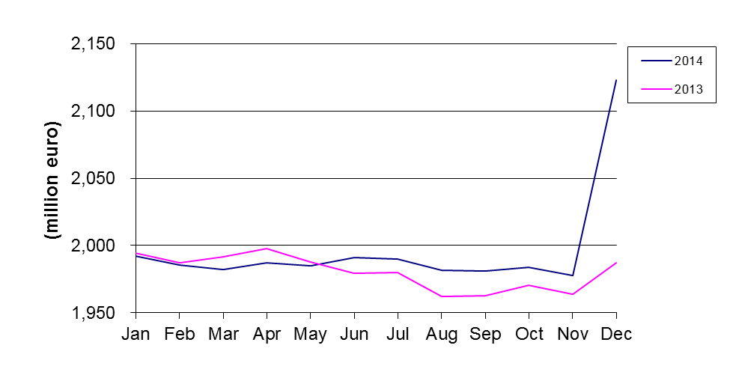
Fig.1: Development of total assets in 2014 and 2013

The net operating result amounted to EUR 29.77 million at 31 December 2014 compared with EUR 31.94 million at 31 December 2013 representing a decrease of -6.8%.

Situation of the Fund

Contributions as at 31 December 2014

Contributions paid in as at 31 December 2014
The net contributions paid into the Fund by the European Union budget decreased by
EUR -1.8 million or -0.2% from EUR 1 030.1 million at 31 December 2013 to EUR 1 028.3 million at 31 December 2014.
This is explained by the movements shown in the following table:
Contributions paid in (in EUR) | Situation at 31/12/2013 | Movements in 2014 | Situation at 31/12/2014
Provisioning | 3 545 485 163 | 58 432 294 | 3 603 917 457
Repayment of surplus | -1 775 870 000 | 0 | -1 775 870 000
Activation of guarantee calls | -562 512 676 | -60 226 739 | -622 739 415
Recovery of historic called amounts | 578 854 354 | 0 | 578 854 354
Repayment of Funds | -755 856 713 | 0 | -755 856 713
Balance | 1 030 100 128 | -1 794 445 | 1 028 305 683

Contributions payable and receivable as at 31 December 2014
As at 31 December 2014 the Fund has recorded EUR 22.2 million (2013: EUR 22.2 million) as contributions payable representing the provisioning for three guarantee calls made by the European Investment Bank in 2014 with regard to Syrian loan defaults (2013: three guarantee calls). In addition, as at 31 December 2014 the Fund has recorded EUR 144.4 million (2013: EUR 58.4 million) as contributions to be paid in by the European Union.

The Fund’s holdings net of accrued interest at 31 December 2014
The Fund’s holdings at 31 December 2014 excluding accrued interest and contributions receivable totalled EUR 1 978.7 million as detailed below:
- EUR 146.8 million in the monetary portfolio (nominal value of interbank term deposits);
- EUR 1.1 million in the current accounts;
- EUR 1 830.8 million in the Available For Sale (AFS) (portfolio market value of fixed rate bonds, floating rate bonds, inflation linked bonds and zero-coupon bonds, excluding accrued interest).
The Fund operates in one currency only, the Euro.

General and segmental analyses of the Fund

Liquidity analysis
The liquidity position of the Fund at 31 December 2014 is outlined in the table below. The liabilities shown in the column "maturity undefined" represent the Contributor's (i.e. European Union's) resources.
Liquidity position as at 31 December 2014 (in EUR million):

Maturity | less than 3 months | 3 months to 1 year | 1 to 10 years | maturity undefined | Total
Total assets | 413 | 226 | 1 499 | 0 | 2 138
Total net assets | 0 | 0 | 0 | -2 115 | -2 115
Total liabilities | -23 | 0 | 0 | 0 | -23
Total net assets and liabilities | -23 | 0 | 0 | -2 115 | -2 138
Net liquidity position | 390 | 226 | 1 499 | -2 115 | 0

General analysis of the results of the Fund
Overall, during the reporting period 1 January 2014 to 31 December 2014 the Fund achieved
EUR 29.77 million in net revenue. The following table outlines the net revenue earned in 2014 and compares it with 2013:
In EUR million | From 1 January to  31 December 2014 |  | From 1 January to  31 December 2013
Interest income on cash & cash equivalents | 0.27 | 0.9% | 0.21 | 0.7%
Interest income on AFS assets | 29.28 | 98.4% | 31.30 | 98.0%
Realised gain on sale of AFS assets | 1.16 | 3.9% | 1.36 | 4.2%
Income from securities lending activity | 0.10 | 0.3% | 0.08 | 0.3%
Commission and other charges | -1.04 | -3.5% | -1.01 | -3.2%
Total | 29.77 | 100.0% | 31.94 | 100.0%

Analysis by segment

Analysis of money market operations
Money-market investments (excluding accrued interest) amount to EUR 147.9 million at 31 December 2014, as compared to EUR 152.1 million the year before.
- Evolution of money-market rates in 2014

The ECB intensified its role as a major economic player in the euro area in 2014. The fragile economic data in the Eurozone which deteriorated as the year progressed, fears of a scenario of deflation and a slowdown in global economic growth, led the ECB, to make explicit its commitment to act with all available instruments if the economic recovery is truncated and worsened long-term inflation away from its goal of price stability.
The ECB held rates at 0.25% until June. At that time, the downward revision of growth and inflation expectations led the ECB to reduce the refinancing rate to 0.15% and the deposit rate to a negative rate of -0.10%. Unconventional measures were also announced: new liquidity injections, targeted long term refinancing operations (designed to enhance the functioning of the monetary policy transmission mechanism by supporting bank lending to the real economy) for at least 4 years, as well as the commitment to maintain liquidity at least until December 2016.
On 4 September, the ECB surprised markets with another rate cut to new record lows for the refinancing and deposit facility rates at 0.05% and -0.20%, respectively, and the announcement of further monetary stimulus intended to combat the deterioration of expectations inflation and stagnation of economic activity in the euro area. In particular, the main measure was the announcement of two programmes of purchases in the secondary markets of covered bonds (bonds covered by pools of mortgages) and Asset Backed Securities (securitization) for two years, amounting to between 0.5 and 1 billion euros, which were launched in the second half of October and November, respectively.
In addition, the ECB President, Mario Draghi, expressed his confidence that this package could be enough, noting that if it were not so, would increase the size and composition of debt purchases programs and may include Sovereign debt. Furthermore, it was indicated that rates will remain low for an extended period of time.
Excess liquidity was the main driver in money markets in 2014, with an environment of negative interest rates in short terms periods. Figure 2 shows the evolution Euribor 1 and 3 months and EONIA in 1 month:

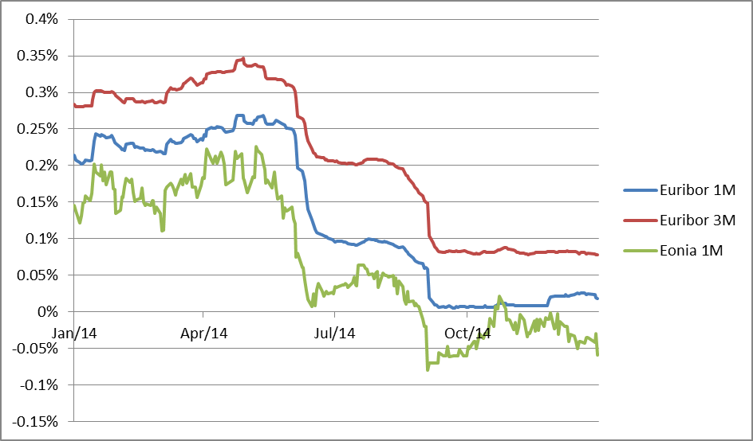

Fig. 2: Evolution of Money Market rates during 2014 (source Reuters)

- Profile of counterparties
In accordance with the agreement between the European Union and the EIB on the management of the Fund, all banks with which deposits are placed should have a minimum short-term credit rating of P-1 (Moody's or equivalent). The breakdown, including accrued interest, is as follows:
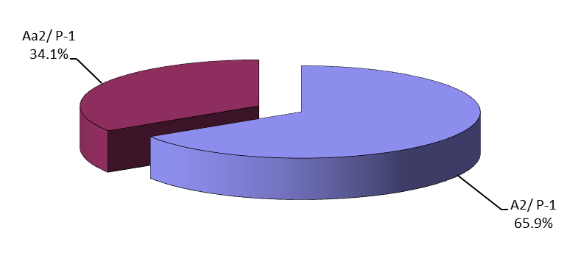
Fig. 3: Short term interbank investments by profile of counterparty at 31 December 2014

- Geographical breakdown
As regards the diversification of counterparty location the EIB is pursuing its objective of geographical distribution throughout the countries of the European Union and complying with the internal credit limits that make these counterparties available. This allows searching for better market on a risk-return basis. The geographical exposure of money-market investments (nominal value) is as follows:
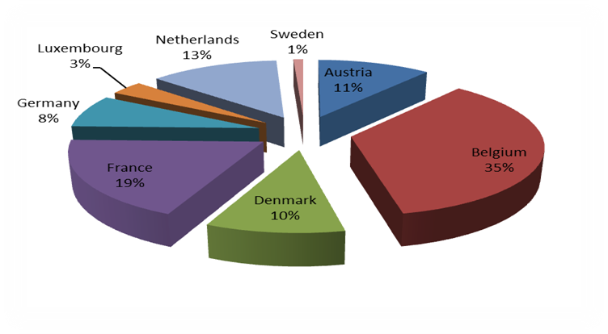

Fig. 4: Money-market investments by geographical exposure

Analysis of bond portfolio results
The bond portfolio, seen as a long-term investment portfolio, is made up of euro-denominated securities. In the Fund’s Financial Statements these securities are classified as Available for Sale (AFS) in line with the EC accounting rule 11. At 31 December 2014, the market value (excluding accrued interest) of fixed rate securities with a residual period to maturity of less than three months amounted to EUR 53.1 million, between 3 months and one year EUR 94.5 million and between one and 10 years EUR 1 041.4 million.
The starting value of the securities in this portfolio is the acquisition cost. The difference between the entry price and the redemption value is the premium/discount spread, which is amortised over the remaining life of each of the securities using the effective interest rate method as specified in the EC accounting rules.
At 31 December 2014, the nominal value of the investment bond portfolio was EUR 1 772.5 million, against a clean market value of EUR 1 830.8 million.
The global (modified) duration of the bond portfolio decreased over 2014 to reach 2.04 at the end of the year. As of 31 December 2014, the clean market value of the investment bond portfolio came to EUR 1 830.8 million (2013: EUR 1 776.9 million) compared with a book value (including premiums/discounts) of EUR 1 774.7 million (2013: EUR 1 740.2 million), which gives an unrealised fair value result of EUR +56.1 million (2013: EUR +36.7 million).

With the combined effects of the Eurozone’s sluggish growth, declining inflationary outlook and increasing likelihood of ECB launching a fully-fledged QE programme, German government bond yield curve bull-flattened (namely longer term rates fell faster than short term rates) in the course of the year 2014, as depicted on figure 5.

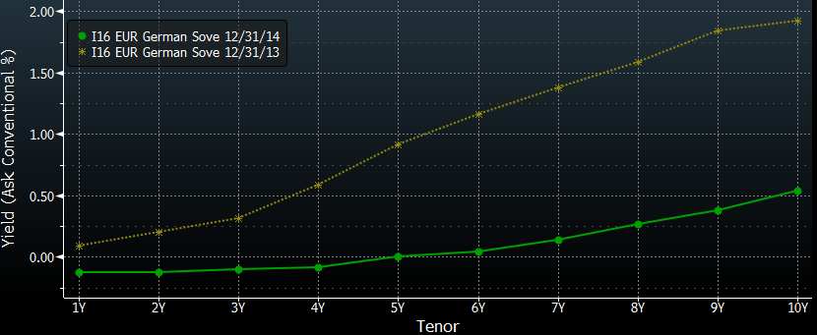

Fig. 5: Euro sovereign yield declined during 2014 (source Bloomberg)

The decline of the yield curves had a positive impact on the Fund’s portfolio performance, which in terms of the percentage return amounted to 2.55%.

In line with the 2014 approved investment strategy and in compliance with the asset management guidelines, a total nominal amount of EUR 419.5 million was invested in fixed and floating rate SSA (EUR 188.2 million or 45%), covered bonds (EUR 178.8 million or 43%) and corporate bonds (EUR 52.5 million or 12%), either on an outright or on a switch basis. The purchases were made both on the primary and on the secondary market. All of the transactions aimed to meet the overall objectives of the portfolio. The charts below outline the total 2014 investments per asset class as well as in terms of country distribution.

Fig. 6: 2014 Investments per asset class
Fig. 7: 2014 Investments per country exposure

Due to their liquidity and generally high credit quality, SSA assets formed the bulk of the 2014 investments. Sovereign and Agency risk out of France and Germany constituted the largest share among the newly opened positions, but they also included other strong names from Austria, Finland and Belgium. For the sake of diversifying away part of the Euroarea risk some EUR denominated papers out of Norway and Canada, as well as papers issued by supranational institutions, were bought.
The covered bond investments were also well diversified geographically, with the Euroarea exposures split between German and Austrian Pfandbriefe as well as Obligations Foncieres and Belgian Pandbrieven. The covered bond asset class, in view of a rich international supply of EUR denominated investments, served as a vehicle for introducing to the portfolio a number of non-Eurozone exposures. In the course of the year several securities out of the Swiss, Norwegian, Danish, Swedish, Australian and Canadian covered bond legislative frameworks were bought.
In line with the strategy, a small proportion of corporate debt has been invested into. The concerned names included Rabobank, Shell, Total and Nestle.
The below chart displays the maturity and instrument format split of the 2014 investments. It can be inferred from the chart that the 5Y tenor, as most attractive spot on the yield curve in terms of risk and return consideration (but also in view of the overall Fund portfolio duration management) has been favoured.

Fig. 8: 2014 Investments per maturity tenor and instrument type

- Breakdown of the investment portfolio between fixed rate and variable rate securities (nominal value)
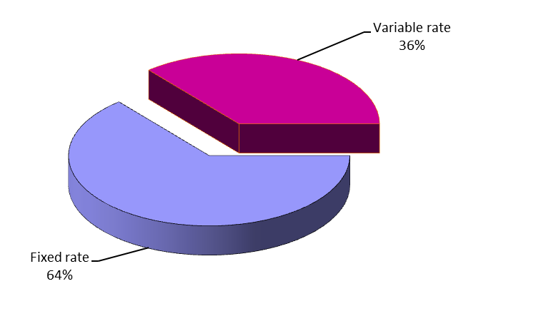
Fig. 9: Investment portfolio breakdown between fixed and variable rate securities at 31 December 2014
- Redemption profile of investment portfolio (nominal value)
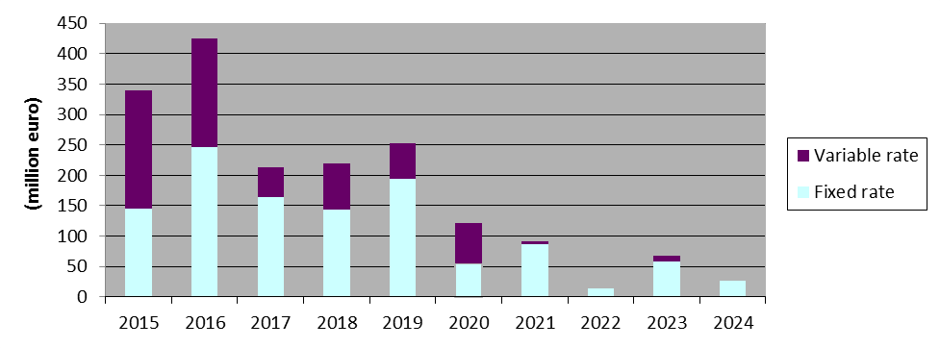
Fig.10: Investment portfolio: Redemption profile at 31 December 2014
The latest final maturity date for fixed rate securities is 25 November 2024.
- Profile of issuers

All the securities held in the portfolio are in line with the management guidelines and meet the following criteria for:
- Securities issued or guaranteed by Member States: minimum rating Baa3;
- Securities issued by a Supranational, other States or Public Company: minimum rating Aa2;
- Covered Bonds or other legal bodies (including structured products): minimum rating Aaa;
- Securities issued by Banks and Corporates: minimum rating Aa2.
The profile of issuers by issuer type and long term rating of the investment portfolio (nominal amount) at 31 December 2014 is as follows:

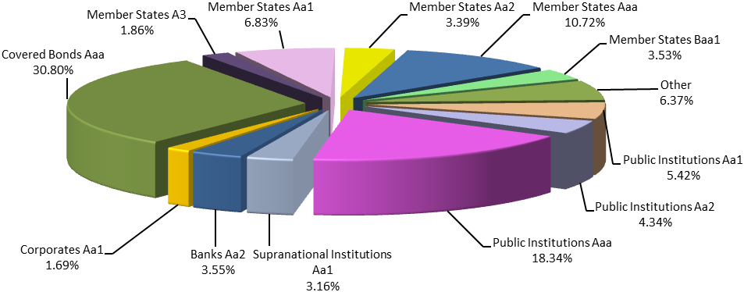
Fig.11: Investment portfolio: Profile of issuers at 31 December 2014

Benchmarking, performance and interest rate risk analysis

Benchmarking
The performance of the Fund is monitored on a marked-to-market (MTM) basis against a composite index. This index is the result of the combination of the following sub-indices:
- Euribid 1M for money-market operations
- Euribid 3M for floating rate notes and fixed rate bond with less than one year to maturity
- IBOXX EUR Sovereign indices for fixed rate bonds issued by sovereign (or similar) issuers, split by maturity buckets
- IBOXX EUR Collateralized Covered indices for fixed rate bonds issued by corporate (or similar) issuers, split by maturity buckets
Index weightings are based on portfolio composition and are reviewed:
- at each end-month day: the dates which define the time buckets (up to 1y, from 1y to 3y, from 3y o 5y, from 5y to 7y and from 7y to 10y) are updated. As a consequence, the shifts between buckets due to the aging of existing positions are accounted only once per month at end-month, following the same procedure underlying the managing of the IBOXX’s indexes;
- during the month, whenever a change higher then ±5% in one of the asset-classes (with respect to the last benchmark’s adjustment) is observed. This change can be the result of:
- the impact of a contribution from the European Commission to the portfolio (external cash flows from the European Commission);
- the impact of a withdrawal from the portfolio to the European Commission (external cash flows to the European Commission);
- the impact of a transaction settled (sales and purchases);
- the impact of a redemption;
- the sum of the impacts of previous events accumulated from the last benchmark’s adjustment, taking also into consideration the changes in the clean values of the positions.

Bucket (years) | Performance Benchmark Sector | Instrument | Average Clean Market Value Composition of 2014
0-1 | 1 m | Money Market | 10.27%
0-1 | 3 m | FRN and Fixed Rate Bonds | 43.03%
1-3 | sovereign | Fixed  Rate  Bonds | 5.90%
1-3 | covered bonds | Fixed  Rate  Bonds | 7.34%
3-5 | sovereign | Fixed  Rate  Bonds | 3.39%
3-5 | covered bonds | Fixed  Rate  Bonds | 1.23%
5-7 | sovereign | Fixed  Rate  Bonds | 15.93%
5-7 | covered bonds | Fixed  Rate  Bonds | 8.02%
7-10 | sovereign | Fixed  Rate  Bonds | 2.66%
7-10 | covered bonds | Fixed  Rate  Bonds | 2.23%
Total |  |  | 100.00%

Performance

The performance of the Fund portfolio was monitored on a marked-to-market basis. During 2014, the portfolio delivered a 2.5539% MTM yearly return, outperforming its benchmark by +19.6 bps. The evolution of the portfolio return and excess return vis-à-vis its benchmark is presented in the following table:
 | Portfolio |  |  |  | Out-performance
 | Market Value (including accrued interest) | Monthly return (absolute return in %) | YTD return (absolute return in %) |  | Monthly  Excess Return compared to benchmark (in%) | YTD  Excess Return (in%)
31/01/2014 | 1 950 953 846 | 0.4498 | 0.4498 |  | -0.0053 | -0.0053
28/02/2014 | 1 996 616 218 | 0.1006 | 0.5509 |  | -0.0201 | -0.0255
31/03/2014 | 1 996 565 302 | 0.1618 | 0.7135 |  | -0.0208 | -0.0464
30/04/2014 | 2 000 668 326 | 0.2055 | 0.9205 |  | 0.0392 | -0.0070
31/05/2014 | 1 998 856 488 | 0.3075 | 1.2308 |  | 0.0603 | 0.0539
30/06/2014 | 2 004 334 086 | 0.2740 | 1.5082 |  | 0.0054 | 0.0594
31/07/2014 | 2 002 301 697 | 0.1522 | 1.6627 |  | 0.0192 | 0.0790
31/08/2014 | 1 994 378 109 | 0.3383 | 2.0066 |  | 0.0563 | 0.1364
30/09/2014 | 1 994 417 998 | 0.1663 | 2.1762 |  | 0.0107 | 0.1476
31/10/2014 | 1 995 840 933 | 0.0713 | 2.2491 |  | 0.0346 | 0.1830
30/11/2014 | 1 990 945 054 | 0.1522 | 2.4048 |  | -0.0094 | 0.1737
31/12/2014 | 1 993 846 360 | 0.1457 | 2.5539 |  | 0.0216 | 0.1960

Interest rate risk
The interest rate risk sensitivity of the MTM value of the portfolio mainly stems from its fixed rate exposure. A 1bp increase of interest rates reduces the value of the portfolio by EUR 407 258 of which EUR 395 126 is related to the fixed rate bond exposure. The global modified duration of the fund increased during 2014 and stood at 2.04 years as of 31 December 2014, compared to 1.53 years as of 31 December 2013.

GF Sub- Portfolios | Market Value (excluding accrued interest) | Modified Duration (Years) | Interest Rate Exposure (+/-1bp)
Floating Rate Notes | 641 794 466 | 0.17 | -/+ 10 895
Fixed Rate Bonds | 1 188 986 291 | 3.28 | -/+ 395 126
Money Market Instruments | 146 799 703 | 0.08 | -/+ 1 237
Cash account | 1 176 786
Total GF | 1 978 757 246 | 2.04 | -/+ 407 258

Annex
GUARANTEE FUND
FINANCIAL STATEMENTS
AS AT 31 DECEMBER 2014

- Balance sheet
- Statement of financial performance
- Statement of changes in net assets
- Cash flow statement
- Notes to the financial statements
- Independent auditor’s report

Balance sheet as at 31 December2014 (in EUR)
ASSETS | Notes | 31.12.2014 | 31.12.2013
NON-CURRENT ASSETS
Available for Sale portfolio | 5
Available for Sale portfolio – cost |  | 1 442 014 346.95 | 1 394 349 787.68
Available for Sale portfolio – actuarial difference |  | 2 620 871.89 | 2 830 052.94
Available for Sale portfolio – adjustment to fair value |  | 54 493 682.62 | 35 027 112.52
Total Available for Sale Portfolio |  | 1 499 128 901.46 | 1 432 206 953.14
TOTAL NON-CURRENT ASSETS |  | 1 499 128 901.46 | 1 432 206 953.14
CURRENT ASSETS
Available for Sale portfolio | 5
Available for Sale portfolio – cost |  | 330 380 880.00 | 345 762 688.23
Available for Sale portfolio – actuarial difference |  | -337 177.65 | -2 717 150.48
Available for Sale portfolio – adjustment to fair value |  | 1 608 172.83 | 1 635 647.34
Available for Sale portfolio – accrued interest |  | 14 629 547.91 | 16 933 098.26
Total Available for Sale portfolio |  | 346 281 423.09 | 361 614 283.35
Short-term receivables
Contributions receivable |  | 144 409 518.00 | 58 432 294.00
Total short-term receivables |  | 144 409 518.00 | 58 432 294.00
Cash and cash equivalents | 6
Current accounts |  | 1 127 193.23 | 1 222 298.07
Short-term deposits – nominal |  | 146 800 000.00 | 150 872 000.00
Accrued interest on short-term deposits |  | 6 011.79 | 8 814.35
Total cash and cash equivalents |  | 147 933 205.02 | 152 103 112.42
TOTAL CURRENT ASSETS |  | 638 624 146.11 | 572 149 689.77
TOTAL ASSETS |  | 2 137 753 047.57 | 2 004 356 642.91
NET ASSETS AND LIABILITIES | Notes | 31.12.2014 | 31.12.2013
NET ASSETS
Contributions | 7
Net contributions paid in |  | 1 028 305 682.61 | 1 030 100 127.55
Contributions payable as guarantee call |  | -22 200 466.06 | -22 191 713.04
Contributions allocated but not yet paid in |  | 144 409 518.00 | 58 432 294.00
Reserves
Fair value reserve - first time application |  | 0.00 | 2 313.96
Fair value reserve |  | 56 101 855.45 | 36 662 759.86
Accumulated surplus |  | 878 284 248.11 | 846 343 661.55
Economic result of the year |  | 29 767 370.43 | 31 940 586.56
TOTAL NET ASSETS |  | 2 114 668 208.54 | 1 981 290 030.44
CURRENT LIABILITIES | 8
Payables
Guarantee call payable | 7 | 22 200 466.06 | 22 191 713.04
Other payables |  | 884 372.97 | 874 899.43
TOTAL CURRENT LIABILITIES |  | 23 084 839.03 | 23 066 612.47
TOTAL NET ASSETS AND LIABILITIES |  | 2 137 753 047.57 | 2 004 356 642.91
Statement of financial performance
For the year ended 31 December 2014
(in EUR)
 | Notes | From 01.01.2014  to 31.12.2014 | From 01.01.2013  to 31.12.2013
Revenue from operating activities |  | 0.00 | 0.00
Expenses from operating activities |  | -1 036 950.92 | -1 014 843.31
Management fees |  | -844 872.97 | -841 299.43
Audit fees |  | -39 500.00 | -33 600.00
Bank fees |  | -152 577.95 | -139 943.88
Result from operating activities |  | -1 036 950.92 | -1 014 843.31
Financial revenue
Interest income |  | 29 542 103.21 | 31 507 572.30
Cash and cash equivalents |  | 267 136.21 | 208 412.77
Available for Sale portfolio |  | 29 274 967.00 | 31 299 159.53
Realised gain on sale of Available for Sale portfolio |  | 1 162 566.88 | 1 364 029.81
Income from securities lending activity |  | 99 651.26 | 83 827.76
Result from non-operating activities |  | 30 804 321.35 | 32 955 429.87
ECONOMIC RESULT OF THE YEAR |  | 29 767 370.43 | 31 940 586.56
Items directly recognised in net assets
Net change in fair value of Available for Sale portfolio |  | 20 658 139.91 | -15 411 253.21
Net amount transferred to statement of financial performance |  | -1 221 358.28 | -1 604 945.84
NET RESULT RECOGNISED IN NET ASSETS |  | 19 436 781.63 | -17 016 199.05

Statement of changes in net assets
For the year ended 31 December 2014
(in EUR)

 | Notes | Contributions | Reserves |  | Accumulated surplus | Economic result of the year | Total
 | Notes | Contributions | Fair value reserve - first time application | Fair value reserve | Accumulated surplus | Economic result of the year | Total
Balance as at 01.01.2013 |  | 1 103 081 775.35 | 11 865.89 | 53 669 406.98 | 802 354 046.04 | 43 989 615.51 | 2 003 106 709.77
Contributions from the European Commission allocated but not yet paid | 7 | 58 432 294.00 | 0.00 | 0.00 | 0.00 | 0.00 | 58 432 294.00
Contributions repaid to the European Commission |  | -30 335 185.93 | 0.00 | 0.00 | 0.00 | 0.00 | -30 335 185.93
Contributions paid to the EIB as guarantee call | 7 | -60 628 847.40 | 0.00 | 0.00 | 0.00 | 0.00 | -60 628 847.40
Change of contributions payable as guarantee call | 7 | -4 209 327.51 | 0.00 | 0.00 | 0.00 | 0.00 | -4 209 327.51
Change of fair value reserve - first time application |  | 0.00 | -9 551.93 | 0.00 | 0.00 | 0.00 | -9 551.93
Change of fair value reserve | 5 | 0.00 | 0.00 | -17 006 647.12 | 0.00 | 0.00 | -17 006 647.12
Allocation of the Economic result of the year 2012 |  | 0.00 | 0.00 | 0.00 | 43 989 615.51 | -43 989 615.51 | 0.00
Economic result of the year 2013 |  | 0.00 | 0.00 | 0.00 | 0.00 | 31 940 586.56 | 31 940 586.56
Balance as at 31.12.2013 |  | 1 066 340 708.51 | 2 313.96 | 36 662 759.86 | 846 343 661.55 | 31 940 586.56 | 1 981 290 030.44
Contributions from the European Commission allocated but not yet paid | 7 | 144 409 518.00 | 0.00 | 0.00 | 0.00 | 0.00 | 144 409 518.00
Contributions paid to the EIB as guarantee call | 7 | -60 226 738.94 | 0.00 | 0.00 | 0.00 | 0.00 | -60 226 738.94
Change of contributions payable as guarantee call | 7 | -8 753.02 | 0.00 | 0.00 | 0.00 | 0.00 | -8 753.02
Change of fair value reserve - first time application |  | 0.00 | -2 313.96 | 0.00 | 0.00 | 0.00 | -2 313.96
Change of fair value reserve | 5 | 0.00 | 0.00 | 19 439 095.59 | 0.00 | 0.00 | 19 439 095.59
Allocation of the Economic result of the year 2013 |  | 0.00 | 0.00 | 0.00 | 31 940 586.56 | -31 940 586.56 | 0.00
Economic result of the year 2014 |  | 0.00 | 0.00 | 0.00 | 0.00 | 29 767 370.43 | 29 767 370.43
Balance as at 31.12.2014 |  | 1 150 514 734.55 | 0.00 | 56 101 855.45 | 878 284 248.11 | 29 767 370.43 | 2 114 668 208.54

Cash flow statement for the year ended 31 December 2014
(in EUR)

 | From 01.01.2014  to 31.12.2014 | From 01.01.2013  to 31.12.2013
Operating activities
Treasury management fee paid during the year | -841 299.43 | -805 306.70
Bank fees / audit fees paid during the year | -186 177.95 | -171 742.27
Contributions paid as guarantee call | -60 226 738.94 | -60 628 847.40
Net cash flows used in operating activities | -61 254 216.32 | -61 605 896.37
Investing activities
Interest received on cash and cash equivalents | 269 938.77 | 219 205.55
Purchase of investments - Available for Sale portfolio | -422 489 999.00 | -523 078 195.53
Proceeds of investments - Available for Sale portfolio | 387 880 985.59 | 324 477 096.51
Interest received - Available for Sale portfolio | 32 894 240.86 | 36 599 210.68
Income from securities lending activity | 99 651.26 | 83 827.76
Net cash flows used in investing activities | -1 345 182.52 | -161 698 855.03
Financing activities
Contributions received from the European Commission | 58 432 294.00 | 155 660 000.00
Contributions repaid to the European Commission | 0.00 | -30 335 185.93
Net cash flows from financing activities | 58 432 294.00 | 125 324 814.07
Net decrease in cash and cash equivalents | -4 167 104.84 | -97 979 937.33
Cash and cash equivalents at the beginning of the financial year | 152 094 298.07 | 250 074 235.40
Cash and cash equivalents at the end of the financial year | 147 927 193.23 | 152 094 298.07
Cash and cash equivalents are composed of
(excluding accrued interest):
Current accounts | 1 127 193.23 | 1 222 298.07
Short-term deposits | 146 800 000.00 | 150 872 000.00
Total cash and cash equivalents | 147 927 193.23 | 152 094 298.07

Notes to the financial statements as at 31 December 2014
- General disclosures
The rules and principles for the management of the Guarantee Fund (the “Fund”) are laid out in the Agreement between the European Commission (the “EC”) and the European Investment Bank (the “EIB”) dated 25 November 1994 and the subsequent amendments of the Annex 2 to the Agreement dated 17/23 September 1996, 8 May 2002, 25 February 2008, 20 October 2010 and 9 November 2010 (the “Convention”).
The main principles of the Fund, as extracted directly from the Convention, are as follows:
- The Fund will operate in one single currency being Euro (EUR). It will exclusively invest in this currency in order to avoid any exchange rate risk.
- The management of the Fund will be based upon the traditional rules of prudence relating to financial activities. Attention is given to control the risks and to ensure that the managed assets have a sufficient degree of liquidity and transferability while considering the Fund’s commitments.
The present financial statements cover the period from 1 January 2014 to 31 December 2014.
EIB’s management has authorized the financial statements for issue on 31 March 2015.

- Significant accounting policies
  - Basis of preparation
The Fund’s financial statements have been prepared in accordance with the accounting rules adopted by the Accounting Officer of the European Commission, in particular “Accounting rule 11 – Financial assets and liabilities” dated December 2004 and updated in October 2006, December 2009 and December 2011. The updated rule is effective for periods beginning on or after 1 January 2012 with the exception of the rules on disclosures in Chapter 9, which became effective for periods beginning on or after 1 January 2014.
The financial statements have been prepared on a going concern basis, which assumes that the Fund will be able to meet the mandatory payments of the guarantees.
According to article 3 and 5 of Council Regulation (EC, Euratom) No 480/2009 of 25 May 2009 if, as a result of the activation of guarantees following one or major default, resources in the Fund fall below the set target amount of 9% of total outstanding capital liabilities arising from each operation, plus any unpaid interest, then the European Commission transfers to the Fund the difference between the target amount and the value of the Fund’s net assets at the previous year-end balance sheet date.
The amounts in the financial statements are not rounded except in the section financial risk management where the amounts are rounded to the nearest thousand EUR.

  - Significant accounting and judgments and estimates
The preparation of financial statements in conformity with the accounting rules adopted by the Accounting Officer of the European Commission requires the use of certain critical accounting estimates. It also requires the EIB Management to exercise its judgment in the process of applying the Fund’s accounting policies. The areas involving a higher degree of judgment or complexity, or areas where assumptions and estimates are significant to the financial statements are disclosed hereafter.
The most significant use of judgments and estimates are as follows:
Measurement of fair value of financial instruments
The fair value of financial assets and financial liabilities that are traded in active markets is based on quoted market prices or broker price quotations. Where the fair values of financial assets and financial liabilities recorded on the balance sheet cannot be derived from active markets, they are determined using a variety of valuation techniques that include the use of mathematical models. The input to these models is taken from observable markets where possible, but where this is not feasible, a degree of judgment is required in establishing fair values.
Impairment losses on financial instruments
The Fund reviews its financial instruments at each reporting date to assess whether an allowance for impairment should be recorded in the statement of financial performance. In particular, judgment by EIB Management is required in the estimation of the amount and timing of future cash flows when determining the level of allowance required.

  - Changes in accounting policies
The Fund has consistently applied to all periods the accounting policies set out in Note 2.4 presented in these financial statements. Following the decision of the Accounting Officer “effective date of disclosure requirements of the EU Accounting rule 11 (Ref. Ares (2013) 171464 – 11/02/2013)“, the Fund retrospectively applied the disclosure requirements to comparative information provided in these financial statements.

  - Summary of significant accounting policies
    - Foreign currency translation
The Fund uses the Euro (EUR) for presenting its financial statements, which is also the functional currency.
Foreign currency transactions are translated at the exchange rate prevailing on the date of the transaction.
Monetary assets and liabilities denominated in currencies other than Euro are translated into Euro at the exchange rate prevailing at the balance sheet date. The gain or loss arising from such translation is recorded in the statement of financial performance.
Non-monetary items that are measured in terms of historical cost in a foreign currency are translated using the exchange rates at the dates of the initial transactions. Non-monetary items measured at fair value in a foreign currency are translated using the exchange rates at the date when the fair value was determined.
Exchange differences on non-monetary assets are a component of the change in their fair value. Depending on the classification of a non-monetary financial asset, exchange differences are either recognised in the statement of financial performance or within the reserves.
Exchange differences arising on the settlement of transactions at rates different from those at the date of the transaction, and unrealised foreign exchange differences on unsettled foreign currency monetary assets and liabilities, are recognised in the statement of financial performance.
The elements of the statement of financial performance are translated into Euro on the basis of the exchange rates prevailing at the end of each month.

    - Financial instruments
All financial assets are recognised in the balance sheet on settlement date basis and measured according to their assigned category.
      - Cash and cash equivalents
The Fund defines cash and cash equivalents as current accounts, commercial papers, treasury bills and short-term deposits with original maturity of three months or less.
      - Available for Sale portfolio
The bond portfolio, seen as Available for Sale portfolio, is composed of Euro-denominated securities.
These securities are classified as Available for Sale (AFS) according to the accounting rules adopted by the Accounting Officer of the European Commission and consequently, are carried out at their fair value through net assets.
In accordance with the decision of the Accounting Officer of the Commission concerning the “Presentation of the Guarantee Fund for external actions and other Available for Sale portfolios” on 31 January 2013, the Available for Sale financial instruments of the Fund’s Portfolio are categorised as current or non-current asset according to their remaining contractual maturity at the balance sheet date. Available for Sale investments with a remaining maturity of less than one year and accrued interest with due date less than one year are presented in the balance sheet as current assets, while Available for Sale investments with a remaining maturity of more than one year are presented in the balance sheet as non-current assets.
Unrealised gains or losses are reported in reserves until such security is sold, collected or otherwise disposed of, or until such security is determined to be impaired. Impairment losses identified are recognised in the statement of financial performance for the year.
On disposal of an Available for Sale security, the accumulated unrealised gain or loss included in net assets is transferred to the statement of financial performance for the year. Interest income on Available for Sale securities is included in “interest income”.
The determination of fair values of Available for Sale investments is generally based on quoted market rates in active markets.
These securities are initially measured at their acquisition cost, being their fair value at this moment. The difference between the entry price and the redemption value, i.e. the premium/discount spread, is amortised over the remaining life of each of the securities using the effective interest rate method as specified under Accounting rule 11.
Securities are considered impaired if there is objective evidence of impairment as a result of one or more events that occurred after the initial recognition of the security (a “loss event”) and that loss event has an impact on the estimated future cash flows of the security that can be reliably estimated.
Evidence of impairment is mainly about significant financial difficulties of the issuer, e.g. a breach of contract, a restructuring of the debt of the issuer or a high probability of bankruptcy. It is important to stress that the disappearance of an active market because the entity’s financial instruments are no longer publicly traded is not evidence of impairment. A downgrade of an entity’s credit rating is not, in itself, evidence of impairment, although it may be evidence of impairment when considered with other available information. A decline in the fair value of a financial asset below its cost or amortised cost is not necessarily evidence of impairment.
If in a subsequent period, the fair value of a debt instrument classified as Available for Sale increases and the increase can be objectively related to an event occurring after the impairment loss was recognised in the statement of financial performance, the impairment loss shall be reversed, with the amount of the reversal recognised in the statement of financial performance.
The sales and purchases of the securities are accounted for at settlement date.

      - Fair value of financial instruments
Fair value is the amount for which an asset could be exchanged, or a liability settled, between knowledgeable, willing parties in an arm’s length transaction.
When applicable, the EIB on behalf of the Fund measures the fair value of an instrument using the quoted price in an active market for that instrument. A market is regarded as active if transactions for the asset or liability take place with sufficient frequency and volume to provide pricing information on an on-going basis.
Where the fair values of financial assets and financial liabilities recorded on the balance sheet cannot be derived from active markets, they are determined using a variety of valuation techniques that include the use of mathematical models. The input to these models is taken from observable markets where possible, but where this is not feasible, a degree of judgement is required in establishing fair values. The chosen valuation technique incorporates all the factors that market participants would take into account in pricing a transaction.
The Fund measures fair values using the following fair value hierarchy that reflects the significance of the inputs used in making the measurements:
- Level 1: Quoted prices (unadjusted) in active markets for identical assets or liabilities;
- Level 2: Inputs other than quoted prices included within Level 1 that are observable for the asset or liability, either directly (i.e., as price) or indirectly (i.e., derived from prices);
- Level 3: Inputs for the asset or liability that are not based on observable market data (unobservable
inputs).
The Fund recognises transfers between levels of the fair value hierarchy as of the end of the reporting period during which the change has occurred.
      - Impairment of financial assets
The EIB assesses at each balance sheet date whether there is any objective evidence that a financial asset or a group of financial assets is impaired. A financial asset or a group of financial assets is deemed to be impaired if, and only if, there is objective evidence of impairment as a result of one or more events that has occurred after the initial recognition of the asset (an incurred “loss event”) and that loss event has an impact on the estimated future cash flows of the financial asset or the group of financial assets that can be reliably estimated. Evidence of impairment may include indications that the borrower or a group of borrowers is experiencing significant financial difficulty, default or delinquency in interest or principal payments, the probability that they will enter bankruptcy or other financial reorganisation and where observable data indicate that there is a measurable decrease in the estimated future cash flows, such as changes in arrears or economic conditions that correlate with defaults.
For the Available for Sale financial assets, an objective evidence would include a significant or prolonged decline in the fair value of the investment below its costs. Where there is evidence of impairment, the cumulative loss (measured as the difference between the acquisition cost net of any principal repayment and amortisation and the current fair value, less any impairment loss on that investment previously recognised in the statement of financial performance) is removed from net assets and recognised in the statement of financial performance. Impairment losses on Available for Sale financial assets are reversed through the statement of financial performance.

    - Contributions
Contributions are increased by:
- Payment allocations made to the Fund by the general budget of the European Union;
- Guarantee recoveries received from EIB.

Contributions are decreased by:
- Payment allocations to be made from the Fund to the general budget of the European Union;
- Guarantee calls made by the EIB.
Contributions to be received from the general budget of the European Union, or to be paid back to the general budget of the European Union are recognized in the balance sheet on the date when they become due or owed according to articles 3, 4, 5 and 6 of the Council Regulation (EC, Euratom) No 480/2009 of 25 May 2009 establishing a Guarantee Fund for external actions (codified version). When it relates to articles 5 and 6 the contributions to be paid or received, based on the year end n-1 difference between the target amount and the value of the Fund’s net assets, are calculated and recorded at the beginning of the year n. When article 4 applies, the contribution to be paid back is calculated and recorded at the date of accession of the new Member State to the European Union.
Contributions to be paid to the EIB in the context of guarantee calls in line with the Recovery Agreement between the European Union and the EIB signed on 25 July 2014 in respect of loans and loan guarantees granted by the EIB for projects outside the European Union (“Recovery Agreement”) are derecognised from the balance sheet on the date when the guarantee call becomes due.
Guarantee recoveries paid from the EIB to the Fund in line with the Recovery Agreement are recognised in the balance sheet as contributions on the date when the guarantee recovery becomes due.
    - Interest income
Interest income covers interest earned on cash and cash equivalents and Available for Sale portfolio and is recorded in the statement of financial performance on an accrual basis.

    - Treasury management fees
According to the Convention, EIB shall receive a treasury management fee which is calculated on the basis of, in the case of securities, the average market value at the end of each month, and in the case of cash and money market deposits, the average nominal value at the end of each month.
Treasury management fees are recorded in the statement of financial performance on an accrual basis.

    - Securities Lending Activity
In April 2008 the Fund entered into an automatic securities lending program with Euroclear Bank SA/NV.
Securities lent within the automatic securities lending program are not derecognized from the Fund’s balance sheet as the control of the contractual rights that comprises these securities is still held by the Fund itself.
Income from securities lending activity is recorded in the statement of financial performance on an accrual basis.

  - Taxation
The Protocol on the Privileges and Immunities of the European Union, appended to the treaty on the European Union and the treaty of the functioning of the European Union, stipulates that the assets, revenues and other property of the Institutions of the Union are exempt from all direct taxes.
- Financial Risk Management
This note presents information about the Fund’s treasury portfolio exposure, its management and control of credit and financial risks, in particular the primary risks associated with its use of financial instruments. These are:
- credit risk – the risk of loss resulting from client or counterparty default and arising on credit exposure in all forms, including settlement risk;
- liquidity risk – the risk that an entity will encounter difficulty in meeting obligations associated with financial liabilities that are settled by delivering cash or another financial asset;
- market risk – exposure to observable market variables such as interest rates and foreign exchange rates.

Risk management organisation
The Risk Management function of EIB ensures that the treasury portfolio is managed in line with the agreed asset management guidelines, especially in respect of the eligible investments, the maximum maturity, the interest rate risk and the credit risk exposure of the Fund’s treasury portfolio. In this respect quarterly reporting is also delivered to the EC concerning the risk and the performance of the Fund’s treasury portfolio. The reporting makes reference to breaches, if any, of the limits set out in the asset management guidelines and includes a comparison of the valuations of the portfolio to a performance index taken as benchmark.
3.2 Credit Risk
Credit risk is the potential loss that could result from client or counterparty default and arising on credit exposure in all forms, including settlement.
3.2.1 Credit risk policy
The treasury portfolio’s agreed asset management guidelines and/or investment strategy define certain limits and restrictions in order to limit the exposure to credit risk of the treasury portfolio. The compliance with these limits is monitored by Risk Management on a daily basis. Such limits and restrictions include eligibility criteria, absolute credit limits in nominal terms depending on issuer category, relative concentration limits depending on issuer category and concentration limits per issue.
3.2.2 Maximum exposure to credit risk without taking into account any collateral and other credit enhancements
The following table shows the maximum exposure to credit risk for the components of the balance sheet (in EUR):
Maximum exposure | 31.12.2014 | 31.12.2013
ASSETS
Available for Sale portfolio | 1 845 410 324.55 | 1 793 821 236.49
Short-term receivables | 144 409 518.00 | 58 432 294.00
Cash and cash equivalents | 147 933 205.02 | 152 103 112.42
Total assets | 2 137 753 047.57 | 2 004 356 642.91
Total credit exposure | 2 137 753 047.57 | 2 004 356 642.91
3.2.3 Credit risk on cash and cash equivalents
3.2.3.1 Analysis of current accounts per profile of counterparties
The following table shows the breakdown of current account balances per maximum long-term counterparty rating (based on the external long term ratings assigned by Fitch, Standard & Poor’s and Moody’s) (in EUR):

Rating | 31.12.2014 | 31.12.2013
A1 | 1 127 193.23 | 1 222 298.07
Total | 1 127 193.23 | 1 222 298.07

All counterparties are maximum rated P-1 short-term (based on the external short term ratings assigned by Fitch, Standard & Poor’s and Moody’s).
The Fund has two current accounts opened with BNP Paribas Fortis and one current account opened with Euroclear Bank as follows (in EUR):

Current accounts | 31.12.2014 | 31.12.2013
BNP Paribas Fortis transitory account | 37 682.51 | 33 976.91
BNP Paribas Fortis current account | 1 068 682.53 | 1 144 843.27
Euroclear Bank current account | 20 828.19 | 43 477.89
Total | 1 127 193.23 | 1 222 298.07

3.2.3.2 Analysis of short term deposits per profile of counterparties
In accordance with the agreement between the European Commission and the EIB on the management of the Fund, all interbank investments should have a minimum issuer short-term rating from Moody’s or equivalent of P-1. The following table shows the breakdown of short term deposits (including accrued interest) per maximum counterparty long term rating (based on the external long term ratings assigned by Fitch, Standard & Poor’s and Moody’s) (in EUR):

Rating | 31.12.2014 |  | 31.12.2013
Aa2 | 50 004 198.59 | 34.06% | 34 600 192.22 | 22.93%
A2 | 96 801 813.20 | 65.94% | 72 706 329.42 | 48.19%
A3 | 0.00 | 0.00% | 43 574 292.71 | 28.88%
Total | 146 806 011.79 | 100.00% | 150 880 814.35 | 100.00%
3.2.4 Credit risk on Available for Sale portfolio
3.2.4.1 Risk concentration per issuance
All the securities held in the portfolio are in line with the management guidelines and meet the following criteria for:
- Securities issued or guaranteed by Member States: minimum rating Baa3;
- Securities issued by a Supranational, other States or Public Company: minimum rating Aa2;
- Covered Bonds or other legal bodies (including structured products): minimum rating Aaa;
- Securities issued by Banks and Corporates: minimum rating Aa2.
The following table shows the breakdown of the Available for Sale portfolio, at market value excluding accrued interest, per security type and rating (in EUR):
Issuer - Rating | 31.12.2014 |  | 31.12.2013
Banks Aaa | 0.00 | 0.00% | 5 000 000.00 | 0.28%
Banks Aa2 | 63 440 347.00 | 3.47% | 58 283 384.80 | 3.28%
European Union Aaa | 21 132 274.45 | 1.16% | 21 507 242.10 | 1.21%
Member State Aaa | 197 601 840.05 | 10.79% | 190 199 502.20 | 10.70%
Member State Aa1 | 127 892 908.85 | 6.99% | 132 579 067.48 | 7.46%
Member State Aa2 | 64 091 116.00 | 3.50% | 109 897 057.00 | 6.18%
Member State Aa3 | 10 727 750.00 | 0.59% | 21 084 170.00 | 1.19%
Member State A1 | 25 855 889.00 | 1.41% | 17 197 780.00 | 0.97%
Member State A2 | 14 157 685.60 | 0.77% | 24 742 260.00 | 1.39%
Member State A3 | 33 763 681.00 | 1.84% | 9 835 700.00 | 0.55%
Member State Ba1 | 17 071 040.00 | 0.93% | 0.00 | 0.00%
Member State Baa1 | 65 750 658.45 | 3.59% | 104 738 951.00 | 5.89%
Member State Baa2 | 0.00 | 0.00% | 27 856 375.00 | 1.57%
Member State Ba2 | 0.00 | 0.00% | 16 108 691.20 | 0.91%
Member State B2 | 10 071 570.73 | 0.55% | 0.00 | 0.00%
Member State B3 | 0.00 | 0.00% | 16 984 122.69 | 0.96%
Covered Bond Aaa | 564 263 853.86 | 30.82% | 465 365 704.56 | 26.20%
Corporate Aaa | 0.00 | 0.00% | 10 019 700.00 | 0.56%
Corporate Aa1 | 31 550 271.50 | 1.72% | 0.00 | 0.00%
Corporate Aa2 | 2 534 650.00 | 0.14% | 0.00 | 0.00%
Public Institution Aaa | 330 158 942.15 | 18.03% | 363 705 421.20 | 20.48%
Public Institution Aa2 | 78 985 314.40 | 4.31% | 34 372 228.00 | 1.93%
Public Institution Aa1 | 98 348 124.10 | 5.37% | 115 731 761.40 | 6.51%
Supranational Aaa | 5 040 500.00 | 0.28% | 0.00 | 0.00%
Supranational Aa1 | 58 791 200.50 | 3.21% | 31 679 019.60 | 1.78%
Non-EU Public Institution Aaa | 4 109 020.00 | 0.23% | 0.00 | 0.00%
Non-EU Public Institution Aa2 | 5 442 139.00 | 0.30% | 0.00 | 0.00%
Total | 1 830 780 776.64 | 100.00% | 1 776 888 138.23 | 100.00%
The above table presenting securities ratings is prepared according to the agreed asset management guidelines. In particular, security ratings of the AFS portfolio refer to the best rating given by Moody’s, Standard & Poor’s or Fitch.
In case of securities for which no security rating is available the rating of the issuer (or guarantor for guaranteed positions) has been taken into account.

3.2.4.2 EU sovereign exposure
The following tables show the portfolio structure by exposure towards EU sovereign (either directly or indirectly) and exposure towards other entities as at 31 December 2014 and as at 31 December 2013 (in EUR):

At 31.12.2014 | Purchase price | Value at maturity | Book Value*)
EU sovereigns
Austria | 11 420 950.00 | 11 500 000.00 | 11 995 792.55
Belgium | 61 817 500.00 | 60 000 000.00 | 64 091 116.00
Czech Republic | 11 042 900.00 | 11 000 000.00 | 10 727 750.00
Finland | 9 478 425.00 | 9 500 000.00 | 9 655 500.00
France | 120 211 395.00 | 121 000 000.00 | 127 892 908.85
Germany | 148 205 130.00 | 149 500 000.00 | 154 541 701.50
Greece | 10 111 500.00 | 10 000 000.00 | 10 071 570.73
Ireland | 19 919 200.00 | 20 000 000.00 | 20 070 800.00
Italy | 56 022 535.00 | 57 500 000.00 | 60 658 858.45
Lithuania | 12 460 600.00 | 13 000 000.00 | 13 481 481.00
Luxembourg | 14 946 600.00 | 15 000 000.00 | 16 903 941.00
Netherlands | 4 500 000.00 | 4 500 000.00 | 4 504 905.00
Poland | 3 716 000.00 | 4 000 000.00 | 4 143 385.60
Portugal | 16 032 480.00 | 16 000 000.00 | 17 071 040.00
Slovakia | 24 688 950.00 | 25 000 000.00 | 25 855 889.00
Slovenia | 10 000 000.00 | 10 000 000.00 | 10 225 700.00
Spain | 4 979 450.00 | 5 000 000.00 | 5 091 800.00
European Union | 20 429 270.00 | 20 500 000.00 | 21 132 274.45
EU Supranational | 46 811 500.00 | 46 000 000.00 | 48 778 300.50
Total EU sovereigns | 606 794 385.00 | 609 000 000.00 | 636 894 714.63
Others | 1 165 600 841.95 | 1 163 505 920.74 | 1 193 886 062.01
TOTAL | 1 772 395 226.95 | 1 772 505 920.74 | 1 830 780 776.64
*) The book value represents the clean market value of the assets excluding accrued interest.
At 31.12.2013 | Purchase price | Value at maturity | Book Value*)
EU sovereigns
Austria | 14 215 300.00 | 14 000 000.00 | 14 082 530.00
Belgium | 88 493 581.53 | 88 000 000.00 | 89 864 657.00
Czech Republic | 21 462 900.00 | 21 000 000.00 | 21 084 170.00
France | 144 945 983.68 | 146 000 000.00 | 152 611 467.48
Germany | 138 218 880.00 | 139 500 000.00 | 144 589 142.70
Greece | 17 661 350.00 | 17 000 000.00 | 16 984 122.69
Ireland | 29 619 200.00 | 30 000 000.00 | 30 571 261.00
Italy | 56 022 535.00 | 57 500 000.00 | 60 525 522.50
Lithuania | 12 460 600.00 | 13 000 000.00 | 13 642 167.50
Luxembourg | 14 946 600.00 | 15 000 000.00 | 14 937 799.50
Netherlands | 16 456 350.00 | 16 500 000.00 | 16 590 030.00
Poland | 3 716 000.00 | 4 000 000.00 | 4 248 860.00
Portugal | 16 032 480.00 | 16 000 000.00 | 16 108 691.20
Slovakia | 36 422 750.00 | 36 500 000.00 | 37 691 180.00
Slovenia | 10 000 000.00 | 10 000 000.00 | 9 835 700.00
Spain | 27 432 225.00 | 27 500 000.00 | 27 856 375.00
European Union | 20 429 270.00 | 20 500 000.00 | 21 507 242.10
EU Supranational | 31 723 650.00 | 31 000 000.00 | 31 679 019.60
Total EU sovereigns | 700 259 655.21 | 703 000 000.00 | 724 409 938.27
Others | 1 039 852 820.70 | 1 036 838 624.14 | 1 052 478 199.96
TOTAL | 1 740 112 475.91 | 1 739 838 624.14 | 1 776 888 138.23
*) The book value represents the clean market value of the assets excluding accrued interest.
In the tables above “EU sovereigns” refer to bonds issued or guaranteed by EU Member States and EU Supranationals while “others” refer to bonds issued by banks, covered bonds, bonds issued or guaranteed by non EU Supranationals or EU and non EU Public Institutions.

The Fund did not participate in any private sector initiative for Greece and therefore no impairment was recorded on its Greek sovereign and sovereign guaranteed exposure for 2013 and 2014.
An exchange agreement was signed between the Hellenic Republic and the EC dated 7 February 2012, whereby the Greek Government Bonds have been exchanged for new debt securities of the Hellenic Republic issued in series having the same nominal amount, interest rate, interest payment dates and redemption dates.
The following mark to market model has been applied to the Greek bonds held:
- a spread curve versus EUR Swap has been prepared using the yields quoted on the following instruments:
- 3 Month Greek Treasury Bill Benchmark;
- 6 Month Greek Treasury Bill Benchmark;
- all securities issued by the Greek Government in replacement of bonds subject to Private Sector Involvement (PSI);
- a discounting curve has been prepared adding the aforementioned spreads to each EUR Swap tenor. Missing nodes have been interpolated linearly;
- the cash flows of the Greek Bonds have been discounted to the Net Present Value.
- Liquidity Risk
Liquidity risk refers to an entity’s ability to meet obligations as they come due, without incurring unacceptable losses. It can be split into funding liquidity risk and market liquidity risk. Funding liquidity risk is the risk that an entity will not be able to meet efficiently both expected and unexpected current and future cash flow needs without affecting its daily operations or its financial condition. Market liquidity risk is the risk that an entity cannot easily offset or eliminate a position at the market price because of inadequate market depth or market disruption.

Liquidity risk management
The treasury portfolio’s agreed asset management guidelines and/or investment strategy define certain limits and restrictions in order to limit the exposure to funding liquidity risk of the treasury portfolio. The compliance with these limits is monitored by Risk Management on a daily basis. Such limits and restrictions include a target liquidity buffer.

- Liquidity risk measurement
The table below provides an analysis of the non-derivative liabilities into relevant maturity groupings based on the remaining period from the balance sheet date to the contractual maturity date while the accrued interests are presented based on the due date of those cash flows. The table is presented under the most prudent consideration of maturity dates where the earliest possible repayment date is shown.

Maturity profile  (at 31 December 2014) | Less than  1 year | 1 year to  5 years | More than  5 years | TOTAL
Guarantee call payable | 22 200 466.06 | 0.00 | 0.00 | 22 200 466.06
Other payables | 884 372.97 | 0.00 | 0.00 | 884 372.97
Total | 23 084 839.03 | 0.00 | 0.00 | 23 084 839.03
Maturity profile  (at 31 December 2013) | Less than  1 year | 1 year to  5 years | More than  5 years | TOTAL
Guarantee call payable | 22 191 713.04 | 0.00 | 0.00 | 22 191 713.04
Other payables | 874 899.43 | 0.00 | 0.00 | 874 899.43
Total | 23 066 612.47 | 0.00 | 0.00 | 23 066 612.47

3.4 Market Risk
Market risk represents the risk that changes in market prices and rates, such as interest rates and foreign exchange rates will affect an entity’s income or the value of its holdings in financial instruments.
- The treasury portfolio’s agreed asset management guidelines and/or investment strategy define certain restrictions (such as concentration limits, modified duration and target combined spread duration) in order to limit the exposure to market risk of the treasury portfolio. The compliance with these limits is monitored by Risk Management on a daily basis.

3.4.1 Interest rate risk position
Interest rate risk arises from the volatility in the economic value of, or in the income derived from the treasury portfolio’s interest rate bearing positions due to adverse movements in interest rates. Exposure to interest rate risk occurs when there are differences in repricing and maturity characteristics of the different assets and liabilities.
3.4.1.1 Interest rate sensitivity analysis
The interest rate sensitivity of the treasury portfolios represents the amount of a potential change in the fair value of the portfolio and is computed on a deal by deal basis assuming a parallel shift of the interest rate curve.
The following table shows the sensitivity to interest rate variations of the three Guarantee Fund (“GF”) treasury sub-portfolios GF-Short term (Short term deposits/zero coupon bonds), GF-FRN (AFS Bond portfolio variable interest), GF-Long term (AFS Bond portfolio fixed interest). It is presented on the same basis as the quarterly risk management reporting delivered to the EC concerning the risk and the performance of the Fund’s portfolio.

31 December 2014
GF sub-portfolios | Clean market value  in EUR'000 | Modified Duration (Years) | IR Exposure  (+/-1bp)  in EUR'000 | IR Exposure (100bp)  in EUR'000 | IR Exposure  (-100bp)  in EUR'000
GF - Short term | 146 800 | 0.08 | -/+ 1.237 | -123 | + 124
GF - FRN | 641 794 | 0.17 | -/+ 10.895 | -1 086 | + 1 093
GF - Long term | 1 188 986 | 3.28 | -/+ 395.126 | -38 367 | + 40 720
TOTAL GF | 1 977 580 | 2.04 | -/+ 407.258 | -39 576 | + 41 937
31 December 2013
GF sub-portfolios | Clean market value  in EUR'000 | Modified Duration (Years) | IR Exposure  (+/-1bp)  in EUR'000 | IR Exposure (100bp)  in EUR'000 | IR Exposure  (-100bp)  in EUR'000
GF - Short term | 190 867 | 0.06 | -/+ 1.199 | -119 | + 120
GF - FRN | 707 245 | 0.16 | -/+ 11.660 | -1 161 | + 1 171
GF - Long term | 1 029 644 | 2.73 | -/+ 285.264 | -27 789 | + 29 301
TOTAL GF | 1 927 756 | 1.53 | -/+ 298.123 | -29 069 | + 30 592

The clean market value of the GF-Short term sub-portfolio as reported above represents the sum of clean market values calculated for short term deposits and zero coupon bonds. Those clean market values are determined as follows:
- Short-term deposits: the sum of the nominal value and total interest at maturity for each position is discounted from the maturity date to the spot date, whereas the spot date equals the valuation date plus two business days. Finally, accrued interest at spot date is subtracted from the calculated market value of the position.
- Zero coupon bonds: the nominal value of each position is multiplied with the observed spot quote/price.

The clean market values of the GF-FRN and GF-Long term sub-portfolios as reported above represents the sum of clean market values calculated for inflation linked, fixed and floating rate bonds. Those clean market values are determined as follows:
- Fixed rate bonds: the nominal value of each position is multiplied by its market quote as observed at valuation date.
- Floating rate bonds (FRNs): the nominal value of each position is multiplied by its market quote as observed at valuation date.
- Inflation linked bonds: the nominal value of each position is multiplied by its market quote as observed at valuation date multiplied by the Inflation Index Ratio.
- Greek bonds: a model based valuation methodology is applied at valuation date (ad-hoc market driven discounting methodology), as described in note 3.2.

3.5 Foreign exchange risk exposure
2. Foreign exchange risk is the volatility in the economic value of, or in the income derived from, the Fund’s positions due to adverse movements of foreign exchange rates.
As all assets and liabilities of the Fund are denominated in Euro, the Fund is not exposed to foreign exchange risk.
- Fair value of financial instruments

  - Accounting classifications and fair value

The following tables show the carrying amounts and fair values of financial assets and financial liabilities, including their levels in the fair value hierarchy. These do not include fair value information for financial assets and financial liabilities not carried at fair value if the carrying amount is a reasonable approximation of fair value.

At 31 December 2014 | Carrying Amount |  |  |  |  | Fair value
in EUR
 | Available for sale | Cash, loans and receivables | Other financial liabilities | Total |  | Level 1 | Level 2 | Level 3 | Total
Financial assets carried at fair value:
AFS portfolio | 1 845 410 324.55 | 0.00 | 0.00 | 1 845 410 324.55 |  | 1 825 140 465.48 | 20 269 859.07 | 0.00 | 1 845 410 324.55
Total | 1 845 410 324.55 | 0.00 | 0.00 | 1 845 410 324.55 |  | 1 825 140 465.48 | 20 269 859.07 | 0.00 | 1 845 410 324.55
Financial assets not carried at fair value:
Short-term receivables | 0.00 | 144 409 518.00 | 0.00 | 144 409 518.00
Current accounts | 0.00 | 1 127 193.23 | 0.00 | 1 127 193.23
Short-term deposits | 0.00 | 146 806 011.79 | 0.00 | 146 806 011.79
Total | 0.00 | 292 342 723.02 | 0.00 | 292 342 723.02
Total financial assets | 1 845 410 324.55 | 292 342 723.02 | 0.00 | 2 137 753 047.57
Financial liabilities not carried at fair value:
Other payables | 0.00 | 0.00 | -884 372.97 | -884 372.97
Guarantee call payable | 0.00 | 0.00 | -22 200 466.06 | -22 200 466.06
Total | 0.00 | 0.00 | -23 084 839.03 | -23 084 839.03
Total financial liabilities | 0.00 | 0.00 | -23 084 839.03 | -23 084 839.03

- Fair value of financial instruments (continued)

  - Accounting classifications and fair value (continued)

At 31 December 2013 | Carrying Amount |  |  |  |  | Fair value
in EUR
 | Available for sale | Cash and Loans and receivables | Other financial liabilities | Total |  | Level 1 | Level 2 | Level 3 | Total
Financial assets carried at fair value:
AFS portfolio | 1 793 821 236.49 | 0.00 | 0.00 | 1 793 821 236.49 |  | 1 761 509 746.62 | 32 311 489.87 | 0.00 | 1 793 821 236.49
Total | 1 793 821 236.49 | 0.00 | 0.00 | 1 793 821 236.49 |  | 1 761 509 746.62 | 32 311 489.87 | 0.00 | 1 793 821 236.49
Financial assets not carried at fair value:
Short-term receivable | 0.00 | 58 432 294.00 | 0.00 | 58 432 294.00
Current accounts | 0.00 | 1 222 298.07 | 0.00 | 1 222 298.07
Short-term deposits | 0.00 | 150 880 814.35 | 0.00 | 150 880 814.35
Total | 0.00 | 210 535 406.42 | 0.00 | 210 535 406.42
Total financial assets | 1 793 821 236.49 | 210 535 406.42 | 0.00 | 2 004 356 642.91
Financial liabilities not carried at fair value:
Other payables | 0.00 | 0.00 | -874 899.43 | -874 899.43
Guarantee call payable | 0.00 | 0.00 | -22 191 713.04 | -22 191 713.04
Total | 0.00 | 0.00 | -23 066 612.47 | -23 066 612.47
Total financial liabilities | 0.00 | 0.00 | -23 066 612.47 | -23 066 612.47

4.2 Measurement of fair values

Assets for which carrying value approximates fair value

For financial assets and financial liabilities that are liquid or have a short term maturity (less than three months), it is assumed that the carrying amount approximates their fair value.

Assets and liabilities carried at fair value

Published price quotations in an active market are the first source for determining the fair value of a financial instrument.

For instruments without available market price, the fair value is estimated using a discounted cash flow model based on either directly or indirectly observable market data (discount curves and estimation curves) prevailing at the balance sheet date.

4.3 Transfers between level 1 and level 2
The table below shows the significant transfers between level 1 and level 2 of the fair value hierarchy (in EUR):
 | 31 December 2014 | 31 December 2013
Transfer out of level 1 into level 2 | 10 032 041.76 | 4 949 223.88
Transfer out of level 2 into level 1 | 9 818 930.78 | 15 168 558.75

The transfer out of level 1 into level 2 is due to changes in market conditions for certain securities for which quoted prices in active markets were no longer available at the balance sheet date. However, there was sufficient information available to measure the fair values of these securities based on observable market inputs.
The transfers out of level 2 into level 1 correspond to securities for which quoted prices in active markets were available at the balance sheet date but not at the previous balance sheet date.

4.4 Level 3 fair value
As at 31 December 2014 and 31 December 2013 the Fund has no financial instruments classified under Level 3.

- Available for Sale portfolio
The following tables show the movements of the Available for Sale portfolio (in EUR):
Balance as at 1 January 2013 | 1 615 570 968.54
Acquisitions | 523 078 195.53
Disposals and withdrawals (original acquisition cost) | -326 339 063.80
Change in carrying amount - actuarial difference | 559 316.26
Change in accrued interest | -2 041 532.92
Change in fair value | -17 006 647.12
Balance as amount at 31 December 2013 | 1 793 821 236.49
Balance as at 1 January 2014 | 1 793 821 236.49
Acquisitions | 422 489 999.00
Disposals and withdrawals (original acquisition cost) | -390 207 247.96
Change in carrying amount - actuarial difference | 2 170 791.78
Change in accrued interest | -2 303 550.35
Change in fair value | 19 439 095.59
Balance as at 31 December 2014 | 1 845 410 324.55

As at 31 December 2014, the nominal value of the investment portfolio was EUR 1 772.5 million (2013: EUR 1 739.8 million), against a market value of EUR 1 830.8 million (2013: EUR 1 776.9 million), excluding accrued interest.
Accrued interest as at 31 December 2014 amounting to EUR 14 629 547.91 (2013: EUR 16 933 098.26) is split between:
- Fixed rate notes EUR 14 279 223.81 (2013 EUR: 16 405 005.93)
- Floating rate notes EUR 350 324.10 (2013: EUR: 528 092.33)

As at 31 December 2014 the market value of securities lent within the automatic security lending agreement with Euroclear (excluding accrued interest) amounts to EUR 24 359 135.98 (2013: EUR 37 605 514.54).
- Cash and cash equivalents
The following table shows the split of cash and cash equivalents (including accrued interest) (in EUR):
Description | 31.12.2014 | 31.12.2013
Current accounts | 1 127 193.23 | 1 222 298.07
Short term deposits | 146 806 011.79 | 150 880 814.35
of which accrued interest | 6 011.79 | 8 814.35
Total | 147 933 205.02 | 152 103 112.42
- Contributions
Contributions are increased by contributions from the general budget of the European Union and by the recoveries of previous interventions made by the Fund with regard to defaulted guaranteed loans. Contributions are either decreased by repayments to the general budget of the European Union or by interventions the Fund is paying with regard to defaulted guaranteed loans. Contributions to/from the budget of the European Union are recognised in the balance sheet on the date when they become due or owed according to articles 3, 4, 5 and 6 of the Council Regulation (EC, Euratom) No 480/2009 of 25 May 2009 establishing a Guarantee Fund for external actions.
The contribution allocated but not yet paid in as at 31 December 2013 amounting to EUR 58 432 294.00 was paid in cash during the reporting period. In 2014, the Fund has been allocated an additional contribution amount of EUR 144 409 518.00 which has not been paid as at 31 December 2014.
In December 2013 the Fund made a capital repayment of EUR 30 335 185.93 to the European Commission following the EU enlargement with a new member: the Republic of Croatia.
The following table shows the movements of the contributions during the reporting period (in EUR):
Balance as at 1 January 2013 | 1 103 081 775.35
Contributions from the European Commission allocated but not paid in | 58 432 294.00
Change of contributions payable as guarantee call | -4 209 327.51
Contributions paid to the EIB as guarantee call | -60 628 847.40
Contributions repaid to the European Commission | -30 335 185.93
Balance as at 31 December 2013 | 1 066 340 708.51
Balance as at 1 January 2014 | 1 066 340 708.51
Contributions from the European Commission allocated but not paid in | 144 409 518.00
Change of contributions payable as guarantee call | -8 753.02
Contributions paid to the EIB as guarantee call | -60 226 738.94
Balance as at 31 December 2014 | 1 150 514 734.55
8 Current liabilities (in EUR)
Description | 31.12.2014 | 31.12.2013
Payables
Guarantee call payable | 22 200 466.06 | 22 191 713.04
Treasury management fees | 844 872.97 | 841 299.43
Audit fees | 39 500.00 | 33 600.00
Total | 23 084 839.03 | 23 066 612.47

Treasury management fees are payable to the EIB on an annual basis.

- Subsequent events
There have been no material post-balance sheet events, which would require disclosure or adjustment to the 31 December 2014 financial statements.

The balance of total assets includes a contribution receivable of EUR 144.4 million which is due to be paid in 2015 (2013: EUR 58.4 million). In the chart presented in figure 1 contributions receivable are recognized as assets in December of the corresponding years.
SSA: refers to issuers that are Sovereign, Supranational or Agencies
Member States securities (including securities guaranteed by Member States) may be kept in an event of downgrade below the minimum requirements. This applies also to cases where the rating downgrade would trigger a lower limit.
Reported ratings are ratings of the respective issues. In the absence of all bond/issue ratings, the respective issuer ratings (in case of guaranteed positions the guarantor ratings) have been reported.
The “Other” category presented in figure 11 includes: Member States A1 (1.41%), European Communities Aaa (1.16%), Member States Ba1 (0.90%), Member States A2 (0.79%), Member States Aa3 (0.62%), Non-EU Public Institutions Aa2 (0.28%), Supranational Institutions Aaa (0.28%), Non-EU Public Institutions Aaa (0.23%), Corporates Aa2 (0.14%), Member States B2 (0.56%).
The EUR 1.177 million “cash account” balance reported in this table does not include any payments relating to commissions, fees and other payments not strictly depending on the positions in the portfolio. This explains why it does not match the EUR 1.1 million total balance of the “current account” balance reported in section 1.2. The “cash account” balance is however reset at the beginning of each year to match the total balance of the current accounts.
This is based on the revised standards IAS 32 and 39 as issued by the IASB on 18 December 2003 and consequently, does not integrate the carved out provisions as set out in the version of IAS 39 endorsed by the European Commission on 19 November 2004.
This accounting rule is based on the following IPSAS standard: IPSAS 28 “Financial Instruments: Presentation”, IPSAS 29 “Financial Instruments: Recognition and Measurement” and IPSAS 30 “Disclosures”.
Decision of the Accounting Officer. Subject: Effective date of disclosure requirements of EU Accounting rule 11(Ref. Ares (2013) 171464 – 11/02/2013).
Decision of the Accounting Officer. Subject: Presentation of the Guarantee Fund for external actions and other available for sale portfolios (Ref. Ares (2013) 122752 – 31/01/2013).
The interinstitutional Agreement between the European Parliament, the Council and the Commission on budgetary discipline and sound financial management adopted on 25 November 2013 sets the multiannual financial framework of the European Union for the period 2014 to 2020.

