5. SOCIAL INCLUSION

EU Youth Indicators
Average age of young people when leaving the parental household | Figure 5-A
At-risk-of-poverty or social exclusion rate for children and young people | Figures 5-B, 5-C and 5-D
At-risk-of-poverty rate for children | Figures 5-E and 5-F
Severe material deprivation rate for children and young people | Figures 5-H and 5-I
Children and young people living in households with very low work intensity | Figures 5-J and 5-K
Self-reported unmet needs for medical care | Figures 5-O and 5-P
Share of young people not in employment, education or training (NEET rate) | Figure 5-S and 5-T

5.1. Introduction
The economic crisis and the subsequent recession continue to have an impact on young people in terms of poverty and social inclusion. According to a recent Eurobarometer survey (), the majority of young Europeans – especially in countries hardest hit by the economic recession – feel that young people have been marginalised by the economic crisis and are being excluded from economic and social life (). Changing labour markets, increasing uncertainty () and high youth unemployment rates (see Chapter 4) influence many aspects of young people's lives including their levels of poverty and deprivation, their living conditions, their health and well-being (see Chapter 6), and even their political and cultural participation (see Chapters 7 and 9). All these aspects contribute to young people's feelings of social exclusion, especially amongst the most vulnerable groups.
This chapter focuses on the main indicators of social exclusion and poverty and examines the most recent trends. Given the importance of living arrangements in determining poverty levels, a distinction is made between young people living independently and those living with their parents. The chapter also examines some specific aspects of poverty and social exclusion including housing, access to health care and in-work poverty. Finally, the last section focuses on the groups most at risk of poverty and social exclusion: young people not in employment, education or training (NEETs), as well as young people from a migrant background.
Given how determining childhood poverty is for the risk of poverty later in life, for several indicators, the EU Dashboard covers both young people and children. The age breakdown used in the chapter for each of these groups reflects the available data provided by Eurostat. In most cases, the reference age groups are 0-16 for children and 15-29 for young people, although for a few indicators only, slightly different age ranges are provided. While an overlap is evident between the two age groups, the data currently available does not allow for further refinement.
5.2. Moving towards independence: young people leaving the parental home
Young people's lives are characterised by phases and episodes of transition towards independence: they move from education to work, and from living with and being supported by their families towards establishing their own household. As Chapters 3 and 4 have already described, this road towards independence is often bumpy, and usually takes many turns before leading to financial independence. As a result, young people are particularly vulnerable to social exclusion and poverty.
The risk of becoming poor is closely linked to a crucial move: leaving the parental home. In fact, moving out of the parental household is found to be the 'strongest predictor behind youth poverty' (). Though moving out of the parental home might not be definitive for many (young people often 'boomerang' back to the parental household if they cannot afford to live independently), the timing of this move differs widely in European countries, influencing the social exclusion and poverty levels among young people.
On average, young Europeans leave the parental home around the age of 26 (). However, as Figure 5-A depicts, there are substantial differences across European countries, as well as between young men and women. Regarding country differences, there is a clear north-west vs. south-east divide in Europe: young people in northern and western Europe generally leave the parental household earlier than their peers from southern and eastern European countries. The average age of leaving the parental home ranges from 19.6 years in Sweden to 31.9 years in Croatia (). As was discussed in the 2012 Youth Report, such differences are partly cultural and partly linked to the economic environment, and have the effect of either encouraging young people to make an early start in independent living or persuading them to postpone this step ().
Young people in northern and western Europe generally leave the parental home earlier than their peers from southern and eastern European countries.
Figure 5-A: EU youth indicator: Average age of young people when leaving the parental household, by country and by sex, 2013
EU youth indicator | Men  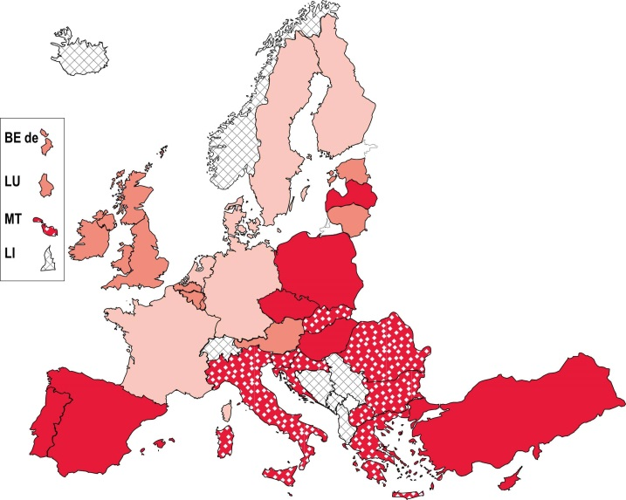 |  |  |  |  | Women  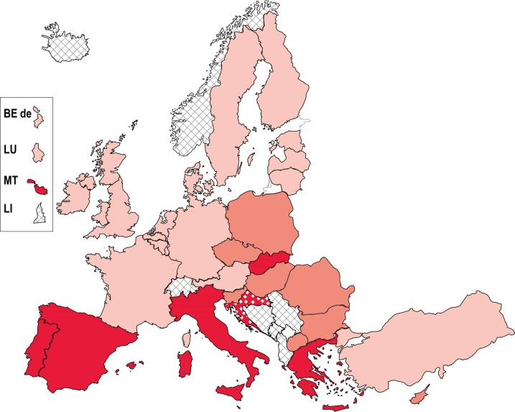
EU youth indicator |  |  | Age 19 - 24.9 |  | Age 25 - 27.5 |  |  | Age 27.6 - 29.9 |  | Age 30+
Source: Eurostat [yth_demo_030]

Common to all European countries, however, is that young women leave their parents earlier than young men, partly due to the fact that women starting to cohabit with their partners at an earlier age than men (). The gender difference was 2.2 years on average in the EU-28 in 2013 (). Differences between men and women are generally smaller in countries where young people tend to establish their own household earlier (only around seven months in Sweden, and around a year in Denmark and Luxembourg), in part because leaving home is not necessarily connected to moving in with a partner. Conversely, gender differences are greater in countries where young people arrive at the crucial point of establishing their own household later in their lives (the gap is almost five years in Bulgaria, Romania and Turkey and 8.4 years in the former Yugoslav Republic of Macedonia ()), and where leaving the parental household coincides more with moving in with a partner (). In some countries in this group, young people tend to stay with their parents even after starting to cohabit with their partner ().
Differences between countries in the average age of leaving the parental home also influences the poverty rates shown in the indicators, as they usually combine the data for both independent young people and those living with their parents, and, as will be shown later, moving out of the family home increases the risk of poverty for young people. For this reason, where possible, the next section will make distinctions between these two groups when comparing levels of poverty and social exclusion.
5.3. Levels of poverty and social exclusion
The main indicator of poverty and social exclusion is the composite indicator of 'at-risk-of-poverty or social exclusion'. This indicator is based on three sub-indicators of poverty: the at-risk-of-poverty rate; the severe material deprivation rate; and the rate of living in a household with very low work intensity. People at risk of poverty or social exclusion are defined as the proportion of the population that falls into at least one of the categories described by the three sub-indicators. While each of these sub-indicators will be defined and illustrated in the following sections, the analysis focuses first on the composite indicator.
As Figure 5-B-a shows, on average in the EU-28, the at-risk-of-poverty or social exclusion rate for young people aged 15 to 29 (29.0 % in 2013) is higher than that for children under the age of 16 (27.3 %) or for the total population (24.5 %). Moreover, the at-risk-of-poverty or social exclusion rates in 2013 stopped increasing for both the total population and children (for children, there had even been small decrease between 2010 and 2011), but continued to rise for young people, widening the poverty gap between young people and the total population. This disparity is mostly due to an increasing proportion of young people living in households with very low work intensity – thus to rising levels of unemployment until 2013 (see Figure 5-J as well as Chapter 4). Within the group of young people, the at-risk-of-poverty or social exclusion rate was the highest for the 20 to 24 age group (31.5 %) in 2013 (), since most young people complete education, enter the job market and strive to become independent at this age (see Chapter 3, Section 3.5).
The at-risk-of-poverty or social exclusion rate continues to rise for young people.
On analysing the gender differences, Figure 5-B-b shows that young women are in a more difficult situation than men – partly because they move out of the parental household earlier – though their at-risk-of-poverty or social exclusion rates have shown a slight decline since 2012, while the rates for men have continued to increase.
Figure 5-B: EU youth indicator: At-risk-of-poverty or social exclusion rate, EU-28 average, 2010-2013

EU youth indicator | by age | 15-29 year olds, by sex
EU youth indicator | % % | % %
EU youth indicator | 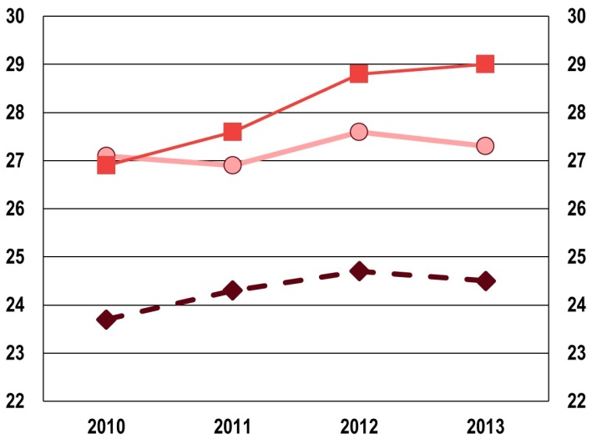 | 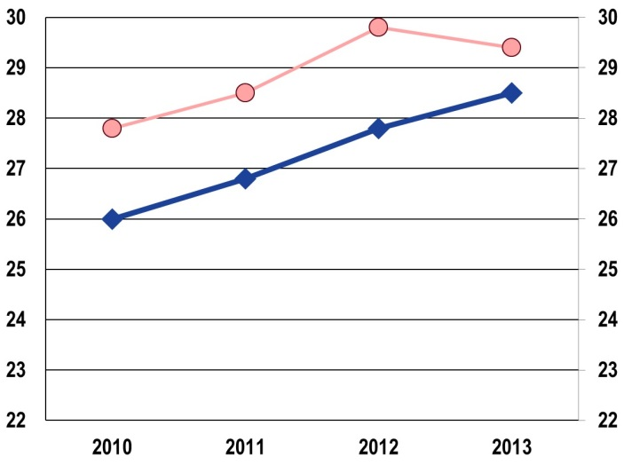
EU youth indicator
   | Aged <16 |  | Aged 15-29 |  | Total
   | Men |  | Women
Source: Eurostat, Statistics on income and living conditions (SILC) [yth_incl_010 and ilc_peps01]
 | Figure 5-C: EU youth indicator: At-risk-of-poverty or social exclusion rate for young people (aged 16-29), EU-28 average, by living arrangements and by age, 2013
EU youth indicator | % %
EU youth indicator | 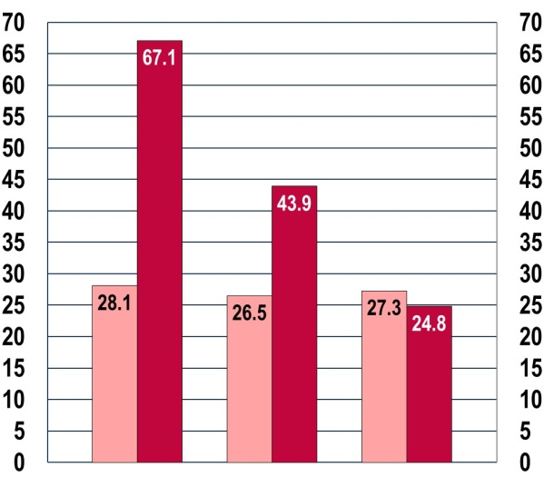
EU youth indicator |  | Aged 16-19 | 20-24 | 25-29
EU youth indicator
   | Living with parents |  | Not living with parents
 | Source: Eurostat, Statistics on income and living conditions (SILC) [yth_incl_030]
As discussed above, moving out of the parental household increases the risk of poverty for young people. Indeed, as Figure 5-C illustrates, the differences between young people living with their parents or living independently are substantial, especially in the younger age groups. In 2013, the gap between young people living with their parents or not was 39.0 percentage points in the 16 to 19 age group, 17.4 percentage points among 20 to 24 year olds, while it was only 2.5 percentage points in the favour independent young people in the oldest, 25 to 29 age group.
Other important factors influencing the risk of poverty or social exclusion of young people include their level of education (the more educated young people are, the lower their risk of poverty ()), or their immigrant status (see Section 5.5.2).

Figure 5-D shows differences across European countries in the at-risk-of-poverty or social exclusion rate. As the figure depicts, for children, the at-risk-of-poverty or social exclusion rate is the highest in Bulgaria, Hungary, Romania, the former Yugoslav Republic of Macedonia and Serbia, exceeding 40 % in all five countries, and even 50 % in Bulgaria and the former Yugoslav Republic of Macedonia. The proportion of young people (aged 15 to 29) at risk of poverty or social exclusion surpasses 40 % in Bulgaria, Greece, Romania and Serbia. The rates for children are the lowest in Finland and Norway; and for young people in the Czech Republic, the Netherlands, Austria, Slovenia and Iceland.
Figure 5-D: EU youth indicator: At-risk-of-poverty or social exclusion rate, by country and by age, 2013
EU youth indicator | % %  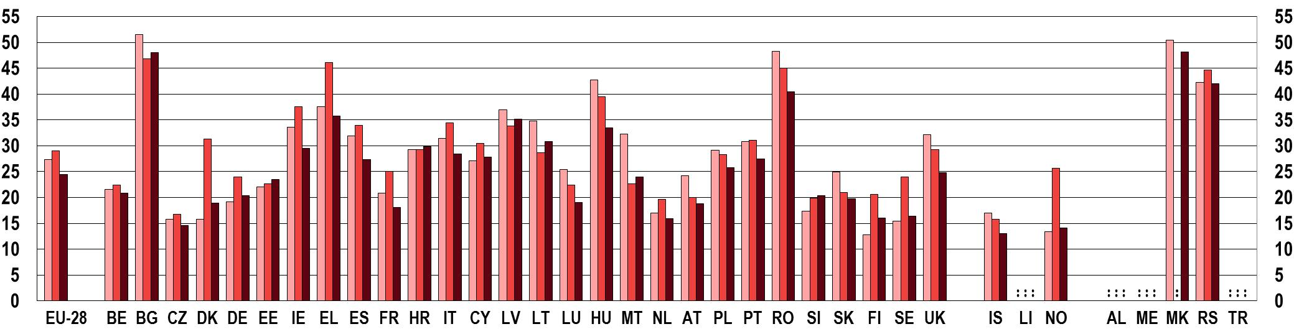
EU youth indicator
   | Aged <16 |  | Aged 15-29 |  | Total population
Source: Eurostat, Statistics on income and living conditions (SILC) [yth_incl_010 and ilc_peps01]

Figure 5-D also illustrates the relatively more vulnerable position of young people in most European countries. Differences between the at-risk-of-poverty or social exclusion rates of young people and the total population are the largest in the Nordic countries, especially in Denmark and Norway, where the share of young people at risk of poverty or social exclusion is more than double that of the total population. This is partly because young people leave the parental home much earlier in this region than in other parts of Europe, thus putting themselves at greater risk. However, as will be discussed below, when taking into account only those not living with their parents, young people in these countries still face a higher risk of being in poverty.

5.3.1. The at-risk-of-poverty rate
The sub-indicator of the composite 'at-risk-of-poverty or social exclusion rate' that measures poverty in relative terms is the at-risk-of-poverty rate. For this indicator, a relative poverty threshold is defined at 60 % of the net median equivalised disposable income (), and the population with income below this threshold is regarded as being at risk of poverty ().
Given the differences across countries in the average age when young people leave the parental household, the at-risk-of-poverty rate can be misleading if used for international comparisons of 15-29 year-olds. For this reason, the Dashboard of Youth Indicators only considers the at-risk-of-poverty rate for children in comparison to the total population (Figure 5-E and 5-F). Nevertheless, it is still helpful to look at the at-risk-of-poverty rates across Europe for young people not living with their parents (Figure 5-G).
On average in the EU-28, the at-risk-of-poverty rate has been decreasing for children since 2010, and for the total population the increasing trend also reversed between 2012 and 2013 (Figure 5-E). Nevertheless, the average at-risk-of-poverty rate for the total population was still higher in 2013 than in 2010.
In the EU-28 on average and in the majority of European countries, the average at-risk-of-poverty rate is higher for children than for the total population (Figure 5-F). The exceptions are Denmark, Germany, Estonia, Finland and Norway, where children have a relatively lower risk of poverty. In 2013, the at-risk-of-poverty rate for children was highest in Bulgaria, Greece, Romania, the former Yugoslav Republic of Macedonia and Serbia, while it was lowest in the Czech Republic, Denmark, Finland and Norway. In contrast to the European trend, the at-risk-of-poverty rates for children grew by more than 3 percentage points between 2010 and 2013 in Greece and Hungary ().
 | Figure 5-E: EU youth indicator: At-risk-of-poverty rate, EU-28 average, by age, 2010-2013
EU youth indicator | % %
EU youth indicator | 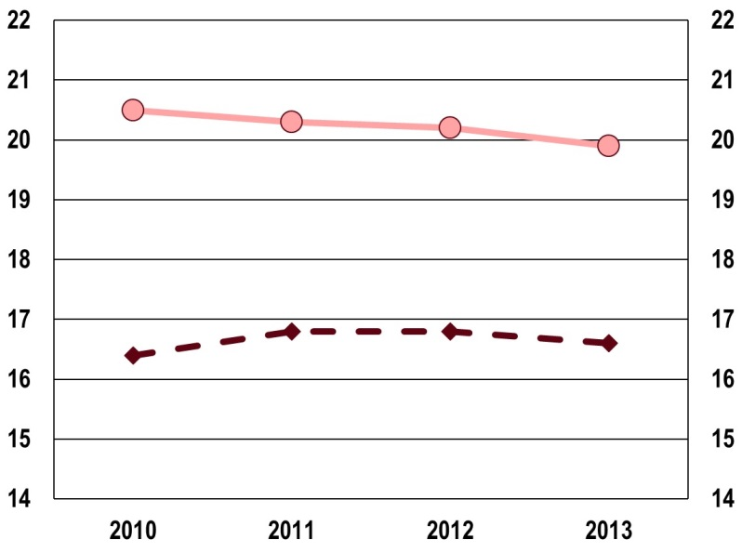
EU youth indicator
   | Aged <16 |  | Total
 | Source: Eurostat, Statistics on income and living conditions (SILC) [ilc_li02]

Figure 5-F: EU youth indicator: At-risk-of-poverty rate, by country and by age, 2013
EU youth indicator | % %  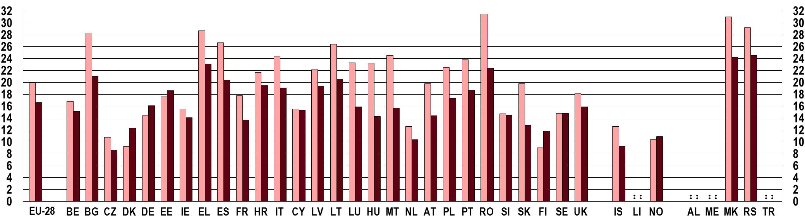
EU youth indicator
   | Aged <16 |  | Total population
Source: Eurostat, Statistics on income and living conditions (SILC) [ilc_li02]

In assessing the risk of poverty for young people, it is useful to examine the extent of the problem for those no longer living with their parents. Figure 5-G therefore includes young people aged 20 to 29 who have moved out of the parental household. This wider age group has been chosen to take into account the differences across Europe in the average age of leaving the parental home. However, it has to be kept in mind that young people aged 20 to 24 living independently are on average twice as likely to be at risk of poverty as their older peers aged 25 to 29 ().
Figure 5-G: At-risk-of-poverty rate for young people (aged 20-29) not living with parents, by country, 2010 and 2013
% %
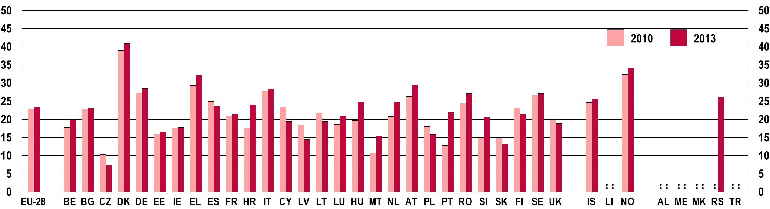
Source: Eurostat, Statistics on income and living conditions (SILC) [yth_incl_060]

In 2013, the highest risk of poverty for young people aged 20 to 29 not living with their parents was found in Denmark – more than 40 %; and the rate also exceeded 30 % in Greece and Norway. Though young people move out of the parental household at different ages in these countries, data still show that young people face much lower income levels than the total population if they choose to live independently. In contrast, the lowest risk of poverty amongst this group in 2013 (below 15 %) was found in the Czech Republic, Latvia and Slovakia.
At-risk-of-poverty rates for young people not living with their parents are relatively high across the EU and, in the majority of countries, increased between 2010 and 2013.
When comparing the proportion of young people aged 20 to 29 living independently and at risk of poverty in 2010 and 2013, data show that in the EU-28 as well as in the majority of countries, this proportion increased in this period. The most significant increases took place in Croatia (6.5 percentage points), Hungary (5 percentage points), Portugal (9.2 percentage points) and Slovenia (5.6 percentage points).

5.3.2. Severe material deprivation
The severe material deprivation rate () complements the at-risk-of-poverty rate in two important respects. First, instead of defining a poverty threshold that varies between countries, it is based on a single European threshold. For this reason, it is a more absolute measure of poverty, and can capture the differences in living standards between countries. Second, while the relative poverty indicator is based on current income, the severe material deprivation rate takes non-monetary resources into account.
As with the indicators discussed above, in 2013, the severe material deprivation rate was the highest for young people (aged 15 to 29), followed by children (under 16 years of age), while the rate for the total population was lower than either sub-group. As Figure 5-H shows, after substantial increases between 2010 and 2012, material deprivation rates started falling across the board. This decline was the largest for children under 16, from 11.7 % to 11 %.
 | Figure 5-H: EU youth indicator: Severe material deprivation rate, EU-28 average, by age, 2010-2013
EU youth indicator | % %
EU youth indicator | 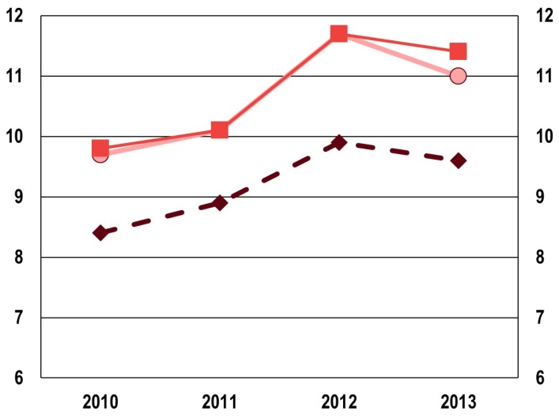
EU youth indicator
   | Aged <16 |  | Aged 15-29 |  | Total
 | Source: Eurostat, Statistics on income and living conditions (SILC) [yth_incl_070 and ilc_mddd11]

The severe material deprivation rate is higher for children and young people than for the total population also in the majority of European countries (Figure 5-I). In the EU-28 in 2013, the severe material deprivation rate was the highest in Bulgaria (exceeding 40 % for both children and young people), followed by Hungary and Romania (exceeding 30 % for the youngest age groups). Conversely, the proportion of both children and young people experiencing severe material deprivation was below 5 % in Luxembourg, the Netherlands, Finland, Sweden, Iceland and Norway.
Severe material deprivation rates vary considerably across European countries, ranging from below 1 % to over 40 %.
Figure 5-I: EU youth indicator: Severe material deprivation rate, by country and by age, 2013
EU youth indicator | % %  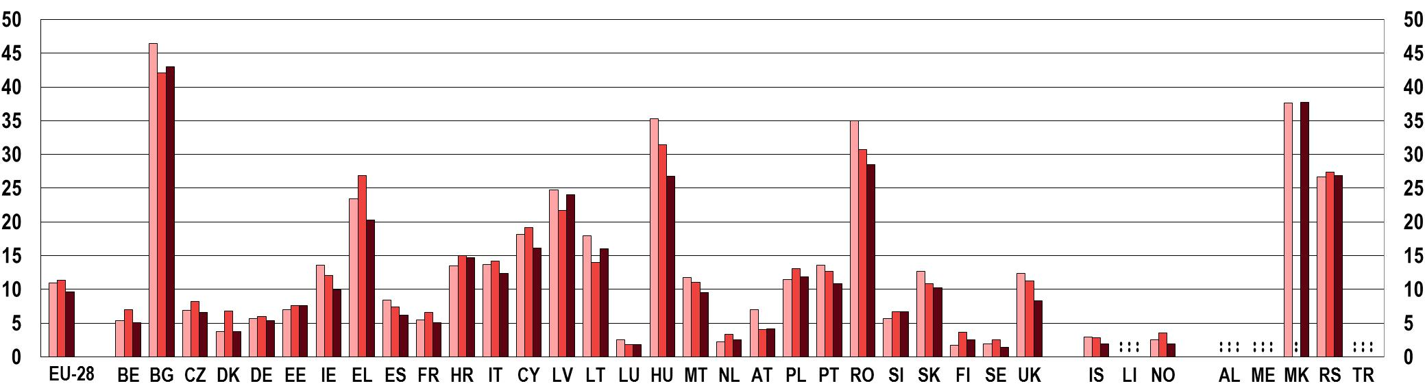
EU youth indicator
   | Aged <16 |  | Aged 15-29 |  | Total population
Source: Eurostat, Statistics on income and living conditions (SILC) [yth_incl_070 and ilc_mddd11]
5.3.3. Households with very low work intensity
Since unemployment influences poverty and social exclusion levels to a great extent, this section focuses on children and young people living in households with very low work intensity. This is the third sub-indicator of the main composite indicator of poverty or social exclusion. The indicator on persons living in households with low work intensity is defined as the share of the population living in a household having work intensity which equals or is below the threshold of 0.20 ().
An increasing proportion of young people live in households with very low work intensity, showing the impact of rising youth unemployment rates.
The changes in the proportion of the population living in households with very low work intensity have not been consistent across the different age groups in recent years. For young people and the total population (people below the age of 60), the proportion has been increasing since 2008 (). However, the rate for young people has been rising faster, to the extent that in 2012, the proportion of young people aged 15-29 living in households with very low work intensity reached the same level as that for the total population under 60 years of age (Figure 5-J). This shows the impact of rising levels of youth unemployment on the poverty levels of young people (). In contrast, the share of children under the age of 18 living in households with very low work intensity decreased between 2010 and 2012 but started rising again in 2013.
 | Figure 5-J: EU youth indicator: Proportion of people living in households with very low work intensity, EU-28 average, by age, 2010-2013
EU youth indicator | % %
EU youth indicator | 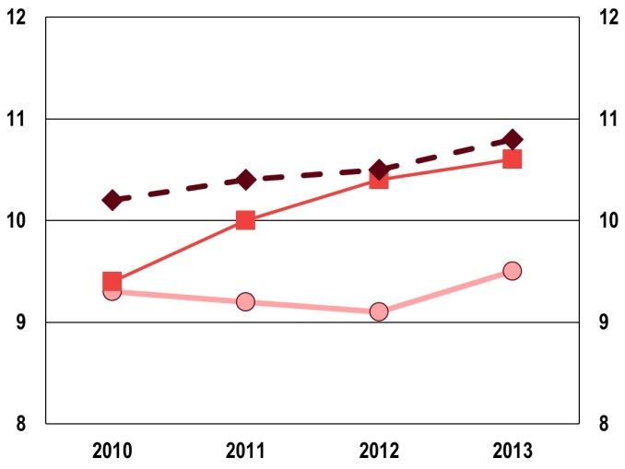
EU youth indicator
   | Aged <18 |  | Aged 15-29 |  | Aged <60
 | Source: Eurostat, Statistics on income and living conditions (SILC) [yth_incl_100 and ilc_lvhl11]
Figure 5-K depicts the wide differences across Europe in the proportions of people living in households with very low work intensity. Different patterns exist regarding the relative position of children (aged under 18), young people and the total population under 60 years of age. In six countries, it is children who are in the most vulnerable position, (Bulgaria, Hungary, Malta, Slovakia, the United Kingdom and Iceland); while in eight others, it is young people aged 15 to 29 (Denmark, Germany, Ireland, Spain, France, Italy, Sweden, Norway). However, in 17 other countries, the proportions of both children and young people living in households with very low work intensity are lower than in the total population under the age of 60.
Figure 5-K: EU youth indicator: Proportion of people living in households with very low work intensity, by country and by age, 2013
EU youth indicator | % %  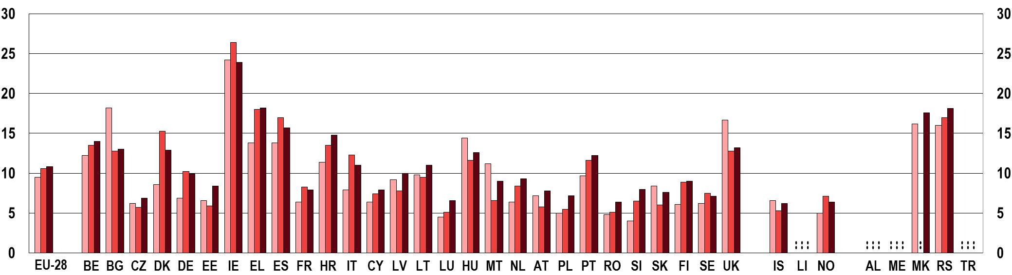
EU youth indicator
   | Aged < 18 |  | Aged 15-29 |  | Aged < 60
Source: Eurostat, Statistics on income and living conditions (SILC) [yth_incl_100 and ilc_lvhl11]

The share of young people aged 15 to 29 living in households with very low work intensity is the highest in Ireland (26.4 %), followed by Greece (18 %), Spain and Serbia (17 %), and Denmark (15.3 %). This proportion is the lowest in Luxembourg, Romania and Iceland.
Nevertheless, given that this indicator is based on household composition, whether young people are living with their parents or not makes a difference. In most European countries, the proportion of young people living in households with very low work intensity is much higher for those not sharing a household with their parents. In 2013, in the 20 to 29 age group, the difference was greatest in Denmark, where the proportion of young people living in households with very low work intensity was 3.5 times higher for those living outside the family home than for those who were still living with their parents (). Differences were also relatively large in Bulgaria, Croatia and Hungary. However, in twelve other countries, particularly in Greece, Spain and Serbia, the proportion of young people living in low-work intensity households was higher among those living with their parents than among those living independently.
5.4. Other aspects of poverty and social inclusion
Poverty and social exclusion are multi-dimensional phenomena which cannot be understood solely in terms of people's income. The other dimensions that should be taken into account include access not only to basic services such as housing and healthcare, but also to good, well-paid jobs. Limited access to these basic necessities forms part of the root cause of poverty and helps to explain how individuals and families become socially excluded.
Homelessness and housing exclusion represents one of the most extreme forms of poverty and deprivation in society today (). One of the key challenges of the Europe 2020 strategy is to provide decent (in terms of quality and cost) housing for everyone. The cost and quality of housing is key to providing adequate living standards as well as promoting young people's well-being; however a shortage of adequate housing is a long-standing problem in most European countries ().
Furthermore, limited access to healthcare contributes to deterioration in people's health and can have repercussions on their ability to work. The relatively high cost of medical examinations and treatments (both important aspects of healthcare) represents a barrier to individuals on low incomes obtaining healthcare and as such becomes a main driver of social exclusion.
Finally, when assessing poverty and social exclusion, it must be remembered that these phenomena do not only affect those who are economically inactive or unemployed. Indeed employment does not necessarily make the risk of poverty disappear. Consequently, young people's employment conditions should be looked at carefully, as in-work-poverty, that is poverty among the employed population, is a key indicator in understanding young people's susceptibility to poverty and social inclusion.

5.4.1. Housing conditions and homelessness
The cost and quality of housing are extremely important for living standards and well-being. Having access to decent housing and being part of a community is crucial if people are to realise their full economic potential and to contribute productively to society (). However, most European countries continue to have a shortage of adequate housing for their population. Currently, there is no single definition of homelessness that is accepted in all EU Member States. In 2010, a range of stakeholders and the European Commission agreed on the European Typology of Homelessness and Housing Exclusion (ETHOS). This typology distinguishes four main concepts of homelessness: 'rooflessness', 'houselessness', 'insecure housing' and 'inadequate housing' (). The attention in this section is on the last concept: inadequate housing.
A useful indicator to measure inadequate housing is the severe housing deprivation rate. Housing deprivation is a measure of poor amenities and is calculated by referring to those households with a leaking roof, no bath/shower and no indoor toilet, or a dwelling considered too dark. Severe housing deprivation is defined as the percentage of the population living in a dwelling which is considered as overcrowded whilst also manifesting at least one of the other shortcomings listed above ().
The housing deprivation rate of young people aged 15-29 was 7.7 % in 2013 at EU-28 level. At country level, the severe housing deprivation rate among young people was the highest in Latvia (22.5 %), Hungary (24.4 %) and Romania (30.2 %). Conversely, Finland (1.3 %) and Belgium (1.5 %) recorded the lowest values (Figure 5-L).
Figure 5-L indicates a decrease (from 8.5 % to 7.7 %) in the housing deprivation rate among young people (15-29) in the EU between 2010 and 2013. Indeed, in two-thirds of countries, the rate fell between 2010 and 2013. The biggest reductions are recorded in Slovenia (10.3 percentage points), Estonia (6.5 percentage points) and Lithuania (6.0 percentage points); while the countries with the highest increase over the period are Denmark (4.1 percentage points), Italy (3.1 percentage points) and the Ireland (2.8 percentage points).
Figure 5-L: Severe housing deprivation rate for young people (aged 15-29), by country, 2010 and 2013
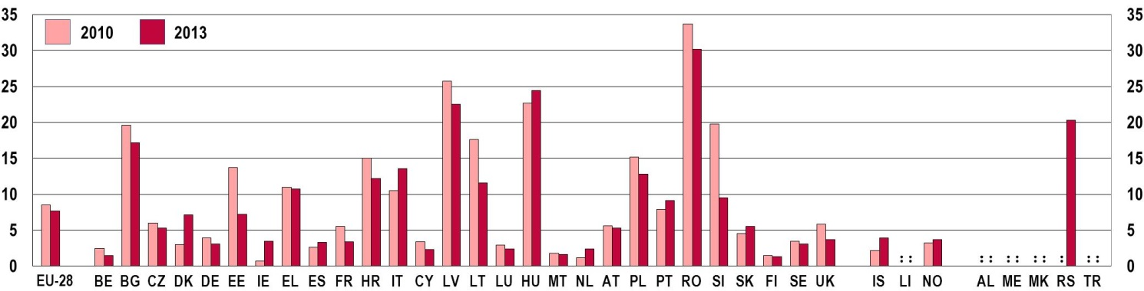
Source: Eurostat, Statistics on income and living conditions (SILC) [yth_incl_140]

The overcrowding rate, which focuses on the availability of sufficient space in the dwelling, can shed further light on the housing conditions of young people. The overcrowding rate is defined by the number of rooms available to the household, the household's size, as well as its members' ages and family situation ().
In 2013, as Figure 5-M shows, the EU-28 average overcrowding rate for young people aged 15-29 was 26.6 %. In comparison to 2010, when the overcrowding rate of young people accounted for 27.2 %, the new rate in 2013 represents a small improvement.
The highest overcrowding rates for young people in 2013 were observed in Bulgaria (60.0 %), Hungary (62.4 %), Romania (69.1 %) and Serbia (67.9%), while the lowest were recorded in Belgium (3.0 %), Cyprus (4.1 %), and Malta (5.8 %). During the period between 2010 and 2013, important improvements were registered in Slovenia (-23.3 percentage points), Estonia (-23.1 percentage points) and Lithuania (-21.8 percentage points).
Figure 5-M: Overcrowding rate among young people (aged 15-29), by country, 2010 and 2013
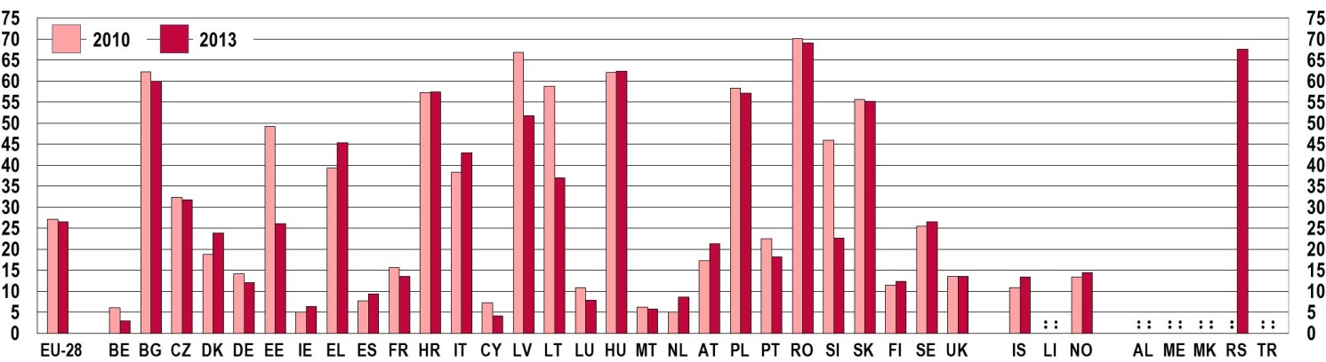
Source: Eurostat, Statistics on income and living conditions (SILC) [yth_incl_150]

As explained in earlier sections, leaving the parental home and establishing a separate household is a crucial moment in young people's lives and has a strong influence on their risk of poverty (see Section 5.3.2). In this respect, housing costs have a significant impact on young people's living conditions. Given that young people have to face many hurdles in their transition from education to work (see Chapter 3), the question of affordable housing is becoming even more important.
The 'housing cost overburden rate' shows the percentage of the population living in households where the total housing costs ('net' of housing allowances) represent more than 40 % of disposable income (). In 2013, 12.7 % of the EU-28 population aged 15-29 lived in households where they spent more than 40 % of their disposable income on housing (Figure 5-N).
Figure 5-N: Housing cost overburden rate for young people (aged 15-29), by country, 2010 and 2013
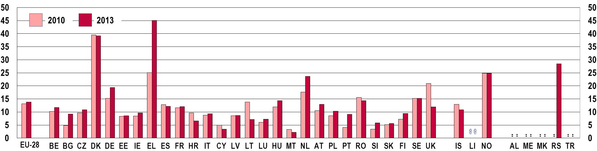
Source: Eurostat, Statistics on income and living conditions (SILC) [yth_incl_160]

The 'housing cost overburden rate' for young people aged 15-29 for the EU-28 rose in comparison to 2010. At country level, over the period between 2010 and 2013, the largest increases in the rate for the age group 15-29 are recorded in Greece (19.8 percentage points), Bulgaria (5.4 percentage points) and Portugal (5.2 percentage points).
The housing cost overburden rate for young people increased between 2010 and 2013.
A deeper analysis into age sub-groups reveals that the relative increase is much higher for young people aged 25-29 (+1.1 percentage points) than for the younger age group 20-24 (+0.2 percentage points). Maintaining their own household was the most burdensome for the younger age group, in Denmark (43.6 %), Greece (49.3 %), and Serbia (32.1 %). Also for the 25 to 29 year-olds, the housing cost overburden rate was the highest in Denmark (25.1 %), Greece (40.6 %) and Serbia (26 %). As was discussed above, Denmark and Greece are among the countries with the highest at-risk-of-poverty rates for young people not living with their parents (see Figure 5-G).

5.4.2. Access to health care
Another important aspect of social inclusion for young people is their access to health care. The self-reported unmet need for medical care is a good indicator with which to assess it. Accordingly, the self-reported unmet need for medical care was included among the EU youth indicators as a further pointer to social exclusion among young people.
In 2013, the proportion of young people aged 16 to 24 reporting unmet needs for medical examination (due to its being too expensive, having to travel too far, or as a result of waiting lists) was 1.5 % at EU-28 level (Figure 5-O). This value is around half the rate for the total population (3.6 %), and is due partly to young people having fewer health-related problems than older age groups (see Chapter 6).
Figure 5-O: EU youth indicator: Self-reported unmet needs for medical examination due to access barriers, by country and by age, 2013
EU youth indicator | % %  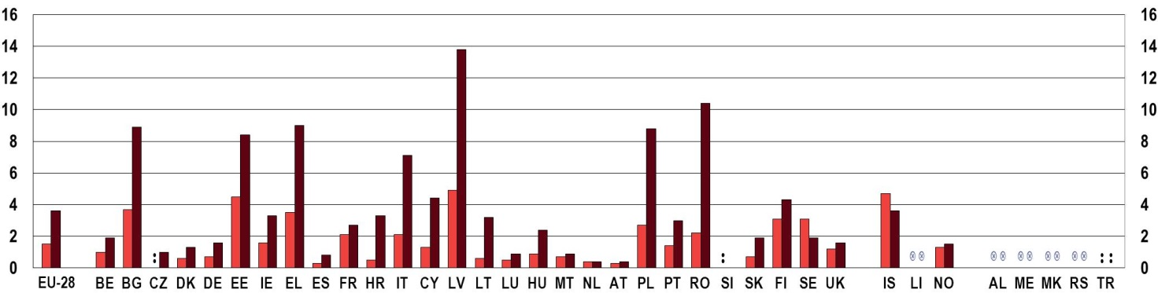
EU youth indicator
   | Aged 16-24 |  | Total
Notes: Czech Republic: data not reliable for young people aged 16-24.
Source: Eurostat, Statistics on income and living conditions (SILC) [hlth_silc_03]

In the EU-28, the proportion of young people (aged 16-24) with unmet medical needs has on average been stable since 2010 (Figure 5-P). In 2013, the highest proportion of young people reporting unmet needs for medical examination was recorded in Latvia (4.9 %) and Iceland (4.7 %). Conversely, Spain (0.3 %) had the lowest proportion of young people reporting unmet needs for medical examination (Figure 5-O). Over the period 2010-2013, the biggest increases in the proportion of young people reporting unmet needs for medical examination were recorded in Estonia (3.0 percentage points) and Greece (2.1 percentage points).
 | Figure 5-P: EU youth indicator: Self-reported unmet needs for medical examinations among young people (aged 16-24) because of barriers to access, EU-28 average, by sex, 2010-2013
EU youth indicator | % %
EU youth indicator | 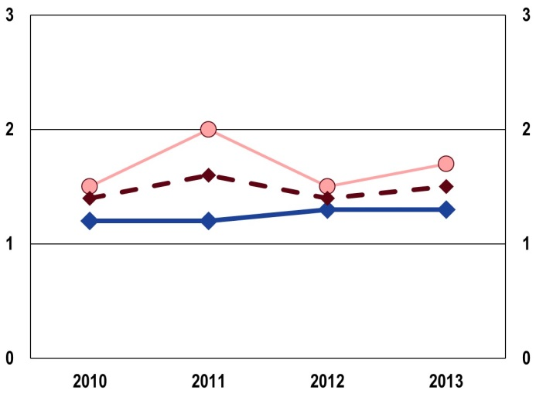
EU youth indicator
   | Men |  | Women |  | Total
 | Source: Eurostat, Statistics on income and living conditions (SILC) [ilc_iw01]
Between 2010 and 2013, young women reported higher levels of unmet medical needs than young men (Figure 5-P). In 2013, the proportion of young women aged 16-24 reporting unmet medical needs was 0.4 percentage points higher than the one recorded for young men in the same age group.
The proportion of young people (aged 16-24) with unmet needs for medical care has been stable on average at the EU-28 level since 2010.

5.4.3. In-work poverty
Poverty among those of working age can reflect both labour market exclusion (not having access to jobs) and in-work poverty (being in employment, but not earning enough to make a living) (). Given the difficulties for young people in the labour market (see Chapter 4), it is particularly important to examine the effect this has on their risk of poverty and social exclusion. The EU-28 average in-work at-risk-of-poverty rate for young people aged 15-29 in 2013 was 9.5 % (Figure 5-Q).
At country level, the highest in-work at-risk-of-poverty rates for young people aged 15-29 were recorded in Romania (21.4 %), Norway (16.7 %), and Greece (14.6 %). On the other side of the spectrum, Belgium (3.6 %), Czech Republic (2.5 %) and Slovakia (2.8 %) showed the lowest rates.
Figure 5-Q: In-work at-risk-of-poverty rate for young people (aged 15-29) by country, 2010 and 2013
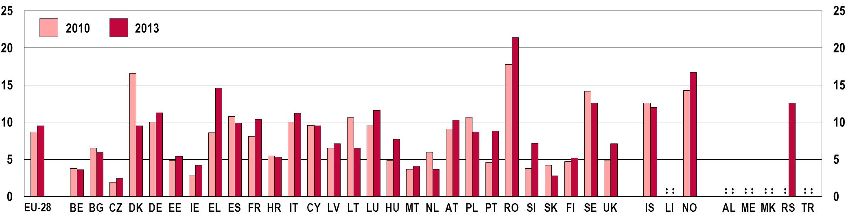
Source: Eurostat, Statistics on income and living conditions (SILC) [yth_incl_130]

Over the period 2010-2013, the EU-28 in-work-at-risk-of-poverty rate for young people (aged 15-29) increased by 0.8 percentage points from 8.7 % in 2010 to 9.5 % in 2013. However, as Figure 5-R shows, the increase took place between 2010 and 2011; since 2011, the in-work-at-risk-of-poverty rate of young people has been falling in the EU-28. Nevertheless, the situation varies at country level: the in-work-at-risk-of-poverty rate for young people increased significantly in Greece (by 6.0 percentage points), Portugal (by 4.2 percentage points), and Romania (by 3.6 percentage points); while it decreased considerably in Denmark (by 7.1 percentage points), Lithuania (by 4.1 percentage points) and the Netherlands (by 2.3 percentage points).
From a gender perspective, the EU-28 average in-work at-risk-of-poverty rate was slightly higher for young men than women in 2013 (Figure 5-R). At country level, the highest gender gap in 2013 (where the rate for men was higher than for women) is recorded in Romania (7.1 percentage points) and Serbia (7.4 percentage points). However, for some countries the gender gap is reversed, with a higher in-work at-risk-of-poverty rate for women than men. This is case in Italy (3.2 percentage points higher for women than men), Lithuania (4.4 percentage points) and Iceland (4.8 percentage points) ().
Figure 5-R: In-work at-risk-of-poverty rate for young people (aged 15-29), EU-28 average, 2010- 2013
% %
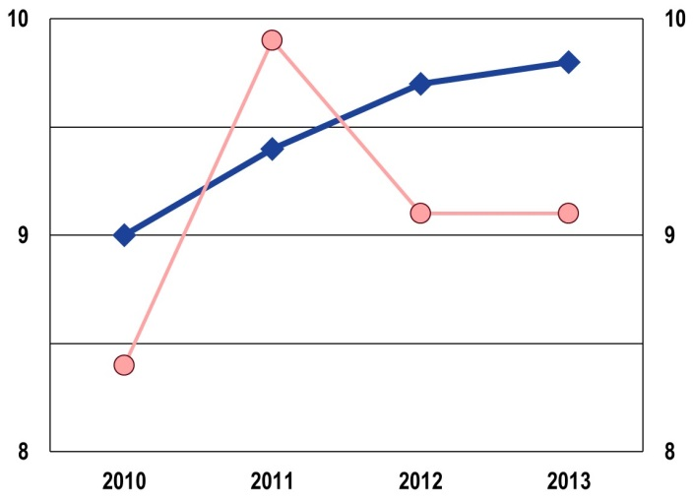
 | Men |  | Women

Source: Eurostat, Statistics on income and living conditions (SILC) [yth_incl_130]

5.5. Groups at risk of social exclusion
After discussing the main poverty and social exclusion indicators as well as specific aspects of poverty, the last section of this chapter turns to specific groups of young people who are more vulnerable to poverty and social exclusion than others. Specific groups of young people most affected by poverty or social exclusion include women, lower educated young people and migrants (). Since the situation of young women was discussed above, two groups of young people were selected for this section: young people who are not in employment, education or training (NEETs) and young people from a migrant background.

5.5.1. Young people not in employment, education or training (NEETs)
The indicator on NEETs aims to capture the predicament of a vulnerable group of young people in transition between education and the labour market. This transition between school and work is increasingly complex and individualised for today's young people (see Chapter 4). Those most at risk are young people having disabilities, coming from a migrant background, having a low level of education, living in remote areas, having a low household income, as well as young people with parents who experienced unemployment, have low levels of education or are divorced ().
The difficulties faced in entering the labour market can lead to young people's disengagement from the world of work, making them vulnerable to social exclusion. The NEET group therefore includes not only the conventional unemployed job-seekers, but also those who are disengaged from both education and work and are therefore not looking for a job (). Being economically inactive, nevertheless, does not always imply disengagement: NEETs also include those unavailable for work (e.g. young carers or those who are sick or disabled), the 'opportunity-seekers' (those who are waiting for better opportunities), and the 'voluntary NEETs' (those who choose to be inactive while travelling or engaging in activities such as arts or self-directed learning) (). Yet, by not accumulating the human capital needed for work, even these last three subgroups are at risk of future social exclusion ().
After a steady rise in NEET rates of those aged 15-24 in the EU-28 from 2009 due to the economic crisis (), the NEET rate reached its peak of 13.1 % in 2012 and then started to decline (Figure 5-S). As Figure 5-S-b shows, this small decrease is due to a decline in the share of unemployed NEETs between 2013 and 2014, and, to a lesser degree, of inactive young people. In addition, looking at the educational background of NEETs reveals that, over the four years considered, the gap between young people with low levels of education and their peers with medium to high levels of education has widened to the disadvantage of the latter group (see Figure 5-S-d).
Following increases up to 2012, small decreases in the share of NEETs were recorded in 2013 and 2014, mainly due to the decline in the share of unemployed NEETs between 2013 and 2014.
In general in the EU-28, NEET rates are higher for women than for men (Figure 5-S-a). However, women are also the group for which the decline in the share of NEETs has been more relevant. Countries show great variation in regard to gender differences: NEET rates are actually higher for men in about half of EU-28 countries. Within the EU-28, differences between women and men exceed three percentage points in the Czech Republic, Hungary, Malta and Romania on the one hand (with higher NEET rates for women), and in Croatia, Cyprus, Luxembourg and Finland on the other hand (with higher NEET rates for men) (). With the exception of Malta, countries in the first group have periods of parental leave that are among the longest in Europe (), which can partly explain the relatively high share of inactive young women. Outside the EU-28, gender differences are the largest in Turkey, where NEET rates for women are exceptionally high (35 %, in contrast to the 14.6 % NEET rate for men), due to their very high inactivity rate ().
Figure 5-S: EU youth indicator: Proportion of young people (aged 15-24) not in employment, education or training (NEET rate), EU-28 average, 2011-2014

 | a) by sex | b) by labour market status
 | % % | % %
 | 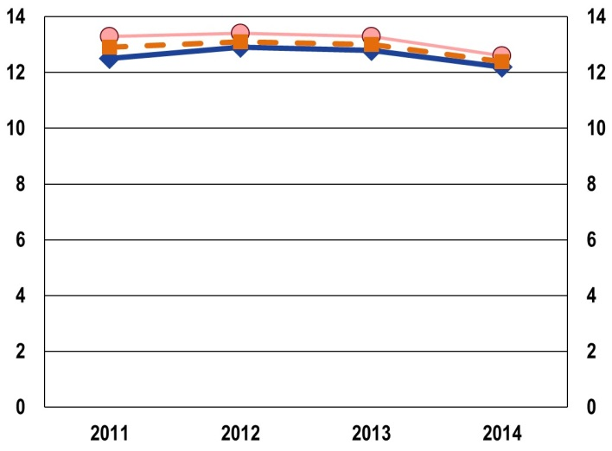 | 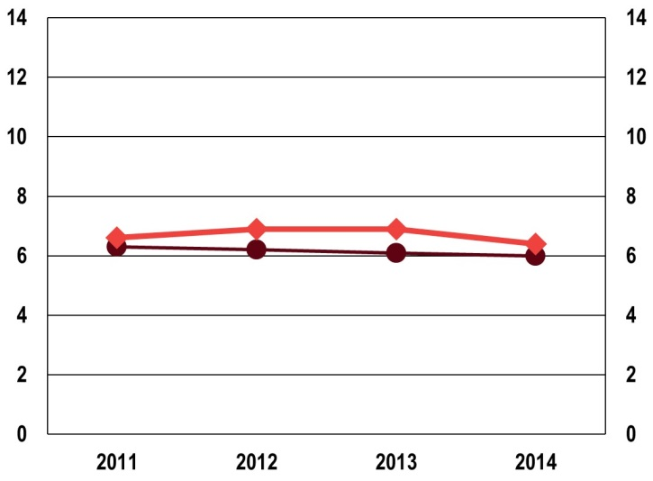
   | Men |  | Women | ○ | Total
   | Unemployed |  | Inactive
EU youth indicator | c) by attitudes towards work | d) by educational attainment
EU youth indicator | % % | % %
EU youth indicator | 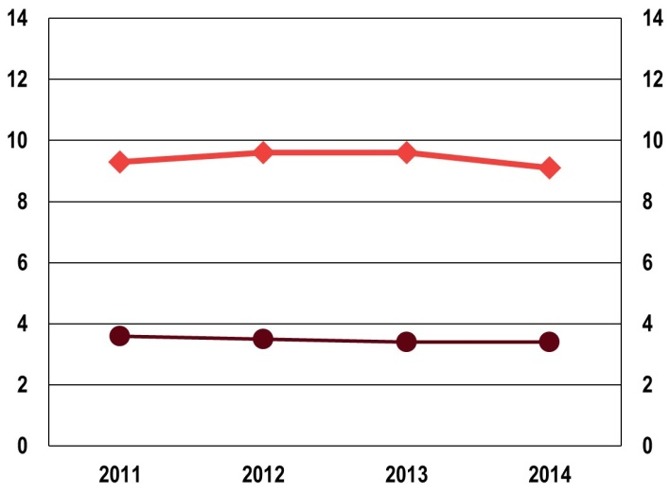 | 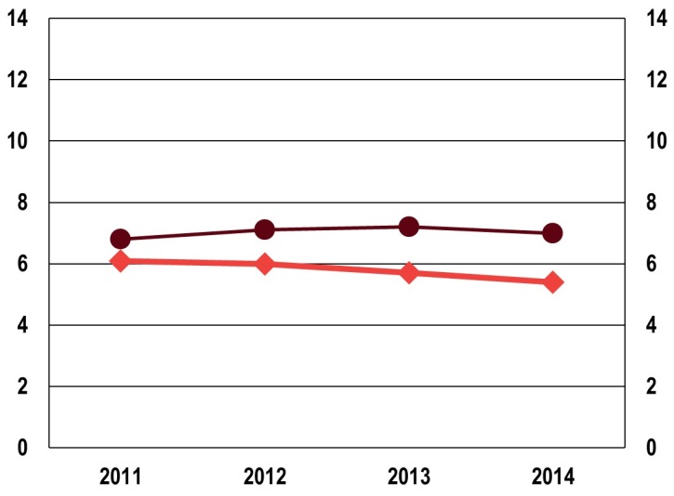
EU youth indicator
   | Persons who would like to work |  | Persons who do not want to work
   | ISCED 0-2 |  | ISCED 3-8
Source: Eurostat LFS [yth_empl_150 and yth_empl_160]

Looking at the differences between countries reveals that in 2014, NEET rates were the highest Bulgaria, Italy, the former Yugoslav Republic of Macedonia and Turkey, all exceeding 20 % (Figure 5-T). On the other hand, NEET rates were around 6 % or below in Denmark, the Netherlands, Iceland and Norway.
Between 2011 and 2014, NEET rates increased by more than 30 % in Luxembourg, the Netherlands and Slovenia (although from a relatively low level) and by more than 20 % in Croatia and Finland, with Croatia registering quite high proportions of NEETs in 2014 (19.3 %). In contrast, NEET rates decreased by more than 15 % in Ireland, Latvia, Lithuania, the United Kingdom and Turkey in this period (Figure 5-U).
Figure 5-T: EU youth indicator: Proportion of young people (aged 15 to 24) not in employment, education or training (NEET rate), by country, 2011 and 2014

EU youth indicator | % %  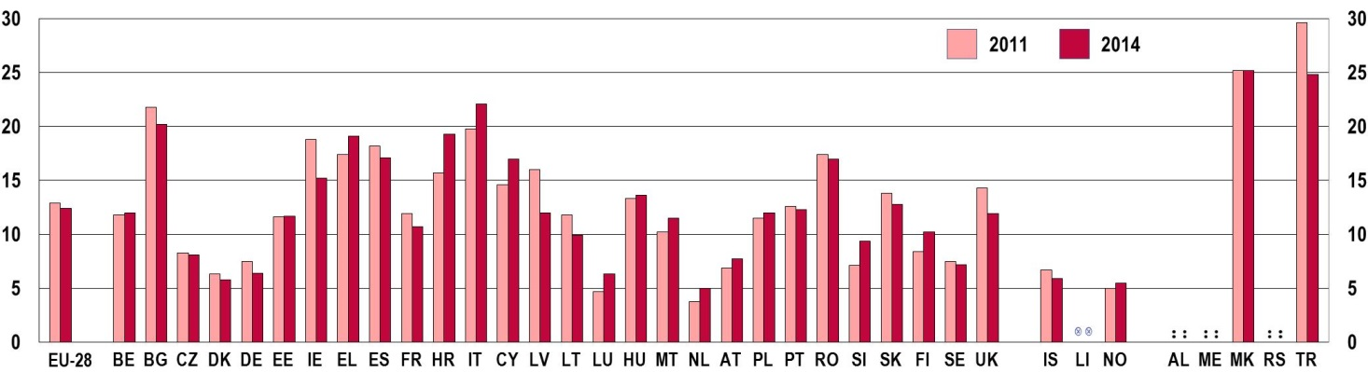
Notes: Break in series: France (2013)
Source: Eurostat LFS [edat_lfse_20]

5.5.2. Young people from a migrant background
Migrants and ethnic minorities are among the groups most vulnerable to poverty and social exclusion. They usually face multiple disadvantages leading to persistent poverty and a marginalised position in society. As the 2012 EU Youth Report pointed out, immigrants often lack the social capital (networks and information) needed for being fully included in society (). As a result, migrants tend to be more at risk of poverty and social exclusion than the native-born population.
Figure 5-U: At-risk-of poverty or social exclusion rate of young people (aged 16-29) by country of birth, EU-28 average, 2010-2013
% %
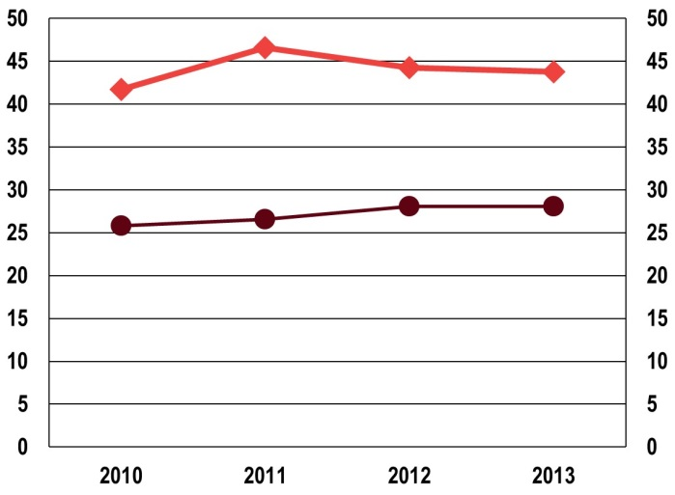
 | Foreign-born |  | Native-born (to reporting country)

Source: Eurostat [yth_incl_020]
Figure 5-U shows the at-risk-of-poverty or social exclusion rates of foreign- and native-born young people. The differences between these two groups are telling: foreign-born young people are considerably more likely to be at risk of poverty or social exclusion than native-born youth in the EU-28 (43.8 % vs. 28.1 % in 2013). Nevertheless, while the rate for native-born young people has continued to grow since 2010, it has slightly declined since 2011 for their foreign-born peers.
The greater risk of poverty or social exclusion for young immigrants is evident in almost all European countries (Figure 5-V). The risks for immigrant youth are especially large in Belgium, Austria and Slovenia, where the share of foreign-born young people who are at risk of poverty or social exclusion is about three times as high as for native-born youths. The smallest gaps in the poverty risk between native- and foreign-born youth are registered in the Czech Republic, Denmark, Ireland, Malta and the United Kingdom. Though the reliability of the data on foreign-born young people is open to question, Hungary appears to be the only country where native-born young people are more vulnerable to the risk of poverty or social exclusion than the foreign-born, mostly due to the composition of the foreign-born population (). The at-risk-of-poverty or social exclusion rates of foreign-born youth are highest in Greece (72.3 %), Belgium (52.9 %), Spain (53.9 %), and Finland (50 %).
Figure 5-V: At-risk-of poverty or social exclusion rate of native- and foreign-born young people (aged 16-29), by country, 2013
% %
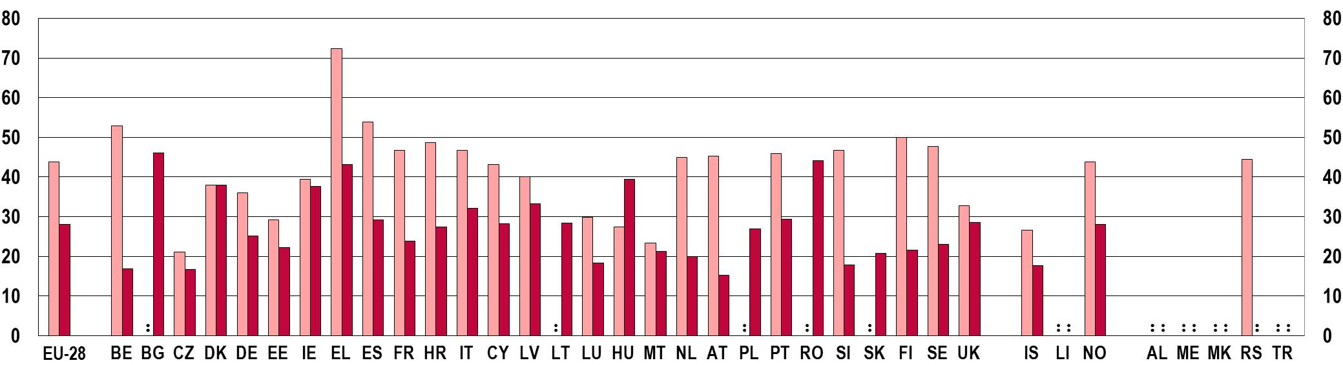

 | Foreign-born |  | Native-born

Notes: Data on foreign-born young people: Data not reliable and not publishable for Bulgaria, Lithuania, Poland, Romania and Slovakia. Data not reliable for Estonia, Latvia and Hungary.
Data on native-born young people: Serbia: not reliable and not publishable.
Source: Eurostat [yth_incl_020]

The situation looks similar when looking at second generation immigrants – the children of foreign-born parents. As Figure 5-W shows, the children of foreign-born parents are almost twice as likely to be at risk of poverty as the children of native-born parents in the EU-28 (31.1 % vs. 17.8 %). In addition, in contrast to the trends described above for young people, while the at-risk-of-poverty rates for children from native-born families decreased between 2010 and 2013, they increased slightly for the children of foreign-born parents ().
The risk for immigrant children is the largest again in Belgium, but it is also high in Denmark and Sweden, where the proportion of children from foreign-born families who are at risk of poverty is more than three times as high as the relevant share of the children of native-born parents. Conversely, in Hungary and Iceland, children from foreign-born families are at lower risk of poverty than children from native-born families. The at-risk-of-poverty rates of immigrant children are the highest in Greece (52.7 %), Spain (46 %), France (37.8 %) and Croatia (37.2 %), while they are lowest in Hungary (9.6 %) and Iceland (11.1 %).
Figure 5-W: At-risk-of poverty rate of children (aged 0 to 17 years) by parental origin and by country, 2013
% %
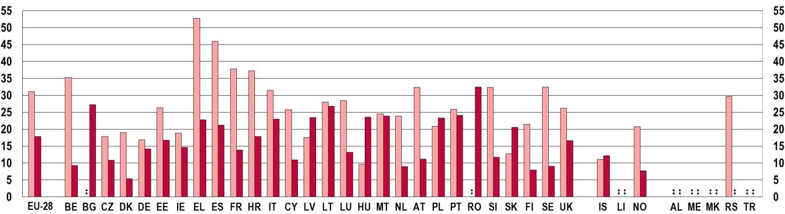

 | Foreign-born |  | Native-born
Notes: Data on children with foreign-born parents: EU-28 average: estimate. Data not reliable and not publishable for Bulgaria and Romania. Data not reliable for Poland and Slovakia.
Data on children with native-born parents: Serbia: not applicable.
Source: Eurostat, Statistics on income and living conditions (SILC) [ilc_li34]

Given the trans-generational transmission of poverty, children from poor families are also more likely to stay in poverty when they become adults (). Immigrant children and those from poorer families are more likely to leave school early and have fewer chances to attain higher education qualifications (), leading to further disadvantages in their working lives. Therefore, special attention must be paid to the issue of educational integration for young people from immigrant families.

(?) Flash Eurobarometer of the European Parliament (EP EB395) on the 'European Youth in 2014'.
(?) European Parliament, 2014.
(?) On inequalities and marginalisation among young people in ten European cities, see the 'CITISPYCE' project: http://www.aston.ac.uk/lss/research/research-centres/interland/citispyce/.
(?) Aassve et al. 2007, p. 331.
(?) EU-28 average. Source: Eurostat [yth_demo_030].
(?) Ibid.
(?) European Commission, 2012a.
(?) Iacovou, 2011.
(?) Source: Eurostat [yth_demo_030].
(?) Ibid.
(?) Iacovou, 2011.
(?) Ibid.
(?) Source: Eurostat SILC [yth_incl_010].
(?) Source: Eurostat SILC [ilc_peps04].
(?) The equivalised disposable income is the total income of a household, after tax and other deductions, that is available for spending or saving, divided by the number of household members converted into equalised adults; household members are equalised or made equivalent by weighting each according to their age, using the so-called modified OECD equivalence scale (Eurostat, 2015b).
(?) Eurostat, 2015c.
(?) Source: Eurostat SILC [ilc_li02].
(?) 2013. Source: Eurostat SILC [yth_incl_060].
(?) The severe material deprivation rate is defined as the percentage of the population that cannot afford at least four of the following nine pre-defined deprivation items: 1) to pay their rent, mortgage or utility bills, 2) to keep their home adequately warm, 3) to face unexpected expenses, 4) to eat meat or proteins regularly, 5) to go on holiday, or to buy a: 6) TV, 7) refrigerator, 8) car, or a 9) telephone (Eurostat, 2015d).
(?) The work intensity of a household is the ratio of the total number of months that all working-age household members have worked during the income reference year and the total number of months the same household members theoretically could have worked in the same period (Eurostat, 2015e).
(?) European Commission, 2012a.
(?) As the chapter on Employment and Entrepreneurship showed, youth unemployment rates started declining after 2013. However, poverty and social exclusion data are only available up to 2013.
(?) Source: Eurostat SILC, [yth_incl_120].
(?) European Commission, 2010a.
(?) Eurostat, 2015f.
(?) European Commission, 2013c.
(?) On ETHOS (Typology on Homelessness and Housing Exclusion), see http://www.feantsa.org/spip.php?article120&lang=en, accessed on 23/03/2015.
(?) Eurostat, 2015g.
(?) Eurostat, 2015h.
(?) Eurostat, 2015i.
(?) European Commission, 2014b.
(?) Eurostat, (SILC) [yth_incl_130].
(?) Eurostat, 2015j.
(?) Eurofound 2012, p. 55-56.
(?) Ibid, p. 23.
(?) Ibid, p. 24-25.
(?) Ibid.
(?) European Commission, 2012a.
(?) Source: Eurostat LFS [yth_empl_150].
(?) European Commission/EACEA/Eurydice/Eurostat 2014, p. 37.
(?) Source: Eurostat LFS [edat_lfse_20].
(?) European Commission 2012a, p. 213-214.
(?) On the typology of countries with respect to the type of migration inflow, see OECD, 2014a.
(?) Source: Eurostat SILC [ilc_li34].
(?) See e.g. Bellani and Bia, 2013.
(?) European Commission/EACEA/Eurydice, 2015.

