4. YOUTH EMPLOYMENT AND ENTREPRENEURSHIP

EU Youth Indicators
Unemployment rates among young people | Figures 4-D and 4-E
Long term youth unemployment rate | Figure 4-F
Unemployment ratio of young people | Figure 4-J
Young employees with a temporary contract | Figure 4-P
Young people who would like to set up their own business | Figure 4-S
Self-employed rate of young people | Figure 4-T

4.1. Introduction
The economic crisis in the European Union has dramatically changed the youth labour market to a degree that in almost all European countries, several years since the start of the crisis, young people are still facing unprecedented difficulties in finding a job. While youth unemployment was already quite high in 2011, during the following two years the situation deteriorated even further in most countries, with eleven of these registering their highest youth unemployment rate for the 15-24 age group either in 2012 or in 2013 (). The crisis has also had an important negative impact on young people aged between 25 and 29.
Analysing the situation of the 15-29 age group as a whole between 2011 and 2014, a significant contraction in employment is evident. Indeed, employment among those aged 15-29 decreased by more than 1.8 million, from 42.2 million in 2011 to 40.4 million in 2014 (). In parallel, young people increased their participation in education and training (for more details see Chapter 3), and they are equally more likely to become unemployed. In 2014, more than 8.5 million young people aged 15-29 were unemployed.
Moreover, an increasing percentage of young people in 2014 had only temporary, part-time work or other non-standard form of employment in comparison to 2011.
The aim of this chapter is to describe both the current situation of the youth labour market as well as the changes that took place between 2011 and 2014. The chapter focuses firstly on economically active young people; it then presents a deeper analysis of young people's position in the labour market; and finally it gives a brief overview of the support available to assist young people in making the transition from education to employment.
4.2. Economically active young people
The economically active population is broadly defined as those who are either in employment or unemployed (). Figure 4-A shows the proportion of economically active young people in the total population, in 2011 and 2014. During the last three years there has been little change for the older age groups (young people aged 20-24 and 25-29), while the youngest age group (those aged 15-19) recorded a small decrease.
During the period 2011-2014, activity rates among young people aged 20-24 and 25-29 remained stable

Young people aged 15 to 19 have always been the least active within the broader youth population, as most are still enrolled in education or training programmes. In 2011, just over one in five of those aged between 15 and 19 were economically active. The 2014 value shows a reduction of 4.7 % compared to 2011.
Figure 4-: Activity rates among young people (aged 15-29), EU-28 average, by age group, 2011 and 2014
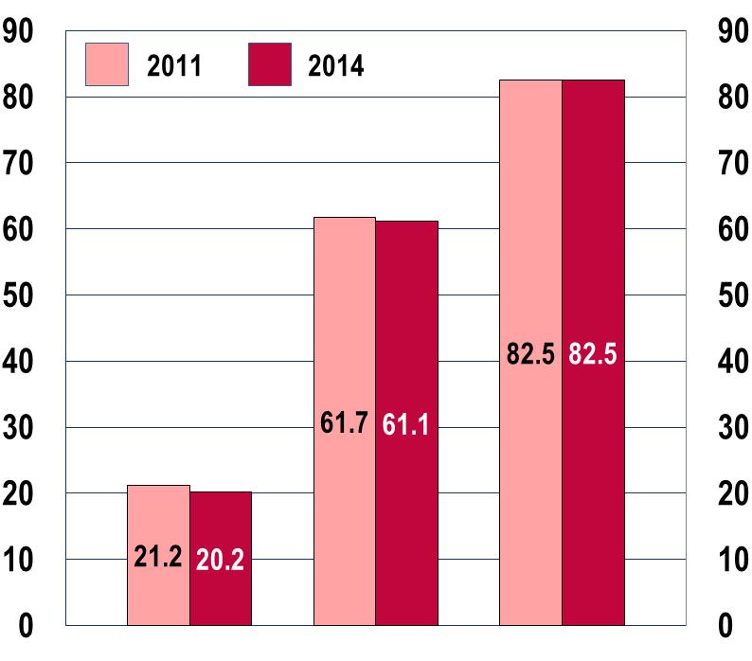
 | Aged  15-19 | Aged  20-24 | Aged  25-29
Source: Eurostat LFS [lfsa_argan]
The EU-28 average hides some significant differences at country level (Figure 4-B-a). Indeed, in approximately a third of countries the youth population aged 15-19 show activity rates significantly above the EU average. The highest values are recorded in Denmark (51.4 %), the Netherlands (59.6 %) and Iceland (71 %). Moreover, in these three countries the 15-19 age group's activity rates are much closer to those of the other groups in the youth population, suggesting an earlier entry to the labour market than in the other countries.

Figure 4-B: a) Activity rates among young people (aged 15-29), by age group and by country, 2014
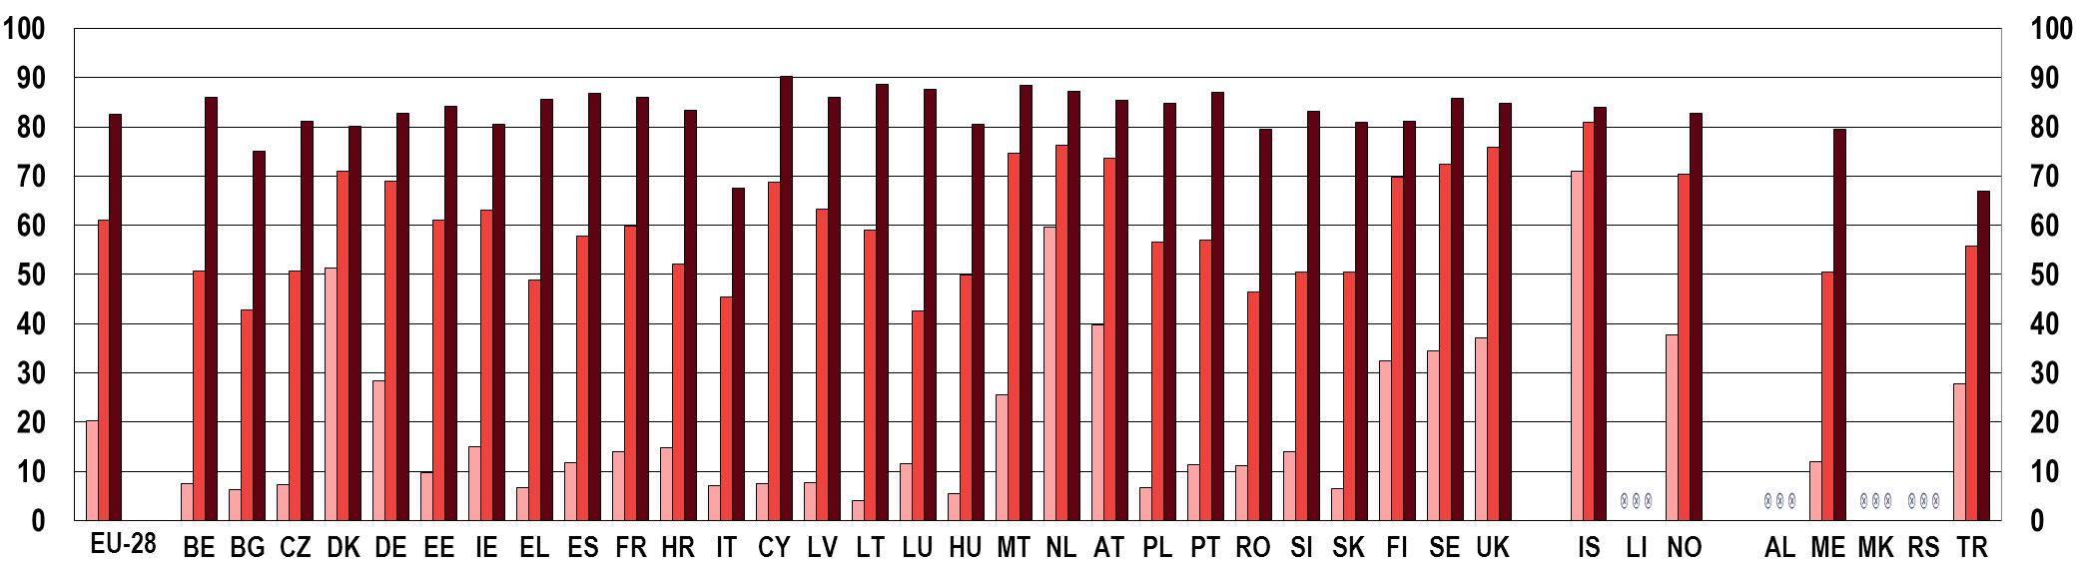
 | Aged 15-19 |  | Aged 20-24 |  | Aged 25-29
Source: Eurostat LFS [lfsa_argan]
Similar variations between countries are observed among young people aged 20-24. In 2014, the highest values are recorded in Iceland (80.9 %) and the Netherlands (76.2 %), while Bulgaria (42.8 %) and Luxembourg (42.5 %) show the lowest activity rates. The EU-28 activity rate is equal to 61.1 %.
As for the oldest age group (young people aged 25-29), the EU-28 activity rate is higher than that of the previous group at 82.5 %. Cyprus (90.2 %) and Lithuania (88.7 %) are the countries with the highest activity rates. Conversely Italy (67.6 %) and Turkey (66.9 %) are those with the lowest values.
Figure 4-B (b) shows the relative changes in the activity rates over the period 2011-2014. Few countries (Croatia, Luxembourg and Hungary) registered a significant increase in activity rate among young people (particularly those aged 15-19). Other countries, conversely, had a significant decrease (Belgium, Estonia, Spain, and Portugal).
Figure 4-: b) Change in activity rates among young people (aged 15-29), by age group andby country, 2011 and 2014
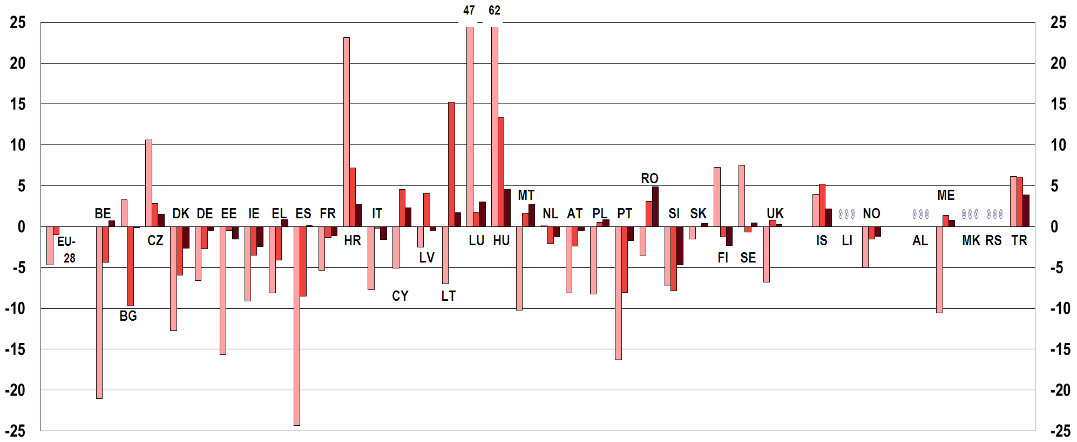

 | Aged 15-19 |  | Aged 20-24 |  | Aged 25-29
Source: Eurostat LFS [lfsa_argan]

4.3. Challenges to young people in the labour market

4.3.1. Unemployment
As illustrated in the previous Youth Report of 2012, since the start of the financial and economic crisis in spring 2008 the increase in youth unemployment (in all the three age groups considered: 15-19, 20-24 and 25-29) has been significantly greater than for the older active population (aged 25-64). This situation is also confirmed for the period 2011-2014.

Unemployment rates among young people
The EU-28 unemployment rate among young people () in 2014 was 26.3 % for those aged 15-19, 20.6 % for those aged 20-24 and 13.6 % for the oldest age group (25-29).
It is worth noting that the unemployment rates among young people were already quite high in 2011. The rates then increased (Figure 4-C) during the period 2011-2014 for the two older age groups (aged 20-24 and 25-29), while for the youngest group (15-19 year-olds), the change shows a moderate improvement (-1.9 %). For the two older age groups the change represents an increase of 4.0 % for young people aged 20-24, and of 7.9 % for those aged 25-29.
The EU-28 unemployment rates among young people aged 20-24 and 25-29 registered a further increase during the period 2011-2014

The high level of unemployment recorded for the 25-29 age group shows an increasing difficulty in entering the labour market for young people who have completed their education (or those who have reached the age where they are expected to have completed it).
Figure 4-C: Unemployment rates among young people (aged 15-29) compared to the 25-64 age group, EU-28 average, by age group, 2011 and 2014
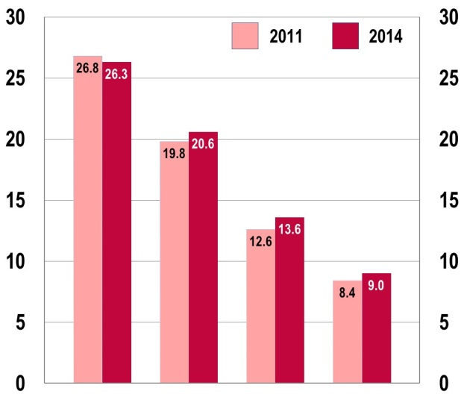
 | 15-19 | 20-24 | 25-29 | 25-64
Source: Eurostat LFS [lfsa_urgan]
As indicated in the Education chapter, the rates of participation in full-time education amongst young people, in the age of transition from education to employment (ages 20-24), have gradually increased since 2000, with a significant surge after the start of the economic crisis in 2008. This change means that there is now greater homogeneity across the two lower age groups comprising young people from age15 through to 24. For this reason, and also to be in line with the indicator on youth unemployment on the EU youth dashboard, the analysis which follows will compare this wider group with the older age group of 25-29 year-olds.
From a gender perspective, over the period 2011-2014 at EU-28 level, the unemployment rates of men and women have followed similar trends (Figure 4-D). The unemployment rate for young men aged 15-24 increased by 3.2 % while for young women it increased by 1.9 %. For the older age group (young people aged 25-29) the increase was roughly 7 %. Rates rose for both age groups until 2013 (for men and women alike) and subsequently fell between 2013 and 2014.

The fact that the crisis hit mainly male-dominated economic sectors (such as the construction sector) contributed to the higher youth unemployment rate amongst young men (particularly for the 15-24 age group). Accordingly, in 2014, the unemployment rate for young men aged 15-24 is slightly higher than that for young women in the same age group (22.6 % and 21.2 % respectively).
 | Figure 4-D: Unemployment rates for young people (aged 15-29), EU-28 average, by age group and by sex, 2011 and 2014
EU youth indicator | 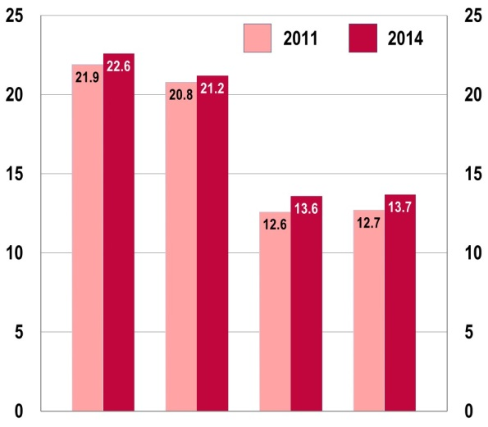
EU youth indicator |  |  | Male |  | Female |  | Male |  | Female
EU youth indicator |  |  | 15-24 |  |  |  | 25-29
EU youth indicator | Source: Eurostat LFS [lfsa_urgan]
At country level, the situation differs considerably. Moreover, important differences exist between young people aged 15-24 and those aged 25-29 (Figure 4-E). On average, the unemployment rate for young people aged 25-29 was 9.8 percentage points lower than the value for young people aged 15-24.
Figure 4-E: EU Youth Indicator: Unemployment rates for young people (aged 15-24 and 25-29), by country, 2014
a) 15-24 age group
EU youth indicator | 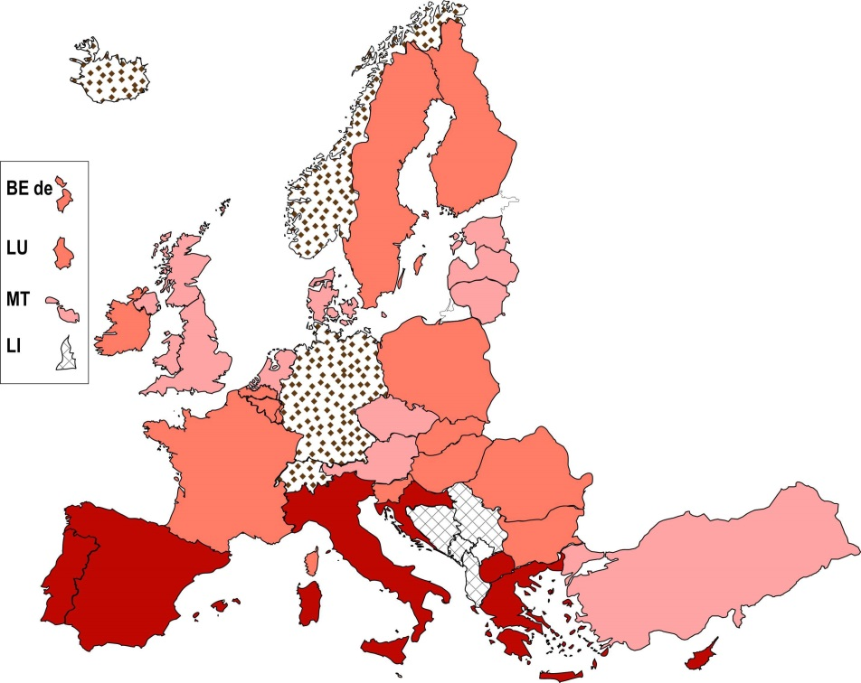
EU youth indicator |  |  | <10 %
EU youth indicator |  |  | 10-20 %
EU youth indicator |  |  | 20-30 %
EU youth indicator |  |  | >30 %
EU youth indicator |  |  | Not available
EU youth indicator |  | Source: Eurostat LFS [lfsa_urgan]
b) 25-29 age group
EU youth indicator | 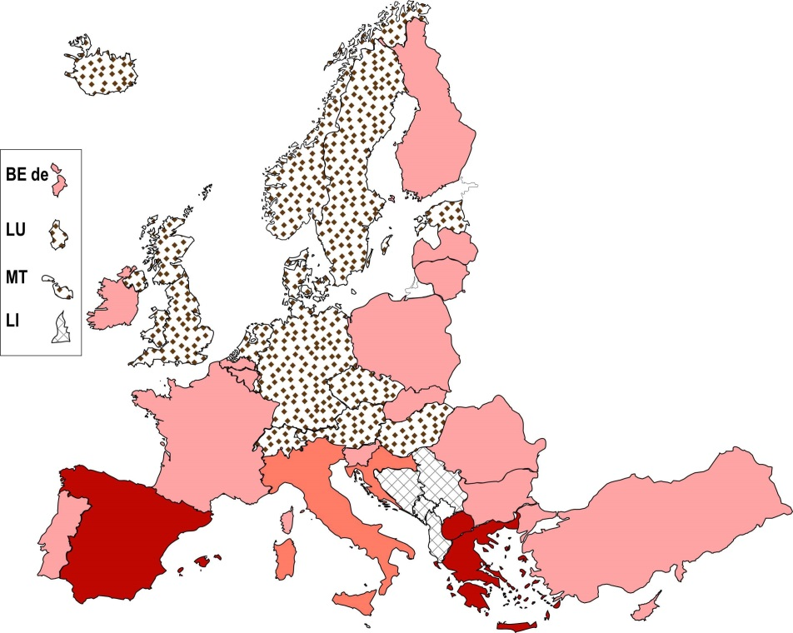
EU youth indicator |  |  | <10 %
EU youth indicator |  |  | 10-20 %
EU youth indicator |  |  | 20-30 %
EU youth indicator |  |  | >30 %
EU youth indicator |  |  | Not available
EU youth indicator |  | Source: Eurostat LFS [lfsa_urgan]
The younger age group (those aged 15-24) is more affected by unemployment. For seven countries the unemployment rate for this age group is above 30 %. Among these countries, particularly high values are recorded in Greece and Spain, which in 2014 had youth unemployment rates for those aged 15-24 of 52.4 % and 53.2 % respectively. On the other hand, only three countries (Germany, Iceland, and Norway) had unemployment rates of below 10 % for young people aged 15-24.
As for the 25-29 age group, the unemployment rate exceeds 30 % in only three countries, Greece (40.8 %), Spain (30.3 %), and the former Yugoslav Republic of Macedonia (39.3 %). For thirteen countries the unemployment rate is below 10 %.
To better understand how the increases in unemployment rates registered in 2014 came about, it is necessary to examine the changes that occurred in the period immediately before, i.e. from 2011 onwards.
The most significant decrease in the unemployment rate among young people aged 15-24 between 2011 and 2014 is registered in Latvia, Lithuania, Estonia and Iceland. Conversely, for seven countries (Belgium, Croatia, Italy, Cyprus, Luxembourg, the Netherlands, and Slovenia) the change represented an increase of at least 24 %.
In Greece, Spain, Croatia, Italy, particularly Cyprus, and Portugal, the youth unemployment rate for the 15-24 age group was already very high in 2011. In these countries the situation for young people deteriorated over the three-year period, although at a slower pace.
The trend for young people aged 25-29 indicates changes of a greater magnitude in many countries. In this age group, the greatest reductions occurred in Estonia, Latvia, Lithuania and Hungary, while the highest increases were recorded in Greece, Italy, and Cyprus (+106 %). Large increases were also registered for Luxembourg and the Netherlands, but both countries had a very low unemployment rate in 2011 (and this is still the case in 2014).
Despite the changes shown over the 2011-2014 period, it should be pointed out that 2013 represented a turning point for almost all countries. Indeed, 25 countries in 2014 recorded a lower unemployment rate for young people aged 15-24 than in 2013 (apart from Finland, Italy, Luxembourg, Austria, Romania, the former Yugoslav Republic of Macedonia and Turkey). Similarly, 23 countries registered a lower unemployment rate in 2014 for the older age group (ages 25-29), in comparison with 2013.

Youth long-term unemployment
The employment situation for young people is further complicated by the phenomenon of long-term unemployment (), which applies to an increasing proportion of young men and women.
The youth long-term unemployment rate differs between age groups (15-19, 20-24 and 25-29 years). The EU-28 average value for the youngest group (15-19 years) in 2014 was 5.8 %, corresponding to a 3.6 % increase in comparison with 2011 (5.6 %).
In 2014, the youth long-term unemployment rate continued to be higher for young men (aged 15-24) than for young women in the same age group.
For young people aged 20-24, the long-term unemployment rate (EU-28 average) increased from 6.5 % in 2011 to 7.7 % in 2014 (+18.5 %). For the 25-29 age group, the increase was from 4.9 % in 2011 to 5.9 % in 2014 (+ 20.4 %). The following analysis of youth long-term unemployment focuses on the older age groups (20-24 and 25-29 years).
In 2011, in both age groups, the proportion of long-term unemployed young men was higher than for young women (see Figure 4-F).

The gender gap further increased over the three years in question. In 2011 the difference between unemployed young men and women was 1.2 percentage points for the 20-24 age group and 0.2 percentage points for the 25-29 age group; in 2014 these values were 1.4 and 0.5 percentage points respectively.
 | Figure 4-F: Long term youth unemployment rate, 20-24 and 25-29 age groups, EU-28 average, 2011 and 2014
EU youth indicator | 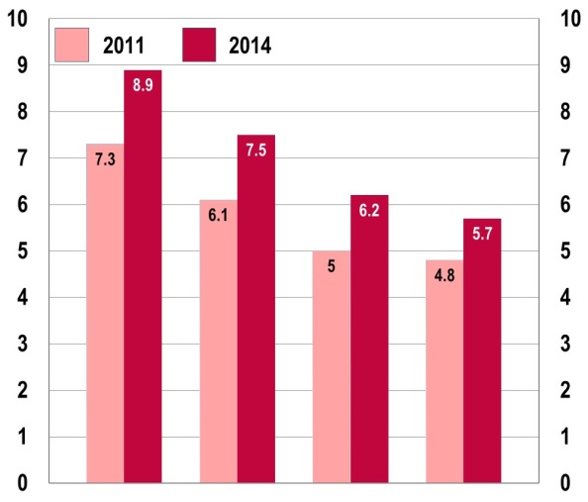
EU youth indicator |  |  | Male |  | Female |  | Male |  | Female
EU youth indicator |  |  | 20-24 |  |  |  | 25-29
EU youth indicator | Source: Eurostat LFS [yth_empl_120]
The EU-28 average conceals variations across Europe in relation to this indicator (see Figure 4-G). In the 20-24 age group, high rates of long-term unemployment were recorded in Greece, Spain, Croatia, Italy and the former Yugoslav Republic of Macedonia.
From 2011, a dramatic increase was registered in Cyprus where the long-term youth unemployment rate for those aged 20-24 surged by 172.5 %. Greece, Italy and Portugal registered an increase equal to or higher than 70 %.
Young people aged between 25 and 29 have been particularly affected by long-term unemployment in Greece and in the former Yugoslav Republic of Macedonia, with values around 30 %. Since 2011, two-thirds of countries recorded an increase in long-term youth unemployment for this age group. The largest increases were registered in Greece (+86.8 %), Italy (+94.4 %), Cyprus (+313.6 %) and the Netherlands (+144.4 %).
On a positive note, significant reductions have been registered in the long-term unemployment rate of those aged 25-29 in Lithuania, Latvia, and Estonia. The three Baltic countries have markedly improved their labour market situation in the last three years, after several years of negative trends.
Figure 4-G: Long-term unemployment rates among young people (aged 20-24 and 25-29), by country, 2011 and 2014
a) 20-24 age group
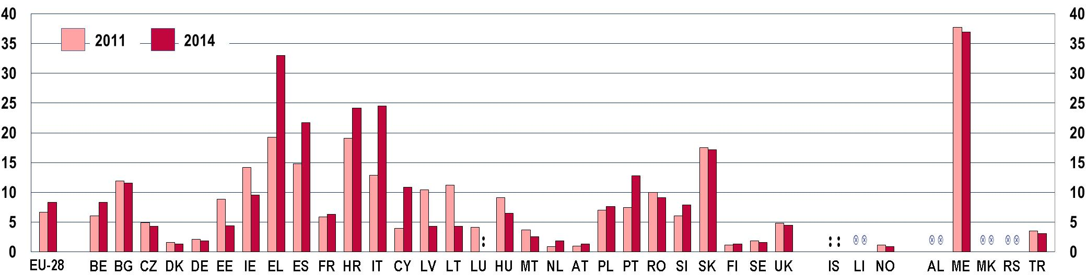
b) 25-29 age group
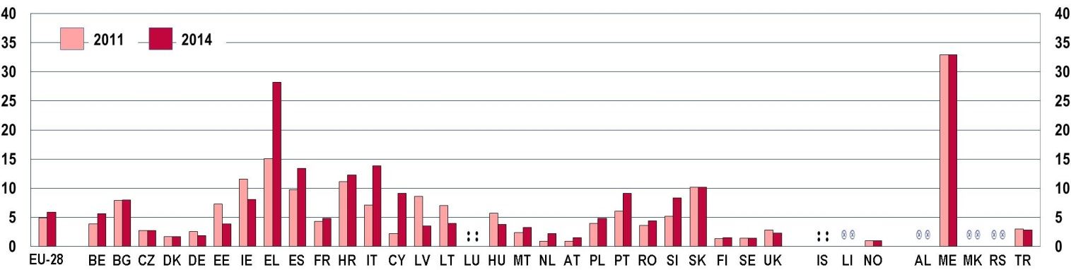
Source: Eurostat LFS [yth_empl_120]

Youth unemployment and educational attainment
The level of educational attainment is a relevant factor in young people's chances of success in finding work. Indeed, Figure 4-H suggests that the higher the education level completed, the lower the youth unemployment rate registered.
The youth unemployment rate in 2014 across the EU-28 was much lower for young graduates from tertiary education than for those with the lowest levels of education.
In 2014 the EU-28 average unemployment rate was 10.5 % among the active population aged 25 to 29 years who had completed tertiary education (ISCED 5-8), and 12.1 % for those with only upper secondary education (ISCED 3-4). For young people aged 20-24, the youth unemployment rates are comparatively higher, but still show a stronger incidence of unemployment amongst those with a lower level of educational attainment.
However, from a comparative perspective, between 2011 and 2014 the EU-28 average unemployment rate increased most amongst those young people (aged 25-29) who had completed tertiary education (+12.9 %).
Figure 4-H: Youth unemployment rate by the highest educational level attained, 20-24 and 25-29 age groups, EU-28 average, 2011 and 2014
20-24 | 25-29
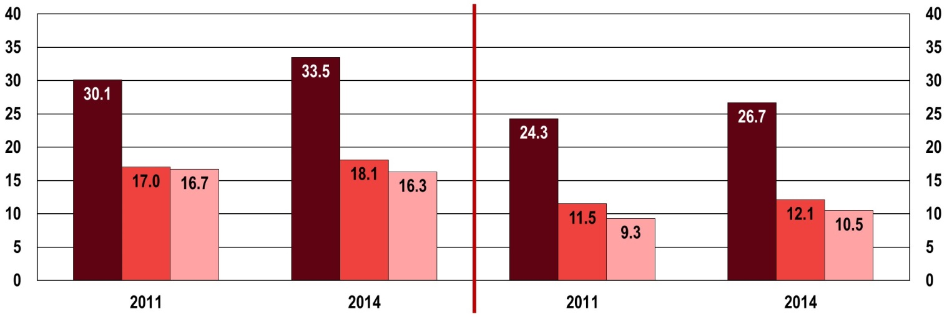

 | ISCED 0 - 2 |  | ISCED 3 - 4 |  | ISCED 5 - 8
Source: Eurostat LFS [yth_empl_120]
For data on educational attainment based on the EU Labour Force Survey (EU-LFS) the International Standard Classification of Education 2011 (ISCED 2011) is applied as from 2014. Up to 2013 ISCED 1997 is used.
For details see http://ec.europa.eu/eurostat/documents/1014465/6636845/EN-Implementation-ISCED2011.pdf
Indeed, the economic crisis has affected young people attaining higher education too, especially in some European countries. Greece, Spain, Croatia, Italy, Cyprus, Portugal, and outside the EU, the former Yugoslav Republic of Macedonia have the highest youth unemployment rates among 25-29 year-olds with an ISCED 5-8 qualification (from 20.1 % for Portugal to 42.4 % for Greece) (Figure 4-I-a).
Figure 4-I-a: Unemployment rate for the 25-29 age group according to the highest educational level attained, by country, 2014
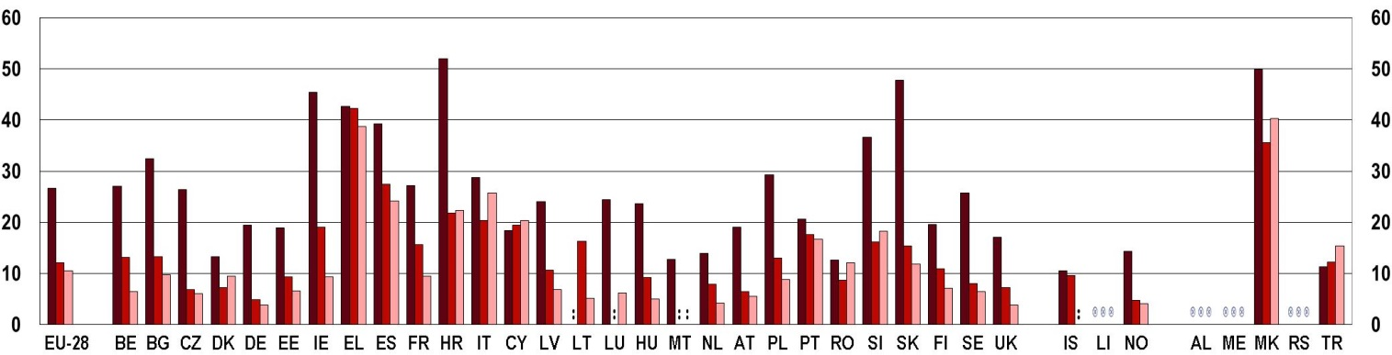

 | ISCED 0 - 2 |  | ISCED 3 - 4 |  | ISCED 5 - 8

Source: Eurostat LFS [yth_empl_090]
Moreover, the economic crisis has created a difficult challenge for young graduates in many countries: they often find themselves overqualified for the opportunities available in the labour market (). This is grasped by Figure 4-I-b, showing the percentage changes in youth unemployment (young people aged 25-29) by education level. What emerges is that in a third of countries between 2011 and 2014, the youth unemployment rate increased more for those with a higher level of attainment (ISCED 5-8) than for those with a lower level (ISCED 0-2) (see also Section 4.4.1 which is devoted to the skills mismatch).
Figure 4-I-b: Changes in the youth unemployment rate of young people aged 25-29, by education level and by country, 2011 and 2014
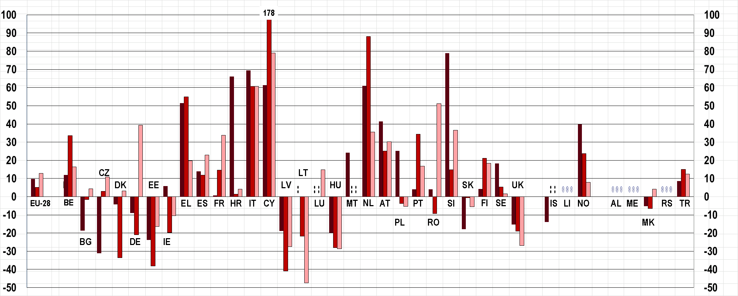
 | ISCED 0 - 2 |  | ISCED 3 - 4 |  | ISCED 5 - 8
Note: For Cyprus end of the bar for ISCED 3-4 is not shown in the graph. The value is equal to 178.6 %.
Source: Eurostat LFS [yth_empl_090]
The largest increase for young people with low educational attainment (ISCED 0-2) is registered in Slovenia (79 %), while Cyprus has seen its youth unemployment rate for young people aged 25-29 increase more than in any other country over the period 2011-2014. The changes account for an increase of 178.6 % for young people with educational attainment at ISCED level 3-4 and 78.9 % for the more highly educated at ISCED level5-8.

Youth unemployment ratio
High youth unemployment rates reflect the difficulties faced by young people in finding jobs. However, many young people – in particular in the 15-24 age group – are still studying full-time and are therefore neither working nor looking for a job. In other words, they are economically inactive and not part of the total labour force figure which is used as the denominator for calculating the unemployment rate. For this reason, the youth unemployment ratio, which is an EU dashboard youth indicator, is used to show the proportion of unemployed youth in relation to the total youth population (employed, unemployed and inactive).
Youth unemployment ratios in the EU are much lower than youth unemployment rates; they have, however, also risen since 2008 due to the effects of the crisis on the labour market.
Figure 4-J shows the unemployment ratios for the 15-24 and 25-29 age groups in European countries in 2011 and 2014. Although the youth unemployment ratios are by definition much lower than youth unemployment rates, as they include economically inactive youth, they have, however, also risen since 2008 due to the effects of the crisis on the labour market (). A positive sign is, however, represented by the decrease (-8 %) in the EU-28 youth unemployment ratio registered between 2013 and 2014. This is the case for 26 countries, while only five countries recorded a further increase. The data analysis reveals how the situation in Europe differs greatly from one country to another.
In a few countries, unemployment affects only a small minority of the 15-24 age group, with ratios below or close to 6 %. This is true for the Czech Republic, Estonia, Germany, Luxembourg, Hungary, Austria, and Norway. The dual education system in some of these countries, which combines courses at school with company apprenticeships, helps to account for the low unemployment ratios among those aged between 15 and 24. At the other end of the spectrum, Spain continues to have the highest proportion of jobless young people in the 15-24 population (19 %), followed by eleven countries in which the unemployment ratio is above the EU-28 average of 9.1 %.
Over the period 2011-2014, the situation has considerably worsened in Croatia (+28.6 %), Italy (+46.8 %), Cyprus (+66.7 %), Luxembourg (+42.9 %) and the Netherlands (+45.3 %). However, despite the recent increase, in Luxembourg and the Netherlands, youth unemployment ratios continue to be relatively low (below 7.1 %).
Figure 4-J: EU youth indicator: unemployment ratio of young people (aged 15-29), by age and by country, 2011 and 2014
a) age 15-24
EU youth indicator | 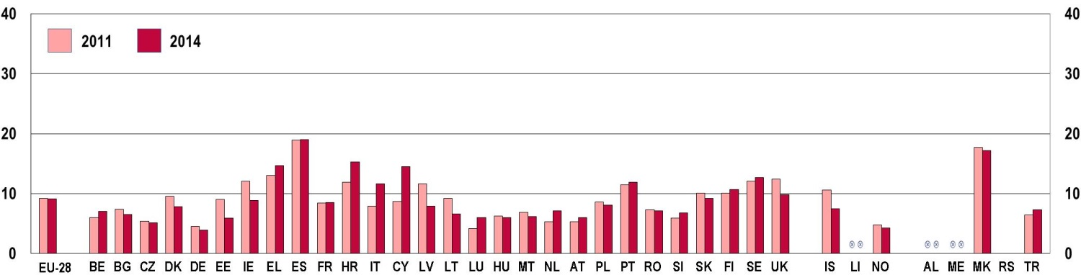

b) age 25-29
EU youth indicator | 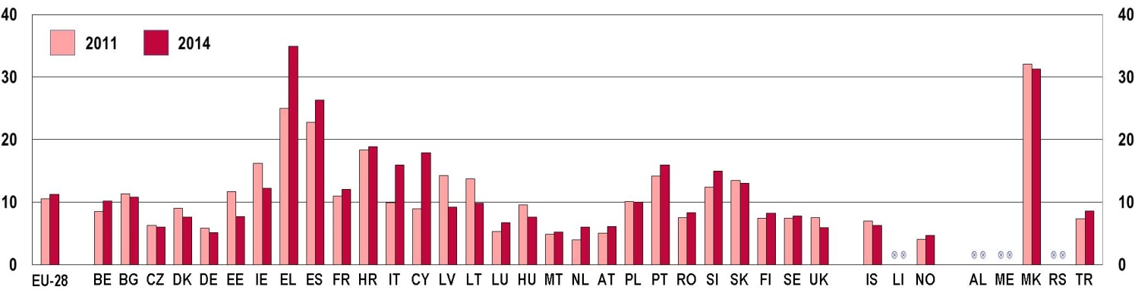

Source: Eurostat LFS [yth_empl_140]
The unemployment ratio for young people aged 25-29 (Figure 4-J-b) in 2014 was higher than that recorded for those aged 15-24 in two-thirds of countries. The highest values in 2014 are registered in Greece (34.9 %) and the former Yugoslav Republic of Macedonia (31.3 %). Norway (4.7 %) and Germany (5.1 %) are the countries with the lowest youth unemployment ratio for the 25-29 age group.
From a comparative perspective, the situation during the period 2011-2014 worsened particularly in Greece (+39.6 %), Italy (+60.6 %), Cyprus (+101.1 %) and the Netherlands (+50.0 %).
A comparison between unemployment rates and ratios indicates a very difficult situation in Greece, Spain, Croatia, Italy, Cyprus and Portugal. Jobless young people in these countries constitute a relatively high proportion of both the entire labour force and the 15 to 24 age group.

Young people's confidence in finding a job
This difficult youth labour market situation is well known by young people of different age groups and it has an impact on their confidence in finding a job once they have finished their education. A recent Eurobarometer () survey addressed also this issue (Figure 4-K). One respondent in four (24 % of the total participants) expressed concerns about finding a job after finishing their education (18 % 'Not very confident' and 6 % 'Not at all confident').
One young European in four is not confident that they be able to find a job when they finish education
Figure 4-K: Young people's confidence in finding a job after finishing education, age group 15-29, EU 28 average, 2014
 | 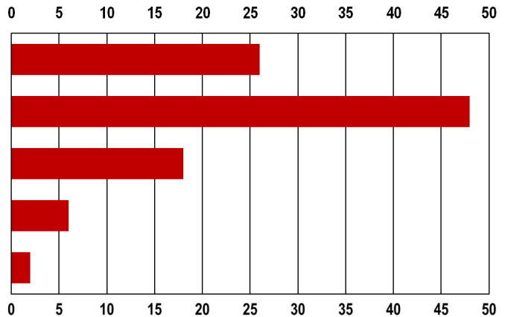 | Notes: The question was 'How confident are you that you will find a job after finishing education?' Base: all respondents. Very confident; Fairly confident; Not very confident; Not at all confident; Don't know; Total 'Confident'; Total 'Not confident'.  Source: 2015 Flash Eurobarometer 408 – 'European Youth'.
Very confident
Fairly confident
Not very confident
Not at all confident
Don't know

When looking at country variations, those most affected by the current economic crisis have a relatively high percentage of respondents feeling 'not confident' in finding a job after finishing education. This is the case in Greece (67 %), Spain (61 %), Cyprus (48 %), and to a lesser extent, Italy (35 %). The highest percentages of people feeling 'very confident' are recorded in countries with very low youth unemployment rates. High levels of confidence are also registered in Estonia (40 %) and Latvia (40 %), two countries that had a severe crisis in 2010 but which have implemented important measures since ().
An additional question in the Eurobarometer () (Figure 4-L) focused on the main concerns young people have when thinking about getting a job. For one respondent in three (31 %), 'not finding a long term contract or a stable job' is not among their main concerns. This response seems justified considering the increasing number of temporary contracts offered to young people in Europe in recent years (see Figure 4-P) as well as the high percentage of young people working on a part-time basis (see Figure 4-M and Figure 4-N).
Only 13 % of respondents considered 'lacking the right knowledge or skills' as an issue, while 16 % saw 'having to move to find a job' as a potential problem.

Figure 4-L: Young people's main concerns when thinking about getting a job, age group 15-29, EU-28 average, 2014
 | 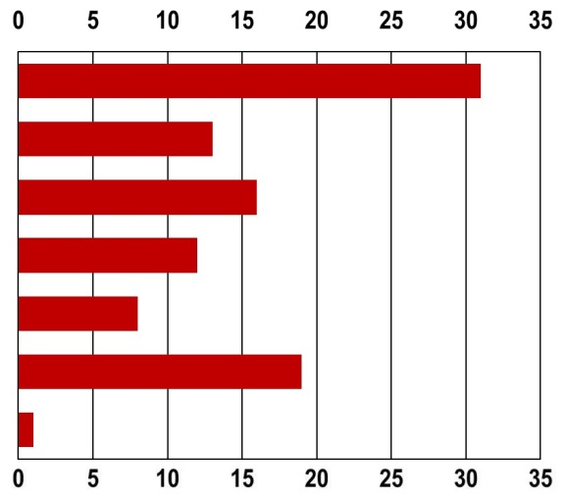 % | Notes: The question was 'What would be your concerns when you think about getting a job? Firstly (main reason)? Base: respondents who are still studying. Not finding a long term contract or a stable job; Lacking the right knowledge or skills; Having to move to find a job; The level of salary; Other; I don't have any concerns; Don't know.  Source: 2015 Flash Eurobarometer 408 – 'European Youth'.
Not finding a long term contract or a stable job
Lacking the right knowledge or skills
Having to move to find a job
The level of salary
Other
I don't have any concerns
Don't Know

4.3.2. Working patterns of young employees
Young people are more likely to be employed on a temporary contract or on a part-time basis than older workers. Young people in Europe also tend to register higher rates of jobs with atypical and unusual schedules, including shifts and weekend or night-time work ().
Working patterns among young people in Europe have been directly affected by the crisis (). As a consequence, more young Europeans might begin their employment career with a traineeship or by taking on part-time or temporary employment contracts interrupted by periods of unemployment or further education and training, thereby moving frequently in and out of the labour market.

Part-time employment among young people
One characteristic of part-time contracts is that it allows young people to combine employment and education. The most recent Eurostat data for 2014 confirm the increasing trend registered over recent years in the proportion of the 15-24 age group working on a part-time basis ().
The part-time employment rate among young people aged 15-24 increased almost everywhere during the period 2011-2014
In 2014, nearly one in three 15- to 24-year-olds in employment worked part-time (Figure 4-M). Huge differences exist between countries. Denmark, Ireland, Spain, the Netherlands, Slovenia, Finland, Sweden, the United Kingdom, Norway, and Iceland are the countries where part-time employment as a percentage of the total employment for young people is higher than the EU-28 average (31.9 %). Conversely, Bulgaria, the Czech Republic, Latvia and Hungary have the lowest part-time employment rates for this group.
Similar patterns are also recorded for young people aged 25-29. Denmark and the Netherlands register the highest rates, while Bulgaria and Slovakia have the lowest. As a general rule, the part-time employment rate of those aged 25-29, for which the EU-28 average is 17.0 %, is between two and three times lower than for younger people aged 15-24 (EU-28 average 31.9 %).
Figure 4-M: Part-time employment rates for the 15-24 age group, by country, 2011 and 2014
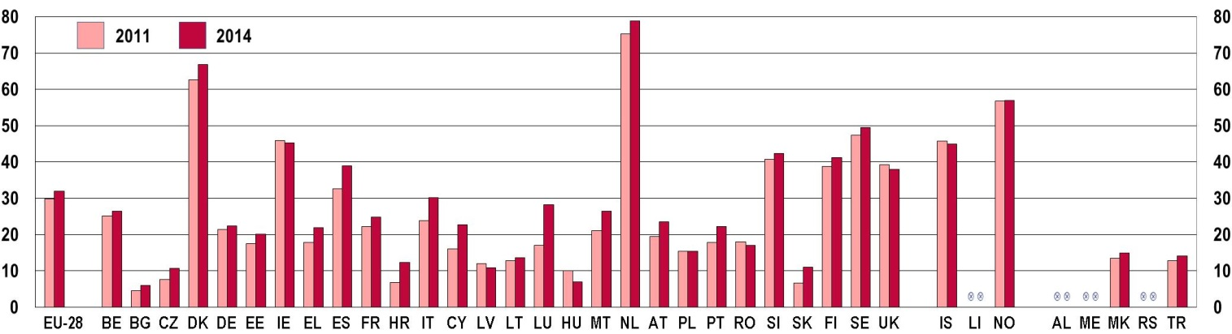
Source: Eurostat LFS [yth_empl_060]
Between 2011 and 2014, the part-time employment rate among young people aged 15-24 increased almost everywhere. In Bulgaria, the Czech Republic, Croatia, Cyprus, Luxembourg, and Slovakia the increase was higher than 30 %.
In reading these data, it is important to bear in mind that part-time work among young people may imply apprenticeship either in the context of a vocational education programme or directly with an employer. Other reasons for choosing part-time work relate to the possibility of combining work and studies, and to accommodate family needs. In many cases, however, part time work is not a deliberate choice for young people.
Indeed, many young people work part-time because they cannot find full-time employment. Figure 4-N shows the high rates of involuntary part-time employment among the 15-24 and 25-29 age groups in several European countries.
Figure 4-N: Involuntary part-time employment as a percentage of total part-time employment for young people (15-29), by age and by country, 2011 and 2014
a) 15-24 age group
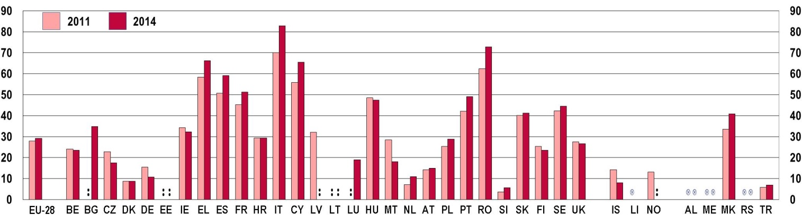
b) 25-29 age group
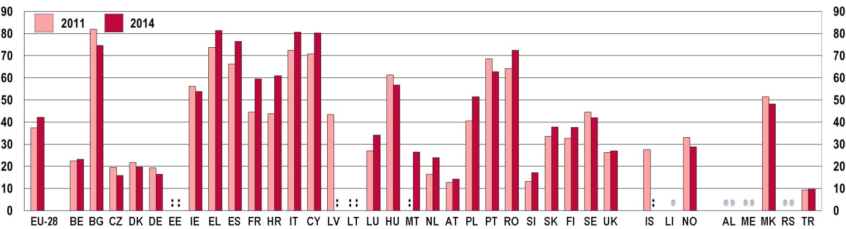
Source: Eurostat LFS [yth_empl_080]
Notes: For Bulgaria, Estonia, Croatia, Latvia, Lithuania, the Netherlands, Austria, Slovenia, Sweden, Iceland and Norway data have low reliability.
In Greece, Spain, France, Italy, Cyprus and Romania, at least one in two young people aged under 25 worked part-time because they had no other choice. In these countries, involuntary part-time work increased by at least 13 % from 2011 to 2014. Significant reductions were, conversely, registered in the Czech Republic, Germany, Malta and Iceland.
Involuntary part-time employment is higher among people aged 25-29 in all countries. The highest values are recorded in Greece, Italy, Cyprus and Spain, where two in three part-time workers aged 25-29 may be considered as being in involuntary part-time work.
By reading together Figure 4-M and Figure 4-N, it is appears evident that for some countries, which record by far the highest share of part-time workers (namely Denmark, the Netherlands and Norway), this it is not really an issue, because working part-time is a choice.
For the first time since 2011, more young men were in involuntary part-time work in 2014 than young women (Figure 4-O). The largest differences between young men and women are registered in Romania, the United Kingdom and the former Yugoslav Republic of Macedonia. Conversely, in France, the Netherlands and Finland, young women have a higher involuntary part-time work rate than men.
Figure 4-O: Involuntary part-time employment as a percentage of total part-time employment for young people (aged 15-24), by country and by sex, in 2014
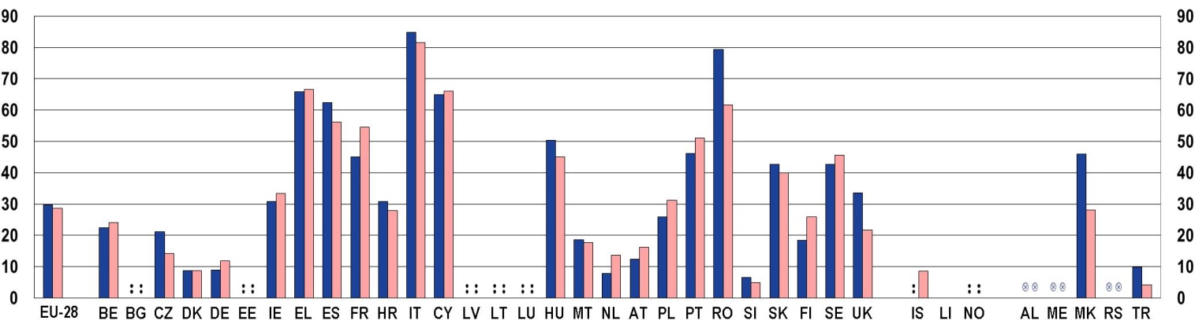
 | Male |  | Female
Source: Eurostat LFS [yth_empl_080]

Temporary contracts for young people
Another characteristic of the youth labour market is the high percentage of temporary contracts () in comparison to other age categories. Temporary employment can be an important step in the transition from education into the labour market (). It gives young people work experience and makes it easier to enter the labour market, and it provides stepping-stones to permanent jobs. Temporary employment also gives employers an opportunity to assess young people's suitability and capacity to perform the tasks required.
However, relatively high rates of temporary employment among young people can also be seen as an indication of career insecurity. Where this is the case, young people may lack the stability needed to allow them to live independently. They can be trapped in a cycle of alternating periods of temporary employment and unemployment, which may adversely affect their status into their thirties and beyond.
After having remained stable over the period 2011 and 2013, the percentage of young people aged 20-29 in temporary employment increased in 2014 (+2.4 % in comparison to 2011). Despite the relatively small change at EU level, at country level, some marked differences exist. Indeed, over the period 2011-2014, Bulgaria (+68.6 %), Cyprus (+48.9 %) and Slovakia (+48.7 %) registered the highest increases. At the other end of the spectrum, Estonia (-18.2 %) and Latvia (-36.5 %) recorded the most significant falls.
In 2014 (Figure 4-P), Spain, France, Croatia, Italy, the Netherlands, Poland, Portugal, Slovenia, Finland and Sweden had a very high percentage of young people aged 20-29 working under temporary contract (more than 30 %).
Figure 4-P: EU Youth Indicator: Young employees aged 20-29 with a temporary contract as a percentage of total number employees, by country, 2011 and 2014
EU youth indicator | 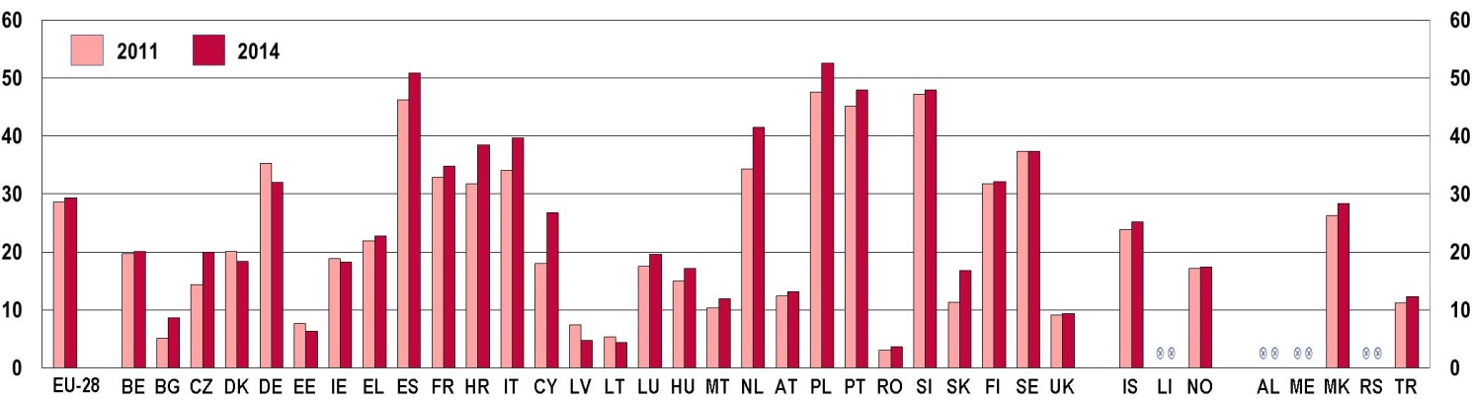
Source : Eurostat LFS [yth_empl_050]
From a gender perspective, the difference at the EU-28 level between the rate of young women and young men aged 20-29 with temporary contracts is not large (Figure 4-Q). However, more significant differences exist in some countries, and in the Czech Republic, Croatia, Cyprus, Lithuania, Finland, Sweden, and Norway, young women have a higher percentage of temporary employment than young men.
The difference at EU-28 level for young men and women aged 20-29 with temporary contracts is small.
Figure 4-Q: Young employees aged 20-29 with a temporary contract as a percentage of total number employees, by country and by sex, 2014
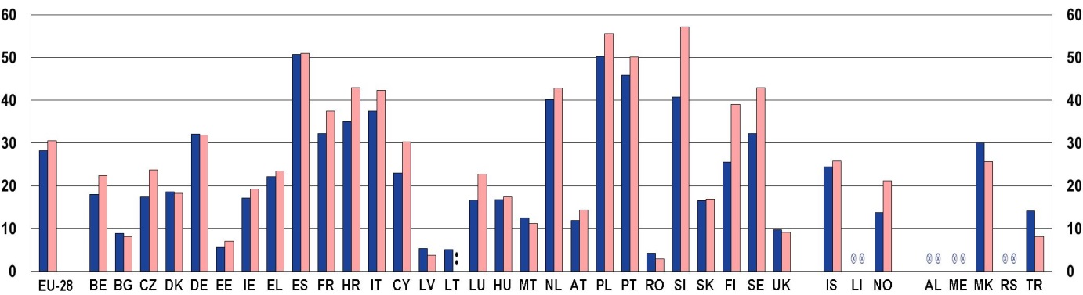
 | Male |  | Female
Source : Eurostat LFS [yth_empl_050]

Atypical working hours for young people
In 2014, the proportion of employed young people in the 15 to 24 age group which had atypical working hours was much higher than for those aged 25-64. This was particularly true in the case of Saturday working (Figure 4-R).

There are important variations in these trends from one EU country to the next, in particular for shift work and working on public holidays. The countries where the largest proportions of young employees are doing shift work (over 40 %) are recorded in the Czech Republic, Croatia, Romania, Slovakia, and, outside the EU, in Iceland and the former Yugoslav Republic of Macedonia. Conversely, in Belgium, and Denmark, the corresponding proportion was below 10 %.
Figure 4-R: Share of employees working atypical and asocial working hours, EU-28 average, by age, 2014
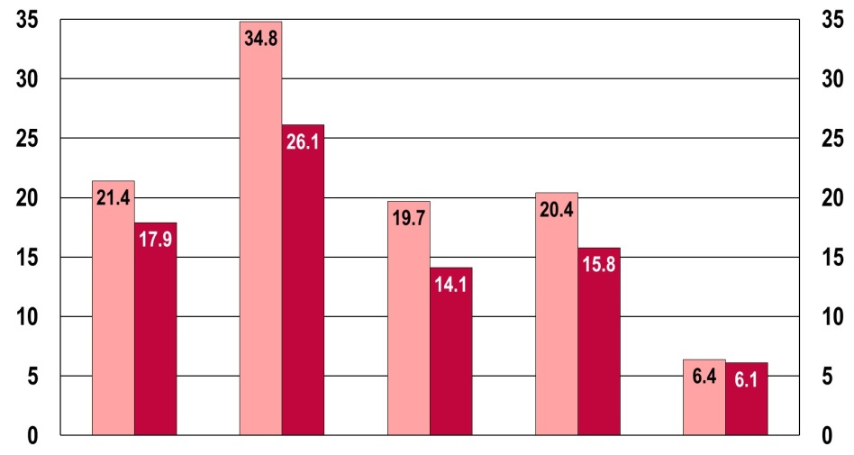
 | Shifts | Saturday | Sunday | Evening | Night
Source: Eurostat LFS [lfsa_ewpshi] [lfsa_ewpsat] [lfsa_ewpsun] [lfsa_ewpeve] [lfsa_ewpnig]
 | 15-24 |  | 25-64

As for working on Saturdays, the highest percentages (over 50 %) are recorded in Ireland, Greece and the former Yugoslav Republic of Macedonia. Conversely, the lowest value is recorded in Portugal, where less than one young employee in ten (9.1 %) worked on Saturday.

4.3.3. Young entrepreneurs
Young people can be confronted with significant barriers in their efforts to turn ideas into projects. Such barriers often comprise social attitudes, lack of skills, inadequate entrepreneurship education, lack of work experience, insufficient capitalisation, lack of networks, and market obstacles ().
Furthermore, a recent Eurobarometer survey () notes that for many young Europeans entrepreneurship does not constitute a possible response to the jobs crisis. Indeed (Figure 4-S), more than half of the respondents declared having no wish to start their own business (52 %). Just one in five (22 %) would like to start a business but considered it too difficult.
Only a quarter of young Europeans are more proactive about starting a business (5 % have done so, 17 % intend to do so in the near future and 3 % tried to start a business but gave up because it was too difficult) ().
The highest percentage of respondents willing to become entrepreneurs is registered in Lithuania (32 % 'intend to start a business in the coming years') and Romania (33 %). Conversely, the lowest values are recorded in Germany (11 %) and Greece (11 %). The country with the lowest percentage of young people that have started a business is Ireland (only 2 %).

Figure 4-S: EU Youth indicator: Young people (aged 15-29) who would like to set up their own business, EU-28 average, 2014
Regarding the start-up of a business, which of the following is closer to your situation?
EU youth indicator |  | 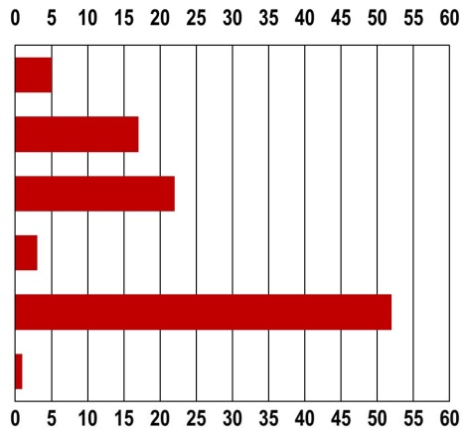 % | Base: all respondents.  Source: Flash Eurobarometer of the European Parliament (EP EB395) on 'European Youth in 2014'.
EU youth indicator | You have started a business
EU youth indicator | You intend to start a business in the coming years
EU youth indicator | You would like to start a business, but you think it is too difficult
EU youth indicator | You tried to start a business, but gave up because it was to difficult
EU youth indicator | You do not want to start a business
EU youth indicator | Don't know

Eurostat data on self-employed () young people identify similar patterns. Indeed, as shown in Figure 4-T, the lowest percentages of self-employed young people among the employed population aged 20-24 are recorded in Germany (1.8 %), and Ireland (1.7 %). On the other side of the spectrum, Italy (11.8 %) and Romania (11.6 %) have the highest percentage of self-employed young people among the employed.
Regarding the 25-29 age group, Luxembourg (3.7 %) and Norway (4.2 %) have the lowest values, while Greece (16.3 %) and Italy (17.3 %) show the highest percentage of self-employed young people among those employed.
Figure 4-T: EU Youth Indicator: Self-employed rate of young people (aged 20-29), by age and by country, 2013
EU youth indicator | 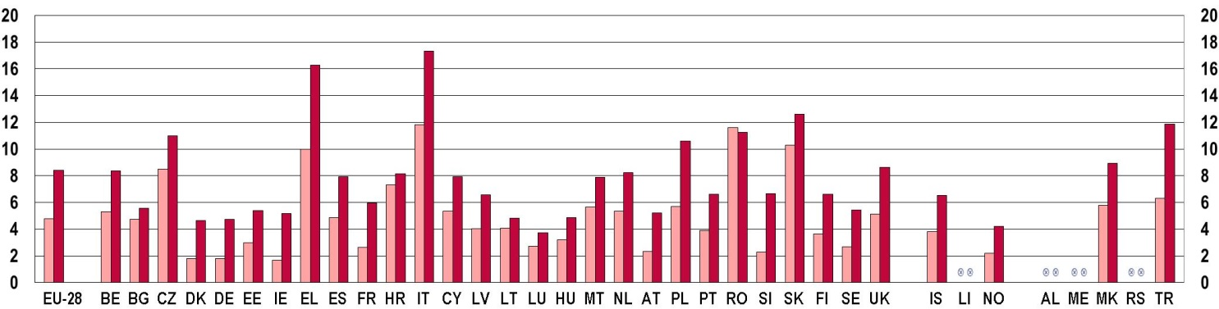
   | 20-24 |  | 25-29
Source: Eurydice calculation on Eurostat data on self-employed young people [yth_empl_040]
4.4. Support for the transition to employment

4.4.1. Career guidance and skills forecasting
Young people have not only had to face higher unemployment since the onset of the economic crisis, but those who are in employment are also now more likely to accept jobs for which they are overqualified. 'Vertical mismatch' refers to the situation where there is a discrepancy between young people's education or skills and the level of education or skills required by their job (). Such vertical mismatch can occur in terms of qualifications or skills, and over-qualification and over-skilling do not always go together ().
Evidence indicates that younger workers, as new entrants into the labour market, tend to experience a higher degree of vertical mismatch (); and this vertical mismatch in the EU is increasing. This is apparent in the collapse in the demand for low-skilled workers and in the greater number of highly educated people taking up jobs that are not commensurate with their qualifications. In parallel to this increase in over-qualified young people, recent research also points towards the danger of skill loss between generations, showing that in certain countries – particularly in Denmark, Sweden or the United Kingdom – younger cohorts have lower level of skills than their older peers, despite having to face a more competitive labour market requiring higher level of skills ().
Figure 4-U depicts 'vertical mismatch' in terms of a qualification mismatch. The figure shows young people's qualifications in relation to their jobs as classified in the International Classifications of Occupations (ISCO ()). The over-qualification rate is defined as the percentage of young people (aged 25-34) with tertiary education occupying a post not regarded as necessitating a tertiary qualification (ISCO level 4 to 9).
Figure 4-U: Distribution of people with tertiary education (ISCED 5-6) aged 25-34 and employed in ISCO 1 or 2 (legislators, senior officials, managers and professionals), in ISCO 3 (technicians and associate professionals) and not in ISCO 1, 2 or 3, by country, 2013
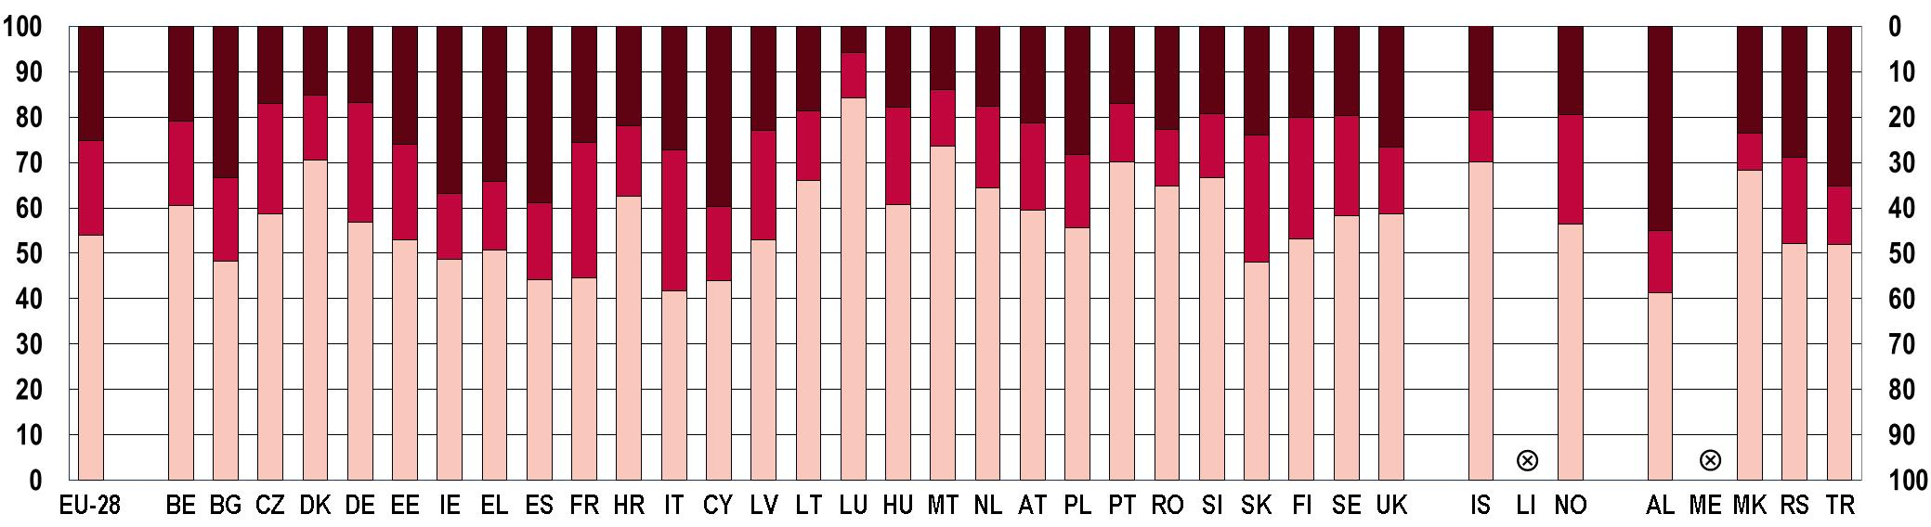

 | ISCO 1 or 2 |  | ISCO 3 | 25-29 |  | Not in ISCO 1, 2 or 3
Notes: ISCO 0 (armed forces) and ISCO missing excluded.
Source: Eurostat LFS and additional collection for the other EHEA countries.

In the EU-28, approximately a quarter of highly qualified young people aged 25-34 are overqualified for their job. In 2013, the countries with the highest over-qualification rates (above 30 %) were Bulgaria, Ireland, Greece, Spain, Cyprus and Turkey. By comparing these data with the unemployment rates discussed in Section 4.3, it emerges that those countries with the highest youth unemployment rates also show the highest over-qualification rates. This implies that when young graduates face difficulties in finding a suitable job matching their qualification levels, they are more likely to accept one with lower-level requirements.
Career guidance is an important service that can support young people facing a difficult transition to employment. Relying on skills forecasting, career guidance can potentially help in directing young people towards professions for which there is greater demand. In addition, career guidance can equip young people with the skills necessary to successfully search for a job.
Career guidance services are available in higher education institutions in almost all European countries (). However, evidence from a recent Eurobarometer survey () suggests that a majority of respondents received no guidance during education. Indeed, only around one in four respondents (24 %) reported having used a career guidance service at some point. In many cases the reason behind this is the lack of access to services (45 % of all respondents).
Only one in four young Europeans report having used a career guidance service at some point.

4.4.2. High-quality traineeships
The extensive use of temporary employment contracts described in Section 4.3 goes hand in hand with the increased use of traineeships as a way for employers to assess the capabilities of new recruits before offering them permanent positions ().
Traineeships provide important opportunities for young people to acquire the experience needed to find a job in the future. According to the Flash Eurobarometer 'The experience of traineeships in the EU' (), around half of the respondents aged 18-35 report having had a traineeship (Figure 4-V) (). The highest percentage was registered in Germany, Cyprus and the Netherlands. At the other end of the spectrum, the Czech Republic, Lithuania and Slovakia had the lowest percentages of respondents who reported having undertaken a traineeship.
Figure 4-V: Proportion of respondents (aged 18-35) who have completed a traineeship, by country, 2013
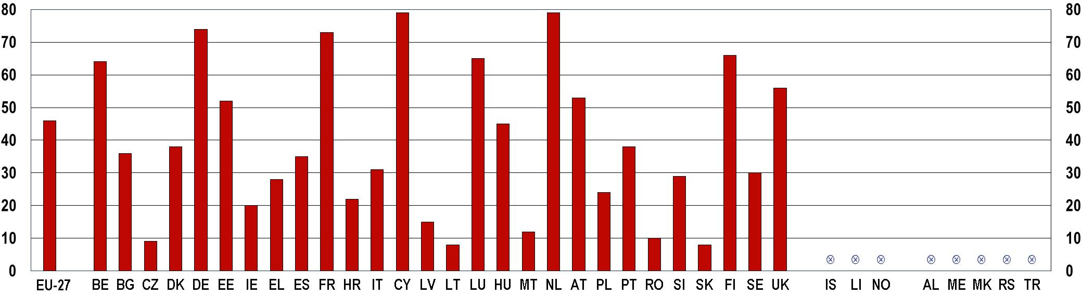
Note: The Question was: Have you ever had any of the following experiences…Traineeship? Base: all respondents.
Source: 2013 Flash EB378, ‘The experience of traineeships in the EU’.

Looking at the gender dimension, 49 % of female respondents have had a traineeship compared with 43 % of males. The highest number of respondents undertaking a traineeship belongs to the 25-29 age group (50 %), while only 43 % of respondents aged between 30 and 35 have done so.
Undoubtedly, one of the aims of traineeships is to provide young people with the skills needed to enter the labour market and to facilitate this process. The Eurobarometer asked, among other things, whether young people had learned things that were useful professionally during their most recent traineeship. The vast majority of respondents (89 %) agreed that they had learned useful things.
Furthermore, respondents were asked whether the traineeship had been or would be helpful in order to find a regular job. On average (EU-27) the majority of young people (aged 18-35) with traineeship experience (71 %) believed this had been the case. The socio-demographic analysis of this data shows that gender, age, university graduation and education, occupation and time when the traineeship was completed, had no significant impact on the percentages recorded.
Unfortunately, a further Eurobarometer question revealed that the majority of trainees (71 %) were not offered an employment contract when they finished their most recent traineeship. In this case, gender data suggests that more men were offered an employment contract at the end of their traineeship than women (31 % versus 24 %).
The majority of trainees were not offered an employment contract when they finished their most recent traineeship.

Conditions of traineeships
The conditions under which traineeships were offered reveal interesting differences between countries. Over one third of young Europeans did not sign an agreement or contract with the hosting organisation that provided the traineeship (Figure 4-W(a)). A more positive aspect is, however, the percentage of young people covered by a health insurance during their traineeship (Figure 4-W (b)): according to the EU-27 average, 76 % of the respondents reported being covered in the event of illness or accident.
Figure 4-W: Share of young people (aged 18-35) who signed a written contract and received health insurance during the traineeship, EU-27 average, 2013

You signed a written agreement or contract  with the organisation or company | In the event of illness or accident,  you would have been covered by insurance
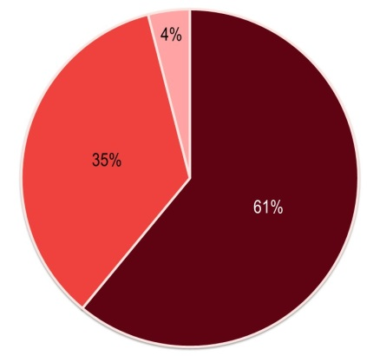 | 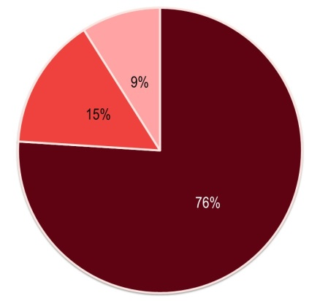
   | Yes |  | No |  | D/K
   | Yes |  | No |  | D/K
Base: respondents who had undertaken at least one traineeship.
Source: 2013 Flash EB378, 'The experience of traineeships in the EU'.

An additional question from the same Eurobarometer investigated whether respondents who had completed more than one traineeship had received financial compensation during one of these. Over two-thirds of respondents (67 %) had not received any compensation, while a third of respondents (32 %) had. Moreover, for 58 % of the respondents, the compensation they received was not sufficient to cover basic living costs such as rent, food, etc. (Figure 4-X). Only slightly more than two in five respondents (41 %) say the financial compensation they received had been sufficient.
Figure 4-X: Share of young people (aged 18-35) who received financial compensation during traineeships and whether it was sufficient to cover basic living costs, EU-27 average, 2013
You received financial compensation | This financial compensation was sufficient  to cover basic costs such as rent, food, etc.
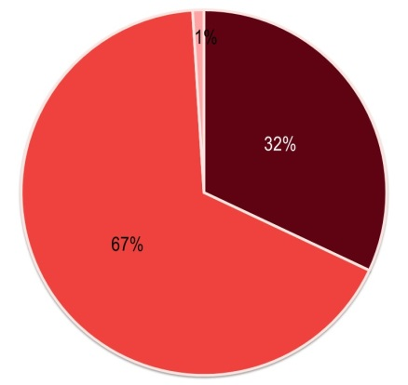 | 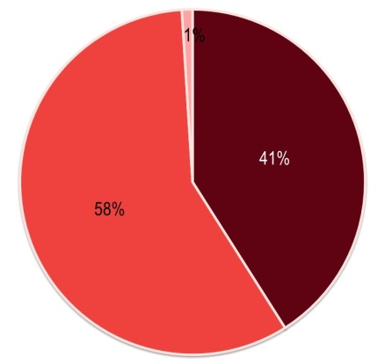
   | Yes |  | No |  | D/K
   | Yes |  | No |  | D/K
Base: respondents who had at least one traineeship.
Source: 2013 Flash EB378, 'The experience of traineeships in the EU'.

Finally, it is worth noting that not all trainees are awarded a certificate or reference at the end of a training period. Indeed, only 64 % of trainees reported that at the end of the traineeship, the organisation or company gave them a certificate or reference describing what they had done. For 34 % of the respondents, this was not the case
(Figure 4-Y).
Figure 4-Y: Proportion of respondents (aged 18-35) who received a certificate at the end of their traineeship, EU-27 average, 2013
At the end of your traineeship the organisation or company gave you a certificate or a letter of reference describing what you had done
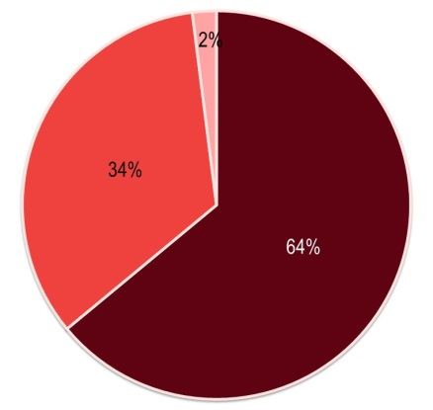
 | Yes |  | No |  | D/K

Base: respondents who had at least one traineeship.
Source: 2013 Flash EB378, 'The experience of traineeships in the EU'.

4.4.3. Geographical career mobility
Geographical career mobility within the EU is an important dimension of the EU youth labour market. During the period 2009-2013, intra-EU movers were predominantly young people.
Indeed, young people aged 15-34 represented 63 % of all intra-EU movers, even though this age category only accounted for around 34 % of the labour force in the EU (average over 2009-2013). Within this broad age group, the youngest cohort (15-24) is the least represented. The majority of those relocating are young adults between 25 and 34 who move to another EU Member State to work ().
Among its many findings, the Flash Eurobarometer survey 'European area of skills and qualifications' from 2014 () contains information on young people's experience of working or studying in another EU country and/or outside the EU.
According to this survey, less than one in ten respondents (8 %) aged 15-24 say they have spent time working in another EU Member State and/or outside the EU. This percentage is relatively low in comparison to older age groups – the highest being in the 25-39 age group at 20 %, with 13 % for the 55+ group.
The percentage of respondents aged 15-24 who have studied in another EU country or outside the EU is slightly higher (9 %) and more in line with figures for the older age groups (12 % for 25-39 year-olds, 9 % for those aged 40-54 and 5 % for the 55+ group).
Another Flash Eurobarometer () addresses the issue of traineeships abroad either in another EU country or elsewhere (Figure 4-Z). Approximately nine in ten of the respondents (89 %) had never undertaken a traineeship abroad.
Figure 4-Z: Proportion of young people (aged 18-35) who have had at least one traineeship abroad, by country, 2013
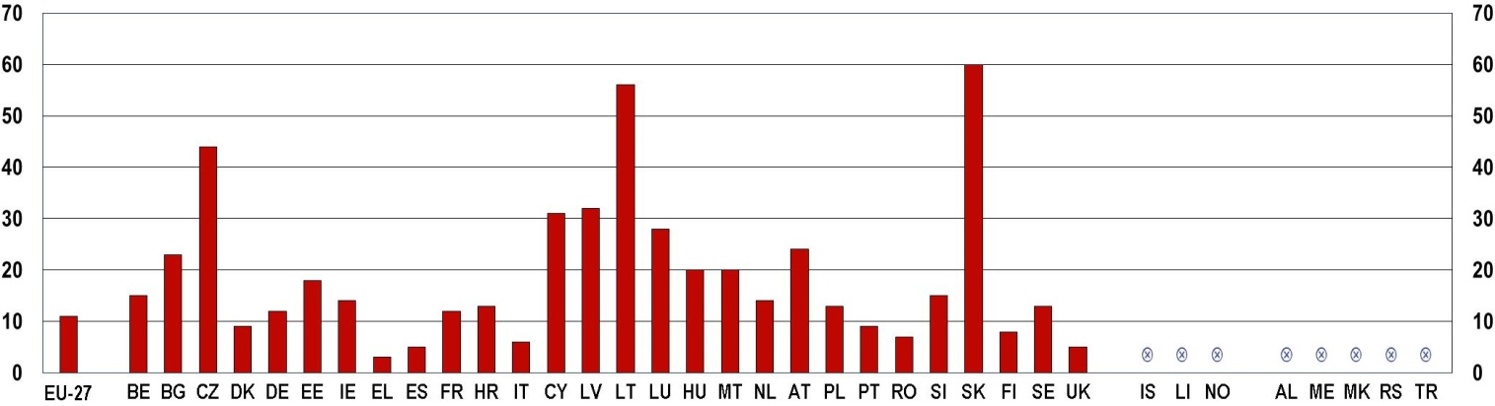
Note: the question was: Overall, how many traineeships have you had abroad? 0 stage, 1 stage, 2 stages, 3 stages, 4 stages. Base: all respondents.
Source: 2014 Flash EB378, 'The experience of traineeships in the EU'. Base: Those EU respondents who have had at least one traineeship.
Across the EU, respondents in Slovakia, Lithuania, the Czech Republic and Latvia are most likely to report that they had undertaken at least one traineeship abroad. Respondents are least likely to have had this experience in Greece, Spain, the United Kingdom, and Italy.

(?) Eurofound 2014a, p. 4-5.
(?) Eurostat, Labour Force Survey (LFS) data, online code: lfsa_egan and lfsa_ugan. Accessed on 28/04/2015.
(?) According to the definition provided by the ILO (International Labour Organisation) and used by Eurostat for collecting data, the economically active population comprises employed and unemployed persons. Inactive persons are those who are classified neither as employed nor unemployed. Those 'not in employment, education or training' (NEET) are not dealt with in this chapter. A full analysis of this very vulnerable group can be found in Chapter 5.
(?) The unemployment rate for a given age group expresses unemployed people in that age group as a percentage of the total labour force (both employed and unemployed). An unemployed person is defined by Eurostat, in accordance with ILO guidelines, as someone aged 15 to 74 (or 16 to 74 in Spain, Italy, the United Kingdom, Iceland and Norway) who is a) without work during the reference week; b) available to start work within the following two weeks (or has already found a job to start within the next three months), and c) who has actively sought employment at some time during the preceding four weeks.
(?) The long-term unemployment rate is the proportion of persons who have been unemployed for 12 months or more, in the total number of unemployed persons in the labour market.
(?) Eurofound 2011b.
(?) See Eurostat, Unemployment statistics: http://ec.europa.eu/eurostat/statistics-explained/index.php/ Unemployment_statistics (accessed on 05/03/2015).
(?) European Commission, 2015b.
(?) European Commission, 2013a.
(?) European Commission, 2015b.
(?) Eurofound, 2013a.
(?) Ibid.
(?) As explained when defining full-time employment, the distinction between full- and part-time work is based on a spontaneous response by the respondent (except in the Netherlands, Iceland and Norway where part-time is used if the usual hours are fewer than 35 hours, and full-time if the usual hours are 35 hours or more; and in Sweden where this criterion is applied to the self-employed). It is not possible to establish a more precise distinction between full-time and part-time employment, since working hours differ between Member States and between branches of activity.
(?) A temporary contract is a fixed-term contract which will terminate if certain objective criteria are met such as the completion of an assignment or the return of the employee who has been temporarily replaced (Eurostat).
(?) Eurofound, 2013b.
(?) OECD, 2012a.
(?) European Parliament, 2014.
(?) Ibid.
(?) Eurostat definition: Self-employed persons are the ones who work in their own business, farm or professional practice. A self-employed person is considered to be working if she/he meets one of the following criteria: works for the purpose of earning profit, spends time on the operation of a business or is in the process of setting up his/her business.
(?) The literature usually distinguishes between vertical and horizontal mismatch. The former occurs when there is a discrepancy between young people's education or skills and the level of education or skills required by their job. Horizontal mismatch refers to a situation where the worker has an adequate qualification level, but in a different field of study to that required by the job (Cedefop, 2010).
(?) See for example Flisi et al, 2014.
(?) Cedefop, 2010.
(?) Flisi et al, 2015.
(?) International Standard Classification of Occupations.
(?) European Commission/EACEA/Eurydice, 2014.
(?) European Commission, 2014f.
(?) Eurofound, 2013b.
(?) European Commission, 2014g. This survey interviewed EU citizens aged 18-35 about their experience with traineeships and the benefits they felt they had received from them.
(?) The question was 'I would like you to think about traineeships. Did you complete one or more traineeships either during or immediately after you completed your education?'
(?) European Commission, 2014g.
(?) European Commission, 2014f.
(?) European Commission, 2014g

