7. PARTICIPATION IN DEMOCRATIC LIFE

EU Youth Indicators
Participation of young people in elections at the local, regional, national or EU level | Figure 7-E
Young people's participation in political or community/environmentally-oriented NGOs | Figure 7-H and Figure 7-I
Proportion of the population who have used the Internet for interaction with public authorities | Figure 7-K
Proportion of the population who have used the Internet to post opinions on civic and political issues via websites | Figure 7-L
Young people elected to the European Parliament | Figure 7-G-bis

7.1. Introduction
Young people are often described as being more disenchanted with politics and less keen on participating, in comparison with older groups in the general population. In this chapter, this view will be challenged using data and information on various forms of political participation and social engagement, and it will be shown how different ways of participating can appeal to young people and motivate them to become more engaged. Indeed, as any other group in society, they develop a desire to become involved in political life when they perceive that their opinions count. Young citizens, therefore, need to have a real stake in political decision-making processes in order to be willing to participate.
This chapter will focus initially on young people's general level of interest in politics, and on their perception of citizenship. It will then examine how young citizens take advantage of different opportunities to actively participate in politics, from the more traditional means such as voting and joining political parties, to the less mediated experiences of engaging in local and non-governmental organisations and social movements. The use of the Internet as a 'new' resource for political participation will then be addressed before concluding with a discussion of the issue of youth exclusion from political engagement.
7.2. Young people's interest in politics and their perception of EU citizenship
Interest in the political life of society is a stepping stone to involvement in community life, and vice versa. Interest prompts an individual to become informed about how decisions are made in the policy-making process, what the opinions of different stakeholders are, and what means of participation are available. Ultimately, interest can engender willingness to actively participate and address shared problems together with other members of the community.
About one third of young Europeans report to be very or quite interested in politics
Results from the European Social Survey conducted in 2012 indicate that, on average, about 33 % of respondents declare to be very or quite interested in politics (Figure 7-A). Some differences exist between countries. Northern and Scandinavian Member States register above average levels of interest. On the other hand, several southern and eastern European countries display comparatively low levels of concern with political issues.
Figure 7-A: Share of young people (aged 15-29) claiming to be 'very' or 'quite' interested in politics, by country, 2002 and 2012
% %
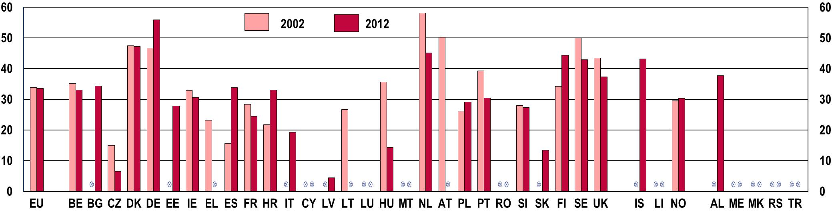
Note: The chart covers the countries for which data exist for 2002 and 2012.
Source: European Social Survey 2002 and 2012
Contrary to the claim that young people are disaffected with politics, interest in political issues amongst young people in Europe has remained stable over the last decade, with approximately one third of respondents reporting to be very or quite interested. Yet, significant changes have occurred in some countries since 2002: while substantial increases have been registered in Germany (+19.9 %), Spain (+117.3 %), Croatia (+51.8 %) and Finland (+29.8 %), rates have dropped in the Czech Republic (-56.7 %), Hungary (-59.7 %), the Netherlands (-22.3 %) and Portugal (-22.6 %).
In order to fully appreciate the figures reported above, it is useful to compare the general level of interest in politics expressed by young people with that reported by other age groups in the general population (Figure 7-B). Within the younger age groups, levels of concern with political issues are highest amongst individuals at the older end of the spectrum (around 40 % of respondents aged 25 to 29 on average declare to be very or quite interested).
Figure 7-B: Level of interest in politics among different age groups, EU-27 average, 2012
% %  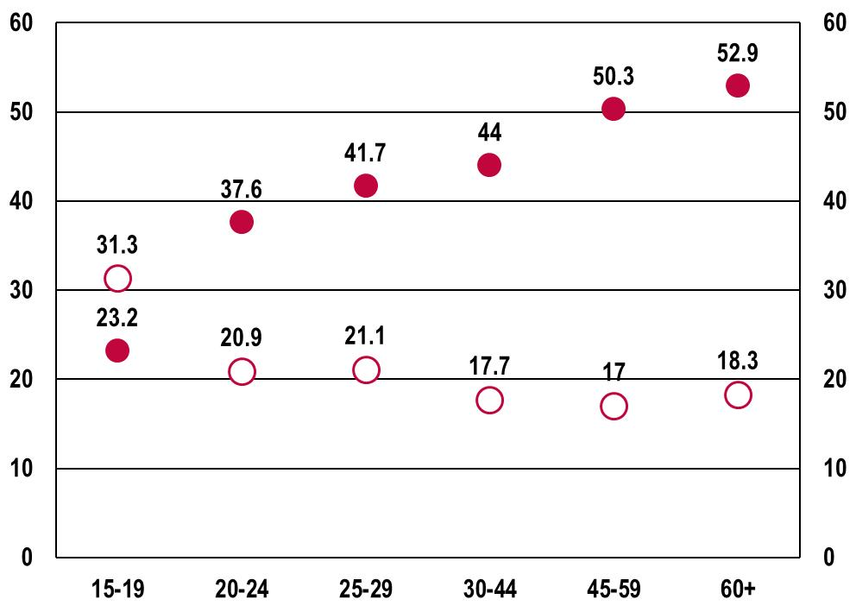 |  |  |  |  |  | Note: The average showed on the chart was calculated on the basis of the countries for which data exist for 2012.  Source: European Social Survey, 2012
 |  | Not at all interested |  | Very + quite interested

This tendency is confirmed when considering the older age cohorts, from 30 to over 60 years. As the figure above illustrates, the degree of attention to political issues increases as individuals grow older. Within the boundaries of the snapshot offered by the 2012 data here illustrated, the notion that young people are comparatively less engaged in following political developments is therefore confirmed.
However, this phenomenon is, at least partly, intrinsic to each generation: individuals tend to become more aware of the political environment as they grow into mature adulthood, become politically socialised, and acquire a larger 'stake' in the social, political and economic life of their community. Therefore, this lower level of interest in politics should not be labelled as a specific characteristic of the current generation of young people but rather as an inherent phase in the average life trajectory ().
Young people's lower levels of interest in politics are partly explained by the fact that political awareness and socialisation take time and reach their highest at older age.
Besides a general interest in politics, identification with a political entity is essential in determining the degree of engagement in political life. Indeed, perceptions of citizenship are crucial in motivating people to participate. Young people report stronger feelings of citizenship towards the European Union than older cohorts (Figure 7-C). It is therefore possible that, compared to older generations, young people might be more inclined to participate at European rather than at national level.
Figure 7-C: Sense of European citizenship, by age group, EU-28 average, 2014
% %  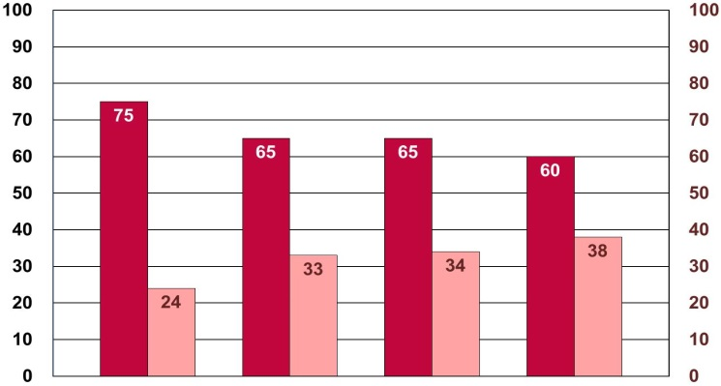 |  |  |  |  |  |  |  |  |  |  | Notes: the question was: 'For each of the following statements, please tell me to what extent it corresponds or not to your own opinion - You feel you are a citizen of the EU'. Base: all respondents. The chart does not show the share of respondents answering 'I don't know'.  Source: Standard Eurobarometer 81, Spring 2014
 |  | 15-24 |  | 25-39 |  | 40-54 |  | 55+
 |  |  | Total YES |  |  |  | Total NO
Data presented in this section shed some light on young people's interest in politics as well as their political identity. Whilst these are important motivational factors, young people must also have the means to actively participate. As in a virtuous circle, the existence of effective means for participation encourages people to become interested in the public sphere, which in turn fosters the desire to take advantage of those means. It is therefore important to identify which forms of participation best meet the needs of young people, keeping in mind that the means young people choose today may not necessarily be those traditionally used by previous generations.
7.3. Young people's participation in representative democracy: voting and joining a political party
Genuine elections with political parties competing on alternative political programmes provide the basis for the functioning of representative democracy. Choosing between the programmes of various parties and candidates, and selecting representatives for public office are the basic actions by which citizens participate in the management of public affairs. This is why election turnout is usually referred to as a relevant measure of citizens' participation.
However, electoral and party engagement seems to have limited appeal for young citizens. A Eurobarometer survey from 2012 indicates that only about one in two young people consider elections as one of the most valuable ways to express their political preferences (Figure 7-D). According to their responses, 47 % among 15-24 year-olds, and 50 % among 25-34 year-olds, believe that voting is one of the two best ways to ensure that their voice is heard by decision-makers. This result is in line with what is indicated in a survey asking young respondents what they consider to be the most effective way for participating in public life in the European Union: voting in elections to the European Parliament was chosen by only 44 % of the sample ().
Traditional forms of political engagement such as voting and becoming members of political parties have limited appeal for young citizens
Figure 7-D: Percentage of young people including 'voting in elections' and 'joining a political party' as one of the two best ways to ensure 'that one's voice is heard by decision-makers', by age group (15-24 and 25-34), EU-27 average, 2012
% %  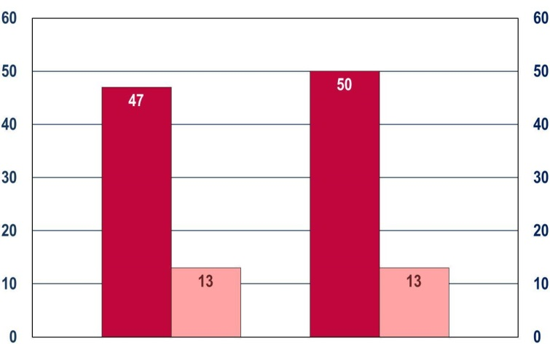 |  |  |  |  |  |  |  |  | Notes: the question was: 'Which two of the following do you think are the best ways of ensuring one's voice is heard by decision-makers?'. Base: all respondents.  Source: Standard Eurobarometer 77, 2012
 |  |  | 15-24 |  |  | 25-34
 |  | Voting in elections |  |  |  |  | Joining a political party
Joining a political party is viewed as an effective way of channelling their views by a much lower proportion of young people: only 13 % in both age groups.
Along with these results, low levels of turnout have been registered amongst young people in recent years. According to the Eurobarometer's results illustrated below, on average about 60 % of young respondents have cast their vote in an election between 2011 and 2014 (Figure 7-E).
Figure 7-E: EU youth indicator: Participation of young people (aged 15-30) in elections at the local, regional, national or EU level, by country, 2011 and 2014
EU youth indicator | % %  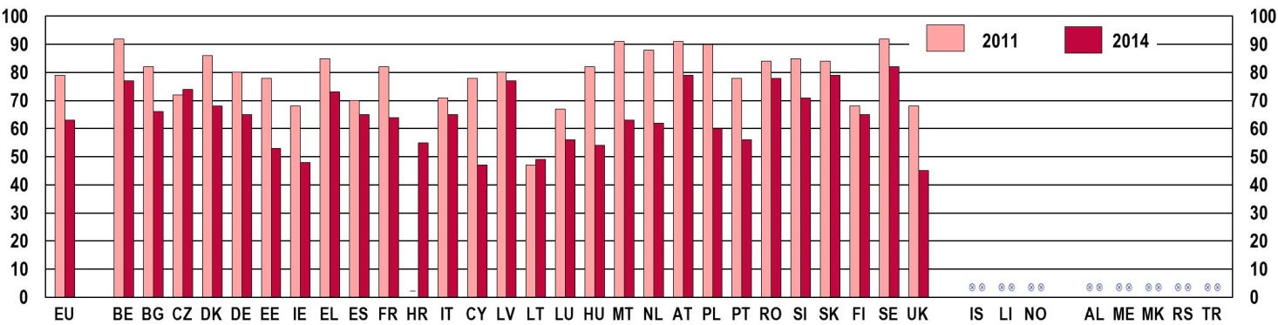
Notes: The question was 'During the last 3 years, did you vote in any political election at the local, regional, national or EU level? If you were, at that time, not eligible to vote, please say so'. Base: respondents who were eligible to vote at the time of the election. EU-27 (2011) and EU-28 (2014)
Source: 2011 Flash Eurobarometer319a 'Youth on the Move', 2015 Flash Eurobarometer 408 'European Youth'
Turnout amongst young voters has declined over recent years. In 2011, an average of almost 80 % of young respondents to the survey declared they had participated in an election in the previous three years. This trend is common to the vast majority of EU Member States, the exceptions being the Czech Republic and Lithuania where a slight increase has occurred ().
The propensity to vote seems to be influenced by the age at which respondents completed their education, indicating that higher levels of education are associated with higher turnout in elections (Figure 7-F).
Figure 7-F: Participation of young people (aged 15-29 who are eligible to vote) in elections at the local, regional, national or EU level, by the age at which they stopped full-time education, EU-28 average, 2014
% %  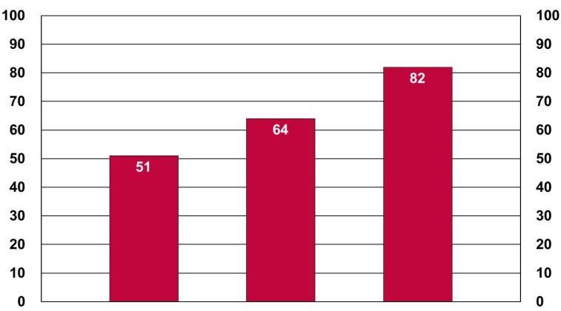 |  |  |  |  |  | Notes: questions were 'During the last 3 years, did you vote in any political election at the local, regional, national or EU level? If you were, at that time, not eligible to vote, please say so'; 'How old were you when you stopped full-time education?'. Base: respondents who were eligible to vote at the time of the election.  Source: Flash Eurobarometer 408 'European Youth', 2015
 |  | 15 | 16-19 | 20+
Both the political level at which elections take place, and the gender of young voters play a role in determining how liklely they are to cast their vote in a ballot (Figure 7-G). Young voters tend to favour local elections, followed by national ones, while regional and European elections attract less interest. In addition, there is a higher turnout among male voters than females, in all types of elections.
Figure 7-G: Participation in elections of young people (aged 15-29), by type of election and by sex, EU-28 average, 2014
% % |  |  |  |  |  |  |  | Notes: questions were 'During the last 3 years, did you vote in any political election at the local, regional, national or EU level? If you were, at that time, not eligible to vote, please say so'. Base: respondents who were eligible to vote at the time of the election.  Source: Flash Eurobarometer 408 'European Youth', 2015
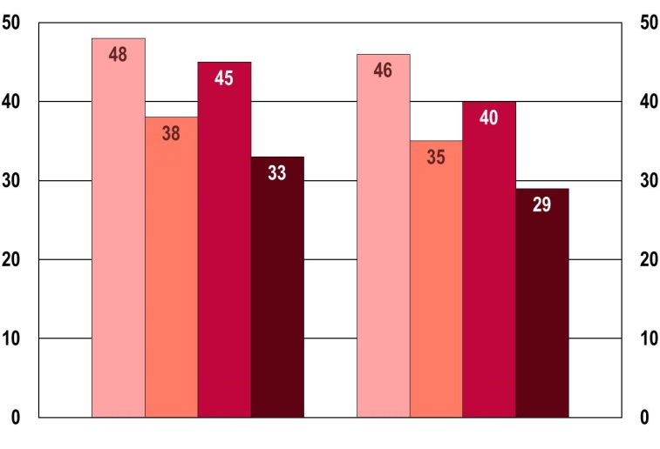
 |  | Male |  | Female
 |  | Yes, at local level |  |  |  | Yes, at national level
 |  | Yes, at regional level |  |  |  | Yes, at EU level
Besides their limited participation in elections, the proportion of people from the younger age groups elected to public office is low, at least at European Union level. Figure 7-H depicts the proportion of Members of the European Parliament aged 30 or under, who were elected to the European Parliament in May 2014. The percentage on the total of the MEPs is minimal, and, what is more, it has almost halved since the previous European elections in 2009.

In line with these results, joining a political party appeals to a rather small proportion of young people (Figure 7-I). Between 2011 and 2014, levels of membership have remained stable at around an average of 5 % in Europe. Significant drops in membership figures since 2011 have been registered in Bulgaria, Estonia, Greece, Cyprus, Lithuania and Poland, while the Czech Republic, Spain, Luxembourg, and Hungary have seen significant increases.
 | Figure 7-H: EU Youth Indicator: Members of the European Parliament aged 30 or under, 2009 and 2014
EU youth indicator | % %  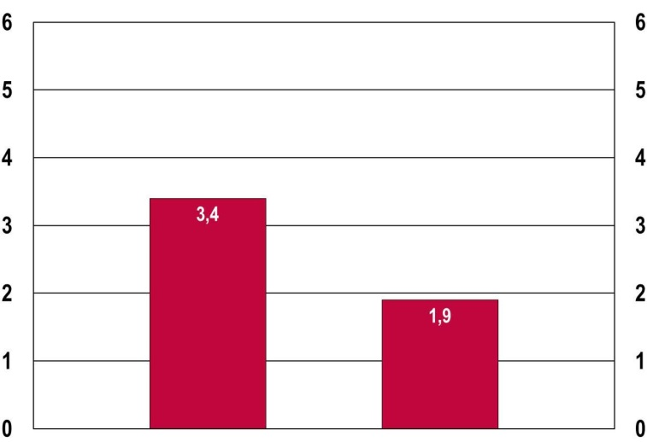
EU youth indicator |  | 2009 |  | 2014
EU youth indicator | Source: European Parliament

Figure 7-I: Membership of political parties amongst young people (aged 15-29), by country, 2011 and 2014
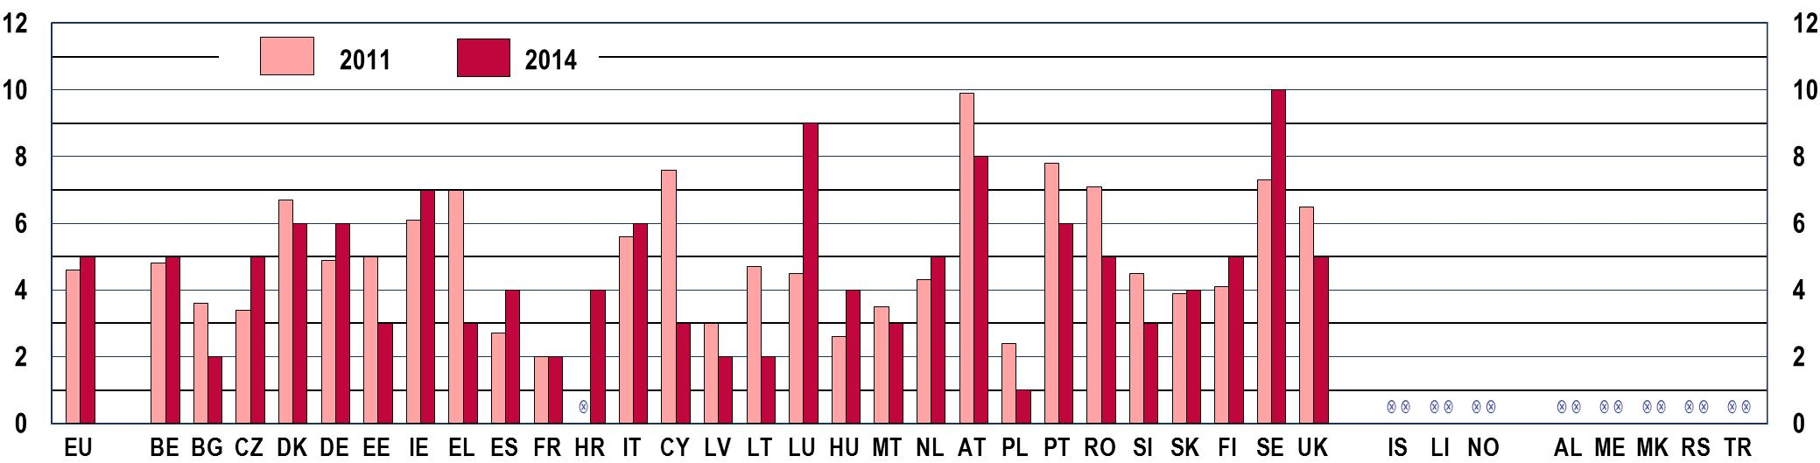

Notes: question was ‘In the last 12 months, have you participated in any activities of the following organisations? (Political Party)’. Base: all respondents. EU-27 (2011) and EU-28 (2014)
Source: 2011 Flash Eurobarometer319a ‘Youth on the Move’, 2015 Flash Eurobarometer 408 ‘European Youth’

Membership of political parties is even more limited amongst young women: on average, they are 50 % less likely to become active in such organisations than men of the same age ().
The limited levels of participation in traditional activities like voting and being active within political parties should not immediately be interpreted as signals that young people are disenchanted with democracy. Indeed, as an on-going research project suggests, 'young people show general support for democratic systems although are often critical of how they work in practice and for them' (). Collecting the views of young individuals from 30
different regions in Europe through surveys, interviews and ethnographic observation, the study indicates that youth dissatisfaction is often with associated political choices (parties, leaders, manifestoes) rather than with democracy and participation per se. It is also to be considered that, though elections and political parties have a pivotal role in democratic societies, they are not the only activities to be taken into account when evaluating political participation. Many other channels are open to people to have their say and to influence political decision-makers and policies, and these may be more attractive to younger citizens.
Young people show general support for democratic systems but are often critical of how they work in practice.
7.4. Other ways young people participate
Young people tend to favour flexible and issue-based forms of active participation such as contributing to the projects of non-governmental associations, participating in community-driven initiatives, joining social movements and expressing political opinions in public spaces ().
Data presented here confirm young people's preference for being active in non-governmental organisations and/or local organisations which address local issues, rather than in political parties. On average, twice as many respondents as those who have been active in a political party stated they had participated in the activities of a local organisation aimed at improving the local community (Figure 7-J).
Figure 7-J: EU youth indicator: Proportion of young people (aged 15-30) who have participated in the activities of organisations aimed at improving their local community, by country, 2011 and 2014
EU youth indicator | % %  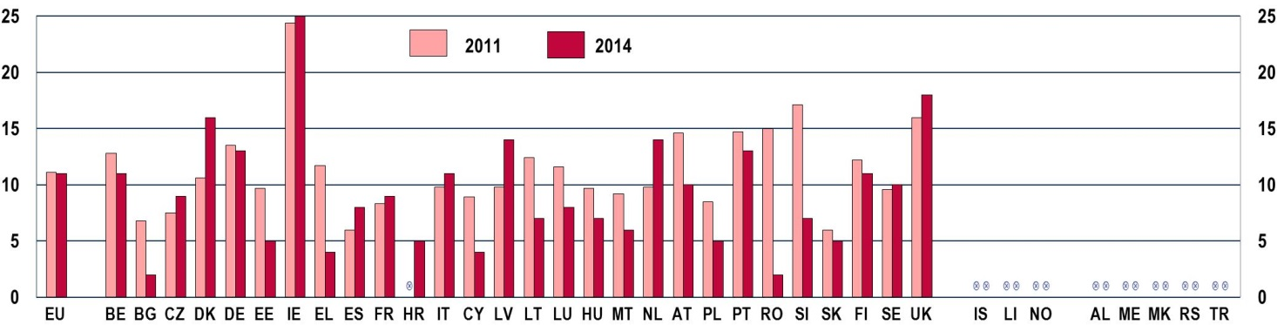

Notes: the question was 'In the last 12 months, have you participated in any activities of the following organisations? (A local organisation aimed at improving the local community)'. Base: all respondents. EU-27 (2011) and EU-28 (2014)
Source: 2011 Flash Eurobarometer319a 'Youth on the Move', 2015 Flash Eurobarometer 408 'European Youth'
On average, the figures remained relatively stable between 2011 and 2014, although important changes occurred in some Member States. Levels of participation fell significantly in Estonia, Greece, and Romania. The proportion of young people taking part in local organisations aimed at improving local communities also declined in Bulgaria, Cyprus, Lithuania, Poland and Slovenia. In contrast, it rose in Denmark, Latvia and the Netherlands.
Frustration with traditional and institutionalised forms of political participation can also result in people choosing to show their interest in issues or express their concerns without any (or with little) mediation by organised bodies, be they political parties or nongovernmental organisations.
In this context, petitions, public demonstrations, boycotts, wearing political symbols such as badges and stickers, become the means of more loose and informal participation in society and in politics, which many young people find worth experiencing (). The 2012 European Social Survey shows that on average about 20 % of young people have recently signed a petition and about 10 % respectively have joined a public demonstration and worn a badge or sticker (Figure 7-K).
Petitions, public demonstrations, boycotts, wearing political symbols such as badges and stickers, become the means of more loose and informal participation in society and in politics, which many young people find worth experiencing.
Figure 7-K: Participation of young people (aged 15-29) in various activities during the three years before the survey, by country, 2010 and 2012
Taken part in a lawful public demonstration
% %
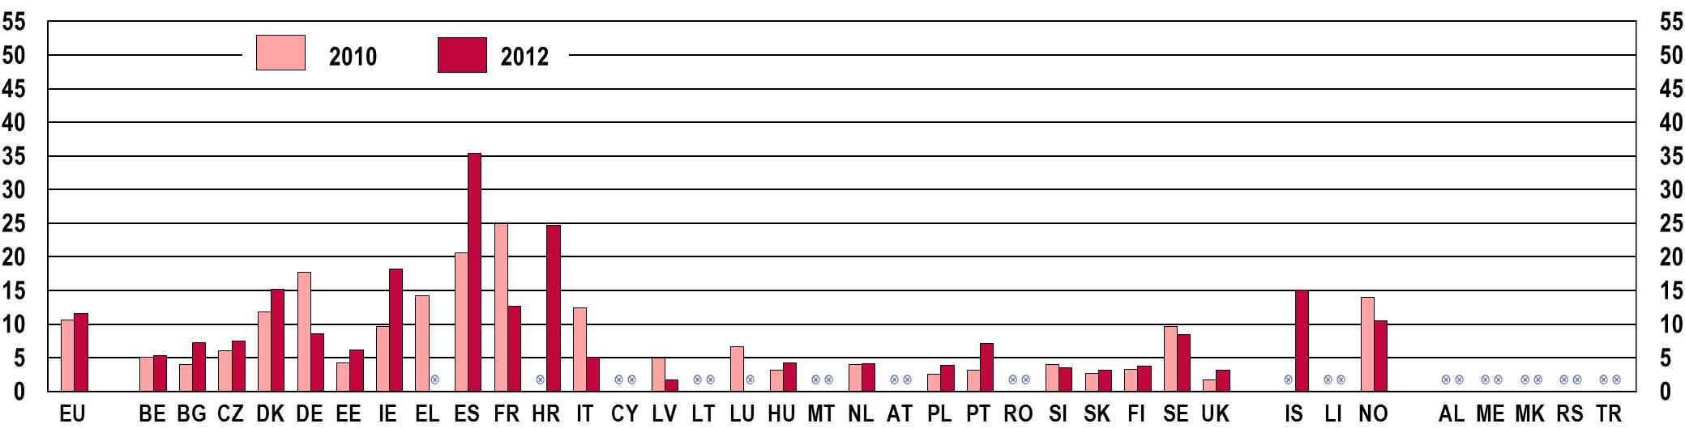
Boycotted certain products
% %
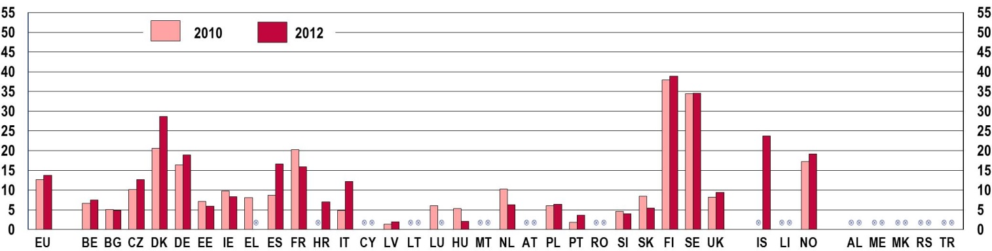
Signed a petition
% %
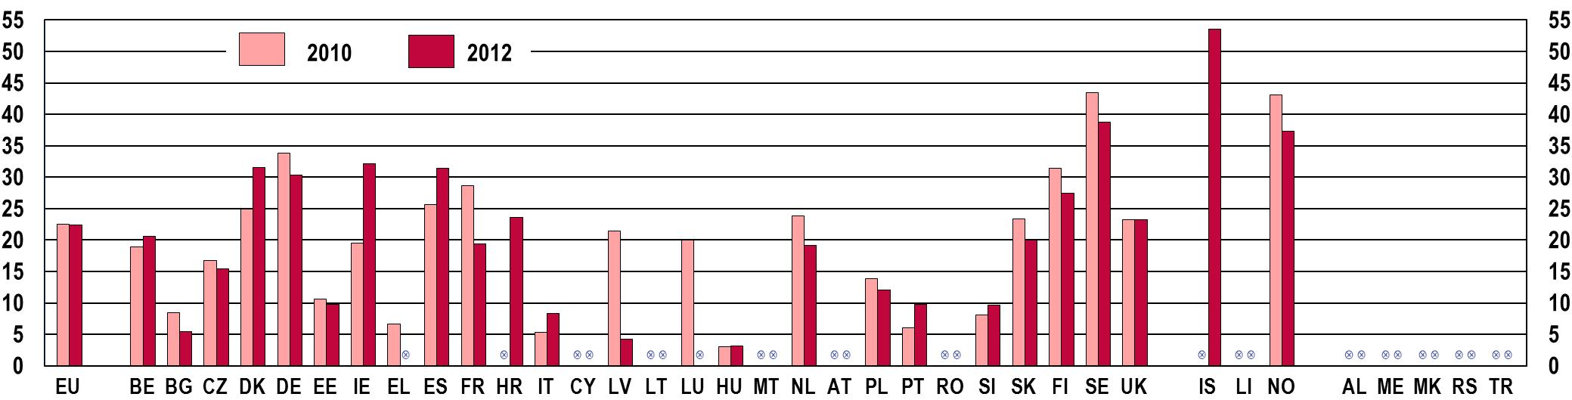

Worn or displayed campaign badge/sticker
% %
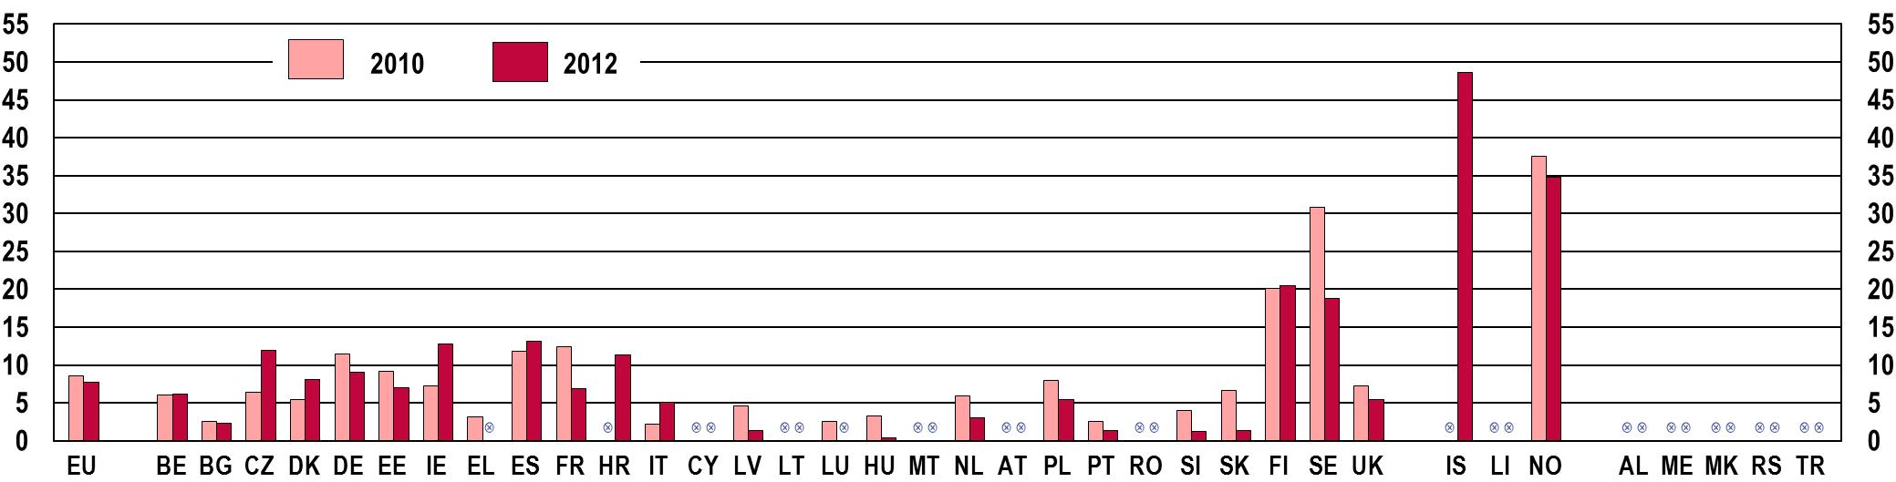
Source: European Social Survey, 2010 and 2012
Some countries appear to register higher levels of youth participation in these activities than others. In general, young people in Germany, Denmark, Ireland, Spain, France, the Scandinavian countries (Finland, Sweden, and Norway) and Iceland tend to engage more in these modes of political participation than their peers in the rest of Europe. Differences between these countries exist: while in Scandinavia higher figures are reported for signing a petition, boycotting products and especially wearing political symbols, in Ireland, Spain and Italy a higher propensity is shown for participating in public demonstrations.
A wide array of opportunities for political participation is also offered by the Internet and its applications, and young people have been in the forefront of using these means of interpersonal communication. The virtual spaces frequented by young people such as online forums, chat rooms, social networks and blogs, serve the same basic function as the physical ones they sometimes replace: establishing collective interaction around common interests. In this sense, they constitute a great resource for political and social engagement, which young people haves been the quickest to recognise and use. For example, the Internet plays a significant role in fostering social contact between young citizens as well as facilitating their interactions with their political representatives and public authorities.
Data collected by Eurostat show that, on average, roughly 50 % of young Europeans have used the Internet to contact or interact with public authorities in 2014, and this figure has increased over the last 4 years (Figure 7-L). In some countries, this percentage is extremely high, indicating a widespread use of online instruments to obtain information from public authorities' websites (Denmark, the Netherlands, Slovenia, Finland, Sweden, Iceland and Norway). Significant increases have been registered in the Czech Republic, Greece, the Netherlands, Portugal, Slovenia, the former Yugoslav Republic of Macedonia and Turkey.
Many young people resort to the Internet and its social media to interact with public authorities and exchange opinions on political issues

Figure 7-L: EU youth indicator: Share of young people (aged 16-24) who used the Internet for interaction with public authorities in the twelve months before the survey, by country, 2010 and 2014

EU youth indicator | % %  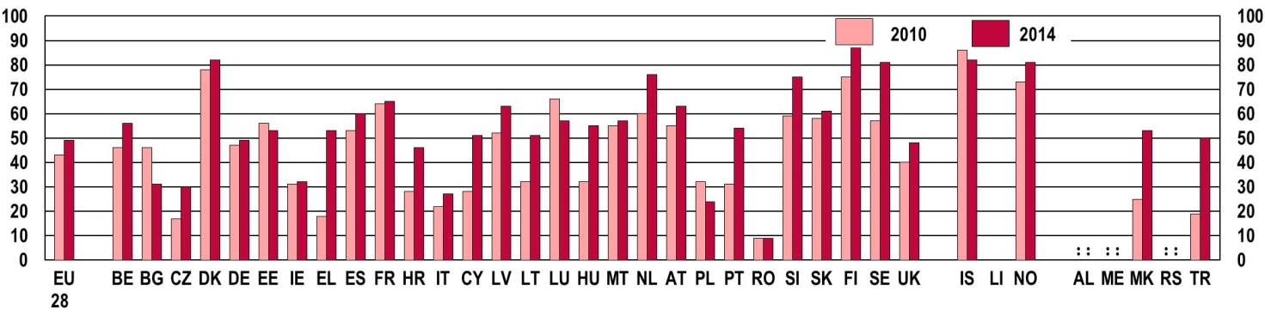
Notes: Data presented in the chart refer to the 16-24 age group, for which figures are available for both 2010 and 2014
Source: Eurostat [isoc_ciegi_ac], 2010 and 2014
On the other hand, young people in some European countries seem less familiar with this form of interaction with public authorities: the Czech Republic, Italy, Poland, Romania and Turkey report levels of interaction with public authorities through the Internet well below the European average. According to the breakdown by sex of the same data collected by Eurostat, young women tend to use the Internet to contact public authorities more than men.
Besides making contact with public authorities, around 18 % of young Europeans take to the Internet to exchange their political opinions through messages and posts on websites (Figure 7-M).
Figure 7-M: EU youth indicator: Share of young people (aged 16-24) who have used the Internet in the last three months to post opinions on civic and political issues via websites, by country, 2013
EU youth indicator | % %  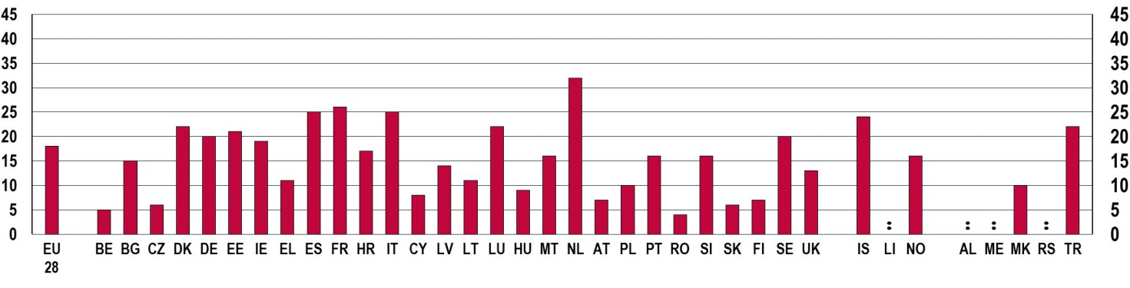
Source: Eurostat [isoc_bde15cua], 2013
Differences between some countries are significant: while young people in Belgium, the Czech Republic, Austria, Romania, Slovakia and Finland do not often resort to this means of communication, a larger proportion of their peers in Spain, Italy, the Netherlands and Iceland do so.
Results for the age group 15-24 and for a longer reference period from a Eurobarometer survey conducted in 2013 show that, on average, young people clearly prefer to express their opinions and ideas through online fora, rather than participating in person in public debates (Figure 7-N). The Internet therefore proves to be an important means for political communication amongst young Europeans.
Figure 7-N: Share of young people (aged 15-24) who participated in off-line and on-line public debates during the two years before the survey, by age groups, EU-28 average, 2013
% %
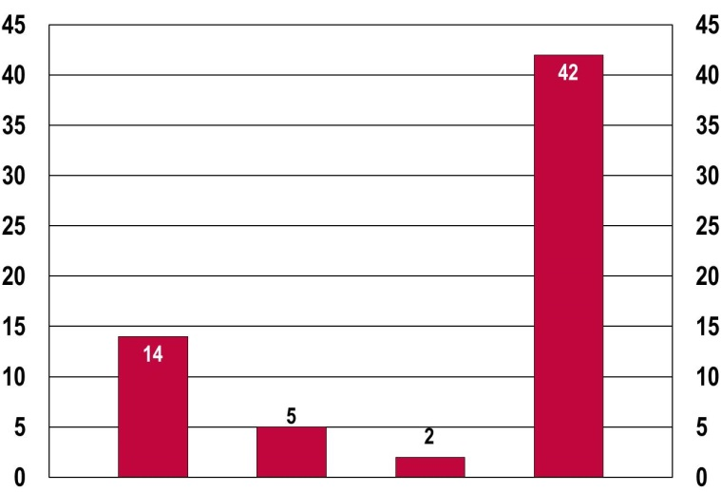
 |  |  |  |  |  | A = Taken part in a public debate at local/regional level
 |  |  |  |  |  | B = Taken part in a public debate at national level
 |  |  |  |  |  | C = Taken part in a public debate at EU level
 |  |  |  |  |  | D = Expressed views on public issues on the Internet or in social media
Notes: question was 'Have you done any of the following in the last two years?'. Base: all respondents.
Source: Flash Eurobarometer 373, 2013
 | A | B | C | D

Evidence offered by the figures illustrated so far help build a picture of the diverse and multi-layered nature of young people's engagement in political and civic activities. As some of the more traditional modes of participation lose their appeal for young Europeans, other more innovative and fluid ways to communicate and interact in the political sphere develop. Overall, the picture that emerges is far from being pessimistic: many young people manifest a desire to have their voice heard and show an interest in engaging in society, through various channels of communication.
7.5. Engaging hard-to-reach young people in political and civic life
Despite the encouraging signs described so far with respect to young people's participation, it is also evident that certain segments of the youth population remain excluded from any form of engagement in the life of their community and must overcome significant obstacles in order to participate. This form of exclusion is closely linked to other aspects of marginalisation; for example, to difficulties in finding employment or accessing vital social services (youth unemployment and social exclusion are discussed respectively in Chapters 4 and 5).
Unfortunately, the absence of quantitative information prevents an examination of the extent and nature of such political exclusion. Therefore, qualitative research investigating the beliefs and behaviours of young people represents an essential source of information in understanding the fundamental reasons behind their exclusion from the political sphere. A recent study on political participation among young people has addressed this topic through extensive interviews and focus groups with young Europeans from six EU Member States (). The results indicated a widespread belief amongst young people that political engagement requires a particular set of skills including aptitude in interpersonal relations, rhetorical dexterity, and networking ability. This opinion was shared by both individuals who did not consider they possessed such skills as well as by those who did. The perceived requirement for political skills was even more evident amongst young people experiencing social and political exclusion, for which a highly formalised model of political engagement was perceived as alien and intimidating. In addition, young respondents from disadvantaged backgrounds reported encountering material obstacles to political participation. Pressing daily concerns left very little time and resources for engagement in civic or political activities, which increased feelings of alienation and ineffectiveness in the social environment (). Last but not least, it is important to acknowledge the challenges posed by a potential digital divide in the use of communication technologies for participative purposes. While the new media offer opportunities for involvement in and information about political processes, they can also restrict access to knowledge and networks to those who have the opportunity to use a computer and surf the internet, thereby replicating the social inequalities existing in the 'non-virtual' environment (data on the use of the Internet amongst young people are discussed in Chapter 9).

(?) Jaime-Castillo, 2008; Wass, 2008
(?) European Parliament, 2014.
(?) It has to be kept in mind that electoral turnout is also influenced by the specific legal regulations in effect in countries. An obligation for citizens to vote currently exists in Belgium, Cyprus, Greece, France, Luxembourg, Liechtenstein and Turkey, although levels of enforcement vary (http://www.idea.int/vt/compulsory_voting.cfm).
(?) European Commission, 2015b.
(?) Further information on the research project, funded under the European 7th Framework Programme, can be retrieved at www.fp7-myplace.eu.
(?) Hoikkala, 2009; Barber, 2010; Gaisel et al., 2010; Santo et al., 2010.
(?) Feixa et al., 2009.
(?) EACEA, 2013
(?) Ibid.

