6. HEALTH AND WELL-BEING

EU Youth Indicators
Share of daily smokers | Figures 6-B and 6-C
Last 12 months prevalence of cannabis use | Figure 6-E
Death by intentional self-harm | Figures 6-N and 6-O

6.1. Introduction
Young people in Europe have higher levels of life satisfaction and report a higher frequency of 'being happy' than older age groups (). Nevertheless, difficulties in their transition to adulthood and independence have an influence on their health and well-being. Vulnerable groups of young people facing unemployment, poverty or social exclusion can especially experience more serious problems in their physical and mental health. For this reason, it is necessary to pay attention to young people's state of health, particularly in the current economic climate.
This chapter examines firstly the general health of young people; it then looks at recent trends in their susceptibility to 'risk behaviour' in terms of smoking, drug and alcohol use, sexual behaviour and physical inactivity. The last section addresses young people's mental well-being. Since the publication of the last EU Youth Report (), no updates have been published on the EU youth indicators on obesity, drunkenness, road accidents and psychological distress; hence, no new analysis is provided on these indicators in this chapter (). Therefore, in order to show progress, where possible, some of these issues are broached in relation to other indicators.
6.2 Young people's state of health
Young people are not only more satisfied with their life than older age groups, but they also feel healthier. As Figure 6-A-a shows, the proportion of young people aged 16 to 24 in the EU-28 who perceive their health to be 'bad' and 'very bad' is 8.4 percentage points lower than for the general population.
Differences between the proportion of young people and the total population feeling 'bad' and 'very bad' are especially wide in Estonia, Latvia, Lithuania, Portugal, Montenegro and Serbia, while they are narrowest in Ireland and Sweden. The proportion of young people feeling to be in 'bad' and 'very bad' health is the highest in Denmark (2.4 %), France (2.3 %), Latvia and the United Kingdom (2.6 %) and Norway (2.7 %), while the lowest in Greece and Spain (0.5 %) and Malta (0.4 %).
However, though the share of young people perceiving to be in 'bad' and 'very bad' health is quite low, there has been a 0.3 percentage points increase in this proportion in the EU-28 since 2010 (Figure 6-A-b). The largest increases took place in France (1.0 percentage points) and the United Kingdom (1.4 percentage points). On the other hand, the share of young people in bad and very bad health decreased substantially in Denmark and Slovenia (by 1.3 percentage points) and Portugal (by 1.4 percentage points).

Figure 6-A: Self-perceived health: feeling 'bad' and 'very bad', by country and by age
a) by age, 2013
% %
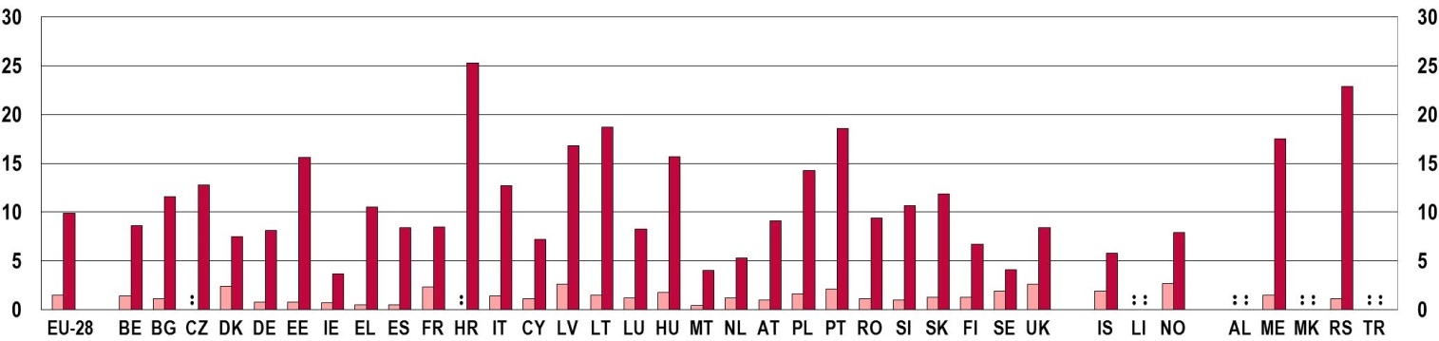
 | Aged 16-24 |  | Total population
Source: Eurostat, Statistics on income and living conditions (SILC) [hlth_silc_01]
b) young people (aged 16-24), 2010 and 2013
% %
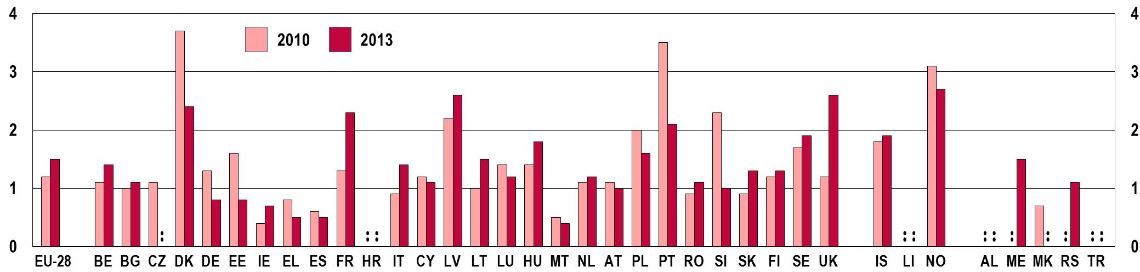
Notes: Data on young people aged 16-24 are not reliable and not publishable for the Czech Republic (2013) and Croatia (2010 and 2013). Data are not reliable for the Czech Republic (total population), Estonia (young people, 2010 and 2013), Croatia (total population), Lithuania (total population and young people, 2010 and 2013), the United Kingdom (young people, 2013), and Serbia (total population and young people, 2013).
Data on young people feeling 'very bad' are not available for Ireland (2010), Lithuania (2010), Malta (2010 and 2013), the Netherlands (2010), Finland (2010) and Iceland (2013. In these cases, data displayed on the figure is the proportion of young people reporting to feel 'bad'.
Source: Eurostat, Statistics on income and living conditions (SILC) [hlth_silc_01]
6.3 Health risks
Despite their generally good health, young people are more prone to risk behaviour than older age groups. Risk behaviours such as smoking, alcohol consumption, drug use, physical inactivity and unsafe sexual practices often cluster together and reinforce each other (). They are all influenced by the same social factors: the level of deprivation and social exclusion, access to education, as well as the family, school and living environment (). Moreover, these behaviours do not only have a strong influence on young people's health and well-being at the time they occur, but also have life-long effects ().
Youth transitions are becoming longer, more complex and more individualised. This impacts on health-related behaviours and has long-term consequences for young people's health.
Young people are the most vulnerable to risk behaviours when their life is in transition (). As has been discussed in earlier chapters, young people undergo various transition periods as they grow up: from childhood to adolescence, from education to work, and from living with their parents to living with their peers or alone. In this context, barriers to accessing higher levels of education, leaving school prematurely, long periods of unemployment or insecure housing situations all increase the probability of young people engaging in risk behaviours (). Moreover, as was shown in Chapters 4 and 5, these transition periods are becoming longer and more complex, thus increasing young people's vulnerability ().
This section provides an overview of the behaviours that may put young Europeans' health at risk. Yet, it has to be noted that data are often limited to only a few countries, or are based on surveys for which no time series is available. This hampers the possibility to make comprehensive comparisons across European countries and through time. Nevertheless, this section provides an analysis based on the most up-to-date comparative data in the relevant fields.

6.3.1. Smoking
Smoking is a well-known health risk and is the leading cause of preventable death (). However, as Figure 6-B-a shows based on data from 2012 and 2013, a relatively large percentage of young people aged 15 to 24 still smoke daily in European countries, especially in the Czech Republic (33.2 %) and France (27.9 %). These are also the two countries with available data where young people smoke more than older age groups. Young men are particularly prone to daily smoking – with more of them smoking on a daily basis than young women in all countries with available data (Figure 6-B-b). Nevertheless, gender differences are quite small in most Nordic countries (Denmark, Sweden, Norway and Iceland) and Luxembourg; whereas almost six times more young men than young women smoke daily in Turkey.
Figure 6-B: EU youth indicator: Share of daily smokers, by country and by age, 2012/2013
a) by age
EU youth indicator | % %  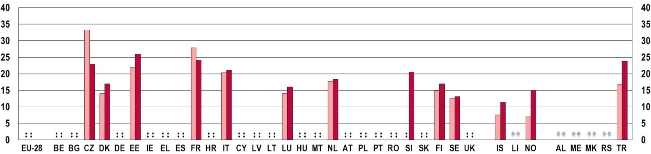
EU youth indicator
   | Aged 15-24 |  | Total population (aged 15+)

b) Share of daily smokers among young people (aged 15-24), by sex
EU youth indicator | % %  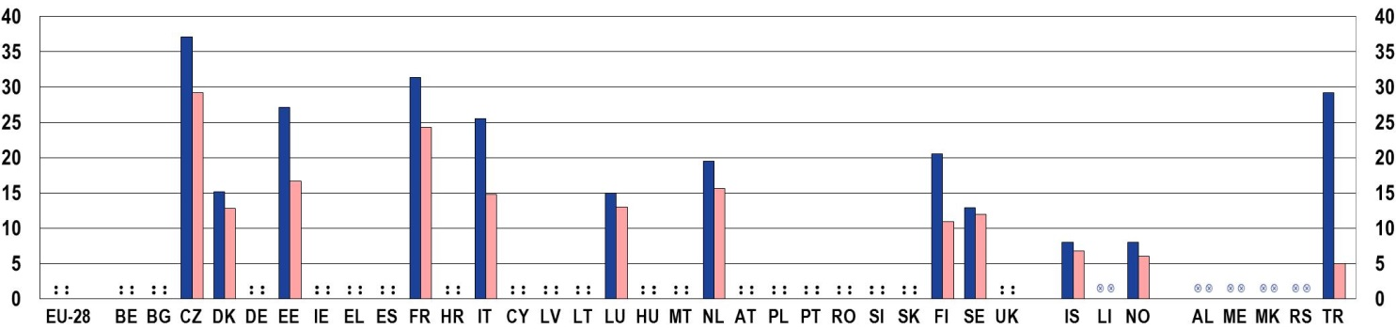
EU youth indicator
   | Men |  | Women
Notes: CZ, EE, FR, NL, SI, FI, SE, TR: 2012; DK, IT, LU, NO, IS: 2013
Source: OECD Health Statistics

The proportion of people who smoke daily has been steadily decreasing since the beginning of the 2000s in almost all European countries with available data (Figure 6-C), pointing towards the effectiveness of anti-smoking campaigns and smoke-free legislation (). Countries registering the greatest decreases in the proportion of young people who smoke daily between 2002 and 2013 are shown on Figure 6-C-a: they are Luxembourg and Norway, with a fall of around 23 and 19 percentage points respectively, followed by the Netherlands, Finland and Iceland. In Luxembourg, Norway, Finland and Iceland, the proportion is now below 15 %. On the other hand, the countries where the proportion of young people smoking daily has remained relatively stable (with a decrease of less than 6 percentage points) are Estonia, France, Italy and Sweden, though France registered a recent increase of 2.3 percentage points between 2010 and 2012 (depicted on Figure 6-C-b).
The proportion of young people smoking daily has been in decline since the early 2000s, though not in all countries.
Among the countries with available data, the only country where the proportion of young people smoking daily has been on the rise since 2002 is the Czech Republic (Figure 6-C-b). This increase has been especially striking in the case of women: the proportion of young female smokers in 2012 was almost the double of the same ratio in 2002 (). Differences between the smoking trends of women and men have also been registered in Estonia and Sweden. In Estonia, the proportion of young women smoking daily has been increasing since 2002; while in Sweden, the proportion of young men smoking daily was growing in this period ().
Figure 6-C: EU youth indicator: Share of daily smokers among young people (aged 15-24), by country, 2002-2013
EU youth indicator | a) | b)
EU youth indicator | % % | % %
EU youth indicator | 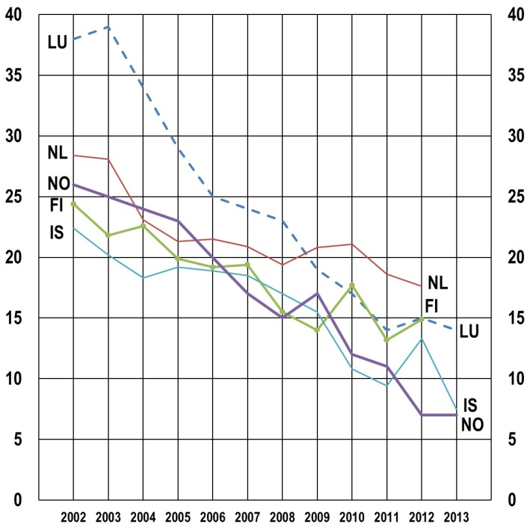 | 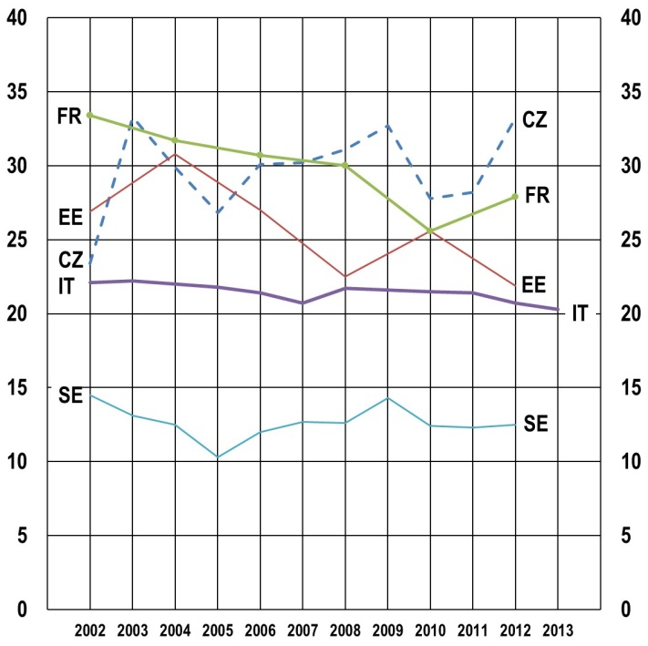
Notes: EE, FR: data not available for 2003, 2005, 2007, 2009 and 2011; IT: data not available for 2004.
Source: OECD Health Statistics

This decreasing trend is also confirmed by a recently released Eurobarometer survey on the attitudes of European towards tobacco (). In comparison to previous surveys, the proportion of smokers (not daily smokers, but smokers in general) decreased in almost all EU-28 countries (). However, no data on young people are available by country in these Eurobarometer surveys.

6.3.2. Alcohol consumption
Alcohol is the most consumed psychoactive substance (). Despite its links with health problems, unsafe sex and violent behaviour, young people do not perceive the occasional drink as a health risk: 77 % of respondents in a recent Eurobarometer survey believed that drinking alcohol once or twice poses 'no risk' or only a 'low risk' (). Nevertheless, regular drinking was perceived differently: 57 % of young respondents thought that regular alcohol consumption posed a high risk to their health (). However, the limits between drinking 'once or twice' and 'regularly' are often drawn arbitrarily and can become blurred.
This section relies on the indicator on the last month prevalence of alcohol use among young people (), based on national survey data collected by the European Monitoring Centre for Drugs and Drug Addiction (EMCDDA). This indicator has to be treated with caution, since it does not distinguish between occasional and regular drinking; neither does it indicate the amount of alcohol drunk on any occasion. Nevertheless, past surveys suggest that young people are less likely to drink daily and more likely to drink 5 or more drinks (heavy episodic or binge drinking) once a week than people above the age of 55 ().
Figure 6-D-a confirms the widespread consumption of alcohol by young Europeans. In almost all countries with available data, more than 50 % of young people (and people from older age groups) reported having drunk alcohol in the past month. Alcohol consumption is slightly less prevalent in Portugal and Romania, where just over 40 % of young people aged 15-24 drink regularly (at least once in the past month), and very low in Turkey, where only 12 % of young people reported drinking alcohol in the month before the data collection. In contrast, drinking alcohol is the most widespread – with more than 70 % of young people reporting recent alcohol consumption – in Germany, Estonia, Cyprus, the Netherlands and Slovenia.
Different patterns of alcohol consumption are evident across Europe. In about a third of countries with available data, consumption increases with age; in another third, the 15-34 age group is the most prone to regular drinking; and in the final third of countries, consumption decreases with age. Countries in this latter group – where young people drink more than older age groups – are Italy, Cyprus, Hungary, Austria, Slovenia and Turkey.
As with smoking, drinking alcohol is more of a habit among men than women (). As Figure 6-D-b depicts, with the exception of the Czech Republic and Norway, alcohol consumption is higher among men than women in all countries with available data. Differences between the sexes are the widest in Turkey, followed by Romania, Bulgaria and Portugal; while they are narrowest in the Czech Republic, Lithuania, Finland and Norway.
Figure 6-D: Last month prevalence of alcohol use, by country and by age, year of the last available national survey
a) by age
% %
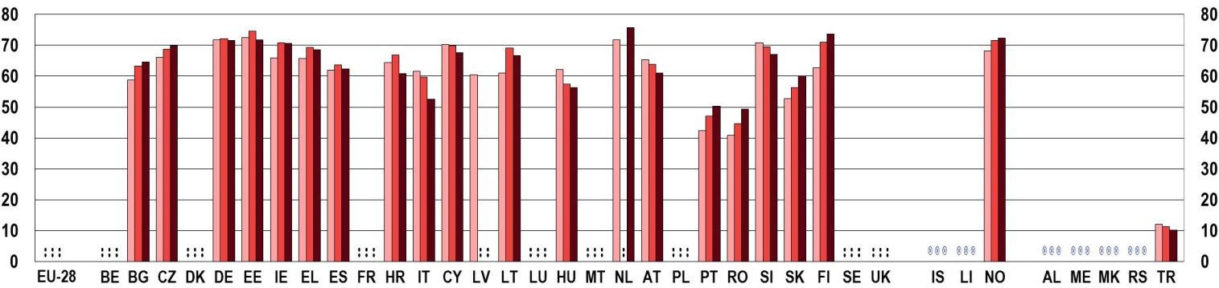
 | Aged 15-24 |  | Aged 15-34 |  | Aged 15-64
b) Last month prevalence of alcohol use of young people (aged 15-24), by sex
% %
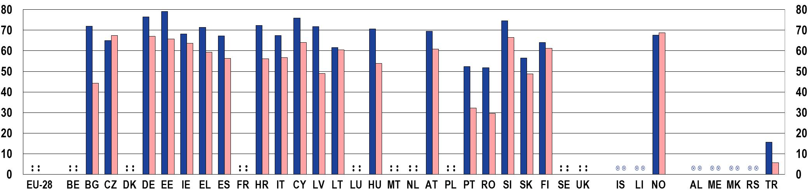
 | Men |  | Women
Notes: EL: 2004; HU: 2007; AT, EE: 2008; NL: 2009; RO, SK, FI: 2010; IE, ES, LV, TR: 2011; BG, CZ, DE, HR, IT, CY, LT, PT, SI, NO: 2012 - Source: EMCDDA.

6.3.3. Drug use
Young people – especially in adolescence – are particularly vulnerable to substance use and substance use disorders (). As mentioned above, the insecurity experienced in this transition period, together with factors such as the experience of deprivation, an insecure family environment or peer pressure all increase the likelihood of risk behaviour.
This section focuses in the first place on cannabis, the most popular drug used by young people aged 15 to 24 (). It also examines data on 'legal highs': new synthetic psychoactive substances that imitate the effects of illicit drugs, but, as yet, are still legal or not controlled. According to the EMCDDA, although the use of such legal highs is still relatively low in Europe, they are growing rapidly. In addition, though they are not perceived as such (see Figure 6-G), accessing them is fairly easy, since they are available online ().
According to the 2014 Eurobarometer survey on drugs, in comparison to alcohol, fewer young people think that using cannabis once or twice poses 'no risk' or only a 'low risk' to health, but this proportion is still relatively high, 50 % (). A majority of respondents (63 %) thought that regular cannabis use posed a high health risk (as discussed above, the same percentage for alcohol was 57 %) (). In contrast, the new synthetic substances are perceived to be much more dangerous: 57 % of respondents thought that using them even once or twice posed a high health risk, while regular use was perceived to be highly risky by 87 % of young respondents ().
Young people are more prone to using cannabis than older age groups. According to national surveys collected by the EMCDDA, in all countries with available data, the likelihood of using cannabis decreases with age, thus young people aged 15 to 24 are much more likely to use this substance than older age groups (Figure 6-E-a). Late adolescence and young adulthood is often described as the age of 'experimentation', when young people try new substances, often without becoming addicted to them.
Young people are more likely to use cannabis than older age groups. Young men are more prone to substance use than young women.
As Figure 6-E-a depicts, the greatest differences between cannabis use among young adults and that of the wider population (between 15 and 64 years of age) are in Hungary, where young adults are more than four times more likely to have used cannabis in the past year than the wider adult population, followed by Denmark, Italy and Norway, where this ratio is almost 3.5.
Figure 6-E: EU youth indicator: Last 12 months prevalence of cannabis use, by country and by age, year of the last available national survey
a) by age
EU youth indicator | % %  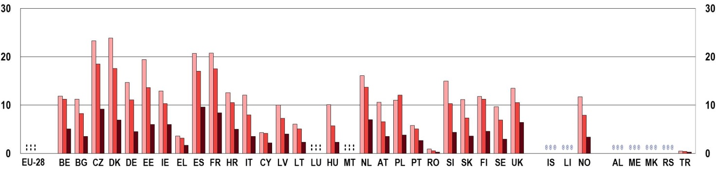
EU youth indicator
   | Aged 15-24 |  | Aged 15-34 |  | Aged 15-64

b) Last 12 months prevalence of cannabis use of young people (aged 15-24), by sex
EU youth indicator | % %  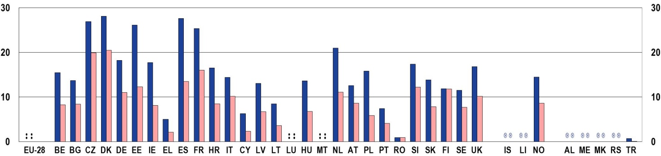
EU youth indicator
   | Men |  | Women
Notes: EL: 2004; HU: 2007; BE, AT, EE: 2008; NL: 2009; FR, RO, SK, FI: 2010; IE, ES, LV, TR: 2011; BG, CZ, DE, HR, IT, CY, LT, PL, PT, SI, SE, UK, NO: 2012; DK: 2013; UK: England and Wales only.
Source: EMCDDA

As with smoking and alcohol consumption, men are more prone to cannabis use than women in all countries with available data (see Figure 6-E-b). The difference between the sexes is the largest again in Turkey, though cannabis consumption is very low for both sexes. Men are more than 2.5 times more likely to use cannabis than women in Greece, Cyprus, Lithuania and Poland. There is no difference between men and women in Romania in their use of cannabis, which is at a very low level in this country, as well as in Finland.

The Eurobarometer surveys on drugs allow for comparing cannabis use in 2011 and 2014, indicating an increase in the European Union from 7.6 % to 10 % (Figure 6-F) (). Countries registering significant increases were Denmark, Germany, Italy, Cyprus, Austria and Finland, while cannabis consumption decreased significantly in Lithuania.
The 2014 survey shows that cannabis use was the most widespread in the Czech Republic (15 %), Denmark, Estonia and Spain (13 %), while its use was reported to be the lowest in Hungary (3 %), Cyprus and Romania (2 %).
In contrast, as Figure 6-F also shows, new substances are rarely used by young Europeans, only 3 % of respondents report using the new synthetic substances. These new drugs were used the most in Ireland, Spain and France (5 %). They are typically used in social settings: 68 % of users reported to have obtained them from their friends, 60 % used them together with friends and 65 % at a party or an event ().
Figure 6-F: Last 12 months prevalence of cannabis and 'new substances' use of young people (aged 15-24), by country, 2011 and 2014
% %
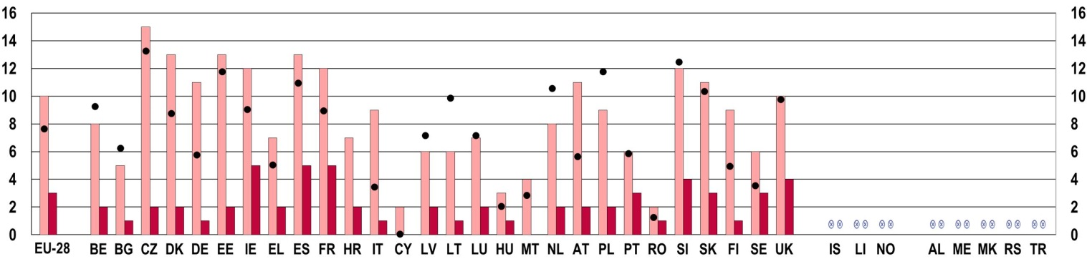
 | Cannabis, 2014 |  | New substances, 2014 |  | Cannabis, 2011
Notes: Questions: 'Have you used cannabis yourself?' and 'New substances that imitate the effects of illicit drugs such as cannabis, ecstasy, cocaine, etc. may now sometimes be available. They are sometimes called (…) 'legal highs', or 'research chemicals' and can come in different forms, for example herbal mixtures, powders, crystals or tablets. Have you ever used such substances?'
Base: all respondents, % of 'yes, in the last 12 months' answers by country, EU-28 in 2014 and EU-27 in 2011
Source: Flash Eurobarometer 401, 'Young people and drugs', 2014 and Flash Eurobarometer 330, 'Youth attitudes on drugs', 2011

Figure 6-G: Young people's (aged 15-24) perception of the difficulty in obtaining drugs within 24 hours, EU-28 average, 2014
Cannabis |  |  | New substances
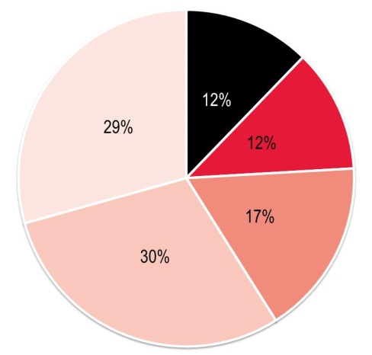 |  | Impossible | 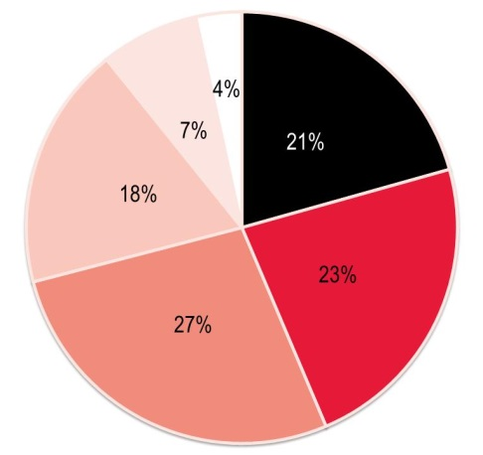
 |  | Very difficult
 |  | Fairly difficult
 |  | Fairly easy
 |  | Very easy
 |  | Do not know/Not available
Notes: Question: 'Q11. How difficult or easy do you think it would be for you personally to obtain the following substances within 24 hours?' – 'Cannabis'; 'New substances that imitate the effects of illicit drugs'
Base: all respondents, EU-28
Source: Flash Eurobarometer 401, 'Young people and drugs', 2014

Differences in the consumption of these two substances are in line with their perceived danger to health as well as the perceived difficulty in accessing them. Figure 6-G depicts young people's perception of the difficulty in obtaining different drugs within 24 hours (15-24 age group). Data show that while the majority of young people (59 %) thought that getting access to cannabis was easy, new substances were perceived to be rather difficult to get hold of: 21 % of respondents thought it impossible to obtain them within 24 hours, and 50 % thought this would be difficult.

6.3.4. Sexual risk behaviour
High-risk sexual behaviour (most notably early first intercourse, multiple sexual partners, or inconsistent condom use) is influenced by the same social factors as the various types of substance use and is even associated with them (). Such risky behaviour carries the danger of contracting sexually transmitted diseases like HIV/AIDS and can result in unplanned pregnancies.
Collecting data on the sexual risk behaviour of young people or on its consequences is difficult and complex. For example, the true incidence of sexually transmitted infections (STIs) is likely to be considerably higher than data suggest, since due to differences in testing methods, screening programmes and surveillance systems across Europe, many cases remain unreported or misdiagnosed.

In the absence of more accurate data, fertility and abortion rates are indications of sexual activity without contraception. Figure 6-H shows the fertility rates of young women aged 15 to 19 in 2010 and 2013. In 2013, fertility rates of 15 to 19 year-old girls were the highest in Bulgaria (4.2 live births per 100 women) and Romania (3.3), and the lowest in the Netherlands (0.4) and Liechtenstein (no live births per 100 women aged 15-19). Almost every country shows declining trends since 2010 for this indicator, with the exception of Bulgaria (no change since 2010), the Czech Republic, Latvia, Lithuania and Hungary. In the EU-28, fertility rates among young women show a 15 % decrease in 2013 compared to 2010.
Fertility rates as well as the percentage of legally induced abortions are decreasing among girls aged 15 to 19.
Figure 6-H: Fertility rate among young women (aged 15-19), by country, 2010 and 2013 (live births per 100 women)
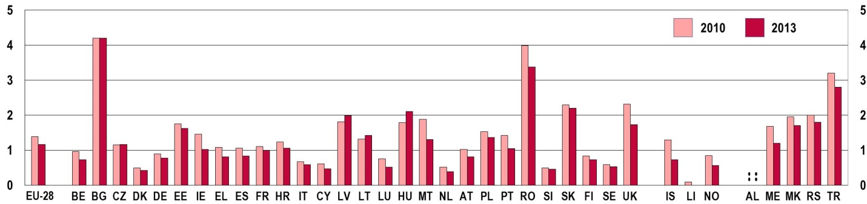
Source: Eurostat [demo_frate]

Similar trends can also be observed based on available data on the percentage of legally induced abortions in the same age group (young women aged 15 to 19). The percentage of young women's abortions declined in every country except Bulgaria, the Czech Republic and Lithuania, though absolute numbers decreased even in these three countries. The decline is especially pronounced in Germany, Romania and the United Kingdom (Figure 6-I). In 2013, the percentage of legally induced abortions for very young women was the highest in Bulgaria, Estonia, Hungary and the United Kingdom.
Figure 6-I: Percentage of legally induced abortions among young women (aged 15-19), by country, 2010 and 2013
% %
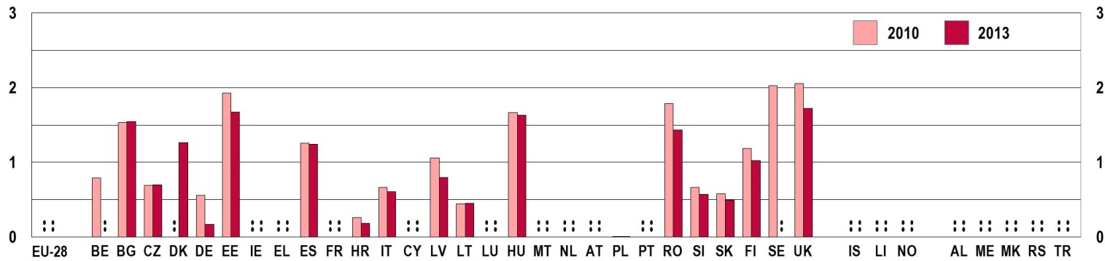
Notes: For Spain, Italy, Slovenia and the United Kingdom, data are from 2012 instead of 2013. Average populations were calculated as the arithmetic averages between the population on the 1 January in the given year, and on 1 January in the following year.
Source: Eurostat [demo_fabort and demo_pjangroup] and own calculations.

6.3.5. Physical inactivity
Physical inactivity is the fourth leading risk factor for global mortality (). Physical inactivity is one of the main causes of obesity, which has long-lasting health consequences if it develops early in childhood ().
Recent Eurobarometer surveys indicate that young people aged 15-24 are the most physically active of the age groups investigated (). As Figure 6-J depicts, only 36 % of young people aged 15-24 seldom or never take exercise or play sport, as opposed to 54 % in the 25-39 age group, 61 % of those aged 40-54 and 70 % of people over 55. Yet, differences between the age groups are much smaller when it comes to engaging in less formalised physical activities like cycling, dancing or gardening: 44 % of young people seldom or never engage in such activities, while the corresponding proportion is 57 % in the oldest (55+) age group (see Figure 6-K).
Similarly, while relatively large differences exist between young women and men in the frequency of taking exercise or playing sport, differences are much smaller when it comes to their engagement in other physical activities (see Figure 6-J and 6-K). Nonetheless, women are more likely to be physically inactive than men: 44 % of young women seldom or never take exercise or play sport, and 49 % seldom or never engage in other physical activities (as opposed to the 26 % and 40 % of men respectively).
Almost half of young women seldom or never engage in physical activity.
Figure 6-J: Proportion of people seldom or never taking exercise or playing sport, by age and by sex, EU-28 average, 2013
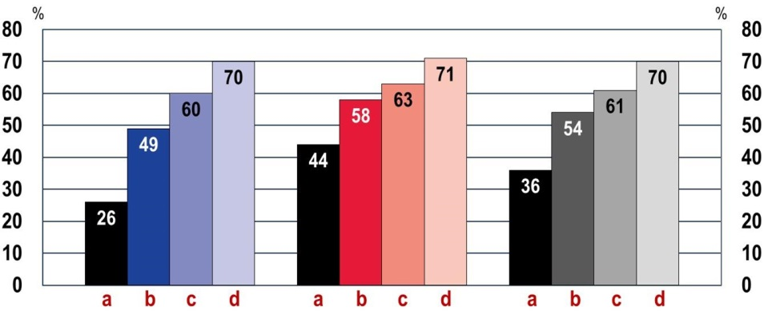
  a | Aged 15-24
  b | Aged 25-39
  c | Aged 40-54
  d | Aged 55+
Men | Women | Total

Notes: Question: 'How often do you exercise or play sport?'
Base: all respondents, % of 'less than 1 to 3 times a month' and 'never' answers, EU-28
Source: Special Eurobarometer 412, 'Sport and physical activity', 2014

Figure 6-K: Proportion of people seldom or never engaging in physical activities such as cycling, dancing or gardening, by age and by sex, EU-28 average, 2013
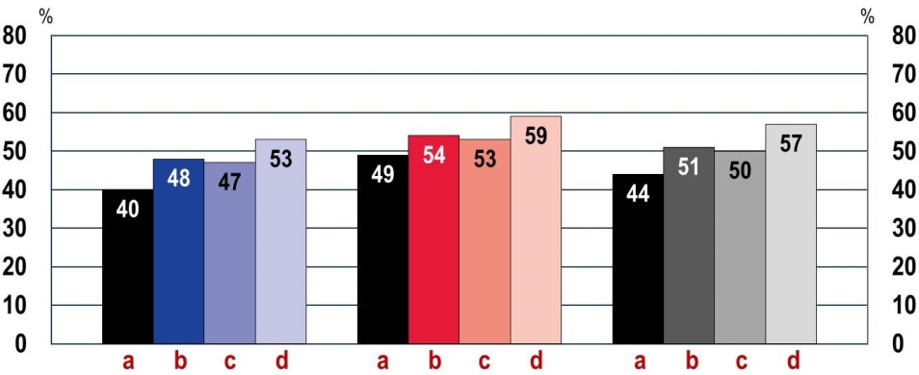
  a | Aged 15-24
  b | Aged 25-39
  c | Aged 40-54
  d | Aged 55+
Men | Women | Total

Notes: Question: 'And how often do you engage in other physical activity such as cycling from one place to another, dancing, gardening, etc.?'
Base: all respondents, % of 'less than 1 to 3 times a month' and 'never' answers, EU-28
Source: Special Eurobarometer 412, 'Sport and physical activity', 2014

Although a direct comparison between the Eurobarometer surveys conducted in 2009 and 2013 is not possible due to a change in the question on physical activity (in 2009, it also included 'walking from one place to another'), the direction of change between the surveys is not encouraging (). While the proportion of young people seldom or never taking exercise or playing sport has decreased since 2009 (especially among young women), data on the share of young people, and primarily on the share of young women seldom or never engaging in other physical activities point towards increasing inactivity.
While sample sizes in Eurobarometer surveys do not allow for analysing young people's inactivity by country, data are available from the European Quality of Life Survey (EQLS) conducted by Eurofound (). As Figure 6-L shows, physical inactivity among young respondents aged between 18 and 24 was particularly high (more than 50 %) in Bulgaria, Cyprus, Romania and Turkey. Young people were the most physically active in the Czech Republic, Austria and Finland.
Figure 6-L: Proportion of young people (aged 18-24) seldom or never taking part in sports or physical exercise, by country, 2011
% %
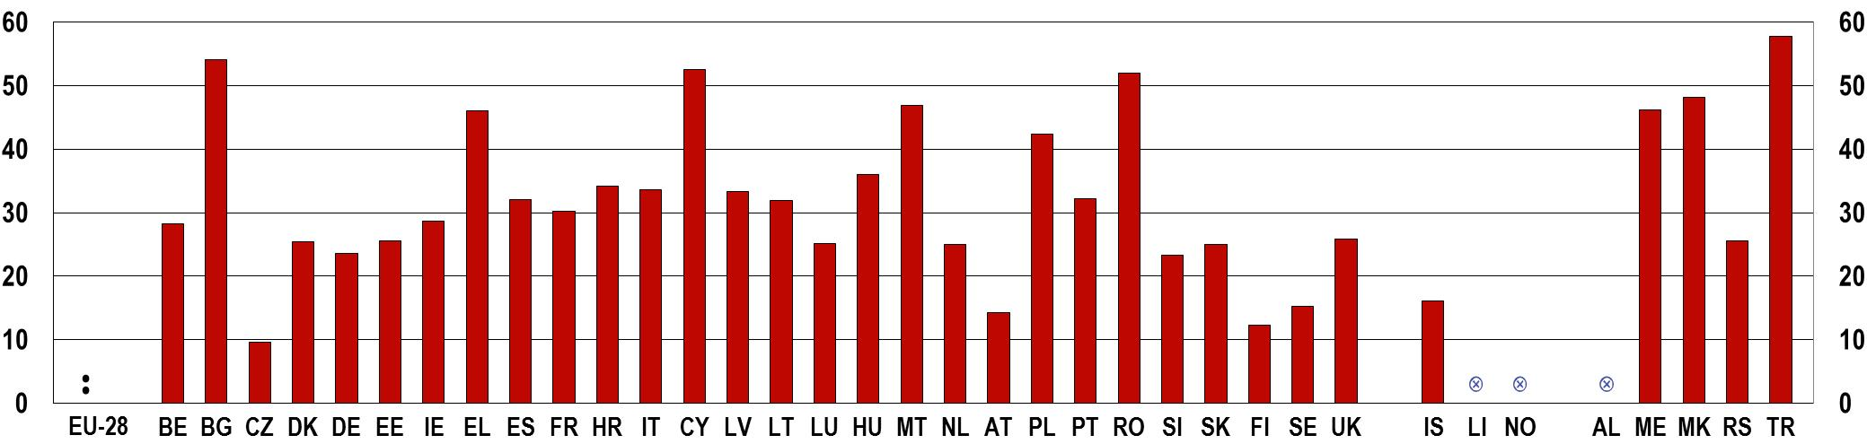
Source: Eurofound, EQLS
6.4 Mental well-being
The transition from childhood to adulthood and the societal and family pressures that young people face in such contexts also influence their mental health. Though mental and psychological distress is still less prevalent among young people than older age groups, special attention has to be paid to young people and the factors influencing their vulnerability. As with risk behaviour, mental health is also influenced by the socio-economic conditions of young people's lives – their level of social exclusion and degree of poverty. For this reason, the economic crisis may also have had an impact on the mental health of young people due to their parents' circumstances as well as their own difficulties (). As Chapters 4 and 5 of this report showed, youth unemployment and social exclusion rates have grown considerably, which certainly influences young people's mental health and psychological well-being.
The mental well-being index developed by the World Health Organization (WHO) is compiled on the basis of five questions () related to a person's mental well-being. The European Quality of Life Survey includes information on this well-being index, and allows for comparisons between countries, age groups, social groups and over time. The higher the average mental well-being score, the better the respondents' perception of their own psychological well-being. For example, as the EQLS survey shows, the mental well-being index is higher for those in employment than for both the unemployed and the inactive ().
Figure 6-M compares the mental well-being index of young people with the total population in European countries. In 2011/12, the mental well-being index of young people aged 18-29 had the highest average scores in the former Yugoslav Republic of Macedonia, Bulgaria and Montenegro, while the lowest were in Sweden, the United Kingdom, Malta and Luxembourg.
Figure 6-M: Mental well-being index, by country and by age, 2007 and 2011/12
% %
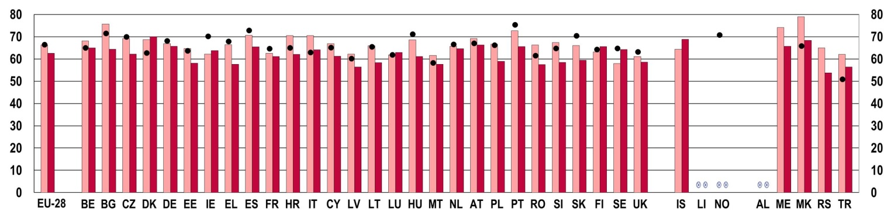
 | Aged 18-29, 2011/12 |  | Total population, 2011/12 |  | Aged 18-29, 2007
Source: Eurofound, EQLS

The figure also shows that young people have higher average scores than the total population almost everywhere. The exceptions are the Nordic countries (Denmark, Finland, Sweden and Iceland), as well as Ireland and Luxembourg, though to different degrees. It is in Sweden in particular (with a difference of more than 6 percentage points), as well as in Iceland (4.5 percentage points) and Finland (2.5 percentage points) where young people's mental well-being is worse than in the total population. In contrast, young people have much higher mental well-being scores than the total population – with a difference of more than 10 percentage points – in south-eastern countries such as Bulgaria, the former Yugoslav Republic of Macedonia and Serbia, and to a lesser extent in Greece, Croatia, Romania, Slovenia and Montenegro.
Looking at recent trends in the mental well-being of young people, while the average EU mental well-being index stayed relatively stable between 2007 and 2011, country variations exist (see Figure 6-M). Among the countries with available data, more countries experienced increases in the average mental well-being index scores of young people than decreases. Average mental well-being scores decreased the most in Ireland, Sweden and Slovakia in this period, while the largest increases were registered in the former Yugoslav Republic of Macedonia, Turkey and Italy.

6.4.2. Suicide
As the 2012 Youth Report showed (), suicide rates were relatively stable in the EU-28, but with a slight increase from 2008, both among young people and in the total population. This increase – and more notable increases in some countries, for example in Greece – can at least partly be linked to the economic crisis ().

Figure 6-N: EU youth indicator: Death by intentional self-harm, crude death rate (per 100000 inhabitants), by age and by sex, EU-28 average
EU youth indicator | a) by age, 2009-2012  % %  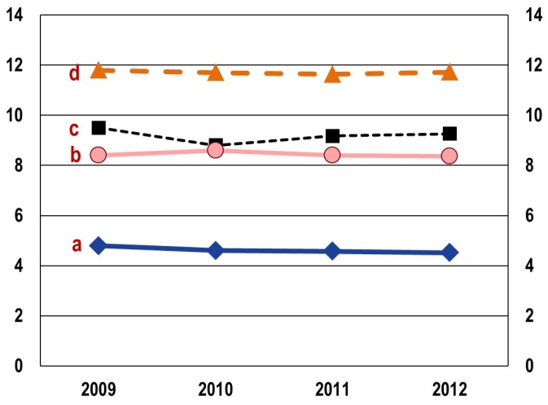 |  |  |  |  | b) by age and by sex, 2012  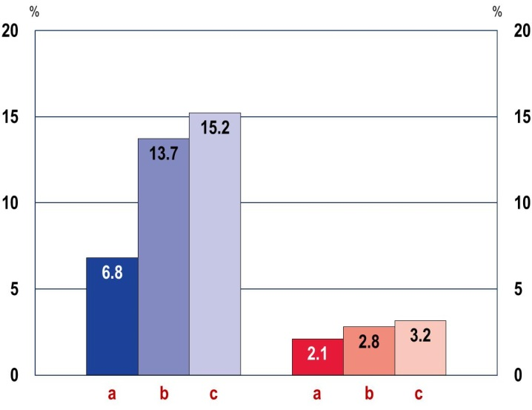
  Men | Women
EU youth indicator |  | a | Aged 15-19 | b | Aged 20-24 |  | c | Aged 25-29 | d | Total
Notes: 2011: break in series; 2012: estimates.
Source: Eurostat [yth_hlth_030, hlth_cd_acdr2]

More recent data, as shown on Figure 6-N-a, confirm the relative stability of suicide rates at the EU-28 level. However, since the method for data collection changed in 2011, conclusions can be drawn only regarding the most recent changes. Between 2011 and 2012, suicide rates slightly increased among young people aged 25 to 29 and among the total population, while stayed relatively stable among young people aged 15 to 19 and 20 to 24.
Suicide rates increase with age. In addition, as Figure 6-N-b shows, suicide rates are much higher among young men than young women in all age groups. More than three times more young men than young women aged 15 to 19 committed suicide in 2012, and this ratio reaches to almost five times more for the 20-24 and 25-29 age groups.
As Figure 6-O depicts, among young men aged 15 to 24, suicide rates were the highest in Ireland, Latvia, Lithuania and Finland. Among young women in the same age group, suicide rates were the highest in Ireland, Finland, Sweden and Norway. Suicide rates were quite low for both sexes in southern countries like Greece, Spain, Italy, Portugal and Turkey. However, in Greece, though suicide rates remain comparatively low, a more than 50% increase took place between 2007 and 2012 ().

Figure 6-O: EU youth indicator: Death by intentional self-harm among young people (aged 15-24), crude death rate (per 100 000 inhabitants), by country and by sex, 2012
EU youth indicator | % %  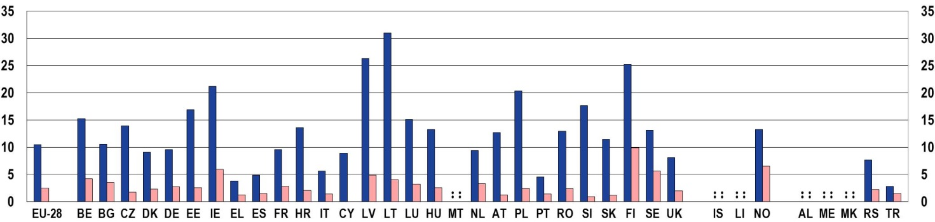
EU youth indicator
   | Men |  | Women
Notes: EU-28: estimates. France: 2011. Malta and Liechtenstein: confidential.
Source: Eurostat [hlth_cd_acdr2]

(?) Eurostat 2013, SILC ad-hoc module on personal well-being [ilc_pw01 and ilc_pw08].
(?) European Commission, 2012a.
(?) These indicators can also be consulted on the website of the European Core Health Indicators (European Commission, 2015a).
(?) Jackson et al., 2012.
(?) Ibid.; Viner et al., 2012.
(?) Sawyer et al., 2012.
(?) Furlong et al., 2003; Jackson et al., 2012.
(?) Furlong, 2002; Jackson et al., 2012.
(?) Furlong, 2002; Jackson et al., 2012.
(?) WHO Regional Office for Europe 2012, p. 141.
(?) See e.g. WHO, 2014.
(?) See OECD Health Statistics, available at: http://stats.oecd.org/Index.aspx?DataSetCode=HEALTH_LVNG# [Accessed 22 January 2015].
(?) Ibid.
(?) Special Eurobarometer 429, 'Attitudes of Europeans towards tobacco and electronic cigarettes', 2015 (European Commission, 2015c).
(?) European Commission 2015c, p. 15.
(?) WHO Regional Office for Europe 2009, p. 82.
(?) Flash Eurobarometer 401, 'Young people and drugs', 2014 (European Commission 2014i).
(?) Ibid. No definitions of 'once or twice' or 'regularly' were given in the questionnaire.
(?) No new data on drunkenness based on the ESPAD survey used in the last EU Youth Report (European Commission, 2012a) were published since 2012.
(?) Special Eurobarometer 331, 'EU citizens' attitudes towards alcohol', 2010 (European Commission, 2010b).
(?) For gender differences regarding the frequency of getting drunk, see the 2012 EU Youth Report (European Commission, 2012a).
(?) WHO Regional Office for Europe 2009, p. 80.
(?) Ibid, p. 84.
(?) EMCDDA, 2012, 2014.
(?) Flash Eurobarometer 401, 'Young people and drugs', 2014 (European Commission 2014i).
(?) Ibid.
(?) Ibid.
(?) Longer-term time series are available regarding the consumption of cannabis and amphetamines in the framework of the European Core Health Indicators (indicator 48 on the 'use of illicit drugs') on the website of the European Commission, DG Health and Food Safety (European Commission, 2015a).
(?) Ibid.
(?) Jackson et al., 2012.
(?) WHO 2010, p. 10.
(?) On obesity, see European Commission, 2012a.
(?) Special Eurobarometer 412, 'Sport and physical activity', 2014 (European Commission, 2014j).
(?) Special Eurobarometer 412, 'Sport and physical activity', 2014 (European Commission, 2014j), and Special Eurobarometer 334, 'Sport and physical activity', 2010 (European Commission, 2010c).
(?) See: https://www.eurofound.europa.eu/european-quality-of-life-surveys-eqls [Accessed 27 July 2015].
(?) EPHA, 2014; WHO Regional Office for Europe, 2011.
(?) The index is based on respondents' evaluations of the following items: 1) 'I have felt cheerful and in good spirits'; 2) 'I have felt calm and relaxed'; 3) 'I have felt active and vigorous'; 4) 'I woke up feeling fresh and rested'; 5) 'My daily life has been filled with things that interest me'. See: http://www.who-5.org [Accessed 4 June 2015].
(?) Eurofound, 2014b.
(?) European Commission 2012a, p. 230.
(?) Thomson et al. 2014, p. 37. See also Branas et al., 2015.
(?) OECD 2014b, p. 28.

