Table of contents

1.
Introduction 3
2. Demography 6
2.1. Introduction 7
2.2. Trends in the European youth population 7
2.3. Mobility among young Europeans 12
3. Education and Training 14
3.1. Introduction 15
3.2. Formal education 15
3.3. Non-formal education and youth work 22
3.4. Learning mobility 24
3.5. Transition from education to employment 28
4. Youth Employment and Entrepreneurship 30
4.1. Introduction 31
4.2. Economically active young people 31
4.3. Young people in the labour market 33
4.4. Support for the transition to employment 49
5. Social Inclusion 55
5.1. Introduction 56
5.2. Moving towards independence: young people leaving the parental home 56
5.3. Levels of poverty and social exclusion 58
5.4. Other aspects of poverty and social inclusion 65
5.5. Groups at risk of social exclusion 71
6. Health and Well-being 77
6.1. Introduction 78
6.2. Young people’s state of health 78
6.3. Health risks 79
6.4. Mental well-being 91
7. Participation in democratic life 95
7.1. Introduction 96
7.2. Young people's interest in politics and their perception of EU citizenship 96

7.3. Young people's participation in representative democracy: voting and joining a political
party………………. 97
7.4. Other ways young people participate 101
7.5. Engaging hard-to-reach young people in political and civic life 105
8. Voluntary Activities 107
8.1. Introduction 108
8.2. Youth participation in voluntary activities 108
8.3. Encouraging youth participation in voluntary activities 112
9. Culture and Creativity 114
9.1. Introduction 115
9.2. Cultural participation 115
9.3. Young people and their use of ICT 120
9.4. Creativity 123
10. Youth and the World 125
10.1. Introduction 126
10.2. Young people's engagement with global issues 126
10.3. Cooperation among young people from different continents 130
References 132
Abbreviations 141

1. INTRODUCTION
In 2009, the Council endorsed a renewed framework for European cooperation in the youth field (2010-2018), also known as the EU Youth Strategy (). The period covered by the framework is divided into three-year work cycles. At the end of each cycle, a European Union (EU) Youth Report should be drawn up by the Commission. The Council specified that the report 'shall consist of two parts: A joint Council-Commission report (political part), and supporting documents (statistical and analytical part). The EU Youth Report will evaluate progress made towards the overall objectives of the framework, as well as progress regarding the priorities defined for the most recent work cycle and identify good practices'. At the same time, the report should serve as a basis for establishing priorities for the following work cycle.
The statistical part of the report presents data and information on the current situation of young people in Europe. Following an introductory chapter on demography, which presents the main trends in the youth population over the last few years, separate chapters are dedicated to the eight 'fields of action' identified in the Council Resolution on the EU Youth Strategy (2010-2018): Education and Training, Employment and Entrepreneurship, Social Inclusion, Health and Well-being, Participation, Voluntary Activities, Creativity and Culture, and Youth and the World.
This report builds on the dashboard of EU youth indicators (), a selection of 41 indicators which measure the most crucial aspects of young people's lives in Europe. Wherever the report uses these indicators, this is highlighted in the text and in the layout of the relevant Figures.
The period when a person is considered to be 'young' differs across Europe according to the national context, the socio-economic development of society and time. Common to all countries is that the period of youth - the transition from being a child to being an adult - is marked by important life changes: from being in education to having a full-time job, from living in the family home to setting up one's own household, and from being financially dependent to managing one's own money.
Relying on Eurostat data, Eurobarometer surveys and other available sources, the population targeted in this report is primarily young people between 15 and 29 years of age. Where possible, the analysis distinguishes between subgroups aged 15 to 19, 20 to 24, and 25 to 29. In other cases, a more limited age range is used, either because of the specifications of survey data, or because the issue in question affects a particular age group (e.g. early school leaving). In addition, children (under 16 years of age) are also included when analysing indicators on poverty or social exclusion.
In line with the analytical part of the EU Youth Report (), the information and analysis cover the EU Member States and, where the available data allows, the EU candidate countries (Albania, Montenegro, the former Yugoslav Republic of Macedonia, Serbia, and Turkey) and EEA EFTA States (Iceland, Liechtenstein, Norway).
The report focuses on the most recent years for which data are available and illustrates trends which have emerged since the publication of the previous Youth Report in 2012.

European youth: cross-cutting trends
Across the different topics covered in detail by each chapter, some general trends affecting young Europeans in these transition stages emerge.
In general, positive trends are registered in the field of education, where all the main indicators showed improvements for the EU as a whole. The proportion of young people with at least upper secondary level attainment and with tertiary degrees has risen, while the percentage of low achievers and early school leavers has declined. Evidence indicates that higher levels of education are associated with more positive conditions in other spheres of life. First of all, the positive relationship between higher levels of education and employment is confirmed. In the EU as a whole, the unemployment rate is much lower for young graduates from tertiary education than for those with the lowest levels of education. Data also illustrate that highly educated youth tend to be more motivated to participate in political elections and cast their vote.
However, challenges do exist for those who do not benefit from the improvements in terms of education. Many young people face difficulties in completing school education and acquiring necessary skills. Indeed, progress is mixed regarding reducing the share of 'low achievers' among 15 year olds. This compounds their socio-economic disadvantages and reduces their opportunities to participate more broadly in society.
The economic crisis which started in 2008 continues to limit young people's chances of success. Employment has become more difficult to find and retain, and, when a job is secured, the risk of being overqualified is high for many young graduates. Unemployment, including long-term unemployment, has continued to rise amongst the young, particularly in countries facing economic hurdles. Here, insecure work conditions linked to temporary contracts and involuntary part-time work continue to be widespread and, in some regions, have even deteriorated. Some signs of improvement in the situation for young people in the labour market emerged between 2013 and 2014, raising the hope that the negative trends provoked by the economic crisis have started to turn around.
Despite improvements in the level of competencies, skills and educational achievements, many young Europeans are facing serious threats such as marginalisation in the labour market, deterioration of living conditions, and obstacles to social integration and political participation.
However, the consequences of several years of great adversity in the labour market have significantly jeopardised the chances of social inclusion for vast numbers of young Europeans. The proportion of young employees unable to make ends meet and living in poverty despite having a job is particularly high in some European countries. Inability to find employment and gain appropriate remuneration clearly affects the possibility for significant numbers of young people to afford the costs of basic goods and services such as food, healthcare, and proper housing. Material deprivation rates for youth have increased in Europe, especially in countries where youth unemployment is high. It has become increasingly difficult for many young people to meet their housing costs (such as rent and utility bills), and, as a consequence, the rate of overcrowding has risen in many EU Member States. Also the possibility for many young people to look after their health and maintain their well-being has reduced: in countries where unemployment and social exclusion are particularly high, increasing proportions of young people report not being able to afford medical care when needed.
Over the last three years, deterioration in the working and living conditions of many young people in Europe has gone hand in hand with a growing detachment from political life and waning engagement in traditional civic activities. Electoral turn-out amongst young voters has declined since 2011 in the vast majority of countries, suggesting a widespread dissatisfaction with traditional modes of political engagement. At the same time, the propensity to dedicate time and energy to the activities of non-governmental organisations has weakened, especially in countries where unemployment and social exclusion are the highest.
Youth participation in cultural activities is also suffering from decreasing trends. Possibly because of reduced financial resources, some are unable to afford to attend cultural events or develop their artistic interests; many young people have refrained from visiting museums, going to the theatre, concerts and movies, and from pursuing their artistic vocations. Attendance at sports and youth clubs has also declined, indicating a withdrawal of many young people from socially inclusive activities.
All in all, despite improvements in the level of competencies, skills and educational achievements, many young Europeans are facing multiple challenges which increase the risk of economic and social exclusion. Marginalisation in the labour market, deterioration in living conditions, and challenges to social integration and political participation are serious threats to young people with fewer opportunities in Europe today.

2. DEMOGRAPHY

EU Youth Indicators
Share of young people in the total population on 1 January | Figure 2-A

2.1. Introduction
Understanding the demographic trends at play in the European youth population is conducive to appreciating the characteristics and behaviours of young people today, which will be described in detail in the other chapters of the report. The size, geographical distribution and demographic features of youth in Europe are related to the quality of life they enjoy, the opportunities at their disposal and their individual and social behaviours.
This chapter therefore introduces the subject matter of the current report. It illustrates the key demographic indicators for European youth, including its proportion in the general population, its projected development, its composition, and the patterns of youth mobility across the continent.
2.2. Trends in the European youth population
On 1 January 2014, almost 90 million young people aged between 15 and 29 years lived in the European Union (). This represents around 18% of the total population of EU-28 (Figure 2-A).
Figure 2-A: EU youth indicator: Share of young people (aged 15-29) in the total population on 1 January, by age group and by country, 2014
EU youth indicator | % %  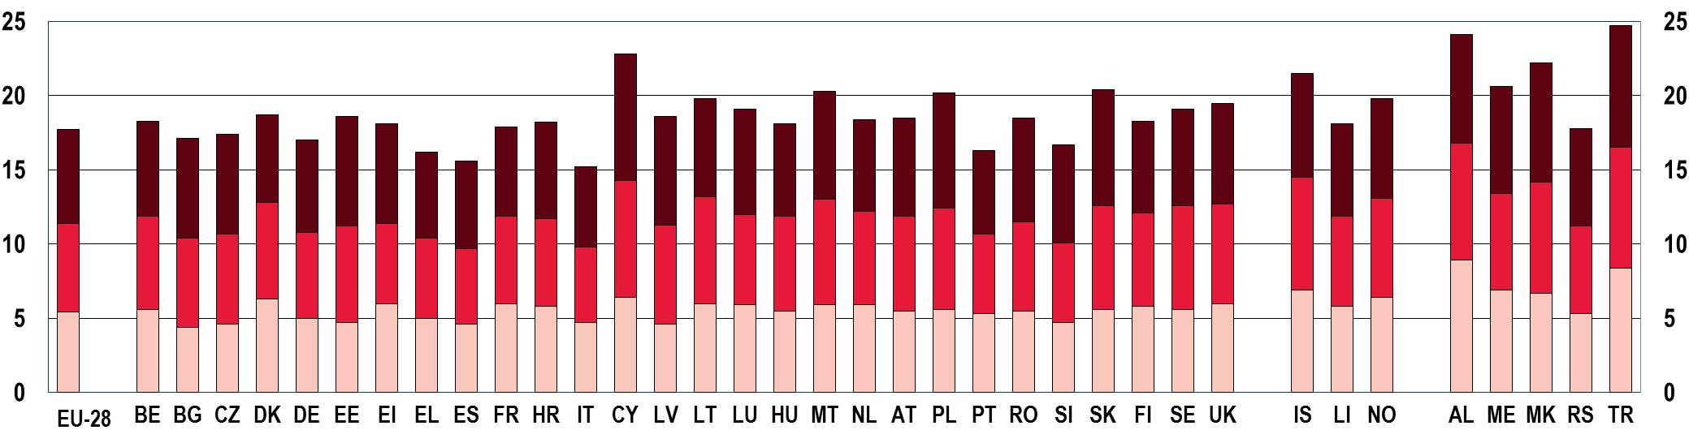
Notes: The population corresponds to the number of persons having their usual residence in the country on 1st January. When 'usual residence' cannot be established, the countries can report of the legal or registered residence.
Source: Eurostat [demo_pjanind]

The proportion of young people in the total population varies across countries. While it is comparatively smaller in Greece, Spain, Italy, Portugal and Slovenia, it reaches the highest levels in Cyprus, Malta, and Slovakia. Albania and Turkey report the highest figures outside of the EU.
In line with the long term trend over the last three decades (see the previous edition of the Youth Report ()), the proportion of young people continued to decline between 2010 and 2014 (Figure 2-B).
The proportion of young people in the European Union continues to decrease…

On average, the 15-19 age group is the most affected by the decline: it registered a 7% decrease over the three years considered. Over a period of only 4 years, it is evident that the proportion of teenagers who entered the 15-19 age group did not fully replace the proportion that moved out of the 25-29 group. This decline in the total numbers of young people in the European Union affects countries to a different extent (Figure 2-C).
Figure 2-B: Share of young people (aged 15-29) in the total population, by age group, EU-28 average, 2010 and 2014
% %
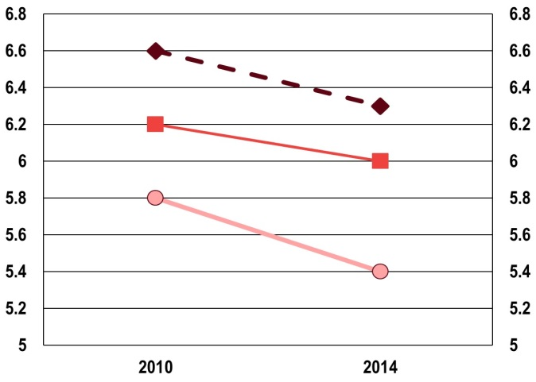
 | Ages 15-19 |  | Ages 20-24 |  | Ages 25-29

Source: Eurostat [demo_pjanind]

Figure 2-C: Share of young people (aged 15-29) in the total population, by country, 2010 and 2014
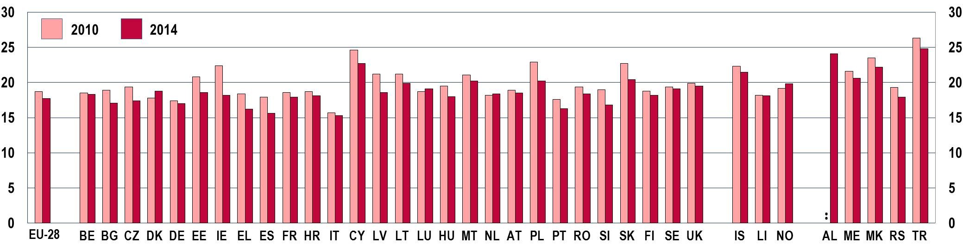
Source: Eurostat [demo_pjanind]
Central, eastern and southern European countries have seen comparatively larger drops in their youth populations than northern ones. However, Ireland is the country recording the highest fall in percentage points since 2010 (-4 pp.). On the other hand, a few countries (Denmark, Luxembourg, and the Netherlands) have witnessed slight increases in the proportion of young people in their population.
There are several reasons behind the decline in the youth population in the vast majority of European countries. While fertility rates rose modestly during the first decade of the century, they remained below what is considered to be the replacement level (). Since 2008, they have recorded a further decline, perhaps partly due to the effects of the economic crisis where it impacted on the level of unemployment and family income, at least in those countries most severely hit by the economic downturn (). In addition, a tendency for women to give birth to fewer children and at a later age in life is observed, which further reduces the proportion of children being born (). These trends are expected to continue in the coming decades, leading to further reductions in the size of the EU youth population (Figure 2-D).
Figure 2-D: Projected share of the youth population (aged 15-29), EU-28 average, 2013-2050
% %
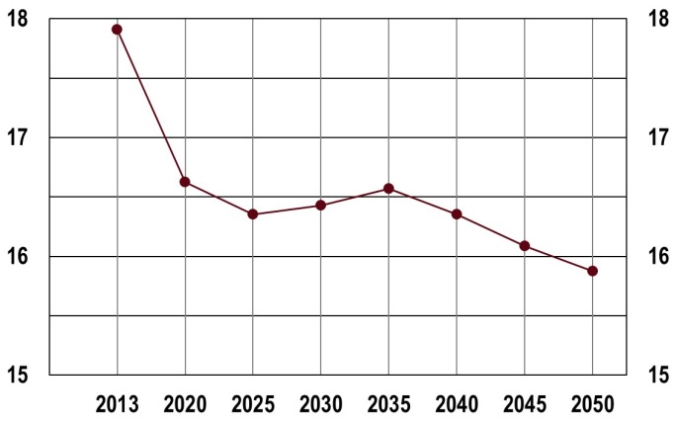
Source: Eurostat [proj_13npms]

Figure 2-E: Projected young-age and old-age dependency ratios, EU-28 average, 1990-2080
% %
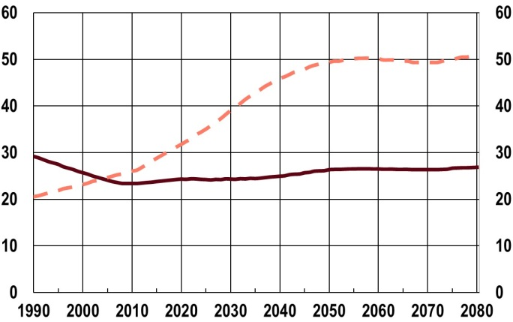 | Note: The old-age-dependency ratio is the ratio of the number of elderly people at an age when they are generally economically inactive (i.e. aged 65 and over), compared to the number of people of working age (i.e. 15-64 years old). The young-age-dependency ratio is the ratio of the number of young people at an age when they are generally economically inactive, (i.e. under 15 years of age), compared to the number of people of working age (i.e. 15-64).
 | Source: Eurostat [demo_pjanind] [proj_13ndbims]
  Young-age dependency ratio
  Old-age dependency ratio

According to population projections developed by Eurostat (Europop2013), while the total EU population is expected to grow through 2050 reaching approximately 525 million in that year, the proportion of young people will decrease from almost 18% in 2013 to below 16% in 2050, equal to over 7 million individuals (). The progressive decline in the share of young people, in a context of gradual growth in the total population and of ever-increasing life expectancy rates, indicates that the EU population is progressively ageing. This is expected to substantially boost the old-age dependency ratio, a measure of the extent to which the working-age segment of the population has to support older age groups through, for example, sustaining public healthcare and pension schemes (Figure 2-E) (). As a result, younger generations will face an increased burden in supporting the remainder of the population as they move into work.
… and the decline is expected to continue in the future.
The steady decrease in the youth population living in the EU over the last decades and the related augmentation of the old-age dependency ratio has been subdued by the growth of immigration from non-EU (). This has occurred in two main ways. On the one hand, the influx of immigration from third countries () compensated for the overall natural change in the general population and reversed an otherwise declining trend in the total population. This phenomenon has occurred during the last two decades and has continued over most recent years (Figure 2-F). Data illustrated in the chart show how the crude rate of total population change rose owing to the growth in the crude rate of net migration plus adjustment, especially since 2012.
The increase in the numbers of young immigrants from outside the EU partially offsets the decrease in EU youth population
Figure 2-F: Crude rates of population change, EU-28 average, 2010-2013
% %
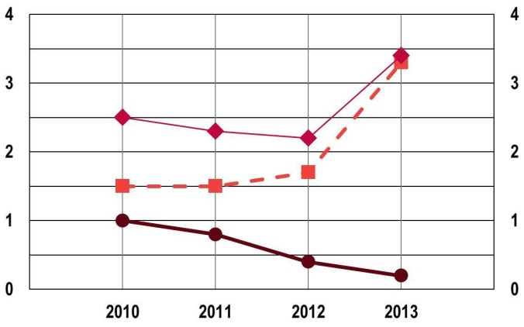 | Notes: A crude rate is calculated as the ratio of the number of events to the average population of the respective area in a given year. The natural change of population corresponds to the difference between the number of live births and the number of deaths during the year. Net migration plus statistical adjustment is calculated as the difference between total population change and natural change.
 | Source: Eurostat [demo_gind]
   | Crude rate of total population change
   | Crude rate of net migration plus statistical adjustment
   | Crude rate of natural change of population

On the other hand, young people aged between 20 and 29 are over-represented in the age structure of immigrants coming into EU countries from outside the Union (Figure 2-G).
Figure 2-G: Young people (aged 15-29) as a proportion of total EU citizens and non-EU citizens living in the EU, by age group, EU-27 average, 2013
% %
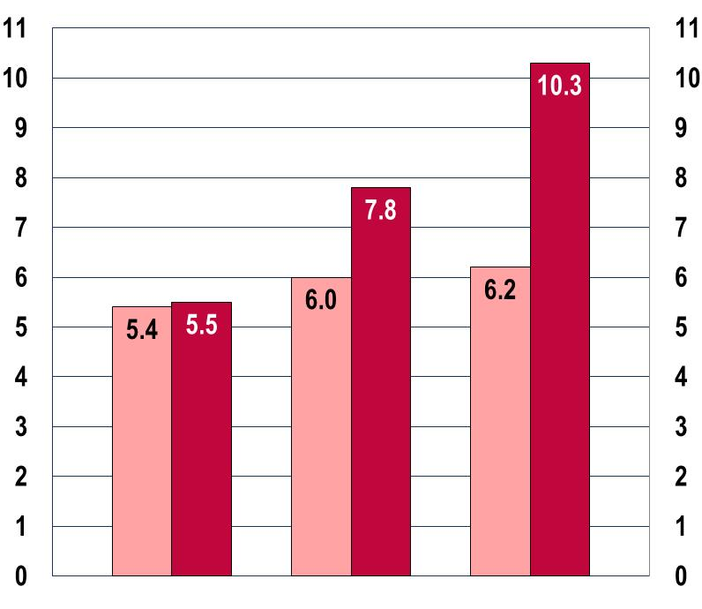 |  |  |  |  | Notes: Citizenship denotes the particular legal bond between an individual and his or her State, acquired by birth or naturalisation, whether by declaration, choice, marriage or other means, according to national legislation.
 | 15-19 | 20-24 | 25-29
 |  |  |  |  | Source: Eurostat [migr_pop1ctz]
   | EU citizens |  | Non-EU citizens

As it appears from the trend illustrated in the first part of the chapter, the contribution of non-EU immigration is not enough to reverse the general decline in the youth population living in the EU, but has nonetheless made it less sharp. The proportion of young people from non-EU countries residing in EU Member States varies across countries (Figure 2-H).
Figure 2-H: Share of young immigrants (aged 15-29) from non-European countries, by country, 2012
% %
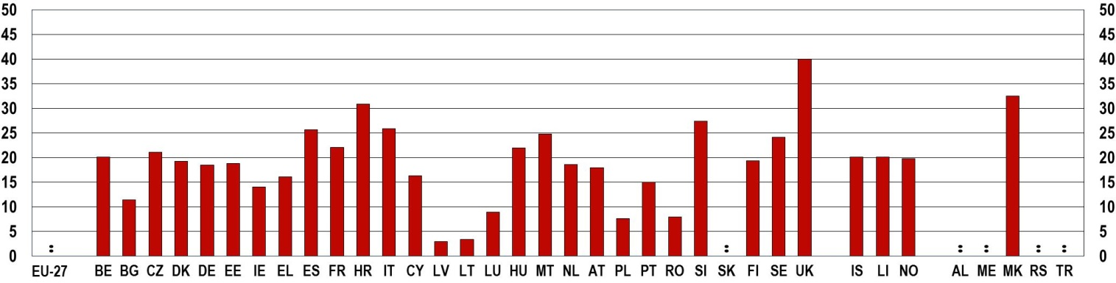
Notes: Immigration denotes the action by which a person establishes his or her usual residence in the territory of a Member State for a period that is, or is expected to be, of at least 12 months, having previously been usually resident in another Member State or a third country.
Source: Eurostat [yth_demo_070]
Most recent data available indicate that in some EU Member States young non-EU residents account for at least one fifth of the total youth population (Belgium, the Czech Republic, France, Spain, Croatia, Italy, Hungary Malta, Slovenia and Sweden). In the United Kingdom the proportion reaches 40%. On the contrary, in Latvia, Lithuania, Luxembourg, Poland and Romania, the share of non-EU young people is below 10%.
2.3. Mobility among young Europeans
Thanks to the increasing opportunities for EU citizens to travel and set up residence across EU Member States, young Europeans have become increasingly mobile and likely to go work or study in another European country (). Crossing geographical and cultural borders and gaining life and work experience in a different context is a great opportunity for a young person to acquire personal skills, learn new languages and appreciate the diversity of European culture.
With over 20% of the immigrants (aged 15-29) coming from another EU Member State, Ireland, Cyprus, Luxembourg and Austria stand out as the countries whose youth population receives in 2012 the highest proportion of young immigrants from other EU countries (Figure 2-I-a). In most of the countries, the share of young immigrants coming from another EU Member State has not changed radically compared to 2010.
However, some exceptions exist. The most significant increase has occurred in Greece, where the percentage of young European immigrants from other EU countries has doubled, although the overall level is relatively low (6%). In contrast, in Estonia and Romania the resident youth population from other EU States has significantly decreased.
Figure 2-I: Share of young (aged 15-29) EU immigrants and emigrants, by country, 2010 and 2012
a) EU immigrants from another EU Member State
% %
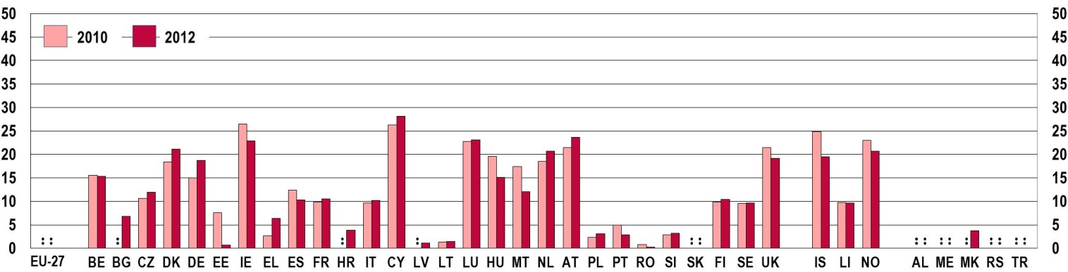
b) EU emigrants to another EU Member State
% %
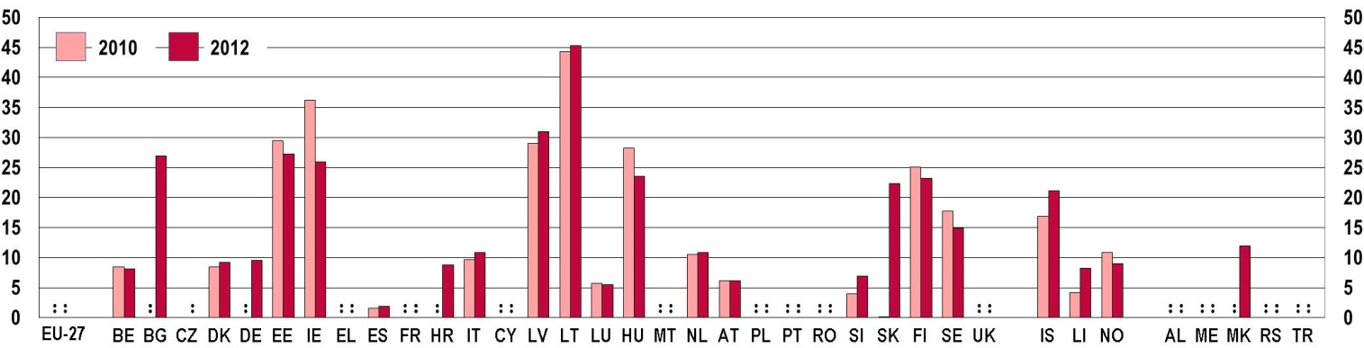
Notes: According to the definitions provided by Eurostat, 'Immigration' denotes the action by which a person establishes his or her usual residence in the territory of a Member State for a period that is, or is expected to be, of at least 12 months, having previously been usually resident in another Member State or a third country; 'Emigration' denotes the action by which a person, having previously been usually resident in the territory of a Member State, ceases to have his or her usual residence in that Member State for a period that is, or is expected to be, of at least 12 months. Source: Eurostat [yth_demo_070] [yth_demo_080]
The largest proportions of young EU citizens leaving their own country of residence to settle in another EU Member State in 2012 are recorded in Bulgaria, Estonia, Ireland, Latvia (where one in four young people have emigrated) and remarkably in Lithuania (where the share reaches 45%) (Figure 2-I-b). The biggest increase in the proportion of young people emigrating over the two years in question is observed in Slovenia. Lichtenstein and Iceland have also seen increases in the share of young people choosing to live in another EU Member State. The opposite trend is illustrated in Ireland, where the proportion of young residents leaving the country to settle in another EU country has declined by almost one third.
Overall, looking at the countries for which data are available for both EU immigrants and emigrants, some are clearly shown to be either countries from which many young Europeans go abroad (for example, Bulgaria, Estonia, Latvia, Lithuania, and Hungary) or countries which receive large numbers of young people (in particular Denmark, Germany, Spain, Luxembourg and Austria).

3. EDUCATION AND TRAINING
EU Youth Indicators
Young people (aged 20-24) who have completed at least upper secondary education (ISCED 3-4) | Figure 3-A
Tertiary educational attainment of people aged 30-34 | Figure 3-B
Early leavers from education and training | Figure 3-C
Young people in upper general secondary education (ISCED 3gen) learning two or more foreign languages | Figure 3-E

3.1. Introduction
The importance of education is unquestioned in today's world. Throughout the years spent in formal education and by means of the opportunities made available through the non-formal and informal sector and through youth work, children and young people have the chance to develop their personal potential, acquire basic skills and qualifications, and become integrated into society at large. Indeed, high-quality and inclusive education for all is one of the most effective defences against the risks of social marginalisation, poverty and exclusion, especially at times of crisis ().
Moreover, education is not only a fundamental determinant of individual life chances, but also of economic development (). Accordingly, obtaining a high-quality education gives the opportunity for young people to succeed in the labour market and find meaningful employment, while spurring long-term economic growth.
This chapter discusses the provision of learning opportunities for young people in Europe in both formal and non-formal settings. Taking a brief look first at the average number of years young Europeans spend in formal education, the chapter then goes on to examine attainment in terms of the educational level completed and student achievement in reading, mathematics and science. The chapter then gives an insight into the participation of young people in non-formal education, including youth work activities, and then turns to analysing how many young Europeans have had the opportunity to widen their learning experiences by going abroad during their studies. Finally, the last section examines the transition of young people to the world of work.
3.2. Formal education
Formal education refers to the structured system of education from pre-primary to tertiary level. This section considers some of the aspects most relevant to young people: the qualifications they attain – or fail to attain if they leave school prematurely – and the skills they acquire in the education system.

3.2.1. Participation and attainment
European children and young people on average spend more than 17 years in formal education, and this period has been increasing in recent years (). Variations between countries are, however, quite significant, with the expected time spent in education ranging from 14 years in the former Yugoslav Republic of Macedonia and around 15 years in Cyprus and Luxembourg, to more than 20 years in Finland and Iceland (). As was explained in the 2012 EU Youth Report (), this is partly due to countries bringing forward the starting age of compulsory education; nevertheless, young people also stay longer in education beyond the compulsory school years (see also Section 3.5).
Young people are also more highly-qualified than older generations. In 2013 () in the EU-28, 81.1 % of young people aged 20-24 had completed at least upper secondary education; whereas only 66 % of people aged 55 to 64 had similar qualification levels ().
The proportion of young people aged 20 to 24 with upper secondary or higher educational attainment increased between 2011 and 2014 in the EU-28 and in almost every country except Bulgaria, the Czech Republic, Slovakia and Sweden (Figure 3-A-a). The Czech Republic and Slovakia are nevertheless still among the countries with a very high share of at least medium-educated young people: together with Ireland, Croatia, Cyprus, Lithuania, Poland and Slovenia, these are the countries where 90 % or more of young people aged 20-24 completed at least upper secondary education. Conversely, the percentage of young people with upper secondary or tertiary attainment levels is less than 70 % in Spain, Iceland and Turkey. However, it has to be noted that a high share of young people with at least upper secondary education does not mean that tertiary attainment is also high in a country (see for example the cases of the Czech Republic, Croatia and Slovakia on Figure 3-B-a).
Young people are increasingly highly educated. The share of young Europeans attaining upper-secondary qualifications continues to increase.
Women generally have higher educational attainment levels than men. As Figure 3-A-b shows, in the EU-28, on average 84.7 % of women completed at least upper secondary education, while the percentage of men with the same attainment level is 79.9 %. This pattern holds true for all countries with available data, with the exception of the former Yugoslav Republic of Macedonia and Turkey, where the share of young men with at least upper secondary educational attainment is 3.9 and 4.4 percentage points higher than that of women, respectively. Gender differences are the largest in Estonia, Spain, Cyprus, and Iceland, with differences of more than 10 percentage points.
Figure 3-A: EU youth indicator: young people (aged 20-24) who have completed at least upper secondary education, by country
a) 2011 and 2014
EU youth indicator | 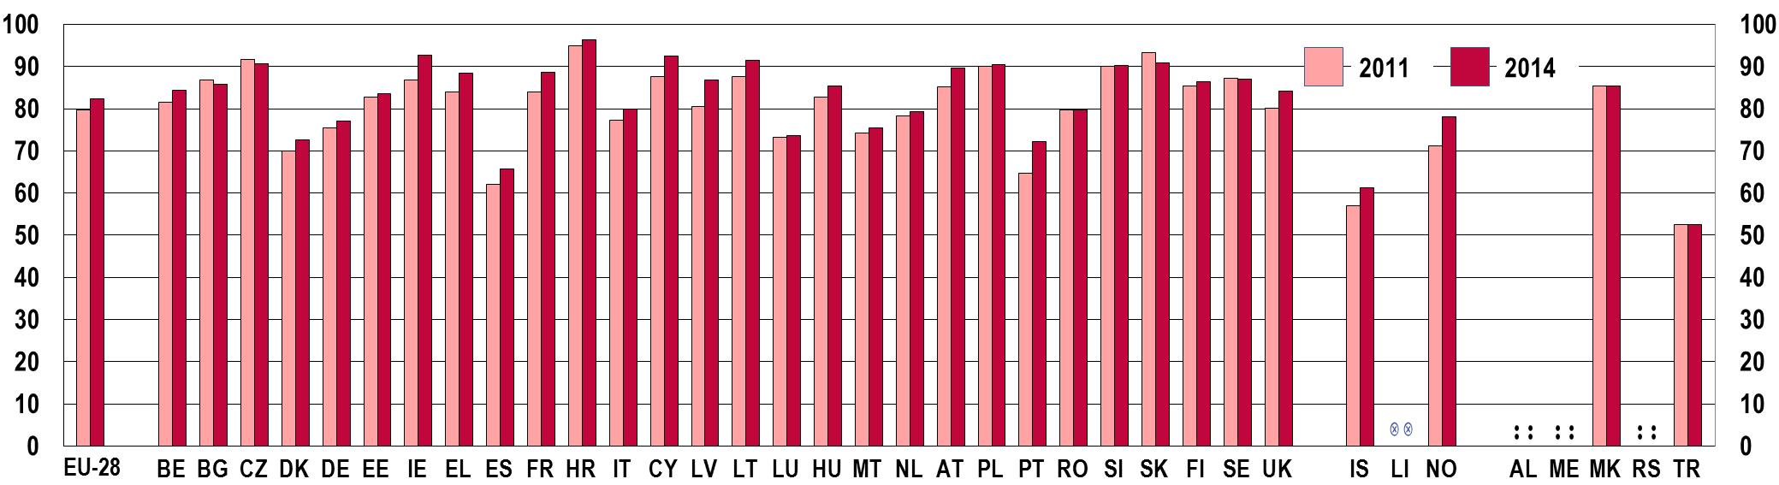

b) by sex, 2014
EU youth indicator | 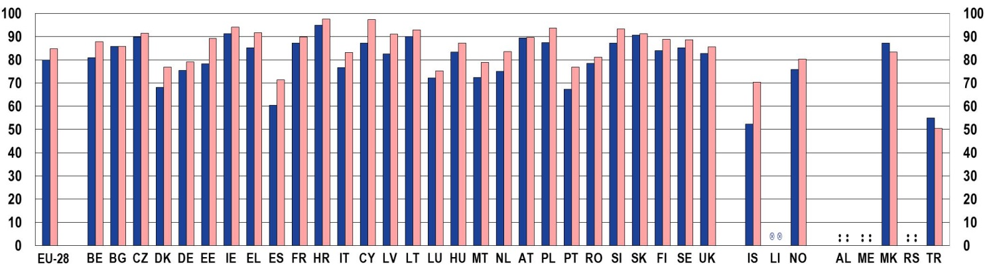
   | Men |  | Women
Notes: For data on educational attainment based on the EU Labour Force Survey (EU-LFS) the International Standard Classification of Education 2011 (ISCED 2011) is applied as from 2014. Up to 2013 ISCED 1997 is used. Nevertheless, data are comparable over time for all available countries except Austria due to the reclassification of higher technical and vocational colleges. However, in the case of this particular indicator, which includes both upper secondary and tertiary levels, data for Austria are also comparable.
Source: Eurostat LFS [edat_lfse_08]
Among higher qualifications, the attainment of tertiary education degrees helps young people the most in securing a job in a high-skilled labour market (as illustrated in the chapter on Employment and Entrepreneurship) (). Indeed, according to recent skills forecasts, the demand for high-skilled labour will continue to grow until 2020, when about 31 % of jobs in Europe will require high-level qualifications ().
On average, over a third of Europeans between 30 and 34 years of age have achieved a tertiary degree
(Figure 3-B-a) (). Several countries reveal percentages much lower than the EU average, in particular the Czech Republic, Italy, Malta, Romania, Slovakia, and, outside the EU, the former Yugoslav Republic of Macedonia and Turkey, where around one in four 30-34 year-olds has a tertiary qualification.
Figure 3-B: EU youth indicator: Tertiary education attainment of people aged 30-34, by country and by sex, a) 2011 and 2014
EU youth indicator | 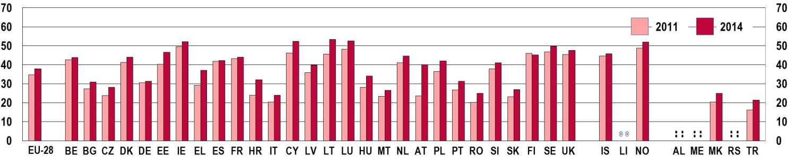
b) by sex, 2014
EU youth indicator | 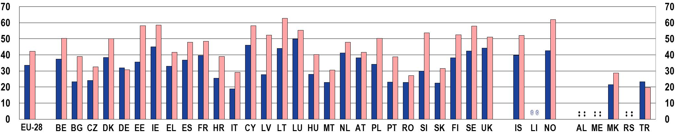
   | Men |  | Women
Notes: For data on educational attainment based on the EU Labour Force Survey (EU-LFS) the International Standard Classification of Education 2011 (ISCED 2011) is applied as from 2014. Up to 2013 ISCED 1997 is used. Nevertheless, data are comparable over time for all available countries except Austria due to the reclassification of higher technical and vocational colleges.
Source: Eurostat LFS [edat_lfse_07]

In line with the gradual increase since 2000 (), the proportion of people aged 30-34 with tertiary level education attainment has grown over the last three years, although at a different pace across European countries (Figure 3-B-a). The most significant relative increases have taken place in Greece and Croatia, with an increase of more than 8 percentage points.
Increasing shares of young Europeans gain tertiary degrees.
In accordance with the general educational attainment trends described above, women attain tertiary degrees in higher percentages than men (Figure 3-B-b). Men are furthest behind in Estonia, Latvia, Lithuania, Slovenia and Norway, while the gender gap is narrowest in Germany and Austria. In Germany, together with Turkey, fewer women than men complete tertiary degrees.
Despite this positive trend in educational attainment, a significant share of young Europeans still face significant difficulties in the education system and feel compelled to leave prematurely without having gained relevant qualifications or a school certificate. This is the case with early leavers from education and training (also referred to as 'early school leavers') – people aged 18-24 with at most lower secondary education and who were not in further education or training during the last four weeks preceding the survey. Amongst the factors contributing to young people leaving education early, their socio-economic status and that of their families proves to have significant weight (). Indeed, early leavers are much more likely to come from families with a low socio-economic status (i.e. where parents are unemployed, have low income and low levels of education), or from vulnerable social groups such as migrants (). Early school leavers are exposed to a particularly high risk of deprivation and social exclusion. In addition, not only does leaving school early result in longer and more frequent spells of unemployment, it also engenders considerable public and social costs ().
On average, about 11 % of Europeans aged 18-24 in 2014 left education having completed lower secondary education at most (Figure 3-C-a) (). Several countries report much higher percentages (especially Spain, Italy, Malta, Portugal, Romania, Iceland and Turkey), while the lowest shares are registered in the Czech Republic, Croatia, Poland, and Slovenia.
Since 2000, there has been a general decline in the proportion of young people leaving school early in Europe. In line with this long-term trend, fewer people left education prematurely in the majority of European countries between 2011 and 2014 (Figure 3-C-a). Spain, Cyprus, Portugal and Norway are the countries where the decrease has been most significant. Among the countries with the highest proportions of early school leavers, Italy and Malta have also shown improvement. However, there are still more than 5 million early school leavers in Europe, and an increase in their share has taken place in Bulgaria and Estonia, and there has been a stagnation in Hungary and Romania, where percentages still higher than the EU benchmark of 10 %.
Across the EU, the proportion of early leavers from education and training is declining.
Figure 3-C: EU youth indicator: Early leavers from education and training (population aged 18-24 with lower secondary education at most and not in further education or training), by country
a) 2011 and 2014
EU youth indicator | 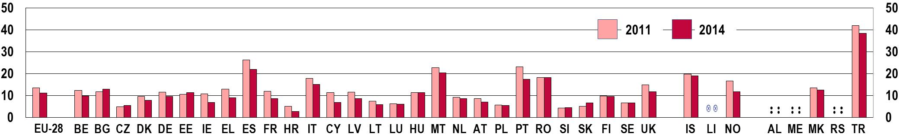
b) by sex, 2014
EU youth indicator | 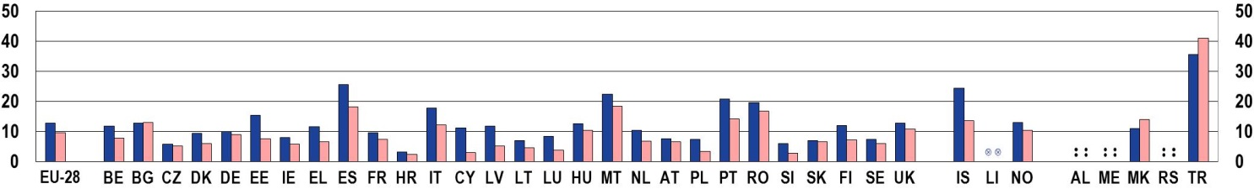
   | Men |  | Women
Notes: For data on educational attainment based on the EU Labour Force Survey (EU-LFS) the International Standard Classification of Education 2011 (ISCED 2011) is applied as from 2014. Up to 2013 ISCED 1997 is used. Nevertheless, data are comparable over time for all available countries except Austria due to the reclassification of higher technical and vocational colleges.
Source: Eurostat LFS [edat_lfse_14]

The risk of leaving education prematurely and with low qualification levels is higher amongst men than women (Figure 3-C-b). This gender gap applies to most European countries, and is widest in Estonia, Spain, Cyprus and Iceland. On the other hand, some countries show similar percentages for men and women (Bulgaria, the Czech Republic, Croatia and Slovakia). Only in the former Yugoslav Republic of Macedonia and in Turkey, and to much a lesser extent in Bulgaria, there are more young women leaving early from education and training.
Young people who have left school prematurely are typically those students who perform poorly in the classroom and on standardised tests, and can be helped to re-enter mainstream education and subsequently to gain higher qualifications through the recognition and validation of learning outcomes achieved by means of non-formal education (discussed in Section 3.3).

3.2.2. Skills
During the years spent in formal education, young people can acquire the skills that are essential if they are to achieve their full potential and be successful in their personal and social lives as well as in their career. Indeed, good levels of basic skills represent the foundation for professional development and social inclusion (). Specifically, reading, mathematics, and science have been recognised as the core competencies to be developed in schools ().
On average, about one in five young people aged 15 demonstrates low levels of proficiency in the three core competencies (Figure 3-D). Figures clearly indicate that pupil performance in these three skills correlate strongly with each other. Countries that show a certain level of performance in one of these basic skills tend to perform similarly in the others. For example, Bulgaria, Cyprus, Romania, Albania, Montenegro and Turkey, show higher proportions of low-achievers in all three areas.
Since 2009, the share of low-achievers in reading, mathematics and science has declined in the majority of European countries.
Since 2009, the share of low-achievers has declined in the majority of European countries, with the exception of Greece, Hungary, Portugal, Slovakia, Sweden, Norway and Iceland where the opposite trend is recorded. However, Europe still counts a worrying number of pupils with very low basic skills and progress is lacking behind, particularly in mathematics.
Figure 3-D: Low-achieving 15 year-old students in reading (a), mathematics (b) and science (c), by country, 2009 and 2012
a) Reading
% %
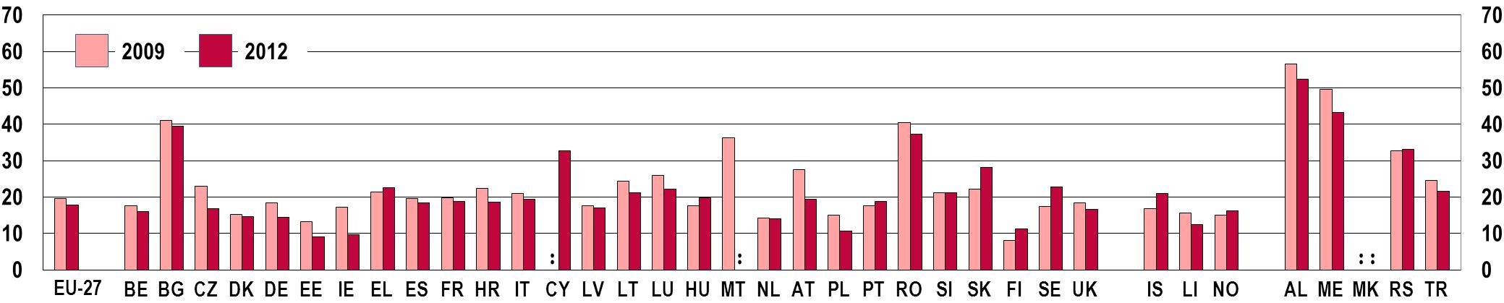
b) Mathematics
% %
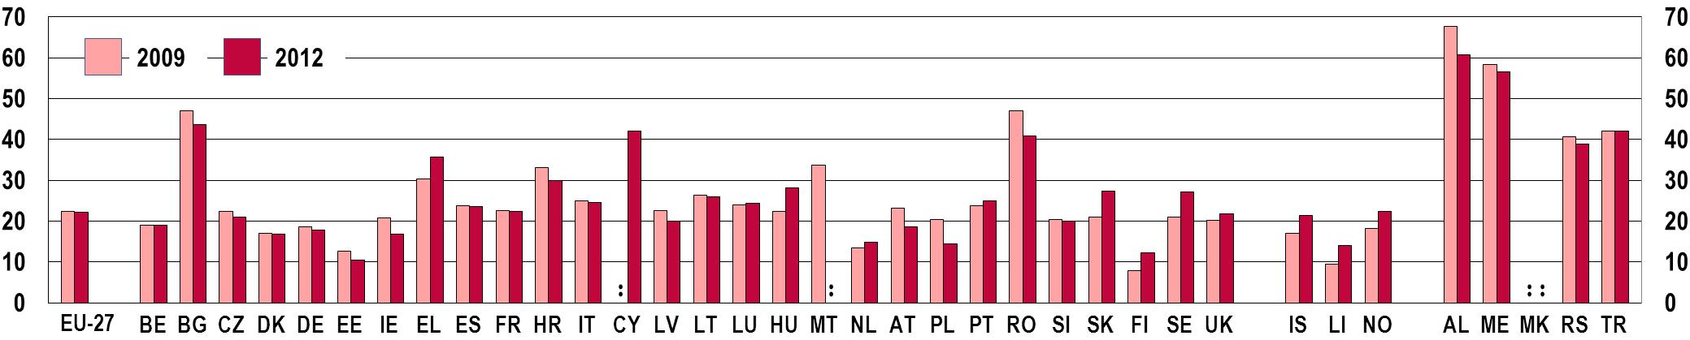
c) Science
% %
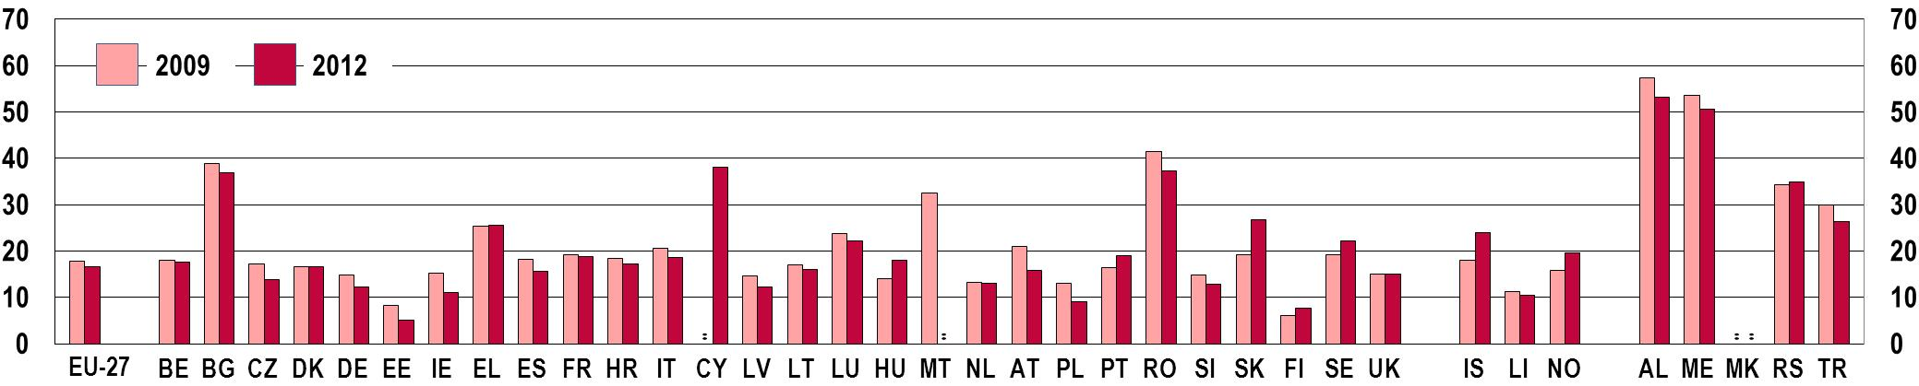
Notes: 'UK' stands for United Kingdom – England, Wales and Northern Ireland. Scotland is not included.
Source: OECD, PISA

In addition to basic skills, knowledge of foreign languages is a significant advantage for young people. It enables them to discover and understand different cultures, and expand their educational and professional prospects by opening up opportunities to study and work abroad.
One in two young students enrolled in general secondary education learns two or more foreign languages in the European Union (Figure 3-E). In some countries, the proportion is much higher, reaching 100 % or nearly 100% in the Czech Republic, Luxembourg, Romania, Slovenia, Slovakia, Finland and Lichtenstein. Conversely, Ireland, the United Kingdom and some southern European Member States show particularly low proportions of young people learning at least two foreign languages.
Figure 3-E: EU Youth indicator: Share of young people in upper general secondary education (ISCED 3gen) learning two or more foreign languages, by country, 2010 and 2012
EU youth indicator | % %  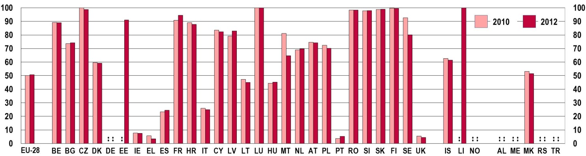
Notes: EU-28 totals are calculated on the basis of the countries for which data are available. Where possible the previous/following year data have been used to compute the EU aggregates.
Germany: data are not available due to a derogation.
Source: Eurostat UOE [educ_ilang]

Over the two years for which data are available, the noticeable variations that have occurred have been decreases in Greece, Malta and Sweden.
The level of skills in foreign languages acquired by young Europeans is not yet being systematically measured across all EU countries. However, the first round of the European Survey on Language Competencies (ESLC) conducted in 2011 in 13 Member States shows wide variations exist across participating countries in the levels of proficiency demonstrated by 15-year-old students in reading, listening and writing in foreign languages ().
3.3. Non-formal education and youth work
Non-formal education and training covers any organised and sustained learning activities that do not take place within the framework of the formal education system (). Non-formal learning is undertaken intentionally but participation in the courses or activities is voluntary (). This type of learning experience usually addresses the needs of specific target groups such as adults wishing to re-enter education, employed or employment-seeking individuals active in the labour market in need of further qualifications, and young people trying to improve specific skills in parallel or as an alternative to formal education.
As acknowledged by the Council of the European Union, non-formal learning can greatly contribute to increasing the motivation of young Europeans to undertake lifelong learning as well as improving their employability and job mobility, provided that mechanisms for recognising the skills acquired are widely available ().
Indeed, non-formal learning can help release the potential of many young people by uncovering and developing their knowledge, skills and competencies and by encouraging the acquisition of new kinds of capacities. While these opportunities are important for all young people, they can be particularly beneficial to those who are at an educational disadvantage ().
Countries differ greatly in terms of the share of young people involved in non-formal education (Figure 3-F). While at least one in five young individuals participate in non-formal education activities in Denmark, France, Cyprus, Sweden and the United Kingdom, other countries register much lower percentages; in particular, Bulgaria, Croatia, Romania, Slovakia and the former Yugoslav Republic of Macedonia. Overall, in individual European countries between 2011 and 2014 only minor variations occurred in the proportions of young people undertaking non-formal learning.
European countries differ widely in the level of participation of young people in non-formal education and training.
Figure 3-F: Share of young people (aged 15-29) participating in non-formal education and training, by country, 2011 and 2014
a) 2011 and 2014
% %
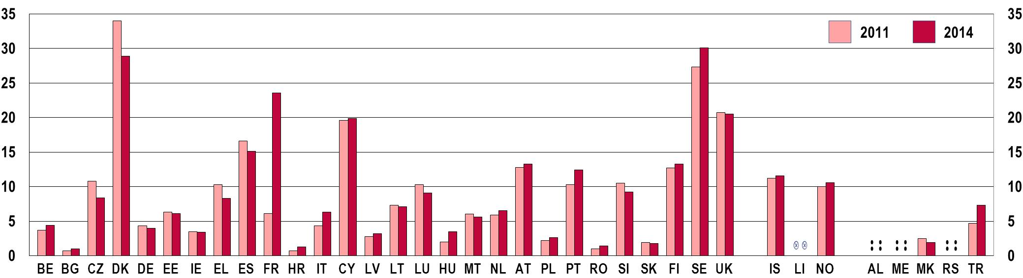
Notes: the Czech Republic, Spain, France, the Netherlands, Poland and Turkey: breaks in time series in 2013 (2014 for Spain and Turkey) make data not comparable with those from 2011.
EU average: data are not shown due to a break in series in data collection (2013).
b) by sex, 2014
% %
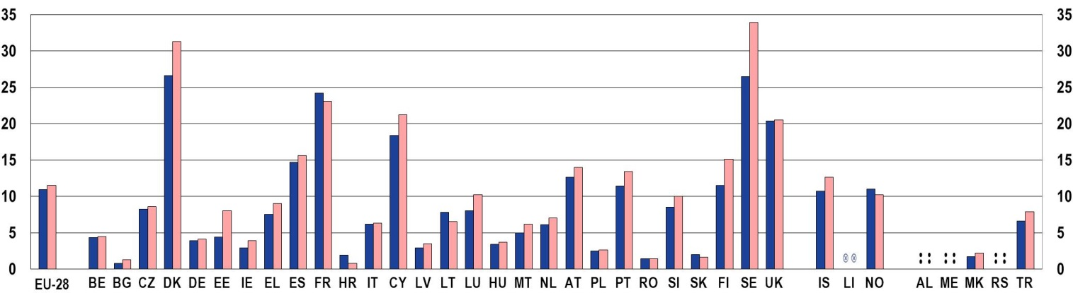
 | Men |  | Women
Notes: Data are not reliable for Bulgaria (men) and Croatia (both men and women).
Source: Eurostat LFS [trng_lfs_09]

As illustrated by Figure 3-F-b, the average share of young women and young men engaging in non-formal learning are very similar. Yet, in most countries, women tend to report somewhat higher rates of participation, with gender differences being the largest (more than 30 %) in Bulgaria, Estonia, Ireland and Finland.
By providing opportunities for non-formal learning, youth work contributes to the acquisition and enhancement of personal and learning skills that prove essential in promoting youth's education attainment.
Non-formal learning might take place in the context of youth work. According to the Resolution of the Council of the EU on youth work from 2010, youth work encompasses activities for and by young people, taking place in the extracurricular and leisure areas, and based on voluntary participation. Such activities see the cooperation of professional and voluntary youth workers, youth leaders, and the active engagement and contribution of young participants ().
Youth work has been shown to exert positive influence on student achievements in education by fostering non-cognitive skills such as persistence, motivation, and self-efficacy (). In particular, young people at risk of dropping out prematurely from education and training may obtain support from youth workers, gaining access to learning resources and individualised assistance and becoming motivated to learn again through participation in the various activities organised for them (). Some youth work programmes have also proven effective in bringing young people who have left school early back into education by, for example, offering preparatory courses for re-insertion into mainstream education or second chance programmes ().
Providing information, advice and guidance to support young people in their decision making during their education and training is another important aspect of youth work (). Indeed, in some European countries, central authorities place guidance services for students under the auspices of youth work organisations, delivered by nation-wide networks independent from schools ().
Because youth work is such a wide field encompassing voluntary leisure-time as well as extra-curricular activities, its contribution goes well beyond supporting young people in their educational experiences. Studies which have investigated the effects of young people's participation in youth work activities show that young people can acquire and reinforce personal skills such as conflict resolution, decision making, goal setting and interpersonal communication that can prove useful in all spheres of life (). Although data on young people's participation in activities organised by youth workers is limited, Chapter 8 of this report provides some insight into the level of participation in organised voluntary activities (Figure 8-A) while Chapter 9 examines their involvement in youth organisations, cultural organisations and sports clubs (Figure 9-C).
3.4. Learning mobility
Learning mobility is generally seen as contributing to the development of a wide range of skills and competences among young people. Most importantly, transversal skills such as language competences, communication, problem-solving, and intercultural understanding are found to be improved by study periods abroad (). According to the Erasmus Impact Study, students participating in the Erasmus mobility programme improve their employability skills more than non-mobile students (). In addition, student mobility programmes also have the potential to contribute to the overall quality of education ().
However, while mobility contributes to the skills development and labour market prospects of individuals, many do not have the possibility to experience learning mobility. First of all, most learning mobility occurs during higher education studies. While data on mobility outside higher education settings are scarce, young people not entering tertiary education clearly have fewer opportunities for learning mobility. In addition, even among higher education students, disadvantaged students participate less in mobility programmes ().
Figure 3-G depicts the proportion of people who, in a recent Eurobarometer survey, declared they had spent time abroad studying. The figure covers all respondents, thus not only young people, but nevertheless gives a useful overview on learning mobility in the different European countries across different age groups.
Figure 3-G: Proportion of people who have spent time abroad (in another EU Member State or outside the EU) studying, by country, 2014
% %
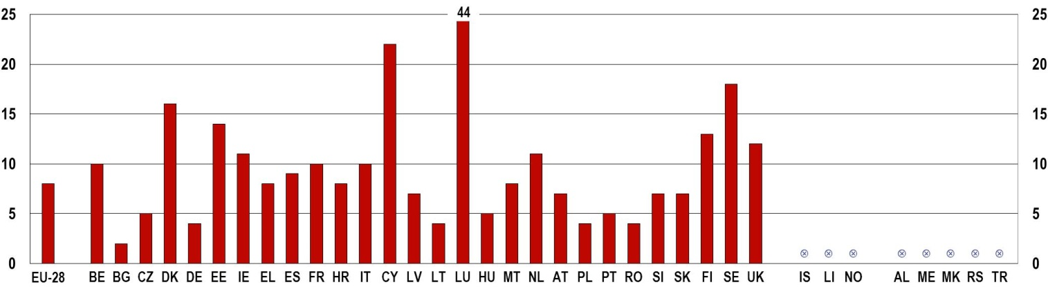
Notes: The question was: 'Have you ever spent time in another EU Member State or outside of the EU…? Studying'.
Base: all respondents, % by country
Source: Special Eurobarometer 417, European area of Skills and Qualifications, 2014

According to the Eurobarometer survey, in the EU-28 in general, the age group with the highest share of people who have studied abroad is the 25-39 age group (12 %), followed by the 40-54 year-olds (9 %) (). In contrast, only 5 % of respondents over the age of 55 had experienced learning abroad (). This indicates that learning mobility is increasing in Europe with each generation. This trend would appear to be contradicted by the figures for the youngest age group (those aged 15-24), where only 9 % of respondents have studied abroad. However, since most young people undertake a period of learning abroad during their higher education studies, many respondents in this age group may not yet have had the opportunity to do so.
Today's young people participate in learning mobility more than older generations. However, differences across countries are substantial.
The country with the largest proportion of respondents that has spent time abroad studying is Luxembourg, where until 2003, when the first and only university was founded, everyone went abroad for higher education studies, and even today all higher education students have some experience of learning mobility. Luxembourg is followed by Cyprus, where the proportion of higher education graduates receiving their degrees abroad is also relatively high (see Figure 3-H). Besides these two countries, learning mobility is most widespread in northern European countries: Sweden, Denmark, Estonia and Finland, with 18 %, 16 %, 14 % and 13 % respectively. On the other hand, the survey indicates that people are the least mobile in Bulgaria, with only 2 % of respondents declaring they had spent time abroad studying.
Given that most learning mobility occurs during higher education studies, more specific data are available on the mobility of higher education students. There are two main types of learning mobility in higher education: credit mobility, which refers to a short period of study in another country when a student may earn credits towards their home-based degree programme; and degree mobility, where a student moves to an institution abroad to take their entire degree course ().
Figure 3-H depicts the latest Eurostudent survey data on temporary enrolments abroad (credit mobility) by higher education students. Among the countries with available data, the Nordic countries – Finland (18 %), Norway (16 %), Sweden (13 %) and Denmark (12 %) – as well as Slovenia (12 %) stand out with the highest credit mobility rates in 2013/14. Conversely, credit mobility rates were the lowest (around 2 %) in Croatia, Slovakia and Serbia.
Figure 3-H: Proportion of higher education students who have been temporarily enrolled abroad (credit mobility), 2013/14
% %
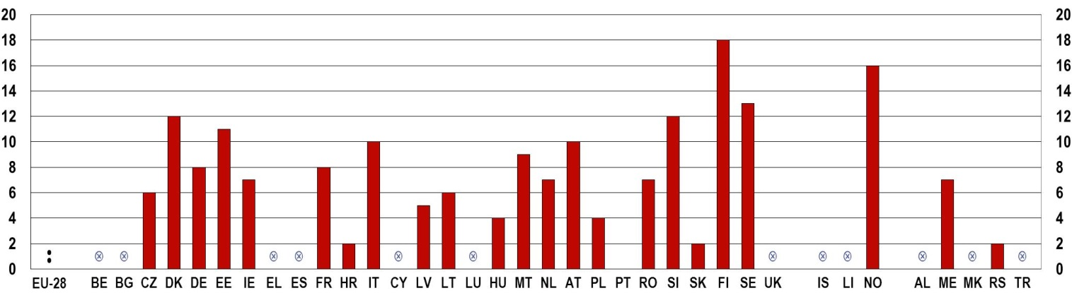
Notes: EUROSTUDENT Question: 4.1 Have you been enrolled abroad as a student in higher education?
Data relate only to temporary international student mobility and therefore only take into account students who resume their studies in the country from which they came prior to their study period abroad.
Deviations from EUROSTUDENT survey conventions: Austria, Switzerland, Finland and France. Deviations from EUROSTUDENT standard target group: Germany and Italy.
Source: EUROSTUDENT V, K.1, K.16.

These data also illustrate that despite the benefits of learning mobility, the majority of higher education students did not report having spent time abroad. This is partly due to a selection bias, since the sample of the survey includes all higher education students, some of whom might not have reached the point in their study course when the opportunity to study abroad had arisen. Nevertheless, when asking about the intention to go abroad, data still show that in the majority of European countries, more than half of students do not even plan to study abroad, especially those from a lower socio-economic background (). The most important obstacles to credit mobility, as indicated by the students not planning a study period abroad, are the additional financial burden (63 %), and the separation from partners, children and friends (47 %) ().
Public funding for learning mobility can reduce the additional financial burden students have to face when going abroad to study. In Europe, the most important source of funding is the Erasmus Student Mobility programme. In fact, most of the European students undertaking short-term periods abroad to earn credits towards a home-based degree (credit mobility) do so through the Erasmus programme, especially in countries where national sources are less available (). In the academic year 2012/13, 212 522 students participated in the programme, and the numbers have been growing each year (). The largest numbers of participating students are from Spain, Germany, France, Italy and Turkey, though the relative share of students participating is the highest in Luxembourg, Liechtenstein, Spain, Lithuania and Latvia (). Interestingly, whilst credit mobility is highest in the Nordic countries, the relative proportion of Erasmus students in Denmark, Sweden and Norway is among the lowest (), pointing towards the availability of other sources of funding for these students.
Students who move to another country to take an entire degree programme (degree mobility), as depicted in Figure 3-I (), mostly stay within the European Higher Education Area (EHEA) (). The majority of students from Liechtenstein, Luxembourg and Cyprus study outside their country, but almost all of them within the EHEA. Besides these three small countries, degree mobility is the highest in Slovakia, Iceland and Malta, with more than 10 % of students studying abroad. At the other end of the scale, the proportion of students leaving their country to get a higher education degree is lowest (below 2 %) in Turkey, the United Kingdom and Spain.
Figure 3-I: Proportion of tertiary education students enrolled abroad (degree mobility), by country of origin, 2011/12
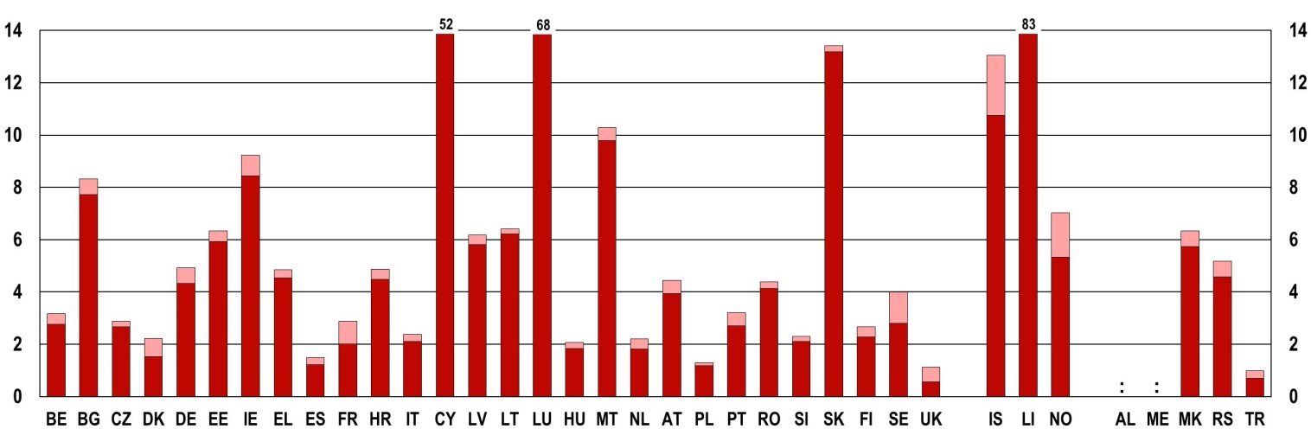
 | EHEA |  | Non-EHEA
Notes: Destinations outside of the EHEA considered are Bahrain, Jordan, Morocco (reference year 2010), Oman (reference year 2011), Qatar, Saudi Arabia, United Arab Emirates, China – Hong Kong Special Administrative Region, China – Macao Special Administrative Region (reference year 2011), Malaysia, Thailand, Israel, India, Ghana, Brazil, Chile, Korea, Australia, Canada, Japan, New Zealand and the United States.
Japan: data refer to foreign students instead of mobile students.
Czech Republic, Greece, France, Italy, Finland, Norway, the former Yugoslav Republic of Macedonia, Turkey, and Serbia: data refer to foreign students instead of mobile students.
Source: European Commission/ EACEA/Eurydice 2015, p. 236.

Among the countries with comparable data, the countries with the highest relative share of mobile students studying outside the EHEA are the United Kingdom, where around half of all mobile students leave the EHEA; and Denmark and Sweden, where around one third do so. Looking at the share of mobile students going outside the EHEA within all (including non-mobile) students, more than 1 % of all students go abroad to study outside the EHEA in Cyprus, Sweden, Liechtenstein, Switzerland and Iceland.
3.5. Transition from education to employment
Completing education and entering the labour market represents an important step in young people's lives. It is the time when the knowledge and skills learnt and aspirations developed during the years spent in education are put to the test, with the objective of gaining meaningful employment and financial independence. This transition has become increasingly complex and individualised for today's young people, as many of them move regularly in and out of work, often having part-time or temporary jobs, or even returning to education after a period of employment () (see also the chapter on Employment and Entrepreneurship) .
For most young Europeans, the passage from education to employment occurs between the ages of 20 and 24 (Figure 3-J). During these ages, the share of young individuals in formal education is overtaken by the share in employment.
This transition occurs later for women than for men. The gender gap in this particular regard is a consequence of the higher percentage of women in the age group 20-24 who continue their studies and postpone joining the labour force without continuing their education.
Figure 3-J: Share of young people (aged 15-29) either in formal education or in employment (but not in both), by age group, EU-28 average, 2013
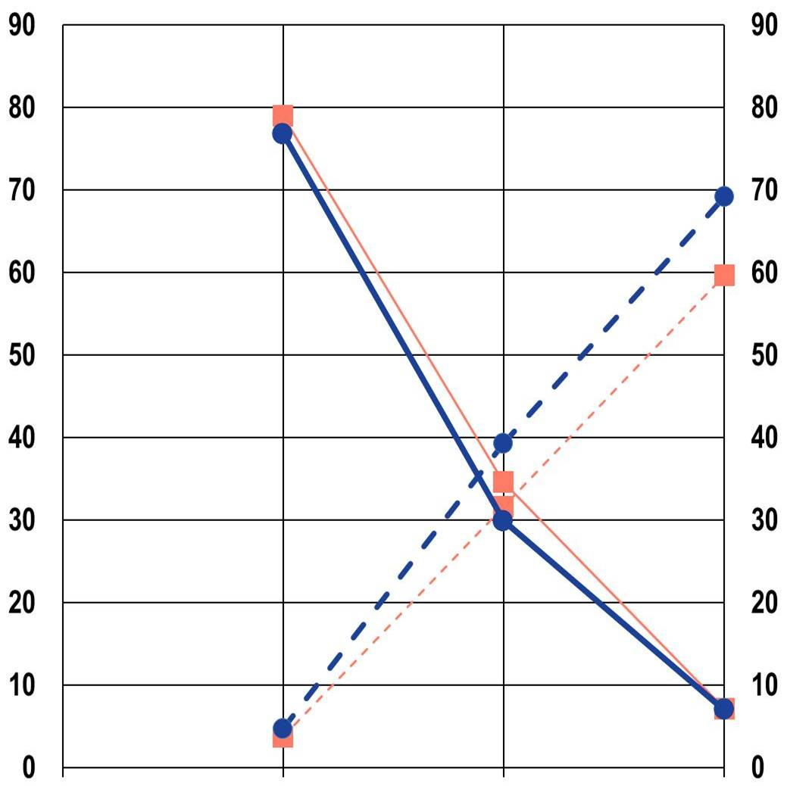
 |  |  |  |  | In formal education and training, but not in employment
 |  |  |  |  |  | Women |  |  | Men
 |  |  |  |  | In employment, but not in education and training
 |  |  |  |  |  | Women |  |  | Men
 | 15-19 | 20-24 | 25-29
Source: Eurostat [edat_lfse_19]

Figure 3-K: Share of young people (aged 20 to 24) either in formal education or in employment (but not in both), EU-28 average, 2011 and 2014
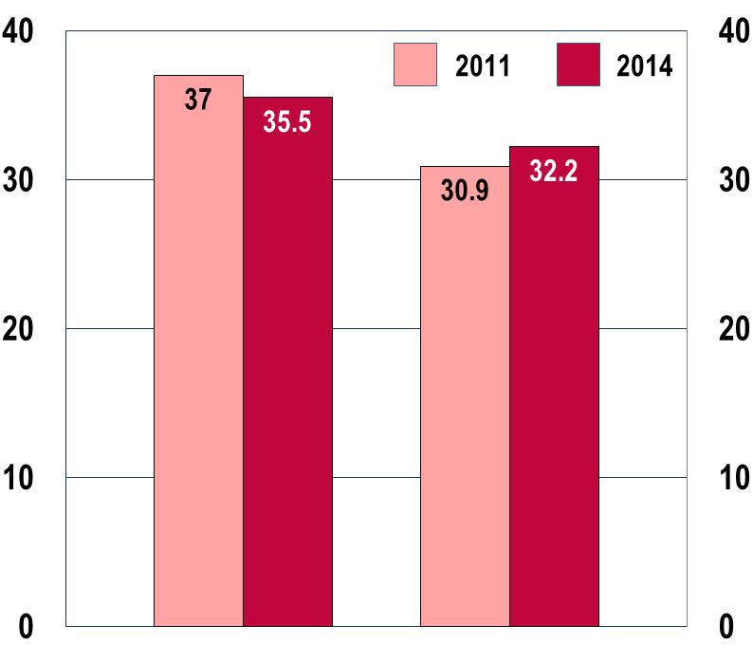
 | In employment, but not in formal education | In formal education, but not in employment
Source: Eurostat [edat_lfse_19]
The rates of participation in formal education amongst young people in the age of transition (20-24) have gradually increased since 2000, with a significant surge after the start of the economic crisis in 2008 (). Alongside this, the rate of employment for the same age group has progressively declined. These trends are confirmed between 2011 and 2014. As an increasing share of young Europeans aged 20 to 24 remains in education, a smaller portion enters the labour market without continuing their education (Figure 3-K).
While the transition from education to employment continues to take place between 20 and 24 years of age for most young Europeans, the share of young people staying in education has increased since 2011.
Data presented in the chart indicate that the decrease in the proportion of young people solely in employment has been greater than the increase in the percentage of those solely in formal education. There is therefore a segment of the youth population aged 20-24 that appears to have left education without having been integrated into the labour force. The challenges encountered by young people experiencing unemployment, and by those who are not in employment, education or training (NEETs) will be illustrated in the chapters on Employment and Social Inclusion respectively.

(?) Council resolution of 27 November 2009 on a renewed framework for European cooperation in the youth field (2010-2018), OJ C 311, 19.12.2009, p. 1-11.
(?) Commission Staff Working Document on EU indicators in the field of youth, SEC(2011) 401 final.
(?) All EU Member States, EU candidate countries and EEA EFTA States were invited to submit National Youth Reports.
(?) Eurostat collects information on the population living in each European country on the 1st of January of each year. Data on young people are available at http://ec.europa.eu/eurostat/web/youth/data/database.
(?) European Commission, 2012.
(?) Eurostat, 2015a. The replacement level is the level of the fertility rate which is necessary to compensate for the mortality rate. Its value should be 2.1.
(?) Ibid.
(?) Ibid.
(?) Ibid.
(?) Bloom et al., 2008.
(?) Bloom et al., 2008; Lanzieri, 2013.
(?) 'Non-EU country' and 'third country' are used interchangeably to indicate any country outside the current 28 EU Member States.
(?) European Commission, 2012a and 2014d.
(?) European Commission 2014a.
(?) EENEE, 2014.
(?) In the EU-28, while school expectancy was 17 years in 2003, it increased to 17.6 by 2012. Source: Eurostat, online data code: educ_igen (School expectancy of pupils and students (ISCED 0-6)).
(?) Ibid.
(?) European Commission, 2012a.
(?) In Section 3.2.1, given the application of the new ISCED 2011 categories by Eurostat from 2014, we rely on data from 2013 for being able to make comparisons over time.
(?) Eurostat, online data code: edat_lfse_08. Data extracted on 16/03/2015.
(?) European Commission/EACEA, 2013.
(?) European Commission 2014a.
(?) The Europe 2020 Strategy includes a target set by the European Council to raise the level of tertiary attainment amongst 30-34 year-olds to 40 % by 2020.
(?) European Commission, 2012a.
(?) European Commission/EACEA/Eurydice/Cedefop, 2014.
(?) Ibid.
(?) European Commission, 2014a.
(?) The ET 2020 Strategic framework includes a target set by the European Council of reducing the share of early school leavers to below 10 % by 2020.
(?) European Commission 2014a.
(?) The Europe 2020 Strategy includes a target set by the European Council to reduce the share of low achievers in reading, mathematics and science amongst 15 year-olds to below 15 % by 2020.
(?) European Commission, 2012b. The European Survey on Language Competences (ESLC) was conducted for the first time in 2011 in Belgium, Bulgaria, Estonia, Greece, Spain, France, Croatia, Malta, the Netherlands, Poland, Portugal, Slovenia and Sweden. In accordance with the Common European Framework of Reference for Languages (CEFR), the survey tests 15-year-old students' abilities in their first and second foreign languages.
(?) This definition is provided by Eurostat in the context of its lifelong learning statistics and is also applied in the EU LFS which collects data on participation in non-formal education and training during the four weeks preceding the survey.
(?) Salto, 2005.
(?) European Council Recommendation of 20 December 2012 on the validation of non-formal and informal learning (2012/C 398/01).
(?) Council of Europe, 2005.
(?) Resolution of the Council and of the representatives of the governments of the Member States, meeting within the Council on youth work, Brussels, 18 and 19 November 2010.
(?) Shernoff and Lowe Vandell, 2007.
(?) European Commission, 2014h. The study offers a detailed and comprehensive assessment of the various traditions and developments of youth work in Europe. It presents both secondary analysis of previous literature and data on the topic, and first-hand evidence collected through interviews. Most of the information presented in this section draws from this study's findings.
(?) Ibid.
(?) Ibid.
(?) Ibid.
(?) Ibid.
(?) European Commission, 2014c.
(?) Ibid, p.14.
(?) Council of the European Union, 2011.
(?) Hauschildt et al., 2015.
(?) European Commission, 2014f.
(?) Ibid.
(?) European Commission/EACEA/Eurydice, 2013b.
(?) Hauschildt et al. 2015, p. 193. Lower socio-economic background here refers to having parents with no higher education qualifications.
(?) Ibid., p. 194.
(?) Ibid., p. 198.
(?) European Commission 2014c, p.8.
(?) Ibid.
(?) Hauschildt et al. 2015, p. 198.
(?) Data presented here need to be treated with caution due to two main limitations. First, the list of destinations outside the EHEA is limited. Second, mobility data may rely on different criteria (i.e. citizenship, prior/permanent residence, prior education), which do not measure exactly the same phenomenon. For example, where data refers to foreign students instead of mobile students, it also includes non-national students who were already living in the country of destination before they began their higher education studies.
(?) A more detailed analysis on degree mobility can be found in the latest Bologna Implementation Report (European Commission/ EACEA/Eurydice, 2015).
(?) Buchmann, 2011; Eurofound, 2012.
(?) European Commission, 2012a.

