REPORT FROM THE COMMISSION TO THE EUROPEAN PARLIAMENT AND THE COUNCIL
concerning the implementation and the results of the Pericles programme for the protection of the euro against counterfeiting in 2014
1. General
The ''Pericles 2020'' programme is an exchange, assistance and training programme for the protection of the euro against counterfeiting, replacing the Pericles programme that was established in 2001 and ran in the period 2002-2013. The Programme was established by Regulation (EU) No 331/2014 of the European Parliament and of the Council of 11 March 2014. This Regulation establishes the duration of the Programme until 31 December 2020. Article 13(3) of the Regulation requires that the Commission shall provide annual information on the results of the Programme to the European Parliament and to the Council. This report responds to that requirement in relation to the year 2014.
The ''Pericles 2020'' programme has several additional features compared to the previous programme. Firstly, Article 8(2)(c) of the Regulation includes as an additional eligible action the purchase of equipment to be used by specialised anti-counterfeiting authorities for protecting the euro against counterfeiting. Secondly, the system of eligible costs has been simplified. Furthermore, Article 10 of the Regulation sets the co-financing rate for grants at 75%, but also allows for an increase in the co-financing rate for grants to a maximum of 90% of the eligible costs in exceptional and duly justified cases which are defined in the Annual Work Programme. Finally, the monitoring and evaluation components of the ''Pericles 2020'' programme have been strengthened.

2. Implementation of the programme and results of committed Pericles actions in 2014
The annual budget for the implementation of the ''Pericles 2020'' programme for the year 2014 was set at EUR 924 200, and was financed from the budget line 24 03 01 of the general budget of the European Union for 2014. A total of EUR 878 517 was committed in 2014.
The implementation of the Programme reflected the commitment of Member States to protect the euro against counterfeiting. Discussions of the multi-annual strategy at the meetings of the Euro Counterfeiting Experts Group (ECEG) made it possible to commit 95% of the overall budget in 2014.
In the year 2014, the Programme funded 10 projects; of these projects, 6 originated from the competent authorities of euro area Member States, while 4 were initiatives of the Commission. 3 actions were implemented in 2014, while 7 actions are being/will be implemented in 2015. In 2014, applicants to the Programme represented three Member States, Italy, France and Spain. This reflects that the countries most affected by euro counterfeiting are more frequent users of Pericles funds. The Regulation, which should extend the application of the ''Pericles 2020'' programme to non euro area Member States, is in the process of adoption by the EU legislator. Therefore, in 2014, the programme was only applicable to euro area Member States.

Graph I and Graph II: Number of actions per Member State (Grants and Procurements 2014)
and Type of action

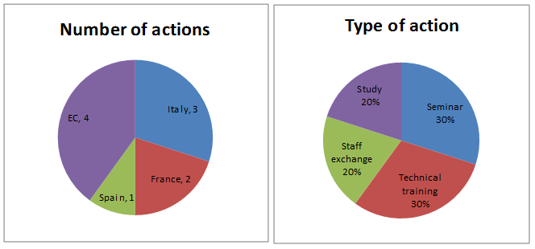
The actions for which commitments were made in 2014 consisted of three seminars, three technical trainings, two staff exchanges and two studies.
These actions took place both inside and outside the EU depending on the specific needs to protect the euro against counterfeiting. Since its inception, Pericles consolidated its regional approach by implementing actions involving particularly sensitive regions of the world. Specific focus areas in 2014 were Latin America (Chile and Colombia), the South East of Europe (Albania and Turkey) and the Mediterranean region.
The following graphs give a breakdown of the origin and professional background of ''Pericles 2020'' programme participants:
Graph III and Graph IV: Origin of participants and Professional background of participants
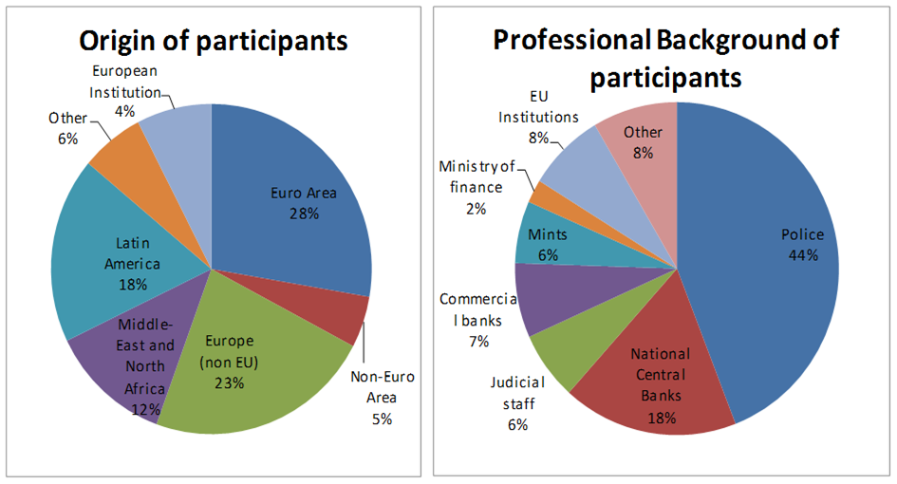
An estimated number of 662 experts participate in Pericles actions for which commitments were made in 2014.
In terms of origin, participants come from 57 countries. The majority of trainees (56%) are European participants: 33% come from the European Union Member States, while non-EU countries in Europe represents the second largest group at 23%; 18% of trainees are from Latin America (mainly Colombia and Chile), and 12% come from the Middle East and North Africa.
With respect to the professional background of participants, members from police forces represent 44% of the total. This is due to the fact that police authorities represent the front line in the fight against euro counterfeiting and police staff includes both investigators and technicians. Nevertheless, an increase in differentiation among the various other categories of participants (56%) compared to the implementation of the previous Pericles programme should be highlighted. This includes high participation from Central Banks (18%), commercial banks (7%), judicial staff (6%) and Mints (6%).
As a result, Pericles implementation meets the transnational and multidisciplinary dimensions of the programme, as required under the Pericles Regulation.

3. Overview of actions committed to in 2014: highlights
The Programme shows a high degree of consistency and complementarity with other relevant programmes and actions at Union level because it is dedicated exclusively to and focuses on preventing and fighting a specific form of organised crime, namely euro counterfeiting. It is therefore complementary and consistent with OLAF's Hercule III Programme which protects the financial interests of the Union, and it shows a high degree of complementarity with, inter alia, DG HOME's Internal Security Fund - Police, which covers the prevention and combating of crime in general.
The ''Pericles 2020'' programme implementation in 2014 demonstrates a positive trend towards an increasing differentiation of the professional backgrounds of participants. In particular, the growing participation of the judiciary in several actions, such as the 3rd International Conference on the Protection of the Euro against Counterfeiting, is noteworthy.
The Programme has succeeded in maintaining its strong regional cooperation in 2014, with several actions taking place in Latin America, the Mediterranean area and the Balkans region.
Furthermore, the 2014 Pericles commitments reflect a full diversification of the type of actions, in particular with the addition of two studies, one on euro counterfeiting and its perpetrators, and the other on enhanced security features for use in euro coins.
A particular highlight of the 2014 ''Pericles 2020'' programme is the 3rd International Conference on the Protection of the Euro against Counterfeiting, held in Frankfurt from 24 to 27 March 2015, and jointly organised with Europol and the European Central Bank. It brought together more than 170 experts from over 40 nationalities in workshops and presentations. The conference was highly successful in exchanging best practices and laying the basis for increased multidisciplinary cooperation between and among the European Institutions, Member States and third countries. This is considered essential for a more structured and efficient response to the new challenges for the protection of the euro against counterfeiting. Emerging trends and threats were identified and analysed, including advances in technology, increasingly deceptive counterfeits and the availability of raw materials for the production of counterfeits on the internet. Technical support for investigations, cross-border coordination of investigations, targeted communication actions to the public, cashiers and retailers, and training programmes such as the ''Pericles 2020'' programme were all considered by the participants as essential elements in a successful fight against counterfeiting.

4. Implementation of Pericles actions in 2014 that were committed to under the previous Pericles programme
2014 saw the implementation of 9 Pericles actions that were committed to under the previous Pericles programme. Of these projects, 5 originated from the competent national authorities of EU Member States – respectively Romania, Italy, Spain, Croatia and Latvia - while 4 projects were initiated by the Commission. The projects consisted of 3 seminars, 2 technical trainings, 3 staff exchanges and the update of the Euro Anti-Counterfeiting Manual. Particular focus areas were South-East Europe and Latin America.

5. Conclusion and way forward
The ''Pericles 2020'' programme continues to be an important and effective tool in the fight against counterfeiting. The Programme forms the basis for the support of studies, maintaining and developing cooperation, and exchanging best practices among all actors involved in the fight against euro counterfeiting. Based on the results of the implementation of the Programme and the continuous analysis of emerging threats discussed in the Euro Counterfeiting Expert Group, the priorities for 2015 are the following:
- increasing emphasis on Member States which are particularly affected by the production and distribution of counterfeits;
- maintaining an efficient framework for the protection of the euro in South Eastern Europe and the candidate country Turkey;
- developing closer cooperation with authorities of those third countries for which there is suspicion or evidence of the presence of counterfeit euro production; and
- reinforcing the protection of euro coins by developing new security features or authentication methods.

Regulation (EU) No 331/2014 of the European Parliament and of the Council establishing an exchange, assistance and training programme for the protection of the euro against counterfeiting (the 'Pericles 2020' programme). This Regulation repealed Council Decision 2001/923/EC of 17 December 2001, 2006/75/EC of 30 January 2006, and 2006/849/EC of 20 November 2006 (OJ L 103, 5.4.2014).
The Annual Work Programme, provided for in Article 10(4) of Regulation (EU) No 331/2014, is annexed to Commission Decision C(2014) 3427 final of 28 May 2014 concerning the adoption of the work programme for 2014 of the Pericles 2020 Programme. The co-financing rate of 90% of the eligible costs may be applicable in one of the following cases: conferences, seminars and workshops taking place outside the EU and having as a main target staff from third countries particularly affected by production and distribution of counterfeits, actions organised by Authorities from Member States entering the euro zone, and actions organised by Authorities applying for the first time.
Some actions are still being implemented in 2015.
The other category includes, inter alia, casino personel and staff from national ministries.
For the degree of differentiation among participants in the previous Pericles programme, see the Report from the Commission to the European Parliament and the Council concerning the implementation and the results of the Pericles programme for the protection of the euro against counterfeiting 2006 -2013 - COM(2014) 550 final.
A comprehensive overview of Pericles actions committed to in 2014 can be found in Annex I.
Regulation (EU) No 250/2014 of the European Parliament and of the Council of 26 February 2014 establishing a programme to promote activities in the field of the protection of the financial interests of the European Union (Hercule III programme) and repealing Decision No 804/2004/EC (OJ L 84, 20.3.2014).
Regulation (EU) No 513/2014 of the European Parliament and of the Council of 16 April 2014 establishing, as part of the Internal Security Fund, the instrument for financial support for police cooperation, preventing and combating crime, and crisis management and repealing Council Decision 2007/125/JHA (OJ L 150, 20.5.2014).
A comprehensive overview of Pericles actions committed to under the previous Pericles programme and implemented in 2014 can be found in Annex II.
The priorities of the Programme for 2015 are an essential part of the Annual Work Programme, which is annexed to Commission Decision C(2015) 2473 of 17 April 2015 concerning the adoption of the work programme for 2015 of the Pericles 2020 Programme.

