

**Annex I**

**1. Terminology**

The Marine Strategy Framework Directive does not define the terms "marine protected area" and "spatial protection measure". The objective of this section is to provide definitions which were used in the preparation of this report and will be applied in the context of the implementation of the Marine Strategy Framework Directive as well as other legislation.

1.1 Marine Protected Areas

In international law, Article 8 of the Convention on Biological Diversity (CBD) sets out the fundamental obligation for Parties to establish protected areas[1]. The definition of protected areas[2] in Article 2 of the Convention provides the basis of the definitions of protected areas and marine protected areas used by other international organisations, such as the International Union for Conservation of Nature (IUCN) [3] or the Regional Sea Conventions (RSC)[4].

In the European Union protected areas are established under the Nature Directives (see Special Areas of Conservation under the Habitats Directive and Special Protected Areas under the Birds Directive). The definition of these areas[5] is in line with the CBD definition of protected areas, i.e. they are geographically defined, they have a clear conservation objective, and management measures shall be taken in their territory to achieve this objective.

Based on common elements of these definitions, the following criteria are proposed for the purpose of defining Marine Protected Areas in the context of the MSFD and all related EU policies[6]:

* they are geographically defined marine areas;
* whose primary and clearly stated objective is nature conservation;
* and are regulated and managed through legal or other effective means to achieve this objective.

1.2 Spatial protection measures

Target 11 of the Strategic Plan for Biodiversity 2011-2020[7] requires that "(…) 10 per cent of coastal and marine areas, especially areas of particular importance for biodiversity and ecosystem services, are conserved through effectively and equitably managed, ecologically representative and well-connected systems of protected areas and other effective area-based conservation measures (…)". There exists, however, no internationally accepted definition of what is meant by "other effective area-based conservation measures".

The Marine Strategy Framework Directive as well as the Birds and Habitats Directives all foresee conservation measures outside protected areas in order to ensure the adequate protection of species and habitats, and to maximise the benefits from protected areas. The Marine Strategy Framework Directive talks explicitly about spatial protection measures[8]. The Habitats Directive foresees the establishment of a strict protection regime for species and sub-species listed in Annex IV of the Directive and protection measures for species and sub-species listed in Annex V[9]. Some of these measures are area-based (e.g. temporary or local prohibition of the taking of specimens in the wild and exploitation of certain populations, establishment of a system of licences for taking specimens or of quotas[10] etc.). The Birds Directive creates a similar structure[11].

Therefore, spatial protection measures are defined following the logic of the MSFD and the Nature Directives, i.e. that spatial protection measures are a wider category than MPAs, and they play a supportive role in nature conservation. Hence, the term "spatial protection measures" is used for[12]:

* area-based conservation measures
* that do not meet the criteria of marine protected areas, either because conservation is not their primary objective, or because their objective focuses on a particular activity or sector in order to protect part of the ecosystem.

In this sense, certain fisheries management measures which have conservation aspects fall under the definition of spatial protection measures. Such fisheries management measures may include special fishing permits or bans on specific fishing gears[13] for specific areas to protect for example vulnerable marine ecosystems or sea grass meadows or certain conservation measures adopted under Article 7 of the Common Fisheries Policy[14].

Certain measures to be taken under the Maritime Spatial Planning Directive might also be considered as spatial protection measures, as one of the objectives of maritime spatial plans is the protection and improvement of the environment.

**2. Relevant EU and international law**

The MSFD[15] aims to ensure the integration of environmental concerns into the different policies, agreements and legislative measures which have an impact on the marine environment[16]. This section will therefore draw up an inventory of EU legislation and international law affecting the establishment of MPAs under the MSFD.

EU legislation

1. **Habitats**[17] and **Birds Directives**[18]**:** foreseedesignation of protected areas which form a coherent European ecological network (Natura 2000 network)[19] and are subject to strong protection and management requirements in order to achieve Favourable Conservation Status for the EU's most vulnerable habitats and species.

1. **Common Fisheries Policy**: its recently reformed Basic Regulation provides for the adoption of conservation measures in line with the objectives of the MSFD and the Habitats and Birds Directives[20]. It also allows for the establishment of protected areas of biological sensitivity[21]. In addition, fishing protected areas can be established under the regulation concerning management measures for the sustainable exploitation of fishery resources in the Mediterranean Sea[22].
2. **Water Framework Directive[23]:** appliesto inland transitional waters, but its provisions are highly relevant for MPAs in near-shore waters which are rich in spawning and nursery grounds and therefore important from a conservation point of view.
3. **Maritime Spatial Planning Directive[24]:** MPAs will form part of maritime spatial plans established under the Directive.

International dimension

1. **United Nations Convention on the Law of the Sea:** requires that Parties take measures to protect and preserve the marine environment in general, and rare or fragile ecosystems, the habitat of depleted, threatened or endangered species and other forms of marine life in particular[25].
2. **Convention on Biological Diversity:** aims to halt biodiversity loss, ensuring the conservation and sustainable use of marine biodiversity. Aichi Biodiversity Target 11[26] aims to conserve 10% of coastal and marine areas through "effectively and equitably managed, ecologically representative and well-connected systems of protected areas and other effective area-based conservation measures". This target has become a global commitment through its inclusion in the Rio+20 outcome document "The Future We Want"[27] and in the proposed goal for oceans[28] in the Post-2015 Development Agenda being negotiated at the UN. Also under the CBD, ecologically or biologically significant marine areas (EBSAs) are being described for their important contribution in supporting the healthy functioning of the oceans, and in recognition of their potential need for some kind of protection. Some 200 EBSAs have been described during regional workshops around the world and have been approved by the Conference of the Parties for inclusion in the CBD EBSA "repository". It is up to states and competent intergovernmental organisations to decide on any management and protection measures for those areas or parts thereof, including by designating them as MPAs.

3. **Regional Seas Conventions:** aim to improve regional governance for the protection of the marine environment. Four RSCs cover the marine waters in the scope of the MSFD: OSPAR for the North East Atlantic, HELCOM for the Baltic Sea, the Barcelona Convention for the Mediterranean and the Bucharest Convention for the Black Sea. All four RSCs have been active in establishing MPAs and assessing MPA network coherence[29].

**Annex II**

**Tables**

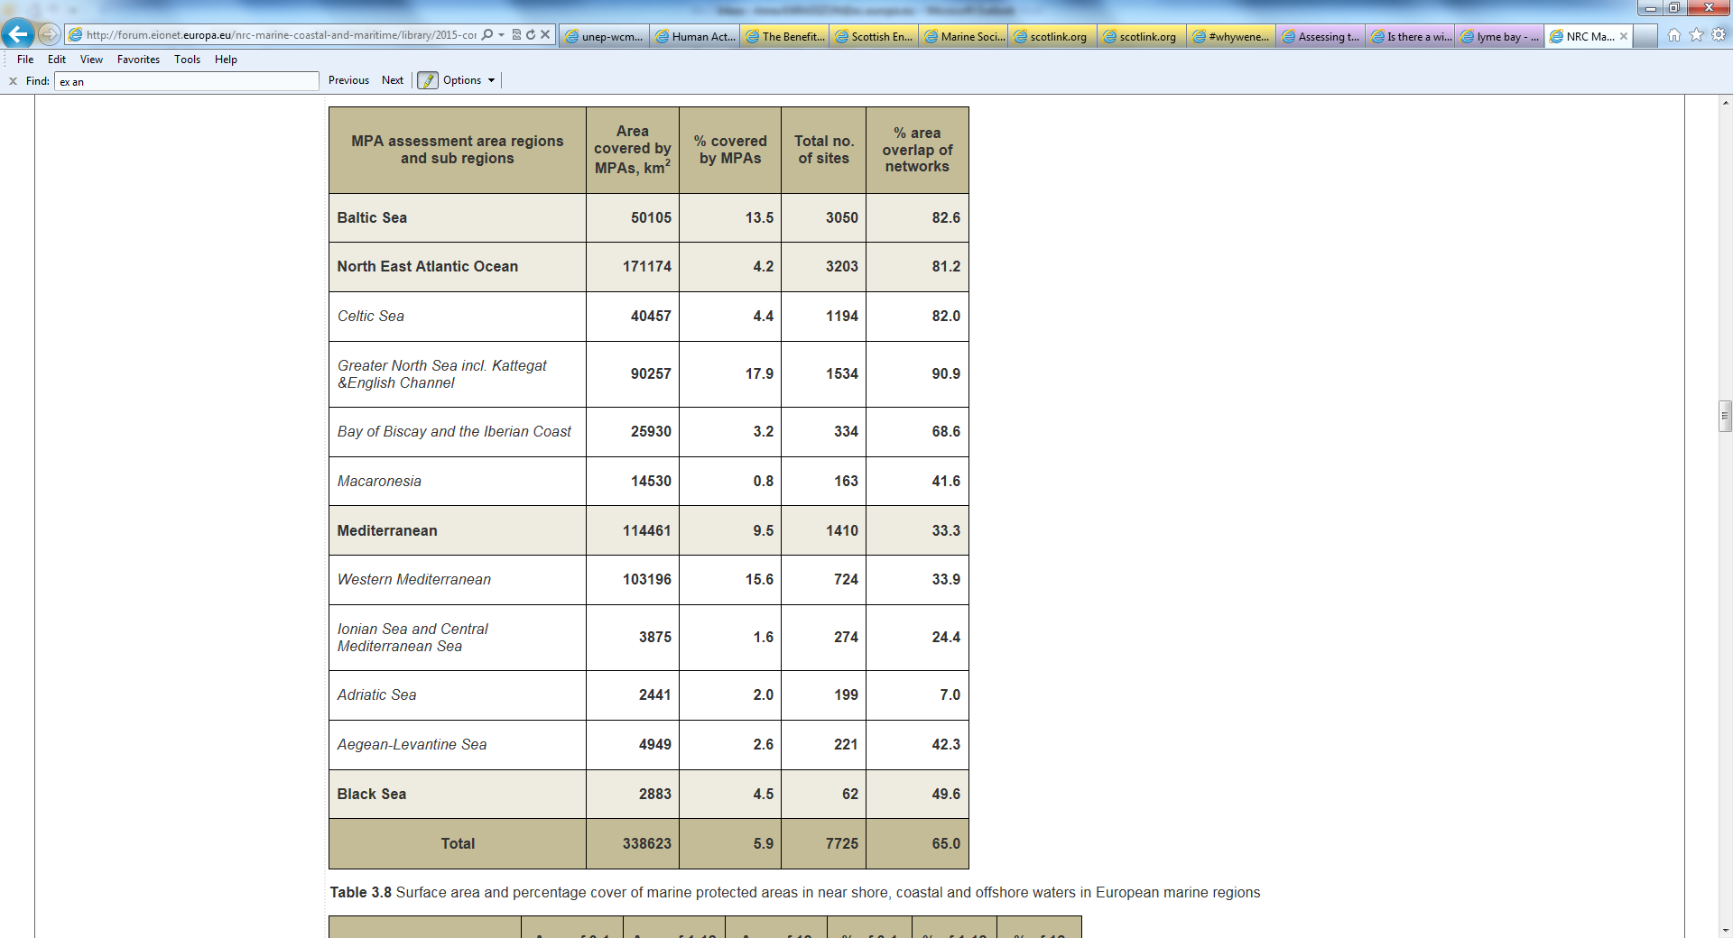

Table 1 - Coverage of marine protected areas in European Seas (2012) [30]

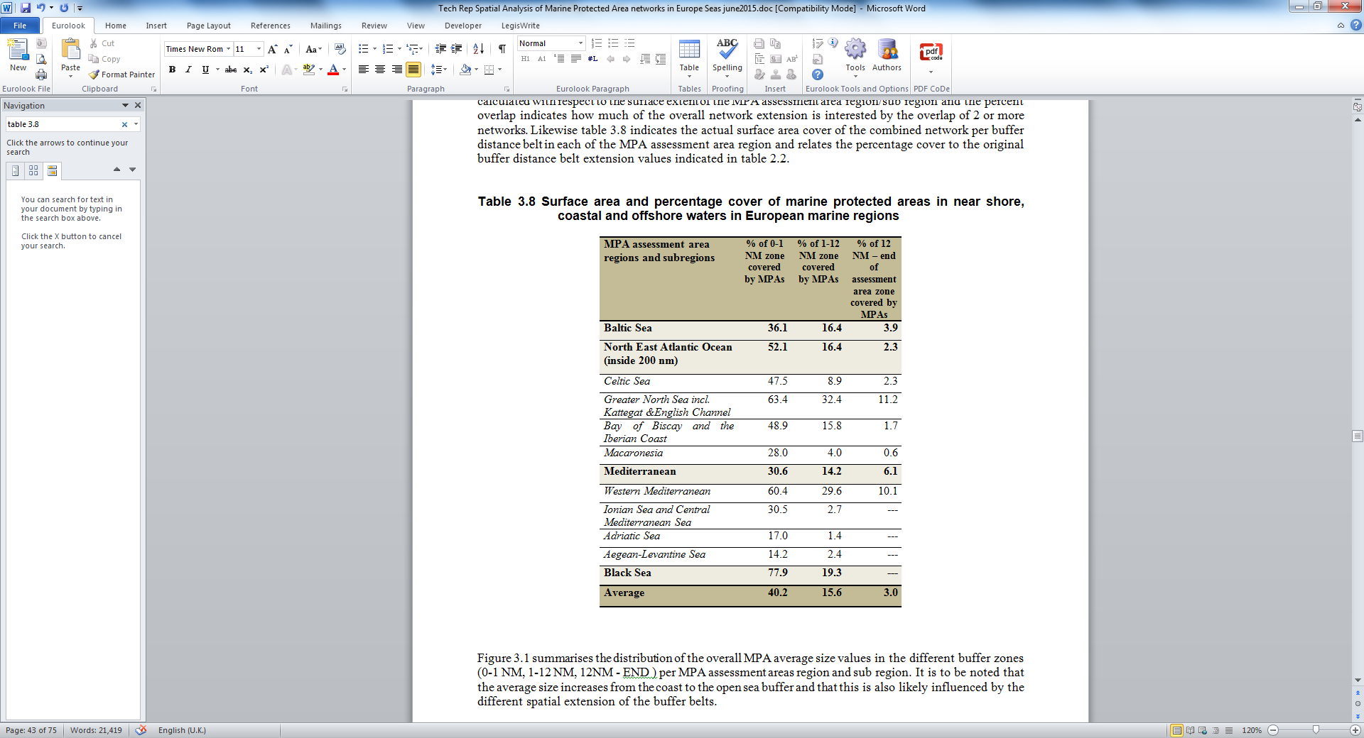

Table 2 – Percentage cover of marine protected areas in European Seas in the 0-1 nm, 1-12 nm and 12 nm-end of assessment area zones (2012)[31]

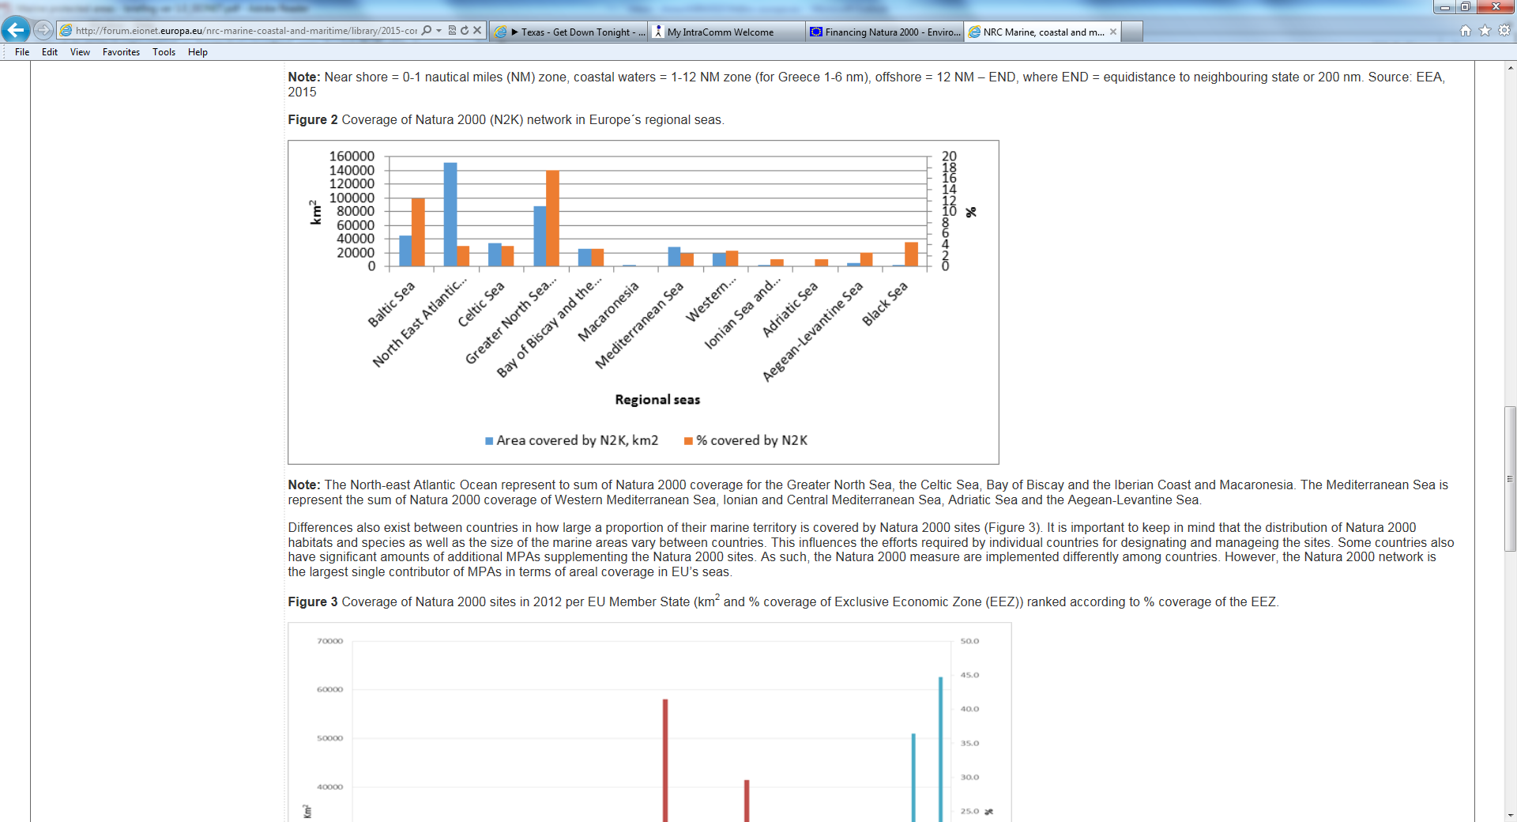

Table 3 - Coverage of Natura 2000 (N2K) network in Europe´s regional seas (2012)[32]



Table 4: Total surface area, percentage cover of RSC sites in MPA assessment area, and overlap with the EU Natura 2000 (N2K) network (2012) [33].

1. This obligation applies to areas under State sovereignty and jurisdiction.
2. "'Protected area' means a geographically defined area which is designated or regulated and managed to achieve specific conservation objectives". Convention on Biological Diversity (1992), article 2.
3. See definition in IUCN (2008), 'Guidelines for Applying Protected Area Management Categories', p. 8.
4. For definitions see OSPAR (2003), 'Recommendation on a Network of Marine Protected Areas 2003/3', article 1.

   HELCOM (2013), 'Overview of the status of the network of Baltic Sea marine protected areas', p. 7.

   Art. 4,6 and 7 of the Protocol to the Barcelona Convention concerning specially protected areas and biological diversity in the Mediterranean (1999).
5. Habitats Directive, Art. 1(l) and Birds Directive, Art. 4.
6. See point 2 of Annex.
7. Convention on Biological Diversity (2010), COP 10, Annex to Decision X/2.
8. See article 13(4) of the MSFD.
9. See articles 12-16 of the Habitats Directive.
10. Habitats Directive, Art. 14.
11. See Birds Directive, Art. 5.
12. See document 'Programmes of measures under the Marine Strategy Framework Directive – Recommendations for implementation and reporting', 25 November 2014. <https://circabc.europa.eu/w/browse/0ee797dd-d92c-4d7c-a9f9-5dffb36d2065>
13. See for instance Council Regulation (EC) No 734/2008 of 15 July 2008 on the protection of marine ecosystems in the high seas from the adverse impacts of bottom fishing gears.
14. See article 7 paragraph 1 (a) (b) (h) (i) and paragraph 2 (c) (d) (e) of the Regulation (EU) No 1380/2013 of the European Parliament and of the Council of 11 December 2013 on the Common Fisheries Policy.
15. MSFD Art. 1.
16. Regarding the general interactions between the MSFD, EU policies and international agreements, see the Report from the Commission to the Council and the European Parliament on the Contribution of the Marine Strategy Framework Directive (2008/56/EC) to the implementation of existing obligations, commitments and initiatives of the Member States or the EU at EU or international levels in the sphere of environmental protection in marine waters, COM (2012) 662, 16 November 2012.
17. Council Directive 92/43/EEC of 21 May 1992 on the conservation of natural habitats and of wild fauna and flora, O.J. L 206, 22.7.1992.
18. Council Directive 79/409/EEC of 2 April 1979 on the conservation of wild birds, OJ L 103, 25/04/1979.
19. Habitats Directive, Art. 3.
20. Regulation (EU) No 1380/2013 of the European Parliament and of the Council on the Common Fisheries Policy, Art. 11.
21. Regulation (EU) No 1380/2013 of the European Parliament and of the Council on the Common Fisheries Policy, Art. 8 on fish stock recovery areas.
22. Council Regulation (EC) No 1967/2006 of 21 December 2006.
23. Directive 2000/60/EC establishing a framework for the Community action in the field of water policy
24. Directive 2014/89/EU of the European Parliament and of the Council of 23 July 2014 establishing a framework for maritime spatial planning. Article 8 of the MSP Directive calls on Member States to integrate activities related to nature and species conservation sites and protected areas into their maritime spatial plans.
25. UNCLOS Art. 192 and 194 (5).
26. Part of the Strategic Plan for Biodiversity 2011-2020, adopted by Parties to the CBD in 2010 (UNEP/CBD/COP/DEC/X/2).
27. UNGA Resolution 66/288 of 27 July 2012 – The Future We Want, Paragraph 177.
28. See Goal 14 in UNGA A/68/970 of 12 August 2014 – Report of the Open Working Group of the General Assembly on Sustainable Development Goals.
29. See sections 2.2 and 3 of this report.
30. EEA (2015) 'Spatial Analysis of Marine Protected Areas in Europe's Seas'.
31. Adapted from Table 3.8 in EEA (2015) 'Spatial Analysis of Marine Protected Areas in Europe's Seas'.
32. European Environmental Agency (2015) 'Marine Protected Areas in Europe's Seas – An overview and reflections on the way forward'.
33. Adapted from Table 3.4 in EEA (2015) 'Spatial Analysis of Marine Protected Areas in Europe's Seas'.