

Table of contents

PREFACE 3

EXECUTIVE SUMMARY 5

1. Strategic target groups 7

**1.1.** **EU SMEs and small midcaps** 7

**1.2.** **EU micro-enterprises** 8

**2.** **Strategic sectors** 9

**2.1.** **Research and innovation (R&I)** 9

**2.2.** **Infrastructure and energy efficiency** 10

**2.3.** **Social enterprises** 12

**2.4.** **Education** 12

**3.** **Strategic non-EU regions** 12

**3.1.** **Enlargement countries** 12

**3.2.** **Neighbourhood countries** 14

**3.3.** **Countries covered by the Development Cooperation Instrument (DCI)** 14

CONCLUSION 16

PREFACE

As most EU Member States experience positive growth rates, Europe is recovering from the economic and financial crisis, but structural and crisis-related weaknesses are still limiting the pace of overall recovery. In particular, high private-sector debt levels and a high ratio of non‑performing loans are restricting banks’ lending capacity, thus hindering economic growth and financial stability. These challenges require prompt action, since the European economy depends heavily on lending by the banking sector and access to equity funding, especially for small businesses, remains limited.

In this economic climate, public finance institutions and private investors are very reluctant to lend to the real economy and in particular to SMEs, whose investments are considered high‑risk. The scale of financing demand, combined with the limited supply of public resources, means that additional capital flows need to be leveraged to fill the gap. The Union is therefore called upon to unlock additional investment from its budget through the use of financial instruments. In the 2014-2020 Multiannual Financial Framework (MFF), it responds to these challenges by:

* offering opportunities to blend public and private resources: The EU has set up innovative financial instruments (such as those established under Horizon 2020 for research and innovation, or COSME for SMEs) and allows Member States to combine European structural and investment funds (ESIFs) with Horizon 2020 and COSME resources under the first joint financial instrument, the SME Initiative. From their launch, both COSME and H2020 financial instruments were met with strong market demand – their initial envelope was quickly depleted and has recently been amended to increase exposure under the European Fund for Strategic Investments (EFSI) risk‑taking capacity;
* developing initiatives to encourage public finance institutions to lend to operators with impaired access to private capital: The EU has developed an Investment Plan for Europe, including EFSI, to mobilise additional investments in the Union over the next three years and ensure increased access to financing for companies with up to 3 000 employees, with a particular focus on SMEs, through the supply of risk-bearing capacity (guarantees) to the European Investment Bank (EIB); and
* promoting a better business environment for private investment by taking steps to develop a Capital Markets Union.[1]

SMEs are the main target of EU support through financial instruments: they account for two thirds of private-sector employment and almost 60% of real added value in the EU. Particular attention is devoted to enterprises and other target groups in strategic sectors, notably research and innovation, infrastructure and energy efficiency, social entrepreneurship and education.

From its experience, the Commission is convinced that financial instruments are an effective way of dealing with the financing needs of the real economy and boosting growth and employment. Implemented in partnership with public and private institutions, they address market failures in the provision of external financing, while avoiding the crowding-out of private investors.

The implementation of the 2007-2013 centrally managed financial instruments has helped to alleviate financial market failures and leverage the positive effects of EU-wide action. The Union’s overall contribution for 2007-2013 instruments amounted to almost EUR 5.5 billion, which by 31 December 2014 supported a financing volume of about EUR 82.9 billion — indicating an aggregate leverage ratio of over 15 (see Graph 1) — benefiting strategic target groups and sectors in the context of internal and external EU policies.

In 2014-2020, the budget envelope of EUR 4.8 billion[2] is targeted to support the financing of EUR 86 billion, implying an average leverage of nearly 18 (see Graph 2). In the coming years, the Union contribution of EUR 890 million committed by 31 December 2014 will support an *expected* financing volume of about EUR 3.8 billion, with an *expected* leverage ratio of about 4.[3]

The Commission is pleased to submit this report on centrally managed financial instruments for internal and external EU policies supported by the Union budget, as required under Article 140(8) of the Financial Regulation.

The report shows the substantial effect of these instruments as at 31 December 2014. It provides an overview of how taxpayers’ money has been used and of the progress made in implementing the financial instruments.

EXECUTIVE SUMMARY

The present report covers EU centrally managed financial instruments for internal and external Union policy areas.

It provides a comprehensive overview of progress to date in the implementation of 2007‑2013 and 2014-2020 financial instruments, ensuring transparency and accountability in the use of taxpayers’ money. It demonstrates that centrally managed financial instruments have achieved substantial financial leverage and shows – on the basis of the currently available evidence – how the instruments pursued their policy objectives. Further technical information can be found in the Annex.

***Graph 1:2007-2013 financial instruments, December 2014 (EUR million)***

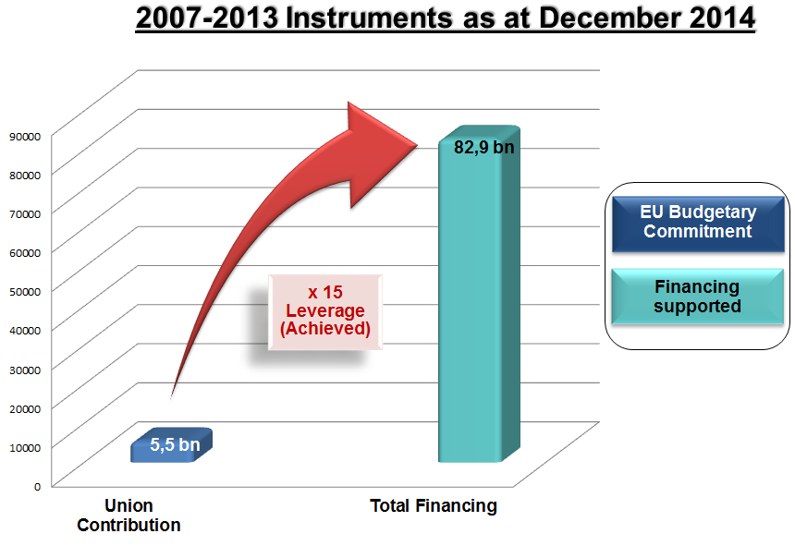

***Graph 2:2014-2020 financial instruments, December 2014 (EUR million)***

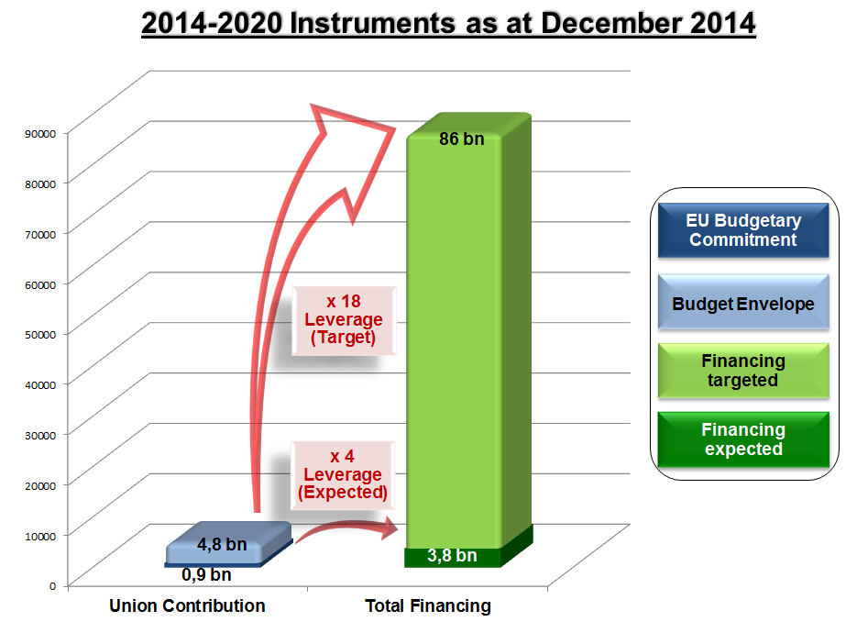

Instruments implemented by Member States in shared management are subject to separate reporting. For the 2007-2013 programming period, an annual summary report on the implementation of financial engineering instruments under ERDF and ESF[4] was published by 1 October each year.[5] As of 2016, the Commission will provide data summaries on progress in implementing financial instruments under shared management as required under the ESIFs Common Provisions Regulation (CPR).[6]

The present report on the centrally managed instruments is complemented by a Commission staff working document (SWD) which contains detailed tables and information on instruments implemented in direct and indirect management mode in 2007-2013 and 2014-2020.

The Commission intends to shape this report as a dynamic tool for decision-making. In particular, we intend to ensure that it is aligned more closely with other documents that provide information on EU financial instruments.[7] Although these are presented for different practical and procedural purposes, and their timing therefore also varies, we aim fully to align their content with a view possibly to merging them into a single report.

## Strategic target groups

* 1. **EU SMEs and small midcaps**

Generally, SMEs emerge as the business category experiencing particular difficulties in accessing finance, and all the more so since the start of the financial and sovereign debt crises.

To address market failures linked to asymmetric information, several guarantee facilities have been set up to extend greater **loan volumes** at better conditions to a riskier set of enterprises. These facilities aim to foster the development of a pan-European SME finance market and to address market failures that are more appropriately tackled at EU level given their widespread nature. As such, they are capable of achieving economies of scale and diffusing best practices:

1. The *SME Guarantee Facility (SMEG07) under the Competitiveness and Innovation Framework Programme (CIP)* has enhanced SMEs’ access to debt finance. As of 31 December 2014, a total of 357 000 SMEs had benefited from EUR 27.3 billion in guaranteed loans over 2007-2014 and the number is still growing;
2. The *COSME Loan Guarantee Facility*, the successor to SMEG07, provides SMEs with capped guarantees for debt financing via loans or leasing, in order to reduce the particular difficulties that viable SMEs face in accessing finance due to their perceived high risk or lack of sufficient available collateral. By the end of 2014, the European Investment Fund (EIF) had concluded due diligence and signed guarantee agreements with three financial intermediaries from three participating countries for a total of EUR 42.4 million. It is estimated that cumulative total financing mobilised for 2014‑2020 will range from EUR 14.3 to 21.5 billion, reaching between 220 000 and 330 000 SMEs. For the three operations signed with financial intermediaries in 2014, the maximum financing available to SMEs amounted to almost EUR 851 million;
3. The *Risk-Sharing Instrument (RSI)* under the 7th Framework Programme is a dedicated guarantee facility for loan and lease finance addressing the finance gap for innovative SMEs and small midcaps (enterprises with up to 499 employees). It has so far provided over EUR 1.59 billion in guarantees and counter-guarantees to 37 banks and guarantee societies, which will enable them to support up to an estimated 3 000 innovative SMEs and small midcaps. By the end of 2014, the volume of financing provided was EUR 831 million, with a Union contribution of EUR 270 million;
4. The *InnovFin SME Guarantee* under Horizon 2020, the successor facility for innovative SMEs and small midcaps for 2014-2020, is expected to mobilise a total loan volume of around EUR 9.5 billion, with a Union contribution of around EUR 1 060 million. For 2014, the overall value of financing supported by the Union contribution is expected to be around EUR 475 million, of which EUR 11 million has already been provided;
5. The *Cultural and Creative Sectors Guarantee Facility* under the Creative Europe programme will provide guarantees to banks dealing with cultural and creative SMEs, thereby strengthening financial capacity in those sectors. The scheme will begin in 2016 and the overall amount of additional loans in the sectors supported by the Union contribution of EUR 121 million is estimated at around EUR 690 million; and
6. The *EU SME Initiative,* designed as a crisis-response instrument,provides uncapped guarantee and/or securitisation to improve access to finance for SMEs, including innovative and high-risk SMEs. It is a joint instrument, combining COSME and Horizon 2020 funds with ERDF-EAFRD resources in cooperation with the EIB/EIF in order to generate additional lending to SMEs. With a commitment of EUR 800 million from the ERDF, the volume of new SME loans supported in Spain is expected to reach EUR 5 723 million for all Spanish regions.

**SMEs** also face particular challenges in raising **equity capital**, with European venture capital suffering a slow-down in private equity activity in 2008-2014 in terms of fund-raising, investment levels (notwithstanding a slight pick-up in 2014) and divestment conditions, and remaining fragmented across countries and all the more dependent on a lifeline from public investors.

Support via EU-level financial instruments is key to tackling this fragmentation. Several equity finance facilities have been set up to strengthen the internal market for venture capital by tackling the market failures encountered (especially by early-stage SMEs that have the potential to achieve high growth), bring innovation to the market and create high added‑value jobs:

1. The *High Growth and Innovative SME Facility (GIF)* under the CIP aims to increase the supply of equity for innovative SMEs in their early stage (GIF1) and in the expansion phase (GIF2). By the end of 2014, a total of EUR 625.2 million in net commitments from the Union budget supported 43 venture capital funds and 371 final recipients, catalysing nearly EUR 1 billion in equity finance;
2. The *Equity Facility for Growth (EFG)* under COSME*,* the successor of GIF2, aims to stimulate the take-up and supply of equity finance for SMEs in their expansion phase. For 2014-2020, it is expected that an indicative commitment of EUR 633 million will support venture capital investments in the range of EUR 2.6 to 3.9 billion, reaching some 360 to 540 SMEs; and
3. The *InnovFin SME Venture Capital* under Horizon 2020*,* the successor of GIF1*,* is designed to improve early-stage R&I-driven SMEs’ and small midcaps’ access to risk finance. A commitment of EUR 430 million indicatively planned for 2014-2020 is expected to support around EUR 2.5 billion of equity financing.
   1. **EU micro-enterprises**

The European micro-finance sector is characterised by a steady fall in bank lending, national governments’ limited capacity to support micro-finance and strong demand for it on the market. This suggests that there is still a clear rationale for intervention at EU level by providing micro-finance institutions with risk-sharing and funding solutions.

More specifically, ‘in several EU Member States high levels of youth unemployment call for ongoing support of inclusive entrepreneurship as an option to (re-)enter the labour market. Micro-loan provision is an important tool for this’.[8] The wide diversification of institutional actors and products offered calls for specific micro-finance facilities aimed at easing loan access for micro-enterprises, which play an important role in creating jobs but continue to face even more difficulties than other SMEs:

1. The *European Progress Micro-finance Facility* (2010-2013) — this consists of:
   1. a guarantee facility, whichprovided up to 20% capped guarantees on portfolios of micro-loans granted by intermediaries to micro–enterprises; and
   2. the *Fonds commun de placement — Fonds d’investissement spécialisé*, a specialised investment fund aimed at increasing access to micro-finance through a range of financial products (notably loans).

As of 31 December 2014, these instruments had provided 31 371 micro-loans to final recipients for a total of EUR 291.7 million (the initial target was 46 000 micro-loans for EUR 500 million by 2018). The Facility is on track to reach the initial target, as new loans will be included between now and 2018; and

1. Programme for Employment and Social Innovation (EaSI)- *Micro-finance and Social Entrepreneurship — Micro-finance,*the successor to the above instruments, is aimed at increasing access to micro-finance for vulnerable groups and micro-enterprises by providing support to micro-credit providers. The Union contribution of at least EUR 86 million is targeted to support 41 000 micro‑loans for a total of EUR 528 million.[9]
2. **Strategic sectors**
   1. **Research and innovation (R&I)**

Evidence that larger, established R&I-intensive firms have problems in accessing debt finance to fund innovation projects is mixed and harder, methodologically, to establish. However, a recent econometric study,[10] as well as empirical experience, suggest that demand for R&I debt financing far exceeds current supply.

To address R&I financing needs, which can hardly be fully met at national level, the Commission set up the *Risk-Sharing Finance Facility (2007-2013)* and, under Horizon 2020, *InnovFin Large Projects, InnovFin MidCap Growth Finance* and *InnovFin MidCap Guarantee*:

1. The *Risk-Sharing Finance Facility (2007-2013)* offers loans and hybrid or mezzanine finance to improve access to risk finance for R&I projects. The Union’s 2007-2014 RSFF contribution of EUR 960 million supported activity accounting for over EUR 9.56 billion of an expected EUR 11.31 billion; and
2. The *Horizon 2020 Loans Service for R&I (2014-2020),* the successor to RSFF, also offers loans and hybrid or mezzanine finance to improve access to risk finance for R&I projects. For 2014-2020, the EU contribution of EUR 1 060 million is targeted to mobilise financing of EUR 13 250 million for the final recipients. By the end of 2014, EU contributions totalling EUR 483 million had already supported financing of EUR 1 157.2 million.
   1. **Infrastructure and energy efficiency**

Transport, telecommunications and energy infrastructures play a crucial role in development and sustainable growth in contexts where private enterprises of all sizes and public entities interact to provide the necessary output. Infrastructure improves the productivity of the economy, enabling growth, and facilitates the interconnection of the internal market.

Also, energy efficiency and its promotion are becoming increasingly important in the Union, in particular in view of its 2020 20% headline target on energy efficiency and further objectives beyond that date.

The goal of EU financial intervention in these sectors is to contribute to overcoming the deficiencies of European capital markets. EU financial instrument programmes for various sub-sectors (transport and energy infrastructure, energy efficiency, including environment and climate action, and ICT) launched in the 2007-2013 period or envisaged in 2014-2020 include:

1. The *Loan Guarantee Instrument for Trans-European Transport Network Projects (LGTT)*, a debt instrument for project finance in trans-European transport and energy networks. As of 31 December 2014, the aggregate outstanding LGTT instrument guarantee stands at a total of EUR 497 million, covering six projects expected to make investments (equity, debt, grants) of EUR 12.1 billion. The Commission’s 2014 *ex post* evaluation concluded that the impact of the LGTT had been positive where it had been applied, but not sufficient to achieve its broader objectives;
2. Under the *Connecting Europe Facility (CEF)*:
   1. the *Project Bond Initiative (PBI, MFF 2007-2013)*, which aims to stimulate capital-market financing for infrastructure projects in the areas of trans‑European transport and energy networks and broadband networks*.* To date, several transactions have reached financial close under the PBI pilot phase:
      1. in 2014, the Union’s contribution of EUR 10 million to TEN-E supported a project-bond credit enhancement of EUR 54.9 million for a project size of EUR 421 million; and
      2. the Union’s contribution to TEN-T supported the financing of:
         * a greenfield transport project for the A11 motorway in Belgium through a EUR 578 million project-bond issue and EUR 79.6 million of equity (with a Union contribution of EUR 200 million); and
         * the A7 *Autobahn* in Germany through a EUR 429 million project-bond issue.

Also in 2014, the budget contribution of EUR 20 million for the ICT sector enabled credit enhancement of around EUR 38 million in support of a bond issue for around EUR 189 million by a French broadband service provider; and

* 1. the *risk-sharing debt instrument* will target projects of common interest in the transport, broadband and energy networks sectors. Starting in 2015, the instrument will build on the existing Project Bond Initiative and the Loan Guarantee for TEN-Transport. Assuming the full budgetary allocation of EUR 3 billion is made available to the instrument, total funding of EUR 18 to 45 billion could be attracted thanks to the Union contribution;

1. The *Private Finance for Energy Efficiency Instruments (PF4EE)* financed under the LIFE programme, which will provide *inter alia* a risk-sharing facility designed to reduce the credit risk faced by financial intermediaries when lending to the energy efficiency sector, combined with technical assistance to financial intermediaries for building a new market segment. The Union contribution of EUR 80 million is expected to support total investment up to about EUR 540 million for 2014-2017;
2. The *2020 European Fund for Energy, Climate Change and Infrastructure (Marguerite)*, a pan-European equity fund which supports infrastructure investment in the transport (TEN-T), energy (TEN-E) and renewables sectors in Member States. The Union contribution of EUR 80 million has been targeted to support funding volumes of around EUR 10.2 billion, of which EUR 4.9 billion of equity and debt financing has already been mobilised (EU contribution: EUR 31.3 million). By 31 December 2014, the Fund had committed EUR 295 million of equity investment to three TEN-T and seven renewable energy projects;
3. The *European Energy Efficiency Fund (EEEF),* a spin-off of the European Energy Programme for Recovery (EEPR), which invests in energy efficiency, renewable energy projects and clean urban transport. By the end of March 2014, the Fund had fully allocated the Union contribution (EUR 125 million) to projects for a total investment of EUR 219 million. EEEF technical assistance support has proved to be useful in helping public authorities prepare projects that will subsequently be financed. In total, approximately EUR 200 million has been allocated to 12 projects, which will generate some EUR 333 million of final investments. By December 2014, EUR 216 million of final investments had already been generated and allocated to nine projects. For 2015, six projects are in the pipeline for a total of EUR 243 million, for which the envisaged EEEF share is EUR 92 million; and
4. The *Natural Capital Financing Facility (NCFF)*, which will finance revenue‑generating or cost-saving pilot projects promoting the conservation, restoration, management and enhancement of natural capital in order to contribute to Union objectives in the areas of nature and biodiversity, and climate-change adaptation. The planned Union contribution for the pilot phase is EUR 60 million, of which EUR 10 million has already been committed.
   1. **Social enterprises**

Among the businesses suffering from credit access difficulties, social enterprises deserve particular attention due to the correlation between social capital and economic growth. Their primary objective is the achievement of measurable and positive social impact.

However, the fact that social enterprises do not primarily seek to maximise profit exposes them to more acute difficulties in accessing finance, as traditional bankers are reluctant to assess their business plans and find it difficult to do so. A new financial instrument provided by the EU in 2014-2020 for social enterprises is the *EaSI Micro-finance and Social Entrepreneurship — Social Enterprise*, which aims to support the development of social enterprises with a budget of at least EUR 86 million.

* 1. **Education**

As a form of human capital accumulation, education is a primary source of economic growth, but to the extent it can be accessed by students of different social and economic backgrounds, it also contributes to social equity and cohesion. Moreover, student mobility has been proven significantly to affect social and economic development.

A new EU financial instrument—the *Student Loan Guarantee Facility* (Erasmus+ Masters Loans, a guarantee facility under the Erasmus+ programme) — aims to support mobility, equity and study excellence via guarantees to financial institutions that agree to provide students with favourable loans for master’s studies in another country. The planned Union contribution of EUR 517 million for 2014-2020 (of which EUR 28.40 million has already been committed) is expected to support loans for up to EUR 3 billion.

1. **Strategic non-EU regions**
   1. **Enlargement countries[11]**

Access to loan finance remains one of the biggest difficulties for SMEs in the Western Balkans, in spite of SMEs becoming the most efficient segment in their economies’ transition and a pillar of growth and employment. Due to their lack of financial history, early-stage SMEs find it almost impossible to access bank financing. Access to finance in the energy sector appears generally vulnerable. These issues are being addressed through the following:

1. The *guarantee facility* under the *Western Balkans Enterprise Development and Innovation Facility (EDIF)* aims to enhance socio-economic growth by promoting preconditions for the emergence and growth of innovative and high-potential SMEs. The Union’s EDIF contribution of almost EUR 22 million is estimated to support total investment of more than EUR 98 million;
2. The *Enterprise Expansion Fund (ENEF)* under the EDIF aims to enhance socio‑economic growth in the region by creating the conditions for the emergence and growth of innovative and high-potential SMEs *in the expansion and development stages*. The financial envelope of EUR 11 million is expected to leverage total investment of EUR 55 million. Overall, given the link between ENEF and the co‑financing facility of the European Bank for Reconstruction and Development (EBRD), the Union contribution will support investment of approximately EUR 110 million for final recipients;
3. The *Enterprise Innovation Fund (ENIF)* under the EDIF supports socio-economic growth in the Western Balkans by creating the conditions for the emergence and growth of *early-stage* innovative SMEs. The Union contribution of EUR 21 million is expected to support investment of approximately EUR 40 million in 2014-2020;
4. The *European Fund for Southeast Europe (EFSE)* is a form of public-private partnership aimed at attracting capital from the private sector for on-lending to micro and small enterprises and households. The Union contribution of EUR 88 million has so far leveraged total financing of EUR 3.2 billion, benefiting 496 716 final recipients in the enlargement region;
5. The *Green for Growth Fund (GGF)* provides dedicated financing for energy efficiency and renewable energy projects to help the target countries reduce CO2 emissions and energy consumption. The Union contribution of EUR 38.6 million is targeted to leverage total investment of EUR 281 million for final recipients. The current portfolio of projects, with 20 partner institutions in nine partner countries, is worth EUR 185.1 million; and
6. The *SME Recovery Support Loan for Turkey* aims to mitigate the impact of the crisis on SMEs, contribute to the development of the Turkish economy and boost employment. The Union contribution of EUR 30 million has mobilised lending for a total of EUR 300 million.
   1. **Neighbourhood countries**[12]

EU-funded programmes aim to foster sustainable, inclusive growth and a favourable investment climate in the European Neighbourhood Policy (ENP) partner countries. The EU pursues the strategic objectives of its neighbourhood policies — establishing better energy and transport infrastructure interconnections between the EU and neighbouring countries, addressing threats to our common environment and promoting smart growth through support for SMEs — through the following:

1. The *Neighbourhood Investment Facility (NIF)*, which aims to increase energy and transport infrastructure and interconnectivity in the region, addressing threats to the environment, including climate change, promoting socio-economic development through support for SMEs and the social sector. In 2007-2014, the Union contribution of approximately EUR 1 159 million leveraged EUR 11.9 billion in loans from European financial institutions (EFIs), with total project costs estimated at EUR 26 billion; and
2. Support for the *Facility for Euro-Mediterranean Investment Partnership (FEMIP)* provides capital to the private sector in Mediterranean partner countries *pari passu* with other commercial investors in the region for the creation, restructuring or growth of enterprises. The Union’s current overall contribution is EUR 224 million.
   1. **Countries covered by the Development Cooperation Instrument (DCI)**

In some non-EU countries, the lack of a well-established institutional framework to safeguard property rights, address market failures and provide incentives for private initiatives is often at the root of SME‑sector underdevelopment, infrastructure shortages and deficient overall investment in health, education and environmental protection. Addressing these problems by financing worthy SMEs, infrastructure and productive investments is the main challenge for the EU in its external policy; it does so via the following instruments:

1. The *Investment Facility for Central Asia (IFCA)* and the *Asian Investment Facility (AIF)* aim to promote investments and key infrastructures with a priority focus on better energy infrastructure, increased protection of the environment and SME growth. The current overall budget is EUR 171.56 million. To date, IFCA contributions of EUR 82 million have leveraged approximately EUR 465 million in financing and AIF contributions of EUR 62 million have leveraged approximately EUR 2 046 million;
2. The *Latin America Investment Facility (LAIF)* aims to promote investments and infrastructures in the transport, energy and environment sectors and to support social- and private-sector development in Latin American countries. In 2009-2014, approximately EUR 210 million leveraged EUR 2.9 billion in EFI loans for total investments of EUR 6.6 billion;[13] and
3. The *Global Energy Efficiency and Renewable Energy Fund (GEEREF)* aims to promote energy efficiency and renewable energy in developing countries and economies in transition. As of end 2014, the total investment supported with the Union’s contribution was about EUR 1 billion.

CONCLUSION

In the period affected by the financial crisis, important sectors of the economy have seen their access to finance severely impaired. Even post-crisis, the hangover effects of deleveraging and financial fragmentation have prolonged financing difficulties in terms of financing volumes and conditions, especially for vulnerable Member States and target groups.

The EU’s financial instruments have proven effective and cost-efficient in addressing these challenges. The Commission has already given a clear commitment to using such instruments more widely. It will explore the possibility of boosting existing instruments or launching new ones in response to market gaps or sub-optimal investment situations, where market-based financing with an EU guarantee, equity investment or a risk-sharing arrangement appears the most appropriate model of support.

At the same time, the Commission will continue to strike the balance between greater assurance for the budgetary authority in terms of reporting, monitoring and audit, and greater efficiency in the implementation of financial instruments. Important work has been done in this regard. The new framework for the implementation of the 2014-2020 instruments includes solid provisions on technical requirements, transparency, internal control and audit and reporting. Also, the remuneration of the entrusted entities has been capped in a consistent and reasonable way so as to align their interests with the Commission’s political objectives.

In addition, procedural requirements have been laid down for centrally managed instruments to ensure that the Union contribution is fully invested and that the funds paid to the entrusted entities are continually calibrated to the specific operational needs of the instrument in question. In the case of instruments established and managed by Member States in shared management with resources from the EU budget, regulatory provisions have been established to link the payment of funds to the actual support that financial intermediaries pass on to final recipients. Reporting on both types of instrument will be more consistently carried out by the Commission as of 2016.

The Commission intends to review the regulatory framework with a view to reducing possible unnecessary bureaucracy in the first phase of implementation and further aligning the design of financial instruments on the most efficient and up-to-date market practices. With this in mind, we will conduct an interim evaluation of the instruments. Similarly, as provided for in the Financial Regulation itself, we intend to review the Financial Regulation provisions on financial instruments and, where appropriate, make proposals to embed lessons learnt from experience, take better account of market practices and further ease implementation. In particular, the review should consider the possibility of combining different forms of support from the EU budget, especially in view of further improving the leverage and thus the efficiency of EU financial instruments.

1. See the Commission Communication *Unleashing the potential of crowdfunding in the European Union* (March 2014).
2. The 2014-2020 envelope does not yet reflect appropriations for new instruments which may be envisaged for enlargement and Neighbourhood countries or countries covered by the Development Cooperation Instrument.
3. The *expected* volume of financing is limited at this stage to amounts resulting from contracts already signed between entrusted entities and financial intermediaries/final recipients. .
4. Acronyms are spelled out in the glossary of the accompanying SWD.
5. The 2013 report is available at/   
   [http://ec.europa.eu/regional_policy/sources/thefunds/instruments/doc/summary_data_fei_2013.pdf.](http://ec.europa.eu/regional_policy/sources/thefunds/instruments/doc/summary_data_fei_2013.pdf)
6. Article 46(4) of Regulation (EU) No 1303/2013.
7. In particular, the working document based on Article 38(5) of the Financial Regulation and the document providing the information required by Article 49(1)(e) of the Financial Regulation.
8. Evers & Jung (2014); <http://ec.europa.eu/social/BlobServlet?docId=12485&langId=en>.
9. The target is subject to change as implementation details and the co-investment are still under negotiation.
10. European Commission (2013a).
11. The former Yugoslav Republic of Macedonia, Montenegro, Serbia, Turkey, Albania. Moreover, Bosnia and Herzegovina, and Kosovo as two potential candidates. In addition, Iceland has put its accession negotiations on hold and no longer wishes to be considered a candidate.
12. Armenia, Azerbaijan, Egypt, Georgia, Israel, Jordan, Lebanon, Moldova, Morocco, Palestine, Tunisia, Ukraine (fully participating ENP members), Algeria (currently negotiating access to the ENP), Belarus, Libya, Syria (outside most ENP structures); see also <http://eeas.europa.eu/enp/index_en.htm>.
13. Based on 27 projects, two of which have been cancelled.