[1]



Delegations will find attached the above mentioned opinion of the Czech Senate.

**ANNEX**

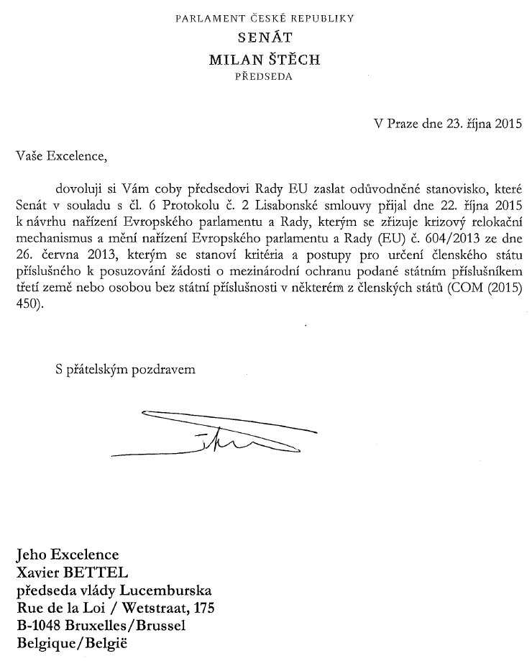

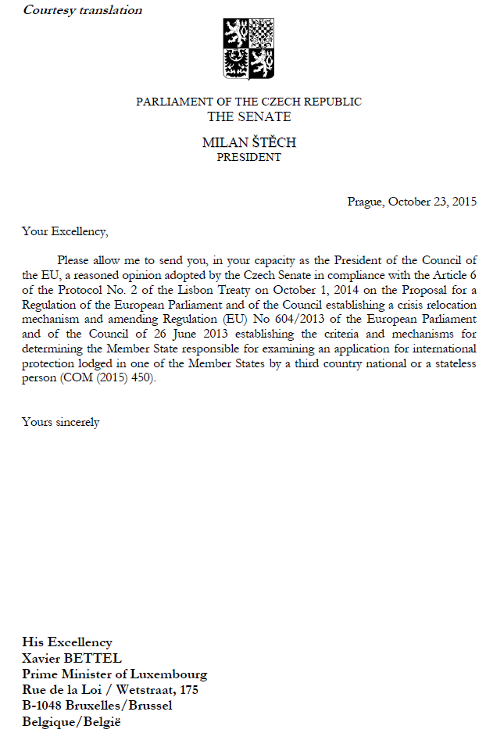



**THE SENATE**

**OF THE PARLIAMENT OF THE CZECH REPUBLIC**

**10TH TERM**

**251st**

**Resolution of the Senate**

delivered on the 13th meeting held on 22th October 2015

**on the Proposal for a Regulation of the European Parliament and of the Council establishing a crisis relocation mechanism and amending Regulation (EU) No 604/2013 of the European Parliament and of the Council of 26 June 2013 establishing the criteria and mechanisms for determining the Member State responsible for examining an application for international protection lodged in one of the Member States by a third country national or a stateless person (Senate Print no. N 033/10)**

**The Senate**

**I.**

1. **Has acquainted itself**

with the proposed Regulation and sees no grounds for departing from its unfavourable opinion on the introduction of provisional or permanent relocation mechanisms obligatory for the Member States and persons concerned;

1. **Agrees**

with the Opinion of the Government, asks the Government to act, both in the Council and the European Council, against the adoption of the proposed regulation and invites the Government to continue, on the basis of solidarity, its participation in those EU measures that really contribute to solving the crisis, especially by supporting all the measures leading to strengthening the control of EU’s external borders, making the reception centres (hotspots) operational as fast as possible, establishing a well-functioning cooperation with third countries and providing efficient humanitarian aid in the affected regions, and calls upon the Government to participate intensively in these measures;

1. **Has come to the conclusion**

that the proposed Regulation does not comply with the principle of subsidiarity, as stipulated in Article 5(3) of the Treaty on European Union, because it violates the principle of conferral, the observance of which is a necessary precondition for the compliance of any EU action with the principle of subsidiarity, and because it does not enable the Union to achieve the objectives of the proposed action better than the existing possibilities of Member States’ action;

1. **Adopts,**

in accordance with Article 6 of the Protocol on the Application of the Principles of Subsidiarity and Proportionality attached to the Treaties, a **Reasoned Opinion** on the incompatibility of the proposed Regulation with the principle of subsidiarity, on the grounds set out in Part II. of this Resolution;

**II.**

1. **Is of the opinion**

that the European Union does not have the competence to introduce, on the basis of Article 78(2)(c) of the Treaty on the Functioning of the European Union or on the basis of any other provision of the Treaties, a permanent relocation mechanism that would be activated by the Commission, and therefore the adoption of such a mechanism would contravene the principle of conferral, on the following grounds:

* the legal basis for reactions to emergency situations in the asylum policy is not Article 78(2)(c) of the Treaty on the Functioning of the European Union, but Article 78(3) of the Treaty on the Functioning of the European Union, according to which, in the event of one or more Member States being confronted by an emergency situation characterised by a sudden inflow of nationals of third countries, the Council may adopt provisional measures for the benefit of the Member State(s) concerned;
* the abovementioned Article 78(3) of the Treaty on the Functioning of the European Union is based on the assumption that the appropriate reaction to an emergency situation consisting in provisional measures has to be agreed by the Member States according to their possibilities and the gravity of the situation because it significantly affects the essential state functions, law and order and national security, and the said article does not allow for a delegation of such power to the Commission;
* the proposal that the Commission itself should at any time in the future decide on relocations negates the power of the Council according to Article 78(3) of the Treaty on the Functioning of the European Union, and therefore does not comply with the Treaty on the Functioning of the European Union; if the legal basis for provisional relocations requires individual decisions of the Council, this power cannot be in general delegated to the Commission;

1. **Is further convinced**

that the proposed regulation does not have a real added value in comparison with the existing possibilities of Member States’ action and does not lead to achieving the declared objectives, thus the requirement that the Union shall act only if the objectives of the proposed action cannot be sufficiently achieved by the Member States, but can rather be better achieved at Union level, is not met given the following grounds:

* the very relocation procedure will cause substantial administrative expenses, relocations are supposed to be implemented in the time span of up to two years and will necessitate performing an array of preliminary actions with the persons designated for relocation, as a result of which it cannot be assumed, contrary to the Commission’s opinion, that this manner of distribution of applicants for international protection among the Member States could accelerate procedures for granting international protection; therefore, the Proposal does not contribute to the achievement of the objectives of Article 78 of the Treaty on the Functioning of the European Union;
* the Commission’s declared objective to ensure the correct application of the Dublin system in times of crisis is in itself contradicted by the proposed Regulation because it introduces a derogation from the rules of the Dublin system; in doing so, the proposed regulation also reduces the pressure on all the Member States to introduce and maintain an effective asylum system respecting human dignity;
* the objective to deal with crisis situations in a spirit of fairness and solidarity is pursued by Article 78(3) of the Treaty on the Functioning of the European Union that provides the Council with sufficient leeway to choose an appropriate form and scope of the solution;

1. **Is convinced**

that until the provisional relocation measures for the benefit of Italy and Greece have been implemented and evaluated, any considerations of introducing a permanent mechanism are premature because in the event of a crisis in another Member State, the Council may again adopt a decision pursuant to Article 78(3) of the Treaty on the Functioning of the European Union; at the same time, the concerns, expressed by the Senate in its 161st Resolution delivered on the 9th meeting held on 18th June 2015 on the proposal for a Council decision establishing provisional measures in the area of international protection for the benefit of Italy and Greece, that given the questionable humanitarian and legal aspects of the proposed form of relocation, it is going to be very hard to implement it in practice in those Member States that would not have been the natural destination of the applicants for international protection, are proving to be well founded;

1. **Emphasizes**

that in accordance with the principle of subsidiarity, the relocation and resettlement of applicants for international protection must be a matter of political decision of each Member State since it is the Member State that will be responsible for further stay of such persons on its territory, both with respect to providing medical and other assistance and to their social, economic and cultural integration, and in terms of maintaining public security; authorities of a Member State must also bear political responsibility for a possible failure in this task and citizens of a Member State must be able to achieve a change of government policy, which would be made impossible if a permanent mechanism to be triggered by the Commission was introduced;

1. **Repeatedly points out**

certain questionable humanitarian and legal aspects of relocation measures that do not envisage the consent of the persons concerned with their relocation to a particular Member State and do not address the problem of secondary movement of relocated persons after the international protection has been granted to them; in the opinion of the Senate, this movement cannot be prevented unless significant restrictions on the relocated persons are imposed, which would be problematic also with respect to the EU law regulating international protection and free movement of persons;

1. **Is of the opinion**

that involuntarily relocated persons will not have the motivation to integrate into the society of the country of relocation and will seek to move to those Member States where they would be naturally heading, noting that this cannot be prevented in the long run; and thus the security risks that will be associated with their stay are considerably increasing;

1. **Is convinced**

that a swift and humanly dignified access to the procedure for granting international protection must be ensured, in a spirit of solidarity, especially by financial, material, technical and personal support for asylum systems of the Member States struggling with the greatest inflow of migrants and by strengthening the control over the EU’s external borders; the Senate supports the Government’s activities aimed at providing such help;

**III.**

1. **Requests**

the Government to inform the Senate about the way this position was taken into account, and about further development of negotiations;

1. **Authorises**

the President of the Senate to forward this Reasoned Opinion to the Presidents of the European Commission, the European Parliament and the Council of the EU.

Milan Štěch

sign manual

President of the Senate

Emilie Třísková

sign manual

Senate Verifier

1. Translation(s) of the opinion may be available on the Interparliamentary EU Information Exchange website (IPEX) at the following address: http://www.ipex.eu/IPEXL-WEB/search.do