

**REPORT FROM THE COMMISSION TO THE EUROPEAN PARLIAMENT, THE COUNCIL, THE EUROPEAN ECONOMIC AND SOCIAL COMMITTEE AND THE COMMITTEE OF THE REGIONS**

**on the implementation, results and overall assessment  
of the 'Europe for Citizens' programme 2007-2013**

In accordance with the Decision N° 1904/2006/EC[1], and building on the conclusions of an external ex post evaluation[2], this report offers an overview of the implementation, results and overall assessment of the 'Europe for Citizens' programme 2007-2013.

**1. Background**

**1.1. Introduction**

The European Union (EU) has recognised on many occasions the need to get closer to the citizens of the Member States and to enable them to fully participate in the construction of an ever closer Union, while emphasising the essential values that are shared by the European citizens.

In order to achieve these objectives, the 'Europe for Citizens' programme was established in December 2006 for a period of seven years (from 1 January 2007 to 31 December 2013). The programme was seen as an initial step towards amore coherent strategy and policy in the area of civic participation. It was designed to support a wide range of activities and organisations promoting active citizenship through the involvement of individual citizens, local authorities and civil society organisations in the process of European integration.

The 'Europe for Citizens' programme (hereinafter referred to as "EFCP" or "the programme") built on previous actions' experience, especially that of the 'Community action programme to promote active European citizenship' (2004-2006)[3], which confirmed the need to develop the dialogue with civil society organisations and municipalities, and to support civic participation.

**1.2. The objectives of the 'Europe for Citizens' programme 2007-2013**

The objectives of the programme were as follows:

* giving citizens the opportunity to interact and participate in constructing an ever closer Europe, which is democratic and world-oriented, united in and enriched through its cultural diversity, thus developing citizenship of the European Union;
* developing a sense of European identity based on common values, history and culture;
* fostering a sense of ownership of the European Union among its citizens;
* enhancing tolerance and mutual understanding between European citizens respecting and promoting cultural and linguistic diversity, while contributing to intercultural dialogue.

The specific objectives of the programme were as follows:

* bringing together people from local communities across Europe to share and exchange experience, opinions and values, to learn from history and to build for the future;
* fostering action, debate and reflection related to European citizenship and democracy, shared values, common history and culture through cooperation within civil society organisations at European level;
* bringing Europe closer to its citizens by promoting Europe's values and achievements, while preserving the memory of its past;
* encouraging interaction between citizens and civil society organisations from all participating countries, contributing to intercultural dialogue and bringing to the fore both Europe's diversity and unity, with particular attention to activities aimed at developing closer ties between citizens from Member States of the European Union as constituted on 30 April 2004 and those from Member States which have acceded since that day.

Given the fact that the general and specific objectives as well as the actions of the programme were defined by the Decision establishing the Europe for Citizens Programme 2007-2013, the Commission and the Education, Audiovisual and Culture Executive Agency did not dispose of great margins of discretion in the implementation of the programme.

**2. key activities and implementation of the programme**

The EFCP provided financial support for a wide range of activities, which were grouped under four actions.

**2.1. The programme's four actions**

**Action 1: Active citizens for Europe**

This measure offered funds for organising town citizens’ meetings and networks of twinned towns, as well as citizens’ projects of a trans-national and cross-sectorial dimension. These activities were all aimed at strengthening mutual knowledge and understanding between citizens from different municipalities and cultures. This action also included support measures with the purpose of improving the quality of town-twinning and citizens’ projects.

**Action 2**: **Active civil society in Europe**

This measure provided structural support for European think tanks and civil society organisations and for projects initiated by civil society organisations. It was aimed at strengthening their ability to operate at European level and thereby to contribute to achieving the overall objectives of the EFCP.

**Action 3: Together for Europe**

***High-visibility events***

This measure supported events organised by the European Commission, sometimes in cooperation with Member States or other relevant partners, with the aim to make European citizens aware of European history and of the EU's achievements and values.

***Studies, information and communication***

In order to provide a better understanding of active citizenship at European level, the European Commission carried out the following studies:

* *Volunteering in the European Union* (2010)
* *Study on Maximising the Potential of Mobility in Building European Identity and Promoting Civic Participation* (2011)
* *Participatory Citizenship in the European Union* (2012)
* *Measuring the Impact of the 'Europe for Citizens' programme* (2013)

Information on the programme's activities and on other initiatives in the citizenship area was provided through an Internet website and other communication tools (brochures, leaflets, DVDs).

***'Europe for Citizens' Contact Points***

Contact Points have been gradually established since 2008 to ensure dissemination of practical information on the implementation of programme, its activities and funding possibilities and to provide assistance to applicants and programme beneficiaries.

In 2013, a total of 28 'Europe for Citizens' Contact Points were operational in participating countries, out of which 22 received operating grants from the European Commission.

**Action 4**: **Active European Remembrance**

This measure offered funds for projects commemorating the victims of mass extermination and deportations as well as for preserving remembrance sites, memorials and archives.

**2.2. Budget**

The financial envelope for the EFCP's implementation from 1 January 2007 to 31 December 2013 was EUR 215 million. This budget was largely criticised for being too modest when compared to the ambitious objectives and high expectations on programme outcomes.

As regards the division of the total budget between the programme's different activities, EUR 78,280 million were granted to towns and municipalities through both types of twinning projects, EUR 14,203 million were spent on remembrance projects and EUR 35,077 million on civil society and citizens' projects whereas EUR 49,935 million were granted as structural support to think tanks and European civil society organisations.

**2.3. Applications received**

Over the 2007-2013 period, almost 20 000 grant applications were submitted. The four main actions of the programme were town twinning citizens' meetings (CM), networks of twinned towns (NTT) remembrance projects (REM) and civil society projects (CSP).

**Total number of submitted applications (2007-2013)**

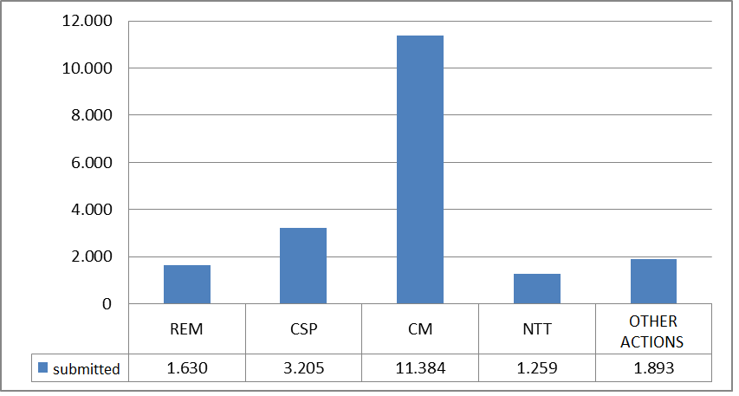

*Source: Activity Report 2007-2013 provided by EACEA*

The programme saw a steady growth in the number of applications of more than 45 % between 2007 and 2013. The lion's share of applications concerned town twinning (almost two thirds of them). Commission and Executive Agency undertook measures to address this increase in an efficient way, in particular the paperless management of the application and reporting procedure, the simplification of internal procedures and shortening of contract conclusion and payment terms.

As a result of the growing number of applications, competition became increasingly fierce between applicants and success rates went down. For example, during the last year of the programme (2013), applications for civil society projects stood only a 4.5% chance of success whereas in 2007 it had been possible to fund 48% of the received projects. Town twinning projects were the least selective, awarding funding to more than 20% of applicants.

At the same time, the budget of projects as well as the number of participants and involved partners and countries increased during the second half of the programme reflecting growing ambition among applicants.

**2.4. Geographical origin of projects**

Germany was the Member State introducing the greatest number of projects (2 791), followed by France (2 537), Hungary (2 434), Italy (2 265) and Poland (1 219).

In 2007, these five countries represented more than 70% of the submitted projects. In 2013, that share was 54 %. However, whilst the shares of France and Germany and, to a lesser extent, Poland dropped significantly, those of Italy and above all Hungary grew considerably, with Hungary accounting for the greatest number of applications submitted during the final year of the programme.

Between the first and the final year of the programme, the relative share of applications from Eastern Europe and the Balkans soared and the relative share of Central and Northern Europe fell. Not only Hungary, but as well Slovakia, Romania and Slovenia saw a significant growth and the three Baltic countries tripled the number of applications over the same period whereas Luxembourg, Denmark and Portugal participated to a limited extent in EFCP. This can partly be explained by the absence of dedicated Europe for Citizens Contact Points in those countries.

**Percentage of projects submitted in 2013 compared to 2007 (by country)**

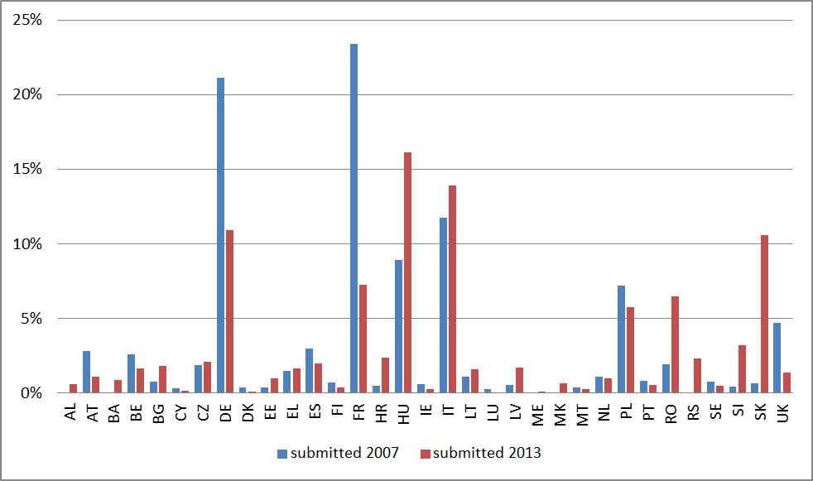

*Source: Activity Report 2007-2013 provided by EACEA*

**2.5. Participants and partners**

Over the years, the projects submitted involved a growing number of participants. Overall, the total number of direct project participants increased from 700 000 in 2007 to 1 175 000 in 2013. This was driven by a steady increase in the number of participants reached by civil society projects and a gradual decline in the number of relatively small town twinning meetings.

The total number of partners for each project also increased considerably. For example, between 2007 and 2013, the number of partners in civil society projects and in networks of twinned towns doubled.

Through the years, it seems that applicants also became more experienced and as a consequence submitted more complex projects involving more participants.

**2.6. Quality of projects**

During the first year of the programme implementation (2007), town-twinning projects were often meetings between people from different countries addressing various general topics like culture, youth, education, sport, tourism or scouting.

Through targeted and strategic actions by the Commission and the Executive Agency, projects funded under the EFCP's town twinning and networks of towns measures were progressively turned into larger, more structured and ambitious projects, more narrowly correlated with the objectives of the programme and its yearly work programmes, involving a larger number of towns and cities and focusing on more concrete issues, like the financial and economic crisis, environment problems or integration of migrants and mobile workers, etc. These projects were more susceptible to have a greater impact on citizens.

In the same way, the requirements in terms of content were tightened up for remembrance, citizens' and civil society projects, creating a stronger link to the programme objectives. Consequently, an increasing number of large-scale organisations introduced more innovative projects with a stronger European dimension.

**2.7. Structural support for organisations**

As foreseen by the Decision establishing the EFCP, the funding mechanism for operating grants was changed during the programme period. From 2007 to 2009, a number of think tanks and civil society organisations[4] were designated for receiving structural support, whereas during the second half of the programme, operating grants were allocated following calls for proposals. The transition towards a competitive selection procedure increased pressure on applicants and beneficiaries, thus contributing to more ambitious work programmes with stronger impact.

**3. What did the Europe for Citizens Programme achieve?**

**3.1. A challenging political context**

The accession of twelve new Member States between 2004 and 2007 presented important challenges to the deepening of European integration. It notably brought to the fore the need to ascertain a shared understanding of European culture and values, but also to facilitate citizens' engagement in the European project and promote their civic participation in Europe.

Between 2007 and 2013, EU institutions also had to undergo the consequences of the economic crisis which affected many European citizens in their daily lives. Faced with the growing electoral success of populist movements that questioned the benefits of European integration, it became important for the EU to demonstrate its added value and to take account of EU citizens' main concerns.

**3.2. The EFCP's relevance**

The EFCP contributed to raise awareness on EU activities and achievements, to foster a sense of ownership of the EU and to enhance mutual understanding and tolerance in a difficult context.

Contrary to most of EU funding programmes, which are directly related to specific EU policies, the EFCP filled a gap by addressing Commission's overall objective to bring citizens closer to the EU through:

- actions promoting civic participation;

- projects fostering citizens' involvement in civil society;

- projects generating interest in all questions pertaining to EU identity and construction;

- a forum for civil dialogue involving a wide array of organisations acting in a global political and societal context.

It served as an important entry point for ordinary citizens who wanted to discuss and engage with the EU, and as a dynamic platform of cooperation between civil society organisations and local authorities to develop citizenship activities (see examples in the annex). In terms of complementarity with other EU initiatives, the programme was sufficiently distinct from other programmes in terms of scope, activities and target groups to provide a complementary offer.

Moreover, the EFCP played an additional role at national level as there were scarcely similar initiatives run by the Member States over the same period.

**3.3. Promoting values**

An important number of projects of the EFCP contributed to promoting fundamental values on which our European societies are based, such as peace, tolerance, mutual understanding and solidarity. The promotion of these values, the involvement of European citizens in the process of integration as well as the concept of European remembrance are issues intrinsically related to the European project. These are matters of common concern where pooled resources can add value.

The evaluation of the programme's implementation showed that bringing together Europeans from different Member States to discuss and work together on issues of common concern increased their awareness of fundamental values, their degree of engagement in society and ultimately their involvement with the European Union. At the same time supporting activities promoting mutual understanding, diversity, dialogue and respect for others can help to develop a sense of belonging and a European identity, based on a shared understanding of European values, culture, history and heritage. These initiatives have the potential to create changes in the attitudes of participants towards other European citizens and to boost their involvement in democratic processes, as well as their knowledge and interest in the European Union, EU institutions and processes.

This was the reasoning behind almost all EFCP projects and activities, ranging from very small town twinning projects with relatively small number of citizens and participating countries for a one-off series of events to large operating grants allowing NGOs to pursue citizenship-focused goals at a more political and institutional level[5] (see examples in the annex).

**3.4. Impact on participating organisations**

The programme helped to advance the town twinning movement by encouraging towns and municipalities to think in more thematic, policy-related ways. Networks of twinned towns were a new measure introduced by the Commission shortly after the start of the EFCP 2007-2013 to complement the traditional town-twinning measure by a new type of larger-scale projects with the aim to increase their impact and sustainability. This was innovative in itself and provided participating towns with an opportunity to forge lasting links, produce substantial outputs and get involved with policy-making processes. The number of applications for the measure "networks of twinned towns" thus increased by more than 50% between 2007 and 2013.

The programme targeted civil society organisations through both operating grants and project funding. The EFCP reached a range of EU-focused organisations that pursued active citizenship in a variety of different ways. This ensured continued attention to relevant areas and the presence of independent voices during EU policy debates. In addition, participating in the programme allowed civil society organisations and their partners to build their capacity and international experience, learn from each other and, in some cases, form sustainable networks.

Remembrance gained increasing prominence during the life of the programme. In the sensitive area of projects relating to the Holocaust and genocide, the intervention of the Commission added substantial value to the debates by encouraging free exchange and the consideration of others’ points of view.

|  |
| --- |
| **Over the 2007-2013 period, the 'Europe for Citizens' programme had approximately 7 million direct participants.**  **The programme reached almost 25 000 towns and cities in Europe and created 350 networks of towns and cities around common issues. 4 250 civil society organisations were mobilised to meet citizens' concerns. More than 500 organisations were involved in remembrance activities vis-à-vis citizens**. |

**3.5. Impact on the policy-making process**

With regard to making a policy impact, the EFCP was able to extend its coverage and to involve citizens at local and regional levels. However, small projects targeting citizens at local level were relatively unlikely to incorporate the expertise and ambition needed to influence policy. Regarding larger-scale projects such as networks of twinned towns, civil society projects and support measures, they provided a way to influence policy while involving citizens, but had difficulties reaching individuals who were not already actively engaged.

Potential impact could as well be achieved when it was possible to create links with the policy-making process. Operating grants and civil society projects aimed at impacting policy processes at European level and succeeded partially, depending on their particular mechanisms, target groups and methods. Factors such as establishing sustainable networks (for example the European Year of Citizens Alliance EYCA) and involving specific target groups (such as children, young people or disadvantaged groups, for example people coming from remote rural areas) proved to play a crucial role.

In addition, the EFCP contributed to policy-making at EU level through the so-called *structured dialogue*[6], which ensured the presence of independent civil society voices in EU debates, carried out research on citizenship related issues and offered a forum for dialogue with the Commission and other institutions.

A tangible policy-impact was reached during the European Year of Volunteering 2011 and the European Year of Citizens 2013 when projects funded by the EFCP contributed to raise awareness on the EU's role in the areas of volunteering and citizenship and thus established synergies with the European policy agenda in these fields.

**4. Conclusions**

The Europe for Citizens Programme 2007-2013 triggered a lot of interest amongst citizens, as the steady growth in number of applications clearly shows. Citizens are eager to take part in discussions and to have their say in EU policies that affect their daily lives. Considering European citizenship as an important element in strengthening and safeguarding the process of European integration, the European Commission used EFCP to give citizens this opportunity and more generally to encourage their engagement in the European project. This approach was based on the idea that participation helps strengthening awareness on EU issues, developing mutual understanding and identification with Europe, and therefore contributes to consolidating the long-term process of European integration.

Even if the long-term impact of the EFCP is difficult to assess, the programme effectively fostered civic participation and democratic engagement and reached large numbers of citizens who otherwise would not have been engaged with the European project. As the only EU programme that targets citizens directly the EFCP provided a unique forum to involve ordinary citizens in the EU through a bottom-up approach. Over the final three years of the programme, the fact that the projects were of higher quality and larger in scale, with closer links to the main themes associated with citizenship and civic participation and that many first time participants were involved considerably augmented its impact. In future, and taking into account the budgetary requirements, the programme will continue to be developed with a view to maximise its impact and deploy its funding strategically focussing on activities targeting citizens directly.

The interim evaluation of the successor programme Europe for Citizens 2014-2020 due in December 2017 will be used to verify in how far the evaluation recommendations of the ex-post evaluation have been followed.

**ANNEX**

**ANNEX 1: 'Europe For Citizens' programme: Examples of good practice projects**

**Town-Twinning and Networks of Twinned Towns**

|  |
| --- |
| ***Volunteering for Europe EUR-VOL***  During the European Year of Volunteering 2011, the city of Trogir (Croatia) welcomed delegates from seven European partner towns for a four-day event addressing the value of voluntary activities with the aim to raise public awareness, involvement and understanding of the contribution that volunteering organsiations make to society. This conference paved the way for the creation of new cooperation networks and common volunteering actions in the areas of environment, art and language learning. At the end of the conference, the representatives of the towns signed an official cooperation memorandum. |

|  |
| --- |
| ***Charter of European Rural Communities***  Since 1989, the European Charter of Rural Communities has brought together 28 rural communities from all 28 EU Member States. This extensive network has chosen to focus on ‘liveability in European communities’ and to examine its various aspects including education, employment, integration of people with disabilities, participation in democracy at local level and involving young people in community life. The motto of the Charter is ‘people meet people’ and this is reflected in the way meetings between Charter members are organised. A major network meeting is organised every year, accompanied by specialised thematic meetings for specific target groups. One of the results of the project is an overview of the way participation in local democracy is organised in different European countries. |

**Civil Society Projects**

|  |
| --- |
| ***Waves of legality, waves of citizenship***  In 2011, the Italian Foundation *Giovanni e Francesca Falcone* together with partner organisations from 4 other countries organised two international events aimed at reinforcing the role of organized civil society in combating and preventing crime. An international conference organised in Paris explored the role of youth. More than 2.000 young people had the opportunity to embark on the *Boat of legality* travelling from Naples to Palermo and to participate in the ensuing city rallies. The project had excellent media coverage and contributed to raising public awareness of the of role civil society in preventing and fighting organised crime. |

**European Remembrance Projects**

|  |
| --- |
| ***Train of Remembrance***  The Train of Remembrance is a project commemorating children and young people from many European countries deported to concentration and extermination camps during the Second World War. The exhibition, held within real train carriages drawn by a steam engine, displays the biographies of young victims from eight European countries. It pays tribute to the aid provided by allied anti-Nazi forces saving the life of thousands of children and young people. The train visited over 100 railway stations attracting 380 000 visitors. The exhibition drew attention to a particular aspect of the Holocaust, i.e. the deportation and extermination of children and young people and brought it to the attention of large numbers of European citizens of today. |

1. Decision N° 1904/2006/EC of the European Parliament and of the Council of 12 December 2006 establishing for the period 2007 to 2013 the programme 'Europe for Citizens' to promote active European citizenship, OJ L 378, 27.12.2006, p. 32-40.
2. Ex post evaluation of the Europe for Citizens Programme, Coffey International and Deloitte, 2015.
3. Council Decision 2004/100/EC of 26 January 2004 establishing a 'Community action programme to promote active European citizenship' (civic participation).
4. The following organisations were earmarked for structural support: *Council of European Municipalities and Regions,* *Groupement d'études et de recherche Notre Europe* and *Institut für Europäische Politik, Platform of European Social NGOs,* the *European Movement* and the *European Council of Refugees and Exiles*, *Association Jean Monnet, Centre* *Européen Robert Schuman* and *Maisons d'Europe.*
5. Ecorys, *Interim evaluation of the Europe for Citizens Programme 2007-2013*, 2011.
6. The *structured dialogue* consisted of regular meetings between the Commission services and approximately 50 key European organisations actively involved in the EFCP to discuss all matters relating to this programme and its implementation.