

Table of contents

1. Introduction 3

2. Background 3

3. The external evaluation of the Directive 4

3.1 Scope of the evaluation 4

3.2 Methodology 5

3.3 Results of the evaluation 5

3.4 Stakeholders feedback on the evaluation 6

4. Issues arising from the evaluation: definitions 7

4.1 Functioning of the current definitions 8

*4.1.1 Subjective criteria* 8

*4.1.2 Discrepancies between customs and excise* 8

*4.1.3 Minimum Excise Duty* 9

4.2 Absence of definitions 9

5. Conclusions and recommendations of the evaluation 10

5.1 Quality of the evaluation 10

5.2 Recommendations 11

6. Follow up and Final Conclusions 13

Annex I. Trends and statistics 15

Annex i.i - weighted average price cigarettes 17

Annex i.ii - tax burden cigarettes 18

Annex i.iii - releases for consumption cigarettes 19

Annex i.iv – packs of cigarettes per adult 20

Annex i.v - releases for consumption fine cut tobacco 21

Annex i.vi – fine cut tobacco per adult 22

Annex i.vii - tax receipts 23

Annex i.viii – tobacco revenue of total tax receipts 24

# 1. Introduction

According to Article 19, paragraph 1 of [Directive 2011/64/EU](http://eur-lex.europa.eu/LexUriServ/LexUriServ.do?uri=OJ:L:2011:176:0024:0036:EN:PDF)[1] the Commission is required to submit a report on the rates and structure of excise duty laid down in this Directive every four years. This report must take into account the proper functioning of the internal market, the real value of the rates of excise duty and the wider objectives of the Treaty and must be based in particular on the information provided by Member States. The present report is one of a series of reports[2] on the functioning of EU rules on excise duties applied to manufactured tobacco that the Commission has submitted since 1992.

Furthermore, the Directive has been identified for evaluation under the Commission's Regulatory Fitness and Performance Programme (REFIT).[3]

The current report presents the results and conclusions of an external evaluation assessing the Directive from these two angles. In addition, it provides the overview of the available statistics reported by Member States concerning the development of the Weighted Average Price (WAP), releases for consumption, tax receipts and tax burden on manufactured tobacco since the Directive entered into force in 2011.

Unlike previous reports, the current report does not focus on increases in the minimum rates of excise duty prescribed by Directive 2011/64/EU. Many increases in the minimum overall excise duty have only entered into force recently; some Member States have been granted transitional periods and some gradual increases must still take effect.[4] The impact of these measures will, therefore, be examined in a future report.

# 2. Background

Directive 2011/64/EU sets out EU rules on the structure and rates of excise duty applied to manufactured tobacco. In particular, it defines and classifies various manufactured tobacco products covered by the Directive according to their characteristics. The structure of the excise duties for the different types of products is also established in this Directive. The Directive aims to ensure both the proper functioning of the internal market and, at the same time, a high level of health protection.[5] A proper functioning internal market presupposes that the way in which Member States tax the consumption of products in this sector neither distorts competition nor impedes their free movement within the EU. In this context, the Directive should ensure that manufactured tobacco products are correctly taxed in the Member State of final consumption.[6] This is important, given that receipts from excise duties on manufactured tobacco contributed overall more than €81 billion to the national budgets of Member States in 2014.

Under the REFIT programme the Commission is committed to ensuring that EU law is fit for purpose and achieves its objectives at least cost and burdens.

# 3. The external evaluation of the Directive

In order to evaluate the functioning of the Directive, the Directorate General for Taxation and the Customs Union (DG TAXUD) commissioned an external evaluation (hereafter: evaluation) from a consortium established by Ramboll Management Consulting AS, The Evaluation Partnership, and Europe Economics.

Following consultation with Member States and in line with the REFIT programme, it was agreed that the objective of the evaluation should be to identify possibilities to improve the legislation in order to reduce administrative costs and burdens for both national administrations and economic operators and to increase the level of compliance and security in collecting excise duties on manufactured tobacco. The evaluation started in December 2012 and was finalised in August 2014. A Steering Group composed of staff from all the relevant Commission Services oversaw the execution of the evaluation.

It should be noted that, as the evaluation has been finalised before the adoption of the new Better Regulation Guidelines on 19 May 2015[7], some of the compulsory elements introduced by these guidelines could not, therefore, be taken into account. Firstly, the evaluation collected stakeholder views through targeted surveys rather than through an open public consultation. Secondly, in line with the objectives of the REFIT programme, the focus has been predominantly on issues related to effectiveness and efficiency.[8]

## 3.1 Scope of the evaluation

As a first step, the evaluation mapped out the main characteristics of the excise systems for manufactured tobacco, with reference to the two principal directives regulating excise duties on manufactured tobacco.[9] The evaluation then focussed on providing answers to the agreed evaluation questions. The findings of the evaluation are grouped according to these evaluation questions, which are listed in paragraph 3.3. The evaluation also identified issues arising from these findings which are considered in Section 4 of this report.

The impact of minimum rates on the protection of health did not come within the scope of the evaluation because many increases in the minimum overall excise duty only entered recently into force, meaning that more time is needed to assess these aspects.[10] In addition, several Member States have been granted transitional periods lasting until 31 December 2017 to reach the minima for cigarettes. For fine cut smoking tobacco, gradual increases in the minimum overall excise duty will take place over a period lasting till 1 January 2020.

## 3.2 Methodology

The evaluation was carried out in three phases: design, data collection and analysis. During the data collection phase, questionnaires were sent to both Member States and economic operators. 27 Member States and 48 economic operators replied to the questionnaires. The received replies were followed-up by telephone calls and face-to-face interviews. In addition, case studies were conducted in 7 selected Member States.[11] Desk research and literature review was also part of this phase. Moreover a qualitative analysis of existing legislation, studies and economic literature was also carried out, as was an analysis of available economic data.

Based on the responses to the questionnaires, the contractor identified both good practices and problems. In the third phase the contractor analysed and compared the different replies and drew up a list of problems faced by tax administrations and economic operators. Finally, a series of recommendations was drawn up to address the problems identified.

## 3.3 Results of the evaluation

**3.3.1 To what extent do the current arrangements for excise duty on tobacco products ensure the proper functioning of the Internal Market and avoid distortions in competition?**

It was found that implementation of the Minimum Excise Duty (MED)[12], the inconsistent treatment of e-cigarettes and certain manufactured tobacco products and the tax induced substitution between and within product groups creates distortions within the internal market. Although, non-harmonised anti-forestalling measures may also negatively affect the proper function of the internal market, harmonisation in these areas is considered neither feasible nor desirable by tax administrations. Besides these exceptions, the evaluation found that the current structure and level of rates generally allow for neutral conditions of competition and the free setting of prices within the internal market.

The impact of derogations and exceptions allowed in the current Directive on cross-border shopping and illicit trade is limited. Moreover, no clear evidence was found to show that any of the changes in the tobacco excise duty levels that have entered into force have led to changes in trade patterns.

**3.3.2 To what extent are the current arrangements for excise duty on tobacco products implemented in a cost-effective way?**

In terms of administrative and compliance costs for tax administrations and economic operators, the greatest negative impact is caused by discrepancies between the excise definitions and the Combined Nomenclature (CN) classification for customs purposes, and the legal uncertainty about the treatment of certain products (including judicial contestations). Even though the costs of legal uncertainty are in general relatively small as it concerns often niche products, the impact on the operator or tax administration has been considered as potentially significant.

**3.3.3 To what extent do the current arrangements of excise duty on tobacco products safeguard Member States' budgetary objectives?**

In general, the definitions of Article 2 -5 of Directive 2011/64/EU are effective for adequate collection of excise duties. In contrast, the definitions are suboptimal for the monitoring of the movement and holding of manufactured tobacco.

## 3.4 Stakeholders feedback on the evaluation

The Steering Group overseeing the evaluation invited stakeholders to present their views on the findings at a meeting organised in Brussels on 6 June 2014. The invitation was extended to all relevant stakeholders, including Member States authorities, economic operators, and health and consumer associations. Following the event, the Commission received written feedback from 3 Member States, 12 associations or federations representing economic operators and one network of NGOs working in the field of public health in Europe.

The comments received were diverse in nature. In general, there was more support for the findings of the evaluation than for the recommendations. In the opinion of most of the stakeholders, the recommendations needed further analysis. Apart from supporting some of the findings, many questions were received concerning the methodology and the use of data.

Concerns were expressed about overrepresentation of some of the stakeholders, thereby affecting the overall dataset. Some had centralised their responses to the questionnaires, while others had asked national branches to answer separately. This was taken into account by the external contractor and appropriate adjustments were made.

Several critical comments were received concerning the calculation of price elasticity of demand and assumptions of the volume of illicit trade as well as the choice to use Euromonitor data. The external contractor ensured that appropriate clarification of these matters was included in the final publication.

Some felt the evaluation should have also focussed on health aspects of tobacco consumption and taxation. However, this was considered premature, as it would have meant taking account of the impact of the new [Tobacco Products Directive](http://ec.europa.eu/health/tobacco/docs/dir_201440_en.pdf) 2014/40/EU[13] which must be implemented by May 2016. In any event, the new Tobacco Products Directive had not yet been adopted at the time the core work for the evaluation was carried out.

In addition to the feedback on the scope and methodology of the evaluation, feedback concerning the recommendations of the evaluation (see also paragraph 5.2) was received:

* Some respondents were of the opinion that the recommendation to consider aligning the minimum rates for cigars/cigarillos with those of cigarettes would have a disproportional effect.
* Others were not convinced that including raw tobacco within the scope of the holding and movement provisions of manufactured tobacco would solve the problems identified.
* Some felt that it would be inappropriate to recommend eliminating discrepancies between excise duty categories and CN codes because the CN codes had been developed for different purposes.
* Some respondents were of the opinion that e-cigarettes should not be included in the scope of the current directive, but that a separate initiative for a harmonised approach of taxation of these products should be considered.

# 4. Issues arising from the evaluation: definitions

Following the entry into force of Directive 2011/64/EU, the definitions of cigarettes, cigarillos, cigars and smoking tobacco were amended to reflect concerns about deficiencies in previous definitions. In the evaluation consideration has been given to the functioning of the new definitions. The evaluation identified a number of issues requiring further examination. These are listed in the following paragraphs.

## 4.1 Functioning of the current definitions

### *4.1.1 Subjective criteria*

The current definitions contain a number of subjective expressions. Classification of products for excise duty purposes therefore requires a certain amount of subjective interpretation. Stakeholders criticised the functioning of the current definitions and, in particular the subjective elements. The difficulties listed below were identified by the evaluation.

* The current formulation of Article 5, in particular phrases such as *‘put up for retail sale’* and *‘capable of being smoked without further industrial processing’* can cause legal uncertainty and differentiated treatment of the same products in Member States.
* The definitions of cigars, cigarillos and smoking tobacco do not provide sufficient legal certainty for classification purposes. The inconsistent treatment of manufactured tobacco products (in particular ‘borderline’ products) can result in different tax situations in each Member State. This might jeopardize the proper functioning of the internal market. Half of the Member States has experiences with products which, in their opinion, represent an attempt to misuse the current definitions in order to benefit from more favourable tax treatment.[14] Several economic operators reported that some of the smaller cigars or cigarillos benefiting from a lower excise duty rate should be considered as cigarettes. In their opinion, these products are direct substitutes for cigarettes.[15]
* The loose formulation of definitions in the Directive or the absence of definitions (see paragraph 4.2) causes legal uncertainty. For example, classification of a product that does not even involve particularly complex problems can take up between 2-8 hours of work for operators.[16] If the classification does present a problem, even more time is required. Therefore, the impact of legal uncertainty on individual operators or tax administrations can be significant.

### *4.1.2 Discrepancies between customs and excise*

Currently two different systems of classifying products for excise and custom purposes are in place. In particular, the definitions set out the Articles 2–5 of Directive 2011/64/EU are not fully consistent with the classification system in place for custom purposes. The discrepancies lead to higher compliance costs for both tax administrations and economic operators.[17] In particular, smaller operators have reported problems due to different definitions for excise and custom purposes which can lead to increased compliance costs because such operators must undertake similar steps twice, under the different systems used by the authorities. In general, 68% of the operators reported that the divergent definitions result in a high increase of administrative costs, while 4% even think that the increase is very high.[18]

### *4.1.3 Minimum Excise Duty*

Member States have since 2011 the option to levy a MED on cigarettes. The introduction of the MED was supposed to provide Member States with framework rules for setting this minimum amount in the same way. However, the evaluation found that Article 8, paragraph 6 is unclear and that, in practice, implementation seems to differ between Member States. Interviews with Member States show that there is currently a range of interpretations used in setting the MED.[19]

## 4.2 Absence of definitions

Currently Directive 2011/64/EU defines cigarettes, cigarillos, cigars and smoking tobacco.

Some undefined products could fall within one of these categories (for instance water pipe tobacco). Others might fall outside the scope of the Directive (the latter is in general the case for raw tobacco, some intermediate products and e-cigarettes). There are also new heated tobacco products on the market in some Member States which are creating differences in treatment.[20] These "heat-not-burn" tobacco products differ from e-cigarettes in that they do contain tobacco. However, instead of burning the tobacco, a heating (as opposed to combustion) process takes place.

Some Member States and economic operators reported that the current definitions are no longer fit for purpose. This is not only because of market developments, but also because of doubts as to whether the current definitions are effective enough to prevent illicit trade.

While recognising that the task of preventing illicit trade in excise products falls (in particular in terms of enforcement) primarily under the responsibility of Member States, the Commission is, nevertheless, of the opinion that EU rules should be as effective as possible in order to combat such trade. The EU has stepped up its efforts in recent years by signing the [Protocol to Eliminate Illicit Trade in Tobacco Products](http://www.who.int/fctc/protocol/Protocol_summary_en.pdf?ua=1), adopting the Tobacco Products Directive containing explicit provisions against illicit trade and the action programme set out in the Commission Communication of 6 June 2013.[21] The amount of duty lost to illicit trade is estimated in the evaluation at around €11.1 billion annually.[22]According to the estimations produced by the external contractor, the reduction in illicit trade could lead to the potential recovery of duty in the range of €6.1 billion to €7.2 billion per annum, after adjusting for a price-induced reduction in the level of consumption (estimated on basis of the average price elasticity of a given market).[23]

Other issues identified were the following:

* The definitions do not allow correct and full use of either the Excise Movement and Control System (EMCS) or the relevant provisions on administrative cooperation and exchange of information, all of which are considered as key elements in the fight against fraud. This is caused, in particular, by the limited scope of Directive 2011/64/EU whereby certain products (such as raw tobacco) are excluded. Several Member States mentioned that a growing amount of raw tobacco was being diverted from legal to illegal trade circuits or sold directly to end-consumers.
* The inconsistent treatment of a number of products (e.g. intermediary products, raw tobacco and by-products) across Member States plays a role in the limited ability of Member State authorities to monitor manufactured tobacco.
* The ‘catch all’ approach contained in the definitions laid down in Article 5 leads to a relative higher taxation of products with different characteristics, such as water pipe tobacco, compared to the other products in this category.
* Excluding e-cigarettes from the scope of excisable products might have significant long term budgetary implications for Member States. Some Member States have begun to levy a national tax on these products. This might in time jeopardize the proper functioning of the internal market if other Member States decide to do likewise in an uncoordinated way which would result in differentiated treatment across the EU.

# 5. Conclusions and recommendations of the evaluation

## 5.1 Quality of the evaluation

The Commission has carefully examined the external evaluation and has also taken account of the feedback received from stakeholders. The work carried out by the evaluation team was judged to be in accordance with the evaluation standards of the Commission.[24] The judgements and conclusions in the evaluation were derived directly from findings based on the evidence collected. To ensure the robustness of the findings, the evaluation used several data collection methods, including surveys, interviews, desk research and case studies. This methodological mix was overall considered as sufficient by the Commission and stakeholders.

However, the Commission is aware that some assumptions had, inevitably, to be made due to a lack of data or information in order to answer the evaluation questions. Some findings lack information on costs and benefits, for instance concerning dual classification and the monitoring of raw tobacco. Also, as the focus of the evaluation has been on effectiveness and efficiency, issues related to relevance, coherence and EU added value have not been addressed in detail. Finally, the evaluation does not capture the potential impacts of the new Tobacco Products Directive 2014/40/EU, which is also expected to have an effect on tobacco consumption.[25]

## 5.2 Recommendations

On the basis of the evidence gathered, the evaluators put forward 16 recommendations with the view to improving the functioning of the regulation concerning excise duty on manufactured tobacco.

**Table 1 – External evaluation recommendations[26]**

| **No** | **Recommendation** |
| --- | --- |
| **Recommendations related to definitions of excisable tobacco products** | |
| 1 | Further analyse the possibility of including e-cigarettes in the scope of excise duty on tobacco products. |
| 2 | Further analyse (with careful consideration to costs and burden involved) the possibility of introducing raw tobacco within the scope of monitoring of excisable tobacco products and/or alternative solutions to ensure the systematic monitoring of the logistics of raw tobacco. |
| 3 | Art 4(1) (a) should be brought in line with the Explanatory Notes to the Combined nomenclature (CNEN) of 2402 10 00. |
| 4 | Art 5(1) (a) “capable of being smoked without further industrial processing” to be revised in order to reduce uncertainty related to the treatment of partially processed tobacco put up for sale with the intention of being smoked (e.g. “without further processing in a tax warehouse”). |
| 5 | In light of the different characteristics of water-pipe-tobacco, a distinct tax category should be developed, allowing the imposition of an appropriate rate structure. |
| 6 | Art 5(1) (b) “put up for retail sale and which can be smoked”, should be revised by removing wording “retail” from the definition, the CN code should be subsequently brought in line. |
| 7 | Further analyse the possibility to afford expanded tobacco a distinct CN code. |
| 8 | In order to remove inconsistencies and legal uncertainty in treatment, further analyse the possibility to include an additional tax category within the scope of the Directive which is to include intermediary products whose monitoring under the EMCS is necessary, this category may make reference direct reference to applicable CN codes (e.g. reconstituted tobacco; tobacco refuse not suitable for smoking, expanded tobacco, etc.). |
| 9 | Aim to eliminate inconsistencies between CN codes and Excise duty categories, prioritising the need for non-excisable products to share the same CN classification as excisable products and for products within the same tariff classification to be potentially classified in multiple excise categories. |
| 10 | Art 4 (1) “given their properties and normal consumer expectations is exclusively intended to be smoked as it is” should be revised to ensure legal clarity and eliminate legal uncertainty and costly disputes. |
| **Recommendations related to rates and structure of the excise duty** | |
| 11 | Consider the possibility of aligning minimum excise taxes on cigars / cigarillos with those of cigarettes in order to eliminate the incentive to market “borderline” products which might attempt to circumvent payment of the higher excise duty. |
| 12 | Revise Art 7 (4) and Art 8 (6) to remove the uncertainty with respect to the limits imposed on the MED. |
| **Recommendations related to other topics analysed in the context of this evaluation** | |
| 13 | A correction message for the e-AD should be introduced in order to correct minor mistakes; however, it should not be possible to change essential data like the quantity, the EPC, the CN-code, etc. |
| 14 | Consider integrating national EMCS systems in the context of market surveillance and for the purposes of criminal investigations. |
| 15 | Transit countries should electronically be informed of movements taking place on their territory. |
| 16 | Consider developing and recommending a uniform risk analysis tool to be used at EU level. |

The Commission has examined the relevance of each of the recommendations and finds the following to be worthy of further consideration:

* Recommendations 4, 6, 10 and 12 suggest creating more accurate definitions in order to reduce legal uncertainty, avoid different approaches in Member States and distortion of the internal market. Addressing these recommendations would have an impact on the work parameters of other recommendations and could take priority.
* The aim of recommendations 3 and 9 is to simplify the current structure by adjusting the categories or definitions of manufactured tobacco in the excise legislation to take account of the classification for custom purposes and the corresponding Explanatory notes to the CN.
* Recommendations 1, 2, 5 and 8 concern the possible introduction of new product categories in order to facilitate an appropriate, equal taxation treatment of (new) products within the internal market and allow Member States to monitor and control sufficiently.
* Recommendation 11 is designed to reduce circumvention. In this context, it should be taken into account that derogations from the definition of cigars and cigarillos granted to Germany and Hungary, ended on 31 December 2014.[27] Furthermore, the current Directive empowers the Member States to tackle the circumvention by increasing the excise duty on cigars only.

The other recommendations are considered to either fall outside the scope of possible revision of Council Directive 2011/64/EU or to be only indirectly linked to it. These include:

* Recommendations 7 and, in part, 6 and 9 relate to customs classification and the corresponding CN codes. The CN is based on the Harmonized System (HS) nomenclature with further Community subdivisions. The Harmonized System is managed by the World Customs Organisation (WCO). These recommendations do therefore not come within the scope of Council Directive 2011/64/EU. However, it might be possible to use the customs classification system as a blueprint for the definitions of manufactured tobacco products in order to decrease legal uncertainty. This could also generate potential cost reducing synergies, which the Commission Services will assess.
* Recommendations 13 to 16 contain adjustments aimed at improving the overall system of excise duty collection in Member States. Consequently, these recommendations are considered to be more relevant to the parallel and on-going evaluation of [Council Directive 2008/118/EC](http://eur-lex.europa.eu/LexUriServ/LexUriServ.do?uri=OJ:L:2009:009:0012:0030:EN:PDF) of 16 December 2008 concerning the general arrangements for excise duty and repealing [Directive 92/12/EEC](http://eur-lex.europa.eu/LexUriServ/LexUriServ.do?uri=CELEX:31992L0012:en:HTML). The evaluation process of this Directive was started in 2014 and is expected to be completed by 2016.

# 6. Follow up and Final Conclusions

Levying taxes on the consumption of products, such as excise duties on manufactured tobacco, should neither distort competition nor hinder the possibility for goods to move freely within the EU in a proper functioning internal market. As part of the REFIT programme, this evaluation has particularly examined questions of efficiency, effectiveness and administrative burden arising from Directive 2011/64/EU in order to ensure that EU legislation on excise duties on manufactured tobacco achieves its policy objectives at least cost.

Overall, the evaluation found that the current structure and level of rates generally allow for neutral conditions of competition and the free setting of prices within the internal market. At the same time, the evaluation findings show that some distortions within the internal market are created through differentiated application of the MED[28], the inconsistent treatment of e-cigarettes and certain manufactured tobacco products and the tax induced substitution between and within product groups.

Within the REFIT context, the evaluation identifies unnecessary administrative and compliance costs for tax administrations and economic operators. These costs result from certain definitions which can lead to legal uncertainty over the treatment of specific products. In addition, the application of different definitions of tobacco products for excise duty and for customs purposes has been found to be problematic, in particularly for Small and Medium Enterprises as it translates into double entries and legal uncertainty.

Finally, with certain exceptions, the Directive has proven to be effective and generally appropriate for enabling adequate collection of excise duties for the large majority of manufactured tobacco products.

In the view of the findings of the evaluation, the Commission will consider the next steps in discussions with Member State experts.[29] These steps could also include a revision of the Directive. Such a revision would involve carrying out a public consultation and an Impact Assessment to gather further evidence, including where possible, quantified estimates on the impacts and proportionality of possible solutions to the problems identified.

In addition to giving consideration to the specific recommendations of the evaluation, the Commission will, in the light of the findings of the evaluation, also examine how to best achieve the following objectives:

* A uniform understanding of application of the MED;
* Limiting tax induced substitution within and between product categories where possible;
* Providing clarity as regards the harmonized definitions and the treatment of novel products, in order to:
  + support consistent treatment and legal clarity on classifying excise products within the EU and;
  + allow Member States to monitor the movement and production effectively
  + Avoid unnecessary administrative costs.

In deciding on next steps, the Commission will also give due consideration to any relevant recommendations made by the Council or European Parliament.

# Annex I. Trends and statistics

Following the most recent revision in 2011 of the legislation on excise duty on tobacco, the excise duty rates on manufactured tobacco were amended. The minimum rates required were increased. For fine-cut smoking tobacco, future gradual increases were also included. Member States were allowed more flexibility in regard to the application of the specific component of the excise duty on cigarettes, the bandwidth of the specific component was increased from 5 - 55% to 7.5 – 76.5% of the total tax burden. In addition, the possibility to create a tax floor for cigarettes by levying a MED was also introduced.

In accordance with Article 19, paragraph 3 of Directive 2011/64/EU and the Commission implementing decision 2011/480/EU[30], Member States are required to provide information on an annual basis to the Commission:

* Excise duty rates;
* Weighted Average retail selling Price (WAP);
* Tax receipts and;
* Releases for consumption of manufactured tobacco.

The information provided to date by Member States in this respect has shown the following.

**Weighted Average Price**

With the entry into force of Directive 2011/64/EU the most popular price category (MPPC) was abolished and replaced by the WAP. Following the introduction of the WAP, the basis for calculating the minimum rates of excise duty for cigarettes and fine-cut smoking tobacco also changed. Annex I.I shows the development of the WAP for cigarettes in each Member State from 2012 to 2015. It should be noted that the WAP for 2012 for instance, is based on the average prices of all cigarettes released for consumption during the previous year. In all Member States, except Malta, the average price of cigarettes released for consumption in 2014 increased compared to 2011. These increases can be due to several reasons, including increase in taxation, which may also influence the price. The drivers behind tax increases can also differ: taxes may be increased to raise revenue, for health policy reasons or to comply with the European minimum requirements[31].

**Tax burden**

Since the WAP was introduced, Member States must report their tax burden as percentage of the WAP (based on the average price of the products released for consumption in the previous year). As can be seen in Annex I.II, the tax burden (incl. VAT) on cigarettes in every Member State fluctuates from one year to the next. If the WAP increases, the tax burden will decrease if rates remain unchanged. Overall, the figures show that the tax burden on cigarettes in the EU in 2015 varied from just below 70% in Luxemburg and Latvia to 85% in the United Kingdom. This figure gives, however, no indication of the amount of tax[32], as the tax burden is expressed in a percentage of the WAP, which is different in each Member State.[33]

**Releases for consumption and tax receipts**

The amount of cigarettes released for consumption declined in most Member States, while the amount of fine-cut tobacco released for consumption fluctuated over the period 2011-2014.[34] The decline of cigarettes released for consumption may have happened for several reasons, for instance advertising bans, anti-smoking campaigns, smoking bans in public places, tobacco taxes and consumption of other tobacco products or the arrival of alternative products on the market such as e-cigarettes or Nicotine Replacement Therapy. Annex I.IV and I.VI show the packages of cigarettes and grams of fine cut tobacco released for consumption related to the population in each Member State. This is no indication of the percentage of smokers in a Member State, because manufactured tobacco released for consumption in one Member State might also be consumed by citizens of other Member States.[35]

The highest amount of revenues from excise duties corresponds to those Member States with the highest population.[36] Which part of the total tax receipts consists of revenue from excise duties on manufactured tobacco differs between Member States.[37]

## Annex i.i - weighted average price cigarettes

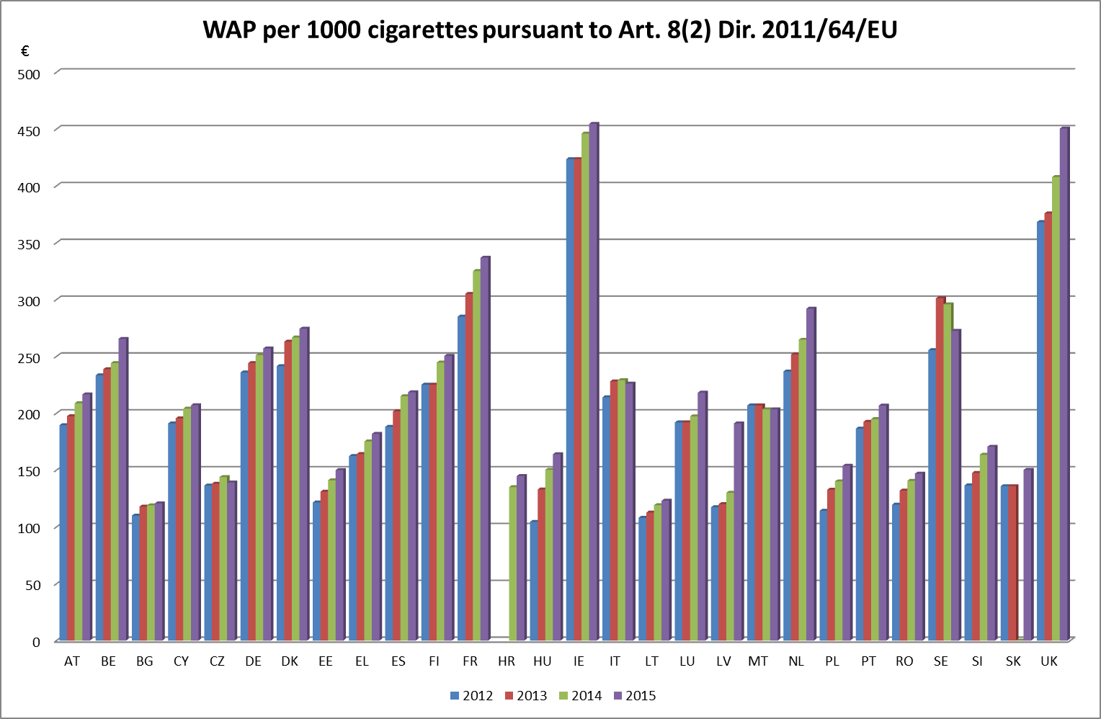

## Annex i.ii - tax burden cigarettes

## 

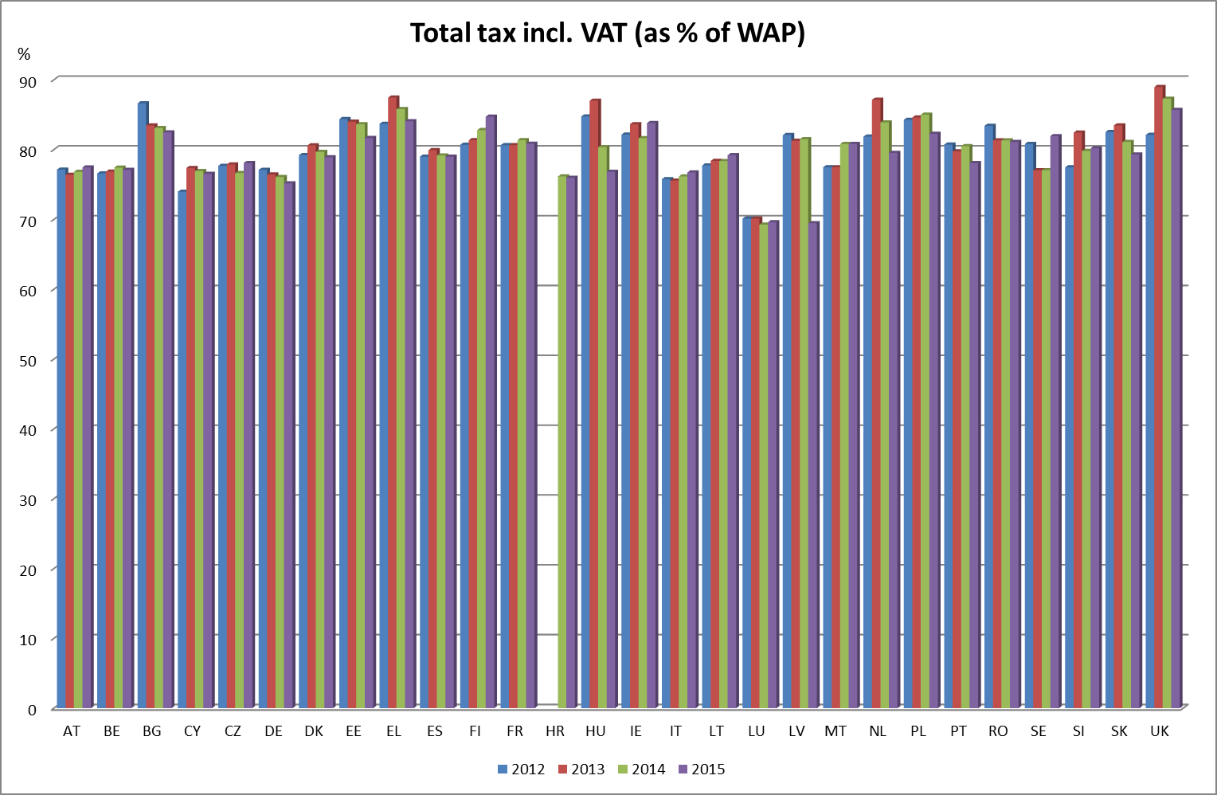

## Annex i.iii - releases for consumption cigarettes

## Annex i.iv – packs of cigarettes per adult

## Annex i.v - releases for consumption fine cut tobacco

## Annex i.vi – fine cut tobacco per adult

## Annex i.vii - tax receipts

## Annex i.viii – tobacco revenue of total tax receipts

1. [Council Directive 2011/64/EU](http://eur-lex.europa.eu/LexUriServ/LexUriServ.do?uri=OJ:L:2011:176:0024:0036:EN:PDF) of 21 June 2011 on the structure and rates of excise duty applied to manufactured tobacco
2. COM (1995) 285  
   COM (1998) 320  
   COM (2001) 133  
   COM (2008) 460   
   The last report of 2008 resulted in Council Directive 2010/12/EU of 16 February 2010 amending Directives 92/79/EEC, 92/80/EEC and 95/59/EC on the structure and rates of excise duty applied on manufactured tobacco and Directive 2008/118/EC

  
3. REFIT is a programme to review the entire stock of EU legislation – to identify burdens, inconsistencies, gaps or ineffective measures and to make the necessary proposals to follow up on the findings of the review.
4. Article 10 and Article 14 of Directive 2011/64/EU.
5. Articles 26, Article 113 and Article 168 of the [Treaty on the Functioning of the European Union](http://eur-lex.europa.eu/legal-content/EN/TXT/PDF/?uri=CELEX:12012E/TXT&from=EN)
6. With exception of the situation as described in Article 32 of Directive 2008/118/EC
7. http://ec.europa.eu/smart-regulation/guidelines/toc_guide_en.htm
8. According to the new Better Regulation Guidelines, an evaluation must assess effectiveness, efficiency, relevance, coherence and EU added value.
9. [Council Directive 2011/64/EU](http://eur-lex.europa.eu/LexUriServ/LexUriServ.do?uri=OJ:L:2011:176:0024:0036:EN:PDF) of 21 June 2011 on the structure and rates of excise duty applied to manufactured tobacco; [Council Directive 2008/118/EC](http://eur-lex.europa.eu/LexUriServ/LexUriServ.do?uri=OJ:L:2009:009:0012:0030:EN:PDF) of 16 December 2008 concerning the general arrangements for excise duty and repealing [Directive 92/12/EEC](http://eur-lex.europa.eu/LexUriServ/LexUriServ.do?uri=CELEX:31992L0012:en:HTML).
10. Article 10 and Article 14 of Directive 2011/64/EU.
11. Germany, Denmark, Finland, Greece, Poland, Romania and United Kingdom.
12. Article 7, paragraph 4 and Article 8, paragraph 6 of Directive 2011/64/EU
13. [Directive 2014/40/EU](http://ec.europa.eu/health/tobacco/docs/dir_201440_en.pdf) of the European Parliament and of the Council of 3 April 2014 on the approximation of the laws, regulations and administrative provisions of the Member States concerning the manufacture, presentation and sale of tobacco and related products and repealing [Directive 2001/37/EC](http://eur-lex.europa.eu/resource.html?uri=cellar:248aee57-abdf-4df2-929e-30c2fa7f22e0.0004.02/DOC_1&format=PDF).
14. See also p. 57 of the [evaluation](http://ec.europa.eu/taxation_customs/resources/documents/taxation/excise_duties/tobacco_products/studies_reports/ramboll-tobacco-study.pdf) on tobacco taxation
15. See also p. 60 of the [evaluation](http://ec.europa.eu/taxation_customs/resources/documents/taxation/excise_duties/tobacco_products/studies_reports/ramboll-tobacco-study.pdf) on tobacco taxation.
16. See also p. 163 of the [evaluation](http://ec.europa.eu/taxation_customs/resources/documents/taxation/excise_duties/tobacco_products/studies_reports/ramboll-tobacco-study.pdf) on tobacco taxation.
17. See also p. 154 of the [evaluation](http://ec.europa.eu/taxation_customs/resources/documents/taxation/excise_duties/tobacco_products/studies_reports/ramboll-tobacco-study.pdf) on tobacco taxation.
18. See also p. 166 of the [evaluation](http://ec.europa.eu/taxation_customs/resources/documents/taxation/excise_duties/tobacco_products/studies_reports/ramboll-tobacco-study.pdf) on tobacco taxation.
19. See table 12 of the [evaluation](http://ec.europa.eu/taxation_customs/resources/documents/taxation/excise_duties/tobacco_products/studies_reports/ramboll-tobacco-study.pdf) on tobacco taxation.
20. The 'heat-not-burn' products were not covered by the evaluation. In the [Fiscalis Project Group on Tobacco (FPG 050)](http://ec.europa.eu/transparency/regexpert/index.cfm?do=groupDetail.groupDetail&groupID=3296&news=1) and during meetings of the [Indirect Tax Expert Group (ITEG)](http://ec.europa.eu/transparency/regexpert/index.cfm?do=groupDetail.groupDetail&groupID=956) the first discussions concerning the tax treatment of these products took place.
21. [COM (2013) 324](http://ec.europa.eu/anti_fraud/documents/2013-cigarette-communication/communication_en.pdf), Communication from the Commission to the Council and the European Parliament, Stepping up the fight against cigarette smuggling and other forms of illicit trade in tobacco products - A comprehensive EU Strategy.
22. According to the estimates of the European Anti-Fraud Office (OLAF) the illicit trade in cigarettes causes annual financial losses of over EUR 10 billion in the budgets of the European Union and its Member States, see also COM (2013) 324.
23. See also p. 46 of the [evaluation](http://ec.europa.eu/taxation_customs/resources/documents/taxation/excise_duties/tobacco_products/studies_reports/ramboll-tobacco-study.pdf) on tobacco taxation
24. <http://ec.europa.eu/smart-regulation/evaluation/docs/standards_c_2002_5267_final_en.pdf>
25. Please note that Member States are required to bring into force the laws, regulations and administrative provisions necessary to comply with this Directive by 20 May 2016.
26. Source: [Final report evaluation](http://ec.europa.eu/taxation_customs/resources/documents/taxation/excise_duties/tobacco_products/studies_reports/ramboll-tobacco-study.pdf) "Study on the measuring and reducing of administrative costs for economic operators and tax authorities and obtaining in parallel a higher level of compliance and security in imposing excise duties on tobacco products"
27. 25 Article 4, paragraph 2 of Directive 2011/64/EU
28. Article 7, paragraph 4 and Article 8, paragraph 6 of Directive 2011/64/EU
29. As a first step, the Commission has been discussing the recommendations in the [Fiscalis Project Group on Tobacco (FPG 050)](http://ec.europa.eu/transparency/regexpert/index.cfm?do=groupDetail.groupDetail&groupID=3296&Lang=EN) during 2015 and will continue in 2016 in order to take the opinions and experiences from experts of Member States into account. A particular focus is given to recommendations 1 and 2 (the inclusion of other products such as raw tobacco and e-cigarettes within the scope of excisable goods).
30. Commission Implementing Decision of 28 July 2011 concerning the list of statistical data on the structure and rates of excise duty applied on manufactured tobacco to be provided by the Member States pursuant to Council Directives 92/79/EEC and 92/80/EEC (2011/480/EU).
31. Europe Economics has also analysed the development of the average cigarette prices based on the available Euromonitor data between 2007 and 2012 in Member States, this is published in figure 35 of the [evaluation](http://ec.europa.eu/taxation_customs/resources/documents/taxation/excise_duties/tobacco_products/studies_reports/ramboll-tobacco-study.pdf) on tobacco taxation.
32. The full list of excise duty rates in each Member State is available in the [Excise Duty Tables for Manufactured Tobacco](http://ec.europa.eu/taxation_customs/resources/documents/taxation/excise_duties/tobacco_products/rates/excise_duties_tobacco_en.pdf);
33. Europe Economics analysis of the amount of tax per cigarettes (including VAT), is represented in figure 23 of the [evaluation](http://ec.europa.eu/taxation_customs/resources/documents/taxation/excise_duties/tobacco_products/studies_reports/ramboll-tobacco-study.pdf) on tobacco taxation.
34. See Annex I.III and I.V
35. Excise duty is only due in the Member State of purchase if the requirements of Article 32 of Directive 2008/118/EC are met.
36. See Annex I.VII
37. Europe Economics has analysed the data published by DG TAXUD on the revenue of taxes on consumption of manufactured tobacco between 2008 and 2012. The results of this analysis can be found in figures 3 to 11 of the [evaluation](http://ec.europa.eu/taxation_customs/resources/documents/taxation/excise_duties/tobacco_products/studies_reports/ramboll-tobacco-study.pdf) on tobacco taxation.