

**1. INTRODUCTION**

On 16 November 2011, the European Parliament and the Council adopted Decision No 1219/2011/EU concerning the subscription by the European Union (EU) to additional shares in the capital of the European Bank for Reconstruction and Development (EBRD).

This report responds to the invitation in recital 8 of the Decision to the Commission (EC) to present to the European Parliament and the Council, by the end of 2015, a report assessing the effectiveness of the existing system of European public financing institutions in promoting investment in Europe and its Neighbourhood - including recommendations on the cooperation between the respective banks and the optimisation and coordination of their activities.

The EC actively supports European and neighbouring countries through a wide range of financial programmes and instruments which are also channelled through International Financial Institutions (IFIs). These involve, amongst others, the EBRD and the European Investment Bank (EIB) Group, which comprises the EIB and the European Investment Fund (EIF). The cooperation between the EC, the EIB Group and the EBRD is framed by the Memorandum of Understanding on activities outside the EU[1] (the so-called "Tripartite MoU", signed in 2011 and revised in 2013).

**2. SCOPE AND METHODOLOGICAL APPROACH**

The analysis covers the period of 2010-2014 and focuses on those EU countries where EBRD is active and on the European Neighbourhood ("the Region") which for the purposes of this report are divided into the following distinct geographical areas: Eastern and Central European EU Member States (EU-11); Southern and Eastern Mediterranean; South Eastern Europe; Eastern Europe and Caucasus; Central Asia; Russia and Turkey[2].

Throughout the Region, the EIB Group and the EBRD are by far the most active IFIs and therefore the conclusions and the recommendations are based on the in-depth analysis of these two IFIs and on an assessment of their cooperation. A more general review, which can be found in the Staff Working Document (SWD) submitted together with this report, was also carried out for other IFIs active in the Region that include: the World Bank Group including its subsidiaries the International Finance Corporation (IFC) and the International Bank for Reconstruction and Development (IBRD), the Black Sea Trade and Development Bank (BSTDB), KfW Entwicklungsbank (KfW), Agence Française de Développement (AFD), the Council of Europe Development Bank (CEB) and Bank Gospodarstwa Krajowego (BGK).

In the report preparation, the EC was assisted by an external consultant in the collection and analysis of the data. Four different operational tools were used in the process: desk research and literature review; stakeholder interviews; database analysis; and case study analysis.

**3. OVERVIEW OF EBRD AND EIB GROUP**

The two IFIs have ***different shareholders, distinct mandates and particular business models***. These differences bring the two IFIs their own specific comparative advantages enabling them to maximize the effectiveness and efficiency of their respective public financing, thus also benefitting the economies in the Region.

As regards the IFIs' ***shareholders***, EBRD is a Multilateral Development Bank (MDB), whose shareholders are the EU Member States, the EU and the EIB, as well as a number of non-EU countries. Its countries of operation include both EU and non-EU countries. As member of the EBRD, the EU is represented by the EC with a seat in the EBRD's Board of Governors and Board of Directors. EIB is also represented in the EBRD by a Governor and by an Executive Director on the Board of Directors. The EU, EIB and Member States have an aggregate shareholding of 63%. Furthermore, the EU is one of the largest grant donors to the EBRD for technical cooperation, investment grants, risk-sharing facilities, performance fees and concessional financing. In 2014, the EU contributed EUR 105 million to the EBRD (representing 31% of received donor funds).

The EIB's shareholders are the 28 Member States and the EIF's shareholders are the EIB (63.7%), the EU (24.3%) and 26 public and private financial institutions (12%). EC is a member of the Board of Directors of the EIB and of the EIF.

As to the IFIs' ***mandates***, the Agreement establishing the Basic Documents of the EBRD (the EBRD's Statutes) sets up the institution with its own privileges and immunities. EBRD's mandate is to "foster transition towards open market-oriented economies and to promote private and entrepreneurial initiative" across Central and Eastern Europe, Central Asia and, more recently, the Southern and Eastern Mediterranean region[3]. EBRD is engaging in countries that are committed to the principles of multiparty democracy, pluralism and market economies; it also contributes to the aim of fostering democracy and the rule of law. While EBRD does not have a specific mandate to pursue EU policies, as it is the case for EIB, it is guided by, and seeks to promote in its operations, EU policies (e.g. under the Environmental and Social Policies, where EU standards are specifically referenced). The EBRD’s transition mandate also highlights another point of distinction in that EBRD actively works with its countries of operations on policy reform to enhance the business and investment climates, promote competitive and appropriate regulated markets which will attract private capital.

The EIB is an EU financial institution established by the Treaty on the Functioning of the EU. It is also considered an MDB. According to its Statute, the EIB has a clear mandate to support the achievement of EU policy objectives. It uses its financing operations to bring about European integration and social cohesion. More than 90% of its activity is focused on the EU internal objectives but it also supports the EU's external and development policies. Outside the EU, the EIB operates on the basis of specific mandates from the Council and the European Parliament or at its own risk in compliance with its Statute. Within the EIB Group, the EIF is the specialist provider of risk finance to SMEs across the EU and Candidate Countries.

Article 19 of the Statute of the EIB requires that all requests for financing from the EIB on its own resources are submitted to the EC for opinion before being presented to the EIB Board for approval. In 1975, the EC set up the ‘Groupe Interservice BEI’ (GIB) through which it prepares a collegiate opinion on the compliance with EU rules and policies of requests for financing received by the EIB. This provides the EC with a strong and formal influence on the activities of the EIB at an early stage of project preparation. Regarding the EBRD, informal coordination meetings between the EU Director and the Directors representing the EIB and the EU Member States are organized in order to achieve a maximum effect of the aggregate 63% shareholding of the EU Member States, the EIB and the EU and to agree on a coherent position in the Board. Furthermore, formal coordination on more strategic issues takes place in the meetings of the Economic and Financial Counsellors (EFC) in Brussels. The EC does not have a formal influence on the EBRD's project preparation at an early stage similar to that achieved through the Article 19 procedure for the EIB projects.

As a subsidiary of EIB and part of the EIB Group, the EIF is an EU financial institution which provides risk finance to SMEs and fosters the implementation of EU policies in the fields of entrepreneurship, technology, innovation and economic development. The EIF operates on the basis of specific mandates from the EU institutions, from the EIB, from EU Member States, and other third parties or at its own risk.

Furthermore, the EIB and the EBRD have different ***business models***. The EBRD's business model is based on assessing the transition impact as well as on principles of sound banking and additionality of the EBRD projects, on environmentally sound and sustainable development, on a higher, but prudent risk-taking capacity, on leveraging additional finance from the private sector and on having a strong presence on the ground in each of its countries of operations. Furthermore, EBRD works with its countries of operation through policy dialogue and the application of conditionalities.

In comparison with the EBRD, the EIB's business model, while equally rooted in sound banking principles, is primarily based on the three pillar methodology assessing the value added of their operations and how they contribute to the balanced development of the internal market by financing productive investments to the extent that funds are not available from other sources on reasonable terms. Projects have to be consistent with EU policies, support EU priority objectives and dialogue with partner countries outside the EU, and undergo a technical, economic, environmental and social appraisal of the EIB's financial and non-financial contribution.

Based on the EBRD's and the EIB Group’s different mandates, the two institutions follow distinct ***pricing policies*** in the financing of their operations. In particular:

* EBRD finances projects when the beneficiary is unable to obtain sufficient financing elsewhere on terms and conditions that the EBRD considers reasonable according to its three principles of sound banking, transition impact and additionality. To reflect its mandate to support market-based economies, in making a loan or in participating in the sale of securities, the EBRD’s margin and/or fee charged are commensurate to the risk undertaken, reflect commercial market conditions and allow for some commercial return (“market-based pricing policy”).
* EIB provides loans or guarantees where the execution of the investment contributes to an increase in economic productivity in general and promotes the attainment of the internal market and funds are not available from other sources on reasonable terms. The pricing policy is based on the notion of risk pricing of technically and economically viable projects covering the costs associated with projects on a not-for-profit basis and the statutory requirement to build up reserve funds. The risk pricing is individual for each project (“risk-based pricing policy”).

These complementary business models also imply differences in the two banks' balance sheets. As shown below, the EIB operates with higher leverage[4] and higher lending volumes than EBRD (please note that the below figures relate to the total balance sheets of the two banks).

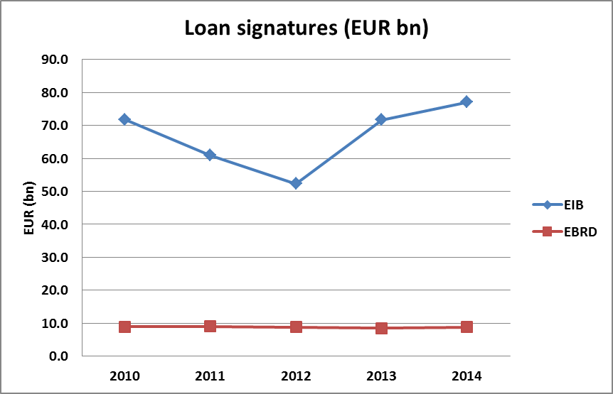 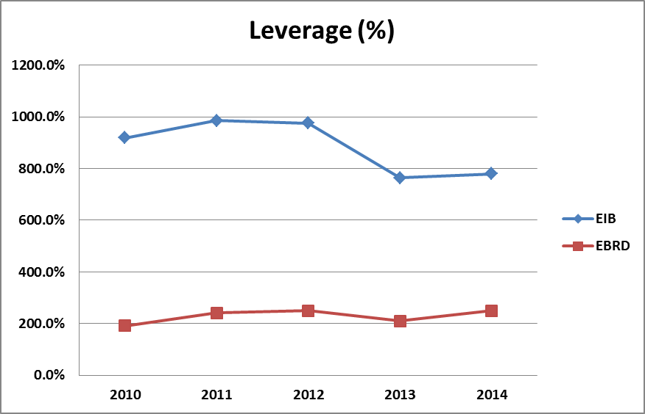

**Diagram 1: Loan signatures and leverage of EIB and EBRD**

In terms of loan origination of the two IFIs, the EBRD has very strong focus on direct lending (86% of its commitments, EUR 45 billion in absolute terms). Also the EIB Group finances most of its operations in a direct manner (72% of its commitments, EUR 67 billion in absolute terms). Besides, it can be highlighted that EIB's direct lending is focused on large projects with well-known and creditworthy counterparts.

The loan size is an aspect which differentiates EIB's and EBRD's lending model. For the period 2010-2014, for EBRD the average loan size was EUR 19 million per operation, while for EIB this was EUR 66 million per operation.

In terms of regional split (in total for the examined period), EBRD's lending in non-EU countries amounted to EUR 34.1 billion in the Region and EUR 9.6 billion in the EU-11, whereas EIB Group financing reached EUR 27 billion in non-EU countries of the Region and EUR 49.4 billion in the EU-11. The relative importance of EU-11 and non-EU countries on the total signatures of the two banks in the Region can be seen in the following chart:

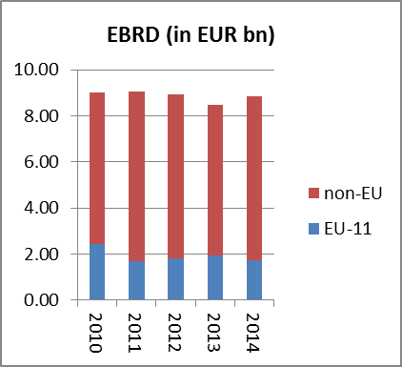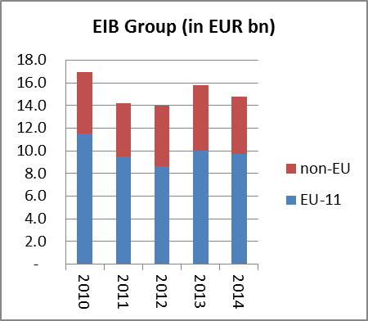

**Diagram 2: Total signatures of EIB Group and EBRD in the Region**

**4. ASSESSMENT OF THE EFFECTIVENESS OF THE INSTITUTIONS**

In order to assess the effectiveness of the existing system of IFIs in promoting investments in the Region, the following areas have been analysed (a more detailed analysis is presented in the attached SWD).

* ***Effectiveness in meeting market needs***: the analysis showed that the EIB Group and the EBRD have developed a broad array of different financial instruments and technical assistance that cover a wide range of market needs. However, a number of factors limit the effectiveness of their operations, as has been highlighted by the stakeholder consultation, such as insufficient development of the regulatory framework in the countries of operation or the fact that joint financial instruments have not managed to provide equity investments due to the additional complexity compared to intermediated loans.
* ***Other effects***: The positive externalities resulting from the operations of the two institutions can be considered as a very important element of enhancing the effectiveness of their interventions. These positive externalities are therefore part of the IFIs’ intervention logic. Positive effects of the two institutions' operations can be identified in various forms, notably:
  + Financial (including demonstration) effects that both IFIs have on the financial sector, in particular through structuring of new products and the identification of new types of beneficiaries. The financial effects are also obtained via support to open financial markets for private investors and the development of market economies, support for domestic capital markets and promotion of international financial and risk-related standards.
  + Economic effects such as the boost to employment, the impact on the real economy, skills upgrading or the promotion of international technical standards.
  + Social, environmental and governance effects. In particular, sectoral reforms and policy dialogue including changes to the legal and regulatory framework; corporate governance including tackling illegal capital flows and potential tax evasion; social performance; tackling climate change and energy efficiency; and improving environmental quality.
* ***Leverage of private financing***: The analysis of the data showed that the EIB Group and the EBRD manage to leverage private sector financing. However, their success in leveraging private funding varies across sectors, countries and the types of financial products and instruments provided.

The analysis also reviewed the relation between the two banks in terms of their ***cooperation***. It is important to highlight that the analysis showed that there is some form of exchange of information, coordination or cooperation between EIB Group and EBRD in almost all operations. This can be ascribed to the fact that there is a very dense network of formal and informal contacts between them at all levels, from the technical staff to the top level of management. The two institutions also strive to avoid duplication of work particularly in the project appraisal and due diligence procedures, in negotiations, financing and in monitoring jointly financed operations. The analysis also identified a number of formal and informal mutual reliance mechanisms which enable the coordination of actions between the EBRD and EIB Group, especially with regard to the exchange of information on projects and clients, joint monitoring and reporting.

Additionally, the analysis demonstrated an increased volume of co-financed operations in the areas where almost-perfect synergies have been identified in terms of sectors (i.e. municipal and environmental infrastructure, energy and transport). The EC plays a role in facilitating the communication and coordination between the EIB, the EBRD and peer institutions. This role could be further enhanced, by exploring *inter alia* the possibility for closer involvement of EBRD in the implementation of EU-funded financial instruments, to the extent allowed e.g. under shared management. However, co-financing or co-investment should not be considered as an objective in itself and should not be imposed in cases where the operation sizes are too small or in situations where private finance may be crowded out, where the financial products needed are not suitable to be provided by more than one IFI, or where the policy objectives of the IFIs are not perfectly aligned.

In terms of ***complementarities and comparative advantages,*** the analysis considered the following aspects: geographical focus, sectoral coverage, the nature of their beneficiaries and financial products provided. The analysis showed that the two IFIs as well as their peer institutions are aware of their comparative advantages - depending on the characteristics of the financial transactions, the types of the financial products and the features of the regional and national markets - and take them into account when screening potential operations and identifying cooperation opportunities.

**5. CONCLUSIONS AND RECOMMENDATIONS**

Based on the analysis above, the EC believes that the existing system of European public financing institutions in promoting investment in Europe and its Neighbourhood is effective: a wide range of market needs are being well served with significant positive effects, and accompanied by the efforts of the IFIs to leverage private financing.

The EC also recognises that the two institutions, the EBRD and the EIB Group, have distinct capabilities that stem from their specific know-how, business models and capital structures. They strive to avoid duplication of efforts particularly in the project appraisal and due diligence procedures, in negotiations, financing and monitoring of financed operations. Furthermore, on an institutional level, a formal information exchange resulting from regular operational and institutional meetings under the MoU framework were also observed.

The analysis also demonstrated that the two institutions co-finance on a project-by-project basis and through joint facilities or funds whenever it makes sense from an investment and policy perspective. This includes in particular large projects (e.g. energy, transport and municipal infrastructure) where the investment costs and risks are high and each institution can leverage its own comparative advantage, and operations where the two institutions' policy objectives and interests are perfectly aligned (again, energy, transport and municipal infrastructure projects can be mentioned but also projects with a focus on the positive climate change impact, such as energy efficiency and renewable energy projects, as well as operations that support the growth of SMEs).

Overall, it can be concluded that both IFIs are well aware of their comparative advantages in terms of their respective mandates, lending models and pricing policies and in general make good use of such comparative advantages.

Notwithstanding the overall positive conclusions, the EC makes the following recommendations (their rationale can be found in the SWD) in order to further enhance the effectiveness of the IFIs' interventions.

**Recommendation 1**

Although there is already an existing and close high-level inter-institutional dialogue in the framework of EU financial instruments[5], the EBRD and the EIB Group could still enhance the cooperation at operational level. The two IFIs should further build on existing synergies between their mandates, business models and the resulting comparative advantages in order to foster their cooperation, in particular when using EU resources in the blending frameworks. When cooperating, the IFIs should consider using a more standardised or systematic approach and minimise the creation of ad-hoc instruments. In those cases when they decide to cooperate with the EC and/or Managing Authorities of various Member States (including possible use of European Structural and Investment Funds 2014-2020 (ESI Funds)[6]), they should preferably use the existing structure of EU financial instruments and/or financial instruments under ESI Funds, including the so-called off-the-shelf instruments[7] where appropriate.

In order to further enhance policy impact and leverage, the EC should continue to play an important role in the funding, setting-up and oversight of joint facilities/funds without necessarily being directly involved in investment decisions or their management. In particular, through blending with EU grants, the involvement of the EC in setting up joint facilities/funds could be further promoted, especially to provide further value-added and to incentivise the cooperation of the two IFIs, although the EIB Group and the EBRD also cooperate without the involvement of EU funds.

Additionally, when using EU funds (including ESI Funds), the two IFIs should to the maximum extent possible build on the already existing reporting obligations at project level, including by the Financial and Administrative Framework Agreement concluded between the EC and EIB Group and the Framework Administrative Agreement between the EC and EBRD, when meeting the relevant reporting requirements for the EU and/ or ESI Funds. In this context, the administrative burden of any new reporting requirements should not become a disincentive for the participation of the private sector in the financing operations of IFIs.

At the same time, some economic effects are not covered by the IFIs' current reporting systems, as is the case for the EBRD regarding employment effects. This could be an area for further alignment of reporting approaches between the EC and the two IFIs, especially when they are using EU resources. Furthermore, both IFIs should improve and streamline how they report on the leverage effects as the analysis identified diverging methodologies for the calculation of leverage figures.

**Recommendation 2**

The analysis showed that there are many examples of mutual reliance, such as the exchange of information during appraisal procedures, sharing due diligence on jointly financed projects, an agreed protocol for procurement on co-financed projects and a multi-IFI understanding on reporting on Climate Finance. However, there may still be potential for enhanced mutual reliance especially in terms of joint contract negotiations, coordination and sharing of market assessments and (as stated above) further alignment of reporting requirements, in particular with EU objectives when EU resources are used. Nevertheless, due consideration has to be given to the differences in their mandates and policy standards that may limit the extent to which each institution can rely on the due diligence and appraisal performed by the other.

Furthermore, risk management considerations may also come into play and which might necessitate that, even when co-financing the same project, the two institutions perform separate diligence procedures, following their own appraisal processes in order to get their respective Boards' approval. As such, complete mutual reliance, especially recognition of procedures or standards does not appear to be the objective per se.

**Recommendation 3**

In light of the institutions' ongoing effort to ensure the *additionality* - in the case of EIB – or *transition impact* - in the case of EBRD, *quality* and *soundness* of their operations, both IFIs should further develop their financial and non-financial incentives as well as Key Performance Indicators, which would continue to strengthen the motivation of their staff towards the achievement of those objectives.

In that context, the EBRD's and the EIB Group’s lending objectives in terms of volume should be accompanied by ambitious targets for the additionality/transition impact, quality and soundness of operations. One important additional consideration in this regard is that the EBRD and the EIB Group should each strengthen their emphasis on the crowding-in of private financing.

The analysis showed that risk-sharing structures (such as junior/subordinated debt, mezzanine products, guarantees, equity, senior debt with higher risk profile) can be used to achieve a high level of private sector participation and should continue to be part of both IFIs' strategies to attract private financing. In appropriate circumstances (such as market failures or market makers), EU blending facilities could provide support in order to pave the way for more private sector financing.

Furthermore, there seems to be scope to also strengthen the motivation staff in both IFIs to maintain policy dialogue between themselves and with the EC, especially on EU policy priorities such as local economic governance, capital markets development, development of sustainable infrastructure etc – see also recommendation 6.

**Recommendation 4**

The cooperation between the two IFIs could be further increased through EBRD's involvement in the Investment Plan for Europe, a flagship EU initiative. EBRD could get engaged, in particular, via Investment Platforms which are foreseen by the European Fund for Strategic Investments (EFSI) Regulation[8]. The EBRD’s expertise and past knowledge in identifying viable projects, developing and bundling projects and attracting potential investors would be valuable for setting up Investment Platforms involving the EU-11 Region.

Investment Platforms aim to further leverage EU funds and to involve public financial institutions, including national promotional banks and institutions, and institutional investors and commercial financiers in the delivery of the EFSI. They can be designed in various forms so as to enable the provision of direct and indirect equity injections as well as guarantees for high-quality securitisation of loans and other products that are granted in pursuit of the aims of the EFSI.

**Recommendation 5**

The two IFIs should increase their efforts to pro-actively involve institutional investors such as pension funds and Sovereign Wealth Funds[9] (SWFs) in co-financing projects in infrastructure in their common countries of operation. SWFs, public pension funds and insurers have ample liquidity available for investments and are the most natural type of investors for long-term financing projects in areas such as infrastructure financing due to their requirement to match long-term liabilities.

This enhanced cooperation may in many instances require so-called "stratification of investors", which means that different classes of shares with different risk-return profiles and degrees of influence are issued within a single investment facility.

For example, the increased interest and expertise of European-based insurance companies and pension funds can be capitalized on. In this context, the EBRD and EIB Group could be encouraged to jointly develop projects with such entities. On the other hand, SWFs should only be engaged when they meet acceptable standards of governance and ensure alignment with the EU policies and legislation.

**Recommendation 6**

The EC should encourage the two banks to be instrumental, in particular, in the development of capital-based products and in policy dialogue. The EBRD could step up its engagement with the EC and countries of operation to deliver on mutually-beneficial policy initiatives. Within the EU-11 for example, both IFIs could assist national governments in developing policies which would help them move towards a common capital market in Europe, as promoted by recently-announced flagship initiative on a Capital Markets Union (CMU). This legislative initiative is in line with the EBRD and the EIB Group’s mandates to finance SMEs and infrastructure projects, to help attract private sector investments and develop an open, stable financial system facilitating access to finance for the private sector.

Finally, there is scope for both IFIs to further work with the EC on policy dialogue to define appropriate joint policy responses to regional and country-specific challenges through regular, structured exchange of policy analysis and discussion on strategies to promote common goals and priorities.

***

1. The Tripartite MoU aims to maximise synergies between the activities of the three partners in common countries of operation by supporting collaboration and cooperation between the two banks along the lines of their respective strengths, expertise and capacities.
2. Detailed description of the countries and definitions are provided in the Staff Working Document.
3. More details on how such transition takes place can be found in the SWD.
4. Leverage = total debt/shareholders' equity
5. As defined in Regulation (EU, Euratom) No 966/2012 of the European Parliament and of the Council of 25 October 2012 on the financial rules applicable to the general budget of the Union.
6. Regulation (EU) No 1303/2013 of the European Parliament and of the Council of 17 December 2013 (the Common Provisions Regulation - CPR).
7. See Article 38(3)(a) CPR. So far, the following off-the-shelf instruments have been adopted by implementing act: No 964/2014 of 11 September 2014: Risk-sharing loan and capped portfolio guarantee for SMEs and renovation loan for individual households.
8. Regulation (EU) 2015/1017 of the European Parliament and of the Council of 25 June 2015 on the European Fund for Strategic Investments, the European Investment Advisory Hub and the European Investment Project Portal and amending Regulations (EU) No 1291/2013 and (EU) No 1316/2013 — the European Fund for Strategic Investments.
9. Subject to compliance with the state aid rules.