

Delegations will find attached the above-mentioned document. [1]

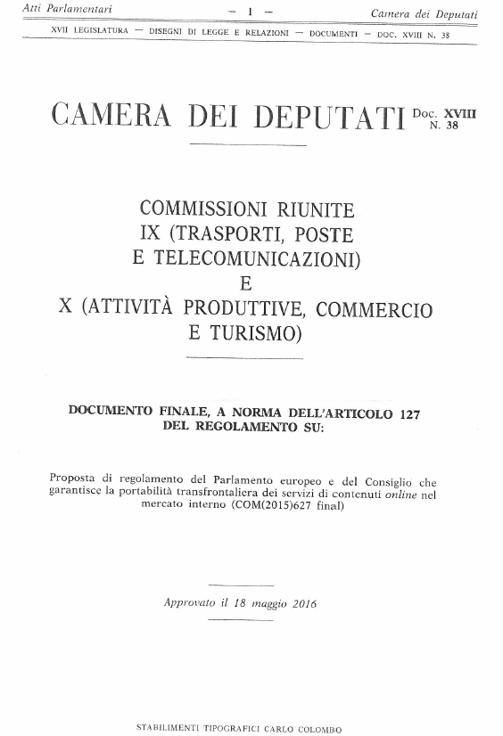

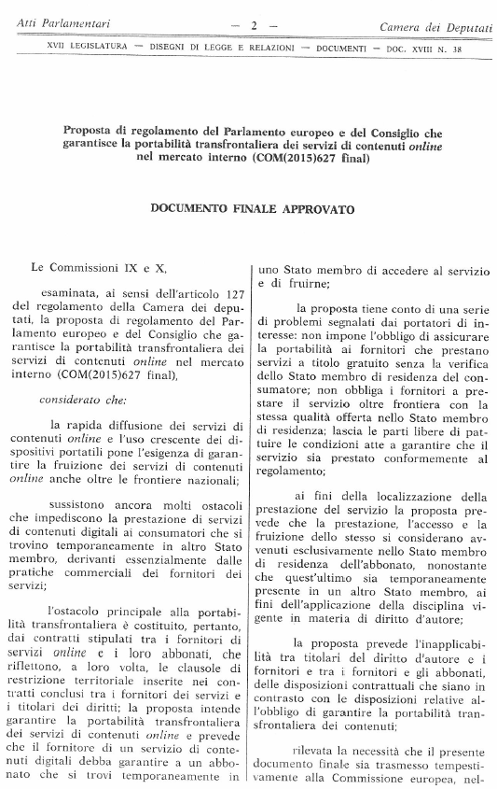

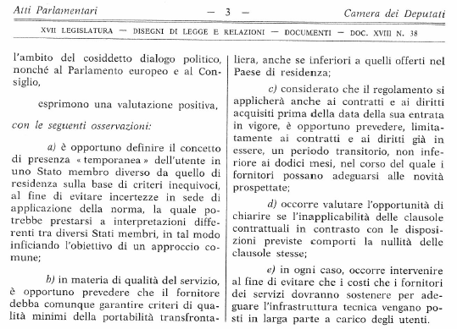

1. Translation(s) of the opinion may be available on the Inter-parliamentary EU Information Exchange website (IPEX) at the following address: <http://www.ipex.eu/IPEXL-WEB/dossier/document/COM20150627.do>