[1]



Delegations will find attached the above mentioned Opinion.

ANNEX

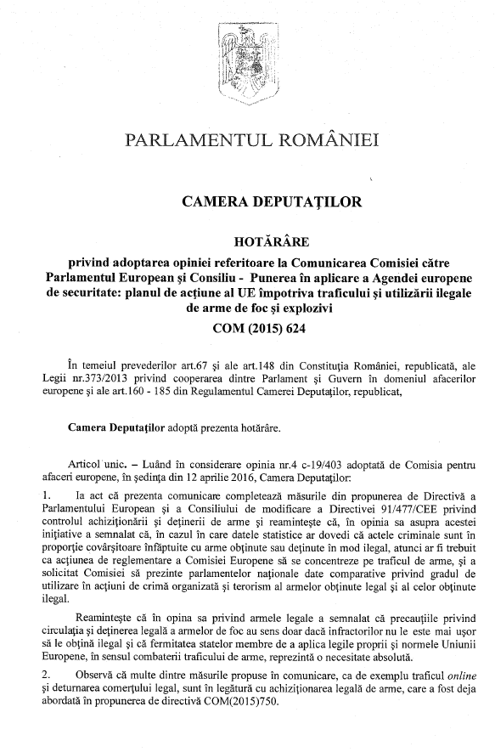

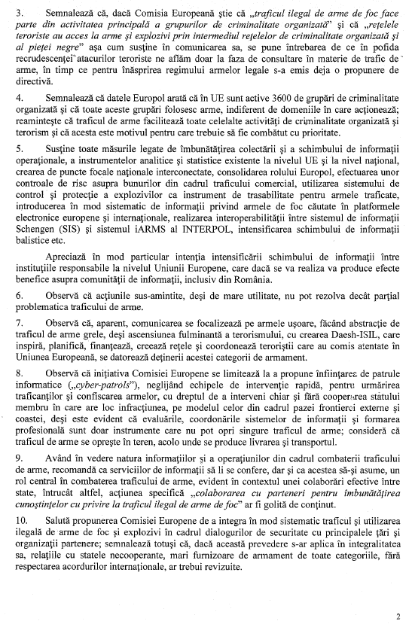

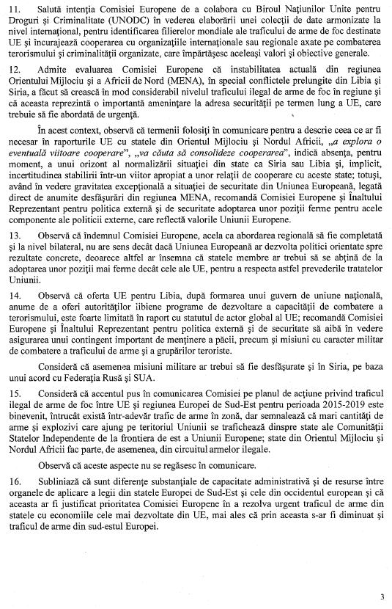

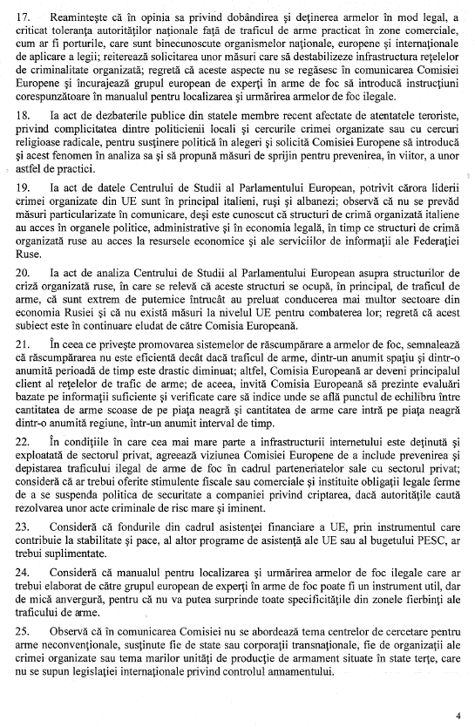

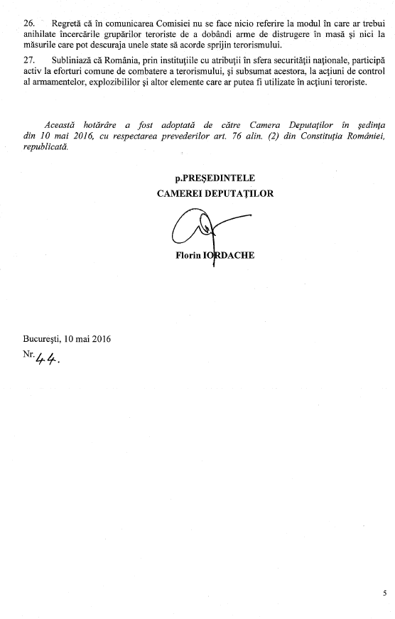

1. The translation(s) of the opinion may ba available on the Interparliamentary EU Information Exchange website (IPEX) at the following address: <http://www.ipex.eu/IPEXL-WEB/search.do>