[1]



Delegations will find attached a copy of the above mentioned opinion.

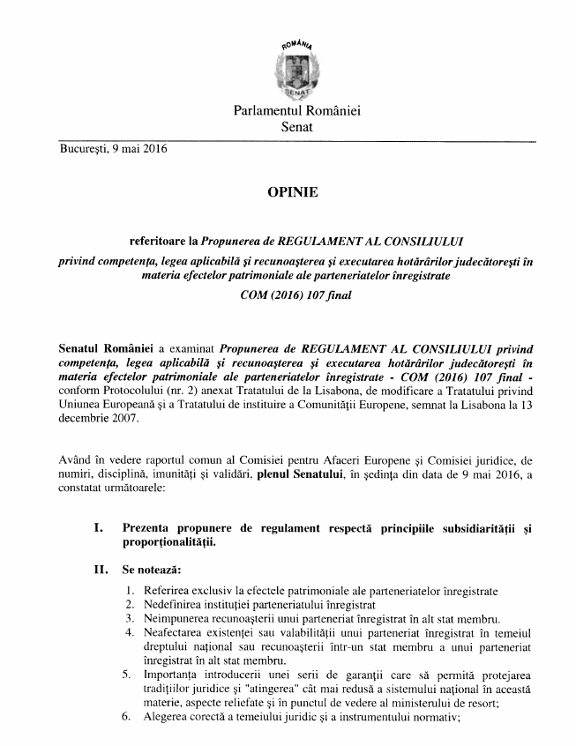

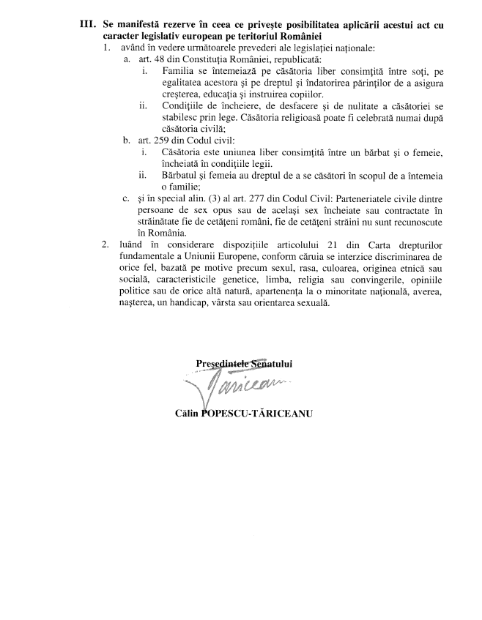

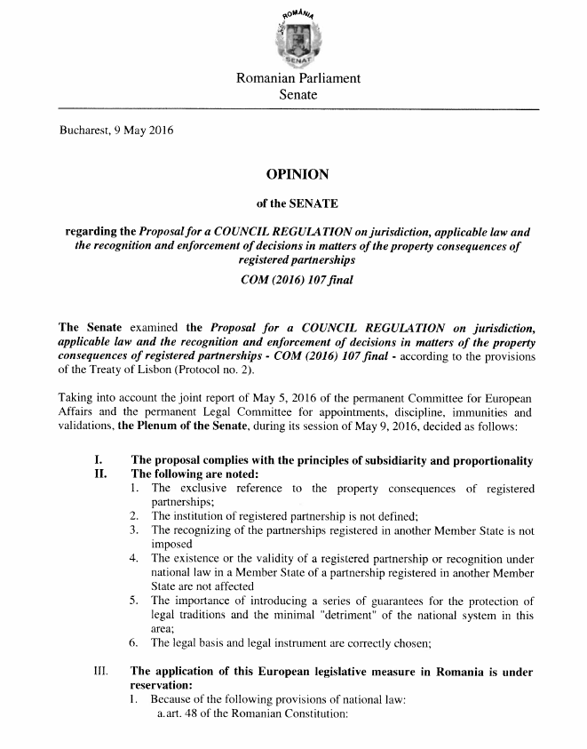

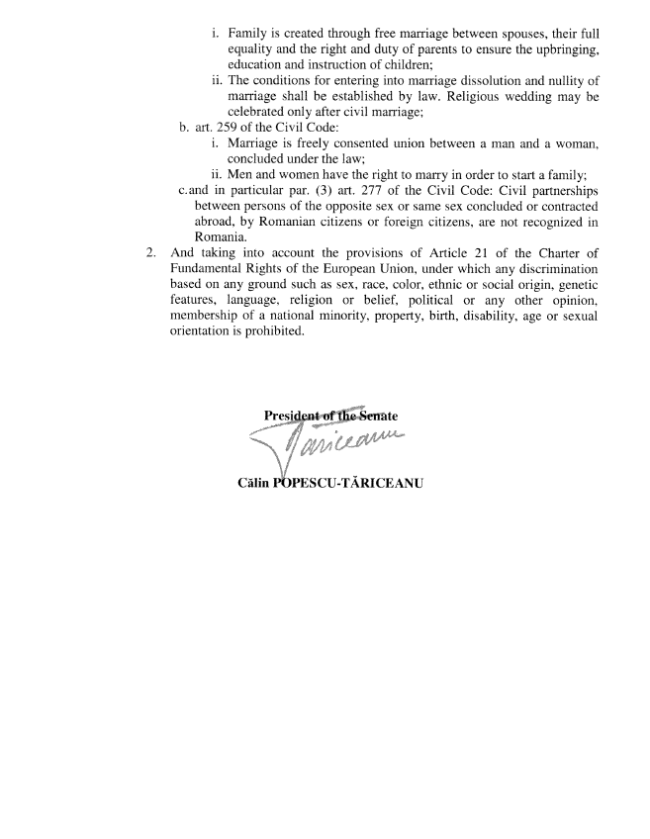

____________________

1. For other available language versions of the opinion, reference is made to the Interparliamentary EU information exchange Internet site (IPEX) at the following address: http://www.ipex.eu/IPEXL-WEB/search.do