[[1]](#footnote-1)



Delegations will find attached the above mentioned opinion.

\_\_\_\_\_\_\_\_\_\_\_\_\_\_\_\_\_\_\_

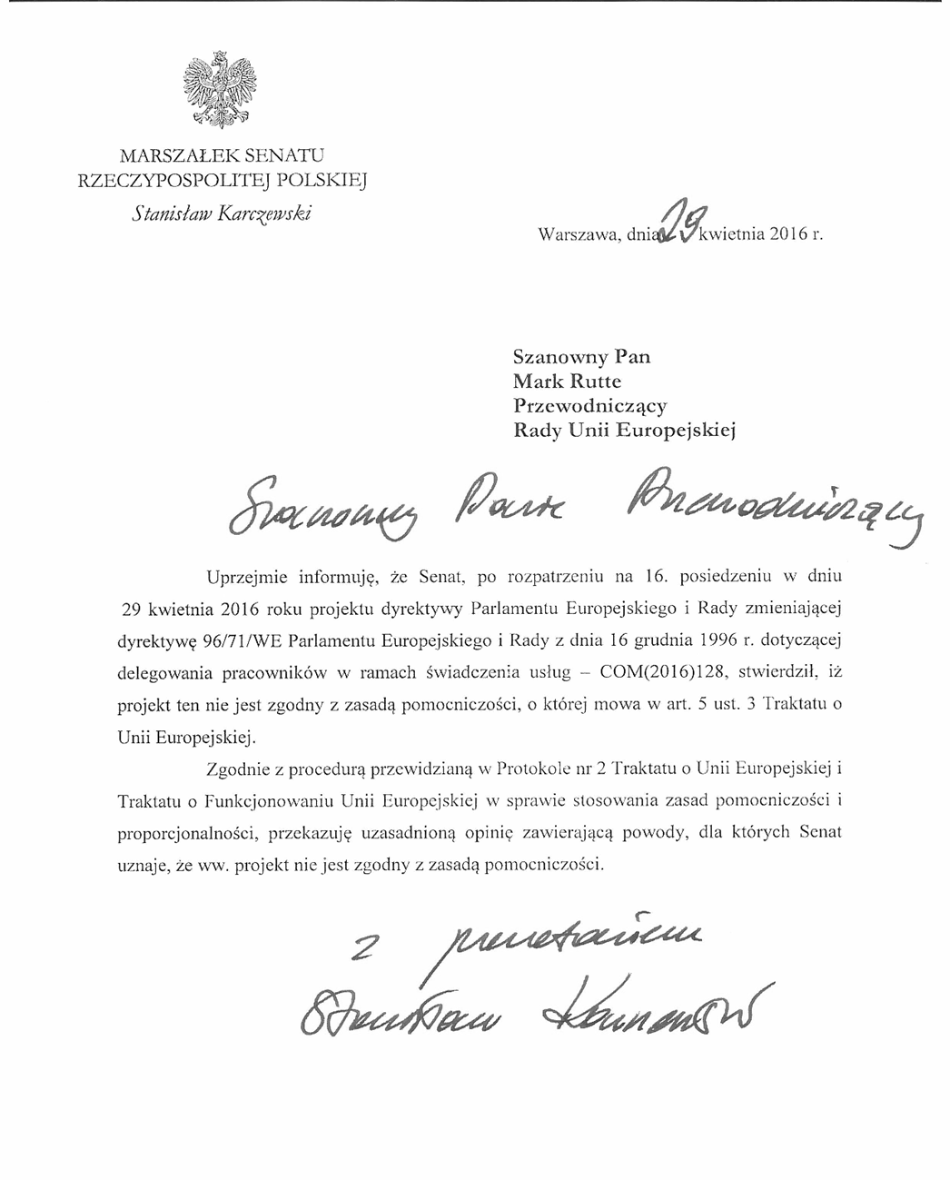

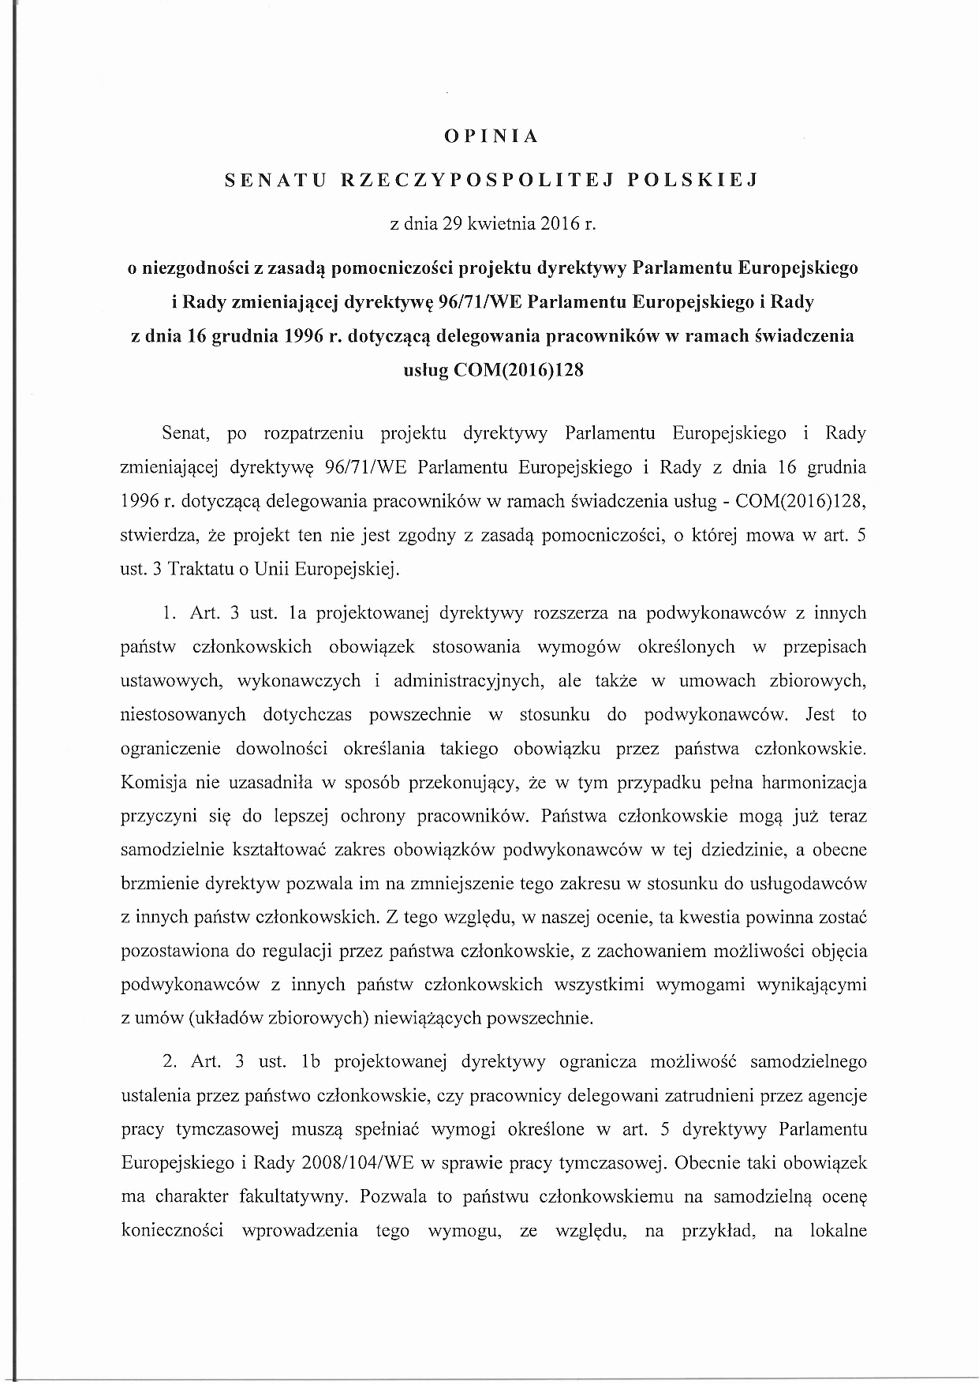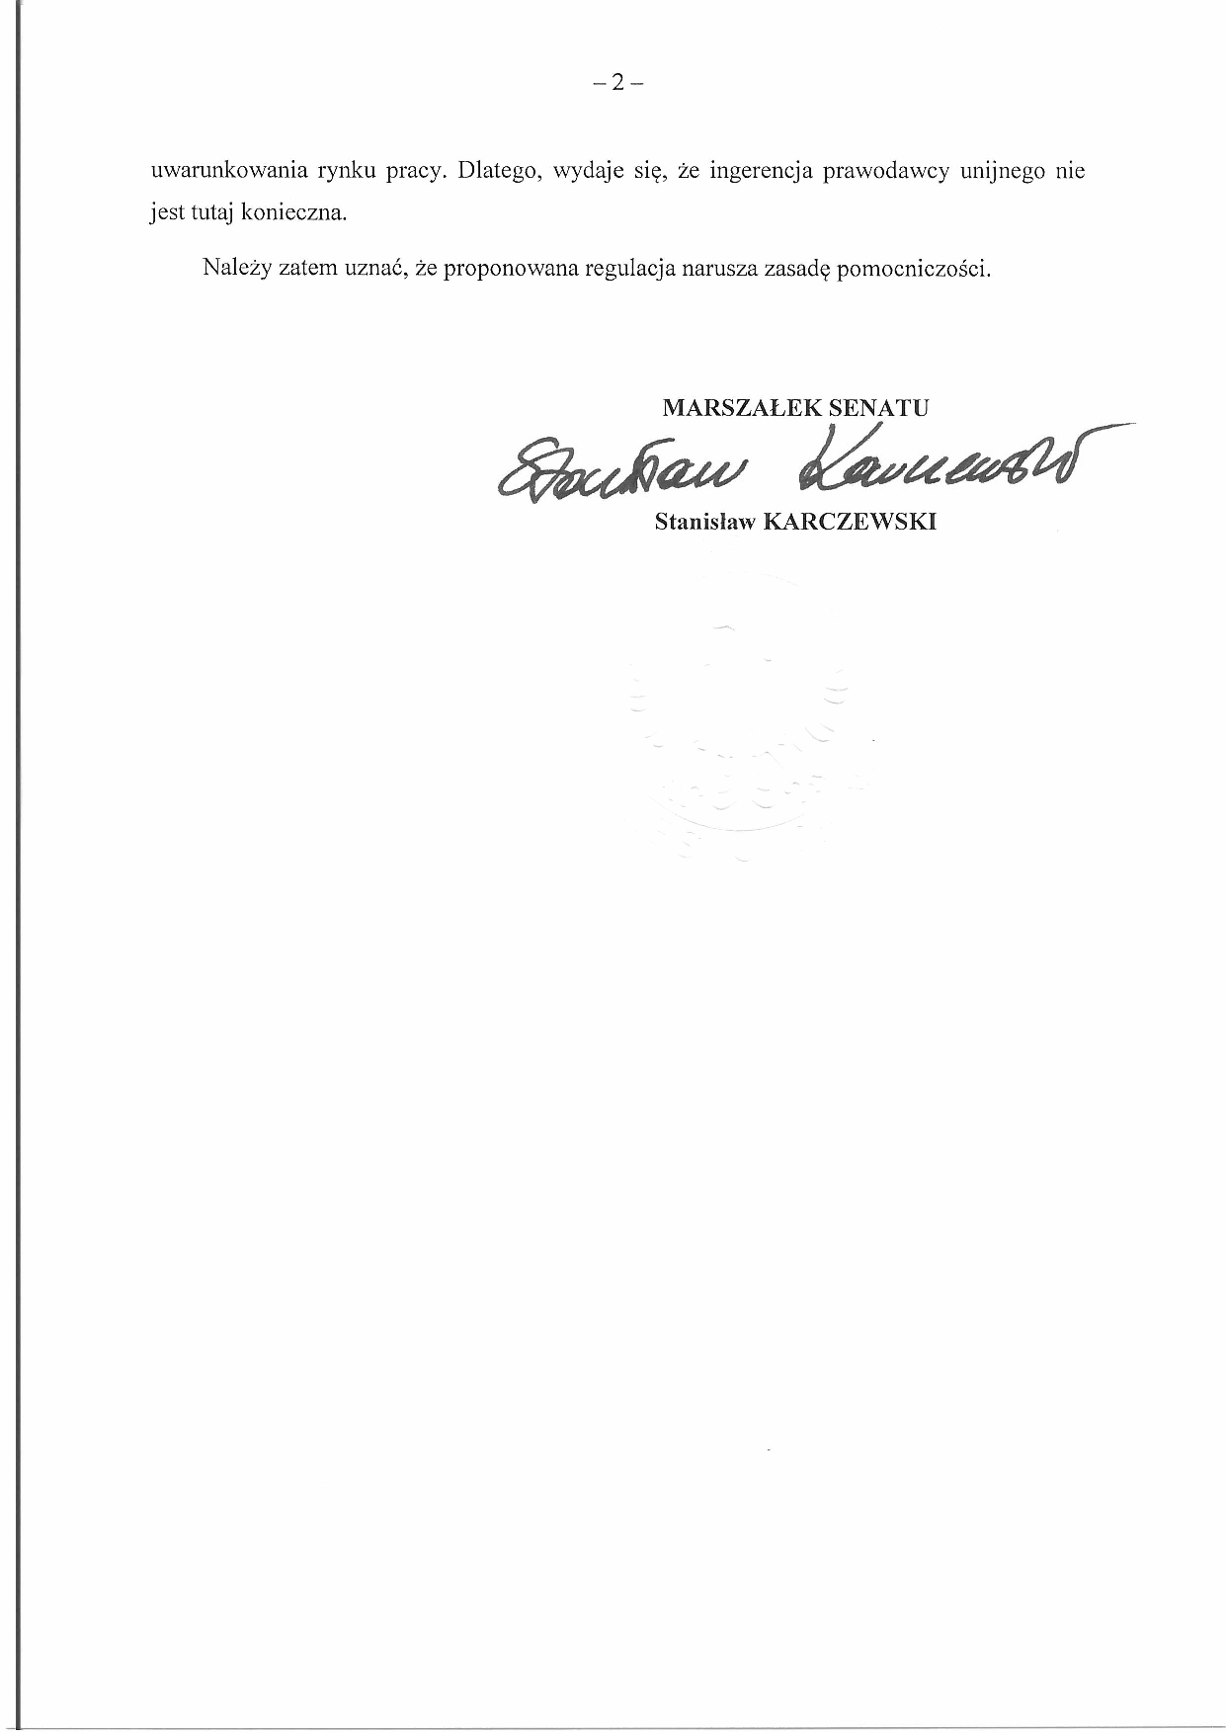

## Opinia_128_PL_Page_2*Courtesy translation*

I would like to inform that the Senate, at the 16th session held on 29 April 2016, examined the proposal for a Directive of the European Parliament and of the Council amending Directive 96/71/EC of the European Parliament and of the Council of 16 December 1996 concerning the posting of workers in the framework of the provision of services - COM(2016)128, and decided that the proposal did not comply with the subsidiarity principle, referred to in Article 5 para. 3 of the Treaty on European Union.

Pursuant to the procedure provided for in Protocol No. 2 of the Treaty on European Union and the Treaty on the Functioning of the European Union as regards the application of the principles of subsidiarity and proportionality, I hereby submit the Senate’s reasoned opinion stating that the above proposal does not comply with the principle of subsidiarity.

/-/ Stanisław Karczewski

*Courtesy translation*

OPINION

OF THE SENATE OF THE REPUBLIC OF POLAND

of 29 April, 2016

**on the incompatibility with the principle of subsidiarity**

**of the Proposal for a Directive of the European Parliament and of the Council amending Directive 96/71/EC of the European Parliament and of the Council of 16 December 1996 concerning the posting of workers in the framework of the provision of services**

COM(2016)128

Having considered the Proposal for a Directive of the European Parliament and of the Council amending Directive 96/71/EC of the European Parliament and of the Council of 16 December 1996 concerning the posting of workers in the framework of the provision of services (COM(2016)128), the Senate finds that the proposal is incompatible with the principle of subsidiarity as referred to in Article 5(3) of the Treaty on European Union.

1. Article 3 (1a) of the proposed Directive submits subcontractors from other Member States to requirements laid down in acts of law, implementing regulations, administrative provisions and collective agreements, to which subcontractors have not been submitted so far on a general basis.

This restrains the Member States’ discretion to establish such an obligation or not. The Commission did not convincingly justify that in this case full harmonisation would contribute to better protection of employees. At present, the Member States are free to decide on the scope of subcontractors' obligations in this field; the current wording of the directives allows them to reduce this scope in relation to service providers from other Member States. Therefore, in our opinion, this issue should be left to the Member States’ regulatory discretion, while providing for the possibility to submit subcontractors from other Member States to all requirements arising from agreements (collective agreements) which are not generally binding.

1. Article 3 (1b) of the proposed Directive restrains the Member States’ discretion to decide whether posted workers employed by temporary work agencies must meet the requirements specified in Article 5 of the Directive 2008/104/EC of the European Parliament and of the Council on temporary agency work. Currently, such an obligation is optional, which allows the Member States to assess by themselves if the introduction of such an obligation is necessary, for instance, due to the local labour market conditions. Therefore, it seems that the intervention of the Union legislator is not required in this case.

Therefore, we find that the proposed regulation is in breach of the principle of subsidiarity.

\_\_\_\_\_\_\_\_\_\_\_\_\_\_\_\_\_\_\_\_\_\_

1. For available translations of this opinion see the interparliamentary EU information exchange site (IPEX) at the following address: http://www.ipex.eu/IPEXL-WEB/dossier/document/COM20160128.do [↑](#footnote-ref-1)