[1]



Delegations will find attached the above mentioned opinion.

___________________

Encl.: […]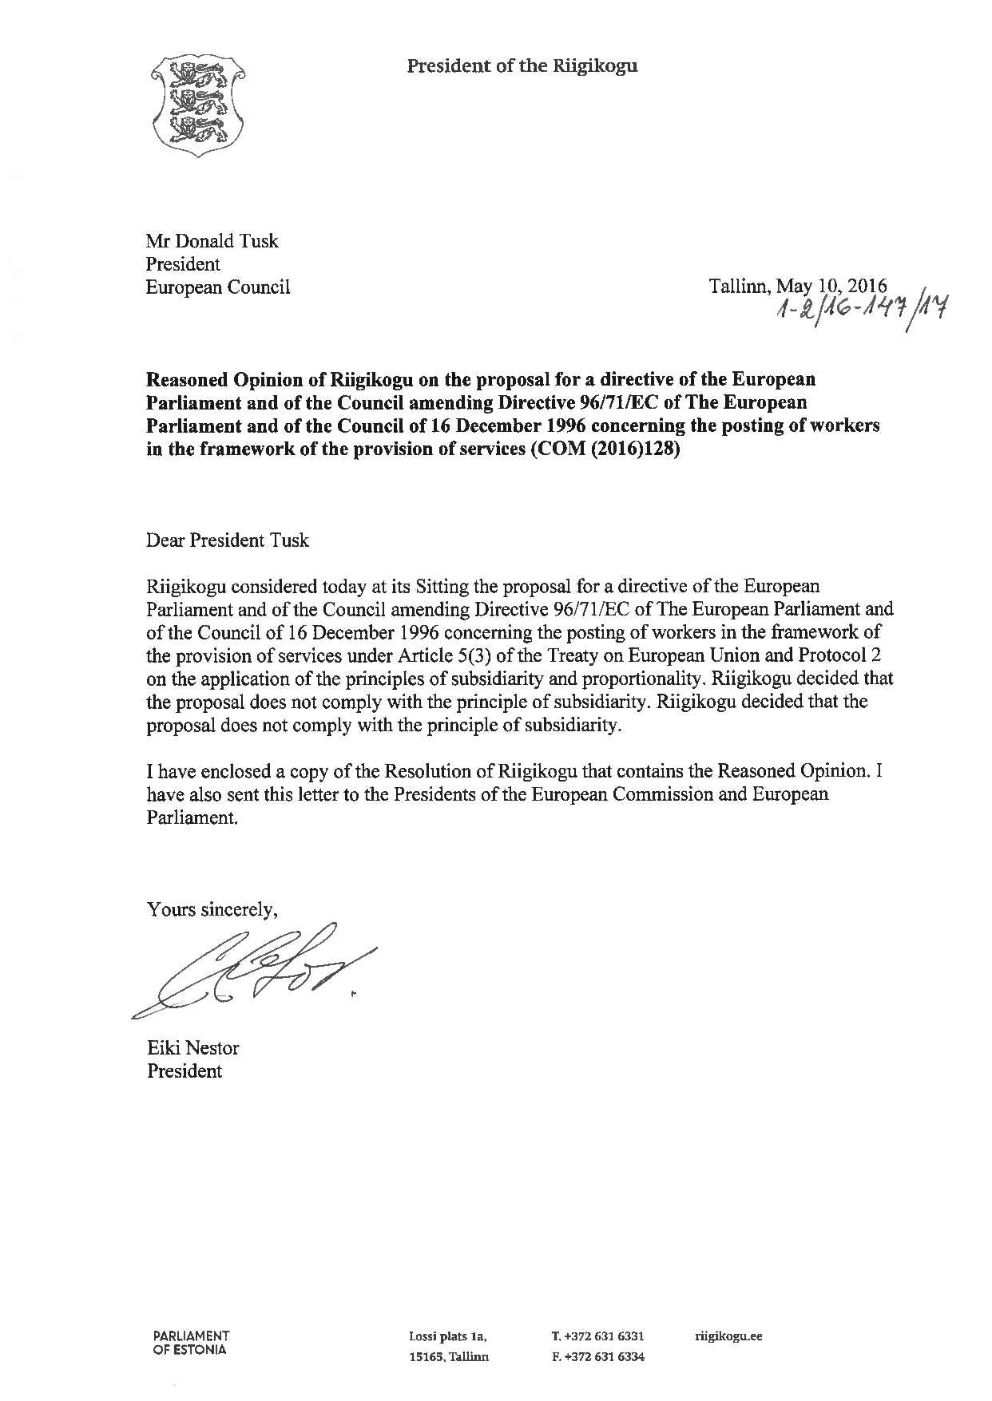²

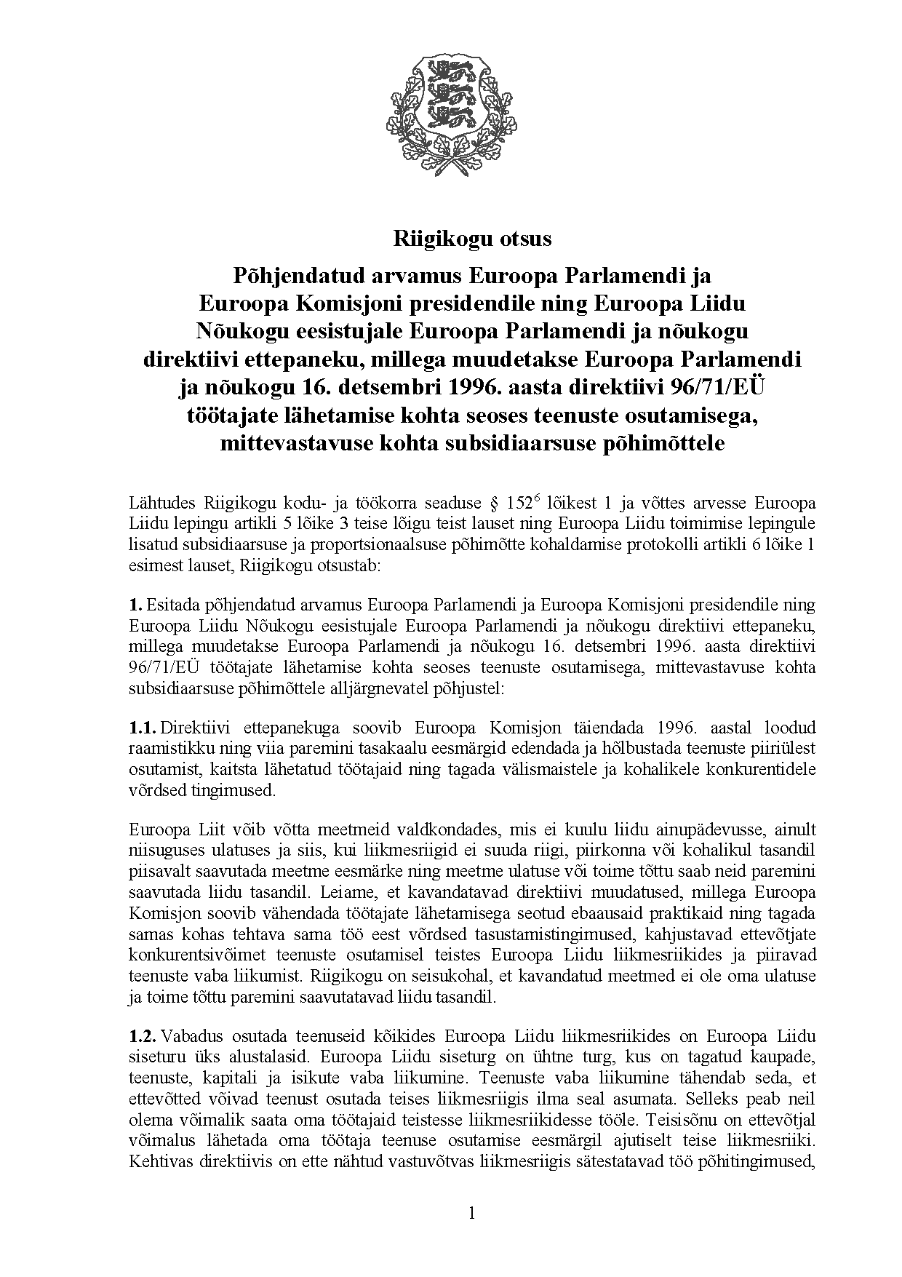

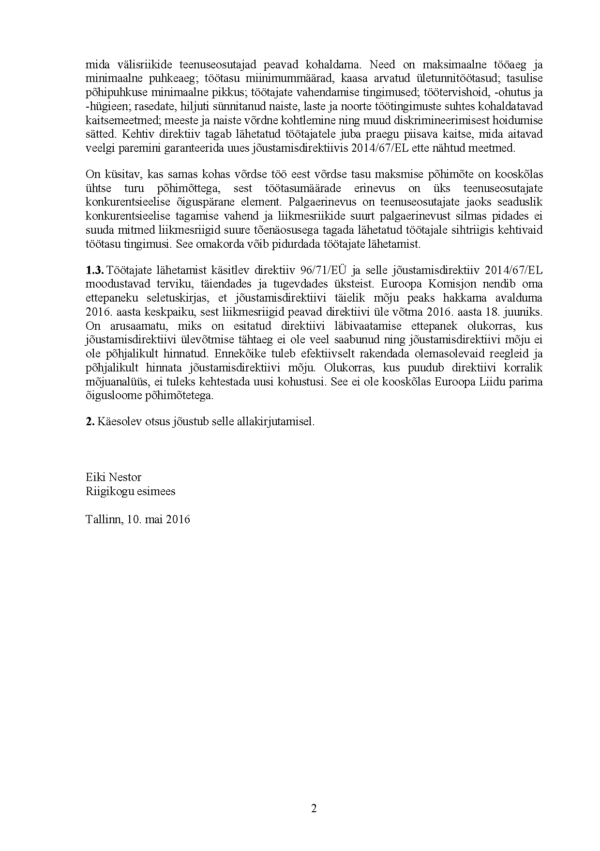

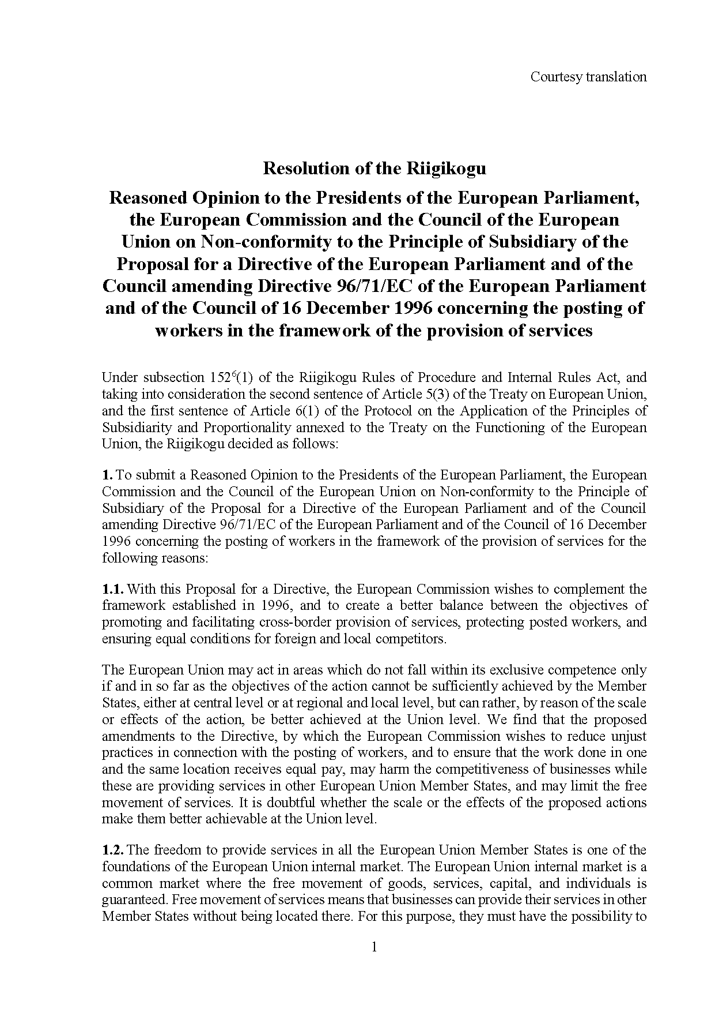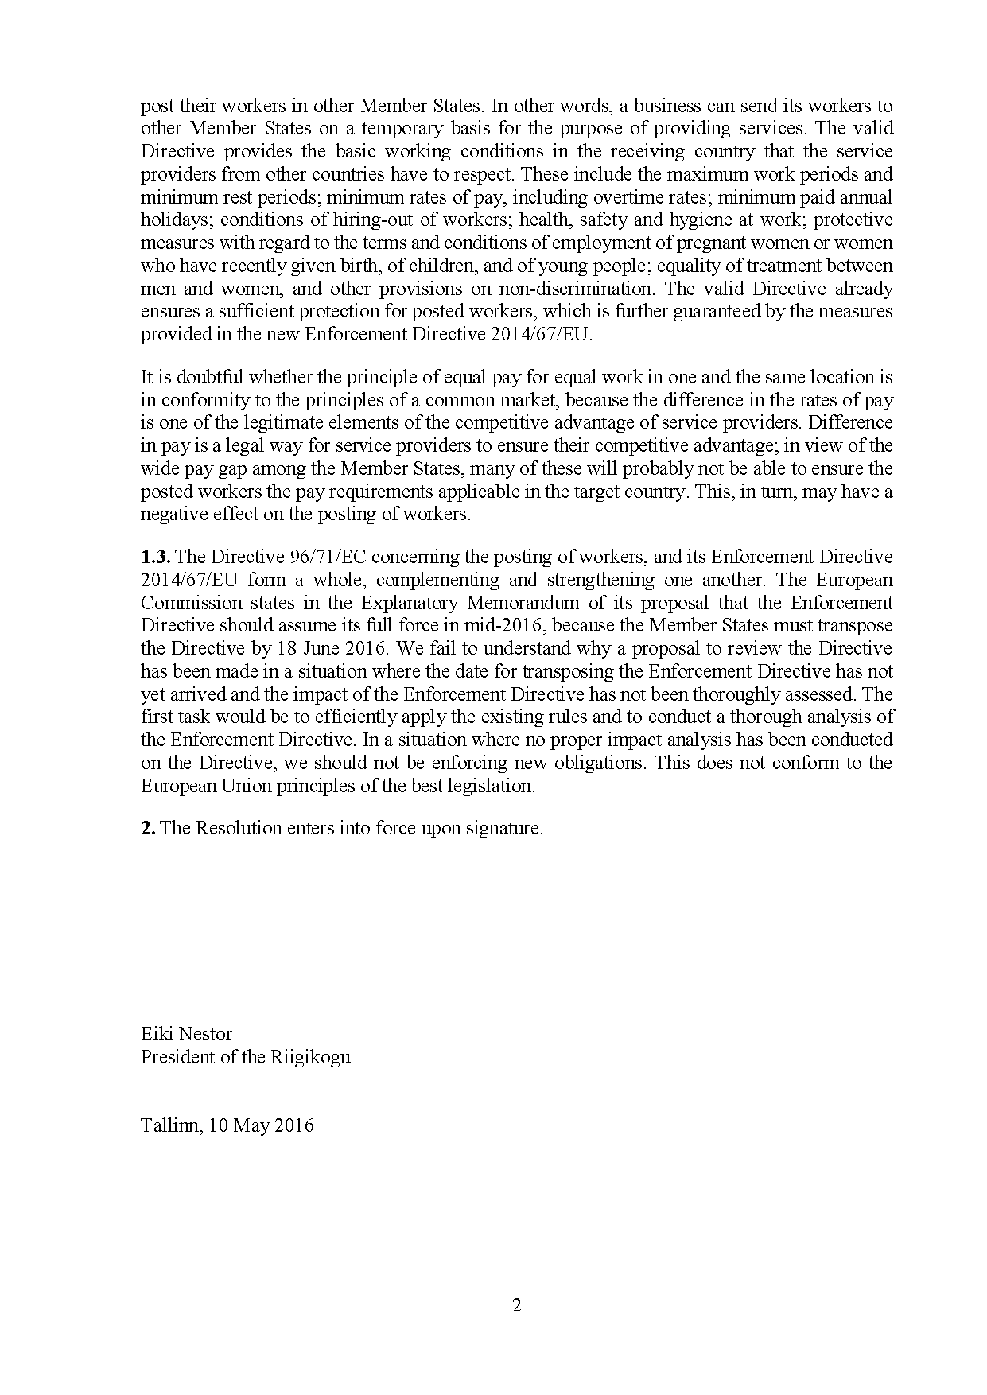

1. For available translations of this opinion see the interparliamentary EU information exchange site (IPEX) at the following address: http://www.ipex.eu/IPEXL-WEB/dossier/document/COM20160128.do