

## Introduction

Adopted in 2009 as part of the Climate and Energy package, Decision No. 406/2009/EC[1] (also called the Effort Sharing Decision, ESD) establishes greenhuse gas (GHG) emission limits for all Member States for 2020. It covers emissions in the transport, buildings, agriculture, small industry and waste sectors. These sectors accounted for more than 55% of total EU GHG emissions in 2013.[2] The objective of the ESD is to reduce GHG emissions in the EU by 10% by 2020 compared to 2005 and promote reductions of GHG emissions within its scope in a fair and cost-effective manner. The ESD entered into force in June 2009.

This report fulfils Article 14 of the Effort Sharing Decision which requires the Commission to draw up a report evaluating the implementation of the ESD and submit it to the European Parliament and to the Council by 31 October 2016. It presents how the Effort Sharing Decision has performed so far and what lessons can be learned with respect to actions taken by Member States to limit greenhouse gas emissions in the sectors covered by the Decision, and the effect on their national emissions. The results of the evaluation are presented in more detail in the Commission staff working document accompanying this report.[3]

While the first year of reporting by Member States under the Decision was 2015, at the time of the evaluation, most of the provisions of the Decision had not yet been applied, making it more difficult to draw conclusions about their appropriateness and to consider any changes based on lessons learned. However, the evaluation could use valuable evidence deriving from the process of legal implementation of the Decision and the preparatory work undertaken by Member States.

## Background

The Climate and Energy Package sets targets for 2020, requiring a 20% reduction in its greenhouse gas emissions from 1990 levels, a 20% share of EU final energy consumption from renewable sources, and a 20% improvement in its energy efficiency.

The 20% GHG emission reduction target for the European Union by 2020 compared to 1990 is equivalent to a 14% reduction compared to 2005. This effort has been divided between the sectors covered by the Emission Trading System (ETS) and sectors under the ESD. In the EU ETS emissions are required to decrease by 21% relative to 2005 levels, while from sectors in the ESD a 10% reduction relative to 2005 is required.

To share the required EU-wide effort of 10 % GHG emission reduction by 2020, national targets for 2020 were set for Member States according to economic capacity on the basis of their relative wealth (measured by 2005 Gross Domestic Product per capita) They range from a 20% emissions reduction by 2020 (from 2005 levels) for the richest Member States to a 20% increase for the least wealthy one. (See Figure 1).

The ESD does not set specific emission targets for the individual sectors covered by the ESD, but leaves it to Member States to choose where and how to achieve the necessary reductions. Emissions and removals from LULUCF are not included in the ESD.

To meet their commitments Member States are supposed to limit their greenhouse gas emissions in the sectors covered by the ESD, and they are expected to implement national policies and measures to fulfil their obligations. Member States can also apply flexibility instruments to meet their obligations and enhance cost-effectiveness, if needed.

The ESD also defines a linear trajectory of corresponding binding emission limits (annual emission allocations, AEAs) for each year from 2013 to 2020. Progress towards the 2020 targets is ensured through annual reporting obligations and compliance checks. Member States are obliged to report on their greenhouse gas emissions and projected progress towards meeting their ESD obligations.

Member States are responsible for implementing policies and measures to meet their obligations under the ESD and are supported by a number of EU measures[4], some of which also are expected to help achieving the EU’s 2020 renewable energy and energy efficiency targets. These supporting EU policies are important to stimulate EU-wide emission reductions in the sectors under the ESD. But it is clear that emission reductions have to be delivered through national policies and measures, in particular in sectors such as transport and buildings.

Figure 1: Member State greenhouse gas emission limits in 2020 under the ESD

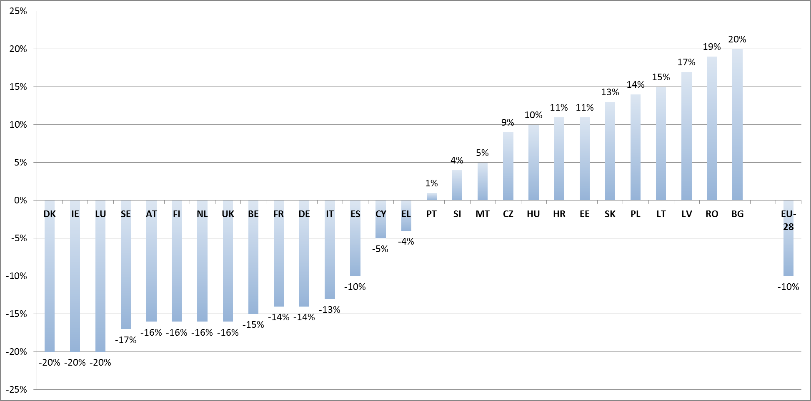

Emission limits in 2020 are set in relation to 2005 emission levels. Source: Decision No. 406/2009/EC.

In order to provide for flexibility for Member States in implementing their commitments and as a means to enhance the overall cost-effectiveness of reaching the EU-wide 2020 target, the ESD provides a range of flexibility instruments. These concern Member States’ possibilities to manage their own AEAs within the compliance period and engage in transfers of AEAs among each other. Should a Member State’s GHG emissions exceed its AEAs for a given year, then it can borrow 5% of its AEAs from the next year or buy AEAs from other Member States or use international project credits in order to meet its annual limits. Should a Member State reduce its emissions by more than needed, thus overachieving its target for a given year, it can keep the surplus AEAs for later use within the commitment period or transfer it to other Member States.[5]

The ESD has an annual reporting and compliance cycle consisting of Member States reporting their GHG emissions in national inventory reports, emissions inventory reviews to validate the reported emissions, and compliance checks (i.e., comparing the actual emission of Member States with their annual emission allocations for a given year). If a Member State's emissions exceed its annual emission allocation, even after accounting for flexibility instruments, they will be subject to certain penalties and have to take corrective measures.

## Scope and method of the evaluation

The evaluation of the Effort Sharing Decision was performed in 2015 by the Commission and was guided by a steering group consisting of members from the concerned directorate-generals in the Commission. The European Environment Agency also participated in this group. The evaluation was supported by an external study of the implementation of the Effort Sharing Decision.[6]

The evaluation explored the impacts of the Effort Sharing Decision both at EU and Member State level with a focus on actions in Member States from 2009 onwards to meet their ESD obligations. It covered the period from when the ESD entered into force in June 2009 to November 2015. In accordance with the requirement in Article 14 of the ESD, the scope of the evaluation included all the provisions and requirements of the Decision, including how the implementation affected competition.

The evaluation assessed the relevance, effectiveness, efficiency, coherence and EU value added with respect of ESD implementation so far. It used evidence from reported emissions and emission trends, adopted policies and measures, as well as questionnaires and structured interviews with Member State experts and other key stakeholders involved in implementing ESD on national level.[7] It also drew on the results of a public consultation on the preparation of a legislative proposal on reducing Member States’ GHG emissions in sectors under the ESD from 2021 to 2030.[8]

The results of the evaluation were used when preparing the impact assessment accompanying the legislative proposal the Commission to continue ESD after 2020 within the 2030 Climate and Energy Framework.

## Implementation - State of play

The ESD is still in an early stage: most reporting requirements for Member States under the ESD occurred for the first time in 2015, and the compliance check for the first two years of the compliance period (2013-2014) is due in 2016. However, thanks to existing annual reporting of emissions it is possible to discern the main emission trends in Member States and on EU level.

Under the ESD, Member states must each year report their GHG emissions. They must also, every second year, report on their implemented national policies and measures and submit updated projections in 2015 with expected progress to their 2020 targets. Each year the Commission compiles the information reported by Member states and publishes a progress report where it analyses and presents Member States’ progress towards their 2020 ESD targets. An assessment of Member States’ progress towards their targets is also part of the European Semester country report published by the Commission every spring. Emission trends and projections in the EU and its Member States are also published each year by the European Environment Agency which assists the Commission with the implementation of the ESD.

Member States have so far fulfilled their reporting obligations and the exchange of information with the Commission is working well. The Commission and Member States expert meet several times every year in working groups under the Climate Change Committee to follow up the implementation of the reporting obligations under the ESD.

Total emission reductions between 2005 and 2013 were achieved in all sectors, ranging from -3 % in agriculture to -25 % in the waste sector. (Figure 2) In this period there was also a convergence of GHG emission intensities across Member States, both per capita and per GDP.

ESD emissions per Member State have also decreased significantly since 2005. In all Member States ESD emission were below their annual limits in 2013 and 2014.[9] Overachievements were typically larger in those countries that were allowed to increase emissions compared to 2005. Countries that experienced a particularly severe economic recession (e.g., Greece, Portugal and Spain) also had emissions significantly below their 2014 limits.

**Figure 2: Achieved EU-wide ESD emission reductions 2005-2013**

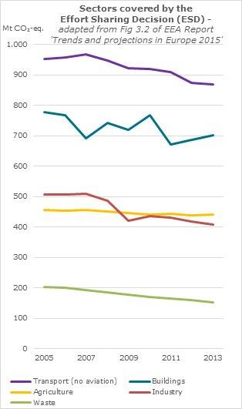

According to Member State projections submitted in 2015, total ESD emissions are expected to keep decreasing until 2020 (Figure 3), continuously being below target at the EU level. 24 Member States are projected to meet their national targets domestically, while four Member States are expected to need additional measures or use flexibility instruments within the ESD to reach their targets.[10]

So far, no Member State has used any of the flexibility instruments provided in the ESD as all countries appear to be meeting their annual emission limits for the first two years of the compliance period. In the future it can be expected that flexibility instruments, such as trade with other Member States, will be used by some Member States that are projected to emit above their limits by 2020. Although the flexibility instruments under the ESD are untested they remain widely supported and were further endorsed by Member States in the stakeholder consultation.

Figure 3: Actual and projected total ESD emissions 2005-2020

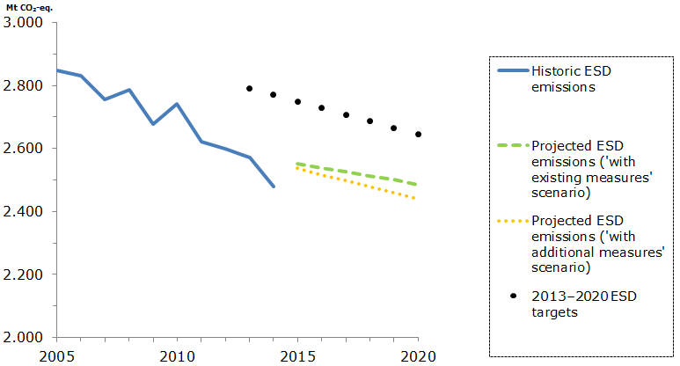

Source: EEA (2015) Trends and projections in Europe 2015, updated with March 2016 emission inventory figures. The black dotted line represents the linear trajectory of the annual emission limits under the ESD for the period 2013-2020.

## Results of the evaluation

In accordance with the Commission’s evaluation guidelines, the evaluation assessed the relevance, efficiency, effectiveness, coherence and EU added value of the Effort Sharing Decision. It also examined whether there were any effect on competition as this was a requirement of Article 14 in the ESD.

### 5.1 Relevance

The objectives of the ESD remain relevant, and still correspond strongly with the needs of the EU. In particular, there remains a need to continue to limit anthropogenic GHG emissions, and put in place appropriate mechanisms to reflect the full social cost of climate change. The ESD remains relevant also for addressing market failures as the binding nature of the Decision helps to provide appropriate price signals for emissions abatement*.*

The European Council Conclusions in October 2014 on the 2030 Climate and Energy Policy Framework confirmed the importance of the ESD and of its continuation to 2030 with all the elements as applied in the Effort Sharing Decision for 2020.

The adoption in December 2015 of the Paris Agreement confirms the commitment at the highest level of the EU to implement domestically steep greenhouse gas emissions reductions also for 2030 and beyond. As laid down in its intended nationally determined contribution (INDC), the EU commits to cut emissions in its territory by at least 40% below 1990 levels by 2030.

### 5.2 Effectiveness

The EU is on track to meet its 2020 GHG emissions reduction target in the ESD sectors. Based on Member States’ reports submitted in 2015, GHG emissions in 2013 and 2014 in all Member States were below their annual limits for these years. Total 2013 emissions covered by the ESD at EU level were 9.7% lower than the 2005 emissions. In 2014 EU emissions covered by the ESD further decreased to a level 12.9% below 2005 levels, which was below the EU-wide ESD target for 2020. This means that the EU is on track to meet its ESD target in 2020 and that all Member States have contributed to the reduction in GHG emissions.

The achieved emission reduction represents a large improvement in performance relative to the business-as-usual scenario when the 2020 targets were first agreed. Emission reductions have so far been much deeper than expected in 2007 when the European Council agreed on the overall EU climate targets for 2020 and the Commission performed the impact assessment of the Climate and Energy Package. According to the business as usual scenario in that impact assessment, EU-wide ESD emissions were expected to increase by 2.4% between 2005 and 2020.[11]

The economic recession has also had an effect on GHG emissions in some ESD sectors to date (especially freight transportation), and these effects are expected to resonate until 2020. However, many sectors (such as buildings and agriculture) covered by the ESD are not directly impacted by the fluctuations in GDP and are more prone to policy influence which gives reasons to conclude that some of the GHG reductions in the ESD sectors can be attributed to policy interventions at EU and Member State level.

In other words, the achieved emission reductions can be in part attributed to climate and energy policies and measures that have already been implemented by Member States (of which some have been in response to the ESD) and are expected to continue limiting emissions in future years.

This observation is further supported by a decomposition analysis that was carried out for the 2005-2012 period covering CO2 emissions from fossil fuel combustion, which account for about 80 % of total GHG emissions, in both ETS and ESD sectors. The analysis concluded that technological changes contributed most to drive down emissions, by far outweighing the contribution of the shift within and between economic sectors, and by far overcompensating GDP related emission drivers in times of economic crisis.

The results showed that CO2 emissions decreased overall by 11.5 % between 2005 and 2012. Technological changes had the most significant effect on driving down emissions, leading to an 18.5 % decrease and by far outweighing the contribution of the shift between economic sectors. Overall, the policies implemented in the field of climate and energy contributed significantly to the take-up of less carbon-intensive technologies, including renewable energy. Growth in economic activity (GDP) caused a 6.8 % increase in emissions. Structural changes in the economy (at constant GDP and CO2 intensity in every economic sector) caused a small increase in emissions, by 1.7 %.[12]

It was not possible to quantify the extent to which the observed trend in historical emissions, and the expected future emissions trends, can reasonably be credited to specific policies. In particular, it is difficult to isolate the impact of the ESD on national climate and energy policies, and from other EU-wide initiatives under the Climate and Energy Package, which have a more direct impact on the different drivers of emissions.

While some stakeholders considered that the ESD has been an important driver for new national policies and measures in certain Member States, others considered that the ESD may have had little or no influence on national policy developments so far. The level of influence of the ESD also appears to vary by Member State, which may reflect the different situation of Member States in relation to their ESD targets, i.e. whether they need to take further action or not.

The evaluation of the ESD showed an increase in the implementation of national policies in the ESD sectors in most years starting from 2007, when the European Council agreed on the overall EU climate targets for 2020. Without the ESD, actions to mitigate emissions in the ESD sectors at Member States level may not have been taken, or may have been taken at a slower pace.

**5.3 Efficiency**

The costs and benefits due to the implementation of measures in ESD sectors are hard to quantify, as a direct link between many national climate and energy policies and emission reductions in sectors under the ESD so far is difficult to establish. This is also due to the fact that policies and measures reported by Member States provide insufficient information on their expected and actual costs and benefits.

The main benefit associated with the ESD relates to the GHG emissions reductions in the sectors covered by the Decision. In addition to any direct costs, the implementation of the ESD has potentially also delivered a number of economic co-benefits, such as improvements in air quality and energy security.

Another more qualitative benefit of the ESD is that it helps Member States in setting up institutional frameworks, targets and data collection and reporting procedures for reducing emissions in the ESD sectors. This benefit is more apparent in those Member States where the policies reducing emissions in these sectors are devolved to a regional level.

Costs from the implementation of the ESD come from two main sources – implementation of policies and measures in relevant sectors and ESD reporting.

With respect to reporting costs, the ESD was found to deliver the outcomes efficiently, although there may still be some opportunities for reducing administrative burdens. Costs related to reporting and compliance are modest and mostly fall on the Commission and the European Environment Agency. There was no major variation apparent between Member States. There may be opportunities for reducing administrative costs at EU level, for example by simplified or less frequent compliance controls.

With respect to the flexibility instruments provided by the ESD, three Member States indicated that they were planning to purchase AEAs from others, whereas ten Member States intended to sell AEAs. The low demand for such transfers might be due to the fact that the ESD is still in the early years of the implementation and that there might be other drivers, not investigated by the evaluation, that would prompt Member States to prefer the implementation of domestic actions rather than buying AEAs from other Member States.

### 5.4 Coherence

Evidence from stakeholder interviews, and to a lesser extent the literature review, suggests that the objectives of the ESD are largely coherent with other EU climate and energy policies, such as the ETS, energy efficiency and renewable energy. Stakeholders identified a strong coherence with the EU objectives relating to energy efficiency and renewable energy, although some stakeholders queried the coherence of the targets themselves.

By providing flexibility as to how Member States deliver their emission limits, the objectives of the ESD was found to be largely coherent with national policy making.

There is a potential lack of coherence between the ESD and other interventions in relation to agriculture and land use, land use change and forestry (LULUCF). Part of the issue with coherence relates to other international commitments, rather than coherence with EU policies; agriculture is included in the ESD and Kyoto Protocol, while LULUCF is in the Kyoto Protocol but not the ESD.

Coherence with other reporting obligations was also identified as strong especially with EU internal and international reporting requirements. However, streamlining opportunities of reporting obligations under the ESD and under EU energy-focused legislation were identified.

### 5.5 EU added value

For a large majority of EU Member States there were no or only weak domestic policy drivers before the ESD, which suggests that without the ESD the actions may not have been taken, or may have been taken at a slower pace.

The evaluation indicated that those Member States having more ambitious GHG targets than the ones under the ESD enshrined in their own national legislation may have taken action anyway in response to those national laws. However, this does not take into account the fact that the discussions around the EU 2020 targets may have helped support the setting of national targets in the first place, by providing certainty that other EU Member States will be taking a minimum level of action. Even where other drivers of action were in place within Member States, the ESD was considered to exert an additional positive influence, even if it was not a primary driver.

Another important added value of the ESD to date has been the improvement in the quality of the emissions data and projections relating to ESD sectors at a national level, which has helped improving policy preparation. The annual reporting of emissions, combined with biennial requirements for reporting of policies and measures, and projections, keep Member State better informed about the progress not only of GHG emissions but also of climate and energy policies. The reporting obligations also give them and other EU stakeholders a tool to compare their performance with that of other countries in the EU.

There was strong consensus from stakeholders that there was a continued need for an instrument such as the ESD also for the period after 2020.

### 5.6 Competition

The evaluation examined whether domestic policies and measures implemented by Member States in response to the ESD may have distorted the internal EU market. Due the lack of specific data regarding the impact of such national measures on the EU internal market, the evaluation outcome is based solely on stakeholder's opinions.

The majority of stakeholders indicated that the ESD has had no or limited impact on competition within the EU. Two respondents indicated that the national mitigation policies induced by the ESD may restrict the potential for growing output from the agriculture sector because of a perceived lower mitigation potential in that sector. However, no stakeholders offered examples of where national policies and measures resulting from the ESD had any adverse impact on specific enterprises or parts of a sector.

## Conclusions

The ESD is still in the early stages of implementation. Nevertheless, it seems clear from the evidence gathered so far that ESD targets have been effective in stimulating new national policies and measures promoting effective reductions of GHG emissions within the ESD scope. Most emission reductions since 2009 have come from technological changes and policies which have resulted in increased uptake of less carbon-intensive technology. This effect has been reinforced by the fact that the ESD was launched together with a number of other EU climate and energy initiatives as part of the 2020 package, in particular on energy efficiency and renewable energy. For several of the ESD sectors, including buildings, transport, agriculture and waste, part of the emissions reductions to date can be attributed to factors that are influenced by policy interventions related to the 2020 package.

Whilst it was possible to identify that the ESD has had some effect in stimulating new national policies in some Member States, there was insufficient evidence to quantify the overall impact of the ESD on GHG emissions at this stage. Evidence on the direct costs of national policies implemented in response to the ESD is very limited; it was not possible to assess these costs with confidence. This is partly due to the fact that national policies and measures reported by Member States so far have provided insufficient information on expected and actual costs and benefits.

The ESD was found to have resulted in limited additional administrative burden on Member State level, although there may be opportunities for reducing administrative costs at EU level, for example by simplified or less frequent compliance controls.

The ESD remains coherent with other EU climate and energy policies. The public consultation showed strong consensus among stakeholders that there continues to be a need for an instrument such as the ESD after 2020.

The ESD was found to add value through EU action. There was a strong level of agreement among Member State stakeholders that the ESD raised awareness of mitigation potential in ESD sectors and contributed to establishing new national institutional and legal frameworks. It also improved coordination on GHG mitigation across the ESD sectors and between national and regional or local governments.

Stakeholders did not present any evidence that national policies resulting from the ESD have unduly distorted competition in the EU internal market.

1. Decision No. 406/2009/EC of the European Parliament and of the Council of 23 April 2009 on the effort of Member States to reduce their greenhouse gas emissions to meet the Community's greenhouse gas reduction commitment up to 2020;

   <http://eur-lex.europa.eu/legal-content/EN/TXT/PDF/?uri=CELEX:32009D0406&from=EN>
2. The current ESD covers the same greenhouse gases as the Kyoto Protocol, with the exception of nitrogen trifluoride NF3. Emissions and removals from land use, land-use change and forestry (LULUCF) are not included in the ESD. GHG emissions from international shipping are not covered by the ESD.
3. SWD(2016) 251
4. Examples of relevant EU legislation are the regulation of CO2 emissions from passenger cars and vans, the Landfill Directive, the Energy Performance of Buildings Directive, the Energy Efficiency Directive, the Renewable Energy Directive, the F-gas Regulation and Mobile Air-Conditioning Systems Directive, the eco-design framework, the Nitrates Directive, and the greening of the Common Agricultural Policy.
5. For more details of the existing flexibility instruments, see annex 4 of SWD(2016) 251 ,
6. A presentation of the methodology applied for the evaluation, and the evidence used, is provided in annex 3 of SWD(2016) 251. For the external study, see *Supporting study for the Evaluation of Decision No. 406/2009/EC (Effort Sharing Decision),* Ricardo Energy and Environment with Trinomic and Vito.
7. The results of the stakeholder consultation are presented in annex 2 of SWD(2016) 251.
8. For more information on this consultation, see <http://ec.europa.eu/clima/consultations/articles/0025_en.htm>
9. Based on emission reports submitted in 2015. See also SWD(2016) 251, p.17.
10. Climate action progress report, COM(2015) 576 final.
11. SEC (2008) 85/3 EC. See also *Supporting study for the Evaluation of Decision No. 406/2009/EC (Effort Sharing Decision),*  p.12.
12. Climate action progress report, COM(2015) 576 final, p.9.