

# legal basis and objective of the report

Offshore oil and gas operations play an important role in reinforcing EU's indigenous production of energy, thus contributing to the security of EU's energy supply. However, these activities need to take place with the application of best practices and the highest levels of safety. For this reason, following the Deepwater Horizon tragedy in the Gulf of Mexico, the Commission proposed new legislation. On 12 June 2013, Directive 2013/30/EU on safety of offshore oil and gas operations[1] (hereafter: OSD or Directive) was adopted. Member States had to bring into force the laws, regulations, and administrative procedures necessary to comply with OSD by 19 July 2015.

The Commission has not yet finalised its assessment whether national legislation of Member States is fully in line with the Offshore Safety Directive. Furthermore, not all Member States have notified to the Commission that they have fully implemented the Directive. Applying the procedures in place the Commission will follow this up bilaterally with each Member State to ensure full transposition as soon as possible. Appropriate staffing and administrative capacity of authorities remain a key element for carrying out all tasks for ensuring a high level of safety of offshore oil and gas operations.

To comply with OSD's requirements from July 2015, each Member State must inter alia have established an authority ("competent authority") which can carry out the regulatory functions required of the Member States pursuant to the Directive. Articles 8 and 9 of the OSD, jointly with its annex III set out the provisions and duties, organisational arrangements and procedures of competent authorities of Member States needed to carry out all functions requested.

The Commission is required under the Directive (Article 27.4) to present to the Member States a report on the adequacy of national expert resources for complying with the regulatory functions pursuant to the Directive and, if necessary, include proposals for ensuring that all Member States' competent authorities are adequately resourced (e.g. overall budget, staffing and equipment) to carry out their duties. The Commission worked closely with Member States in 2013 and 2014, mainly in the context of the EU Offshore Authorities Group (EUOAG)[2], to assess their available resources and their plans for further capacity building of their competent authorities. The Commission presented in June 2014 to Member States representatives in the EUOAG its findings and discussed them with EUOAG delegates in a dedicated workshop. It also presented the findings in a meeting of the Council's Energy Working Party, where Member States asked the Commission for further assessment of the situation in Member States and particularly of their plans for capacity building in the context of OSD transposition, to be presented in an in-depth written report. Further exchanges between the Commission services and the Member States have been taking place in a bilateral manner since.

To respond to this request of Member States and with regard to its obligation under Article 27(4) OSD, the Commission presents this report and the accompanying Staff Working Document on national expert resources in Member States' competent authorities and on their adequacy for complying with regulatory functions set out in the OSD.

Details of the methodology applied and the information base used for this report are included in the Staff Working Document (Part 1).

# functions and categories of expertise of Competent Authorities to comply with the provisions of the OSD

The Member State's competent authority must be established with a capability to carry out the required regulatory functions. A competent authority will require an organisation including policies, procedures and processes, a range of technical and regulatory competences (specific to the offshore sector) as well as arrangements with stakeholders to carry out the regulatory functions effectively. However at the time when the Commission gathered data for this analysis, all Member States did not have established, fully functioning competent authorities, which involves transposition of the relevant part of the OSD.

## Overview on typical regulatory functions, competences and processes

An existing, fully functioning competent authority, which operates already in a regulatory environment resembling the one sought by the OSD, was used to analyse and determine the scope of regulatory functions, the supporting regulatory systems and the associated competences of the staff. The main functions are:

* Assessment of reports on major hazards (RoMHs) and of design notifications for new installations (for both production and non-production installations);
* Assessment of notifications of and information on wells operations;
* Assessment of material change information & a thorough periodic review every 5 years relating to previously accepted reports on major hazards;
* Oversight of compliance with existing installations (inspection, investigation, enforcement).

These functions and the key organisational arrangements (systems, staff) are further outlined in the staff working document (Part 2), which provides additional technical details to this report.

## 2.2. Interaction with stakeholders

The OSD also requires Member States to ensure that owners and operators and the competent authority have arrangements in place for exchanges of knowledge and information with the key stakeholders. This requirement includes an obligation for each competent authority to prepare and revise standards and guidance on best practice in close collaboration with the relevant stakeholders.

# EU Member States offshore oil and gas installations and activities

The resource requirements are linked to the size of the offshore industry including the number of installations[3] and related offshore activities e.g. the number of assessments of major hazard reports, notifications of well operations and the number of inspections. Even Member States with a small industry or with ambitions to develop an offshore sector still require a minimum administrative overhead.

The determination of resource needs in relation to the size of the Member States' industry is based on a survey[4] of existing installations in 2014 and estimated size/structure of the Member State's offshore industries in 2016, carried out by the Commission's Joint Research Centre (see Staff Working Document, part I).

**Figure 1: Number of Offshore Installations by Member States in the EU in 2014**

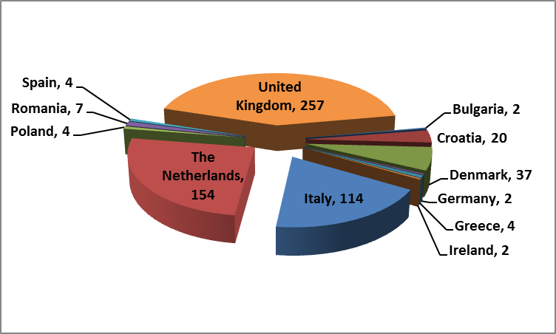

Based on the size of the offshore industry i.e. number of offshore installations, the Member States can be divided into three groups. Whereas group 1 includes the Member States with high numbers of oil and gas production installations, group 2 Member States have low numbers of installations; Member States of Group 3 have no production installations but planned or foreseeable exploration activities:

* Group 1: Croatia, Denmark, Italy, Netherlands, UK
* Group 2: Bulgaria, Germany, Greece, Ireland, Poland, Romania and Spain
* Group 3: Cyprus, France, Malta, Portugal

The large majority of the installations in the EU are currently located in the five Member States of Group 1.

In addition to the number of installations present within the Member States, the number of exploration wells and the number of well operations on existing wells are a significant source of offshore oil and gas activity. Data was collected on past averages of drilling exploration wells and other well activities in each Member State. This type of data is difficult to establish precisely as the drilling and well operations are highly dependent on many factors and subject to change. Therefore, baseline and high offshore activity options were developed to allow the estimations of the required resources of competent authorities for regulatory functions on offshore well activities and exploration. These estimations were compared with the current and planned resources for competent authorities in Member States to conclude on the adequacy of national expert resources.

Furthermore, the analysis was based on the assumption that larger and mature oil and gas industries would have relatively stable numbers of well operations and exploration programs whereas the new and emerging oil and gas industries could see more variation in these exploration activities. The baseline option means that the offshore sector would remain stable without change to the current level of offshore activity (July 2014 survey), whereas the high offshore activity option is based on the assumption of a 20% increase in exploration in Member States with an established offshore oil and gas industry and a 50% increase in exploration and well operations in Member States with small or developing offshore oil and gas industries.

# EU Competent Authority Resource Requirements for OSD compliance

The analysis of the expert human resources needed for each Member State's competent authority to perform offshore regulatory functions was carried out using a bottom-up estimation of the required resources from the regulatory functions of the competent authority.

As part of the estimation of the required expert human resources, Member States provided qualitative ratings to their current systems and procedures, as well as the expected ratings for these systems for 2016. A proportion of the competent authorities' resources have been attributed to the development of these regulatory systems and arrangements.

The estimation of required resources refers to future needs of the Member States which inevitably depend on their future activities. To provide an understanding on how these estimates depend on the activities, the two scenarios used for estimating future levels of offshore activity (see chapter 3) have again been considered. The resource requirements were estimated for each of the 5 main categories of regulatory task:

- assessment of major hazard documents,

- inspection of installations,

- the investigation of incidents, the development of regulatory policy,

- process and procedures, and

- guidance and standards development with stakeholders.

They were estimated using the two offshore activities scenarios.

A comparison between the 2014 and 2016 scenarios point out at a significant increase in resource requirements as the Offshore Safety Directive is implemented. This is due largely to the requirements for the assessment of reports on major hazards (RoMH) as competent authorities will receive all reports of major hazards for new and existing installations between July 2015 and July 2018.  After this 3 years period, the resource requirements for the assessment of reports of major hazards will drop substantially. The resource requirements would be higher if the high offshore activity level was applicable instead of the baseline scenario. However, the baseline option is considered more relevant to the current economic climate.

Furthermore, the high level of resource requirements for the development of regulatory policies (~15% of total resource requirements) and the up-dating of guidance and standards (~20%) reflect the amount of additional work required to develop such policies, procedures and processes and such arrangements for interacting with all stakeholders associated with the regulatory functions of the directive.

Information on the current status and planned developments of the regulatory procedures and processes and the arrangements with stakeholders, as presented in the next section, indicates a likelihood that the resource requirements for developing these regulatory procedures and arrangements will also drop after the initial years of implementation of the OSD. However, these areas will still require review and further improvement as competent authorities develop.

# Current and planned levels of competent authority resourcing within EU Member States

The Commission with the collaboration of existing competent authorities, if already established, or with the help of responsible administrations in charge of developing them, gathered information on the size and composition of current and planned future expert resources within the competent authorities (2014 and 2016).

Data was gathered on the current and planned status of regulatory policies, processes and procedures in comparison with the requirements of Article 8 and 9 and Annex III of the OSD.

On analysis of the data, assumptions were made on the approximate resource requirements of Member States in compliance with the requirements of the OSD.

**Figure 2: Available and projected staff by Member State (full time equivalent (FTE), 2014 and 2016)**

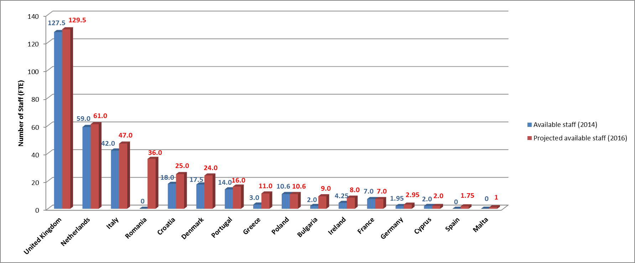

Information from the survey shows that Member States plan to increase staff numbers in their competent authorities by 2016. To have all necessary skills available for carrying out regulatory functions in line with the OSD they envisage training/development of current staff, outsourcing arrangements/offshore technical consultants, intergovernmental department transfers or sharing of resource and external recruitment.

## Current and planned status of regulatory policies, procedures and processes

Group 1 Member States' competent authorities currently have established regulatory policies, procedures and processes but not necessarily fully compliant with all the requirements in OSD. Competent authorities of Group 1 plan to make the necessary developments by 2016; some Group 1 Member States require more development than others.

Key policies, procedures and processes requiring further work within Group 1 Member States competent authorities include:

* Assessment of reports on major hazards;
* Well operations notification assessment procedures;
* Offshore technical and regulatory internal guidance;
* System of training or competence assurance for offshore regulatory personnel

Competent authorities in Group 2 currently have less developed regulatory policies, procedures and processes than Group 1 Member States as for most of these Member States this is the first time that they have had to implement an offshore major hazard safety regime. However they are developing the necessary systems to achieve compliance with the OSD, bringing additional pressure on expert resources to competent authorities in Group 2.

Competent authorities in Group 3 currently have the least developed offshore regulatory support systems. They generally need to establish some of the regulatory policies, procedures and processes but not to the level of Group 1 Member States given the extent of their offshore activities. In general, Group 3 Member States believe that they can improve their regulatory support systems to be reliable and robust by 2016. This will bring significant additional pressure on their competent authority's resources.

## Current and planned organisational arrangements for the interaction with stakeholders

Group 1 Member State's competent authorities at the time of the survey had well established organisational arrangements for the interaction with stakeholders; however significant improvements in the interaction with technical standards committees and other competent authorities are required. Three Member States seem to comply with most criteria examined and for the other two more development efforts are required.

Group 2 Member State's competent authorities have more basic organisational arrangements for working with stakeholders and developing these standards but they have smaller industries to address. Therefore, these arrangements can be on a smaller scale but this will still involve applying a significant proportion of resources from their competent authority. There is a lack of interaction with unions and workers’ representatives and with international and national technical standards committees in several of these Member States.

Group 3 Member State's competent authorities have the most basic organisational arrangements for working with stakeholders and developing standards but have the smallest industries to address with fewer licensees, owners or operators active. There are significant shortfalls, mainly in the interaction with unions and workers’ representation, and international and national technical standards committees. Group 3 Member States believe that adequate organisational arrangements will be in place by 2016. The development of these arrangements is likely to require a significant proportion of their available resource given the size of their competent authorities.

# analysis of potential gaps between resources in place/planned and required as estimated

An analysis of the gaps between required resources as established in chapter 4 and the provision of actual resources (2014) and Member States' plans for 2016 (chapter 5) was carried out for each of the three groups of Member States and the EU as a whole for the baseline and high activity scenarios.

For each scenario, the required regulatory competences for the three main regulatory functions were calculated (as outlined in Part 1 of the Staff Working Document). The adequacy of the expert human resources for a certain Member State's competent authority was then calculated by subtracting the estimated required resources from the currently (or planned) available resources.

At the time of the survey carried out by JRC as mentioned above, the oil price was $115 per barrel, however, this has fallen to less than $ 40 per barrel and this will significantly reduce the level of offshore exploration activity. With regard to these current economic conditions, accordingly the baseline option is considered as most appropriate for comparing the required resources against the proposed available resources in 2016.

**Figure 3: Estimated required competences and the actual and planned levels of offshore competence (FTE) in 2016 - baseline scenario**



**Source: Bio by Deloitte**

***Group 1:***

The estimated overall requirement for offshore technical and regulatory resource in 2016 for Group 1 Member State's competent authorities is ca. 288 FTE (Full Time Equivalents) and the total numbers of proposed offshore technical and regulatory expertise available in 2016 is shown to be almost the same. On average, a 10 - 20% increase in the number of required staff is needed between 2014 and 2016. There are, however, noticeable shortfalls in the technical categories of diving (-17.5%), pipelines (-12.8%), mechanical (-10%), electrical (-9%), structural engineering (-25%) and naval architecture (-60%).

At the EUOAG, all Member States of this group have indicated difficulties in recruitment of such qualified offshore technical competences for various reasons including competitive salary and availability of the desired skills.

***Group 2:***

The estimated overall requirement for offshore technical and regulatory resources in Group 2 Member State's competent authority is ca. 50 FTE. The total numbers of offshore technical and regulatory expertise is shown to be significantly positive i.e. >50 FTE, due to significant resources of one Member State of this group across the technical disciplines.

There are a number of countries with relatively high levels of a single competence. However, with one exception there is no Member State with the full range of offshore technical competences.  This is understandable as there is a wide range of offshore technical competences and most of the shortfalls are less than one FTE.  In some cases Member States have addressed such gaps with short term contracting of external consultants. Most Member States indicated that they would consider possible agreements with other competent authority for sharing competences. The most significant shortages identified are in “Regulatory Specialists & Safety Management Systems”. Further training or development may address this issue.  There are funding problems reportedin four Member States in Group 2.

***Group 3***

These Member States have no production installations and therefore their offshore activities will mainly include offshore drilling programs.  The estimated overall requirement for offshore technical and regulatory resources in Group 3 Member State's competent authority is ca. 16 FTE.  Generally, smaller competent authorities have gaps in the range of offshore competences available within their organisation, e.g. in particular process engineering, environmental protection specialists, diving and some other engineering disciplines were highlighted as in shortfall.  Most Group 3 Member States competent authorities indicated possible agreements with other competent authorities for sharing competences to address such small shortfalls which would be acceptable.  The estimate of the regulatory resource requirements did not include the assessment of reports on major accident hazards for mobile offshore drilling units (MODUs)/installations that are not based permanently in the Member State's jurisdiction. This would be a significant additional resource requirement on the occurrence of offshore drilling programmes.

The above resource requirements were calculated considering only the regulatory functions and regulatory procedural requirements. It is acknowledged that there will be further resources required to establish and maintain an organisation with the capability of being a competent authority. The EU Member States competent authorities are all at different levels of maturity and this study has not included any estimate on the level of resource required to establish the organisational structure of each competent authority. It is therefore likely, particularly for new or changing organisations that additional resources will be required to develop the organisation to be a competent authority.There are funding limitations, which are particularly serious in two Member States in Group 3.

# Conclusions and recommendations

Information received from Member States and the industry, first of all in the framework of the EUOAG, alleged that offshore oil and gas operations in certain areas of the EU as the North Sea are likely to decline due to the substantial downturn of oil prices. Less offshore operations may reduce the projected workload for competent authorities and their need for resources, although the decommissioning of installations also requires specific expertise. This means that the shortfalls determined on the basis of the earlier survey may be less pronounced than formerly expected.

The comparison between estimated needs and polled actual situation shows shortfalls across the EU in 2014 of ca. 10%. The comparison between the actual administrative capacity in 2014 with the requirements of resources of competent authorities in 2016, a year after the implementation deadline of July 2015, indicates that shortfalls for certain disciplines could increase without adequate action by Member States. These predicted gaps varied by Member State. Member States are aware that a re-enforcement of resources is necessary and plan to recruit and train staff.

If Member States recruit in line with their plans, most disciplines appear well sourced and a clear gap may only develop in the category for diving (-21%), mechanical engineering (-8%), emergency response (-14%) and naval architecture (-14%). Nevertheless, the availability of sufficient numbers of human resources and the attraction of offshore expertise to the competent authorities to carry out the regulatory functions is still a risk to the successful implementation of the OSD.

Adequate financial resources are necessary to recruit qualified staff, particular in certain technical disciplines, and to train new recruits in areas for which qualified persons are not available. To attract specialists in disciplines with apparent shortages requires appropriate pay levels.

If figures are broken down by groups of Member States, shortfalls appear more pronounced in several categories as for example for diving, mechanical, electrical and structural engineering, emergency response and naval architecture as reported in section 6. However, there are considerable variations between the different groups (for details see also Part 3 of the staff working document).

Further to determining targets for resources, an operational strategy for meeting them, broken down in milestones and actions, should contribute to address any shortfalls in 2016. A wide range of options on which these strategies may be based on is available, which includes sources for recruitment of specialists, collective and shared training, bilateral/multilateral expert transfer, knowledge sharing and networks of 3rd party expertise (for further details see also Part 4 of the staff working document).

Member States should ensure that their competent authority is developed allowing the recovery of their costs from the licensees, owners and operators of offshore oil and gas activities.

Group 1 Member States competent authorities should avoid any shortfall of competences by the recruitment of adequate numbers of offshore regulatory and technical expertise and the training of staff in the relevant regulatory functions. Further to the human resource component they need to optimise regulatory processes and associated systems.

Group 2 (low numbers of installations) and Group 3 Member States (no production installations, plans to develop) competent authorities are likely to have shortfalls in a number of offshore disciplines in 2016 but they are generally expected to be less than 1 full time equivalent person. This situation leads to the difficulty in providing the full range of offshore expertise within a competent authority of a Member State with a small or developing offshore oil and gas industry. In this context Member States may consider sharing and pooling of resources within a networking arrangement. To make such a proposal operational, Member States need to deal with practicalities regarding liability and logistics in Member States public service systems.

Small and emerging competent authorities should adjust the available options to their specific needs. For example the network of third party expertise in a joint support scheme could include entities shared by several Member States or may employ for less sensitive functions experts from the industry. For further details on the range of options, please see Part 4 of the staff working document. For example a Virtual Centre of Offshore Safety Expertise to assist the Member States’ competent authorities in meeting their competence requirements.

Finally, the European Union Offshore Authorities Group could contribute to the required co-operation between Member States and the Commission to develop instruments to facilitate sharing and pooling of staff, in particular for the benefit of the smaller emerging competent authorities.

1. OJ L 178 of 26 June 2013, p. 66 - 106
2. “Set up by Commission Decision of 19 January 2012 (OJ C 18 of 21 January 2012, p. 8 – 1), the EUOAG is a forum for the exchange of regulatory and technical experiences and expertise both amongst and between national authorities and the Commission on all issues relating to offshore major accident prevention. For more details see the official EUOAG website, operated by the JRC [http://euoag.jrc.ec.europa.eu/].''
3. The term 'installation' is as used in the definition of Article 2(19) of the OSD.
4. JRC (Joint Research Centre) Science for Policy report 'National expert resources for overseeing offshore safety in the EU'.