

REPORT FROM THE COMMISSION TO THE EUROPEAN PARLIAMENT AND THE COUNCIL

on the implementation of Regulation (EC) No 428/2009 setting up a Community regime for the control of exports, transfer, brokering and transit of dual-use items

**1. Introduction**

Article 23(3) of Regulation (EC) No 428/2009 calls for the Commission to submit an annual report to the European Parliament on the activities, examinations and consultations of the Dual-Use Coordination Group (DUCG). Furthermore, the Commission Communication (COM(2014)244) recognises that the publication of reports and non-sensitive control information could be critical steps to enhance transparency and improve operators' compliance and their capacity to implement controls. This report, prepared by the Commission and the DUCG with inputs from Member States,[[1]](#footnote-1) provides information on the implementation of the Regulation in 2015, and includes aggregated export control data for 2014.

**2. Evolution of the policy and regulatory framework**

**2.1. Export control policy review**

Further to the adoption of Communication (COM(2014)244) of 24 April 2014, the Commission launched an impact assessment with a view to evaluating the costs and benefits associated with the various review options and identifying the most suitable regulatory and non-regulatory actions (<http://ec.europa.eu/smartregulation/> impact/planned\_ia/docs/2013\_trade\_015\_duxc\_en.pdf). The Commission contracted an external consultant[[2]](#footnote-2) to conduct, from December 2014 to October 2015, a data-collection project in order to support the impact assessment through the development of a methodology for the collection and analysis of data and information regarding the dual-use industry and the economic and social impacts of controls, related problems and corresponding review actions. In parallel, the Commission conducted, from 15 July to 15 October 2015, an online public consultation to collect stakeholders' and public's input regarding the review objectives and options and their likely impact on the EU's export control policy. The results of the consultation are summarised at <http://trade.ec.europa.eu/doclib/docs/2015/november/tradoc_154003.pdf>.

Furthermore, the Commission conducted targeted consultations and outreach to key stakeholders. The Commission consulted the Council's Dual-Use Working Party, providing updates on the data collection project as well as on the ongoing impact assessment. The export control policy review was also on the agenda of the European Parliament on several occasions, e.g. a joint DROI-INTA Committee on 23 April 2015, focussing on the impact of intrusion and surveillance systems on human rights in third countries, and a workshop on dual-use export controls organized by the INTA and SEDE Committees on 15 June 2015. Export controls were also the subject of a number of parliamentary questions in the INTA Committee as well as in plenary session on 5 October 2015. Lastly, an Export Control Forum was organised on 7 December 2015, jointly with the Luxembourg Presidency of the EU, to exchange views with industry and civil society stakeholders. The report of the Forum is available at: <http://trade.ec.europa.eu/doclib/docs/2015/december/tradoc_154041.pdf>.

**2.2. Amendments to Regulation (EC) No 428/2009**

Council Regulation (EC) No 428/2009 was amended once over the reporting period. Commission Delegated Regulation (EU) No 2420/2015[[3]](#footnote-3) of 12 October 2015 updated the EU Control List in Annex I to the Regulation, and incorporated modifications agreed at the multilateral export control regimes in 2014. The 2015 EU control list thus incorporates over 100 amendments, most of which stem from the Wassenaar Arrangement and the Missile Technology Control Regime. These amendments concern, in particular, the control of machine tools, avionics technology and aircraft wing-folding systems, spacecraft equipment and civil Unmanned Aerial Vehicles as well as the removal from the control list of certain encrypted information security products. Annexes II and IV of the Regulation were also updated in line with the Annex I amendments. The new updated and consolidated EU Control List became applicable on 25 December 2015, thereby allowing the EU to adhere to its international commitments with regard to export controls and helping EU exporters where control parameters were relaxed.[[4]](#footnote-4)

**2.3. National implementing measures**

The Regulation is binding in its entirety and directly applicable in all Member States, but foresees that Member States should take measures for the implementation of certain provisions, and that information on those measures should be published in the Official Journal of the European Union. An Information Note was published in the Official Journal of 13 February 2015[[5]](#footnote-5), providing an overview of measures taken by Member States including, inter alia, the extension of brokering and transit controls, the extension of controls to non-listed items for reasons of public security and human rights consideration, the introduction of national general export authorisations, the application of intra-EU transfer controls for non-listed items, the enforcement of controls, as well as information relating to national export control authorities.

**3. Activities of the Dual-Use Coordination Group**

Article 23 of the Regulation sets up a DUCG bringing together experts from the Commission and Member States to examine any issue concerning the application of export controls with a view to practically improving their consistency and effectiveness throughout the EU.

**3.1. Consultations on implementation issues**

Over the reporting period, the DUCG provided a forum for consultations on a number of topical issues concerning the implementation of the Regulation. The DUCG held seven meetings, and discussed specific control issues such as the interpretation of the clause "specially designed component", the requirement for T5 certificates at the customs office of exit of exported items, the control of inverters, the application of the definition of "exporter" to "resellers", the application of transit controls under the dual-use regulation, and the control of dual-use research.

The DUCG conducted a technical exchange of information regarding the implementation of national measures, and prepared an updated Information Note on national measures for publication in the Official Journal (see above).

The DUCG reviewed the methodology and approach for data exchange, and conducted a comprehensive licensing data collection exercise (on 2014 data) in order to increase information exchange between Member States and public transparency about EU dual-use export controls. The DUCG also collaborated to the "data collection project" implemented by Stockholm International Peace Research Institute (SIPRI) and Ecorys to support the impact assessement for the export control policy review.

The DUCG monitored the activity of a joint (with customs) technical sub-group examining the potential convergence of customs' "Authorised Economic Operators" programmes with export control "internal compliance programmes". The DUCG endorsed the conclusions of the technical sub-group, in particular as regards the development of common guidelines for EU-wide standards for Internal Compliance Programme (ICP) and to enhance cooperation between customs and export control authorities.

The DUCG monitored the activity of the "Surveillance technology expert group" ("STEG"), bringing together experts from Member States and the Commission to discuss issues related to the control of cyber-surveillance technology and exchange information on relevant developments. The STEG reviewed developments regarding the implementation and technical parameters of controls, and exchanged views on the national, European and multilateral approaches to controls as well as on their potential impact on human rights and the security of the EU and its citizens. The STEG also held sessions with stakeholders from industry, academia and other civil society organizations.

**3.2. Technical support to the preparation of updates to the EU control list**

The DUCG held technical consultations in support of the preparation of a Commission Delegated Regulation updating the EU Control List. National experts shared technical expertise and training with competent authorities highlighting the most important changes to the control list on the occasion of a special session of the DUCG.

**3.3. EU Guidelines on Dual-Use Export Controls**

The DUCG initiated preparations for EU Guidelines supporting structured exchange of information and consultations between Member States with respect to the application of note 3 to Category 5 Part 2 of Annex I to Regulation (EC) No 428/2009 – the "cryptography note" – and regarding the definition of "exporter" in situations in which a reseller is involved.

**3.4. Exchange of information between competent authorities**

The DUCG continued to suport the further development of the Dual-use e-System (DUeS), a secure and encrypted electronic system hosted by the Commission, to enable effective exchange of information between export control authorities and the Commission. The DUCG introduced new functionalities and improvements into DUeS, in particular to support enhanced exchange of information regarding, *inter alia*, denials issued on the basis of Articles 2 and 2a of Regulation (EU) No 833/2014[[6]](#footnote-6) (EU sanctions to Russian Federation), intangible technology transfers. Also, in December 2015, a new, more secure function for user access and management was introduced. Importantly, a new section was created in the DUeS in October 2015 to support the exchange of information on denials issued under Regulation (EC) No 1236/2005[[7]](#footnote-7) concerning trade in certain goods which could be used for capital punishment, torture or other cruel, inhuman or degrading treatment or punishment (the "Anti-torture" regulation), and in line with the Commission's approach to enhance the synergies between various security export control instruments.

**3.5. Transparency and dialogue with industry and academia**

The DUCG held a "DUCG-Industry Forum" on 7 December 2015 in Brussels with industry associations, dual-use companies and civil society organisations to discuss review options and the findings of the online public consultation in the context of the export control policy review (<http://ec.europa.eu/trade/import-and-export-rules/export-from-eu/dual-use-controls/index_en.htm>).

The DUCG also prepared documentation to support exporters' implementation of the regulations. In particular, a "Comprehensive Change Note" summarises, for information purposes, the control text changes to the EU control list introduced under Commission Delegated Regulation (EU) 2015/2420 (<http://trade.ec.europa.eu/doclib/docs/2015/october/tradoc_153892.pdf>).

**3.6. Export control monitoring and enforcement**

The Commission promotes effective monitoring and enforcement of export controls within the EU through various support actions. In 2015, the Commission released an updated version of the 'correlation table' linking customs codes with dual-use classifications and continued inclusion of export control measures into the EU's online customs tariff database (TARIC) (http://trade.ec.europa.eu/doclib/docs/2016/february/tradoc\_154240.pdf).

**3.7. Pool of Experts**

In 2015, the Pool of Experts operated by Commission’s Joint Research Centre (JRC) and experts made available by Member States continued to provide support to EU export control authorities requesting advice in relation to concrete licensing cases. In total, seven advices were provided to six Member States competent authorities over the reporting period.

**3.8. Capacity building**

The DUCG supported the preparation of an export control pilot simulation exercise (SimEX 2015) for customs and licensing officers, jointly organised by DG TAXUD and the JRC, which took place on 17-19 March 2015. For its part, the JRC continued the series of technical seminars for licensing authorities in collaboration with the US Department of Energy. The 8th seminar was held on 22-23 April 2015 in Ispra, Italy, and attended by over 100 licensing officers and technical experts from EU export control authorities.

With respect to third countries, the "EU P2P Outreach programme" on dual use items in partner countries continued in 2015, making expertise available in 34 countries to strengthen export controls worldwide according to the needs and priorities of the countries concerned.

**4. EU export controls – Key Data**

It is difficult to get reliable information on dual-use exports as there is no correspondingly defined economic sector. However the Commission and Member States collect data that allow for approximate estimates of exports of dual-use goods based, on the one hand, on customs commodities identified by the correlation table, which include dual-use goods, and, on the other hand, on specific licensing data collected by competent authorities. 2014 export data estimates are presented below. To be noted, estimates presented hereafter do not include services and intangible technology transfers associated with the trade in dual-use goods.

**4.1. EU dual-use trade: items and destinations**

The Regulation primarily applies to the export of about 1869 dual-use items listed in Annex I (the "EU Control List") and classified in 10 categories (Figure 1). These dual-use items relate to circa 1000 customs commodities[[8]](#footnote-8), including chemicals, metals and non-metallic mineral products, computers, electronic and optical products, electrical equipment, machinery, vehicles and transport equipment etc. and typically fall at the high–tech end of this large, mixed commodity area.

Annex_I_Nr_of_items

*Figure 1: Number of dual-use items listed in Categories of Annex I further to the adoption of Regulation (EU) 2015/2420, compared to Regulation (EU) No 1382/2014.*

Using the correlation between customs codes and dual-use classifications, it is estimated that controls apply to items included in an 'export domain' representing approximately 20% of EU total exports (Figure 2).

DUED by Time

*Figure 2: Estimated value of the 'dual-use export domain' and total exports.*

A large part of the dual-use export domain concerns exports towards 'E001 countries' benefiting from general export authorisations. This reflects the EU export market structure in the relevant commodities as well as trade facilitation under EUGEAs (Figure 3)[[9]](#footnote-9).

DUED BY PARTNERS (BARS)

*Figure 3: Destination countries and sub-regions for EU dual-use export domain in 2014.*

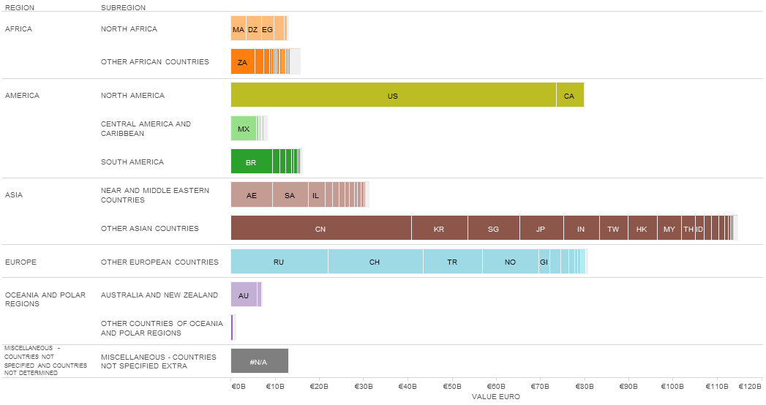

*Figure 4: Destination countries by world regions and subregions, 2014.*

Top 50 Table

*Figure 5: Top 50 extra-EU destinations by value in the dual-use export domain 2014[[10]](#footnote-10).*

**4.2. Applications, licences, denials**

The DUCG has exchanged information and collected licensing data, in order to improve the understanding of export controls and their economic effect. Some data collected for the reporting period is reported below; it should be noted however that not all Member States collect all data. The information provided below thus represents approximate estimates of aggregate quantities and value within the limits of the data made available by Member States.

*Figure 6: Volume (number) of authorisations and denials in 2010-2014[[11]](#footnote-11).*

*Figure 7: Value (mln EUR) of authorisations and denials in 2010-2014.*

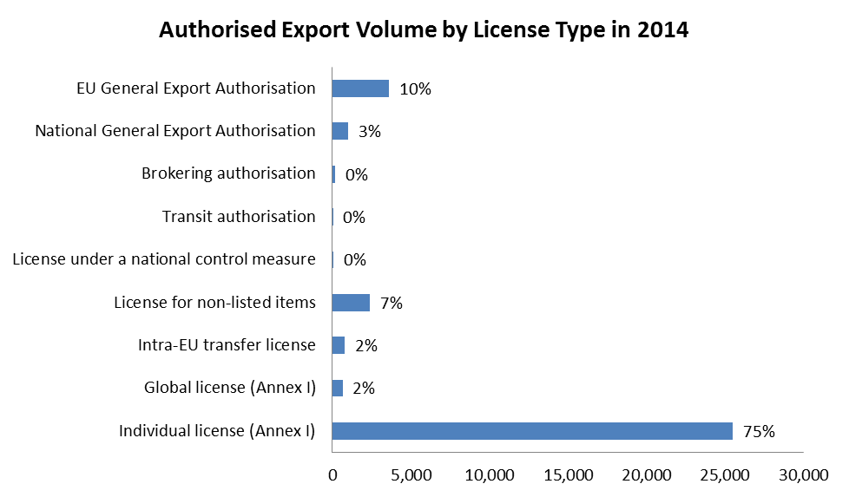

*Figure 8: Volume (number) of authorisations per category in 2014 data.*

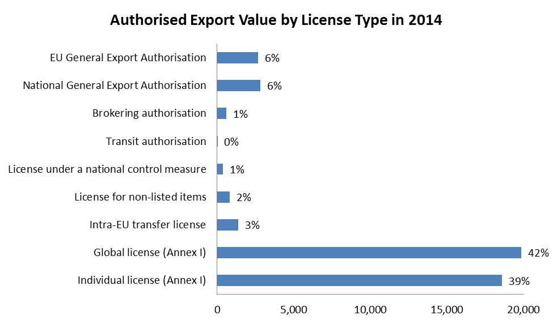

*Figure 9: Value (mln EUR) of authorisations per type in 2014.*

The total value[[12]](#footnote-12) of applications reached EUR 59 billion and controlled dual-use exports thus represented over 3.4% of total extra-EU exports. Authorised dual-use trade amounted to EUR 41.5 billion, representing 2.4% of total extra-EU exports, with a majority of transactions authorised under individual licenses (approx. 25.000 single licenses issued in 2014). Only a small portion of exports were actually denied: approximately 472 denials were issued in 2014, representing about 11.5% of the value of controlled dual-use exports in that year, and 0.4% of total extra- EU exports[[13]](#footnote-13).

1. Some competent authorities also publicly report on trade in dual-use items. [↑](#footnote-ref-1)
2. The Stockholm International Peace Research Institute (SIPRI) implemented the project jointly with Ecorys. [↑](#footnote-ref-2)
3. OJ L 340, 24.12.2015, p. 1. [↑](#footnote-ref-3)
4. A corrigendum to Regulation 2015/2420 was published in OJ L 60, 5.3.2016, p. 93 (<http://eur-lex.europa.eu/legal-content/EN/TXT/PDF/?uri=OJ:JOL_2016_060_R_0012&from=EN>). [↑](#footnote-ref-4)
5. OJ C 51, 13.2.2015, p. 8. [↑](#footnote-ref-5)
6. OJ L 229, 31.7.2014, p. 1. Council Regulation (EU) No 833/2014 of 31 July 2014 concerning restrictive measures in view of Russia's actions destabilising the situation in Ukraine. [↑](#footnote-ref-6)
7. OJ L 200, 30.7.2005, p.1. Council Regulation (EC) No 1236/2005 of 27 June 2005 concerning trade in certain goods which could be used for capital punishment, torture or other cruel, inhuman or degrading treatment or punishment. [↑](#footnote-ref-7)
8. The notion of *dual-use export domain* refers to this large, mixed commodity area which includes dual-use items. The trade of dual-use items takes place *within* this commodity area, but is not identical to it, since by far, not all of the commodities within the *dual-use export domain* are export-controlled. Measurements by the Commission's Joint Research Centre, based on Eurostat’s COMEXT database, result in a stable estimate of a *'dual-use export domain'* representing about 20% of EU total exports (including intra-EU trade). [↑](#footnote-ref-8)
9. "Stores and provisions extra" are defined as delivery of ships' and aircraft's stores. "N.det.Extra" includes countries and territories not specified within the framework of trade with third countries (these codes are usually used for goods delivered for offshore installations). [↑](#footnote-ref-9)
10. "Stores and provisions extra" are defined as delivery of ships' and aircraft's stores. "N.det.Extra" includes countries and territories not specified within the framework of trade with third countries. (These codes are usually used for goods delivered for offshore installations). [↑](#footnote-ref-10)
11. In Figure 6 and Figure 7, "Applications" data include all applications for licenses, including notifications under general authorisations, thus providing an indication of "controlled exports". In cases where no application data is available, the charts makes use of authorisation data as estimate for application data. "Authorisations" data refers to dual-use exports authorised under individual and global licences. It should be noted that applications do not necessarily correspond to the sum of authorisations and denials, as a number of applications may be cancelled and some applications may not be finalised within the same year. "Denial" refers to the volume and value of denied exports. [↑](#footnote-ref-11)
12. This figure includes value for applications and notifications under General Export Authorisations. [↑](#footnote-ref-12)
13. The value of denials in 2014 (EUR 6.8 billion) reflects exceptional circumstances, as denials values are generally much lower as shown in Figure 7. [↑](#footnote-ref-13)