

Table of Contents

ANNEX 1 3

PROCEDURAL INFORMATION 3

1. Identification of the lead DG: 3

2. Political guidance, Agenda Planning and Work Programme 3

3. Organisation and timing 4

4. Consultation of the Regulatory Scrutiny Board 5

5. External consultant 7

6. Terminology 8

7. Evidence and sources 9

ANNEX 2 16

STAKEHOLDER AND EXPERT CONSULTATIONS 16

1. Consultation strategy and process 16

2. Public consultation on the EU Blue Card and the EU’s labour migration policies 16

2.1. Purpose, target audience and communication strategy 16

2.2. Respondents to the Public Consultation 17

2.3. Selected Responses to the Online Survey of the Public Consultation 20

2.3.1. Chapter 1: Labour markets 21

2.3.2. Chapter 2: Availability of information 27

# ANNEX 1

# PROCEDURAL INFORMATION

## 1. Identification of the lead DG:

DG Migration and Home Affairs (HOME)

## 2. Political guidance, Agenda Planning and Work Programme

Since the issuance of his Political Guidelines in July 2014[1], Commission President Jean-Claude Juncker has underlined at several instances that he wants Europe to become at least as attractive as the favourite migration destinations such as Australia, Canada and the USA. As a first step he announced a review to address the shortcomings of the “Blue Card” Directive, its unsatisfactory state of implementation, its practical application that continues to be impeded by red tape at national level, and to identify ways and means of substantially broadening its impact in attracting more highly skilled workers into the EU[2].

On 13 May 2015, the European Agenda on Migration[3] announced a review of the EU Blue Card, as a part of the new policy on legal migration, to make it more effective in attracting talent to Europe. The potential for enhanced intra-EU mobility for EU Blue Card holders would be explored. The review would also look into a possible extension of scope to entrepreneurs willing to invest in Europe, and assess possible ways to provide legal certainty to service providers.

The first implementation report on the EU Blue Card Directive of 22 May 2014[4] concluded that it was too early to draw final conclusions on the success of the instrument because of the short period elapsed since its adoption and the lack of sufficient data. However, the report already voiced some serious concerns about the shortcomings of the Directive.

Since early 2015, in line with the Better Regulation Guidelines[5], DG HOME has been conducting monitoring, in-depth evaluation, stakeholder consultation, and impact assessment activities to prepare and support the review of the Directive. An Inception Impact Assessment was published on 16 July 2015[6]. After the State of the Union speech in September 2015 announced a legal migration package including a revised Blue Card for early 2016[7], these activities have been greatly expedited and intensified. Hence, the necessary tasks have taken place at high pace and in parallel with each other in an extremely compressed timeframe.

The Commission Work Programme 2016 announced on 27 October 2015 that in order “*to meet Europe's future demographic and labour market needs, we will present a renewed approach on legal migration, including measures to improve the Blue Card Directive*”[8], while its Annex I on New initiatives listed (nr. 18) ‘Better Migration Management’ as one of the initiatives under the title ‘Towards a New Policy on Migration’, specifying that the extension of the Blue Card approach was to be a part of it[9].

In a Communication adopted by the Commission on 6 April 2016[10]it is further specified that the Commission will propose changes to the current Blue Card Directive with the purpose of strengthening it as a Europe-wide scheme. This would be achieved by developing a harmonised EU common approach, which would include more flexible admission conditions, improved admission procedures and enhanced rights, including intra-EU mobility.

For DG HOME' Agenda Planning purposes the initiative is titled ‘Review of Directive 2009/50/EC of 25 May 2009 on the conditions of entry and residence of third-country nationals for the purposes of highly qualified employment ('EU Blue Card' Directive)’, with reference 2016/HOME/025.

## 3. Organisation and timing

The impact assessment is based on a number of studies and existing literature, reports and consultations. Since early 2015, the Commission has consulted stakeholders, organised meetings with experts and other interested parties in order to identify problems and develop options for possible action. In the following are listed the internal and external meetings arranged in order to support the review.

*Inter-Service Steering Group*

An *Inter-Service Steering Group on the Review of the Blue Card Directive* was set up to which the following services were invited: DEVCO, EAC, EEAS, EPSC, JUST, NEAR, RTD, CNECT, GROW, ECFIN, EMPL, EPSC, SG, SJ, JRC, RTD, SANTE and TRADE.

Three meetings chaired by the SG were held on the 5 June, 10 November and 17 December 2015. The first meeting[11] introduced the policy initiative, the initial identification of problems and the planning of evaluation and impact assessment activities. The second meeting[12] reported on the progress of the review and participants provided input. At the third meeting[13] the policy options and draft assessment of impacts were presented. After each meeting, the members of the Inter-Service Steering Group were given the opportunity to comment in writing on a draft version of the impact assessment report and its annexes.

Furthermore several bilateral meetings have taken place with other Commission services in 2015 and 2016 to address specific issues of interest, in particular with DG EMPL, RTD, CNECT, GROW, TRADE, ECFIN, JUST, as well as with the Commission Legal Service.

*External meetings and consultations:*

* 25 March 2015: First meeting of the Commission’s Expert Group on Economic Migration
* 20 May 2015: First Meeting Expert group RTD: Support Scheme for Non-EU Entrepreneurial Innovators
* 27 May 2015: Launch of the online Public consultation Economic migration and Blue Card (open until 30 September)
* 4 November 2015: Conference call with OECD expert on salary thresholds
* 5 November 2015: Meeting with and targeted consultation of German business associations
* 13 November 2015: First meeting of European Migration Network's Skilled Migrants Expert Group
* 18 November 2015: Call with IOM on refugees and asylum-seekers and the Blue Card
* 26 November 2015: Meeting with UNHCR on refugees and asylum-seekers and the Blue Card
* 3 December 2015: Workshop Labour Market Observatory (EESC)
* 7 December 2015: Second meeting of the Commission’s Expert Group on Economic Migration
* 21 January 2016: Meeting HOME with OECD experts on quantification models for projections of permits and economic impacts for the policy options
* 27 January 2016: Meeting with SME stakeholders to present and discuss 'better migration management', with a focus on the EU Blue Card Directive
* 27-28 January 2016: 1st European Dialogue on Skills and Migration
* 18 April 2016: Meeting Labour Market Observatory (EESC)

For a precise breakdown of and details on the stakeholder consultation, see Annex 2.

## 4. Consultation of the Regulatory Scrutiny Board

The Regulatory Scrutiny Board (RSB) issued a first opinion on 4 March 2016 requesting resubmission. The opinion asked to elaborate the problem analysis further on the skills shortages in the EU labour market, explaining why the current EU and/or national schemes are not sufficient to address the issue, and compete with other developed countries, and more clearly show the value added of an EU approach over the national schemes. For the latter, the Board considered that the report should better explain and substantiate the importance of the greater intra-EU mobility that could be attached to the Blue Card. Furthermore, the opinion emphasised that the report should clearly establish whether and how the Blue Card is linked to other policy priorities such as trade and refugee matters. It also underlined that the objectives should be better aligned with the problem analysis, and better explain how this initiative fits with other related EU initiatives (e.g. labour mobility, Skills Agenda[14]). It should be clarified how the assessed policy packages have been composed. In terms of the impact analysis, the Board recommended to draw out the impacts of the policy options on the labour and skill shortages more clearly, and clarify which option(s) are foreseen to be the most effective and efficient to attract highly skilled third-country workers.

|  |  |
| --- | --- |
| **Main recommendations for improvement** | **Modifications in the IA report** |
| 1. Clarify the addressed problems, the intervention logic and their EU dimension | * The figures on **international comparison** have been strengthened in the IA report in order to show how the EU is currently underperforming in attracting HSW compared to international competitors. * The narrative on EU added value was strengthened. More information has been added on **MS approach to HSW** to show that MS do not seem to have objectives conflicting with those of the Blue Card (**revised Annex 6);** * The **advantages of and need for intra-EU mobility** has been further explained in the report, together with a clearer presentation of the views from stakeholders on this aspect. * The narrative and data on **(shortages of) medium skilled workers** has been included in the problem definition, including views from stakeholders and experts * The arguments on **measuring the EU’s successfulness in attracting talents** have been strengthened, based on existing labour shortages and international comparisons; * The interaction has been clarified between the **intra-EU mobility of (existing) EU workers** in addressing shortages across the EU labour market, **and structural skills mismatches** that cannot be alleviated only by intra-EU mobility of domestic workers. |
| 2. Clarify the objectives and policy options | The **objectives** have been **revised/clarified** and better linked to the problems, drivers and policy options.  The IA clarifies how the **policy options packages have been conceived and composed** and explains how individual policy options have been screened and selected to address the problems' drivers.  The numbering of the policy options has bene slightly changed to be more in line with the underlying logic of the options packages.   * **The impact of the different salary thresholds** for the different policy option packageshas been clarified |
| 3. Focus the impact analysis on the main labour market aspects | In response to the main question on **impact analysi**s and preferred options:   * The IA better clarifies the **impact of the options,** especially the **economic impacts** and **on labour shortages** ; * The **administrative costs and gains** are presented by separating the costs to public authorities from private companies and individuals, adding a new administrative cost model for public authorities (quantified per policy option), and providing examples and case studies on the administrative cost for companies and individuals (which is not possible to quantify) (see **new Annex 15**) * The IA explains **better why certain policy options** have not been assessed in-depth and **added more policy options** for a preliminary assessment; * Options have been screened first on **legal feasibility** criteria, then on **effectiveness/efficiency** and at the end **on political feasibility**; * The report has been reviewed, clarified and corrected as regards the **consistency of the impact analysis (ratings and narrative);** * A **preferred option** has been indicated |
|  | **Other changes:**   * The overall readability of the report has been improved; * The distinction between TCN service providers and TCN entrepreneurs has been clarified (**annex 11 was revised**); * The situation of beneficiaries of international protection and asylum seekers, in particular their current labour market access, has been addressed in a new annex including the different situations across MS (**new Annex 16**); * The characteristics of the current Blue Card have been made more explicit (see **table added in Annex 5);** * The differences between the ICT and Blue Card Directives have been clarified; * The non-legislative actions that have already been undertaken have been included; * The definition of "ISCO" and other acronyms used has been included. |

Based on the revised version of the Impact Assessment, the RSB issued a positive opinion on 18 March 2016. There were some recommendations for further improvement of the report. Firstly, the problem analysis should better explain the functioning and scale of labour and skills shortages. This has been done by inserting additional information, including a graph and table, on future labour and skills shortages to Section 2.4, the baseline scenario. Secondly, the RSB recommended that the objectives be simplified and linked to the problem drivers; therefore, specific flowcharts have been added in Annex 3. Furthermore, the RSB noted that the logic of the policy options and some choices made in packaging them should be better explained, as well as some details regarding certain options. These requests have been addressed in Section 5.2 of the report, for instance by better explaining the logical trade-off between the inclusiveness of admission conditions and generosity of rights attached to any labour migration scheme. The choice of discarding the option bringing international service providers within the Blue Card scheme has been further substantiated in Section 5.1.

## 5. External consultant

An external contractor (ICF) has assisted DG Home by conducting a study to support the work on the Impact Assessment report. The call for the study was launched in June 2015, three substantive bids were evaluated in July-August, leading to the award decision at the end of August. After the announcement of the legal migration package for early 2015, the timetable and deliverables for the study had to be anticipated. Due to the tight timeframe the contractor and DG HOME have worked on the same substance partially in parallel. The kick-off meeting for the study took place in September, an inception report was delivered in October and a draft interim report in December, designed to feed into the impact assessment work of the Commission. There were two expert meetings organised by the contractor to discuss the problem definition and to develop and evaluate the policy options.

*Progress of the study to support the impact assessment:*

* 22 July 2015: Meeting Opening Committee on the bids for the study to support the impact assessment
* 6 August 2015: Meeting Evaluation Committee on the bids for the study
* 19 August 2015: Meeting Evaluation Committee
* 31 August 2015: Award Decision
* 24 September 2015: Kick-off meeting with contractor for the study
* 15 October 2015: Inception report
* 19 October 2015: Inception meeting
* 29 October 2015: Expert meeting on problem definition and policy options
* 1 December 2015: ICF Expert meeting on policy options and impacts
* 15 December 2015: Draft Interim Report for the ‘Study for an impact assessment on a proposal for a revision of Council Directive 2009/50/EC (“EU Blue Card Directive”)’
* 16 December 2015: Interim meeting ICF-DG HOME
* 6 January 2016: Additional input by ICF to assess the impacts of different policy options
* 26 February 2016: Additional note by ICF estimating economic impacts and administrative costs

## 6. Terminology

The current EU Blue Card Directive regulates the conditions of entry and residence of third-country nationals for the purposes of highly qualified employment. A third-country national is any person who is not a citizen of the Union within the meaning of Article 17(1) of the Treaty (hereinafter TCN).

While the terms 'highly skilled' and 'highly qualified' are often used interchangeably, including in this impact assessment, there is a distinction between 'highly skilled', referring to someone who has the required adequate and specific competence as proven by higher educational qualifications and/or extensive (vocational) experience, and 'highly qualified', referring to someone who has required adequate and specific competence as proven by higher educational qualifications only (see [EMN Glossary](http://ec.europa.eu/dgs/home-affairs/what-we-do/networks/european_migration_network/glossary/index_h_en.htm)).

The current Blue Card requires ‘higher professional qualifications’ which, in general, means qualifications attested by evidence of *higher education qualifications*, hence 'highly qualified’. However, the Directive also contains an optional clause according to which Member States may allow that ‘higher professional qualifications’ can also mean qualifications attested by at least five years of *professional experience* of a level comparable to higher education qualifications. Therefore, for the purpose of this impact assessment, **the more generic term 'highly skilled' is preferred**. In addition, this term allows for better comparison with parallel national schemes and for considering the extension of the scope of the EU Blue Card Directive beyond educational qualifications.

Furthermore, the current Blue Card Directive concerns TCNs who are in an employment relation. This means the employment of a person who in the Member State concerned, is protected as an employee under national employment law and/or in accordance with national practice, irrespective of the legal relationship, for the purpose of exercising genuine and effective work for, or under the direction of, someone else; and is paid. Therefore, the term **‘highly skilled workers’ (HSW)** is preferred with the understanding that these HSW are TCNs.

However, the impact assessment also considers the extension of the scope of the EU Blue Card Directive to categories that are non-employment based (e.g. self-employed TCN Service Providers and innovative TCN entrepreneurs and start-ups) or that are employed under third-country employment laws (e.g. some TCN Service Providers). In those specific sections the wider term 'highly skilled professionals' is used with the understanding that these are TCNs.

## 7. Evidence and sources

The evaluation and impact assessment were supported by a wide variety of sources and evidence collected through desk research, a comprehensive literature review, inter-service cooperation, expert consultations and focused group discussions. The Impact Assessment Report draws on numerical estimates and calculations, as well as qualitative material such as expert opinions and case studies. The following list represents an indicative selection, but by no means an exhaustive list of the wide range of internal and publicly available sources used[15]:

* [The Impact Assessment of the 2007 Proposal for an EU Blue Card Directive](http://ec.europa.eu/smart-regulation/impact/ia_carried_out/docs/ia_2007/sec_2007_1403_en.pdf) (SEC(2007) 1403)
* A study on the transposition of Directive 2009/50/EC ‘EU Blue Card’ by an external contractor (June 2013)
* [The Commission’s first Implementation report (COM(2014)0287 final](http://www.europarl.europa.eu/meetdocs/2014_2019/documents/com/com_com(2014)0287_/com_com(2014)0287_en.pdf))
* [The Commission’s European Agenda on Migration of 13 May 2015](http://ec.europa.eu/dgs/home-affairs/what-we-do/policies/european-agenda-migration/background-information/docs/communication_on_the_european_agenda_on_migration_en.pdf)
* Information collected by the Commission from the National Contact Points on the Blue Card Directive. Information is collected on topics such as salary thresholds, volumes of admission, labour market tests, return and readmission, ethical recruitment, specimens of residence cards, fees.
* [Materials produced for and by the Expert Group on Economic Migration (EGEM): Meetings held on 25 March, and 7 December and 2015 in Brussels - available materials include](http://ec.europa.eu/transparency/regexpert/index.cfm?do=groupDetail.groupDetail&groupID=3253):
* Discussion papers prepared by Commission services;
* Minutes of the meetings;
* Written contributions submitted by the members of the EGEM.
* [OECD/European Union (2014), Matching Economic Migration with Labour Market Needs, OECD publishing](http://www.oecd-ilibrary.org/favicon.ico)
* OECD/European Union, Review of Labour Migration Policy in Europe (forthcoming: expected April 2016).

The OECD/EU review aims to assess to which extent the EU, as a destination region for labour migrants from outside the Union, can compete on the global labour market for skills, and to which extent EU policy instruments have helped to foster EU attractiveness. It aims to provide recommendations to increase the attractiveness of the EU as a single labour market and to improve the efficiency of EU instruments geared towards managing labour migration.

The review encompasses a number of thematic papers and a synthesis report, which will be published in 2016. It is co-funded by the European Commission's DG Home Affairs and the OECD.

The following is a list of draft papers of the project that are not yet considered final but several of these have informed the impact assessment:

|  |
| --- |
| **General Context and Contribution of Labour Migration in Europe** |
| *Jean-Noël Senne and Anda David, DIAL/Université Paris Sud ; DIAL/Université Paris Dauphine*  Draft circulated at 2nd OECD-EU Dialogue on International Migration And Mobility, entitled "*A descriptive analysis of immigration to and emigration from the European Union: where does the EU stand within OECD?*" DELSA/ELSA/MI(2015)1 |
| The paper presents the main characteristics of immigration and emigration to/from the EU. Amongst other things, it confirms the EU27 tend to attract low-educated migrants compared to other OECD destinations. Also, EU+12 countries have a very low immigration rate (2%). |
| **Labour Migration Policy Development in the EU: Policy Features and Influence of Directives** |
| *Jonathan Chaloff, OECD* |
| The paper provides an analytical overview of the instruments in place to manage labour migration. It clearly shows EU labour migration policy is demand-driven. Caps are set, but no targets, showing the emphasis is on controlling numbers rather than aiming at a certain economic benefit. It shows the changes to national policies imposed by the EU Blue Card Directive and includes policy options for improving it. |
| **The Impact of the Implementation of Council Directives on Labour Migration Flows from Third Countries to EU Countries** |
| *Tommaso Colussi, Institute for the Study of Labor (IZA).* |
| An econometric analysis of Directives showed little or no impact of the adoption of EU acquis on aggregate numbers of targeted migrants (researchers, highly-skilled migrants). However, benefits of harmonisation and other effects which do not change aggregate numbers but reduce barriers/costs/externalities were not considered. |
| **The Impact of the Long-Term Residents Directive and of Naturalisation on Intra-EU Mobility of Foreign Skilled Workers** |
| *Friedrich Poeschel, OECD* |
| The paper identifies positive causal effects of long-term residence and naturalisation on the mobility of third-country nationals in the EU. The effect of long-term residence is sizeable – the results suggest that third-country nationals with long-term residence are 5% more likely to be mobile than they would have been without this status. This points to the possibility of allowing mobile third-country nationals to contribute more to rapid labour market adjustment in the EU. |
| **Europe as a Single Labour Market Destination** |
| *Flore Gubert and Jean-Noël Senne, DIAL/Paris School of Economics; DIAL/Université Paris Sud*  Draft circulated at 2nd OECD-EU Dialogue on International Migration And Mobility, entitled " *Is the European Union attractive for potential migrants?An investigation of migration intentions across the world*" DELSA/ELSA/MI(2015)6 |
| The paper used Gallup survey data to measure the attractiveness of the EU as a migration destination. Although the survey contains a large number of replies, few would be of people with clear plans to emigrate. This was mitigated by doing the analysis on an aggregate (regional) basis rather than an individual country-of-origin basis. |
| **The Impact of International Students and Post-Graduation Internal Mobility: An Analysis of Student Mobility and Retention Rates** |
| *Reinhard Weisser, Institute of Labour Economics, Leibniz University Hannover* |
| The paper measures retention rates amongst TCN students in the EU and explores policies to improve it. It shows the EU is the most attractive area for studying abroad, with almost 1 million international (non-EU) students enrolled in 2012. Furthermore, their nationalities reflect the importance of their respective countries of origin in the world economy, rather than proximity to the EU or historic ties (as is the case in most other categories of migration). Students from Asia and Latin America choose the EU as a destination much more frequently than 10 years ago. Aggregate stay rates from stayers from all non-EU source countries lie within a range of 16.4 to 29.1%. Internationally mobile students see their studies abroad as an integral part of their career path. Subsequent staying decisions are not taken lightly but made in light of perceived opportunities. |
| **The Role of Employers and Employer Engagement in Labour Migration from Third Countries to the EU** |
| *Sankar Ramasamy, OECD* |
| The paper includes several worthwhile suggestions of how to maintain or create a level playing field between large and small companies when it comes to international recruitment. It also explores policies for attracting (wealthy) investors, but highlights there is scant evidence to support their economic benefits. |
| **Strengthening Co-operation with Countries of Origin** |
| *Corinne Balleix, Sciences Po Aix* |
| The paper highlights the potential of international cooperation in general and Mobility Partnerships in particular, while also pointing to their limited reach so far. Ethical recruitment is approached from various angles (including workers' rights), and not limited to so-called "brain drain". |
| **The Impact of Intra-EU Mobility on Immigration by Third-Country Foreign Workers** |
| *Emily Farchy, OECD* |
| The paper uses the natural experiment of EU enlargement to isolate free movement effects from economic variables. It concludes that intra-EU mobility of EU workers negatively impacts migration from third countries (a 10 % increase in the population share of mobile EU workers leads to 5-6 % decrease in the share of TCN). |
| **The Community Preference Principle in Labour Migration Policy in the European Union** |
| *Sophie Robin-Olivier, La Sorbonne School of Law (University of Paris I)* |
| The paper, submitted for the first time for review, gives a comprehensive overview of the sources and applications of the community preference principle, in law and in policy. |

* Relevant EMN Ad Hoc Queries[16], such as:
* 166. Permits for highly skilled workers, 22 October 2009
* 171. Admission to labour market, 3 November 2009
* 181. Labour market legislation limiting TCNs access, 24 November 2009
* 218. Skilled immigration, 20 April 2010
* 236. Employment and work of aliens, 16 June 2010
* 271. Recognition of professional qualifications, 3 November 2010
* 368. Transposition of article 6 of directive 2009/50/EC, 24 January 2012
* 388. Establishing a complex monitoring system for TCN employment, 14 March 2012
* EMN Studies on economic migration[17], such as:
* Attracting Highly Qualified and Qualified Third-Country Nationals, 2013, including an overall study and studies per Member State.
* [Admitting third country nationals for business purposes, 2014, including studies per Member State.](http://ec.europa.eu/dgs/home-affairs/what-we-do/networks/european_migration_network/reports/docs/emn-studies/emn_study_admitting%20third-country_nationals_for_business_purposes_specifications_eu_2014.pdf)

In addition, work on the Impact Assessment was inspired by the numerous academic publications on the topic of labour migration, and high-skilled migration in particular. The following is a non-exhaustive selection of recent academic and think tank publications on the Blue Card, highly skilled migration and related topics that have been consulted[18]:

* Betts, A., Cerna, L. (2011) High-Skilled Labour Migration. In Betts, A. (Ed.) Global migration governance. 1-33. Oxford: Oxford University Press
* Boeri, T. (ed.) (2012) Brain Drain and Brain Gain. The Global competition to Attract High-Skilled migrants. Oxford University Press
* Boswell, C., ‘Theorizing Migration Policy: Is There a Third Way?’ in International Migration Review, 41(1), 2007, pp. 75-100;
* Boswell, C., Stiller, S., Straubhaar, T. (2004) Forecasting Labour and Skills Shortages: How Can Projections Better Inform Labour Migration Policies? EC, DG Employment and Social Affairs
* Busse, M.,Morehouse, C. (2013) Unblocking the Lifeline of Talent. CEPS Policy Brief No. 306 (Published jointly with the Bertelsmann Stiftung)
* Cerna, L. (2014) Attracting high-skilled immigrants: policies in comparative perspectives. *International Migration*, 52(3)
* Cerna, L. (2013) The EU Blue Card - preferences, policies, and negotiations between Member States, *Migration Studies*
* Cerna, L. (2010) Policies and practices of highly skilled migration in times of the economic crisis. *ILO International Migration Papers* No. 99
* Czaika, M. and de Haas, H. (2001) On the effectiveness of Immigration Policies. IMI working Paper
* Desiderio, M. V. (2014) Policies to support immigrant entrepreneurship'. MPI August 2014
* Desiderio, M. V. and Hooper, K., The Canadian Expression of Interest System for Managing Skilled Migration: A New Model for the EU?, MPI-Europe, March 2016.
* Devitt, C. (2011) Varieties of Capitalism, Varieties in Labour Immigration. *Journal of Ethnic and Migration Studies*, 37(4)
* Doomernik, J., Koslowski, R., Thränhardt, D. (2009) The Battle for the brains: why immigration policy is not enough to attract the highly skilled. FMG: Institute for Migration & Ethnic Studies (IMES)
* Duncan, N. Immigration Policymaking In The Global Era. In Pursuit Of Global Talent (2012) New York: Palgrave Macmillan
* Eisele, K. (2013) Why Come Here If I Can Go There? Assessing The ‘Attractiveness’ Of The EU’s Blue Card Directive For ‘Highly Qualified’ Immigrants. CEPS Papers No. 60 / October 2013
* Grutters, C., Strik, T. (2013) The Blue Card Directive. Central themes, problem issues, and implementation in selected member states WLP
* Gümüs, Y. K. (2010) EU Blue Card Scheme: The Right Step in the Right Direction?, European Journal of Migration and Law 12, 435–453
* Hailbronner, K.,Schmidt, J. M. (2010) Council Directive 2009/50/EC. In Hailbronner, EU Immigration and Asylum Law - Commentary on EU Regulations and Directives, 2010 (new version Hailbronner / Thym, EU Immigration and Asylum Law upcoming in 3rd quarter 2015)
* Haley, L. (2012) The Challenges to Lawmaking With Respect to Highly Qualified Immigration: A Comparison of the European Union and United States. European Union Law. Working Papers No. 8, 2012
* Helbling, M., Bjerre, L., Römer, F., and Zobel, M. (eds.) (2013) How to measure immigration policies.” Migration and Citizenship. Newsletter of the American Political Science Association. Organized Section on Migration and Citizenship 1(2): 4-8
* Iván, I., di Bartolomeo, A., de Bruycker, P., Renaudiere, G., Salamońska, J., Venturini, A., Study for the LIBE Committee of the European Parliament, Exploring New Avenues for Legislation for Labour Migration to the European Union, Migration Policy Centre, Robert Shuman Centre for Advanced Studies, European University Institute, September 2015
* Kalantaryan, S., Martín, I. (2015) Reforming the EU blue card as a labour migration policy tool?. Migration Policy Centre; Policy Brief; 2015/08
* Koslowski, R. (2014) Selective Migration Policy Models and Changing Realities of Implementation. International Migration, 52(3)
* Martín, I., & Venturini, A. (2015) A comprehensive labour market approach to EU labour migration policy. Migration Policy Centre; Policy Brief; 2015/07
* Martin, P. (2012) Attracting Highly Skilled Migrants: US Experience and Lessons for the EU. Robert Schuman Centre for Advanced Studies
* Paul, R., The Political Economy of Border Drawing: Arranging Legality in European Labor Migration Policies, Berghahn Books, 2015
* Peers, S., Guild, E., Acosta Arcarazo, D, Groenendijk, K., Moreno-Lax, V. (ed.), (2012) EU Immigration and Asylum Law (Text and Commentary). Second Revised Edition
* Rainer, M. (2014) The Global Race For Talent: Europe's Migration Challenge. Bruegel policy brief 2014/02
* Rinne, U. (2012) The Evaluation of Immigration Policies. IZA Discussion Paper
* Ruhs, M. (2013) The Price of Rights. Regulating International Labor migration. Princeton University Press
* Triadafilopoulos, T. (2013) Wanted and Welcome? Policies for Highly Skilled Immigrants in Comparative Perspective. Springer-Verlag New York

# ANNEX 2

# STAKEHOLDER AND EXPERT CONSULTATIONS

## Consultation strategy and process

The core of the strategy has been to carry out broad consultations of stakeholders. On 27 May 2015 the Commission launched an internet-based ***public consultation*** *on the EU Blue Card and the EU’s labour migration policies*, welcoming contributions from all interested stakeholders. It was launched as part of the first implementation package of the European Agenda on Migration on 27 May 2015. Until its closure on 30 September 2015, a total of 625 individuals and organisations had responded to the consultation.

Furthermore, a wide range of **targeted stakeholder consultations** were carried out to collect opinions from stakeholders and to address potential information gaps. The Commission also held and attended several **expert meetings.** These are described in detail in Chapter 3.

Finally, the **LIBE secretariat of the European Parliament, the Council, the Committee of the Regions and the European Economic and Social Committee** were invited to several of the meetings and consultations and participated as observers at different occasions.

## Public consultation on the EU Blue Card and the EU’s labour migration policies

### 2.1. Purpose, target audience and communication strategy

Stakeholders were invited to share their views on the EU's policy on legal migration, including on the review of the Blue Card Directive. The consultation was available online between 27 May 2015 and 30 September 2015 and contributions were received either through the online questionnaire, or as written position papers.

The public consultation was addressed to the broadest public possible to collect views and input from all possible stakeholders, including those who will be directly affected by the policy, but also those who are involved in ensuring its correct application or might have other interests in the policy. Contributions were received from EU citizens and third-country nationals (residing inside or outside the EU), employers (from multinationals to SMEs) and their associations, private and public employment organisations, trade unions, national ministries, regional and local authorities, media workers, academics, international organisations, representatives of countries of origin, and various civil society actors.

To ensure that all relevant parties have an opportunity to express their opinions, the explanatory text and the questions were available in all official EU languages and a communication strategy was developed early on. As a part of the launch of the first follow-up measures to the European Agenda on Migration, information on the public consultation was spread by means of a press conference and a press release. In addition, the consultation was published on all relevant DG HOME websites such as the home affairs portal on Europa, the EU Immigration Portal (where it featured as a pop up), and the European Website on Integration.

For further dissemination, DG HOME relied on existing networks (i.e. European Migration Network, National Contact Points for different directives, National Contact Points on Integration), as well as civil society organisations with a special interest in migration issues, business associations and social partners. Other Commission Services, the Committee of the Regions, the network of major European cities "Eurocities" as well as Commission Representations in Member States and delegations in third countries participated to further promote the consultation. Finally, information about the consultation was sent directly to known stakeholders such as experts, academics, think-tanks and migrants' associations and promoted via the Commission’s social media accounts.

The questions covered a range of issues relating to economic migration in general, the attractiveness of the EU as a migration destination, the situation on the European labour markets, the availability of information and the Blue Card scheme in particular. The chapter on the EU Blue Card focussed on its current functioning and ways to address possible shortcomings of the scheme. Another important theme was the possibilities for the EU to boost its attractiveness in the global competition for highly skilled workers. Based on identification at the beginning of the consultation respondents were divided in categories and the questions were adapted accordingly via targeted profiles.

### 2.2. Respondents to the Public Consultation

* **Respondents by category of stakeholder**

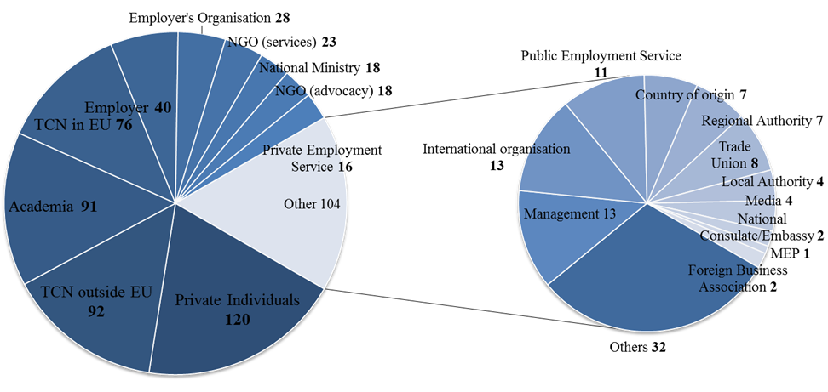

**Total responses to the consultation:** 625

Of which 610 responded to the online questionnaire and 15 sent position papers

* **Respondents by current country of residence**

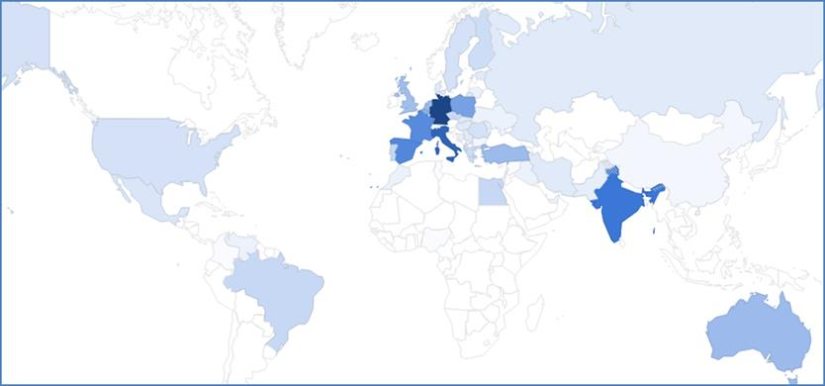

**Overviews of selected categories of respondents**

* **National Ministries and other national institutions by Member State**

|  |  |
| --- | --- |
| Institution | Member State |
| Ministry of the Interior | CZ, FI, FR, DE, EL, HU, NL, SK |
| Ministry of Labour and Social Affairs/ Welfare/ Enterprise | AT, IT, SK, IE, LV |
| REM contact point | FR |
| General Secretariat for Gender Equality | EL |
| Ministry of Education | LV |
| Ministry of Economics | LV |
| Ministry of Foreign Affairs | LV |

* **EU-based Employers and Employers' Associations**

|  |  |  |  |
| --- | --- | --- | --- |
| **Employers** | | **Employer's organisation** | |
| **MS** | **Company** | **MS** | **Organisation** |
| **CZ** | IBM Czech Republic | **AT** | Industrialists Association |
| **EE** | Tieto Estonia AS | Chamber of Commerce Austria |
| The Spacepol Corporations | **BE** | BUSINESSEUROPE |
| Ericsson Eesti As | International Union for Road-Rail Combined Transport |
| **DE** | German Caritasverband | Pearle*-Live Performance Europe |
| Runne Facility Management GmbH | **CZ** | Confederation of Industry of the Czech Republic |
| SAP | **FI** | The Federation of Finnish Enterprises (Suomen Yrittäjätry) |
| Heitkamp & Thumann Group | **DE** | Employers' Association of Insurance Companies in Germany |
| Falquez, Pantle und Pritz GbR | Association of Bavarian Chemical Industry |
| BASF | Confederation of German Employers' Associations (BDA) |
| **IT** | SoftInstigate Srl | Bavarian Business Association |
| **PL** | Poloniacare24 | Bavarian metal and electrical industry association |
| Aktivmed24 | Association of Bavarian Metal and Electrical Industry |
| Adeniyi Anthony Odeyale | Federal Employers' Association of HR services |
| AP Uniapol Development | State Association of Business Associations Nordrhein-Westfalen |
| MR JOB | Federal Employers Association Chemistry |
| **PT** | Center of Sciences of the Algarve Sea (Cerntro de Ciencias do Mar do Algarve) | **PL** | Section Welfare Agency (Sekcja Agencji Opieki) |
| **ES** | LPI-Europe | Association of Employment Services (Stowarzyszenie Agencji Zatrudnienia) |
| National Renewable Energy Centre | **Employers and employers' organisation from outside the EU:** **13** | |
| Sbiomedic | **Anonymous employers and employers' organisations:** **14** | |

### 2.3. Selected Responses to the Online Survey of the Public Consultation

In the online survey respondents were asked to identify themselves as one of 20 categories, which were grouped into 6 profiles.

|  |  |
| --- | --- |
| **Profiles** | **Categories of respondents** |
| 1 | Employers and employers' associations, Managers |
| 2 | Private/public employment organizations, Trade unions |
| 3 | Ministries, NGOs (support network, assistance, services), Regional & local authorities, Consulates/embassies |
| 4 | Media, Private individuals, Academia, NGOs (advocacy), International organisations, Organisations or authorities of the countries of origin, others |
| 5 | Non-EU migrant workers and entrepreneurs already residing/ having previously resided in the EU |
| 6 | (Potential) Non-EU migrant workers and entrepreneurs currently outside of the EU |

Each of the six profiles was directed to a set of specifically tailored questions across 5 chapters: (1) Labour markets, (2) Availability of information, (3) Attractiveness of the EU, (4) the EU Blue Card, and (5) Qualifications. Some questions were addressed to all profiles, some only to the profiles to which the particular question was relevant. A total of 60 questions were asked, of which many were followed up by targeted questions based on the initial answer.

In the following sections, a selection of responses to the public consultation will be presented according to the five thematic chapters. The selection is based on the relevance of the questions and the representativeness of the responses. The highlighted profiles in the list below each response indicate to which ones of the six profiles the specific question was posed. In general, the responses are grouped per profiles; however, where relevant or where there are significant differences in responses, the answers for some of the 20 specific categories of respondents are filtered out and presented separately.

### **2.3.1. Chapter 1: Labour markets**

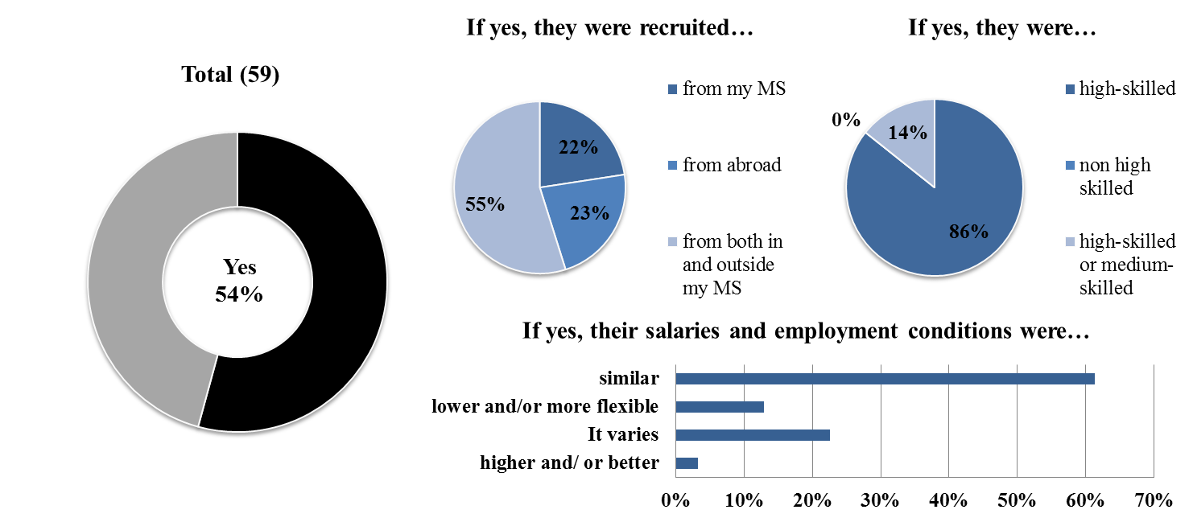

**Question 1:**Have you ever recruited non-EU migrant workers?

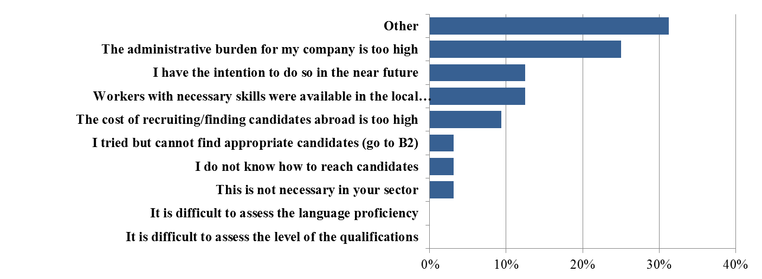

**Follow-up to Question 1:**If you have never recruited non-EU migrant workers before, what were the main reasons for not doing so? Select up to three reasons.

**Total: 32 responses by 26 respondents**

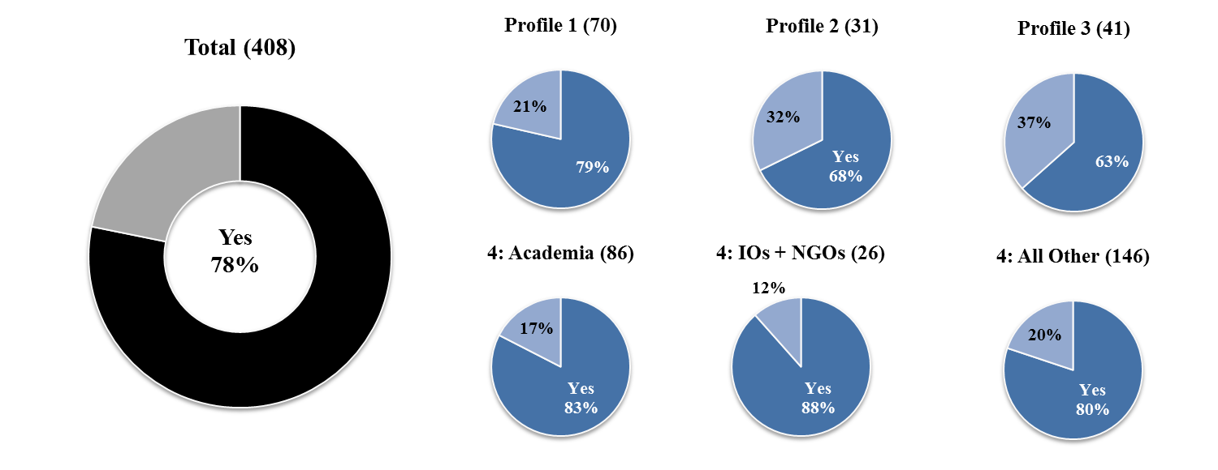

**Question 3:** Do you think that further initiatives at EU level, in particular with regards to highly skilled jobs, are necessary to improve the effectiveness of national tools for the identification of labour and skills shortages?

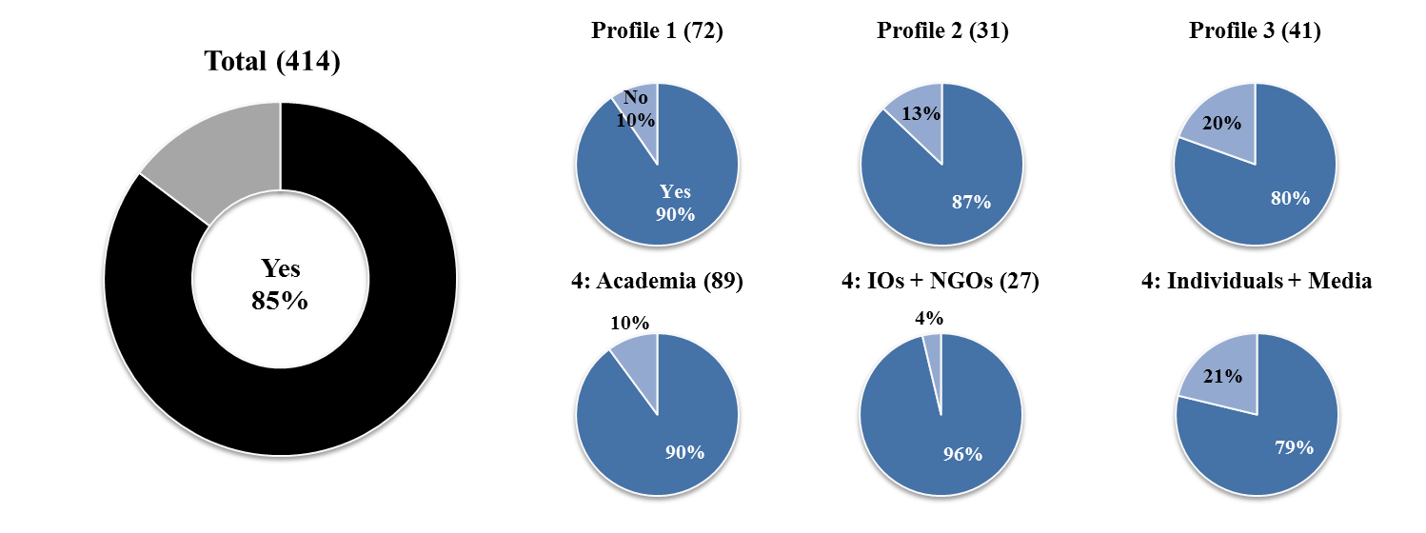

**Question 2:** In order to address labour shortages, a number of policy measures can be taken such as recruiting from other EU Member States, increasing the retirement age and labour market participation rates, or active labour market policies. Besides such measures, do you consider that it is also necessary to recruit migrant workers, including entrepreneurs, from outside the EU to address labour shortages in particular sectors/occupations in the EU?

**Follow-up to question 3:** If yes [to question 3], why are further EU level initiatives necessary to identify shortages?

The following views were frequently voiced across all four profiles:

* Need for a better understanding of labour-matching and more efficient tools for identification of labour shortages;
* Need for coordination of individual efforts of Member States and mutual learning;
* Development of better online tools and information-sharing between Member States;
* Need for more transparency of the national instruments;
* Need for a better link between identifying shortages and the policy responses to address them – for example, in Ireland there is an evidence-based procedure for identifying skills/labour shortages and adjusting labour migration policy;
* Preventing brain drain and facilitating brain circulation: more attention should be paid to these challenges and further action from EU might be needed.

**Selected responses from the following profiles:**

* **Academics**

A total of 51 academicsresponded**,** representing various institutions. According to many respondents further EU initiatives are needed in order to coordinate individual efforts of Member States. National tools for identification of shortages were seen as selective, inefficient and not functioning optimally, whereby shortages and labour mismatches largely persist in Member States. It was also warned that if skill shortages are not identified the EU might face a progressive underdevelopment in the long term. In addition, it was mentioned that functioning tools would allow for better adjustment of education programmes at post-graduate level to meet the specific needs of the European labour market.

* **Employers or employers' organisations**

A total of 35 employers and employers' organisations responded to this question. Nine of the German employers' organisations, the BDA, the AGV Versicherungen, the BAP and others had coordinated their responses and all remarked that further EU level initiatives are necessary in order to "create transparency concerning national instruments for the measurement of skill shortages and demographic change, wherever they exist[19]." According to some respondents, tools for identification of labour shortages are indispensable in the context of global competition. One respondent highlighted that the labour market in the EU is not functioning optimally as, on the one hand, the existing skilled labour across EU is not very well-recognised and, on the other hand, shortages persist. Policymakers have to dispose of adequate data on skills shortages and changes in the demand structure and labour market to be able to implement policy changes at a shorter notice based on this. One respondent noted that further initiatives at EU level are needed to identify the need of skilled workforce. In this regard, information-sharing between Member States is necessary.

* **International Organisations**

Seven responses were received from this group. They underlined that labour market knowledge produced by the EU and MS could be better systemized, including both general data on shortage occupations and the necessary skill profiles for specific sectors and occupations. Such data should be made easily available to employers, workers and recruiters. One respondent highlighted that in many Member States shortages do not translate well into migration policies – identifying shortages is usually in the remit of the Ministry of Labour while migration is under the auspices of the Ministry of Interior. The EU could provide exchange of information on how to link shortages with migration policy. Another set of responses focused on information-sharing with third countries. It was highlighted that advertisement of shortages to TCNs and in countries of origin is very limited and that this constitutes an area for improvement.

* **National ministries**

Five responses were received from national ministries. They highlighted that it is necessary to improve the existing tools in order for the EU and the Member States to be ready to respond to the continuously changing global context. They also emphasised that improving the effectiveness of the existing tools would allow for early identification of labour and skills shortages and labour market imbalances in the EU Member States. The respondents also stated that there should be mechanisms and/or policies introduced on how to overcome the identified labour market imbalances and risks.

Furthermore, it was stated that highly skilled workers are often hired to companies operating in multiple Member States, and that a more coherent European approach would ease the mobility of specialists inside the EU. Furthermore, a need for improved tools to identify labour shortages in low wage sectors and sectors dominated by undeclared work was recognised.

* **NGOs, Organisations or authorities of the countries of origin and trade unions**

Nine responses were received from NGOs, one from an organisation or country of origin and one from a trade union. Responses underlined that the tools are not accurate and do not respond timely to shortages. They stated that national authorities limit their scope within their borders. Thus the national authorities are not equipped to assess their situation in comparison with the EU common market. Replies highlighted that the key response to shortages of health personnel in Europe must come from the capacity to domestically train, recruit and retain those professionals. Preventing brain drain from third countries is also important. Further EU initiatives are needed to achieve a greater efficiency of these tools.

**Follow-up to question 3:** If no, why do you consider that no further EU level initiatives are necessary to identify shortages?

The following arguments were frequently voiced across all categories:

* Existing tools in place are sufficient.
* Existing tools should be left to market forces and to employers;
* Some tools are too administratively difficult to handle, not very reliable and instead efforts should be placed in engaging employers;
* A number of respondents, although not answering the question posed, expressed views that labour market gaps should be filled with unemployed EU nationals rather than trying to attract TCNs.

**Selected responses from the following profiles:**

* **Academia**

Nine responses were received from this category.Three respondents considered that the tools currently available are sufficient and the EU should not take further action in this area. Two respondents highlighted that job-matching should be left to the market forces and for employers to find workers. One respondent stated that more efforts should be focussed on the recognition of qualifications, which is of higher importance.

* **Employer, employer’s organisations and executive and senior-level management**

Eleven responses were received from employers, employer’s organisations and executive and senior-level management. Some respondents expressed the view that the tools currently available are sufficient and that the EU should not take further action in this area. Two respondents highlighted that the labour market needs in Member States are too heterogeneous for the EU to have a role in the identification of shortages and that this approach would not be flexible.

* **National ministries**

A total of six responses were provided by national ministries. Some respondents underlined that the existing tools are adequate. One respondent flagged that Member States are best placed to assess their labour market needs and to respond appropriately and that access to the national labour market is under national competence. Another respondent highlighted that addressing labour market shortages should be better solved by demand and supply.

* **NGOs**

Four responses were provided on this question by NGOs. One respondent pointed out that tools do exist but it is necessary to motivate employees and employers to use them. Some tools for identification are too cumbersome.

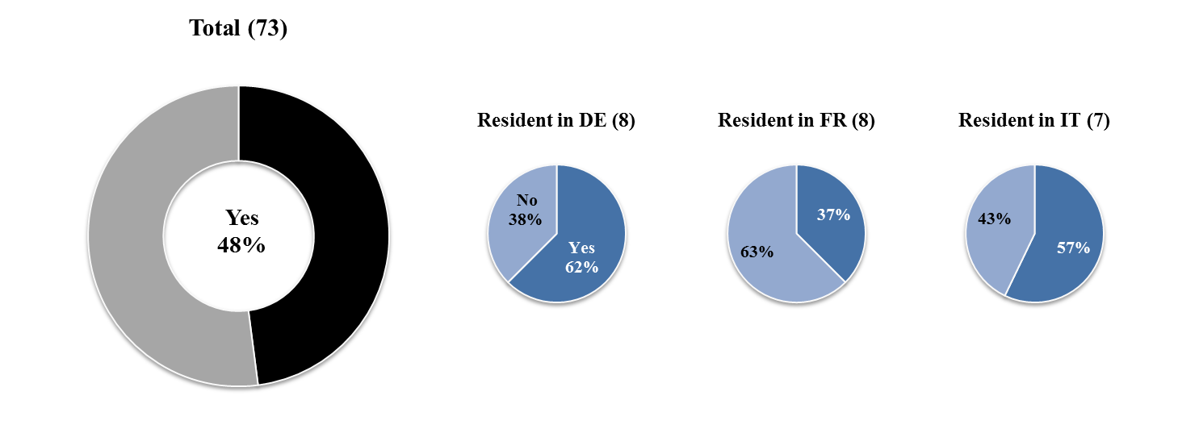

**Question 4:** Did you manage to find a job easily in the Member State where you are working?

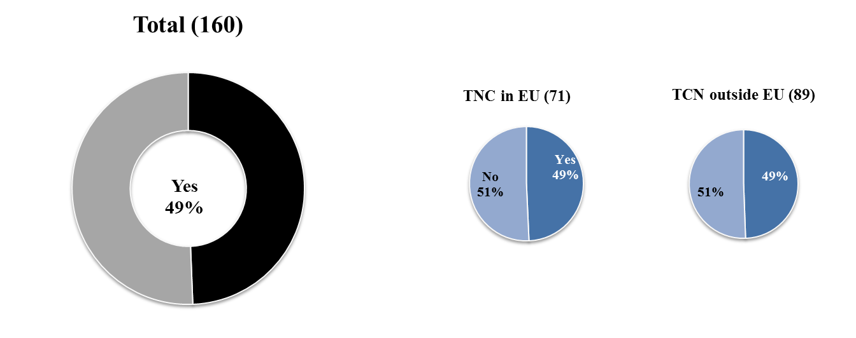

**Question 5:** (If you were to move to Europe), would your intention be to start up a business?

### **2.3.2. Chapter 2: Availability of information**

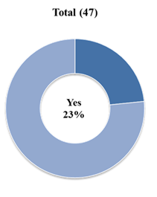

**Question 6:** Do you think that further initiatives at EU level, in particular with regardsto highly skilled jobs, are necessary to improve the effectiveness of tools for the identification of labour and skills shortages?

**Question 7:**If you have recruited third-country workers, did you use a third party to help with the immigration procedures and the authorities? E.g. a lawyer or specialised firm?

**Selected responses from employers and employer’s organisation**

The majority of respondents who relied on professional help did so because the application procedures are too complex and the consequences in the case of non-compliance with the requirements (even when involuntary) are severe. In addition, using a third party saves time. For instance, one major company explained that they used a global service provider because legal requirements are complicated and in-house legal professionals often do not have enough expertise.

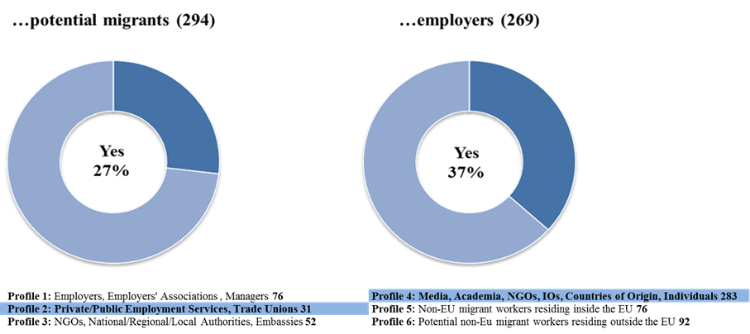

**Question 8*:*** Do you think adequate information on national immigration systems is easily available to…

**Question 9:**Did you/ do you find information easily about job vacancies in EU Member States and/or about labour market shortages in particular sectors or particular Member States?

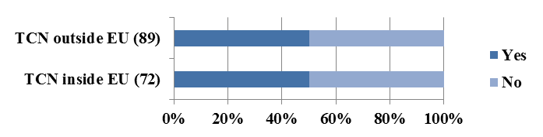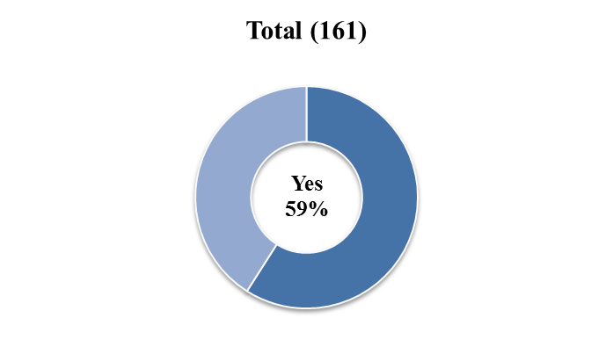

**Question 10:**Did you find information easily about legal ways to come to Europe?

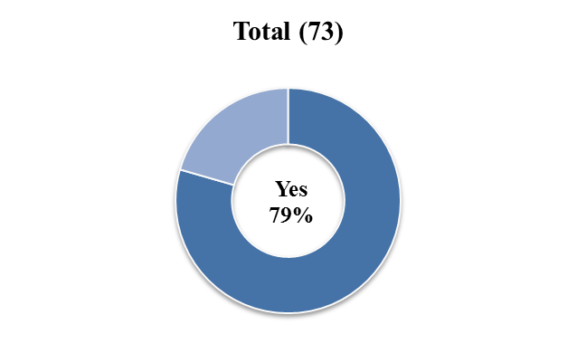

**Selection of obstacles identified by Non-EU migrant workers and entrepreneurs in the EU**

* Information is available in national languages, rather than English. If translation is provided, it is not clear;
* Information provided by foreign representations is often not clear or coherent;
* Due to the lack of standardised procedures across Member States, third-country nationals find it difficult to understand the different entry and residence requirements;
* Setting up a business is burdensome without a secured right of residence in the host country;
* Information is lacking on how to set up a small business or work as a freelancer in the EU.

**Question 11:**Do you inform employers and/or potential non-EU workers about recruitment possibilities?

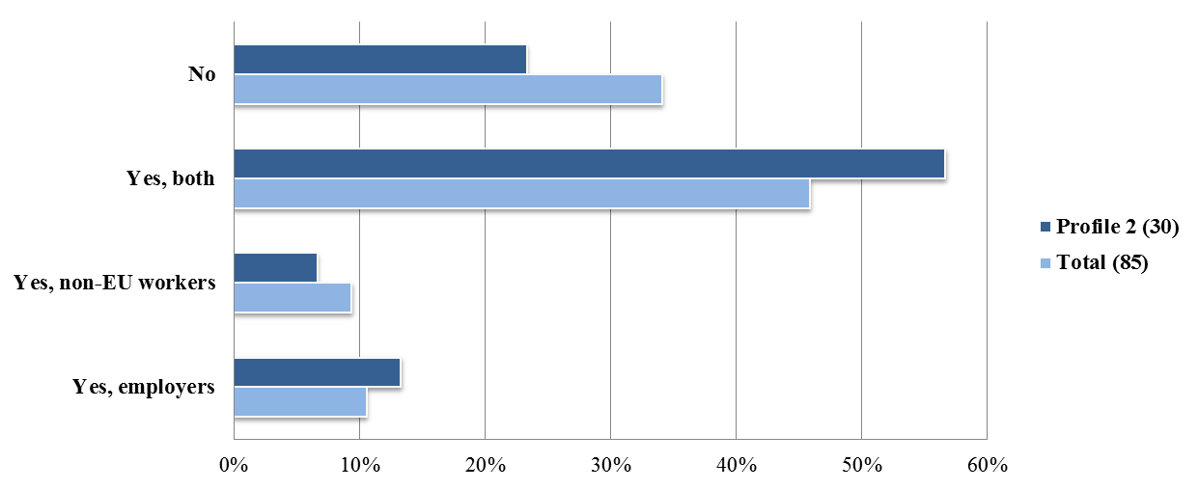

1. [Political Guidelines Juncker](http://ec.europa.eu/priorities/sites/beta-political/files/juncker-political-guidelines_en.pdf.), EP, Strasbourg, 15 July 2014.
2. See: Juncker’s [Priorities for this Commission](http://juncker.epp.eu/my-priorities), on Juncker’s EPP website, Spring-Summer 2014; Juncker’s [Mission letter to Commissioner Dimitris Avramopoulos](https://ec.europa.eu/commission/sites/cwt/files/commissioner_mission_letters/avramopoulos_en.pdf), 1 November 2014.
3. Communication from the Commission to the European Parliament, the Council, the European Economic and Social Committee and the Committee of the Regions of 13 May 2015, A European Agenda On Migration, [COM(2015) 240 final](http://ec.europa.eu/dgs/home-affairs/what-we-do/policies/european-agenda-migration/background-information/docs/communication_on_the_european_agenda_on_migration_en.pdf)
4. Communication from the Commission to the European Parliament and the Council of 22 May 2014 on the implementation of Directive 2009/50/EC on the conditions of entry and residence of third-country nationals for the purpose of highly qualified employment (“EU Blue Card”), COM(2014) 287 final.
5. Better Regulation Guidelines, 19 May 2015, SWD(2015)111 final.
6. Inception Impact Assessment, [Review of Directive 2009/50/EC of 25 May 2009 on the conditions of entry and residence of third-country nationals for the purposes of highly qualified employment (“EU Blue Card” Directive)](http://ec.europa.eu/smart-regulation/roadmaps/docs/2016_home_025_review_eu_blue_card_directive_en.pdf), 16 July 2015.
7. President Juncker’s [State of the Union](http://ec.europa.eu/priorities/state-union-2015_en) speech, European Parliament, Strasbourg, 9 September 2015.
8. Communication from the Commission to the European Parliament, the Council, the European Economic and Social Committee and the Committee of the Regions of 27 October 2015, ‘Commission Work Programme 2016 - No time for business as usual’, [COM(2015) 610 final](http://ec.europa.eu/atwork/pdf/cwp_2016_en.pdf)
9. Annex I on [New initiatives](http://ec.europa.eu/atwork/pdf/cwp_2016_annex_i_en.pdf)
10. [Communication from the Commission to the European Parliament and the Council 'Towards a Reform of the Common European Asylum System and Enhancing Legal Avenues to Europe' COM(2016) 197 final](http://ec.europa.eu/dgs/home-affairs/what-we-do/policies/european-agenda-migration/proposal-implementation-package/docs/20160406/towards_a_reform_of_the_common_european_asylum_system_and_enhancing_legal_avenues_to_europe_-_20160406_en.pdf)
11. Participants: SG, HOME, SJ, DEVCO, JUST, TRADE, NEAR, EAC, EPSC, EMPL, RTD, JRC, CNECT.
12. Participants: SG, HOME, EAC, ECFIN, SANTE, TRADE, GROW, EMPL, JUST, RTD, JRC.
13. Participants: SG, HOME, EAC, ECFIN, EMPL, EPSC, GROW, JRC, JUST, RTD, SANTE, TRADE.
14. A New Skills Agenda for Europe (forthcoming), COM(2016) 381 final
15. Where explicitly used, this material is referenced in the Impact Assessment report. In other cases it served as background material.
16. See database on: <http://ec.europa.eu/dgs/home-affairs/what-we-do/networks/european_migration_network/reports/index_en.htm>
17. See database on: <http://ec.europa.eu/dgs/home-affairs/what-we-do/networks/european_migration_network/reports/index_en.htm>
18. Where explicitly used, this material is referenced in the Impact Assessment report. In other cases it served as background material.
19. Complete citation in original language: "Herstellung von Transparenz über nationale Instrumente zur Messung von Fachkräfteengpässen und zur demografischen Entwicklung soweit verfügbar (z.B. Engpassanalyse in Deutschland). Potentielle Blue Card-Inhaber könnten somit prüfen, in welchem Mitgliedstaat ihr Beruf als Mangelberuf geführt ist."