

Table of Contents

Annex 2 – part 2 3

2.3.2. Chapter 2: Availability of information 3

2.3.3. Chapter 3: Attractiveness of the EU 5

2.3.4. Chapter 4: The EU Blue Card 8

# Annex 2 – part 2

## 2.3.2. Chapter 2: Availability of information

**Question 12:**What channels do you use/ have you used to find job vacancies in the EU?

**Total: 453 responses by 160 respondents**

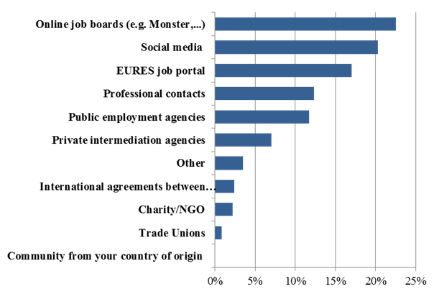

**Follow-up to question 12:** Are you satisfied with these channels?

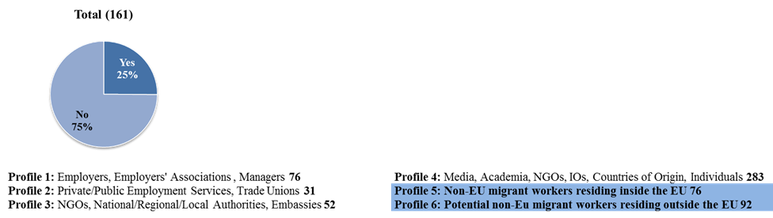

**Question 13:**What are the channels that you use/have used to obtain information on the legal requirements to migrate in response of those vacancies?

**Total 313 responses by 160 respondents**

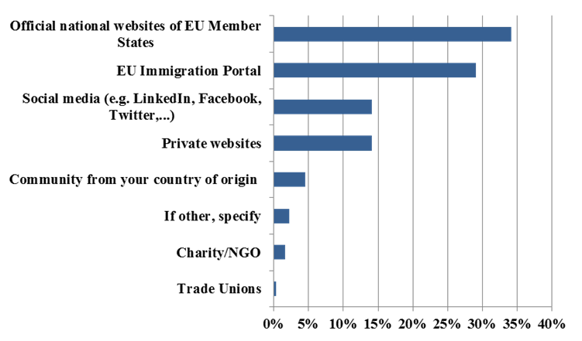

**Follow-up to question 13:**Are you satisfied with these channels?

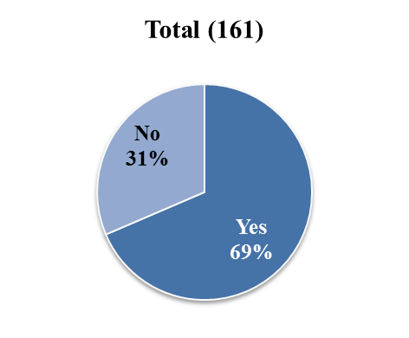

## 2.3.3. Chapter 3: Attractiveness of the EU

**Question 14:**How would you rate the attractiveness of the EU on the following factors?

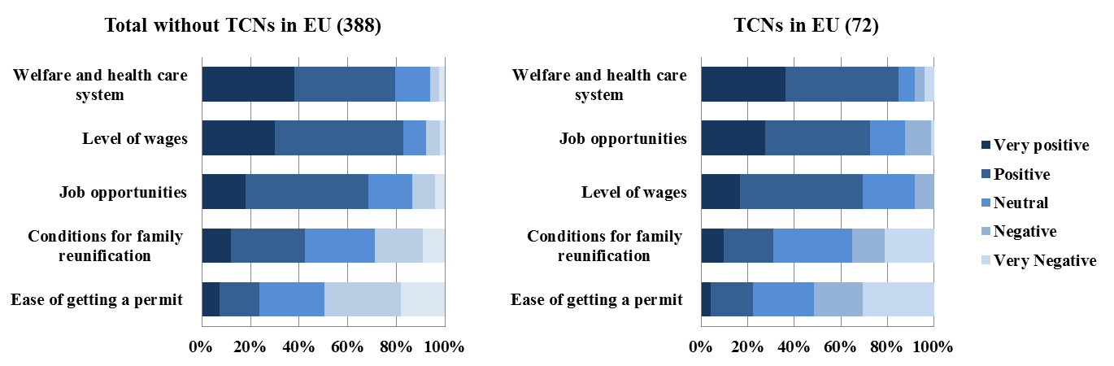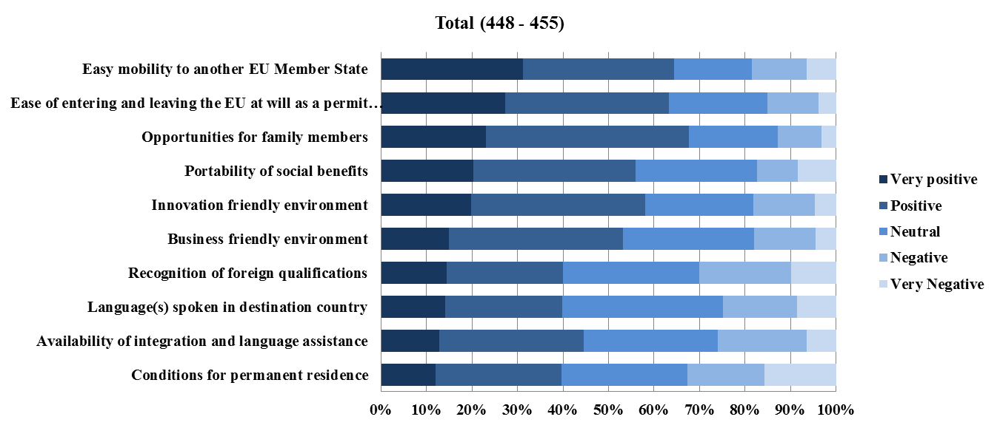

**Question 15:**On which of the following issues could the EU do more to improve its attractiveness as a migration destination for highly qualified non EU migrants? (maximum 3options)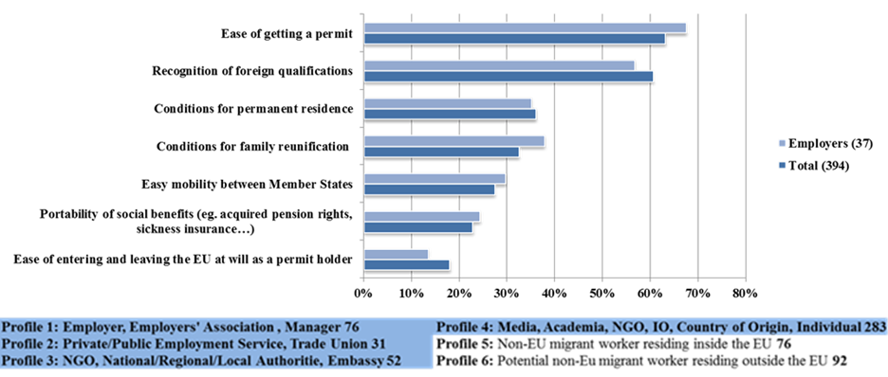

**Question 16:** Do you think more should be done, at the EU level, to improve the attractiveness of the EU Member States for highly-skilled migrants?

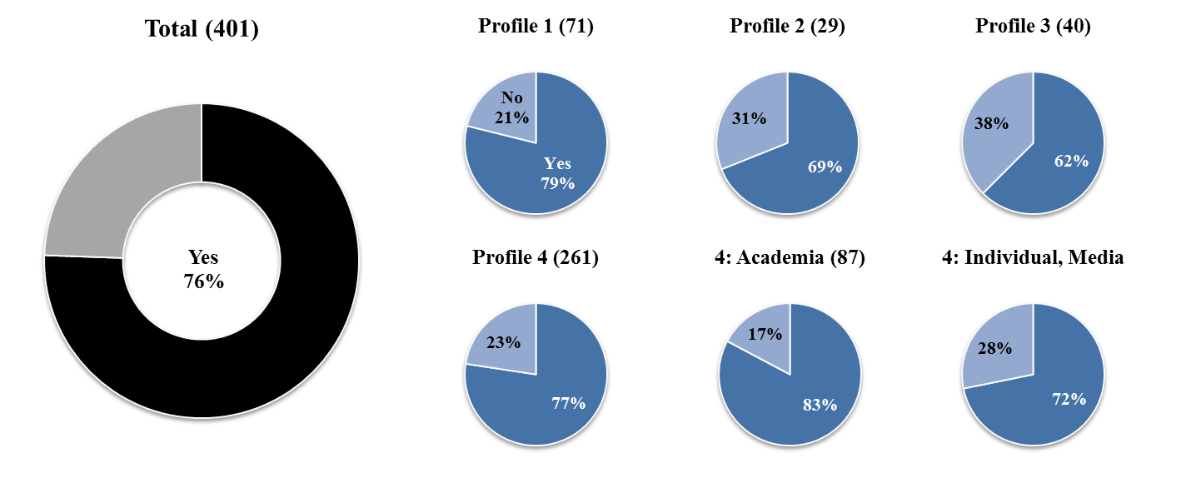

**Question 17:** In the country/ies in which you are active, do you consider that the system for managing labour migration addresses both the immediate employers’ needs and the long-term challenges such as demographic ageing and other social aspects?

**Question 18:** Which EU Member State(s) did you/would you consider migrating to? Only one choice.

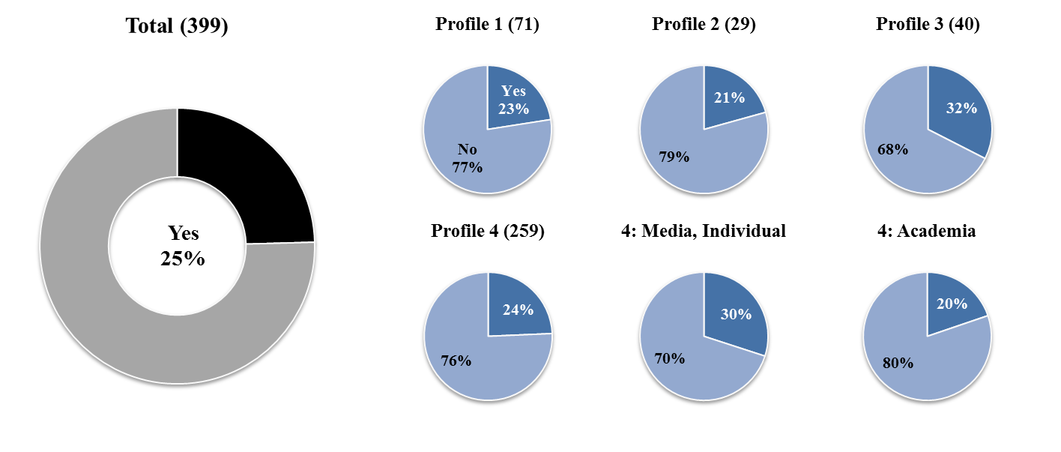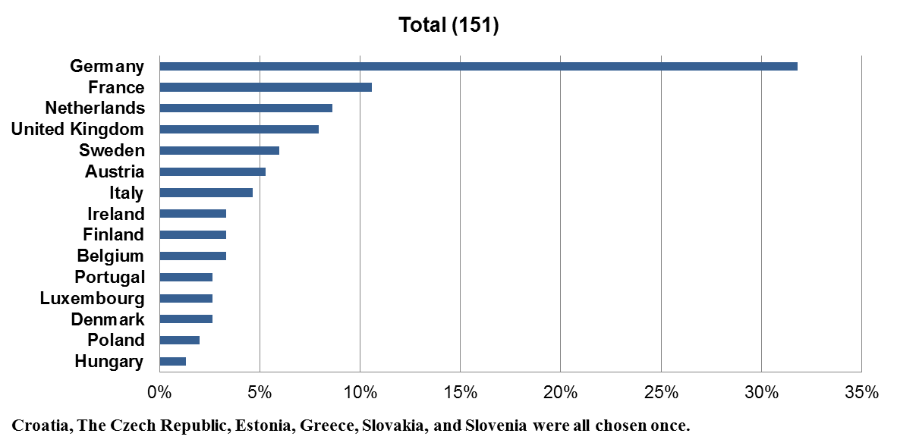

**Question 19:**Did you/would you consider other destinations besides the EU? If so, which one(s)?

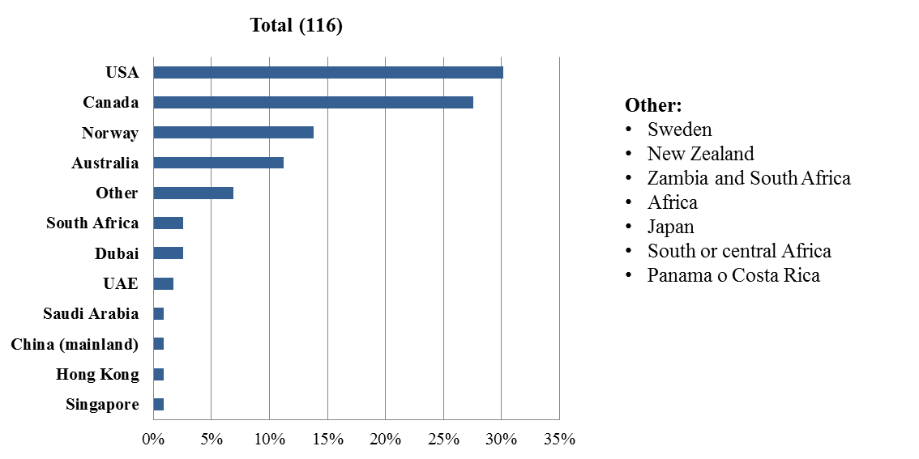

**Follow-up to question 19:** Why are you interested in other destinations or why did you finally move to another destination other than Europe?

**Factors mentioned in favour of USA:**

* More entrepreneurial environment and lower taxes;
* Career opportunities and innovations;
* Better living standards;
* Relatively higher GDP growth rate and lower unemployment levels;
* English language ;
* Possibility to move around across the country without differing visa requirements or restrictions.

**Factors mentioned in favour of Canada:**

* Open and flexible immigration policies;
* Easy access to permanent residency and citizenship;
* Attractive express entry system with job portals;
* Flexible recognition of qualifications;
* Ease of family reunification;
* English/ French language.

## 2.3.4. Chapter 4: The EU Blue Card

**Question 20:** Had you ever heard of the EU Blue Card before this survey?

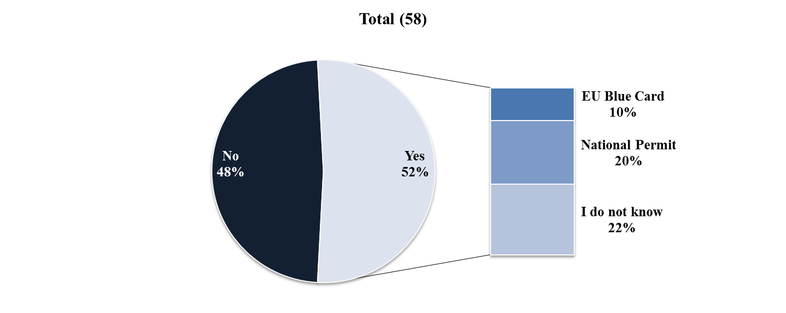

**Question 21:** Were/Are you employed as, or were/are you interested in coming to the EU as a highly qualified worker? If yes, did you apply for/would you apply for a BC?

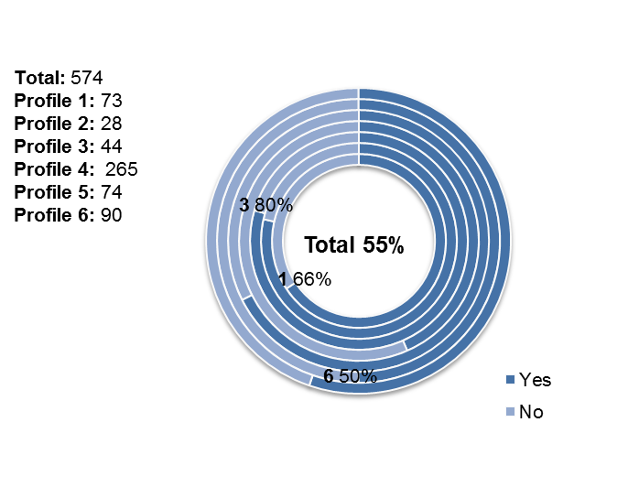

**Follow-up to question 21:** If yes, do you consider that its attractiveness could be improved?

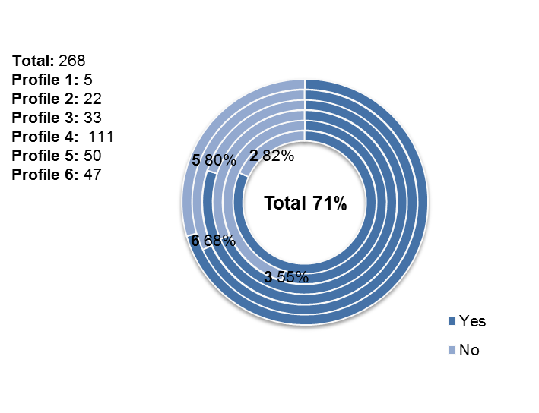

**Follow-up to question 21:** If no, please explain why you have not applied for an EU Blue Card

* **TCNs residing outside the EU**

From this category 13 responses were received. Five respondents answered that they have applied or consider applying for a Blue Card. In four cases, respondents struggled to receive a job offer. Two respondents highlighted that the required salary level is too high. For example, one respondent said that within academia salaries are not generally high, so sometimes the 1.5 times average salary threshold is exclusive even for the very highly educated. One respondent flagged that most of the companies ask for advanced knowledge of the host country's language, which is considered a major barrier to work in the multilingual Europe. Finally, one respondent shared that they had been misinformed of a need to stay in Europe for 5 years to be able to apply for an EU Blue Card.

* **TCNs residing in the EU**

15 responses were received from this category. Six respondents replied that they are considering applying for an EU Blue Card, and a further five respondents had considered applying but opted for a national residence permit (e.g. from Finland, France and Italy) instead. One respondent pointed out that under the national scheme it was easier to apply for family reunification. Another respondent regretted the lack of mobility rights as all the documentation has to be presented again in the second Member State.

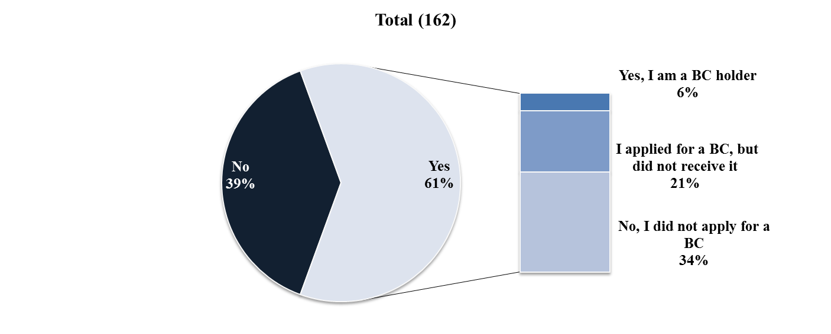

**Question 22:** Have you ever employed a non-EU highly qualified worker? If yes, what work permit did you use?