

Table of Contents

Annex 2 – part 3 3

2.4. Responses to the public consultation received through position papers 15

3. Targeted stakeholder consultations 25

3.1 Member States 25

3.2 International Organisations 25

3.3 Business representatives and social partners 25

3.4 Expert consultations 26

# Annex 2 – part 3

#### 2.3.4. Chapter 4: The EU Blue Card

**Question 23:** Did you apply for/would you consider applying for another program for highly qualified workers other than the EU Blue Card?

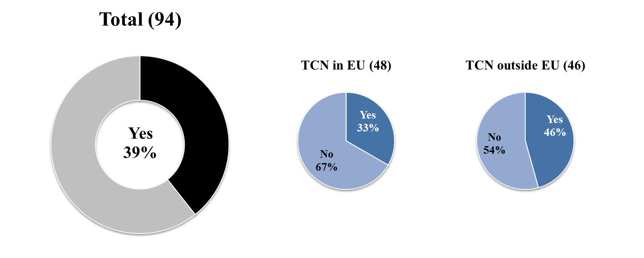

**Follow-up to question 23:** If yes, please specify for which other program you applied.

* **Non-EU migrant workers and entrepreneurs currently outside the EU**

16 responses were received from this category. Four respondents said that they have applied for or considering the Danish Green Card; one mentioned the Red-White-Wed card for employment in Austria; one mentioned UK Tier 2 and another respondent said that they are considering schemes in Canada, USA and Australia. Further responses included a Working Holiday Visa and entrepreneur visas of various EU countries.

* **Non-EU migrant workers and entrepreneurs currently in the EU**

Out of the total of 12 respondents, three had applied for or considered the Critical Skills permit in Ireland; one a Finnish specialist permit; one a Danish Green Card; one a Dutch residence permit and one a USA scheme. Two respondents expressed that they would consider any programme for the highly skilled.

**Follow-up to question 23:** Why did you apply for another programme?

* **Non-EU migrant workers and entrepreneurs currently outside the EU**

Out of 11 respondents, two respondents applied for another programme because they did not have a job offer as required for the EU Blue Card. Two respondents found the procedure for the other scheme to be more open and flexible. Another respondent said that UK and Denmark (which do not apply the EU Blue Card) are attractive because of the English language used in these countries.

* **Non-EU migrant workers and entrepreneurs currently in the EU**

Out of the seven respondents, four respondents said that applying for the national permit was easier. One respondent also emphasized that under the other scheme the applicant may change employers freely rather than being tied to a contract with the EU Blue Card.

**Question 24:** Are you aware of any specific reason why you were recruited under a different program than the EU Blue Card?

The number of responses was 41, of which thirteen respondents were not aware of a specific reason. Reasons given included:

* Salary threshold is too high (5 respondents);
* EU Blue Card was unavailable in the country (4 respondents);
* EU Blue Card did not exist at the time of application (2 respondents);
* Recruitment under another scheme cost less for the employer (1 respondent);
* Applicant was not eligible for the EU Blue Card (1 respondent);
* Employer proposed another option (2 respondents);
* Employers are not aware of the EU Blue Card and there is general reluctance to engage in bureaucratic work permit procedures (1 respondent);
* National immigration officers stated it is too complicated to get an EU Blue Card (1 respondent).

**Question 25:**What aspects are most important for the attractiveness of the EU Blue Card? Please indicate the factors you consider important. (max. three answers possible)

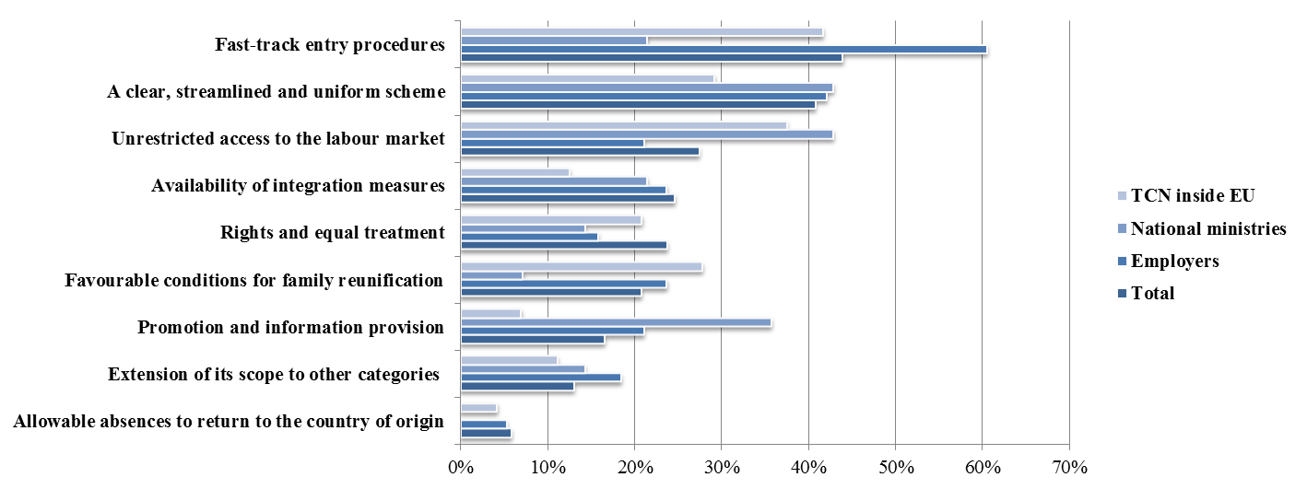

**Total: 1232 responses by 569 respondents**

**Question 26:** Do you consider that the admission conditions of the current EU Blue Card Directive are adequate? If no, please indicate the specific criteria which you consider should be made more flexible.

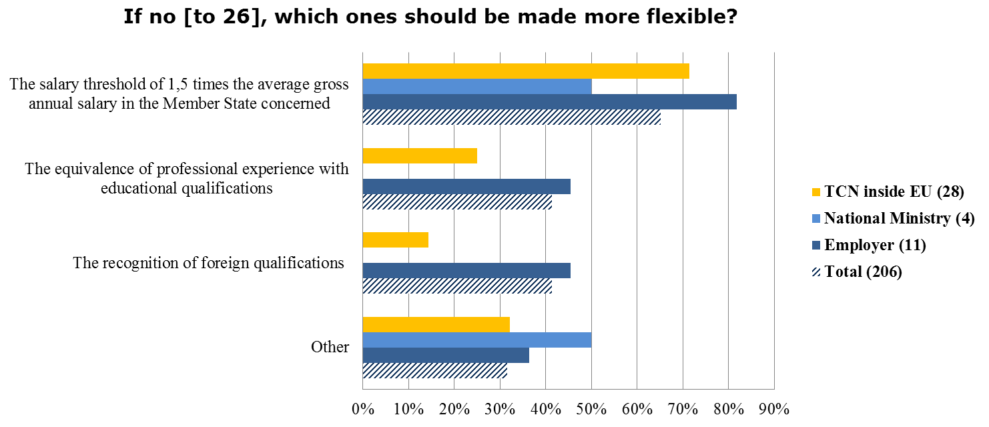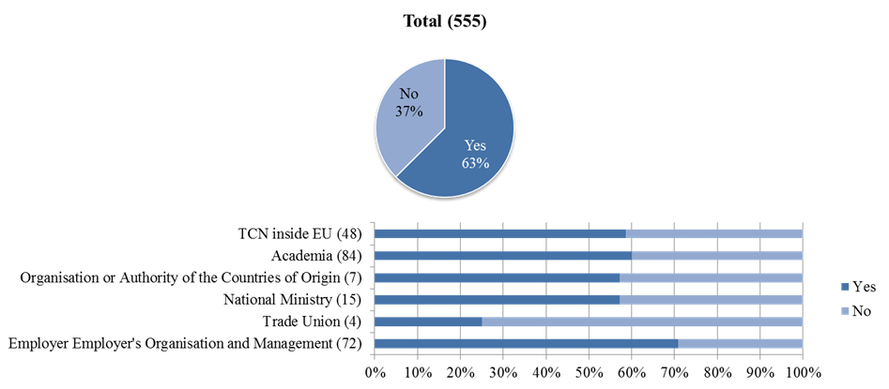

**Follow-up to question 26:** If you selected 'other' please specify.

**The following arguments were voiced across categories:**

* The requirement to have a binding contract before arrival is too restrictive;
* The Blue Card does not address some key categories, such as recent graduates and start-ups.

**Selected responses from the following profiles:**

* **Academia**

Four academics suggested that the requirement of a one-year work contract should be loosened. On the other hand, one respondent flagged that even one year might be too short to carry out an international move and therefore, at least two years should be required. In addition, the better portability of social benefits and pensions was mentioned by one respondent.

* **Employer, employer’s organisation and executive and senior-level management**

Three employers and employers' organisations argued that a salary threshold at EU level interferes with the freedom of individual employers and workers to negotiate the salary. Setting the threshold too high can also discourage employers from recruiting highly skilled TCNs through the EU Blue Card scheme. Two respondents demanded a more flexible definition of highly qualified. For example, the binding work contract together with the salary requirement make the scheme unattainable for entrepreneurs and shareholders that would like to work in their own company, particularly if this is a start-up. Two respondents demanded more flexibility and transparency to the eligibility criteria. One respondent highlighted that the lengthy process of recognition of qualifications jeopardises the fast and easy entry through the EU Blue Card. This was seen as particularly problematic in cases where individual immigration offices have varied interpretations of adequate recognition. One respondent argued that the EU Blue Card scheme should be discontinued as it exacerbates the problems in re-training and adequately recruiting EU citizens.

* **NGOs**

One respondent was in favour of introducing a job seeking permit for TCNs in order to open legal and safe avenues for migration to the EU. From the viewpoint of start-up companies it was seen as problematic that only regular, monetary wages are taken into account for meeting the salary threshold, but not for instance company shares.

* **Private individuals**

Two respondents expressed the view that the EU Blue Card should be made more restrictive and apply the labour market test more rigorously to make sure that job openings are adequately filled by EU nationals. In addition, it should be verified that TCNs do not have a criminal record or figure on a terrorist list.

* **Non-EU migrant workers and entrepreneurs currently outside the EU**

The requirement to have a binding contract before arrival makes it very hard to apply for the Blue Card. In addition, companies should be more flexible for TCN applicants who have English language proficiency, but do not speak the local language. Because the work contract/job offer requirement does not reflect the multifaceted nature of the modern labour market, there should be a dedicated path for freelancers and the self-employed.

* **Non-EU migrant workers and entrepreneurs currently in the EU**

Three respondents confirm that it is difficult to obtain a work contract without a work permit, which effectively hinders access to the EU Blue Card. Employees should be allowed to request and apply for the EU Blue Card on their own accord independently of the employer, as many employers are not aware that such a card exists or they believe that the application process is too difficult or time-consuming. It was also argued that any legal residence in an EU Member State should count towards the long-term residence status.

**Question 27:** In your opinion, in order to make the EU as a whole more attractive for highly qualified migrant workers: A) it is better to opt for one unified and visible EU-wide scheme, such as an improved EU Blue Card without parallel national programmes, or B) it is better to keep parallel national programmes for highly qualified migrants workers?

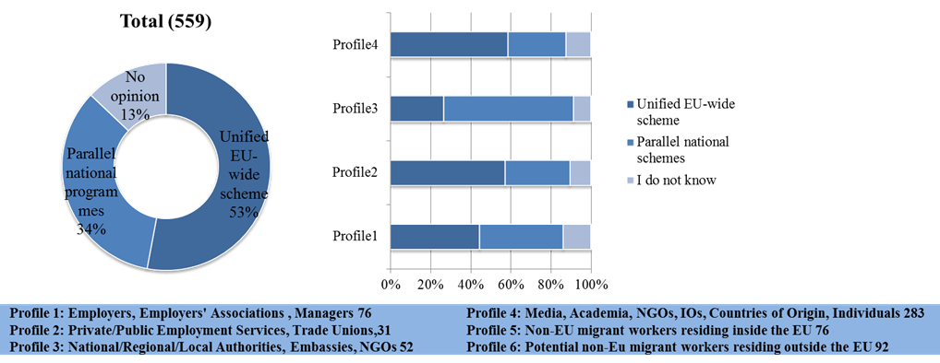

**Follow-up to question 27:**Why are you in favour of one unified and visible EU-wide scheme, such as an improved EU Blue Card without parallel national programmes? Please indicate the factors you consider important. Multiple answers possible.

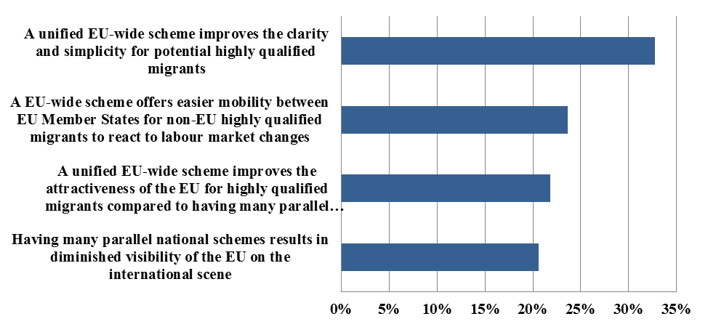

**Total: 659 responses by 293 respondents**

**Follow-up to question 27:**Why are in favour of keeping parallel national programmes for highly qualified migrants? Please indicate the factors you consider important - multiple answers possible.

**Total: 445 responses by 189 respondants**

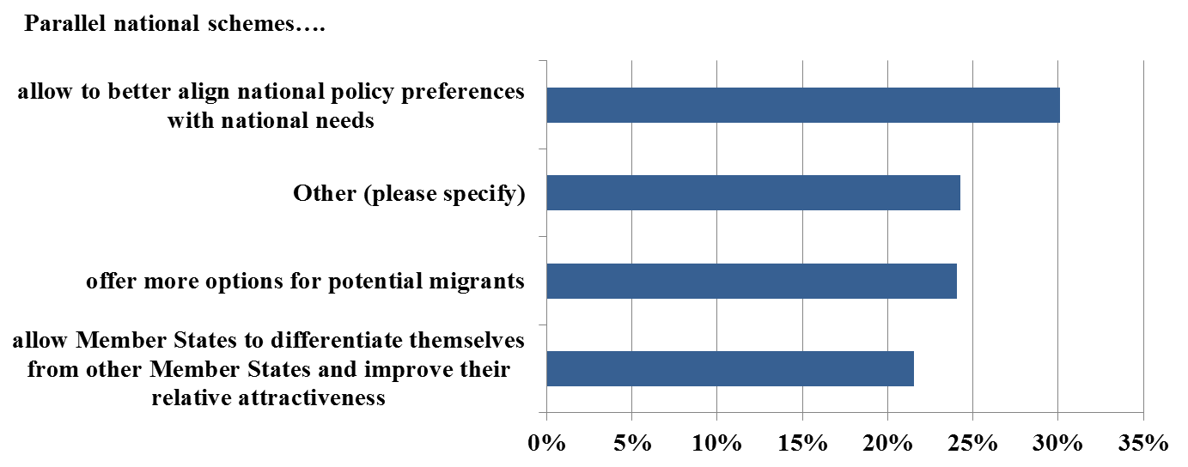

**Question 28:**Do you consider that the EU Blue Card scheme could be more attractive if its scope were to be expanded to certain additional categories? If yes, which additional categories should be included?

**Question 29:**Do you have further comments on how the EU can be made more attractive for highly qualified workers (in particular in relation to the Blue Card directive)?

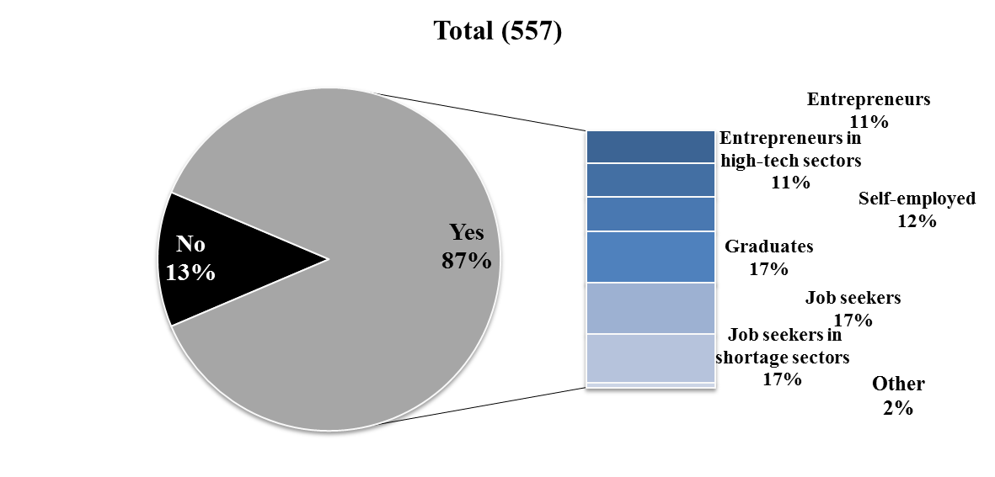

**The following ideas were frequently voiced across all categories:**

* Facilitating entry conditions and reducing red tape;
* Improving consistency in implementation across Member States;
* Increasing efforts to actively promote the EU Blue Card;
* Developing the recognition of qualifications;
* Lowering the salary requirements to accommodate (a) specialists in shortage occupations, also with mid-level skills; (b) start-ups and (c) graduates.

**Selected responses from the following profiles:**

* **Academia**

Five respondents suggested that the EU should facilitate and simplify entry and residence conditions for the highly skilled. In addition it was suggested that the EU could devote more attention to filling shortages also in occupations belonging to ISCO major group 3[1]. Another respondent encouraged the EU to improve the prospects for family reunification as well as integration assistance. It was also mentioned that more could be done to promote the EU Blue Card. To this end the scheme should encompass some distinct benefit that no main competitor country offers.

* **Employer, employer’s organisation and executive and Senior-Level management**

Four respondents asked for entry procedures and conditions for intra-EU mobility to be streamlined for all TCNs and EU nationals alike. The same number proposed to reduce application processing times. Three respondents called attention to the lack of consistency in the implementation of the EU Blue Card across Member States. It was also suggested that all existing EU instruments on labour migration should be promoted more intensively. In addition, the EU Blue Card should not replace but complement the national schemes. Mechanisms for pre-arrival recognition of qualifications and professional experience should be developed. One respondent argued that the EU Blue Card should be discontinued as it is damaging the employment prospects of EU citizens. One respondent mentioned specific problems in recruiting nurses and regretted that medium skilled persons cannot be attracted under the EU schemes, mostly because of the high salary requirements.

* **International organisations, NGOs, private employment services, organisations of authorities in countries of origin**

Five respondents were of the opinion that the requirements, especially the salary threshold, should be lowered because the EU must attract young, qualified workers having difficulties to reach the high threshold. Five respondents asked for increased efforts regarding the recognition of qualifications. Three respondents demanded more attention to be paid to the loss of human capital and brain drain in developing countries, especially in key sectors such as healthcare. One respondent proposed to expand the scope of the EU Blue Card to start-up entrepreneurs.

* **Private individuals**

Four respondents asked efforts and funds to be devoted to labour market activation of EU citizens and not on attracting people from outside the EU. Four others suggested providing more information on the scheme and increasing transparency.

#### 2.3.5. Chapter 5: Qualifications

**Question 30:**Do you consider the current procedures for the recognition of non-EU qualifications adequate?

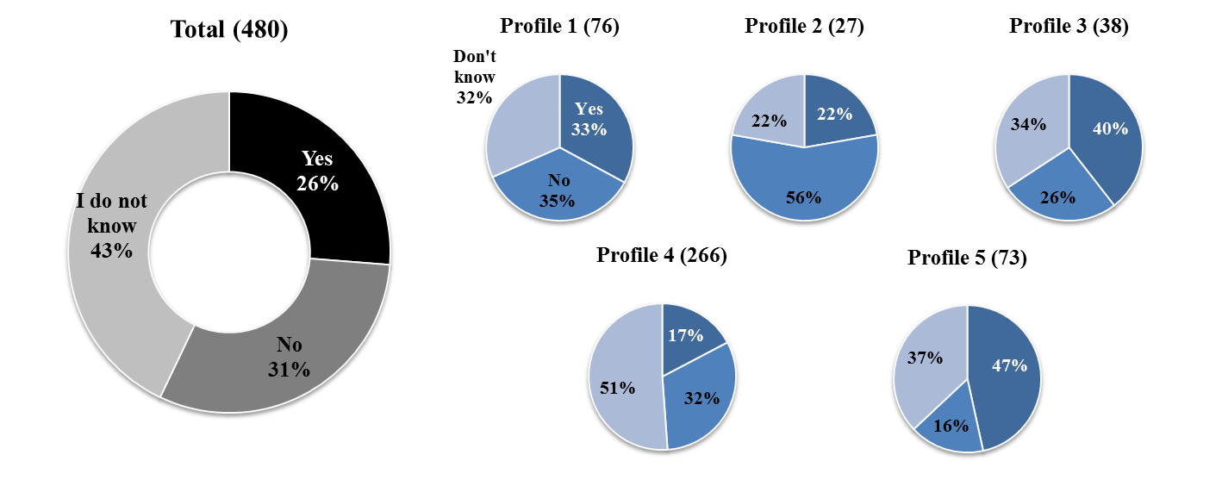

**Selected responses from the following profiles:**

* **Academia**

All respondents highlighted the need for a more unified scheme for recognition that would abolish bureaucratic and lengthy procedures and prevent that every Member State applies its own rules. Respondents emphasized the aim for a more transparent, clear and simple one-stop-shop procedure. One respondent flagged that even between Member States many qualifications are not recognised.

* **Employers, employers' organizations and executives and Senior-Level management**

Opinions from this group centred on the lack of uniform recognition of qualifications, and non-transparency and inefficiency of the process. Employers' organisations urged the Commission to ensure that all Member States establish proper recognition systems and to promote transparency of these systems at EU level. Recognition needs to be facilitated through greater trust between the relevant actors in the countries of origin and countries of destination respectively.

* **International organisations, national ministries, NGOs and organisations in the countries of origin**

Respondents called for further efforts in achieving streamlined, transparent and time-efficient systems for the recognition of qualifications, also at pre-arrival stage. Procedures need to be better tailored to the needs of various sectors, and employers need to be able to foresee recognition outcomes. One respondent argued through an example that a narrow interpretation of "equivalent degree" can lead to unreasonable outcomes if the degree or profession does not currently exist in the Member State in question.

**Question 31:**Did you have to apply to have a worker's non-EU qualification officially recognized? If yes, how long did it take?

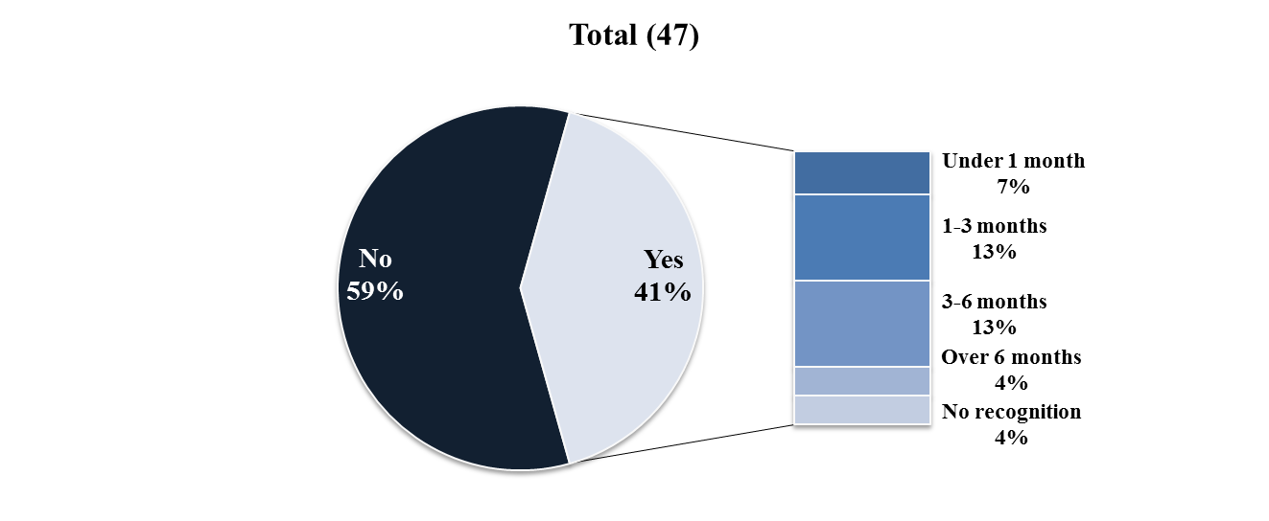

**Question 32:** Do you provide help/advice on the recognition of qualifications from outside the EU

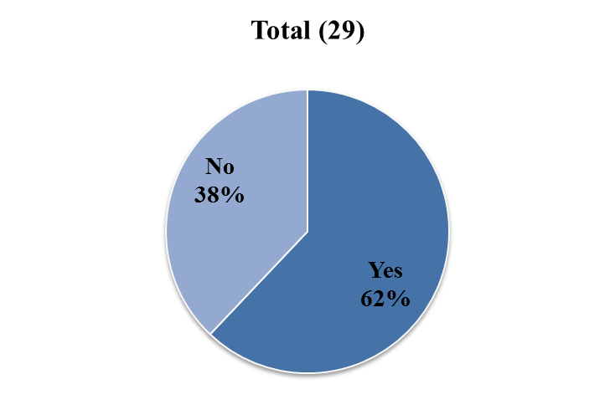

**Question 33:**Are you employed below your qualifications in your current job?

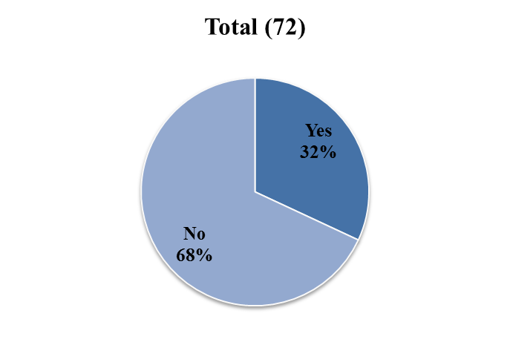

**Question 34:**Was your qualification recognised in the Member State where you work?

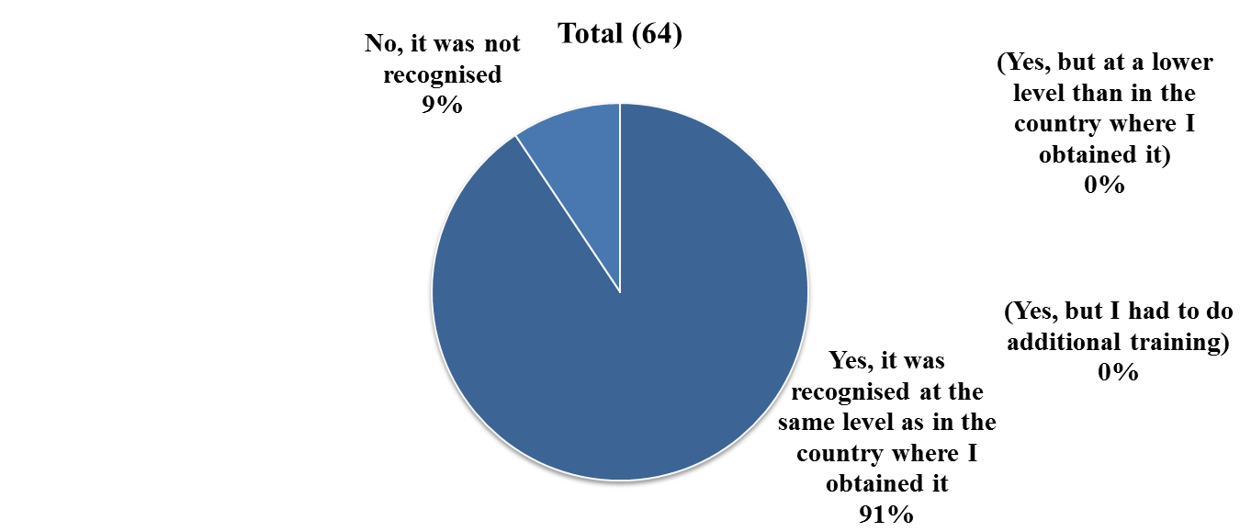

**Question 35:**Was it difficult to get your non-EU qualification recognized?

**Follow- up to question 35:**If yes, please explain.

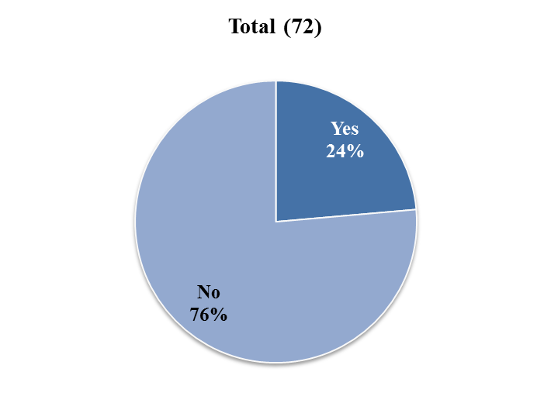

* **Non-EU migrant workers and entrepreneurs currently in the EU**

Respondents repeatedly mentioned the burdensome requirements. One respondent, for instance, listed the documents that were needed to get a PhD recognised in a Member State, including translations, an apostille certificate, conventions, and notary works. Another example given by a respondent is that their certificates written in English had to be translated into the local language which further had to be equated vis-à-vis the national education system. In addition, it was mentioned that the process of having qualifications recognised takes a long time and the results are difficult to predict.

**Question 36:**Did you use a third party to help with the recognition of qualifications and the authorities? If yes, please explain.

* **Employers**

One employer shared a negative experience whereby national authorities had refused to recognise a diploma despite a preceding check against a recognition database and by an employment agency. Employers reported using lawyers and global service providers to help with the application process.

* **Non-EU migrant workers and entrepreneurs currently in the EU**

The following service providers were mentioned: translators, lawyers, and WES (World Education Services) in validating a non-EU certificate.

### 2.4. Responses to the public consultation received through position papers

#### 2.4.1. Respondents and overview of common positions

In response to the public consultation **14 individuals and organisations** sent extensive position papers to inform the Commission of their views and make their interests known.

Contributions were received from a **wide variety of actors**: employers’ trade and business associations (DKG, NASSCOM, PEARLE, USCIB), trade unions (DGB, EUROCADRES, ECA), international organisations (UNHCR), (Members of Parliament (DE), employment agencies (SAZ), regional governments (Land Baden-Wuerttemberg (DE), and Regional Land Kärnten (AT)), NGOs (EPHA) and experts’ associations (SVR).

Most business organisations and trade unions reflected on the specific features and needs of the sectors they represent, suggesting ways to improve the attractiveness of the EU Blue Card for their member organisations. UNHCR reflected on the possibilities for making the EU Blue Card more accessible for refugees. All contributions mentioned the importance of internationalisation for modern companies and acknowledged their need for mobile workers. There was also a widespread agreement that labour migration policies need to become more consistent across Member States. It was also noted, however, that the price for a uniform policy cannot be an agreement reflecting the lowest common denominator.

Nearly all contributions (except ECA) called for some requirements of the EU Blue Card to be relaxed in order to make it more attractive and effective. The following suggestions emerged repeatedly:

* Including refugees in the scope of the Directive (DGB, UNHCR and the MPs).
* Waiving the requirement for educational qualifications (DGB, MPs, Pearle, SAZ).
* Lowering the salary threshold and/or changing its calculation method (DGB, DKG, MPs, Pearle).
* Improving the information available on the EU Blue Card (DGB, SAZ, SVR, USCIB).
* Enhancing intra-EU mobility (Eurocadres, Pearle, NASSCOM, USCIB).
* Introducing a job-seeker permit for highly skilled workers (MPs, SAZ).
* Waiving the requirement of a one-year work contract (Pearle, UESCIB).
* Including admission conditions for the self-employed (Pearle, SAZ).
* Harmonising schemes for the highly qualified across Member States (SVR, NASSCOM, Eurocadres, USCIB).

#### 2.4.2. Summaries of the contributions

**Ministry for the Federal Council, Europe and International Affairs of the German state of Baden-W**ü**rttemberg**

|  |
| --- |
| Baden-Württemberg is the third biggest of the German States in terms of both surface area and population size, withan area of 35,751 square kilometres supports a population of around 10.8 million people.[2][3]As of May 31 2015, 3 274 Blue Card holders lived in Baden-Württemberg as well as 849 former Blue Card holders who had become permanent residents. |

In light of existing labour shortages for skilled professionals without tertiary education, the ministry suggests that the EU Blue Card should be opened up to **medium-skilled** TCNs, provided they can provide proof of higher professional qualifications, in line with the national prerequisites for the position in question. In addition a certain, not clearly identified, minimal salary threshold should be observed. The current **salary thresholds are hard to reach** for young professionals, especially those employed by universities, and should therefore be reduced.

In addition, the recruitment of TCNs for professions on the national **shortage list** should be allowed independently of any salary requirements. Member States should be allowed to introduce additional criteria, such as language skills, along the lines of a **points-based system**. Both **refugees and tolerated TCNs** should be allowed to apply for the EU Blue Card. According to the German Institute for Employment Research, Sweden has successfully encouraged this kind of status change.[4]

In its 11 Welcome Centres, the state of Baden-Württemberg informs potential candidates about the EU Blue Card. In contrast, **lack of the necessary expertise** seems to obstruct the delivery of similar services through the **German representations abroad**. This is likely to be a widespread problem that could be remedied with information and advertisement campaigns.

**DGB (Confederation of the German Trade Unions)**

|  |
| --- |
| The Confederation of German Trade Unions (German: Deutscher Gewerkschaftsbund, DGB) is an umbrella organisation for eight German trade unions, in total representing more than 6 million people.[5] |

*General comments*

In its contribution the DGB stresses the central importance of human and workers' rights as well as the fundamental principle of equal pay for equal work. It furthermore expresses that common rules need to be based on a shared and comprehensive approach towards migration, which takes account of the interests of countries of origin and destination as well as those of potential immigrants and domestic workforce in the Member States. In light of the variety of parallel national schemes for highly qualified third country nationals, the DGB sees the Blue Card Directive as only one instrument, albeit an important one, for attracting highly qualified workers.

*The Blue Card: scope and admission requirements*

DGB argues that Article 3 should be amended so that some of the, **currently excluded categories of persons could obtain an EU Blue Card**, in particular beneficiaries of international protection, persons residing on a discretionary basis and third-country seasonal workers already living in the EU.

The requirement of formal **education qualifications** **may be a tangible obstacle for potential migrants,** especially given that the recognition procedure often has to be initiated from abroad. The alternative admission condition, namely at least 5 years of **professional experience is difficult to implement**. The DGB is generally in favour of facilitated **entry and residence for skilled workers without higher education qualifications**, but does not consider that the Blue Card Directive should be extended to cover this category.

The DGB is of the opinion that highly qualified workers should be remunerated in line with their technical qualifications and actual position in the organisation. It therefore suggested **linking the salary threshold to the average gross annual salary of the relevant qualification group**. The DGB alleges that in Germany the salary threshold lies below the reference value and that the country has made no use of the possibility mentioned in article 5(4) to enforce the application of collective agreements. This might lead to attempts by companies to pay Blue Card holders less than the customary wage of a domestic employee in a comparable position.

DGB finds that an investigation into the *practical implementation* of the rights of EU Blue Card holders such as mobility, social rights and equal treatment should be carried out. More *information* to employers and potential migrants should be disseminated to increase the number of EU Blue Cards issued.

**DKG (German Hospital Association)**

|  |
| --- |
| The ‘Deutsche Krankenhausgesellschaft e.V. (DKG)’ is a Federal Association of Hospital Operators and represents 28 member associations of hospital owners: 16 state associations and 12 national ones. It currently represents 1 996 hospitals with 1.1 million employees.[6] |

DKG recognises that TCNs help to alleviate **skill shortages in the health care sector**. At the end of 2014 German hospitals employed around 28 000 foreign doctors, almost half of whom came from outside the EU. As a result of demographic changes, the shortages and thereby the demand for foreign workforce will only increase.

In these circumstances the DKG welcomes the EU Blue Card in principle, but regrets that its scope and usefulness are very much limited. Main problems are the high **salary threshold** as well as the fact that **the lower threshold for shortage occupations is applied only to ISCO major groups 1 and 2**. The DKG therefore proposes the salary requirements in the Directive to be lowered. In the DKG's view, for employment on the basis of the EU Blue Card, it would be sufficient to pay the relevant **industry-standard rate**. At least, **ISCO major group 3 (Technicians and associate professionals)** should be included as potential beneficiary of the lower salary threshold.

**European Public Health Alliance (EPHA)**

|  |
| --- |
| The European Public Health Alliance is a member-led non-profit association registered in Belgium, which reunites public health NGOs, patient groups, health professionals, and disease groups.[7] |

The EPHA emphasises that the revision of the Blue Card Directive must not result in increased '**brain drain' of highly qualified health workers** from non-EU countries to the EU-28 Member States. While few Blue Cards have so far been granted to nationals of the least developed countries, even a small loss can make a huge impact where such professionals are desperately needed. Moreover, middle-income countries that are already sending large amounts of health workers may be at even higher risk of brain drain following the revision of the Directive.

To alleviate the risk of brain drain, the EPHA supports the following recommendations, which are also advanced by their partners of the HW4All project:

* Articles 3.3. and 8.4. on ethical recruitment should be maintained in any revised version of the DIR and must be transposed in national legislation across the EU;
* A health sector impact assessment should be integrated into the reporting process on numbers of Blue Cards awarded by occupation;
* Countries of origin not officially listing 'shortage professions' but which are nonetheless sending significant numbers of health workers to Europe, should be engaged in political dialogue in line with WHO Code provisions;
* For health workers, ensuring the possibility of return under satisfying conditions is an incentive to continue their careers at home (and transfer skills). A specific section on conditions of return should therefore be added to the Directive including the following: 1. portability of acquired social security rights abroad (e.g. old age, invalidity, occupational accidents, sickness, maternity and unemployment benefits); 2.reimbursement of the social security contributions which do not give rise to rights (where third county nationals have not met the qualifying conditions for acquiring social security rights, and in absence of specific agreements); 3.assistance for reintegration into the work market of origin (e.g. training, financial aid, valorising acquired competences, access to micro-credit)

With a view to the current humanitarian crisis EPHA furthermore argues for more legal migration channels, especially for TCNs who are not highly skilled. In light of the aging population in Europe, the health and care sector holds immense opportunities for migrants of all education levels.

Lastly, in order to maintain a sustainable health care system, Europe needs to invest in training health professionals and potential health workers already living here in Europe.

**EUROCADRES (Council of European Professional and Managerial Staff)**

|  |
| --- |
| The Council of European Professional and Managerial Staff is an umbrella organisation that reunites 59 national and European trade unions and represents almost 6 million professionals and managers.[8] |

Eurocadres highlights the importance of professional mobility and the exchange of skills for a dynamic labour market. The EU Blue Card will only be more widely used in the future if it presents clear advantages over comparable national permits. In terms of **admission conditions** certain criteria need to be upheld, in particular the requirement for professional qualifications. Regarding **salaries** complete equality with nationals and the prevention of wage dumping is crucial.

Eurocadres proposes the following three measures to increase the attractiveness of the EU Blue Card:

* fast-track entry procedures;
* availability of integration support (e.g. language courses, job orientation); and
* easy intra-EU mobility to take up employment opportunities in other Member States.

In principle, Eurocadres finds that one unified and visible **EU-wide scheme without national parallel schemes** would increase the attractiveness of the EU, add clarity and simplicity and provide easier intra-EU mobility. It would, however, be counter-productive if the abolition of national schemes would lead to further restrictions and reduction of the possibilities for highly skilled workers to migrate to the EU. Therefore, those national systems that cover workers ineligible for the EU Blue Card will inevitably have to remain in place. While the abolition of national schemes could improve matters in some Member States, in others it might result in greater administrative burden and costs.

Eurocadres would, furthermore, welcome making **the EU Blue Card scheme** more accessible to **international students** who obtained a higher education degree in the EU. If **job-seeking permits** were to be granted, the job-seekers sustenance would have to be secured in order to prevent them from falling victim to work exploitation. Expanding the EU Blue Card scheme to **entrepreneurs** could, in principle, be beneficial, given their positive impact on job creation, innovation and mobility. Yet, in the absence of a salary threshold other prerequisites would be needed to prevent social dumping.

Eurocadres further states that taking into account the enduring difficulties with the **recognition of foreign qualifications**, the most important effort needed from Member States would be to better use the qualifications frameworks to support recognition.

**ECA (European Cockpit Association)**

|  |
| --- |
| The European Cockpit Association is the representative body of European pilots at EU level. It represents over 38 000 European pilots from the national pilot associations in 37 European countries. In addition, ECA has 2 associate members from outside the European region.[9] |

The ECA notes that the inherently cross-border nature of the aviation sector exposes it to particular challenges in terms of labour law, social security and choice of jurisdiction. In particular, the following two questions remain unsolved:

* When does a pilot from a third country need a work permit to enter the EU?
* Under which conditions can an EU carrier hire a TCN?

The ECA argues that the sector of civil aviation is particularly exposed to **commercial practices and behaviours that are on the verge of legality**. The patchwork of national policies concerning pilots encourages ‘rule shopping’, for example regarding the most advantageous location to register an airplane.

The ECA suggests the following remedies:

* Admissions under the EU Blue Card scheme should be based on real and proven skill shortages;
* Harmonised labour markets test for the aviation sector should be conducted across the EU, instead of national tests;
* Abuse of the EU Blue Card by importing TCN workers in order to undercut the wages of domestic workers needs to be prevented.

According to the ECA, although some companies hire foreign personnel, the civil aviation sector does not suffer from shortages. Moreover, the actions of employers themselves have an effect on perceived shortages; they may e.g. be reluctant to provide training for qualified but unexperienced pilots. Admission of TCN workers should be allowed only based on genuine demand, and an EU-wide labour market test should be compulsory and enforced. When for cultural or language-related reasons companies need to employ foreign personnel, this should be possible only under strict conditions.

The ECA underlines that the same rights for EU nationals and TCNs should be guaranteed and the EU Regulations on social security rights should be enforced. Member States should keep the right not to issue residence permits for certain professions, sectors or regions. As employing foreign workers should be the result of the lack of a suitable European workforce, EU Blue Card holders should not be allowed to change employers, unless the same conditions under which they were originally admitted still apply.

**Letter from Members of Parliament Volker Beck and Brigitte Pothmer (Alliance '90/The Greens, DE Bundestag)**

|  |
| --- |
| Alliance '90/The Greens (German: Bündnis 90/Die Grünen) is a political party in Germany. In the 2013 federal elections, the party won 8,4% of the votes and 63 out of 630 seats in the Bundestag.[10] |

The MPs demand that at least in certain employment sectors that register shortages, the EU Blue Card should be opened to qualified professionals without a higher education degree. There should be no exclusion of certain categories, and especially refugees should be able to apply. Furthermore, EU Blue Card holders should at an early stage be granted unrestricted access to the EU labour market. Lowering the salary threshold should be explored, as shortages of skilled professionals exist also in sectors in which salaries do not meet the average annual salary. The MPs find that granting job-seeker permits is also an option to be considered. In general, a comprehensive approach to labour shortages and demographic challenges should be adopted, including fighting youth unemployment and increasing the employment rate of women and elderly.

**NASSCOM (Indian National Association of Software and Services Companies)**

|  |
| --- |
| NASSCOM is the industry association for the information technology and business process management sector in India. It represents 1 400 companies which collectively generate 95 % of industry revenue in the country.[11] |

Many NASSCOM members operate in the EU and hire TCN workers. However, NASSCOM members do not currently apply for EU Blue Cards on a systematic basis due to, among other things, the patchy implementation of the scheme, the lack of clarity, and the difficult recognition of Indian qualifications. A harmonised set of admission rules and procedures for migration and mobility across the EU should be aimed at. Complying with national rules and procedures is often onerous, costly and time-consuming for employers, especially when hiring TCNs or when sending workers to another EU country on assignment for more than 3 months.

**Pearle (Performing Arts Employers’ Associations League Europe)**

|  |
| --- |
| Pearle is the European federation representing through its members and associations about 7 000 theatres, theatre production companies, orchestras and music ensembles, opera houses, ballet and dance companies, festivals, concert halls, venues and other organisations within the performing arts and music sector across Europe.[12] |

* *The mobility needs of the artistic sector*

The artistic sector is much internationalised and often employs workers from outside the EU. At the moment Pearle finds that the EU legislation neglects the needs of this sector. The logic of shortages does not apply here, as employers want to hire people with the appropriate skills and artistic portfolio. An EU labour migration policy should provide for a framework which allows a level playing field *for all sectors*, so that sectors that need to attract third-country nationals, in particular for *short-term periods* (up to one year, possibly two years) are able to employ them. The Touring visa is a step in the right direction, although it remains subject to restrictive conditions such as a stay of maximum ninety days on the territory of one Member State. With regard to *mobility*, TCN workers shall be able to perform in any EU Member State taking part in the tours planned across Europe, including the possibility to travel both inside and outside of Schengen area. An EU labour migration policy should also build further on *specific rules* that exist in different Member States, which for example exempt certain economic sectors and occupations from the economic needs test. EU legislation should also cover self-employed workers.

* *The EU Blue Card*

Pearle notes that the EU Blue Card has not been used by employers in the live performance sector. The *conditions* are too strict for the performance sector: while it is obvious that performers are highly skilled, often they do not have *tertiary education qualifications*. Often performers are young talents, so the *professional experience requirement* is not a suitable requirement either. Yet, the years of training and scholarship could be taken into consideration, though a flexible interpretation of experience. The requirement of a one-year work contract is too long, and it should be changed into “up to a year or more”, as programmes in the theatre last maximum 9 months. Since the performers often combine or alternate self-employed and employed statuses, the Blue Card could address their needs if “work or service contacts” were included. The salary requirement is too high, and it should rather be comparable to the salary for the same job or activity in the sector concerned. It is important that Member States keep the possibility not to apply the *labour market test*, and in fact many of them have specific regulations in place for artists.

**SAZ (Polish Association of Employment Agency)**

|  |
| --- |
| The Stowarzyszenie Agencji Zatrudnieniai is the biggest employers' organisation in Poland. The members of the association are agencies specialising in delivering various HR services, such as recruitment for permanent employment in Poland and abroad, personal counselling and temporary work/outsourcing. This Association has 200 offices and branches across Poland and around 7000 clients, being Polish and foreign enterprises.[13] |

* *Labour migration legislation*

The SAZ argues that mobility should be fostered through the complete implementation of the Free Movement Directive 2004/38/EC. Poland is increasingly experiencing immigration flows. The present rules to guarantee equal treatment in terms of salary are sufficient for third-country nationals, whereas the situation is more problematic for posted workers. Simplified immigration procedures which grant rights gradually should be adopted. The labour migration legislation should be needs-based, and therefore not require qualifications or experience. The system to recognise foreign qualifications should be harmonised and simplified. Labour shortages should be addressed primarily by activating EU internal resources and fostering mobility.

* *The Blue Card*

The EU is already attractive for foreign workers. When the EU Blue Card is not used, as it is the case in Poland, more information should be provided to employers and workers. Job seekers and the self-employed should be included in the scope.

**SVR (Expert Council of German Foundations on Integration and Migration)**

|  |
| --- |
| The Sachverstaendigenrat Deutscher Stiftungen fuer Integration und Migration brings together migration experts from seven independent foundations: Mercator Foundation, Volkswagen Foundation, Bertelsmann Foundation, Freudenberg Foundation, Robert Bosch Foundation, Donors' Association for German Science and the Vodafone Foundation.[14] |

According to the SVR, Germany is satisfied with the current EU Blue Card and considers that all that is needed is *better marketing*. It is recognised, however, that at EU level the EU Blue Card is less successful. One reason for this is the presence of *national parallel schemes*. The large number of different systems creates an *excess of red tape* and *a major* *information barrier* for the EU Blue Card. One of the key challenges for the Commission will therefore be to draw the attention of national decision-makers more effectively to the advantages of the EU Blue Card as an independent European instrument.

**UNHCR**

|  |
| --- |
| The Office of the United Nations High Commissioner for Refugees (UNHCR) was established by the United Nations General Assembly in 1950. The agency is mandated to lead and co-ordinate international action to protect refugees and resolve refugee problems worldwide. Its primary purpose is to safeguard the rights and well-being of refugees. It strives to ensure that everyone can exercise the right to seek asylum and find safe refuge in another State, with the option to return home voluntarily, integrate locally or to resettle in a third country. It also has a mandate to help stateless people. |

The UNHCR argues that although refugee protection and labour migration are based on different rationales, they can intersect, and the need for international protection runs parallel to the need of self-reliance. Highly qualified refugees should be included in the EU Blue Card, as well as in any EU labour migration instrument. This is because refugees need to have the same employment opportunities as other migrants. In particular, by including them in the EU Blue Card, they could benefit from information about legal migration opportunities, facilitation of contact with employers, mechanisms to recognise qualifications, better targeted skills development and the issuance of Convention Travel Documents or, where not possible, other valid travel documents. In addition, the right to family life needs to be protected.

The UNHCR stresses that the status under the EU Blue Card scheme should not be less favourable than the previous refugee status, and it should be acquired only on a voluntary basis, after an informed decision.

**USCIB (United States Council for International Business)**

|  |
| --- |
| The United States Council for International Business is a pro-trade, pro-market liberalization organization with an active membership base of some 300 multinational companies, law firms and business associations. |

* *The needs of multinational companies*

According to the USCIB, Mobility of highly skilled workers is crucial for competitiveness and there is an increasing demand for it in the service sector. Companies need clear and consistent labour migration rules. The business models of all multinational companies require managers, professionals and technical specialists moving across countries, both by intra-corporate transfers of existing staff and by moving individuals employed on a contractual or project basis. Current labour migration policies impose costs and administrative burden on employers that can be sustained only by large companies. A successful skilled migration policy should be transparent and certain, simple and efficient, and consistent across multiple jurisdictions.

* *The Blue Card*

The EU Blue Card weaknesses as identified by the USCIB are (1) the impossibility to work in another Member State without applying for another EU Blue Card, (2) the requirement of a one-year work contract, (3) the lack of implementation of the Blue Card in some Member States and (4) the presence of parallel national schemes. A consistent scheme across Member States, rising above the lowest common denominator, should be developed. A model for a more integrated EU Blue Card system could be the World Trade Organization Agreement on Trade Facilitation. This should include streamlined processing, universal protocols for the movement of workers into and within the EU, and information in a single portal.

* *Recognition of skills*

The USCIB alleges that the procedures for recognition are at the moment lengthy. The suggestions are a harmonisation of qualifications accreditation across the EU, engaging industry associations and representative bodies to develop accords for mutual recognition of accreditation bodies, and providing exemptions for certain highly skilled occupations.

## 3. Targeted stakeholder consultations

### 3.1 Member States

Between October 2015 and January 2016, a number of bilateral meetings on the Blue Card were held with certain Member States (AT, BE, DE, ES, FI, FR, IT, LU, NL, PT, SE and SK). These Member States generally had successfully implemented the Blue Card Directive or were asked to share their experiences with a relevant national scheme for highly qualified workers. In addition, a targeted consultation of Member States representatives in the Trade Policy Committee (Services and Investment) was held in October 2015 with the aim to collect data for the impact assessment, in particular on the issue of service providers.

### 3.2 International Organisations

Throughout the review the Commission carried out a constructive exchange with major international organisations (OECD, UNHCR, IOM). A shared research project with the OECD on the effect of different salary thresholds on various social groups has already led to many directly relevant results and will culminate in a paper scheduled for publication in spring 2015. In discussions with the UNHCR on a potential humanitarian dimension of the Blue Card Directive was highlighted the need to continue to respect the rights of refugees (including *non-refoulement*) even if a parallel labour migration track was to be established or promoted.. Additional topics touched upon the challenges that refugees can face in obtaining travel documents as well as presenting the necessary qualifications. It was suggested that waiving some admission conditions for refugees would make the scheme more accessible to them. Also non-legislative support measures such as enhanced job-matching and skills validation could be envisaged.

### 3.3 Business representatives and social partners

A [workshop "Towards a revised Blue Card Directive: Results of the public consultation](http://www.eesc.europa.eu/?i=portal.en.events-and-activities-revised-blue-card)" was organised in collaboration with the Labour Market Observatory (LMO) and the Permanent Study Group on Immigration and Integration (IMI) of European Economic and Social Committee on 3 December 2015. The aim of the workshop was to obtain the views of national social partners on the use of the Blue Card in their countries and on possible improvements of the scheme.

During the workshop, the Commission informed the social partners of the review of the Blue Card as well as the results of the public consultation. This presentation was followed by a panel discussion involving a Blue Card holder, a representative of Eurocadres (view of the trade union of managerial and professional staff), and a representative of Eurochambres (view of the entrepreneurs at European and national level), and a targeted discussion with participating (national) social partners as well as current and potential Blue Card holders.

During the debate some of the following arguments and suggestions were presented and questions raised:

* How can we ensure compliance with wage norms and working conditions? Should we set up an EU-wide "social Europol", create an EU-wide database of TCN or help Member States in coordinating their efforts to monitor and fight abuses?
* Can we improve the recognition of qualifications? Can it be speeded up, can Member States draw on each other's experiences in the recognition process and in tackling false degrees?
* Why is the EU Blue Card needed at all, given that there are so few cards issued in certain Member States? Why continue with the sectorial approach on legal migration?
* How can we improve access to permanent residence, so as to provide certainty to the highly qualified worker and to improve intra-EU mobility rights?
* Some wished to see the EU Blue Card used to address needs of asylum seekers, but reactions were mixed.
* Could we envisage the creation of a pool of EU Blue Card holders, allowing employers to look for these profiles in a database?
* Can the role of social partners be strengthened, e.g. when assessing and recognising foreign qualifications.

On 5 November 2015 a meeting with major German employers' organisations organized in cooperation with the BDA/BDI helped to further clarify and substantiate the position of multinational companies as well as SMEs. The following organisations were present, shared their experiences with the recruitment of (highly qualified) third country nationals and provided input for the Impact Assessment: German Retail Federation (HDE), The German Confederation of Skilled Crafts (ZDH), Federation of German Employers' Associations in the Metal and Electrical Engineering Industries (Gesamtmetall), German construction industry (Bauindustrie), Bavarian industry Association (VBW), and Confederation of German Employers' Associations (BDA).

### 3.4 Expert consultations

#### 3.4.1 Commission Expert Group on Economic Migration (EGEM)

In early 2015, a Commission *Expert Group on Economic Migration* (EGEM)[15] was established to provide expertise on a range of issues related to economic migration with a view to contribute to the elaboration of a new European policy on legal migration and a review of the Blue Card Directive.The EGEM is chaired by DG HOME but other DGs (EAC, ECFIN, EMPL, GROW, RTD) also follow its activities closely.

After a public call for interest, launched on 21 January 2015 and open until 20 February 2015, 21 members were withheld. Members of the expert group might represent common or specific interests (migrants, business or public interest, specific economic sectors such as health care, IT, international recruitment advisers or agencies), as well as European level interest groups such as trade unions, employers' organisations, academic institutions, small and medium-sized enterprises and international organisations. The members are either individual experts appointed in their personal capacity, individuals appointed to represent a common interest shared by stakeholders in a particular policy area, or various organisations including companies, associations, non-governmental organisations, trade unions, universities, research institutes, EU agencies, EU and international organisations.

Concretely, the EGEM consist of 21 members of which **4 experts in a personal capacity and 17 organisations representing academics** (Migration Observatory Oxford, MPC, FIERI, MPI, OECD), recruitment and immigration law practitioners (FRAGOMEN, MIGREAT) representatives of large employers (BDA, BUSINESSEUROPE, Council for Global Immigration, TABC, EESC) and SMEs (UEAPME, EESC), trade unions (ETUC, ITUC, EESC) and migrants’ organisations (European Network of Migrant Women).

More information on the selection procedure, the members, the mission and tasks, the meeting agendas, discussion papers and meeting reports as well as written contributions by the members are [publically available](http://ec.europa.eu/transparency/regexpert/index.cfm?do=groupDetail.groupDetail&groupID=3253) on the Register of Commission Expert Groups.

During the **first meeting** on 25 March 2015, the experts discussed ways to "better manage Labour Migration at EU level". The main subject for discussion was the review of the EU Blue Card. A [summary of the meeting](http://ec.europa.eu/transparency/regexpert/index.cfm?do=groupDetail.groupDetailDoc&id=19237&no=2) is available online.

The **second meeting** on 7 December 2015 was focused on the “Policy options for a revised Blue Card”. A summary of the meeting will also be made available online shortly.

|  |
| --- |
| Summary of the second meeting of the Expert group on economic migration (7 December 2015)  **Participants:**  **Experts:** Sverker Rudeberg (BUSINESSEUROPE), José Manuel Olivar (UEAPME), Séverine Féraud (BDA), Iván Martin (MPC), Paul Adamson (TABC), Christine Nanlohy (ENoMW), Lynn Shotwell (CFGI), Marco Cilento (ETUC), Josephine Goube (MIGREAT), Kornelia Lienhart (EUROCHAMBRES), Jonathan Chaloff (OECD), Jo Antoons and Andrea De Bie (FRAGOMEN), Maria Vincenza Desiderio (MPI), Zuzanna Muskat-Gorska (ITUC), Madeleine Sumption (The Migration Observatory), Matthias Mayer (Bertelsmann Foundation)  **LIBE Secretariat of the EP** (Rosa Raffaelli), **Secretariat of the EESC** (Irini Pari), **ICF** **Consulting Services** (Nick Bozeat and Martina Belmonte), and the **European Commission** (HOME B1)  **Introduction**  The central objective of the second EGEM meeting on 7 December 2015 was to discuss selected policy options relevant for the upcoming Impact Assessment report related to the review of the Blue Card Directive[16]. The options are presented in the discussion paper (No 3) distributed to EGEM members by COM ahead of the meeting to serve as a basis for the assessment of feasibility and impacts of the different options.  The meeting was divided in five thematic blocks, the first two of which were devoted to admission conditions (qualifications and salary threshold), role of the private sector, labour market tests and labour market access. The three remaining rounds of discussions centred on the intra-EU mobility rights of EU Blue Card (BC) holders, access to the BC for asylum seekers and beneficiaries of international protection, and non-legislative measures to promote the BC.  **Block 1: Admission conditions - qualifications and salary threshold**  Views varied widely on the fundamental question whether the **admission conditions** should be further tightened, upheld as they stand, or liberalised. Experts were divided between those who argued that the BC should remain first and foremost a selective instrument for a small coveted and privileged group of the very highly skilled, and others who advocated for more flexible admission conditions in order to respond more effectively to existing labour market needs and employment opportunities. Some encouraged the extension of the scope to the medium-skilled, given that this category might reasonably be expected to be of particular importance to SMEs. Alternatively, it was suggested to waive certain conditions for shortage sectors, where both high and medium skilled workforce may be needed.  It was agreed that there is a probable trade-off between the inclusiveness of the BC scheme and the rights granted to BC holders.Several experts underscored the importance of intra-EU mobility as a central benefit of the BC, and cautioned that more lenient admission conditions might jeopardise the political attainability of increased mobility. One participant suggested that these conflicting objectives could be rendered compatible through a two-tier system with different admission conditions and granting differentiated rights.  As a quantitative backdrop to the debate was heard a **presentation by** **Jonathan Chaloff (OECD)**, featuring his quantitative analysis on the exclusionary effects of different **salary thresholds**. The data suggested that the current BC salary threshold has widely varying effects in different MS, and in some countries it would seem necessary to be able to set a lower threshold than the current 1.5 times the average salary. However, there are also many MS where the current threshold is not extremely exclusive when compared to the average income of domestic workforce by education levels. Furthermore, there was no clear correlation identifiable between the inclusiveness of the salary threshold in a given MS and the number of issued BCs.  A number of experts upheld the salary threshold as the most adequate proxy for skills, arguing that a selection based on qualifications alone would increase the likelihood of fraud, and that the salary represents a precise reflection of the employer's skills assessment. Others pointed out the problems associated with a salary threshold - especially for employers - and argued that there is no need to set requirements at EU level. A particular issue is that in some sectors and for third country nationals in particular, the non-monetary or non-taxable benefits make up a large share of the material compensation, which is a concept not easily compatible with a salary threshold.  Some participants called for the salary threshold to be abolished completely, while others thought it would be enough to lower it, but they all agreed that it represents an important obstacle for SMEs to hire highly skilled workers. In addition, many spoke out in support of Jonathan Chaloff's findings on the uneven effect of the harmonised multiplier, arguing that salary thresholds should largely be a matter of domestic policy; MS authorities (in cooperation with social partners) are best equipped to adapt to the different features of their labour markets. It was proposed that instead of a threshold, only a minimum safeguard concerning salaries should be included in the Directive. One expert recalled that, independent of the salary requirements for admission, the right to equal treatment with national workers remains a fundamental principle.  Next, the idea of differentiated thresholds by sectorwas discussed and also embraced by some, as the rudimentary nature of the current threshold was seen as a problem. Others warned that differentiated thresholds by sector would unduly overcomplicate matters, especially in countries where collective agreements and negotiations between social partners play an important role in the determination of wage levels.  It was generally agreed that the **recognition of qualifications** needs to be streamlined, either through EU level mechanisms or closer cooperation between Member States, but that the requirement to prove higher educational qualifications should be maintained.One expert pointed out that the requirement for *any* type of tertiary degree is too general, suggesting that particular disciplines should be targeted more specifically.  When it comes to ensuring fair competition between large and small enterprises for international recruitment, experts recognised that the condition of a **contract or a binding job offer** imposes large costs on employers and therefore represents a significant disadvantage for SMEs. This problem could be solved through an '**expression of interest system'** or a pool of candidates whose qualifications have been recognized in advance. TCNs who respond to a particular labour market need should be allowed to enter, even without a pre-existing job offer.  Finally, it was emphasized that relevant **professional experience** should be better identified and recognised, and potentially imposed on MS to accept as alternative to education certificates. It was suggested that the period of professional experience required (now five years) should be the same as the time it takes to acquire the minimum educational qualification, namely a Bachelor's degree, that is to say it should not be longer than three years.  Linked to the discussion on admission conditions, there were inquiries as to the **numerical target** of permits to be issued under the revised BC scheme. COM indicated that any substantial increase from the current low numbers would be seen as positive, but setting any specific target would be difficult. The objective for the BC review is twofold: to attract higher numbers of workers, but without watering down the status of the BC as a prioritised scheme. In addition, the results depend largely on issues outside the sphere of migration policy, such as economic situation in MS. On this point, one participant speculated that 100 000 to 200 000 BCs issued per annum could be a realistic target, seeing how successfully some smaller countries already attract highly skilled workers.  **Block 2: Role of the private sector, labour market tests and labour market access**  Many experts, especially but not only those representing businesses, expressed support for a **greater involvement by employers or other private sector entities in the admission procedures**, voicing their hope that this would increase the efficiency and predictability of the process. It was reminded by many that the system needs to be attractive for employers, because often they are the ones who make the choice of applying for a BC – instead of another permit.  Yet, many also urged some caution, warning that a mandatory **sponsorship system**, or one that would introduce any form of differentiation in terms of admission conditions (e.g. exemption from the official check of qualifications), would grant a potentially distorting monopoly position to a group of agencies and employers. In addition, such a system would favour larger enterprises. According to one expert, one could level the ground for SMEs by complementing such a trusted employers system with a system of trusted intermediary agencies.  Further to the same question, one expert expressed his concern that a mandatoryemployer sponsorship system would hamper the application of the Directive and would adversely affect the objective of facilitating access, because MS could use the system to create additional obstacles. Even if MS were to act in good faith, the system might still complicate matters unnecessarily. A complementary, optional sponsorship system with fast track procedures is something that MS could in theory already apply today, and the fact that no such systems exist for the BC suggests that no real need for them exists. In any case, if the general BC scheme works well, there is not supposed to be much room for trusted employer systems.  The experts largely agreed that **labour market tests** (for the highly skilled) are a political device that are often driven by local, short-term objectives and have questionable effectiveness. They have a definite negative impact in terms of administrative burden. Based on this observation some concludedthat they should ideally be abolished**.** Given that this approach might be politically challenging, a compromise option was espoused by many, according to which the application of labour market tests to BC applicants should at least be aligned with existing national schemes for highly qualified workers, or only be permissible under exceptional circumstances. Alternatively, national public employment agencies could be given a timeframe (10 days to 2 weeks) to veto an application before it would automatically count as granted. The example of Sweden, where the EU preference test can be fulfilled simply by putting the job advertisement on EURES for a short period of time, was presented as an alternative third model.  In opposition to this negative assessment of labour market tests, two experts argued that they function as an important safeguard for the Member States who should be free to apply them in accordance with their domestic needs. Labour market tests also help in identifying shortages. This viewpoint was backed by a third intervention, which argued that while the test is an administrative hurdle, this might be a goal in itself: applying the labour market test discourages the employment of TCN workers thus inducing employers to favour domestic workers. Therefore, even if the rejection rate was zero, the labour market test would still fulfil its purpose and employers would have to be transparent about the jobs they offer. Overall, it was concluded that the (perceived) need for labour market tests will depend on the revised target group of the BC. Experts also repeatedly stated that the issuance of the first BC could be treated differently from subsequent entries into other MS.  The option that BC holders could be explicitly allowed to pursue an **entrepreneurial activity in parallel to their primary employment** was enthusiastically welcomed. This would not only increase the attractiveness of the BC to (potential) migrants, but should also be relatively uncontroversial, seeing that entrepreneurial activities generate tax revenues and jobs. In addition, having an explicit provision on the issue would abolish the current grey area and diverging practices across MS. As a safeguard against using the BC as a stepping stone, access to self-employment could be restricted for an initial period.  Further to the question of **labour market access**, many experts advocated for a general liberalisation, allowing BC holders greater flexibility in their choice of employer. Immigration policies should not serve as retention tools, which can be more appropriately provided through in-house practices or tax incentives.  **Block 3: Intra-EU mobility**  BC is meant to provide a distinctly attractive scheme for a group of migrants who are likely to have a long term positive effect on the EU economy – and who also tend to have a wider range of professional options than lower skilled workers. In this context, experts agreed on the importance of mobility as a central benefit of the BC and advocated for a significant reduction of barriers to mobility. It is often argued that enhanced mobility is not positive for smaller MS which may end up losing talent they have managed to attract in favour of bigger MS with more opportunities. On the other hand, with a high-mobility BC also smaller MS could potentially attract highly skilled workers well above the numbers that they would be receiving under a purely national scheme **–** either for a shorter or a longer period.  In terms of concrete conditions for mobility it was suggested that the second MS makes use of the information already available about the individual, particularly regarding their skills and employability. Consequently, only country-specific conditions, such as qualifications for regulated professions and the salary threshold should be maintained, while genuinely comparable factors should not again be checked. In particular, no labour market test should be applied in mobility situations, given that the worker is already part of the common labour market.  Experts had varied views on the need or not to differentiate between **long-term and short-term mobility**. Generally, the business representatives emphasized the need to regulate short-term business trips and the temporary mobility of employees within the same company; these were seen as existing areas of uncertainty for the employers. Some form of notification was suggested for short-term mobility, even if it was agreed that it could lead to procedural complexity. There were some who favoured having the intra-corporate transferee[17] mobility scheme also for the BC, even though the target group there is different. On the other hand, it was argued that while *employers* already have the possibility to move their workers around, the central idea of the BC should be to give individual *employees* mobility options allowing them to pursue professional opportunities across Member States.  Returning to the seemingly unavoidable **trade-off between mobility and admission conditions**, the experts agreed that as precondition for increased mobility the admission conditions would have to be sufficiently stringent. If the salary threshold was so exclusive that only top talent would be admitted, there would be no major obstacles to giving them extensive mobility rights. In contrast, it would be tricky to increase mobility while simultaneously extending the personal scope. It was suggested that the distinction between short-term and long-term mobility could help to address as many situations as possible.  **Block 4: Humanitarian link of the EU Blue Card scheme**  It was widely agreed that any inclusion of asylum seekers or beneficiaries of international protection in the BC scheme would not be likely to lead to high numbers of permits issued. In addition, several experts reminded that theasylum systemshould in no way be seen as a solution to the demographic problems faced by the EU, as international protection has to be granted to those who qualify independently of these contextual reasons. A certain separation of the labour migration and international protection track should therefore be maintained. It was also concluded that the situation of asylum seekers is different from those who have already been granted a protection status.  The inclusion of **beneficiaries of international protection** in the BC was seen as a relatively uncontroversial option, and there were no major objections voiced. However, the added value was not seen as very evident, as the protection status already brings extensive rights including full labour market access. Experts agreed that the obtained BC should not in any case lead to the loss of protection status. It was suggested that a parallel BC status could help refugees avoid stigmatisation and thereby enhance their labour market integration.  In the case of **asylum seekers** the issue was identified as more complicated and controversial. Arguing for the inclusion, some mainly business representatives stated it is currently risky for employers to hire asylum seekers, as the latter can be forced to leave the country should the asylum claim prove unsuccessful. Employers tend to favour early labour market access for asylum seekers, and the possibility to apply for a BC would complement this right, even if only for a limited group. Trade unions reminded that asylum seekers could be at risk of falling victim to abuse and inferior working conditions and therefore, if a BC was to be issued, it would have to provide all the same rights as any BC. The potential pull factor created by giving access to asylum seekers was acknowledged, but it was also argued that the selective nature of the BC would make the risk limited. However, it was pointed out by one expert that opening the BC to asylum seekers would bring pressure to give them access to other residence permits as well, which would not necessarily be advisable. One expert also pointed out that if **rejected asylum seekers** were given access to the BC, also any other categories of (regular or irregular) migrants should get this right.  **Block 5: Non-legislative measures to increase the attractiveness of the EU Blue Card**  Some experts found that central stakeholders – especially employers – lack adequate knowledge of the BC scheme, and even the EURES portal is not so widely known. In principle, the idea to better **promote** the BC, for instance at European and MS representations outside of the EU as well as university campuses, was widely supported. Yet, some experts warned that it could be counterproductive to advertise the BC without being able to offer concrete opportunities in terms of job offers or permits, or even to present a united EU front in attracting the highly skilled. It was also argued that the EU and MS should focus on things private entities cannot cover, such as implementation guidelines and cooperation between authorities, actions which fall under **support** rather than promotion.  In addition, it was indicated that it is important to focus future efforts on **employers** to improve not only their knowledge of the BC but also job matching, and to provide concrete support especially to SMEs. In particular, a European support system for the recognition of qualifications was seen as potentially helpful. If one wanted to be more ambitious one could consider creating a pool of highly skilled migrants who have been pre-selected as potential applicants for a BC. |

#### 3.4.2. European Migration Network's Sub-Group on Skilled Migrants (SMEG)

On 13 November 2015, a first meeting of the new EMN Skilled Migrants Expert Group took place with experts from Member States for a technical discussion on issues related to the Blue Card, the national parallel schemes for highly skilled workers and their interaction. The two main topics discussed during the first meeting were (1) Reasons for high/low numbers of EU Blue Cards vs. national schemes in Member States; (2) What could be done from MS perspective to improve the EU Blue Card scheme.

#### 3.4.3 Topical Expert Groups

On 20 May 2015 RTD hosted an expert meeting on a support scheme for innovative entrepreneurs in cooperation with HOME. JRC and REGIO held a meeting on the regional aspects of the Blue Card directive on 13 November 2015, in cooperation with HOME.

#### 3.4.4 Additional expert and stakeholder consultation activities by external contractor

Activities undertaken by the external contractor in preparation of their Interim Report to complement the information gathering already conducted by the Commission:

|  |  |
| --- | --- |
| *Activity undertaken* | *Progress and results* |
| **Expert Groups and Meetings** | |
| (1) Expert workshops of ICF expert group | An expert group of 11 experts was set up for the purpose of ICF’s study. Two whole-day expert workshops were organised on the 29th October and on 1st December 2015. During the first meeting the experts were asked to comment on the advantages and disadvantages of different options for potential improvements to the EU Blue Card. At the second meeting the discussion focussed on the merits and potential impacts of changes to admission procedures and the rights of Blue Card holders that had been organised into specific policy options. |
| **Focussed stakeholder consultations** | |
| (1) National authorities | National authorities in six selected Member States have been contacted and invited for interviews. |
| (2) EU level Employer organisations | A total number of 14 employer organisations at EU level at EU level were selected and contacted for interviews. |
| (3) Employer organisations at national level | A total number of 19 employer organisations at national level were selected on the basis of sectors where labour shortages where experienced as well as national umbrella organisations. |
| (4) Trade unions at EU level | A total number of 3 trade unions at EU level were selected and contacted for interviews. |
| (5) Organisations in sending countries | Seven countries were selected based on a combination of statistical sources and covering different regions: India, China, Philippines, Iran, Ukraine, Brazil and Egypt. A total number of 22 organisations in the seven countries were selected. |

1. ISCO major group 3 includes technicians and associate professionals. For more information on ISCO classifications, see Annex 7.
2. www.baden-wuerttemberg.de/en/our-state/the-state-and-its-people/
3. www.dgb.de/uber-uns/dgb-heute/mitgliederzahlen/2010 (accessed on: 14/01/2016)
4. doku.iab.de/aktuell/2015/aktueller_bericht_1508.pdf
5. [www.dgb.de/uber-uns/dgb-heute/mitgliederzahlen/2010](http://www.dgb.de/uber-uns/dgb-heute/mitgliederzahlen/2010) (accessed on: 14/01/2016)
6. [www.dkgev.de/dkg.php/cat/26/aid/12923/title/Mitglieder_der_DKG](http://www.dkgev.de/dkg.php/cat/26/aid/12923/title/Mitglieder_der_DKG)
7. www.epha.org/r/163
8. [www.eurocadres.eu/about-us/our-member-organisations/](http://www.eurocadres.eu/about-us/our-member-organisations/)
9. [www.eurocockpit.be/pages/about-eca](http://www.eurocockpit.be/pages/about-eca)
10. [www.bundeswahlleiter.de/de/bundestagswahlen/BTW_BUND_13/presse/w13034_Endgueltiges_amtliches_Ergebnis.html](https://www.bundeswahlleiter.de/de/bundestagswahlen/BTW_BUND_13/presse/w13034_Endgueltiges_amtliches_Ergebnis.html)
11. [www.nasscom.in/vision-and-mission](http://www.nasscom.in/vision-and-mission)
12. [www.pearle.ws/en/pearle](http://www.pearle.ws/en/pearle)
13. [www.saz.org.pl/przylacz-sie/](http://www.saz.org.pl/przylacz-sie/)
14. [www.svr-migration.de/sachverstaendigenrat/aufgaben-und-ziele/](http://www.svr-migration.de/sachverstaendigenrat/aufgaben-und-ziele/)
15. Register of Commission Expert Groups: [Expert Group Economic Migration (E03253)](http://ec.europa.eu/transparency/regexpert/index.cfm?do=groupDetail.groupDetail&groupID=3253)
16. Council Directive 2009/50/EC of 25 May 2009 on the conditions of entry and residence of third-country nationals for the purposes of highly qualified employment, <http://eur-lex.europa.eu/legal-content/EN/TXT/PDF/?uri=CELEX:32009L0050&from=EN>
17. Directive 2014/66/EU of the European Parliament and of the Council of 15 May 2014 on the conditions of entry and residence of third-country nationals in the framework of an intra-corporate transfer, <http://eur-lex.europa.eu/legal-content/EN/TXT/PDF/?uri=CELEX:32014L0066&from=EN>