Table of Contents
ANNEX 3 LINKS BETWEEN PROBLEMS, OBJECTIVES AND POLICY OPTIONS 4
1. Problem Tree – Context, Problem Drivers, Problems and Consequences 4
2. Links between Problems, Problem Drivers and Objectives in Problem Area 1 5
3. Problems, Objectives and Policy options in Problem Area 1 6
4. Links between Problems, Problem Drivers and Objectives in Problem Area 2 7
5. Problems, Objectives and Policy options in Problem Area 2 8
ANNEX 4 Problem assessment from socio-economic perspectives 9
1. Demography and Migration 9
1.1. Forecasted developments of (working-age) population in the EU-28 9
1.2. Contribution of third-country migration to population developments 14
2. Skills needs and shortages in the EU 16
2.1. Summarising data and knowledge on current and future skills shortages in the EU 16
2.2. Bottleneck occupations 19
2.3. CEDEFOP projections of future employment by skill / qualification level 20
2.4. CEDEFOP projections of future employment by sectors and occupations 23
ANNEX 5 EVALUATION OF THE BLUE CARD DIRECTIVE 24
1. Introduction 24
2. Evaluation of the Directive Provisions and their National Transposition 24
2.1. General remarks 24
2.2. Admission conditions 25
2.3. Procedures and formalities related to the EU Blue Card 28
2.4. Rights granted to EU Blue Card holders and their family members 29
2.5. Intra-EU mobility 32
3. Conclusions 33
ANNEX 6 MEMBER STATES’ NATIONAL SCHEMES TARGETING HIGHLY SKILLED WORKERS 43
1. Main approaches in Attracting the Highly Skilled 43
2. Personal Scope and Admission Conditions in the National Schemes 44
3. Procedural Aspects in the National Schemes 47
4. Rights Granted to Workers and their Family Members 48
5. Evaluating the Effectiveness of the National Schemes 50
6. Interaction Between the National Schemes and the EU Blue Card 54
7. Example of a Point-Based System: The United Kingdom 57
8. Tables on Issued Permits and Details of National Schemes 60
9. Country Fiches of Selected Member States 66
COUNTRY FICHE: AUSTRIA 67
COUNTRY FICHE: GERMANY 84
COUNTRY FICHE: FRANCE 101
COUNTRY FICHE: ITALY 115
COUNTRY FICHE: THE NETHERLANDS 127
COUNTRY FICHE: SPAIN 136
COUNTRY FICHE: THE UNITED KINGDOM 149
ANNEX 7 ANALYSIS RELATED TO VARIATIONS OF THE ADMISSION CONDITIONS OF THE EU BLUE CARD 169
1. Introduction 169
2. The Minimum Length of the Work Contract or Job Offer 170
2.1. Overall data for EU25 170
2.2. Detailed data per Member State 171
3. Higher Educational qualifications 174
4. The Minimum Salary Threshold 176
4.1. Implementation of the salary threshold in the current Blue Card Directive 176
4.2. Impact of the salary threshold in the current Blue Card Directive 177
4.3. Potential impact of modifying the salary threshold in a revised Blue Card Directive 190
4.4. ISCO-08 categories for applying the lower salary threshold in the current Blue Card Directive and in a revised Blue Card Directive 194
5. The "Labour market test" or "Economic Needs Test" 196

ANNEX 3
LINKS BETWEEN PROBLEMS, OBJECTIVES AND POLICY OPTIONS
- Problem Tree – Context, Problem Drivers, Problems and Consequences
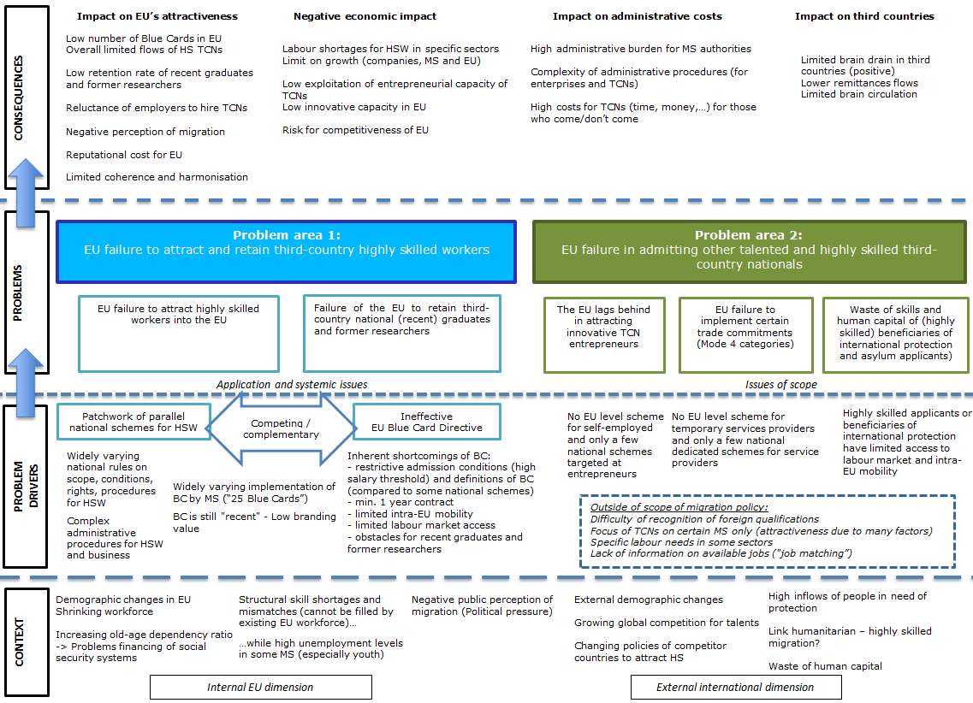
- Links between Problems, Problem Drivers and Objectives in Problem Area 1
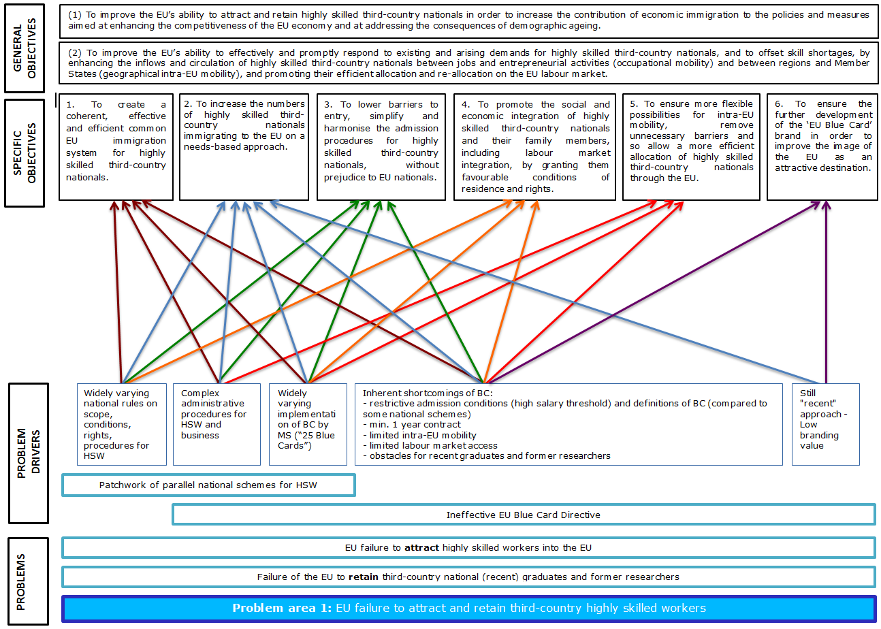
- Problems, Objectives and Policy options in Problem Area 1
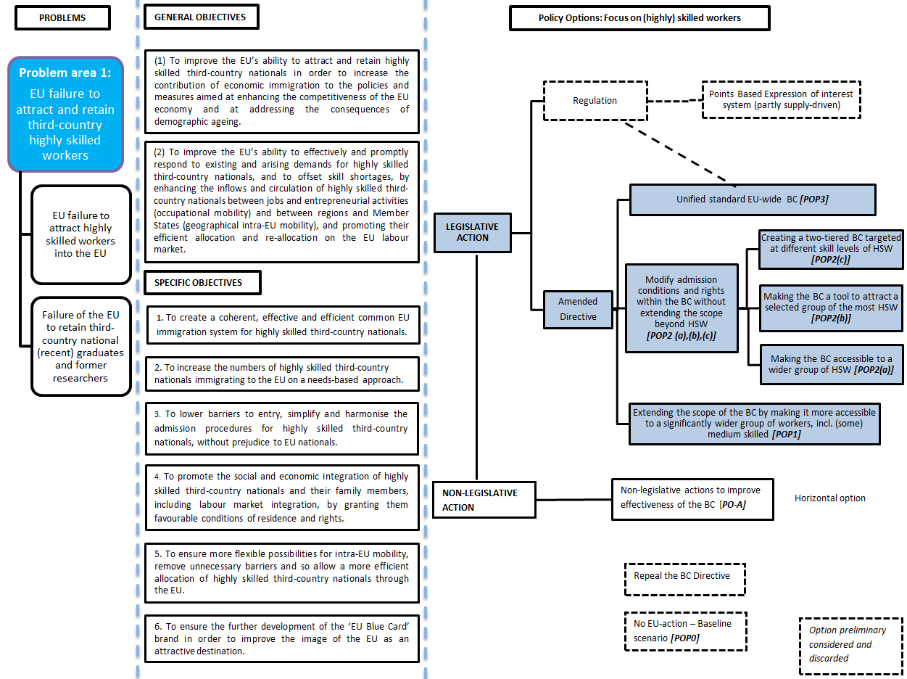

Links between Problems, Problem Drivers and Objectives in Problem Area 2
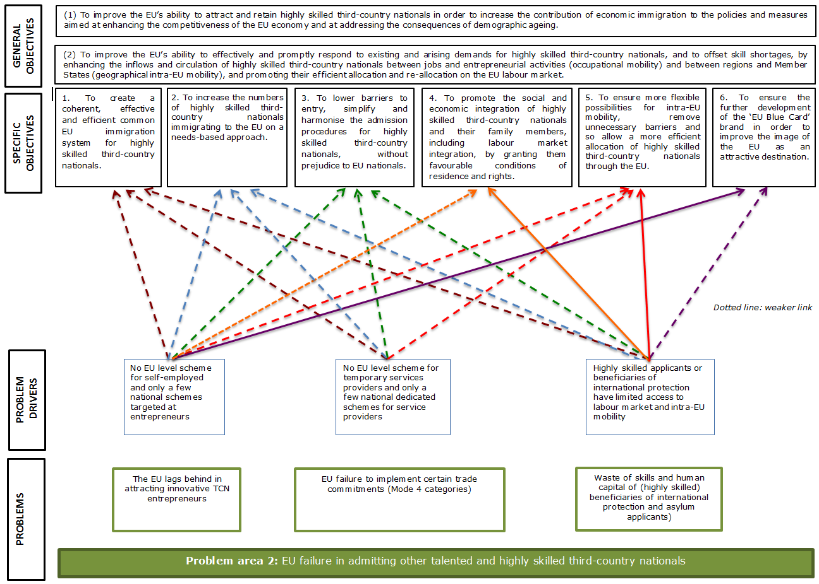

Problems, Objectives and Policy options in Problem Area 2
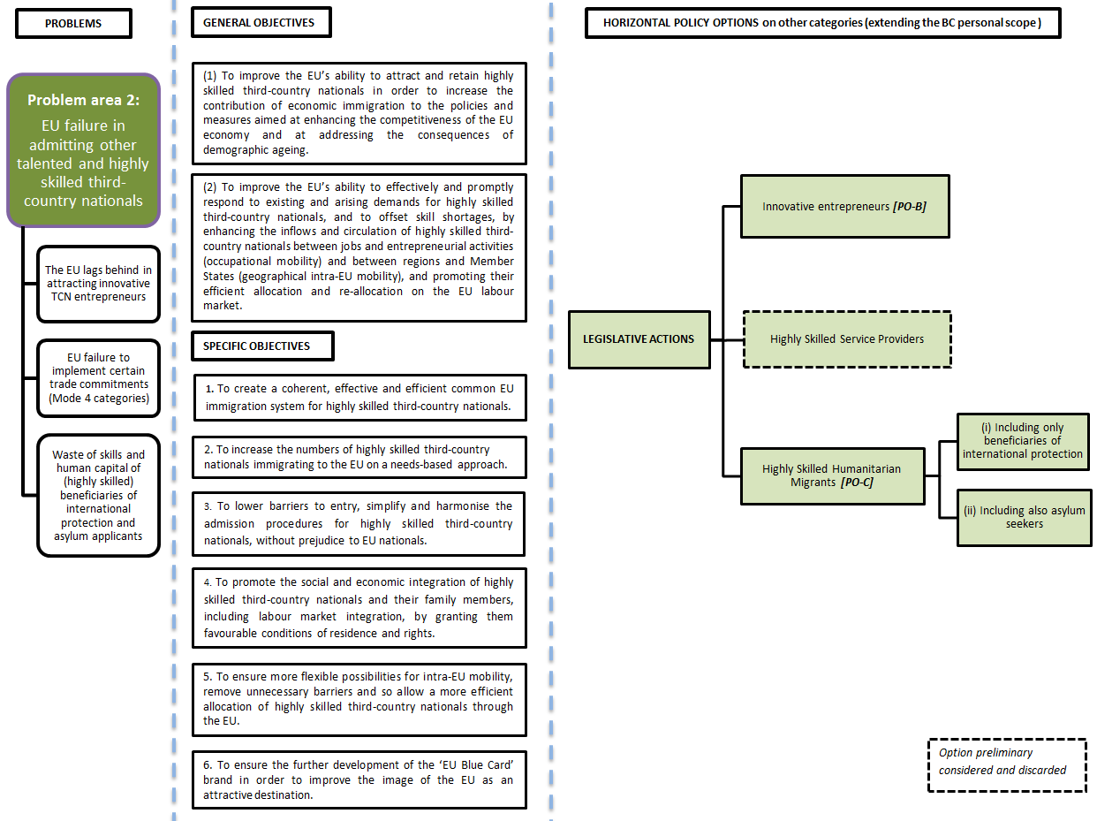

ANNEX 4
Problem assessment from socio-economic perspectives

1. Demography and Migration
EU Member States, as other parts of the world, will be affected by radical demographic changes in the next decades. This will affect the capacity of economic growth, sustainability of social security systems as well as the global weight of the EU in the world and in comparison to its competitors.
The charts and tables below present the main elements of the demographic changes forecasted in the EU and highlight the potential contribution of migration to attenuate their impacts. This concerns in particular the size and share of working-age population; the old-age dependency ratio; as well as indicators on the "ageing of skills" (measured as the share of the population aged 45 and more in the overall working-age population).

1.1. Forecasted developments of (working-age) population in the EU-28
In order to highlight the role of migration in attenuating the impact of the ageing process, the indicators below, based on the Europop2013, the latest population projections released by Eurostat, are broken down under two scenarios:
a) main scenario - produced based on 'main input dataset';
b) no migration variant - obtained by considering the component of international net migration equals zero (see methodological box below).
Chart 1: Population and working-age (15-64) population developments over 2014-2060, EU-28, in millions
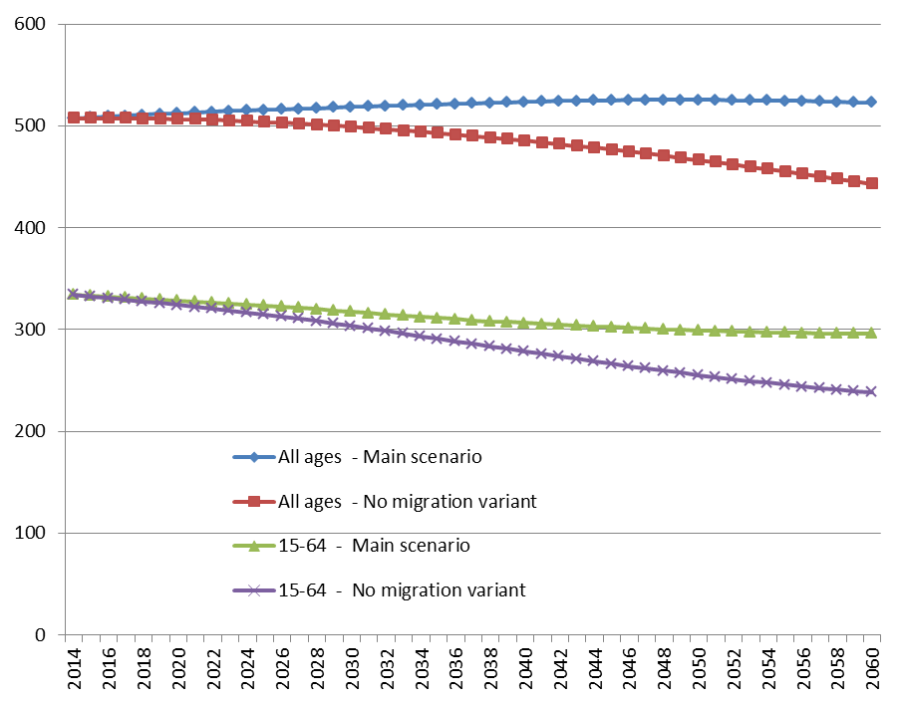
Source: Eurostat, Europop2013, proj_13npms and proj_13npzms
Chart 2: Working-age (15-64) population as a share (in %) of total population over 2014-2060, EU-28
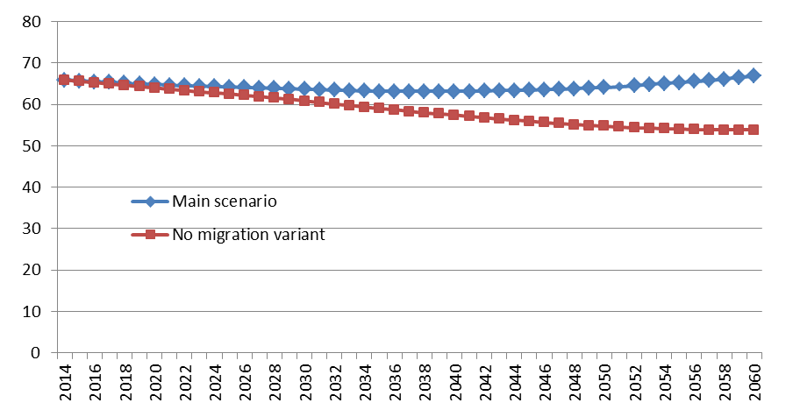
Source: Eurostat, Europop2013, proj_13npms and proj_13npzms
Considering the overall population (i.e. of all ages) in EU-28, it is forecasted to slightly increase in the next decades (from around 507 million in 2014 to 521 million in 2034) before stabilising later on (523 million in 2060). However, the situation would be different, should the contribution of international migration be equal to zero: in that case, the overall population (i.e. of all ages) would decline by 13 million over 2014-34 (-2.6%) and by a 64 million over 2014-2060 (-12.7%).
As far as labour market and sustainability of social security are concerned, it is more relevant to analyse how working-age (15-64) population will develop in the next decades. As a matter of fact, 2014 is the first year when the working-age population started to decline in the EU-28, the starting point of a protracted decrease. In the main scenario developed by Eurostat, the working-age population will decline by 21.7 million over 2014-2034 (-6.5%) from 334.1 to 312.4 million - and by 38.1 million over 2014-60 (11.4%). Again this development would be even more severe in the 'no-migration variant' as the drop of the working-age population would be close to 41 million (-12.2%) in the next 20 years (2014-34) and by around 96 million (-29%) over 2014-60.
Consequently, the share of working-age population in overall population will decline in the next decades, from currently 65.9% to 56.6% in 2060 in the main scenario and to even lower share (53.8%) in the no-migration variant.
Bearing in mind that potential economic growth is the sum over employment and productivity growth, the declining working-age population may have implications for the EU's long-term growth prospects. Without additional migration from third countries and substantial progress in terms of higher employment rates, the pressure to generate ever higher productivity gains will be immense. Based on these considerations, several recent analyses concluded that qualified migration should be part of a broad policy concept to maintain the EU's growth potential through the decades to come.
Another key measure for the sustainability of social security and economic dependency is the so-called old-age-dependency ratio, defined as the ratio between the number of persons 65+ over the number of working-age persons (15 to 64 years), expressed as percentage (see Chart 3).
This ratio is forecasted to sharply increase in the next decades, from 28% in 2014 to 42% in 2034, putting pressure on growth and on the sustainability of social security systems in particular for the pensions systems. In the no-migration variant the ratio in 2034 would be even more worrying, reaching 45%. Considering a longer time horizon (2060) the old-age-dependency ratio will further increase, to reach 50% in the main scenario (meaning that there will be one person aged 65+ for every two persons aged 15-64) and a higher level (60%) in the no-migration variant.
Chart 3: Old age dependency ratio over 2014-2060, EU-28
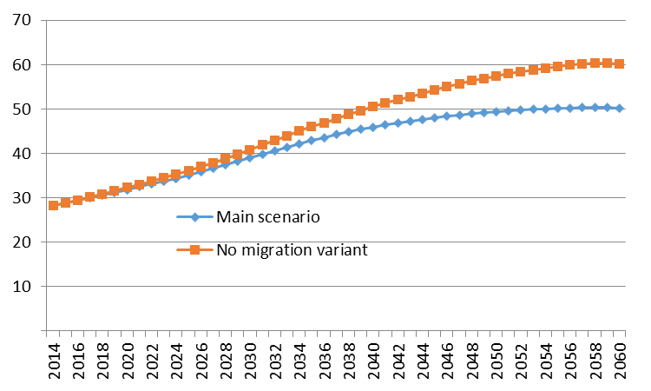
Source: Eurostat, Europop2013, proj_13ndbims and proj_13ndbizms
Ageing will not only affect the overall size of the population and the distribution between those of working-age and the others – it will also involve a rising average age of the workers. The share of older working-age people (aged 55-64 years) in total working-age population will increase from today's 19.5% to 22.2% around 2030. Their absolute numbers actually continue to increase until 2027. That is, even in a period of overall workforce decline, the EU disposes an increasing stock of experienced older workers. Taking stock of their experience older workers generally have higher level of productivity. Yet they are also more likely to have achieved their higher level of education a long time ago. For some sectors and occupations, this "ageing of skills" may be a worrying phenomenon if the labour market needs workers with up-to-date qualifications, in the context of structural change and technological changes. It is therefore important to consider how the share of those aged 45+ (i.e. those having achieved their higher level of education since more than around 20 years) in the overall labour force is forecasted to evolve in the forthcoming decades. From 2014 to 2034, the share of persons aged 45+ in the overall working-age population will increase from 41.5% to 43.1% while developments without the contribution of international migration would lead to a quicker ageing of skills, with a share of 45.2% in 2034.
The various indicators provided above all lead to the same conclusion: ageing will be a major challenge for the EU-28 as the working-age population will decline, both in absolute terms and as a share of the total population. The positive net migration assumed by Eurostat in their projections will not prevent ageing to happen; however it could contribute to attenuating its impact. Table 1 below provides a synthetic view of the various indicators.

Box 1: Forecasting population developments with or without the contribution of international migration
EUROPOP2013 population projections is a 'Convergence Trends' scenario that includes short-term (nowcasting), medium-term (trend) and long-term (convergence) components.
Computations are based on cohort-component method with 1st January 2013 base population, disaggregated by sex and age. Data on population, live births and deaths used as input data in EUROPOP2013 round are official statistics provided by the national statistical authorities to Eurostat in the frame of annual demographic data collection. Migration flows have been measured in terms of net migration (including statistical adjustment) and computed as residual from the annual demographic balance.
The 'main input dataset' includes the 2013 base-population and the assumptions for fertility, mortality and international net migration (including statistical adjustment), and defines the frame of main scenario for producing the population projections. Four variants ('no-migration variant', 'reduced-migration variant', 'higher-fertility variant' and 'lower-fertility variant') were obtained by modifying one of the assumptions' component while the other components of the 'main input dataset' were maintained constant.
The data used in this annex mainly refer to the 'main scenario' (produced based on 'main input dataset') in comparison to the 'no-migration variant' - obtained by considering the component of international net migration equals zero. It should be noted that Eurostat also publishes statistics under a "reduced migration variant", considering that the component of international net migration is reduced by 20%.
In Europop2013, "net migration (including statistical adjustment)" is a general estimation of the net migration based on the difference between population change and natural change between two dates (including other changes which cannot be attributed to births, deaths, immigration or emigration between that time period).
One of the implications is that, for a given Member State, net migration is the result (apart from so-called "statistical adjustment") of the difference, in a given year, between immigration flows and emigration flows with the rest of the world. Flows to and from other EU Member States are therefore also included into this net migration definition, and not only migration flows from third-countries. However, this is not the case when using the EU-28 aggregate as net migration refers then only to the differences between immigration flows and emigration flows with third-countries.
As shown in the table below, the net migration assumed by Eurostat in the main scenario would be around 920.000 per year for the period 2015-19 and slightly higher than 1 million over 2020-24. For both periods, this represents a positive contribution of net migration to the EU-28 population around +0.2% per year.
Annual net migration assumed in Eurostat Europop2013 main scenario (all ages), EU-28, in thousands
Source: Eurostat, Main scenario - International net migration by age and sex [proj_13nanmig]
Source for the box: Eurostat, Europop2013, Metadata available at: http://ec.europa.eu/eurostat/web/population-demography-migration-projections/population-projections-/database
Table 1: Summary table of forecasted population developments and indicators, EU-28
a) Main scenario
Source: Eurostat, Europop2013, proj_13ndbims and proj_13ndbizms
b) No-migration variant scenario
Source: Eurostat, Europop2013, proj_13ndbims and proj_13ndbizms

1.2. Contribution of third-country migration to population developments
Migration from third-countries plays a significant role in the population dynamics of European Member States. Since the mid-90s, natural change of the population is on average around or less than 0.1% per year while positive net migration has always been higher, especially during the period 2002-08. It means that the increase in the population of the EU-28 Member States has mainly been due to positive net migration rates (i.e. the fact that inflows outweighed outflows).
Chart 4: Population change by component, EU-27, 1990-2014 (per 1000 inhabitants)
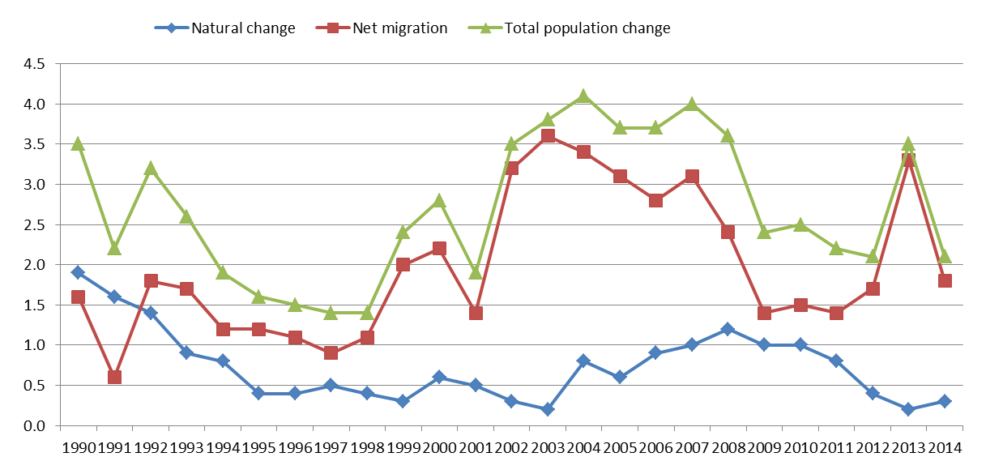
Source: Eurostat (online data code: demo_gind), Note: net migration includes statistical adjustment. Breaks in series in 2000, 2001, 2008, 2010, 2011 and 2012 .Provisional estimates for 2013 and 2014.
For the EU-28 as a whole, net migration has been positive and around or higher than 1.5 million per year over 2002-2007, representing an increase in EU-28 population around 0.3% per year.
Over the period 2009-12, net migration to the EU has slightly diminished to around +1.5% per year. This is to be put in relation to the economic crisis which implied decreasing immigration and increasing emigration (both Europeans and return migration to origin countries). Nevertheless, even over the period 2008-12, net migration still contributed around two thirds of the total population increase.
According to Eurostat, in many EU-28 Member States, immigration is not only increasing the total population, but also bringing in a much younger population.

Table 2: Net migration to the EU-28, in millions and in % of population (2000-14)
 | In millions | In % of pop.
2000 | 1.1 | 0.22
2001 | 0.7 | 0.14
2002 | 1.6 | 0.32
2003 | 1.8 | 0.36
2004 | 1.7 | 0.34
2005 | 1.5 | 0.31
2006 | 1.4 | 0.28
2007 | 1.5 | 0.31
2008 | 1.2 | 0.24
2009 | 0.7 | 0.14
2010 | 0.8 | 0.15
2011 | 0.7 | 0.14
2012 | 0.9 | 0.17
2013 | 1.7 | 0.33
2014 | 0.9 | 0.18

Source: Eurostat (online data code: demo_gind). Note: net migration includes statistical adjustment. Breaks in series in 2000, 2001, 2008, 2010, 2011 and 2012 .Provisional estimates for 2013 and 2014. Figures in millions: own calculations based on variables "Average population - total" and "Crude rate of net migration plus statistical adjustment".

2. Skills needs and shortages in the EU

2.1. Summarising data and knowledge on current and future skills shortages in the EU
The term “labour/skill shortage” has no universally agreed upon definition and in practice, measuring occupational labour shortages is difficult (see box on definition below). Against this background, the section below aims at summarising briefly the main data and knowledge on current and future skills shortages in the EU Member States. It is based mainly on few recent key studies at EU level in particular:
- European Commission, Mapping and Analysing Bottleneck Vacancies in EU Labour Markets (2014)
- OECD/EU, Matching economic migration with labour market needs (2014)
- European Migration Network, Determining labour shortages and the need for labour migration from third countries in the EU (2015)
- European Parliament, Labour Market Shortages in the European Union (2015)
- European Parliament, Exploring New avenues for legislation for labour migration to the European Union (2015)
- IOM-LINET, Labour shortages and migration policy, 2012
Based on a review of those studies, the situation can be summarised as follows:
- In the EU there is currently no overall "labour shortages" as the tightness of the EU-28 labour market has decreased substantially compared to the pre-crisis period and that unemployment is high compared to the number of vacancies. However, we do observe tighter labour markets in some Member States than in others, highlighting that labour demand and supply are not balanced across Member States. Moreover, quantitative shortages may grow if the economic recovery picks up.

- Within Member States and regions, sector and occupation specific labour shortages do already occur. According to the European Company Survey (Eurofound, 2015), two in five companies (39%) claim to have difficulties recruiting people with the required skills to fill their open vacancies. This share is particularly high in the manufacturing sector (43%). Moreover, many employees have difficulties to find a job which matches their qualification level. This signals the presence of skill mismatches and possibly skills shortages.

- Skills shortages can be observed for low, medium and high skilled jobs. However, it is clear that in the long-run (CEDEFOP forecasts for 2025) the expected level of employment will rise much more among jobs requiring high level of education: +15 million or +23% over 2012-25 than among jobs requiring medium level of education (+3.6 million or +3%) and even more compared to jobs where a low level of education is sufficient (-11.5 million or -24%).

- By 2020, the EU economy would be able to absorb 825.000 additional workers in ICT jobs, if demand is not hampered by supply bottlenecks. In the health sector, a potential shortfall of around 1 million workers is estimated by 2020, rising up to 2 million if long term care and ancillary professions are taken into account. This means that around 15% of total care would not be covered compared to 2010.

- Throughout Europe there is some consistency across Member States when it comes to occupational groups with shortages: metal, machinery and related trade workers, science and engineering as well as ICT professionals. However, when analysed in detail, the specific occupations experiencing shortages differ between Member States.

- The studies reviewed, in particular the 2015 EP study on Labour Market Shortages in the European Union also concludes that "additional training and retraining is necessary to counter these shortages, which take time to have an effect (…) and reducing the current labour market shortages is therefore not a quick-fix for unemployment".
Box 2: Definitions of labour and skills "shortages"
When individual employers cannot find the workers they need to fill open vacancies, labour shortages occur. Labour shortages refer to a situation in which labour demand exceeds labour supply. However, a distinction should be made between quantitative and qualitative labour shortages.
In case of a quantitative labour shortage, there is an absolute lack of workers in the labour market. Labour demand is larger than labour supply, resulting in a large share of difficult-to-fill vacancies and a low unemployment rate. Quantitative shortages can be caused by increased demand for specific goods or services or economic growth more generally. The insufficient supply of labour can be caused by a decline in the working age population due to ageing or emigration or by a decrease in participation rates due to early retirement or the inactivity of certain groups.
In case of a qualitative labour shortage, labour demand and labour supply are roughly in equilibrium (balanced), but a large share of unfilled vacancies and a high unemployment rate exist simultaneously. This signals a qualitative mismatch between supply and demand. A common cause is skill mismatch, either because there are not enough graduates with the necessary skills to fill open vacancies, or because skill requirements have changed or because job requirements by employers do not fit with the competences of jobseekers and graduates.
Qualitative shortages can also be caused by a mismatch between the preferences of jobseekers and the characteristics of the open vacancies. This occurs when jobseekers do not want to fill a vacancy because of the working conditions offered or because the sector is seen as unattractive. Moreover, the lack of sufficient and correct labour market information for both employers and jobseekers can also contribute to qualitative shortages.
However, it should be noted that a labour shortage is always relative in the sense that it refers to labour demand in excess of labour supply of people willing to work at a particular wage and under particular working conditions at a particular place and point in time. Offering better wages and working conditions can thus be effective at resolving shortages. Employers who do not increase wages in the face of shortages indicate that they expect to find a candidate at the current wage and labour conditions. Shortages are therefore relative to the terms offered, as wage levels might be the reason why students and jobseekers do not to opt for a field of study or job which could reduce the shortage.
One also finds the distinction between cyclical and structural shortages. Skills mismatches will always exist as a part of the frictional dynamics of the labour market and due to the business cycles (i.e. cyclical labour shortages). However, persistent or structural shortages can be detrimental to economic recovery and growth. Some structural changes, such as the adoption of new technologies, may increase the demand for certain skills that are not available in the labour market in the short run, creating skills shortages even when unemployment is high. Therefore, one of the main challenges faced by policy makers is identifying real, structural labour shortages, which cannot be met by the local labour force even if the labour market is functioning well or measures are taken to improve it, e.g. by supporting labour matching or by investing in education and training.
In practice, measuring occupational labour shortages is difficult. Using interviews is imprecise and tends to be biased. Objective labour market information, such as vacancy rates, unemployment rates, and changes in wage rates can be extremely useful but, in many countries, data on detailed occupations are not necessarily available.
Source: based on European Parliament, Labour Market Shortages in the European Union (2015) ; European Migration Network, Determining labour shortages and the need for labour migration from third countries in the EU (2015); OECD/EU, Matching economic migration with labour market needs (2014)

2.2. Bottleneck occupations
The recent study commissioned by the European Commission on Mapping and Analysing Bottleneck Vacancies in EU Labour Markets (2014) provides information about the top-20 bottleneck occupations on the EU labour markets (in all Member States and including Iceland, Norway and Liechtenstein). Bottleneck occupations were defined as occupations where there is evidence of recruitment difficulties, i.e. employers have problems finding and hiring staff to fill vacancies, based on indicators such as duration of vacancy filling, past/existing bottleneck vacancies and expected bottleneck vacancies.
When considering occupational group (ISCO at 2 digit level), bottleneck occupations concern various occupations within metal and related trades workers, science and engineering, IT and health professionals and construction worker (Table 3 below).
From the point of view of the sectors confronting bottlenecks, Manufacturing, Construction, Health, Tourism, IT, Commerce, Transport, Professional, scientific and technical activities, Financial and insurance activities and Education are the economic activities which are most affected. In manufacturing, Construction and Transport recruitment difficulties are at skilled manual level while in most other activities high skilled labour are more problematic to fill(Education, Professional, scientific and technical activities, Financial and insurance activities, ICT and Health).
Table 3: Top 20 bottleneck vacancies at ISCO 2-digit level, EU level
Source: European Commission , Mapping and Analysing Bottleneck Vacancies in EU Labour Markets (2014)

The study on bottleneck occupations also concluded that:
- Skills shortages are the main reason for most of the bottlenecks occupations. The data also suggest a relation with skill level: a lack of skills is reported for most high skill level occupations, while the role of working conditions is of higher importance at lower skill levels.

- Among occupational groups there are clear differences between how employers work to mitigate recruitment problems. While recruitment abroad is relatively common among health professionals, it is less used to recruit science and engineering professionals. Among the skilled manual occupations, employers mainly cope by providing training and development to existing staff, and to a limited degree on labour mobility.

- There are structural shortages at EU level, which should be a priority for EU level policies. When trends differ between countries, mobility can offer a good opportunity for reducing bottlenecks. This concerns especially occupational groups within the top 5 at 2-digit level. Mobility schemes could add value in this respect, but they should be narrowly defined, preferably at ISCO 4-digit level (or even more specific). For instance ICT professionals, one of the top 5 bottleneck occupational groups, schemes should be oriented to occupations within the 4-digit groups ―Software developers and ―Systems analysts, which are both within the top 20 bottleneck vacancies at 4-digit level.

2.3. CEDEFOP projections of future employment by skill / qualification level
As there is currently no general agreement on "labour shortages", OECD/EU (2014) concluded that the issue of labour market needs is "better approached in the broader context of skill needs and mismatches". The European Centre for the Development of Vocational Training (Cedefop) is monitoring current and future skills needs in Europe. In 2013, there were more low-educated workers in the EU than jobs at that level, suggesting an over-supply of low-skilled workers. The reverse is true for jobs requiring medium-level qualifications, while at higher level, supply and demand were more or less in line. An overall balance between aggregate labour supply and demand can, however, hide micro-level qualitative mismatches. These may be due, for example, to frictions, barriers to mobility, or asymmetric information between employers and workers .
In the EU28, changes in the skill composition of employment between 2012 and 2025 are expected to show a sharp increase in the share of jobs employing higher-educated labour (by 23%), while demand for medium-level jobs is expected to increase moderately (3.5%) and that of lower-skilled workers is expected to decrease significantly, by 24% (Chart 5). It means that the share of jobs requiring a high level of education will increase from 30% of the total in 2012 to 36% in 2025..

Chart 5: Projected employment trends by level of education, EU28, 2012-25

Source: Cedefop. Notes: Baseline scenario; Low = ISCED 0-2; Medium = ISCED 3-4; High = ISCED 5-6
Moreover, CEDEFOP also breaks down future employment levels by group of occupations with four broad categories: i.e. high-skilled (ISCO 1-3), skilled non-manual (ISCO 4-5), skilled manual (ISCO 6-8) and elementary jobs (ISCO 9). According to this nomenclature, the increase in the share of high-skilled jobs (in terms of % of total employment) would be from 40% in 2010 to 44% of the total in 2025 while other groups will see their relative weight decreasing.
Chart 6: Employment share by skill level, 2000-25, (EU 27+), CEDEFOP baseline scenario (%)
Source: Cedefop.
The expected development in employment over 2012-25 across occupations is the result of both employment growth (expansion) as well as replacement demand. Indeed, even in occupational groups that will be declining, there will be a number of job openings, driven by replacement demand (see chart 7 below).
Overall, the occupational group that will see the largest increase in absolute number in total job openings will be: "Technicians and associate professionals" (ISCO 3), "Professionals" (ISCO 2) and "Legislators, senior officials and managers" (ISCO 1). Those three groups, all considered as highly skilled occupations will benefit from both replacement demand and expansion. In absolute terms, the lowest skilled group ("Elementary occupations", ISCO 9) will also grow, though mainly due to replacement demand and representing less than11% of all jobs in 2025.
Chart 7: Total job opportunities, CEDEFOP baseline scenario (EU-27+) 2012-25 (000s), by group of occupations (ISCO)
Source: Cedefop.

2.4. CEDEFOP projections of future employment by sectors and occupations
The expected development in employment over 2012-25 across economic sectors will also vary across expansion and replacement demand (see table 4 below).
The NACE sectors where the expansion demand is expected to be the strongest (with + 2 million or more) will be "Real Estate, Professional, Scientific and Technical Activities", Wholesale and Retail Trade and Human Health and Social Work.
When taking into account replacement demand, the largest number of job openings will be, with more than 10 million each: Wholesale and Retail Trade, Human Health and Social Work, Manufacturing and "Real Estate, Professional, Scientific and Technical Activities".
Table 4: Total job opportunities, CEDEFOP baseline scenario (EU-27+) 2012-25 (000s), by economic sector (NACE), broken down by expansion versus replacement demand (in %)

ANNEX 5
EVALUATION OF THE BLUE CARD DIRECTIVE

1. Introduction
Directive 2009/50/EC on the conditions of entry and residence of third-country nationals for the purposes of highly qualified employment (the Blue Card Directive) already provides an EU-wide scheme for highly qualified third-country nationals. It determines the conditions of entry and residence for highly qualified workers and their family members in the first and subsequent Member States, as well as their rights. The Directive was meant to promote the objective of the EU becoming the most competitive and dynamic knowledge-based economy in the world. This was to be achieved e.g. through developing well-managed migration policies, helping Member States to meet existing and future labour market needs. Labour shortages were to be addressed by facilitating admission and fostering mobility, namely through fast-track procedures and enhanced social and economic rights.

2. Evaluation of the Directive Provisions and their National Transposition

2.1. General remarks
The national transposition of the Blue Card Directive was to be completed by June 2011. However, only four Member States completed the transposition on time, whereas most countries had relevant national measures enter into force during the year 2012 or some even in 2013. The first implementation report, assessing the conformity of national legislations with the provisions of the Blue Card Directive, was adopted in May 2014. It concluded that there are a number of deficiencies in the transposition and, more specifically, that Member States have been neglecting their reporting obligations under the Directive. This makes it difficult to get an overall picture of the legal transposition and practical application of this Directive in the Member States and to identify possible implementation challenges.
According to Eurostat data the numbers of EU Blue Cards issued remain limited and vary greatly across Member States (see Annex 12). In 2014, Germany issued almost 90 per cent of the EU total, with many other Member States issuing very few to none. Due to the economic crisis, the situation in many countries has for a prolonged period remained unfavourable to the creation of highly skilled employment. However, one explanation can also be found in the national parallel schemes for attracting highly qualified migrants that many Member States continue to run and that compete with the EU Blue Card and with each other. This creates a fragmented landscape of numerous regimes for admitting highly qualified migrants. Furthermore, the current Directive sets only minimum standards and leaves considerable leeway to Member States through many "may"-clauses and references to national legislation, which also leads to a low level of coherence. One reason behind this is that the former legislative procedure required unanimity in the Council. Therefore, there are not only various national schemes but also 25 very different EU Blue Card approaches adding diversity to the migration policies addressing the highly skilled.
The following pages present the most important issues arising from the current provisions of the Directive and their implementation.

2.2. Admission conditions
Description of the provisions
The Blue Card Directive sets out a number of conditions for issuing an EU Blue Card. Few of the provisions on admission conditions entail full harmonisation, in the sense that neither more lenient nor more stringent conditions in the Member States are allowed. This is the case for the Articles on a valid work contract or, if applicable, a binding job offer for at least 1 year (Art. 5(1)(a)), and necessary qualifications for regulated and unregulated professions (Art. 5(1)(b-c)). However, there is some leeway in the Directive regarding the higher professional qualifications, as Article 2(g) foresees that they may be attained not only by means of higher education, but also through 5 years of pertinent professional experience, if national law so provides. Around half of the Member States have opted for this possibility.
The third admission condition apart from the work contract and the required qualifications is the salary threshold (Art. 5(3)). This was subject to intense discussions when the current Directive was being negotiated. In the original Commission proposal, the salary threshold was set at three times the national minimum wage, or, if not applicable, at no less than three times the minimum income under which citizens of the Member State concerned are entitled to social assistance, or at a level in line with applicable collective agreements or practices in the relevant occupational branches. It seemed that this calculation method rather well corresponded to the thresholds that Member States (which had schemes in place prior to the EU Blue Card) applied to highly skilled workers. Also, minimum wages and other corresponding data had already been used as a reference when calculating the sufficient income required from third-country nationals as a condition for other types of resident permits (Directive 2003/86/EC on family reunification and Directive 2003/109/EC on long-term residents).
The discussion went in different directions with Member States wishing for either lower or higher thresholds, and it became clear that both the reference salary and the "highly skilled multiplier" to be applied were controversial issues. Finally, it was concluded to set the threshold at the minimum level of 1.5 times the national average salary. As a result, Member States are free to impose a higher, but not a lower threshold in their national legislation. Member States may use Eurostat data to determine the average gross salary, but they may also use national data. It seems that also lower thresholds than those foreseen by the Directive are applied in reality (see Chart 1 in Annex 7); although the transparency of the calculation method applied to the national thresholds is hampered by the fact that national data can be used for determining the reference salary. Member States may add flexibility to the salary requirement by introducing a lower salary threshold of at least 1.2 times the average gross annual salary for certain occupations facing shortages (Art. 5(5)).
Member States may make the issuance of EU Blue Cards conditional upon a labour market test (Art. 8(2)) or limit it to pre-determined volumes of admission (Art. 6). These are measures to enable adjustments to the national labour market situation and protect the domestic workforce. Regarding Article 6, retaining the right to determine the volumes of admission of third-country nationals entering their labour market is guaranteed for Member States by Article 79(5) of the Treaty on the Functioning of the European Union.
Member States also have the right to refuse an application for an EU Blue Card to ensure ethical recruitment with the purpose of avoiding "brain drain" (Art. 8(4)) or in cases where the employer in question has been sanctioned for undeclared work and/or illegal employment (Art. 8(5)). No extensive information is available on Member States' practices regarding these provisions, but Member States have not reported many rejected applications on these grounds.
Assessment of the conditions
The bar set by the EU Blue Card Directive for potential applicants is arguably quite high. The material conditions are cumulative and absolute: the requirements of a one-year work contract, relevant qualifications and sufficient salary all need to be fulfilled simultaneously and without exceptions. The requirement of a one-year work contract has the effect of excluding categorically those highly qualified workers whose initial contract is for a shorter period, even if there were reasonable prospects for getting an extension subsequently (see Chapter 2 in Annex 7). The salary threshold is higher than in most corresponding national schemes, and obtaining the EU Blue Card can be difficult especially for younger professionals. In addition, as demonstrated in Charts 2–4 of Annex 7, the current threshold has a very different impact across Member States for reasons related to differences in the distribution of wages. Only the minimum level for the salary is defined in the Directive, which allows Member States to apply a very high threshold for the EU Blue Card if they wish to limit the number of persons admitted under that scheme. Furthermore, as stated above, the fact that Member States do not have to use Eurostat data for determining the benchmark salary hampers the transparency of the calculation method of each national threshold, and therefore also complicates the enforcement of the provision by the Commission.
Requiring a certain level of qualifications is essential in a scheme addressing highly skilled workers. However, the current provisions in the Directive can be criticised for being rudimentary. For workers in unregulated professions any education reaching the required level which is relevant for the employment concerned is accepted. There is no room left for Member States to make the requirement more specific (or higher or lower) based on labour market needs or other considerations. On the other hand, the current provisions are simple to apply and to communicate to stakeholders. In addition, there is no obvious way to broaden the required qualifications level without including also medium skilled workers. For regulated professions there is no specific level of qualifications required, as presenting the necessary documents for exercising the profession in question is sufficient.
For this admission condition, the main matter of concern does not seem to be the required qualification levels as such, but rather procedural obstacles. Getting qualifications obtained in third countries recognised in the EU can be burdensome, the results are uncertain and practices across Member States vary greatly. However, it is important to distinguish between regulated and unregulated professions. For the former Member States have specific criteria which have to be fulfilled in order to be able to exercise that profession in that country, and therefore, if the EU Blue Card is to be issued for such employment, it is necessary to ensure that the qualifications are adequate. Therefore, the room for any added flexibility is limited. For unregulated professions, however, the situation is different. For unregulated professions, the qualifications requirements in the context of the EU Blue Card only serve to guarantee that the applicant is indeed highly qualified in the occupation or sector indicated in the work contract or job offer. Therefore, obliging the applicant to go through the full recognition procedure of third-country qualifications – which could take months – only in order to qualify for an EU Blue Card may be disproportionate. Nothing in the current Directive provides guidance to Member States on how to assess applicants' qualifications.
Another issue related to the qualifications is the role of professional experience and how it can be validated as an alternative to educational accomplishment. Under the Directive it is optional for Member States to recognise at least 5 years' professional experience, but even those Member States having transposed this option have not reported established practices in this respect. Validating experience gained abroad is undoubtedly challenging, but it seems important to be able to reach also those persons whose high qualifications and skills are not based on education.
As indicated, Member States are allowed to impose labour market tests on EU Blue Card applicants. While the objective to protect the local workforce may be justified, labour market tests have the tendency of prolonging processing times, as they are often carried out by another authority than the one responsible for issuing the residence permit. They also increase incertitude regarding the outcome of the application procedure and therefore may deter both employers and migrants from lodging the application in the first place.
In addition to issues related to each individual condition, the leeway given to Member States in multiple aspects contributes to the creation of a patchwork of EU Blue Card admission schemes in the 25 Member States: obtaining an EU Blue Card can be considerably more difficult in one Member State than in another. The more admission conditions vary across Member States, the more difficult it is to provide information on the EU Blue Card at EU level or to portray an image of a streamlined instrument for the highly skilled. The current low level of harmonisation makes the EU Blue Card virtually impossible to promote towards third countries as an EU-wide scheme.

2.3. Procedures and formalities related to the EU Blue Card
A swift and predictable procedure for obtaining an EU Blue Card is likely to be crucial for its attractiveness both in the eyes of employers and potential migrant workers. There are many provisions in the Directive aimed at guaranteeing that the EU Blue Card performs well in this respect. However, statistics show that the EU Blue Card has remained less widely issued than the national permits for highly skilled, and there are many Member States issuing practically no EU Blue Cards. This indicates that the objective of making the EU scheme fast and streamlined has not yet been satisfactorily reached. However, due to the low numbers of issued EU Blue Cards it is also possible that relevant stakeholders are not thoroughly aware of the conditions or rights associated with that permit, and the procedure may thereby seem overly complicated. The different degree of use and familiarity with the Blue Card scheme by the national authorities also has an effect on how this option is presented to potential applicants.
In addition to the role played by national legislation and national authorities, there are also a number of elements in the Directive itself that should be addressed in order to further enhance procedural clarity and efficiency. Firstly, Member States are required to notify their decision on an EU Blue Card application within 90 days from its lodging (Art. 10(1)). In total 11 Member States have chosen to set a shorter national time limit varying between 7 and 60 days, often to be in line with general deadlines for migration procedures rather than as a prerogative for the highly skilled. Therefore, it seems that there is still room for shortening the maximum processing time. In the current directives on legal migration there are only maximum time limits indicated, whereas processing the application "as soon as possible" is the main rule. In order to concretise what is meant to be the regular procedural timeframe envisaged by the EU legislator, a target processing time (shorter than the maximum) could be useful.
However, it is not sufficient to look only at the legislative time limits for an EU Blue Card application. Attention should also be paid to the overall time that goes into obtaining all the necessary documentation (including the recognition of qualifications) and to actually get the permission to enter the host country. Member States do not generally count the time required for getting relevant qualifications recognised or for obtaining the requisite visas towards the 90-day (or shorter national) time limit. This is a plausible approach as such, confirmed in Recital 12 of the Directive. According to information provided by the Member States, the recognition of qualifications alone can prolong the overall processing times by numerous months. For highly skilled workers and their employers several months of application processing may already result in the loss of valuable opportunities. As indicated above, the Directive should determine what is meant by adequate validation of qualifications (for unregulated professions) for the purposes of the EU Blue Card. This could lead to greater flexibility and faster overall processing in Member States.
Secondly, apart from processing times, the rules on who can submit the application and where are also highly relevant for the smoothness of the process. The Directive allows multiple options in this regard. According to Article 10(1) Member States are free to choose if it is the employer or the employee - or one or the other - who may lodge an application for an EU Blue Card. All possible options exist in Member States: some require that it is one or the other party alone (most commonly the employee), some require action from both sides and some accept applications from either party as well as from a lawyer acting on behalf of either one of them. Similarly, paragraphs 2-4 of Article 10 allow leeway for Member States to determine if they accept in-country applications. A solution where only applications lodged abroad would be accepted is possible only under a standstill clause, applied by two Member States (Luxembourg and Sweden). Most countries accept applications in their territory from all legally staying TCNs (at least under further conditions), whereas some require a preceding national residence permit or long-stay visa. As a result, if a potential applicant inquires about how to go about applying for an EU Blue Card, the answer is again very different depending on the Member State.
Thirdly, the Directive requires Member States to set a standard validity for the EU Blue Card. This can vary between 1 and 4 years. However, if the work contract is valid for less than the standard period, the validity of the permit will be the duration of the contract plus 3 months. Member States have adopted standard periods varying between 1 and 5 years, 1 and 2 years being the most frequent options. However, the standard validity does not necessarily have much significance, as work contracts for a determined period often call for a shorter permit. It should also be noted that the same validity provisions apply whether it is a question of a first EU Blue Card or a renewal, whereas it would be reasonable in many cases to grant the renewed EU Blue Card for a longer period than the initial one, as there is already a stronger presumption of continuous residence. To sum up, the current provisions on the validity of the permit have very limited harmonising effects, but still seem to lead to a relatively rigid system within Member States.

2.4. Rights granted to EU Blue Card holders and their family members
Equal treatment, labour market rights and access to permanent residence
Highly skilled workers are a favoured group of migrants in the EU acquis. This is particularly visible in the rights granted to EU Blue Card holders. According to Article 14 of the Directive, right to equal treatment with Member State nationals is granted in numerous fields, such as working conditions, access to education and vocational training, recognition of diplomas, and social security rights. There are possible limitations only regarding access to study and maintenance grants and loans as well as access to housing, both of which have been applied only by a minority of Member States. It is also possible to subject access to universities and post-secondary education to specific prerequisites under national law. In many Member States that opted for this possibility such prerequisites entail generally applicable standard linguistic or other requirements intended to facilitate the successful completion of studies. In conclusion, no major shortcomings in the equal treatment of EU Blue Card holders seem to exist in legislative terms. Obviously, the actual entitlement is still determined by the relevant national practices in each Member State.
Article 12 of the Directive regulates EU Blue Card holders' access to the labour market of the host country. Multiple angles have to be considered when discussing the labour market access of the highly skilled. When employers hire highly skilled persons, they have a legitimate wish to retain the talent they have managed to attract. However, dependency of migrant workers on their employers should be generally reduced to prevent any form of exploitation, even though the risks are typically smaller for the highly skilled. Furthermore, employers have contractual means to provide the right incentives and need not rely on migration rules to retain their employees. In addition, if the change of employer is strictly limited and marked by administrative hurdles, this is bound to reduce the attractiveness of the migration option. Clearly, there is a need for safeguards to ensure that the persons admitted as highly skilled also end up in corresponding occupations and the EU Blue Card scheme is not used for abusive purposes by either employers or migrants.
The current Directive provision basically states that during the first 2 years access to the labour market shall be restricted to employment fulfilling the conditions of the EU Blue Card. If the employer changes, a prior authorisation from the competent authorities – and sometimes obtaining a new EU Blue Card – is required. For other relevant changes prior notification is sufficient, if a Member State so chooses. After the initial 2 years Member States may opt for granting equal treatment with their own nationals concerning access to highly qualified work or, alternatively, require that the EU Blue Card holder still communicates pertinent changes. Member States seem to have chosen a variety of schemes in this respect, using the leeway provided by the Directive (see Table 2). Therefore, the level of flexibility and potential administrative burden are very different across Member States. It is questionable whether such a complicated Directive provision is necessary, as it is in any case possible for Member States to withdraw the EU Blue Card if the conditions are no longer fulfilled – this would be the case if the person took up employment that was not highly qualified.
In the current Directive there are no rules on access to self-employed activity. Evidently, as the ground for residence the highly qualified employment of EU Blue Card holders has to remain their principal activity. However, without precise provisions at EU level, it is unclear if Member States allow access to secondary entrepreneurial activity, which might, in the medium to long term, lead to innovation and job creation.
Akin to the issue of labour market access is the question how Member States address the temporary unemployment of an EU Blue Card holder. The Directive requires that unemployment of less than three consecutive months and occurring only once shall not result in termination of the right of residence. More favourable conditions are allowed, and a few Member States have chosen to be more flexible in this regard. The vast majority, however, applies the Directive provision unaltered (see Table 2). The period of 3 months seems to be proportionate and consistent with other EU policies.
Directive 2003/109/EC on long-term residents generally applies to Blue Card holders, but there are a few derogations foreseen in Article 16 of the Blue Card Directive. First of all, periods of residence in different Member States can, under certain conditions, be cumulated to count towards long-term residence. Also, longer absences from the EU are allowed without a negative effect on obtaining or retaining the status. However, Member States may choose to limit the latter prerogative to those who return to their country of origin for economic activity, study or volunteer service, an option taken up by 13 Member States (see Table 2). Not being tightly bound to continuous physical presence in a specific country may be crucial for highly skilled workers (and promotes circular migration), while sufficient links to the host country still remain necessary for the EU Blue Card to serve its purpose.
Apart from the flexibility in the calculation of residence periods as described above, the EU Blue Card holders are not granted fast-track access to long-term resident status, as the required period of residence is still the standard 5 years. Outside of the Directive provisions, Germany has chosen to grant EU Blue Card holders fast-track access to national permanent residence status: this permit may be granted after 33 months of residence or already after 21 months if the person has at least level B1 knowledge of German. This possibility has been widely used by EU Blue Card holders residing in Germany: between July 2012 and the end of 2015 altogether 37 093 EU Blue Cards had been issued in Germany. At the end of 2015 the stock of EU Blue Card holders in Germany was 26 679 third-country nationals (72% of the total number of EU Blue Cards issued in Germany), while 2 813 former Blue Card holders were no longer residing in German (8%). In addition, some 8 211 persons (22%) who were granted an EU Blue Card since 1 August 2012 had received another German residence permit in the meanwhile. Of those 7 571 (20%) obtained national permanent residence (unbefristetes Aufenthaltsrecht, 6 669 (18%) were settlement permits (Niederlassungserlaubnis nach § 19a Abs. 6 AufenthG). At the end of October 2015, 1 935 EU Blue Card holders had obtained a national permanent residence title after 33 months of residence, 4 601 after 21 months and 883 without time specification. The share of former EU Blue Card holders changing status to national permanent residence in Germany can be expected to rise further. Former EU Blue Card holders who change status to a national permanent residence lose their rights under the EU Blue Card, including the mobility provisions, and the facilitated access to EU long-term residence.
For many third-country nationals, accelerated access to permanent residence is an important element of attractiveness security and a guarantee for a level of stability favourable to the establishment of a family. A representative German survey interrogated EU Blue Card holders on their long-term stay prospects: 70.4% plan to stay for the long term (at least 10 years) while only 8% of respondents did not plan to stay longer than 5 years.
Family members of EU Blue Card holders
Article 15 of the Blue Card Directive foresees significant derogations from conditions included in Directive 2003/86/EC on family reunification specifically designed for family members of EU Blue Card holders. These include exemptions from pre-entry integration measures, waiting period, and temporal restrictions in access to the labour market. These alleviations can be regarded as central in attracting highly skilled workers with families and should continue to be guaranteed in all Member States. In terms of access to the labour market, Directive 2003/86/EC only provides for equal treatment with the sponsor. As in this case the sponsor's permit can be tied to one professional field at least for the first 2 years, this may imply limitations also for the family member, depending on how the provision is applied in Member States. Therefore, the comparison to the EU Blue Card holder sponsor seems ill suited for this purpose.
If national law so provides, family members are able to cumulate periods of residence in different Member States when counting towards an independent residence permit, but this option has been transposed by only seven Member States. Given that the rights of family members crucially complement those of the worker, a weakening of their position due to an exercise of their intra-EU mobility rights is rather problematic.
Family reunification applications of EU Blue Card holders have to be processed no later than 6 months after being lodged (instead of 9 months in the general regime). Many Member States have opted for an even shorter time limit starting from 30 days. As the confidence about being able to be joined by family members without delay could be a major factor in the migration decision of a highly skilled worker, the current time of 6 months in the Directive can be considered unnecessarily long. This is confirmed by the fact that many Member States have voluntarily committed to a speedier examination of the application, and many have reported that they allow applications for the worker and the family members to be lodged simultaneously – an approach taken in Directive 2014/66/EU on intra-corporate transferees . EU Blue Card holders now face a wide range of time limits of up to 6 months across Member States, instead of being clearly guaranteed immediate access to family reunification regardless of the country they choose.

2.5. Intra-EU mobility
The Blue Card Directive (Art. 18) provides for a rather conservative approach on intra-EU mobility compared to e.g. the more recent Directive on intra-corporate transferees. After 18 months of residence EU Blue Card holders may move to another Member State and apply for a new EU Blue Card there. The second Member State shall apply the same admissions conditions as for any applicant, although according to Article 4(2)(a) they may choose to introduce more favourable provisions regarding the salary threshold, an option not applied by any Member State. If the second Member State rejects the application, the first Member State has the obligation to readmit the EU Blue card holder, even if the permit has expired.
The possibility to move from one Member State to another is a right only an EU-wide scheme can provide, and therefore this question is especially pertinent when assessing the added value of the EU Blue Card. The current mobility scheme can be considered very limited, as it only allows lodging an application for a new EU Blue Card from within the territory of a second Member State, without any further derogation from the regular procedures and conditions. The only tangible mobility benefit is the possibility to cumulate the periods of residence in the first Member State when counting towards long-term resident status in the second Member State. In the more recent comparable instruments the mobility rights are more extensive and there are separate rules for short- and long-term mobility; in case of long-term mobility the application in the second Member State is subject to fewer formalities compared to the initial one. Annex 9 includes a more detailed analysis of mobility provisions in relevant EU instruments for legal migration.
When asked in a survey about their views on mobility possibilities in the EU Blue Card, 87.4% of 4 116 responding German Blue Card holders to a survey consider improved mobility within the EU important (visa-free travel and the possibility of moving to another MS) while 13% say that they have already or will probably make use of it. 66.6% would consider an extension of the possibility for easy "short-term" mobility to 12 months useful, another 27% simply do not know if this could proof useful, but very few oppose this.

3. Conclusions
Clearly the EU Blue Card in its current form does not exhaust its potential for adding value to the competing and complementary national schemes for highly skilled workers. First, some of the approaches taken in the Directive are unsuited to fulfil the requirements of today's highly skilled labour market. The salary threshold is relatively high and its impact varies greatly depending on the wage distribution in each Member State. As a whole, the admission conditions are quite stringent and may exclude certain categories of highly skilled workers, especially those who work in sectors with lower salaries or who have recently graduated. Procedural problems may ensue when applicants are trying to get their qualifications obtained in a third country recognised in an EU Member State. The intra-EU mobility provisions in the Directive do not entail facilitated access to the labour markets of Member States other than the one having granted the first EU Blue Card. Yet, such facilitated mobility would greatly enhance the overall attractiveness of EU area compared to overseas competitors.
Due to the high level of flexibility in the Directive, the issuing of Blue Cards across Member States is inconsistent in terms of admission conditions, procedures and associated rights. It seems that the Directive has failed to provide adequate harmonisation, while simultaneously being too rigid to be relevant in many Member States. It is virtually impossible to provide information about the EU Blue Card to potential employers or migrants at EU level, as the instrument is so different across Member States and remains so clearly secondary to national schemes in many countries. Finally, the current Directive allows Member States to grant any residence permit to highly qualified workers, which means that there are no limitations regarding parallel national systems. As a result, the EU Blue Card seems to face remarkable competition from national schemes targeting (partially) the same group of migrants. There are indications of efforts being concentrated to developing and promoting the national scheme instead of the EU Blue Card, as described in Chapter 6 of Annex 6. All of these issues combined lead to the fact that creating an image of the EU Blue Card as an up-to-date, coherent and attractive EU-wide scheme towards employers and highly skilled workers is very challenging.

Table 1: Key features of the current Blue Card Directive
CHARACTERISTICS OF THE CURRENT BLUE CARD
Basic approach: demand or supply-driven | Demand-driven: a work contract or binding job offer of at least 1 year is required
Required qualifications | Unregulated professions: post-secondary higher education programme of at least 3 years (bachelor, master, doctor) or at least five years of equivalent professional experience, relevant for the occupation/sector specified in the work contract  Regulated professions: evidence of fulfilling the conditions for exercising that regulated profession in the Member State concerned
Salary threshold | The salary of the worker has to be at least 1.5 times the average annual salary in the Member State concerned.  For shortage occupations belonging to ISCO major groups 1 and 2 (managers and professionals), a lower threshold of at least 1.2 times the average annual salary is allowed.
Labour market test | Member States are allowed to impose a labour market test both at first admission and when the Blue Card holder moves to a second Member State to apply for a Blue Card there; this means that they may verify the unavailability of domestic workforce before admitting a third-country national worker.
Quotas for admission | Member States may set a limit to the number of third-country nationals admitted yearly under the Blue Card scheme; it applies to first admission and move to a second Member State.
Duration of the permit | Standard validity is from 1 to 4 years, and if the work contract is shorter, the length of the contract plus three months.
Recognised employers | No system of recognised employers: all employers get similar treatment
Access to employment outside the original contract | During the first two years, access is restricted to work fulfilling the Blue Card conditions, and a change of employer requires prior authorisation. After two years, Member States may either grant equal treatment with nationals regarding access to highly skilled employment or require that relevant changes are communicated.
Access to long-term residence | Access to long-term resident status and, once obtained, retaining the status is facilitated: residence periods in different Member States are cumulated and longer absences from the territory of Member States are allowed compared to the general scheme.
Family reunification rights | There are favourable derogations from the Family Reunification Directive: no waiting period or pre-entry integration measures can be imposed, the maximum processing time of applications is shorter, and family members have immediate access to the labour market.
Intra-EU mobility | After 18 months of residence in one Member State, a Blue Card holder is allowed to move to a second Member State and apply for a new Blue Card there, with the same conditions applying as for the first admission. Residence period in the first Member State is taken into account when long-term resident status is applied for in the second Member State.

Table 2: Transposition of the provisions related to rights in the Blue Card Directive
MS | Labour market access (Art. 12)  Transposition study 2013 | Temporary unemployment (Art. 13)  Transposition study 2013 | Access to education and vocational training: grants and loans (Art. 14(2))  Transposition study 2013 | Access to university and post-secondary education (Art. 14(2))  Transposition study 2013 | Access to long-term resident status/withdrawal of the status: possible limitation of the more favourable time frames to economic activity/studies in the country of origin (Art. 16(5))  Transposition study 2013 | Family members: processing time (Art. 15(4))  Transposition study 2013 | Family members: access to autonomous permit, periods in other MS (Art. 15(7))  Transposition study 2013
AT | First two years: Restricted to BC conditions, new employer means new BC application  After two years: Equal treatment if a person obtains a national permit (Red-White-Red Card Plus) | Consequences of unemployment not specifically dealt with in national law, 3 months of unemployment allowed when renewing the permit | No limitations | Possible to limit the annual number of TCN students admitted in universities | Limitation applied with a different scope than in the Directive | 6 months | Immediate right to autonomous permit
BE | First two years: Restricted to BC conditions, new authorisation needed in case of change  After two years: Changes need to be communicated | Unemployment of more than 3 months or occurring more than once leads to revoking the BC | No limitations | Entry exams and other procedures exist in certain fields of higher education | No limitations | 4 months (+3 months in complex cases) | Periods not accumulated
BG | First two years: Restricted to BC conditions, prior authorisation for a change of employer  After two years: Changes need to be communicated | Unemployment of more than 3 months or occurring more than once leads to revoking the BC | No limitations | No limitations | Limitation fully applied | 45 days | Accumulation of periods foreseen
CY | First two years: Restricted to BC conditions, prior authorisation required for a change of employer  After two years: Changes need to be communicated | Unemployment of more than 3 months or occurring more than once leads to revoking the BC | Limitation fully applied | Prerequisites possible, but not specified in law | Limitation fully applied | 6 months | Periods not accumulated
CZ | First two years: Restricted to BC conditions, prior authorisation for a change of employer  After two years: Changes need to be communicated | Unemployment of more than 3 months or occurring more than once leads to revoking the BC | No limitations | Special admission conditions possible for those having already passed a university study programme or a part of it | No limitations | 180 days | Accumulation of periods foreseen
DE | First two years: Restricted to BC conditions, prior approval required for a change of employer  After two years: Equal treatment | Consequences of unemployment not specifically dealt with in national law | Limitation fully applied | Knowledge of German is required before admission to higher education in some Federal states | No limitations | 3 months (not set as deadline, but after that applicants may take action against the authority) | Periods not accumulated
EE | First two years: Restricted to BC conditions, prior authorisation required for a change of employer  After two years: Equal treatment (however, there is a general obligation of notifying beginning and end of employment) | Unemployment of more than 3 months (be it 3 consecutive months or altogether) leads to revoking the BC | No limitations | No limitations | Limitation applied with a different scope than in the Directive | 2 months after admissibility of application | Periods not accumulated
EL | First two years: Restricted to BC conditions, prior authorisation needed for change of employer  After two years: Changes need to be communicated | Consequences of unemployment not specifically dealt with in national law | Limitation fully applied | Prerequisites possible, but not specified in law | Limitation may be applied as defined in the Directive | 6 months | Accumulation of periods foreseen
ES | Initial authorisation (1 year) allows access to that specific employment only, changes are communicated upon renewal | Unemployment of more than 3 months or occurring more than once leads to revoking the BC | No limitations | No limitations | Limitation applied with a different scope than in the Directive | 45 days | Periods not accumulated
FI | First two years: Restricted to BC conditions (change of employer possible without communication)  After two years: Equal treatment | Unemployment of more than 3 months leads to revoking the BC | Access depends on whether permit is continuous or temporary (BC can be both) | There are general prerequisites for access to higher education | No limitations | 6 months | Periods not accumulated
FR | First two years: No clear provision, but in general, if conditions for BC are no longer met, it can be revoked (no notification required)  After two years: Equal treatment | Involuntary unemployment: if the person is unemployed at the moment of first renewal, permit is extended for 1 year, thereafter it may be revoked  Voluntary unemployment may immediately lead to revoking the BC | No limitations | No limitations | No limitations | 6 months | Periods not accumulated
HR | First two years: Change of employer requires a new application for a new permit  After two years: Changes communicated | Unemployment of more than 3 months or occurring more than once leads to revoking the BC | No limitations | No limitations | Limitation fully applied |  | Periods not accumulated
HU | First two years: Restricted to BC conditions, change of employer requires prior authorisation  After two years: Equal treatment | Unemployment of more than 3 months or occurring more than once leads to revoking the BC | No limitations | No limitations | No limitations | 30 days | Periods not accumulated
IT | First two years: Restricted to BC conditions, change in employer subject to prior authorisation  After two years: Equal treatment | Unemployment does not immediately affect the right of residence (residence allowed for the remainder of the permit or at least 1 year) | No limitations | No limitations | No limitations | 180 days | Periods not accumulated
LT | First two years: Restricted to BC conditions, change in employer requires prior authorisation  After two years: Equal treatment | Unemployment of more than 3 months or more than once leads to revoking the BC | No limitations | Some conditions regarding admission and funding apply | Limitation applied with a different scope than in the Directive | 6 months | Periods not accumulated
LU | First two years: Restricted to BC conditions, prior authorisation needed for changes affecting Art 5 conditions  After two years: Communication needed of changes in terms of Art 5 | Unemployment of more than 3 months or more than once leads to revoking the BC | Limitation fully applied | There are general prerequisites for access to higher education | No limitations | 6 months | Accumulation of periods foreseen
LV | Not transposed | Unemployment of more than 3 months or more than once leads to revoking the BC | No limitations | No limitations | Limitation fully applied | 30 days | Accumulation of periods foreseen
MT | First two years: Restricted to BC conditions, any relevant change subject to prior authorisation  After two years: Communication needed of changes in terms of Art 5 | Unemployment of more than 3 months or more than once leads to revoking the BC | Limitation fully applied | Specific prerequisites are possible under national law | Limitation applied with a different scope than in the Directive | 6 months | Periods not accumulated
NL | First three years: restricted to BC conditions, however no prior authorisation is required in case of change, only prior notification  After three years: Equal treatment | Unemployment of more than 3 months or more than once leads to non-renewal of the BC (no mention of revoking) | No limitations | There are general prerequisites for access to higher education | Limitation fully applied | 6 months | Accumulation of periods foreseen
PL | First two years: if salary/position/employer changes, application for modification of BC is needed: of other conditions change, only notification  After two years: Notification | Unemployment of more than 3 months or occurring more than once leads to revoking the BC | No limitations | There are general prerequisites for access to higher education (knowledge of Polish if that is the language of studies etc.) | No limitations | 6 months | Accumulation of periods foreseen
PT | First two years: restricted to BC conditions, however no prior authorisation is required in case of change, only notification  After two years: Equal treatment (implied in the absence of provisions) | No specific provision, unemployment not listed as ground for revoking BC | No limitations | There are general prerequisites for access to higher education | No limitations | 3 months (+ additional 3 months in case of exceptional complexities) | Periods not accumulated
RO | Maximum validity period of BC is two years, work authorisation is valid for one employer and one position only | Unemployment of more than 3 months or more than once leads to revoking the BC | No limitations | No limitations | Limitation fully applied | 30 days (+15 days if additional proof needed) | Accumulation of periods foreseen
SE | First two years: Limited to one employer and one type of work, changes require a new BC  After two years: Limited to one type of work, changes require a new BC | Unemployment of more than 3 months leads to revoking the BC | No limitations for studies in Sweden | There are general prerequisites for access to higher education | No limitations | 6 months | Periods not accumulated
SI | First two years: Change of employer requires prior authorisation  After two years: Change of employer requires notification | Unemployment of more than 3 months or more than once leads to revoking the BC (+additional provision on involuntary unemployment) | No limitations | No limitations | Limitation applied with a different scope than in the Directive | 1 month (+2 months if investigations needed) | Periods not accumulated
SK |  | Unemployment of more than 3 months may result in not renewing the BC (revoking not mentioned) | Access to students' loans is limited to permanent residents | No limitations | No limitations | 90 days | Periods not accumulated

Table 3: Transposition of the provisions related to admission conditions and procedures in the Blue Card Directive
MS | Salary threshold: EUR/year (in 2016 if not otherwise indicated) Data collected from National Contact Points for the Blue Card  *) Lower threshold with the coefficient of 1,2 transposed  Transposition study 2013 | Standard regulated validity of Blue Card (years) (2013)  Transposition study 2013 | Maximum processing times in days (2013):  Transposition study 2013 | Avarage processing times  EMN Ad Hoc Query 465/2013 | Labour market test applied (2015)  Data collected from National Contact Points for the Blue Card | Quota applied (in 2015)  Data collected from National Contact Points for the Blue Card
AT | 58 434 | 2 (or contract+3 months) | 45/56 |  | Y | N
BE | 51 494 | 1 | 90 |  | Y (legally possible, hardly applied in practice) | N
BG | ~ 8 180 | 1 (or contract+3 months) | 7 | 5 weeks (including national work permit and D-visa) + 1-2 months for qualifications | Y | N
CY | 23 964 (in 2014) | 1 (or contract+3 months) | 90 |  | Y | Y: 0
CZ | ~ 17 620 | 2 (or contract+3 months) | 90 |  | Y | N
DE | 49 600 | 4 (or contract+3 months) | 90 | No info on BC applications, qualifications max 3 months | N | N
EE | 18 096  * | 2 (or contract+3 months) | 60 | 4 months including qualifications | Y | Y: 1 322
EL | 30 675 (in 2015) | 2 (or contract+3 months) | 90 |  | Y (applied through quotas) | Y: 44 (for both 2015 and 2016 in total)
ES | 33 909 (in 2015) | 1 | 45/56 | Average cumulative time 2 months | Y/N  (employment situation may be taken into account, with exceptions related to some groups of HSW) | N
FI | 54 288 | 2 (or contract+3 months) | 90 | 41 days, no information available on obtaining qualifications or other documents | N | N
FR | 53 331 | 3 | 90 | 2-3 months | N | N
HR | ~19 527 (in 2015) | 2 (or contract + 3 months) | 30/60 |  | N | N
HU | ~13 762  * | 4 (or contract+3 months) | 90 | No information on BC applications, qualifications 2-3 months | Y | Y: 59 000
IT | 24 789 (in 2014) | 2 (or contract+3 months) | 90 |  | Y | N
LT | 23 160 (in 2014) | 1 (or contract+3 months) | 60 | 4 months, all included | Y (only if applies for another job during first 2 years) | N
LU | 71 946 (in 2015)  * | 2 (or contract+3 months) | 90 | No information on average times, but in principle all examination including qualifications should be carried out within 90 days | N | N
LV | 13 776 (in 2015) | 5 (or contract+3 months) | 60 | 51 days' standard for ordinary migration procedure (no specific information on average times), qualifications for regulated professions 4 months | N | N
MT | 24 054 (in 2014)  * | 1 (or contract+3 months) | 90 |  | Y | Y: No quota established (information up to 2014 available)
NL | 64 385 | 4 (or contract+3 months) | 90 | No info on average times, obtaining qualifications not included in 90 days | N | N
PL | ~15 504 | 2 (or contract+3 months) | 30/60 | 86 days, qualifications 1-4 months depending on the case | Y | N
PT | 23 711 (in 2014)  * | 1 (or contract+3 months) | 60 | No information on average times, the whole procedure cannot take more than 80 days | N | N
RO | 25 828 (in 2015) | 2 (or contract+3 months) | 30 |  | Y (applied through quotas) | Y: 800
SE | 59 532 (in 2015) | 2 (or contract+3 months) | 90 |  | N | N
SI | 28 006 (in 2015) | 2 (or contract+3 months) | 30 | Cumulative time approx. 4 months, of which 38 days for the BC and 30 days for qualifications | Y | N
SK | 15 102 ( in 2015) | 3 (or contract+3 months) | 30/60 | 2-5 months for the whole procedure, qualifications max 2-3 months for regulated professions | Y | N

ANNEX 6
MEMBER STATES’ NATIONAL SCHEMES TARGETING HIGHLY SKILLED WORKERS

- Main approaches in Attracting the Highly Skilled
The EU Blue Card Directive allows Member States to grant any national residence permit to persons fulfilling the conditions of the Blue Card and also to other highly skilled workers. This means that both competing and complementary national schemes have continued to exist in parallel with the EU Blue Card. In this annex the different national schemes are described and compared to the EU Blue Card. At the end of the annex there are detailed country fiches of six Member States prepared by an external contractor assigned to carry out a study to support the drafting of the Impact Assessment. There is also a specific section describing the system in the United Kingdom, which is a Member State not applying the Blue Card Directive, but represents a major labour market and has a pertinent scheme in place to attract highly qualified workers.
Member States have taken different kinds of action to attract highly qualified workforce. There is no attempt here to fully categorise these approaches, and they are only selectively described to serve as benchmarks for the EU Blue Card. A simplified general overview is provided in Table 2. Specific attention is given to countries issuing a relatively high number of national permits to the highly skilled such as Austria, France, the Netherlands, Spain, and Sweden. The overview of national schemes is largely based on information collected from Member States through exchanges with EMN national contact points and in bilateral meetings with relevant authorities. The European Migration Network (EMN) Focussed Study "Attracting Highly Qualified and Qualified TCNs" from 2013 has also been used.
The two basic options for admitting highly skilled workers are demand-driven and supply-driven systems. The former are generally based on an existing job offer or work contract and often entail a labour market test; this means that the availability of national (including legally residing TCNs) and EU workforce needs to be checked before hiring a new TCN (TCN) applicant for the job. The rationale is to attract TCN workforce in areas where there are labour shortages or otherwise specific need for skilled workers. According to an EMN Study from 2013 where 23 Member States provided responses, 16 Member States favour a demand-driven, employer-led system for the highly skilled and generally, a labour market test was applied, although highly skilled workers may also be exempt from the generally applicable test. It seems that all Member States applying the EU Blue Card lean rather towards this approach than the supply-driven one (see Table 2), although there may be some elements from both.
Supply-driven systems are often based on points collected by the applicant and a pre-selection or pooling of potential candidates. The added human capital created by highly skilled migrants is the central motivation for this approach, instead of or in addition to considerations related to labour market needs and shortages. These systems are less frequently used in the EU than the demand-driven schemes, whereas they are more popular in overseas competitor countries (see Annex 8). In the Austrian national scheme there are three categories of third-country workers for whom the collection of points is relevant for entry. However, even in this system a work contract or binding job offer is necessary for obtaining a residence permit, whereas a six-month job-seeking visa is possible for the very highly qualified. Similar job-seeking opportunities are granted in the Netherlands and Germany.
Many Member States have introduced specific residence permits for the highly skilled (e.g. Austria, Belgium, Cyprus, Finland, France, Germany, the Netherlands, Portugal, Spain) although other groups of applicants such as investors or researchers may also be eligible for them. Some have opted to include the highly-skilled in the general regime for third-country workers; countries with no specific scheme to attract the highly skilled (in addition to the EU Blue Card) include Bulgaria, Croatia, the Czech Republic, Latvia, Lithuania, Luxembourg, Poland, the Slovak Republic and Sweden. The Czech Republic used to have a specific scheme for the highly qualified (Green Card), but all labour migration apart from the EU Blue Card was gathered under one "Employee Card" in June 2014. There are also schemes in place that target both medium and highly skilled, such as the one in Greece.
- Personal Scope and Admission Conditions in the National Schemes
As indicated above, Member States have different approaches to granting residence permits to highly skilled workers: either through a targeted scheme of their own, as a part of a wider scheme for prioritised workers or under the general scheme for workers. Therefore, the definition of highly skilled has a different relevance based on which of these options has been chosen by the Member State. It is also possible to introduce a scheme only for certain professions; in Italy, the specific permit outside of the yearly quota is reserved only to certain professions at different skills levels: e.g. translators, interpreters and university professors. In Germany the EU Blue Card is the principal channel for attracting the highly skilled, and the most relevant complementary national permits are the ones for qualified job-seekers and scientific researchers. National schemes are often broader than the EU Blue Card covering groups such as investors, researchers, intra-corporate transferees and entrepreneurs; all of these are included in the Spanish national scheme for the highly skilled, for instance.
The definition of highly qualified is generally composed of three possible elements: education, salary, and professional experience, of which the last one is the least frequently used. International standards such as ISCO and ISCED can be used to determine a highly qualified profession or education. Most common is to require the first level of tertiary education (Bachelor), but often the requirements reflect the specificities of national education systems and are not as clear-cut as in the Blue Card Directive. In Austria, different education levels give different numbers of points; the requirements are more flexible for identified shortage occupations where also medium-skilled workers may be eligible (category of skilled workers in shortage occupations). Sometimes a minimum level of education is not specified, but it is rather required that the person has the necessary skills and expertise to take up the position in question (e.g. Estonia, France for certain categories, Spain). There are also countries where no particular educational level is required from the highly skilled, such as in the Netherlands, where the scheme is based on employer sponsorship, and the only material condition is meeting a salary threshold. The underlying idea is that the (recognised) employer is trusted to verify that the future employee is qualified for the job in question.
Professional experience may have either an independent or a complementary significance in defining who is highly qualified. In Portugal, five years of professional experience may replace university degree as an admission criterion. In France, for persons admitted as “employees” (salariés) higher education needs to be completed with professional experience; for holders of bachelor's degree the required period is three years and for master's degree one year.
The salary threshold and its level can be determined in different ways. In fact, there is no immigration scheme without any salary threshold but there are different purposes that also determine how the threshold is set. A salary threshold can be used as a proxy for skills as part of the entry conditions to filter out highly skilled, as a market conformity check to guarantee sufficient and equal pay for highly skilled third-country national workers compared to the local labour force (EU nationals and third-country nationals already present), or as a minimum guarantee to avoid inferior conditions for migrant workers or social dumping.
A salary threshold as proxy for skills is generally defined with reference to a benchmark figure and a multiplying factor to adapt its purpose to filer out highly skilled. Across the Member States the benchmark figure is as diverse as the average salary (Estonia), the minimum wage (France), the threshold for a relevant social security scheme (Austria) or the wage indexes (Belgium, Cyprus). In some cases, there is a figure based on estimations upon introducing the scheme, which is then indexed annually (the Netherlands). In Finland, there is no threshold or calculation method fixed in the legal provisions, but the salary is supposed to be higher than average and there are administrative guidelines on the reference amount. There can be a lower salary requirement in place for priority sectors suffering from labour shortages (Austria) as well as for young and/or recently graduated applicants (Austria, the Netherlands). In Austria, there are numerous salary thresholds in place for different categories of highly skilled, and for some groups there are many target levels of salaries to provide different numbers of points. In Belgium, there are two thresholds, one for highly skilled workers and a higher one for managers.
Also market conformity or minimum wage options are common across Member States. In Italy and Portugal, only attaining the minimum wage (general or category-specific) is required, at least for some groups of highly skilled. In Hungary it is required that the TCN is not paid significantly (over 80 %) less than what is the regular wage for that position. In Poland, obtaining a work permit requires that the salary matches what is regularly paid for workers in that position, and in Latvia, attaining the average salary is required. In Spain, no specific threshold is set as the admission conditions are flexible and each application is assessed on a case by case basis, but there is a comparison made with regular wages in similar positions. There are also many other Member States where there are no salary thresholds in the national schemes apart from requirements related to the respect of minimum wages and collective agreements (Germany, Greece, Croatia, Italy, Slovenia, Slovak Republic, Sweden).
Comparing salary thresholds of the EU Blue Card to those of national schemes is not simple, as there may be different permits at national level accessible to those highly skilled workers who would also be covered by the Directive. Also, there are sometimes different thresholds for different categories. The following table shows some examples of how the national thresholds relate to the one applicable to the EU Blue Card; it is specified for each Member State which category was chosen for the comparison. It is rather clear that there is a tendency to set a significantly lower threshold in the national scheme, if there even is one. This is linked to the fact that the Blue Card Directive sets a minimum threshold – which is quite high as it is – but not a maximum.
Picture 1: Salary thresholds in selected schemes (2015 data)

There are no indications of Member States requiring generally a minimum length of work contract or job offer comparable to the one-year rule in the EU Blue Card and therefore, those schemes are open to workers with shorter contracts. In fact, on average between 2008 and 2014 in the 25 Member States applying the Blue Card, 5,17% of the first permits issued under national schemes for highly skilled workers are issued for a length of validity from 3 to 5 months, 46,42% for a validity from 6 to 11 months, and 48,42% for a validity of 12 months or over. This implies that in many Member States it is possible to receive a national HSW permit with a work contract or job offer of less than 12 months, while this is not possible under the Blue Card for a first permit. This is a major advantage as it may be appropriate for employers to favour a short contract first and then move on to longer extensions or open-ended contracts. Carrying out a labour market test before issuing a residence permit is foreseen in the Blue Card Directive, and many Member States apply it also in their national scheme, whereas highly qualified workers may also be exempt from the otherwise applicable test. Some Member States have chosen to apply the test on EU Blue Card applicants, but not on those applying for a national permit for the highly skilled.
In conclusion, the admission conditions of the EU Blue Card are relatively high and demanding compared to some national schemes (see Annex 5 for more details), while some of the national schemes also allow for more flexibility and/or case-by-case assessments. Notably, the salary threshold distinguishes the EU Blue Card scheme from many of the national schemes, as the former uses salary as a proxy for skills while the latter appear to use the salary threshold more often as either as a market conformity check or as a minimum guarantee. Consequently, in any given Member State the level of the salary threshold of the Blue Card is usually relatively high in comparison with the level of the threshold in the national scheme.
- Procedural Aspects in the National Schemes
As a part of their strategy to attract highly qualified workers, many Member States offer fast-track procedures for this group of applicants. Fast-tracking can mean different things; either it is a specific scheme with fewer conditions applying and it can be reserved to a prioritised group of migrants or employers, or it can be an arrangement where a shorter processing time is guaranteed in exchange for a higher application fee. Overall, Member States generally issue permits for the purposes of highly skilled employment relatively quickly and the national equivalent permits rarely exceed the 90 days maximum processing time of the Blue Card Directive (at least not in legislative terms). However, while there are no extensive statistics on actual average processing times per Member State to allow for an in-depth and across the board comparison, anecdotal evidence suggest that national schemes for highly skilled have swift procedures.
When discussing the efficiency of a particular immigration procedure, attention needs to be drawn to all administrative obligations that the applicant needs to fulfil before being able to take up residency and employment in the host country. For the highly skilled these include getting the necessary qualifications recognised and possibly obtaining the required visa once the authorisation has been granted. It is generally different authorities that are in charge of the different stages of the procedure.
The processing times are necessarily dependent on the admission conditions of the scheme and the level of evidence required from the applicant. In the Netherlands, for example, the target time limit for processing an application of a highly skilled worker under the national scheme is two weeks. The system is based on sponsorship by recognised employers and a fast-track procedure offered to them: no qualifications are assessed or labour market test applied, as meeting the salary threshold is sufficient. The salary is also checked for market conformity meaning that it should correspond to the salary usually paid to persons in a similar position. The starting point is that employers are trusted to make necessary assessments before recruitment and also to give correct information to the authorities. Naturally, if this trust is violated, the status of recognised employer and access to fast-track procedure can be lost. For non-recognised employers there is only the regular scheme for work permits (with a labour market test) available.
A specific status for recognised employers is also used in some other Member States (including Italy, Spain and Sweden), and can vary from a formal procedure to more practical cooperation between migration authorities and employers regularly recruiting TCNs. For instance in Sweden, the system is based on agreements between the Migration Agency and employers hiring a specific minimum number of TCNs per year (in 2015 this was 20 per year) and there are no costs involved for the employer.
Another example of an accelerated procedure is the Spanish national scheme; the processing time is 20 days, after which the application is considered as tacitly rejected. The conditions are flexible and issuing the permit is largely based on a case-by-case assessment. There is no formal qualifications requirement for unregulated professions, or a labour market test. Also in Spain there is a system of recognised employers, whereby some conditions targeted to employers can be waived. In Poland, there is no scheme for the highly skilled, but many of these migrants make use of the "simplified procedure" enabling work up to six months and possible subsequent transition to a work permit without being subject to a labour market test.
The procedures are different across Member States in terms of who may submit the application and where. The most common option is that the worker lodges the application at a foreign representation (e.g. embassy or consulate) while still outside the territory of the destination country, but there is flexibility to this rule. In Spain, an application for a national highly skilled permit can be lodged in the territory, whereas EU Blue Card applications are accepted only abroad. There are also countries where the employer initiates the procedure in the host Member State (Italy, the Netherlands). It is also possible that the employer has to first obtain authorisation and after that the employee can apply for a residence permit (Belgium).
The most common legally set validity period for the first residence permit is one year, unless the underlying work contract is shorter which in practice results in a significant number of permits granted for a shorter validity period; only 48,42% of the first permits issued under national schemes for highly skilled workers are issued for a length of validity of 12 months or over, while all the rest is issued for a shorter validity period. However, there are also possibilities to issue the permit for a longer or even unlimited period. In Spain and the Slovak Republic, the first permit is most often issued for two years, which is the maximum period (also in Italy the maximum is two years), and in France on average for three years for other categories than "employees" (salarié), for whom the average length is one year. In the Netherlands the first permit can be issued for five years if the work contract is open-ended. Permits for the highly skilled are normally renewable and the extensions are sometimes granted for a longer period than the initial permit (e.g. in Finland the first permit is granted for one year, but the extension can be up to four years, if the validity of the work contract is equally long).
- Rights Granted to Workers and their Family Members
Rights granted to highly skilled TCN workers are generally quite extensive under national schemes, and usually more generous than the rights granted to migrant workers with lower skills levels. This is also reflected in the broad equal treatment provisions of the EU Blue Card Directive. Specific rights granted to the highly skilled can be e.g. access to highly skilled employment outside the original contract (e.g. in Italy after two years and in the Netherlands after three years of residence), facilitated conditions for and faster access to permanent residence or citizenship (Germany, Greece), financial and tax incentives to both employers and (highly) qualified employees (Belgium, Finland, France, Ireland, Luxembourg, Malta, Netherlands and Sweden).
Furthermore, improved family reunification rights are often granted, e.g. obtaining residence permits for family members can be facilitated, they can be granted access to the country simultaneously with the worker (an option chosen by more than half of Member States), they can be exempt from pre-entry integration measures (Austria, Germany), and they can be allowed to benefit from unrestricted access to the labour market (Austria, Belgium, France (for certain categories), Germany, Lithuania, Italy, Netherlands, Slovenia, Slovak Republic (where no work permit is required), Sweden) or access under similar conditions as the main permit holder (Germany for some categories).
Other incentives applied include the exemption from having to obtain formal recognition of higher education degrees (Austria and Czech Republic), as well as other support mechanism to facilitate the recognition procedures for other forms of education and professional experience.
However, any rights or facilitation granted through national schemes for highly skilled is necessarily limited to the territory of the Member States concerned. Consequently, as opposed to the EU Blue Card, no intra-EU mobility rights can be granted by any national scheme for highly skilled TCNs, neither for short, medium nor longer term, while business needs more and more require employees to be mobile and geographically flexible, especially in the higher segment of the labour market.
Typically, Member States limit access to the labour market for highly skilled TCNs to some extent because they consider. that persons admitted as highly skilled should end up in commensurate positions. Therefore, the permit is sometimes linked to a specific employer or sector, and for changes in employment it can be required to notify these to the competent authorities, get prior authorisation or even a new permit before any new employment can be taken up. In the Netherlands the permit holder is tied to the initial employer for three years, after which a new permit is possible provided that the salary threshold is met. In France, the professional activity has to remain the same for the first two years, and in Italy, the same applies for the chosen sector. In Spain, there is basically immediate access to any qualified employment, as long as authorities are notified (for EU Blue Card holders there are restrictions during the first year). In Austria, Red-White-Red Card holders are tied to one employer, but unlimited access to the labour market can be attained by applying for a Red-White-Red Card Plus, which is accessible for Red-White-Red Card holders after one year and for EU Blue Card holders after two years.
- Evaluating the Effectiveness of the National Schemes
While several national schemes were studied in-depth for this Impact Assessment, to date the most extensive overview and comparison of schemes for highly skilled third-country nationals across EU Member States remains the 2013 Study of the European Migration Network on Attracting Highly Qualified and Qualified Third-Country Nationals.
This study evaluated the effectiveness of policies and measures of Member States. A first constraint it identified was that the understanding of who is a highly qualified and qualified third-country national varies in the Member States, with different definitions and concepts existing. Member States therefore do not have concrete definitions of these individuals but rather seem to mix definitions with concepts of whom these individuals are and with specific academic, salary and professional requirements set for these individuals.
However, the EMN Study found that the EU Blue Card Directive influenced the concepts used in the Member States, by setting out common definitions for both “highly qualified employment” and “higher professional qualifications”, especially when Member States had no prior concepts and definitions. It considered that the development and detail of concepts relating to (highly) qualified workers in the Member States can be associated with the level of maturity of national policy.
According the EMN Study, only a few Member States have specific evaluation systems in place for regularly assessing the impacts of their policies aimed to attract highly skilled third-country nationals (Ireland and the Netherlands) while others had published reports reviewing some aspects of the effectiveness of their policies although a thorough evaluation was not conducted and periodic evaluation and monitoring is not in place (Austria, France, Germany, Spain, Sweden and the United Kingdom).
The EMN Study grouped the good practices of Member States’ policies to attract highly skilled third-country nationals, thus focussing on areas for improvement and possible future reforms for other Member States as most of these good practices were only identified in a number of Member States.
Information provision:
- The provision of relevant, up-to-date information and guidance to (highly) qualified third-country nationals to inform them of the migration process and the situation that awaits them in the Member State.
- The establishment of focal points in some selected third countries, e.g. to provide information about job opportunities and on conditions and procedures for obtaining the appropriate permits.
Adaptation of migration procedures:
- Replacing generic highly-skilled routes by more specialised routes for exceptionally talented individuals, qualified workers and employees of international companies and ensuring that (highly) qualified third country nationals are granted with clearly differentiated permits compared to other non-qualified migrants.
- Using premium services to speed up the processing time for (highly) qualified third- country nationals. Fixing a salary threshold in order for the salaries to be at an achievable level, or to avoid excessive pressure on some sectors.
- Maintaining an open, employer-driven system for labour immigration that minimises bureaucracy while preventing wage- dumping and exploitation of foreign workers by untrustworthy employers.
Introduction of incentives to attract (highly) qualified migrants:
- Tax advantages to attract and retain (highly) qualified third country nationals. Improved family reunification rights in accordance (at least) with the provisions of the Blue Card.
- Focussing the policies not only on attracting (highly) qualified third-country nationals but also on effectively retaining them.
Customisation of labour market practices:
- Ensuring that (highly) qualified third country nationals are employed in sectors showing a shortage of domestic supply. This also implies a better and more efficient shortage/needs analysis; and
- Involvement of national institutions in scrutinising whether applicants are of the right calibre for talent routes as such institutions can identify exceptionally talented applicants well
Use of evaluations:
- The establishment of a system for the regular evaluation of policies, strategies and schemes in order to determine the obstacles existing for attracting (highly) qualified third-country nationals to the territory and to identify measures to remove such obstacles.
In addition, the EMN Study highlighted a number of existing challenges and barriers of Member States’ policies to attract highly skilled third-country nationals:
- Characteristics which are inherent to the Member State’s culture, history and traditions (language, public debate related to immigration, community conflicts, etc.);
- Economic, social and educational factors (economic crisis, salaries/wages, working conditions, etc.);
- Immigration rules and measures (bureaucracy, lack of information, waiting time to process visa applications in the Member State etc.).
While the first two cannot be addressed through immigration policy, the findings of the study on the third area are particularly relevant for the overview and evaluation of national schemes for highly skilled third-country nationals. The EMN Study provided some more detail on the challenges and barriers of the immigration rules and measures:
- Salary thresholds have differing impacts in the Member States. In some (Germany and Luxembourg), the thresholds can act as a possible deterrent as, in some cases, these prove to be very difficult to achieve, especially for younger individuals. In other Member States (France, Italy, Latvia, Lithuania and Slovenia), the salary thresholds are achievable but are not considered as being competitive for attracting third-country nationals to their territory. Moreover, in Finland, the income level is considered to be low compared to the cost of living.
- Similarly, working conditions (limited services to employees and career opportunities) are perceived as a factor lowering the attractiveness of Member States to (highly) qualified third-country nationals, and limited access to public services (e.g., information provided in English).
- Immigration rules and procedures are also considered to create practical problems in the majority of Member States (Belgium, Czech Republic, Estonia, France, Germany, Greece, Italy, Ireland, Latvia, Lithuania, Luxembourg, the Netherlands, Slovenia, Slovak Republic, Spain, Sweden, United Kingdom). Bureaucracy and more specifically the recognition of diplomas and qualifications and the direct and indirect costs of the application process were cited as the most common barriers. A survey conducted among service users in the United Kingdom showed that about two thirds of applicants said that the application process was longer than expected. Those who wish to reduce waiting time may use paid for premium services, where a decision can be issued within 24 hours of an appointment in most cases.
- Geographic limitation of residence permits for work and residence has been identified as a barrier in Spain.
- The diversity of residence permits for work purposes have resulted in a fragmentation of the policy aimed at attracting (highly) qualified third country nationals, creating confusion amongst the target group in France.
- Excessive times to process visa applications in the Member States has also been identified as a barrier for (highly) qualified third country nationals wishing to work in the EU (Germany, Spain and Sweden). The delays are mainly linked to the time taken for the labour market tests required for some occupations, the involvement of various offices in the visa issuing process, the use of paper forms instead of an electronic system linked to a database, as well as the burdensome registration process or shortages of staff at immigration authorities.
- A lack of provision of information and guidance (or awareness thereof) to (highly) qualified third country nationals is also considered as an obstacle in some Member States (Belgium, Estonia, Finland, Italy, Lithuania, Luxembourg, the Netherlands and the United Kingdom), for example with regard to information on schooling possibilities, social and medical care, taxation, family reunification rights, and the specific documentary requirements of these.
The national evaluations undertaken by some Member States have outlined that the challenges and barriers existing have led to the following impacts:
- The shortage occupations lists do not necessarily keep pace with current needs (France, Ireland); in Ireland, it is noted that proactive policy measures may not have been developed rapidly enough to respond to persistent skills demand, particularly in ICT and health sectors.
- Initially agreed targets for (highly) qualified third country nationals entering the Member States have not been reached for some categories of permits (France, Netherlands);
- Policies aimed at attracting (highly) qualified third country nationals have ultimately had a limited impact on migration flows, mainly regarding the “skills and talents” residence permit (France) or have not been flexible enough to satisfy the internationalisation needs of national enterprises (Spain).
Besides a qualitative evaluation of how well the targeted group of highly skilled workers is reached, an attempt can be made to measure the effectiveness of national schemes in attracting highly-skilled workers quantitatively through the number of relevant permits granted and the retention rate of admitted highly skilled workers.
Table 1 (section 8) shows the number of EU Blue Cards and national permits targeting highly skilled issued 2012-2014. However, these statistics only give a rough picture and some caveats apply. As indicated above, the Blue Card Directive was implemented late by most Member States, some event as late as the end of 2013, so the available statistics for 2012, 2013 and 2014 only offer a partial picture. Also, the national permits that are included in the statistics vary across Member States and in some cases the personal scopes of the national schemes are very different from the EU Blue Card, sometimes including also investors, entrepreneurs, intra-corporate transferees etc. Some Member States appear to have issued no national permits to the highly skilled according to the Eurostat statistics, but this may not be accurate as these workers may have been admitted under a general labour migration scheme so that differentiated statistics are not available.
Apart from these somewhat problematic statistics on issued national permits to highly skilled, there is little data available on the overall effectiveness of the national schemes. For instance, there’s is no specific data on the retention rate of admitted highly skilled workers.
Member States have usually not set a precise target of how many permits they wish or expect to be granted annually when setting up a scheme for the highly skilled. However, in Austria, when the Red-White-Red was introduced in July 2011, social partners estimated the annual number cards to be issued at around 8 000. So far the numbers have been around 1 000 per year, which is far below the estimate but still higher than what was issued before the scheme was introduced. Around half of Red-White-Red Card holders apply for an extension in the form of a Red-White-Red Card Plus after one year. In France, when the "skills and talents" residence permit was introduced on 2006, the estimations were set at 2 000 issued permits a year, while the actual numbers have been much lower with only some hundreds issued annually. The French national authorities estimate that the procedure may be still too lengthy and the list of required documents excessive. France is in the process of reviewing its immigration legislation and a new "talent passport" is being developed (target for adoption in 2016), bringing the different categories of highly skilled migrants under one umbrella.
Among the national schemes the Dutch system appears successful in absolute numbers and has seen a consistent year-on-year growth. The scheme has increased the share (now up to 70 %) of highly qualified workers among all labour migrants coming to the Netherlands. The overall approach of the Dutch scheme is that admission conditions for low and medium skilled workers are relatively strict, whereas the scheme for the highly qualified is flexible and open. In addition, the residence permit for the highly qualified is complemented by permit categories such as the ‘orientation year’ for recent graduates from Dutch or top international universities which allows them to search a job in the Netherlands with few conditions attached.
Overall, as demonstrated in the problem definition and baseline scenario of the impact assessment, Member States and the EU as a whole face already face significant labour shortages in particular sectors that cannot be filled by the existing EU workforce, and these shortages are projected to exacerbate sharply in coming years. From this picture it is very clear that the current overall inflow of highly skilled workers, via national parallel schemes and the EU Blue Card, is by far not sufficient to address the existing and, if maintained at the current level, certainly not the projected future labour shortages in the EU.
Also in an international comparative perspective, the overall EU-wide number of permits issued for the highly skilled (EU Blue Cards and national permits together) remains low in comparison with third-country competitor schemes (see Annex 8).
- Interaction Between the National Schemes and the EU Blue Card
In many Member States, the EU Blue Card is being used in parallel with other national schemes for the issuing of permits to (highly) qualified third-country nationals wishing to migrate to their territory.
Yet, in the 2013 EMN Study, many Member States identified a number of benefits arising from the provisions of the EU Blue Card Directive.
Firstly, the Study found that the EU Blue Card Directive influenced the concepts used in the Member States, by setting out common definitions for both “highly qualified employment” and “higher professional qualifications”, especially when Member States had no prior concepts and definitions. A number of Member States considered the introduction of a definition of highly qualified third-country nationals which did not exist in national legislation prior to the transposition of the Directive, as the main benefit. This enabled some of these Member States to form their own national policy in line with the EU acquis. The development and detail of concepts relating to (highly) qualified workers in the Member States can be associated with the level of maturity of national policy and the Blue Card Directive has arguably taken this policy area forward in several Member States.
In addition, the following main benefits were also identified by several Member States: the facilitation of intra-EU mobility; providing the possibility to change jobs; the possibility of temporary unemployment; the facilitated access to long-term residence; and the facilitation of family reunification.
Finally, the Directive also improved, simplified or speeded up the administrative process in several Member States.
In addition to the benefits of the EU Blue Card, one of the obstacles identified by a number of Member States in the EMN Study was that the salary threshold for the EU Blue Card is set at a very high level, which does not reflect the realities of the national labour markets, particularly where general salary levels are high. Even though the EU Blue Card introduced advantages to the national systems in the majority of Member States that did not yet have a highly skilled system, Austria and the Netherlands indicated that the EU Blue Card, as implemented in their national legislation, was no more advantageous than their national parallel schemes for highly skilled workers that were already in place.
The statistics indicate that national residence permits for the highly skilled remain more widely issued than EU Blue Cards – even though the comparison is difficult due to different scopes of the schemes. Nevertheless, while the numbers for national highly skilled permits in EU25 have increased from 19 755 in 2012, 21 940 in 2013, to 24 922 in 2014, the numbers of EU Blue Cards have risen even more sharply from 3 664 in 2012, 12 964 in 2014, to 13 852 in 2015 (see statistics in Annex 12). However, due to the described shortcomings of the statistics, it cannot simply be concluded that these permits are additional. Because of the widely diverging systems and definitions across Member States, highly skilled third-country nationals who may previously have been “hidden” in the statistics of general labour migration schemes, may now be more inclined to opt for an EU Blue Card.
Czech Republic, France, Italy, Luxembourg, Austria and Romania issued more than 100 EU Blue Cards in 2014, while Germany issued 87,5 % of all EU Blue Cards in 2014. Multiple explanations are possible for the wide variations between Member States in the number of Blue Cards granted and the distribution between EU Blue Cards and national permits.
First of all, the size of the Member State, its population and its GDP size clearly play a role. Furthermore, its economic situation, unemployment rate, competitiveness and economic growth are likely to have an impact on its attractiveness. In addition, social (salaries, working conditions, etc.) and educational factors (educational system, rate of highly educated in the population, numbers of foreign students) come into play. Also, factors that cannot be controlled easily by government policies play a role, such as the Member State’s culture, history and traditions (language, public debate related to immigration, community conflicts, etc.).
Finally, the wide variations between Member States in Blue Cards issued and within Member States in Blue cards and national permits, are also explained by the policy choices made by Member States that sometimes apply and promote the EU Blue Card in considerably different ways than their national schemes.
While there are certain inherent factors to the EU Blue Card scheme which limit its potential target group and impede its effective marketing, as explained in Annex 5, some Member States clearly prefer their national schemes for highly skilled as they consider these better adapted to their national labour market situation, easier to administer and to promote to potential applicants than the EU scheme.
However, the successful German Blue Card example shows the potential of not having a competing national scheme, but only complementary schemes. While Germany was very reluctant during the negotiations on the Blue Card Directive, afterwards the German authorities made the conscious policy choice to make full use of the Blue Card to streamline and reform its national system for highly skilled workers. In fact, the current Blue Card Directive allows for a high level of flexibility and leaves much leeway to Member States to adapt it to their national policy preferences.
In the public consultation carried out for the purposes of the Blue Card review, out of 559 respondents to the question, 53 % (296) was in favour of a unified EU-wide scheme, while 34 % (191) favoured parallel national schemes. Out of the 296 in favour of a unified EU-wide scheme, 33 % considered that that a unified EU-wide scheme improves the clarity and simplicity for potential highly qualified migrants, 24 % found that a EU-wide scheme having offers easier mobility between EU Member States for non-EU highly qualified migrants to react to labour market changes, 22 % considered that it improves the attractiveness of the EU compared to having many national parallel schemes and 21 % that many parallel national schemes results in diminished visibility of the EU on the international scene. In contrast, of the 191 respondents who favoured parallel national schemes 30 % considered that these allow to better align national policy preferences with national needs, 24 % thought that these offer more options for potential migrants, and 22 % found that these allow Member States to differentiate themselves from other Member States and improve their relative attractiveness (multiple answers were possible).
The overview of national schemes shows that many of the same elements are generally present in the national schemes as in the EU Blue Card (Table 2 in section 8). There are no major differences in the rights provided for by the schemes apart from intra-EU mobility, which can only be provided for by the EU Blue Card. However, it seems that admission conditions in the national schemes are generally more favourable and inclusive, and there is more room for case-by-case assessments and flexible interpretations of the rules than within the EU scheme. This contributes to swift processing of applications and overall attractiveness of the policy. In some cases, Member States seem to favour their national schemes by providing more extensive rights than what is attached to the EU Blue Card: e.g. in Austria the Red-White-Red Card provides for quicker access to the Red-White-Red Card Plus and in Spain, labour market access is wider in the national scheme.
The relationship between the EU Blue Card and the national schemes is complex. Member States are in greatly varying positions when it comes to attracting the highly qualified yet an EU instrument should be relevant for all countries applying the Directive. The interaction between the EU scheme and national schemes is different depending on each of the national solutions adopted. In Germany, the national permit categories do not compete with but complement the EU Blue Card, which is the principal permit issued to the highly qualified. In countries such as Austria, the Netherlands and Spain, where the national scheme is clearly in competition with the EU Blue Card, there are also complementary instruments to address groups of migrants not covered by the EU Blue Card. Addressing these groups is relevant for the attractiveness and competitiveness as a whole; these groups can involve innovative entrepreneurs, recent graduates on their way to meeting the standards of highly skilled, highly qualified job seekers and medium-skilled workers in shortage occupations. Therefore, the competitive and complementary elements in relation to the EU Blue Card exist in parallel within the national systems.
There are also many Member States without a specific national permit designed for the highly qualified, e.g. in Sweden there is one permit for all skills levels. In a way, in this case, there is some competition with the EU Blue Card but there should be room for a targeted approach on top of the general one. The effectiveness of these schemes is difficult to evaluate because permits issued to the highly qualified within such a general scheme are not disaggregated in statistics. Indeed, there are many zeros in the national permit column in Table 1 for those countries without a specific scheme.
Member States have different labour market structures and situations and their preferred design for the measures to attract a skilled workforce may differ accordingly. This is reflected in the various national schemes they have adopted and continue to run in parallel with the EU Blue Card. However, when only focussing on national schemes, the attractiveness to highly skilled third-country nationals of access to the wider EU labour market through flexible intra-EU mobility options is lost. In addition, one clear and simple EU-wide scheme has a significantly higher global branding potential, than several dozen individual schemes of Member States. Thus, a focus on national schemes also loses out on enhanced global visibility. In the current situation the national schemes compete with each other and with the EU Blue Card, and the overall number of permits issued across Member States to highly skilled third-country nationals remains low in international comparison.
- Example of a Point-Based System: The United Kingdom
Legal and policy framework
The United Kingdom (UK) does not apply the Blue Card Directive, but has a national scheme with major differences compared to the approaches discussed previously in this Annex. Examining the UK system becomes particularly interesting if the EU chooses to consider introducing a point-based system in the long term. The Tier visa system is the main immigration route for TCNs to come to the UK to work, study, invest or train. The system categorises applicants according to five 'tiers'. In order to be eligible for a visa in any of the five tiers, the applicant has to pass a points-based assessment. In work visa applications, points are generally awarded according to the applicant's ability, experience and age. The applicant must reach a score above a minimum threshold to be successful. The minimum number of points required varies for each tier. The system was phased in between 2008 - 2010, replacing the previous work permits and entry schemes. Since 2011 the UK offers only one channel for skilled migrants: the Tier 2 visa.
To be eligible for Tier 2, the applicant must have a skilled job offer, and a certificate of sponsorship from an organisation that is a licensed sponsor registered with the UK Border Agency. For this registration to be accepted, the employer has to meet certain requirements for the particular category of Tier 2 and accept certain responsibilities to assist with immigration control. All applications for a sponsor licence must be accompanied by a number of supporting documents, and meet a list of eligibility and suitability criteria. The employer has to show that it has the human resource and recruitment systems in place to meet the sponsor duties and it can offer a genuine vacancy that meets the criteria of the category concerned. Evidence of previous non-compliance by the employer is also taken into account. A sponsor licence is valid for four years. The 'Certificate of Sponsorship' is a unique reference number that links the TCN to the specific job and employer (there is no paper certificate) and serves as a guarantee that the applicant is able to undertake a specific job and intends to do so. The sponsor has a number of record keeping and reporting duties for the applicants that it sponsors. The UK Border Agency must be informed e.g. in case of longer absences from work, resignation or dismissal of the migrant, as well as any other significant changes in the circumstances. The sponsor also has to report if the migrant may be engaging in criminal activity.
Tier 2 includes four different categories, namely: (1) General (subject to annual limit of 21 700, excl. in-country visa changes); (2) Minister of Religion; (3) Sports and Creative workers and (4) Intra Company Transferees (ICT). Points are awarded under a points-based system for a number of parameters: qualifications (this ranges from GCSE A-Level equivalents to doctoral degrees), expected future earnings, type of sponsorship, English language skills and available maintenance. The applicant must score a minimum of 50 points for attributes, 10 points for the English language requirement, 10 points under the maintenance requirement and be over 16 years old. Applicants must not be in breach of immigration laws for any period of overstaying, except in some specific situations. Before entering the UK under the General scheme, applicants must hold a minimum of £ 945 in savings over the last 90 days, or proof of support by their sponsor for the first month. The job must pay £20 800 or the appropriate rate for the occupation (whichever is higher). The appropriate rates are set at the 25th and 10th percentiles of UK earnings for the occupation, for experienced and new employees respectively. Applicants that reach a salary of at least £ 155 300 or more are in principle not affected by the annual cap limit on Tier 2 General visas.
Moreover, experience remains an important factor. For example, welding traders need at least 3 years of experience on the job whereas chefs need 5 years of experience (and the job cannot be fast food or a standard fare outlet) and s/he has to earn a minimum of £29 570 per year (after housing and food deductions).
Concerning social rights of migrants, workers under the Tier 2 scheme must be paid the same as a UK resident would be in that job type. However, they have no access to public funding or benefits for the whole duration of the visa. As family members the Tier 2 visa covers husband, wife or partner, child under 18, and child over 18 if they are already in the UK as a dependant. Each dependant must have £ 630 available to them in addition to the £ 945 required for the applicant him/herself, before applying.
There are different routes to access a Tier-2 visa, namely the following:
- The Shortage Occupation List (SOL): This channel allows TCN workers to apply for jobs that are listed as shortage occupations at national level. There are currently 32 different occupation groups listed, which are reviewed by the Migration Advisory Committee (MAC) in order to reflect market and policy changes on employment and skills set in need.
- The Resident Labour Market Test (RLMT): The RLMT allows migrants to take up jobs that have passed the labour market test. The announcement has to be published for a minimum of 28 days before being opened up to TCN workers. The RLMT allows determining if and where there is a shortage of specific skills within the UK.
- The Intra-company Transfer (ICT): This channel is not designed to fill labour shortages and there is no cap for this group.
The Tier 2 General visa (SOL and RLMT) applicants are capped at 20 700 grants per year, which are allocated on a monthly basis through restricted Certificates of Sponsorships. There are 2 550 certificates available each April, and 1 650 certificates are made available each subsequent month. Places are allocated on a point basis. If the cap is close to being reached, SOL applicants will be given priority over RMLT applicants. Furthermore, the sponsor can be exempt from the RLMT in case the applicant is already present under a Tier 4 visa (Students) and applies to switch to a Tier 2 visa whereby s/he provides a Certificate of Sponsorship and a UK recognised degree.
The application needs to be submitted within 3 months after the Certificate of Sponsorship has been issued. If it is granted, entry clearance is allowed as from 14 days before the job starts. If the application is rejected, an administrative review can be carried out within 28 days after rejection (which can only happen once). The applicant can reside in the UK on a Tier 2 (General) visa for a maximum of 5 years and 14 days, or the time indicated on the Certificate of Sponsorship plus 1 month (whichever is shorter). The visa can be extended for another 5 years, as long as the total stay is not more than 6 years. It is also possible to switch to a Tier-2 (General) visa from another visa category. Whether the applicant can apply from the UK or only from abroad depends on the visa s/he is switching from.
Key statistics
Between 2013 and 2014, there was an increase with 16% in sponsored visa applications for Tier 2 visas. Visas issued to skilled workers with a job offer under Tier 2 (including dependants) increased by 13 % from 80 000 in 2013 to 90 700 in 2014. Out of these, 29 627 visas were issued under SOL and RLMT; 60 481 visas were for ICTs and 617 visas fell under the category of “others”.
In June 2015, the cap for Tier 2 General migrants was reached for the first time since its introduction in 2010. This led the MAC to undertake an urgent review on the key aspects of the Tier 2 system. The final number in September 2015 was 92 859, which is mainly due to in-country extensions from previous ICT visas. The statistics used by the government cannot distinguish between in country extensions and switching of categories (a detailed breakdown on numbers of visas granted can be found in Annex 1 Table 5). Looking at the nationalities of the skilled worker applications, India, US, Australia, China and Japan respectively make up 77 % of applicants. India accounts for over half (55 %) of the migrant workers. There has also been an increase in the number of migrants from South Asia and Oceania coming to the UK. From 2013-2014, the number of South Asian citizens arriving for work related reasons doubled and 91 % had a definite job in place. Rejection rates in the past year were very low. Almost all (97 %) of skilled worker applications were granted. Similarly, the vast majority (95 %) of applications for extension of stay for skilled workers were granted. Looking at the permanent settlement in the UK, a fifth of the 2008 cohort of highly skilled worker visas were granted settlement five years later and a further 8 % still have valid leave to remain (this data must be used tentatively as the UK visas system and categories of skilled workers has changed since 2008).
- Tables on Issued Permits and Details of National Schemes
Table 1: Number of issued EU Blue Cards and national permits for the highly skilled
 | 2012 |  | 2013 |  | 2014
 | Blue Cards | National schemes | Blue Cards | National schemes | Blue Cards | National schemes
BE | 0 | 95 | 5 | 73 | 19 | 2 484
BG | 15 | 0 | 14 | 0 | 21 | 0
CZ | 62 | 69 | 72 | 69 | 104 | 46
DE | 2 584 | 210 | 11 580 | 11 | 12 108 | 13
EE | 16 | 0 | 12 | 0 | 15 | 0
EL | 0 | 0 | n/a | 0 | n/a | 0
ES | 461 | 1 231 | 313 | 1 480 | 39 | 2 137
FR | 126 | 3 037 | 371 | 2 667 | 597 | 2 567
HR | in force: 2013 | n/a | 10 | 565 | 7 | 0
IT | 6 | 1 695 | 87 | 1 543 | 165 | 1 066
CY | 0 | 600 | 0 | 385 | 0 | 469
LV | 17 | 106 | 10 | 82 | 32 | 122
LT | in force: 2013 | 0 | 26 | 0 | 92 | 0
LU | 183 | 21 | 236 | 0 | 262 | 0
HU | 1 | 0 | 4 | 0 | 5 | 0
MT | 0 | 0 | 4 | 0 | 2 | 0
NL | 1 | 5 514 | 3 | 7 046 | 0 | 7 123
AT | 124 | 1 158 | 108 | 1 228 | 128 | 1 083
PL | 2 | 206 | 16 | 387 | 46 | 691
PT | 2 | 313 | 4 | 767 | 3 | 989
RO | 46 | 0 | 71 | 0 | 190 | 0
SI | 9 | 0 | 3 | 0 | 8 | 0
SK | 7 | 0 | 8 | 0 | 6 | 0
FI | 2 | 749 | 5 | 971 | 3 | 1 120
SE | in force: 2013 | 4 751 | 2 | 4 666 | 0 | 5 012
EU25 | 3 664 | 19 755 | 12 964 | 21 940 | 13 852 | 24 922
DK | not applicable | 4 088 | not applicable | 5 730 | not applicable | 5 698
IE | not applicable | 1 408 | not applicable | 1 707 | not applicable | 2 438
UK | not applicable | 8 070 | not applicable | 3 081 | not applicable | 2 478
EU28 |  | 33 321 |  | 32 458 |  | 35 527

Sources: Eurostat EU Blue Cards by type of decision, occupation and citizenship [migr_resbc1]; Last updated on 12/02/2016 and extracted on 28/04/2016; Data national schemes: Eurostat, Remunerated activities reasons: Highly skilled workers, First permits issued for remunerated activities by reason, length of validity and citizenship [migr_resocc], Last update on 27/04/16, extracted on 28/04/2016,
Table 2: Overview of national schemes in Member States applying the EU Blue Card
MS  Relevant scheme(s) | Demand-driven (D) or supply-driven (S) | Qualifications | Salary threshold  (in addition to minimum wage or market conformity testing) | Labour market test | Quota | Duration of first permit | Access to employment outside the original contract | System of recognised employers | Access to permanent residence facilitated
EU Blue Card | D | Unregulated professions: 3 years of post-secondary education or 5 years of equivalent professional experience  Regulated professions: fulfilling the conditions for exercising that profession in the MS concerned | Y  (based on average salary) | Y  (optional) | Y (optional) | 1-4 years or length of work contract + 3 months | After 2 years (before that requires prior authorisation) | N | Y (periods in different MS cumulated, longer absences allowed)
AT  Red-White-Red Card | D | Depends on the permit what level, points | Y  (based on a social security threshold) | Y/N  (depending on the scheme) | N | 1 year | After 1 year (by obtaining RWR+) | N | Y (after 1 year access to Red-White-Red Plus)
BE  Work permit B for highly skilled | D | Higher education diploma | Y  (based on wage indexes) | N | N | 1 year | N | N | N
BG  (no scheme known) | N/A | N/A | N/A | N/A | N/A | N/A | N/A | N/A | N/A
CY  (a) Highly skilled scheme  (b) TCNs employed in companies of foreign interest | D | Academic/professional qualifications | (a) N (minimum wage based on collective agreements etc.)  (b) Y (based on wage index) | (a) Y/N (depending on the salary)  (b) N | N | 1 or 2 years | (a) After 1 year  (b) Immediate access to companies of foreign interest | N | N
CZ  Employee Card, a general scheme for all skills levels | D | No minimum level | N  (minimum wage) | Y  (with some exceptions) | N | 3-24 months | Y (change of employer requires prior consent from authorities) | N | N
DE  A range of permits for HQW | D | Usually a university degree | N | N  (for HQW) | N | Up to 3 years depending on the category | After 2 years in most cases | N | Y (for certain categories)
EE  Permit for top specialists | D | No minimum level | Y  (based on average salary) | Y  (with some exceptions) | Y | Up to 2 years | Y (as long as conditions set in the residence permit are fulfilled) | N | N
EL  Three categories of mid/high qualified | D | Depending on category, education or professional experience | N | N | N | Up to 2 years | N | N | Y (for certain categories)
ES  Permit for HQW | D | No specific level required, case-by-case assessment | N  (case-by-case assessment | N | N | 1-2 years | Y (changes need to be notified and new position must be highly qualified) | Y | Y (longer absences are allowed without effect on renewal)
FI  Permit for specialists | D | Higher education normally required | Y  (higher than average salary) | N | N | Up to 1 year | Y (change of employer within the same field is allowed) | N | N
FR  Permit for "skills and talents" | D | Qualifications necessary for the specific project | N  (resources necessary for the project) | N | N | 3 years | Y (the professional activity has to remain the same) | N | N
HR (no scheme known) | N/A | N/A | N/A | N/A | N/A | N/A | N/A | N/A | N/A
HU  General scheme for workers | D | No minimum level | N (Cannot be over 80% lower than salary normally paid in corresponding position) | Y | Y | Up to 2 years | N | N | N
IT  Extra-quota permits for certain professionals | D | Qualifications required for certain professions | N (similar salary to what is paid in corresponding positions) | N | Y (there are permits inside and outside the quota) | Up to 2 years | After 2 years in most cases | Y | N
LT (no scheme known) | N/A | N/A | N/A | N/A | N/A | N/A | N/A | N/A | N/A
LU (no national scheme since the introduction of EU Blue Card) | N/A | N/A | N/A | N/A | N/A | N/A | N/A | N/A | N/A
LV  General scheme for TCN workers | D | No minimum level | N  (average salary) | Y  (with some exceptions) | N | Up to 5 years | N | N | N
MT  (no scheme known) | N/A | N/A | N/A | N/A | N/A | N/A | N/A | N/A | N/A
NL  Permit for HQW | D | No minimum level | Y  (administratively determined figure, index-linked) | N | N | Up to 5 years | Y (position has to be highly qualified and salary threshold met) | Y | N
PL  General scheme for workers | D | No minimum level | N (has to correspond to salary in a comparable position) | Y (with the exception of shortage occupations) | N | Up to 3 years | Y (the work permit can be amended at the holder's request) | N | N
PT  Residence permit for academic research and/or highly skilled activity | D | Y | N | Y | N | 1 year | Y | N | N
RO (No scheme known) | N/A | N/A | N/A | N/A | N/A | N/A | N/A | N/A | N/A
SE  General scheme for workers | D | No minimum level | N  (enough for subsistence) | N (except for 10-day advertisement of position) | N | Up to 2 years | After 2 years change of employer is possible within the same occupation | Y | N
SI Personal work permit | D | HQW implies higher education | N | Y | N | Up to 1 year | Y | N | N
SK  General work permit | D | HQW implies Bachelor level | N  (minimum wage or requirements of collective agreements) | Y  (with some exceptions) | N | Up to 2 years | Y (change of employer requires a new labour market test) | N (some employers with investment certificates can be exempt from acquiring work permits for their employees) | N

- Country Fiches of Selected Member States
This Chapter presents in detail the national schemes in six selected Member States having relevant systems in place to attract highly qualified workers, namely: Austria, France, Germany, Italy, Spain and the United Kingdom. The fiches have been prepared in January 2016 by an external contractor (ICF International) as a part of a study to support the Impact Assessment. The contractor remains responsible for the accuracy of the data and any analysis included in the fiches.

COUNTRY FICHE: AUSTRIA

Key Points to note:
The Red-White-Red (RWR) Card was introduced in 2011 to attract qualified and highly qualified TCNs across five categories: (1) very highly qualified workers; (2) qualified workers in shortage occupations; (3) other key workers; (4) graduates of Austrian universities and colleges of higher education and (5) self-employed key workers.
The system is points-based, except for graduates and self-employed key workers. The applicants earn points based on specific criteria (special qualifications and skills, work experience, language skills and age).
Applications are submitted through a ‘one-stop-shop’ process, whereby the applicant submits a single application for the residence and the work permit.
Candidates in the two categories of the (1) very highly qualified workers and (4) graduates have the possibility to apply for a six-month visa for the purpose of job search before applying for a RWR Card.
The RWR Card is issued for 12 months and the holder is bound to one employer. The RWR Card holder can file an application for a RWR Card Plus after 10 months, which grants full access to the labour market.
Although the RWR Card scheme has led to an increase of third-country nationals coming to Austria, the country has still the lowest number of permanent labour migrants relative to the population.
There is competition between the RWR Card and the EU Blue Card. One category under the RWR Card, (1) very highly qualified workers are comparable with third-country nationals in the sense of the EU Blue Card.
The introduction of the EU Blue Card served as a catalyst for the RWR Card and has contributed to expedite its adoption.

Overview of the scheme
Austria introduced the Red-White-Red (RWR) Card and the RWR Card Plus scheme on 1 July 2011. The goal of the scheme was not only to attract HQW, but also to attract workers in the medium-qualified segment for shortage occupations. The EU Blue Card was introduced at the same time. The RWR scheme is points-based and includes five different categories:
Very highly qualified workers;
Qualified workers in shortage occupations;
Other key workers;
Graduates of Austrian universities and colleges of higher education;
Self-employed key workers.
The RWR Card is advertised as a flexible immigration scheme, which aims to facilitate the immigration of qualified third-country workers and their families with a view to permanent settlement in Austria, based on personal and labour-market related criteria.
Design of the scheme
The following general requirements under the Austrian settlement and residence legislation need to be fulfilled for any residence permit:
Adequate means of subsistence: regular monthly income equal to standard rates of the General Social Insurance Act (ASVG) which are EUR 872,31 (for singles), EUR 1 307,89 (for couples) and EUR 134,59 (for each additional child);
Health insurance coverage;
Adequate accommodation according to local standards.
The requirements that need to be fulfilled when applying for the RWR Card differ across the five categories of TCNs.
(1) Very highly qualified workers may apply for a six-month visa for the purpose of job search or directly for a RWR Card if they reach a minimum of 70 points according to the specific criteria (special qualifications and skills, work experience, language skills, age) shown in figure 1.1.
Eligibility criteria for very highly qualified workers
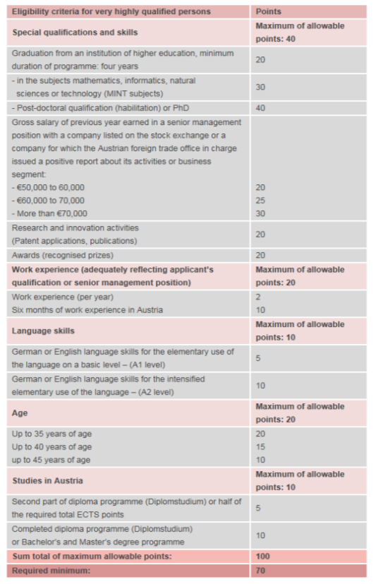
Source: http://www.migration.gv.at/en/types-of-immigration/permanent-immigration-red-white-red-card/very-highly-qualified-workers.html (accessed 1 December 2015)
(2) Qualified workers in shortage occupations may apply if they are able to provide proof of completed training in a shortage occupation under the regulation and if they have received a binding job offer in Austria and the prospective employer is willing to remunerate them with the minimum pay stipulated by law, regulation or collective agreement. The list of shortage occupations is issued each year by the Federal Ministry of Labour, Social Affairs and Consumer Protection in consultation with the Federal Ministry Science, Research and Economy in accordance with the developments on the Austrian labour market. For 2016 these are the following:
Milling machinists
Metal turners
Technicians with a higher level of training for mechanical engineering
Roofers
Graduate engineers in mechanical engineering
Technicians with a higher level of training (engineer) for power engineering technology
Graduate power engineers
Graduate nurses who started with their complementary training in Austria until the end of 2015 and have completed it at the time of application.
According to the points-based system applicants must reach a minimum of 50 points according to the specific criteria set out in figure 1.2 (qualifications, work experience according to qualification, language skills, age):
Eligibility criteria for qualified workers in shortage occupations
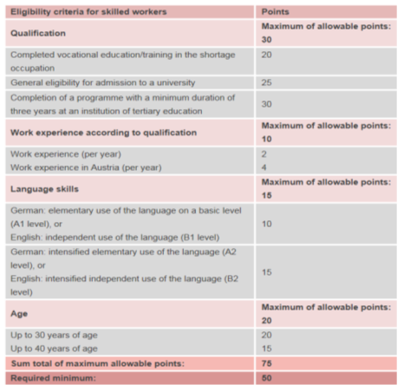
Source: http://www.migration.gv.at/en/types-of-immigration/permanent-immigration-red-white-red-card/qualified-workers-in-shortage-occupations.html (accessed 1 December 2015)

(3) Other key workers may apply if they earn the statutory minimum salary plus holiday and Christmas pay, which is EUR 2 790 gross monthly for key workers over 30 years of age and EUR 2 325 gross monthly pay for key workers under 30 years of age in 2015. Applicants must reach at least 50 points of the specific criteria in figure 1.2 (same as for the qualified workers in shortage occupations). However, the qualification criteria differ as shown in figure 1.3:

Eligibility criteria for other qualified workers (difference to qualified workers in shortage occupations)
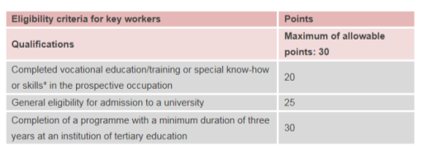
Source: http://www.migration.gv.at/en/types-of-immigration/permanent-immigration-red-white-red-card/other-key-workers.html (accessed 1 December 2015)

(4) Graduates of Austrian universities and colleges of higher education may apply, if they completed a Diploma programme (Diplomstudium) at least from the second part onward or a master’s programme at an Austrian public university, university of applied sciences or accredited private university. They may reside in Austria for a further 6 months for the purpose of searching for employment, provided that they fulfil the general requirements under the Austrian settlement and residence legislation (see above). If, within these 6 months, graduates are able to furnish proof of an employment offer from a specified employer under a work contract which corresponds to their level of qualifications, they will be issued a RWR Card, provided that the employer pays the locally customary gross minimum salary comparable to a salary Austrian graduates (junior employees) would receive, but in any case a minimum of EUR 2 092,50 a month, plus special payments (holiday and Christmas pay). This rule does not apply to graduates who have only obtained a bachelor’s degree in Austria and who work less than full time (40hrs). For graduates, there is no point system.
(5) Self-employed key workers may apply if their self-employed occupation creates macroeconomic benefit in Austria going beyond its own operational benefit. This may be the case if the intended occupation involves a sustained transfer of investment capital to Austria, creates new jobs or secures existing jobs in Austria, the settlement of the key worker involves the transfer of know-how the introduction of new technologies, or the key worker’s company is of considerable significance for the entire region. For self-employed key workers, there is no points-based selection.
Under the RWR Card the Austrian government applies a labour market test only for other key workers. In this case the Public Employment Service (AMS) verifies whether no equally qualified person registered as a jobseeker at the AMS can be placed.
For all categories but that of the self-employed, a binding job offer is necessary when applying for the RWR Card. Only very qualified workers and graduates have the possibility to obtain a jobseeker visa to enter (or to stay in) Austria and search for a job before applying for the RWR card.
Application Procedure
The application must be made either in person at the competent settlement authority (if eligible to stay in Austria) or at the Austrian embassy in the home country. The employer has also the possibility to submit an application.
For the Jobseeker Visa the following documents must be submitted: valid travel document (e.g. passport), birth certificate or similar document, photo not older than 6 months, evidence of locally customary accommodation (e.g. lease contract, preliminary agreement on tenancy rights or ownership evidence), evidence of health insurance covering all risks (compulsory health insurance or equivalent insurance policy), evidence of adequate means of subsistence (payslips, pay certificates, employment contracts, insurance benefit certificates, evidence of retirement or other pension or insurance benefits, investment capital or sufficient own assets). Additional documents required under the points system are documents confirming (i) special qualifications and skills, (ii) work experience, (iii) language skills and (iv) periods of study in Austria.
Applications from (1) very highly qualified workers, (2) qualified workers in shortage occupations, (3) other key workers and (4) graduates of Austrian universities and colleges of higher education are circulated from the competent settlement authority (‘Niederlassungsbehörde’) to the relevant branch of the AMS. The AMS verifies the specific admission requirements and shares its findings with the competent settlement authority. If the applicant meets the criteria proposed, and if the workplace is according to the qualification of the applicant, the settlement authority checks the other legal requirements (general requirements for the granting of residence permits), and if everything is fulfilled issues the RWR Card. Applications from (5) self-employed key workers are received by the competent settlement authority and sent to the office of AMS. The AMS publishes an opinion on the overall economic benefits of self-employed key workers. If the opinion is positive and the self-employed key workers fulfil the general requirements for the granting of residence permits, the RWR card is issued.
The application costs include the Jobseeker Visa (for (1) very HQW and (4) graduates) EUR 100, the RWR Card EUR 100 and the costs of personalisation (photography and signature) EUR 20. For the recognition of qualifications the costs are EUR 150. There are additional fees and administration costs (not specified).
The competent settlement authority must decide on the issuance of the RWR card within eight weeks. According to an interviewed representative of the Federal Ministry of Interior, the actual processing time is usually also 8 weeks. The applicant must pick up the residence permit in person at the relevant branch of the settlement authority. Information on the duration of the individual process can be obtained from the competent authority. The duration of the proceedings depends in particular on whether the documents are complete.
TCNs who hold a RWR Card may apply for a RWR Card Plus, if they were employed in accordance with the criteria decisive for eligibility for a minimum of ten months during the preceding twelve months. If the holder of a RWR Card applies for a RWR Card again, the conditions for extending the permit are the same as for receiving the RWR Card for the first time.
Rights granted under the scheme
The RWR Card entitles the holder to fixed-term settlement and employment by a specified employer. In case of a change of employer within the first year a new RWR card must be requested. A change of employer is only possible after receiving the RWR Card plus or an Austrian long-term residence permit (according to Directive 2003/109/EC). There is no facilitation for permanent residence compared to other permits (the prerequisite of five years continuous residence must be fulfilled in any case). Family reunification is possible for the nuclear family and registered partners. Family members shall obtain the RWR Card plus, provided they meet the general granting requirements. The RWR Card plus grants its holders free access to the labour market and is valid for 1 year.
Statistical overview
Despite the fact that the scheme has attracted more HQW, Austria has still the lowest number of permanent labour migrants among the European OECD countries relative to the population. Table 1.1 shows the key statistics of the RWR card compared to the EU Blue Card as of November 2015.
Key statistics of the RWR Card compared to the EU Blue Card
Statistics November 2015 | RWR Card | RWR Card Plus | EU Blue Card
Valid residence permits (as of November 2015) | 1 626 | 89 949 | 259
Disaggregated by gender | 449 female  1 177 male | 45 636 female  44 313 male | 83 female  176 male
Disaggregated by nationality (top 10) | (1) Bosnia-Herzegovina: 345  (2) Serbia: 179  (3) Russian Federation: 140  (4) Ukraine: 118  (5) India: 106  (6) USA:103  (7) China: 78  (8) Canada: 67  (9) Turkey: 51  (10) FYROM: 36 | (1) Turkey: 20,409  (2) Serbia: 17,470  (3) Bosnia-Herzegovina: 11 248  (4) Kosovo: 8 750  (5) FYROM: 4,960  (6) Russian Federation: 3 636  (7) China:2 069  (8) Nigeria: 2 026  (9) India: 2 020  (10) Ukraine: 1 697 | (1)Russian Federation: 68  (2) Ukraine: 37  (3) India: 24  (4) Brazil: 20  (5) USA: 17  (6) Serbia:13  (7) Bosnia-Herzegovina: 12  (8) China: 8  (9) Turkey: 8  (10) Japan: 7
Disaggregated by age | 0-14: 0  15-18: 1  19-24: 189  25-29: 583  30 -34: 432  35-39: 240  40-44: 91  45-49: 47  50-54: 25  55-59: 12  60-64: 4  >=65: 2 | 0-14: 35 602  15-18: 3 361  19-24: 6 218  25-29: 9 977  30 -34: 11 151  35-39: 8 662  40-44: 6 289  45-49: 3 863  50-54: 2 410  55-59: 1 343  60-64: 622  >=65: 451 | 0-14: 0  15-18: 0  19-24: 1  25-29: 19  30 -34: 82  35-39: 72  40-44: 40  45-49: 17  50-54: 17  55-59: 7  60-64: 4  >=65: 0
Permits issued 2015 (until 30 November 2015) | 1 110  very highly qualified workers: 51  qualified workers in shortage occupations: 176  other key workers: 822  graduates of Austrian universities and colleges of higher education: 34  self-employed key workers: 27 | 3 327 | 109
Disaggregated by gender (for 2015) | 254 female  856 male | 2 049 female  1 278 male | 35 female  73 male
Ratio total number of HQW permits / general employment permits (as of November 2015) | 91 834 / 438 137
Relative number compared to size of the workforce | Workforce: 3 929 642; Employment permits issued 438 137 = 11 % of the total workforce
Source: http://www.bmi.gv.at/cms/BMI_Niederlassung/statistiken/files/2015/Niederlassungs_und_Aufenthaltsstatistik_November_2015.pdf (accessed 26 January 2016)
In Austria 7 693 TCNs have become naturalized in 2014 and in total 273 662 have a permanent residence status as of November 2015. Around 11 % of TCNs (of a total number of 436 893 TCNs residing in Austria) are unemployed.
Regarding intra EU mobility, the RWR Card holders do not have this possibility, in contrast to EU Blue Card holders who can apply for an EU Blue Cardin another MS than Austria. According to a representative from the Federal Ministry of Labour, Social Affairs and Consumer protection an application for an EU Blue Card in Austria is more likely to succeed, if the applicant has already had an EU Blue Card from another MS (as it is assumed that the applicant already fulfils the basic requirements).
If TCNs with a RWR Card lose their job they can stay in the country for a reasonable amount of time. As soon as the RWR Card holder becomes unemployed a process of retracting the card starts that can take up to 3 months. If the RWR Card holder finds another job that allows for issuing a RWR Card then the process is being redirected to issuing a new RWR Card. If this is not the case the RWR Card is withdrawn.
Comparative overview Red-White-Red Card and the EU Blue Card
Compared to the EU Blue Card, the number of HQW attracted by the RWR Card is considerably higher. However, the number is much lower than anticipated during the introduction phase of the scheme. During the introduction phase of the scheme, there was no numerical goal, but the social partners in Austria calculated with around 8 000 RWR Card holder per year. The introduction of the RWR Card coincided with the opening of the Austrian labour market for the EU-8 countries, which migrated in large numbers to Austria. Over 75 % of the total permanent immigration to Austria is due to the free movement of EU citizens which counterbalances the rather low number of RWR Card holders. Nevertheless, according to the interviewed representatives from the Federal Ministries, the scheme does attract TCN HQWs in segments where labour shortages exist.
There are two important distinctions between the RWR Card and the EU Blue Card that can contribute to the attractiveness of the RWR Card:
In contrast to the EU Blue Card the RWR Card covers a broader spectrum of TNCs, including qualified workers in shortage occupations and entrepreneurs.
The salary threshold for the RWR Card is considerably lower compared to the EU Blue Card. The salary threshold is different for each category of RWR Card holders, but it is generally set according to the average salary in the occupation (for differences see the mapping sheet). In contrast, the salary threshold for the EU Blue Card is 1,5 times the average gross annual salary. The Austrian government made the strategic decision not to include the option of a lower salary threshold (1,2 times higher than the average gross annual salary for shortage occupations) in order to focus the issuance of the EU Blue Card permits to very highly qualified TCNs.
The RWR Card is seen as the main permit for the highly qualified and qualified workers. The EU Blue Card functions as an addition to the RWR Card for very highly qualified workers. Further distinctions of the RWR Card and the EU Blue Card are:
Years of experience can only be used as an addition to formal qualification, to balance a lack of points due to the incomplete fulfilment of other requirements (e.g. language level). For EU Blue Card applicants, on the other hand, professional experience is not taken into account, in spite of the possibility to recognise experience under Article 2(g) of the EU Blue Card Directive. .
Whereas labour market tests are obligatory for the EU Blue Card, under the national scheme labour market tests are only carried out for certain categories of workers. .
The RWR Card scheme is a point based system for 1) very highly qualified workers, 2) qualified workers in shortage occupations, and 3) other key workers. The Blue Card, on the other hand, is issued based on cumulative criteria.
Disadvantages of the RWR Card compared to the EU Blue Card include the initial shorter validity of the permit. Whereas the EU Blue card is issued for two years, the RWR Card is initially only issued for one year. It is debatable, however, if this amounts to a substantial disadvantage, as some applicants might resent the fact of being bound to one employer for two years and might prefer to apply for a RWR Card Plus which then grants free labour market access..
To be eligible for long term residency, holders of the RWR Card must have lived in Austria for at least 5 years. While EU Blue Card holders must also fulfil the condition of 5 years of residence; they can accumulate periods spent as Blue Card holders in different Member States. .
In terms of labour rights and the right to family reunification there are no differences between the EU Blue Card and the RWR Card. Family members of EU Blue Card holders and RWR Card holders both receive the RWR Plus Card and have full access to the labour market. .
Evaluation of the scheme
Coherence, complementarity and competition between national scheme and EU Blue Card
According to the interviewed representatives of the Federal Ministry of Labour and of the Federal Ministry of the Interior, the competition between the EU Blue Card and the RWR Card scheme is limited. Only one category under the RWR Card, namely the group of very highly qualified workers would likely be eligible for the EU Blue Card. Hence, these stakeholders characterise the schemes as complementary to the Blue Card, as it attracts a much wider range of TCNs and sets different salary thresholds. In light of the partial yet existent overlap, however, a certain amount of competition is incontrovertibly taking place.
The interviewed representatives of the Federal Ministries confirmed that the EU Blue Card is coherent with national policies in the fields of migration, integration education and labour policies. Concerning integration requirements, EU Blue Card holders, as a category expected to integrate easily, are not under any specific obligations.
Efficiency, effectiveness and impact of the national scheme and the EU Blue Card
Effectiveness
The introduction of the RWR Card scheme has led to the increase of HSWs coming to Austria, although this number was much lower than anticipated. There have been no targets in policy documents on the number of HSWs to be attracted. However, the social partners expected around 8 000 HSWs per year, thus a considerably higher number than the actual average, which fluctuates around 1 000 HSWs per year since the introduction of the scheme. Around half of the RWR Card holders apply for the RWR Card Plus after the first year (e.g. 1 177 RWR Cards were issued in 2013 and 706 RWR Plus Card permits were issued a year later as extensions). The identified reasons for extending the permit, changing to another permit, or leaving the country are mainly personal.. The RWR Card is being promoted through the online portal ‘migration.gv.at’ where information is accessible in English and German. Furthermore, the Federal Ministry of Labour and the Federal Ministry of the Interior offer information on their homepages and through leaflets in different languages. The Federal Ministry of the Interior also provides information during events and conferences. Interviewed stakeholders find that promotion could be further strengthened through a better involvement of employer associations such as the Chamber of Commerce and the Federation of Austrian Industries.
Although the RWR Card attracts less HSWs than initially expected, the scheme is generally considered effective. The new points based system is credited, in particular, for taking into account a wider range of criteria, including applicants age and language skills. A recent evaluation study of the Austrian immigration system conducted by the OECD has influenced the decision of the Austrian government to increase and improve the promotion of its national scheme..
Conversely, the EU Blue Card is regarded as less attractive and less effective by the national administrators. Since its introduction, in the same year as the RWR Card, the EU Blue Card attracted around 100 very highly qualified workers per year. Until 30 November 2015, 109 EU Blue Cards were issued. This compares with 51 RWR Cards for very highly qualified workers and a total of 1 110 RWR Cards until 30 November 2015. The introduction of the EU Blue Card led to an expedited introduction of the RWR Card in Austria. According to the representative of the Federal Ministry of Labour, the social partners perceived the focus of the EU Blue Card as too narrow for the needs of the Austrian labour market, where highly qualified and medium qualified workers are equally in demand. According to the representative from the Federal Ministry of the Interior there are two main reasons for the low effectiveness of the EU Blue Card compared to the RWR Card:
The RWR Card is specifically tailored to the needs of the Austrian labour market (as described above) and is open to a broader range of HSWs, due, among other factors, to the lower salary threshold.
The RWR Card has been better promoted by the Austrian authorities.
According to the interviewed representative of the Federal Ministry of Labour, focusing only on changes in the current provisions of the EU Blue Card will not enhance its attractiveness. The Directive 2014/66/EU on intra-corporate transfer (ICT) might have a deterrent effect on the number of EU Blue Cards issued in Austria, as employers might opt for these permits rather than the EU Blue Card. The employees would be bound to an employer and would not have the option to switch to a RWR Plus Card after two years as is the case now with the EU Blue Card.
Efficiency
The administrative cost for the EU Blue Card and the RWR Card are judged to be reasonable. Because no specific department at the competent residence authorities deals exclusively with residence permits for HQWs, no exact statistics about the cost of issuing these permits are available. For now there are only preliminary plans for introducing special counters for HQWs. There is no evidence that the administrative procedure itself has deterred any TCNs from applying either for the RWR Card or the EU Blue Card. To the contrary, the application procedure has been simplified when the RWR card was introduced. HQWs apply at a ‘one-stop-shop’ at the competent residence authority in Austria, or at the Austrian embassy abroad. The residence authority is sending the application to the AMS that conducts the labour market test, where necessary, and sends the results back to the residence authority that informs the applicant of the decision. Thereby the applicant is only in contact with the residence authority, which enhances the efficiency of the process.
Impact
The impact of the EU Blue Card on Austria has been limited in terms of the number of permits issued. As described above, however, the introduction of the Blue Card has served as a catalyst that accelerated the adoption of the RWR Card. .
The introduction of the RWR Card has contributed to a higher number of HQWs compared to the previous ‘key workers’ directive in Austria. Around half of the RWR Cards issued each year are extended as RWR Cards Plus. The impact on the competitiveness of Austria is seen as limited by the interviewed representatives of the Federal Ministries. The number of RWR Cards issued is small and thus Austria needs to further increase its attractiveness for HQWs.

References
Federal Government of Austria (2015), “Permanent immigration - Red-White-Red Card”, available at http://www.migration.gv.at/en/types-of-immigration/permanent-immigration-red-white-red-card.html (accessed 30 November 2015).
Federal Government of Austria (2015), “Very highly qualified workers”, available at http://www.migration.gv.at/en/types-of-immigration/permanent-immigration-red-white-red-card/very-highly-qualified-workers.htm (accessed 1 December 2015)
Federal Government of Austria (2015), “Shortage occupations list 2016”, available at http://www.migration.gv.at/en/types-of-immigration/permanent-immigration-red-white-red-card/qualified-workers-in-shortage-occupations/shortage-occupations-list-2016.html (accessed 21 December 2015)
Federal Government of Austria (2015), “Qualified workers in shortage occupations”, http://www.migration.gv.at/en/types-of-immigration/permanent-immigration-red-white-red-card/qualified-workers-in-shortage-occupations.html (accessed 1 December 2015)
Federal Government of Austria (2015), “Other key workers”, http://www.migration.gv.at/en/types-of-immigration/permanent-immigration-red-white-red-card/other-key-workers.html (accessed 1 December 2015)
Federal Government of Austria (2015), “Students and graduates”, available at http://www.migration.gv.at/en/types-of-immigration/permanent-immigration-red-white-red-card/students-and-graduates.html#c2973 (accessed 1 December 2015)
Federal Government of Austria (2015), “Self-employed key workers”, available at http://www.migration.gv.at/en/types-of-immigration/permanent-immigration-red-white-red-card/self-employed-key-workers.html (accessed 1 December 2015)
Federal Government of Austria (2015), “Family reunification”, available athttp://www.migration.gv.at/en/types-of-immigration/permanent-immigration-red-white-red-card/family-reunification.html (accessed 3 December 2015)
Federal Government of Austria (2015), “EU Blue Card”, available at http://www.migration.gv.at/en/types-of-immigration/permanent-immigration-red-white-red-card/eu-blue-card.html (accessed 3 December 2015)
Federal Government of Austria (2015), “Red-White-Red Card plus”, available at http://www.migration.gv.at/en/types-of-immigration/permanent-immigration-red-white-red-card/red-white-red-card-plus.html (accessed 1 December 2015)
Federal Ministry of Finance (2015), “Budget 2014/2015”, available at https://www.bmf.gv.at/budget/das-budget/budget-2014-2015.html (accessed 6 January 2016)
Federal Ministry of Interior (2015), ”Niederlassungs- und Aufenthaltsstatistik November 2015”, http://www.bmi.gv.at/cms/BMI_Niederlassung/statistiken/files/2015/Niederlassungs_und_Aufenthaltsstatistik_November_2015 (accessed 26 January 2016)
Federal Ministry of Labour, Social Affairs and Consumer protection (2010), “Die Rot-Weiß-Rot-Karte – das neue Zuwanderungssystem. Bessere Qualifikation, höheres Wirtschaftswachstum, raschere Integration“, available at: http://www.sozialministerium.at/cms/site/attachments/3/6/0/CH0016/CMS1291897740667/101209_rotweissrotcard_layoutiert.pdf (accessed 26 January 2016)
Interview with representative from the Federal Ministry of Labour, Social Affairs and Consumer Protection, 2 December 2015
Interview with the representative of the Federal Ministry of Interior on 3 December 2015.
OECD (2014), “Recruiting immigrant workers: Austria 2014”, available at http://www.oecd-ilibrary.org/social-issues-migration-health/recruiting-immigrant-workers-austria-2014_9789264226050-en;jsessionid=2i12tvlnfh8jh.x-oecd-live-02 (accessed 1 December 2015)
OECD (2014), “Recruiting immigrant workers: Austria 2014 Assessment and Recommendations”, available at http://www.keepeek.com/Digital-Asset-Management/oecd/social-issues-migration-health/recruiting-immigrant-workers-austria-2014/assessment-and-recommendations-english-deutsch_9789264226050-4-en#page1 (accessed 1 December 2015)
OECD (2014), “Recruiting immigrant workers: Austria 2014 Executive Summary”, available at http://www.keepeek.com/Digital-Asset-Management/oecd/social-issues-migration-health/recruiting-immigrant-workers-austria-2014/executive-summary-english-deutsch_9789264226050-3-en#page1 (accessed 1 December 2015).
Public Employment Service (AMS, 2015), “Die Blue Card für Drittstaatsangehörige“, available at http://www.ams.at/service-arbeitsuchende/auslaenderinnen/zugangsberechtigungen/blue-card-drittstaatsangehoerige (accessed 21 December 2015)
Public Employment Service AMS (2016), “Arbeitsmarktdaten Online - labour market data - general overview”, available at http://iambweb.ams.or.at/ambweb/ (accessed 26 January 2016)
Public Employment Service (AMS, 2015), “Die Zulassung ausländischer Schlüsselkräfte“, available at http://www.ams.at/service-arbeitsuchende/auslaenderinnen/zugangsberechtigungen/zulassung-auslaendischer-schluesselkraefte (accessed 21 December 2015)
Public Employment Service (AMS, 2015), “Das "Jobseeker" Visum”, available at http://www.ams.at/service-arbeitsuchende/auslaenderinnen/zugangsberechtigungen/jobseeker-visum (accessed 21 December 2015)
Statistics Austria (2015), “Zahl der Einbürgerungen im Jahr 2014 um 3,7% gestiegen“, available at http://www.statistik.at/web_de/statistiken/menschen_und_gesellschaft/bevoelkerung/einbuergerungen/080905.html (accessed 21 December 2015)
Statistics Austria (2014), “Arbeitsmarktsituation von Migrantinnen und Migranten in Österreich 2014“, available at http://www.statistik.at/web_de/services/publikationen/3/index.html?includePage=detailedView&sectionName=Arbeitsmarkt&pubId=717 (accessed 1 December 2015)

COUNTRY FICHE: GERMANY

Key Points to note:
The main scheme in Germany for attracting and retaining highly qualified TCNs is the EU Blue Card (“Blaue Karte EU”).
There are other complementary schemes for the purpose of employment of third-country nationals encompassing qualified and highly qualified third-country nationals (defined in Sections 18 – 21 Residence Act).
A residence permit for qualified skilled workers seeking employment was introduced in 2012 and gives third-country nationals the possibility for job search within a six-month period.
There is no competition between the national residence permits in Germany and the EU Blue Card. On the contrary, it is observed that the schemes are coherent and complementary to the EU Blue Card. They are characterised as complementary, since the national residence permits and the EU Blue Card do not attract the same third-country nationals.
The administrative costs for the EU Blue Card and the national permits are regarded as reasonable.
The impact of the EU Blue Card on Germany has been substantial in terms of the absolute number of permits issued. However, the overall impact of the EU Blue Card on attracting highly qualified TCNs is described as limited.

Overview of the national permits
Since its introduction in 2012, the EU Blue Card is the main scheme for highly qualified third-country nationals (TCNs) in Germany. Germany has only minor national schemes for highly qualified TCNs. In general, the German labour migration system is open for migration of qualified and highly-qualified TCNs. There have been several legislative reforms in the past few years that contributed to a simplification of the application process for highly qualified TCNs that want to enter Germany for employment purposes. The system is demand-driven and based on market needs. It is implemented in the ‘demography strategy’ of the German federal government.
In order to work in Germany TCNs need a residence title for the purpose of employment. There are several residence titles for qualified and highly qualified TCNs listed in Part 4, Residence for the purpose of economic activity, sections 18-21 of the Residence Act (“Aufenthaltsgesetz”). The German immigration legislation does not solely focus on highly qualified TCNs. The following Sections 18-21 of the Residence Act include qualified TCNs as well:
Section 18: Employment;
Section 18a: Residence permit for the purpose of employment for qualified foreigners whose deportation has been suspended;
Section 18b: Settlement permit for graduates of German universities;
Section 18c: Residence permit for qualified skilled workers seeking employment;
Section 19: Settlement permit for highly qualified foreigners;
Section 19a: EU Blue Card;
Section 20: Research;
Section 21: Self-employment.
The residence titles are supposed to attract TCNs in specific sectors, where qualified or highly qualified labour is needed. The following section describes the national permits for highly qualified TCNs, excluding the EU Blue Card under Section 19a.
Design of the national permits
The following general requirements under section 5 of the German Residence Act need to be fulfilled for any residence permit:
Secured means of subsistence;
No grounds for expulsion;
Passport obligation pursuant to Section 3 is met;
Adequate visa (if necessary).
TCNs that meet these general requirements and can present a valid job offer (except self-employed applicants) can receive a residence permit for the purpose of employment. Generally, a labour market test is carried out by the Federal Employment Agency that verifies whether no equally qualified person registered as a jobseeker can be placed. Thus TCNs may only be employed after the consent of the Federal Employment Agency, except managers and those engaged in scientific, research and development activities. The further requirements differ across the residence permits.
Residence permit for employment (§ 18 Residence Act)
This residence permit is the general permit for TCNs who do not meet the conditions of the EU Blue Card or exercise a specific (qualified or non-qualified) profession as laid down in the regulation (“Beschäftigungsverordnung”, e.g. ICTs, teachers, au pairs).
Residence permit for the purpose of employment for qualified foreigners whose deportation has been suspended (18a Residence Act)
A TCN whose deportation has been suspended for reasons of international law or on humanitarian grounds may be granted a certificate confirming the suspension of deportation (“Duldung”). This certificate is not a residence permit. However, the TCN has the possibility to apply for a residence permit under 18a Residence Act. This residence permit may be issued to a TCN whose deportation has been suspended (“geduldeter Ausländer”) and who has the prospect of a job in the following three cases: (1) the TCN has completed a vocational qualification or higher education studies in Germany; (2) the TCN has been continuously employed for two years in Germany with a foreign higher education qualification, recognized in Germany and which is appropriate to the employment carried out, or (3) the TCN was employed as a qualified worker continuously for three years in a position that requires a vocational qualification. The permit will only be issued, if the federal employment agency grants its approval. Other requirements include having sufficient living space, a sufficient command of German and generally complying with the laws in Germany.
Settlement permit for graduates of German universities (18b Residence Act)
TCNs who have completed their studies at a German university or a comparable German educational establishment may be granted a settlement permit. The permit is only granted, if the graduate has had a residence permit as described in Sections 18 (general employment), 18a (employment for qualified foreigners whose deportation has been suspended), 19a (EU Blue Card) or 21 (self-employment) for two years. Further the graduate must have a job in accordance with the earned degree. Other requirements include contributions into the statutory pension scheme for at least 24 months and sufficient command of German, sufficient living space and compliance with German laws.
Residence permit for qualified qualified workers seeking employment (18c Residence Act)
A TCN who lives outside Germany, who has a German university degree or a recognised or equivalent foreign higher education qualification, and who can secure subsistence, may be granted a residence permit for the purpose of seeking employment according to the earned qualification for duration of a maximum of 6 months. Also TCNs living in Germany with a residence permit for employment may apply for the residence permit for seeking employment after the end of their employment or research project. This residence permit is solely for the purpose of seeking employment, cannot be prolonged and does not entitle the holder to pursue economic activities. A labour market test is not carried out.
Settlement permit for highly qualified foreigners (19 Residence Act)
In exceptional cases, a settlement permit for highly qualified TCNs can be obtained. The goal is to attract particularly qualified TCNs by offering them immediately a settlement permit. Such highly qualified TCNs are researchers with special technical knowledge, teaching personnel in prominent positions or scientific personnel in prominent positions. The labour market test may be waived in certain cases. As seen below in table 1.1, the figures are rather low with only 168 permits issued in 2014, whereby only 22 such persons entered Germany in 2014. The remaining 146 were already residents in Germany.
Research (20 Residence Act)
TCNs can apply for a residence permit for research purposes, if they have a hosting agreement with a research institute recognized by the Federal Office for Migration and Refugees, and if they have secured means of subsistence. The permit transposes Directive 2005/71/EC. It is issued for at least one year or, if the project ends earlier, for the duration of the project. No labour market test is carried out.
Self-employment (21 Residence Act)
Entrepreneurs may be issued a residence permit for self-employment, if there is an economic interest or a regional need for the business, and if their business creates a positive effect on the economy. Entrepreneurs must have secured their financing. The following criteria must be fulfilled: viability of the underlying business idea, business experience of the applicant, amount of initial investment, effects on employment and education situation, and contribution to innovation and research. TCNs who graduated from a German university or have a residence permit for researchers can immediately receive a self-employment permit, if the work is related to the university education or previous research. A residence permit for self-employment is issued for three years.
Application Procedure
The application must be made in person either at the German embassy in the home country or at the proper Immigration Authority office (if eligible to stay in Germany). The required documents include a valid passport; health insurance; sufficient financial resources; employment contract/offer of employment (not for the residence permit for qualified skilled workers seeking employment).
Applications are circulated to the Federal Employment Agency. Exemptions include applications for a residence permit for researchers, for the purpose of job search, for highly qualified workers (in some cases) and self-employed. The Federal Employment Agency verifies the specific employment-related admission requirements and shares its findings with the competent authority. If the applicant meets the criteria proposed, and if the position corresponds to the qualifications of the applicant, the authority checks if the applicant fulfils the general requirements for the granting of residence permits and issues the residence permit.
The application costs include a fee of €60 for visas of any category. A reduction of, or exemption from visa fees is possible in certain cases . The fees for permits are either €100 for residence permits valid up to one year or €110 for residence permits valid over a year and for the EU Blue Card. Extension fees are €65 for an extension for up to three months, or €80 for an extension over the three months. The fees for a permanent residence permit are €250 for highly qualified under Section 19 Residence Act, €200 for self-employed under Section 21 Residence Act, and €135 for all other permanent residence permits.
There is no maximum processing time set out explicitly in the legislation, but after three months applicants may go to court in order to obtain the sought permit. Since the respective local immigration authorities are in charge of granting permits, the processing times differ between the respective authorities and they usually amount to several weeks. The applicant must pick up the residence permit in person at the relevant authority. The conditions for extending the permits are the same as for the initial permit.
Rights granted under the national permits
The above described residence permits entitle the holder to fixed-term settlement and employment by one employer. A change of employer is possible without permission after two years in most cases.
Researchers, under Section 20 of the Residence Act, may work in the same field alongside their research activities. Permanent residence is facilitated in case of permits issued under Section 18b and Section 19 of the Residence Act, as these represent immediate settlement permits.
Family reunification is possible for the nuclear family and registered partners. Family members can obtain a residence permit to create or preserve family unity. The requirements include sufficient living space, means of subsistence, and basic German skills. The duration is linked to the duration of the sponsor’s permit (main applicant). Since September 2013, all those coming to join a member of their family also have full labour market access.
Statistical overview
The available national residence permits in Germany attract a certain number of highly qualified TCNs. However, the EU Blue Card remains the main scheme for attracting these TCNs. The residence permit for qualified workers seeking employment (18c Residence Act), the settlement permit for highly qualified foreigners (19 Residence Act), and the residence permit for the purpose of research (20 Residence Act) might attract similar TCNs as the EU Blue Card and are thus used for comparison. The following table 1.1 shows the key statistics of the main national residence permits compared to the EU Blue Card. In 2014 a total of 64 518 permits were issued, whereby the highest number of permits was issued under section 18 of the Residence Act (Employment), after the approval of the Federal Employment Agency amounting to a total of 34 630 permits in 2014 (whereby 16 181 permits were issued to TCNs who entered Germany 2014 and the remaining 18 449 were issued to TCNs who changed from other permits). The second highest number of permits was 11 848 permits issued under section 19a of the Residence Act (EU Blue Card).
Key statistics of the national residence permits compared to the EU Blue Card
Statistics 2014 | 18c Residence Act (qualified qualified workers seeking employment) | 19 Residence Act (highly qualified) | 19a Residence Act  (EU Blue Card) | 20 Residence Act  (Researchers) | Total (including remaining permits set out in 18 and 21 Residence Act)
Total number of permits issued in 2014 | 186 | 168 | 11 848 | 694 | 64 518
Entry in 2014 | 93 | 31 | 4 673 | 397 | 31 020
Disaggregated by nationality (top 5, entry in 2014) | N/A | (1) USA: 6  (2) India: 4  (3) China: 4  (4) Turkey: 3  (5) Australia: 3 | (1) India: 1,116  (2) Russian Federation: 512  (3) Ukraine: 440  (4) USA: 377  (5) China: 307 | (1) China: 86  (2) USA: 53  (3) India: 41  (4) Japan: 31  (5) Brazil: 23 | (1) India: 8 220  (2) USA: 7 487  (3) China: 7 349  (4) Japan: 3 844  (5) Bosnia and Herzegovina: 3 493
Relative number compared to size of the workforce 2014 | Workforce: 38,9 million (1,8 million employment permits issued) = 4,6 % of total workforce
Source: Eurostat, 2014 and http://www.bamf.de/SharedDocs/Anlagen/DE/Publikationen/Broschueren/bundesamt-in-zahlen-2014.pdf;jsessionid=2A1967DD36CB6B577537842063F8A3B1.1_cid368?__blob=publicationFile (accessed 23 December 2015)
In Germany 89 314 TCNs were naturalized in 2013. In total 6 233 have gained a permanent residence status during 2014. Around 13% of TCNs (of a total number of 8,1 million TCNs residing in Germany) were unemployed at the end of 2014.
Regarding intra-EU mobility, TCNs with the residence permit under Section 20 of the Residence Act (researchers) are free to stay in other Member States for research purposes for up to three months. TCNs holding the other residence permits do not have this possibility, in contrast to EU Blue Card holders who can apply in another Member State.
If TCNs holding one of the national residence permits lose their job, they can stay in the country for a reasonable amount of time. In general a residence permit can be withdrawn, if the reason for obtaining the permit is not valid anymore (including situations of unemployment). However, the actual process is at the discretion of the different immigration authorities. There are no precise legal requirements, since all aspects of the individual case are considered. The decision in each individual case depends, for example, on the chances of finding subsequent employment or the acquired rights to unemployment benefits. Regarding job loss of EU Blue Card holders, the three-month period set by the Directive is applied.
Comparative overview national residence permits and the EU Blue Card
Compared to the EU Blue Card, the number of highly qualified TCNs attracted by national residence permits is considerably lower. The permits attract specific TCNs mainly with the goal to fill sectorial gaps. There are no quotas or targets formulated, neither for the national permits, nor for the EU Blue Card as the system of attracting highly qualified TCNs is strongly demand-driven. Every TCN that fulfils the requirements may apply for and obtain a permit.
There are several distinctions between the national permits and the EU Blue Card:
The EU Blue Card was transposed as the main permit for highly qualified TCNs since its introduction in 2012. Germany is a good example showing that an implementation of the Directive according to the needs of the national labour markets is possible, since the EU Blue Card Directive leaves freedom for Member States to adapt it as necessary.
A broad range of TCNs may apply for the EU Blue Card, including recent graduates, if they fulfil the conditions in Germany.
The duration of the EU Blue Card is maximum four years at the time of first issuance (but renewable), or the duration of the employment contract plus three months. The Blue Card holder is bound to one employer for the first two years.
The EU Blue Card is the only residence permit with a salary threshold, EUR 49 600 in general and EUR 38 688 in shortage professions (natural scientists, mathematicians, engineers, physicians and academic specialists in information and communications technology). The shortage professions are defined in the German Employment Ordinance (Section 2 subs. 2) as occupations belonging to Groups 21 (Science and engineering professionals), 221 (Medical doctors) and 25 (Information and communications technology professionals) of the International Standard Classification of Occupations (ISCO).
Where the general salary threshold of EUR 49 600 is met, the issuance of the EU Blue Card is not subject to the labour market test. In shortage professions, where the salary threshold of EUR 38 688 is met, only a test securing the comparability of the working conditions is applied..
Regarding long term residency, holders of the national residence permits (except holders of the settlement permits) must have at least five years of continuous residence in Germany before being eligible to apply for a long term residence permit. In contrast, after only 33 months working on the basis of the EU Blue Card, having paid into pension funds or similar insurance services, and showing simple German language skills (A1 level CEFR), the EU Blue Card holder may receive long-term residence in Germany. After proof of sufficient German language skills (B1 level CEFR), the EU Blue Card holder can receive the permanent residence permit already after 21 months. The long-term residence permit lifts the salary threshold. Compared to most other permit categories, the permanent residence permit can be obtained faster, and with less language skills.
Furthermore, EU Blue Card holders are able to cumulate the time spent in another Member State (at least 18 months) to apply for long term residency on the basis of the EU long-term residence directive.
In terms of rights at the labour market and family reunification there are no differences between the EU Blue Card and the national permit holders, as the duration is linked either to the duration of the EU Blue Card or the national permit and the family members have unlimited access to the labour market.

Evaluation of the national scheme
Coherence, complementarity and competition between national permits and EU Blue Card
Before the introduction of the EU Blue Card in 2012 in Germany there have been discussions about the introduction of a national permit. However, the EU Blue Card was adapted to the national labour market and is now the main permit for highly qualified TCNs. As an additional permit, the residence permit for qualified skilled workers seeking employment (Section 18c Residence Act) was introduced to enable highly qualified TCNs to search for a job in Germany, and after finding a job to apply for the EU Blue Card or another residence permits for employment. There are no plans to introduce further permits or schemes for highly qualified TCNs.
According to the interviewed representatives of the Federal Ministry of Interior the competition between the Blue Card and the national permits is basically non-existent. The residence permits described in table 1.1 could attract the same TCNs as the EU Blue Card. However, the numbers of permits issued are lower in comparison to the EU Blue Card and the stakeholders characterise them as complementary to the EU Blue Card.
In terms of coherence with the migration and labour policies and interventions in the field of education, integration and economic policies at the national level, the interviewed representatives of the Federal Ministry of Interior confirmed that the EU Blue Card is coherent with the regulations at the national level. Concerning integration policies, there are no special requirements (or offers) specifically for EU Blue Card holders. The permit holders may participate in the offered integration courses on a voluntary basis.
After the EU Blue Card was introduced a high number of TCNs changed status from another permit to the EU Blue Card – about half of the EU Blue Cards issued were to TCNs already present in Germany under another residence permit. Since 2013 the number of new EU Blue Cards granted as a first permit has been increasing.
Efficiency, effectiveness and impact of the national permits and the EU Blue card
Effectiveness
The introduction of the EU Blue Card has led to the increase of numbers of highly qualified TCNs coming to Germany, contributing to the highest number of EU Blue Cards issued since its introduction, compared to the other EU Member States that transposed the directive.
The national residence permits and the EU Blue Card are promoted mainly through the online portal ‘make-it-in-germany.com’ whereby information is given in English, German and Spanish as well as shorter information in other languages such as French, Serbian and Turkish. The portal was introduced by the Ministries of Labour and Social Affairs and Economic Affairs and Energy as well as the Federal Employment Agency in 2012. Also the Federal Ministries of Foreign Affairs and the Interior as well as the Office for Migration and Refugees have been involved in the development of the online portal. The Office for Migration and Refugees has further extensive information about the possible residence permits for employment purposes available at the homepage.
The representatives of the Federal Ministry of Interior explained that there has been a high number of EU Blue Cards issued. However, since the introduction, the EU Blue Card has not contributed to a substantial increase of the total number of TCNs entering Germany for employment purposes. The higher number is rather due to the favourable economic conditions in Germany and not necessarily to the EU Blue Card, especially when taking into account that a high number of the EU Blue Cards issued are for TCNs already residing in Germany.
The aspect of intra-EU Mobility is negligible, as only 112 of EU Blue Cards were issued to TCNs coming from another Member States until 31 March 2015 (out of 22 000 in total up to this date).
Efficiency
The administrative cost for the EU Blue Card and the national permits are regarded as reasonable. There is no specific department at the competent immigration authorities dealing with residence permits for highly qualified TCNs. Therefore, there are no exact statistics about the cost of issuing these permits. There is no evidence that the administrative procedure for application has had a deterrent effect for TCNs to apply either for the national scheme or the EU Blue Card. In contrast, the procedure for application has been simplified when the EU Blue Card was introduced. TCNs apply at a ‘one-stop-shop’ at the competent immigration authority in Germany (or at the German embassy abroad, if a visa to enter the country is needed). The authority is sending the application to the Federal Employment Agency that conducts the labour market test and sends the results back to the authority that informs the applicant of the decision. The applicant is only in contact with the authority. ‘Welcome centres’ for highly qualified TCNs have been implemented in the immigration authorities in bigger cities and regions.
Impact
The impact of the EU Blue Card on Germany has been substantial in terms of number of permits issued. However, the interviewed representatives from the Ministry of Interior do not necessarily link this to the transposition of the EU Blue Card Directive. There was already a trend towards an opening of the labour market in Germany, and the EU Blue Card can be seen as a vehicle for legislative changes (e.g. the introduction of the residence permit for qualified skilled workers seeking employment).
The EU Blue Card has been integrated into the larger developments, but there is no significant independent ‘impact’. The EU Blue Card brand can contribute to a stronger awareness and use of the EU Blue Card. However, if companies are interested in employing highly qualified TCNs from abroad, they will also accept other legislative provisions. This is not necessarily bound to the EU Blue Card directive.

References
European Commission (2009), “Commission Recommendation of 29 October 2009 on the use of the International Standard Classification of Occupations (ISCO-08). (Text with EEA relevance) (2009/824/EC)”, available at http://ec.europa.eu/eurostat/documents/1978984/6037342/ISCO-08.pdf (accessed 26 January 2016).
Eurostat, 2014
Federal Employment Agency (2014),"Analyse des Arbeitsmarktes für Ausländer Dezember 2014“, available at https://statistik.arbeitsagentur.de/Statischer-Content/Statistische-Analysen/Analytikreports/Zentrale-Analytikreports/Monatliche-Analytikreports/Generische-Publikationen/Analyse-Arbeitsmarkt-Auslaender/Analyse-Arbeitsmarkt-Auslaender-201412.pdf (accessed 23 December 2015)
Federal Employment Agency (2015),“Zulassung zum deutschen Arbeitsmarkt“, available at https://www.arbeitsagentur.de/web/content/DE/BuergerinnenUndBuerger/ArbeitundBeruf/ArbeitsJobsuche/ArbeitinDeutschland/Arbeitsmarktzulassung/Detail/index.htm?dfContentId=L6019022DSTBAI750887 (accessed 22 December 2015)
Federal Foreign Office (2015), “Visa regulations”, available at http://www.auswaertiges-amt.de/sid_515D4272179C93ABBDAB649B57299FE2/EN/EinreiseUndAufenthalt/Visabestimmungen_node.html#doc480844bodyText4 (accessed 23 December 2015)
Federal Ministry of Finance (2015), “Bundeshaushalt 2014. Ausgaben: Bundesamt für Migration und Flüchtlinge“, available at http://www.bundeshaushalt-info.de/#/2014/soll/ausgaben/einzelplan/0633.html (accessed 6 January 2016)
Federal Ministry of Interior (BMI, 2015), “Arbeitsmigration”, available at http://www.bmi.bund.de/DE/Themen/Migration-Integration/Zuwanderung/Arbeitsmigration/arbeitsmigration_node.html (accessed 22 December 2015)
Federal Ministry of Interior (BMI, 2014), “Haushalt”, available at http://www.bmi.bund.de/DE/Ministerium/BMI-Vorstellung/Haushalt/haushalt_node.html (accessed 6 January 2016)
Federal Ministry of Justice and Consumer Protection (BMJV, 2015), “Act on the Residence, Economic Activity and Integration of Foreigners in the Federal Territory. Residence Act. (Federal Law Gazette I p. 162)”, available at http://www.gesetze-im-internet.de/englisch_aufenthg/englisch_aufenthg.html#p0042 (accessed 15 December 2015)
Federal Ministry of Justice and Consumer Protection (BMJV, 2015), “Act on the Residence, Economic Activity and Integration of Foreigners in the Federal Territory. Residence Act. (Federal Law Gazette I p. 162). § 18a Aufenthaltserlaubnis für qualifizierte Geduldete zum Zweck der Beschäftigung“, available at http://www.gesetze-im-internet.de/aufenthg_2004/__18a.html (accessed 8 January 2016)
Federal Ministry of Justice and Consumer Protection (MBJV, 2015). “Beschäftigungsverordnung – BeschV. § 2 Hochqualifizierte, Blaue Karte EU, Hochschulabsolventinnen und Hochschulabsolventen“, available at http://www.gesetze-im-internet.de/beschv_2013/__2.html (accessed 26 January 2016)
Federal Ministry of Justice and Consumer Protection (BMJV, 2015), “Act on the Residence, Economic Activity and Integration of Foreigners in the Federal Territory. Residence Act. (Federal Law Gazette I p. 162). Section 60a Temporary suspension of deportation”, available at http://www.gesetze-im-internet.de/englisch_aufenthg/index.html (accessed 8 January 2016)
Federal Office for Migration and Refugees (BAMF, 2015), “Blaue Karte EU”, available at http://www.bamf.de/DE/Migration/Arbeiten/BuergerDrittstaat/BlaueKarte/blaue-karte-node.html (accessed 5 December 2015)
Federal Office for Migration and Refugees (BAMF, 2015), “Migration to Germany – Welcome to Germany”, available at http://www.bamf.de/EN/Startseite/startseite-node.html (accessed 25 November 2015)
Federal Office for Migration and Refugees (BAMF, 2014), “Wanderungsmonitoring: Erwerbsmigration nach Deutschland. Jahresbericht 2014“, available at https://www.bamf.de/SharedDocs/Anlagen/DE/Publikationen/Broschueren/wanderungsmonitoring-2014.pdf?__blob=publicationFile (accessed 5 December 2015)
Federal Office for Migration and Refugees (BAMF, 2013), “Studying and Working in Germany. A brochure on the legal requirements of residence for TCNs”, http://www.bamf.de/SharedDocs/Anlagen/EN/Publikationen/Broschueren/bildung-und-beruf-in-deutschland.pdf?__blob=publicationFile#page=7 (accessed 1 December 2015)
Federal Office for Migration and Refugees (BAMF, 2015), “Anerkennung von Forschungseinrichtungen zum Abschluss von Aufnahmevereinbarungen“, available at http://www.bamf.de/DE/DasBAMF/Aufgaben/Forschungseinrichtungen/forschungseinrichtungen-node.html (accessed 23 December 2015)
Federal Office for Migration and Refugees (BAMF, 2015), “Research stays in Germany Information on entry and stay of researchers from non-EU countries (section 16 to 21 – especially section 20 – Residence Act)”, available at http://www.bamf.de/SharedDocs/Anlagen/EN/Publikationen/Flyer/forschungsaufenthalte.pdf?__blob=publicationFile (accessed 23 December 2015)
Federal Office for Migration and Refugees (BAMF, 2015), “Das Bundesamt in Zahlen 2014 Asyl, Migration und Integration“, available at http://www.bamf.de/SharedDocs/Anlagen/DE/Publikationen/Broschueren/bundesamt-in-zahlen-2014.pdf;jsessionid=2A1967DD36CB6B577537842063F8A3B1.1_cid368?__blob=publicationFile (accessed 23 December 2015)
Federal Office for Migration and Refugees (BAMF, 2015), “EU Blue Card FAQs”, available at http://www.bamf.de/EN/Infothek/FragenAntworten/BlaueKarteEU/blaue-karte-eu-node.html (accessed 23 December 2015)
Federal Statistical Office (2015), “Ausländische Bevölkerung“, available at https://www.destatis.de/DE/ZahlenFakten/GesellschaftStaat/Bevoelkerung/MigrationIntegration/AuslaendischeBevolkerung/Tabellen/AufenthaltsrechtlicherStatus.html (accessed 23 December 2015)
Interview with representatives of the Federal Ministry of Interior, 17 December 2015
Make it in Germany (2015),“Mein Willkommensportal! Lernen Sie Deutschland anhand Ihrer Interessen kennen“, available at http://www.make-it-in-germany.com/ (accessed 25 November 2015)
Make it in Germany (2015), “Citizens of other states”, available at http://www.make-it-in-germany.com/en/for-qualified-professionals/working/guide/visa#citizens-of-other-states (accessed 01 December 2015)
Municipal Immigration Departments Düsseldorf (Kommunale Ausländerbehörde Landeshauptstadt Düsseldorf, 2015), “Gebühren für elektronische Aufenthaltstitel (Eat)“, available at http://www.duesseldorf.de/auslaenderamt/aufenthalt/eat_gebuehren/index.shtml (accessed 23 December 2015)
Municipal Immigration Departments Düsseldorf (Kommunale Ausländerbehörde Landeshauptstadt Düsseldorf, 2015), “Aufenthaltserlaubnis zur unselbständigen Erwerbstätigkeit“, available at http://www.duesseldorf.de/buergerinfo/33/03/33ae05.shtml (accessed 23 December 2015)

COUNTRY FICHE: FRANCE

Key Points to note:
Highly-qualified TCNs (HQW TCNs) in France can apply for a number of residence permits. The most relevant one for comparison with the EU Blue Card is the Carte de séjour compétences et talents (‘Residence permit for competences and talents’) created in 2006 to attract foreign talent. Nine different types of profiles can apply, including independent professionals (artists, authors, etc.), athletes, investors and employees. It provides certain advantages that are not available under other residence permits. Under this residence permit, the TCN is required to present a project (definition of project includes paid employment) which makes “a significant or lasting contribution, through their skills or talents, to France’s economic development or to its intellectual, scientific, cultural, humanitarian or athletic prestige, and directly or indirectly, to that of their own country”.
In the period 2008-2011, less than 300 Residence permits for competences and talents were issued on average per year. Since the introduction of the scheme in 2006 up to 2012, a total number of 1,364 TCNs. This figure has been considered far from the targets set - 2,000 residence permits per year.
In France, work-related (including highly qualified) migration has been relatively small despite efforts to boost it. This has been accounted to a number of reasons, including lengthy administrative procedures; lack of flexibility of certain residence permits and difficulties with the recognition of foreign qualifications for regulated professions.
In revision of its legal migration policy, France has planned to introduce in 2016 a so-called ‘talent passport’ which aims to streamline the immigration of qualified TCNs and make France more attractive for TCN skilled workers.

Overview of the schemes
This section outlines the policy context in France which led to the development of residence permits for HQW TCNs.
Design of the scheme
The policy to attract international talents commenced in 2006 when the concept of ‘selective’ immigration was enshrined in the Law on Immigration and Integration adopted on 24th July 2006. This was followed by the design of two residence permits targeted at qualified TCNs: the temporary residence permit for seconded employees and the Residence permits for competences and talents. The latter is the main scheme comparable to the EU Blue Card. Other residence permits which qualified TCNs can apply to in France are also considered in this Country Fiche but those are not looked at in as much detail.
The focus of France’s policies for attracting foreign talents has traditionally been put on ‘circular’ migration rather than on a ‘settlement’ migration. The policy has not aimed to fill in any specific labour shortages. As highlighted by representatives of the Ministry of Interior consulted, France has had a high fertility rate by European standards, coupled with a high unemployment rate, especially amongst young graduates. Those two factors do not place France in a position where its immigration policy has focused on filling gaps in the qualified labour force unlike other EU Member States.
With regard to policy measures for filling labour shortages, a national list of shortage occupations was drawn in 2008. Professions include a variety of sectors (mainly finance, IT, construction, electricity and electronics) and mostly require low to medium-level of qualifications. The list does not concern highly qualified workers specifically and most professions included in this list would not meet the EU Blue Card salary threshold. Finally, according to the Ministry of Interior’s preparatory document to the 2014 reform, this list needed to be re-examined with social partners and regional authorities as it was no longer relevant to current needs. Separate lists of labour shortages also exist as part of bilateral agreements with certain third countries.
Since 2006, the labour migration policy in France remains oriented towards attracting foreign talents. The National Pact for growth, competitiveness and employment adopted by the government on 6th November 2012, aimed amongst other objectives, to attract international talent. This reflects the objective to increase work-related migration compared to immigration for family reunification reasons and to improve the admission procedures of work-related migrants. For example, since 2011, in the prefectures of 8 departments, dedicated offices were established to provide information to holders of the residence permits ‘competences and talents’ and ‘seconded employees’ on all procedures required (work permit, medical examinations, residence permits etc.).
However, the policy to attract foreign talents has had limited results. Reasons invoked in the Ministry of Interior’s preparatory document to the 2014 reform relate to:
the multiplicity of work-related residence permits in France (in terms of duration, application procedures and eligibility criteria), which can create confusion amongst employers and potential migrants;
low number of employment opportunities for foreign workers, especially in the context of the economic crisis;
employers’ preference to hire job applicants which are well integrated in French society as reflected by the possession of a French qualification;
work-related migration in France has mainly been seen as a secondary channel for labour force rather than as a substantial source of labour, or part of internationalisation strategies of multinational companies (e.g. via inter-company transfers);
a certain disconnection between the length of residence permits and that of work contracts.
A 2013 European Migration Network (EMN) study highlighted additional issues, such as the complexity of procedures and poor information and support provision on applications in administrations (préfectures).
Such assessments prompted a recent reform of France’s legal migration policy. The Law on the rights of migrants was adopted at first reading on 23 July 2015 and is to be implemented in 2016. The reform is part of the current government’s priorities in the field of migration which are:
to improve the admission and integration of legal migrants;
to improve the attractiveness of France by facilitating the mobility of international talent;
to fight illegal migration with respect to fundamental rights.
One of the flagship initiatives of this reform is the so-called ‘talent passport’ which aims to streamline qualified work-related immigration and to make France more attractive for TCN skilled workers. It groups different work-related residence permits under one umbrella title. The ‘talent passport’ will be open to a variety of profiles: from investors, researchers, and artists to qualified employees. By grouping a number of residence permits under the umbrella term ‘talent passport’, the rationale is to have more visibility for employers and potential migrants under one single initiative. Under the ‘talent passport’ the duration of all residence permits has been extended to 4 years, thus removing annual administrative renewal processes as is the case with some other permits, and simplifying possibilities to transition to a permanent resident status. The reform also foresees simplifying access to work for foreign qualified students in France.
The law also aims to improve the reception of TCNs in the prefectures (the local administrative centres where applications to residence permits are processed). The ‘Strategic Council of attractiveness’ released a report in January 2015 listing a series of planned or ongoing initiatives to 'attract international talent'. One of the planned initiatives is the creation of a dedicated resources centre to inform and guide ‘talent passport’ holders and their families on how to settle in. It would provide guidance on residence and work-related procedures managed by various administrative bodies and will operate via a personal account. Users would only need to submit the required information once to the various public authorities.
Application procedure
Written applications are submitted at the embassy or consulate in the country of origin. The application requires a number of supporting documents. The application should broadly demonstrate:
Presentation of the applicant’s project meeting the criteria set forth by the National Commission of Competences and Talents;
Proof that the applicant is capable of carrying out this project.

The application will be reviewed and accepted/rejected based on:
The project’s interest/quality;
The applicant’s motivation/commitment;
The applicant’s skills and qualifications; and
The means to carry out the project.
An acceptance or rejection letter is received approximately two to three months after sending the application. If accepted, before issuing a temporary visa, the candidate is required to come in for an interview at the consulate/embassy, mainly to review the application and intentions for going to France.
Comparative overview of national schemes and the EU Blue Card
There are a number of resident permits which allow a HQW TCN to enter into France depending on their specific profile. Those permits are detailed along with the EU Blue Card in the table below.
The three closest to the Blue Card are:
Residence permit for competences and talents: It is granted to TCNs capable of contributing to the economic development and influence of France and his/her country of origin, and showcase their ability to do so. Nine different types of profiles can apply.
Residence permit for seconded employees: The permit concerns employees sent to France within inter-company transfers. They must come for an assignment of duration of at least 3 months and bring specific expertise.
Temporary residence permit for employment which can be issued to all skill levels of workers.
Finally, since 2011, foreign scientists or researchers can also apply for a one year visa. On average, 2,000 foreign scientists receive it each year.
Table 1.1 below provides a comparative overview of work-related residence permits which HQW TCNs can apply to in France and which are now to be grouped under the ‘passport talents’.
Overview of work-related residence permits HQW TCN can apply to in France
 | EU Blue Card | Temporary residence permit for employment | Temporary residence permit for seconded employees | Residence permits for competencies and talents
Planned to be included under the ‘passport talents’ initiative | Yes | No | Yes | Yes
Residence permit duration | 1 to 3 years | 1 years | 3 years | 3 years
Job offer required | Yes – at least 1 year contract | Yes – at least 1 year contract | Intra-company transfer  The candidate must already be an employee (at least for 3 months) of the company | No but the candidate must come to France to implement a project which will develop the country’s attractiveness and demonstrate s/he has resources to do so
Salary threshold | At least 1.5 times the average reference annual gross salary - 53.331 euros in 2015 (monthly net wage of 3.300 euros) | At least the same salary as other employees filling a similar post | At least 1.5 times the minimum salary (monthly net wage of 1.700 euros) | Ability to demonstrate s/he has resources to implement his/her project
Qualifications | Qualification demonstrating 3 years of higher studies OR 5 years of equivalent work-related experience | Coherence between job requirement and qualification level | No | Ability to prove talents and competences to implement their project, e.g. publications, research work, sports, etc
Labour market test | No | Yes unless the position is for a job under the List of shortage occupations (Liste de métiers sous tension) | No | No
Work permit required | Yes | Yes | Yes but cannot work outside of the company transfer | No Permit holders have to exercise the professional activity for which they obtained the permit.
Residence renewal | Possible if conditions of first permit are respected | Possible if conditions of first permit are respected | Only if the ‘mission’ which justified the employee’s transfer has to be extended | Possible if conditions of first permit are respected
Family rights | Automatic granting of “family and private life” residence permit for family members – of same length of residence permit as the Blue Card holder and granting access to work | Granting of 1 year ‘visitor’ residence card (i.e. no access to work) to family members  Following 18 months in France, family members can apply to “regroupement familial” (family reunification) procedure | Automatic granting of “family and private life” residence permit for family members – of same length of residence permit as the sponsor | Automatic granting of “family and private life” residence card for family members – of same length as the residence permit of the sponsor
Source: Comparative table of the main residence permits dedicated to professional immigration, 24 April 2014 : http://www.immigration.interieur.gouv.fr/Immigration/L-immigration-professionnelle/Tableau-comparatif-des-cartes-de-sejour-dediees-a-l-immigration-professionnelle
STATISTICAL OVERVIEW
Work-related migration has been relatively small in France. It represented 9 % of the total 193,000 new residence permits delivered in 2012.
Between 2008 and 2011, the largest number of residence permits delivered for work reasons were the residence permit for seconded employees and residence permit for researchers. According to national stakeholders consulted, approximatively 2,500 to 3,000 residence permits for seconded employees are granted on a yearly basis.
As indicated in the Ministry of Interior’s preparatory document to the 2014 reform, the residence permit for competences and talents did not meet its objectives. Since its creation in 2006 and up until the end of 2012, only 1,364 permits were granted to TCNs. This represents an average of 200 cards a year when the initial estimations were of 2,000 permits a year. In comparison, every year, the number of EU Blue Cards granted has doubled which indicates a progressive take-up of EU Blue Cards.
Figures on work-related residence permits granted in France (2009-2014)
 | 2009 | 2010 | 2011 | 2012 | 2013 | 2014
Total number of first work-related residence permits granted to TCNs considered as qualified or highly qualified | 4,354 | 4,549 | 4,914 | N/a | N/a | N/a
- Male | 3,163 | 3,359 | 3,602 | N/a | N/a | N/a
- Female | 1,191 | 1,190 | 1,312 | N/a | N/a | N/a
Temporary residence permit for employment | N/a | N/a | N/a | N/a | N/a | Approx. 5,000
Residence permit for seconded employees | N/a | N/a | 2,854 | 2,710 | N/a | 2,319
Residence permit for competences and talents | 368 | 319 | 289 | 284 | N/a | N/a
Residence permits for researchers | N/a | N/a | N/a | N/a | N/a | 3,278
EU Blue Card holders (primary) | N/a | N/a | N/a | 175  (incl. 49 renewals) | 504  (incl. 133 renewals) | 846  (incl. 245 renewals)
Total EU Blue Card holders (primary and family members incl.) | N/a | N/a | N/a | N/a | N/a | 889

Currently there is no data in France on the intra-EU mobility of holders of the EU Blue Card. This is also due to the 18 months threshold required, considering that the EU Blue Card was effectively implemented in France from 2012. The first notifications would then have been received around 2014. One official consulted mentioned he had not received any notifications of this from another EU Member State when this is required under the provisions of the EU Blue Card Directive, yet mobility may nonetheless have occurred.
Rights granted under the schemes
This section highlights the main differences between the national scheme and the EU Blue Card.
Rights given to family members: The national permits for HQW TCNs and the EU Blue Card grant facilitated access to family reunification whereby family members are allowed to access work (without requiring a special authorisation). There is also no need to go through the standard family reunification process in France (which requires a prior 18 months stay in France before making the request).
The ease to change from temporary resident status to permanent resident status: In France, the holder of an EU Blue Card has access to an EU long-term residence permit after five years uninterrupted stay in the EU, provided the EU Blue Card holder has resided continuously in France for the last two years. During the required five years of continuous residence, a maximum absence of 12 consecutive months and 18 months in total is allowed. Under national schemes, opportunities to change to a permanent resident status differ. In France, a TCN can apply for French nationality following five years of residency. This duration can be reduced to two years under certain conditions, e.g. when the TCN has successfully completed two years of study at an academic level institution in France, or, if they “contribute to France’s influence” (rayonnement). This in turn can depend on conditions under which the TCNs’ entry residence permit can be renewed. In addition, an underlying rationale to permits for qualified TCNs was circular migration and a return to the country of origin, rather than facilitating access to permanent residence.
Administrative procedures: Currently, in comparison to the EU Blue Card, more supporting documents are required to apply for the Residence permit for talents and competences. The average duration of the processing of applications is higher for the Residence permit competences and talents (2 to 3 months) than for the EU Blue Card (1-2 months for issuing of the work permit and visa; 1-2 weeks for issuing the EU Blue Card). This is also determined by the maximum processing time: 4 months for the Residence permit for talents and competences as opposed to 3 months for the EU Blue Card. The shortcomings of the national schemes are being addressed with the introduction of the ‘talent passport’ which extends the duration of residence permits to four years. Under the passport talents, the duration of residence permits will be extended to 4 years thus reducing the regularity of administrative procedures, and simplifying opportunities to change to a permanent resident status (5 years on territory requirement). These changes are supposed to act as incentives for 'foreign talents' to choose France as a country of destination. The Law on the rights of migrants also introduces a new one-year long residence permit for entrepreneurs or those working in certain professions.
Evaluation of the national scheme
Coherence, complementarity and competition between national scheme and the EU Blue Card
There is no information on the extent to which persons eligible to the EU Blue Card apply for the Temporary residence permit for employment instead. Considering the lack of criteria within the Temporary residence permit for employment regarding the level of qualifications, and the fact that some rights are weaker (e.g. family rights, see Table 1.1), it is likely that highly qualified TCNs do not choose Temporary residence permit for employment. As indicated in a 2013 EMN study, the Temporary residence permit for employment covers a very large public and applies more to those qualified TCNs who do not meet the eligibility criteria of the other available permits (EU Blue Card or Residence permit for seconded employees or residence permit for talents and competences. It is often granted to TCNs having graduated from higher level studies in France or TCNs with little professional experience. According to interviewees, the EU Blue Card aims at attracting TCNs with higher competences than those eligible under the other residence permits, and with the aim of retaining them for a longer period of time.
The residence permit for competences and talents could have targeted a similar population to the EU Blue Card, to the extent that employees can also apply and provided they meet the EU Blue Card salary threshold. According to interviewees, the main ‘comparative’ advantage of the national permit is that it is granted for a longer period than the EU Blue Card. This advantage will soon no longer apply as the future passport talents plans to extend all residence permits to four years.
With regard to coherence of the national schemes and the EU Blue Card, the salary threshold for the EU Blue Card – which is almost twice as high as that of the Residence permit for seconded employees (see table 1.1) - ensures that there is no overlap in eligible populations.
Finally it is to be noted that the Law on the rights of migrants introduces provisions to make access to residency and work for foreign students and entrepreneurs easier.
Efficiency, effectiveness and impact of the national scheme and the EU Blue Card
As already mentioned above, work-related (including highly qualified) migration has been relatively small in France, despite efforts to boost it. This, according to French authorities can be broadly explained by: (1) the length of administrative procedures, (2) the lack of flexibility in certain residence permits (e.g. researchers) and (3) issues with the recognition of foreign qualifications for regulated professions.
According to one source of information, reasons for the low take-up of the residence permit for talents and competences relate to:
Reported difficulties for TCNs to understand differences with existing residence permits targeting similar profiles;
The requirements that holders of the permit work exclusively in relation to the ‘development of a project’. However many project developers need to have ‘side-jobs’ (unrelated to their project) in order to sustain themselves and deliver their projects, and this is not allowed.
The criteria to meet for development projects proposed to be eligible under the residence permit for talents and competences were to be specified by the National Commission for competences and talents, which was to meet twice a year; however, this has not happened as regularly. Some have argued that the criteria are too restrictive or simply not known by potential applicants. This has reportedly resulted in a large number of rejected projects.
Lack of knowledge of the existence of this card in certain prefectures, resulting in delays in issuing or renewing them.
Considering the number of EU Blue Card holders in comparison to holders of the Residence permits for talents and competences, the EU Blue Card is more successful. As already mentioned above, the residence permit for talents and competences failed expectations. Its low take-up puts its relevance into question. This is now being addressed with the introduction of the ‘talent passport’ in 2016.
No data exists on the cost-effectiveness, or level of administrative burden, of managing the different permits presented.
To assess the relevance, effectiveness and added value of the EU Blue Card, in comparison to existing schemes and to the future passport talents, French officials consulted mentioned that beyond the attractiveness of any particular scheme, employment prospects as well as long term residence possibilities are key determinants of migrants’ choices in countries of destination. France’s economic situation and unemployment rate (i.e. factors external to the design and implementation of any specific schemes) should therefore also be considered when assessing its policies to attract ‘foreign talents’.

References
Documents
Point de contact français du Réseau européen des migrations (REM), Note d’information Première étude ciblée 2013, Attirer les talents étrangers en France : bonnes pratiques et enseignements tirés, July 2013.
Ministère de l’intérieur, Secrétariat général à l’immigration et à l’intégration, Les données de l’immigration professionnelle et étudiante, Document préparatoire au débat au Parlement, April 2013
http://www.immigration.interieur.gouv.fr/Info-ressources/Documentation/Rapports-publics/Document-preparatoire-au-debat-sans-vote-sur-l-immigration-professionnelle-et-etudiante
Comparative table of main residency permits for work migration, available on the Ministry of Interior’s website and dated 24 April 2014 http://www.immigration.interieur.gouv.fr/Immigration/L-immigration-professionnelle/Tableau-comparatif-des-cartes-de-sejour-dediees-a-l-immigration-professionnelle
Céline Savarino from Migration Conseil, Carte Compétences et talents : à quand son retour ? Les raisons du faible succès rencontré par ce titre de séjour, April 3, 2015 (available online)
Draft law modified by the Senate on 13 October 2015, Projet de loi portant diverses dispositions relatives à la maîtrise de l’immigration
http://www.senat.fr/petite-loi-ameli/2014-2015/717.html
French Government publication reporting on the June 2015 Conseil stratégiquede l’attractivité
http://sayouitofrance-innovation.com/wp-content/uploads/2015/06/CSA_PDF_global_FR.compressed.pdf
Webpages
Ministry of interior website presenting the different resident permits for qualified TCNs
http://www.immigration.interieur.gouv.fr/Immigration/L-immigration-professionnelle/La-carte-de-sejour-temporaire-portant-la-mention-salarie-en-mission
Government webpage on two draft laws reforming foreigners’ rights and the field of asylum
http://www.gouvernement.fr/action/le-droit-des-etrangers-et-la-reforme-de-l-asile webpage updated on 23 December 2015
Ministry of Foreign Affairs website providing information on its action to attract investors and foreign talents
http://www.diplomatie.gouv.fr/fr/politique-etrangere-de-la-france/diplomatie-economique-et-commerce-exterieur/renforcer-l-attractivite-de-la-france/article/l-action-du-maedi-pour-attirer
Webpage of French Consulate in Washington presenting the Carte Compétences et talents
http://www.consulfrance-washington.org/spip.php?article519
Webpage of French Embassy in Japan presenting the Carte Compétences et talents
http://www.ambafrance-jp.org/La-carte-de-sejour-Competences-et
Information site on the Carte de séjour compétences et talents http://cartecompetencesettalents.tumblr.com/process (no information on who administers this webpage)
Interviews
Interview with two representatives of the French Ministry of Interior from the Direction de l'immigration, Direction générale des étrangers en France, 4 December 2015
Interview with two representatives of the French Ministry of Interior, Département des statistiques, des études et de la documentation, Direction générale des étrangers en France, 4 December 2015
Data provided by French authorities to the Commission or to ICF
2014 data (temporary figures) provided by France within exchanges with the Commission via the EMN
Data on EBC holders in France provided to ICF by Ministry of Interior in an email on 4 December 2015. The excel file was named “MI/DGEF/DIMM/SDST/BDCRP - Données AGDREF provisoires” and dated 4 June 2014

COUNTRY FICHE: ITALY
Key Points to note:
The EU Blue Card has introduced a general scheme for highly qualified workers (HQW) that did not exist previously in Italy.
HQWs can enter Italy 1) through the EU Blue Card scheme (extra-quotas), 2) through the annual quotas dedicated to HQWs, and 3) through extra-quotas special entries pursuant to Art.27 of the Law 186/1988 (Testo Unico). .
Labour migration quotas are set annually according to the economic circumstances. In 2014, the quotas allocated to entries from outside Italy for non-seasonal work were as low as 5,500 and were specifically allocated.
Recently, the government has allocated some places in the quotas specifically for HQWs, especially entrepreneurs, investors and independent workers.
The art. 27 (entries outside the quotas) has 17 sub-categories (including seconded managers and professionals, translators and interpreters and professional nurses).
Employers can sign agreements with the Ministry of Interior and Labour for Art. 27 and the EU Blue Card which speed up the application process by establishing a system of trusted employers. By signing the agreements, employers (also via employers’ associations) commit to comply with the rules; in turn, the Ministry does not make case-by-case controls, but only random controls.
Most permits on art. 27 are allocated to seconded managers and HQW and sub-contracted workers.
The Ministry of Interior is committed to review the EU Blue Card to enhance its effectiveness; however, the demand for highly qualified foreign workers seems limited, due to the economic crisis and the production structure (largely based on SMEs) of the Italian economy.
The EU Blue Card is coherent with initiatives to increase the competitiveness of the economy through labour migration (e.g. Start-Up Visa).
The EU Blue Card and the art. 27 are not competitive schemes, as they have different scopes and rationales. The number of EU Blue Cards issued increased in 2015 (around 600), but in general national authorities judge that it is too early to evaluate its effectiveness. Simplifying agreements between employers and the Ministries of Labour and Interior are currently being developed for the EU Blue Card.

1. Overview of the scheme
Design of the scheme
The main labour migration channel in Italy is regulated by a quota system, in place since the adoption of Law 186/1988 (Testo Unico). A Flow Decree is issued every year by the government, which allocates places by categories of migrants according to certain (but not pre-established – i.e. the professions may change over time) criteria. These criteria vary annually and may cover nationality, types of professions and conversions to other permits. Highly qualified migrants can apply within the quotas as ‘general’ employees and ‘general’ self–employed; however, specific quotas defined in the Flow Decree (annually on average 3,500) for HQWs are also available.
In 2014, the Flow Decree set the quotas at 17,850 places, most of which (12,350) are for conversions from other residence permits for TCNs already residing in Italy and 5,500 for entries from outside the country, divided as follows:
2,400 for specifically defined highly qualified workers;
1,000 for TCNs who participated to training courses organised by Italy in the country of origin;
100 for TCNs of Italian origins;
2,000 for workers participating in the EXPO 2015.
In 2016, the quotas will be (no official decree has yet been published) set to zero for entries from outside the territory (meaning that no permits will be issued to workers from third countries entering from outside Italy), because no demand has been identified and quotas from the previous year have gone partially unfilled. Quotas for conversions from other residence permits will be issued instead. Residence permits issued under quotas are not considered a national parallel scheme because they are not identified as a scheme specifically designed for HQWs. Quotas are the main entry channel for TCNs from outside the country and include all types of jobs and skill levels. A sub-set of quotas can be allocated to specific professions (since 2004, domestic workers, construction workers, transportation workers, managers have been included), or specific countries (citizens of South American countries with Italian origins, citizens from countries Italy has agreements with and who participated in training courses organised by Italy in the countries of origin), but this is not consistent over years (for instance, since 2004, a quota was allocated to managers in 2004, 2005, 2006, 2007 and 2014). Moreover, the interpretation of "manager" by the government in 2004, 2005, 2006 and 2014 included mainly entrepreneurs and self-employed workers.
Besides this general quota-based immigration regime, the Italian legislation has foreseen the possibilities of entries outside the quotas limited to certain categories of workers (art. 27 of 186/1988 Act) since its entry into force in 1988. The art. 27 ‘entries outside the quotas’ have been identified as the Italian national parallel scheme for highly qualified workers, although it presents considerable differences compared to the EU Blue Card. It concerns several categories at different skill levels. HQWs are mainly involved in cases of workers' secondment (letter a); this means that once TCNs are on the territory on secondment, they can apply for the conversion of the permit into a work permit outside the secondment upon the first renewal, for which quotas are always available. Other forms of entry that are not regulated by the Flow Decrees are volunteers (art. 27-bis), researchers (art. 27-ter) and the Blue Card (art. 27 quarter).
The categories included under article 27 are the following:
Managers or highly qualified personnel seconded in Italy (let. A);
University language teachers (let. B);
University professors in charge of an academic assignment in Italy (let. C);
Translators and interpreters (let. D);
Domestic help in specific cases (let. E);
Trainees and workers seconded for professional training (let. F);
Skilled workers seconded in Italy (let. G);
Maritime workers (let. H);
Employees transferred due to contract work (let. I);
Workers employed in circuses or travelling shows abroad; artists and technicians working in lyrical dramas, theatres, ballets and concerts; dancers, artists and musicians employed in entertainment facilities, theatres, radio or TV channels, within cultural or folk events (lett. L-M-N-O);
Professional athletes (let. P);
News correspondents (let. Q);
Foreign workers that, according to international agreements in force in Italy, carry out researches or occasional work in the framework of exchange or youth mobility programs or placed au pair (let. R);
Professional nurses (art. 27, let. R-bis);
For the comparison with the EU Blue Card, a number of categories (which could potentially be covered under the EU Blue Card) included in the following analysis are: managers or highly qualified personnel seconded in Italy (let. A), translators and interpreters (let. D), trainees and workers seconded for professional training (let. F), skilled workers seconded in Italy (let. G) and professional nurses (let. R-bis).
Application Procedure
For entries based on art. 27, there are no common requirements to all sub-categories. Employers that hire seconded managers and highly qualified personnel (let. A) should have a link with the previous employers of these workers (intra-corporate link). The requirements on such a link, originally interpreted in a restrictive sense, have been loosened, and now not only branches but also joint ventures are included.
There is no educational qualification requirement, except for interpreters and translators (let. D) and nurses (let. R-bis): for the former, the approved certification from the embassy; for the latter, the formally recognised degree is required. Nurses also need to pass an exam of Italian language and professional rules.
There is no particular salary threshold set; however, the salary for all relevant categories should be equivalent to the salary offered by the company for the same position. This is normally (i.e.in case of no previous agreement between the employer and the Ministry) monitored by the Direzione Territoriale del Lavoro (Territorial Labour Authority, branches of the Ministry of Labour at the provincial level) prior to issuing each permit.
There is no experience requirement, except for managers and highly qualified personnel (let. A), who should have worked for at least 6 months in the company before being seconded. A binding job offer is required, although artists and managers can also work on a freelance basis. No labour market test is carried out, and this is the case for all migration categories in Italy, including quotas entries. Finally, regardless of the entry scheme, the migrant who loses the job has the right to stay in the country as a job seeker for at least one year.
According to the general application procedure, the employer needs to file a permit request online to the Sportello Unico (One-Stop Shop of the Police), that checks the general eligibility of the migrant to come to Italy. If no security-related obstacles arise, the Sportello Unico electronically forwards the request to the Direzione Territoriale del Lavoro, which will check the compliance of the proposed contract with the national legislation. Other documents that are checked are the social insurance, the employer’s guarantee that the workers have adequate housing, to pay for the migrant's possible return, and to communicate any changes in the employment terms. Once the compliance is certified within 20 days, the request is accepted and both the TCN and the employer are notified by the online system. If no reply has been produced in 20 days, an automatic positive response is issued. The TCN can therefore request the visa and enter the Italian territory. Within 8 days after the entrance, the TCN has to present him/herself at the Sportello Unico to sign the ‘contratto di soggiorno’ (residence contract) and the request for residence permit.
The procedure described above applies to all entries within the quotas, outside the quotas and EU Blue Cards. It takes up to 60 days according to the legislation, although a Ministry of the Interior interviewee confirms that the processing time varies in practice.
For article 27 permits and EU Blue Card a simplified procedure has been introduced recently. Employers can sign an agreement (memorandum of understanding) with the government in which they certify that they comply with the labour and migration legislation and will continue to do so. Once employers have been certified by the government, they enjoy simplified procedures in case they want to hire a migrant worker. Especially, the checks by the Direzione Territoriale del Lavoro which take up to 20 days are only made on an ad-hoc basis and not automatically. The employers only communicate the terms of employment, but do not have to receive the approval case-by-case, because the employer is committed to complying with the legislation. Ex-post checks are undertaken randomly as is envisaged in the agreement that employers have signed. This facilitated procedure may halve the time of the application procedure. At the moment, agreements have been signed only for art. 27. Agreements for the EU Blue Card which are explicitly foreseen by the law (art. 27 quarter, 8) are currently under discussion.
The permit based on art. 27 can be renewed if the same conditions are met and for the same employer; however, TCNs may stay on the territory with that permit only up to 4 years (except nurses and professors, who can be hired on open-ended contracts). The TCNs can continue to stay on the territory, only if they convert their permits into another permit through the quotas specifically allocated for conversions.
In Italy, all permits are valid for 2 years (including quotas, Blue Card, art. 27) if the contract is open-ended, otherwise for 1 year. The costs are 80 euros for 1-year permits, 100 euros for 2-year permits and 200 euros for managers and highly qualified personnel.
Rights granted under the Scheme
With regard to labour market mobility, the permit of art. 27 is bound to the sector the migrant works in. However, the person can change employer and permit after the first renewal. The transfer for managers and highly qualified personnel shall not exceed 4 years; professors and nurses can have open-ended contracts and trainees cannot stay for more than 2 years. Migrants entering within the quotas can change employers, under the obligation of notifying the change.
To be granted family reunification, the worker should have a minimum annual salary (5,831€ in 2014) and a job offer of at least one year. Family members holding a family permit have access to employment.

2. STATISTICAL OVERVIEW
In 2012 (only year in which statistics for art. 27 have been found⁾, the total approval granted to requests for article 27 were 3 354 out of 4 410 applications. The numbers by category, according to the same study, are as follows (in the brackets are the applications submitted):
a. Managers and highly specialised personnel: 1 142 (1 322);
b. University lecturers: 1 (1);
c. Professors and researchers: 35 (38);
d. Translators and interpreters: 14 (67);
e. House help: 53 (157);
f. Trainees: 228 (375);
g. Workers with temporary specific positions: 703 (816);
h. Subcontracted workers: 1 069 (1 334);
i. Occasional and au pair workers: 41 (221);
j. Nurses 68 (79);
There are no statistics available per entry scheme on migrants’ labour market integration and mobility. Therefore, only overall statistics can be provided. In 2013, 100,712 TCNs acquired Italian citizenship. This amounts to 2 % of non-EU citizens residing in Italy at the time. In 2015 (up to December) in Italy there were 2 248 747 long-term residents from a total number of 3 929 916 immigrants (i.e. 57 %).
The unemployment rate of foreigners (EU and non-EU) has increased considerably during the years following the economic crisis,: in 2014, this amounted to 16,1% for foreigners and 11,5% for Italians (Istat). The unemployment rate for foreigners is higher also for those with tertiary education: in 2014, the total unemployment rate for highly educated was 7,8%; for Italian graduates this was 7,5%, whereas for foreigners (EU and non EU) it was 12.9% (Istat).
Statistics on the sectors where immigrants on art. 27 work are not available.

3. COMPARATIVE OVERVIEW BETWEEN THE NATIONAL SCHEME AND THE EU BLUE CARD
It should be noted that the permits under Art. 27 and the EU Blue Card are not comparable due to different objectives and target groups of TCNs. Art. 27 was not conceived as a scheme to attract HQWs, but rather as a secondary migration channel to accommodate the needs of specific sectors experiencing shortages (nurses); requiring international personnel (artists, translators and interpreters, sportsmen), or of specific international employers (seconded workers). Secondments, moreover, were conceived by the legislation as temporary working relationships (renewals only up to 4 years for managers and highly qualified personnel). However, the art. 27 has created a facilitated entry scheme for migrants fulfilling specific criteria, who may, once on the national territory, more easily apply for conversions into the ‘general’ work permits within the established quotas.
In 2012, the total approval granted to requests for article 27 were 3 354 (see section above). It is worth to note that the biggest categories are managers and highly qualified personnel and subcontractor workers. Besides the EU Blue Card (6 issued in 2012), the other main entry channel was through quotas as allocated by the Flow Decree. These were as follows:
2 000 for highly qualified freelancers and entrepreneurs
100 for Latin American workers with Italian ancestors
4 000 conversions from seasonal employment into subordinate employment
6 000 conversions from study and internship into subordinate employment
1 000 conversions from study and internship into self-employment
500 conversions for LTR in other EU countries into subordinate
250 conversions for LTR in other EU countries into self-employment
Compared to the total population that entered for the first time from abroad for work purposes (art 27 + BC + Flow Decree), art 27 amounted to 62 % and categories a, b, c, d, f, g, and r to 41 %. Many of the workers who actually entered through the art. 27 could not have entered through other channels (except for freelancers), whereas the EU Blue Card requires the fulfilment of additional conditions (meeting salary threshold, that in Italy is particularly low – 25 000 Euros in 2015, and presenting qualifications).
However, according to Istat, the number of work-related permits issued in 2012 was 70,898. Subtracting from this number the EU Blue Cards issued, the available quotas for non-seasonal (mainly conversions), and seasonal workers, art. 27 permits issued, 18,688 permits remained, which are probably the number of renewals. This shows that Italy mainly relies on the foreign labour force already present in the territory, and recruits from abroad only under specific circumstances, most of which relate to skilled employment.
The number of the EU Blue Card in 2012 was significantly low (6). However, the figures are rapidly increasing: 87 in 2013, 165 in 2014 and more than 600 in 2015.
As previously noted, for most of art. 27, there is a limit to the allowed renewals under the scheme. The foreign workers cannot apply for long term residence directly. So the art. 27 is not effective in itself to retain foreign workers, unless it is used as a bridging permit, that grants a privilege entry access, for which conversions are sometimes available. On the contrary, the EU Blue Card is more suitable to retain talent, as long-term residence is accessible without conversion.
With regard to fast-track procedures, the cases under art. 27 benefit from the simplified procedure whereby employers (or employers’ associations) sign agreements with the ministry to speed up the decision process. The processing time is therefore halved. The simplified procedure is currently under development for the EU Blue Card, whereas it will remains inapplicable to entries through quotas. The art. 27 is not a flexible scheme as the applicable categories are narrowly defined; however, no educational achievement is required and the interpretation of the link between companies (letter A) has recently been flexibly interpreted.
Art. 27 imposes specific requirements on the type of employment, whereas the EU Blue Card imposes more requirements on the employee (degree, salary). Entries within the quotas impose limitations on the professions allowed (managers, freelancers, entrepreneurs and start-up entrepreneurs as defined by the requirements for the Start-Up Visa). Compared to the quotas, the Blue Card and art. 27 both allow unlimited regulated entries. They both benefit from fast procedures through the system of accredited employers. The art 27 was foreseen as a temporary permit, whereas the EU Blue Card allows direct access to (and offers some facilitations for) the long-term residence. The major obstacles, as came up during the interviews, for the EU Blue Card is the qualification requirement, as many workers have acquired their qualifications through experience and professional courses (e.g. chefs). The major obstacle with regard to the art. 27 for detached workers is the link between the foreign and national company that, although less strictly interpreted, remains in place.

EVALUATION OF THE SCHEME
Coherence, complementarity and competition between national scheme and the EU Blue Card
The Blue Card targets highly qualified workers, the art. 27 targets skilled and HQW in the context of detachment, workers in shortage occupations (e.g. nurses) and other categories. The objectives of the art. 27 and EU Blue Card are therefore not the same, but not in conflict either. The recent Italian legislative development is characterised by the efforts made by the Italian government (Ministry of Interior, of Labour and of Economic Development) in making the Italian migration policy faster and geared toward highly skilled and innovative entrepreneurs. The memorandum of understanding signed by employers and the Ministries establishes fast-track procedures for certified employers and is available for art. 27, while it is under development for the EU Blue Card. Furthermore, in 2014, a Start-Up Visa was implemented, with the aim of attracting young and innovative start-up entrepreneurs. Quotas do not serve the specific purpose of attracting highly qualified workers, although there are specific quotas allocated for freelancers, entrepreneurs and managers.
The art. 27 and the EU Blue Card are only partially overlapping in scope. University language teachers, university professors, translators and interpreters, and professional nurses may apply both for the EU Blue Card and for the art. 27. Managers or highly qualified personnel seconded to Italy may apply for the EU Blue Card, if they fulfil the relevant requirements. However, the most relevant EU Directive in this case would be the Intra Corporate Transferees Directive, currently being transposed at the national level. Many applicants under the art. 27 are highly unlikely to be eligible for the EU Blue Card. In scope, therefore, the art. 27 and the Blue Card are more complementary than competing.
With regard to the requirements, if on the one hand the Blue Card imposes restrictive requirements to the employee (salary threshold, educational qualification), the art. 27 imposes restrictive requirements on the type of employment (for managers and highly qualified personnel, eligible only if seconded). In principle, the scope of the quotas is much wider that the one of the EU Blue Card and art. 27, because it includes all self-employed, employees and seasonal workers. However, over time, the government has allocated specific quotas for specific professions and/or nationalities. Recently, entrepreneurs, freelancers and managers have acquired more and more importance compared to other categories, with regard to entries from outside the territory (excluding thus conversions to other permits). They only partially overlap with the Blue Card, which does not cover entrepreneurs and self-employed workers.
Efficiency, effectiveness and impact of the national scheme and the EU Blue Card
With regard to the effectiveness of the EU Blue Card in Italy, a recent change in the legislation waived the link between the type of qualification and the job position, and imposed only a recognition of the diploma by the embassy in the foreign country. Moreover, the memorandum of understanding that certifies certain (categories of) employers is still under development, and will make the EU Blue Card more attractive as the procedures will be fast-tracked. The figures of the EU Blue Card issued reveals that a significant increase is ongoing and in 2015 the numbers were more than two times as high than in 2014 (more than 600).
With regard to the salary threshold of the EU Blue Card, it is worth noting that in Italy this is particularly low (25,000 Euros in 2015) in comparison to other EU Member States.
It has to be noted, however, that in Italy the need of HQW remains low. As emphasised by the representative of the major Italian employers’ confederation Confindustria consulted, 90 % of the Italian economic structure is composed by SMEs that are less inclined to invest in highly qualified personnel from third countries than big enterprises. Confindustria does not invest efforts in lobbying for more open migration policies as this is not perceived as an economic need. The trade unions do not oppose or otherwise take an active role, as they do not perceive highly skilled migration as a significant issue in Italy. An example from the engineering sector paradigmatically shows the lack of interest of the Italian employers for highly qualified foreign workers. Italy, as many other EU countries, registers shortages in the ICT sector. An interview with the general director of the OICE revealed that the Italian engineering companies are not interested at all in recruiting from abroad, but rather in relocating Italian companies abroad, for instance in India, where the labour cost is lower than in Italy.
The art. 27 is considered an effective scheme by the Ministries, whereas the interview from Confindustria stressed that the definition of the intra-corporate link of the letter A) has been interpreted too narrowly. However, looking at the statistics by category of the art. 27, it is clear that most permits are issued to seconded managers and highly qualified personnel in multi-national companies.
There is not much evidence available about the efficiency of the EU Blue Card and the art. 27. The involvement of employers through specific agreements with the ministries allows migrants and employers to save time and fast-track the applications. It is worth to note that these agreements do not involve costs for employers, but only a declaration of commitment. Another aspect that had a negative impact on the efficiency of the EU Blue Card has been recently improved and concerns the requirement of presenting qualifications that are relevant for the job performed. This required a specific certification from the embassies in the countries of origin, which was not efficient in terms of time and resources. The ‘relevant’ qualification requirement has been reviewed, and a mere certification of the authenticity of the qualification has made the procedures more efficient. With regard to the administrative costs for issuing residence permits, data is not available. The Ministry of Interior pointed out that the Sportello Unico deals with all immigration-related requests and that therefore singling out the cost for issuing residence permits, and specifically for art. 27, quotas and EU Blue Card, is impossible. From the requirements, it can be noted that the administrative cost for the EU Blue Card and art. 27 are similar, especially once the agreements to designate trusted employers are implemented also for the EU Blue Card. However, it can be assumed that quotas are less efficient as they involve more monitoring and consultations, as trusted employers are not available and territorial authorities must be consulted.
The impact of the EU Blue Card has been noticeable in Italy, as it opened up a migration channel for highly qualified workers outside the territory, which was lacking before its introduction. In general, in the last years, the quotas for entries outside the countries have been minimized, and the only access to Italy was the art. 27. Although the art. 27 responds to the demands of the internationalisation of the firms (e.g. seconded personnel), it covers a limited scope and limited numbers of renewals
Finally, notwithstanding the positive and innovative impact of the EU Blue Card, the demand of HQW in Italy is still low, as the number of the EU Blue Card issued and interviewees confirm.

References
Decree of the Ministry of Interior 6th October 2011, http://img.poliziadistato.it/docs/Decreto_6_10_2011_Contributo_rilascio_e_rinnovo_permesso_soggiorno.pdf
Decree of the President of the Council of Ministries, dated 11th December 2014, http://www.immigrazione.biz/upload/decreto_flussi_11_12_2014.pdf, viewed on 6th January 2016
Decree of the President of the Council of Ministries, dated 11th December 2014, http://www.immigrazione.biz/upload/decreto_flussi_11_12_2014.pdf, viewed 6th January 2016.
Decree of the President of the Council of Ministries, dated 13th December 2003, http://www.boorea.it/allegati/Decreto%20flussi%20migratori%202004.pdf, viewed on 8th January 2016
Decree of the President of the Council of Ministries, dated 16th October 2012, http://www1.interno.gov.it/mininterno/export/sites/default/it/assets/files/24/2012_11_23_gazzettauff20121016_DPCM.pdf, viewed on 6th January 2016
Decree of the President of the Council of Ministries, dated 17th December 2004, http://www.dottrinalavoro.it/wp-content/uploads/2015/02/flussi05DPCMextracom.pdf, viewed on 8th January 2016
Decree of the President of the Council of Ministries, dated 17th December 2006, http://img.poliziadistato.it/docs/decreto_extracom.pdf, viewed 8th January 2016
Decree of the President of the Council of Ministries, dated 30th October 2007, http://www1.interno.gov.it/mininterno/site/it/sezioni/servizi/old_servizi/legislazione/immigrazione/0988_2007_11_30_decreto_flussi_2007.html, viewed on 8th January 2016.
EMN Focussed Study 2013, Attracting Highly Qualified and Qualified TCNs, http://www.emnitaly.cnr.it/eng/wp-content/uploads/2015/02/Attracting-Highly-Qualified-and-Qualified-Third-Country-Nationals-2013.pdf, viewed on 8th January 2016
Eurostat, 2015
http://www.lavoro.gov.it/DTL/AL/Pages/DPLAlessandria.aspx?t=DTLNotizieHome, viewed 8th January 2016
Interview with a representative of the Ministry of Interior, 17th November 2015
Interview with a representative of the Ministry of Labour, 4th December 2014
Interview with the General Director of OICE, Organizzazione ingegneri e consulenza tecnica economica (organisation of engineers and technical and economic consultants), 3rd December 2015
Interview with the Head of Labour Division, Confindustria, 25th November 2015
Istat, 2016
Legislative Decree 286/1988 (Testo Unico)
Ministry of Interior (Italy) Website
Ministry of Interior, http://www.integrazionemigranti.gov.it/Attualita/IlPunto/Documents/focus%20blu%20card.pdf , viewed on 8th January 2016
Ministry of Interior, memorandum of understanding list http://www1.interno.gov.it/mininterno/export/sites/default/it/sezioni/sala_stampa/notizie/immigrazione/0885_2007_11_26_link_ai_patronati_e_associazioni_-_decreto_flussi.html viewed 6th December 2015
Ministry of Labour and Social Policy (Italy) Website
Tuscan Region, FAQs on taxes exemptions, http://www.regione.toscana.it/-/domande-frequenti-sull-esenzione-dal-ticket-per-reddito, viewed on 8th January 2016

COUNTRY FICHE: THE NETHERLANDS

Key Points to note:
The labour migration policy in the Netherlands is aimed at strengthening the knowledge economy and attracting highly qualified workers (HQWs) and is restrictive for medium and low skilled migration.
The Highly Skilled Migrants Scheme in the Netherlands was introduced in October 2004. The main features of the scheme are the salary requirements which are set on an annual basis and the employer sponsorship.
In addition to the main scheme for attracting HQWs, a scheme for highly educated graduates for seeking employment – the so-called ‘Orientation year for highly educated persons’ – was introduced in January 2009.
Only a recognised employer can submit an application on behalf of a highly skilled migrant. The employer submits an application for a provisional residence permit (mvv) or/and a residence permit at the same time.
Access to the labour market is restricted to labour as a highly skilled migrant. The TCN (TCN) is not tied to the first employer and is possible to change employers, but if the second employment does not qualify as highly skilled, s/he may need to apply for a general combined residence and work permit for labour migration (GVVA),
The national scheme is seen as very effective by national stakeholders from the Immigration and Naturalisation Service (IND) and also judging from the absolute number of permits issued – about 8,500 permits issued in 2014 and as a share of the total residence permits issued for remunerated activities – 70%.
The EU Blue Card and the national scheme run in parallel and target the same category of TCN HQWs and hence, they can be considered as being in competition.

Overview of the scheme
The labour migration policy in the Netherlands is aimed at strengthening the knowledge economy and attracting highly qualified persons. For those at the top end of the labour market, who provide an important positive contribution to the Dutch economy and culture, the labour migration policy is inviting. By contrast, the Dutch policy is highly restrictive for TCNs who are less highly educated and/or who earn a lower salary. This is also indicative from the share of residence permits issued for highly skilled migrants which accounts for 70 % of the total residence permits issued for remunerated activities.
The policy for highly qualified labour migrants came into being in the mid-2000s. A motivation in this direction was provided by the report “Mobility without borders for highly skilled migrants: How can we draw talent to the Netherlands?” published by the Innovation Platform (established by the Ministry of Economic Affairs to encourage and initiate innovative development) in 2004. The report set out recommendations for improving the accessibility of the Netherlands with regard to international highly skilled workers. According to the Innovation Platform, the Netherlands was not performing well in this area in comparison with its neighbouring countries and more policy solutions were needed in order to attract and keep the most talented highly skilled migrants, for whom there is stiff competition from other countries.
In a letter to the Dutch House of Representatives dated 25th May 2004, the Minister at that time expressed the belief that the admission of highly skilled migrants from outside the European Union represented an absolute condition attached to the Netherlands' ambition in becoming a knowledge economy. This policy objective was subsequently translated into simplified admission procedures in order to expedite the entry of the required highly skilled workers into the Netherlands.
The Highly Skilled Migrants Scheme in the Netherlands was introduced in October 2004. The main features of the scheme are the salary requirements, which are fixed on an annual basis, and the employer sponsorship. If the agreed salary does not meet the regular market level, the application can be rejected. The Ministry of Social Affairs is responsible for assessing the market conformity.
In addition to the main scheme for attracting HQWs, a scheme for highly educated graduates for seeking employment – the so-called ‘Orientation year for highly educated persons’ – was introduced in January 2009. This scheme will not be reviewed in detail for the purposes of this Country Fiche.
Design of the scheme
This section provides an overview of the main features of the Highly Skilled Migrants Scheme.
Education requirements: Proof of education qualifications is not required under the Highly Skilled Migrants Scheme. Education is required under ‘Orientation year for highly educated persons’ whereby applicants should have obtained a Master's degree (or have a doctorate) at one of the top 200 universities or at an accredited degree programme in the Netherlands to qualify for a residence permit in view of the Highly Educated Migrants Scheme.
Salary requirements: To qualify as a highly skilled migrant, the applicant has to satisfy the criteria for the monthly gross income. For employees from the age of 30 upwards a higher income requirement applies than for employees under the age of 30, as well as for those who have graduated in the Netherlands. The amount of the salary thresholds is index-linked on a yearly basis. This income requirement does not apply if the TCN performs scientific research or if s/he is a physician in training to become specialist. In that case, the income must at least meet the provisions listed in the Dutch Minimum Wage Act (wml). Table 1.1 below provides the salary requirements set for 2015.
Experience: Relevant work experience is not required for obtaining the Highly Educated Migrants Permit.
Recognised employer (sponsorship system): The Dutch scheme is based on a system of ‘recognised sponsors’, which provides for simplified fast-track decision-making. The cost for being recognised as a trusted employer is € 5.116. The conditions for being recognised as a trusted employer include:
Registration in commercial register;
No bankruptcy or suspension of payment;
Employer is considered reliable;
With regard to SMEs, the government is investigating whether it would be possible for SME’s to pay lower fees for becoming a recognised sponsor.
Other conditions: No labour market test is carried out and there are no numerical quotas for admission set. Furthermore, no priority lists of labour shortages are used. The TCN should not be a risk to public order or national security and should be willing to undergo a tuberculosis test upon arrival in the Netherlands. Certain nationalities are exempt from this obligation.
Salary requirements for 2015
Type of knowledge migrant | Standard amount per month excluding holiday pay
Highly qualified migrant 30 years or older | € 4,189
Highly qualified migrant younger than 30 years | € 3,071
Highly qualified migrant after orientation year graduated/highly educated | € 2,201
EU Blue Card applicant | € 4,908
Source: IND website https://ind.nl/EN/individuals/residence-wizard/work/highly-skilled-migrant/Pages/default.aspx#paragraph1

Application procedure
Only a recognised employer can submit an application on behalf of a highly skilled migrant. The employer submits an application for a provisional residence permit (mvv – an authorisation for temporary stay) or/and a residence permit at the same time. The provisional residence permit is a special visa for stay of more than three months in the Netherlands. This is called the Entry and Residence Procedure (TEV).
The difference between the authorisation for temporary stay (mvv) and the residence permit is that an mvv should be obtained prior to entering the country while the residence permit can be obtained as soon as the TCN who has an mvv (or is exempt from it) enters the Netherlands. Not everyone needs a provisional residence permit to apply for a residence permit in the Netherlands. Nationals of Australia, Canada, Japan, Monaco, New Zealand, South Korea, the United States and the Vatican are exempt from the provisional residence permit (mvv) requirement.
Prior to applying for authorisation for temporary stay (mvv) and/or the residence permit, the company in question needs to be registered as a recognised employer. When applying for a residence permit, a labour contract indicating the salary needs to be included with the application. Recognised companies qualify for the fast-track procedure. This means that the Immigration and Naturalisation Service (IND) aims to decide within 2 weeks after having received an application for the TEV procedure or for a residence permit. The Netherlands has started with digital applications by recognised sponsors. The application fee for the applicant is € 870.
Rights granted under the scheme
The residence permit is granted for the same duration as the employment contract, with a maximum duration of 5 years.
Labour market access: Access to the labour market of holders of the residence permits for highly qualified workers is restricted to labour as a highly skilled migrant. The TCN is not tied to the first employer and it is possible to change employers. However, change of employer is allowed as long as the salary threshold is met and the second employer is also a recognised sponsor. After three years all restrictions are lifted and the migrant has unlimited access to the labour market. If a TCN holding a work permit for general employment has found another employment as a highly skilled migrant, the purpose of stay may be changed to stay as a highly skilled migrant. The (future) employer will apply for this change of purpose. If TCNs find employment other than as a highly skilled migrant, they may also apply for a residence permit based on work as a labour migrant.
As highlighted above, the admission policy framework in the Netherlands for low and medium skilled labour from third countries is very restrictive, because the labour potential in the Netherlands and in the rest of the EU is considered to be sufficient to provide for these types of employment. A revised Labour Act for Aliens entered into force on 1st January 2014 which contained several stricter enforcements, such as a more stringent testing of the prioritised labour supply (labour market test). The main rule of the Labour Act for Aliens is that an employer is prohibited from hiring a TCN to carry out activities without being in possession of a permission to hire TCNs (TWV) or a permission for work and residence purposes (GVVA).
Employers are generally required to obtain a permission to hire TCNs (TWV) before they can hire employees from outside the EU to work in the Netherlands. An exception is the highly skilled migrant category where the employer does not need to have a permission to hire TCNs.
Residence rights: During his/her stay with a residence permit, the highly skilled migrant is allowed three months to find another job if the employer has cancelled the contract ahead of schedule and the employee is not to blame. If they find a job which is not highly skilled they will need to apply for a work permit. After three years all restrictions are lifted and the migrants get unlimited access to the labour market. After five years the highly skilled migrant is eligible for long-term residence.
Family reunification is allowed for spouses, same sex partners, unmarried partners, and minor children. Family members are allowed to work for any employer and a work permit is not required.
The web-site of the IND provides information on conditions and procedures for application. In addition, there are 8-9 expatriate centres in different cities in the Netherlands where TCNs can get information e.g. on how to register with local authorities.
Evaluation of the scheme
Coherence, complementarity and competition between national scheme and the EU Blue Card
The EU Blue Card and the national scheme run in parallel and target primarily the same category of TCN HQWs and thus, can be considered as being in competition, even though the admission conditions are not entirely similar. According to the national stakeholders consulted, the main factor which influences the low take-up of the EU Blue Card in the Netherlands is the successful national scheme. This can be seen when comparing the number of the EU Blue Cards issued (0 EU Blue Cards issued in 2014) with the national scheme (8,540 issued in 2014).
As opposed to the EU Blue Card, there is no qualification requirement under the national scheme. The main condition is the salary threshold. In the Netherlands in 2015, the monthly salary threshold for the EU Blue Card was set at €4,908, which is higher than for the national scheme, where highly skilled TCNs, 30 years of age or older, need to earn an annual salary of at least €4,189 (excluding the holiday pay). For highly skilled TCNs younger than 30 years of age, the salary threshold is €3,701. (see table 1.1 above)
Another difference between the EU Blue Card and the national scheme is that under the national scheme there is a condition of having a recognised sponsor while this is not the case for the EU Blue Card. If the applicant wants to work in a company which is not a recognised sponsor, they can either use the EU Blue Card or the general national scheme for labour migrants.
Effectiveness, efficiency and impact of the national scheme and the EU Blue Card
Effectiveness
According to national stakeholders consulted from the IND, since its introduction the permit has seen an increase year on year and is considered as very successful. The number of permits issued has increased by 30 % from 5,800 in 2013 to 8,540 in 2014. The number of permits under the national scheme represents a significant 70 % of all residence permits issued for remunerated activities. This is explained by the selective admission policy adopted in the Netherlands whereby admission for low and medium skilled jobs to TCNs is highly restricted.
Available statistics national scheme
Year | Permit | Total number of national permits | As a share of total permits issued in the MS | As a share of first permits issued for all remunerated activities
2013 - 2014 | National schemes for Highly Skilled Migrants Scheme | 2013: 5.800  2014: 8.540 | 2014: 12 % | 2014: 70%
Source: Information from exchanges between the Commission and MS via EMN
Interviewed stakeholders from IND commented that in addition to attracting HQWs the national scheme did not have other aims (such as filling in labour shortages or any other objectives).
It was also underlined that in addition to the design of the immigration rules other factors are important such as career opportunities and living conditions. These are seen as attractive in the Netherlands by the interviewees from IND which has contributed to the take-up of national schemes for Highly Skilled Migrants Scheme.
Efficiency
Efficiency of the national schemes can be measured in terms of the financial and human resources deployed both at administrative and regulatory level. This is also related to administrative efficiency in processing application documents under the residence permits. No statistics on financial and human resources have been collected from national stakeholders in the Netherlands because budgets and staff of immigration services are collective for all permits and it is not possible to obtain concrete disaggregated statistics for particular permits, even estimates. According to information from IND, the authorities aim at reducing the administrative burden while striking the balance with the prevention of fraud. The fast-track decision making is seen as positive and there is no evidence of complaints from employers under the sponsorship system. In case of fraud or abuse by the employer, the status of recognised employer can be revoked.
Impact
The impact of the scheme to developing knowledge economy or contributing to knowledge spill-overs is seen as positive by the stakeholders interviewed from IND. The numbers of highly skilled admitted under the scheme have increased year-on-year and has reached about 8,500 admitted in 2014. According to the interviewed stakeholders from IND, this is seen as a sufficiently high number to contribute to the development of knowledge economy and contributing to positive economic development and competitiveness.
References
Information provided via telephone interview with two representatives of the Immigration and Naturalisation Service (IND), 7 December 2015.
Information from exchanges between the European Commission and Member States via the European Migration Network (EMN)
EMN study, National Report for the Netherlands (2015), ‘Labour market shortages and migration’
EMN study, National Report for the Netherlands (2013) ‘Attracting highly qualified and qualified TCNs’
Immigration and Naturalisation Service, Information on highly skilled migrants, https://ind.nl/EN/individuals/residence-wizard/work/highly-skilled migrant/Pages/default.aspx#paragraph1(accessed beginning of December 2015)
WRR [Scientific Council for Government Policy] (2012) In betere banen [In better jobs], p.14.
UWV (2015): Welke beroepen bieden kansen? [Which occupations offer opportunities?]
Innovation platform (2004) Innovatieplatform Grenzeloze Mobiliteit kennismigranten: Hoe krijgen we het talent naar Nederland? Den Haag: Innovatieplatform
Eurostat, 2014
EU Immigration Portal
https://ind.nl/EN/business/employer/newsletters/Pages/Tuberculosis-test.aspx (accessed 5th December 2015)
https://ind.nl/EN/individuals/residence-wizard/work/highly-skilled-migrant/Pages/default.aspx#paragraph1 (accessed 5th December 2015)

COUNTRY FICHE: SPAIN

Key Points to note:
In 2013, the Spanish Government approved the Law on support for entrepreneurs and internationalisation (Ley de Apoyo al Emprendedor y su Internacionalización, “LAPI”). This law introduces a new scheme related to international mobility and highly qualified migration. Amendments were introduced by the Law 25/2015.
The aim of the scheme is to attract highly qualified workers (HQWs) from third countries who can make a contribution to economic growth in Spain. Several categories were included: investors; entrepreneurs; highly qualified professionals; researchers and workers engaged in intra-corporate transfers (within the same company or corporate group).
The national scheme includes a specific work and residence authorisations procedure for the above-mentioned categories. Authorisations are processed by Large Business and Strategic Groups Unit (UGE) – a specialised unit under the General Secretariat for Immigration of the Ministry of Employment and Social Security. These authorisations are not subject to the requirement of the national labour market test because they are considered to contribute to economic growth.
The company recruiting the highly qualified TCNs can apply for a residence visa, which is valid for one year. After this year, the concerned companies can apply for a residence permit for HQW for the duration of the contract without having to apply for a visa. This residence permit has a validity period of two years, renewable.
The scheme is based on business demand so the Spanish companies can seek out the highly qualified workers.

Overview of the scheme
This section outlines the policy context of the scheme and its elements.
Design of the national scheme
The national scheme on international mobility was introduced in Section 2 of Title V of the Entrepreneurial Support and Internationalisation Act (Ley 14/2013), which entered into force in 2013. Prior to Ley 14/2013, international mobility aspects were regulated by general immigration legislation, which contained limited provisions on highly qualified workers (HQWs).
The new law was adopted after a detailed assessment of Spanish qualified labour migration in 2012. The analysis was carried out by a multidisciplinary team composed of the representatives of the following institutions: Ministry of Employment and Social Security, Ministry of the Interior, Ministry of Foreign Affairs and Co-operation as well as the Ministry of Employment and Competitiveness. This assessment revealed that the Spanish immigration policy was lacking the economic internationalisation component and was seen as inefficient in attracting HQWs. To address this, the national scheme aims to facilitate on grounds of economic interest the entry and/or stay in Spain of:
Investors;
Entrepreneurs;
Intra-corporate transferees;
Researchers; and
Highly qualified professionals.
Under the national scheme the category of HQW includes a wide range of highly qualified professionals (e.g. executives and/or highly qualified staff of large business, strategic industries, and business projects).
The national scheme introduces flexible criteria to facilitate the entry and residence in Spain of HQWs. The flexibility is considered to be one of the key elements of the scheme. These criteria apply to all the categories of beneficiaries and include the following:
The labour market test is not needed;
Foreign nationals holding visas do not need to obtain an Identity Card for Foreign Nationals;
The simultaneous application for a permit for residence and work by family members (spouse and any children under the age of 18 or those older than 18 objectively incapable to support themselves) is possible.
Moreover, the scheme allows for the possibility to change from one status to another between different types of permits when the HQW has already legally resided in Spain. For instance, of particular interest is the change between the status of students of business schools to entrepreneurs/investors.
A set of flexible criteria are also introduced for each of HQW categories. An overview is provided in the table below.
Flexible criteria by categories
Categories | Flexible criteria
Investors | It is sufficient to travel to Spain at least once during the authorised residence period, in order to obtain the investor residence permit.
Entrepreneurs | The possibility to apply for a residence permit regardless of his/her physical presence in Spain. In addition, a business residence permit may be granted to any TCN looking to start up a business activity in Spain.
High Qualified Professionals | Export (large and small-medium size) companies may demand a residence permit for highly qualified professionals covering the duration of the job contract.
Researchers | The residence and training permit is granted for 2 years, renewable. The need to attract HQWs in Research & Development has increased.
Workers engaged in intra-corporate transfers | Facilitation and the transfer of HQWs is possible for business development purposes.
As a start the objective criteria are checked and afterwards the authorities make sure that the skills fit with the requirements for the job. The national scheme provides a set of requirements to ensure that the process takes place without affecting the formal, economic and security safeguards (see below). All foreigners opting to benefit from the provisions of Section 2 of Title V of Ley 14/2013 should meet the general requirements for stay and residence of foreign nationals in Spain. These requirements include the following:
Formal requirements:
To be over the age of 18 years;
To pay the visa or permit processing fee.
The payment of this fee is in line with the provisions of the Law on Rights and Freedoms of Foreign Nationals Act (Ley Orgánica 4/2000 (LOEX). The fees are applied in respect to the principles of equity and equivalence of the tax system. They may change at the beginning of each financial year in conformity with the annual state budget. For instance, the fees applied in 2014 were €70.40 for the initial residence permit and €75.60 for the renewal of the residence permit.
Economic requirements:
To have sufficient resources for themselves and for the family members;
To have a public or private health insurance.
Security requirements:
Not be listed as ‘rejectable’ in the Schengen Area;
Not be present in Spain illegally;
Not having a criminal record in Spain for offences under Spanish law and not having committed an offence in the countries with which Spain has agreements;
Compliance with Money Laundering and Anti-Trafficking law.
In addition to the above, the different categories need to meet certain specific requirements. 0 below provides a full overview of these requirements.
Specific requirements by category
Category | Specific requirements
Investors | A significant investment in Spain, directly (as an individual) or indirectly ( via a legal person)  This investment should be done within a period not exceeding 60 days prior to the application, and it should include:  - €2 million in Spanish public debt securities;  - €1 million in stocks or holdings in Spanish companies;  - €1 million in bank deposits within the Spanish financial institutions.  The purchase of a property in Spain of a value equal to or greater than €500,000.  The investment (or business) should be of an economic interest for Spain, e.g. the necessity to create jobs in the sector where is most needed in order to promote the Spanish economy
Entrepreneurs | TCNs who carry out an innovative activity of special economic interest for Spain. This assessment is conducted by the Economic and Trade Office of the region in which the entrepreneur records the initial visa application. This refers to the two-stage application process in the case of entrepreneurs: the State Secretariat for Trade, specifically the Economic and Trade Offices (for visa applications) and the Directorate General for International Trade and Investment (for permit applications).
Highly qualified professionals | The companies recruiting highly qualified TCNs must lodge a request for permit in any of the following situations:  Large enterprises or SMEs working in a strategic sector of economic interest;  Large enterprises or SMEs involved in projects of general interest;  When the employee is a graduate and/or a postgraduate from Spanish universities and reputable business schools.  At the time of application and in addition to the specific criteria outlined below, a case-by-case assessment is carried out to check that the TCN is highly skilled and to ensure that they correspond with the requirements for the job.  Specific documents for the company (alternative):  Documents certifying that one or more of the following requirement are met:  More than 250 employees;  Business turnover of €50 million;  Foreign investment of €1 million in the previous three years;  Investment stock value or position in excess of €3 million;  Company established in Spain and having business projects considered to be in the general interest;  TCN having received a university degree or qualification from a business school in Spain;  Copy of the job contract;  Job description.  Requirements for the employee:  ID card or passport;  Be over 18 years old;  Public/private certificate of health insurance;  Background check;  Proof of sufficient financial sources to support family members during residence in Spain.
Researchers | TCNs who enter and/or stay in Spain with the aim to conduct training, research, development and innovation activities in public or private institutions need to satisfy the following criteria:  Conduct scientific research, development and innovation work at business undertakings or Research and Development and investment entities established in Spain;  Be subject to an agreement with a public or private research institution;  Belong to teaching staff hired by universities, centres or institutions of higher education; and research, or business schools established in Spain.
Workers on intra-corporate transfer | This category includes TCNs who were transferred to Spain in the context of a working or professional relationship, or for professional training, with a company or corporate group established in Spain. They need to prove:  A real business activity;  Higher education qualification of minimum of 3 years;  A prior and continuous professional or employment relationship more than 3 months with one or more of the group companies;  A letter accrediting the transfer

Application procedure
The application procedure is simplified with the aim of increasing the recruitment of talented TCNs and attracting foreign investment to Spain. In this regard, the residence permit is managed under a single procedure. This is done in compliance with the requirement of Directive 2011/98/EC on a single application procedure for a single permit for TCNs to reside and work in the territory of a Member State. Moreover, the overall application process is speeded up: visa applications are processed within 10 working days and residence permits within 20 working days (compared to the former 6 months).
The visa application can be submitted at a consulate (without the intervention of the Immigration Office). The processing of the residence application is done through a special unit - UGE. The residence permit is valid for one year, with possibility to renew. The companies on behalf of HQW can apply for a residence visa with duration of one year. After this year, the concerned companies can apply for a residence permit for HQW for the duration of the contract without having to apply for a visa. This residence permit has a validity period of two years, and is renewable.
A joint or simultaneous application for a permit or, if applicable, a visa, is foreseen for the spouse and children under the age of 18 or those dependents who are objectively incapable of providing for themselves due to health reasons. The processing period is the same as for all categories of Law 14/2013: 10 working days for visa and 20 working days for residence permit.
The residence permit may be granted:
After the start of the activity, without prior stay in Spain;
Directly to persons seeking entry to undertake entrepreneurial business activities (start-up) or to HQW who are in Spain and have another visa or permit.
In any case, the identification card for foreign nationals is not compulsory. The same application procedure for long-term residence and citizenship remains. In addition, the general requirements for stay and residence of foreign nationals in Spain apply to holders of the national permit.
Rights granted under the national scheme
Labour market rights: The HQW may change employer if the new position is also highly qualified. A change of employer must be notified to the UGE.
Residence rights: The residence permit may be renewed even when there are absences over six months per year. The residence permit is two years renewable up to maximum five years (1+2+2). Afterwards, permanent residence is granted.
Family reunification: The spouse and any children under the age of 18 or elderly dependent persons (including the parents of the permit holder/spouse) can apply jointly and simultaneously for a permit or a visa (if applicable).
Equal treatment: The national scheme also recognises the principle of equal treatment with nationals in Spain with respect to access to social services and benefits, whether basic or specific. Once TCNs are legally recognised as residents, they benefit from the same treatment.
Statistical overview
Over the period September 2013 - December 2014, the total number of visas and permits granted to all the categories (including family members) of Ley 14/2013 amounted to 5,580. The full overview is provided in the table below:
Number of visas/permits granted by category (September 2013 – December 2014)
Investors | Entrepreneurs | Highly qualified professionals | Researchers | Intra-Corporate Transferees | Family members of all categories
531 | 82 | 1,231 | 369 | 907 | 2,461
Source: Ministry of Employment and Social Security
From the total of 369 permits granted to researchers (not including their family members):
213 permits were issued for researchers working at universities,
71 permits for researchers working at the Spanish National Research Council;
42 permits for researchers working for foundations; and
43 permits for researchers working in other sectors.
The estimated value of the investment in Spain since the introduction of the scheme in 2013 until the end of 2014 totalled to €694 million. As regards the creation of jobs, the estimation was that 12,685 new jobs were created.
According to Eurostat data for the period 2012-2014, 4,848 permits were granted to HQW in Spain. 0 shows the number of permits granted per year. While the number of residence permits issued through the national scheme has been progressively increasing, the number of permits via the EU Blue Card is seen to be decreasing.
Number of residence permits through the national scheme
Years | Admission of highly qualified TCNs | EU Blue Card
2012 | 1,231 | 443
2013 | 1,480 | 313
2014 | 2,137 | 37
Source: Eurostat data 2012-2014 [migr_resocc]
Comparative overview national scheme and the EU Blue Card
Table 1.5. below highlights the main differences between the Blue Card and the national scheme.
Distinctive elements between the Blue Card and the national scheme
 | EU Blue Card | National scheme
Definition of HQW | Rigid definition of "highly qualified professionals" in the Directive: including salary threshold and 3 years of studies or 5 years of work experience. | ‘HQW’ includes a wide range of highly qualified professionals (e.g. executives and/or highly qualified staff of large business, strategic industries, business projects etc.).The assessment of HQW is made on a case-by-case basis taking into account the position, level of qualifications and salary.
Admission of HQW | Lack of flexibility in the national transposition of the Directive; the labour market test is applied largely | Flexible recruitment - no labour market test applied
Procedure | 45 working days after lodging the application before the competent authority (90 days' maximum processing time in the Directive). | 20 day period after submitting the application before the UGE.  One specific procedure for all categories of the law. Under this scheme, facilitation procedures are possible for companies registered with the UGE, under specific conditions such as: business turnover of over €50 million in Spain, annual foreign investment, not less than €1 million, three years prior to the registration and etc.).  This registration is for three years, renewable. Any modification must be notified to the UGE within a 30-day period.
Duration of the permit | One year, renewable. | One year, renewable for two-year period. Absences up to six months allowed.  The residence permit may be renewed even when there are absences over six months per year in the case of residence visas and permits for investors or workers of companies that, conducting businesses abroad, have their base of operations in Spain.
Processing authority for permit | Processing authority is generally the Immigration Office. For large companies, the UGE is involved. | One specialised unit (Large Business and Strategic Groups Unit - UGE) that process all permit residence applications.
Salary threshold | 1.5 times the gross annual average salary, which is determined according to the National Institute for Statistics. | Not applicable
Intra-EU mobility | The intra-EU mobility is granted to TCN only after having acquired a long-term residence permit. Such a permit is granted after five years legal and continuous residence in Spain. Even after the fulfilment of these criteria, the free movement may be limited by the second Member State. | Intra-EU mobility as such is not possible. It promotes the entry of investment and talented HQW in Spain. The scheme is designed with a view to protecting the domestic labour market rather than supporting the internationalisation of the economy.
Specific categories | No provisions for investors, entrepreneurs and students (separate EU instruments for students, researchers and ICT) | It includes specific provisions for investors, entrepreneurs, graduates and intra-corporate transferees.
Evaluation of the national scheme
Coherence, complementarity and competition between national scheme and the EU Blue Card
Both the EU Blue Card and the national scheme aim at attracting international talent to stimulate economic growth and employment. The same context motivated the adoption of these two instruments.
There is a level of competition between the national scheme and the EU Blue Card in so far as both instruments target HQWs from third countries. However, in term of the application procedure the national scheme is seen as more flexible and less burdensome for highly qualified professionals (e.g. flexible and fast application procedures as described above) with a potential interest for the Spanish economy than the EU Blue Card. According to the representatives of the Secretary of State for Foreign Trade consulted, this is mainly due to the lengthy and complex procedure foreseen for the EU Blue Card scheme in the national law. Under the EU Blue Card scheme, the term ‘highly qualified professional’ is rigid, requiring higher education qualifications of three years or at least five years of professional experience. According to the Ministry of Employment and Social Security, the strict definition created a few obstacles to the hiring of foreign professionals. Further differences between the EU Blue Card and the national scheme are outlined in Table 1.5 above.
Furthermore, according to the Ministry of Employment and Social Security, the small and medium size enterprises are more familiar with the provisions and the requirements provided by the national scheme.
As demonstrated above, since the introduction of the national scheme in 2013, the number of applicants via this scheme has increased while the number of EU Blue Cards has progressively decreased.
Efficiency, effectiveness and impact of the national scheme and the EU Blue card
The information gathered from interviews with representatives of the Ministry of Employment and Social Security and the State Secretary for Foreign Trade revealed a correlation between the increased numbers of HQW in Spain with the introduction of the national scheme. The labour shortages in certain sectors (e.g. ICT) have been reduced through the recruitment of skilled TCNs.
Since the introduction of the national scheme, several bilateral agreements have been adopted between Spain and third countries (Mexico, Saudi Arabia, Canada, Colombia, New Zealand), with the aim to promote mobility among skilled young people. These agreements are intended to create the opportunity for the highly skilled young people of an international professional or experience that can improve their training and skills acquisition for the future. Moreover, a Memorandum of Understanding was concluded with Mexico in 2014 aiming to facilitate the international mobility.
In 2014, negotiations were conducted within the framework of the General Cooperation Agreement (signed in 2007) between the Saudi Arabia and Spain. The Bilateral Committee under the Agreement addressed the facilitation of international mobility for qualified Saudi citizens in Spain under the same terms as Spaniards in the kingdoms of Saudi Arabia.
According to the State Secretary for Foreign Trade, Spanish companies have recognised the benefits under the national scheme. Likewise, the number of permits for highly qualified professionals has observed a year-on-year increase. As regards investors, 531 visas and/or residence permits were granted: 490 for property investments, 29 for investments in financial assets and 12 for projects in the general interest.
The success of the Spanish national scheme has also retained the attention of international press. The New York Times published an article highlighting the improvement introduced in Spain through the adoption of Ley 14/2013.
There is no information about the efficiency of the scheme available.

References
Directive 2011/98/EU of the European Parliament and of the Council of 13 December 2011 on a single application procedure for a single permit for TCNs to reside and work in the territory of a Member State and on a common set of rights for third-country workers legally residing in a Member State, OJ L 343, 23.12.2011, p. 1–9
EMN Study 2014, Admitting TCNs for business purposes
EMN, Annual Immigration and Asylum Policy Report. Spain 2013
General Secretariat for Immigration and Emigration of the Ministry of Employment and Social Security – Entrepreneurial support act of 27 September 2013 (Ley 14/2013), International Mobility Section, Ministry of Employment and Social Security, 2015.
http://ec.europa.eu/eu2020/pdf/COMPLET%20EN%20BARROSO%20%20%20007%20-%20Europe%202020%20-%20EN%20version.pdf, accessed mid-December 2015
http://extranjeros.empleo.gob, accessed mid-December 2015
http://extranjeros.empleo.gob.es/es/unidadgrandesempresas/ley14_2013/index.html, accessed mid-December 2015
http://noticias.juridicas.com/actualidad/noticias/3160-publicada-la-ley-14-2013-de-27-de-septiembre-de-apoyo-al-emprendedor/, accessed mid-December 2015
http://noticias.juridicas.com/base_datos/Admin/lo4-2000.html, accessed mid-December 2015
http://www.boe.es/buscar/act.php?id=BOE-A-2013-10074, accessed mid-December 2015
http://www.consilium.europa.eu/en/policies/strategic-guidelines-jha/, accessed mid-December 2015
http://www.empleo.gob.es/es/destacados/HOME/impacto_reforma_laboral/index.htm, accessed mid-December 2015
http://www.empleo.gob.es/estadisticas/pte/welcome.htm, accessed mid-December 2015
http://www.nytimes.com/2014/11/23/business/international/at-spains-door-a-welcome-mat-for-entrepreneurs-.html, accessed 8 January 2016.
Interview with a representative of the Ministry of Employment and Social Security, 23 November 2015
Interview with a representative of the State Secretary for Foreign Trade, 20 November 2015
Report on the Implementation of the International Mobility Section of the Entrepreneurial Support and Internationalisation Act of 27 September 2013, Ministry of Labour and Social Security, 2015

COUNTRY FICHE: THE UNITED KINGDOM

Key Points to note:
The UK has two entry routes for qualified TCNs (TCNs): Tier 1 for exceptional talent and Tier 2 for qualified workers. TCNs under Tier 1 exceptional talent are defined as “exceptionally talented individuals in the fields of science, humanities, engineering, the arts and digital technology [likely] to enrich the United Kingdom’s knowledge economy and cultural life”. TCNs under Tier 2 are defined as qualified workers and fall under four categories: general; intra-company transfers (ICTs); minister of religion and sportsperson.
Eligibility criteria for Tier 1 are set by relevant competent bodies for ‘exceptional talent’ and ‘exceptional promise’ applicants. With regard to Tier 2, employers must be registered as sponsors.
The UK government has set a maximum quota for Tier 1 exceptional talent and Tier 2 general visas. No cap exists for ICTs.. Tier 1 exceptional talent had a cap of 1 000 per year, with 500 places released in April and 500 places released in October. Tier 2 general visas are capped at 20 700 grants per year, which are allocated on a monthly basis through restricted certificates of sponsorship (RCoS).
There were only 112 Tier 1 exceptional talent applications in 2014, with 108 being granted. This accounts for only 11 % of the annual limit. Under the Tier 2 visa, there has been an 8 % increase in the number of sponsored visa applications for qualified workers. The final number in September 2015 was 92 859, which is mainly due to in-country extensions from previous ICT visas.

Brief overview of scheme
In the UK, there is a tiered visa system for TCNs. The system HQWs was introduced in 2008, yet has undergone reform since then, to meet changing labour market needs. Since 2011, there have been two entry routes for qualified TCNs: Tier 1 for exceptional talent and Tier 2 for qualified workers. For the purposes of comparison to the EU Blue Card, both Tier 1 and Tier 2 schemes are examined in this Country Fiche. However, it should be noted that the scope of the eligible categories under Tier 1 and Tier 2 is broader than the EU Blue Card and encompasses ‘qualified workers’. TCNs under Tier 1 exceptional talent are defined as “exceptionally talented individuals in the fields of science, humanities, engineering, the arts and digital technology [likely] to enrich the United Kingdom’s knowledge economy and cultural life”. In addition to ‘exceptional talent’, an ‘exceptional promise’ category under Tier 1 includes applicants who may still stand at the beginning of their careers, but have already shown their potential to make significant contributions as future leaders in their field. Eligible applicants have already been internationally recognised as having made significant contributions as leaders in their field, or have already demonstrated potential to contribute significantly as future leaders in their respective field. A designated competent body will advise the Home Office if the applicant meets these criteria. Table 1.1 provides an overview of eligibility criteria set by the competent bodies.
Eligibility criteria of competent bodies under Tier 1
Body | Exceptional talent applicants | Exceptional promise applicants
Science bodies (British Academy, Royal Academy of Engineering and Royal Society) | Applicants are eligible in a number of disciplines in the areas of science, engineering, humanities and medicine.  Active researcher in the field  PhD/equivalent research experience  Recommendation letter from an eminent person resident in the UK supporting the Tier 1 visa application  Meeting one or more of the qualifying criteria:  Being a member of an academy  Have been awarded a prestigious internationally recognised prize;  Written recommendation of a senior member of reputable UK organisation | Applicants are eligible in a number of disciplines in the areas of science, engineering, humanities and medicine.  Active researcher in the field  PhD/equivalent research experience  Recommendation letter from an eminent person resident in the UK supporting the Tier 1 visa application  Be at an early career stage  Have been awarded, hold, or have held in the past five years, a prestigious UK-based Research Fellowship, or an international Fellowship
Arts Council England | Eligible in a number of disciplines  Professionally engaged in producing work of outstanding quality  Can show recent and regular activity of being engaged professionally in the respective field  Can show a substantial track record in at least one country other than the country of residence | Eligible in a number of disciplines  Professionally engaged in producing work of outstanding quality  Can show recent and regular activity of being engaged professionally in the respective field  Can show a developing track record in at least one country other than the country of residence
Tech City UK | One of the mandatory and two of the qualifying criteria should be met:  Mandatory criteria  a proven track record of innovation working for a digital technology sector as director or founder or employee of a digital technology sector company;  proof of recognition for work outside of the immediate occupation that has contributed to the advancement of the sector  Qualifying criteria:  significant technical, commercial or entrepreneurial contribution in the digital technology sector as either a director, founder or employee of a digital technology company;  recognised as a world leading talent in the digital technology sector  undergone continuous learning/mastery of new digital skills  exceptional ability in the field by making academic contributions through research | Tech City UK has a single set of criteria to cover all applicants, whether the applicants are at the beginning of their careers or at a more advanced stage.

TCNs under Tier 2 are defined as qualified workers and fall under four categories: general; intra-company transfers (ICTs); minister of religion and sportsperson.
There are three main application routes within the Tier 2 process: the shortage occupation list (SOL); the resident labour market test (RLMT); and the intra-company transfer route.
Shortage occupation list: The SOL encompasses TCNs applying to occupations identified by government as shortage areas. There are 32 occupational groups on the current SOL. These cover a wide range of sectors, but include a particularly high number of roles in sectors such as health and social care, where there is a long lead time to train professionals, as well as occupations in high-value growth sectors such as advanced manufacturing and technology. The SOL is reviewed periodically by the independent Migration Advisory Committee (MAC) to reflect labour market and policy changes. The list in Scotland includes an additional employment and skills shortage category.
Resident labour market test: The RLMT relates to TCNs entering jobs that have been unsuccessfully advertised domestically for at least 28 days before opening it up to TCNs.
ICTs are not designed to fill in labour shortages and it is a separate category.
The majority of highly qualified worker TCNs enter through the Tier 2 general or ICT routes.
Design of the scheme
Requirements for workers
Tier 2 general applicants must hold a job offer within the UK. The employer has to register as a sponsor and receive a Certificate of Sponsorship (CoS) before a TCN can apply for the visa. If a sponsor is fully approved (A-rated) and certifies that it can support and accommodate the TCN for the first month of employment, the TCN does not require a certain levels of savings (GBP 945) before applying for the visa. A RLMT is conducted for all Tier 2 general visas, but is not necessary for occupations on the SOL, or for Tier 1 exceptional talent visas. The test does not require that a vacancy is listed on the EURES mobility platform. Visa fees are lower for occupations on the SOL.
There are four main areas of requirements that TCNs have to meet before being granted a Tier 1 or Tier 2 visa:
Education. For Tier 1 exceptional talent visas a PhD (ISCED level 6) is required for natural and social scientists, medical researchers, engineers, or scholars in the fields of humanities. There are no formal qualification requirements for exceptionally talented applicants in the fields of arts and culture and technology (see table 1.1 above). Tier 1 visas are not linked to a specific job as the individual is granted a visa based on their personal attributes. They are endorsed by one of five designated bodies: Arts council of England; British Academy; Royal Academy of Engineering; Royal Society; and Tech City UK. For a Tier 2 visa, at least a National Qualifications Framework (NQF) Level 6 qualification is required, which is equivalent to a degree level. There are some exceptions, including creative occupations and overhead lines workers. The UK has a list of jobs that require skills equivalent to at least NQF Level 6. It is up to the employer to recruit a suitable applicant and carry out necessary qualification checks. The employer can choose a person without formal qualifications, but the Home Office can reject an applicant if they are not appropriately qualified where there are mandatory professional requirements. Applicants, resident in the UK under the Tier 4 visa for students, who want to switch to the Tier 2 visa, must have a CoS and a UK recognised degree. The sponsor will then be exempt from the RLMT. Graduate entrepreneurs from Tier 1 can also switch to a Tier 2 general visa without the sponsor undertaking the RLMT.
Salary. For Tier 2 general visas, the job must pay GBP 20 800 or the appropriate rate for the occupation (whichever is higher).The appropriate rates are set at the 25th and 10th %iles of UK earnings for the occupation, for experienced and new employees respectively. Tier 2 ICT long term staff (up to 5 years) must be paid at least GBP 41 500, or the appropriate rate for the role (whichever is higher). Short-term staff and graduate trainees (up to 12 months) and skills transfer applicants (up to 6 months) must be paid at least GBP 24 800, or the appropriate rate for the role (whichever is higher). If applicants are earning more than GBP 155 300 they are not affected by the yearly cap on general admissions. Tier 2 ministers of religion must receive pay and conditions at least equal to those given to settled workers in the same role. This can include a traditional salary, stipend, customary offering, board and lodgings or a combination - but must comply or be exempt from the national minimum wage regulations. Tier 2 sportspersons must comply with national minimum wage regulations. All the salary thresholds are calculated independently by the MAC, using data from employers.
Years of experience. Tier 1 exceptional talent applications to the Art Council are considered beyond academic qualifications if, the applicant has an endorsement from an internationally recognised institution, recognition in the media and has been shortlisted for/have nominations for awards. Tier 2 holders can be recruited by an employer based on their years of experience rather than formal qualifications. Applicants must meet any existing salary thresholds or mandatory professional requirements. There are two minimum salary rates, one for new entrants and one for experienced staff. The requirement relating to years of experience varies by occupation/route. For example, ICTs must have worked for at least 12 months for the sending business. In the context of the SOL, chefs are required to have at least five years’ experience, while welding traders must have at least three years’ experience. Recent changes in 2013 introduced a genuineness test for Tier 2 ministers of religion.
Language. For all tier 2 applicants (except ICTs), knowledge of the English language needs to be proved when applying. This can be achieved through passing an approved English language test with at least CEFR level B1 in reading, writing, speaking and listening, or having an academic qualification that was taught in English and is recognised by UK NARIC as being equivalent to a UK bachelor’s degree, master’s degree or PhD. Certain nationalities are exempt from these tests (e.g. Australia, Jamaica, USA).
Requirements for employers
Employers have to meet certain requirements under the UK’s national facilitated system for trusted employers. To be a trusted employer, they have to check that their foreign workers have the necessary professional accreditations, only assign the CoS to workers when the job is suitable for sponsorship and keep UK visa and immigration informed if the worker is not meeting the standards of their visa. Employers must have HR systems in place to monitors their employees’ immigration status, keep copies of workers’ passport and right to work information, track and record employees’ attendance, and keep employee contact details up to date. Furthermore, the employer must report any significant changes in their own circumstances within 20 working days (for example, if they stop trading or become insolvent, substantially change the nature of their business and/or are involved in a merger or take-over).
The business license may be downgraded, suspended or withdrawn if the employer does not meet these specific requirements and recognition is evaluated periodically. Employers take on a cost to become a sponsor, the level of which depends on the size and nature of the business. For Tier 2 small charitable sponsors, the cost to be a trusted employer is GBP 536 (small is defined by an annual turnover of 6.5 million or less and 50 employees or less). The cost for a medium or large business is GBP 1 476. Further requirements have to be taken into account when employing TCNs under the age of 18. The employer has to make sure that workers under 18 have suitable care arrangements for travel to and arrival in the UK and living arrangements. A letter of consent needs to be given by the parents, and for workers under 16 a license from the education authority in the area where TCNs will work must be acquired.
Application procedure
In 2015, 84 % of Tier 1 and 98 % of Tier 2 visas were resolved within 15 days. Applications are required to be submitted within 3 months of the CoS being granted to the employer. If the application is accepted, then entry clearance is allowed from 14 days before the start date of the job. If the application is rejected then an administrative review can be applied for within 28 days of the rejection. This can only happen once. Applications can be submitted through an online procedure. On top of application fees, there is a healthcare surcharge of GBP 200 per person per year (for example, GBP 1 000 for a five year visa). Procedures for renewal are only applicable for tier 2 visas. The salary conditions for renewal are verified with the employer prior to the assignment of a CoS. The conditions for the extensions of the permit vary with each visa category.
For Tier 1 exceptional talent, extensions can be applied for only if the endorsing organisation will approve the TCN’s work and the TCN is still working in the stated field. For Tier 2 general and ICT visas, the TCN must have the same or similar job, must be working for the same employer and must be earning the appropriate salary. For Tier 2 ministers of religion and sportspersons, a new CoS is required from the employer before an extension can be granted. Costs of applications vary between types of Tier 2 visa, whether the job is on the SOL, and whether the applicant is inside applying for extension/switching visa or applying outside of the UK. Furthermore, for ICTs whether the visa is short term or long term affects the cost. There is the opportunity of paying a higher cost for a premium service if applicants want to extend or switch their visa within the UK. The overall breakdown of costs for applications is shown in Tables 1-4.
Rights of workers
The rights of TCN highly qualified workers under Tier 1 exceptional talent and Tier 2 visas can be split into four main categories:
Duration of residence permit. Tier 1 exceptional talent visas have a maximum duration of 5 years and 4 months. Tier 2 general visas have a maximum of 5 years and 14 days, and the visa can be extended for up to 6 years. Tier 2 ICTs vary with the type of job role. Long-term staff earning less than GBP 155 300 per year can stay for 5 years and 1 month; whereas long-term staff earning more than GBP 155 300 per year can stay for 9 years. Graduate trainee and short-term staff ICTs have a maximum duration of 12 months, while skills transfer ICTs can only reside for 6 months in the UK. Tier 2 minister of religion visas have a maximum duration of 3 years and 1 month. Sportsperson visas last for 3 years (yet can extend up to 6 years). All Tier 2 general visa holders can apply for indefinite leave.
Labour market access. The only restrictions for Tier 1 exceptional talent visa holders are that they cannot work as a doctor or dentist in training or as a professional sportsperson. Apart from those restrictions, the visa is flexible on work and study rights. All Tier 2 visa holders must work for the role defined within the CoS. They can work in a second job as long as it is in the same sector, at the same level of the main job and does not exceed 20 hours per week. Tier 2 ministers of religion and sportsperson visa holders can have a second job. However, if it is in a different sector and is not voluntary work, they must apply for a new visa application and get a new CoS from the second employer. TCNs under Tier 2 are allowed to study, but some courses require an Academic Technology Approval Schemes certificate to be presented to the education institution. If a tier 2 applicant becomes unemployed, the sponsor must report this within 10 days. Leave is curtailed to 60 days after resignation/dismissal.
Family reunification. Dependents are able to come to the UK on the Tier 1 and Tier 2 visas. This covers spouse or partner, child under 18 and child over 18 if they are already in the UK as a dependant. Each dependant must have GBP 630 available to them in addition to the GBP 945 required by the applicant for themselves before applying. Dependants already in the UK can switch or extend their visa to stay with the Tier 2 applicant. If a child is born in the UK under a Tier 2 visa then permission can be granted for the child to stay (so that it is possible to travel in and out of the UK with the child).
Social rights. All workers under the Tier 2 visa must be paid the same as a resident UK worker would be paid in the same job. However, they have no access to public funding and benefits under the visa. It should be noted that TCNs might have access to private benefits provided by the employer. There is no support to improve language proficiency. Permit holders and family members are able to access integration measures at the same cost as other TNCs. Those seeking settlement are required to complete and pass a ‘Life in the UK’ test. This test (based on information contained in the Life in the UK handbook) is designed to ensure that those who settle in the UK have a thorough understanding of the history and culture of the UK.
What has happened in practice?
Numerical targets and quotas
The UK government has set a maximum quota for Tier 1 exceptional talent and Tier 2 general visas (ICTs do not have a cap). Tier 1 exceptional talent had a cap of 1 000 per year, with 500 places released in April and 500 places released in October. Tier 2 general visas are capped at 20 700 grants per year, which are allocated on a monthly basis through restricted certificates of sponsorship (RCoS). The cap only applies to out of country applications and in country tier 4 dependant applications. There are 2 550 RCoS available each April, and 1 650 certificates are made available each subsequent month. Places are allocated according to a points based selection procedure. Points are, for example, awarded to a workers in shortage occupations and according to a worker's salary level. If the cap is close to being reached, SOL applicants will be given priority over RMLT applicants. These caps should not be seen as targets. The cap for Tier 2 general visas was created by the MAC in 2011/12 and was based on the maximum contribution of Tier 2 visas to overall net migration, in order for migration to be at a sustained level.
Visa applications granted in year of Sept. 2014 – Sept 2015
Non-UK nationals have accounted for three quarters of the total growth in employment rates in the UK over the last year. The majority of this growth is from qualified TCNs. Last year, only 112 Tier 1 exceptional talent applications were filed and 108 permits were granted. This accounts for only 11 % of the annual limit.
Under the Tier 2 visa, there has been an 8 % increase in the number of sponsored visa applications for qualified workers. The final number in September 2015 was 92 859, which is mainly due to in-country extensions from previous ICT visas. The statistics used by the government do not distinguish between in-country applications for extensions and for status changes. Long-term ICTs had the highest number of visas. Just under half of the applicants, or 23 890 individuals, worked in the information and communication sector. Five sectors accounted for 85 % of the increase. Alongside information and communication, this includes professional, scientific and technical activities (10 711), financial and insurance activities (6 832), human health and social work activities (3 332) and education (2 800). Looking at the nationalities of applicants for the qualified workers' permit, 77 % are Indian, US-American, Australian, Chinese or Japanese. India alone accounts for over half (55 %) of the qualified TCNs. There has also been an increase in the number of TCNs from South Asia and Oceania. Since 2013/2014, the number of South Asian citizens arriving for work related reasons has doubled. Of those arriving from South Asia, 91 % had a binding job offer.
Rejection rates in the past year were very low. Almost all (97 %) of qualified worker applications were granted. Similarly, the vast majority (95 %) of applications for extension of stay for qualified workers were granted. Looking at the achievement of permanent settlement in the UK, a fifth of the 2008 cohort of highly qualified worker visas were granted settlement 5 years later and a further 8 % still have valid leave to remain (this data must be used tentatively as the UK visas system and the categories of qualified workers have changed since 2008).
Effectiveness of the UK National Scheme
Attracting and retaining HSWs
To determine whether a migration scheme is successful, various generic measures are used, such as an increase in the numbers of highly qualified workers within the country, high retention rates of qualified workers, and whether quantitative policy targets are met. However, each migration policy has to be placed within the wider context of the national policy objectives.
In the UK, the overarching policy objective is to bring down net migration. This has been reflected in the policy changes for highly qualified workers. The changes that took place in the re structure of the Tier 1 visa, resulting in the emergence of the Tier 2 visa, had the ambition of making immigration criteria more stringent for highly qualified workers. A main focal point for the UK government was to reduce the misuse of the migration system, and tighten quality control on visa requirements. For example in 2008, 900 colleges were closed as they were deemed to serve for immigration fraud. This led to the termination of the post study work route, meaning that TCN students are no longer able to switch into the UK labour market. Nevertheless, UK Prime Minister David Cameron insisted in his Speech on Immigration in May 2015 “Let me be clear: none of these measures will stop us from rolling out the red carpet for the brightest and the best: the talented workers and brilliant students who are going to help Britain succeed”.
The UK Home Office views both the Tier 1 and Tier 2 schemes as successful in decreasing the numbers of immigration and increasing the quality of TCNs. For Tier 1 exceptional talent, the Home Office works with sector specialists, such as Tech City UK, to allocate visas. This endorsement model ensures that the quality of visas granted is high and that TCNs do not abuse the system as the reputation of the partners are at stake. However, as mentioned earlier, in 2015 only 11 % of the quota for Tier 1 exceptional talent visas was used. This could be understood as a sign that the visas are not optimally allocated.
In contrast to Tier 1, the Tier 2 general visa cap was exceeded for the first time in June 2015. The maximum exposure of the scheme could be seen as successful in increasing overall competiveness between TCNs and resulting in higher quality applicants. On the other hand employers might argue that this caps limits labour market access and can restrict the growth of business, ultimately leading to the persistence of labour market shortages. High retention rates, increasing efficiency and reducing the need for further recruitment, might serve to alleviate these shortages. Where one stands on this debate depends on whether or not one understands the labour market to be a closed, finite entity.
Meeting labour marker shortages
It is difficult to evaluate the effect of the UK scheme on the labour market. The European Migration Network Focused Study on the UK in 2014 states that ‘there are no formal mechanisms by which the UK monitors the effect of labour migration polices in relation to shortage occupations’. The MAC was recently asked to review the Tier 2 scheme with a particular focus on whether it is meeting labour market demands or leading to an undercutting of the national labour work force. One area under review is the economic rationale for setting new salary thresholds. Higher salary thresholds would contribute to the government’s aim of reducing qualified immigration to the UK. However, this could negatively impact the growth of firms that cannot fill labour shortages and could further reduce the benefits of attracting qualified workers in the first place (reducing skills variety and international connections within the economy). Increasing salary thresholds would disproportionality impact low-paid occupations and the public sector. The notion of Tier 2 TCNs undercutting resident workers has so far had little evidence to support it (as shown in the MAC’s recent analysis), yet a more in depth analysis on this point is being conducted.
In November 2015 there was a call for evidence to the MAC to examine if there is a national shortage of nurses or specific nursing job titles. NHS employers argued in a review that there needs to be a more equal system of points allocation so that there is fair provision of the certificates of sponsorships (which are capped). The idea of a shortage list that is constantly changing is a deemed to be a good idea, yet there is a fixed period on the list for all occupations and this does not take into account the context of each job in terms of their supply and demand and time to train. A proposed Immigration Skills Charge would be used to up skill UK workers through increasing apprenticeships and trainings. Yet whether this is an effective mechanism of reducing overseas recruitment is debated. Some employers think that pay as a proxy for highly-specialised skills or skills shortages is a good reflection of skill, yet others think that pay more reflects age and experience and not necessarily skill.
Increasing knowledge-based economy
Another way to measure success is through the evidence of skills transferred from highly qualified workers to the national workforce and the overall development of knowledge based economies. This can vary hugely by employer, creating difficulty in drawing overall conclusions for the whole of the UK economy. In the UK, training programmes for new employees within companies can be inadequate, limiting the productivity of highly qualified workers. This could restrict the level of skills transfer to national workers. There is more evidence of skills transfer from ICTs at management level within international businesses. It could be thought that the longer highly qualified workers are retained within a company then the greater contribution to the knowledge based economy. So, higher retention levels of highly qualified TCNs in the UK might have a successful longer-term effect on the development of knowledge based economies. This area needs further study and research to back up assumptions.
Efficiency and unexpected impacts
Other impacts that are important to consider when evaluating effectiveness of the UK scheme are the efficiency of the scheme and the unexpected impacts that have resulted. In comparison to international standards, the UK is regarded highly in terms of efficiency within their immigration systems. Compared to Germany, the UK opens application routes every month, instead of once a year. Yet the UK’s monthly cap could have a negative effect on less demanded qualified workers, such as graduates, through creating an uncertainty of whether they will be able to qualify or not in regards to high competition within the points based allocation of places. There are also premium services that are available for businesses requiring fast transactions. The visa system is rarely the main attraction for highly qualified workers in deciding upon destinations (diasporas, career opportunities, education and lifestyle are more highly regarded), yet feedback to UK Home Office has implied that applicants are attracted to the clarity of the UK rules and guidance. The application routes are now online so that they can be processed faster. The burden of administration procedures has had a more negative effect on small and medium enterprises (SMEs) compared to larger companies. SMEs arguably have less capacity to apply for and monitor TCNs under the Tier 2 visa. Large companies predominantly outsource the administrative burden to agencies in hiring and looking after TCNs under the Tier 2 visa. However, the costs involved in attracting and retaining TCNs for companies must be justified given the fact that employers are exceeding the quotas for Tier 2 general visas and the number of ICTs are increasing. Overall the UK does not feel that they need to advertise their visas schemes as they are in high demand and serve a practical purpose to fill in labour shortages.
One unexpected impact is that roughly 80 to 90 % of ICTs are within the IT sector. This dominating influx of highly qualified workers to IT projects raises the question of whether more efforts need to be placed in improving the resident workforce’s knowledge and expertise in IT to limit effects of displacement. Another unexpected impact is that TCNs could negatively affect the UK housing market through creating increased competition with UK nationals such as renting properties in London stopping nationals from getting on the housing ladder. Highly qualified workers also need low qualified workers to sustain their lifestyles, such as creating greater demands on public transport, housing, cleaning and other public services. The immigration of highly qualified workers can have a knock on effect on immigration of all types of workers, going against the government’s intention of reducing overall net migration.
In terms of administrative costs of immigration services to the UK, in 2013/14 the UK Home Office estimated to spend roughly GBP 1.7 billion (this includes all types of immigration, not just highly qualified). Half of that cost was estimated to be covered through visa fees and the other half through taxation. The administrative costs include costs of deciding applications and costs of operating immigration controls. From the period of 2011 to 2015 the UK government planned to reduce overall spending on immigration and costs of boarder control by GBP 450 million. This was aimed to be achieved by reducing support costs, boosting productivity and improving value for money from commercial suppliers.
Advantages and disadvantages of the UK scheme compared to the EU Blue Card
The UK opted out the EU Blue Card in 2009 as reportedly ‘the government does not want to participate in the perceived EU race for talent’ between Member States. This does not seem to have made the UK less attractive for TCNs and the UK scheme is a competitor to other national schemes within Europe. An advantage of the UK schemes is that, as it is a national scheme, there are set regulations in place, so the TCNs are clear on the requirements and conditions of the visa, compared to the EU Blue Card where regulations vary between Member States. It is hard to compare the EU Blue Card and the UK scheme, due to this differentiation between Member States. For example salary thresholds under the EU Blue Card vary with each member state’s average gross salary.
One advantage of the UK scheme over the EU Blue Card could be greater flexibility in education and qualification requirements of TCN applicants. Under the EU Blue Card the applicant must have certain years of experience and qualifications which cover all job occupations across all sectors. The UK has more flexible requirements that are dependant more on the employer and vary hugely between occupations and sectors. Another advantage could be time taken to process an application. The time taken to process an EU Blue Card application can take no longer than 90 days, where as in the UK nearly all visas are processed within 15 days. The UK also has more flexible family reunification rights as allows the reunification of a partner or spouse to the applicant. The EU Blue Card allows for reunification of a spouse but the reunification of a partner is decided upon differently between each member state.
A disadvantage of the UK scheme compared to the EU Blue Card could be that the EU Blue Card offers greater security of holders if they are unemployed. EU Blue Card holders can reside within the host country for up to three months if unemployed giving them a greater opportunity to look for work. Under the UK scheme TCNs can only reside in the UK for maximum 60 days. The EU Blue Card also offers holders the right to equal treatment with member state nationals within the workplace and with access to public goods. While the UK scheme offers these rights in the workplace, TCNs are not allowed to access state welfare benefits.
A main attraction of the EU Blue Card, to the UK scheme, is that the EU Blue Card offers intra-EU mobility after 18 months of residence. TCNs in the UK do not have access to the EU labour market until they gain permanent residence, which is at least five years. However analysis on intra-EU mobility has shown that it has not been that successful in practice due to the fact that the EU Blue Card holder has to apply for a new EU Blue Card in the Member State that they want to move too. Once a TCN becomes a permanent UK resident, they will have greater freedom of movement than a TCN on an EU Blue Card.
Tier 1 (Exceptional Talent) visa costs:
Applicant type | Stage 1 endorsement application | Stage 2 visa application
TCN | £281 | £281
TCN (Turkey or Macedonia) | £281 | £226
All dependants |  | £562
Source: UK Home Office. (2015), National Statistics – Work, available at: https://www.gov.uk/government/publications/immigration-statistics-july-to-september-2015/work#further-analysis-qualified-work-tier-2) (accessed mid November 2015)

Tier 2 (General) visa costs
Tier 2 (General) Type | Applicant type | Apply (outside the UK) | Extend or switch by post in the UK | Extend or switch in person in the UK (premium service)
Tier 2 General (up to 3 years) | TCN worker | £564 | £651 | £1,051
Tier 2 General (up to 3 years) | TCN worker (Turkey or Macedonia) | £509 | £596 | £996
Tier 2 General (up to 3 years) | All dependants | £564 each person | £651 each person | £1 051 each person
Tier 2 General (up to 3 years) – shortage occupation | TCN worker | £428 | £428 | £828
Tier 2 General (up to 3 years) – shortage occupation | TCN worker (Turkey or Macedonia) | £373 | £373 | £773
Tier 2 General (up to 3 years) – shortage occupation | All dependants | £428 each person | £428 each person | £828 each person
Tier 2 General (more than 3 years) | TCN worker | £1 128 | £1 302 | £1 702
Tier 2 General (more than 3 years) | TCN worker (Turkey or Macedonia) | £1 073 | £1 247 | £1 647
Tier 2 General (more than 3 years) | All dependants | £1 128 each person | £1 302 each person | £1 702 each person
Tier 2 General (more than 3 years) – shortage occupation | TCN worker | £856 | £856 | £1 256
Tier 2 General (more than 3 years) – shortage occupation | TCN worker (Turkey or Macedonia) | £801 | £801 | £1 201
Tier 2 General (more than 3 years) – shortage occupation | All dependants | £856 each person | £856 each person | £1 256 each person
Source: UK Home Office. (2015), National Statistics – Work, available at: https://www.gov.uk/government/publications/immigration-statistics-july-to-september-2015/work#further-analysis-qualified-work-tier-2) (accessed mid November 2015)
Tier 2 (Intra Company Transfer) visa costs:
Tier 2 (Intra Company Transfer) Type | Applicant type | Apply (outside the UK) | Extend or switch by post in the UK | Extend or switch in person in the UK (premium service)
Short-term Staff, Graduate Trainee or Skills Transfer | TCN worker | £ 445 | £ 445 | £ 845
Short-term Staff, Graduate Trainee or Skills Transfer | TCN worker (Turkey or Macedonia) | £ 390 | £ 390 | £ 790
Short-term Staff, Graduate Trainee or Skills Transfer | All dependants | £ 445 per person | £ 445 per person | £ 845 per person
Long-term Staff (up to 3 years) | TCN worker | £ 564 | £ 651 | £ 1 051
Long-term Staff (up to 3 years) | TCN worker (Turkey or Macedonia) | £ 509 | £ 596 | £ 996
Long-term Staff (up to 3 years) | All dependants | £ 564 per person | £ 651 per person | £ 1 051 per person
Long-term Staff (more than 3 years) | TCN worker | £ 1 128 | £ 1 302 | £ 1 702
Long-term Staff (more than 3 years) | TCN worker (Turkey or Macedonia) | £ 1 073 | £ 1 247 | £ 1 647
Long-term Staff (more than 3 years | All dependants | £ 1 128 per person | £ 1 302 per person | £ 1 702 per person
Source: UK Home Office. (2015), National Statistics – Work, available at: https://www.gov.uk/government/publications/immigration-statistics-july-to-september-2015/work#further-analysis-qualified-work-tier-2) (accessed mid November 2015)

Tier 2 (Minister of Religion) and Tier 2 (Sportsperson) visa costs:
Applicant type | Apply | Extend or switch online | Extend or switch in person (premium service)
TCN worker | £ 564 | £ 651 | £ 1,051
TCN worker (Turkey or Macedonia) | £ 509 | £ 596 | £ 996
All dependants | £ 564 per person | £ 651 per person | £ 1 051 per person
Source: UK Home Office. (2015), National Statistics – Work, available at: https://www.gov.uk/government/publications/immigration-statistics-july-to-september-2015/work#further-analysis-qualified-work-tier-2) (accessed mid November 2015)

A table to show the number of tier 2 visas granted in 2014 and 2015:
Visa type | Year ending September 2014 | Year ending September 2015 | Change | %age Change
Qualified (Tier 2) visas granted | 86 771 | 92 859 | +6 088 | +7 %
of which:
Main applicants total | 50 069 | 54 174 | +4 105 | +8 %
Tier 2: General | 14 051 | 16 883 | +2 832 | +20 %
Tier 2: Intra Company Transfers | 2 142 | 2 177 | +35 | +2 %
Tier 2: Intra Company Transfers: Short Term | 21 039 | 21 346 | +307 | +1 %
Tier 2: Intra Company Transfers: Long Term | 12 247 | 13 198 | +951 | +8 %
Tier 2: Ministers of Religion | 388 | 424 | +36 | +9 %
Tier 2: Sportsperson | 146 | 116 | -30 | -21 %
Work Permit Holders | 56 | 30 | -26 | -46 %
Dependants total | 36 702 | 38 685 | +1 983 | +5 %
Tier 2: Dependant | 13 607 | 15 264 | +1 657 | +12 %
Tier 2: Intra Company Transfers Short Term | 8 442 | 8 776 | +334 | +4 %
Tier 2: Intra Company Transfers Long Term | 14 601 | 14 628 | +27 | +0 %
Work Permit Holders | 52 | 17 | -35 | -67 %
Source: UK Home Office. (2015), National Statistics – Work, available at: https://www.gov.uk/government/publications/immigration-statistics-july-to-september-2015/work#further-analysis-qualified-work-tier-2) (accessed mid November 2015)

References
Cook, G. Policy lead, Economic Migration Policy, Home Office. Interview on 04 December 2015.
Kalantaryan, S & Martin, I. (2015), Reforming the EU Blue Card as a Labour Migration Policy Tool?, Migration Policy Centre, EUI, available at: http://cadmus.eui.eu/bitstream/handle/1814/35744/MPC_PB_2015_08.pdf?sequence=1&isAllowed=y (accessed mid November 2015)
Migration Advisory Committee. (2015), Review of Tier 2 - Analysis of Salary Thresholds, available at: https://www.gov.uk/government/uploads/system/uploads/attachment_data/file/452805/Review_of_Tier_2_-_Analysis_of_salary_thresholds.pdf (accessed mid November 2015)
NHS Employers. (2015), Submission tier 2 review and joint health and care letter to MAC, available at: http://www.nhsemployers.org/~/media/Employers/Documents/Workforce%20supply/NHS%20Employers%20SUBMISSION%20tier%202%20review%20and%20joint%20letter%20-%20Sept%202015%20FINAL.pdf (accessed mid November 2015)
Office for National Statistics. (2015), Migration Statistics Quarterly Report, May 2015, available at: http://www.ons.gov.uk/ons/dcp171778_404613.pdf (accessed mid November 2015)
Salt, J. Professor, Migration Research Unit, University College London. Interview on 01 December 2015.
Salt, J. (2014), International Migration and the UK - Annual Report of the UK SOPEMI Correspondent to the OECD, Migration Research Unit, University College London, available at: http://www.geog.ucl.ac.uk/research/transnational-spaces/migration-research-unit/pdfs/copy_of_Sopemi_UK_2014_dr1.pdf (accessed mid November 2015)
UK Government. (2015), Tier 2 (General) Visa, available at: https://www.gov.uk/tier-2-general/overview (accessed mid November 2015)
UK Government. (2014), Tier 2 Shortage Occupation List – Government-approved version – valid from 6 April 2014, available at: https://www.gov.uk/government/uploads/system/uploads/attachment_data/file/308513/shortageoccupationlistapril14.pdf (accessed mid November 2015)
UK Home Office. (2013), Fees and charging immigration and visas consultation document, available at: https://www.gov.uk/government/uploads/system/uploads/attachment_data/file/256443/Fees_and_charging_immigration_and_visas.pdf (accessed mid November 2015)
UK Home Office. (2015), National Statistics – Work, available at: https://www.gov.uk/government/publications/immigration-statistics-july-to-september-2015/work#further-analysis-qualified-work-tier-2 (accessed mid November 2015)
UK Home Office Science. (2015), Determining labour shortages and the need for labour migration from third countries in the UK - European Migration Network Focused Study, available at: http://ec.europa.eu/dgs/home-affairs/what-we-do/networks/european_migration_network/reports/docs/emn-studies/emn-studies-28a_uk_labour_shortages_english_final.pdf (accessed mid November 2015)
UK Visas and Immigration. (2015), Tier 1 (Exceptional Talent) Policy Guidance version 11/5: Tier 1 (Exceptional Talent) of the Points Based System. available at: https://www.gov.uk/government/uploads/system/uploads/attachment_data/file/477902/T1__ET__Guidance_11_2015.pdf (accessed mid November 2015)
UK Visas and Immigration. (2015), Tier 2 of the Points Based System – Policy Guidance, available at: https://www.gov.uk/government/uploads/system/uploads/attachment_data/file/421842/Tier_2_Guidance_04_2015.pdf (accessed mid November 2015)

ANNEX 7
ANALYSIS RELATED TO VARIATIONS OF THE ADMISSION CONDITIONS OF THE EU BLUE CARD
- Introduction
Currently, the cumulative material conditions for acquiring an EU Blue Card are:
- presenting a valid work contract or binding job offer for highly qualified employment of at least one year;

- meeting the required qualifications
  - for regulated professions: a document attesting fulfilment of the conditions as provided for in national law for the exercise that regulated profession;

  - for unregulated professions: presenting documents attesting higher professional qualifications relevant in the occupation or sector specified in the work contract or in the binding job offer as provided for in national law, meaning:
    - higher educational qualifications; or,
    - optional for Member States, relevant and equivalent professional experience of at least 5 years, in the sector or occupation specified in the work contract or job offer;

- meeting the salary threshold of

  - 1,5 times the average gross annual salary in the Member State concerned; or,

  - optional for Member States, a lower threshold of 1,2 times the average gross annual salary for specified shortage occupations, meaning professions which:
    - are in particular need of third-country national workers and for which the Member State has communicated an annual list with professions to the Commission; and
    - belong to the major groups 1 and 2 of ISCO.
These cumulative conditions define what a highly-skilled migrant is for the purpose of the Blue Card and thus also determine the scope of the Directive by their exclusion effect. This annex analyses the effect of these conditions in terms of selection/exclusion effect. In particular, it attempts to present to what extent the conditions in the current Blue Card Directive are rather inclusive or, on contrary, exclusive for potential highly skilled migrant workers from third-countries – and what could be the impact of modifying those conditions.
It is to be noted that the potential impacts of modifying the admission conditions are analysed in detail, as far as data availability allows, in Annex XIV.
- The Minimum Length of the Work Contract or Job Offer
Eurostat statistics on the length of granted permits under national parallel schemes for admitting highly skilled workers in the 25 Member States that also have the Blue Card Directive show that a significant amount of these permits are granted for periods that are less than the minimum length of the work contract or job offer required for a Blue Card.

2.1. Overall data for EU25
Residence permits for highly skilled workers (national schemes), distribution length of validity (in the 25 Member States applying the Blue Card) - Graph

Source: Eurostat, Remunerated activities reasons: Highly skilled workers. OCC_HSW. Extracted on 09.12.15
Residence permits for highly skilled workers (national schemes), distribution length of validity (in the 25 Member States applying the Blue Card) - Graph
EU 25 | Total | From 3 to 5 months | From 6 to 11 months | 12 months or over
2008 | 16.157 | 413 | 10.402 | 5.342
 |  | 2,56% | 64,38% | 33,06%
2009 | 14.980 | 978 | 7.871 | 6.131
 |  | 6,53% | 52,54% | 40,93%
2010 | 17.053 | 691 | 8.431 | 7.931
 |  | 4,05% | 49,44% | 46,51%
2011 | 19.751 | 1.080 | 8.700 | 9.971
 |  | 5,47% | 44,05% | 50,48%
2012 | 19.755 | 791 | 9.659 | 9.305
 |  | 4,00% | 48,89% | 47,10%
2013 | 21.940 | 1.015 | 11.680 | 9.245
 |  | 4,63% | 53,24% | 42,14%
2014 | 24.916 | 1.994 | 5.712 | 17.210
 |  | 8,00% | 22,93% | 69,07%
Source: Eurostat, Remunerated activities reasons: Highly skilled workers. OCC_HSW. Extracted on 09.12.15

2.2. Detailed data per Member State
Residence permits for highly skilled workers (national schemes), distribution length of validity (in the 25 Member States applying the Blue Card) - 2012
2012 | DURATION
GEO/TIME | Total | 3-5 months |  | 6-11 months |  | 12 months or over
EU28 | 33.321 | 1.282 | 3,85% | 10.869 | 32,62% | 21.170 | 63,53%
EU 25 | 19.755 | 791 | 4,00% | 9.659 | 48,89% | 9.305 | 47,10%
BE | 95 | 4 | 4,21% | 19 | 20,00% | 72 | 75,79%
BG | 0 | 0 |  | 0 |  | 0
CZ | 69 | 4 | 5,80% | 5 | 7,25% | 60 | 86,96%
DK | 4.088 | 371 | 9,08% | 759 | 18,57% | 2958 | 72,36%
DE | 210 | 0 | 0,00% | 0 | 0,00% | 210 | 100,00%
EE | 0 | 0 |  | 0 |  | 0
IE³ | 1.408 | 120 | 8,52% | 451 | 32,03% | 837 | 59,45%
EL | 0 | 0 |  | 0 |  | 0
ES | 1.231 | 55 | 4,47% | 156 | 12,67% | 1.020 | 82,86%
FR | 3.037 | 7 | 0,23% | 108 | 3,56% | 2.922 | 96,21%
HR
IT | 1.695 | 80 | 4,72% | 981 | 57,88% | 634 | 37,40%
CY | 600 | 19 | 3,17% | 293 | 48,83% | 288 | 48,00%
LV | 106 | 1 | 0,94% | 78 | 73,58% | 27 | 25,47%
LT | 0 | 0 |  | 0 |  | 0
LU | 21 | 0 | 0,00% | 0 | 0,00% | 21 | 100,00%
HU | 0 | 0 |  | 0 |  | 0
MT | 0 | 0 |  | 0 |  | 0
NL | 5.514 | 0 | 0,00% | 5.514 | 100,00% | 0 | 0,00%
AT | 1.158 | 2 | 0,17% | 1.067 | 92,14% | 89 | 7,69%
PL | 206 | 55 | 26,70% | 151 | 73,30% | 0 | 0,00%
PT | 313 | 6 | 1,92% | 25 | 7,99% | 282 | 90,10%
RO | 0 | 0 |  | 0 |  | 0
SI | 0 | 0 |  | 0 |  | 0
SK | 0 | 0 |  | 0 |  | 0
FI | 749 | 82 | 10,95% | 158 | 21,09% | 509 | 67,96%
SE | 4.751 | 476 | 10,02% | 1.104 | 23,24% | 3.171 | 66,74%
UK³ | 8.070 | 0 | 0,00% | 0 | 0,00% | 8070 | 100,00%

Source: Eurostat, Remunerated activities reasons: Highly skilled workers. OCC_HSW. Extracted on 09.12.15
Residence permits for highly skilled workers (national schemes), distribution length of validity (in the 25 Member States applying the Blue Card) - 2013
2013 | DURATION
GEO/TIME | Total | 3-5 months |  | 6-11 months |  | 12 months or over
EU28 | 32.458 | 1.658 | 5,11% | 12.845 | 39,57% | 17.743 | 54,66%
EU 25 | 21.940 | 1.015 | 4,63% | 11.680 | 53,24% | 9.245 | 42,14%
BE | 73 | 7 | 9,59% | 12 | 16,44% | 54 | 73,97%
BG | 0 | 0 |  | 0 |  | 0
CZ | 69 | 1 | 1,45% | 8 | 11,59% | 60 | 86,96%
DK | 5.730 | 519 | 9,06% | 815 | 14,22% | 4.396 | 76,72%
DE | 11 | 0 | 0,00% | 0 | 0,00% | 11 | 100,00%
EE | 0 | 0 |  | 0 |  | 0
IE⁴ | 1.707 | 124 | 7,26% | 350 | 20,50% | 1.233 | 72,23%
EL | 0 | 0 |  | 0 |  | 0
ES | 1.480 | 109 | 7,36% | 174 | 11,76% | 1.197 | 80,88%
FR | 2.667 | 9 | 0,34% | 97 | 3,64% | 2.561 | 96,03%
HR | 565 | 54 | 9,56% | 299 | 52,92% | 212 | 37,52%
IT | 1.543 | 62 | 4,02% | 893 | 57,87% | 588 | 38,11%
CY | 385 | 9 | 2,34% | 158 | 41,04% | 218 | 56,62%
LV | 82 | 0 | 0,00% | 68 | 82,93% | 14 | 17,07%
LT | 0 | 0 |  | 0 |  | 0
LU | 0 | 0 |  | 0 |  | 0
HU | 0 | 0 |  | 0 |  | 0
MT | 0 | 0 |  | 0 |  | 0
NL | 7.046 | 0 | 0,00% | 7.046 | 100,00% | 0 | 0,00%
AT | 1.228 | 1 | 0,08% | 1.227 | 99,92% | 0 | 0,00%
PL | 387 | 98 | 25,32% | 262 | 67,70% | 27 | 6,98%
PT | 767 | 26 | 3,39% | 34 | 4,43% | 707 | 92,18%
RO | 0 | 0 |  | 0 |  | 0
SI | 0 | 0 |  | 0 |  | 0
SK | 0 | 0 |  | 0 |  | 0
FI | 971 | 62 | 6,39% | 165 | 16,99% | 744 | 76,62%
SE | 4.666 | 577 | 12,37% | 1.237 | 26,51% | 2.852 | 61,12%
UK⁴ | 3.081 | 0 | 0,00% | 0 | 0,00% | 3.081 | 100,00%

Source: Eurostat, Remunerated activities reasons: Highly skilled workers. OCC_HSW. Extracted on 09.12.15

Residence permits for highly skilled workers (national schemes), distribution length of validity (in the 25 Member States applying the Blue Card) - 2014
2014 | DURATION
 | Total | 3-5 months |  | 6-11 months |  | 12 months or over
EU28 | 35.527 | 2.684 | 7,55% | 7.420 | 20,89% | 25.423 | 71,56%
EU 25 | 24.916 | 1.994 | 8,00% | 5.712 | 22,93% | 17.210 | 69,07%
BE | 2.484 | 160 | 6,44% | 288 | 11,59% | 2.036 | 81,96%
BG | 0 | 0 |  | 0 |  | 0
CZ | 46 | 4 | 8,70% | 3 | 6,52% | 39 | 84,78%
DK | 5.698 | 469 | 8,23% | 924 | 16,22% | 4.305 | 75,55%
DE | 13 | 0 | 0,00% | 0 | 0,00% | 13 | 100,00%
EE | 0 | 0 |  | 0 |  | 0
IE⁵ | 2.438 | 221 | 9,06% | 784 | 32,16% | 1.433 | 58,78%
EL | 0 | 0 |  | 0 |  | 0
ES | 2.137 | 201 | 9,41% | 144 | 6,74% | 1.792 | 83,86%
FR | 2.561 | 13 | 0,51% | 136 | 5,31% | 2.412 | 94,18%
HR | 0 | 0 |  | 0 |  | 0
IT | 1.066 | 17 | 1,59% | 557 | 52,25% | 492 | 46,15%
CY | 469 | 9 | 1,92% | 130 | 27,72% | 330 | 70,36%
LV | 122 | 0 | 0,00% | 121 | 99,18% | 1 | 0,82%
LT | 0 | 0 |  | 0 |  | 0
LU | 0 | 0 |  | 0 |  | 0
HU | 0 | 0 |  | 0 |  | 0
MT | 0 | 0 |  | 0 |  | 0
NL | 7.123 | 548 | 7,69% | 1.254 | 17,60% | 5.321 | 74,70%
AT | 1.083 | 6 | 0,55% | 1.074 | 99,17% | 3 | 0,28%
PL | 691 | 254 | 36,76% | 308 | 44,57% | 129 | 18,67%
PT | 989 | 5 | 0,51% | 47 | 4,75% | 937 | 94,74%
RO | 0 | 0 |  | 0 |  | 0
SI | 0 | 0 |  | 0 |  | 0
SK | 0 | 0 |  | 0 |  | 0
FI | 1.120 | 103 | 9,20% | 330 | 29,46% | 687 | 61,34%
SE | 5.012 | 674 | 13,45% | 1.320 | 26,34% | 3.018 | 60,22%
UK⁵ | 2.478 | 0 | 0,00% | 0 | 0,00% | 2.478 | 100,00%

Source: Eurostat, Remunerated activities reasons: Highly skilled workers. OCC_HSW. Extracted on 09.12.15

- Higher Educational qualifications
The UNESCO’s International Standard Classification of Education is an internationally used standard framework to categorize and report cross-nationally comparable education statistics. It is occasionally updated in order to better capture new developments in education systems worldwide. In the ISCED 2011 classification, the educational level is usually defined as follows: High (ISCED 5 and above: tertiary); Medium (ISCED 3-4: upper secondary and post-secondary non-tertiary); Low (ISCED 0-2: none, (pre-)primary and lower secondary).
Table: ISCED 2011 levels of education and comparison with ISCED 1997. The level currently covered by Blue Card Directive indicated in shaded frame.
- The Minimum Salary Threshold
In order to be eligible to apply for a Blue Card, candidates must have a job offer meeting the salary threshold of:
  - 1.5 times the average gross annual salary in the Member State concerned, or

  - Optional for Member States, a lower threshold of 1.2 times the average gross annual salary for shortage occupations.
The section below analyses the impact of these conditions in terms of inclusion/exclusion effect (i.e. to what extent this condition can be met easily by highly-skilled worker) and what would be the impact of modifying the conditions. It is partly based on the analysis conducted by the OECD Migration Division in the frame of the joint project "Review of EU labour migration policy" as well as on the input provided by OECD experts within the Expert Group on Economic Migration. It is to be noted that the potential impacts of modifying the admission conditions in particular the minimum salary threshold, are analysed in detail, as far as data availability allows, in Annex XIV.

4.1. Implementation of the salary threshold in the current Blue Card Directive
The figure below shows the current salary thresholds applied across EU Member States, in thousands euros, as well as in % of average gross income for full-time employment. The wide variation in absolute levels means that there are widely divergent salary requirements for highly qualified work permits in Europe, reflecting the differences in average salaries across EU Member States.
The variation in % terms (i.e. the fact that the diamonds in the chart are not aligned on a 150% line) could be somewhat more surprising as the rule in the Blue Card Directive mentions clearly "at least 1.5 times the average gross annual salary". However, this variation is driven by two elements:
- the 1.5 factor is set as a minimum, meaning that some Member States decided to apply a higher level (Romania, Lithuania);

- Member States used different benchmarks (data sources and definitions) to set the thresholds at national level.
Chart 1: EU Blue Card thresholds: required salary in thousands euros and as a percentage of the average annual gross income of full-time employed, 2014

4.2. Impact of the salary threshold in the current Blue Card Directive
In order to analyse what the impact of the salary threshold in the current Blue Card Directive, analysis below looks at:
- how hard it is for a "highly-educated" worker to meet the salary threshold in different EU countries;

- what the situation is for those who recently graduated (who may be less likely to qualify due to lower salary at entry in the labour market);

- whether the lower salary threshold option (1.2 for some shortage occupations) makes a difference;
- and how to the Blue Card salary threshold compare to salary threshold set by existing national schemes.

Box: Data sources, definitions and limitations
Ideally, when measuring the inclusiveness of the Blue Card scheme in terms of salary threshold, one should use data on potential salaries of third-country (highly-skilled) third-country migrants. However as no information is available on this, one has to use data on current salaries of full-time employed (with high education) whatever their nationality as a proxy. The logic is as follows: if in a given country, the salary threshold is above what most workers (with high education) earn, it means that the Blue Card is quite exclusive and that only a small number of potential third-country migrants could get a job offer that met the salary threshold conditions. On the contrary, if most workers (with high education) in a given country earn more than the salary threshold, it can be interpreted as being inclusive.
The main data source used in this section is the distribution of gross annual income of the full-time employed according to EU-SILC (and GSOEP for Germany) which is compared to the official salary thresholds set by the Member States in relation with the Blue Card (or with national schemes for Member States not covered by the Blue Card such as DK, IE and UK). EU-SILC was chosen as the data source because other data source on earnings have strong limitations: (Eurostat) National accounts data allow to calculate average salary but do not provide the distribution of income and do not contain the breakdown by education level of the employees. The Structure of Earnings Survey contains data on the distribution of income by education level but is only available every 4 years (latest is 2010) and does not cover all sectors (broadly speaking the public sector is excluded) and all company sizes (establishments with less than 10 employees are not included in many Member States). Finally, the EU-Labour force survey does not contain actual earnings levels but only on earnings categories (deciles). Nevertheless, it should be clear that even EU-SILC may have limitations: a rather low number of observations per country (no possibility to breakdown the data in many categories except if pooling together several waves) as well as the self-reported nature of the salary data which may impact on reliability.
Another methodological point relates to the target group "highly-educated workers". In the dataset used, highly-educated workers are those with level 5 and over in the ISCED 1997 nomenclature, meaning that it includes workers with the level ISCED 5b (short first tertiary programme) who are excluded from the scope of the Blue Card Directive. Given that workers with ISCED 5b level have on average lower salaries than other tertiary educated (ISCED 5a and 6 levels), according to data such as the Structure of Earnings Survey 2010, the EU-SILC data on salaries used in this section may underestimate the salary level of tertiary educated persons. In that case, the level of "exclusiveness" of the Blue Card scheme may be exaggerated, i.e. there may be more workers eligible than estimated. Unfortunately, available data does not allow estimating the size of this bias.
In the last part of this section (4.3 Potential impact of modifying the salary threshold in a revised Blue Card Directive) the income distribution has not been compared to the official threshold set by the Member States but to several thresholds calculated by multiplying the factor set at different levels (1.0, 1.2, 1.5, 1.7,…) by the average wage of full-time workers as estimated from the EU-SILC (and GSOEP for Germany). This explains differences in the share of full-time workers earning above the threshold (of 1.5 times the average gross salary), for instance EU average of 35% in Chart 3 (using the official thresholds) vs 29% in Chart 9 (using the estimated thresholds).
Finally, another limitation is the absence of reliable data on the potential number of workers without higher educational qualifications who could apply to a Blue Card on the basis of their professional experience. In the current Blue Card directive there is the option for Member States to admit, instead of persons with higher educational qualifications, those with "relevant and equivalent professional experience of at least 5 years, in the sector or occupation specified in the work contract or job offer". In the case this admission condition would be modified, for instance by forcing Member States to recognize making this alternative admission condition, the target group of the Blue Card potential applicants would increase. However, there is no data available to estimate this increase.

4.2.1. Level of in/exclusiveness of the salary threshold for tertiary educated workers
Chart 2 depicts the share of full-time employed workers earning more than the salary thresholds. It shows clearly that in most Member States, only a limited share of workers (0 to 30%) in the economy earns more than the salary threshold, meaning that the Blue Card looks currently as a rather 'exclusive' scheme. It also provides evidence that, in terms of salary threshold, the national schemes applied by Member States not bound by the Blue Card Directive (DK, UK, IE) are less exclusive than the Blue Card.
Chart 2: Share of full-time employees whose salary is above the salary threshold (Blue Card and other national schemes)
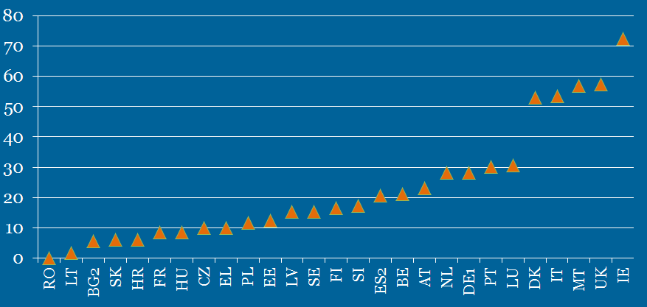
Source: EU-SILC and GSOEP for DE. Income data 2011-2013; thresholds in 2014. Low values for Romania and Lithuania are due to wage threshold set at high levels in those countries (i.e. higher than the 1.5 factor applied by most Member States).

Chart 3: Share of full-time employees with tertiary education whose salary is above the Blue Card salary threshold (in comparison with all full-time employed)
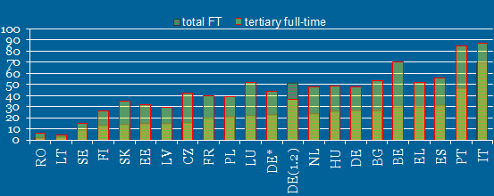
Source: EU-SILC and GSOEP for DE. DE (1.2) refers to the lower threshold (1.2 times the average salary). Low values for Romania and Lithuania are due to wage threshold set at high levels in those countries (i.e. higher than the 1.5 factor applied by most Member States).
Nevertheless, the comparison makes more sense when applied only to those having tertiary education as it is basically the target group of the EU Blue Card Directive. Indeed, Chart 3 demonstrates that in most Member States, 30-50% of full-time workers with tertiary education level earn at least the level of salary threshold (the un-weighted average across EU countries covered is around 35%). In other terms, unsurprisingly, when focusing on tertiary educated employees, the Blue Card looks less restrictive than for the full population of employees (while continuing to be more restrictive that most of the comparable national schemes – see below point 3.2.4).
Moreover, chart 4 confirms that most workers with less than tertiary education do not meet the Blue Card salary requirements. The current threshold largely excludes persons with primary education level as well as secondary-level education, though for the latter, this is not true in all Member States.

Chart 4: Share of full-time employees whose salary is above the salary threshold, by level of education
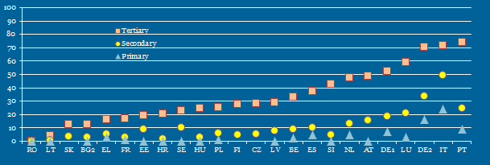
Source: EU-SILC and GSOEP for DE. DE² refers to the lower threshold (1.2 times the average salary).
However, the share of tertiary educated workers earning more than the salary threshold (or in other terms the level of inclusiveness of the Blue Card) varies largely across Member States (visible in both charts 3 and 4). This variation is driven by two main factors: (a) the wage distribution in the respective Member States (b) the level at which Member States set their salary thresholds.
Chart 5 below shows in more detail how the wage distribution (for full-time workers with tertiary education) compares to the actual salary threshold (as well as to the mean and median wage). Several situations emerge across Member States:
- In a few Member States (group 1), most tertiary educated workers would qualify, i.e. they currently earn more than the Blue Card threshold. Two of these Member States are precisely those currently granting the highest number of Blue Cards (DE in absolute levels and LU in proportion of its size) while it is not the case for IT and PT. It shows that, in any case, there is not a simple correlation between the level of the threshold and the number of Blue Cards granted.
- In another set of countries (group 2) , the threshold falls close to the middle of wage distribution of tertiary-educated full-time employed, so the threshold has a more exclusive effect than for group 1;
- In most other Member States (groups 3, 4 and 5), the Blue Card threshold is rather high compared to the wage distribution of tertiary-educated full-time employed meaning that it is a rather exclusive scheme.
- In group 4, this reflects notably the compressed wage distribution (found for instance in Nordic countries) which makes the threshold more restrictive (relatively few workers earning more than 1.5 times the average wage, even when tertiary educated).
- By contrast, the extreme situation in group 5 is rather driven by the fact that those Member States (Romania and Lithuania) set the threshold at very high levels (i.e. higher than the 1.5 factor applied by most Member States).
In conclusion, the fact that the distribution of salaries looks very different from one EU country to another impacts strongly on the inclusiveness of the Blue Card scheme across Member States. This has several implications:
- While the definition of a common minimum denominator for the salary threshold was seen as necessary to ensure a minimum level of harmonisation in the admission conditions throughout the EU, in practice it does not have a strong harmonising effect as wage distributions vary largely across countries;
- In countries where incomes are concentrated (close mean and median), small shifts in the threshold would translate into big changes in eligibility while in countries with long flat tails, shifting the threshold would make less difference.

Chart 5: Wage distribution (for full-time workers with tertiary education) compared to the salary threshold and to mean and median wage, for selected Member States
Key: Green=1.5*mean, Red=1.5*median, Blue=BC Salary threshold
Group 1
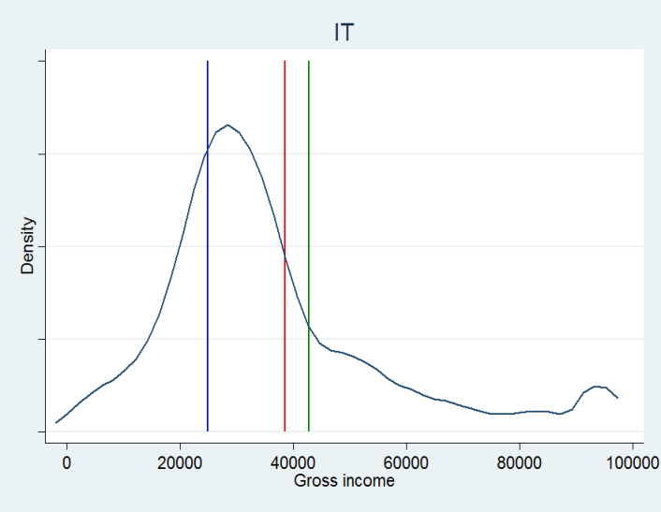 | 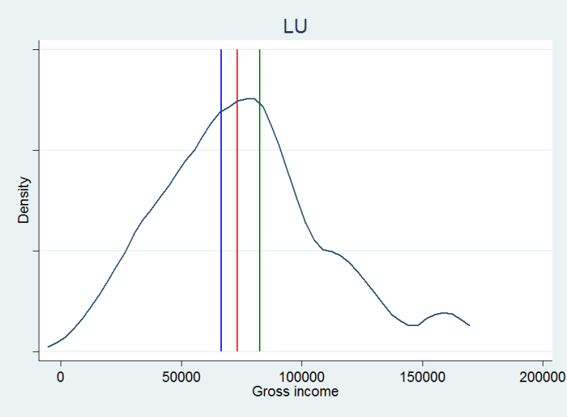
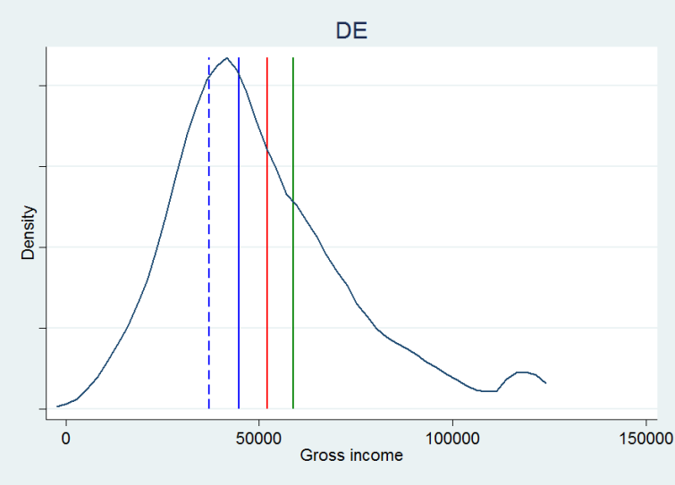 | 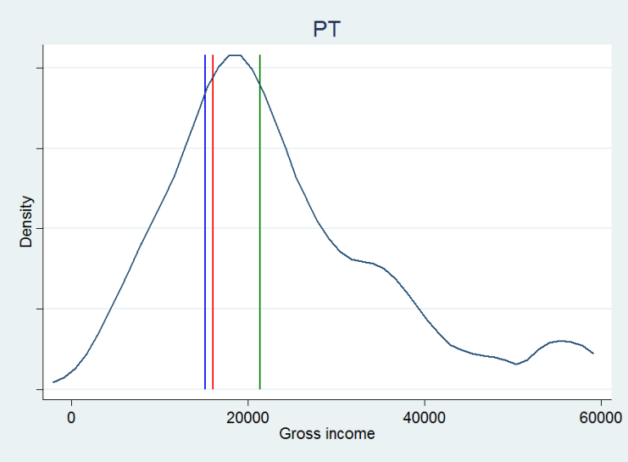

Group 2
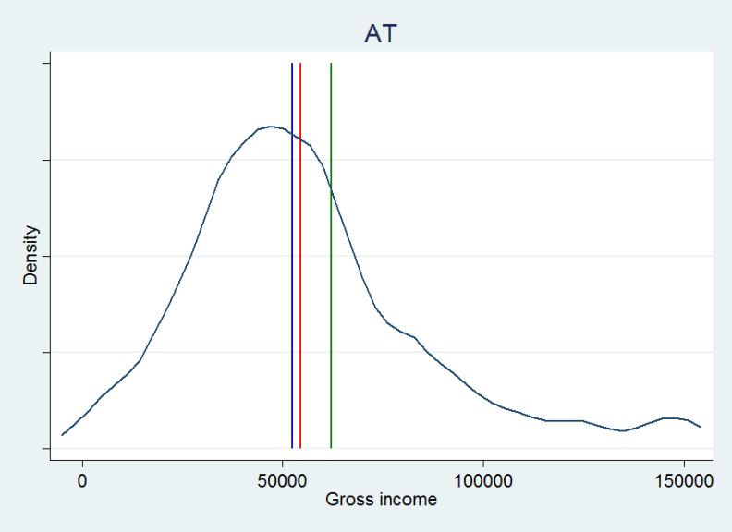 | 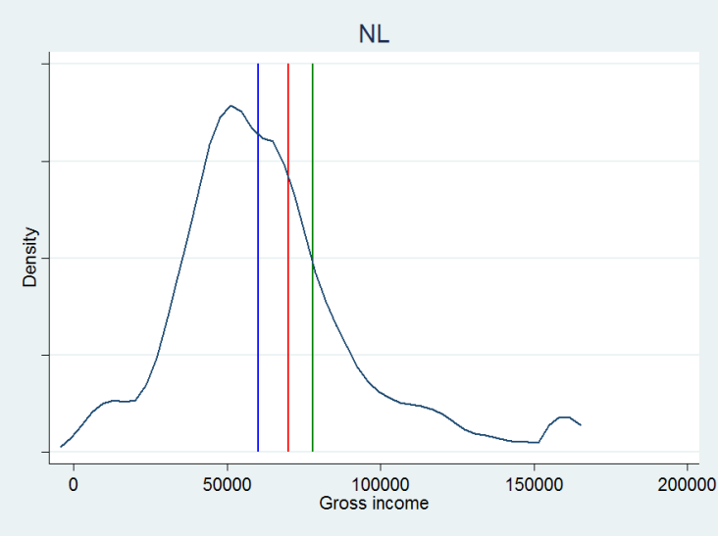
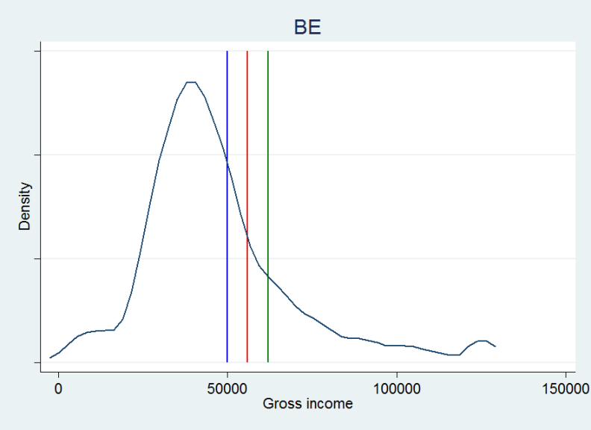 | 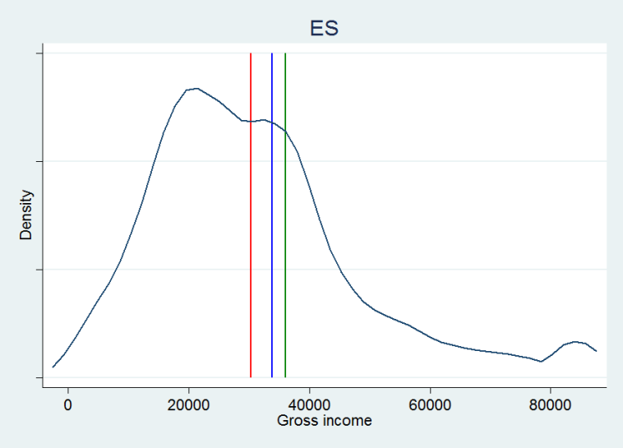
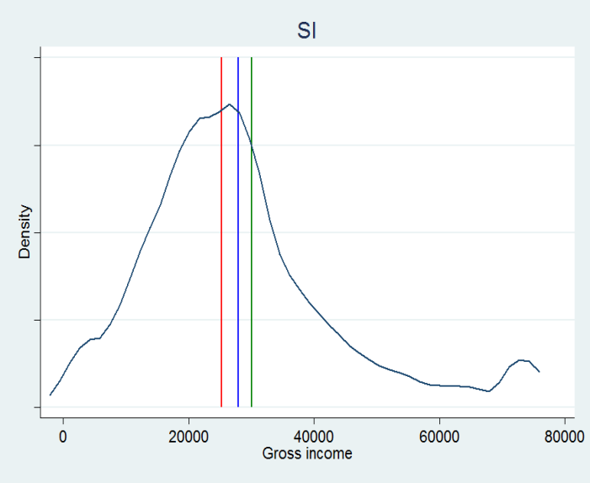

Group 3
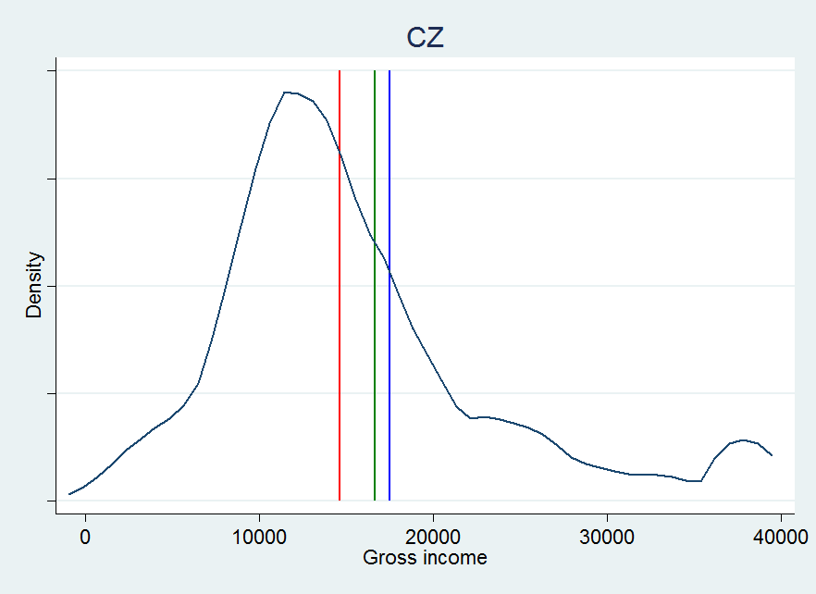 | 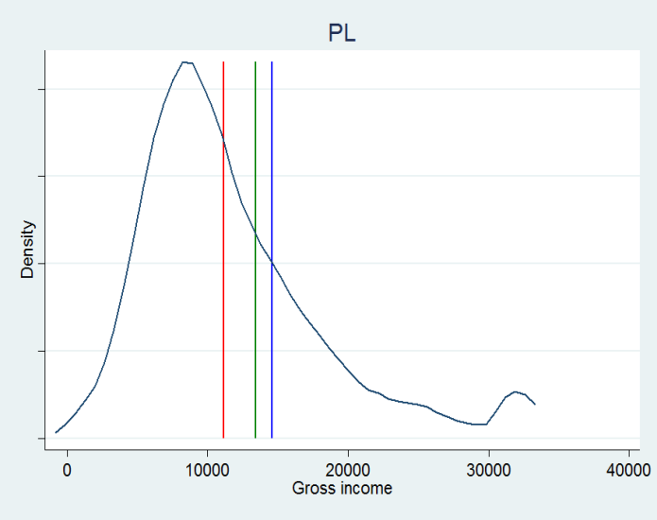
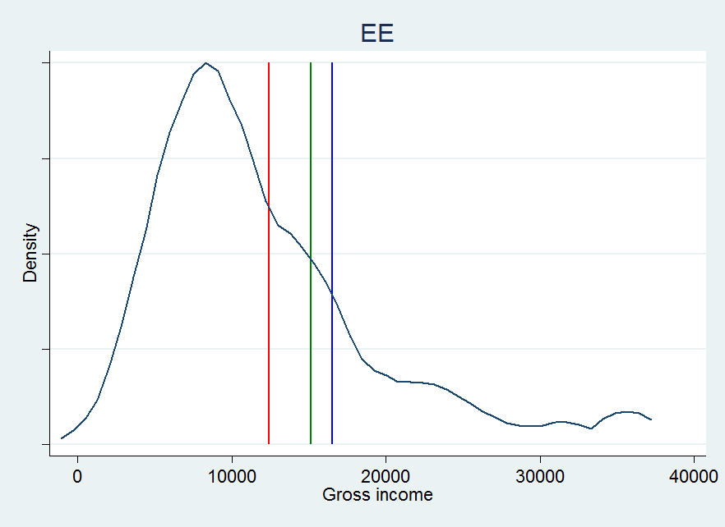 | 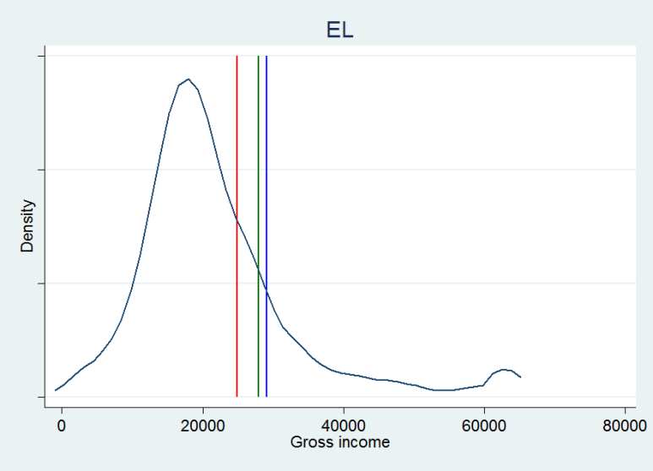

Group 4
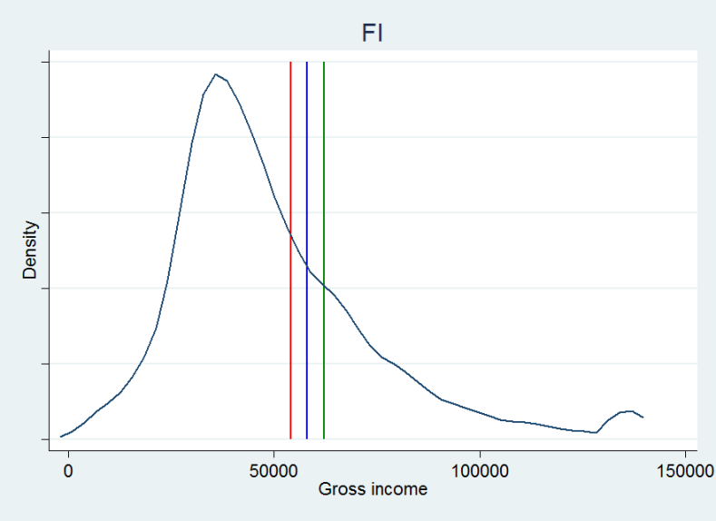 | 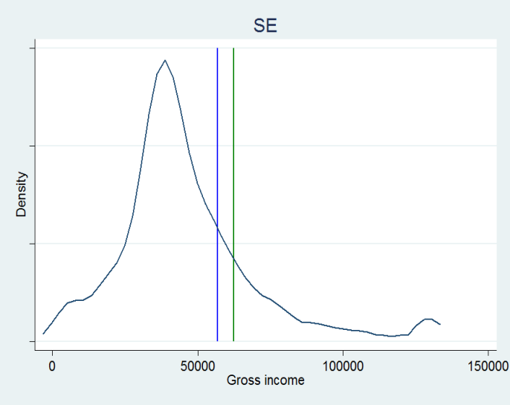
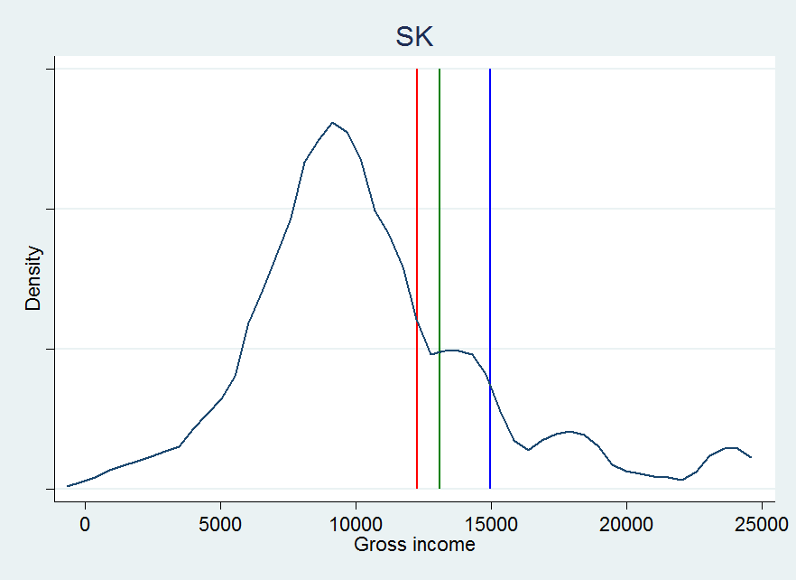 | 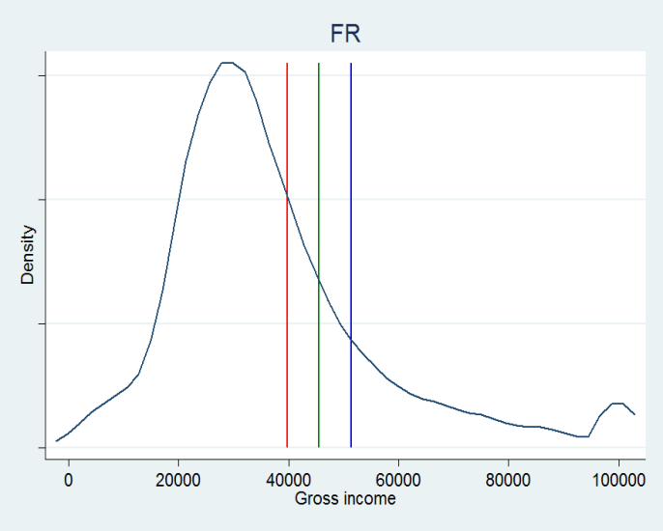

Group 5
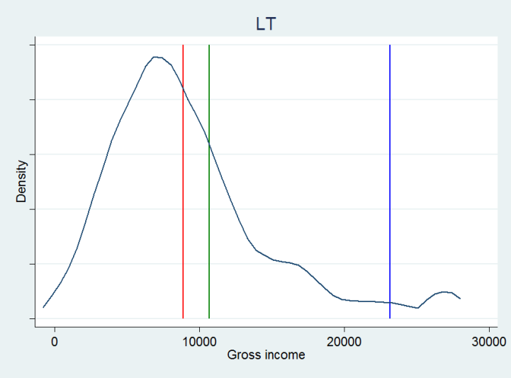 | 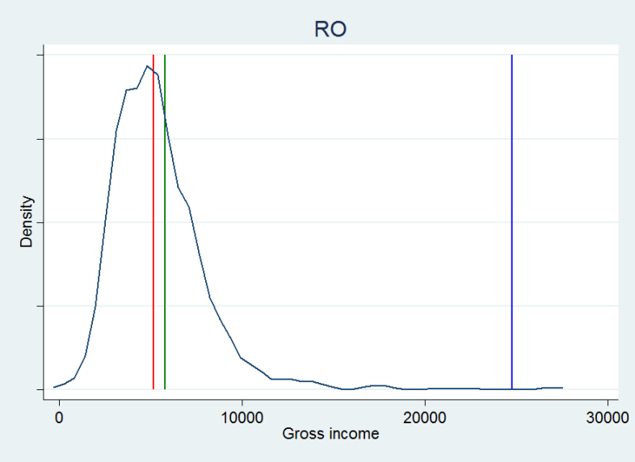

Source: EU-SILC and GSOEP for DE

4.2.2. Impact of salary threshold for attracting young talents
Another question regarding the salary thresholds relates to their impact on inclusiveness for the group of recent graduates. Recent (tertiary) graduates have a lower level of earnings at entry in the labour market than the average tertiary-educated worker. Chart 6 below shows that in most Member States, only 20% or less of tertiary educated (full-time workers) aged 25-30 earn more than the salary threshold – and less than 10% in half of the Member States. This is indeed much below the share among all full-time tertiary educated workers. It points to the fact that the provisions of the current Blue Card Directive may not allow EU Member States to attract many young talents from third-countries.
Chart 6: Share of tertiary educated full-time workers whose salary is above the salary threshold (distinction between all versus only those aged 25-30)
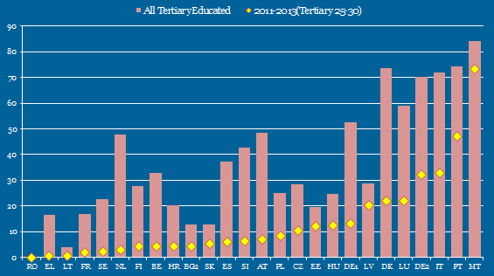
Source: EU-SILC and GSOEP for DE. OECD presentation at the Expert Group on Economic Migration.

4.2.3. Impact of lower salary threshold for shortage occupations
While the analysis above refers to how the earnings of tertiary educated workers in the Member States relate to the official thresholds set by the Member States (i.e. in most of the cases around 1.5 times the average gross annual salary in the Member State concerned) it does not take into account, that some Member States chose to derogate from the main scheme in terms of the salary threshold and to apply a lower threshold of 1.2 times the average gross annual salary for shortage occupations.
Chart 7 illustrates - for selected Member States that did choose to apply the lower threshold level for shortage occupation – that the lower threshold does make a difference as, unsurprisingly, a larger proportion of tertiary educated would qualify, i.e. earn a higher level than the 1.2 threshold compared to what they would earn with the standard factor (1.5).
The lower threshold makes a big difference in eligibility for DE (which indeed issues around half of Blue Card permits under this lower threshold scheme), EE and LU. On the contrary, this is not the case for Spain, because Spain has set salary threshold at sector-level (only Member State to have implemented the Blue Card in this way).
Chart 7: Share of tertiary educated full-time workers whose salary is above the salary threshold (distinction between standard 1.5 factor and the 1.2 optional factor for shortage occupations)
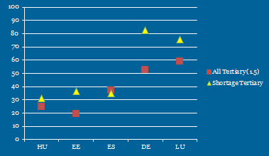
Source: EU-SILC and GSOEP for DE. OECD presentation at the Expert Group on Economic Migration

4.2.4. Level of Blue Card salary threshold in relation to other national schemes
As the limited number of Blue Cards issued over the last few years is partly related to the co-existence of national schemes, it is also important to analyse the level of the salary thresholds applied in the national schemes in comparison with the Blue Card.
Chart 8 below clearly shows (at least for selected Member States that do have national schemes with salary thresholds), that the salary thresholds in the national schemes are lower than for the Blue Card.
While the national schemes may differ from the Blue Card in terms of scope (more or less focussed on highly skilled) and in terms of criteria (some countries take into account the age of the applicant), it can be concluded from this broad comparison that the national schemes are less 'exclusive' than the Blue Card.
Chart 8: Required salary as a percentage of the average annual gross income of full-time employed, 2014, Blue Card vs. other salary-based permits (in selected Member States)
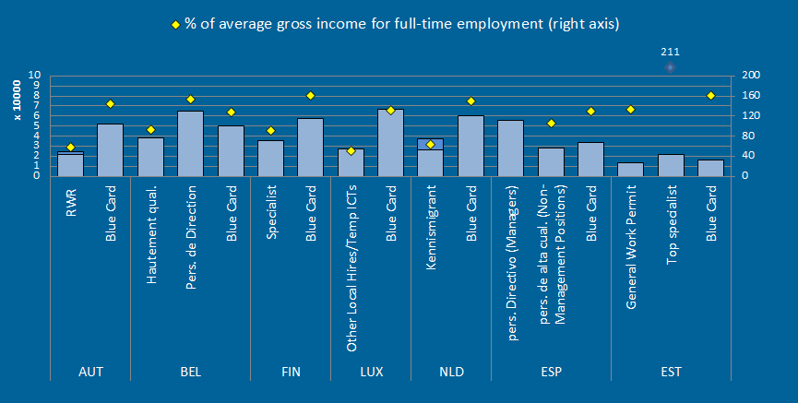

Source: OECD analysis based on OECD average gross income, March 2014 exchange rates. Note: NLD and AUT apply thresholds according to age. OECD presentation at the Expert Group on Economic Migration

4.3. Potential impact of modifying the salary threshold in a revised Blue Card Directive
Beyond the analysis of the in/exclusiveness of the current Blue Card Directive presented above, this section presents information on the impact of modifying the salary thresholds. It is to be noted that the potential impacts of modifying the admission conditions in particular the minimum salary threshold, are analysed in detail, as far as data availability allows, in Annex XIV.
On the basis of EU-SILC data, one can assess what would be impact of setting the factor of the salary threshold at different levels between 1 and 2 times the average gross salary. Chart 9 shows that, at EU level on average:
- only around 14% of tertiary educated earn more than twice the average wage,
- this proportion goes up to 29% when the factor is brought down to 1.5 (current threshold in the Blue Card Directive)
- and to 47% if the factor would be set at 1.2 level (current optional level for shortage occupations but used only in a few Member States).
In other terms, one could make the Blue Card Directive even more exclusive than currently by setting the factor of the salary threshold at two times the gross annual salary. In that case, only slightly more than 10% of highly educated workers across most EU countries (EU average of 14% and a range from 7% in Sweden to 27% in Portugal) would be eligible to a Blue Card (from the point of view of the salary threshold at least).
On the contrary, setting the factor of the salary threshold at 1.2 times the gross annual salary would make the Blue Card much more inclusive as around 40% in many Member States (EU-average of 47%, ranging from 32% in Sweden to 66% in Portugal) would met the salary requirements.
Chart 10 and 11 detail the differences it could make (in terms of change in the share of tertiary educated meeting the salary requirements expressed in percentage points) to modify the factor of the salary threshold either from 1.5 to 1.2 / 1.0 (less exclusive) or from 1.5 to 1.7 / 2.0 (more exclusive).
For instance, the potential gain at EU level in terms of share of tertiary educated meeting the salary requirements when modifying the factor for the salary threshold from 1.5 to 1.2 is around 18 pps (percentage points), from 29% to 47% (as visible in chart 9) and can be found in chart 10 (blue bar for EU-23). This value ranges from 12 pps in EE to 25 pps in HR. Bringing the factor of the salary threshold down to 1.0 would enlarge potential population of highly educated workers by 34 pps at EU level (from 29% to 63%, see table below). This 'gain' would range from 24 pps in EE to 37 pps in HR.
On the contrary, if one would want to make the EU Blue Card more exclusive (targeted at most talented migrant workers having very high levels of salaries), chart 11 shows that modifying the factor for the salary threshold from 1.5 to 1.7 would lead to have a decline in share of the tertiary educated meeting the salary requirements by 8.5 pps from 29% to 20.5% (ranging from 5 pps in EL to 15 pps in HR). Making it even more exclusive by bringing the factor for the salary threshold from 1.5 to 2.0 would lead to excluding around from 10-20 pps of the share of 'eligible' population of tertiary educated workers - that would reach rather low levels in most Member States, as already visible in chart 9.
Chart 9: Simulation exercise: share of tertiary educated full-time workers earning more than the salary threshold as set at different levels (factor 1.2, 1.5 and 2.0)
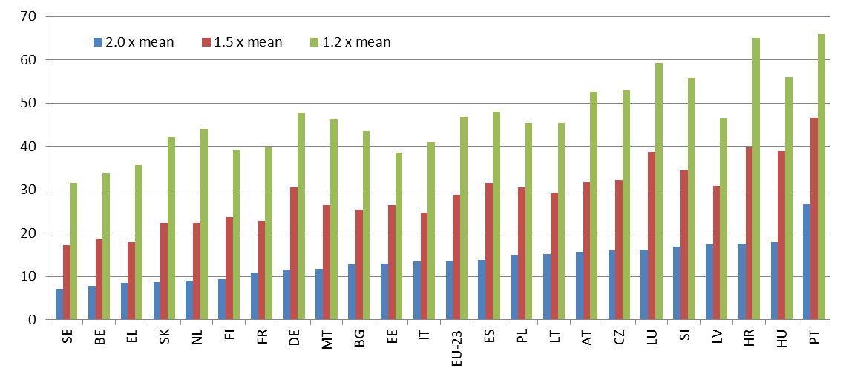
Source: EU-SILC and GSOEP for DE. EU-23 is the unweight average of the 23 EU Member States for which data was available and reliable.
Chart 10: Simulation exercise: "Making the Blue Card less exclusive": increase (in percentage points) in the share of tertiary educated potentially eligible to a Blue Card if the salary threshold was changed from 1.5 to 1.2/1.0

Source: EU-SILC and GSOEP for DE. EU-23 is the unweight average of the 23 EU Member States for which data was available and reliable.

Chart 11: Simulation exercise: "Making the Blue Card more exclusive": decrease (in percentage points) in the share of tertiary educated potentially eligible to a Blue Card if the salary threshold was changed from 1.5 to 1.7/2.0
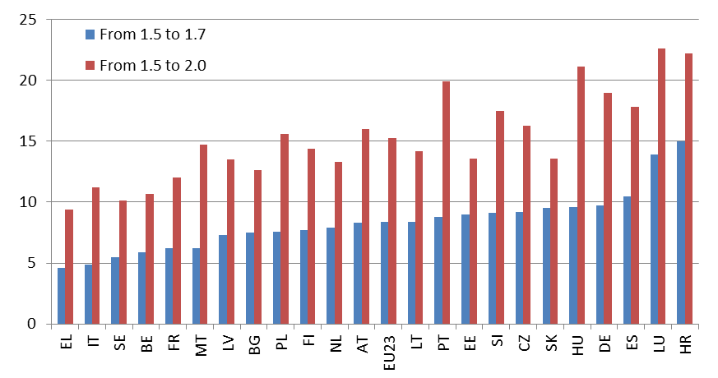
Source: EU-SILC and GSOEP for DE. EU-23 is the unweight average of the 23 EU Member States for which data was available and reliable.

Table 1: Full simulation results: Share of the population of full-time employees with tertiary education earning above the threshold, according to different factors levels
Source: EU-SILC and GSOEP for DE. EU-23 is the unweight average of the 23 EU Member States for which data was available and reliable.

4.4. ISCO-08 categories for applying the lower salary threshold in the current Blue Card Directive and in a revised Blue Card Directive
The International Standard Classification of Occupations (ISCO) is one of the main international classifications for which the International Labour Organization (ILO) is responsible. ISCO is a tool for organizing jobs into a clearly defined set of groups according to the tasks and duties undertaken in the job. The basic criteria used to define the system are the skill level and specialization required to competently perform the tasks and duties of the occupations.
The ISCO-08 divides jobs into 10 major groups. Each of the ten major groups is made up of two or more sub-major groups, which in turn are made up of one or more minor groups. Each of the 130 minor groups is made up of one or more unit groups. Each major group is denoted by a 1-digit code. Each sub-major group is denoted by a 2-digit code, comprising the major group code plus one digit. In the same way, minor groups are denoted by 3- digit codes and unit groups by 4-digit codes. The list below gives an overview at 2-digit or sub-major group level.
Three main skill levels of jobs can be distinguished. While there is no fixed rule, Major Groups 1, 2 and 3 are often regarded as high skilled professions, Major Groups 4, 6 and 7 as medium skilled, and Major Groups 5, 8 and 9 as low skilled. Sometimes Major Group 5 is considered as medium skilled. In other classifications, sometimes Major Groups 1, 2 and 3 are considered as high-skilled non-manual, Major Groups 4 and 5 as low-skilled non-manual, Major Groups 6, 7 and 8 as skilled manual and Major Group 9 as elementary occupations.
The current Blue Card Directive allows for a derogation from the general salary threshold (at least 1,5 times the average gross annual salary), by applying a lower threshold at 80% of the general threshold (at least 1,2 times the average gross annual salary) for employment in specific professions where it is considered by the Member State concerned that there is a particular lack of available workforce and which belong to the Major Groups 1 and 2 of ISCO (recital 10 and Article 5(5)). There is no such restriction to Major Groups of ISCO for the general threshold.
MAJOR GROUP 1 – MANAGERS
• 11 Chief executives, senior officials and legislators
• 12 Administrative and commercial managers
• 13 Production and specialized services managers
• 14 Hospitality, retail and other services managers

MAJOR GROUP 2 – PROFESSIONALS
• 21 Science and engineering professionals
• 22 Health professionals
• 23 Teaching professionals
• 24 Business and administration professionals
• 25 Information and communications technology professionals
• 26 Legal, social and cultural professionals

MAJOR GROUP 3 - TECHNICIANS AND ASSOCIATE PROFESSIONALS
- 31 Science and engineering associate professionals
- 32 Health associate professionals
- 33 Business and administration associate professionals
- 34 Legal, social, cultural and related associate professionals
- 35 Information and communications technicians

MAJOR GROUP 4 - CLERICAL SUPPORT WORKERS
- 41 General and keyboard clerks
- 42 Customer services clerks
- 43 Numerical and material recording clerks
- 44 Other clerical support workers

MAJOR GROUP 5 - SERVICE AND SALES WORKERS
- 51 Personal service workers
- 52 Sales workers
- 53 Personal care workers
- 54 Protective services workers

MAJOR GROUP 6 - SKILLED AGRICULTURAL, FORESTRY AND FISHERY WORKERS
- 61 Market-oriented skilled agricultural workers
- 62 Market-oriented skilled forestry, fishery and hunting workers
- 63 Subsistence farmers, fishers, hunters and gatherers

MAJOR GROUP 7 - CRAFT AND RELATED TRADES WORKERS
- 71 Building and related trades workers, excluding electricians
- 72 Metal, machinery and related trades workers
- 73 Handicraft and printing workers
- 74 Electrical and electronic trades workers
- 75 Food processing, wood working, garment and other craft and related trades workers

MAJOR GROUP 8 - PLANT AND MACHINE OPERATORS AND ASSEMBLERS
- 81 Stationary plant and machine operators
- 82 Assemblers
- 83 Drivers and mobile plant operators

MAJOR GROUP 9 - ELEMENTARY OCCUPATIONS
- 91 Cleaners and helpers
- 92 Agricultural, forestry and fishery labourers
- 93 Labourers in mining, construction, manufacturing and transport
- 94 Food preparation assistants
- 95 Street and related sales and service workers
- 96 Refuse workers and other elementary workers

MAJOR GROUP 0 - ARMED FORCES OCCUPATIONS
- 01 Commissioned armed forces officers
- 02 Non-commissioned armed forces officers
- 03 Armed forces occupations, other ranks

- The "Labour market test" or "Economic Needs Test"
The current EU Blue Card Directive allows for the imposition of a so-called labour market test (LMT). The Directive does not specify what form such a test should take, if it is implemented. Table 2 shows Member States do not apply LMTs to all labour migration channels. Refusal rates on LMTs appear to be low for the admission of highly-qualified workers.
Labour Market Tests applying to national schemes and EU Blue Cards
Country | EU Blue Card | National Scheme for highly qualified | General National Scheme
Austria | LMT (most cases) | LMT (some cases) | LMT
Belgium | Allowed, but not applied | No LMT | n.a.
Bulgaria | LMT (except for shortage occupations from 2016) | n.a. | LMT
Czech Republic | LMT | n.a. | LMT
Germany | No LMT | No LMT | LMT
Greece | LMT | n.a. | LMT
Hungary | LMT | n.a. | LMT
Finland | No LMT | No LMT | LMT
France | No LMT | LMT | n.a.
Estonia | LMT | LMT (some exceptions) | LMT
Italy | LMT, except for pre-approved employers | LMT, except for pre-approved employers | LMT
Latvia | LMT | n.a. | LMT
Lithuania | No LMT, unless salary is <3x average | LMT | n.a.
Luxembourg | No LMT | n.a. | LMT
Netherlands | No LMT | No LMT | LMT
Poland | LMT | n.a. | LMT
Romania | No LMT | n.a. | LMT
Sweden | LMT | n.a. | LMT
Slovenia | LMT | n.a. | LMT
Slovak Republic | LMT | n.a. | LMT
Spain | LMT | No LMT | n.a.
Source: Jonathan Chaloff / OECD, The Impact of EU Directives on the Labour Migration Framework in EU Countries, forthcoming.

http://ec.europa.eu/eurostat/web/population-demography-migration-projections/population-projections-/database
Peschner, J. and Fotakis, C. (2013), Growth potential of EU human resources and policy implications for future economic growth, European Commission, DG EMPL, Working Paper 3/2013
European Commission, ESDE 2015, Chapter " Mobility and Migration in the EU: Opportunities and Challenges".
While Eurostat population projections do not contain the breakdown for those being economically active (or in employment), the share of those aged 45+ can be measured in proportion of the overall working-age population (15-64).
Due to the limited reliability of emigration and immigration statistics in many EU Member States, it is preferable to calculate net migration as the difference between population change and natural change between two dates. It is called "net migration (including statistical adjustment)" as it includes other changes which cannot be attributed to births, deaths, immigration or emigration between that time period.
Similarly, in a joint OECD-DIHK survey of German employers in 2011, about half of firms reported staff shortages in medium skilled occupations, compared with less than 20% for low-skilled workers and 42% for the highly-skilled. A breakdown according to company size shows that 55% of small companies reported shortages at the intermediate level while 70% of large companies were looking for highly skilled workers.
Empirica, "E-skills and e-leadership skills 2020", Working Paper, May 2015.
Commission estimates, "Action Plan for the EU health workforce", Commission Staff Working Paper (SWD (2012)93 final).
Cedefop (2014b), “Projected Labour Market Imbalances in Europe: Policy Challenges in Meeting the Europe 2020 Employment Targets”, in OECD-EC (2014), Matching Economic Migration with Labour Market Needs, OECD Publishing, Paris, http://dx.doi.org/10.1787/9789264216501-en.
European Commission (2012a), “The Skill Mismatch Challenge in Europe”, Employment and Social Developments in Europe 2012.
CEDEFOP (2013), Roads to recovery: three skill and labour market scenarios for 2025.
With the exception of elementary jobs which will see their share slightly increase but representing only around 11% of all jobs.
Council Directive 2009/50/EC of 25 May 2009 on the conditions of entry and residence of third-country nationals for the purposes of highly qualified employment, OJ L 155, 18.6.2009, p. 17–29
Communication from the Commission to the European Parliament and the Council on the implementation of Directive 2009/50/EC on the conditions of entry and residence of third-country nationals for the purpose of highly qualified employment, COM(2014) 287 final, http://eur-lex.europa.eu/legal-content/EN/TXT/PDF/?uri=CELEX:52014DC0287&from=EN
The UK, Ireland and Denmark are not bound by the Blue Card Directive due to their opting out in accordance with the relevant protocols annexed to the Treaties.
DE, EE, EL, ES, FR, LT, LU, MT, PL, PT, SE and SK.
Council Directive 2003/86/EC of 22 September 2003 on the right to family reunification, Chapter V; OJ L 251, 3.10.2003, p. 12–18
Council Directive 2003/109/EC of 25 November 2003 concerning the status of third-country nationals who are long-term residents, OJ L 16, 23.1.2004, p. 44–53
This refers to the factor (now at least 1.5) used to reach the threshold salary for highly qualified taking the benchmark figure (now the average salary) as a starting point.
This option has been transposed by 9 Member States: CY, DE, EE, EL, ES, HU, LU, MT and PT, but not all of them have actually set such a lower threshold.
Applied by 17 Member States in one form or another, except DE, ES, FI, FR, LV, NL, PT, and SE.
Foreseen in the national law of 7 Member States: CY, EE, EL, HU, MT, RO and SI.
Option taken up by BE, CY, DE, EL, LU and MT.
See Chapter 2 in Annex 6 for comparison between the national schemes and the EU Blue Card and Chart 6 in Annex 7 for the exclusion effect for young professionals.
See Chapter 3 in Annex 7 on ISCED levels.
Regulated professions are different across Member States and many of them can be classified as highly skilled, but arguably not all of them. See an EU database on regulated professions per Member State: http://ec.europa.eu/growth/tools-databases/regprof/index.cfm?action=regprofs
In the Public Consultation carried out to support (e.g.) the Blue Card review in 2015, problems related to qualifications were subject to a specific Chapter (5). See Annex 2 for details.
In the Public Consultation, when asked about the most important aspects for the attractiveness of the EU Blue Card, the most reoccurring first priority was a fast-track entry procedure; a clear, streamlined and uniform scheme was the second most important aspect. See Question 25 in Annex 2.
See Table 1 in Annex 6.
AT, BG, EE, ES, LT, LV, PL, PT, RO, SI, SK.
EMN Ad Hoc Query 465/2013.
One year in BG, CY, ES, LT, MT, and PT; 13 months in BE; two years in AT, CZ, EL, FI, IT, LU, PL, RO, SE and SI; two years and three months in EE; three years in FR and SK; four years in DE, HU and NL; and five years in LV.
Applied by CY, DE, EL, FI, LU, MT, SK.
Applied by CY, DE, EL, ES, FI, LU, MY, PL, RO, SK.
BE, DE, FI, LU, NL, PL, PT, SE.
According to the Common European Framework of Reference for Languages.
BAMF, 2015 Wanderungsmonitor.
Data directly obtained from the BAMF.
Counting back 33 months from December 2015 gives April 2013 which is still fairly early in the existence of the Blue Card in Germany, counting back 21 months gives April 2014. Soon those who arrived later in 2013 and 2014 will become eligible for permanent residence.
See results public consultation in Annex 2.
Hanganu, E. and Heß, B., ‘Die Blaue Karte EU in Deutschland: Kontext und Ergebnisse der BAMF-Befragung’, Forschungsbericht 27, Bundesamt für Migration und Flüchtlinge, Nürnberg, 2016, forthcoming. For this survey about 18 000 EU Blue Card holders in Germany were contacted and a total of 4 340 (approximately 27 %) responded.
BG, CZ, EL, LU, LV, NL, RO.
See Annex 12.
In 2013 these included AT, BE, CZ, DE, EE, FR, EL, LT, IT, LU, NL, SV, ES, SE; Attracting Highly Qualified and Qualified Third-Country Nationals, EMN Focussed Study 2013, p. 19.
Directive 2014/66/EU of the European Parliament and of the Council of 15 May 2014 on the conditions of entry and residence of third-country nationals in the framework of an intra-corporate transfer, OJ L 157, 27.5.2014, p. 1–22
Directive 2014/66/EU of the European Parliament and of the Council of 15 May 2014 on the conditions of entry and residence of third-country nationals in the framework of an intra- corporate transfer, and proposal for a Directive on conditions of entry and residence of third-country nationals for the purposes of research, studies, pupil exchange, remunerated and unremunerated training, voluntary service and au pairing (Recast).
Hanganu, E. and Heß, B., ‘Die Blaue Karte EU in Deutschland: Kontext und Ergebnisse der BAMF-Befragung’, Forschungsbericht 27, Bundesamt für Migration und Flüchtlinge, Nürnberg, 2016, forthcoming. For this survey about 18 000 Blue Card holders were contacted and a total of 4 340 (approximately 27 %) responded.
Council Directive 2009/50/EC of 25 May 2009 on the conditions of entry and residence of third-country nationals for the purposes of highly qualified employment, OJ L 155, 18.6.2009, p. 17–29,
EMN Study, Synthesis Report - Attracting Highly Qualified and Qualified Third Country Nationals, European Migration Network, 2013.
Belgium, Estonia, Finland, France, Germany, Greece, Ireland, Italy, Latvia, Lithuania, Luxembourg, Netherlands, Slovak Republic, Spain, Sweden, and United Kingdom; EMN Study, Synthesis Report - Attracting Highly Qualified and Qualified Third Country Nationals, European Migration Network, 2013, p. 18.
Very highly qualified workers, skilled workers in shortage occupations and other key workers.
International Standard Classification of Occupations by the International Labour Organisation; levels 1-3 (managers, professionals, associate professionals) are the ones generally associated with highly-qualified work
International Standard Classification of Education by UNESCO; levels 5, 6 and 7 (post-secondary education, first and second stages of tertiary education) are those most often sufficient for highly-qualified persons
For a more extensive analysis and comparison of salary thresholds, see Annex 7.
No extensive data has been collected on the issue, but e.g. in FI, NL, and SE, there is no minimum length required, although there may be general rules that residence permits are not issued for a very short stay. In CZ and IT the minimum length of residence permit is three months and in FR permits can be issued from a period of a few months upwards.
See Annex 1, section 2 for detailed statistics on the length for validity of national first permits.
See Table 2.
This option has been taken up by AT, BE (although national authorities report that in practice, labour market tests are not carried out despite the legal possibility), and ES.
In 2013, it included the following countries: AT, CZ, DE, EE, EL, ES, FR, IT, LT, LU, NL, SE, SI, SK; EMN Study, Synthesis Report - Attracting Highly Qualified and Qualified Third Country Nationals, European Migration Network, 2013, p. 19.
According to data provided by EMN national contact points, in Finland, the estimated average processing time in 2014 was 19 days, in Sweden 91 days (however this is for all workers of all skills levels) and in Slovenia 30 days; in the Netherlands the target is two weeks and in Spain the application has to be decided within 20 days to avoid tacit rejection due to administrative silence.
See Annex 1, section 2 for detailed statistics on the length for validity of national first permits.
See Table 2.
For a more extensive overview and details, see: EMN Study, Synthesis Report - Attracting Highly Qualified and Qualified Third Country Nationals, European Migration Network, 2013, p. 18-20.
Business trips in other Member States, e.g. participation in internal meetings in other offices, in public business conferences and seminars, trade exhibitions or fairs, giving or receiving training, visiting client sites, negotiating business deals, sales and marketing activities in other Member States, internal or external audit missions, maintenance work, etc.,
E.g. longer assignments or postings, e.g. in other offices of the same employer, at clients’ sites, etc.; or regular trips to one or multiple other Member States, e.g. regional managers, regional sales representatives, regional HR officers, etc.
E.g. transfer of longer duration to another office of the same group (e.g. to HQ at the occasion of a promotion), a long term assignment to a client; or change of job to an employer in another Member States, e.g. a career move to a competitor which offers better conditions or another sector in need for certain specific skills (e.g. transversal skills such as ICT or HR).
The European Migration network (EMN) is an EU-funded network (established by Council Decision 2008/381/EC adopted on 14th May 2008) with the aim of providing up-to-date, objective, reliable and comparable information on migration and asylum topics to policy makers (at EU and Member State level) and the general public. The Commission services coordinate the EMN in cooperation with National Contact Points (EMN NCPs) appointed by EU countries plus Norway. In their own countries, the EMN NCPs form national networks with a wide-range of relevant stakeholders. The EMN does not normally engage in primary research; instead, its key strength is to collect, document and make available, in an accessible and comparative manner, data and information held or collected at national and EU level. The network further analyses and synthesizes this information to improve its comparability and harmonization at EU level. In this way, the EMN makes a valuable contribution to evidence-based policymaking.
EMN Study, Synthesis Report - Attracting Highly Qualified and Qualified Third Country Nationals, European Migration Network, 2013, p. 13; The table in Annex 3 of the study provides a full overview of the national concepts existing in the Member States in 2013.
EMN Study, Ibid., p. 14.
EMN Study, Ibid., p. 24.
Other Member States may also apply some of these practices but did not notify this in their national report.
EMN Study, Ibid., pp. 25-27.
According to Austrian statistics, numbers of issued RWR Cards have grown from 600 permits in 2011 to 1 640 permits in 2014 (the latter may also contain renewals, as numbers are higher than Eurostat figures in Table 1). Bundesministerium für Inneres, Establishment and Residence Statistics (Niederlassung und Aufenhalt).
Information received from Austrian Ministry of Labour, Social Affairs and Consumer Protection.
Information received from French Ministry of the Interior.
According to information from the Dutch Immigration Service, there was an increase of 30 % from 2013 to 2014 (from 5 800 to 8 540 permits). These figures, however, do not correspond to Eurostat data in Table 1, which may be explained by different statistical methods and definitions (are status changers included or not etc.)
Information from exchanges between the Commission and MS via EMN; Information provided by IND and Eurostat [migr_resocc].
Consultations with the Immigration Service, the Ministry for Social Affairs and Employment, and the Ministry for Security and Justice.
Belgium, Czech Republic, Germany, Estonia, France, Greece, Hungary, Italy, Lithuania, Luxembourg, Netherlands, Poland, Slovak Republic, Slovenia and Sweden.
EMN Study, Ibid., p. 28.
EMN Study, Synthesis Report - Attracting Highly Qualified and Qualified Third Country Nationals, European Migration Network, 2013, p. 14..
The introduction of the possibility of temporary unemployment can be considered as a real added value of the EU Blue Card since this did not exist in many Member States prior to the transposition of the Directive into national law. This flexibility allows (highly) qualified third-country nationals to stay in the EU territory in order to look for another employment if their work contract is terminated, which helps to enhance the attractiveness of the EU for such workers.
In Austria, the advantage of an EU Blue Card compared to the national Red-White-Red card is limited. Slight advantages only arise when it comes to intra-EU mobility. In the Netherlands, the national Highly Skilled Migrants Scheme has a lower threshold than the EU Blue Card because it does not include an educational requirement and has a lower salary criterion.
UK visas and immigration, Tier 2 and 5 of the Points Based System – Guidance for sponsors, version 11/15, p 26.
Workpermit.com, The Five Tier Points-Based Immigration System, Tier 2: Sponsorship Licence.
UK Visas and Immigration, Tier 2 of the Points Based System – Policy Guidance, 2015.
UK Visas and Immigration, Tier 2 of the Points Based System – Policy Guidance,2015
UK Home Office Science, ‘Determining labour shortages and the need for labour migration from third countries in the UK’, European Migration Network Focused Study, 2015.
OGL,‘Tier 2 (General) Visa, 2015.
UK Visas and Immigration , ‘Tier 2 of the Points Based System – Policy Guidance, 2015.
UK Government, Visas and Immigration, Tier 2 (General) visa.
UK Government, Visas and Immigration, Tier 2 (General) visa, Switch to this visa.
UK Home Office, , United Kingdom Annual Policy Report 2014. Prepared for the European Migration Network, 2015.
UK Home Office Science, ‘Determining labour shortages and the need for labour migration from third countries in the UK’, European Migration Network Focused Study, 2015.
Evershed, UK Immigration e-briefing: Migration: Tier 2 under review, 2015.
Salt, J. , International Migration and the UK - Annual Report of the UK SOPEMI Correspondent to the OECD, Migration Research Unit, University College London, 2014.(Available online at:
Office for National Statistics. Migration Statistics Quarterly Report, May 2015.
Office for National Statistics. Migration Statistics Quarterly Report, May 2015.
The information included in this table has been mainly gathered from Member States through the European Migration Network contact points. The main purpose is to compare schemes targeted to the highly qualified, but if a particular Member State has indicated a general scheme to be compared with the EU Blue Card, those schemes have been included as well. The fact that no scheme has been presented for a specific Member State means that according to the information available to the Commission, the country in question does not have a scheme in place specifically for highly qualified workers, apart from the EU Blue Card. They may still be admitted through a general scheme for labour migrants.
OECD (2014), “Recruiting immigrant workers: Austria 2014 Executive Summary”, http://www.keepeek.com/Digital-Asset-Management/oecd/social-issues-migration-health/recruiting-immigrant-workers-austria-2014/executive-summary-english-deutsch_9789264226050-3-en#page1 (accessed 1 December 2015).
Federal Government of Austria (2015), “Permanent immigration - Red-White-Red Card”, available at http://www.migration.gv.at/en/types-of-immigration/permanent-immigration-red-white-red-card.html (accessed 30 November 2015).
Ibid.
Federal Government of Austria (2015), “Shortage occupations list 2016”, available at http://www.migration.gv.at/en/types-of-immigration/permanent-immigration-red-white-red-card/skilled-workers-in-shortage-occupations/shortage-occupations-list-2016.html (accessed 21 December 2015).
Federal Government of Austria (2015), “Students and graduates”, available at http://www.migration.gv.at/en/types-of-immigration/permanent-immigration-red-white-red-card/students-and-graduates.html#c2973 (accessed 1 December 2015).
Federal Government of Austria (2015), “Self-employed key workers”, available at http://www.migration.gv.at/en/types-of-immigration/permanent-immigration-red-white-red-card/self-employed-key-workers.html (accessed 1 December 2015).
Public Employment Service (AMS, 2015), “Die Zulassung ausländischer Schlüsselkräfte“, available at http://www.ams.at/service-arbeitsuchende/auslaenderinnen/zugangsberechtigungen/zulassung-auslaendischer-schluesselkraefte (accessed 21 December 2015).
Public Employment Service (AMS, 2015), “Das "Jobseeker" Visum”, available at http://www.ams.at/service-arbeitsuchende/auslaenderinnen/zugangsberechtigungen/jobseeker-visum (accessed 21 December 2015).
Unless otherwise indicated, all information is from: http://www.migration.gv.at/en/types-of-immigration/permanent-immigration-red-white-red-card.html (accessed 1 December 2015).
Interview with the representative of the Federal Ministry of Interior on 3 December 2015.
European Commission (2003), “Directive concerning the status of third-country nationals who are long-term residents”, http://eur-lex.europa.eu/legal-content/EN/TXT/PDF/?uri=CELEX:32003L0109&from=EN (accessed 30 November 2015).
Federal Government of Austria (2015), “Red-White-Red Card plus”, available at http://www.migration.gv.at/en/types-of-immigration/permanent-immigration-red-white-red-card/red-white-red-card-plus.html (accessed 1 December 2015).
OECD (2014), “Recruiting immigrant workers: Austria 2014 Executive Summary”, available at http://www.keepeek.com/Digital-Asset-Management/oecd/social-issues-migration-health/recruiting-immigrant-workers-austria-2014/executive-summary-english-deutsch_9789264226050-3-en#page1 (accessed 1 December 2015).
Unless otherwise indicated, all data is from the Austrian Ministry of Interior statistical overview of settlement and residence permits as of November 2015 (latest available data): http://www.bmi.gv.at/cms/BMI_Niederlassung/statistiken/files/2015/Niederlassungs_und_Aufenthaltsstatistik_November_2015 (accessed 26 January 2016).
Only one of the 109 Blue Cards issued until 30 November 2015 has been issued for a Blue Card holder coming from another Member State. See Federal Ministry of Interior (2015), “Niederlassungs- und Aufenthaltsstatistik November 2015”, p. 27, http://www.bmi.gv.at/cms/BMI_Niederlassung/statistiken/files/2015/Niederlassungs_und_Aufenthaltsstatistik_November_2015.pdf (accessed 26 January 2016).
AMS (2016), “Arbeitsmarktdaten Online - labour market data - general overview”, available at http://iambweb.ams.or.at/ambweb/ (accessed 26 January 2016).
Statistics Austria (2015), „Zahl der Einbürgerungen im Jahr 2014 um 3,7% gestiegen“,available at http://www.statistik.at/web_de/statistiken/menschen_und_gesellschaft/bevoelkerung/einbuergerungen/080905.html (accessed 21 December 2015).
Federal Ministry of Interior (2015), “Niederlassungs- und Aufenthaltsstatistik November 2015”, available at http://www.bmi.gv.at/cms/BMI_Niederlassung/statistiken/files/2015/Niederlassungs_und_Aufenthaltsstatistik_November_2015.pdf (accessed 26 January 2016).
Statistics Austria (2014), “Arbeitsmarktsituation von Migrantinnen und Migranten in Österreich 2014“, available at http://www.statistik.at/web_de/services/publikationen/3/index.html?includePage=detailedView&sectionName=Arbeitsmarkt&pubId=717 (accessed 1 December 2015) Information on how many TCNs change employer, move countries and how many get permanent residence status was not possible to obtain.
Interview with representative from the Federal Ministry of Labour, Social Affairs and Consumer protection, 2 December 2015.
Interview with representative from the Federal Ministry of Interior, 3 December 2015.
Social partnership is a specific concept in Austria whereby several partners including the government, the association of employers and employees as well as the association of unions together make decisions regarding labour issues in the country.
Federal Ministry of Labour, Social Affairs and Consumer protection (2010), “Die Rot-Weiß-Rot-Karte – das neue Zuwanderungssystem. Bessere Qualifikation, höheres Wirtschaftswachstum, raschere Integration“, http://www.sozialministerium.at/cms/site/attachments/3/6/0/CH0016/CMS1291897740667/101209_rotweissrotcard_layoutiert.pdf (accessed 26 January 2016).
OECD (2014), “Recruiting immigrant workers: Austria 2014 Assessment and Recommendations”, available at http://www.keepeek.com/Digital-Asset-Management/oecd/social-issues-migration-health/recruiting-immigrant-workers-austria-2014/assessment-and-recommendations-english-deutsch_9789264226050-4-en#page1 (accessed 1 December 2015).
Federal Government of Austria (2015), “Permanent immigration - Red-White-Red Card”, available at http://www.migration.gv.at/en/types-of-immigration/permanent-immigration-red-white-red-card.html (accessed 1 December 2015).
Interview with representative from the Ministry of Labour, Social Affairs and Consumer protection, 2 December 2015.
Ibid.
Federal Government of Austria (2015), “EU Blue Card”, available at http://www.migration.gv.at/en/types-of-immigration/permanent-immigration-red-white-red-card/eu-blue-card.html (accessed 3 December 2015).
Public Employment Service (AMS, 2015), “Die Blue Card für Drittstaatsangehörige“, available at http://www.ams.at/service-arbeitsuchende/auslaenderinnen/zugangsberechtigungen/blue-card-drittstaatsangehoerige (accessed 21 December 2015).
Interview with representative from the Federal Ministry of Labour, Social Affairs and Consumer protection, 2 December 2015.
Federal Government of Austria (2015), “EU Blue Card”, available at http://www.migration.gv.at/en/types-of-immigration/permanent-immigration-red-white-red-card/eu-blue-card.html (accessed 3 December 2015).
Federal Government of Austria (2015), “Family reunification”, available at http://www.migration.gv.at/en/types-of-immigration/permanent-immigration-red-white-red-card/family-reunification.html (accessed 3 December 2015).
Interview with representative from the Federal Ministry of Interior, 3 December 2015.
Federal Ministry of Labour, Social Affairs and Consumer protection (2010), “Die Rot-Weiß-Rot-Karte – das neue Zuwanderungssystem. Bessere Qualifikation, höheres Wirtschaftswachstum, raschere Integration“, http://www.sozialministerium.at/cms/site/attachments/3/6/0/CH0016/CMS1291897740667/101209_rotweissrotcard_layoutiert.pdf (accessed 26 January 2016).
Interview with representative from the Federal Ministry of Labour, Social Affairs and Consumer protection, 2 December 2015.
Interview with representative from the Federal Ministry of Interior, 3 December 2015.
Ibid.
Ibid.
OECD (2014), “Recruiting immigrant workers: Austria 2014”, available at http://www.oecd-ilibrary.org/social-issues-migration-health/recruiting-immigrant-workers-austria-2014_9789264226050-en;jsessionid=2i12tvlnfh8jh.x-oecd-live-02 (accessed 1 December 2015).
Directive 2014/66/EU of the European Parliament and of the Council of 15 May 2014 on the conditions of entry and residence of third-country nationals in the framework of an intra-corporate transfer, OJ L 157, 27.5.2014, p. 1–22.
Interview with representative from the Federal Ministry of Labour, Social Affairs and Consumer protection, 2 December 2015.
The budget of the Federal Ministry of interior was EUR 2,577, including expenses for staff of EUR 1,923 (both in million EUR). The budget of the Federal Ministry of Labour was EUR 7,039, including expenses for staff of EUR 84 (both in million EUR). See: https://www.bmf.gv.at/budget/das-budget/budget-2014-2015.html (accessed 6 January 2016).
Comment: the lack of official statistics on administrative cost and other statistics concerning the permit holders themselves has been criticized in the 2014 evaluation of the Austrian immigration system conducted by the OECD. See OECD (2014)., “Recruiting immigrant workers: Austria 2014.”, available at http://www.oecd-ilibrary.org/social-issues-migration-health/recruiting-immigrant-workers-austria-2014_9789264226050-en;jsessionid=2i12tvlnfh8jh.x-oecd-live-02http://www.oecd-ilibrary.org/social-issues-migration-health/recruiting-immigrant-workers-austria-2014/executive-summary-english-deutsch_9789264226050-3-en (accessed 1 December 2015).
Interviews with representatives from the Federal Ministry of Labour and Federal Ministry of Interior
Interview with representative from the Federal Ministry of Labour, Social Affairs and Consumer protection, 2 December 2015.
Interview with representative from the Federal Ministry of Interior, 3 December 2015.
Ibid.
Interview with representatives of the Federal Ministry of Interior, 17 December 2015.
Federal Ministry of Interior (BMI, 2015), “Arbeitsmigration”, available at http://www.bmi.bund.de/DE/Themen/Migration-Integration/Zuwanderung/Arbeitsmigration/arbeitsmigration_node.html (accessed 22 December 2015).
Federal Ministry of Justice and Consumer Protection (BMJV, 2015), “Act on the Residence, Economic Activity and Integration of Foreigners in the Federal Territory. Residence Act. (Federal Law Gazette I p. 162)”, available at http://www.gesetze-im-internet.de/englisch_aufenthg/englisch_aufenthg.html#p0042 (accessed 15 December 2015).
Interview with representatives of the Federal Ministry of Interior, 17 December 2015.
Federal Ministry of Justice and Consumer Protection (BMJV, 2015), “Act on the Residence, Economic Activity and Integration of Foreigners in the Federal Territory. Residence Act. (Federal Law Gazette I p. 162)”, available at http://www.gesetze-im-internet.de/englisch_aufenthg/englisch_aufenthg.html#p0042 (accessed 15 December 2015)
Federal Employment Agency (2015),“Zulassung zum deutschen Arbeitsmarkt“, available at https://www.arbeitsagentur.de/web/content/DE/BuergerinnenUndBuerger/ArbeitundBeruf/ArbeitsJobsuche/ArbeitinDeutschland/Arbeitsmarktzulassung/Detail/index.htm?dfContentId=L6019022DSTBAI750887 (accessed 22 December 2015).
Federal Office for Migration and Refugees (BAMF, 2013), “Studying and Working in Germany. A brochure on the legal requirements of residence for third-country nationals”, http://www.bamf.de/SharedDocs/Anlagen/EN/Publikationen/Broschueren/bildung-und-beruf-in-deutschland.pdf?__blob=publicationFile#page=7 (accessed 1 December 2015).
Unless otherwise indicated, the information regarding permit requirements stem from: Federal Ministry of Justice and Consumer Protection (BMJV, 2015), “Act on the Residence, Economic Activity and Integration of Foreigners in the Federal Territory. Residence Act. (Federal Law Gazette I p. 162), available at http://www.gesetze-im-internet.de/englisch_aufenthg/englisch_aufenthg.html#p0042 (accessed 15 December 2015).
Federal Ministry of Justice and Consumer Protection (MBJV, 2015). “Beschäftigungsverordnung – BeschV. § 2 Hochqualifizierte, Blaue Karte EU, Hochschulabsolventinnen und Hochschulabsolventen“, available at http://www.gesetze-im-internet.de/beschv_2013/__2.html (accessed 26 January 2016).
Federal Ministry of Justice and Consumer Protection (BMJV, 2015), “Act on the Residence, Economic Activity and Integration of Foreigners in the Federal Territory. Residence Act. (Federal Law Gazette I p. 162). § 18a Aufenthaltserlaubnis für qualifizierte Geduldete zum Zweck der Beschäftigung“, available at http://www.gesetze-im-internet.de/aufenthg_2004/__18a.html (accessed 8 January 2016).
Federal Office for Migration and Refugees (BAMF, 2015), “Research stays in Germany Information on entry and stay of researchers from non-EU countries (section 16 to 21 – especially section 20 – Residence Act)”, available at http://www.bamf.de/SharedDocs/Anlagen/EN/Publikationen/Flyer/forschungsaufenthalte.pdf?__blob=publicationFile (accessed 23 December 2015).
Interview with representatives of the Federal Ministry of Interior, 17 December 2015.
Federal Office for Migration and Refugees (BAMF, 2014), “Wanderungsmonitoring: Erwerbsmigration nach Deutschland. Jahresbericht 2014“, available at https://www.bamf.de/SharedDocs/Anlagen/DE/Publikationen/Broschueren/wanderungsmonitoring-2014.pdf?__blob=publicationFile (accessed 5 December 2015).
Federal Office for Migration and Refugees (BAMF, 2015), “Das Bundesamt in Zahlen 2014 Asyl, Migration und Integration“, available at http://www.bamf.de/SharedDocs/Anlagen/DE/Publikationen/Broschueren/bundesamt-in-zahlen-2014.pdf;jsessionid=2A1967DD36CB6B577537842063F8A3B1.1_cid368?__blob=publicationFile (accessed 23 December 2015).
The full list of accredited research organisations is available at Federal Office for Migration and Refugees (BAMF, 2015), “Anerkennung von Forschungseinrichtungen zum Abschluss von Aufnahmevereinbarungen“, available athttp://www.bamf.de/DE/DasBAMF/Aufgaben/Forschungseinrichtungen/forschungseinrichtungen-node.html (accessed 23 December 2015).
Council of the European Union (2005), “Council Directive 2005/71/EC of 12 October 2005 on a specific procedure for admitting third-country nationals for the purposes of scientific research”.
Federal Office for Migration and Refugees (BAMF, 2015), “Research stays in Germany Information on entry and stay of researchers from non-EU countries (section 16 to 21 – especially section 20 – Residence Act)”, available at http://www.bamf.de/SharedDocs/Anlagen/EN/Publikationen/Flyer/forschungsaufenthalte.pdf?__blob=publicationFile (accessed 23 December 2015).
Federal Office for Migration and Refugees (BAMF, 2013), “Studying and Working in Germany. A brochure on the legal requirements of residence for third-country nationals”, http://www.bamf.de/SharedDocs/Anlagen/EN/Publikationen/Broschueren/bildung-und-beruf-in-deutschland.pdf?__blob=publicationFile#page=7 (accessed 1 December 2015).
Ibid.
Federal Foreign Office (2015), “Visa regulations”, available at http://www.auswaertiges-amt.de/sid_515D4272179C93ABBDAB649B57299FE2/EN/EinreiseUndAufenthalt/Visabestimmungen_node.html#doc480844bodyText4 (accessed 23 December 2015.)
Municipal Immigration Departments Düsseldorf (Kommunale Ausländerbehörde Landeshauptstadt Düsseldorf, 2015), “Gebühren für elektronische Aufenthaltstitel (eAT)“, available at http://www.duesseldorf.de/auslaenderamt/aufenthalt/eat_gebuehren/index.shtml (accessed 23 December 2015).
Make it in Germany (2015), “Citizens of other states”, available at http://www.make-it-in-germany.com/en/for-qualified-professionals/working/guide/visa#citizens-of-other-states (accessed 01 December 2015).
Interview with representatives of the German Ministry of Interior, 17 December 2015.
Municipal Immigration Departments Düsseldorf (Kommunale Ausländerbehörde Landeshauptstadt Düsseldorf, 2015), “Aufenthaltserlaubnis zur unselbständigen Erwerbstätigkeit“, available at http://www.duesseldorf.de/buergerinfo/33/03/33ae05.shtml (accessed 23 December 2015).
Exchanges between the European Commission and Member States via the European Migration Network (EMN).
Federal Ministry of Justice and Consumer Protection (BMJV, 2015), “Act on the Residence, Economic Activity and Integration of Foreigners in the Federal Territory. Residence Act. (Federal Law Gazette I p. 162)”, available at http://www.gesetze-im-internet.de/englisch_aufenthg/englisch_aufenthg.html#p0042 (accessed 15 December 2015).
Federal Office for Migration and Refugees (BAMF, 2013), “Studying and Working in Germany. A brochure on the legal requirements of residence for third-country nationals”, http://www.bamf.de/SharedDocs/Anlagen/EN/Publikationen/Broschueren/bildung-und-beruf-in-deutschland.pdf?__blob=publicationFile#page=7 (accessed 1 December 2015).
Exchanges between the European Commission and Member States via the European Migration Network (EMN).
Section 18 is the general employment permit for TCNs, as described in paragraph 0.
Federal Office for Migration and Refugees (BAMF, 2014), “Wanderungsmonitoring: Erwerbsmigration nach Deutschland. Jahresbericht 2014“, available at https://www.bamf.de/SharedDocs/Anlagen/DE/Publikationen/Broschueren/wanderungsmonitoring-2014.pdf?__blob=publicationFile (accessed 5 December 2015).
Ibid.
Around 60% have already been residents in Germany and changed from other permits to the EU Blue Card. See Federal Office for Migration and Refugees (BAMF, 2014), “Wanderungsmonitoring: Erwerbsmigration nach Deutschland. Jahresbericht 2014“, available at https://www.bamf.de/SharedDocs/Anlagen/DE/Publikationen/Broschueren/wanderungsmonitoring-2014.pdf?__blob=publicationFile (accessed 5 December 2015).
Ibid.
Federal Office for Migration and Refugees (BAMF, 2015), “Das Bundesamt in Zahlen 2014 Asyl, Migration und Integration“, available at http://www.bamf.de/SharedDocs/Anlagen/DE/Publikationen/Broschueren/bundesamt-in-zahlen-2014.pdf;jsessionid=2A1967DD36CB6B577537842063F8A3B1.1_cid368?__blob=publicationFile (accessed 23 December 2015).
Ibid.
Ibid.
Eurostat, 2014
Federal Office for Migration and Refugees (BAMF, 2014), “Wanderungsmonitoring: Erwerbsmigration nach Deutschland. Jahresbericht 2014“, available at https://www.bamf.de/SharedDocs/Anlagen/DE/Publikationen/Broschueren/wanderungsmonitoring-2014.pdf?__blob=publicationFile (accessed 5 December 2015)
Federal Statistical Office (2015), “Ausländische Bevölkerung“, available at https://www.destatis.de/DE/ZahlenFakten/GesellschaftStaat/Bevoelkerung/MigrationIntegration/AuslaendischeBevolkerung/Tabellen/AufenthaltsrechtlicherStatus.html (accessed 23 December 2015)
Federal Employment Agency (2014), "Analyse des Arbeitsmarktes für Ausländer Dezember 2014“, available at https://statistik.arbeitsagentur.de/Statischer-Content/Statistische-Analysen/Analytikreports/Zentrale-Analytikreports/Monatliche-Analytikreports/Generische-Publikationen/Analyse-Arbeitsmarkt-Auslaender/Analyse-Arbeitsmarkt-Auslaender-201412.pdf (accessed 23 December 2015). Information on how many TCNs change employer or move between Member States was not possible to obtain.
Federal Ministry of Justice and Consumer Protection (BMJV, 2015), “Act on the Residence, Economic Activity and Integration of Foreigners in the Federal Territory. Residence Act. (Federal Law Gazette I p. 162), available at http://www.gesetze-im-internet.de/englisch_aufenthg/englisch_aufenthg.html#p0042 (accessed 15 December 2015) (accessed 15 December 2015)
Interview with representatives of the German Ministry of Interior, 17 December 2015
ibid
ibid
Federal Ministry of Justice and Consumer Protection (BMJV, 2015), “Act on the Residence, Economic Activity and Integration of Foreigners in the Federal Territory. Residence Act. (Federal Law Gazette I p. 162), available at http://www.gesetze-im-internet.de/englisch_aufenthg/englisch_aufenthg.html#p0042 (accessed 15 December 2015)
Federal Office for Migration and Refugees (BAMF, 2015), “Blaue Karte EU”, available at http://www.bamf.de/DE/Migration/Arbeiten/BuergerDrittstaat/BlaueKarte/blaue-karte-node.html (accessed 5 December 2015)
Federal Office for Migration and Refugees (BAMF, 2015), “EU Blue Card FAQs”, available at http://www.bamf.de/EN/Infothek/FragenAntworten/BlaueKarteEU/blaue-karte-eu-node.html (accessed 23 December 2015)
Federal Ministry of Justice and Consumer Protection (MBJV, 2015). “Beschäftigungsverordnung – BeschV. § 2 Hochqualifizierte, Blaue Karte EU, Hochschulabsolventinnen und Hochschulabsolventen“, available at http://www.gesetze-im-internet.de/beschv_2013/__2.html (accessed 26 January 2016)
A complete list of groups is available here: http://ec.europa.eu/eurostat/documents/1978984/6037342/ISCO-08.pdf (accessed 26 January 2016).
Federal Office for Migration and Refugees (BAMF, 2015), “EU Blue Card FAQs”, available at http://www.bamf.de/EN/Infothek/FragenAntworten/BlaueKarteEU/blaue-karte-eu-node.html (accessed 23 December 2015).
Federal Office for Migration and Refugees (BAMF, 2015), “Blaue Karte EU”, available at http://www.bamf.de/DE/Migration/Arbeiten/BuergerDrittstaat/BlaueKarte/blaue-karte-node.html (accessed 5 December 2015).
Interview with representatives of the Federal Ministry of Interior, 17 December 2015.
Exchanges between the European Commission and Member States via the European Migration Network (EMN).
Interview with representatives of the Federal Ministry of Interior, 17 December 2015.
Interview with representatives of the Federal Ministry of Interior, 17 December 2015.
Exchanges between the European Commission and Member States via the European Migration Network (EMN).
Make it in Germany (2015),“Mein Willkommensportal! Lernen Sie Deutschland anhand Ihrer Interessen kennen“, available at http://www.make-it-in-germany.com/ (accessed 25 November 2015).
Federal Office for Migration and Refugees (BAMF, 2015), “Migration to Germany - Welcome to Germany”, available at http://www.bamf.de/EN/Startseite/startseite-node.html (accessed 25 November 2015).
Interview with representatives of the Federal Ministry of Interior, 17 December 2015.
Ibid, Latest available figures for Germany.
The budget of the Federal Ministry of Interior in 2014 was EUR 5.9 billion in total, whereby the migration budget (including integration courses and other integration measures) was EUR 336 million (see: Federal Ministry of Interior (BMI, 2014), “Haushalt”, available at http://www.bmi.bund.de/DE/Ministerium/BMI-Vorstellung/Haushalt/haushalt_node.html, 6 January 2016). The expenses (in EUR 1,000) of Federal Office for Migration and Refugees (which functions under the Federal Ministry of Interior) amounted in 2014 to a total of EUR 159,277, including expenses for remuneration of staff: EUR 58,335; fringe benefits of staff: EUR 41,737; administration expenses (without IT): EUR 16,975; remuneration of temporary staff: EUR 7,823; training and further education: EUR 1,706 (see Federal Ministry of Finance (2015), “Bundeshaushalt 2014. Ausgaben: Bundesamt für Migration und Flüchtlinge“, available at http://www.bundeshaushalt-info.de/#/2014/soll/ausgaben/einzelplan/0633.html, 6 January 2016).
Interview with representatives of the Federal Ministry of Interior, 17 December 2015.
Ibid.
9 distinct categories: young graduates, scientists, highly qualified workers, investors, executive officers, entrepreneurs, inter-company transferees, and artists, as well as foreign workers with an international reputation in a scientific, literary, intellectual, educational or sporting field.
http://www.immigration.interieur.gouv.fr/Immigration/L-immigration-professionnelle/La-carte-de-sejour-competences-et-talents
Carte de séjour temporaire salarie en mission.
Carte de séjour compétences et talents.
Ministère de l’intérieur, Secrétariat général à l’immigration et à l’intégration, Les données de l’immigration professionnelle et étudiante, Document préparatoire au débat au Parlement, April 2013 and confirmed by interviews with Ministry of Interior officials.
Liste des métiers caractérisés par des difficultés de recrutement, fixée par l’Arrêté du 18 janvier 2008 relatif à la délivrance, sans opposition de la situation de l’emploi, des autorisations de travail aux étrangers non ressortissants d’un État membre de l’Union européenne, d’un autre État partie à l’Espace économique européen ou de la Confédération suisse.
The decree of 18 January 2008 sets regional lists of shortage occupations applicable to TNCs. Thirty jobs are concerned, six at national level: - Executives in audit and accounting, - IT research & development engineer (informaticiens d’études), IT experts, building engineers, construction site managers, foremen.
Ministère de l’intérieur, Secrétariat général à l’immigration et à l’intégration,, Document préparatoire au débat au Parlement, April 2013 http://www.immigration.interieur.gouv.fr/Info-ressources/Documentation/Rapports-publics/Document-preparatoire-au-debat-sans-vote-sur-l-immigration-professionnelle-et-etudiante
France has signed several agreements on the joint management of migratory flows which includes provisions on immigration for professional reasons. Those provisions establish a list of occupations for which labour market tests are not needed. Qualified occupations (IR, finance) are included in those lists (alongside less skilled occupations, e.g. catering or security). Signed agreements are: Accord franco-sénégalais 2006, Accord franco-gabonais 2007, Accord franco-congolais 2007, Accord franco-béninois 2007, Accord franco-tunisien 2008, Accord franco-mauricien 2008, Accord franco-capverdien 2008, Accord franco-burkinabé 2009, Accord franco-camerounais 2009 (to be ratified). Point de contact français du Réseau européen des migrations (REM), Note d’information Première étude ciblée 2013, Attirer les talents étrangers en France : bonnes pratiques et enseignements tirés, Juillet 2013.
Pacte national pour la croissance, la compétitivité et l’emploi.
Point de contact français du Réseau européen des migrations (REM), Note d’information Première étude ciblée 2013, Attirer les talents étrangers en France : bonnes pratiques et enseignements tirés, Juillet 2013.
Ministère de l’intérieur, Secrétariat général à l’immigration et à l’intégration, Les données de l’immigration professionnelle et étudiante, Document préparatoire au débat au Parlement, April 2013 http://www.immigration.interieur.gouv.fr/Info-ressources/Documentation/Rapports-publics/Document-preparatoire-au-debat-sans-vote-sur-l-immigration-professionnelle-et-etudiante
http://www.diplomatie.gouv.fr/fr/politique-etrangere-de-la-france/diplomatie-economique-et-commerce-exterieur/renforcer-l-attractivite-de-la-france/article/l-action-du-maedi-pour-attirer
Ministère de l’intérieur, Secrétariat général à l’immigration et à l’intégration, Les données de l’immigration professionnelle et étudiante, Document préparatoire au débat au Parlement, April 2013 http://www.immigration.interieur.gouv.fr/Info-ressources/Documentation/Rapports-publics/Document-preparatoire-au-debat-sans-vote-sur-l-immigration-professionnelle-et-etudiante
Point de contact français du Réseau européen des migrations (REM), Note d’information Première étude ciblée 2013, Attirer les talents étrangers en France : bonnes pratiques et enseignements tirés, Juillet 2013.
Projet de loi de réforme relatifs l'un au droit des étrangers
http://www.gouvernement.fr/action/le-droit-des-etrangers-et-la-reforme-de-l-asile
http://www.gouvernement.fr/action/le-droit-des-etrangers-et-la-reforme-de-l-asile
Passeport talents.
http://www.gouvernement.fr/action/le-droit-des-etrangers-et-la-reforme-de-l-asile , webpage updated on 23 December 2015.
Interview with Ministry of interior.
Conseil stratégique de l’attractivité.
http://sayouitofrance-innovation.com/wp-content/uploads/2015/06/CSA_PDF_global_FR.compressed.pdf
http://www.consulfrance-washington.org/spip.php?article519
REM - Étude ciblée - Attirer les talents étrangers en France, 2013.
REM - Étude ciblée - Attirer les talents étrangers en France, 2013.
Visa de long séjour valant titre de séjour portant la mention « scientifique-chercheur ».
Source : Application de gestion des ressortissants étrangers en France (AGDREF) / Département des statistiques, des études et de la documentation (DSED) cited in REM - Étude ciblée - Attirer les talents étrangers en France, 2013.
Point de contact français du Réseau européen des migrations (REM), Note d’information Première étude ciblée 2013, Attirer les talents étrangers en France : bonnes pratiques et enseignements tirés, Juillet 2013.
Ministère de l’intérieur, Secrétariat général à l’immigration et à l’intégration, Les données de l’immigration professionnelle et étudiante, Document préparatoire au débat au Parlement, April 2013 http://www.immigration.interieur.gouv.fr/Info-ressources/Documentation/Rapports-publics/Document-preparatoire-au-debat-sans-vote-sur-l-immigration-professionnelle-et-etudiante
REM - Étude ciblée - Attirer les talents étrangers en France, 2013, quoting Secrétariat général à l’immigration et à l’intégration, Les données de l’immigration professionnelle et étudiante, Document préparatoire au débat au Parlement, avril 2013.
Ministère de l’intérieur, Secrétariat général à l’immigration et à l’intégration, Les données de l’immigration professionnelle et étudiante, Document préparatoire au débat au Parlement, April 2013 http://www.immigration.interieur.gouv.fr/Info-ressources/Documentation/Rapports-publics/Document-preparatoire-au-debat-sans-vote-sur-l-immigration-professionnelle-et-etudiante and interviews with officials from the Ministry of interior.
Employers fill in the application file for their employee.
Ibid.
2014 data (temporary figures) provided by France within exchanges with the Commission via the EMN.
2011 and 2012 data from http://www.immigration.interieur.gouv.fr/Immigration/L-immigration-professionnelle/La-carte-de-sejour-temporaire-portant-la-mention-salarie-en-mission and 2014 data (temporary figures) from SMEG questionnaire.
2014 data (temporary figures) provided France within exchanges with the Commission via the EMN.
2014 data (temporary figures) provided France within exchanges with the Commission via the EMN.
2012 and 2013 data provided by France within exchanges with the Commission via the EMN- not clear of figures only include primary BC holders or whether family members are also included. 2014 data: Cartes bleues européennes accordées, renouvellées ou retirés pour 2014 en France, et leurs membres de famille. MI/DGEF/DIMM/SDST/BDCRP - Données AGDREF provisoires - Le 4 juin 2014.
Ibid.
Ibid.
Ibid.
https://www.service-public.fr/particuliers/vosdroits/F2213
Other conditions are detailed at https://www.service-public.fr/particuliers/vosdroits/F2213
Adding information on this criteria is available at https://www.service-public.fr/particuliers/vosdroits/F15830
Ibid
Projet de loi de réforme relatifs l'un au droit des étrangers.
Article 9, Art. L. 313-10. http://www.legifrance.gouv.fr/affichLoiPreparation.do;jsessionid=0B8EED9DF9D790B693DF9F88502A7631.tpdila20v_2?idDocument=JORFDOLE000029287359&type=contenu&id=2&typeLoi=proj&legislature=14
Point de contact français du Réseau européen des migrations (REM), Note d’information Première étude ciblée 2013, Attirer les talents étrangers en France : bonnes pratiques et enseignements tirés, Juillet 2013.
Ibid.
Ibid.
Ibid.
Ibid.
Projet de loi de réforme relatifs l'un au droit des étrangers.
Interviews with two representatives of the French Ministry of Interior on 4 December 2015.
Céline Savarino, Migration Conseil, Carte Compétences et talents : à quand son retour ? Les raisons du faible succès rencontré par ce titre de séjour, avril 3, 2013.
According to information provided by the Ministry of Interior on 6 January 2016.
Interviews with two representatives of the French Ministry of Interior on 4 December 2015.
The Flow Decree is issued at the end of each year but it is valid for the same year. For example, the Decree is issued in December 2014 but the provisions are valid for the past year – 2014. It was supposed (according to the 1988 Act) to be a multiannual programmes, but in fact it has never worked multi-annually. The system is perceived as a sort of regularisation system.
Every year, two decrees are issued: for seasonal and non-seasonal flows (art. 3 of the Legislative Decree 286/1988 (Testo Unico).). In the reminder of the text, only decrees for non-seasonal flows are considered.
‘General’ entries, migration routes and quotas refer to those not specifically set for highly skilled.
In the 2014 Decree (GU Serie Generale n.300 del 29-12-2014) the quotas included 2400 places for entrepreneurs doing a business of interest for the Italian economy, making a relevant investment in Italy, that sustain and increase the revenues; freelance professionals; managers; artists world-wide renowned or highly qualified; innovative start-uppers (linked to the recently introduced Start Up Visa).
Decree of the President of the Council of Ministries, dated 11th December 2014, http://www.immigrazione.biz/upload/decreto_flussi_11_12_2014.pdf, viewed on 6th January 2016.
Interview with the Ministry of Interior, 17th November 2015. The decree was supposed to be published in December 2015, but as for 8th January 2016, it has not been published yet.
Decree of the President of the Council of Ministries, dated 13th December 2003, http://www.boorea.it/allegati/Decreto%20flussi%20migratori%202004.pdf, viewed on 8th January 2016.
Decree of the President of the Council of Ministries, dated 17th December 2004, http://www.dottrinalavoro.it/wp-content/uploads/2015/02/flussi05DPCMextracom.pdf, viewed on 8th January 2016.
Decree of the President of the Council of Ministries, dated 17th December 2006, http://img.poliziadistato.it/docs/decreto_extracom.pdf, viewed on 8th January 2016.
Decree of the President of the Council of Ministries, dated 30th October 2007, http://www1.interno.gov.it/mininterno/site/it/sezioni/servizi/old_servizi/legislazione/immigrazione/0988_2007_11_30_decreto_flussi_2007.html, viewed on 8th January 2016.
Decree of the President of the Council of Ministries, dated 11th December 2014, http://www.immigrazione.biz/upload/decreto_flussi_11_12_2014.pdf, viewed on 6th January 2016.
This letter will probably be modified in reception of the Directive of Intra-Corporate Transferees, which is at the moment (Interview with the Ministry of Interior, 17th November 2015). Under discussion at the national level.
Interview with the Ministry of Labour, 4th December 2015.
See a list of the branches here: Ministry of Labour and Social Policy (Italy) Website; http://www.lavoro.gov.it/DTL/AL/Pages/DPLAlessandria.aspx?t=DTLNotizieHome, 8 January 2016
Art. 22, 2 of the Legislative Decree 286/1988 (Testo Unico).
Ministry of Interior (Italy) Website, http://www.interno.gov.it/it/temi/immigrazione-e-asilo/modalita-dingresso/sportello-unico-limmigrazione, viewed on 8th January 2016.
The employer’s guarantee that the employees have housing does not necessarily require them to provide housing to their employees but to make sure that their employees have where to live (this can be done by requesting and verifying their tenancy agreements/address).
Art. 5, 9 of the Legislative Decree 286/1988 (Testo Unico) and Interview with the Ministry of Interior, 17th November 2015.
The list of employers that have signed the memorandum of understanding (protocolli di intesa) can be found here Ministry of Interior (Italy) Website; http://www1.interno.gov.it/mininterno/export/sites/default/it/sezioni/sala_stampa/notizie/immigrazione/0885_2007_11_26_link_ai_patronati_e_associazioni_-_decreto_flussi.html viewed 6th December 2015.
Interview with the Ministry of Interior, 17th November 2015.
Except seconded managers and highly qualified personnel, who cannot be convert their permit but can be hired after the posting period (Interview Ministry of Interior 17th November 2015.
Quotas for conversions are allocated every year and in general they are not underspecified with respect to the need (Interview Ministry of Labour, 4th December 2014).
Decree of the Ministry of Interior 6th October 2011, http://img.poliziadistato.it/docs/Decreto_6_10_2011_Contributo_rilascio_e_rinnovo_permesso_soggiorno.pdf
Except seconded managers and highly qualified personnel, who come to Italy in the framework of their contract as seconded personnel (Interview Ministry of Interior 17th November 2015).
Art. 30, 2 of the Legislative Decree 286/1988 (Testo Unico).
The source of 2012 data is the EMN Focused Study 2013, Attracting Highly Qualified and Qualified Third country Nationals, http://www.emnitaly.cnr.it/eng/wp-content/uploads/2015/02/Attracting-Highly-Qualified-and-Qualified-Third-Country-Nationals-2013.pdf, viewed on 8th January 2016.
EMN Italy, Focussed Study 2013, Attracting Highly Qualified and Qualified Third country Nationals (Based on data from the Ministry of Interior); http://www.emnitaly.cnr.it/eng/wp-content/uploads/2015/02/Attracting-Highly-Qualified-and-Qualified-Third-Country-Nationals-2013.pdf
Eurostat, migr-acq.
Eurostat, migr_acqs.
“tasso di disoccupazione”; http://dati.istat.it/, viewed on 8th Decemebr 2016.
“tasso di disoccupazione”; http://dati.istat.it/, viewed on 8th Decemebr 2016.
Decree of the President of the Council of Ministries, dated 16th October 2012, http://www1.interno.gov.it/mininterno/export/sites/default/it/assets/files/24/2012_11_23_gazzettauff20121016_DPCM.pdf, viewed on 6th January 2016.
Renewals, conversions and seasonal employment excluded.
Istat, permessi di soggiorno dei cittadini stranieri, viewed on 20th december 2015.
Interview with the Ministry of Labour, 4th December 2014.
Art. 9 of the Legislative Decree 286/1988 (Testo Unico).
Interview with the Ministry of Labour, 4th December 2014.
Interview with the Ministry of Labour, 4th December 2014.
Own calculation based on Art. 27-quarter.4.c of the Legislative Decree 286/1988 (Testo Unico) and amount of minimum salary referred to in the legislation here http://www.regione.toscana.it/-/domande-frequenti-sull-esenzione-dal-ticket-per-reddito, and http://www.integrazionemigranti.gov.it/Attualita/IlPunto/Documents/focus%20blu%20card.pdf, viewed on 8th January 2016.
(Organizzazione ingegneri e consulenza tecnica economica - organisation of engineers and technical and economic consultants), member of Confindustria and of the European Federation of Engineering Consultancy Associations in Brussels, 3rd December 2015.
Interview Ministry of Interior, 17th November 2015.
Attempts to reach the Department of Public Security – Immigration and Borders Police have been carried out, but as for 6th January, we received no reply.
European Migration Network (EMN) study, National Report for the Netherlands (2013) “Attracting highly qualified and qualified third-country nationals” available at: http://ec.europa.eu/dgs/home-affairs/what-we-do/networks/european_migration_network/reports/docs/emn-studies/attracting/19._netherlands_national_report_attracting_highlyqualifiedtcns_july2013_final_en.pdf
Ibid.
Information from exchanges between the Commission and MS via EMN; Information provided by IND; Sttaistics extracted from Eurostat [migr_resocc] December 2015.
Innovation platform (2004) Innovatieplatform Grenzeloze Mobiliteit kennismigranten: Hoe krijgen we het talent naar Nederland? Den Haag: Innovatieplatform.
European Migration Network (EMN) study, National Report for the Netherlands (2013) “Attracting highly qualified and qualified third-country nationals” available at: http://ec.europa.eu/dgs/home-affairs/what-we-do/networks/european_migration_network/reports/docs/emn-studies/attracting/19._netherlands_national_report_attracting_highlyqualifiedtcns_july2013_final_en.pdf
Foreign nationals who hold the nationality of one of the EU/EEA Member States, Australia, Canada, Israel, Japan, Liechtenstein, Monaco, New Zealand, Surinam, the United States and Switzerland are exempt from taking the tuberculosis test. https://ind.nl/EN/business/employer/newsletters/Pages/Tuberculosis-test.aspx
European Migration Network (EMN) study, National Report for the Netherlands (2015), ‘Labour market shortages and migration’ available at: ec.europa.eu/dgs/home-affairs/what-we-do/networks/european_migration_network/reports/docs/emn-studies/20a_netherlands_determining_labour_shortages_final.pdf
Tewerkstellingsvergunning (work permit).
Gecombineerde vergunning voor verblijf en arbeid (Combined residence and work permit).
Information provided by IND
Interview with IND.
Consolidated version available at: http://www.boe.es/buscar/act.php?id=BOE-A-2013-10074
http://noticias.juridicas.com/actualidad/noticias/3160-publicada-la-ley-14-2013-de-27-de-septiembre-de-apoyo-al-emprendedor/
The Ministry of Employment and Social Security has recently published an analysis of the impact of the labour reform, which is available at http://www.empleo.gob.es/es/destacados/HOME/impacto_reforma_laboral/index.htm. See also OECD report on the main effects of the 2012 labour market reform in Spain.
http://extranjeros.empleo.gob.es/es/unidadgrandesempresas/ley14_2013/index.html
EMN, Annual Immigration and Asylum Policy Report. Spain 2013.
General Secretariat for Immigration and Emigration of the Ministry of Employment and Social Security – Entrepreneurial support act of 27 September 2013 (Ley 14/2013), International Mobility Section, Ministry of Employment and Social Security, 2015. http://extranjeros.empleo.gob.
http://noticias.juridicas.com/base_datos/Admin/lo4-2000.html
Report on the implementation of the International mobility section.
Report on the Implementation of the International Mobility Section of the Entrepreneurial Support and Internationalisation Act of 27 September 2013, Ministry of Labour and Social Security, 2015.
Directive 2011/98/EU of the European Parliament and of the Council of 13 December 2011 on a single application procedure for a single permit for third-country nationals to reside and work in the territory of a Member State and on a common set of rights for third-country workers legally residing in a Member State, OJ L 343, 23.12.2011, p. 1–9.
According to the national data gathered by the Ministry of Employment and Social Security.
http://www.empleo.gob.es/estadisticas/pte/welcome.htm
Ibid.
Ibid.
Please note that the table presents data from Eurostat on the admission of highly qualified workers which is not necessarily corresponding to the national scheme on international mobility introduced by Ley 14/2013. The national permit was introduced in 2013 while Eurostat data provides the admission of highly qualified TCNs from before that.
EMN Study 2014, Admitting third-country nationals for business purposes, page 4 available at: http://ec.europa.eu/dgs/home-affairs/what-we-do/networks/european_migration_network/reports/docs/emn-studies/26a.spain_business_study_en_version.pdf
Interviews with representatives of the Ministry of Employment and Social Security and the State Secretary for Foreign Trade.
Ibid, EMN Study 2014.
http://www.consilium.europa.eu/en/policies/strategic-guidelines-jha/, Implementation report, page 47.
http://www.nytimes.com/2014/11/23/business/international/at-spains-door-a-welcome-mat-for-entrepreneurs-.html
Arts council of England; British Academy; Royal Academy of Engineering; Royal Society; and Tech City UK.
UK Visas and Immigration. (2015), “Tier 1 (Exceptional Talent) Policy Guidance version 11/5: Tier 1 (Exceptional Talent) of the Points Based System”, available at: https://www.gov.uk/government/uploads/system/uploads/attachment_data/file/477902/T1__ET__Guidance_11_2015.pdf) (accessed mid November 2015)
National academy or a foreign member of academies of other countries (in particular any of the UK national academies).
UK Visas and Immigration. (2015) “Tier 1 (Exceptional Talent) Policy Guidance version 11/5: Tier 1 (Exceptional Talent) of the Points Based System”, available at: https://www.gov.uk/government/uploads/system/uploads/attachment_data/file/477902/T1__ET__Guidance_11_2015.pdf (accessed mid November 2015).
Exceptional Talent and Exceptional Promise applications: dance, music, theatre, visual arts, literature, museums, galleries and combined arts. Exceptional Talent applications only: film, television, animation, post-production and visual effects.
Ibid.
The 2014 SOL included: Production managers and directors in mining and energy, biological scientists and biochemists, physical scientists, natural and social science professionals, civil engineers, mechanical engineers, electrical engineers, electronics engineers, design and development engineers, production and process engineers, other engineering professionals, IT business analysts, architects and systems designers, programmers and software development professionals, environmental professionals, medical practitioners, medical radiographers, nurses, secondary education teaching professionals, social workers, quality control and planning engineers, engineering technicians, medical and dental technicians, artist, dancers and choreographers, musicians, arts officers, producers and directors, graphic designers, buyers and purchasing officers, welding trades, aircraft maintenance and related traders, line repairs and cable jointers, chefs.
UK Government. (2014), Tier 2 Shortage Occupation List – Government-approved version – valid from 6 April 2014, available at: https://www.gov.uk/government/uploads/system/uploads/attachment_data/file/308513/shortageoccupationlistapril14.pdf) (accessed mid November 2015).
UK Home Office Science. (2015), Determining labour shortages and the need for labour migration from third countries in the UK - European Migration Network Focused Study, available at: http://ec.europa.eu/dgs/home-affairs/what-we-do/networks/european_migration_network/reports/docs/emn-studies/emn-studies-28a_uk_labour_shortages_english_final.pdf) (accessed mid November 2015).
2014 SOL for Scotland included: Physical scientists and medical practitioners
UK Home Office Science. (2015), Determining labour shortages and the need for labour migration from third countries in the UK - European Migration Network Focused Study, available at: http://ec.europa.eu/dgs/home-affairs/what-we-do/networks/european_migration_network/reports/docs/emn-studies/emn-studies-28a_uk_labour_shortages_english_final.pdf) (accessed mid November 2015).
UK Home Office Science. (2015), Determining labour shortages and the need for labour migration from third countries in the UK - European Migration Network Focused Study, available at: http://ec.europa.eu/dgs/home-affairs/what-we-do/networks/european_migration_network/reports/docs/emn-studies/emn-studies-28a_uk_labour_shortages_english_final.pdf) (accessed mid November 2015).
Exchanges of information with the European Commission and EMN NCPs under the EMN.
UK Visas and Immigration. (2015), “Tier 2 of the Points Based System – Policy Guidance”, available at: https://www.gov.uk/government/uploads/system/uploads/attachment_data/file/421842/Tier_2_Guidance_04_2015.pdf (accessed mid November 2015).
Ibid.
Salt, J. (2014), “International Migration and the UK” - Annual Report of the UK SOPEMI Correspondent to the OECD, Migration Research Unit, University College London, available at: http://www.geog.ucl.ac.uk/research/transnational-spaces/migration-research-unit/pdfs/copy_of_Sopemi_UK_2014_dr1.pdf (accessed mid November 2015).
UK Home Office Science. (2015), “Determining labour shortages and the need for labour migration from third countries in the UK” - European Migration Network Focused Study, available at: http://ec.europa.eu/dgs/home-affairs/what-we-do/networks/european_migration_network/reports/docs/emn-studies/emn-studies-28a_uk_labour_shortages_english_final.pdf (accessed mid November 2015).
Salt, J. (2014),” International Migration and the UK” - Annual Report of the UK SOPEMI Correspondent to the OECD, Migration Research Unit, University College London, available at: http://www.geog.ucl.ac.uk/research/transnational-spaces/migration-research-unit/pdfs/copy_of_Sopemi_UK_2014_dr1.pdf (accessed mid November 2015).
UK Visas and Immigration (2015), “Tier 2 of the Points Based System – Policy Guidance”, available at: https://www.gov.uk/government/uploads/system/uploads/attachment_data/file/421842/Tier_2_Guidance_04_2015.pdf (accessed mid November 2015).
UK Government. (2015), “Tier 2 (General) Visa”, available at: https://www.gov.uk/tier-2-general/overview (accessed mid November 2015)
UK Home Office. (2015), “National Statistics – Work”, available at: https://www.gov.uk/government/publications/immigration-statistics-july-to-september-2015/work#further-analysis-qualified-work-tier-2 (accessed mid November 2015).
Cook, G. Policy lead, Economic Migration Policy, Home Office. Interview on 04 December 2015.
UK Home Office. (2015), “National Statistics – Work”, available at: https://www.gov.uk/government/publications/immigration-statistics-july-to-september-2015/work#further-analysis-qualified-work-tier-2 (accessed mid November 2015).
Salt, J. (2014), “International Migration and the UK” - Annual Report of the UK SOPEMI Correspondent to the OECD, Migration Research Unit, University College London, available at: http://www.geog.ucl.ac.uk/research/transnational-spaces/migration-research-unit/pdfs/copy_of_Sopemi_UK_2014_dr1.pdf (accessed mid November 2015).
Office for National Statistics. (2015), “Migration Statistics Quarterly Report, May 2015”, available at: http://www.ons.gov.uk/ons/dcp171778_404613.pdf (accessed mid November 2015).
Salt, J. Professor, Migration Research Unit, University College London. Interview on 01 December 2015.
Cook, G. Policy lead, Economic Migration Policy, Home Office. Interview on 04 December 2015.
Cook, G. Policy lead, Economic Migration Policy, Home Office. Interview on 04 December 2015.
Salt, J. Professor, Migration Research Unit, University College London. Interview on 01 December 2015.
The Rt Hon David Cameron MP and Home Office, PM speech on immigration, Prime Minister's Office, 10 Downing Street, delivered on 21 May 2015, available at https://www.gov.uk/government/speeches/pm-speech-on-immigration
Cook, G. Policy lead, Economic Migration Policy, Home Office. Interview on 04 December 2015.
Ibid.
Ibid.
Salt, J. Professor, Migration Research Unit, University College London. Interview on 01 December 2015.
Ibid.
Ibid.
Migration Advisory Committee. (2015), “Review of Tier 2 - Analysis of Salary Thresholds”, available at: https://www.gov.uk/government/uploads/system/uploads/attachment_data/file/452805/Review_of_Tier_2_-_Analysis_of_salary_thresholds.pdf (accessed mid November 2015).
Ibid.
Ibid.
NHS Employers. (2015), “Submission tier 2 review and joint health and care letter to MAC”, available at: http://www.nhsemployers.org/~/media/Employers/Documents/Workforce%20supply/NHS%20Employers%20SUBMISSION%20tier%202%20review%20and%20joint%20letter%20-%20Sept%202015%20FINAL.pdf (accessed mid November 2015)
Ibid.
Ibid.
Ibid.
Migration Advisory Committee. (2015), “Review of Tier 2 - Analysis of Salary Thresholds”, available at: https://www.gov.uk/government/uploads/system/uploads/attachment_data/file/452805/Review_of_Tier_2_-_Analysis_of_salary_thresholds.pdf (accessed mid November 2015).
Salt, J. Professor, Migration Research Unit, University College London. Interview on 01 December 2015.
Cook, G. Policy lead, Economic Migration Policy, Home Office. Interview on 04 December 2015.
Salt, J. Professor, Migration Research Unit, University College London. Interview on 01 December 2015.
Cook, G. Policy lead, Economic Migration Policy, Home Office. Interview on 04 December 2015.
Ibid.
Ibid.
Salt, J. Professor, Migration Research Unit, University College London. Interview on 01 December 2015.
Salt, J. Professor, Migration Research Unit, University College London. Interview on 01 December 2015.
Ibid.
Cook, G. Policy lead, Economic Migration Policy, Home Office. Interview on 04 December 2015.
Ibid.
Ibid.
Salt, J. Professor, Migration Research Unit, University College London. Interview on 01 December 2015.
Ibid.
Ibid.
UK Home Office. (2013), “Fees and charging immigration and visas consultation document”, available at: https://www.gov.uk/government/uploads/system/uploads/attachment_data/file/256443/Fees_and_charging_immigration_and_visas.pdf (accessed mid November 2015)
Ibid.
Ibid.
Cook, G. Policy lead, Economic Migration Policy, Home Office. Interview on 04 December 2015.
Ibid.
Kalantaryan, S & Martin, I. (2015), “Reforming the EU Blue Card as a Labour Migration Policy Tool?”, Migration Policy Centre, EUI, available at: http://cadmus.eui.eu/bitstream/handle/1814/35744/MPC_PB_2015_08.pdf?sequence=1&isAllowed=y (accessed mid November 2015).
Ibid.
Besides, of course, the "standard conditions", i.e. the need of having a valid travel document, not being a threat to public policy and public security etc.
Corresponding to ISCED level 6 (ex 5A), i.e. a tertiary education programme, of at least 3 years (e.g. bachelor, licence).
This Member State is not bound by and does not apply the Blue Card Directive. Figures refer to permits issued under national schemes.
See footnote 3.
See footnote 3.
Source: UNESCO Institute for Statistics, Report on International Standard Classification of Education ISCED 2011, published in 2012. Available at: www.uis.unesco.org/Education/Documents/isced-2011-en.pdf
In particular the forthcoming OECD paper: J. Chaloff, The Framework for Labour Migration in European Union Countries and the Policy Impact of the EU Blue Card Directive (first draft presented at 12 June 2015 "2ND OECD-EU Dialogue on International Migration and Mobility: Forward-Looking Labour Migration Governance in Europe").
In those two Member States the thresholds are so high that, in % terms, they are not visible in the scale used in the chart.
Directive 2009/50/EC does not fix the benchmark, leaving Member States free to choose the data sources. See Article 20(3) "For the purpose of the implementation of Article 5(3) and, where appropriate, 5(5), reference shall be made to Commission (Eurostat) data and, where appropriate, national data".
The data source for salary used in Chart 1 is the average annual gross income of full-time employed according to OECD statistics available at: http://stats.oecd.org/Index.aspx?DataSetCode=AV_AN_WAGE .
"Gross annual salary" is not defined in the Directive beyond Article 5(3) "the gross annual salary resulting from the monthly or annual salary specified in the work contract or binding job offer shall not be inferior to a relevant salary threshold defined and published for that purpose by the Member States, which shall be at least 1,5 times the average gross annual salary in the Member State concerned". This leaves it unclear whether other compensation that is not strictly salary may be taken into account for meeting the salary threshold. For instance, in kinds-benefits (e.g. company housing, company car, gym membership, school sponsoring for children, private health or dental insurance), employer contributions to social security and pension schemes, 13 or 14th month holiday payments, etc. Such elements can be a substantial part of the compensation package, especially for expat contracts, and thus drive up costs for employers. If these cannot be taken into account for meeting the salary threshold, this may drive up the recruitment costs for employers and have an additional exclusion effect.
This practice is clearly at odds with the purpose of the salary threshold as stated in Recitals (10) "The definition of a common minimum denominator for the salary threshold is necessary to ensure a minimum level of harmonisation in the admission conditions throughout the Community" and (11) "The sole purpose of this salary threshold is to help to determine, taking into account a statistical observation published by the Commission (Eurostat) or by the Member States concerned, the scope of the EU Blue Card established by each Member State on the basis of common rules".
Highly-educated workers are those with ISCED level 6 and over (ISCED 2011 nomenclature (see point 2 above).
The Blue Card threshold or, for Member States not bound by the Directive, the threshold applied in the respective national schemes.
This is due to the large differences in wage spread between Member States, i.e. in some Member States (e.g. SE) the spread between the lowest and highest salaries is less wide than in other Member States (e.g. NL, AT). In IT and PT the exclusion of secondary educated appears lower (i.e. the wage spread appears less wide). However, this is due to the salary threshold being set significantly lower than allowed by the Directive. See Chart 1 in which the values for IT and PT are aligned around the 100% line instead of the 150% line.
Member States can set a higher level than 1.5 of the average salary, as Romania and Lithuania did. This can also be influenced by the data source/definition.
Age range being used as a proxy for recent graduates.
The Blue Card Directive indeed allows this where "it is considered by the Member State concerned that there is a particular lack of available workforce and where such professions are part of the major group 1 and 2 of the ISCO (International Standard Classification of Occupation) classification".
As salaries are likely to be higher in shortage occupations, pegging the Blue Card threshold to the mean salary in the occupation (such as Spain did) made it finally more difficult to obtain a Blue Card.
Specific data extractions based on EU-SILC micro-data (and GSOEP for Germany).
The various levels tested were the following: 1.0, 1.1, 1.2, 1.4, 1.5, 1.7 and 2.0, see full results in Table below.
The difference with the 35% figure refers to in the previous section (commenting Chart 3) comes from the different benchmarks used, as explained in the methodological box above.
See ISCO website: http://www.ilo.org/public/english/bureau/stat/isco/index.htm

