Eighth Report on the Implementation Status and the Programmes for Implementation (as required by Article 17) of Council Directive 91/271/EEC concerning urban waste water treatment

1. Policy context 3
2. Overall compliance assessment 4
2.1. Collecting systems and individual or other appropriate systems (Article 3) 5
2.2. Secondary or biological treatment (Article 4) 5
2.3. More stringent or tertiary treatment and sensitive areas (Article 5) 5
2.4. Big cities/big dischargers 8
2.5. Trends in compliance 8
2.6. Compliance information at regional level 9
2.7. Remaining challenges 9
3. Action to promote compliance 10
3.1 Funding programmes 10
3.2 Implementation programmes (Article 17) 10
3.3 Improving data management and dissemination 13
3.4 Legal enforcement 14
4. Creating jobs and growth by investments in infrastructure for water services 14
5. Innovation: key to support resource efficiency and growth 15
6. Conclusions 17

1. Policy context
Uncollected and untreated wastewater generated by the EU's 500 million inhabitants is a major source of pollution that affects quality of fresh and marine waters and presents a risk to human health and biodiversity.

The Urban Waste Water Treatment Directive establishes minimum requirements for collection and treatment of urban wastewater and is one of the key policy instruments under the EU water acquis. Implementation of the UWWTD since its adoption in 1991 has, in particular, significantly reduced discharges of major pollutants such as organic load and nutrients, main drivers for eutrophication in waters. However, implementation is still far from complete. Some of the Member States that joined the EU in 2004 or later face important compliance gaps.

Implementation is challenging due to financial and planning aspects linked to the construction of waste water infrastructure. To help meet these challenges, the EU dedicated a significant amount of funding under the EU Cohesion Policy funds (17.8 billion EUR in the 2007-2013 programming period, which is still subject to changes). Investments in infrastructure lead, directly and indirectly, to economic growth and employment and therefore contribute to one of the key priorities of the current Commission to boost jobs, growth and investment.

This report combines for the first time data reported by Member States on collection and treatment of urban waste water and on implementation programmes. This gives a clear view on the compliance gaps and the intended action by Member States to fill those gaps, as well as the estimated investment needs and timelines to meet them.

Continued efforts to improve and maintain compliance with the UWWTD are essential, as also recognised by the 7th Environmental Action Programme, which states that, in order to protect, conserve and enhance the EU's natural capital by 2020, the impact of pressures on transitional, coastal and fresh water must be significantly reduced in line with the WFD's requirements.

High quality sanitation services are also an important concern for EU Citizens, as reflected in the European Citizen’s Initiative (ECI) ‘Right2Water’. The Commission recognised this and has committed to take steps to meet the concerns raised. These include reinforcing implementation, actions to improve transparency in water data management and a more structured dialogue between the stakeholders.

2. Overall compliance assessment
The compliance assessment is performed on the basis of the Methodology for data evaluation, available in EEA's Reportnet.
All the 28 EU Member States have submitted datasets under this reporting exercise. These are mainly data for the year 2012 and in exceptional and justified cases for 2011 (CY, HU and LT).

Only 25 Member States' data were assessed. The data reported by IT and PL were of insufficient quality. For HR, no compliance obligation was applicable by 2012.

The 8th Implementation Report covers more than 19,000 towns and cities ("agglomerations") above 2,000 inhabitants, generating a pollution corresponding to 495 million so called population-equivalents (p.e.). Compared to the previous report a decrease of approximately 100 million p.e. has been noticed, mainly due to the recalculation of the agglomerations’ size on basis of new data from census, tourists and industry in CZ, ES, HU and RO, and the non-inclusion of population data from IT and PL.

Almost 15,000 towns and cities (86% of the EU pollution load) are in the 15 Member States constituting the EU until 2004. The remaining are in the 13 Member States that joined the EU in 2004, 2007 and 2013. Many agglomerations in several of the latter Member States (BG, CY, LV, HU, RO SI and SK) have to comply with deadlines later than 2011/2012 and have therefore not been assessed in this report.

Compliance rates at EU-15 level have been found to be, in general, very high. At individual Member State level, rates of 95-100% are quite frequent. Results are much lower in EU-13, especially in sensitive areas. However, significant progress has been observed since the time of the last report (SWD (2013) 298 final).

Results for the EU-28 overall, however, are still very high because of relatively low contribution of annual polluting load by the EU-13 (14%).

Introducing a new approach: distance to compliance

In order to have a broader view of the situation in Member States on the target to collect and treat their waste waters, this report includes for the first time an assessment of the gaps in actual correctly collected, connected and treated waste water. This approach is additional to the official compliance assessment which is used to asses compliance with legal obligations arising from the UWWTD. The methodology and results are presented in annex and can be summarized as follows:

Although there is still much work ahead to ensure full compliance with the UWWTD, much progress has been made and a vast part of Europe's urban waste water actually undergoes appropriate treatment before it is released back into the environment.

To reach full compliance, action is needed to overcome the existing gaps:
• 11 million p.e. (2%) have to be connected and treated, or addressed through IAS;
• 48 million p.e. (9%) of the urban waste water already connected have to meet the performance of a secondary treatment; and
• 39 million p.e. (12%) of the urban waste water already connected have to meet the performance of a more stringent treatment.

2.1. Collecting systems and individual or other appropriate systems (Article 3)
Most Member States collect a considerable part of their waste waters, with an average rate of compliance of 98 % (up from 94% in the previous report). 20 Member States reach compliance rates of 100%. All Member States have either maintained or improved previous results, except BG. Only two Member States still showed compliance rates below 60% (BG and SI). There are still countries where there is only partial collection of sewage, applying individual or other appropriate systems (IAS) in a relatively high rate (above 20%). This is the case of EL, HU, LV, LT, and SK.

2.2. Secondary or biological treatment (Article 4)
92% of the waste waters in the EU received secondary treatment in compliance with the provisions of the UWWTD, 10 percentage points up from the previous Report. 16 Member States reached 90-100% compliance, another 5 had levels of compliance in the range of 50-90% (CY, CZ, ES FR and PT, and 3 (BG, MT, SI) reached lower levels. Even though the compliance rates in EU-13 Member States are still trailing behind, with an overall rate of 68%, there has been a substantial improvement in comparison to the previous Report, in which only 39% of the waste waters received appropriate secondary treatment.

2.3. More stringent or tertiary treatment and sensitive areas (Article 5)
Nearly 75% of the territory in the EU is now designated as sensitive area. 15 Member States have designated their entire territory as such, whereas 13 Member States have identified only certain water bodies as "sensitive". HU and SI have committed to apply in the future more stringent treatment in the part of their territory that is located in the Danube catchment and was not considered by such treatment obligations under their respective Accession Treaties. Details of sensitive areas in are available in the EEA data viewer.

With an overall compliance rate of 88%, there has been a substantial improvement since the previous Report, of 11 percentage points. However, due to delays in implementation of more stringent treatment in EU-13 Member States, those Member States show an average compliance rate of 32%. Overall, 9 Member States reached levels below 50%, another 4 Member States had levels in the range of 50-90% and, on the positive side, 12 countries show compliance rates of 90-100%. Difficulties in reaching full compliance include the high investment needs, mobilisation of the necessary funding, long and complex procedures for creating new infrastructure and for improving existing one.

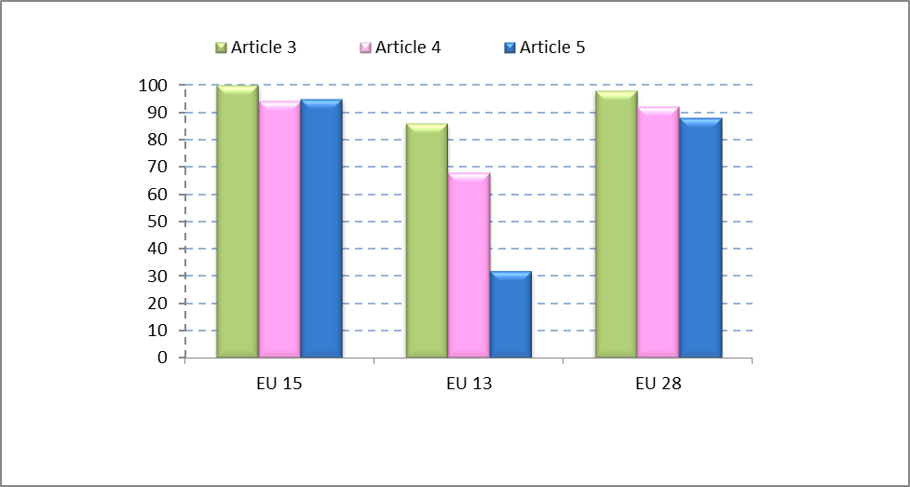
Figure 1: Compliance results at EU-28, EU-15 and EU-13 level regarding Articles 3 (collection), 4 (secondary treatment) and 5 (more stringent treatment). Average values are reflected, weighted by pollution load generated by individual Member States.

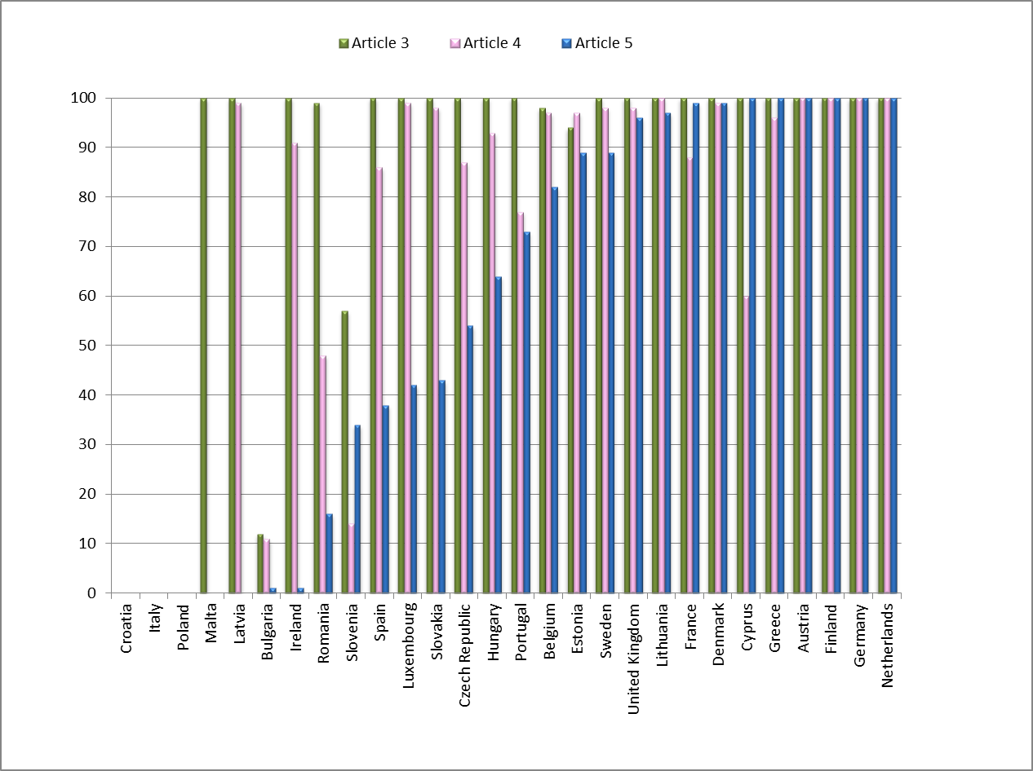
Figure 2: Compliance results per Member State for Articles 3 of the UWWTD (collection), 4 (secondary treatment), and 5 (more stringent treatment). Member States are classified showing first those with lowest compliance levels for Article 5, and then in increasing order of compliance. In LV, compliance results for Article 5 were equal to 0% because, LV reported that none of the treatment plants applied more stringent treatment, even if N and P-performance is compliant with the requirements of the UWWTD. Lower compliance rates under Article 4 as compared to under Article 5 are possible, since Article 5 only refers to sensitive areas. Compliance rates in RO have been calculated on the basis of the percentage of total load found in compliance for Articles 3, 4 and 5 respectively, according to the requirements in the Accession Treaty, rather than on the basis of the percentage of load associated with agglomerations that are in full compliance (data on the list of agglomerations associated with the compliance rates required in the Accession Treaty were not available).

2.4. Big cities/big dischargers
There are 463 big cities (> 150,000 inhabitants) covered by this Report. This is over 100 less than in the previous Report, mainly due to the non-inclusion of Italian and Polish data. The pollution load that is produced by big cities represents 46% of the total generated load. Approximately 89% of this load undergoes treatment that is more stringent than what would be required by the UWWTD. The percentage of load non-collected or collected and untreated has decreased from 5% to 2.2% since the previous Report. However, the degree of compliance varies significantly amongst big cities. For instance, only 14 of the 28 capitals of the EU Member States can be considered to be in full compliance in 2011/2012, which are nevertheless 3 capitals more than at the time of the previous report.

2.5. Trends in compliance
Compliance results throughout the years show a positive trend, with the exception of the decrease from years 2005/06 to 2007/08 due to the fact that some countries with poorer results did not report data in 2005/06. Long-term trends should be looked at with prudence, since data reported have not always covered the same Member States/agglomerations for several reasons, such as: sub-optimal IT systems in the first exercises, gradual expiry of transitional deadlines at EU-13 level or deficient reporting by some Member States.

The current report includes new data on CY, EE, LV, HU, SI, SK and RO, as new deadlines have expired entailing new compliance obligations. On the other hand, data for IT, PL, HR could not be considered in the calculation of the EU results.

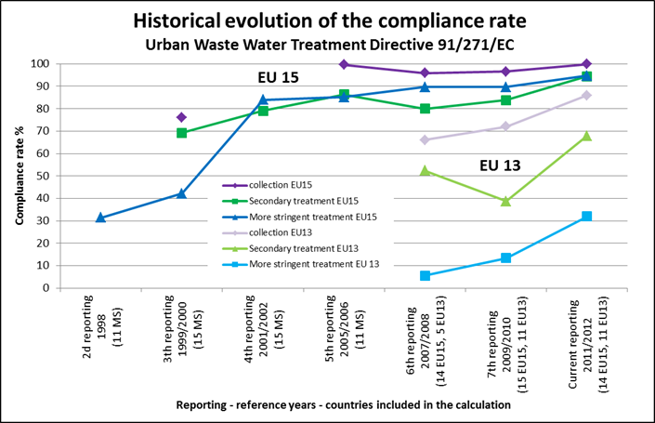
Figure 3: Evolution in compliance rates since reference year 1998 (based on incomplete - data sets available).

2.6. Compliance information at regional level
In this report, for the first time, the Commission has processed and included results at regional level. This allows providing for a more accurate and nuanced overview on implementation within Member States, where overall figures are not always useful.
Member States with high compliance rates at national level usually show such trend all over their regions. However, lower compliance rates at national level are often due to poor performance of some of their regions (e.g. in BG, SI, PT, ES, IE).
Regions have been classified as "rural", "urban" or "balanced" in function of the distribution of their population respectively in predominantly "small" agglomerations, predominantly "large" agglomerations or in a balanced number of both.
The share of regions with high compliance rates (90-100% ) for Articles 3, 4 and 5 (if applicable) shows that the so-called "urban" regions achieve better results, closely followed by the "balanced" regions, the "rural" regions showing lower rates. This may be explained by the later compliance deadlines for smaller agglomerations.
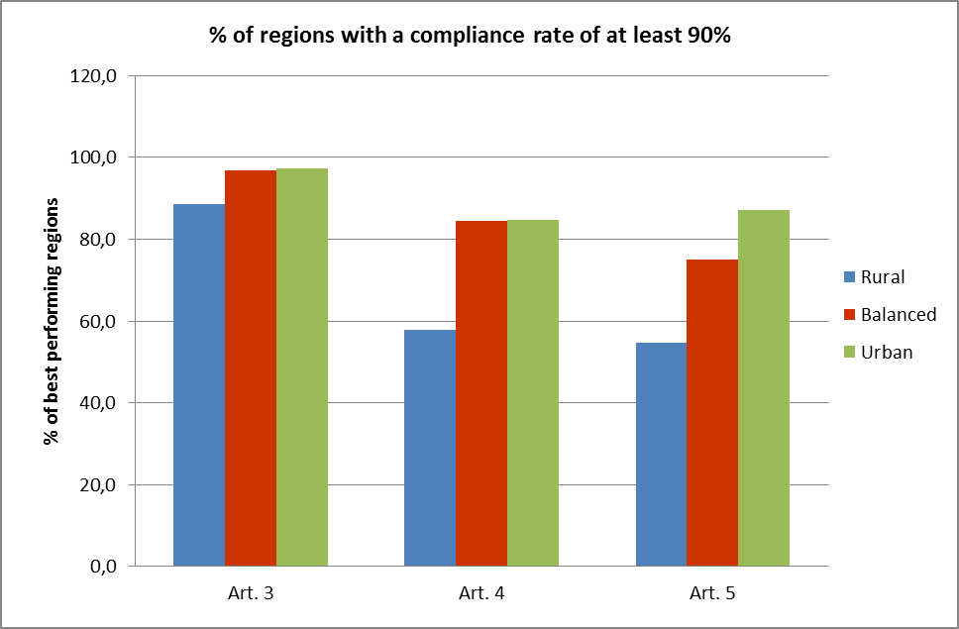
Figure 4: Percentage of regions (urban, rural or balanced), in which compliance rates between 90 and 100 % are reached for Articles 3, 4 and 5.

2.7. Remaining challenges
Despite the improvement in compliance with the UWWTD, there are still some challenges ahead:
- Timely provision of good quality and complete datasets by all Member States, enabling a higher reliability of the compliance results. The development of the structured information and implementation frameworks (hereinafter SIIFs) could be a way to facilitate a more effective and streamlined way to provide the information requested under the UWWTD.
- Some EU-13 Member States are still lagging behind to meet their current compliance obligations, especially on waste water treatment, and in particular on the more stringent treatment. EU-13 Member States with pending deadlines must ensure that the right steps towards compliance are taken before the expiry date of the transitional periods. An adequate planning on infrastructure priorities and securing the investments needed is essential.
- The low compliance rates in certain EU-15 Member States and regions, where deadlines for compliance expired years ago, make their improvement also a priority.
- Compliance in big cities has improved, but a relevant number of them discharging into sensitive areas still does not apply more stringent treatment. This is of particular concern because of the stress they put on the aquatic environment.

3. Action to promote compliance
To help Member States to achieve the objectives of the UWWTD, a number of actions are taking place, such as bilateral dialogues, developing implementation programmes, securing infrastructure investments through the European Structural and Investment Funds and improving management and dissemination of implementation data. Where non-compliance persists, the Commission initiates formal action for the violation of EU law.

3.1 Funding programmes
Construction of waste water collection and treatment infrastructure requires important investments, for which the EU offers funding opportunities under the European and Structural and Investments Funds. Over the past programming periods these funds have played a crucial role in enabling Member States to carry out investments to meet the provisions of the UWWTD. In the programming period 2007-2013, about 17.8 billion € from Cohesion Policy funds have so far been allocated to such infrastructure in 22 Member States. Negotiations on the operational programmes for the period 2014-2020 are currently in their final stage. For this period certain ex-ante conditions need to be fulfilled, which include, for investments in water services, a water pricing policy. This mechanism provides adequate incentives to use water resources efficiently and an adequate contribution by the different water uses to the recovery of the costs of water services at a rate that is determined in the river basin management plans elaborated under the WFD. It also ensures that investments are made within a strategic framework and that funding contributes to the implementation of the EU environmental acquis.

3.2 Implementation programmes (Article 17)
Member States have reported in 2014 information on their implementation programmes, under Article 17 of the UWWTD. The follow up of this article has been ‘reactivated’ by the ‘Water Blueprint’ as an action to improve compliance rates. Combining the information on compliance with information on planned and ongoing implementation programmes allows assessing whether the intended measures will be sufficient to reach compliance within a reasonable timeline and with the right priorities. The implementation programmes contain as well valuable information on financial planning and resources needed.
Member States reported on 8600 projects related to infrastructure for waste water collection and treatment, as well as for individual or other appropriate systems, to be carried out between 2014 and 2027; the majority of reported projects will be finalized by 2018. Most projects (70%) aim to reduce or annul the level of non-compliance with already applicable requirements, while a smaller part (30%) will help ensuring compliance by the time pending deadlines will expire. 37% of the projects concern investments in collecting systems and 63% relate to treatment plants.
Most of the projects are planned in EU-13. The rest concern Member States where distance to meet the objectives is longer (e.g. IT and ES), Member States with pending deadlines concerning recently designated sensitive areas (e.g. FR) or with infrastructure that was compliant but has to be renewed. Planned infrastructure for treatment covers 7 % (43 million p.e.) of the overall generated pollution load in the EU.

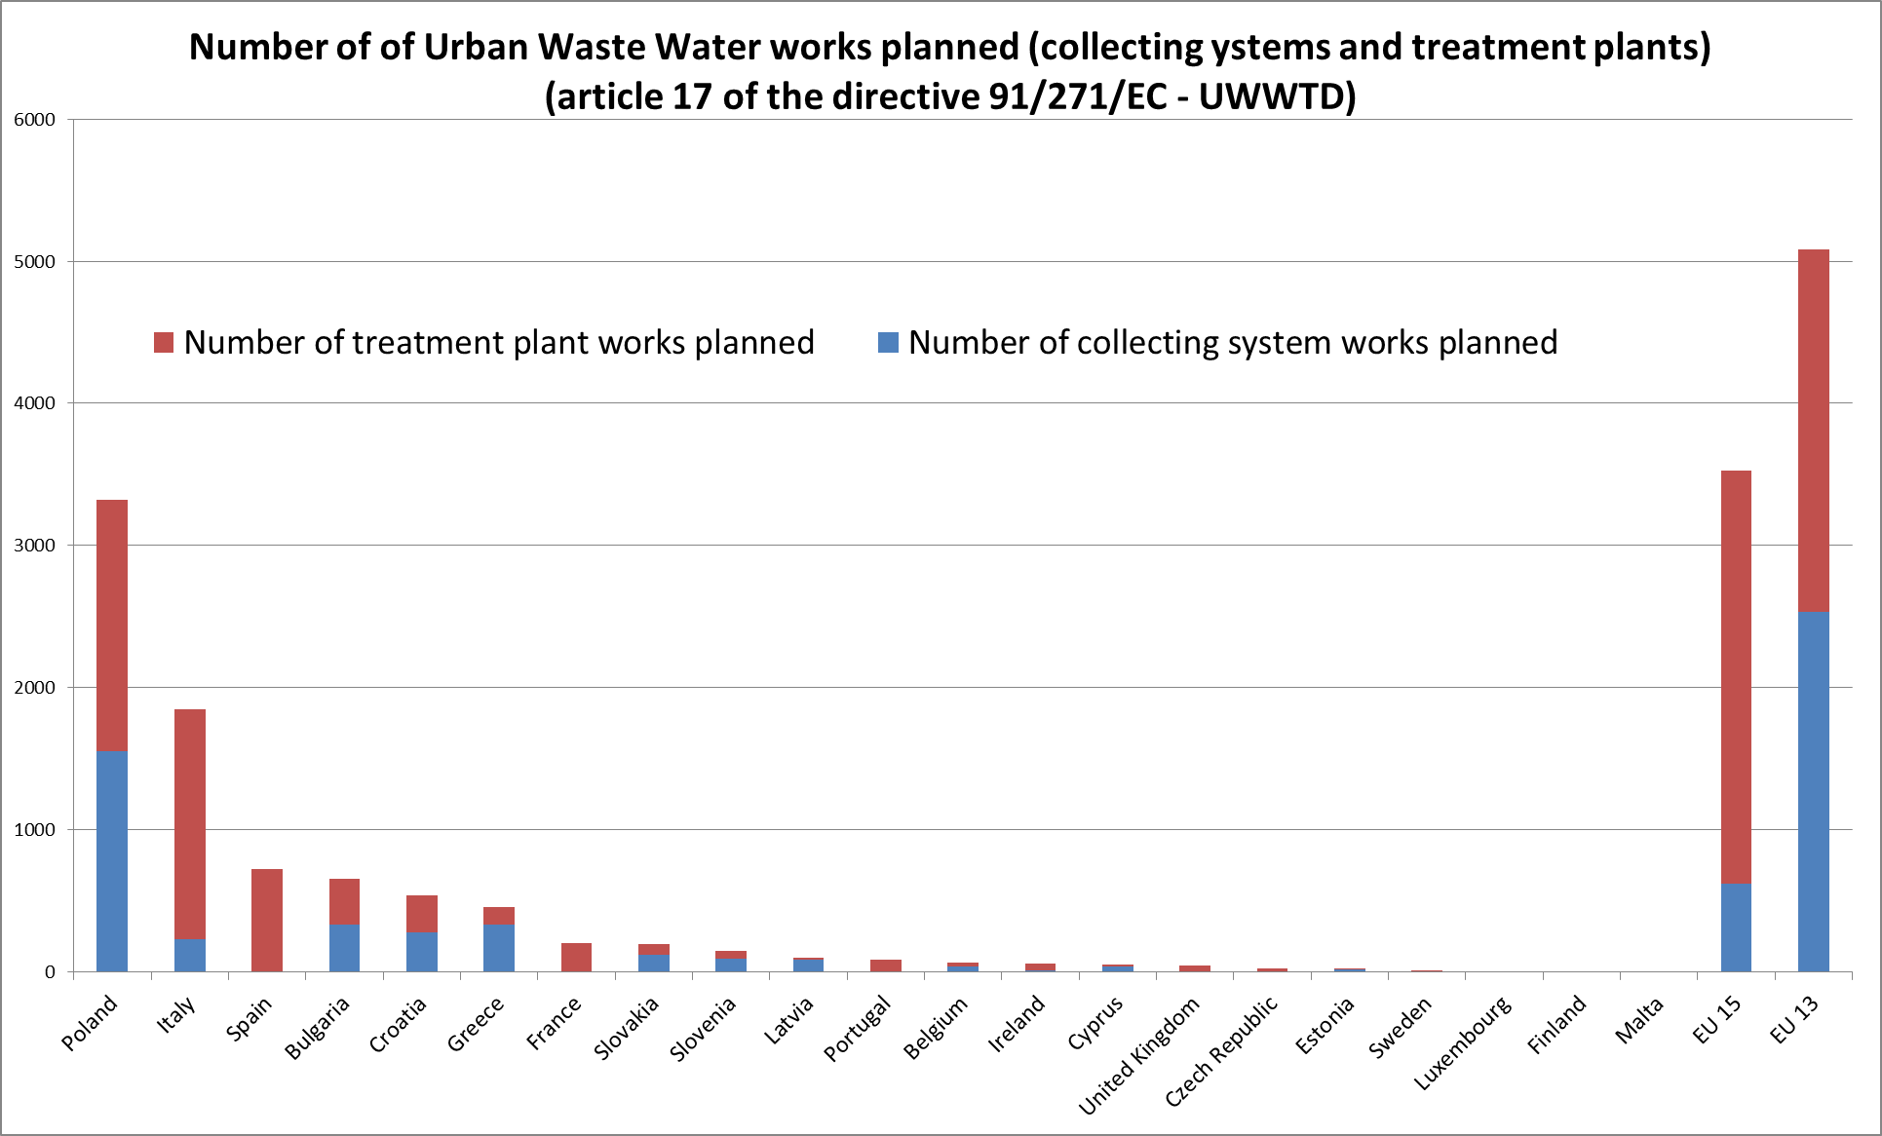
Figure 5: Number of works planned for urban waste water collecting systems and treatment plants.
The total forecasted investment needed for construction of new projects necessary to reach full compliance with the UWWTD is estimated at € 22 billion, evenly distributed between collection and treatment infrastructure. Planned EU related co-funding represents 25 % of the total investment needs.
The investment plans go beyond that and also include estimates needed for extension and renewal of existing systems. These show that yearly investment rates will continue to increase by 14% compared to the current situation, reaching an average of almost € 25 billion a year: between 2015 and 2018, about € 100 billion will be invested in waste water infrastructure.
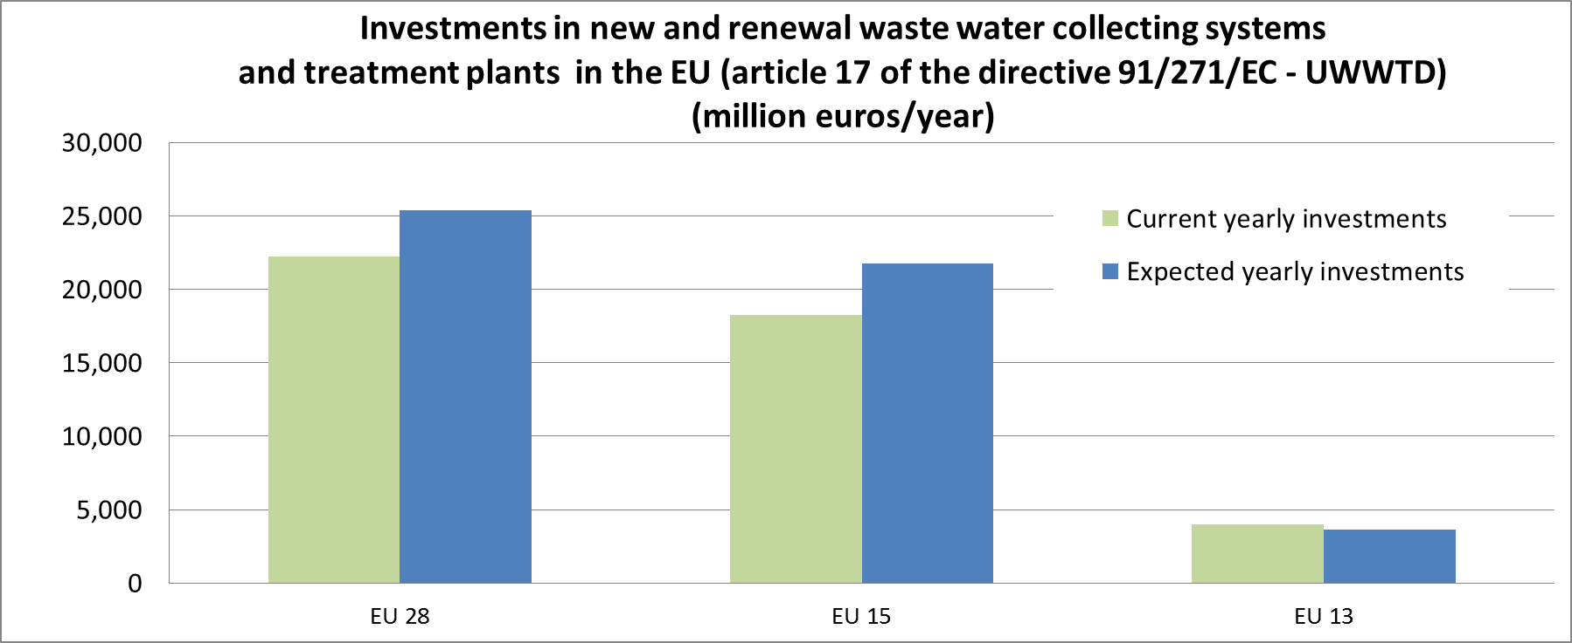
Figure 6: Current versus expected investments in urban waste water collecting systems and treatment plants.
Investment amounts represent 50 € per inhabitant for the coming years.
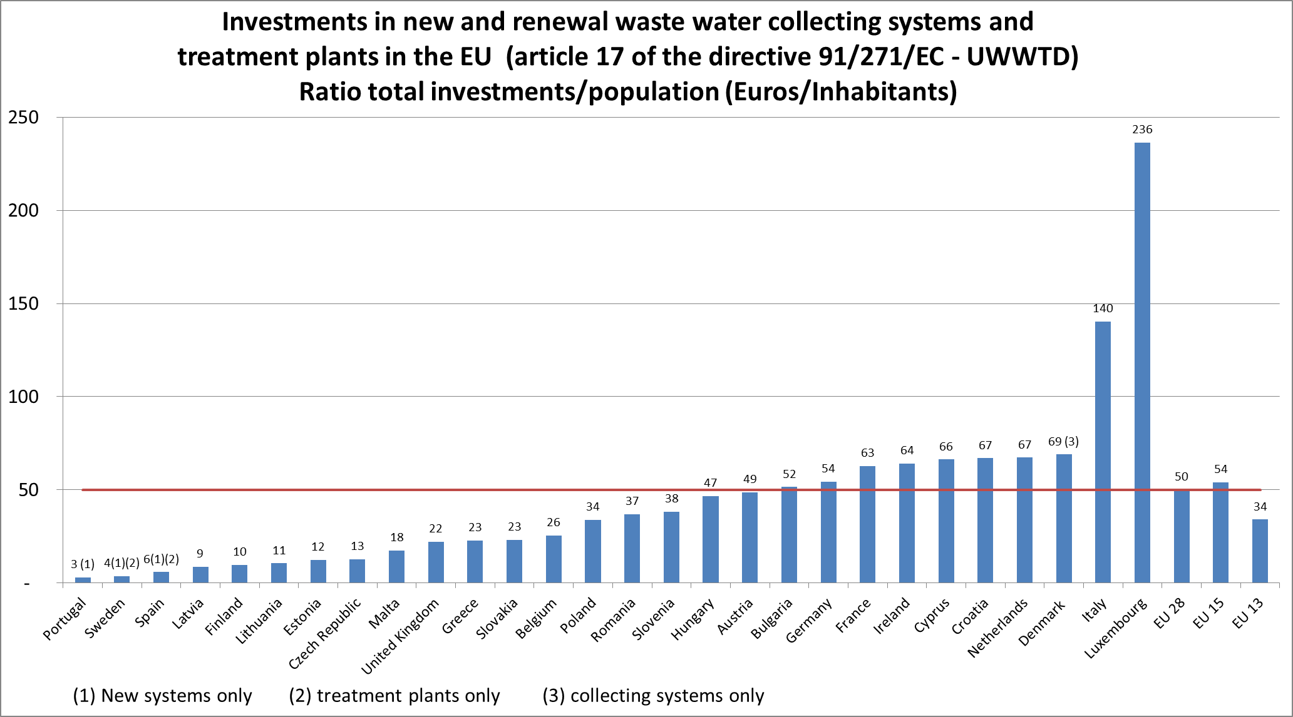
Figure 7: Investment per capita in urban waste water collecting systems and treatment plants
Trends vary, however, among the Member States: whereas in some countries investments will increase or remain stable, in others they will decrease, as shown in the figure below.
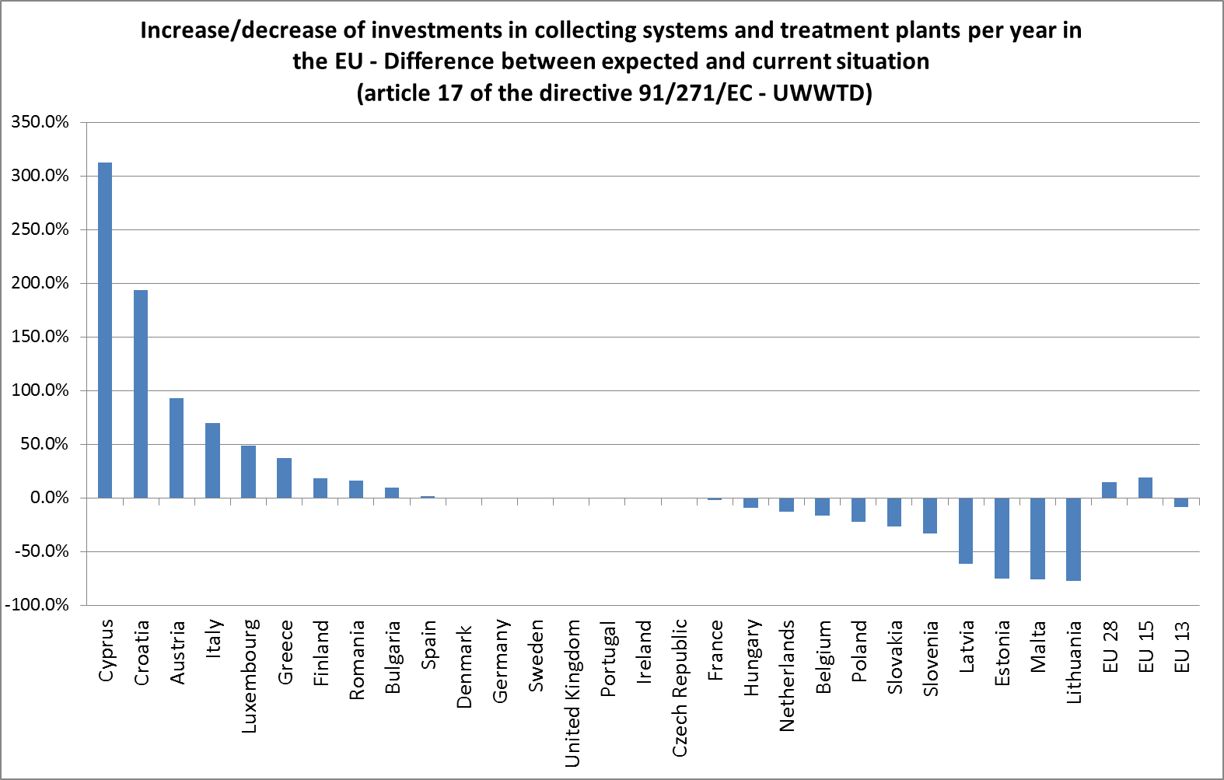
Figure 8: Current versus expected yearly investments in urban waste water collecting systems and treatment plants

3.3 Improving data management and dissemination
Since 2012 the European Commission runs a pilot programme under the UWWTD to help Member States to improve reporting processes and data dissemination towards the public by the development of the Structured Implementation and Information Framework (SIIF). The concept was firstly introduced in the Communication on improving the delivery of benefits from EU environment measures. Improved data management will contribute to better implementation of the UWWTD and to reduction of administrative burden, also by allowing an efficient fulfilment of requirements under the INSPIRE Directive 2007/2/EC and Directive 2003/4/EC on public access to environmental information. So far four Member States (CY, LT, SI and IE) have been involved in the development of national SIIF, including improved IT systems and websites on waste water data. In the next phase, three more Member States will join (HR, PL and RO). The Commission is also closely working with the EEA to improve the organisation and dissemination of information at EU level. The result of the pilot SIIF programme will be used to develop operational SIIF for other Member States and EU interested partners.

3.4 Legal enforcement
The Commission has been ensuring Member States' compliance with the UWWTD mainly through continued dialogue and compliance promotion action but also, when necessary, by entering into bilateral dialogue and launching infringement procedures against non-compliant Member States. This has usually been done by "horizontal" cases, covering several agglomerations falling under the same compliance obligations, for the "older" Member States since the expiry of the relevant deadlines in the UWWTD, and for the "newer" Member States gradually as the deadlines for compliance expire.
Regarding the first group, the Court of Justice of the EU has issued seven judgments since the beginning of 2013, three of which were based on Article 260 of the Treaty on the Functioning of the EU, meaning that the Court imposed a lump sum and penalty to three Member States (BE, LU and EL) for failure to comply with previous judgments from 2004, 2006 and 2007. These are the first cases in which the Court has imposed fines for failure to comply with the UWWTD. Five cases are currently pending before the Court.
The Commission has also launched since 2012 a number of horizontal cases, covering up to several hundreds of agglomerations in one single Member States.
Finally, for "newer" Member States, interim, specific deadlines have been established in their respective Accession Treaties, and have already started expiring. The Commission checks Member States' compliance with these interim deadlines mainly via the regular reporting exercises.
Based on the 7th report (2009-2010), the Commission has started bilateral dialogues with 10 Member States.. The suspected breaches vary between Member States, as not all the interim deadlines are the same.

4. Creating jobs and growth by investments in infrastructure for water services
The construction of infrastructure to provide quality waste water services requires a high amount of investments and operations, which contribute to an important extent to jobs and growth in the water industry sector.
If only the industrial sector is considered, it represents an added value of about 15 billion € per year.
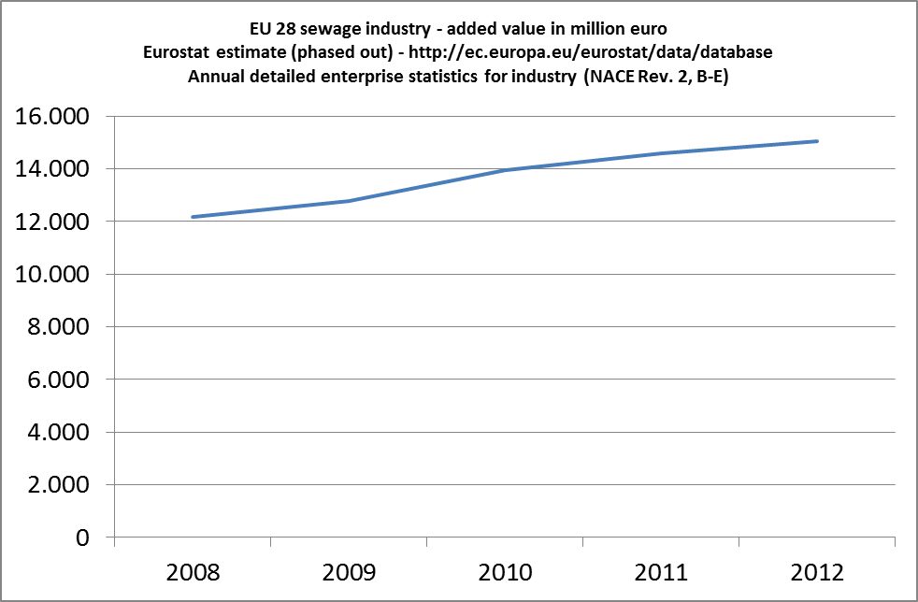
Figure 9: Evolution of added value of EU28 sewage industry from 2008 to 2012
Looking at the larger picture, it is to be noted that the waste water management in the goods and services sector represents more than 600,000 jobs, an annual production value of more than 100 billion € and an annual added value of about 42 billion € (investments, maintenance, operation, export of technology and knowledge).
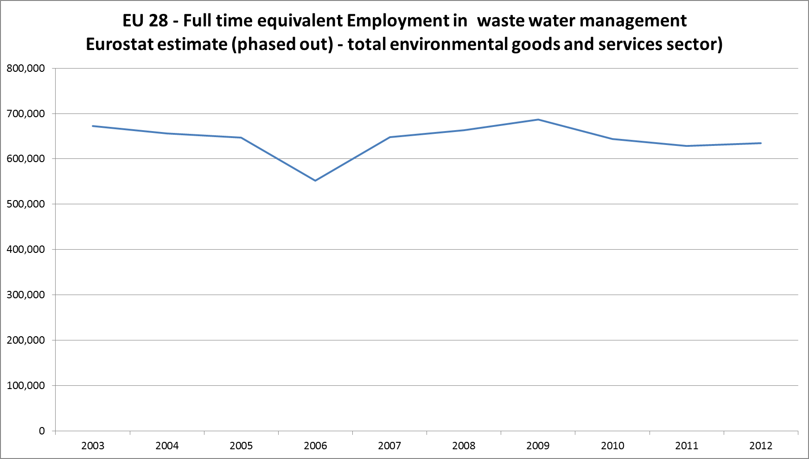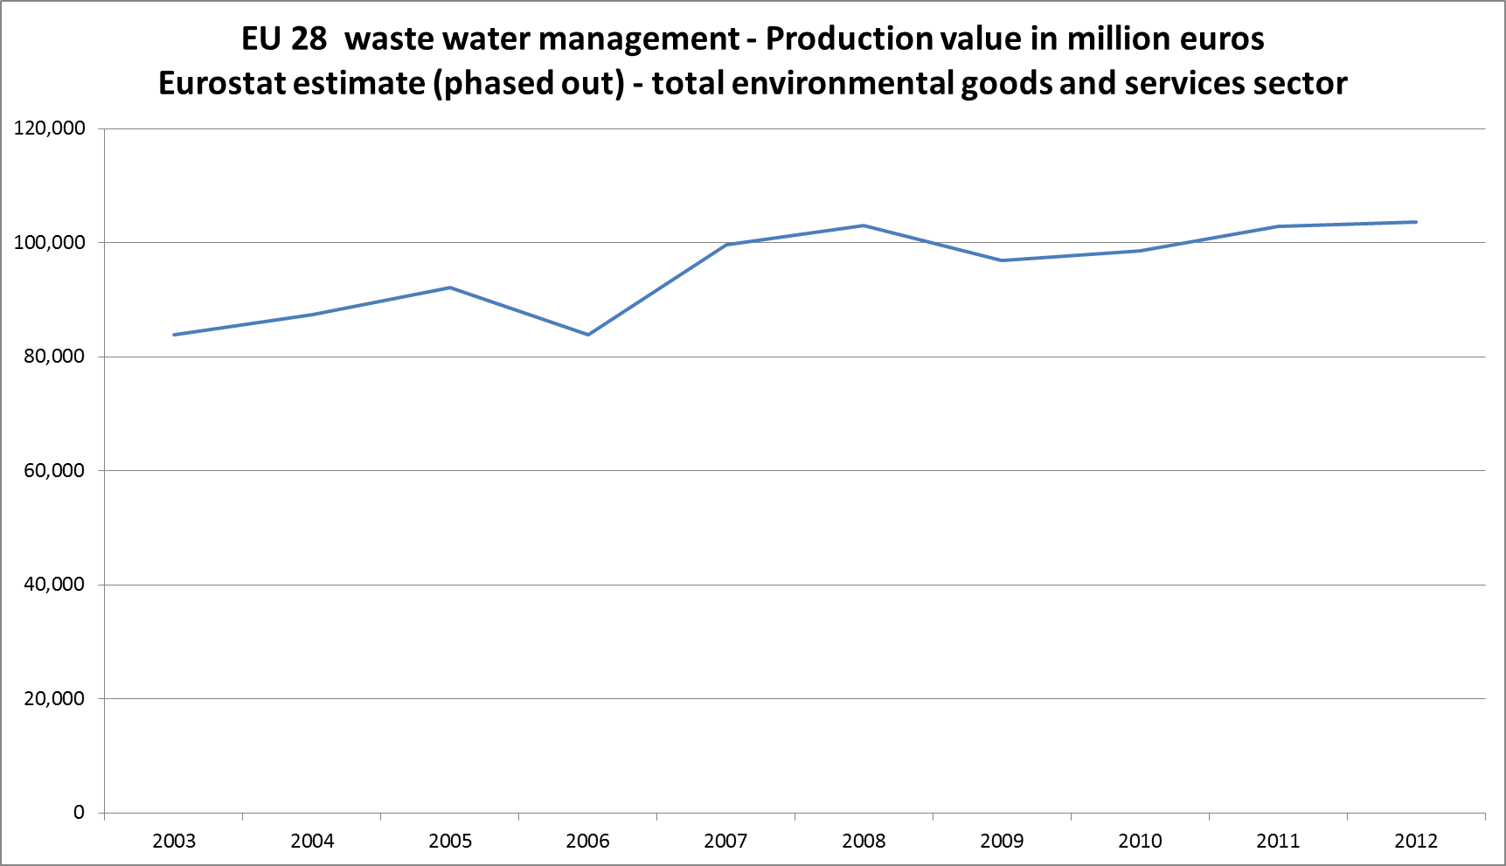
Figure 10: Evolution of full-time equivalent employment and of production value in waste water management in EU28 from 2003 to 2012
As presented above, the waste water sector will continue to increase.
Implementation of the UWWTD therefore contributes not only to achieve the environmental objectives, but also importantly contributes to boost jobs, growth and investment. Under the Commission’s Investment Plan, several selected projects for support relate to investments in waste and drinking water infrastructure.

5. Innovation: key to support resource efficiency and growth
To ensure high quality water services for citizens in the most cost effective way it is essential to invest in the development and large scale implementation of innovative solutions to increase resource efficiency, such as solutions for energy recovery, nutrient recovery and processing to marketable products and water re-use. Innovation is also an important driver to increase competiveness, job creation and economic growth.
The European Innovation Partnership for Water (EIP) aims to facilitate the development of innovative solutions and to create market opportunities, both inside and outside EU. 8 Priority areas have been identified, namely water reuse and recycling, water and wastewater treatment including recovery of resources, water-energy nexus, flood and drought risk management, ecosystem services, water governance, decision support systems and monitoring, smart technologies and financing for innovation. At the core of EIP Water are its voluntary 29 multi-stakeholder Action Groups. Their partners develop, test, scale up, disseminate and stimulate the uptake of innovations by the market and society for major water-related challenges. Several projects have already been launched. These are the central element of EIP Water's implementation phase. Innovative solutions are also essential for reducing the adverse impact on the environment in areas with high population density and for turning them into "smart cities".
The importance of research and innovation for water has been also recognised in Horizon 2020, the 2014-2020 EU funding programme for research and innovation. In the context of Horizon 2020 Work Programme 2014-2015, water has been identified as a focus area with a view of bringing innovative water solutions to the market, and supporting the implementation of the EIP and Joint Programming Initiative on water by Member States. Focus was given inter alia to demonstration and market replication projects to bridge the gap from innovative water solutions to market replication. Further, within the Horizon 2020 Work Programme 2016-2017, water issues are addressed across the entire Horizon 2020 structure with a view of continuing the efforts undertaken in the 2014-2015. Actions to boost water innovation for Europe and beyond are particularly addressed in the areas of the circular economy, sustainable cities, climate services, territorial resilience etc. In particular, Societal Challenge "Climate action, environment, resource efficiency and raw material" of Horizon 2020 promotes the concept of systemic approach through, large scale demonstration/pilot projects, with a sufficient level of novelty and progress with respect to the state of the art and aiming to implement and test new technological and non-technological solutions. These projects should also act as a way to attract most interest from innovators and innovation users (e.g. industries, financial actors, academia, research, private or public entities, regions, cities, citizens and their organisations, etc..), thus helping to unlock additional public/private investments in the water sector and strengthen synergies with other relevant EU funding mechanisms such as the European Structural and Investment Funds (ESIF), in particular under the European Regional Development Fund (ERDF).
Quite relevant for the waste water sector are innovative solutions for water re-use and its potential contribution to an important extent to resource efficiency. In follow-up of the Water Blueprint the Commission looks currently at the possible creation of an EU-level instrument to encourage water re-use, which is a requirement under Article 12 of the UWWTD.

6. Conclusions
- The implementation of the UWWTD has significantly reduced organic and nutrient pollution load discharges in the EU and therefore plays a key role to achieve good environmental status of marine and fresh waters.
- Despite challenges such as substantial investment needs and long-term planning, high compliance rates are reached in EU-15. In EU-13, still significant compliance gaps exist, especially on treatment. Reinforced action and investments are needed to reach full compliance within reasonable time delays.
- Implementation programmes show that Member States plan significant investments to close the compliance gaps by constructing waste water infrastructure. Member States need to continue to collect the necessary information to timely identify future investment needs and operation costs, and to improve or maintain the performance of their current systems.
- Additional efforts are needed to improve the quality and the timeliness of the data reported on the implementation of the UWWTD. To this end, processes and tools are being revised and developed by the Commission in collaboration with EEA and Member States.
- The water industry sector is an important contributor to economic growth and job creation. Investments to reach full compliance with EU legislation have significant potential to create new jobs and growth.
- Investments in innovative technologies are essential to make the water industry more resource efficient and also contribute to job creation and economic growth.

Directive 2000/60/EC of the European Parliament and of the Council of 23 October 2000 establishing a framework for Community action in the field of water policy, hereafter 'WFD'
Directive 2008/56/EC of the European Parliament and of the Council of 17 June 2008 establishing a framework for community action in the field of marine environmental policy (Marine Strategy Framework Directive)
Council Directive 91/271/EEC concerning urban waste water treatment, hereafter ‘UWWTD’
http://www.eea.europa.eu/soer-2015/synthesis/report/3-naturalcapital
Political guidelines for the next Commission: http://ec.europa.eu/index_en.htm
Article 15 of the UWWTD
Article 17 of the UWWTD
Decision N° 1386/2013/EU; paragraph 28
COM(2014)177 final
http://ec.europa.eu/dgs/secretariat_general/followup_actions/citizens_initiative_en.htm
See http://rod.eionet.europa.eu/obligations/613.
"Population equivalents" or p.e., term used in the UWWTD, covers the organic pollution generated by the inhabitants of a village/town, and other sources such as non-resident population and agro-food industries.
The terms EU-13, EU-15 and EU-28, with a clear meaning at EU level, will be used in the 8th Report even if, in reference to implementation figures, they are linked to 11, 14 and 25 Member States respectively as HR, IT and PL data have not been processed.
See Annex
PL and HR not included and IT partially included in the calculation. Percentages relate to the p.e. load generated and subject respectively the expired and pending deadlines.
Individual systems or other appropriate systems that achieve the same level of environmental protection as collecting systems
http://www.eea.europa.eu/data-and-maps/uwwtd/interactive-maps/urban-waste-water-treatment-maps
Not including Zagreb (still without compliance obligations) and Warsaw (not possible to be assessed).
http://eur-lex.europa.eu/legal-content/EN/TXT/?qid=1405007191767&uri=CELEX:32014D0431
http://eur-lex.europa.eu/legal-content/EN/TXT/?uri=CELEX:52012DC0673
EL, HU and RO reported under the old Article 17 template and were therefore not obliged to give detailed information about the projects
Tables 2 and 3 of decision 2014/431/EU: Commission Implementing Decision of 26 June 2014 concerning formats for reporting on the national programmes for the implementation of Council Directive 91/271/EEC (notified under document C(2014) 4208)
EL, HU and RO are note taken into account in this calculation
Table 4 of the Article 17 Implementing Decision
Each Member State has reported information corresponding to different periods of time. A yearly average per year was calculated to compare each Member State situation. "Current situation" can be considered as the average yearly investment between 2009 and 2013 and "expected situation" as the average yearly investments between 2014 and 2018.
Communication(2012)95 final
http://inspire.ec.europa.eu/
http://eur-lex.europa.eu/legal-content/EN/TXT/?uri=CELEX:32003L0004
Based on software ‘freely’ available
IE: http://uwwtd.oieau.fr/ CY: http://uwwtd.oieau.fr/cyprus/ - LT: http://uwwtd.oieau.fr/lithuania/ - SI: http://uwwtd.oieau.fr/Slovenian/
http://www.eea.europa.eu/data-and-maps/uwwtd/interactive-maps/urban-waste-water-treatment-maps
A list of most relevant infringement cases to date and judgments since end 2012 is provided in the Annex.
C-533/11: the Court ordered BE to pay a 10 million € lump sum as well as 859 404 € for each 6-month period until full compliance with the judgment.
C-576/11: the Court ordered LU to pay 2 million € lump sum as well as 2800 € for each day until full compliance with the judgment.
C-167/14: the Court ordered EL to pay 10 million EUR lump sum as well as 3 640 000 EUR per semester until full compliance with the judgment.
Eurostat (NACE Rev. 2, B-E) http://ec.europa.eu/eurostat/data/database
Eurostat http://ec.europa.eu/eurostat/web/environment/environmental-goods-and-services-sector/database
Political guidelines for the next Commission : http://ec.europa.eu/index_en.htm
COM/2014/0903 final: http://ec.europa.eu/priorities/jobs-growth-investment/plan/index_en.htm
http://www.eip-water.eu/about
http://ec.europa.eu/environment/water/blueprint/follow_up_en.htm

