

**Staff Working Document**

**5G Global Developments**

**Table of contents**

1. Preamble 3

2. 5G Early Context 3

3. What is 5G? 4

4. Migration and co-existence aspects 8

5. 5G opportunities 12

6. Coordinated market deployment, learning our lessons from 4G 14

7. Radio Spectrum Issues 16

8. Trials and early roll out 18

9. Standards 20

10. Investments Issues 22

11. Conclusions 24

Annex: 5G Targeted Survey, Summary Figures 25

# Preamble

This Staff Working Document presents a short summary of 5G developments worldwide and of the main issues currently at stake which impact the anticipated deployment of 5G networks. It accompanies the Communication "*5G for Europe: An Action Plan*" with the aim of providing background information explaining the context within which the 5G Action Plan is being presented by the European Commission.

It draws on multiple consultations, events[1] with stakeholders, several studies[2], numerous input from Industry[3], early results[4] of the 5G-PPP and the results obtained through a targeted consultation that took place from 13 June 2016 to 11 July 2016[5].

# 5G Early Context

Public reflections on a new generation of 5G communications technologies started in 2011, based on the prospects for new markets, new usages and advanced technologies which could not be considered during the time frame of development of the 4G/LTE standards (current generation of mobile communications systems)previous generation (4G).

This triggered European 5G related R&D projects under the EU 7th Framework Programme, which acted as technological pathfinders for the core 5G technological options[6]. The 5G Public Private Partnership (5G PPP) was then created in 2013 under the Horizon 2020 Research & Innovation programme by the European Commission with the objective of fostering European 5G industrial leadership. Today, the 5G PPP implements a set of strategic industry-led projects[7] with a total of 166 stakeholders. An EU funding of €700 million is planned for the initiative, leveraging at least €3.5 billion from the private sector between 2014 and 2020.

At the global level, several prominent 5G industrial public private partnerships have been launched between 2013 and 2015 involving leading operators, vendors, universities, and research institutes in the field of mobile communications:

* The **IMT-2020 (5G) Promotion Group** in **China (**2013), the major platform to promote the research of 5G in China including deployment aspects.
* The **5G Forum** in the Republic of **Korea** (2013), with a budget of $ 1.4 billion (2/3rd private, 1/3rd public), leading work on technologies and infrastructures for early 5G deployment in Korea in 2018 at the winter Olympic games.
* The **5G Mobile Communication Promotion Forum** (5G MF) in **Japan** (2014), a promotional organization for R&D and standardization collaborative activities. It leads the preparation of the 5G deployments in Japan for the Tokyo Olympic Games of 2020.
* Furthermore, in 2015 the **5G Americas** industry association was reshaped to focus on industry preparation towards 5G migration in the US and in South America.

These activities with governmental support have generated a global momentum, which has significantly accelerated the pace of 5G developments over the last 18 months. In that context, the European Commission DG CONNECT has signed Joint Declarations of co-operation with its counterparts in South Korea, Japan, China and Brazil to foster alignment of 5G global visions and approaches towards standards and radio spectrum[8]. A closer cooperation is also being established with key US organisations.

# What is 5G?

The concept of very high performance 5G networks results from a combination of different factors.

**From the service and business perspective:**

* **A significant increase in mobile video consumption** will drive around six times higher traffic volumes per device in North America and Europe after 2020. The popularization of cloud-delivered Media and Social Media content to smart devices puts additional constraints on the intermediate communication links, whilst ever richer content calls for significant capacity increase. Virtual reality applications are expected to require gigabit/s capability whilst the generalization of 8K Ultra High Definition Televisions[9] and UHDTV streaming should require capacities of more than 100Mb/s for a single user.

From the 5G perspective, the corresponding services are called "enhanced Mobile Broadband", also referred to as eMBB in the following text, and target applications with aggregated speeds higher than 10 Gb/s.

* **The advent of Machine to Machine communication,** with large numbers of connected devices (massive IoT) used in professional and industrial applications or in smart cities deploying large populations of sensors, calls for highly efficient radio networks and very low energy consumption.

From the 5G perspective, the corresponding services are called "massive Machine to Machine Communication", also refered to as mMTC in the following text, and target applications with millions of devices/km².

* **New time-demanding applications** requiring instant reaction, i.e. very low latency in the order of 1ms, cannot be served by today's existing technology with the required guarantee of performance[10]. Typical applications include remote surgery, connected cars (mainly for safety services and fast prediction of surrounding conditions), smart factories and robotics, or detection of faults in energy grids. These time critical applications will, in most cases, have to combine 5G connectivity with distributed (mobile) cloud technology in order to meet the required end-to-end response times.

From the 5G perspective, the corresponding services are called "Ultra Reliable Low Latency" also refered to as URLL in the following text, and target applications with very low latency requirements.

**From the technological perspective:**

Several disruptive technologies are expected to act as game changers:

* **The prospect of economic fibre-like radio access** with data rates beyond 10 Gb/s is within reach, notably through the usage of higher frequency bands above 6 GHz and related technologies. Today, spectrum allocations for wireless broadband are situated below 6GHz. Higher frequency bands will offer larger capacities for disruptive capabilities, such as a large number of simultaneous communications with users/devices, and open the prospect for user data rates meeting the International Telecommunication Union (ITU) requirements for 5G (i.e. exceeding 10 Gb/s). Multiple trials performed by industry in 2016 showed that speeds higher than 10 Gb/s and up to 70 Gb/s can be achieved using spectrum above 6 GHz. A vast majority of vendors and operators aim at using spectrum around 30 GHz (25-32 GHz) for early 5G trials at high speeds, where commercial implementation may be feasible in the short term.
* **Network Function Virtualisation** (NFV) offers the prospect of implementing specific network functions (e.g. Content Delivery Network, Customer Premises Equipment management etc.) in software running on generic hardware, without the need for costly hardware-specific machines. The expected impacts are i) a drastic reduction in capital expenditure (capex) and network management costs – operational expenditure (opex); ii) reuse and sharing of the same functionality between several customers; iii) higher innovation capability through easy introduction of new software functionalities and creation of a "network app" market place. The trend towards virtualisation is profound in the industry. For instance, Telefonica plans to virtualise at least 30% of its network in the short term; AT&T plans to virtualise 75% of its network by 2020 to cope with mobile traffic explosion. More than 250 companies support the ETSI-NFV Industry Specification Group (ISG) which is one of the leading bodies for NFV functional specifications.
* **Software Defined Networking** (SDN) is a complementary trend to NFV that allows the control of network resources to be opened to third parties, with the possibility for these third parties to manage their own physical or virtual resources individually, as needed, with the required level of performance tailored to actual needs. This possibility goes much beyond the management capabilities offered to today's MVNO's[11].

In the context of 5G developments, and in view of supporting ad-hoc digital business models of industrial users, SDN and NFV are seen as key components to enable these specific categories of professional users to control their network capabilities dynamically according to their needs. As network resources are potentially available to third parties through open interfaces, they also open the possibility for smaller players to innovate through development of specific service offers building on network resources made available for third party access and programmability.

The core capabilities outlined above go much beyond the current and future 4G/LTE capabilities in the following ways:

* **Speed**: Today, 4G data rates (accessible to multiple users) are at about 500 Mb/s, which enables in average a maximum data rate of 50 Mb/s per user. Evolution scenarios contemplated by standardisation organisations like 3G PP[12] target a maximum capability for 4G up to 3Gb/s[13].
* **Flexibility to accommodate demanding professional-grade applications**: 4G core network architectures and capability do not widely implement SDN/NFV based functions. This does not allow the resource allocation flexibility that is needed in scenarios where a radio access has to serve applications with very different requirements (e.g. connected vehicle users with very low latency requirements or video streaming users with very high downlink speed requirements). The lack of open interfaces also pre-empts the emergence of innovative service offers in the new domains.
* **Instant response time**: Core 5G application requirements such as low latency of 1ms (10 to 20 ms for 4G), serving 1 million devices/km² (about 1000 device/km² for 4G) or fast deployment of new services in the order of 1 hour deployment time (measured in days with current technology) are not part of today's 4G technology.

Against this background, 5G definition and use cases have been developed by industry. The ITU recommendation [ITU‑R M.2083‑0](http://www.itu.int/rec/R-REC-M.2083/en), approved in September 2015, defines the overall objectives of the future development of IMT for 2020 and beyond. It calls for 5G system improvements that cover three generic classes of services, based on anticipated market developments. These are outlined in the "ITU triangle" below:

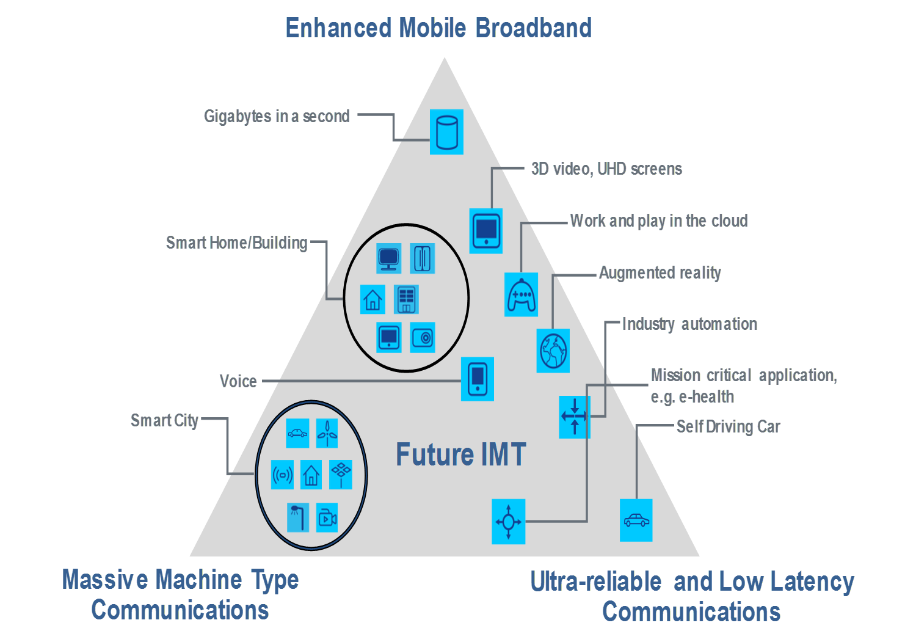

The ITU Vision document also characterises the increased performance level needed to achieve the 5G (IMT 2020) vision, as outlined in the figure below (IMT advanced refers to 4G)

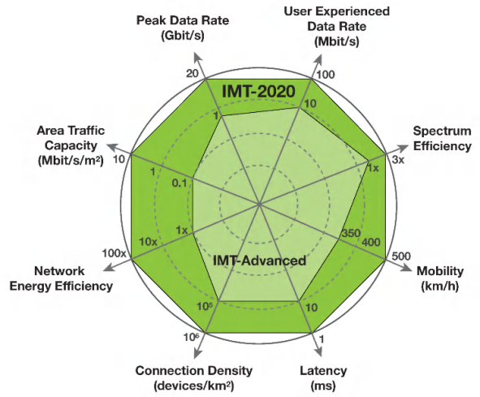

The 5G PPP Vision document summarises well these objectives (extract below):

*"5G will not only be an evolution of mobile broadband networks. It will bring new unique network and service capabilities. Firstly, it will ensure user experience continuity in challenging situations such as high mobility (e.g. in trains), very dense or sparsely populated areas, and journeys covered by heterogeneous technologies. In addition, 5G will be a key enabler for the Internet of Things by providing a platform to connect a massive number of sensors, rendering devices and actuators with stringent energy and transmission constraints. Furthermore, mission critical services requiring very high reliability, global coverage and/or very low latency, which are up to now handled by specific networks, typically public safety, will become natively supported by the 5G infrastructure. 5G will integrate networking, computing and storage resources into one programmable and unified infrastructure[14]. This unification will allow for an optimized and more dynamic usage of all distributed resources, and the convergence of fixed, mobile and broadcast services. In addition, 5G will support multi tenancy models, enabling operators and other players to collaborate in new ways."*

Similar considerations can be found in other industry publications, e.g. the white paper developed by the Next Generation Mobile Network Alliance (NGMN)[15].

**Relevant results of the targeted survey:**

There is a widely shared understanding that **5G will be of a disruptive nature**, **a key infrastructure for Europe** and a **core asset to support competitiveness**. This view is expressed by about 70% of respondents, and opposed by only 10%. In the same context, 63% of the respondents agreed with the view that **5G will be a strategic infrastructure in Europe** for the telecom industry, the industries that use connectivity and society in general. **These views are well shared across all categories of respondents,** with some marginal disagreements.

# Migration and co-existence aspects

**Evolution from 4G**: within the overall 5G development time frame, it is important to note that 4G will continue to be developed and enhanced, and also to be deployed. 5G is not conceived as a technology replacing 4G, but rather enhancing it and complementing it with new service capabilities. At this time, it is considered that the usage of 4G will continue for many years, before eventually 5G takes over completely. A valid similarity can be found with the current 4G introduction pattern, with 4G ramping up whilst earlier 3G/2G are still in use in other frequency bands and still growing globally in the case of 3G. See example graph of technology co-existence below[16].



Therefore, 5G will be designed to co-exist with 4G, and is expected to support the advent of multi technology operations, with terminals having the capability to connect to the best available network, as a function of the service requirements of the application. Each radio access being introduced in a different frequency band, the terminal may eventually dynamically select the best radio access for the considered application. This also encapsulates the usage of WiFi and unlicensed bands, which should be much more tightly integrated into the connectivity offer portfolio of a service provider, and will help to provide "tailor made" connectivity to users as part of their application requirements. The industry is currently working on the required functionality that makes this multi radio convergence possible already partially in a 4G/LTE context. This evolutionary perspective is a key aspect to support gradual investments in 5G, offering an introduction perspective designed to gradually complement the 4G offer.

Considering that 5G will "piggyback" on 4G and thus enhances it, the deployment of 4G is considered as a pre-requisite for a successful introduction of 5G. 4G will ensure the continuity of service when and where 5G functionalities are not fully available in some parts of the infrastructure. This is also reflected by responses to the targeted survey from mobile operators stating that mobile operators are expected to spend USD 1.7 trillion worldwide on their network equipment between 2014 and 2020, much of it to upgrading to 4G architecture. That is almost double the USD 878 billion spent from 2009 to 2013 at the time when 3G was being built.

**Typical example of a foreseen evolution strategy towards 5G, the case of "connected vehicles" application:** a typical upgrading strategy is being pursued in the area of connected vehicles, as outlined below. It is to a large extent also relevant to other specific industry sector applications.

In the case of connected vehicles, it is not envisaged that 5G would simply supersede earlier investments in **ITS-G5**[17] technology, as currently deployed in Europe and in other regions of the world. This technology is based on an evolution of the WiFi standard (802.11.P) and is recognised as a technology of choice for early ITS deployment in Europe, as outlined in the C-ITS platform final report[18], targeting primarily road safety services in the first instance.

The main scenario contemplated for the introduction of 5G functionalities is for the provision of additional services compared to the earlier rolled out technologies, following a **hybrid communication** approach.

As identified in the C-ITS platform report, the main set of agreed services is for the Day 1 level, and covers:

* Hazardous location notifications:
* Slow or stationary vehicle(s) & Traffic ahead warning
* Road works warning
* Weather conditions
* Emergency brake light
* Emergency vehicle approaching
* Other hazardous notifications
* Signage applications:
* In-vehicle signage
* In-vehicle speed limits
* Signal violation / Intersection Safety
* Traffic signal priority request by designated vehicles
* Green Light Optimal Speed Advisory (GLOSA)
* Probe vehicle data
* Shockwave Damping (falls under ETSI Category “local hazard warning”)

In addition, the C-ITS platform of the Commission has already identified a set of "Day 1.5" services and is working on higher levels of vehicle automation.

From a technological point of view the automotive sector works against "Phases"[19], each with a greater service capability.

Phase 1

Generally, the Day 1 applications of the C-ITS platform can be considered as ‘awareness driving’, e.g. the traffic participants share status information, to allow others to understand the current status of conditions around them.

Phase 2

For the next phase, it is expected that the participants will also share the observations, e.g. the data from their sensors, in addition to status data. This can be envisaged to allow provision of information about traffic participants that are not themselves able to provide status information, e. g. because they are not C-ITS equipped. This second phase is often called ‘sensing driving’.

Phase 3

Again building on top of the information provided in the first two phases, a third phase is envisaged to enable ‘cooperative driving’. To allow that, it will be necessary to share intentions, e. g. the participants will inform the others about their intentions, such as lane changes, planned trajectories etc.

Phase 4

The third phase will most likely be followed by a fourth phase that will allow the participants to make coordinated actions, e. g., forming platoons, coordinating lane merging etc. This phase is often called ‘synchronised cooperative driving’.

Phase 5

The next and major step after the above phases will be moving towards an "accident-free" driving system, based on automated driving with optimised traffic flows. The 5G technology is expected to play a growing role in the set of technologies (some of which are likely to be duplicated to provide redundancy and security) which will be required to reach the goals of an "accident free" environment.

The overall evolution is summarised below:

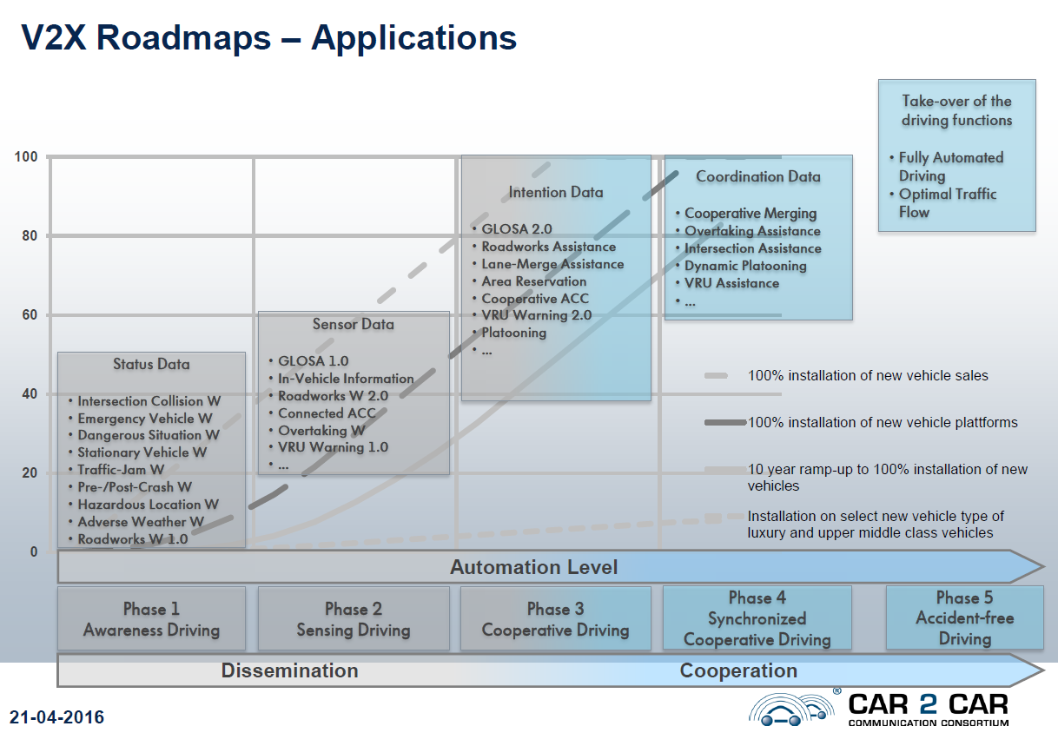

According to the Car 2 Car consortium[20], the use cases for 5G in vehicles are:

* Map update for highly automatic driving - Instantly update the map of a vehicle's surrounding.
* Precise Positioning - support for vehicles without high precision location tracking like cars.
* Audio / Video Streaming (Entertainment), Online Gaming.
* Sensor and State Map Sharing (Sensor Raw Data) -Transmit raw sensor data such that others can use their own classifiers to infer decisions.

The above 5G introduction scenarios for the automotive sector take into account the view of the C-ITS platform report, namely: "*… a hybrid communication concept is therefore needed in order to* ***take advantage of complementary technologies.*** *It is therefore essential to ensure that C-ITS messages can be transmitted independently from the underlying communications technology (access-layer agnostic) wherever possible[21]".*

# 5G opportunities

From a market perspective, it is predicted that 5G revenues may reach US$250 billion in 2025, with North America, Asia-Pacific, and Western Europe being the top markets[22], based on clear prospects that critical and massive "Machine to Machine" communications will generate substantially higher revenues in addition to enhanced Mobile Broadband services. A study carried out for the Commission[23] indicates that the benefits of 5G introduction across four industrial sectors may reach €113 billion per annum. In 2025 it is expected that €62.5 billion will be generated from first order benefits in the four key industrial sectors examined in the study.

Leading market actors also predict that 5G will already represent more than 150 million connections in 2021[24] globally, more than the number of current 4G/LTE subscriptions in Europe (147 million). The study mentioned above, carried out for the European Commission, identifies several "first order" benefits for 5G introduction in 4 sectors: automotive, healthcare, transport, utilities:

"First order" benefits focus on the more direct benefits to the producers of goods and services. These benefits predominantly fall into three categories:

***1. Industries*** will exploit 5G capabilities to obtain benefits in three key areas of their activity:-

* ***Strategic benefits*** will arise from greater access to information about the supply chain, internal operations, market characteristics and consumer utilisation of goods and services.
* ***Operational benefits*** and enhanced productivity will arise from increased real-time access to information about operations (inside/outside the workplaces and throughout the supply chain).
* ***Direct User benefits*** should arise for consumers from access to ‘improved’ goods or services. Improvements could include cost, quality, usability, reliability and longevity.

***2. Data and information for administrators and third parties***: Enhanced access to 5G capabilities and information, including real-time data, will help administrators and other third parties to enhance the provision of services (to private and public sectors) including traffic management, security and data for pupic healthcare management.

***3. New business models*** will utilise 5G capabilities to enable new business models to develop and new goods and services to be provided

These benefits are quantified in the table below:

|  |  |  |  |  |  |
| --- | --- | --- | --- | --- | --- |
| ***industrial sectors benefits*** | **Automotive (€ mn)** | **Healthcare (€ mn)** | **Transport (€ mn)** | **Utilities (€ mn)** | **Total (€ mn)** |
| Strategic | 13,800 | 1,100 | 5,100 | 775 | **19,770** |
| Operational | 1,800 | 4,150 | 3,200 | 2,700 | **11,850** |
| Consumer | 13,900 | 207 | - | 3,000 | **17,110** |
| Third Party | 13,700 | 72 | - | - | **13,770** |
| **Total** | **42,200** | **5,530** | **8,300** | **6,470** | **62,500** |

There are also significant "second order" benefits, estimated at €50 billion in the year 2025, based on the "knock-on" impacts resulting from the use of goods and services. They generally concern more indirect benefits to society.

The above results provide some guidance for the industry related trials that are likely to be supported in Europe to test the introduction of the new 5G services.

These data also indicate that fast-paced digitalisation of key industrial sectors (such as transport, logistics, automotive, manufacturing, media, entertainment) and the public sector (including smart cities, public safety, health and education) provides ample opportunities for Europe’s information and communication technologies (ICT) industry to bring to market new and innovative solutions whilst positively contributing to societal requirements.

Despite this availability of early data, the business opportunities still require further investigation because the digitalization of the many industries in transformation will significantly disrupt the current business models. A particularly relevant example is the transformative effect and economic shift towards new service delivery models (e.g. where "on demand" approaches will replace long term planned contracts) for which the expected significant redistribution of revenues streams cannot yet be fully assessed. **This implies the need for increased cooperation between the various communities of stakeholders to be able to assess more precisely the evolution of the value chain.**

|  |
| --- |
| **Relevant results of the EC targeted survey:**   * **The importance of the 5G "holistic" perspective**, encompassing the widest possible range of 5G use cases from the beginning, is well reflected in the survey results: 50% of respondents agree that 5G European deployment should target as a priority from the start the services that enable the creation of ecosystems with key industries, namely mMTC and URLLC classes of use cases. This holistic apptroach is massively supported by the ICT industry and SMEs whilst 20% disagree. Within this latter group can be found individuals, small players in specific markets like content production, and a few academics and research centres. Only two large operators disagree with the view of the core ICT community. * There are also differences of view with regard to the market prospects. 78% of the respondents believe that by 2020, roughly at the time of 5G commercial introduction, eMBB will be the dominant market application. * This is however modulated by the facts that in 2025, 5 years after 5G introduction, 42% of the respondents also believe that mMTC will be the largest market, ahead of eMBB. The dividing line is between the IT industries outside of the telecom sector, potential 5G users, which place mMTC and URLL ahead, whilst the classical telecom actors tend to have higher expectations for eMBB. |

# Coordinated market deployment, learning our lessons from 4G

Today, the proportion of 4G/LTE subscriptions measured against the total population is 75% in the US, 82% in the Republic of Korea, 65% in Japan, and 28 % in the European Union[25]. These figures suggest a delay in market deployment of 4G in Europe that many attribute to a lack of a coordinated approach within the single market, in particular with regards the time table for the release of the radio spectrum frequencies to operators, as well as the initial unavailability of 4G devices in the EU [26].

International comparisons show that there is an objective correlation between early availability of spectrum and fast market take up. In the US auctions of the 700 MHz band were held as early as 2008. Subsequently, Verizon launched its LTE network in 2010 and by July 2012 had more than 304 cities covered with LTE, about 75% of the US population. AT&T launched its network in 2012, and had more than 47 city markets with LTE by July of that year. In comparison, Europe organized its auctions significantly later, and in a somewhat dispersed order. Auctions of suitable LTE spectrum (mainly 800 MHz and 2600 MHz bands) occurred over a wider time span in Europe: in 2010 in Germany, in 2011 and 2012 in France, in 2011 in Italy and Spain, and 2013 in UK and Poland[27]. This has led to a corresponding "lag time" for actual network deployment and commercial pan-European 4G operations. It is interesting to note that in spite of early auctions in Europe over the last 2 years, the 700 MHz band will not be fully available on an EU-wide scale before 2020, 12 years after its US-wide availability. This interdependency also highlights the strategic importance of making the 700 MHz band available for mobile wireless applications as quickly as possible, especially for the purpose of reaching appropriate coverage objectives in due time[28].

The early identification of suitable and harmonised frequency bands is also an important factor. The figure below outlines the different regional approaches towards 4G spectrum availability, illustrating the current difficulty in achieving global harmonization, a risk that is likely to arise also with 5G. Despite the size of the country, Verizon in the US was able to reach 97% population coverage within three years of launch, due to its initial assignment of low frequency, high propagation "coverage band" spectrum in the 700 MHz range. On the other hand, later regional choices of spectrum not massively adopted by lead markets may have slowed down the speed for local availability of suitable terminals. This demonstrates once again that late adoption and lack of global spectrum harmonization have an adverse impact on the take-up of services and on the pan-European footprint that can be achieved by those services.

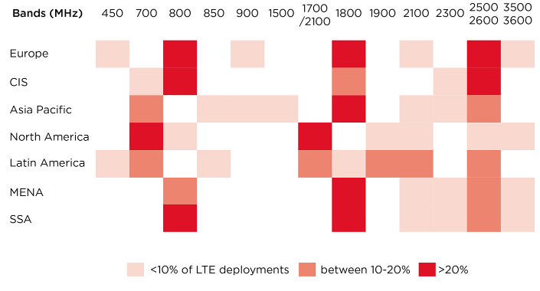

Share of LTE deployments by frequency band, by region (January 2015). *Source: GSMA Intelligence*

**Relevant results of the EC targeted survey:**

The issues raised by the delayed 4G licensing is well reflected in the results of the targeted survey. As regards the best introduction model for a new network technology (taking 2G, 3G, and 4G as example scenarios), the model that was used for the introduction of 4G (absence of coordination besides the technical harmonisation of spectrum) gets the most negative assessment, with 40% of respondents considering the 4G introduction scenario as the model to exclude in the future, and only 27% rating it positively The model that gets the highest support is the 2G co-ordinated introduction model, with 40% of positive rating and only 21% considering this scenario as outdated. This is particularly clear in the responses of users of technologies and non-ICT industries. However, IT players in the telecom sector have more of a "neutral" position on average in the survey, albeit supporting the view that the 4G licensing model, complemented by a target time frame for making available 5G bands and licensing conditions, i.e. introducing some MS coordination, would be the best compromise.

# Radio Spectrum Issues

From a spectrum availability perspective, the agenda is framed by the ITU process towards defining 5G bands above 6 GHz at the World Radio Conference 2019 (WRC-19). The WRC-15 decided to put on the agenda of WRC-19 a specific agenda item related to 5G frequency bands as follows:

* *WRC-19 Agenda Item 1.13: to consider identification of frequency bands for the future development of International Mobile Telecommunications (IMT) including possible additional allocations to the mobile service on a primary basis in accordance with resolution COM6/20 (WRC‑15)*
* *RESOLUTION COM6/20 (WRC-15) invites ITU-R to conduct and complete in time for WRC‑19 the appropriate sharing and compatibility studies for the frequency bands:*
* *24.25-27.5 GHz, 37-40.5 GHz, 42.5-43.5 GHz, 45.5-47 GHz, 47.2-50.2 GHz, 50.4-52.6 GHz, 66-76 GHz and 81-86 GHz (with allocations to the mobile service on a primary basis), and 31.8-33.4 GHz, 40.5-42.5 GHz and 47-47.2 GHz (which may require additional allocations to the mobile service on a primary basis)*

Several leading nations however clearly intend to accelerate the timing of 5G deployment through focusing on alternative spectrum ranges, both below and above 6 GHz. This is notably the case of:

* The Republic of Korea, which has already identified spectrum and assigned 3 blocks of 1 Ghz each to 3 operators at 28 GHz, and which is currently deploying infrastructure to be in time for the Olympic Games in Pyun Cheong in 2018, where early 5G introduction is planned. It may be noted that the deliberate choice of the 28 GHz frequency band does not conform to the ITU resolution above;
* Japan, is taking steps to introduce 5G in bands below 6 GHz in the context of the Tokyo Olympic Games in 2020, with the intention of designating 5G spectrum by the end of 2016;
* China, has started a comprehensive 5G trial programme, aiming at full testing of a complete 5G system before 2020. The programme runs over 3 phases: phase one, until end of 2018, is primarily R&D and validation of key technologies and subsystems; phase two, from 2018 to 2020, is about system and products R&D trials; phase 3, post 2020, is about gradual commercial introduction and application trials, with a likely focus on industrial applications. Though China is not part of the nations willing to accelerate the pace of the International organisations, the intention of China is to be part of the leading nations for 5G introduction. To that end, CN has already selected the 3,4 -3,6 GHz band for early trials and later introduction.
* The USA is part of those nations willing to accelerate the pace of 5G introduction. Worth noting is the low reliance of the US administration on global standardisation bodies, and their paradigm that spectrum allocation is the decisive key to fast track 5G. This is well illustrated by the statement of FCC chairman Tom Wheeler[29]:

*“The United States approaches the kind of opportunity 5G presents somewhat differently from other countries. We do it by indicating which spectrum will be made available and then relying on a private sector-led process for producing technical standards best suited for those frequencies. We won’t wait for the standards to be first developed in the sometimes arduous standards-setting process or in a government-led activity.”*

In line with this approach, the FCC released on 14 July 2016 the "Spectrum Frontier" rulemaking, laying down a set of applicable 5G frequency bands in the US together with their conditions of use. Similarly to the Korean case, some of the frequency choices (28 GHz band) do not follow the above ITU Resolution. The fast track approach of the FCC is also mirrored by US operators' initiatives, targeting 5G introduction by 2018.

In February 2016, several operators, KT, NTT DoCoMo, SK Telecom and Verizon, agreed to form a new global initiative called the 5G Open Trial Specification Alliance[30]. In July 2016, major US operators also announced having already completed 5G specifications[31].

In Europe, and in view of the fast-track spectrum developments in key regions, the Radio Spectrum Policy Group (RSPG) has launched work to identify by the end of 2016[32] pioneer spectrum bands for Europe's early 5G launch as of 2018, in line with the ITU priorities and thus with a maximum potential for global harmonisation. Furthermore, the RSPG plans to deliver an Opinion on a 5G spectrum roadmap, including aspects of spectrum allocation and authorisation, by early 2018. To this end, the Commission is working with the Member States within the RSPG and also plans to initiate technical studies at EU level to enable timely harmonisation measures delivering 5G spectrum to market players.

In that context, and considering the importance of 2020 as a target date for roll-out of large scale commercial 5G networks, the following aspects are considered as the most important by the stakeholder community:

- Making the 700 MHz available, preferably Europe wide, to mobile services by 2020 as proposed in the relevant proposal for a Commission Decision addressing UHF bands (see section 6).

- Exploiting the opportunities offered by spectrum already harmonised in the EU for mobile broadband applications below 6GHz, more particularly the 3.4-3.8 GHz band.

- Identifying before WRC-19 the applicable frequency bands above 6GHz having the widest possible harmonisation potential.

|  |
| --- |
| **Relevant results of the EC targeted survey:**   * **The central role of spectrum availability is well reflected** in the survey. Whilst 46% of respondents do not consider it necessary to already identify the 5G pioneer bands by the end of 2016, a majority of 63% consider that these bands need to be identified by the end of 2017. This includes the ICT industry, user industries and a number of SMEs. Only a limited share of respondents, 24%, believe that it would be acceptable to wait until the results of the next WRC conference in 2019 before allocating the spectrum, including one large operator, one vendor, and the satellite industry with a few individual respondents. Overall there is **strong support for early decisions on 5G pioneer bands in advance of WRC-19**. * There is **large support for bands to be globally harmonised**: 73% find it is a must, only 9% disagree. Those who are neutral or disagree include mainly academics and industries in non-ICT domains, like banks or transport solution providers. There is a relative majority group of 40%, mainly composed of large industrial players, who disagree with the proposition that lack of harmonisation can be compensated by technology using a "tuning range" approach. * Regarding the identification of pioneer bands, **3 spectrum bands gain most preference** for 5G introduction in Europe: the highest scores go to the **700 MHz, the 3.4-3.8 GHz band and the 24-27 GHz** frequency ranges. However, it is worth noting that 40% of the respondents place themselves in the category "do not know". It is also interesting to further underline that the 28-29 GHz option, contemplated in the US, has not much support whilst the 31-33 GHz option, seen as more appropriate in Europe, also gets limited support. There is a clear preference for the lowest possible spectrum bands, due to their propagation characteristics. The respondents most supportive of the 3 preferred pioneer bands mentioned above include network operators, ICT technology suppliers and a few industry users, e.g. from the energy and transport sectors. |

# Trials and early roll out

In addition to the trial directions mentioned in section 4 above, intensive cooperation between industries have taken place over the last year to define the core 5G characteristics needed to serve innovative business models (transport and especially the automotive sector, health, energy, smart factories, media and entertainment). This work was mainly conducted in the context of the 5G PPP[33] and allowed a number of business cases to be identified that would require availability of technologies beyond the capabilities of existing networks. The diagram below illustrates these requirements.

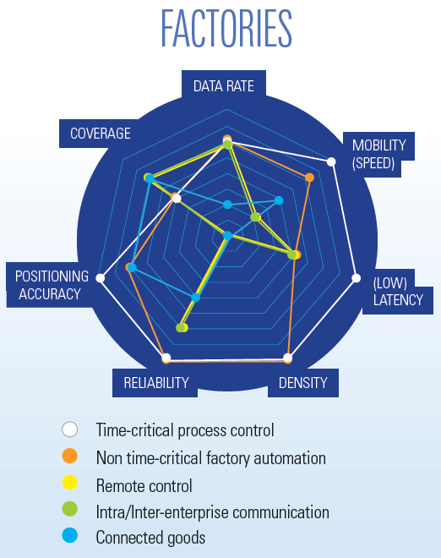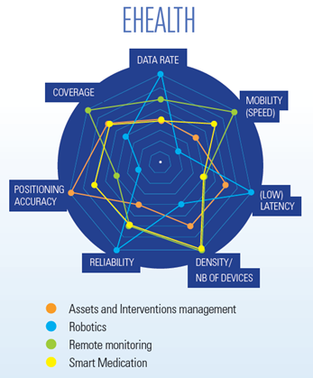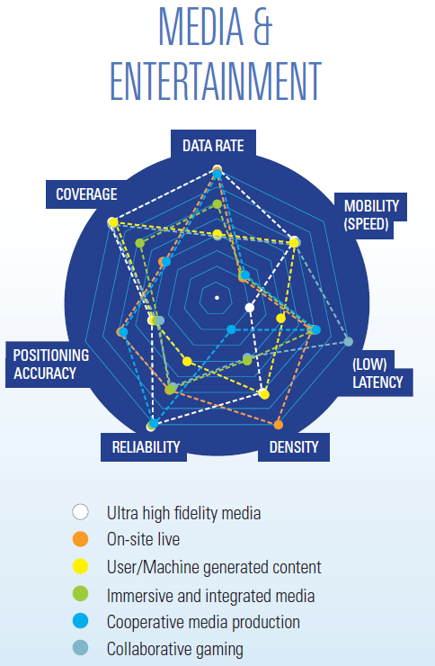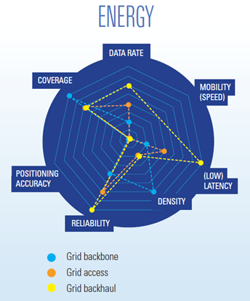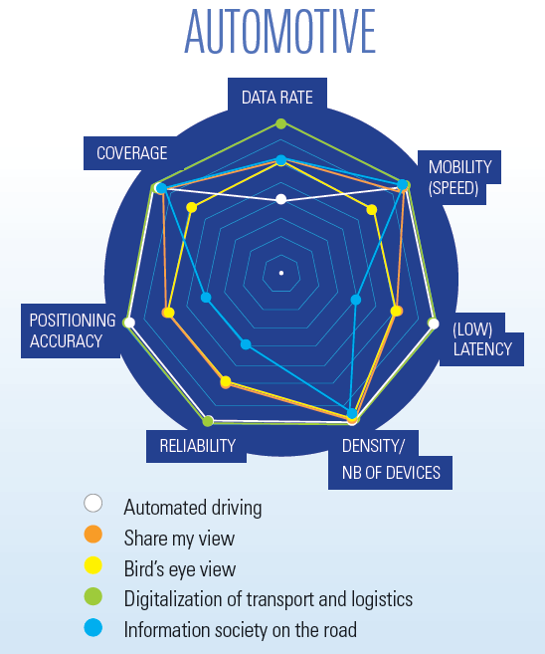

These figures illustrate the fact that automotive health and media and entertainment are potentially the most demanding use cases (applications) in terms of requirements that cannot be satisfied with existing technologies[34], which implies that industry needs further trials and joint work before validating new technologies and business models.

The European positioning of stakeholders vis-a-vis these developments is reflected in the box below.

|  |
| --- |
| **Relevant results of the EC targeted survey**:   * Regarding the default 5G introduction date set by the standardisation organisations as 2020, the relative majority of respondents, 43%, support this as a target with only 18% disagreeing. It needs to be noted however that a part of the "neutral" and disagreeing respondents do actually **call for earlier introduction**. Altogether, more than **50% of respondents estimate that early trials and pilots are needed before 2020** i.e. that by 2018 cross-country trials and pilots should already be available on a large scale if Europe wants to achieve significant commercial deployments in 2020. This category includes basically all ICT solution providers and a significant proportion of operators. It also includes content companies and some non-ICT industry players, who state that in some cases the need is already there today (e.g. low latency communications). A limited number of respondents from large companies indicate that the timing of actual deployments, especially when they require large investments, should be decided by operators according to their business plans (1 operator). * Regarding the need for showcasing events in Europe (e.g. mirroring the Olympic game 5G showcasing events in Asia) there is a **good support for such initiatives to "show" European leadership**, with 56% of the respondents agreeing, and massive support from large industrial (ICT or other industries) actors. Only 25% do not see the interest. Supporters include primarily larger companies and users, whilst disagreement comes mainly from SMEs, academics, a citizen association and individual responses. Three operators are also in that category, but no technology suppliers. Views vary on the date for such events: **2018 is proposed by half of the supporters whilst** 2017 and 2019 get about 25% each. * Regarding trials and use cases that Europe should concentrate on, the picture is diverse, but the majority of respondents, about 60%, focus on **Automotive/Connected vehicles/Traffic management and media and entertainment**. These cases are also well flagged in the industry manifesto. The typology of these respondents is dominated by the ICT service and technology providers, with smaller content companies. |

# Standards

The main technical steps for the preparation of the commercial introduction of 5G are framed by the agenda of international standardisation bodies. 3GPP, the key global standardisation body in the area of mobile communication network standardisation, officially started the standardisation process in September 2015, with an inception workshop in Phoenix that gathered more than 500 participants. Since then, the standardisation agenda has been defined. 3GPP has planned to deliver a first release, release 15, (mainly focused on broadband with some complementary aspects related to low latency use cases) by mid 2018 whilst a second release covering the complementary use cases, related to industry applications, would be available by the end of 2019 under 3G PP release 16. There is still some uncertainty related to the exact content of the work item to be started in March 2017: the actual standard specification phase after the study item collecting the industrial requirements. A full agreement on this next phase has not yet been reached, in particular regarding the question whether the first phase should focus on eMBB only or already accommodate additional use case scenarios. The figure below shows the standardisation time line agreed at the last 3G PP TSG RAN[35] plenary meeting in Busan, in June 2016. The next important decision point will take place in March (on the strategy for new radio interfaces).

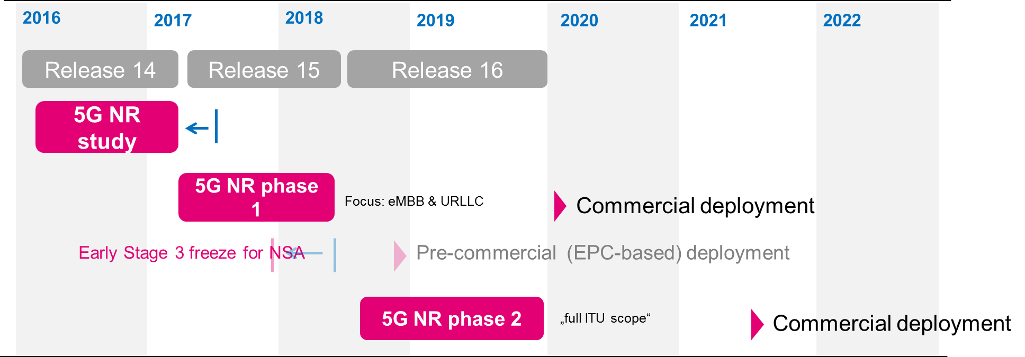

*Source, Deutsche Telekom, EUCNC 2016 conference*

The timing outlined in the above figure relates mainly to new radio access and new radio access network architecture. In parallel, 3GPP is also actively working on standards to redefine the core network under the 3GPP "System Architecture" (SA) Group. This standardisation track, which eventually should support different industrial users with differentiated controls of their service requirements, is also key to support future network based innovation through SMEs and start-ups. However, due to the current focus on radio access, this part of the standardisation exercise attracts less attention from the stakeholder community

From a global (as well as European) perspective, these fast-track approaches focused on radio access raise a number of challenges:

* The risks that a parallel, potentially proprietary, specification develops outside of 3G PP, as was the case with WiMax – LTE parallel tracks, also limiting openness and innovation capabilities;
* The risk that the standardisation bodies accelerate their pace under commercial pressure, limiting the scope of the standard and its ability to evolve to cover a more holistic set of use cases;
* The risk that the core network standards get less attention, limiting the potential openness of future network platforms, hence limiting the prospects for developing an innovative community of third party developers;
* The risk that Europe lags behind, in spite of a globally recognised technological excellence.

|  |
| --- |
| **Relevant results of the EC targeted survey**:  ***Standards***   * Regarding standards, the survey **results do not oppose an acceleration** of the pace of the standardisation process. However a number of respondents point to the **risk of limiting the scope of standards**. 64% of respondents agree that the standards should **not be limited in priority to the eMBB** use case but should rather include from the onset the other "industry" driven use cases such as **Machine to Machine communication and ultra-low latency** use cases. Virtually all operators and associations, with technology providers as part of that category, complemented by research institutes and SMEs in various sectors (content, transport), hold that view. Only 11% disagree, mainly individual respondents and a few SMEs. * There is also strong support for standards that address both the radio access and the core network architecture, to support new business models. 60% of respondents agree that **the two issues should be tackled together**, i.e. radio should not be the only focus. This trend confirms the earlier public consultation on standards that took place under the DSM initiative. It includes most of the ICT service and technology providers with user companies in different sectors (transport, energy, bank, content). Those who did not support such a combined approach are mainly SMEs, individuals and national organisations. * There is very good support for the principle whereby the European Commission should set out a strategy to ensure that appropriate standards can be developed and agreed in a timely manner in areas concerning the interface between communications functions and third party service providers (like industrial users). This role for the Commission is supported by 65% of the respondents (13% disagree). Those who did not support such combined approach are like under the previous topic mainly SMEs, individuals and some national organisations. |

# Investments Issues

The success of the commercial deployment of 5G will depend critically on the timeliness and intensity of investments in two key areas:

1. **Investments in infrastructure**: mainly to lay out a dense fibre network infrastructure to ensure the backhauling of 5G cells, as well as to finance the installation of the actual 5G cell equipment. The densification of cells is necessary to optimise both capacity and spectrum re-use between base stations.
2. **Investments in service innovation:** to stimulate the emergence of the new 5G-enabled services. This includes both the financing of pilot projects at the end of the research and development cycle and investment to support an ecosystem of innovative companies where the new services will be "discovered" and developed (ecosystem of both start-up companies and larger organisations).

***Investment in infrastructure***

Each successive generation of mobile infrastructure has cost more than previous generations. Every generation has required more spectrum and cells have got smaller, meaning there has generally been a linear increase in base station numbers, the costs of which have been reduced in a linear manner by more efficient technologies.

The actual prospect of such investments will be affected by multiple and complex factors including regulation, market readiness, interest rates, etc.. 5G being a new technology in sight with disruptive effects, work is still needed to understand how European conditions by 2020 can be made most conducive to investment in 5G. However, the survey results, as outlined below, confirmed within a larger stakeholder base a number of issues which were already addressed during the preparatory steps of the 5G Action Plan in the context of the high level industry reflection group launched by Commissioner Oettinger at the last Mobile World Congress in Barcelona.

|  |
| --- |
| **Relevant results of the targeted survey**:   * 57% of the respondents are of the opinion that the telecom **operators can finance the deployment of 5G** in Europe. This is supported by academics, SMEs, national organisations and one OTT. The disagreements come from all operators and operators associations, from technology suppliers and a number of user industries across sectors. This is to be modulated by the fact that a relative majority of 45% believe that **co-investments with other industrial sectors represent a realistic scenario** for industry driven use cases. This is supported by all ICT players but also by a number of industries in user sectors and SMEs. It is to be noted that, at the moment, most key players in the field believe that the level of investments required for the 5G deployment across Europe is hard to estimate, given the different strategies each operator will decide to follow and the scenarios and use cases initially considered. * A sizeable share of respondents (45%) consider that **public funding is necessary for full deployment of 5G** networks across the EU, notably through the European Fund for Strategic Investment, the European Investment Bank, national or regional funds. This trend is very visible among replies from large industry players. Infrastructure support is the main target (see below). * A clear majority of 63% of respondents agree that Infrastructure **funding should be focused on backbone fibre networks**, and facilitate competition in the development of 5G . Only 12% disagree. * 54% support the idea that **5G deployment would be facilitated through specific measures reducing the cost of deployment of access facilities**. The main identified issues include: i) addressing issues related to building permits and rights of way (in line with other major infrastructure projects, such as electricity pylons, and their low rents/legal protection); ii) planning restrictions on small cells; iii) harmonizing radiation limitations at a European level so as to avoid some countries and regions having significantly more severe rules than the harmonised norm; iv) taxes on sites and administrative fees. |

***Investment in service innovation activities***

5G will also require substantial investment in more downstream innovation than previous generations of communications systems. In fact, the integration of the future advanced "5G connectivity" in applications across key industry sectors will follow innovation models close to the "Internet innovation" process, where experiments and trials take a larger role in comparison to the linear R&D approach that has prevailed in network innovation so far. New business ecosystems will emerge in which a multiplicity of players will meet, compete and work together. This will open opportunities to start-ups and smaller players, which will eventually profit from the innovation capabilities offered by networks providing open interfaces to develop network "apps" and services, similarly to "app" developments already taking place through cloud computing platforms.

To address this challenge, industry suggested setting up a 5G Venture Fund[36] to accompany the European innovative start-up companies aiming at developing 5G technologies and applications across industrial sectors. This could eventually become a catalyst for substantial digital innovation at European scale, beyond connectivity, and accelerate the ultimate digitisation of a larger number of industries and sectors.

The proposed approach under consideration is to set up a mechanism combining several sources of equity financing from both corporations and public authorities through a shared EU decision platform that would reflect a common strategy and provide consistency in co-investment decision making (a targeted venture financing facility).

Under this possible arrangement, companies could bring together some part of their corporate venture capital investment leveraged by public funding resources tentatively related to EU Financial Instruments such as the "Single EU Equity Financial Instrument", as a typical example. The synergies between such an initiative and similar investment activities in the digital sector would deserve to be explored as to avoid overlap with existing financing opportunities. It would also be relevant to ensure an adequate coordination with the main infrastructure investments and with the trial projects financed from other sources.

# Conclusions

5G developments world-wide are accelerating and deployment has now become part of the 5G agenda of leading regions. The European Commission has a significant role to play in promoting 5G deployment, as clearly shown in the targeted survey, with 73% of the respondents agreeing with this assumption. The present Staff Working paper outlines a number of key issues that need to be addressed to move forward with a 5G deployment agenda, notably in the fields of spectrum, standards, pre-commercial introduction trials, investment-friendly regulation and support. These correlate with the set of actions proposed in the 5G Action Plan and provide supporting material in view of its wider European adoption.

# Annex: 5G Targeted Survey, Summary Figures

A total of **249 replies** were submitted within the deadline.

* 197 (79%) are providers or users of communication products and services.
* 224 (90%) are relying on connectivity as the main means or as an important part of doing business.

**Country distribution:**

|  |  |
| --- | --- |
| Institution/organisation/business operating in: | Total |
| Germany | 48 |
| United Kingdom | 23 |
| Belgium | 20 |
| Sweden | 16 |
| Netherlands | 15 |
| France | 15 |
| Ireland | 14 |
| Spain | 11 |
| Finland | 9 |
| Italy | 8 |
| Austria | 8 |
| Portugal | 7 |
| Poland | 6 |
| Romania | 5 |
| Denmark | 4 |
| Hungary | 2 |
| Slovak Republic | 2 |
| Bulgaria | 2 |
| Luxembourg | 2 |
| Cyprus | 1 |
| Slovenia | 1 |
| Lithuania | 1 |
| Latvia | 1 |
| Other | 28 |
| Grand Total | 249 |

**Type of organisations and sectors:**

National Authority: 5

Regional Authority: 2

Representative Association at EU level: 11

Non-governmental organisation: 21

Representative Association at national level: 0

SME: 83

ICT Industry: 97

International organisation: 19

Other: 58 (includes non ICT industries)

Note: Respondents had the possibility to select none, one, or **more than one type of organisation or sector** to characterise their area of activity. This means that the total of this distribution list does not match the total of respondents.

1. See: e.g. https://5g-ppp.eu/event-calendar/
2. See footnotes 4 and 5 above.
3. Notably the *5G Manifesto for timely deployment of 5G in Europe*, 7 July 2016: <http://ec.europa.eu/newsroom/dae/document.cfm?action=display&doc_id=16579>;
4. White paper "5G Empowering Vertical Industries": https://5g-ppp.eu/roadmaps/
5. <https://ec.europa.eu/digital-single-market/en/news/targeted-consultation-co-ordinated-introduction-5g-networks-europe>  
   Please see respondent profile in annex. It is planned to publish shortly a public summary report of the results of the targeted consultation.
6. https://5g-ppp.eu/projects/
7. <web link Cordis to list of projects H2020>
8. https://ec.europa.eu/digital-single-market/en/5G-international-cooperation
9. 8K refers to the number of "pixels" (picture elements) with 4 times better horizontal and vertical definition of an image compared to traditional High Definition TV standards (2K pixels for horizontal definition)
10. Typical LTE latency is today at about 10ms.
11. A Mobile Virtual Network Operator operates resources contracted from a network operator owning physical and logical network infrastructure.
12. 3G partnership Project, the lead global standardisation body for mobile Communications created in the late 90s to address 3G Global standards
13. LTE-A-PRO version
14. This does not refer to a single physical infrastructure, nor to a single ownership structure.
15. NGMN 5G White Paper (2015):

    http://www.ngmn.org/fileadmin/ngmn/content/images/news/ngmn_news/NGMN_5G_White_Paper_V1_0.pdf
16. GSMA report: Understanding 5G: Perspectives on future technological advancements in mobile
17. "ITS" is the acronym for Intelligent Transport System. "G5" is a standard for car-to-car communications and should not be confused with "5G".
18. http://ec.europa.eu/transport/themes/its/doc/c-its-platform-final-report-january-2016.pdf
19. <http://www.codecs-project.eu/fileadmin/user_upload/pdfs/D3.1_653339_CODECS_Workshop_Perspectives_In_Functional_Roadmapping_Summary_V1.0_c.pdf>
20. ETSI 5G Summit, "From Myth to reality", 21 April 2016, Towards accident-free driving, <https://docbox.etsi.org/Workshop/2016/20160421_5G_FROM_MYTH_TO_REALITY/SESSION_C_MASSIVE_M2M/TOWARDS_ACCIDENT_FREE_DRIVING_ANDERSEN_CAR_COM_CONSORTIUM.pdf>
21. The C-ITS Platform recommends that for short-range communications in the 5.9 GHz band initially the communication system to be used is IEEE802.11p/ETSI ITS-G5, and to study whether geographical coverage obligations can be introduced to increase coverage of C-ITS services through existing cellular communications infrastructure, and therefore foster uptake of C-ITS services.
22. ABI research: https://www.abiresearch.com/press/expanding-beyond-mobility-management-enterprise-mo/
23. Study SMART 2014/0008: "Identification and quantification of key socio-economic data to support strategic planning for the introduction of 5G in Europe", addressing mainly 4 sectors: the automotive, health, transport and energy sectors.
24. Ericsson Mobility Report 2016.
25. Source: Idate, figures of 2015.
26. See e.g. Mobile Wireless Performance in the EU & US, May 2013, GSMA and Navigant economics
27. This was the planned date for Poland; the actual auction was further delayed to 2015
28. The Commission's proposal for a Decision of the European Parliament and of the Council on the use of the 470 – 790 MHz frequency bands in the Union, COM(2016) 43 final, provides that the relevant spectrum be made available across the EU by 2020.
29. Remarks of FCC Chairman Tom Wheeler at March 8, 2016 Satellite Leadership Dinner.
30. https://www.nttdocomo.co.jp/english/info/media_center/pr/2016/0222_02.html
31. [http://www.verizon.com/about/news/verizon-first-us-carrier-complete-5g-radio-specifications-pre-commercial-trials-continue-full](%09http://www.verizon.com/about/news/verizon-first-us-carrier-complete-5g-radio-specifications-pre-commercial-trials-continue-full); these specifications are focused on eMBB use case and seem limited to fixed wireless access.
32. Document RSPG16-031Final, see http://rspg-spectrum.eu/public-consultations
33. White Paper: 5G empowering vertical industries.
34. A "dot" on the outermost line of the spider diagrams below means that (part of) the requirement of the considered business model can not be met with today's networks
35. Technical Specification Group "Radio Access Network" of 3G PP.
36. See page 3 and 4 of *the 5G Manifesto for timely deployment of 5G in Europe*, 7 July 2016: <http://ec.europa.eu/newsroom/dae/document.cfm?action=display&doc_id=16579>.