

**ANNEX 9 – out-of-commerce works in cultural heritage institutions** 113

Annex 9A – Cultural heritage institutions in Europe, their holdings and digital collections 113

Annex 9B – Copyright and digitisation 119

Annex 9C – The '20th century black hole' 120

Annex 9D – Transaction costs in individual rights clearance – estimates and examples 124

Annex 9E – ECL and PoR: overview, national examples and evidence of opt-out levels 129

Annex 9F – The existence of collective management structures by sector 132

Annex 9G – Stakeholder co-operation (e.g. MoU) in the area of digitisation and making available of heritage 133

Annex 9H – Illustration of the impacts of the three considered options for OOC 134

Annex 9I – Technology for rights information for digitisation purposes 136

Annex 9J – Social and economic impacts of digitisation 137

**ANNEX 10 – TEACHING** 140

Annex 10A – Development of digital and online education 140

Annex 10B – Perception of the copyright-related obstacles in education 144

Annex 10C – Compensation and Licensing schemes for educational uses 147

Annex 10D – Data on digital uses and secondary licensing income 153

**ANNEX 11 – TDM** 155

Annex 11A – The scientific publishing market: facts and figures 155

Annex 11B – Technical aspects of tdm 158

Annex 11C – TDM: the current EU legal framework 159

Annex 11D – Initiatives facilitating tdm in practice 160

Annex 11E – TDM: Published articles on TDM in the EU (2011-2016) 163

**ANNEX 12 – USE OF PROTECTED CONTENT BY ONLINE SERVICES STORING AND GIVING ACCESS TO LARGE AMOUNTS OF USER UPLOADED CONTENT** 164

Annex 12A – General information on, and examples of, content identification technologies 164

Annex 12B –Results from the flash eurobarometer on Internet users’ preferences for accessing content online (n°437/March 2016) 172

**Annex 13 – PUBLISHERS** 175

Annex 13A – Aggregated data on press circulation and news publishing industry trends in EU MS 175

Annex 13B – Legal provisions in some EU MS national laws related to the protection of publishers 189

Annex 13C – Main Agreements or other initiatives between online service providers and Press publishers 193

Annex 13D – Data on Member States with an author-publisher split of compensation due under exceptions and limitations 198

**ANNEX 14 – TRANSPARENCY AND BALANCE IN THE CONTRACTS OF AUTHORS AND PERFORMERS** 200

Annex 14A – Examples of national legislation and soft-law 200

Annex 14B – Examples of content of reporting statements 212

Annex 14C – Assessment of reporting in different sectors 213

Annex 14D – Contract adjustment mechanisms in legislation and in practice 220

**ANNEX 15 –** **LIST OF MAIN RELEVANT DIRECTIVES RELATED TO THIS IA AND GLOSSARY** 225

Annex 15A – List of main relevant directives related to this IA 225

Annex 15B – Glossary 225

# ANNEX 9 – out-of-commerce works in cultural heritage institutions

## Annex 9A – Cultural heritage institutions in Europe, their holdings and digital collections

***Cultural heritage institutions in Europe***

**Estimations of the number of cultural heritage institutions in Europe**

|  |  |  |
| --- | --- | --- |
| **Type of institution** | **Source: Poole**[1] | **Source: EBLIDA**[2] |
| National libraries | 45 sites (Council of Europe members) | - |
| Higher education/university libraries/academic libraries | 10,161 sites | 2013: 5,974 (23 countries)  2015: 4,452 (14 countries)  (includes university and national libraries) |
| School libraries | 164,436 sites | - |
| Public libraries | 205,336 sites | 2013: 56,664 (25 countries)  2015: 38,262 (15 countries) |
| Special libraries | 29,089 sites | - |
| Museums | 17,673 sites (EU) | - |

No overall number for the EU or Europe could be found for archives. For ES only, a Government directory counts 36,632 archives.[3]

***Holdings: magnitude, variety and digital collections***

*European level*

|  |  |
| --- | --- |
| Libraries | Poole[4] estimated that in European libraries held:   * between 59 and 95 million individual book *titles* (excluding multiples and book series) * a total book *stock* of approximately 5.4 billion books (including multiples and book series) * between 1.47 to 2.36 billion pages to be digitised * approximately 6.9 million rare books eligible for digitisation (includes pamphlets and incunabula, and excluding material that is too fragile to digitise) * about 540 million newspaper pages * about 7.23 million maps * about 8.64 million photographs   In the ENUMERATE 2015 survey[5] on average 62 % of library respondents (87% of national libraries) said that they collect born-digital material. |
| Museums | Poole estimated that in 2010 European museums held:   * almost 75.43 million works of art * approximately 265 million man-made artefacts eligible for digitisation (excluding material that is too fragile to digitise) * 350 million photographs suitable for digitisation   In a NEMO survey,[6] at least 58 % of museum respondents indicated that their collections included works other than "museum objects":   * 58 % said that they hold archival pieces and archives * 56 % said that they hold library collections * 44 % said that they hold audio-visual collections; * 12 % said that they hold other types of works.   In the ENUMERATE 2015 survey, on average 52 % of museum respondents said that they collect born-digital material. |
| Archives | Poole estimated that in 2010 EU national archives held (estimations based on 25 national archives surveyed):   * more than 26.98 billion pages of archival records, of which 17.27 billion suitable for digitisation * approximately 692,908 units of microfilm * approximately 8.29 million photographs   In the ENUMERATE 2015 survey, on average 68 % of archive and other record office respondents said that they collect born-digital material. |
| CHIs (in general) & other institutions | Poole estimated that in 2010 EU CHIs held approximately:   * 10.81 million hours of audio material * 12.14 million hours of video materials * 1.04 million hours of film   In the ENUMERATE 2015 survey, on average 69 % of CHI respondents identifying themselves as other than libraries, museums, archives and other record offices collect born-digital material. |

*Examples at institutional level[7]*

The following figures give an *estimation* of archival holdings in FI. This is a minimum estimation as it covers 17 among the main archival institutions in FI but not all of them, and information was not available for all types of works for all the surveyed institutions. It should therefore not be regarded as a precise record of these institutions holdings. For time-based works (sound recordings and living images), data was sometimes collected in terms of hours, sometimes in terms of individual items (e.g. individual phonograms).

|  |  |  |
| --- | --- | --- |
| **Type of work** | **Quantity** | **Range (smallest to largest individual collection)** |
| Documents | 286,762 shelf metres | 344 to 208,274 |
| Photographs | 4,559,135 units | 14,000 to 1,140,545 |
| Sound recordings | 77,800 hours + 17,292 items | 489 to 35,210 hours / 650 to 8,669 items |
| Living image | 8,383 hours + 4,412 items | 110 to 4,050 hours / 128 to 2,684 items |
| Posters, drawings, maps | 2,182,654 items | 67 to 1,753,257 |
| Total works subject to copyright | Depending on the institution, it can vary from 0.25% to 95-100% | |

(Information provided by the national archives of FI, data refers to 2014)

Data referring to each of the 17 institutions is shown in the following table. It should be noted that not some of the figures are estimations.

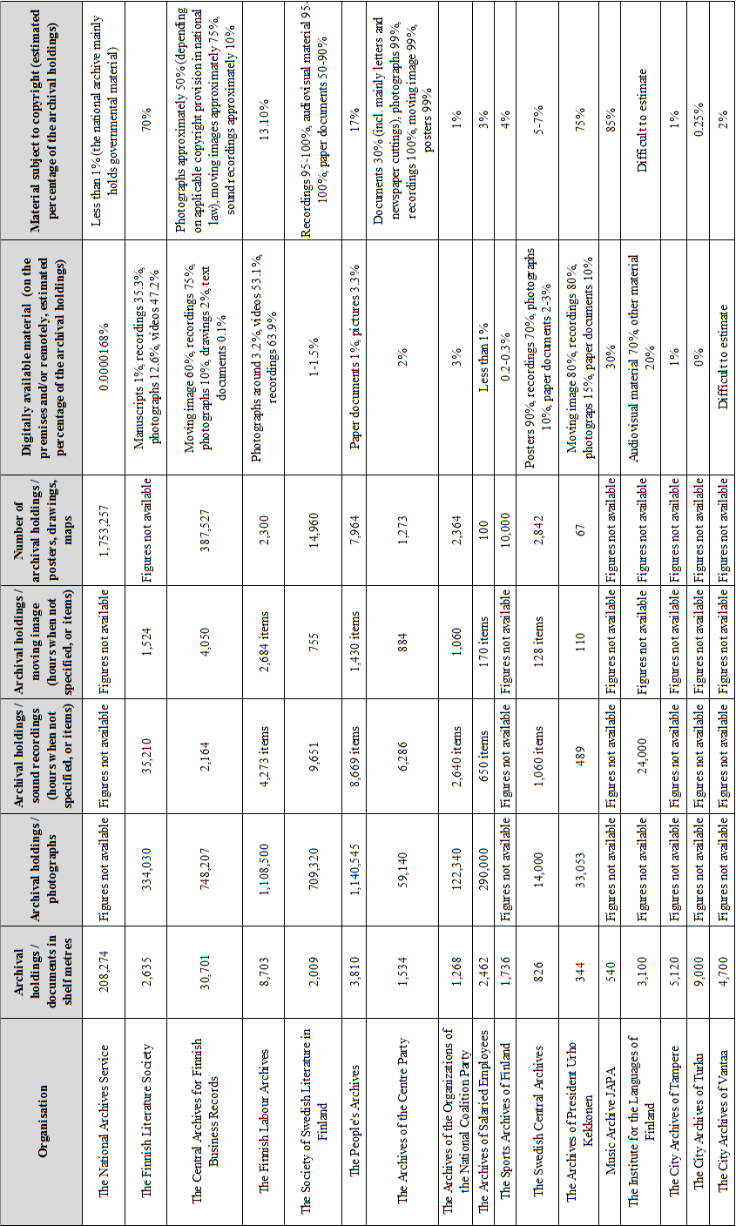

|  |  |  |
| --- | --- | --- |
| **Institution** | **Figures** | **Sources[8]** |
| Bavarian State Library (DE) | In 2014 the library had 10,222,000 volumes in its collection, of which 160,000 were added in that year only. Its music department holds approximately 388,000 scores, 40,000 manuscripts, 92,000 sound carriers and 164,000 between books and periodicals on music and is the guardian of about 303 musician archives. The book collection of its Eastern Europe department amounted to about 890,000 volumes in 2005 and acquires approximately 15,000 titles in Eastern European languages every year. Its picture archives include some 140,000 pictures. Its map collection includes approximately 400,000 sheets.  In February 2016, the volume of its digitised objects was 629 terabytes | Website of the library (Bayerische Staatsbibliothek), last accessed on 04/03/2016  Website of the Münchener DigitalisierungsZentrum, last accessed on 04/03/2016 |
| Library of the Institute of Slavic and Baltic Philology of the Eötvös Loránd University (HU) | The library has 68,175 volumes and covers books, as well as periodicals and student dissertations. | Website of the library last accessed on 17/06/2016 |
| National Library of Sweden | The library holds 18 million items, equivalent to 140,000 linear metres of shelving, as well as 8 million hours of audio and audio-visual materials. | Website of the library last accessed on 09/07/2015 |
| British Library (UK) | The library estimates its holdings in between 150 and 200 million items, growing of some 0.8 kilometres of new items every month. The Sound Archive of the library has approximately 6.5 million sound recordings, growing by approximately 4,000 a month. Digital content stored in the long-term digital library system is estimated at 280 terabytes, or 11,500,000 items, including 2 billion pages of UK web content. This is expected to increase to approximately 5 petabytes by 2020. | British Library, "Living Knowledge: the British Library 2015-2023", September 2015  British Library, "Digital Preservation Strategy 2013-2016", March 2013  Website of the library last accessed on 23/05/2016 |
| Museum of Modern Art in Vienna (MUMOK, AT) | The museum has an image database of approximately 9,000 objects and 130,000 images, and an online collection completed in 2012 that counts 4,643 objects and 9,500 images of works from the 20th and 21st centuries. | AT 2015-2013 national report on the implementation of the Commission Recommendation on Digitisation and Online Accessibility of Cultural Material and Digital Preservation |
| Fashion Museum of the Province of Antwerp (MoMu, BE) | The museum's collections include:   * a 'core' collection of approximately 25,000 garments, of which about one third is estimated to be in-copyright, one third orphan, and one third in the public domain; * an archival collection of approximately 300 shelf metres, of which about a third is estimated to be in copyright; * a documentation collection of approximately 50 shelf metres (including items like photos, cards, press clippings, folders and flyers) which is estimated to be in-copyright. | R.Peters – L. Kalshoven, "Europeana Factsheet. What rights clearance looks like for Cultural Heritage Organisations – 10 case studies", Europeana Factsheet, 23 June 2016 |
| Nordic Museum (Nordiska Museet, SE) | The museum holds approximately 250,000 books and journals and 6 million photographs, of which roughly 10-15 % is considered to be still protected by copyright belonging to external right holders (the museum does not hold the rights). Part of these collections are 7,000 press photographs of the archive of publishing house Saxon & Lindström. The museum's archival holdings amount to 4,500 shelf metres. | Website of the museum last accessed 17/05/2016  R.Peters – L. Kalshoven, "Europeana Factsheet. What rights clearance looks like for Cultural Heritage Organisations – 10 case studies", Europeana Factsheet, 23 June 2016 |
| Victoria and Albert Museum (UK) | The museum holds more than 2.5 million objects. | R.Peters – L. Kalshoven, "Europeana Factsheet. What rights clearance looks like for Cultural Heritage Organisations – 10 case studies", Europeana Factsheet, 23 June 2016 |
| State Archive of Cyprus | Records amount to 11,526,000 linear metres of shelving. | Information provided by the State Archive of CY |
| German Federal Archives | The archives hold approximately 11 million pictures. | Information provided by the DE Federal Archive |
| National Archives of Denmark | The archive holds 107,287 archives, and in total they contain 4,564,034 items (boxes or volumes) (2015). | Information provided by the National Archive of DK |
| Netherlands Institute for Sound and Vision | It is estimated that the institute's archives, which also comprise the NL public broadcasters' archive, contain on million hours of audio-visual material and three million items of non-AV materials, including photographs. | R.Peters – L. Kalshoven, "Europeana Factsheet. What rights clearance looks like for Cultural Heritage Organisations – 10 case studies", Europeana Factsheet, 23 June 2016 |
| Czech National Film Archive | The film archive holds150 million metres of film, more than half a million photographs, over 30,000 posters, 134,000 items of promotional materials, in addition to other archival materials and a film library. | Website of the archive last accessed 17/06/2016. |
| International Institute of Social History (NL) | The collections of the institute include about 1 million printed volumes and 400 archives. They include 713,547 prints and drawings, 129,901 posters and 570, 956 photos, in addition to a range of ephemera. | Website of the institute last accessed 18/05/2016  R.Peters – L. Kalshoven, "Europeana Factsheet. What rights clearance looks like for Cultural Heritage Organisations – 10 case studies", Europeana Factsheet, 23 June 2016 |
| Cultural Heritage Institute of Spain | The photographic archive of the institute includes more than 700,000 items. Its library holds 40,000 books and more than 1,600 magazine titles. | Website of the institute last accessed on 25/05/2016. |

***Aggregators***

Heritage content aggregators are service organisations that collect content metadata from several CHIs so that they are available online at a single access point. According to the "Report on the Implementation of Commission Recommendation 2011/711/EU" prepared by the European Commission in 2014, 24 MS had at least one national aggregator. Aggregators can cover all domains or specific ones (e.g. written cultural heritage). Examples of cross-domain aggregators include Kulturpool in AT, the Deutsche Digitale Bibliothek in DE, Hispana in ES, Culture.fr in FR, the "Hrvatska kulturna baština" portal in HR, CulturaItalia in IT, Letonica in LT, Polona in PL.

Aggregators with a European scope also exist, notably Europeana, covering all types of works and cultural heritage items, but also more specific ones like the Archives Portal Europe and he European Film Gateway.

## Annex 9B – Copyright and digitisation

The term 'digitisation', particularly in the phrase 'mass digitisation' is commonly used to describe both the analogue-to-digital reproduction (or creation of 'surrogates') of original works *and* the making available of the digitised copy through digital networks, for instance on Internet pages, portals and aggregators (see Annex 9A for a definition of aggregators). In other words, in this meaning the term encompasses the broader "set of management and technical processes and activities by which material is selected, processed, converted from analogue to digital format, described, stored, preserved and distributed".[9] 'Digitisation' can however also be used to refer to the reproduction/conversion (analogue to digital) only. This is the case when digitisation is done for preservation purposes. It should be noted that digitisation does not encompass *all* preservation activities, nor is digitisation carried out only or mainly for preservation or intended to replace the preservation of physical objects in their original form.

Digitisation involves acts that are relevant for copyright purposes as they involve certain rights, notably the reproduction and making available rights. Clearing these rights in order to carry out digitisation activities can imply varying costs.

Copyright-related aspects are however only one element of digitisation activities. Particularly, the *costs* of digitisation are attributable to a wide set of factors that go beyond the transaction costs associated to the identification of the copyright status of a given work, copyright clearance with right holders and the payment of licence fees, where applicable. Other costs include, for example, those related to the selection of materials, scanning, the creation of metadata, ongoing preservation, maintenance of web servers, user outreach and support, training, management costs etc. According to a 2014 survey of cultural heritage institutions,[10] copyright clearance is estimated to account on average for 3% of the costs of setting up a digital collection by CHIs (as part of "incidental costs" that also include analogue to digital conversions, which take up 37% of expenditure, and metadata creation, estimated at 19%). Licences account for 8% of "structural costs" (those related to the ensuing maintenance, enhancement and preservation of a digital collection). These data do not distinguish between works covered by copyright and those that are not, and therefore, if in-copyright collections only were considered, the relative weight of copyright-related costs could be higher. It is also estimated that, beside digitisation intended as a conversion of works from analogue to digital, the long-term preservation and the provision of access to the digitised works can cost 10 to 100 % of the initial cost of creating the digital object.[11] The actual mass digitisation of European heritage and its digital preservation therefore depends on this mix of factors, where the availability of sufficient funding also plays a major role.

Copyright-related issues can however still be a *defining factor* in the decision and/or the possibility by CHIs to proceed with digitisation projects at all, as often reported by institutional respondents in the public consultation,[12] depending on their relative weight. Such relative weight can be very high when individual transactions (a single licence) are the rule and cover only one work or a limited number of works. In these cases, transaction costs can be high compared to the number of concerned works in a given collection, affecting digitisation activities.[13] For example, film heritage institutions indicate that, apart from funding, the other obstacle to the digitisation of film collection is the high financial and human resources for clearing rights.[14]

## Annex 9C – The '20th century black hole'

The term '20th century black hole' is used to designate the relatively low level of works from the 20th century in digital collections of CHIs available to the public online, if compared to works from other centuries. The notion can apply to both individual institutions and aggregators. Such situation can be the result of various factors and no direct causal relation between copyright rules and the '20th century back hole' has been clearly established. The '20th century black hole' is however referred to as a possible illustration of the difficulties CHIs have in clearing copyright as copyright-protected works are also the most recent one in collections that spans centuries (for authors' rights, in the EU copyright extends to the life of the author plus 70 years).

The most recent exercise to capture the '20th century black hole' was made by the Europeana Foundation, based on a sample of 6,223,992 digital items out of the approximately 45 million present in Europeana[15] at the moment of the calculation. This is illustrated in the graph and table below.

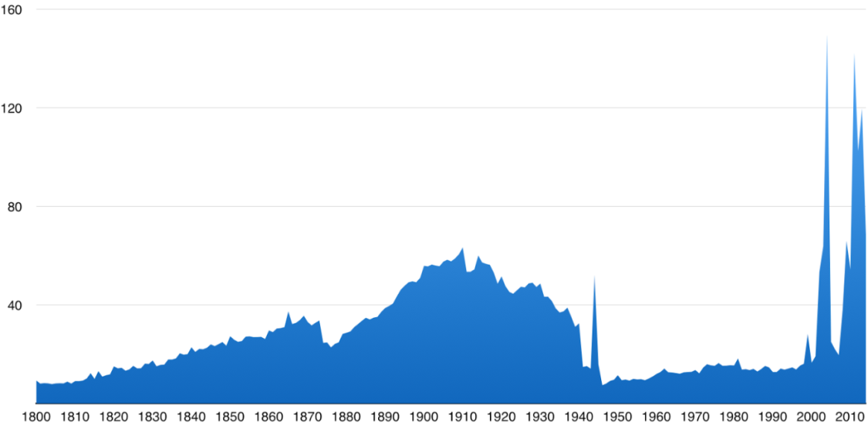

*X-axis = year Y-axis = thousands of works*

(source of graph: Europeana.pro website - available under a CC0 licence)

The distribution of the digital object in the sample across historical periods is reported in the table below:

|  |  |  |
| --- | --- | --- |
| **Time period** | **Number of objects** | **Percentage** |
| 1st half (1800-1849) | 747,741 | 12.01% |
| 2nd half (1850-1899) | 1,656,069 | 26.61% |
| 1st half (1900-1949): | 2,179,361 | 35.02% |
| **2nd half (1949-1999)** | **680,084** | **10.93%** |
| 21st century | 960,737 | 15.43% |

At institutional level, data available on the collection of digitised books from the Bavarian State Library also indicates a relatively low number of digitised books from the 20th century compared to previous ones, as illustrated in the table below. [16]

***Sound recordings and audiovisual works in digital collections***

The low level of audio and audio-visual works in online digital collections, compared to other works, is also often mentioned as an illustration of the under-representation of in-copyright works in those collections. This is based on the assumption that audio and audio-visual recordings are a recent production (dating back to the 20th and 19th century at the earliest). In this case too, no direct causal relation with copyright rules can be established in this Impact Assessment.

According to data provided by Europeana, the representation of sound and video-based works is relatively low compared to the total in the Europeana online collection, as illustrated by the following graphs referring to Europeana in general and broken-down per MS of origin:[17]

## Annex 9D – Transaction costs in individual rights clearance – estimates and examples

***Nature and availability of data***

While data on the overall costs of mass digitisation, at aggregated or project level, have been available for the purposes of this impact assessment, data specific to the *transaction costs* related to copyright clearance in the context of preservation or mass digitisation activities is more scarce, often anecdotal or specific to particular projects or circumstances. When available, data generally refer to the time required for copyright clearance (e.g. person-hours), and less frequently to costs expressed in monetary terms. Differences apply to different cultural sectors (print, sound, cinema and audio-visual, visual arts etc.) making available data unsuitable for comparisons or aggregation.

The figures provided below should therefore be used with caution, to the extent that they are samples of an identified problem and are particular to individual MS (for example as regards personnel costs, average salaries, the available administrative infrastructure available to CHIs etc.), projects and types of works. The financial equivalent of values expressed as time (e.g. person-hours) is in some cases the result of estimations made by the Commission's services for illustrative purposes, and should be treated and quoted as such.

Data included below generally refers to digitisation projects whose objective is the making available of works, in addition to the creation of a digital object starting from an analogue format. They were mainly provided by CHIs.

***Transaction costs***

Individual licensing is meant here as clearing the rights of one or several works whose rights are owned by the same right holder. For the purposes of this document, rights clearance is intended as starting after that the CHI has selected the works in its collection to be digitised and made available to the public, and generally requires the following steps:

1. Determining the copyright status of the works: public domain, in-copyright or unknown copyright status.
2. Identifying and locating the right holders.
3. Contacting the right holders.
4. Asking for permission/negotiating with right holders.

All these steps involve 'transaction costs', i.e. costs incurred by the parties in pursuing an economic exchange, except from the agreed price (we use the expression transaction costs even for those cases where a successful rights clearance process does not give rise to any licence fee payment but only to a right holder's authorisation to use the work). Although in the case of transactions to be agreed upon between an institution and the relevant right holders these costs are mostly attributed to the institution, the rights clearance process may also give rise to costs on the side of the right holder (e.g. to reply to institutions' requests). The costs related to steps 1 and 2 are commonly referred to as "identification" or "search" costs, while those resulting from steps 3 and 4 may be called "negotiation" or "bargaining" costs.

In the case of digitisation projects by CHIs, given the nature of the works involved, these transaction costs may become high enough to erode the gains that can be obtained through the transaction, and by far exceed the value of the use for the user or the available or allocated budget. This could result in the prospective licensee not even starting the transaction process or the transaction not coming to a conclusion with transaction costs already incurred becoming sunk costs (i.e. non recoverable).[18] Some CHIs having resorted to individual rights clearance in tests or individual projects indicated to the Commission's services that the incurred transaction costs preclude such approach being adopted as ongoing practice.

"Identification costs" can be reduced by technology-based tools that automate the diligent search that is required to establish the copyright status of a work and find its right holders (and those who can issue licences on their behalf). Existing tools, notably ARROW, have proven to be useful in reducing the time it takes to do that (see Annex 9I below).

***Estimations and examples***

*Printed works*

A study on individual rights clearance of printed works held in the British Library[19] (hereinafter: **'the BL study'**), including the transaction costs associated with it, based on a sample of 140 books, resulted in an average of **4 hours per book** to perform steps 1 to 4 as described above. This figure results from considering all works of the sample used in the study, even in those cases where not all the four steps were needed (e.g. because after step 1 it was clear that the work was in the public domain). Where every step had to be taken, clearance took an average of **5 hours and 56 minutes for each book**. It should be noted that these calculations refer to rights clearance carried out 'manually'. The study showed that by using the ARROW system it would take approximately 5 minutes per book to obtain rights information (e.g. copyright status, in or out-of-commerce, right holders and licensing CMO, where available).

An indicative estimation of the financial cost equivalent to the time spent for individual rights clearance as per the study above can be obtained by taking into account the average hourly personnel costs for the staff that is assumed to be in charge of rights clearance in relevant institutions. As the data used in the study refers to the UK, we take here as a proxy for those personnel costs the average hourly earnings for librarians, archivists and related professionals as used by the UK government in its impact assessment on a "Copyright exception for archiving and preservation", carried out in 2012.[20] That figure amounted to GBP 13.21 in 2011. Assuming an uplift of 16% to account for overheads, as per the UK impact assessment, the cost per hour in the UK can be assumed for the purposes of this assessment to be GBP 15.32, which equals to approximately EUR 17.62 according to the average official exchange rate in 2011.[21] Taking the BL study average as a basis (4 hours and 5 hours and 56 minutes, i.e. 5.93 hours, to clear the rights of a book, in the two scenarios), an estimate of the cost of clearing the rights of a single book in this case study can be roughly estimated to be as high as **EUR 70.48 per book on average and 104.49 per book when all the steps had to be taken** (4 hours or 5.93 hours x EUR 17.62). This calculation does not take into account the reduction in identification costs that can be brought about by the ARROW system (ARROW is not available in all MS and can only be used for books).

The **Wellcome Library** in the UK engaged in a project to digitise and make available books published between 1850 and 1990 and other materials related to the history of genetics. 987 of the initial list of candidate books were made available after a rights clearance process that also identified in-commerce works (excluded from the project) and works that were out-of commerce. The overall rights clearance costs, which also included fees paid to collecting societies for support in identifying rights, were estimated at an approximate total of **GBP 45,000, i.e. around GBP 46 or EUR 52.90 per each work made available**.[22] The Wellcome Library concluded that the type of rights clearance used in this project "is not scalable".[23]

*Sound recordings*

The **British Library** carried out a digitisation project concerning 45,000 sound recordings for its "Sound Archive Project". The reported cost was of **4,300 person-hours**.[24]

*Visual works*

**ANLux**, the national archives of Luxembourg, engaged in a project to make available 7,263 photographs dating back to the 1950s to 1970s from the collection of a government department charged with the touristic and economic promotion of the country.[25] ANLux reported[26] that, except from well-known national professional photographers, the rights clearance process was very time-demanding and that it can be estimated at approximately 1.5 person-day per author (photographer), even though all right holders were Luxembourgish. This amounts in total to approximately **33 person-days** for only 22 photographers involved. Taking as a reference an average archivist salary for LU of approximately EUR 43.25 per hour[27] and an average of 8.16 hours worked per day[28], this amounts to a total cost of approximately EUR 11,645, **or EUR 529 per author, EUR 1.60 per photo in the initial set of selected photograph and 1.78 per photograph made available** (ANLux ultimately made available 6,544 photos out of 7,263). More than 90% of the right holders agreed to the digitisation and making available of the works free of charge. The individual licensing of the photographs took 2-3 years on its own and the project, started originally in 2004, was completed only in 2015. ANLux reported that the making available of the online photo exhibition resulted in a peak of visits at their website, confirming an interest from the public, but given the high transaction costs they would not be likely to venture in a similar project in the lack of a collective licensing opportunity.

The **NL-based International Institute of Social History (IISH)** asked an external service provider for an estimation of the cost of clearing rights to make available online 20,799 photos in its collection whose photographers (253 in total) were known.[29] The estimation provided (excluding licence fees) was EUR 15,000, equating to approximately **EUR 60 per single photographer** and **EUR 0.70 per picture**. The IISH described this cost as seemingly "proportionate" but still "prohibitive". The IISH estimated an overall cost per picture also including further administrative work to be done after the rights clearance process to publish the photo online at approximately **EUR 1.40 per picture**.

The photographs selected for the estimation were those of individual photographers for whom the IISH held at least 10 pictures in their collections, distributed as follows, depending on the number of photographs present in the institute's archives for each photographer:

|  |  |  |
| --- | --- | --- |
| Photographs whose author is known but not necessarily the right holder | | |
| Number of photos of each author | Number of authors | Total items |
| 1 | 2,306 | 2,308 |
| 2 to 9 | 1,347 | 4,582 |
| 10 to 19 | 128 | 1,744 |
| 21 to 49 | 72 | 2,176 |
| 50+ | 53 | 16,859 |
| **TOTAL** | **3,906** | **27,669** |

More generally, the IISH indicates that a rough estimate of for rights clearance of works in general in its holdings would be **EUR 10** per item.[30]

The **Victoria and Albert Museum (V&A)** engaged in a project to digitise and make available a collection of protest posters from the 20th century. The museum estimated that it took 546 working hours / 78 working days to identify right holders, where possible, and clear rights for 1,189 posters, requiring 1,913 enquiries to individual right holders due to multiple right holders in a single poster in certain cases. At a cost of GBP 10.50 per hour, the total transaction costs are estimated at approximately **GBP 5,733** or **GBP 4.82 / EUR 5.69[31] per work if all concerned works in the collection are considered and GBP 12.52 / EUR 14.77[32] per work if only the 458 posters for which they received explicit authorisation are considered**.[33]

Another example is a digitisation project carried out by the **Wellcome Library** in the UK of posters used in AIDS awareness campaigns. Even though the posters were quite recent (1980s), the transaction costs linked to the rights clearance concerning 1,400 works reached **EUR 70,000** or an average of **EUR 50 per poster**.[34]

*Audio-visual works*

The **Netherlands Institute for Sound and Vision (NISV)** cleared rights on an individual basis for a collection of 6,700 short films made by non-professionals and created between the '10s and '80s of the 20th century, with a view to making them available online on the Amateurfilm Platform (a joint initiative with two other NL archival organisations). Rights clearing was considered necessary also for those works whose rights had already been transferred to the person who had put together the collection and had donated it to the NISV, as such transfer had occurred in the pre-internet era. The rights clearance process lasted about 2 and a half years, resulting in the making available online of 1,410 of the films, by 42 authors. NISV personnel spent approximately 200 hours in legal tasks related to contracts and another 800 hours in project management and rights clearance. The total cost of such work, excluding the initial elaboration of a rights clearance strategy, is estimated at **EUR 37,634**, excluding other costs like a licence with a CMO for cases where films included music and costs related to the organisation of information days for right holders and other 'community building' activities. This equates to approximately **EUR 26.70 per short film made available**.[35]

*Various types of works*

The **German National Library** (**DNB**, *Deutsche National Bibliothek)* made a broad estimation of the transaction costs involved in five projects for the digitisation and making available of approximately 25,800 items in its collections. These case studies refer to works that were determined to be in the public domain or, in a number of cases, in copyright but out-of-commerce, and eligible for licences also covering the rights of right holders not represented in the licensor CMO.[36] The estimated transaction costs mainly refer to the determination of the public-domain/in-copyright status of works, the determination (for copyright works) of their eligibility for the above mentioned collective licensing system, and obtaining such licence from a CMO in 500 cases. They therefore don't include costs for locating and contacting individual right holders and negotiating with each of them individually, as such cost was not incurred by the DNB (the institution decided to focus on public domain works or those that can be eligible for the collective licensing system mentioned above, which is based on a presumption of representation allowing CMOs, in certain specific cases, to also issue licences on behalf of non-represented right holders). The estimated transaction cost (excluding licence fees) was **EUR 7.47** on average per item made available. For works eligible to the out-of-commerce licensing mechanism, a EUR 1, one-off registration fee per item must be added; in the case at hand, this concerned 500 items.

The five projects covered the following items, for a total of 25,761 of them:

|  |  |  |
| --- | --- | --- |
| **Project** | **Number of items** | **Type of works** |
| 1 | 22,275 | Monographs about the German Exiles dating back to the 1930-1950s |
| 2 | 1,500 | Objects related to the 1st World War (including monographs, brochures, flyers, posters) |
| 3 | 500 | Legal text-based works (mainly books and journals) dated 1900 or later |
| 4 | 863 | Legal texts and commentaries, dated 1900 or later |
| 5 | 623 | Shellac records and wax cylinders from 1900 to 1960 |
| **TOTAL** | 25,761 | - |

The DBN estimated that approximately **3,000 person-hours** were needed to clear rights for all these collections, at a cost of EUR 64 per person per hour (including overheads but excluding assistance from the library's internal legal department).[37]

|  |
| --- |
| ***Summary of results of the case studies***  Overview of estimated transaction costs for rights clearance based on the above case studies:   * EUR 53 and 104 per single book * EUR 0.70 and EUR 1.70 per single photograph * EUR 5.70 and EUR 50 for a single poster * EUR 26.70 for a single short amateur movie * EUR 7.45 (in a project that also uses a collective licensing system allowing for licences covering the rights of non-represented right holders) and EUR 10 for mixed collections.   **Important notice:** these figures are case-specific and are calculated using different methods and assumptions (e.g. cost per item in the initial set of works vs. cost per actual work made available, clearance work carried out in-house vs. uses of external service providers, number of steps required, reference wage values used, different criteria for the selection of initial set of works etc.). They should therefore not be compared, or considered and quoted as having general validity. |

## Annex 9E – ECL and PoR: overview, national examples and evidence of opt-out levels

***Legal mechanisms allowing for collective licences to apply to works and other subject matter of right holders who are not members of the licensing collective management organisation (CMO)***

**Extended Collective Licensing (ECL)** and **Presumptions of Representations (PoR)** are legal techniques allowing for collective licences to apply to works and other subject matter of right holders who are not members of the licensing collective management organisationused in some MS for the licensing of works in high volumes and low individual value, where the conclusion of individual transactions would be too burdensome and costly in terms of transaction costs to be incurred by the parties (e.g. photocopying in schools).

Under **ECL** mechanisms, theeffectsof freely negotiated licensing agreements between a user and a CMO, which represents its own members, can be extended by operation of the national law to the non-members of the CMO. This mechanism has been regularly used in some members of the European Economic Area (SE, FI, DK, NO and IS) since the 1960s, and has been more recently introduced in other EU MS.

Under a **PoR**, a legal fiction establishes that the CMO is deemed to represent the interests and rights of non-members, pursuant to the relevant provisions under national law. In this case, the extended effect does not apply to the licence itself, but to the CMO's mandate. As a result, the CMO would be able to provide a licence which would cover works and other protected subject-matter whose rights are owned by its members, as well as by non-members, in the areas of application, to the extent, and under the conditions allowed by national law.

Both mechanisms generally include some core principles to offer safeguards for the protection of the interests of the outsiders. These are:

1. **Sufficient representativeness of the licensor CMO**, i.e. the requirement that the negotiating CMO is representative of a significant number of right holders in a given sector or type of works and for a given use. The fulfilment of this requirement must in some cases be formally acknowledged via an authorisation by a competent public authority, as part of government authorisation procedures where foreseen in national law.
2. **Explicit possibility for non-members to continue managing their rights individually (opt-out)**: non-members should normally have the right to opt out of ECL or PoR schemes and measures are often foreseen, including **transparency/publicity** procedures, so that sufficient information is available to them. In some cases, for example in certain schemes for the use of OOC works by CHIs, concerned works have to be encoded in public registers leaving time to right holders to have them withdrawn (this gives users to have certainty on what works or other protected subject-matter are excluded from the extended effect of the licence).
3. **Equal treatment between represented and non-represented right holders**: if they do not opt out, non-members are entitled to receive remuneration for the use of their works, as per the agreed licence and under the same rules that apply to members, in furtherance of the general principle of non-discrimination.

In addition to these, national legislation on ECL or PoR can also include additional elements, for example as regards proof required to the CMOs of them abiding by certain governance and transparency requirements, mediation, arbitration or legal procedures intervening in case the parties disagree on the terms and conditions of the licence being negotiated, opt-outs for members etc.

***Examples of existing EEA Member State legislation providing for extended collective licensing or presumptions of representation for collective management organisations (CMOs) applicable to the digitisation and dissemination of out-of-commerce (OOC) works by cultural heritage institutions (CHIs)***

The following list[38] illustrates some of the existing legislation in MS providing for collective licences that also cover the rights of right holders who are not members of the CMO that issued the licence. It covers provisions that can be used for licences for the digitisation and dissemination to the general public of full OOC works by CHIs, either because they specifically cater for that use, or because they have a broader scope that encompasses it (collections of works in CHIs irrespective of whether they are OOC, or general mechanisms). Additional specificities may apply nationally that are not covered here.

|  |
| --- |
| Key:  ECL = extended collective licensing mechanism  PoR = presumption of representation mechanism |

**DK** – General ECL provision (use or sector is not defined in law) which can be applied to the digitisation and dissemination of works in CHI collection, upon Government approval of the scheme.

**FI** – Specific ECL provision for the reproduction and communication to the public, including making available, of works in the collection of archives, and libraries or museums open to the public, irrespective of whether the works are OOC.

**SE** – Specific ECL provision covering the reproduction and making available by certain libraries and archives of works (irrespective of whether they are OOC) contained in their collections, and general ECL provision that can be used for CHIs other than libraries and archives.

**DE** – Specific PoR provision for OOC books, journals, newspapers or other writings published before 01/01/1966 (and embedded images) in the collections of publicly accessible libraries, educational establishments, museums, archives and film or audio heritage institutions. Works can be licensed through this mechanism if they are listed in an OOC works register managed by the federal Patent and Trademark Office. Works are inserted in the list if, after an initial proposal for insertion by a cultural institution, no right holder has objected within 6 weeks. Right holders can also opt their works out at any time later through the Patent and Trademark Office or the concerned CMO.

**SK** – ECL mechanism applicable to various uses including the reproduction, making available and distribution of OOC works. The representative CMO is considered to be the one which directly (not on the basis of reciprocal agreements with another CMO) represents the biggest number of rightholders on the territory of the Slovak Republic and is indicated in the list of CMOs administered by Ministry of Culture. This broader provision (applicable to various uses) replaced a previous one that only applied to OOC literary works in written form in the collection of CHIs.

**PL** – Specific ECL provision for the reproduction and making available of books, newspapers, magazines or other forms of printed material published before 24/05/1994 in the collection of archives, educational institutions, universities, research institutes and cultural institutions. Works can be licensed through this mechanism if they are in a list published and administered by the Ministry of Culture and National Heritage, and no opt-out notification has been submitted by right holders to the CMO within 90 days of the registration.

**UK** – General ECL provision. The area of application is not defined in the law but CMOs need to obtain authorisation by the Government before operating a scheme. In order to be authorised for a maximum of 5 years, CMOs must demonstrate that they have procedures in place to allow outsiders to opt-out of the scheme including before the scheme commences.

**HU** – General ECL mechanism that can apply to OOC works. Collective management of rights is subject to registration by the government in general, ECL schemes can therefore be run only by registered CMOs.

**NO** – Specific ECL provision applicable to archives, libraries and museums for the reproduction and making available of works in their collections (irrespective of whether they are OOC), in addition to a general ECL provision.

***Data on opt-out levels***

In a licensing mechanism based on the PoR in DE as described above for OOC books, there was no objection by any rightholder. Licensing under this mechanism started in 2015. 1,442 books were licenced in 2015 and 2,419 in 2016 so far, with 18 libraries participating. [39]

In the ECL-based project Bokhylla, which allows the National Library of Norway to make available online books of Norwegian literature, including in-commerce ones, only approximately 3,700 book titles were subject of an opt-out, against 205,000 titles made available online (the first figure represents about 1.8% of the total titles made available).[40]

Very low opt-out rates were also reported to the UK Government by certain Scandinavian CMOs in the context of the UK's consideration of legislation introducing ECL provisions. In the same context, the Copyright Licensing Agency, which in the UK offers a blanket licence that the UK Government describes as similar to an ECL in nature, indicated that works excluded from the repertoire offered amount to 0.0007%.[41]

## Annex 9F – The existence of collective management structures by sector

Licensing mechanisms as described in Annex 9E require that, for the creative sector at stake, collective management of rights is possible and that at least one collective management body exists (or can be set up) that has or can obtain the required mandates and negotiate licences for the relevant uses. It also requires well-functioning CMOs.

The landscape of collective management across the EU is varied. Depending on the MS and sector, collective management is generally more or less used for exercising rights. At the current moment, CMOs can claim different levels of representativeness of entire sectors and do not necessarily hold, or are in the position to easily collect, the necessary mandates from right holders.

As regards **literary works** (as in books, journals and other written matter), CMOs are well developed and present across Europe. They represent a large part of right holders, particularly when it comes to secondary uses, and in many cases they deal specifically with uses in and by libraries (for example for reprography rights and the collection of the remuneration right attached to public library lending). It is in fact with CMOs in the literary sector that well-known existing collective licences for the digitisation and making available of CHIs holdings have been concluded.[42]

For **musical works** the CMO landscape is also well developed, with CMOs representing authors for most rights. In this sector, collective management is already common, although licences with CHIs related to heritage works are not yet frequent.As regards phonograms producers and performers in the music sector, CMOs are also well developed (often taking the form of joint producers-performers societies). They tend to deal with the management of forms of exploitation such as broadcasting, public performance and certain online uses such as simulcasting and some forms of webcasting.

In the **visual arts** field, collective management is available, but more widespread in certain MS than in others, and more developed for fine art than photography. Visual art and photography CMOs exist for example in all Nordic countries and in NL, but are absent in some other MS. Agreements between CHIs and CMOs, for the digitisation and making available of works online have already taken place.[43]

In the **audio-visual sector** (cinematographic works and other audio-visual works such as documentaries) collective management tends to be limited to remuneration rights for authors and performers (when they exist) and cable retransmission, although in certain MS CMOs also manage for authors such forms of exploitation as broadcasting, public performance and certain online uses such as on-demand services of broadcasters. This is an area where collective management plays a limited role.

The rights in **other works** that make up the collection of CHIs, including new types of works like videogames, are generally not managed collectively or come in shapes and forms that are not directly or obviously considered as falling within the types of works that existing CMOs manage traditionally.

## Annex 9G – Stakeholder co-operation (e.g. MoU) in the area of digitisation and making available of heritage

In addition to the appropriate collective management structure (see Annex 9F) the success of collective licensing, including with an extended effect, depends on the openness and willingness of stakeholders to support it as a mutually beneficial solution, or one that is anyway supported by right holders and users. This is why stakeholder dialogue and cooperation, leading for example to instruments like Memoranda of Understanding or model contracts, can be conducive to the establishment of the necessary conditions for collective licensing to take place and be successful.

For books and learned journals, in 2011 a Memorandum of Understanding (hereinafter: 'the 2011 MoU') was agreed – under the auspices of the Commission - between right holders and libraries to facilitate the clearance of the rights through collective management. It acknowledges the need that MS adopt legislative measures backing collective management schemes applying to all right holders in a particular category (including non-members). It foresees that sufficient safeguards are needed in terms of CMO representativeness, opt-out clauses, transparency obligations etc. The 2011 MoU, implementation is monitored by a task force of stakeholders.

This type of initiatives can:

(i) act as an incentive for relevant sectors to organise themselves so that collective licences can actually be negotiated (for example by setting up the necessary collective management infrastructure and mandating CMOs as appropriate);

(ii) assist in the practical negotiation and conclusion of those licences; and

(iii) identify those cases and MS where there is a need for a legislative solutions to support its implementation.

The "Licences for Europe" stakeholder dialogue convened by the Commission in 2013 resulted in a "Statement of Principles and Procedures for facilitating the digitisation of, access to and increased interest of European citizens in European cinematographic works".[44] The statement is however relevant for individual licensing transactions and is not per se of special assistance in mass digitisation contexts.

## Annex 9H – Illustration of the impacts of the three considered options for OOC

***Illustration of the practical impacts of the baseline scenario and the considered options through an hypothetical ideal case study***

*Baseline scenario*

A CHI (A) wishes to digitise and made available on its website a collection of 2,000 books related to a particular artistic movement. Another CHI (B) is willing to do the same for 1,000 self-standing drawings related to a certain scientific discipline. Both wish to give access across borders in the EU to the collections. The maximum monetary equivalent that each of these CHIs can devote to rights clearance work is EUR 10,000 (CHIs would not undertake the project at all beyond this ceiling). It is assumed that there are no orphan works in these collections and that not all the concerned right holders are represented in the relevant CMOs. It is also assumed that transaction costs for both kinds of works for the clearance of rights attached to the works are on average EUR 50 per work through individual licensing, and less than EUR 10,000 for obtaining a single licence through a single CMO for all the concerned works.

If resorting to individual rights clearance A and B would spend respectively EUR 100,000 and EUR 50,000 in resources for transaction costs (licence fees, if requested by right holders, would be on top) and would therefore not proceed with the project.

Under the status quo CHI A would have the possibility to see these transaction costs reduced to less than EUR 10,000 only in the small group of MS that already have provisions in their national laws allowing for CMOs to licence the rights of 'outsiders. CHI B would have this possibility in an even lower number of MS, i.e. those that have such mechanisms potentially covering all types of works (e.g. general ECL provisions), as in some MS these mechanisms are only available for books or print works. Outside of these cases, transaction costs would still be EUR 100,000 and EUR 50,000 respectively, and the projects would therefore not be taking place.

The possibilities for right holders to obtain licensing revenues and see their works digitised and made available (and therefore discoverable again) through the projects of CHI A and B would, accordingly, only exist in the same reduced group of MS. Even in these cases, the possibilities to make the works owned by outsiders available across borders in the EU based on a licence would not be possible for either CHI A or B.

*Option 1*

Under this option, CHI A would be able to proceed with its digitisation project, since the possibility to reduce its potentially high transaction costs (EUR 100,000) to below EUR 10,000 will be possible in all MS. CHI B would however still be in the position to see the same reduction of transaction costs (from EUR 50,000 to under EUR 10,000) only, again, in a small number of MS. In most MS the project would therefore not be undertaken.

Only the right holders of the book collection held by CHI A would have a new opportunity to see their works exploited and therefore obtain licensing revenue out of it irrespective of the MS. They would also be in the position to opt out of the scheme if they wish so (for example because they would like to exploit the work themselves at one point in the future). For the drawings collection of CHI B, these opportunities would only exist in a small number of MS, as under the baseline scenario.

Only CHI A would be in the position to make the books whose right holders are outsiders available across borders in the EU. For CHI B, this possibility would not even exist in those MS where transaction costs can be reduced to under the ceiling that allows for the project to be financially viable for it.

*Option 2*

As in Option 2, CHI A would be able to proceed with its digitisation project, since the possibility to reduce its potentially high transaction costs (EUR 100,000) to below EUR 10,000 would be possible in all MS.

CHI B would be able to do so in the short term in all MS where a CMO representing visual artists exists and has the right mandates, as the necessary legal framework would exist in all MS. The number of MS where such CMOs are available would possibly increase thanks to the stakeholder dialogues that the Commission would foster. In all these cases, CHI B would be in the position to negotiate licences in a way that transaction costs can be brought down to below EUR 10,000.

Relevant right holders for the book collection of CHI A would have a new opportunity to see their works exploited and therefore obtain licensing revenues potentially everywhere in the EU. The right holders of the drawings in the collection of CHI B would also have the same opportunity in all MS where a suitable licensing infrastructure exists. In all these cases, right holders would be in the position to object to the use of their work if they wish so.

Both CHIs A and B would be in the position to make their works whose right holders are outsiders available across borders in the EU, once a licence is concluded.

## Annex 9I – Technology for rights information for digitisation purposes

The EU, the creative industries and the user community have invested in technology-related innovation projects aimed to generate tools that allow obtaining rights information relevant for digitisation projects in a quicker and more accurate way. Their objective is to allow users, typically CHIs, to obtain information such as the copyright status of a work (in or out-of-copyright), whether it is orphan, its in- or out-of-commerce status, its right holders and available licensors in a quicker and more accurate way. This enables to reduce the time it takes to perform certain of the steps that right clearance processes involve. These tools and projects are at the moment either in a research and development phase (FORWARD, see below) or already established systems (ARROW). They are not concerned with the negotiation and issuing of licences and cannot, as such, be considered solutions to that part of the transaction cost issue explained under Annexes 9D and 9E, and to the outsider problem explained therein, at least to a substantial degree. It should also be noted that their geographical spread is not yet pan-European (although it potentially is) and that they are generally suitable for medium to large-scale projects.

***ARROW***

ARROW is a digital service infrastructure that can be used to facilitate libraries and other users in their diligent search for right information related to text-based works that are to be included in digitisation programmes. The ARROW rights information infrastructure (RII) links to and queries a network of data sources[45] and can deliver, in automated form, relevant information, including the copyright status of a given work (in or out-of copyright), its orphan work status, whether it is in- or out of commerce, its right holders, up to whether a collecting society can issue licences for the concerned work.

The infrastructure, born out of projects financed by the Competitiveness and innovation framework programme of the EU, was at the time the relevant projects ended available in 9 MS where the system is completely implemented, and at an advanced implementation stage in 7 additional MS.[46]

The ARROW system can be adapted to medium to large digitisation projects.

***FORWARD project***

The FORWARD project,[47] also funded by the Competitiveness and innovation framework programme of the European Union, aims to create a system for audiovisual content, particularly in the context of film heritage, and implement this system by linking to different rights information sources within a single infrastructure. The FORWARD system aims at significantly reducing the high transaction costs associated to rights clearance, relying on existing rights information sources; where they do not exist or are not available, cerain data might still need to be searched manually by users.

Once in place, the system would allow users to determine the copyright status of audiovisual works and whether they are orphan works. The system furthermore will log all requests and subsequently create a database of film rights.

## Annex 9J – Social and economic impacts of digitisation[48]

As a relatively recent phenomenon, the actual social and economic impact of digitisation[49] has not been conclusively studied and quantitative conclusions are hard to be drawn, particularly at EU level. The cultural heritage community and scholars that investigate digitisation as a research subject acknowledge that better evidence and analysis of impact is needed than is currently available, as opposed to a pure focus on outputs (e.g. number of digitised items, website visits, app use). They also often insist that such impact needs to be defined by indicators of value that are not uniquely economic.[50] Efforts are being made to that end, starting from the elaboration of appropriate assessment frameworks,[51] notably in the context of Europeana and its professional network.[52] This section includes the information that it was possible to collect on the impact of digitisation as considered reasonable for the purposes of this impact assessment.

The areas that are generally accepted as being affected the impacts of digitisation from a societal end economic point of view include the following:

*Public enjoyment, participation in society and community building*

Digitisation provides for new opportunities for individual members of the public or groups to engage with their heritage, for pure entertainment, personal study or research (e.g. on family history or local identities). Digital resources can also reinforce the sense of belonging to communities of all sizes and can be particularly important for geographically dispersed ones. The possibility to access heritage at a distance and under new formats can be crucial for the social inclusion of disadvantaged groups (e.g. people with disabilities, people that do not speak certain languages, people who live away from cultural institutions).[53] This kind of impact is frequently demonstrated at disaggregate level, through case studies or anecdotal evidence. A study carried out to determine the social economic value of continued investment in Europeana in 2015-2020 has however estimated the economic value of time spent on Europeana by the general public as ranging from EUR 1.5 to 2.2 million.[54] The value or effects of digitised resources from this perspective is sometimes described by expressions like 'existence and/or prestige value', 'community value', 'inheritance/bequest value',[55] 'usage value', 'option value', 'social value'.[56]

*Education and learning*

Digitised resources add to the sources that can be used in teaching and in learning environments more broadly. It is considered that digitised resources can open new perspectives to teaching (e.g. it can become a more exploratory or active process). Digitised heritage makes it easier to use audio and video materials and to combine formats in teaching environments, including in new e-learning tools.

*Scientific research and particularly research quality*

The availability of digitised heritage online allows new areas of research as richer research content becomes available in formats that can be analysed with newer techniques and under different perspectives. It is also generally understood that digitisation helps researcher focus less on data collection than on its analysis (for example because finding relevant terms or data in a single document does not require reading the whole document). In general, digitisation makes research on heritage materials more efficient, for example because it allows the immediate comparison of related documents that are physically held in dispersed collections (through 'virtual reunification').

*Direct economic opportunity*

In addition to the 'indirect' economic impact deriving from the social, educational and research impacts indicated above, the direct economic benefits of digitisation can generally be referred to two main areas:

* **Impact on the cultural industries**. Digitisation makes works discoverable again. When works are in copyright, digitisation can generate new revenue opportunities for concerned right holders, particularly when works are out-of-commerce and therefore no actual exploitation occurs otherwise. It occurs for example that old footage held by film heritage institutions is used for news reporting or in new film productions. Through its preservation potential, digitisation makes the life of works, and therefore this new exploitation potential, last longer. On the other end of the chain, digitisation helps cultural industries wanting to re-use previous material in discovering it in easier way, reducing their search costs and providing broader choice. These effects are enhanced by the presence of aggregators like Europeana and are typically associated to the notion of 'long tail'.
* **Impact on other industries**. The Comité de sages charged by the European Commission in 2010 to reflect on how to foster digitisation, online accessibility and preservation of cultural heritage in Europe identified three main areas where digitisation can boost employment and growth:[57]

1. Economic activity directly related to digitisation practices itself. This includes digitisation services, to which digitisation activities can be outsourced, and the production of the related machinery and software. The Report indicates that the process of digitisation, irrespective of its level of sophistication, is labour intensive and therefore a potential job creator.
2. Services and products emerging from digitised cultural content as a 'raw material'. Tourism, education and new technologies (for example mobile applications) are singled out as the areas where this effect could be more strongly felt. This area can partly overlap with the impact on cultural industries described above.

The study on the social economic value of continued investment in Europeana in 2015-2020 calculated the potential economic benefit on tourism as ranging from EUR 43.9 to 68.3 million.[58]

One particular area where economic benefits derive from the digitisation of heritage are festivals. It is for example estimated that that the city of Bologna benefited from more than EUR 1 million from the 2013 edition of its film heritage event "Il Cinema Ritrovato".[59]

1. Economic activity related to the storage, preservation and processing of digital material.

*Environmental benefits*

It is also generally assumed that the ability for researchers, the general public and end-users in general to access cultural heritage resources at a distance brings about environmental benefits deriving from reduced travel and the related environmental impact.

# ANNEX 10 – TEACHING

## Annex 10A – Development of digital and online education

**Use of digital works by educators and learners (at all education levels)**

The graph below illustrates the trends in certain MS as to the use of digital and non-digital works by educators and learners. **Both (digital and non-digital) types of works remain important, even if learners tend to slightly favour the use of digital works.**

Data come from an online survey of learners and educators carried out in 2015 (more than 2000 respondents from 9 MS).

*Source: Study 'Assessment of the impact of the European copyright framework on digitally-supported education and training practices'*



**Use of digital resources in secondary education**

The graphs below illustrate the use of digital tools and resources in schools in 2011/2012. It shows for example that **digital books or textbooks were used at least once a week by 33% of students in lower secondary schools (grade 8) and by 23% of students in upper secondary school (grade 11)**.

The data is based on a survey of students, teachers and head teachers realised in 2011/2012 (190.000 responses).

*Source: 'Survey of Schools: ICT in Education: benchmarking access, use and attitudes to technology in Europe’s schools, Final study report, February 2013[60]*

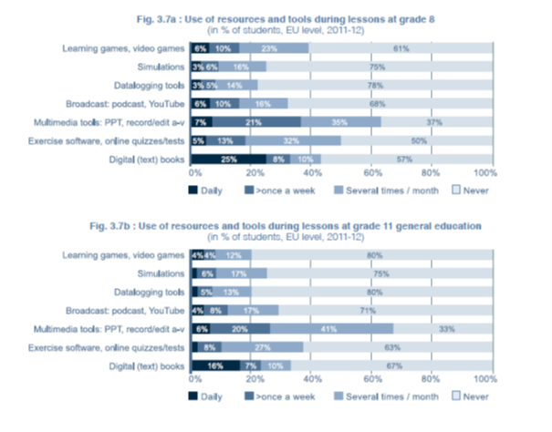

**E-learning higher education**

The figures below represent higher education institutions' replies to the 2013 survey on e-learning carried out by the European Universities Association on e-learning (249 participating higher education institutions). Main findings:

* **82% of institutions indicated that they offer online courses**
* **In 40% of the institutions at least half of the students are engaged in e-learning**
* **85% of institutions indicated that they use digital courseware** and **81% online repositories of educational material** (at least in some faculties).
* **50% of institutions indicated that they offer a personalised study portal to their students.**

*Source: 'E-learning in European higher education institutions, results of a mapping survey conducted in October-December 2013', European University Association[61]*

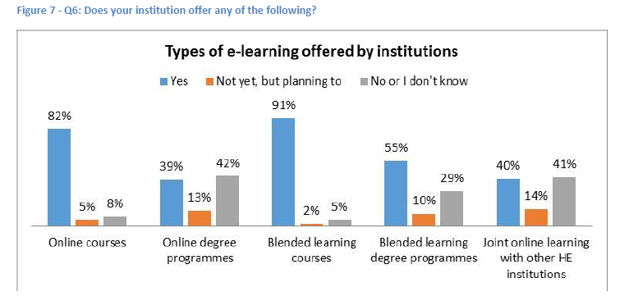

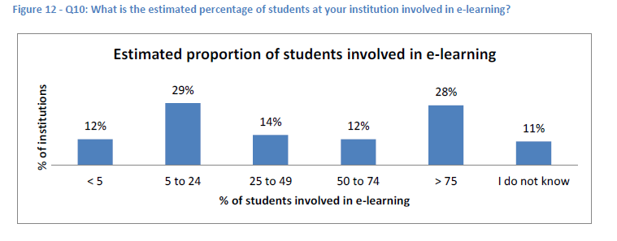

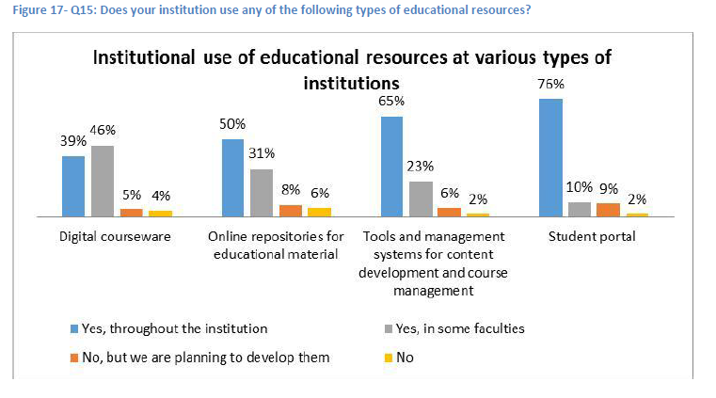

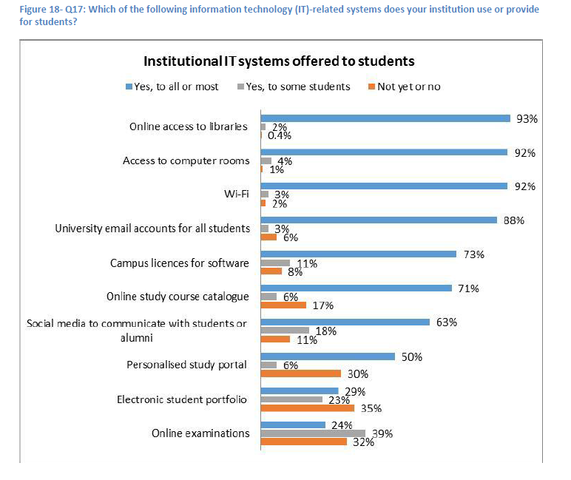

## Annex 10B – Perception of the copyright-related obstacles in education

*Source: Study 'Assessment of the impact of the European copyright framework on digitally-supported education and training practices',*

**Perceptions of copyright-related obstacles and consequences on teaching activities**

The figures presented below enable to identify the types of copyright-related restrictions encountered by educators and learners and the consequences on the use of illustrative content in teaching activities. Data come from an online survey of learners and educators carried out in 2015 (more than 2000 respondents from 9 MS).

**The obstacles most frequently reported by educators are related to legal uncertainty (34% of educators), cost of the licences (31%) and technological protection measures (31%). In most cases, educators facing these problems chose not to use protected content and/or to look for alternatives.**

Rates of reported restrictions with educational context

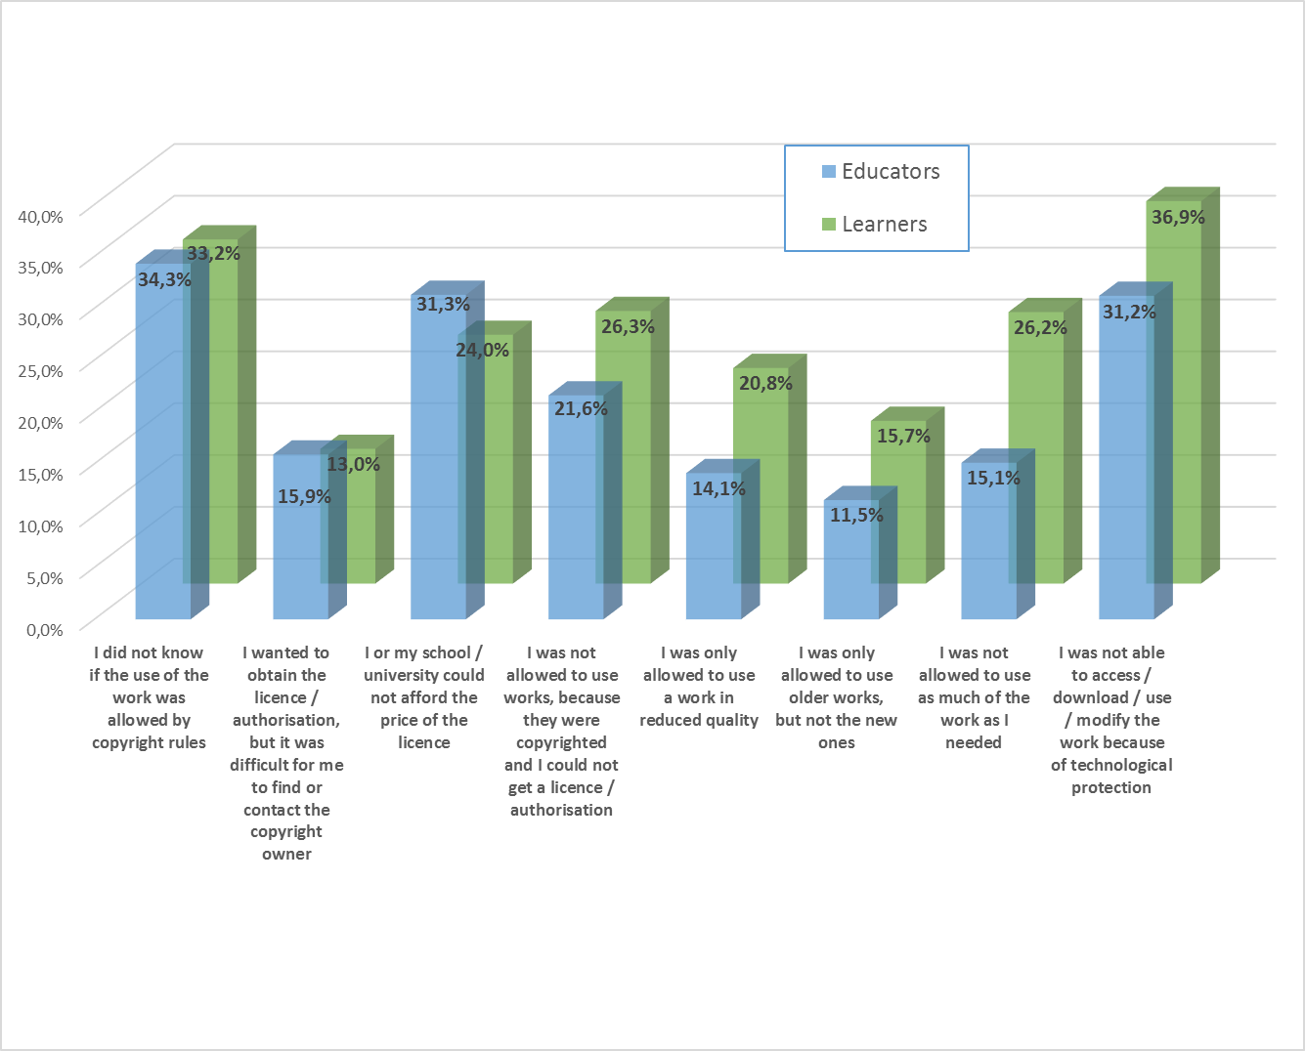

The impact of obstacles on activities of educators and learners

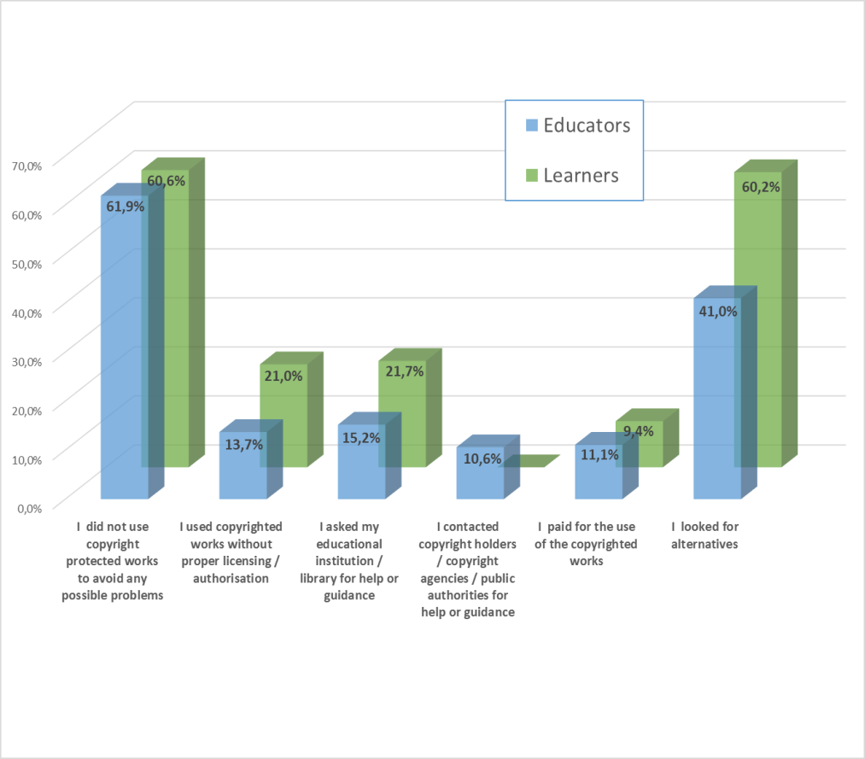

**Experience related to the access to and quality of protected content in digital education**

The following figures are based on a different online survey carried out in 2015 among stakeholders active the field of copyright in digitally supported education (about 500 respondents in 28 MS and Iceland, Norway, Lichtenstein), including both right holders and users and their representatives.[62]

**Users are rather critical regarding the access to protected works (about 62% of users finding it difficult to access and use protected works), but are more positive about the quality of these works (54% of users considering the quality of protected works is high).**

More than 60% of users find it difficult to access and use protected works





**Identification of cross-border problems**

**In addition to the lack of information on copyright rules in other countries, users report problems related to differences between national exceptions and to the limited scope of the licences.**

Cross-border related problems in the field of digitally supported education encountered by users of works and their representatives

**Perception of open licence works**



## Annex 10C – Compensation and Licensing schemes for educational uses

The use of protected content for teaching purposes is allowed under different types of agreements, compensation or licensing schemes in MS:

* In some cases, these agreements are directly linked to the teaching exception and their purpose is mainly to organise the compensation of right holders, where this is required in national laws (FR, DE, ES). Licensing schemes are also frequently used in those countries to complement the exception (allowing for additional uses, e.g. textbooks in FR and DE).
* In other MS (UK, IE), licensing schemes prevail over the teaching exception.
* Finally, certain MS do not have a teaching exception in their law but foresee extended collective licensing (ECL) for educational uses (DK, FI, SE).

This annex presents the main features of these compensation/licensing schemes in certain MS.

**Licensing/compensation schemes implementing and/or complementing the teaching exception**

**FRANCE**

Legislation

The teaching exception in France applies to uses in the digital learning environment, to the extent that access to protected content is limited to teachers and students. The exception allows the use of extracts of works only and does not apply to resources specifically intended for education (e.g. textbooks) and to sheet music. The French legislation foresees an obligation of compensation for right holders.

Agreements/licences

The Ministry of Education and Higher Education concluded a series of agreements with CMOs in order to apply the teaching exception and organise the compensation required by law as well as to complement the exception by covering additional uses and works (e.g. use of textbooks). These agreements apply to all educational establishments (primary, secondary, higher education). They are based on voluntary collective licensing and are organised by sector and types of works, as illustrated in the table below.

|  |  |  |  |
| --- | --- | --- | --- |
| **Sector/works** | **CMO** | **Scope / Permitted uses** | **Compensation / Remuneration** |
| **Print works** (incl. works of visual arts and print music)[63] | CFC, AVA, SEAM | Works covered  The agreement covers works from more than 2000 publishers and pictures from more than 100000 authors. Textbooks and sheet music, which are excluded from the scope of the teaching exception, are covered by this agreement.  The CFC website offers a search engine allowing educational establishments to identify the publishers, newspapers and authors (in the case of pictures) covered by the agreement.  Digital and online uses  The agreement allows the reproduction and making available of extracts of works through digital means in the classroom or through online means, via a secure electronic network (intranet/VLE) or via email to the extent it remains limited to teachers and pupils involved in the teaching activities.  The agreement does not cover the use of digital textbooks, unless these uses are explicitly allowed by the publishers.  Extent of copying  The agreement allows the use of extracts of works only (no quantitative limitation), except in the case of short works such as poems or visual art works for which entire works can be used.  The notion of "extract" is defined only for works which are not covered by the teaching exception in France, i.e. textbooks (e.g. max 4 consecutive pages and max 10% of a book) and sheet music (max 3 consecutive pages and max 10% of the work).  Cross-border uses: the agreement does not include any reference to cross-border uses but allows uses in the context of distance learning (CNED). | Remuneration to CFC (including for SEAM and SACD) and AVA: 1,700,000 € by year for 2014-2015 covering primary, secondary and higher education (1,437,000 to CFC and 263,000 to AVA). This covers only digital uses, allowed under the exception (compensation) + additional uses (remuneration for exclusive rights). |
| **AV and cinematographic works**[64] | PROCIREP | The agreement allows to show (in the teaching context) an entire film or documentary only if it is a recording of a broadcast (from free TV) and to use extracts of DVDs/ VODs (including the possibility to make these extracts available on secure electronic networks, up to 6 min). For using entire films, educational establishments must ask the authorisation to the right holders. The agreement excludes recreational uses. | Remuneration to PROCIREP: 150,000€ by year |
| **Musical works**[65] | SACEM | The agreement allows to perform or listen to an entire work in the classroom and to make extracts available on the intranet of educational establishments (max. 30s). | Remuneration to SACEM: 150,000€ by year |

**GERMANY**

Legislation

The teaching exception in Germany applies to uses in the digital learning environment, to the extent that access to protected content is limited to those taking part to teaching activities. The exception allows the use of limited parts of works or small scale works and does not apply to resources specifically intended for schools (e.g. textbooks) and to recently released cinematographic works. The German legislation foresees an obligation of compensation for right holders.

Agreement/ licences

There is a compensation scheme agreed between eight collecting societies (for audio, audiovisual, graphic) and higher education authorities for the uses of certain types of works under the teaching exception. However, negotiations for a framework agreement fixing the compensation due under the exception have failed so far for published works.

Regarding textbooks (which are excluded from the exception), a specific licensing agreement was reached between the Culture and Education Ministers of the Länder, the association of educational publishers and the collecting societies VG Wort, VG Bild-Kunst and VG Musikedition. Under this agreement teachers are allowed to copy protected content (10% of a given work up to a maximum of 20 pages can be copied). Digitisation of small extracts of works, digital distribution and storage on teachers' computers is included. Compensation is paid at Länder level.

**SPAIN**

Legislation

The Spanish legislation foresees a new exception (entry into force in November 2015) for universities and public research, allowing to use a chapter of a book or an article in a magazine or journal (around 10% of the whole work as a general rule) for the purpose of illustrating teaching or scientific research.[66] Online uses under internal secure networks accessible only by registered users are allowed. The legislation foresees that right holders have the right to equitable compensation for the uses allowed under this exception, subject to compulsory collective management.

Licences

CEDRO (Spanish CMO for authors of literary works and publishers) and VEGAP (CMO for visual artists) reached an agreement with Spanish universities in March 2016 in order to organise the compensation required by the new legislation. The amount of compensation to be distributed to right holders has been set up at €3 million / year.

**Licensing schemes prevailing over exceptions**

**UK**

Legislation

The UK legislation includes a fair dealing provision for illustration for instruction that cannot be overridden by contracts. In addition, the legislation foresees an exception, which is however subject to the availability of licences, for copying and use of extracts of works (as well as for the recording of broadcasts) by educational establishments.

Licences

From April 2014, the Department of Education provides licences from the following CMOs for all primary and secondary state-funded schools in England:

* Copyright Licensing Agency (CLA), for print and digital copyright content in books, journals and magazines
* Newspaper Licensing Agency (NLA), for newspapers and magazines
* Schools Printed Music Licence, for printed music
* Educational Recording Agency, for recording and use of copies of radio and television programmes
* Filmbank and Motion Picture Licensing Company, for showing of films

|  |  |
| --- | --- |
| **CLA/NLA licence[67]** | |
| **Works covered** | Type of works: print and digital books, journals, magazines, newspapers, printed music (for schools). The licence includes textbooks and academic books (including digital books).  Repertoire: The licence covers all published works, unless a right holder chooses to exclude their work/s (the percentage of excluded works is estimated to be 0.2% and the revenue collected and identified for works that have not been expressly mandated is 1% per year on average).  The CLA website offers an online search tool (also available as a mobile app) allowing educational establishments to check if a work is covered by the licence. |
| **Digital uses** | Digital uses and works are included in CLA licence: scanning, digital copying, making available of digital copies within a secure electronic network (including course packs). |
| **Extent of copying** | The licence allows the use of 5% of a work or one chapter of a book, one article of a serial publication, one short story or poem of max 10 pages from an anthology. |
| **Cross-border uses** | Cross-border uses by distance learners registered with UK higher education institutions are allowed (if works are accessed under secure electronic networks).  In addition, CLA is running a trial scheme (which would be an optional licence add-on) to cover students based at an overseas campus of a UK institution or a third-party organisation that a UK university is in partnership with. |
| **Remuneration** | In 2014/15 CLA collected £15.7m from schools, £5.8m from further education institutions and £13.9m from higher education institutions. Total: £35.4m. Photocopying representing 79% of this total and scanning and digital re-use 21%. |

**IRELAND**

Legislation

The Irish legislation includes a fair dealing provision for the purpose of research and private study, as well as exceptions allowing reprographic copying and recording of broadcasts and cable programmes by educational establishments.[68] However these exceptions do not apply if there is a certified licensing scheme covering the same uses. ICLA (Irish Copyright Licensing Agency) licensing scheme for educational uses is certified under a statutory instrument.

Licences

|  |  |
| --- | --- |
| **ICLA licence** | |
| **Works covered** | Type of works: Print and digital books, journals, magazines, and newspapers (under certain conditions). The licence does not cover printed music, workbooks, maps, charts. Photographs, illustrations and diagrams are only covered by the licence where they are integral to the text. The ICLA licence for schools also covers the rental of schoolbooks under Textbook Rental Schemes.  Repertoire: The licence covers all published works (published in Ireland or in countries covered by a reciprocal agreement), unless a right holder chooses to exclude their work/s. A list of excluded works is available on the ICLA website.  The repertoire varies according to the type of uses (photocopying, scanning and digital distribution, digital publications). |
| **Digital uses** | Digital uses (scanning, digital copying, posting on intranet or VLE) of print or digital works are included under ICLA licence. |
| **Extent of copying** | The licence allows copying 5 % or one chapter of a published work or one entire article of a publication, or one short story or poem of max 10 pages. |
| **Cross-border uses** | Cross-border uses by distance learners receiving direct tuition from IE higher education institutions are allowed. |
| **Remuneration** | Not available |

**Extended collective licensing (ECL)**

The use of protected content for educational activities is based on extended collective licensing (ECL) in Denmark, Finland and Sweden

**DENMARK**

Licences

Copydan Writing has been approved by the Danish Ministry of Culture to enter into licence agreements covering the exploitation of works for educational activities.

|  |  |
| --- | --- |
| **Kopiosto licence** | |
| **Works covered** | Types of works: Print works in analogue or digital format  Repertoire: legal extension of the repertoire, including to foreign right holders, on the basis of ECL. In Denmark, it is not possible for an individual right holder to opt out of licence agreements entered into on the basis of the specific ECL provisions (including on educational uses). |
| **Digital uses** | Scanning, digital display, storage on intranet |
| **Extent of copying** | The extent of digital copying allowed under the licence is 20% of a publication but not more than 20 pages. Scanning, digital copying and use of newspapers are not allowed. |
| **Cross-border uses** | Not available |
| **Remuneration** | In 2015, Copydan Writing distributed 41 mill € to Danish and foreign rights holders for educational uses (photocopying and digital uses) of protected content. |

**FINLAND**

Licences

Kopiosto licences are centrally acquired by the Ministry of Education for primary and secondary schools, including vocational secondary school, and by Universities Finland and the Rectors' Conference of Finish Universities for higher education institutions. The table below presents the specific conditions applying to the use of print works. Further agreements are in place for the recording of television broadcasts for teaching and research.

|  |  |
| --- | --- |
| **Kopiosto licence** | |
| **Works covered** | Type of works: Print works (books, newspapers, magazines, photographs). Workbooks and exercise books are excluded from the licence. The licence does not cover software, audio-visual and other works broadcast on television or radio.  Repertoire: legal extension of the repertoire, including to foreign right holders, on the basis of ECL. Non-represented right holders can opt out to prohibit the (digital) copying and use of their works. Kopiosto maintains a list of right holders (and prohibited works) that opted out from the licence. |
| **Digital uses** | The licence allows photocopying, printing and digital copying of printed publications and of online materials. It allows the distribution of digital copies via secure networks and, for higher education, via email to the teaching group. |
| **Extent of copying** | Primary schools: The extent of digital copying allowed under the licence is 5 pages but no more than 50% of a print publication  Upper secondary schools: The extent of digital copying allowed under the licence is 15 pages but no more than 15% of a print publication  Higher education: The extent of digital copying allowed under the licence is 20 pages but no more than 20% of a print publication, or a full scientific article and 50% of an article published in a compilation |
| **Cross-border uses** | The licence covers distance learning (online courses available via secure networks) but does not allow cross border uses. |
| **Remuneration** | Licensing revenue: 16,1M€ in 2014 for photocopying and digital uses of publications |

**SWEDEN**

Licence

Bonus Copyright Access' licenses the use of print works for all schools and higher education institutions in Sweden. Licences for the use of AV works and broadcast are concluded with other organisations.

|  |  |
| --- | --- |
| **Bonus Copyright Access licence** | |
| **Works covered** | Type of works: Print works (books, textbooks, newspapers, magazines, photographs, sheet music), including digital publications.  Repertoire: legal extension of the repertoire, including to foreign right holders, on the basis of ECL. Non-represented rights holders have the possibility of prohibiting the use of their works. |
| **Digital uses** | The licence allows photocopying, printing and digital copying of printed publications and of online materials. It allows the distribution of digital copies via secure networks via email to the teaching group. |
| **Extent of copying** | The extent of digital copying allowed under the licence is 15% of a publication but not more than 15 pages. Copying from websites or digital publications is allowed up to a quantity correspond to 15 pages. |
| **Cross-border uses** | The licence covers distance learning (online courses available via secure networks) but does not allow cross border uses. |
| **Remuneration** | Not available |

## Annex 10D – Data on digital uses and secondary licensing income

**Digital uses under collective licensing schemes**

The availability of data related to the extent and value of digital uses under existing collective licensing schemes (ECL or voluntary/mandatory collective management) is limited, mainly because reproduction rights organisations (RROs) generally do not measure income from analogue and digital uses separately. The available data (in most cases, estimates) is presented below:

*In countries where digital uses are allowed under ECL*

The estimates provided by RROs in Sweden and Denmark indicate that about 50% of the revenues collected from educational bodies derives from digital uses.[69]

In Finland, the licensing organisation (Kopiosto) indicated in its 2013 annual report that digital and online uses accounted for 23% of its licensing income from educational institutions.[70] Such uses are estimated to account for 30% of its licensing income in 2014.[71]

*In countries where digital uses are allowed under voluntary collective licensing with an obligation for educational establishments to take up a licence if available*

In the UK, digital uses (scanning and digital re-use) accounted for 18% of the revenue distributed by CLA to right holders in 2013/2014, 21% in 2014/2015 and 28% in 2015/2016 (average for all types of education institutions). However, uses in schools are much more limited than in higher education institutions, where they represent 62% of the revenue distributed from CLA licence, notably because of the increasing use of digital course packs.[72]

*In countries where digital uses are allowed under voluntary collective licensing*

In Spain, the RRO (CEDRO) estimates that 50% of its income from usages in schools and 57% of its income from uses in universities is derived from digital uses.

In Greece, the RRO (OSDEL) estimates that 58% of its income for usages in universities is generated by digital uses.

*In countries where digital uses are allowed under the exception with compensation*

In France, the compensation required for digital uses represents about 8% of the amount collected for secondary uses of protected works in all education levels.[73] However, this amount is not directly related to the actual extent of digital uses, as it is determined by the sectoral agreement. For educational publishers in particular, digital uses represent about 4% of secondary licensing income from primary and secondary schools, but already 17.5% of the revenue collected from higher education institutions.[74]

**Secondary licensing income for educational publishers**

The table below illustrates the relative importance of secondary licensing income in the turnover of educational publishers in countries where the use of textbooks or other educational resources currently requires a licence.



# ANNEX 11 – TDM

## Annex 11A – The scientific publishing market: facts and figures

Scientific publishers’ business model has traditionally been subscription-based only, but today, with the coming of digital age and the changing needs of researchers, the publishers' business models have become more varied. Notably, open access publishing is now widespread alongside with the traditional subscription model and an increasing number of “traditional” publishers now also offer open access solutions.

**The STM market**

The 2013 revenues for the global Scientific Technical and Medical (STM) market (this includes journals, books, technical information, databases, etc.) in the EMEA region has been estimated at 7056 millions of dollars.[75] Revenues from journals and books amount approximately to 56% of this market. This market is expected to grow at about 4% annually through 2017. The main revenues linked to journal publishing are generated by academic library subscriptions (68-75%), followed by corporate subscriptions (15-17%), advertising (4%), membership fees and personal subscriptions (3%) and various author-size payments (3%).

In 2014, there were around 34.550 scholarly peer-reviewed journals publishing more than 2.5 million articles a year.[76] There are around 5.000 to 10.000 journal publishers globally.[77]

It is estimated that universities and other institutional users spend 5.5 billion dollars on content each year.[78] For the UK, GBP 80million per annum is paid on big deals.[79] More generally, the UK's higher education institutions pay between GBP160 million and 192 million for journals subscriptionsand it is estimated that the French academic sector pays at least EUR 120 million per year for subscription to scientific journals.[80]

Researchers are the authors of scientific publications but generally assign their rights to publishers. Authors' remuneration in the field of scientific publishing does not usually take the form of royalties, other factors such as career recognition and prestige (including as a mean to obtain grants also play a more important role.

The cost for publishing an article greatly varies. For instance, for subscription-based journal, it was estimated that this cost would be between EUR 3800 and 5000.[81] Regarding open access journals, according to one of the main actors of the sector (PLOS, which has already published more than 100.000 open access articles) the costs for publishing an article are about 1.000 USD.[82]

**Commercial TDM licensing market**

The information provided by the STM association and its members indicates that they do not clearly separate business licensing from TDM which makes the provision of numeric data on the specific commercial value of TDM licensing market difficult.  The market for explicit TDM rights is part of a whole series of usage rights into the commercial market for journal content. Overall, the STM publishers have indicated that researchers in commercial healthcare/pharmaceutical and engineering markets value highly the commercial usage rights which include right tools and content formatting needed for their TDM research. They foresee that the TDM market in Europe for publishers, based on current estimations (2million in 2015) will be worth in excess of 56 million in 2019. Their members report that even if the pharma sector tends to be more advanced in its use of mining technologies, the use of TDM is on increase also in other sectors, such as chemical manufacturing.

STM publishers provide different services to their customers, depending on their TDM research needs. Examples of how their customers may carry out TDM include:

* use of third-parties (e.g. Northern Light) to help pull data through a single hosting point, and publishers work with them on behalf of the customer.
* data from publishers fed directly and integrated into their customers' own systems;
* use of proprietary systems and data warehousing tools (e.g. Oracle) to consolidate various data sources.

Some corporate customers, who may be conducting TDM occasionally, benefit from once-off licenses which are combined with “locally-hosted” licenses, while others may work through intermediaries (such as Copyright Clearance Centre).

**Open access publishing**

There are currently two main open access publishing models (although a number of alternatives and variations on these exist and are under development):

Green open access (self-archiving): Under this model, the published article (or in some cases, the final peer-reviewed manuscript) is archived by the author – or a representative – in an online repository before, alongside or after its publication. There is generally delayed open access to the article (‘embargo period’). Publication costs are covered by subscription fees and pay-per-download/view fees received during this embargo period.

Gold open access (open access publishing): Under this model, the published article is immediately freely available to the reader upon publication. Open access journals can be subsidised or the publication costs can be covered by a one-off payment by the author (often referred to as Author Processing Charges – "APCs"). The APCs are often covered by the author's research grant or paid by the author's employer (e.g. the research center or university). Under both FP7 and Horizon 2020, gold open access costs incurred *during* project duration are eligible for reimbursement. In addition, a Pilot action on the coverage of gold open access *after* project end began in Spring 2015.

In the case of open access publications, there exists a trend towards using licenses to publish in which authors retain copyright and authorize under certain conditions different uses of the content. The most widely-used licenses in this context are Creative Common Licenses ('CC-licenses') that are publicly available and aim to facilitate the online dissemination of contents by providing several 'easy to apply/understand' copyright licenses.[83]

Nowadays, open access articles represent between 12 to 20% (depending on the sources[84]) of all scientific papers published each year and this figure is steadily rising.[85] Open access journals are around 26-29% of all journals. There are currently around 10.090 fully open access journals listed in the directory of open access journals.[86] Purely open access publishers generally act more as service providers and disseminators of knowledge. Their goal is to ensure the widest possible access ~~to~~ the content. Many (though not all) open access publishers allow TDM in their licenses: several of them have opted for a CC-BY license[87] (instead of a CC-BY-NC[88] or a CC-BY-SA license[89]) to allow TDM. As for funding bodies, they are gradually beginning to consider provisions that would ensure that TDM is possible.

## Annex 11B – Technical aspects of tdm

Text and Data Mining (TDM) is a term commonly used to describe automated analysis of large volumes of text and data. Depending on the context, other terms used to describe the same techniques are business intelligence, information analysis or text and data analytics.

TDM is used for various purposes including scientific research, e.g. gene-disease mapping, clinical trial analysis, patent-mapping, sentiment analysis or development of language technologies, financial services. The sources for texts and data mined can be open access repositories, proprietary databases, social networks as well as all kinds of publicly available internet websites. Depending on the case, the person intending to do TDM will already have access to the content (e.g. on the basis of a subscription contract) or will ask for specific access

Once access to content is available or granted, TDM generally implies the reproduction of the text or the data, either temporarily, e.g. by caching the content or permanently, e.g. by creating a database of key elements for facilitating searches (index).There are also TDM technologies which allow for analysing content without making any copies of the analysed content, e.g. by website crawling or screen-scrapping. Content that is text and data mined may come in different formats, such as machine readable formats (e.g. XML) or PDFs, which may be more or less easily mined. The data retrieved often needs to be normalized, annotated and aggregated into a corpus to allow for an efficient use of mining software. The normalization, annotation can be done either by the publishers, including as part of a commercial offer (e.g. data in an XML format, provided in a structured way) or by the researchers themselves, which is more the case for researchers in the public interest research organizations, who tend to prefer using their own tools (relying also more on PDFs than commercial users).

The process of analysing the texts or data is to be distinguished from its result. The output of TDM might consist for example of a summary of the analysed text and data, visualisations such as graphics or charts, but also of new knowledge, patterns, and combinations of data that may lead to new discoveries and research results.

**Protection of databases used for TDM**

An important area linked to the technical aspects of TDM concerns the safeguards needed to ensure the integrity and security of databases, in view of potentially big number of users and the commercial value of the databases for their owners. The STM publishers in particular consider the technical safeguards critical to their business and have raised the attention of the Commission to this point. They have put in place enhanced access and usage control measures to avoid unauthorized access to and distribution of their content. For example, access to their data is controlled through IP address validation of their subscribers and different user authentication means, relying on their customer-issued access credentials that they integrate with, or their own issued credentials or API keys (in case of direct machine to machine access to content via an API provided by the publisher). Other examples of safeguards used by STM publishers focus on the prevention of abuse through the application of algorithms to differentiate between normal access patterns by their subscribers and illicit access attempts by pirates. In case of abuse, a range of measures may be taken, including temporary blocking of access, imposing download timeouts for a certain period, using CAPTCHA challenges or limiting the downloading rate. Users have often challenged measures applied by publishers.

## Annex 11C – TDM: the current EU legal framework

TDM techniques which do not involve copying of protected content are not copyright relevant altogether. TDM techniques may be covered by the mandatory exception in Article 5.1 of the InfoSoc Directive and in Article 6.1 of the Database Directive.[90] TDM carried out for non-commercial research purposes could also be exempted from the authorisation requirement under the existing optional “research” exceptions[91] under both the above mentioned Directives,[92] depending on whether and how these exceptions have been implemented in the Member State where the mining takes place. Legal uncertainty arises because some Member States have not implemented the exception in Article 5.3 a) of the InfoSoc Directive[93] and other Member States have implemented it in a more restrictive way than provided for in the Directive.[94] For instance, in some Member States, the research exception only applies "to illustrate" scientific research.[95] This limited scope would *de facto* exclude TDM from the scope of the exception. Other national exceptions only allow the reproduction of "extracts of works", which could also prevent them from applying to TDM.[96] So far only the UK has adopted an explicit TDM exception.[97]

A table summarising MS implementation of the research exception in the Infosoc Directive is presented in Annex 4.

## Annex 11D – Initiatives facilitating tdm in practice

Different initiatives exist at different levels and by different players that aim at facilitating the TDM in practice for researchers. These range from the facilitation of access to a widest possible range of data via common infrastructures (single gateways) to the provision of text and mining tools. Some examples of such initiatives, far from exhaustive, are provided in the below table.

|  |  |
| --- | --- |
| ***Industry led initiatives to facilitate finding and licensing of content from different sources through common infrastructures*** | i) **CrossRef** – established in 2000 by scholarly publishers as an independent, non-profit entity, it enables researchers to navigate electronic journals, across publishers, based on open-standards technology (the Digital Object Identifier, or DOI, system). More concretely, researchers can use the CrossRef search engines to download the DOIsof content they are interested in asa list, without having to go to each paper to extract the DOI from it. They can then submit the list of DOIs (either constituted by the search engine or directly by them) to the CrossRef Text and Data Mining API that tells them where the full text can be found and what they can do with it, based on the license information provided by the relevant publisher. If TDM is authorized, the researcher sends a request for the full-text using the DOI and retrieves the full text in order to mine it. The publisher is responsible for delivering the full text of the content requested. If the publisher requires a separate licence for TDM, the researcher must proceed with the CrossRef Click-through Service. He then can review, accept or reject the terms and conditions of the publisher. Once the researcher agrees to the terms and conditions, he is assigned an API token. There is one API token per researcher (which provides an overview of all the accepted and refused licences). This token allows the publisher to check whether the researcher has accepted the terms and conditions (the API token is included in the request). Publishers are also assigned token with which they can verify whether a researcher has agreed to the terms and conditions.  CrossRef's TDM service has been launched in May 2014 and is free of charge to researchers.  For more information, see <http://www.crossref.org/>  ii) **PLSClear** **TDM** : a web service functions as a digital clearing house for researchers’ requests. It leads researchers through a simple request form developed by a group of leading publishers. This gathers basic information about the text mining project (including the content to be mined and the format for reuse). The form is then forwarded to the appropriate manager within the publishing company.  For more information, see <http://www.plsclear.com/pages/ClearTDMWizard.aspx>  iii) **CCC’s RightFind™ XML for Mining** – a service developed by the Copyright Clearance Centre which allows commercial life science researchers to create sets of full-text XML articles from more than 4,000 peer-reviewed journals produced by over 25 STM publishers, and import them into their preferred text mining software.  Reserachers can identify articles from publications to which they subscribe and from those that fall outside their subscriptions. Publishers participating in the offering include SpringerNature, Wiley, BMJ, the Royal Society of Chemistry, Taylor & Francis, SAGE, Cambridge University Press, Oxford University Press, American Diabetes Association, American Society for Nutrition, Future Medicine and more.  For more information, see <http://www.copyright.com/copyright-clearance-center-launches-text-mining-solution/> |
| ***Licensing arrangements facilitating TDM through a collecting society : the Finnish example*** | The FIN-CLARIN consortium consists of a group of Finnish universities along with CSC – IT Center for Science and the Institute for the Languages of Finland (Kotus). FIN-CLARIN helps the researchers in Finland to use, to refine, to preserve and to share their language resources. The Language Bank of Finland is the collection of services that provides the language materials and tools for the research community. FIN-CLARIN is a member of CLARIN ERIC that aims to build a common infrastructure for the digital humanities in Europe.  The FIN-CLARIN relies on a licensing arrangement between the collecting society (Kopiosto) and the Language databank that allows the creation of a database consisting of all publications digitized by the National Library and commercial e-publications behind a paywall to which the publisher has given permission and to make the database available to the research community for TDM purposes (no full text). Full-text services are allowed via special permission.  Additionally, the Kopiosto research material deposit agreement allows researchers, as long as needed for a verification purposes, to download and store any set of research material, or a collection of works, if the object of the research or part of the essential source material is in the Finnish Social Science Data Archive. The New KOPIOSTO -University agreement allows researchers, when necessary for scientific research, to scan and copy even entire works and publications, transmit copies via closed network, within the research group, and keeping the copies as long as the research takes place as long as the University research is considered to be non-commercial.  (Source: the websites of the Language Bank of Finland and FIN-CLARIN and presentation by Kopiosto) |
| ***Open source text and data mining tools*** | **i) OpenMinTeD** – a three-year EU project under the H2020 programmeproject which aims at making operational a virtuous cycle in which:  a) primary content is accessed through standardised interfaces and access rules  b) by well-documented and easily discoverable text mining services that process, analyse, and annotate text  c) to identify patterns and extract new meaningful actionable knowledge, which will be used  d) for structuring, indexing, and searching content and, in tandem,  e) acting as new knowledge useful to draw new relations between content items and firing a new mining cycle".  The platform, still in progress, aims to "foster and facilitate the use of text and data mining technologies in the scientific publications world". OpenMinTeD is planning to achieve this goal on the basis of three pillars:  1) getting research community requirements through use cases in life sciences, agriculture and biodiversity, social sciences, and scholarly communication;  2) building an interoperability framework and enacting guidelines "to allow existing tools, resources and content to become an integral part of the infrastructure" and specifically "to allow publishers, institutional or thematic repositories, scholarly or learning societies and providers of textual data to deliver content for TDM purposes in a uniform way";  3) developing a service oriented platform in order "to make the infrastructure components visible and accessible by all" thanks to notably an annotation service.  Additionally, OpenMinTeD will support trainings for users and developers of text and data mining.  For more information, see <http://openminted.eu/>  ii) **ContentMine –** software and training resources by a project funded by the Shuttleworth Foundation. The tools, resources and services are [fully Open](http://opendefinition.org) and can be re-used by anybody for any legal purpose. The aim of the project is *to enable everyone to perform research using humanity’s accumulated scientific knowledge….To make this a reality we are building software and training resources so that together we can liberate 100,000,000 facts from the scientific literature.*  For more information, see <http://contentmine.org> |

## Annex 11E – TDM: Published articles on TDM in the EU (2011-2016)

*Source: Lisbon Council, 2016, based on Reed Elsevier Science Direct database.*

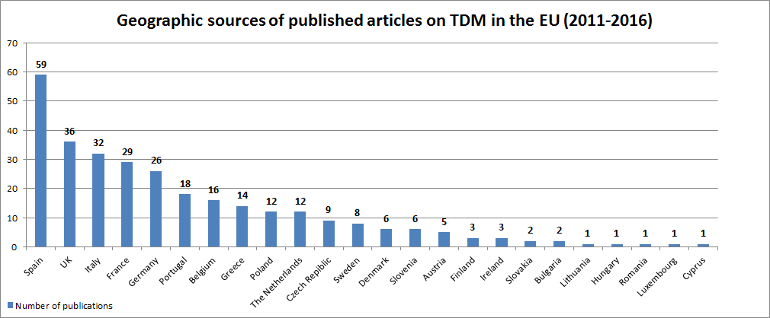

# ANNEX 12 – USE OF PROTECTED CONTENT BY ONLINE SERVICES STORING AND GIVING ACCESS TO LARGE AMOUNTS OF USER UPLOADED CONTENT

**Annex 12A –** **General information on, and examples of, content identification technologies**

Content recognition or identification technologies (or Automatic Content Recognition technologies[98]) help to detect content by online services. Different technologies exist and may be used depending on the type of content to be identified. The availability and effectiveness of technologies depends on the type of content.

**1. Main types of technologies**

There are two main types of content recognition technologies:

* Fingerprinting, and
* Watermarking.

**Fingerprinting** can be used for audio, video and image content recognition. It allows easily recognisable features of the content to be extracted and thus identified as unique features of that content. These features are then compared against a reference database. For example, fingerprinting technology can look for a given musical pattern or melody in a soundtrack, and match it to a melody in a database. Using special features, or fingerprints, content owners can easily find out whether someone uploaded their content on a given site. The level of accuracy of a fingerprint can be very high, allowing the tracking of almost any content. Examples of service providers using fingerprinting technologies are Audible Magic,[99] Vobile [100] and INA ('Signature' system).[101]

**Figure 1 Graphical representation of the process of watermarking and fingerprinting[102]**



Content identification suppliers provide various services. The most typical service provided to online services consists of an access to a fingerprinting database which is used to check against content that an end user wants to upload. This content is matched against an audio or video file provided by right holders and present in the database.

and video files. For example, Audible Magic's reference database contains music and audio-visual soundtracks. The 'Signature' detection system of INA specializes in videos, including when their soundtracks have been changed. Analytics and/or statistics can be provided to allow for a better understanding of the usage of (e.g. viewing, listening) of a song or video. Statistics can include summaries of what viewers search for, how they view their favourite shows or movies, listen to favourite music (audience measurement), how images are used. This information can then be used for targeted advertising by the services. Analytics and statistics can also be provided to right holders in relation to the usage of their content.

The generation of fingerprints can be done by the right holder using software provided by the technology supplier, the technology supplier or the platform itself. Costs related to the generation of the fingerprints depend on the type of content and are not necessarily charged to copyright owners. The latter often have the facility to register business rules that will inform individual sites how their content should be handled. Common business rules are “Block”, “Allow” or “Monetize”. Audible Magic indicated that it has ingested over 24 million fingerprints of copyright content since its establishment in 1999, and currently ingests new fingerprints at a rate of around 250,000 each month.

**Watermarking** can also be used for audio, video and image content recognition. It is an invisible tattooing operation that only allows identifying tattooed copies. Digital watermarks are embedded into the content and make each copy of the content a unique copy. Watermarks are commonly included in theatrical movie releases to allow tracing any illegally recorded version back to the original one. Civolution[103] and Music Trace[104] are examples of service providers providing digital watermarking.

**2. Examples of content identification technologies used by some major online services**

**2.1. Content identification on YouTube**

Since 2007, YouTube uses Content ID, a technical tool developed by Google, based on fingerprinting, which allows the screening of visuals, phonographic data, etc. The files that are uploaded on YouTube are matched against a reference database which includes files submitted by content owners with their chosen business rule (see below). It is reported that there are currently more than 35 million active reference files in the database.[105]

In case a new video is uploaded on YouTube and a match is found against a ‘hash’, the owner of the original content can decide that the following rules apply:[106]

* + Content has to be blocked;
  + Content can be viewed freely and viewing statistics are gathered;
  + Content is being monetized (add advertisements).

**Figure 2 Screenshot of the choice and steps a content owner can take[107]**

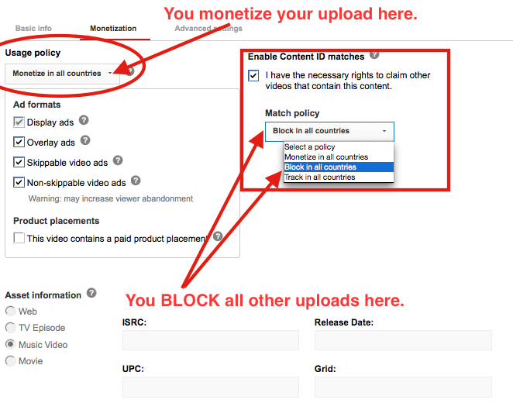

**2.2. Content identification on SoundCloud**

It is reported that SoundCloud uses two different content recognition technologies:

* SoundCloud makes use of Audible Magic' technology since 2010.
* Since 2012, SoundCloud has An in-house content recognition technology (as a result of acquiring specialised companies) since 2012.[108]

on SoundCloud, it is matched against both databases. The company fingerprints and matches every audio file at upload, and again after 40 hours and again after 14 days.

In addition, SoundCloud also has a so-called emergency upload tool to enable rights holders to insert individual reference files directly into the reference database - this enables rights holders to act quickly in the event of leaks, rather than waiting for a reference file to be delivered via their usual supply chain.

According to SoundCloud's own estimates, it has spent approximately EUR 5-10 million in developing its content identification system, plus the substantial historical and ongoing cost of employing 7 full time engineers and product managers to develop and maintain the technology, and 5 full time employees to manage takedown notices, copyright disputes and account terminations.[109]

**2.3. Content identification on Pinterest**

Based on publicly available information, it is not known whether Pinterest uses content identification software. It nevertheless acquired an image recognition and visual search startup ‘VisualGraph’ in 2014.[110] As part of the license agreement with Getty Images, Pinterest makes use of PicScout API, a subsidiary of Getty Images providing tools to allow images to be easily tracked, analysed and monetised online.[111] This allows Pinterest to identify Getty Images and then link those images with Getty’s metadata.[112]

**2.4. Content identification on Vimeo**

Vimeo uses ‘Copyright Match’.[113] Vimeo partnered with Audible Magic to implement the use of this technology.

**2.5. Content identification on Dailymotion[114]**

uses Audible Magic. Dailymotion also makes use of the ‘Signature’ technology developed by INA.[115] While audio content is cross-referenced with Audible Magic's database, video is matched against the ‘Signature’ database. It is reported that if a match is detected, the content will be removed.

**3. Examples of suppliers providing different types of technologies**

Content recognition technologies are available on the market from various suppliers. Some online services have developed such technologies in-house, while others are using the services of technology providers. A non-exhaustive list of providers is presented below**[116]**:

**Services/products offered by content recognition technology provider**

| Provider | Description of offered services | Products / payment plan | Price | Description of products/payment plans covered |
| --- | --- | --- | --- | --- |
| Attrasoft Inc. | * Single site image search engine * Video Search Engine * Image recognition * Object detection within an image * Video object detection * Image tagging * Surveillance video analysis * Steganography | * A number of products featuring the services offered | Upon request | Products include: Attrasoft Mini-AttraSeek, Attrasoft ImageDeepLearner, Attrasoft ImageFinderLite, Attrasoft ImageFinderSeg, Attrasoft ImageFinder, Attrasoft VideoFinderLite, Attrasoft FlashFinderLite, Attrasoft IFSurveillance, Attrasoft VideoFinderLive, Attrasoft VideoFinder , Attrasoft TransApplet 8.0, Attrasoft SecureImageMessage, Other Products. |
| Audible Magic | * Copyrighted content identification * Ensuring copyright compliance * Collegial compliance insurance * Content identification on devices and apps * (creation and) maintenance of media works database * Anti-piracy | A number of specific products, in particular:   * Compliance Automation for Media Sharing platforms | Music / Film, TV for (depending on the number of transactions):   * $1,000/$500 for up to 5,000 transactions * $1,500/$750 for between 5,0001 and 10,000 * Etc * $5,500/$2,750 for between 45,001 and 50,000 | * Audible Magic offers flexible, multi-tiered pricing plans designed to meet the needs of broad range of customers. Monthly service fees start at $500 for use of Audible Magic’s Film/TV database and $1,000 for use of Audible Magic’s Music Database. * One time setup fee $2,500 * Pricing for this service is based on the number of transactions sent to Audible Magic in a billing month. Subscribers are only billed for the transactions that are used, according to the monthly transaction ranges in the following table |
| BMAT | Music identification service | Vericast | Upon request | Vericast is a global music identification service that monitors millions of songs over 3000 radios and televisions across more than 60 countries worldwide.  The solution provides real time recognition and auditable reporting based on an audio fingerprint that is resistant to signal alterations such as voice over, broadcast mastering or noisy channel degradation. |
| Civolution | * Copyright compliance * Copyright management | A number of products and solutions to help media content owners, rights holders and distributors to protect and manage their assets throughout the entire lifecycle, from the Pre-Release stage through Digital Cinema, B2B and B2C distribution | Price is upon request | Description of features depends on the chosen product in consultation with Civolution |
| Dubset | Identification of original master recordings of a mix or remix. | Two products: [MixBANK](http://www.dubset.com/mixbank) and  [MixSCAN](http://www.dubset.com/mixscan) | Upon request | Dubset's MixSCAN® technology parses mixes & remixes into smaller micro audio segments and uses a combination of acoustic and textual fingerprinting technologies, along with proprietary heuristics and pattern analysis technology, to identify all the original master recordings used in the mix or remix. This information is then used to build a unique MixDNA track list and copyright structure that can be used to control usage and distribution of content by rights holders, and collection and administration of streaming royalties.  MixSCAN® utilizes a library of over 100 million master recordings and dozens of additional authoritative databases to ensure accurate track identification and label/publisher rights holder association. |
| Enswers | * Analysis of sound, image and video content | ACR development kit | Upon request | It provides access to a library of software that helps you develop content recognition applications and utilities and includes APIs, utilities, extensive documentation and sample demos. |
| Audience measurement | It is a system that uses personal mobile devices to automatically detect audio from TV to measure individual viewership. The only hardware our system requires are servers that fingerprint TV broadcasts in real-time, and all the subjects need to do is install a mobile app on their phone and enter their profile information. The audio source from real-time TV broadcast feeds and subject’s mobile devices are fingerprinted and matched against each other, then stored  with individual profiles for data analytics. |
| Embedded ACR | This product allows to provide a platform that enables applications to deliver engaging interactive programming synchronized in real-time to what the user is watching on television. |
| Geo Track ID | Detection of music in the online and offline world |  | Upon request | Monitoring of tracks and reporting on usage. |
| Google | * Detection of objects on images * Detection of inappropriate content * Detection of emotional facial attributes * Extraction of text from images | * Cloud Vision API | 0 | * 1-1,000 units per month * Label Detection, Optical Character Recognition, Explicit Content Detection, Facial Detection, Landmark Detection, Logo Detection |
| Price per feature | * 1,001 – 1mln units per month * $5 for Label Detection, * $2.5 for Optical Character Recognition, Explicit Content Detection, Facial Detection, Landmark Detection, Logo Detection |
| * 1,000,0001 – 5 mln units per month * $4 for Label Detection, * $2 for Optical Character Recognition, Explicit Content Detection, Facial Detection, Landmark Detection, Logo Detection |
| * 5,000,001 – 20 mln units per month * $2 for Label Detection, * $0.6 for Optical Character Recognition, Explicit Content Detection, Facial Detection, Landmark Detection, Logo Detection |
| INA | * Detection of videos and images |  |  | * Signature is an automatic video copy detection system. It enables TV broadcast & Internet monitoring for right payment optimization, as well as content monetization and incoming video stream filtering on platforms. |
| LTU technologies (as part of Jastec) | * Content Tracking (Media intelligence, Brand protection, Social media monitoring, Copyright protection) * Brand Intelligence * Mobile Visual Search * Online Visual Search * Investigations | Hajime | 99€/month | * 500 images in the database * 2,500 queries * Bug only support |
| Kenschusei | 249€/month | * 25,000 images in the database * 125,000 queries * Email support |
| Hyojun | 599€/month | * 100,000 images in the database * 500,000 queries * Email support |
| Puro | 1,299€/month | * 250,000 images in the database * 1,000,000 queries * Email & Phone support |
| Senpai | 2,199€/month | * 500,000 images in the database * 2,500,000 queries * Email & Phone support * Free image consulting |
| Sensei | 3,499€/month | * 1,000,000 images in the database * 5,000,000 queries * Email & Phone support * Free image consulting |
| Customised | Upon request | * High volumes of images * Dedicated server * High performance guaranteed * Multi Search API on different sites * Integration in your own system |
| Recognise.im | * Object recognition * Similar images recognition * Multiple object recognition | Start | 0 USD | * Scan limit: 500 * Photo limit: 100 * Valid for 3 weeks |
| Startup Package | $ 300 net/month | * Scan limit: 50,000 * Photo limit: 10,000 |
| Standard Package | $1,700 net/month | * Scan limit: 100,000 * Photo limit: 50,000 |
| Premium Package | $ 3,000 net/month | * Scan limit: 300,000 * Photo limit: 100,000 |
| Enterprise Package | $ 4,000 net/month | * Scan limit: 1,000,000 * Photo limit: 500,000 |
| Customised | Upon request | * Upon request |
| Shazam | * Music recognition * TV recognition | * Shazam app | Free | It creates an acoustic fingerprint based on the sample and compares it against a central database for a match. If it finds a match, it sends information such as the artist, song title, and album back to the user. |
| SoundHound Inc | * Sound recognition * Sound search | Mobile app ‘SoundHound’  Voice recognition virtual assistant app ‘Hound’  Voice enabled developer platform ‘Houndify’ | Price is upon request | Description of features depends on the chosen product in consultation with SoundHound |

**Annex 12B –Results from the flash eurobarometer on Internet users’ preferences for accessing content online (n°437/March 2016)**

The Flash Eurobarometer was carried out at the request of the European Commission’s Directorate-General for Communications Networks, Content and Technology by the TNS Political & Social network in the 28 Member States of the European Union, between 10 and 21 March 2016.

The survey was designed to explore a range of issues related to the manner in which users access the following types of content online: music, films/TV series, images and news. In particular, the following issues were covered:

* At what frequency do Internet users access each of these types of content?
* What type of access do they tend to use (free and/or paid)?
* What type of services do Internet users turn to when they want to access these types of content?
* What are Internet users’ main criteria when choosing a service to access and consume these types of content?

This survey specifically focused on Internet users aged 15 to 45 years old, since they represent the main users of the online contents being considered. A succinct summary of the main results at EU level is provided below.

**MAIN RESULTS AT EU LEVEL FREQUENCY AND TYPE OF ACCESS**

The majority of respondents declare using the Internet to access various types of cultural content in digital format, **more than once a week**: 72% of respondents declare using the Internet to access the **press or news** more than once a week, followed by 63 % for **music**, 54% for **images** and 53% for **films or TV series.**

All four types of content are predominantly accessed online **for free**: nearly eight in ten respondents (78%) mentioned using free services (exclusively or mainly) to access **music** online. Similarly, 70% of respondents use exclusively or mainly free services to access **films or TV series** online, and this proportion reaches 85% for **images** and 87% regarding accessing the **news** online.

**ACCESS TO MUSIC ONLINE**

The four **types of services** mentioned most often by respondents to access music online are *video or music-sharing websites* (31 %)*, professional music streaming services* (22%)*, online radio stations* (16%) and *online social media* (14%).

The four **important criteria** most often mentioned for choosing a service are the following: *the service provides access to content for free* (71%); *the service offers good quality audio/video* (53%); *it doesn’t require users to register* (40%); and *it allows to listen to music and also watch music videos* (34%).

**ACCESS TO FILMS AND TV SERIES ONLINE**

To access films or TV series online, respondents mentioned using predominantly the four following **types of service**: *professional film and TV series streaming services* (25%)*, video-sharing websites* (22%)*, broadcasters’ online TV services* (19%)and *online platforms providing access to a selection of TV channels or VOD services* (13%).

The four **important criteria** most often mentioned for choosing a service are the following: *the service is free* (64% of respondents); *the service offers good quality audio/video* (52%); *it offers a large catalogue and wide variety of films and TV series* (43%); and *streaming is not interrupted by ads* (42%).

**ACCESS TO IMAGES ONLINE**

The four **types of services** mentioned most often by respondents to access images online are: *search engines* (53%), *online social media* (27%), *websites where users can share images* (12%) and *professional photo websites or image banks* (6%).

Half of the respondents (50%) most often *use search engine results to* *access the websites where the images are located*, while 40% declare *viewing and using the images only on the search engine results page (without accessing the websites referenced in the results)*.

The four most mentioned **important criteria** for choosing a service are the following: *the service provides access to content for free* (84%); *the service doesn’t require the user to register* (60%); *it provides a quick browse and selection of images coming from different webpages* (52%); and *the service provides high quality professional images (size, proportion, etc.)* (40%).

**ACCESS TO THE NEWS ONLINE**

The respondents who access the news in digital format most often use the four following **types of services** to do so: *the websites or apps of newspapers or magazines* (42%), *online social media* (22%), *search engines* (21%) and *online news aggregation services* (14%).

When they access the news via news aggregators, online social media or search engines, respondents are divided on what they do next: nearly half of respondents (47%) mention that they most often *browse and read the main news of the day without clicking on links to access the whole articles*. Conversely, a similar proportion (45%) say they *click on available links to read the whole articles on their original webpage*.

The four **important** **criteria** most often mentioned as being important when choosing a service to read the news online are: *the service is free* (77%); *it doesn’t require any registration* (54%); *opening or reading an article is not interrupted or disturbed by ads* (40%); and *the service is offered by a newspaper or magazine with a good reputation* (35%).

For more information, see the Eurobarometer.

# Annex 13 – PUBLISHERS

## Annex 13A – Aggregated data on press circulation and news publishing industry trends in EU MS

**1. Member States specific data on circulation/audiences, digital revenues and forecast**

Source**:** Data provided by the press publishing sector (EPC, EMMA, ENPA and NME after carrying out an internal survey among their members) - May 2016. Data cover 39 publishers from 8 MS (Belgium, Finland, France, Germany, Italy, Poland, Spain and UK).

|  |  |  |  |  |  |  |  |  |
| --- | --- | --- | --- | --- | --- | --- | --- | --- |
| **Member States** | **BE** | **FR** | **DE** | **FI** | **PL** | **IT** | **ES** | **UK** |
| **Circulation/ audiences** | | | | | | | | |
| Daily Newspaper  **Print circulation** | - 8 %  (2010-2014) | -11 %  (2011-2015) | -14 %  (2011-2015) | -22 %  (2010-2014) | -35 %  (2010-2014) | -52 %  (2010-2014) | -38 %  (2010-2014) | -18 %  (2010-2014) |
| Consumer Magazines  **Print circulation** | - 6 %  (2012-2013) | -12 %  (2010-2013) | -13 %  (2011-2015) | -14 %  (2010-2013) | -16 %  (2010-2013) | -15 %  (2010-2013) | -39 %  (2010-2013) | -29 %  (2010-2013) |
| Unique users/browsers  (**Digital audiences**) | 114 %  (2011-2015) | 82 %  (2011-2015) | 86 %  (2011-2015) | - | 152 %  (2011-2015) | 121 %  (2011-2015) | 146 %  (2011-2015) | - |
| **Revenues** | | | | | | | | |
| **Digital revenues** (newspapers and magazines)  % total revenue | 11 %  (2015) | 17 %  (2015) | 7 %  (2015) | 13 %  (2015) | 9 %  (2015) | 11 %  (2015) | 8 %  (2015) | 18 %  (2015) |
| **Total revenues growth** | -9 %  (2010-2013) | -4 %  (2010-2013) | -9 %  (2010-2013) | -13 %  (2010-2013) | -17 %  (2010-2013) | -26 %  (2010-2013) | -26 %  (2010-2013) | - 13 %  (2010-2013) |
| **Forecast** | | | | | | | | |
| Forecast **print revenues** growth | -17 %  (2014-2019) | -20 %  (2014-2019) | -16 %  (2014-2019) | -24 %  (2014-2019) | -13 %  (2014-2019) | -25 %  (2014-2019) | -17 %  (2014-2019) | -20 %  (2014-2019) |
| Forecast **digital revenues** growth | 56 %  (2014-2019) | 11,4 %  (2014-2019) | 149 %  (2014-2019) | 118 %  (2014-2019) | 53 %  (2014-2019) | 153 %  (2014-2019) | 78 %  (2014-2019) | 74 %  (2014-2019) |
| Forecast **total revenues** growth | **-10 %**  (2014-2019) | **-2 %**  (2014-2019) | **-7 %**  (2014-2019) | **-10 %**  (2014-2019) | **-8 %**  (2014-2019) | **-10 %**  (2014-2019) | **-10%**  (2014-2019) | **-6 %**  (2014-2019) |

Source: Data provided by the press publishing sector (EPC, EMMA, ENPA and NME after carrying out an internal survey among their members) - May 2016. Data cover 39 publishers from 8 MS (Belgium, Finland, France, Germany, Italy, Poland, Spain and UK).

This graph refers to the growth of digital audience (webtraffic) of 39 publishers across the 8 European Markets (BE, FI, FR, DE, IT, PL, ES and UK).

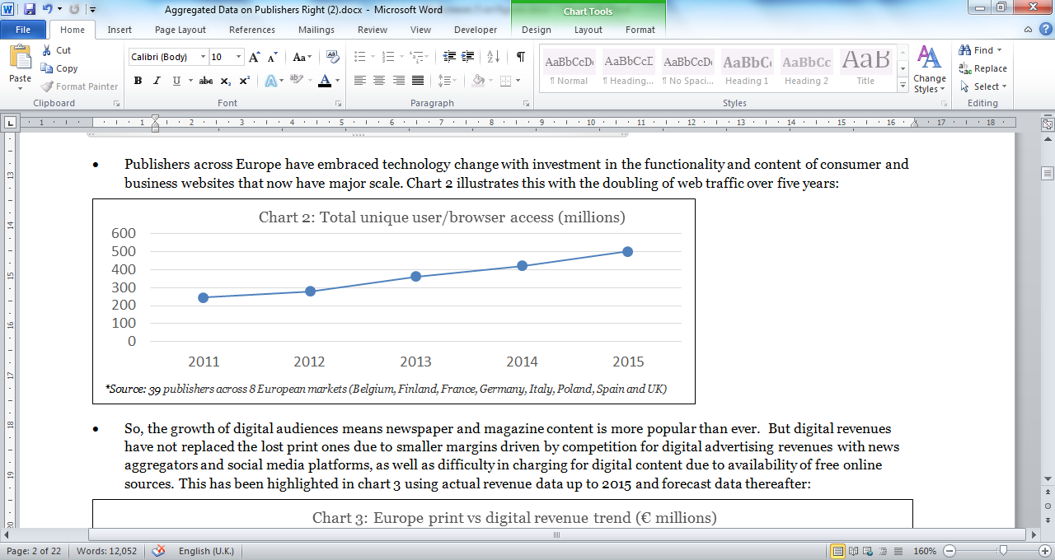

|  |  |  |  |  |  |
| --- | --- | --- | --- | --- | --- |
|  | **2011** | **2012** | **2013** | **2014** | **2015** |
| Unique user/browser data (millions)* | 248.4 | 278.2 | 362.9 | 419.6 | 503.4 |

**2. Aggregated data on print circulation of daily newspapers (Europe)**

Source: PwC – Global entertainment and media outlook 2015 - 2019 *-* [*http://www.pwc.com/gx/en/industries/entertainment-media/outlook.html*](http://www.pwc.com/gx/en/industries/entertainment-media/outlook.html)

|  |  |  |  |  |  |  |  |  |  |  |
| --- | --- | --- | --- | --- | --- | --- | --- | --- | --- | --- |
|  | 2010 | 2011 | 2012 | 2013 | 2014 | 2015 | 2016 | 2017 | 2018 | 2019 |
| Print circulation for daily newspaper (Europe) | 103,995 | 100,654 | 95,456 | 90,979 | 86,143 | 82,622 | 79,243 | 76,092 | 73,079 | 69,745 |

**3. Consumers' habits as regards main sources of news**

Source: Reuters Institute Digital News Report 2015. <http://www.digitalnewsreport.org/>, p.15

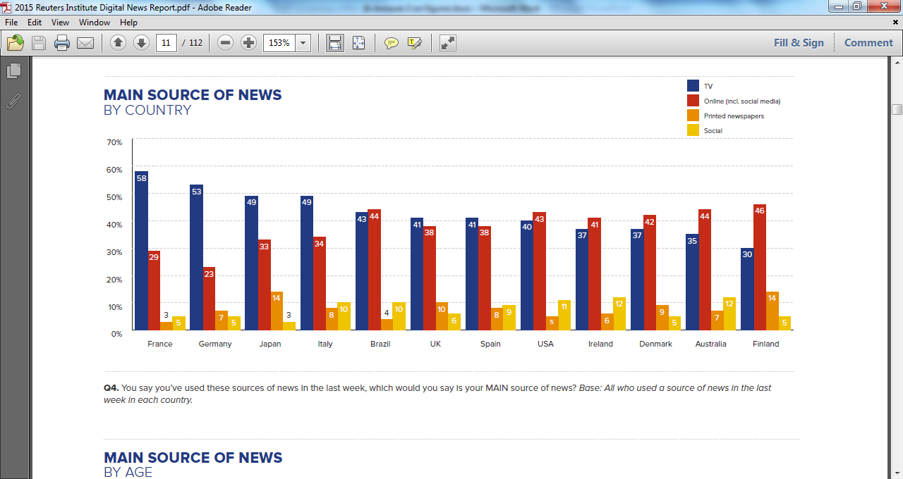

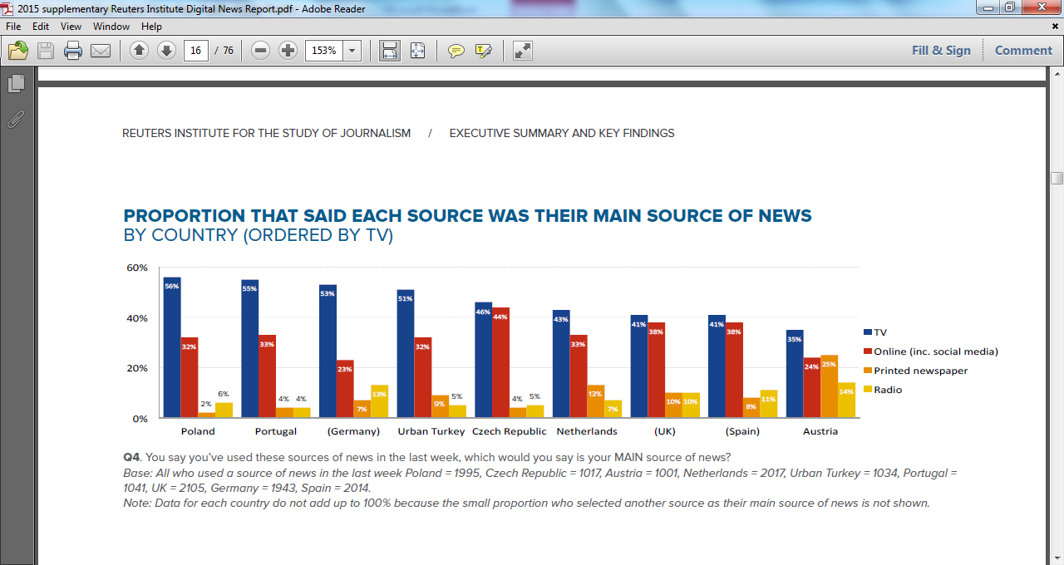

Source: Reuters Institute Digital News Report 2016. <http://www.digitalnewsreport.org/>, p.10

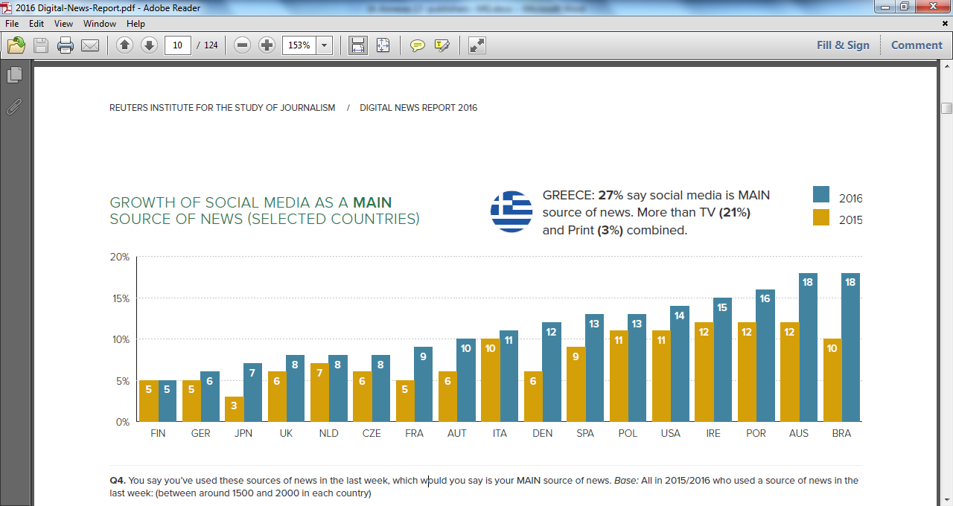

**4. Eurobarometer and Reuters Data on Internet users' preferences (as to the types of services) for accessing content online**

Source: Eurobarometer on Internet users' preferences for accessing content online (n° 437/ March 2016) **-** Types of services used to access the news online

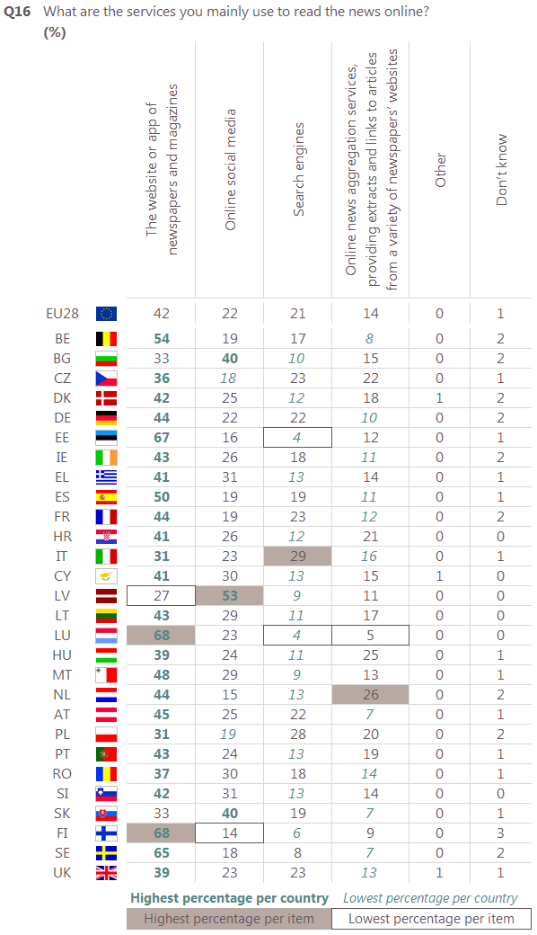

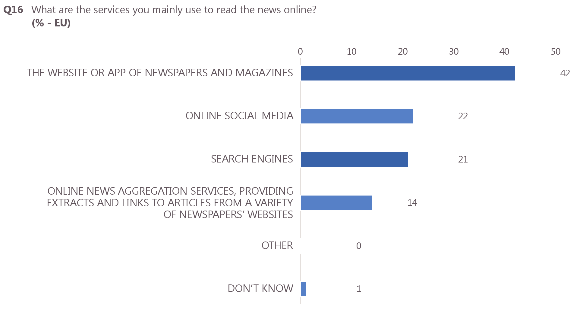

Source: Reuters Institute Digital News Report 2016, <http://www.digitalnewsreport.org/>

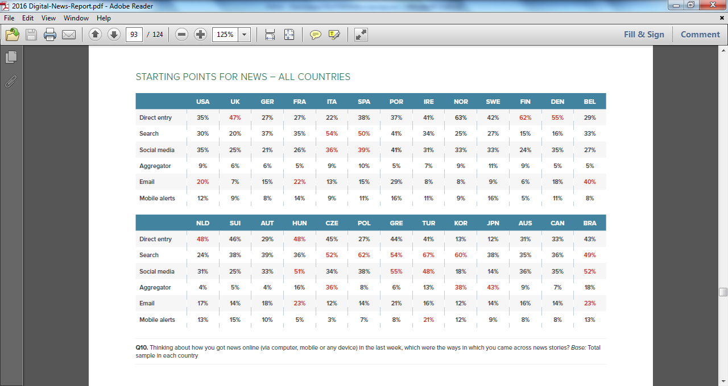

**5. Eurobarometer data on consumer's habits when accessing news online**

Source: Eurobarometer on Internet users' preferences for accessing content online (n° 437/ March 2016) – Use of news aggregators, online social media or search engines to access the news online

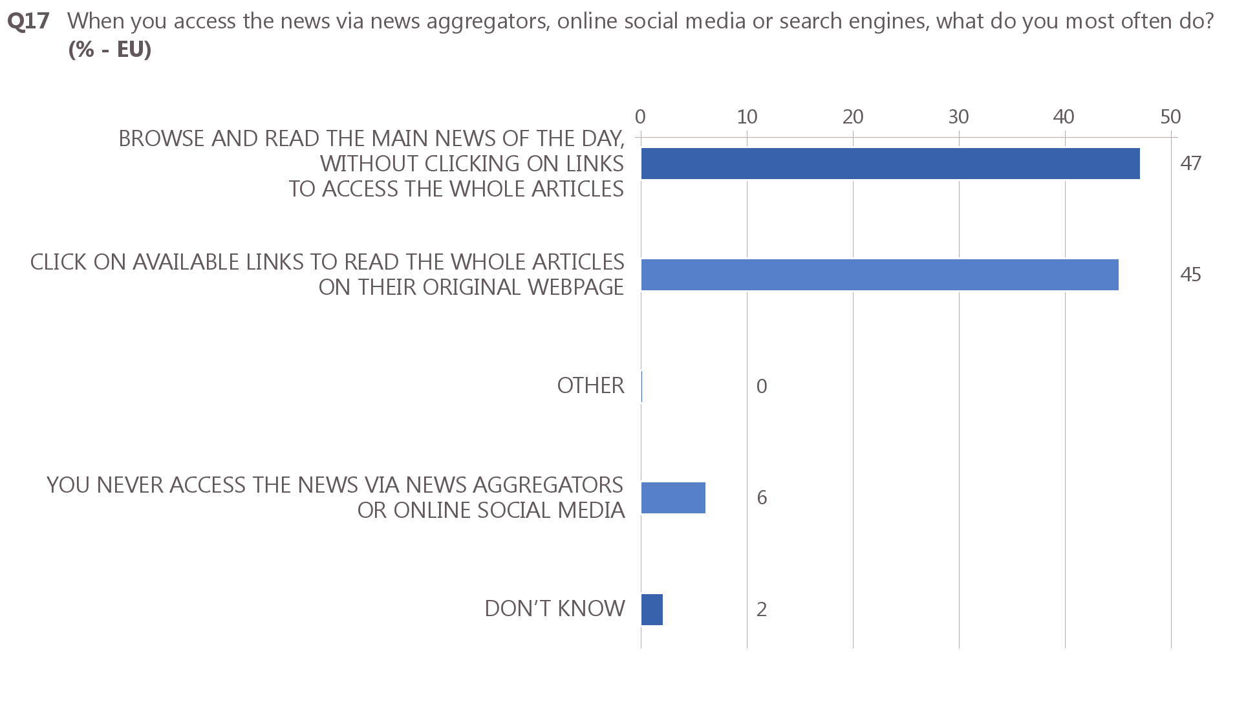

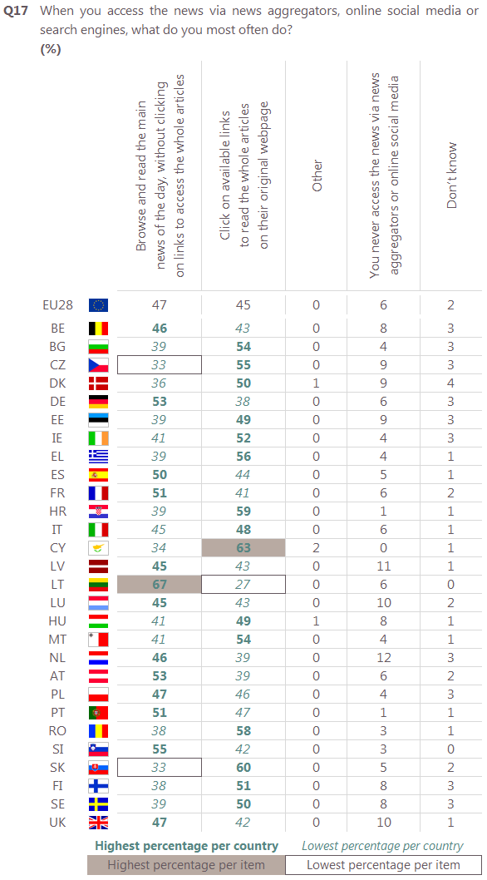

**6. Aggregated data on print advertising revenues of daily newspapers and magazines (Europe)**

Source: PwC Entertainment and Media Outlook 2015 - 2019

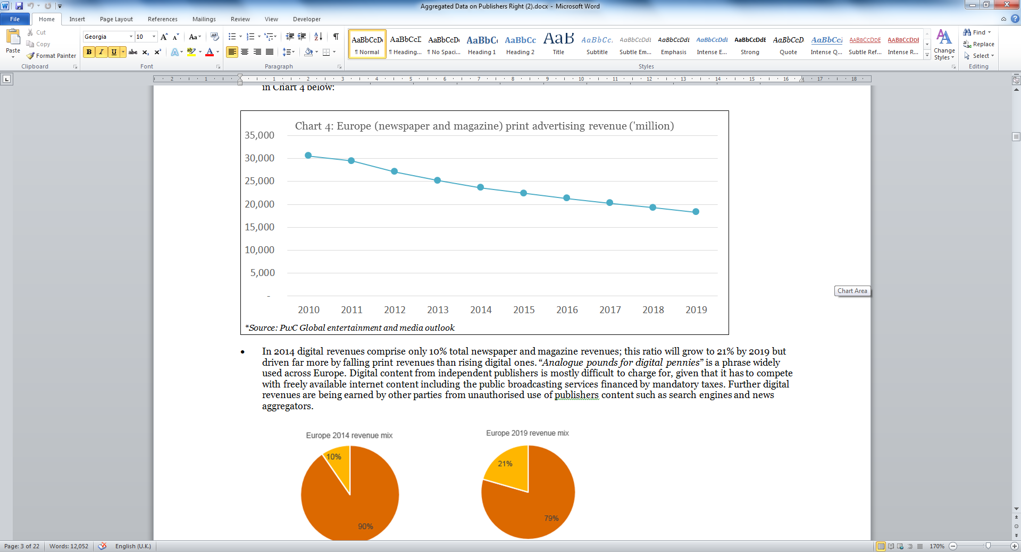

|  |  |  |  |  |  |  |  |  |  |  |
| --- | --- | --- | --- | --- | --- | --- | --- | --- | --- | --- |
|  | **2010** | **2011** | **2012** | **2013** | **2014** | **2015** | **2016** | **2017** | **2018** | **2019** |
| European print advertising revenue (€m)* | 30,600 | 29,460 | 27,086 | 25,192 | 23,622 | 22,418 | 21,331 | 20,254 | 19,275 | 18,309 |

**7. Aggregated data on print vs digital revenue trend of daily newspapers and magazines (Europe)**

Source: PwC Entertainment and Media Outlook 2015 - 2019

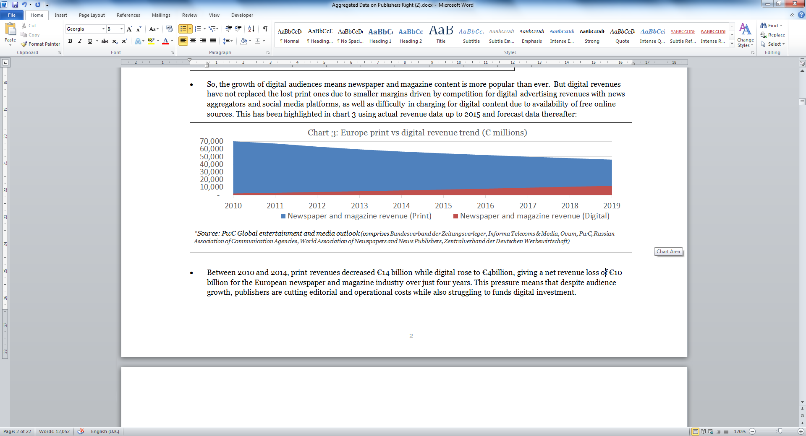

|  |  |  |  |  |  |  |  |  |  |  |
| --- | --- | --- | --- | --- | --- | --- | --- | --- | --- | --- |
|  | **2010** | **2011** | **2012** | **2013** | **2014** | **2015** | **2016** | **2017** | **2018** | **2019** |
| European newspaper and magazine revenue (Print) in €m * | 70,302 | 67,375 | 63,248 | 59,728 | 56,852 | 54,479 | 52,286 | 50,147 | 48,193 | 46,280 |
| European newspaper and magazine revenue (Digital) in €m* | 2,034 | 2,901 | 3,970 | 4,962 | 6,011 | 7,117 | 8,317 | 9,582 | 10,842 | 11,971 |

## Annex 13B – Legal provisions in some EU MS national laws related to the protection of publishers

In some EU Member States, press publishers benefit from a number of provisions in their copyright national law. The scope of these provisions varies among Member States, but they could be grouped in the following types:

* Ancillary rights (e.g. DE), whereby specific exclusive rights are granted to press publishers.
* Provisions on collective works, whereby a publisher may be granted rights as the person who publishes a work made up of contributions from different creators and discloses it under his name.
* Provisions on presumption of transfer, whereby the employer is presumed to hold the rights of his employees, subject to different conditions pursuant to national law.
* Copyright protection of the typographical arrangement of published editions, whereby the publisher is granted protection related to the format and layout of the publication of works.
* Finally, if exceptions or limitations apply to the above-mentioned rights, publishers may benefit from compensation (e.g. ES).

The table below presents a summary of some of the provisions in place in some EU Member States.

| **MS** | **Provision** | **Type of provision** | **Remarks** |
| --- | --- | --- | --- |
| DE | Article 87f-h of the Act on Copyright and Related Rights | Ancillary right for press publishers | The press publisher is granted the exclusive right to make the press product or parts thereof available to the public for commercial purposes, unless this pertains to individual words or the smallest of text excerpts.  The term of protection of this right is one year after publication of the press product.  Authors are entitled to an equitable share of the remuneration.  The right may not be asserted to the detriment of the author or the holder of a right related to copyright whose work or subject-matter is contained in the press product.  Exception for uses by commercial providers of search engines or commercial providers of services which process the content accordingly. |
| DK | Article 6 of the Copyright Act | Presumption of transfer of rights to the employer | Conditions:  (i) subject to agreement to the contrary.  (ii) there is a permanent and regular relation of employment.  (iii) the work is created as a part of the employment contract. |
| EL | Article 51 of Law 2121/1993 Copyright, Related Rights and Cultural Matters | Copyright protection of the typesetting and format of published editions | Publishers of printed matter have the right to authorise or prohibit the reproduction by reprographic, electronic or any other means of the typesetting and pagination format of the works published by them, if that reproduction is made for exploitation purposes. |
| ES | Article 51 of Texto Refundido de la Ley de Propiedad Intelectual | Presumption of transfer of rights to the employer | Condition:  In the absence of an agreement in writing. |
| Article 8 of Texto Refundido de la Ley de Propiedad Intelectual | Provisions on collective works | Copyright vests in the person who publishes a collective work and discloses it under her name, subject to agreement to the contrary. |
| Article 32.2 of Texto Refundido de la Ley de Propiedad Intelectual | Compensation right for the use by content aggregators | Publishers' right to equitable compensation stemming from an exception to their right of making available to the public, regarding small fragments of content already disclosed by periodic publications.  Content aggregators (mostly news aggregators), as the beneficiaries of the exception, are the debtors of the compensation, which cannot be waived by rightholders and is subject to compulsory collective management. |
| Article 52 of Texto Refundido de la Ley de Propiedad Intelectual | Authors' rights to use their works reproduced in periodical publications | In the absence of provision to the contrary, authors shall preserve their right to use those works in any form that does not prejudice the normal exploitation of the publication in which they have been inserted. |
| FR | Art. L. 113-2(3) and 5 of Code de la Propriété Intellectuelle | Provisions on collective works | Rights granted to the person or legal entity that takes the initiative of creating and publishing a collective work, unless proved otherwise. |
| HU | Article 7 (2) of the Copyright Act | Provisions on collective works | The copyright owner of a collective work shall be the natural person who edits/collects it, without prejudice to the independent rights of the authors of the individual works and of the right-holders in subject matter covered by related rights included in the collection. |
| IE | Section 23 of the Copyright and Related Rights Act | Employer considered copyright owner of a work made by an employee | Conditions:  (i) subject to agreement to the contrary.  (ii) the employee of the proprietor of a newspaper or periodical may use the work for any purposes, other than making it available to other newspapers or periodicals. |
| Section 17(2)(c) and 29 of the Copyright and Related Rights Act | Copyright protection of the typographical arrangement of a published edition | The publisher is considered the author of the typographical arrangement of a published edition.  Term of protection: 50 years after the date on which it is first lawfully made available to the public. |
| IT | Article 12 bis of the LdA | Employer is granted an exclusive right to exercise the exploitation rights on the works created by employees |  |
| Articles 3, 7 and 42 of the LdA | Provisions on collective works | The person who organises and directs the creation shall be deemed its author, independently and without prejudice of the copyright on the works or part of the works that make it up.  The author of the article or another work that has been reproduced in a collective work has the right to reproduce it in separate extracts or collected in a volume, but she has to indicate the collective work from which the single work is taken and the date of publication. |
| NL | Article 7 of the Aw | Employer considered author of a work made by an employee | Condition:  When employee's labour consists in the making of ‘literary, scientific or artistic works’. |
| PL | Article 12 of the Polish Copyright Act (PrAut) | Employer is granted an exclusive right to exercise the exploitation rights on the works created by employees | Conditions:  (i) subject to agreement to the contrary.  (ii) the work is created as a part of the employment contract.  (iii) within the limits resulting from the purpose of the employment contract and the mutual intent of the parties. |
| Article 11 of the Polish Copyright Act (PrAut) | Provisions on collective works | Rights in a collective work, especially an encyclopaedia or a periodical, are vested originally in the publisher.  Rights to individual autonomous parts of the work belong to their authors. |
| PT | Article 19 of Código do Direito de Autor e dos Direitos Conexos | Provisions on collective works | Copyright belongs to the single or collective entity that has organised and directed its creation and in whose name the work has been disclosed or published.  If it is possible to distinguish the individual contributions of some or all of the authors in a collective work, the provisions on individual contributions to works apply.  Newspapers and other periodicals are deemed to be collective works. |
| RO | Article 6 of the Law on Copyright and Neighbouring Rights | Provisions on collective works | Unless otherwise agreed, the copyright in a collective work shall belong to the person, whether natural person or legal entity, on whose initiative and responsibility and under whose name the work was created. |
| Article 45 of the Law on Copyright and Neighbouring Rights | Authors' rights to use their works reproduced in periodical publications | Unless otherwise agreed, the owner of the copyright in a work appearing in a periodical publication shall retain the right to use it in any form, provided that the publication in which the work appears is not thereby prejudiced. |
| Article 44 of the Law on Copyright and Neighbouring Rights | Employer is authorised to use a work made by an employee | Condition:  The use of the work by employer is done within the framework of the object of his activity. |
| UK | Section 11(2) of the Copyright, Designs and Patents Act | Employer considered copyright owner of a work made by an employee | Conditions:  (i) subject to agreement to the contrary.  (ii) the work is made in the course of the employee's employment. |
| Section 9(d) of the Copyright, Designs and Patents Act | Protection of typographical arrangements of a published edition | The publisher is considered the author. |
| Section 8 and 16 of the Copyright, Designs and Patents Act | Copyright protection of the typographical arrangement of a published edition | Copyright expires at the end of the period of 25 years from the end of the calendar year in which the edition was first published. |

## Annex 13C – Main Agreements or other initiatives between online service providers and Press publishers

## 1. Global agreements between online service providers and press publishers across Europe

|  |  |  |  |
| --- | --- | --- | --- |
| **Online service providers general initiatives** | **Involved parties** | **Object** | **Description** |
| **Digital News Initiative (DNI)**  *Google*  *2015* | Initially: Partnership between Google and eight European newspapers: Les Echos, FAZ, The Financial Times, The Guardian, NRC Media, El País, La Stampa and Die Zeit  Today 160 European newspapers participate in the DNI. | The DNI focuses on three areas in digital journalism:   * Product development: Google collaborate with news organisations to develop new business models in journalism, so as to increase revenue, traffic and audience engagement, beneficial to all. * Supporting innovation: Google set a €150 million innovation fund over three years. So far, this fund has given grants of a combined €27 million to 128 projects in 23 EU countries. * Training and research: over 12,000 journalists, academics and students across Europe have received training support from the Google News lab team since April 2015. | Google presents the DNI as a forum allowing an ongoing discussion between the Technology and News sectors aiming at encouraging more sustainable news ecosystem and encouraging innovation in digital journalism.  Source: Google's contribution to the 2016 Public consultation. |
| **Accelerated Mobile Pages Project (AMP)**  *Google/ DNI*  Mobile  *2016* | Partnership between publishers around the world and technology companies (LinkedIn, Google, Pinterest and Twitter, etc.)  Today, this standard is used by over 100 European publishers | AMP is one example of the collaboration triggered by DNI – a mobile publishing format/platform.  This is an open-source standard aiming at improving the entire mobile content system for everyone, particularly at making publishers’ webpages load faster on mobile devices while giving them a better control of their branding (the design of their pages).  This initiative, helping publishers to reach an increasingly audience on mobile, enables them as well to benefit from a better monetisation, including through a better and faster integration of ads. | With such open-source initiative, Google wants to limit the decline of mobile web as a destination for news searches particularly while, notably in US, readers are more likely to find news through their Facebook feed.  **Audiences:**  - AMP format is being used by Google search (so far, only in mobile browsers) and by Twitter, LinkedIn, Pinterest, Medium and Nuzzel.  Source: Google's contribution to the 2016 public consultation. |
| **Instant Articles (FBIA)**  *Facebook*  Mobile  *2015-2016* | Facebook was testing IA with a small set of publishers (such as Liberation in FR) but as of April 2016, the program is opened to any content publishers | Instant Articles is a mobile publishing format/platform. It aims to enhance the user access to publishers' content on Facebook, by enabling them to load and read them far quicker within their Facebook app (mobile).  Facebook considers that, for publishers, it maximises the publication process and reach and thanks to a strong IT structure they get the ability to track (content and audience analytics: total views, time spent, etc.) and monetise their content through various advertising options.  For instance, publishers can sell and serve their own advertisements and keep 100 % of revenue, and they can monetise with ads from Facebook's Audience Network.  Source: Instant Articles: Frequently Asked Questions <https://developers.facebook.com/docs/instant-articles/faq?locale=en_US> | According to Facebook, for publishers this tool represents a faster mobile optimised way to publish and distribute their content as quickly as possible.  For instance, the FR **newspaper Libération** reports that publishing on Instant Articles has been positive. Regarding their traffic, they did not lose any user: people, on mobile, are still reading their stories published on their website (60 %) and on Facebook (40 %). The time spent by readers on FBIA has jumped. They have 10 % more followers on their Facebook Libération page, and they are successfully monetising their articles, per page and stories reach, with Facebook's Audience Network. (Source: Xavier Grangier, "Liberation on Facebook's Instant Articles, 17 March 2016 <https://www.linkedin.com/pulse/lib%C3%A9ration-facebooks-instant-articles-xavier-grangier> )  **Audiences**:  - FBIA will only be shown to users of the Facebook mobile app. |
| **Apple's News**  *Apple*  Mobile  *2016* | Apple initially opened this program to 20 publishers but as of March 2016, the platform has been opened to all publishers. Those already on Apple News: New York Times, CNN, Huffpost, The Atlantic, NPR, Buzzfeed, VOx, etc. | This App is a mobile publishing format/platform, which includes content from different news publishers while ensuring the latter to better control the design of their page (custom typography, image and linked text), the article traffic (Analytic tools) and to better monetise their content through advertising solutions.  With this tool, Apple considers that the user is able to access faster and quicker content from different sources in the same app. This content is organised into channels (publisher content's home in news) and assigned to topics, allowing then the users to follow what best match their interest. | For publishers, this tool will, as with FBIA and AMP, make news articles load more quickly on mobile devices and provide a better mobile experience.  According to Apple, this tool also allows them to earn revenue by including advertisements in their Apple News Format channel and articles. They can sell their own ads and keeping 100 % of revenue or allow Apple to sell ads in their content: they keep 70 % of the revenues.  **Audiences**:  - Publishers' content published to Apple News are only available to IPHONE and IPAD users  Source: "Publishing with Apple News format",  <https://developer.apple.com/news-publisher/> |

**2. Local agreements and initiatives between online service providers and press publishers across Europe**

| **Local agreements/ initiative** | **Involved parties** | **Object** | **Financial aspect and other remarks** |
| --- | --- | --- | --- |
| *Google – FIEG (Italian Newspaper Publishers Federation)*  **Italy**  *7 June 2016* | ***Google – FIEG* (Italian Newspaper Publishers Federation)** | General: Collaboration agreement aiming at "promoting innovative approach for Italian Media in the digital era**"**  This agreement envisages "the recognition of the importance of copyright and the valorisation of editorial content with the use, via revenue sharing, of the mobile solution Google Play Newsstand and the video platform YouTube".  This implies a Google's investment of €12 million over three years and a focus on **four strategic areas**: **mobile and video, copyright protection tools and training** (ex. Distribution of content on mobile devices via Google Play Newsstand, use of Google Analytics tools, creation of a Digital Lab@Fieg, joint action for the protection of online content).  Source**:** Ansa, **"**FIEG-Google deal to boost media sector", 7 June 2016,  <http://www.ansa.it/english/news/lifestyle/arts/2016/06/07/fieg-google-deal-to-boost-media-sector-2_f044ce22-ebd3-4010-814d-e5a20cd88ad1.html> | Google will earmark 12 million euros over three years with a focus on copyright protection of news publishers' content. |
| Google  **France**  *02/2013* | **Google and FR Newspaper publishers** | The agreement consists in two initiatives:  1° The creation by Google of a €60 million digital-publishing innovation fund to help support transformative digital publishing initiatives for French readers.  2° The French publishers' increase of online revenues by using Google's advertising technology.  Source: Google Official Blog, "Google creates €60m Digital Publishing Innovation Fund to support transformative French digital publishing initiatives", Feb 1, 2013  <https://googleblog.blogspot.be/2013/02/google-creates-60m-digital-publishing.html> | According to Google, this is a **business and technology agreement**.  Creation of a €60 million innovation fund for digital news publishers. |
| Google  **Belgium**  *12/ 2012* | **Google - Belgian French language news publishers, authors' societies** | Background: Google was sued in 2006 by Copiepresse, an association of Belgian newspaper publishers, for displaying snippets in Google News and linking to cached copies of their page in Google search. On 13 February 2007, the Court of Appeal held Google liable for copyright infringement. In 2012, the parties announced having reached a set of agreements to end all litigation.  Under these, they agreed to collaborate on:  - a mutual promotion of their services, for instance: the publishers will optimise their use of Google's Adwords to attract new readers;  - an increase of publishers' revenues, by a better monetisation (paywalls subscription and advertising solution such as Ad sense);  - an increase of reader engagement, by implementing Google+ social tools on publishers' websites and launching official YouTube channels;  - an increase of the accessibility of the publisher's content, in particular on mobile platforms.  Under the agreements, Google had also to pay the publishers' legal fees.  Source: Google Europe Blog, "Partnering with Belgian news publishers", Dec.12, 2012  <http://googlepolicyeurope.blogspot.be/2012/12/partnering-with-belgian-news-publishers.html> | Google considers that "this is not paying Belgian publishers or authors to include their content in its services. [It is rather a collaboration] on a broad range of **business initiatives**". |

**3. Example of an EU online service providing access to press content further to an agreement with press publishers**

|  |  |  |  |
| --- | --- | --- | --- |
| **Local agreements/ initiative** | **Involved parties** | **Object** | **Financial aspect and other remarks** |
| Blendle  Netherlands  *2015* | Blendle (a Dutch digital start-up) and the major magazine and newspaper publishers in the Netherlands, as well as New York Times, Wall Street Journal, Washington Post. | Blendle's ambition is to "*put all newspapers and magazines in the country behind one (quite sexy) paywall and make it so easy to use that young people start paying for journalism again".*  The idea behind their business model is to provide a similar experience to iTunes, for press contents.  It is a micropayment model (pay per article / no monthly fees for entire websites), with less reliance on advertising and support for good quality journalism with:  - a better reading and paying experience (with only one click)  - a better consumer experience (with notably a refund policy)  - a support to users to find the press content that best match their interest.  Source: "Blendle: a radical experiment with micropayments in journalism, 365 days later", 28 April 2015.  <https://medium.com/on-blendle/blendle-a-radical-experiment-with-micropayments-in-journalism-365-days-later-f3b799022edc> | After one year, Blendle has informed that the platform had already 250,000 users, of which the majority is under 35 years old. |

## Annex 13D – Data on Member States with an author-publisher split of compensation due under exceptions and limitations

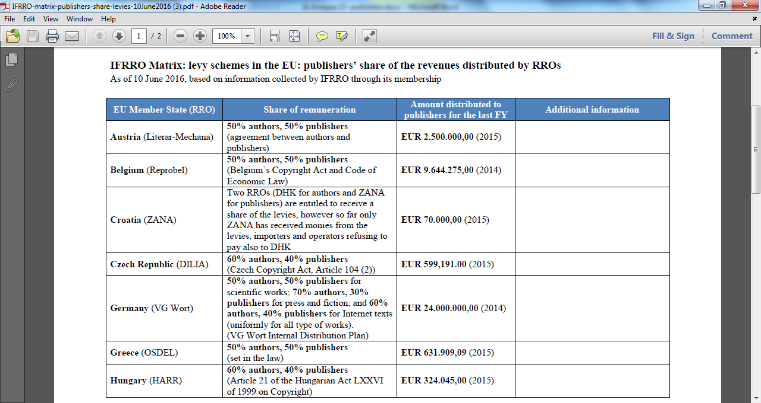

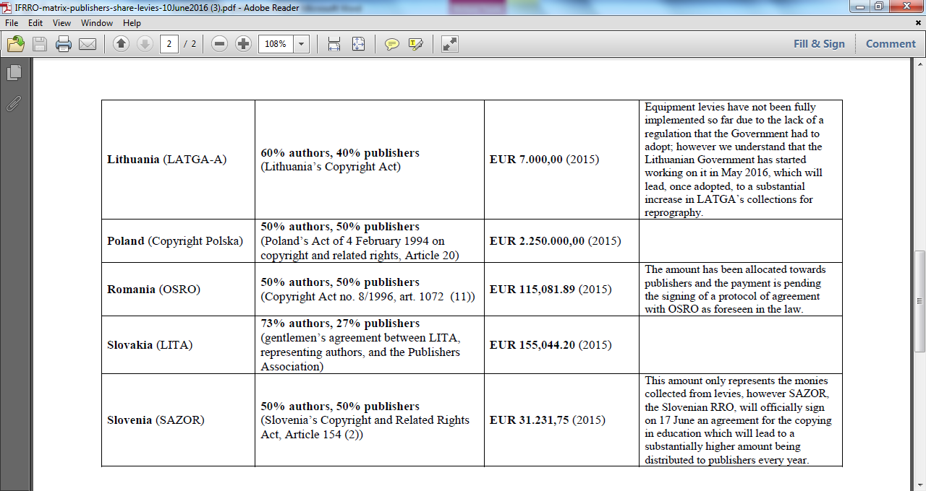

# ANNEX 14 – TRANSPARENCY AND BALANCE IN THE CONTRACTS OF AUTHORS AND PERFORMERS

## Annex 14A – Examples of national legislation and soft-law

References to legislation are indicated in the table "Examples of national legislations currently in force" below. This list is non-exhaustive and is only intended to provide examples of legislations and soft-law regulations.

***BELGIUM***

Belgian copyright law provides for several reporting obligations according to the type of the contract. Book publishers shall send to the author at least once a year a statement of the sales, revenue, assignments for each mode of exploitation. Where the remuneration is proportional to the revenues generated from the exploitation of an audiovisual work, the producer shall produce once a year a revenue statement (differentiating each mode of exploitation).

***BULGARIA***

A reporting obligation is imposed on audiovisual producers which shall, at the request of the authors, produce a reporting statement at least once a year.

***CROATIA***

Croatian copyright law provides transparency obligations for publishers and for audiovisual producers. Authors have the right to control at any time the accuracy of information provided by their publisher. No reporting obligation is however imposed on publishers. Film producers shall automatically transmit to their authors a report on the profits for each form of their work at least once a year.

***CZECH REPUBLIC***

The Czech copyright law provides a general transparency obligation according where the amount of royalty is proportional to the exploitation of the work. The licensee shall be obliged to facilitate the audit by the author of the relevant accounting documents.

***DENMARK***

A general reporting obligation has been introduced into Danish copyright legislation. Upon the request of creators, contractual counterparties have to make a settlement of revenues where the remuneration is proportional to the revenues at least once a year and may be required to provide any underlying information.

***FINLAND***

Finish law provides for reporting obligations imposed on publishers towards authors when a sale or rental has taken place for which the author is entitled to be remunerated. In such as case, the publisher shall render account to him within nine months from the end of the year concerning the sales or rentals during the year and the number of copies in stock at the end of the year.

***FRANCE***

Current French legislation provides for several reporting obligations according to the type of the contract.

Audiovisual producers shall transmit, at least once a year, to the authors and the joint authors a statement of revenues generated from the exploitation of the work with respect to each mode of exploitation[117]. In addition, the reporting obligations imposed on audiovisual producers were strengthened by a memorandum of understanding signed in 2010 by the main French audiovisual stakeholders. Under this MoU, producers undertook to communicate in addition to authors whose remuneration is proportional to the revenues generated by the film, within two months following the closing of the final cost of the cinematographic work, a statement containing *inter alia* the final cost of the work and the balance of the cost of the work still to be amortized. In addition, on 7 July 2016, a new law has been enacted which strengthens the obligations imposed on audiovisual producers in case of the assignment of the audiovisual contract to a third party and which introduces new transparency obligations imposed on the executive producers and the distributors (see below).

In the publishing sector, a framework agreement on the publishing contract in the digital era signed in 2013 extended the publishers' reporting obligations provided by the French Intellectual Property Code and the French Code of Practice ('Code des usages'). Book publishers shall now produce, once a year, a reporting statement that shall contain specific information both for printed copies of books (number of copies manufactured, number of stock-in copies, etc) and for books exploited in their digital format. French legislation provides that if the report has not been transmitted to the author within six months from the reporting date defined by the contract, the author can give formal notice to the publisher to provide him with the report. If the book publisher does not communicate the report within three months following the formal notice, the contract will be terminated as of right.

For phonogram producers, current French legislation does not provide any reporting obligations. Yet, on 18 October 2015, 18 music industry stakeholders signed a memorandum of understanding ("protocole d'accord") for a fair development of online music under the auspices of the French Ministry for Culture, under which they undertook to guarantee a fair remuneration to artists (Objective no. 5). More specifically, phonogram producers committed, inter alia, to report to artists on the revenues generated from the exploitation of their works in a transparent way. The format of the report which shall be available in an understandable and user-friendly layout both to the artists and their managers will be determined at a later stage by a stakeholders' dialogue.

Finally, French legislation imposes lighter reporting obligations on entertainment promoters which have to notify to the author or his representatives the exact program of public performances and to supply to them a documented statement of receipts.

***GERMANY***

Under the current German copyright law, a reporting obligation exists for music producers that shall provide, upon the performer's request, information on the revenue generated by the exploitation of the audio recording and other information necessary to assess his remuneration.

***GREECE***

Audiovisual producers shall give once a year all the information concerning the exploitation of the work. Audiovisual producers are exempted of such obligations for short advertising films.

***HUNGARY***

Hungarian cinematographic producers shall, at least once a year, render account to the author of the revenues generated by the exploitation of the film.

***ITALY***

Italian copyright law provides for an annual reporting obligation imposed on publishers concerning sold copies in the cases of profit participation agreements,

***LITHUANIA***

At the author's request, the publisher shall give written information including the number of copies sold as well as the revenues generated.

***POLAND***

Polish copyright legislation provides for a general transparency obligation. Where the remuneration is proportional to the revenues generated by the exploitation of the work, the author is entitled to receive information or to have access to the documentation necessary to establish such remuneration.

***PORTUGAL***

Book publishers shall transmit once a year to the authors a reporting statement including *inter alia* the number of sold and returned books and the balance of payment.

***ROMANIA***

Under Romanian copyright law, the audiovisual producer shall produce annually an account of the takings according to each mode of exploitation. Besides, the producer of theatrical or musical performance shall communicate at least once a year to the author the number of performances as well as a state of takings.

***SLOVAKIA***

Where the royalties are proportional to the revenues generated by the exploitation of the work, the Slovakian copyright law provides a general transparency obligation which enables the author to control the accounting record of his contractual counterparty necessary for determining his remuneration.

***SLOVENIA***

Slovenian legislation provides a general transparency obligation according to which, where the agreed remuneration is proportional to revenues, contractual counterparties must keep the documents necessary to determine the amount of such revenues. In addition, a specific obligation falls on film producers that have to send at least once a year to the co-authors of the work a report on the revenues generated by the cinematographic work.

***SPAIN***

Spain provides for reporting obligations applicable to publishing contracts, audiovisual contracts and public performance contracts. The creators' contractual counterparties have to render accounts of the revenues resulting from the exploitation of a book, an audiovisual work or from the execution of a public performance where remuneration is proportional to the revenues.

***SWEDEN***

The Swedish copyright law provides for a legal reporting obligation only in the book sector. The publisher shall render account yearly to the author of the revenues generated by the exploitation of its work and of the number of copies sold as well as the stock at the end of the year.

***UNITED KINGDOM***

UK legislation does not provide for any reporting obligations. The UK Publisher Association undertook to foster constructive and co-operative relationships with book authors and to attempt to address some of the areas which may lead to avoidable conflict by publishing a Code of Practice on Author Contracts (1982, updated 1997 and 2010). This Code of Practice provides that "*the publisher must ensure that the author receives a regular and clear account of sales made and monies due*" (point 11).

***Table - Examples of national legislations currently in force***

| **COUNTRY** | **PUBLISHING SECTOR / CONTRACTS** | **AUDIOVISUAL SECTOR / CONTRACTS** | **PHONOGRAM PRODUCERS CONTRACT/ MUSIC SECTOR** | **PUBLIC PERFORMANCE CONTRACTS** |
| --- | --- | --- | --- | --- |
| **Belgium**  Loi du 19 avril 2014 portant insertion du Livre XI «Propriété Intellectuelle » dans le Code de droit économique, et portant insertion des dispositions propres au Livre XI dans les Livres I, XV et XVII du même Code | **Article XI.198**  Notwithstanding any contrary agreement, the publisher will send the author, at least once a year, a statement of sales, revenue and assignments for each mode of exploitation.  Except in case of re-publishing of the work, the publisher is exempted from this obligation if the work is not exploited in any manner whatsoever, for five consecutive years. | **Article XI.206**  The amount of the remuneration is, unless otherwise stated, proportional to the revenue generated from the exploitation of the audiovisual work. In this case, the manufacturer will send the artist - performer, at least once a year, a statement of the generated for each mode of exploitation. |  | **Article XI.202**  The beneficiary of the representation agreement is required to communicate to the author or his assignee the exact program of public performances and to provide a documented statement of its revenues. |
| **Bulgaria**  Law on Copyright and Neighbouring rights (Published in State Gasette No 56/1993; amended No 63/1994, No I 0/1 998, No 2812000, No 77/2002) |  | Accounting to the Authors: Art. 66. At the request of the persons referred to in Art. 62, the producer shall provide to them at least once a year a statement on the revenues from each type of use of the work.  [Art. 62. defines rights owners: (1) director, the author of the screenplay and the director of photography, artist-director. (2) The authors of the music, the dialogue, the pre-existing literary work on which the audiovisual work was based, the costume designers, the set designers, as well as the authors of all other material, incorporated in the audiovisual work, shall enjoy the copyright in their individual works. (3) A producer within the meaning of this Title shall be the physical person or the legal entity who organizes the production of the work and provides its financing.] |  |  |
| **Croatia**  Copyright and Related Rights Act (O.G. 167/2003) | **Article 58(1)** Verification of accuracy of information - The author shall have the right of insight and control, at any time, of the publisher's business records and documentation, to verify the accuracy of information provided to him by the publisher. | **Article 119** Report on remuneration for rights to audiovisual work The film producer of an audiovisual work must at least once a year submit to the co-authors a report on the profits for each form of use of the work. |  |  |
| **Czech Republic**  Consolidated version of Act No. 121/2000 Coll., on Copyright and Rights Related to Copyright and on Amendment to Certain Acts (the Copyright Act). | **Article 49(4)** Where the amount of the royalty has been agreed in dependence on the proceeds from the utilisation of the licence, the licensee shall be obliged to make it possible for the author to audit the relevant accounting documents or other documentation in order to establish the real amount of the royalty. Where the licensee thus provides the author with information designated by the licensee as confidential, the author may not divulge such information to any third party, nor use it according to his needs in contravention of the purpose for which it has been made available to him. | | | |
| **Denmark**  Consolidated Act No. 1144 of October 23rd, 2014 | **Settlement and Control – Article 57**  (1) If the author's remuneration depends on the assignee's turnover, sales figures, etc., the author may demand that settlement is made at least once a year. The author may likewise demand that the settlement be accompanied by satisfactory information on the circumstances forming the basis of the calculation of the remuneration.  (2) The author may demand that the accounts, bookkeeping and inventory together with certifications by the party who has exploited the work in connection with the annual settlement according to subsection (1) be made available to a state-authorised public accountant or registered accountant appointed by the author. The accountant shall inform the author of the correctness of the settlement and of irregularities, if any. The accountant shall otherwise observe secrecy about all other matters that become known to him in connection with his review.  (3) The provisions of subsections (1) and (2) shall not be deviated from to the detriment of the author. | | | |
| **Finland**  Copyright Act (404/1961) | **Section 35(2)** (2) If, during a fiscal year, sale or rental has taken place for which the author is entitled to be remunerated, the publisher shall render account to him within nine months from the end of the year concerning the sales or rentals during the year and the number of copies in stock at the end of the year. The author shall moreover have the right to obtain information, at his own request, about the number of copies in stock at the end of a year even after the end of the accounting term. |  |  |  |
| **France**  Intellectual Property Code – as amended by Order no. 2014-1348 of 12 November 2014 | **Article L. 132-13** The publisher is accountable. The author may, in the absence of special conditions stipulated in the contract, require at least an annual production by the publisher of a statement of the number of copies published during the year and giving the date and the importance of prints and the number of copies in stock. Except contrary usage or agreement, this statement shall also contain the number of copies sold by the publisher and the copies unusable or destroyed by accident or force majeure, and the amount of royalties due or paid to the author.  **Article L. 132-14** The publisher shall provide the author with all evidence required to establish the accuracy of his accounts. If the publisher fails to provide the necessary evidence, he will be forced by the judge  **Article L.132-17-3** I. - The publisher shall for each book explicitly and transparently report to the author on his remuneration. To this end, publisher the addresses to the author, or makes available through an electronic communication process, a statement of accounts stating:  1. When the book is published in a printed form, the number of copies made during the year, the number of copies in stock at the beginning and end of the year, the number of copies sold by the publisher, number of copies excluding duties and destroyed during the period;  2. When the book is published in digital form, the income from sales by unit and each of the other operating modes of the book;  3. In all cases, the list of transfers of rights carried out during the year, the amount of the corresponding royalties due or paid to the author as well as the rates of remuneration provided for in different publishing contract.  A specific part of this statement of accounts is devoted to the exploitation of the book in digital form.  Accountability is performed at least once a year, on the date specified in the contract or, in the absence of a date no later than six months after the closing of accounts.  II. - If the publisher has not fulfilled its obligation of accountability in the manner and within the time stated in I, the author has a period of six months to notice the publisher to carry it .  When this notice is not acted upon within a period of three months, the contract is automatically terminated.  III. - When the editor has not performed, for two successive years, its reporting obligation, the contract is automatically terminated within six months of the second formal notice.  IV. - The editor remain still under the obligation, even in the absence of formal notice by the author, to meet its legal and contractual obligations of accountability | **Article L. 132-28** Audiovisual producers shall transmit, at least once a year, to the authors and the joint authors a statement of revenues generated from the exploitation of the work with respect to each mode of exploitation  **[Stakeholders dialogue] - Memorandum of understanding (2010)** Within 2 months following the determination of the final cost of the cinematographic work, the audiovisual producer shall communicate to the authors where remuneration is proportional to the revenues generated by the work:  - the final cost of the work,  - the balance of the cost of the work still to be amortized,  - the nature and the amount of publishing costs to be opposed to authors | **No legislation**  **[Stakeholders dialogue] - Memorandum of understanding for a fair development of online music (2015)**  Phonogram producers undertook to guarantee a fair remuneration to artists (Objective no. 5).  They committed to report to artists on the revenues generated from the exploitation of their works in a transparent way.  The report shall be available in an understandable and user-friendly format both to the artists and their managers that will be determined at a later stage by a stakeholders' dialogue.  From the signature of the MoU, phonogram producers undertook to (i) provide reports in an electronic format (ii) listing the royalties received from the main distributors (by mode of exploitation and by territory), (iii) to designate a representative in companies having more than 10 employees to handle questions relating to reporting obligations, and to (iv) provide a global overview of all discounts applied to the artist's remuneration base. | **Article L .132-21** Entertainment promoters shall notify to the author or his representatives the exact program of public performances and to supply to them a documented statement of receipts |
| **Germany**  Copyright Act of 9 September 1965 (Federal Law Gazette Part I, p. 1273) |  |  | **Article 79a**  **Performer’s right to remuneration**  (4) The producer of the audio recording shall be obliged to provide the performer upon request with information about the revenue generated and other information required to quantify the right to remuneration in accordance with paragraph (1). |  |
| **Greece**  Law No. 2121/1993 on Copyright, Related Rights and Cultural Matters |  | **Article 34 (3)** The author of an audiovisual work shall retain the right to a separate fee for each form of exploitation of the work. The aforementioned fee shall be agreed as a percentage, specified in the relevant contract. The calculation of the percentage shall be based on gross revenues, without exception, or the gross expenditure or on the combined gross revenues and expenditure, realized in the course of the exploitation of the work. The producer of the audiovisual work is obliged once a year to give the author of the work all information concerning the exploitation of the work, in writing, showing him also all relevant documents. Short advertising films shall be exempt from the provisions of this paragraph. |  |  |
| **Hungary**  Act LXXVI of 1999 on Copyright |  | **Article 66** (5) The producer shall be accountable to the author, by manners of use, in writing and at least once a year, on the income related to the use of the cinematographic creation. |  |  |
| **Italy**  Law No. 633 of April 22, 1941, for the Protection of Copyright | **Article 130** When contracts provide for a proportional remuneration, the publisher shall render account every year of the sold copies. |  |  |  |
| **Lithuania**  Law on Copyright and Related Rights 18 May 1999 No VIII-1185 Vilnius | **Article 46** Publisher’s Duties under the Publishing Agreement: 7) at the author’s request, furnish necessary written information together with necessary documents, or their copies, indicating the number of copies of the published work, income received from the sold copies of the published work, and the calculated remuneration. |  |  |  |
| **Poland**  Act No. 83 of February 4, 1994, on Copyright and Neighboring Rights | **Article 47** If the remuneration of the author depends on the proceeds from the use of his/her work, the author shall have the right to receive information and to have access, as necessary, to the documentation being essential to determine such remuneration. | | | |
| **Portugal**  Code of Copyright and Related Rights | **Article 96 (Accountability)** 1 - If the compensation due to the author depend on the results of the sale or if your payment is subject to the evolution of this, the publisher shall provide the author with accounts at the agreed time or, failing that, every six months, as at 30 June and 31 December each year. 2 - For the purposes of the preceding paragraph, the publisher shall transmit to the author by registered letter within 30 days immediately following the end of the period, the map of the state of sales and returns that took place during this period, accompanied by the payment of the balance. 3 - The editor always will provide the author or representative of the elements of his writing, indispensable for the proper verification of accounts, it referred to in the preceding paragraph. |  |  |  |
| **Romania**  Law No. 8 of March 14, 1996 on Copyright and Neighboring Rights |  | **Article 71(2)** The producer shall be obliged periodically to submit to the authors an account of the takings according to each mode of exploitation. |  | **Article 61(1)** The assignee shall be obliged periodically to communicate to the owner of the copyright the number of theatrical or musical performances and also the state of the takings. To that end, the theatrical or musical performance contract shall also specify the intervals between such communications, which shall not however be fewer than one a year. |
| **Slovakia**  Act No. 618/2003 on Copyright and Rights Related to Copyright | **Article 4 (2)** If remuneration was agreed upon according to the revenues resulting from the exploitation of the licence, the licensee shall be obliged to enable the author to control his/her accounting records or other documentation necessary for determining the remuneration. If in this case the licensee provides the author with the information marked by the licensee as confidential, the author may neither pass such information onto a third person nor use such information for himself/herself in conflict with the purpose for which the information was provided to him/her. (3) If remuneration was agreed upon according to the revenues resulting from the utilization of the licence, at least once a year the licensee shall be obliged to provide the author, with information regarding the revenues resulting from the utilization of the licence separately for each manner of use of the work and simultaneously, the licensee shall also be obliged to provide the author with the remuneration accounting statement, if not agreed otherwise. | | | |
| **Slovenia**  Copyright and related rights act of 30 March 1995 | **Article 82 – Accounting** (1) Where the royalty or remuneration is agreed to, or determined in proportion to the revenues derived from the exploitation of the work, the user of the work must keep the books or other documentation necessary to determine the amount of such revenues. (2) The user of the work shall allow the author to inspect the documentary evidence mentioned in the foregoing paragraph, and shall send him adequate reports on the revenues, both at usual intervals and to the necessary extent. | | | |
|  | **Article 108 Royalty**  (2) Film producer must at least once a year send to the co-authors of an audiovisual work a report on the revenues, separately for each authorized form of exploitation of the work. |  |  |
| **Spain**  Real Decreto Legislativo 1/1996, de 12 de abril | **Article 64** The publisher shall: 5. Provide to the author the stipulated remuneration and, and when it is proportional to the revenues, at least once a year, render accounts of the revenues. It shall also make available annually to the author a statement which contains information relating to the printing, the distribution and the existing stocks. To this end, if the author so requests, the publisher shall submit supporting documents. | **Article 90** 3. (...) The managers of public performance premises should regularly make available to the authors the amounts collected in respect of such remuneration. For this purpose, the Government may introduce the appropriate control procedures. 5. In order to provide to the author with the exercise of the rights in relation to the exploitation of the audiovisual work, the producer shall, at least once a year, upon the request of the author, provide him with the necessary documentation. |  | **Article 78** The contractor shall: 5. Submit to the author or his representatives the exact program of public performances, and where remuneration is proportional to the revenues, a revenue statement. Also, the transferee must facilitate the verification of such programs and statements. |
| **Sweden**  Act on Copyright in Literary and Artistic Works Swedish Statute Book, SFS, 1960:729 | **Article 35**  The publisher shall provide the author with a certification from the printer or whoever else reproduces the work concerning the number of copies produced.  If during the fiscal year sales have taken place for which the author is entitled to remuneration, the publisher shall render account to him within nine months from the end of the year, stating the number of copies sold during the year and the number in stock at the end of the year. At his request, the author is also otherwise entitled to obtain a statement of the number in stock by the end of the year. |  |  |  |
| **United Kingdom** | **[Stakeholders' dialogue] - The Publishers Association Code of Practice on Author Contracts Guidelines for Book Publishers Code of Practice 2010**   * (11) The publisher must ensure that the author receives a regular and clear account of sales made and monies due. * (12) The publisher must ensure that the author can clearly ascertain how any payments due from sub-licensed agreements will be calculated. * (13) The publisher should if possible keep the author informed of important design, promotion, marketing and sub-licensing decisions. * (18) The publisher should endeavour to keep the author informed of changes in the ownership of the publishing rights and of any changes in the imprint under which a work appears. |  |  |  |

***2. Examples of draft legislations or legislations recently enacted***

France and Germany are considering or have enacted new legislations imposing or strengthening reporting obligations imposed on the contractual counterparties of creators.

The German draft law foresees a general reporting obligation in case of the utilisation of an author's work in return for payment once a year on the basis of the information usually available in the ordinary course of business. The draft law provides a list of exceptions under which the contractual partner would not have to comply with such obligation (subordinate contribution to a work, computer program, and disproportionate claim).

On 7 July 2016, a new French law has been enacted which strengthens transparency obligations imposed on audiovisual producers and imposes transparency obligations on executive producers and on audiovisual distributors:

* Executive film producers have to establish, within six months following the completion of the audiovisual work, a production report that shall be transmitted to the author of the script, the author of the adaptation, the author of the dialogue, the author of the musical compositions and the director. The report shall enumerate all the costs engaged for the preparation, the realisation and the post-production of the work. It is specified that the format of the report will be determined during a stakeholders' dialogue;
* Distributors have to establish, within six months following the theatrical release of the work, an exploitation report which shall contain the revenues generated and the costs incurred by the exploitation of the work, as well as the net revenues to which the producer is entitled to, the price paid by the public, and the retained commission if any. This report shall be transmitted to the producers of the work who shall then communicate it to the author of the script, the author of the adaptation, the author of the dialogue, the author of the musical compositions and the director.

| * **COUNTRY** | **CURRENT LEGISLATION** | **DRAFT LEGISLATION** |
| --- | --- | --- |
| **Germany**  (Government Draft Law - as of March 16, 2016, amending the current German Copyright Act) | N/A | **Article 32d - Entitlement to information and accountability (NEW)**  (1) In case of utilisation of his work in return for payment the author may request information and accountability from the contractual partner on the scope of the utilisation of the work and the income and benefits drawn from it once a year on the basis of the information usually available in the ordinary course of business.  (2) The claim persuant to paragraph 1 shall be excluded if  1. the author provides only a subordinate contribution to a work, a product or a service; a contribution is of subordinate nature in particular if it characterizes the overall impression of a work or the composition of a product or service to a less extent.  2. a computer program is subject of the protection  3. the claim of the contracutal partner is disproportionate for other reasons.  (3) Paragraphs 1 and 2 may be departed from to the detriment of the author only by means of an agreement based on a joint remuneration rule (article 36) or a collective agreement. |

|  |  |  |
| --- | --- | --- |
| **France**  Law enacted on 7 July 2016 | **Article L. 132-28**  Audiovisual producers shall transmit, at least once a year, to the authors and the joint authors a statement of revenues generated from the exploitation of the work with respect to each mode of exploitation | **Article L. 132-28**  Audiovisual producers shall transmit, at least once a year, to the authors and the joint authors a statement of revenues generated from the exploitation of the work with respect to each mode of exploitation  **Any assignment of an audiovisual production contract to a third party can intervene only after prior information of the co-authors of the assignor in a minimum period of one month prior the effective date of the assignment. Any audiovisual production contract is subject to the requirement provided for in this paragraph.** |
| N/A | **Transparency of production accounts - Obligations of executive producers**  Art. L. 251-1. - Any producer who, in his capacity as executive producer, took the initiative and accountability, artistic and technical realization of an audiovisual work in the genres of fiction, animation, creative documentary or audiovisual adaptation of live performance, admitted to the benefit of financial aid for the production of National Center of Cinematography, and he has guaranteed the successful completion shall, within six months from the date of completion of the audiovisual work, prepare and transmit the production account of the work to other co-producers, companies with which it has concluded a financing contract giving them a share in the operating income, the television service publishers who contributed to financing the production of the work and the authors listed in Article L. 113-7 of the code of intellectual property and, where applicable, audiovisual to publishers holding adaptation rights of a printed work, provided that it concluded with these authors or publishers a contract giving them a share in the operating income of the work, conditioned to the amortization of the cost of production.  The production account is also transmitted to any other person or entity with which the executive producer has a contract giving it a share in the revenue of the work, conditioned to the amortization of the cost of production.  The production account includes all expenses incurred for the preparation, implementation and post-production of the work, shall determine the final cost and indicates the means of funding. |
| N/A | **Transparency of operating accounts - Obligations of distributors**  Art. L. 251-5. - Any distributor who, as assignee or agent has operating rights for the commercialization of an audiovisual work in the genres of fiction, animation, creative documentary or audiovisual adaptation live show and admitted to the benefit of financial aid for the production of the National film Centre is, in the first three months of the year following the first broadcast of the work by a service editor television, shall at least once a year during the term of the contract concluded with the executive producer, produce and transmit to the latter the operating account of this work.  The elements of the operating account are provided for each mode of exploitation of the work in France and for each operating territory in which the work is exploited abroad, except for the elements that are not individualized. Operating costs and their depreciation status are indicated only when they are taken into account for calculating the amount of net revenue that is owed to the producer. Financial aids received by the distributor are mentioned only if they relate to the work concerned. The depreciation status of the minimum amounts guaranteed is indicated in all cases. |
| N/A | **Transparency of operating accounts - Obligations of executive producers**  Art. L. 251-9. Executive Producer transmits the operating account that is given to it under subsection 1 of this section to the other co-producers, undertakings to which it is linked by a financing contract giving them a share in the operating income, the authors listed in Article L. 113-7 of the code of intellectual property and , where applicable, to audiovisual publishers holding adaptation rights of a printed work. For the authors, this transmission takes the place of the provision of the statement of revenue provided for in Article L. 132-28 of the Code.  The operating account is also transmitted to any other person or entity with which the executive producer has a contract giving it a share in the revenue of the work. |

## Annex 14B – Examples of content of reporting statements

|  |  |
| --- | --- |
| ***Book publishing*** | * Number of copies sold in each format and for each territory * Number of (or the equivalent calculation) copies made available through online services (subscription/streaming) * Number of (or the equivalent calculation) copies made available through libraries (for lending) * Number of copies (or the equivalent calculation) used for marketing purposes * Number of free copies/author's copies * Advance paid to the author * VAT * Number of copies returned * The publisher's calculated royalty from the retailers' price/net income and royalty percentage of each format, including the number of copies sold at a discount (on sale or through campaigns) * Balance owed by publisher or author |
| **Audiovisual** | * Number of copies of the audiovisual work sold or rented for each network and territory * Unit price of the audiovisual work * VAT * Advance paid to the authors * Revenues for each territory and for each mode of exploitation * Number of copies (or the equivalent calculation) copies made available through online services (subscription/streaming) |
| **Music** | * Number of physical records sold / streams / downloads * Territories covered * Unit price of the musical work and revenues generated by the exploitation of the work * VAT * Revenues for each territory and for each mode of exploitation * Royalty rates and royalties amounts |

## Annex 14C – Assessment of reporting in different sectors

This annex presents real examples of costs connected with periodic reporting to authors as well as estimations of cost for all companies in the sector both in monetary and time terms.

The real life examples come from companies who already prepare such reports in book publishing and in the audiovisual sector. They were acquired through interviews and meetings conducted by Commission. These circumstantial evidence is presented in subchapters (a). The estimations and extrapolations are based on key figures provided in examples in subchapters (a) as well as on several additional assumptions needed to present a holistic picture per size category. Given that estimations are based on extremely limited evidence they should be treated with caution, as an illustration of potential scenario rather than hard facts. These estimations are provided in subchapters (b). A set of common assumptions used for estimation is reported in the last subchapter.

***Book publishing***

a) Evidence from stakeholders

Stakeholders report that a large majority of book publishing deals (and all of them in case of foreign authors) are royalty-based which require some form of accounting and reporting to authors. (Lump-sum deals are common in academic publishing and commissioned books.) However, such reporting may not be very transparent if it does not specify modes and territories of use, stock information, or revenue split and expenses. According to an Eastern-European publisher, the most common reporting frequency is semi-annual but it can be quarterly occasionally and it is at least annual almost everywhere in the industry. They are currently publishing 600 titles per year and holding approximately 2500 titles in distribution. Until recently, they have been using spreadsheets for accounting and reporting but they are now developing an internal reporting system like all large European publishers. Reporting on 600 titles takes 1 week for two staff, and the average time required for compiling and sending a report on a title is 8 minutes. It is reported that simpler cases can be dealt with in 2-3 minutes while the more difficult ones can take 10-15 minutes. Reporting is easier and quicker for smaller companies with fewer titles because there are fewer sources to gather information from. The one-off cost of the reporting system was approximately €10,000. The new system is expected to further economise staff requirements for reporting while allowing a more reliable and even more frequent reporting.

A large French publisher reports that they use a commercial business management enterprise software which they have adapted to their specific needs. Because of the large number of authors they report to, they need to have automated and integrated accounting and reporting processes. The cost of such software (with functionalities that go far beyond reporting) and the necessary human resources may be higher but relative cost of an individual report is moderate.

b) Extrapolation

There were around 28 thousand book publishers in the EU in 2013 according to Eurostat, employing around 150 thousand persons with combined turnover of €26,7bn (Table 1.)

|  |  |  |  |  |  |
| --- | --- | --- | --- | --- | --- |
| Table 1. Statistical characteristics of Book Publishers in EU in 2013 | | | | | |
|  | Micro | Small | medium-sized | large | TOTAL |
| No. of enterprises EU | 25,587* | 2,137* | 616* | 163* | 28,503 |
| Turnover (EUR million) | €3,074* | €4,201* | €7,155* | €12,263* | €26,693 |
| turnover per publisher (EUR) | €120,137 | €1,965,841 | €11,615,918 | €75,230,275 | €936,494 |
| No. of persons employed | 25,382* | 25,679* | 36,188* | 64,409* | 151,700 |
| average no. of persons employed per firm | 1.0 | 12.0 | 58.7 | 395.1 | 5.3 |
| * - estimation based on distribution of group NACE J581 “Publishing of books, periodicals and other publishing activities”  Classification to size group based solely on employment criterion  Source: Eurostat, NACE code J5811 - Book publishing ; own calculations | | | | | |

*Assumptions:*

The time reported in (a) is assumed to be the same for all book publishers in the EU irrespective of location or size. Three variants are analysed minimum (3 minutes per report per title), average (8 min) and maximum (15 min). The firm in (a) is medium-sized, with 600 titles and one off cost of €10,000. These are reference values to estimate the number of titles of one-off cost for other size categories, with the assumption that for micro companies they stand at 25% of the medium-sized values, for small at 50% and for large at 1000%. The reporting frequency is once a year.

*Results:*

* **Micro publishers**

One off cost is assumed at €2,500 per company. Time to report on 150 titles should take on average 20h (min. 7.5h; max.37.5h) representing 1.12% (min. 0.4%; max. 2.1%) of average annual working hours of company’s workforce. This corresponds to average annual cost of €460 (min. €170; max. €870) or 0.4% (min. 0.14%; max.0.72%) of annual turnover.

* **Small publishers**

One off cost is assumed at €5,000 per company. Time to report on 300 titles should take on average 40h (min. 15h; max.75h) representing 0.18% (min. 0.07%; max. 0.35%) of average annual working hours of company’s workforce. This corresponds to average annual cost of €930 (min. €350; max. €1,700) or 0.05% (min. 0.02%; max.0.09%) of annual turnover.

* **Medium-sized publishers**

One off cost is assumed at €10,000 per company. Time to report on 600 titles should take on average 80h (min. 30h; max.150h) representing 0.08% (min. 0.03%; max. 0.14%) of average annual working hours of company’s workforce. This corresponds to average annual cost of €1,900 (min. €700; max. €3,500) or 0.02% (min. 0.01%; max.0.03%) of annual turnover.

* **Large publishers**

One off cost is assumed at €100,000 per company. Time to report on 6000 titles should take on average 800h (min. 300h; max.1500h) representing 0.11% (min. 0.04%; max. 0.21%) of average annual working hours of company’s workforce. This corresponds to average annual cost of €18,600 (min. €7,000; max. €35,000) or 0.02% (min. 0.01%; max.0.05%) of annual turnover.

|  |  |  |  |  |  |
| --- | --- | --- | --- | --- | --- |
| **Table 2. Calculations for book publishers** | | | | | |
|  | Micro | Small | Medium-sized | Large |  |
|  |  |  |  |  |  |
| Titles | 150 | 300 | 600 | 6000 |  |
| average time per title (min) | 8 | 8 | 8 | 8 |  |
| minimum time per title (min) | 3 | 3 | 3 | 3 |  |
| maximum time per title (min) | 15 | 15 | 15 | 15 |  |
|  |  |  |  |  |  |
| annual frequency | 1 | 1 | 1 | 1 |  |
|  |  |  |  |  |  |
| average total time (hours) | 20 | 40 | 80 | 800 |  |
| minimum total time (hours) | 7.5 | 15 | 30 | 300 |  |
| maximum total time (hours) | 37.5 | 75 | 150 | 1500 |  |
|  |  |  |  |  |  |
| % of time annually of average workforce/ company (av.) | 1.12% | 0.18% | 0.08% | 0.11% |  |
| % of time annually of average workforce / company (min) | 0.42% | 0.07% | 0.03% | 0.04% |  |
| % of time annually of average workforce/ company (max) | 2.09% | 0.35% | 0.14% | 0.21% |  |
|  |  |  |  |  |  |
| estimated average cost per publisher (EUR) | €464 | €929 | €1,857 | €18,571 |  |
| estimated minimum cost per publisher (EUR) | €174 | €348 | €696 | €6,964 |  |
| estimated maximum cost per publisher (EUR) | €871 | €1,741 | €3,482 | €34,820 |  |
|  |  |  |  |  |  |
| average annual cost as % of turnover | 0.39% | 0.05% | 0.02% | 0.02% |  |
| minimum annual cost as % of turnover | 0.14% | 0.02% | 0.01% | 0.01% |  |
| maximum annual cost as % of turnover | 0.72% | 0.09% | 0.03% | 0.05% |  |
|  |  |  |  |  |  |
| *Source: Evidence from company, Eurostat, own calculations* | | | | | |

***Audiovisual***

a) Evidence from stakeholders

It can be assumed that producers could rely on some form of reporting when they comply with the transparency obligations. They can receive sales and revenue data from distributors directly, more often from sales agents and sometimes from collection account managers (or collection agents). According to a collection account manager, producers will do everything to discover the revenues related to their films which data they then put into their administration that even smaller companies always have. Due to the complex financing of European audiovisual works, producers are often required to report to public film funds and other financiers. Based on available evidence, in the audiovisual sector reporting would include final production costs and information on financing/recoupment to the extent necessary for authors and performers assess the economic value. Creators will need to understand when an audiovisual work breaks even and when revenues start flowing or turn into profit. Stakeholders report that producers are willing to share such information so that creators understand the financial risk taken by the producer.

According to a Danish producer, all authors entitled to royalty (composer, screenwriter, director) based on unionised contracts receive reporting and others can have access to sales and revenue information if they request it. There is a lot of trust and transparency because the Danish Film Institute publishes a lot of information and 90% of the projects (including most co-productions) involve a collection agent.

An audiovisual producer active in several Nordic countries also reported that the example/benchmark to look at in the audiovisual sector is collection statements generated by collection account managers. These companies are assigned by producers of films with usually more complex financing structures to collect all revenues and disburse them on the basis of the financing agreements. Multiple sources confirmed that the collection statements sent regularly by these companies should be more or less sufficient for compliance with the reporting obligation, therefore, producers receiving these could simply forward them to creators while others could use these as templates for reporting. Collection account managers would also add an additional layer of trust in the reported figures as they are an independent third party representing the project and not the producer. Established collection account managers report that the cost of engaging such a company (whose services go way beyond simple reporting as it collects and disburses revenue) depends on the budget but it is in the range of €4,000-€8,000 + 0.5-2,5% of the revenues after deducting costs. Another collection account manager reports that creating a report for a film starts with setting up the structure of the report, normally tailoring a previous example to the circumstances. Depending on the complexity, this can take up to 2-3 hours. Following this first exercise, a simple regular report can be created in 15 minutes and even the very complex ones can be done in 60 minutes. They noted that reporting is facilitated by a method of collecting and aggregating revenue data, in their case a unique database, but producers should always have some way of keeping track of their revenues. According to this company, difficulties in reporting in the audiovisual sector arise when information is not available or unclear but this will not affect the producer's ability to comply with the obligation and share the available information with the creators. An Eastern-European independent producer involved in many co-productions across Europe reports that they create and email their own reports to creators which takes approximately 10-15 minutes (although this can be more if they comply fully with the proposed obligation) each time. It is to note that for audiovisual works creators would receive almost the same reports as the modes of exploitation and the generated revenues would be the same for the same work.

Frequency of reporting would depend on the lifecycle of the work. For example, a Swedish feature film contract stipulates that: "*As of twelve months counted from the date of the premiere of the film the Producer shall every six months, no later than six weeks after each six-month period, render an account of the accrued receipts and pay such royalty to the Writer. As of two years from the date of the premiere of the film the Producer shall render such accounts once each year, no later than six weeks after the end of each twelve-month period. As of three years from the date of the premiere of the film the Producer shall render such accounts only when such de facto receipts are received*."

Also, a French producer mentioned that many companies in the audiovisual sector regularly produce reporting statements for accounting purposes. He stated that it took from 0.5 hour to two days to establish a statement report depending on the complexity of the reporting (different exploitations, gathering of information from different partners, number of creators involved). He added that reporting statements of his production company were produced by an external service provider who charged in average €1,000 per movie per year. In addition, financing stakeholders may require engaging a collection agency in order to manage financial flows and reporting statements, that is remunerated on a percentage of the revenues generated by the exploitation of the movie (between 0.5 and 1%).

Assuming that a producer wants to produce their own reporting for a film that has 8 authors/performers with a significant contribution to the work and reporting occurs annually, reporting would take: 2-3 hours set-up + 1*15-60min (first report) + 7*15min (subsequent reports to other creators on the same film and same period would be much quicker) = 4-6 hours. For subsequent years, the set-up time would not be required. Considering an average independent producer with 3-6 "active" projects in distribution, the annual time required to generate reports could amount to 12-36 hours. As for external service providers, it can be assumed that third parties would offer simpler services than what is required from a collection agent usually (revenue collection and disbursement on top of reporting) and prices would more in the range of €1,000 per movie per year and would not reach the lower ceiling of collection agency fees (€4,000 + 0.5-1% of revenues).

b) Extrapolation

There were around 77 thousands audio-visual producers in the EU in 2013 according to Eurostat, employing around 217 thousand persons with combined turnover of €34bn (Table 7).

|  |  |  |  |  |  |
| --- | --- | --- | --- | --- | --- |
| Table 3. Statistical characteristics of audio-visual producers in the EU in 2013. | | | | | |
|  | micro | small | medium-sized | large | TOTAL |
| No. of enterprises EU | 73,687* | 3,025* | 546* | 68* | 77,326 |
| Turnover (EUR million) | €9,648* | €8,642* | €8,146* | €7,423* | €33,860 |
| turnover per publisher (EUR) | €130,935 | €2,856,866 | €14,919,517 | €109,164,884 | €437,880 |
| No. of persons employed | 76,056* | 49,770* | 41,902* | 49,412* | 217,200 |
| average no. of persons employed per firm | 1.0 | 16.5 | 76.7 | 726.6 | 2.8 |
| * - estimation based on distribution of group NACE J591 - Motion picture, video and television programme activities  Classification to size group based solely on employment criterion  Source: Eurostat, NACE code J5911 Motion picture, video and television programme production activities | | | | | |

*Assumptions:*

Scenario I. The time reported in (a) is assumed to be the same for all of audio-visual producers in the EU irrespective of location or size. Three variants are analysed for minimum (2h setup per production and 15 minutes per report per author/performer), average (2.5h setup and 37.5 min) and maximum (3h setup and 1h). The firm in (a) is medium-sized, with 6 productions and 8 authors/performers. These are reference values to estimate the number of productions and authors for other size categories, with the assumption that for micro companies they stand at 25% of the medium-sized values, for small at 50% and for large at 1000%. The reporting frequency is once a year.

Scenario II. Assumes that all the reporting is done by an external provider who is charging a flat fee per production of €1,500 (min. €1,000; max. €3000 on the assumption of being lower than the fees of a collection agent as explained above). Number of productions as in scenario I.

*Results:*

* **Micro producers**

*Scenario I.* Time to report on 2 productions each having 2 authors/performers is on average 7.5h (min. 5h; max.10h) representing 0.4% (min. 0.3%; max. 0.5%) of average annual working hours of company’s workforce. This corresponds to average annual cost of €170 (min. €120; max. €230) or 0.13% (min. 0.09%; max.0.18%) of annual turnover.

*Scenario II.* The average cost per producer is €3,000 (min. €2,000; max. €6,000) representing 2.29% (min. 1.5%; max. 4.58%) of annual turnover.

* **Small producers**

*Scenario I.* Time to report on 3 productions each having 4 authors/performers is on average 15h (min. 9h; max.21h) representing 0.05% (min. 0.03%; max. 0.07%) of average annual working hours of company’s workforce. This corresponds to average annual cost of €350 (min. €210; max. €490) or 0.01% (min. 0.01%; max.0.02%) of annual turnover.

*Scenario II.* The average cost per producer is €4,500 (min. €3,000; max. €9,000) representing 0.18% (min. 0.1%; max. 0.32%) of annual turnover.

* **Medium-sized producers**

*Scenario I.* Time to report on 6 productions each having 8 authors/performers is on average 45h (min. 24h; max.66h) representing 0.03% (min. 0.02%; max. 0.05%) of average annual working hours of company’s workforce. This corresponds to average annual cost of €1,000 (min. €560; max. €1,500) or 0.01% (min. 0.004%; max.0.01%) of annual turnover.

*Scenario II.* The average cost per producer is €9,000 (min. €6,000; max. €18,000) representing 0.06% (min. 0.04%; max. 0.12%) of annual turnover.

* **Large producers**

*Scenario I.* Time to report on 60 productions each having 80 authors/performers is on average 3150h (min. 1320h; max.4980h) representing 0.2% (min. 0.1%; max. 0.4%) of average annual working hours of company’s workforce. This corresponds to average annual cost of €73,000 (min. €30,600; max. €115,600) or 0.07% (min. 0.03%; max.0.1%) of annual turnover.

*Scenario II.* The average cost per producer is €90,000 (min. €60,000; max. €180,000) representing 0.08% (min. 0.05%; max. 0.16%) of annual turnover.

|  |  |  |  |  |  |
| --- | --- | --- | --- | --- | --- |
| **Table 4. Calculations for audiovisual producers** | | | | | |
|  | Micro | Small | Medium-sized | Large |  |
| No. of productions | 2 | 3 | 6 | 60 |  |
| No of authors/performers per title | 2 | 4 | 8 | 80 |  |
|  |  |  |  |  |  |
| average set up per production (h) | 2.5 | 2.5 | 2.5 | 2.5 |  |
| minimum set up per production (h) | 2.0 | 2.0 | 2.0 | 2.0 |  |
| maximum set up per production (h) | 3.0 | 3.0 | 3.0 | 3.0 |  |
| average time per author/performer (h) | 0.625 | 0.625 | 0.625 | 0.625 |  |
| minimum time per author/performer (h) | 0.25 | 0.25 | 0.25 | 0.25 |  |
| maximum time per author/performer (h) | 1 | 1 | 1 | 1 |  |
| annual frequency | 1 | 1 | 1 | 1 |  |
|  |  |  |  |  |  |
| **I. Producer does reporting internally** |  |  |  |  |  |
|  |  |  |  |  |  |
| average total time (hours) | 7.5 | 15 | 45 | 3150 |  |
| minimum total time (hours) | 5 | 9 | 24 | 1320 |  |
| maximum total time (hours) | 10 | 21 | 66 | 4980 |  |
| % of time annually of average workforce per company – average | 0.40% | 0.05% | 0.03% | 0.24% |  |
| % of time annually of average workforce per company – minimum | 0.27% | 0.03% | 0.02% | 0.10% |  |
| % of time annually of average workforce per company – maximum | 0.54% | 0.07% | 0.05% | 0.38% |  |
|  |  |  |  |  |  |
| estimated average cost per producer (EUR) | €174 | €348 | €1,045 | €73,123 |  |
| estimated min cost per producer (EUR) | €116 | €209 | €557 | €30,642 |  |
| estimated max cost per producer (EUR) | €232 | €487 | €1,532 | €115,604 |  |
|  |  |  |  |  |  |
| average annual cost as % of turnover | 0.13% | 0.01% | 0.01% | 0.07% |  |
| minimum annual cost as % of turnover | 0.09% | 0.01% | 0.004% | 0.03% |  |
| maximum annual cost as % of turnover | 0.18% | 0.02% | 0.010% | 0.11% |  |
|  |  |  |  |  |  |
| **II. Producer does reporting via external provider** | | | | | |
|  |  |  |  |  |  |
| external provider average flat fee | €1,500 | €1,500 | €1,500 | €1,500 |  |
| external provider min flat fee | €1,000 | €1,000 | €1,000 | €1,000 |  |
| external provider max flat fee | €3,000 | €3,000 | €3,000 | €3,000 |  |
|  |  |  |  |  |  |
| average cost per producer | €3,000 | €4,500 | €9,000 | €90,000 |  |
| min cost per producer | €2,000 | €3,000 | €6,000 | €60,000 |  |
| max cost per producer | €6,000 | €9,000 | €18,000 | €180,000 |  |
|  |  |  |  |  |  |
| average annual cost as % of turnover | 2.29% | 0.18% | 0.06% | 0.08% |  |
| minimum annual cost as % of turnover | 1.53% | 0.11% | 0.04% | 0.05% |  |
| maximum annual cost as % of turnover | 4.58% | 0.32% | 0.12% | 0.16% |  |
|  |  |  |  |  |  |
| *Source: Evidence from company, Eurostat, own calculations* | | | | | |

***Summary table: Costs and time per company by size groups***

Average annual reporting cost as % of turnover

|  |  |  |  |  |
| --- | --- | --- | --- | --- |
| ***Company size*** | ***Micro*** | ***Small*** | ***Medium*** | ***Large*** |
| *Book Publishers* | 0.39% | 0.05% | 0.02% | 0.02% |
| *Audio-visual\** | 0.1% - 2.3% | 0.01% - 0.2% | 0.06% - 0.10% | 0.07% - 0.08% |

* the range illustrates estimations for three scenarios for the annual reporting described above.

Average time spent on reporting annually as % of average working time

|  |  |  |  |  |
| --- | --- | --- | --- | --- |
| ***Company size*** | ***Micro*** | ***Small*** | ***Medium*** | ***Large*** |
| *Book Publishers* | 1.12% | 0.18% | 0.08% | 0.11% |
| *Audio-visual* | 0.4% | 0.05% | 0.03% | 0.24% |

***Common data used for cost calculations***

-Hourly wage – €23.21 per hour. EU average hourly wage of “Technicians and associate professionals” of 2010 adjusted by 25% overhead as reported in Eurostat: Structure of Earnings Survey

-Number of hours actually worked and paid per employee (EU28, 2012) (hours per year) – 1808 hours (Estat, lc_nnum2_r2)

## Annex 14D – Contract adjustment mechanisms in legislation and in practice

***Examples of contracts adjustment mechanism in Member States legislations***

This list of contract adjustment mechanisms on the basis of a disproportion between the agreed remuneration and the generated revenues (hereafter: "better-seller clause" for the purposes of this impact assessment, as explained under description of option 3) is non-exhaustive and is only intended to provide examples of legislations and soft-law regulations.

***BELGIUM***

Belgium legislation provides for better-seller clauses for publishing and performance contracts:

* Publishing contracts: in case of flat remuneration, an imperative beter-seller clause allows the author to claim for a revision of the remuneration agreed upon by the parties, in case of success.
* Performance contracts: there is an imperative better-seller clause in case the success of the shows is significantly disproportionate to the flat remuneration according to which the author is entitled to claim for an “equitable remuneration”.

**Article XI.196 (2)**[118]: "*If the author has assigned to the publisher the publishing rights to such conditions that, given the success of the work, the agreed fixed remuneration is manifestly disproportionate to the benefit derived from the exploitation the work, the publisher shall, at the request of the author, agree to a salary modification in order to grant a fair share of the profit to the author. The author may not waive enjoyment of this right* ".

**Article XI.202**: "*If the author has authorized the public performance of a work to conditions such that, given the success of the work, the agreed lump sum is clearly disproportionate to the benefit derivate from the public performance, the holder of a performance contract shall, at the request of the author, agree to a salary modification in order to grant the author a fair share of the profit. The author may not waive enjoyment of this right."*

***CROATIA***

Croatian copyright legislation provides for a better-seller clause where the profit derived from use of the work is obviously disproportional to the agreed or fixed remuneration to which the author cannot renounce.

**Article 54[119] - Right of the author to modify a contract for the purpose of fairer share in the profit:** "*(1) If the profit derived from use of the work is obviously disproportional to the agreed or fixed remuneration, the author shall be entitled to demand the amendment of the agreement for the purpose of fixing more equitable share in the profit deriving from the use of his work.(2) The author may not renounce the right referred to in paragraph (1) of this Article*".

***CZECH REPUBLIC***

Czech copyright legislation provides for a better-seller clause.

**Article 49(6)[120]:** "*Where the amount of the royalty has not been derived from the proceeds from the utilization of the licence and where such an amount is so low that it is in obvious disproportion to the profit from the utilisation of the licence and to the importance of the work for the achievement of such profit, the author shall be entitled to an equitable supplementary royalty*".

**FINLAND**

The Finnish copyright legislation provides for a general renegotiation provision if the case where a condition in an agreement on a transfer of copyright is unreasonable in view of good agreement practices in the field or in other respects. The law expressly mentions that a compensation for a transfer should be deemed as a condition in an agreement. Finnish creators can therefore seek adjustment of their remuneration on the basis of this legal provision.

**Section 29[121]:**"*The adjustment of an unreasonable condition in an agreement on a transfer of copyright*

*(1) If a condition in an agreement on a transfer of copyright is unreasonable in view of good agreement practice in the field or in other respects, or if its application would result in an unreasonable situation, the condition may be adjusted or ignored.*

*(2) The assessment of the reasonability of a condition shall take into account the entire content of the agreement, the position of the parties, conditions prevalent at the time of making the agreement and afterwards, as well as other factors.*

*(3) If the condition referred to in subsection 1 is such that the staying in force of the rest of the agreement in unadjusted form cannot be considered reasonable because of the adjustment of the condition, the agreement may be adjusted in other respects or made expire.*

*(4) A compensation for the transfer of a right shall also be deemed a condition in an agreement.*

*(5) Provisions on the adjustment of an unreasonable condition in an employment contract on a transfer of copyright are laid down in section 2 of Chapter 10 of the Employment Contracts Act (55/2001).*

*(6) Other provisions on the adjustment of an unreasonable condition are laid down in section 36 of the Contracts Act (228/1929)*".

***FRANCE***

French legislation provides that, in case of flat remuneration, the author might claim a revision of the remuneration if his prejudice amounts to at least 7/12 of the remuneration he would have been entitled to if the remuneration had been proportional.

**Art. L. 131-5**[122]: "*If the exploitation right has been assigned and the author suffers a prejudice of more than seven-twelfths as a result of a burdensome contract or of insufficient advance estimate of the proceeds from the work, he may demand review of the price conditions under the contract.*

*Such demand may only be formulated where the work has been assigned against lump sum remuneration.*

*The burdensome contract shall be assessed taking into account the overall exploitation by the assignee of the works of the author who claims to have suffered a prejudice.*".

***GERMANY***

German copyright law provides for a fairness clause when the agreed remuneration is significantly disproportionate to the proceeds and benefits derived from the exploitation of the work.

However, it is currently highly debated whether German courts can revaluate flat fees on the basis of common rules of control of general terms and conditions set out in the German Civil Code (in particular, in s. 307 BGB).

**Article 32**a[123] -Author’s further participation:

*"(1) Where the author has granted an exploitation right to another party on conditions which, taking into account the author’s entire relationship with the other party, result in the agreed remuneration being conspicuously disproportionate to the proceeds and benefits derived from the exploitation of the work, the other party shall be obliged, at the author's request, to consent to a modification of the agreement which grants the author further equitable participation appropriate to the circumstances. It shall be irrelevant whether the parties to the agreement had foreseen or could have foreseen the amount of the proceeds or benefits obtained.*

*(2) If the other party has transferred the exploitation right or granted further exploitation rights and if the conspicuous disproportion results from proceeds or benefits enjoyed by a third party, the latter shall be directly liable to the author in accordance with paragraph (1), taking into account the contractual relationships within the licensing chain. The other party shall then not be liable.*

*(3) The rights under paragraphs (1) and (2) may not be waived in advance. An expected benefit shall not be subject to compulsory execution; any disposition regarding the expected benefit shall be ineffective. The author may, however, grant an unremunerated nonexclusive exploitation right for every person.*

*(4) The author shall not have a right pursuant to paragraph (1) if the remuneration has been determined in accordance with a joint remuneration agreement (Article 36) or in a collective agreement and explicitly provides for a further equitable participation in cases under paragraph (1)".*

***HUNGARY***

Hungarian legislation provides for a better-seller clause in case a work becomes more popular than what was expected when the contract was concluded. In such as case, the author has the possibility to initiate a court proceeding to modify the initially agreed remuneration.

**Article 48**[124]: "*According to the general provisions of civil law the court may alter the license agreement even if such an agreement infringes the author's substantive lawful interest in having an equitable share in the income on use for the reason that because of the considerable increase in the demand for the use of the work following the conclusion of the agreement the difference in value between the services respectively provided by the parties becomes strikingly great*".

***NETHERLANDS***

The new Dutch copyright law enacted on 1 July 2015 has introduced a better-seller clause provision into the copyright legislation. An author may claim additional fair compensation in court if the agreed compensation is seriously disproportionate to the proceeds from the exploitation of the work. It the rights were assigned to a third party, the author may also claim such compensation against that third party.

**Article 25d[125]:** "*1. The maker may claim additional fair compensation in court from the other party to the contract if, having regard to the performances delivered by both parties, the agreed compensation is seriously disproportionate to the proceeds from the exploitation of the work.*

*2. If the serious disproportion between the maker’s compensation and the proceeds from the work’s exploitation arises after the other party to the contract with the maker assigns the copyright to a third party, the maker may bring the claim as meant in the first paragraph against that third party"*.

***POLAND***

Under Polish copyright law, a better-seller clause allows the author to request to a court to reassess his remuneration in case of gross discrepancy between remuneration of the author and benefits of the acquirer of author’s economic rights or licensee.

**Article 44**[126]: "*In the event of gross discrepancy between the remuneration of the author and the benefits of the acquirer of the author's economic rights or the licensee, the author may request the court for a due increase of his/her remuneration*".

***PORTUGAL***

Portuguese copyright law provides for a better-seller clause and details on how the remuneration should be adjusted. The case of proportional remuneration is specifically mentioned (the percentage established is clearly lower than that customarily paid in transactions of the same nature).

**Article 49 - Additional Compensation[127]:** "*1 - When the intellectual creator or his successors which transferred its right, suffers grave economic injury resulting from the manifest disproportion between their income and profits earned by the beneficiary of those acts, he may claim additional compensation, which will focus on profits generated by the exploitation. 2 - In the absence of agreement, the additional compensation referred to in the previous paragraph shall be fixed taking into account the normal results of exploitation of all the similar works of the author. 3 - If the price of the transfer or assignment of copyright has been fixed in the form of participation, the right to additional compensation shall apply only where the percentage established is clearly lower than that customarily paid in transactions of the same nature. 4 – This right expires if it is not exercised within two years from the discovery of the suffered* *serious injury* ".

***ROMANIA***

Under Romanian copyright law, a better-seller clause allows the author to request to a court to reassess his remuneration in case of an obvious disproportion between the remuneration of the author of the work and the profits of the person who has secured the transfer of the economic rights.

**Article 43(3)**[128]: "*Where there is an obvious disproportion between the remuneration of the author of the work and the profits of the person who has secured the transfer of the economic rights, the author may request the competent jurisdictional bodies to revise the contract or increase the remuneration accordingly*".

***SLOVENIA***

Slovenian copyright law provides for a general better-seller clause under which the author may request that the agreed remuneration be reviewed in case of a disproportion with the profit generated by the exploitation of his work.

**Article 81(2)**[129]: "*Where the profit derived from the exploitation of the work is in manifest disproportion to the agreed upon or determined royalty or remuneration, the author may demand that the contract be revised, so that a more equitable share of the revenues is provided for him*".

***SPAIN***

Spanish copyright legislation grants to authors, in case of lump-sum remuneration, a possibility of action during ten years following the transfer of rights, to request the revision of the contract if there is a manifest disproportion between the remuneration of the author and the benefits obtained by the contractual counterparty.

**Article 4**7[130]: "*Where a lump-sum remuneration has been agreed, if there is an obvious disproportion between the author's remuneration and the benefits obtained by the assignee should occur in the transfer lump sum, the author may demand that the contract be revised and, failing agreement, request to the court to determine a fair remuneration in the light the circumstances of the case. This authority may be exercised within ten years following the transfer of the rights*".

**ANNEX 15 –** **LIST OF MAIN RELEVANT DIRECTIVES RELATED TO THIS IA AND GLOSSARY**

## Annex 15A – List of main relevant directives related to this IA

* Directive 2001/29/EC of the European Parliament and of the Council of 22 May 2001 on the harmonisation of certain aspects of copyright and related rights in the information society (the "**InfoSoc Directive**" or "**the Directive**").
* Council Directive 93/83/EEC of 27 September 1993 on the coordination of certain rules concerning copyright and rights related to copyright applicable to satellite broadcasting and cable retransmission (the "**Satellite and Cable Directive**").
* Directive 96/9/EC of the European Parliament and of the Council of 11 March 1996 on the legal protection of databases (the "**Database Directive**").
* Directive 2006/115/EC of the European Parliament and of the Council of 12 December 2006 on rental right and lending right and on certain rights related to copyright in the field of intellectual property (the "**Rental and Lending right Directive**").
* Directive 2009/24/EC of the European Parliament and of the Council of 23 April 2009 on the legal protection of computer programs (the "**Software Directive**").
* Directive 2012/28/EU of the European Parliament and of the Council of 25 October 2012 on certain permitted uses of orphan works (the "**Orphan Works Directive**").
* [Directive 2014/26/EU](http://eur-lex.europa.eu/legal-content/EN/AUTO/?uri=celex:32014L0026) of the European Parliament and of the Council of 26 February 2014 on on collective management of copyright and related rights and multi-territorial licensing of rights in musical works for online use in the internal market (the "**CRM Directive**")

## Annex 15B – Glossary

"**Collective management organisations (CMOs)**": organisations traditionally set up by rightholders at national level to manage copyright or related rights on their behalf.

"**Collective rights management**": includes one or more of the following services: the grant of licences to commercial users, the auditing and monitoring of rights, the enforcement of copyright and related rights, the collection of royalties and the distribution of royalties to rightholders.

"**Commercial users**" or **“service providers”**: any person or entity involved in the provision of goods or services that for these activities needs a licence from rightholders of copyright and/or related rights.

"**Creative industries**": include services such as publishing activities (e.g. books, periodicals), motion pictures, video and television programme production, sound recording and music publishing activities, programming and broadcasting activities, computer programming, advertising, design activities, photographic activities, translation and interpretation activities, creative arts and entertainment activities.

"**Distribution right**": the right to authorise or prohibit any form of distribution to the public of the original or copies of a work or other protected subject matter, by sale or otherwise. (Article 4 of the InfoSoc Directive and Article 9 of the Rental and Lending Directive).

"**Massive Open Online Courses (MOOCs)**"**:**online courses aimed at unlimited participation and open access via the internet.

"**Open Educational Resources (OERs)**"**:** any type of educational materials that are in the public domain or released under an open license. The nature of these open materials means that anyone can legally and freely copy, use, adapt and re-share them. OERs range from textbooks to curricula, syllabi, lecture notes, assignments, tests, projects, audio, video and animation.[131]

"**Orphan works**"**:** a work is considered to be orphan if none of the rightholders in that work is identified or, even if one or more of them is identified; none is located despite a diligent search.

"**Other protected subject-matter**": output of holders of related rights i.e. performers, phonogram and film producers and broadcasting organisations.

"**Repertoire**": the sum of the works and rights of all rightholders that a collecting society directly represents.

"**Reproduction right**": the right to authorise or prohibit direct or indirect, temporary or permanent reproductions of a work or other protected subject matter by any means and in any form, in whole or in part (Article 2 of the InfoSoc Directive).

"**Reprography copying**": a possible exception or limitation of the reproduction right in respect of reproductions on paper or any similar medium, effected by the use of any kind of photographic technique or by some other process having similar effects (Article 5(2)(a) of the InfoSoc Directive)

"**Right of communication to the public**": the right to authorise or prohibit any communication to the public of a work or other protected subject matter, by wire or wireless means. Recognised as a broad exclusive right encompassing the making available right (see below) to authors (Article 3(1) of the InfoSoc Directive); of a more limited scope for other rightholders (Article 8 of the Rental and Lending Directive).

"**Right of making available**": the right to authorise or prohibit the making available to the public of a work or other protected subject matter in such a way that members of the public may access them from a place and at a time individually chosen by them (Article 3 of the InfoSoc Directive).

"**Three-step test**"**:** Copyright exceptions may only be applied in certain special cases (first step) which do not conflict with a normal exploitation of the work or other subject-matter (second step) and do not unreasonably prejudice the legitimate interests of the rightholder (third step).

"**Work**": creative output of authors protected by copyright. It includes: literary (a novels , poetry, etc.), dramatic (plays, opera librettos, etc.), musical (e.g. a musical comositon) and artistic (photography, painting, etc.) works.

1. N. Poole, "The Cost of Digitising Europe’s Cultural Heritage. A Report for the Comité des Sages of the European Commission", November 2010.
2. Surveys carried out by the European Bureau of Library, Information and Documentation Associations (EBLIDA) in 2013 and 2015. The 2013 survey covers information related to years 2011-2012 (except for one country surveyed, which provided information for 2006), covering 23 countries for academic libraries and 25 countries for public libraries (mostly EU MS). The 2015 survey covers information related to years 2013-2015, covering 14 countries for academic libraries and 15 countries for public libraries.
3. Censo-Guía de Archivos de España e Iberoamérica (last accessed 20/06/2016).
4. These figures do not distinguish between in-copyright and out-of-copyright works. N. Poole, "The Cost of Digitising Europe’s Cultural Heritage. A Report for the Comité des Sages of the European Commission", November 2010.
5. G.J. Nauta – W. van den Heuvel, DEN Foundation on behalf of Europeana/ENUMERATE, "Survey Report on Digitisation in European Cultural Heritage Institutions 2015", June 2015.
6. Network of European Museum Organisations (NEMO), "Survey on museums and Copyright", August 2015.
7. Sources are mainly CHI themselves.
8. Where not otherwise specified, information was provided to European Commission services via direct contacts with the national authority or institution mentioned.
9. N. Poole, "The Cost of Digitising Europe’s Cultural Heritage. A Report for the Comité des Sages of the European Commission", November 2010.
10. N. Stroeker – R. Vogels, Panteia on behalf of ENUMERATE, "Survey Report on Digitisation in European Cultural Heritage Institutions 2014", June 2014.
11. See N. Poole, "The Cost of Digitising Europe’s Cultural Heritage. A Report for the Comité des Sages of the European Commission", November 2010.
12. See also See R.Peters – L.Kalshoven, "What rights clearance looks like for Cultural Heritage Organisations – 10 case studies", Europeana Factsheet, 23 June 2016 for concrete examples.
13. This problem can be more acute for certain types of works (e.g. right holders are often more numerous in an audio-visual work than in a print one).
14. European Commission, "Report on the Implementation of the European Parliament and Council Recommendation on Film Heritage 2012-2013", 2014.
15. Works were selected on the basis of how reliable data on the date of creation of the original work was (as opposed to the date of creation of its digital reproduction or other temporal references that are available to institutions when providing their metadata to Europeana). See "Europeana Factsheet. The 20th Century Black Hole: How does it show up on Europeana?", September 2015 for more information on the methodology used, the overall level of accuracy and explanations on the accuracy concerns at the basis of the selection of the sample.
16. Data retrieved from the website of the Munich Digitization Center (MDZ) - http://www.digitale-sammlungen.de (last accessed on 21/03/2016).
17. Europeana Statistics Dashboard (last accessed 20/04/2016).
18. See Gregor Langus *et alii,* " Assessing the economic impacts of adapting certain limitations and exceptions to copyright and related rights in the EU", Charles River Associates, October 2013, and for its application to CHI preservation and digitisation contexts, J. Boulanger *et alii*, "Assessing the economic impacts of adapting certain limitations and exceptions to copyright and related rights. Analysis of specific policy options", Charles River Associates, May 2014.
19. B. Stratton, "Seeking New Landscapes. A rights clearance study in the context of mass digitisation of 140 books published between 1870 and 2010", The British Library Board, 2011.
20. UK Government, "Impact assessment on copyright exception for archiving and preservation", 2014, <http://www.legislation.gov.uk/ukia/2014/157/pdfs/ukia_20140157_en.pdf>
21. 1.15 EUR per GBP (European Central Bank reference exchange rates).
22. The ARROW system was used in this case (see Annex 9I for more on ARROW).
23. These costs do not include royalty payments and do not cover the effort to identify all the right holders involved. See R. Kiley, "Clearing rights to digitise books published in the 20th century: a case study prepared by the Wellcome Library, the Authors' Licensing and Collecting Society and the Publishers Licensing Society", June 2013.
24. A. Vuopala, "Assessment of the Orphan works issue and Costs for Rights Clearance", May 2010.
25. For 23 photographs, the right holder could not be identified and for the remaining 696 excluded photographs, authorisation was not received by the heirs of the respective two photographers at the time of collecting the data.
26. Information provided by ANLux to the Commission's services.
27. For the purposes of this calculation, the average hourly wage for "Technicians and associate professionals" was used as available for LU from EUROSTAT for 2010 (data for more recent years than 2010 was not available).
28. Based on EUROSTAT data on hours worked per week of full-time employment in LU for 2014 (the ANLux project was carried out in 2014-2015).
29. Although not necessarily the right holder.
30. Case study based on information provided by the concerned CHI as part of R.Peters – L.Kalshoven, "What rights clearance looks like for Cultural Heritage Organisations – 10 case studies", Europeana Factsheet, 23 June 2016.
31. Based on an exchange rate of 1.18 EUR per GBP (European Central Bank reference exchange rates).
32. Based on an exchange rate of 1.18 EUR per GBP (European Central Bank reference exchange rates).
33. Case study based on information provided by the concerned CHI as part of R.Peters – L.Kalshoven, "What rights clearance looks like for Cultural Heritage Organisations – 10 case studies", Europeana Factsheet, 23 June 2016.
34. A. Vuopala, "Assessment of the Orphan works issue and Costs for Rights Clearance", May 2010.
35. Case study based on information provided by the concerned CHI as part of R.Peters – L.Kalshoven, "What rights clearance looks like for Cultural Heritage Organisations – 10 case studies", Europeana Factsheet, 23 June 2016.
36. This is possible in DE for out-of-commerce books, journals, newspapers or other writings (and embedded images) published before 01/01/1966, based on the provision in law that CMOs responding to certain criteria are presumed to also represent the rights of right holders that are not members of the CMO for licence. See also Annex 9E.
37. Case study based on information provided by the concerned CHI as part of R.Peters – L.Kalshoven, "What rights clearance looks like for Cultural Heritage Organisations – 10 case studies", Europeana Factsheet, 23 June 2016.
38. The list is not necessarily exhaustive.
39. Data as of July 2016, provided to the European Commission services by DE CMO VG WORT.
40. Data as of July 2016, provided to European Commission services by Norwegian CMO Kopinor. The Bokhylla project is aimed at giving access to Norwegian works of literature from the whole of the 20th century. Its ultimate target is to make available 250,000 books by 2017. The service is only available to Norwegian IP addresses.
41. UK Government, "Impact assessment on Extended Collective Licensing "ECL", May 2012.
42. This is the case, for example, in NO (Bokhylla project between the National Library of Norway and CMO KOPINOR) and in DK (agreement with CMO COPYDAN Writing for works to be made available on the website of the Royal Library).
43. For example, an agreement with CMOs KUVASTO (visual artists) and KOPIOSTO (photographers) in FI for the online display of works held by the Finnish National Gallery.
44. The statement was signed by the Association des Cinémathèques Européennes (ACE), the Federation of European Film directors (FERA), the International Federation of Film Producers Association (FIAPF), the Society of Audiovisual Authors (SAA).
45. Including library catalogues, Books in Print (BIP) databases and Reproduction Rights Organisations (RRO) repertoire.
46. ARROW and ARROW Plus website (<http://www.arrow-net.eu/>) last accessed on 16/06/2016.
47. <http://project-forward.eu>.
48. Considerations made here are valid for the digitisation of digital heritage irrespective of the copyright status of the works considered.
49. The term 'digitisation' refers here to the digitisation of cultural heritage, as opposed to broader or other meanings, and is used both to refer to the creation of digital equivalents of works in analogue formats, and to this operation associated to the broader making available of the work thanks to such conversion. Although most of the impacts associated to 'digitisation' inherently refer to the second meaning, some of the considerations made in this section are also applicable to the first meaning, notably when digitisation has a preservation objective.
50. See for example S. Tanner, "Measuring the Impact of Digital Resources. The Balanced Value Impact Model", King's Collece London, October 2012 and "Europeana Strategy 2015-2020, Impact".
51. See notably the Balanced Value Impact Model which, drawing from different impact assessment practices currently available, provides an impact assessment model specifically geared towards the benefits of digitisation and digital resources. The focus is broader than cultural heritage, as it also encompasses the academic and cultural industries sector. The model is presented in S. Tanner, "Measuring the Impact of Digital Resources. The Balanced Value Impact Model", King's Collece London, October 2012.
52. Understanding impact is one of the pillars of Europeana's 2015-2020 strategy.
53. These and other aspects are explored more in depth, with a UK focus, in S. Tanner and M. Deegan, "Inspiring Research, Inspiring Scholarship: The Value and Impact of Digitised Resources for Learning, Teaching, Research and Enjoyment", JISC, 2011.
54. Depending on more optimistic or pessimistic scenarios. The study aimed to measure the social and economic benefits of Europeana as a digital service infrastructure as such, based on a number of assumptions, rather than the impact of the digitisation and making available of cultural heritage *per se*. However, given the mission of Europeana, we consider these benefits to be illustrative of the latter as well, with the exception of the calculations the study made of the cost savings benefiting to cultural heritage institutions that use Europeana as an infrastructure. The study concludes that the most significant impacts that can be quantified are these savings (estimations range from EUR 14.2 to 22.1 million depending on scenarios)and the potential impact on tourism as an economic activity (see main text below). It also states that welfare effects are associated to the creative industries, education and research but could not be measured in a significant way. See various authors, "The value of Europeana", September 2013.
55. See S. Tanner, "Measuring the Impact of Digital Resources. The Balanced Value Impact Model", King's College London, October 2012 and "Europeana Strategy 2015-2020, Impact".
56. See various authors, "The value of Europeana", September 2013.
57. E. Niggemann, J. De Decker, M. Lévy, "The new Renaissance. Report of the "Comité des sages", 10 January 2011.
58. Depending on more optimistic or pessimistic scenarios. See various authors, "The value of Europeana", September 2013.
59. European Commission, "Report on the Implementation of the European Parliament and Council Recommendation on Film Heritage 2012-2013", 2014.
60. <https://ec.europa.eu/digital-agenda/sites/digital-agenda/files/KK-31-13-401-EN-N.pdf>
61. <http://www.eua.be/Libraries/publication/e-learning_survey.pdf?sfvrsn=2>
62. Most of the answers came from representatives of non-profit educational institutions (31.8 %), libraries and archives (12.3 %), governments/public authorities (10.4 %), educational businesses (10.4 %), authors (8.7 %) and collective management institutions (8.5 %).
63. 2014 Memorandum of Understanding on use of books, published musical works, periodical publications, works of visual art for the purpose of illustrating teaching or research activities See: <http://eduscol.education.fr/numerique/textes/reglementaires/aspects-juridiques/droit-auteur>
64. 2009 Agreement on the use of cinematographic and audiovisual works for the purpose of illustrating teaching or research activities ; see: <http://procirep.fr/IMG/pdf/Accord_Education_Nationale_2009.pdf>
65. 2009 Agreement on the live interpretation of musical works, the use of audio recording of musical works and the use of video-music for the purpose of illustrating teaching or research activities; see: <http://www.education.gouv.fr/cid50450/menj0901121x.html>
66. In addition, the legislation includes an exception (not subject to compensation) allowing teachers of official educational establishments to use fragments of works (for illustrating teaching (in the classroom or for online education). The use of textbooks or academic books is not allowed under this exception (except under very specific conditions).
67. CLA offers a licence for newspaper content to all education institutes on behalf of NLA.
68. The Irish legislation also foresees an exception allowing the copying of works in the course of instruction (not subject to licences), however this does not apply to copying made by reprographic process.
69. BONUS Copyright Access (SE) estimates that, at least, 50% of its revenue collection for usages in schools and from universities and other tertiary education derives from digital uses. COPYDAN (DK) estimates that some 50% of the income from usages in schools, and some 80% of the usages in universities, is connected to digital uses. Source: IFRRO
70. Source: Kopiosto Annual Report 2013, . Distribution of 2013 revenue from licences to educational institutions: €8.05million for photocopying and €2.45million for digital uses (total:€10.5 million ). See: <http://www.kopiosto.fi/kopiosto/kopiosto_in_brief/en_GB/kopiosto_in_brief>
71. In its 2014 Annual Report, Kopiosto indicated that the total revenue from licences to educational institutions (covering photocopying and digital uses of publications) amounted to : €11.56 million in 2014. The report also explains that licensing income from educational institutions increased by 10.1% from 2013, mainly due to a centralised Digital Licence acquired by the Ministry of Education and Culture for almost all educational institutions.
72. Source: CLA/ALCS/PLS
73. In France, the compensation required at national level on annual basis for digital uses of print works is €1.7 million (covering all types of educational institutions). The total amount (including photocopies) -distributed to authors and publishers was €17.5m for primary and secondary schools and €4.5m for higher education. Source: FEP
74. Source: FEP
75. See the 2015 STM report, p. 23 (based on the Outsell report). The global STM revenues are estimated at $25.2 billion. See also the Max Planck Institute study, "Disrupting the subscription journals' business model for the necessary marge-scale transformation to open access", 2015, p. 5, which indicates that worldwide annual sales of academic journal currently generate EUR 7.6 billion.
76. See the 2015 STM report and the above-mentioned Max Planck Institute study which estimates that around 2 million journal articles are published each year.
77. The 2012 STM report, p.33. Moreover, the main English-language trade and professional associations for journal publishers collectively include 657 publishers producing around 11,550 journals.
78. Presentation from S. Reilly (Liber) before the European Parliament, "Publishing and copyright issues in the digital environment - focus on scientific research and educational issues", 26 March 2015.
79. Source: UCL
80. Max Planck Institute study, "Disrupting the subscription journals' business model for the necessary marge-scale transformation to open access", 2015, p. 8.
81. See the above-mentioned Max Planck Institute study, p. 5.
82. See also and the above-mentioned Max Planck Institute study, p. 6. Costs are in average below 2000 EUR.
83. For an overview of the different licenses, see: <https://creativecommons.org/licenses>
84. The 2015 STM report provides for that about 12% of articles published is open access. See the recent Max Planck Institute study, "*Disrupting the subscription journals' business model for the necessary marge-scale transformation to open access"*, 2015, which indicates that open access publications have reached a market share of 13% (without counting the hybrid componenet). See also Mikael **Laakso; Bo-Christer Björk, "***Anatomy of open access publishing: a study of longitudinal development and internal structure",* available on <http://www.biomedcentral.com/1741-7015/10/124>.: "*Over the past decade, OA journal publishing has steadily increased its relative share of all scholarly journal articles by about 1% annually. Approximately 17% of the 1.66 million articles published during 2011 and indexed in the most comprehensive article-level index of scholarly articles (Scopus) are available OA through journal publishers, most articles immediately (12%) but some within 12 months of publication (5%).*"
85. One of the reasons is that an increasing number of research funders are mandating open access. For example, the European Commission requires that all publications resulting from Horizon 2020 be published in Open Access, and is running a Pilot on Open Research Data requesting that the data underlying scientific publications resulting from Horizon 2020 be open access, and asking concerned beneficiaries to establish data management plans
86. See the Directory of open access journals website (<https://doaj.org/>) and the 2015 STM report.
87. A CC-BY license only requires the user to credit the author. This is the most accommodating CC license. For instance, Wiley (one of the main scientific publishers) reported to the Commission that their open access content under a CC-BY license may be freely used for mining purposes.
88. A CC-BY-NC license prevents any commercial use of a work but allow any non-commercial use. The user must credit the author.
89. Under the CC-BY-SA license, the user must credit the author and license the new creation under the same licensing terms. This is for instance the license used by Wikipedia.
90. The exception for temporary reproduction in Article 5.1 of the InfoSoc directive is subject to several conditions the temporary acts reproduction must be transient or incidental [and] constitute an integral and essential part of a technological process. Moreover, such acts of reproduction must have as their sole purpose to enable both the transmission in a network between third parties by an intermediary, or a lawful use of a work or other subject- matter, and which have no independent economic significance. The exception covering the normal use of the structure of the database by the lawful user under Article 6.1 of the Database directive covers acts that are necessary for the lawful user to access a copyright-protected database.
91. For a legal assessment of how these exceptions can apply to TDM, see the study conducted by De Wolf & Partners on the legal framework of text and data mining, 2014, pp. 50-71.
92. See Articles 5.3 a) of the InfoSoc directive and Articles 6.2 (b) and 9(b) of the Database directive.
93. For instance, the Netherlands. See the study conducted by De Wolf & Partners on the legal framework of text and data mining, 2014, p. 51.
94. For an overview of the differences in the implementation of the research exception, see the study conducted by CRIDS and De Wolf&Partners on the application of Directive 2001/29/EC on copyright and related rights in the Information society, 2013.
95. For instance, France. It is considered that the research exception (article L.122-5 3° of the French Code of Intellectual Property which implemented into French law article 5.3, a) of Directive 2001/29) does not cover TDM (see in this respect the report of the Conseil supérieur de la propriété littéraire et artistique, "Mission sur l'exploration de données – "Text and Data Mining"", under the supervision of Jean Martin and Liliane de Carvalho, p. 30-31.
96. For instance, Italy and Luxemburg.
97. The exception covers data analytics carried out for the purposes of non-commercial scientific research.
98. http://www.civolution.com/wp-content/uploads/2014/02/ACR-Creating-Content-Aware-Ecosystems-Civolution-White-Paper-Jan2013.pdf
99. https://www.audiblemagic.com/about/
100. http://www.vobileinc.com/about/
101. http://www.institut-national-audiovisuel.fr/en/products-services/signature.html
102. Source:<https://www.smpte.org/sites/default/files/users/user26068/BBTB%20109%20Watermarking%20and%20Fingerprinting%20-%20Wim%20Bus.pdf>
103. http://www.nexguard.com/
104. http://www.musictrace.de/products/products.en.htm
105. https://www.youtube.com/yt/press/statistics.html
106. https://support.google.com/youtube/answer/2797370?hl=en-GB.
107. Source: <https://thetrichordist.com/2015/03/04/youtubes-content-id-375-00-per-million-views-this-is-what-were-fighting-for/>
108. http://techcrunch.com/2014/10/11/soundcloud-posted-a-29m-loss-in-2013-on-revenues-of-14m/
109. See their reply to the public consultation on online platforms, https://ec.europa.eu/eusurvey/pdf/answer/6acf2b21-865a-402c-876a-e2b67c0ceef9.
110. <http://www.visualgraph.com/>, <http://techcrunch.com/2014/01/06/pinterest-visualgraph/>.
111. http://www.picscout.com/what-is-picscout/
112. See Article https://techcrunch.com/2013/10/25/pinterest-inks-deal-with-getty-images-will-pay-a-fee-for-the-photo-agencys-metadata/
113. <https://vimeo.com/blog/post/copyright-match-on-vimeo>,<https://vimeo.com/help/faq/legal-stuff/copyright-match>.
114. http://www.dailymotion.com/gb/legal/contentprotection
115. http://www.institut-national-audiovisuel.fr/en/products-services/signature.html
116. The aim of the table is to give an indicative and non-exhaustive list of available services covering different content and different features, based on publicly available information. It is not to be read as a comparison of services and their prices.
117. Article L. 132-28 of the French Intellectual Property Code
118. Loi du 19 avril 2014 portant insertion du Livre XI « Propriété Intellectuelle » dans le Code de droit économique, et portant insertion des dispositions propres au Livre XI dans les Livres I, XV et XVII du même Code
119. Copyright and Related Rights Act (O.G. 167/2003)
120. Consolidated version of Act No. 121/2000 Coll., on Copyright and Rights Related to Copyright and on Amendment to Certain Acts (the Copyright Act)
121. Copyright Act (404/19610)
122. French Intellectual Property Code
123. Copyright Act of 9 September 1965 (Federal Law Gazette Part I, p. 1273), as last amended by Article 8 of the Act of 1 October 2013 (Federal Law Gazette Part I, p. 3714)
124. Act LXXVI of 1999 on Copyright (as of 28/10/2014)
125. Law of March 6, 2003, on the Supervision of Collective Management Organizations for Copyright and Related Rights
126. Act No. 83 of February 4, 1994, on Copyright and Neighboring Rights (as amended up to October 21, 2010)
127. Code of Copyright and Related Rights
128. Law No. 8 of March 14, 1996 on Copyright and Neighboring Rights
129. Copyright and related rights act of 30 March 1995 as last amended on 15 December 2006
130. Real Decreto Legislativo 1/1996, de 12 de abril – Last modification 31/12/2011
131. UNESCO definition.