Contents

1. Technical references to main data & figures 5
2. Overview of climate targets 6
3. EU wide trends (inventory) and projections (WEM) per sector 9
4. Member States progresses towards Effort Sharing Decision targets 17
5. Key figures for Kyoto CP1 compliance 24
6. Member States Climate Finance 28
7. Adaptation to climate change 30
Index of Tables

Table 1: Overview of Climate targets 6
Table 2: Emissions (Mt CO₂ eq) covered by the Kyoto Protocol 16
Table 3: Emissions (MtCO₂eq) covered by the Climate and Energy Package 16
Table 4 : RELATIVE gap between historic emissions and ESD targets for 2013 and 2014 (in % of 2005 base year emissions) 17
Table 5 : Estimated (2015) and projected (2020) RELATIVE gap between emissions and ESD targets (in % of 2005 base year emissions) 19
Table 6: Historic (2013-2014), estimated (2015) and projected (2016-2020) ABSOLUTE gaps between emissions and annual limits under the Effort Sharing Decision (in Mt CO₂ eq) 21
Table 7: Initial Assigned Amount units, GHG emissions 2008-2012 (tCO2eq), and Kyoto Protocol units in the retirement account 24
Table 8: Total quantity of Kyoto Protocol units requested to be carried over from first to the second commitment period 26
Table 9 : Climate finance provided to developing countries (2014). 28

Index of Figures

Figure 1: Share of emissions by IPCC sector category in the EU-28; 2014 9
Figure 2: Past change in EU-28 GHG emissions by IPCC sector categories. 10
Figure 3: EU- 28 GHG emissions per sector: inventory and WEM projections scenario 12
Figure 4:GHG emissions intensity in the EU; 1990, 2005 and 2015. Percentages reflect annual average reduction between 2015-1990. 14
Figure 5: GHG emissions per capita in the EU; 1990, 2005, and 2015. Percentages reflect annual average reduction between 2015-1990. 15

- Technical references to main data & figures

Source of data:
Emissions up to 2014 are based on data from the official 2016 inventory submissions by the Member States. They have been compiled according to the 2006 IPCC guidelines, and the new global warming potentials from the IPCC Fourth Assessment Report (AR4).
Emissions estimates for the year 2015 are based on approximated inventory data provided in 2016 by the Member States or estimated by the EEA on behalf of the Commission, where needed.
Projected emissions are based on Member States' submissions of 2015, and on the updated projections submitted by Member States in 2016 under the MMR. Projections have been quality-checked, gap-filled and adjusted where necessary by the EEA on behalf of the Commission. For the gap filling and ETS/non-ETS split estimation, data from the EU Reference Scenario based on the PRIMES and GAINS models have been used.

Notes related to Figures presented in the Climate Action Progress Report:
Figure 1: the scope of the emissions presented is as under the Climate and Energy Package (including international aviation). The quantification of the EU 2030 target is indicative.
Figure 2: The 2015 gap is the difference between 2015 estimates in the non-ETS sector and the 2015 targets as a percentage of ESD base-year emissions (i.e. 2005 emissions backwards calculated from the 2020 Annual Emission Allocations). The 2020 gap is the difference between projected non-ETS emissions and targets in 2020 as a percentage of base year emissions.

- Overview of climate targets
Table 1: Overview of Climate targets
 | International commitments |  |  | EU domestic legislation
 | Kyoto Protocol |  | Paris Agreement | 2020 Climate and Energy Package |  | 2030 Climate and Energy Framework
 |  |  | Paris Agreement | EU ETS | ESD | EU ETS (as proposal COM(2015) 337 final) | ESR (as proposal COM(2016) 482)
Target year of period | Second commitment period (2013-2020)  (target for EU-28) |  | Already in force – covers the period post 2020 | 2013-2020 | 2013-2020 | 2021-2030 | 2021-2030
Emission reduction target | -20% |  | at least -40% in 2030 | -21% compared to 2005 for ETS emissions | Annual targets by MS. In 2020 -10% compared to 2005 for non-ETS emissions | -43% compared to 2005 for ETS emissions | Annual targets by MS. In 2030 -30% compared to 2005 for non-ETS emissions
Emission reduction target |  |  | at least -40% in 2030 | Overall target: -20% GHG emissions reduction vs 1990" |  | Overall target: "at least -40% domestic GHG emissions reduction vs 1990"
Further targets | - |  | • limiting global warming to well below 2°C.;  • every 5 years to set more ambitious targets as required by science;  • report on implementation/ track progress towards the long-term goal through a robust transparency and accountability system.  • balance between anthropogenic emissions by sources and removals by sinks of greenhouse gases in the second half of this century | ✓Renewable Energy Directive: 20% share of renewable energy of gross final energy consumption; |  | ✓At least 27% share of renewable energy in EU energy consumption;
Further targets |  |  |  | ✓Energy Efficiency Directive : Increase energy efficiency by 20 % |  | ✓At least 27% improvement in energy efficiency (to be reviewed by 2020, having in mind an EU level of 30%)
Base year | 1990, but subject to flexibility rules. 1995 or 2000 may be used as its base year for NF3 |  | 1990 | 1990 for overall emission reduction target; 2005 for targets broken down into ETS and non-ETS emissions, 2007 projections of 2020 energy consumption for energy efficiency |  | 1990 for overall emission reduction target; 2005 for targets broken down into ETS and non-ETS emissions
LULUCF | Included ARD and forest management, other activities if elected  (new accounting rules) |  | Included | Excluded |  | Included:  July 2016, the Comission launched a proposal for a regulation on the inclusion of GHG emissions and removals from LULUCF into the 2030 climate and enegy framework (COM/2016/0479 final) and the rules of its inclusion as of 2021.
Aviation*** | Domestic aviation included. International aviation not attributed. |  | Economy-wide action encouraged | Domestic and some international aviation included in EU ETS | Aviation generally excluded | Domestic and some international aviation included in EU ETS | Aviation generally excluded
Use of international credits | Use of KP flexible mechanisms subject to KP rules |  | Possible | Upper limit for credit use for period 2008-2020 at a maximum of 50 % of the reduction effort below 2005 levels | Annual use of carbon credits is limited to up to 3 % of each Member State's ESD emissions in 2005 | No | No
Carry-over of units (*)from preceeding periods | Subject to KP rules including those agreed in the Doha Amendment |  | No | EU ETS allowances can be banked into subsequent ETS trading periods since the second trading period | No carry over from previous period | Indefinite validity of allowances not limited to trading periods, no need to carry over. | No
Gases covered | CO2, CH4, N2O, HFCs, PFCs, SF6, NF3 |  | CO2, CH4, N2O, HFCs, PFCs, SF6, NF3 | CO2, CH4, N2O, HFCs, PFCs, SF6 |  | CO2, CH4, N2O, HFCs, PFCs, SF6, | CO2, CH4, N2O, HFCs, PFCs, SF6, NF3
Sectors included | Energy, IPPU, agriculture, waste, LULUCF | Energy, IPPU, agriculture, waste, LULUCF | Energy, IPPU, agriculture, waste, LULUCF | Power & heat generation, energy-intensive industry sectors, aviation | Transport (except aviation), buildings, non-ETS industry, agriculture (except forestry) and waste | Power & heat generation, energy-intensive industry sectors, aviation | Transport (except aviation), buildings, non-ETS industry, agriculture (except forestry) and waste
GWPs used | IPCC SAR | IPCC AR4 | IPCC AR4 | IPCC AR4 |  | IPCC AR4
Applicable to number of MS | 15 (additional KP targets for single MS) | 28 and Iceland | 28 Member States + possibly Iceland and Norway | 28 ^{(**)} |  | 28

Source: European Commission
Note: (*) For the CP2 it refers to carry over from CP1. For the ETS it refers to carry-over from previous trading period under the scheme itself
(**) Iceland, Liechtenstein and Norway are also covered under the EU-ETS
(***) To be reviewed after the ICAO Assembly
.
- EU wide trends (inventory) and projections (MS WEM) per sector
  - Emission trends in the main sectors
    - Change in sectorial emissions

In 2014, energy-related activities, such as energy production and final use including transport were responsible for 78 % of the greenhouse gas (GHG) emissions in the EU. Agriculture was responsible for 10 % of total emissions, followed by the sector Industrial Processes with 9 % and Waste with 3 %.
Figure 1: Share of emissions by IPCC sector category in the EU-28; 2014
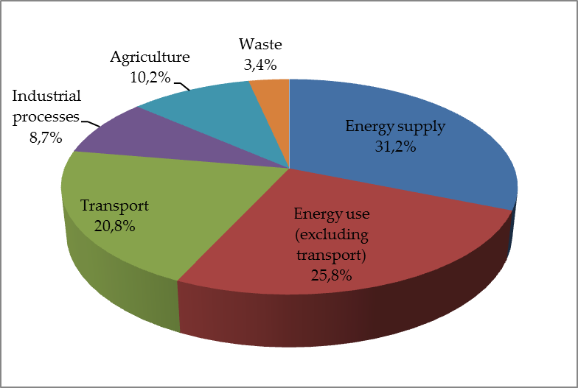
Source: EEA, EU greenhouse gas inventory, 2016 inventory data

GHG emissions decreased in the majority of sectors between 1990 and 2014, with the notable exception of transport (see figure 2), including international transport and refrigeration and air conditioning.

Figure 2: Past change in EU-28 GHG emissions by IPCC sector categories.
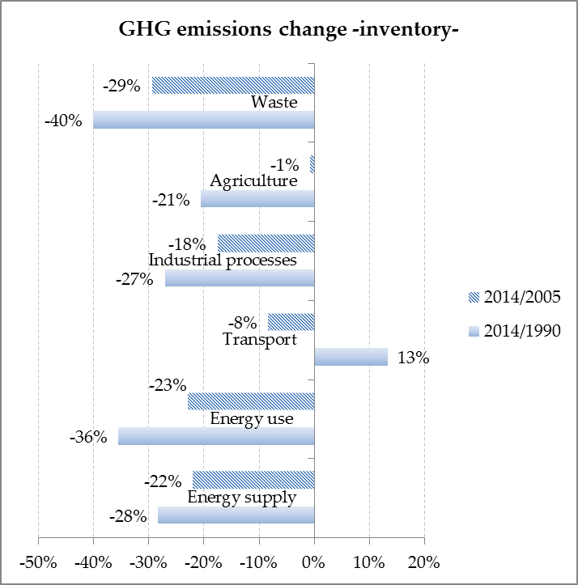
Source: EEA, 2016 EU greenhouse gas inventory

Total emissions from energy supply fell by 6.5% in 2014 compared to 2013 levels, a total decrease by 28% in the period 1990-2014. Energy supply concerns the production of energy, such as electricity or fuels like gasoline, coal, etc. In terms of emissions, energy supply comprises mainly the emissions from public electricity and heat production (thermal power plants), which together with the other supply-side sources, namely petroleum refining and manufacture of solid fuels (coal), are responsible for the bulk of all energy-related emissions. The emissions from electricity and heat production decreased strongly since 1990 thanks to improvement in the transformation efficiency, in the context of lower heat production and higher electricity production between 1990 and 2014. In addition to improved energy efficiency there has been a move towards less carbon intensive fuels and higher generation of electricity from renewable sources. Renewable energy production in the EU reached 25.4 % share of total primary energy production in 2014.
Emissions from energy use (manufacturing industries and construction, residential and service sectors) fell by 36% between 1990 and 2014. Manufacturing industries and construction was the sector responsible for largest emission reductions in the EU, in particular due to substantial improvements in carbon intensity, with emissions from solid fuels more than halving over the period, improved energy efficiency in restructured iron and steel plants and structural changes in the economy, with higher share of services and lower share of energy intensive industries in the GDP. Emissions in the residential sector also substantially decreased since 1990, notably due to energy efficiency improvements from better insulation standards in buildings and less carbon intensive fuel mix. 2014 was the hottest year on record in Europe, and the milder temperatures of autumn/winter months have partly contributed to the lower heat demand by households and therefore lower GHG emissions.
Transport, responsible for around 21% of the total EU emissions in 2014 (about 23% of the total emissions if international aviation is included) is the only sector where emissions have increased over the period 1990-2014, by approximately 13 %. Transport emissions have been on a decreasing trend since 2007 but again increased in 2014. The biggest emission source within transport was by far road transport (around 95% share of the emissions in transport sector in 2014). The overall net increase in emissions was accounted for by a strong uptake of diesel and decline of gasoline use. Energy efficiency improvements and to a lesser extent increased use of less carbon intensive fuels such as LPG and biodiesel blends have led to levels of road transport emissions that would have otherwise been higher.
Emissions from Agriculture in the EU have also shown a steady decline since 1990 levels, with an overall decrease of 21% in 2014. The largest reductions in emissions in the sector occurred due to decreasing use of fertiliser and manure and to declining cattle numbers.
Industrial Processes, covering non-energy (i.e. non-combustion) emissions that stem from chemical processes where greenhouse gases are released were responsible for 9 % of the EU total emissions in 2014. While overall emissions from the sector were cut by 30% since 1990, due to industrial emissions policy and gains in energy efficiency in industrial processes, emissions from hydrofluorocarbons (HFCs) almost quadrupled since 1990 levels, due to their use as substitutes to the ozone-depleting substances banned under the Montreal Protocol. HFCs are mostly used in refrigeration and air conditioning and the increase in emissions is consistent with both warmer climatic conditions in Europe and higher standards of comfort demanded.
The Waste sector is responsible for 3% of total EU emissions and is also one of the sectors with largest emission cuts of 40% from 1990 levels. Emissions from managed waste disposal on land account for almost two thirds of total waste emissions, and showed the greatest decrease of all waste-related emissions, due to reduction of the amount of biodegradable waste going to landfills and to increase of CH₄ recovered and utilised (combustion of biogas for electricity and/or heat generation) or flared.
  - Projections
This section presents Member State projections of GHG emissions under the “with existing measures scenario” (WEM), differentiated by sector and aggregated to EU-28 level. Projections are presented for the years 2015, 2020, 2025, 2030 and 2035, and are displayed in CO₂ equivalents. It should be noted that the projections of emissions related to fuel sold to ships and aircrafts engaged in international transport are not included in the totals reported in this section.
The GHG WEM projections of the European Union represents a business-as-usual scenario aggregated from 28 national WEM projections where only policies and measures that have been adopted or already implemented in the Member State are considered, as far as covered by national projections. With regard to EU policy coverage the WEM projection is thus a conservative scenario. The 2016 data set of projections is based on last year's 2015 projections submissions (for Member States that did not submit new projections in 2015, the EU Reference scenario 2013 was used for gap-filling purposes) and it has been updated with the 2016 submission updates provided by some Member States.
According to the WEM projections, emissions are estimated to be 23% lower in 2020 and 26% lower in 2030, as compared to 1990. When additional measures are taken into account (projections that also encompass planned policies and measures; "WAM"), projections submitted by Member States lead to a reduction of emissions by 25% in 2020 and 29% in 2030, compared to 1990. The aggregated projection for 2020 is broadly consistent with the results of the new EU Reference Scenario 2016 published by the European Commission, while for 2030 the latter projects a stronger decline of -35% in 2030 compared to 1990.
    - Total aggregate GHG emission projections per sector
From a sectoral perspective, the largest share of emission reductions comes from the energy sector (supply and use, excluding transport). 'Energy supply' and 'energy use' are the two sectors which contribute the most to emissions (57%). These emissions are projected to decrease by approximately 34 % for energy use, and 32% in the case of energy supply in 2020, reaching further reductions in 2030 of 38% and 37%, respectively (vs. 1990). In absolute terms, the 'energy supply' sector is expected to contribute quantitatively more to emissions reduction in the next decades.
Transport is the most important sector where emissions are expected to increase between 1990 and 2020. They will be 13 % higher in 2020 than in 1990 and stay at about this level until 2030. The LULUCF emissions present a slightly increasing trend, foreseen to reach 2% in 2020 and 3% in 2030 (vs. 1990).
The rest of the sectors are projected to decrease significantly their GHG emissions in the next decades, the majority of them by 2020. The industry sector is projected to decrease its emissions by approximately 28 % in 2020 and 31% in 2030 (vs. 1990). Agriculture is projected to fall 18% and 16% in 2020 and 2030, respectively. Finally, the sector that foresees the biggest decrease (not in absolute terms but relative to its emissions) is the 'waste sector' with a cut of 44% in 2020 and projects to reduce its emissions by half in 2030 (vs. 1990).

Figure 3: EU- 28 GHG emissions per sector: inventory and WEM projections scenario
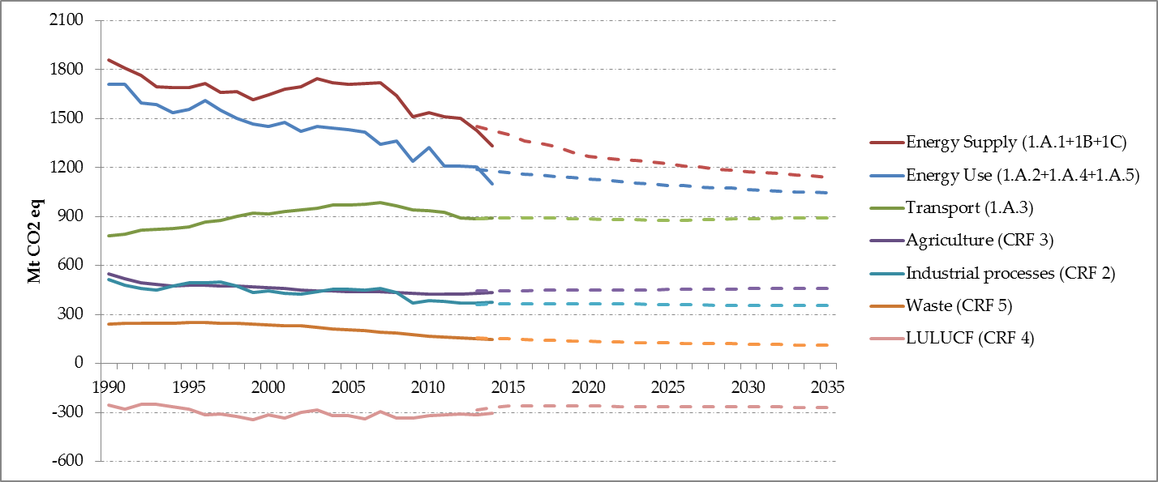
Source: EEA, European Commission
Notes: *sectors in the legend include indication of respective(s) IPCC sectoral codification.
**The observed discrepancy between 2014 projections and inventory is explained by the fact that there was no major projections update in 2016 submission under Article 14 of MMR. This means that for most MS the reference year used for projections remains 2013 (or a year before), not being possible to update their models with the most recent inventory data (up to the year 2014). The projections data set therefore remains significantly close to the previous one of 2015. Nevertheless, as part of the QA/QC process carried out by the European Topic Centre on Air and Climate Change (ETC/ACC) supporting the European Environmental Agency (EEA), the reference year used in MS projections has been checked against the GHG emissions for that same year from the latest inventory submission. This is done to ensure that projections are calibrated with the reference year used by MS for preparing their projections.

  - Convergence in GHG emissions intensity and emissions per capita

All Member States have experienced an improvement in GHG emissions intensity with the average annual reduction rate ranging from 0.8 % to 5.1 %. This has led to a convergence of performances between Member States (Figure 4).

Figure 4:GHG emissions intensity per GDP in the EU; 1990, 2005 and 2015. Percentages reflect annual average reduction between 2015-1990.
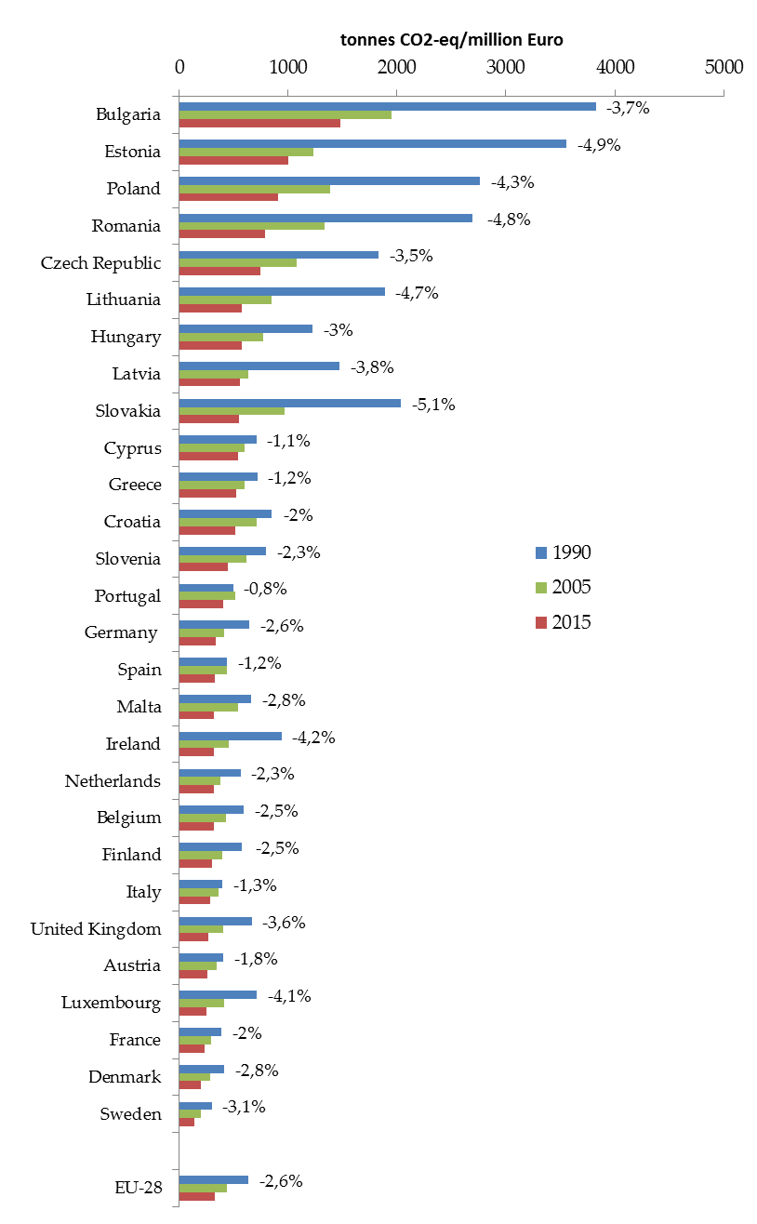
Source: Commission, EEA
Note: approximated 2015 data.
Furthermore, as shown in Figure 5, emissions per capita have been decreasing and converging since 1990 in all Member States except for Portugal and Spain. Nevertheless for these two countries the emissions per capita are well below EU average.
Figure 5: GHG emissions per capita in the EU; 1990, 2005, and 2015. Percentages reflect annual average reduction between 2015-1990.
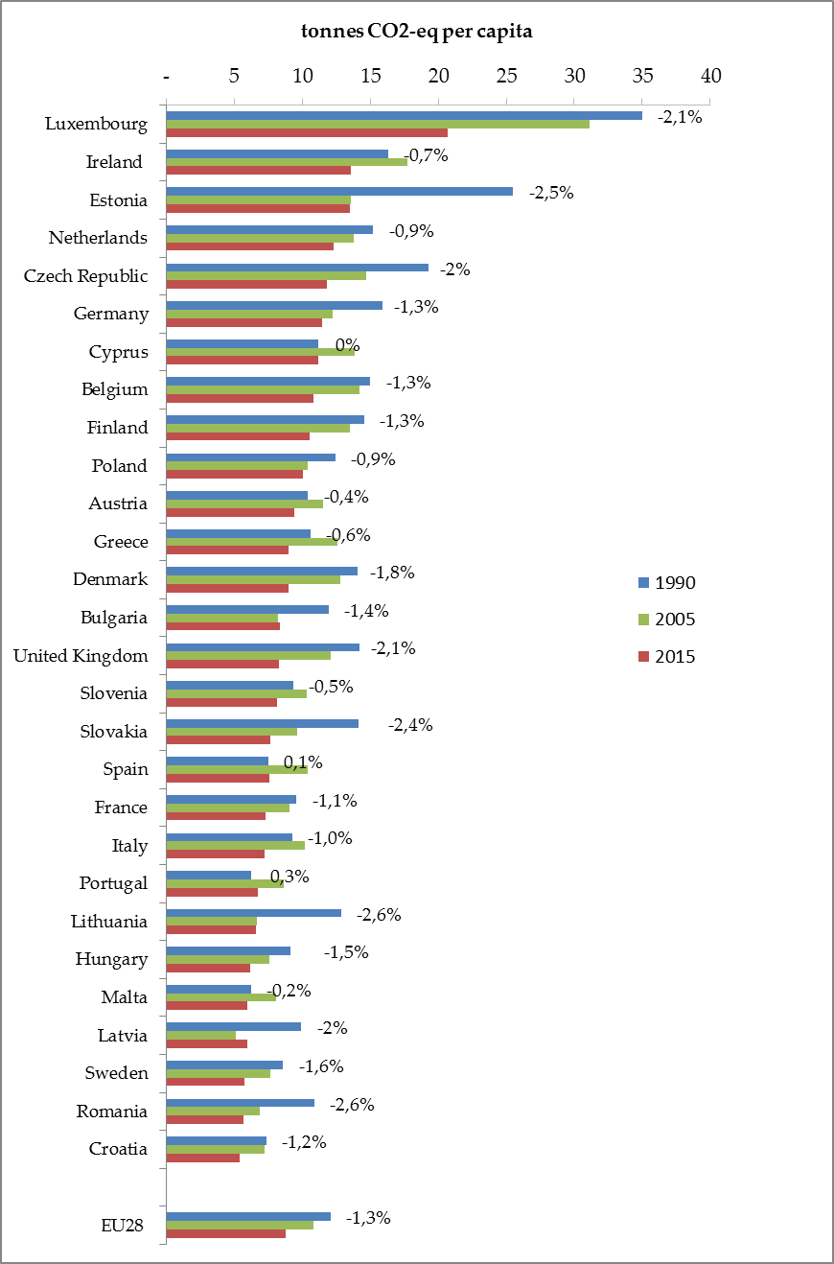
Source: Commission, EEA.
Note: approximated 2015 data

  - Comparison of the EU-28 GHG total emissions and projections under the Kyoto Protocol and under the Climate and Energy Package

The EU 20 % reduction commitment by 2020 under the Climate and Energy package covers EU CO₂ emissions to the extent aviation is covered under the EU ETS. Since 2012 emissions that means all flights from international flights departing from, to and within the EU. The Kyoto Protocol includes GHG emissions from domestic aviation only (inventory category).
The table below presents the quantitative differences between the scopes of the Kyoto Protocol and of the Climate and Energy Package. Reductions achieved by the EU-28, in 2014, when the emissions from international aviation are also taken into account, amount to -23 % compared to 1990 levels. When excluding international aviation, the reduction amounts to -24%.

Table 2: Emissions (Mt CO₂ eq) covered by the Kyoto Protocol
 | 1990 | 2005 | 2014 | 2020
Total GHG emissions | 5,665 | 5,217 | 4,282
Of which domestic aviation | 14 | 20 | 15
Projections as compilation of MS data, WEM scenario |  |  |  | 4,235
-20% compared to Kyoto base year⁽¹⁾ |  |  |  | 4,641
Note: (1) The Kyoto base year emissions is different from 1990 emissions level and it is estimated at 5,798 Mt CO₂ eq.; 5,802 Mt CO₂ eq. including Iceland
Table 3: Emissions (MtCO₂eq) covered by the Climate and Energy Package
 | 1990 | 2005 | 2014 | 2020
Total GHG emissions | 5,735 | 5,348 | 4,419
of which domestic aviation | 14 | 20 | 15
of which international aviation | 70 | 132 | 137
Projections as compilation of MS data, WEM scenario |  |  |  | 4,387
-20 % compared to 1990 |  |  |  | 4,588

- Member States progresses towards Effort Sharing Decision targets
A strong monitoring and compliance system has been put in place to monitor Member States' action and help them take corrective measures if they fail to meet their ESD targets. Inventory data submitted by the Member States needs to undergo a detailed Union review, before ESD emissions are officially determined by the European Commission. Last year technical problems with UNFCCC reporting software did not allow Member States to submit their inventories in time for the review to take place. Thus in 2016 emissions had to be reviewed both for 2013 and 2014. The 2016 review was exceptionally comprehensive – the whole inventories of all Member States had to undergo detailed 'second step' checks, ensuring inter alia proper transition of inventory reporting to 2006 IPCC guidelines. The reviewed inventory data is based on updated IPCC inventory guidelines, of which only the change of global warming potentials is reflected in the absolute ESD targets set in 2013.
Table 4 below shows that Malta is the only Member State with historic ESD emissions above its targets. Malta will now have four months to use flexibility provisions under ESD (e.g. trading ESD units with other Member States), in order to comply with ESD and avoid compliance procedures.

Table 4 : RELATIVE gap between historic emissions and ESD targets for 2013 and 2014 (in % of 2005 base year emissions)
 | 2013 |  |  | 2014
Country | A) | B) | C*)= B - A | D) | E) | F*)= E – D
Country | 2013 ESD target compared to 2005 | 2013 ESD emissions data compared to 2005 | Relative gap 2013 vs. ESD 2013 target | 2014 ESD target compared to 2005 | 2014 ESD emissions data compared to 2005 | Relative gap 2014 vs. ESD 2014 target
Austria | -9% | -14% | -4% | -10% | -17% | -7%
Belgium | -2% | -7% | -5% | -3% | -12% | -9%
Bulgaria | 12% | -7% | -20% | 13% | -5% | -18%
Croatia | 4% | -20% | -24% | 5% | -22% | -27%
Cyprus | -5% | -37% | -32% | -5% | -37% | -32%
Czech Republic | 1% | -1% | -2% | 2% | -7% | -9%
Denmark | -3% | -12% | -8% | -6% | -14% | -9%
Estonia | 8% | -1% | -9% | 8% | 4% | -4%
Finland | -6% | -6% | -1% | -7% | -11% | -3%
France | -6% | -12% | -7% | -7% | -15% | -9%
Germany | -5% | -7% | -2% | -6% | -12% | -6%
Greece | -8% | -31% | -23% | -7% | -30% | -23%
Hungary | -5% | -27% | -23% | -3% | -27% | -25%
Ireland | -4% | -13% | -10% | -6% | -14% | -8%
Italy | -9% | -19% | -10% | -10% | -22% | -12%
Latvia | 9% | 4% | -6% | 11% | 7% | -4%
Lithuania | -4% | -12% | -9% | -1% | -9% | -8%
Luxembourg | -6% | -8% | -2% | -8% | -13% | -5%
Malta | 6% | 14% | 7% | 6% | 17% | 11%
Netherlands | -4% | -15% | -12% | -5% | -23% | -18%
Poland | 9% | 5% | -4% | 10% | 2% | -8%
Portugal | -3% | -24% | -21% | -2% | -23% | -21%
Romania | 2% | -2% | -4% | 4% | -2% | -7%
Slovakia | 2% | -10% | -13% | 4% | -16% | -20%
Slovenia | 2% | -9% | -12% | 3% | -13% | -16%
Spain | -4% | -16% | -11% | -5% | -16% | -11%
Sweden | -7% | -21% | -14% | -8% | -23% | -15%
United Kingdom | -8% | -13% | -5% | -9% | -17% | -8%
* Negative gap indicates over delivery, while positive gap indicate shortfall towards ESD targets.
Note: The 2005 base year ESD emissions are not readily available from emission inventories and registries because the ETS scope and hence also the ESD scope has undergone several changes between 2005 and today. Thus 2005 ESD emissions consistent with the latest ETS scope were re-constructed using the following formula: 2005 ESD emissions = 2020 absolute ESD target / (1 + % 2020 ESD target).

Table 5 below presents the calculations underpinning Figure 2 of the Climate Action Progress Report.

Table 5 : Estimated (2015) and projected (2020) RELATIVE gap between emissions and ESD targets (in % of 2005 base year emissions)
 | 2015 |  |  | 2020
Country | A) | B) | C*)= B - A | D) | E) | F*)= E – D
Country | 2015 ESD target compared to 2005 | 2015 ESD proxy emissions data compared to 2005 | Relative gap 2015 proxy vs. ESD 2015 target | 2020 national target (ESD target) compared to 2005 | Projected 2020 non-ETS emissions compared to 2005 (with existing measures) | Gap between projected 2020 non-ETS emissions versus 2020 ESD targets
Austria | -11% | -15% | -4% | -16% | -12% | 4%
Belgium | -5% | -8% | -3% | -15% | -10% | 5%
Bulgaria | 14% | -3% | -17% | 20% | -5% | -25%
Croatia | 6% | -25% | -31% | 11% | -9% | -20%
Cyprus | -5% | -31% | -25% | -5% | -43% | -38%
Czech Republic | 3% | -9% | -12% | 9% | -8% | -17%
Denmark | -8% | -15% | -7% | -20% | -19% | 1%
Estonia | 9% | -3% | -11% | 11% | -2% | -13%
Finland | -9% | -11% | -2% | -16% | -16% | 0%
France | -8% | -13% | -5% | -14% | -17% | -3%
Germany | -7% | -9% | -2% | -14% | -15% | -1%
Greece | -7% | -30% | -24% | -4% | -26% | -22%
Hungary | -1% | -23% | -22% | 10% | -28% | -38%
Ireland | -8% | -11% | -2% | -20% | -8% | 12%
Italy | -10% | -19% | -9% | -13% | -18% | -5%
Latvia | 12% | 9% | -3% | 17% | 7% | -10%
Lithuania | 2% | -10% | -11% | 15% | -3% | -18%
Luxembourg | -10% | -14% | -3% | -20% | -15% | 5%
Malta | 6% | 25% | 19% | 5% | -16% | -21%
Netherlands | -7% | -20% | -13% | -16% | -21% | -5%
Poland | 10% | 2% | -8% | 14% | 6% | -8%
Portugal | -2% | -24% | -22% | 1% | -25% | -26%
Romania | 7% | -6% | -12% | 19% | 4% | -15%
Slovakia | 5% | -14% | -19% | 13% | -4% | -17%
Slovenia | 3% | -12% | -14% | 4% | -8% | -12%
Spain | -6% | -16% | -10% | -10% | -12% | -2%
Sweden | -10% | -24% | -14% | -17% | -28% | -11%
United Kingdom | -10% | -16% | -5% | -16% | -19% | -3%
* Negative gap indicates over delivery, while positive gap indicate shortfall towards ESD targets.

Table 6: Historic (2013-2014), estimated (2015) and projected (2016-2020) ABSOLUTE gaps between emissions and annual limits under the Effort Sharing Decision (in Mt CO₂ eq)
 |  | ESD reviewed |  |  |  | Proxy emissions |  | WEM projections
 |  | 2013 |  | 2014 |  | 2015 |  | 2016 |  | 2017 |  | 2018 |  | 2019 |  | 2020
Country | Mt CO2 eq. | emissions/  target | absolute gap to target | emissions/  target | absolute gap to target | emissions/  target | absolute gap to target | emissions/  target | absolute gap to target | emissions/  target | absolute gap to target | emissions/  target | absolute gap to target | emissions/  target | absolute gap to target | emissions/  target | absolute gap to target
Austria | emissions | 50,1 | -2,5 | 48,2 | -3,9 | 49,2 | -2,3 | 51,5 | 0,5 | 51,4 | 1,0 | 51,3 | 1,5 | 51,3 | 1,9 | 51,0 | 2,2
Austria | target | 52,6 | -2,5 | 52,1 | -3,9 | 51,5 | -2,3 | 51,0 | 0,5 | 50,4 | 1,0 | 49,9 | 1,5 | 49,3 | 1,9 | 48,8 | 2,2
Belgium | emissions | 74,3 | -4,1 | 70,1 | -6,8 | 73,0 | -2,3 | 72,6 | -1,1 | 72,4 | 0,2 | 72,2 | 1,5 | 71,9 | 2,7 | 71,6 | 4,0
Belgium | target | 78,4 | -4,1 | 76,9 | -6,8 | 75,3 | -2,3 | 73,8 | -1,1 | 72,3 | 0,2 | 70,7 | 1,5 | 69,2 | 2,7 | 67,7 | 4,0
Bulgaria | emissions | 22,2 | -4,7 | 22,9 | -4,3 | 23,3 | -4,2 | 23,3 | -4,4 | 23,2 | -4,8 | 23,0 | -5,3 | 22,8 | -5,7 | 22,7 | -6,1
Bulgaria | target | 26,9 | -4,7 | 27,2 | -4,3 | 27,5 | -4,2 | 27,7 | -4,4 | 28,0 | -4,8 | 28,3 | -5,3 | 28,5 | -5,7 | 28,8 | -6,1
Croatia | emissions | 15,1 | -4,5 | 14,7 | -5,1 | 14,1 | -5,9 | 16,8 | -3,3 | 16,9 | -3,4 | 17,0 | -3,5 | 17,1 | -3,6 | 17,2 | -3,7
Croatia | target | 19,6 | -4,5 | 19,8 | -5,1 | 20,0 | -5,9 | 20,2 | -3,3 | 20,4 | -3,4 | 20,6 | -3,5 | 20,8 | -3,6 | 21,0 | -3,7
Cyprus | emissions | 3,9 | -2,0 | 3,9 | -2,0 | 4,3 | -1,6 | 3,7 | -2,2 | 3,7 | -2,2 | 3,7 | -2,3 | 3,6 | -2,3 | 3,6 | -2,4
Cyprus | target | 5,9 | -2,0 | 5,9 | -2,0 | 5,9 | -1,6 | 5,9 | -2,2 | 5,9 | -2,2 | 5,9 | -2,3 | 5,9 | -2,3 | 5,9 | -2,4
Czech Republic | emissions | 61,5 | -1,0 | 57,6 | -5,6 | 56,6 | -7,3 | 60,4 | -4,3 | 59,6 | -5,8 | 58,8 | -7,4 | 58,0 | -8,9 | 57,2 | -10,5
Czech Republic | target | 62,5 | -1,0 | 63,2 | -5,6 | 64,0 | -7,3 | 64,7 | -4,3 | 65,4 | -5,8 | 66,2 | -7,4 | 66,9 | -8,9 | 67,7 | -10,5
Denmark | emissions | 33,7 | -3,1 | 32,6 | -3,3 | 32,4 | -2,6 | 32,4 | -1,8 | 31,6 | -1,6 | 31,2 | -1,1 | 31,0 | -0,4 | 30,8 | 0,3
Denmark | target | 36,8 | -3,1 | 35,9 | -3,3 | 35,0 | -2,6 | 34,1 | -1,8 | 33,2 | -1,6 | 32,3 | -1,1 | 31,4 | -0,4 | 30,5 | 0,3
Estonia | emissions | 5,8 | -0,5 | 6,1 | -0,2 | 5,7 | -0,7 | 5,6 | -0,7 | 5,6 | -0,7 | 5,7 | -0,8 | 5,7 | -0,8 | 5,7 | -0,8
Estonia | target | 6,3 | -0,5 | 6,3 | -0,2 | 6,3 | -0,7 | 6,4 | -0,7 | 6,4 | -0,7 | 6,4 | -0,8 | 6,4 | -0,8 | 6,5 | -0,8
Finland | emissions | 31,6 | -0,2 | 30,1 | -1,1 | 30,0 | -0,8 | 29,8 | -0,5 | 29,4 | -0,4 | 29,2 | -0,2 | 28,8 | -0,1 | 28,4 | 0,0
Finland | target | 31,8 | -0,2 | 31,3 | -1,1 | 30,8 | -0,8 | 30,3 | -0,5 | 29,8 | -0,4 | 29,3 | -0,2 | 28,8 | -0,1 | 28,4 | 0,0
France | emissions | 366,1 | -28,0 | 353,5 | -35,9 | 365,1 | -19,3 | 356,5 | -22,9 | 353,8 | -20,5 | 351,2 | -18,2 | 348,5 | -15,9 | 345,8 | -13,5
France | target | 394,1 | -28,0 | 389,5 | -35,9 | 384,4 | -19,3 | 379,4 | -22,9 | 374,4 | -20,5 | 369,3 | -18,2 | 364,3 | -15,9 | 359,3 | -13,5
Germany | emissions | 460,2 | -12,3 | 436,8 | -29,0 | 448,7 | -10,4 | 440,0 | -12,4 | 435,4 | -10,3 | 430,9 | -8,2 | 426,3 | -6,1 | 421,7 | -4,0
Germany | target | 472,5 | -12,3 | 465,8 | -29,0 | 459,1 | -10,4 | 452,4 | -12,4 | 445,7 | -10,3 | 439,0 | -8,2 | 432,3 | -6,1 | 425,6 | -4,0
Greece | emissions | 44,2 | -14,8 | 44,4 | -14,9 | 44,5 | -15,1 | 47,5 | -12,4 | 47,5 | -12,8 | 47,5 | -13,1 | 47,5 | -13,5 | 47,4 | -13,8
Greece | target | 59,0 | -14,8 | 59,3 | -14,9 | 59,6 | -15,1 | 59,9 | -12,4 | 60,3 | -12,8 | 60,6 | -13,1 | 60,9 | -13,5 | 61,2 | -13,8
Hungary | emissions | 38,4 | -12,0 | 38,4 | -13,1 | 41,0 | -11,6 | 38,6 | -15,2 | 38,5 | -16,3 | 38,5 | -17,5 | 38,4 | -18,7 | 38,4 | -19,9
Hungary | target | 50,4 | -12,0 | 51,5 | -13,1 | 52,6 | -11,6 | 53,8 | -15,2 | 54,9 | -16,3 | 56,0 | -17,5 | 57,1 | -18,7 | 58,2 | -19,9
Ireland | emissions | 42,2 | -4,7 | 41,7 | -4,1 | 43,6 | -1,0 | 43,8 | 0,3 | 44,0 | 1,7 | 44,4 | 3,2 | 44,7 | 4,6 | 45,0 | 6,0
Ireland | target | 46,9 | -4,7 | 45,8 | -4,1 | 44,6 | -1,0 | 43,5 | 0,3 | 42,4 | 1,7 | 41,2 | 3,2 | 40,1 | 4,6 | 39,0 | 6,0
Italy | emissions | 273,3 | -34,8 | 265,3 | -40,9 | 272,4 | -31,8 | 272,8 | -29,4 | 273,7 | -26,6 | 274,5 | -23,8 | 275,4 | -21,0 | 276,2 | -18,2
Italy | target | 308,2 | -34,8 | 306,2 | -40,9 | 304,2 | -31,8 | 302,3 | -29,4 | 300,3 | -26,6 | 298,3 | -23,8 | 296,4 | -21,0 | 294,4 | -18,2
Latvia | emissions | 8,8 | -0,5 | 9,0 | -0,3 | 9,2 | -0,2 | 8,7 | -0,9 | 8,8 | -0,9 | 8,9 | -0,8 | 9,0 | -0,8 | 9,1 | -0,8
Latvia | target | 9,3 | -0,5 | 9,4 | -0,3 | 9,4 | -0,2 | 9,5 | -0,9 | 9,6 | -0,9 | 9,7 | -0,8 | 9,8 | -0,8 | 9,9 | -0,8
Lithuania | emissions | 11,8 | -1,2 | 12,3 | -1,0 | 12,1 | -1,5 | 12,7 | -1,3 | 12,8 | -1,6 | 12,9 | -1,9 | 12,9 | -2,2 | 13,0 | -2,5
Lithuania | target | 12,9 | -1,2 | 13,3 | -1,0 | 13,7 | -1,5 | 14,0 | -1,3 | 14,4 | -1,6 | 14,7 | -1,9 | 15,1 | -2,2 | 15,5 | -2,5
Luxembourg | emissions | 9,4 | -0,2 | 8,9 | -0,5 | 8,8 | -0,3 | 8,6 | -0,4 | 8,6 | -0,2 | 8,6 | 0,0 | 8,6 | 0,2 | 8,6 | 0,5
Luxembourg | target | 9,5 | -0,2 | 9,3 | -0,5 | 9,1 | -0,3 | 8,9 | -0,4 | 8,7 | -0,2 | 8,5 | 0,0 | 8,3 | 0,2 | 8,1 | 0,5
Malta | emissions | 1,3 | 0,1 | 1,3 | 0,1 | 1,4 | 0,2 | 0,9 | -0,2 | 0,9 | -0,2 | 0,9 | -0,2 | 0,9 | -0,2 | 0,9 | -0,2
Malta | target | 1,2 | 0,1 | 1,2 | 0,1 | 1,2 | 0,2 | 1,2 | -0,2 | 1,2 | -0,2 | 1,2 | -0,2 | 1,2 | -0,2 | 1,2 | -0,2
Netherlands | emissions | 108,3 | -14,7 | 97,9 | -22,8 | 102,0 | -16,4 | 106,7 | -9,4 | 105,4 | -8,5 | 104,0 | -7,6 | 102,6 | -6,7 | 101,2 | -5,8
Netherlands | target | 122,9 | -14,7 | 120,7 | -22,8 | 118,4 | -16,4 | 116,1 | -9,4 | 113,9 | -8,5 | 111,6 | -7,6 | 109,3 | -6,7 | 107,0 | -5,8
Poland | emissions | 186,1 | -7,5 | 181,5 | -13,3 | 181,6 | -14,5 | 188,3 | -9,0 | 188,5 | -10,1 | 188,7 | -11,2 | 188,8 | -12,3 | 189,0 | -13,4
Poland | target | 193,6 | -7,5 | 194,9 | -13,3 | 196,1 | -14,5 | 197,4 | -9,0 | 198,6 | -10,1 | 199,9 | -11,2 | 201,1 | -12,3 | 202,3 | -13,4
Portugal | emissions | 38,6 | -10,7 | 38,8 | -10,8 | 38,6 | -11,3 | 39,8 | -10,4 | 39,4 | -11,1 | 38,9 | -11,8 | 38,5 | -12,4 | 38,1 | -13,1
Portugal | target | 49,3 | -10,7 | 49,6 | -10,8 | 49,9 | -11,3 | 50,1 | -10,4 | 50,4 | -11,1 | 50,7 | -11,8 | 51,0 | -12,4 | 51,2 | -13,1
Romania | emissions | 72,7 | -2,9 | 72,5 | -4,9 | 70,0 | -9,3 | 71,6 | -9,5 | 72,9 | -10,0 | 74,3 | -10,4 | 75,7 | -10,9 | 77,0 | -11,3
Romania | target | 75,6 | -2,9 | 77,5 | -4,9 | 79,3 | -9,3 | 81,1 | -9,5 | 82,9 | -10,0 | 84,7 | -10,4 | 86,6 | -10,9 | 88,4 | -11,3
Slovakia | emissions | 21,1 | -2,9 | 19,8 | -4,6 | 20,2 | -4,6 | 22,4 | -2,7 | 22,5 | -3,0 | 22,5 | -3,3 | 22,6 | -3,6 | 22,6 | -3,9
Slovakia | target | 24,0 | -2,9 | 24,4 | -4,6 | 24,7 | -4,6 | 25,1 | -2,7 | 25,5 | -3,0 | 25,8 | -3,3 | 26,2 | -3,6 | 26,5 | -3,9
Slovenia | emissions | 10,9 | -1,4 | 10,5 | -1,9 | 10,7 | -1,7 | 11,2 | -1,2 | 11,1 | -1,3 | 11,1 | -1,4 | 11,1 | -1,4 | 11,0 | -1,5
Slovenia | target | 12,3 | -1,4 | 12,4 | -1,9 | 12,4 | -1,7 | 12,4 | -1,2 | 12,4 | -1,3 | 12,5 | -1,4 | 12,5 | -1,4 | 12,5 | -1,5
Spain | emissions | 200,3 | -27,3 | 199,8 | -25,9 | 199,4 | -24,3 | 201,1 | -20,7 | 202,9 | -17,0 | 204,8 | -13,2 | 206,8 | -9,2 | 208,4 | -5,8
Spain | target | 227,6 | -27,3 | 225,6 | -25,9 | 223,7 | -24,3 | 221,8 | -20,7 | 219,9 | -17,0 | 218,0 | -13,2 | 216,1 | -9,2 | 214,2 | -5,8
Sweden | emissions | 35,3 | -6,4 | 34,5 | -6,5 | 34,0 | -6,4 | 33,7 | -6,0 | 33,3 | -5,8 | 32,9 | -5,6 | 32,5 | -5,3 | 32,1 | -5,1
Sweden | target | 41,7 | -6,4 | 41,0 | -6,5 | 40,4 | -6,4 | 39,8 | -6,0 | 39,1 | -5,8 | 38,5 | -5,6 | 37,8 | -5,3 | 37,2 | -5,1
United Kingdom | emissions | 339,5 | -19,3 | 324,4 | -29,8 | 328,7 | -21,0 | 337,8 | -7,4 | 333,1 | -7,6 | 327,9 | -8,2 | 323,3 | -8,3 | 315,6 | -11,5
United Kingdom | target | 358,7 | -19,3 | 354,2 | -29,8 | 349,7 | -21,0 | 345,2 | -7,4 | 340,7 | -7,6 | 336,1 | -8,2 | 331,6 | -8,3 | 327,1 | -11,5
Note: Negative gap indicates over delivery, while positive gap indicate shortfall towards ESD targets.
Source: EEA, European Commission.
(1) 2013 and 2014 ESD emissions from the 2016 ESD comprehensive review of inventory data.
(2) 2015 emissions data are approximated inventory data (Art. 8 of the MMR)
(3) 2016-2020 projected emissions in effort sharing sectors from MS with existing measures

- Key figures for Kyoto CP1 compliance

Table 7: Initial Assigned Amount units, GHG emissions 2008-2012 (tCO2eq), and Kyoto Protocol units in the retirement account

 |  |  | Total quantity of Kyoto Protocol units in the retirement account
 | IAA | GHG emissions 2008-2012 | AAUs | ERUs | RMUs | CERs | tCERs | lCERs | Total
Eu-15 | 19621381509 | 18822263095 | 17.368.888.639 | 445.838.157 | 302.009.951 | 725.166.210 | 1.615.811 | - | 18.843.518.768

 |  |  | Total quantity of Kyoto Protocol units in the retirement account
 | IAA | GHG emissions 2008-2012 (tCO2eq) | AAUs | ERUs | RMUs | CERs | tCERs | lCERs | Total
Austria | 343.866.009 | 414.658.054 | 362.501.669 | 11.975.750 | 6.786.726 | 33.393.909 | - | - | 414.658.054
Belgium | 673.995.528 | 626.308.776 | 590.701.837 | 9.451.546 | - | 26.162.846 | - | - | 626.316.229
Denmark | 276.838.955 | 297.947.591 | 257.813.160 | 14.510.576 | 8.654.523 | 17.005.884 | - | - | 297.984.143
Finland | 355.017.545 | 338.353.531 | 304.541.813 | 4.088.755 | 17.449.492 | 12.273.471 | - | - | 338.353.531
France | 2.819.626.640 | 2.538.856.531 | 2.425.839.655 | 24.706.979 | 23.648.026 | 64.661.871 | - | - | 2.538.856.531
Germany | 4.868.096.694 | 4.706.574.671 | 4.245.979.938 | 194.764.982 | 39.728.163 | 226.101.588 | - | - | 4.706.574.671
Greece | 668.669.806 | 598.504.091 | 568.566.201 | 11.322.449 | 2.052.032 | 16.563.409 | - | - | 598.504.091
Ireland | 314.184.272 | 308.508.846 | 280.189.478 | 4.294.121 | 16.291.152 | 6.512.114 | 1.221.981 | - | 308.508.846
Italy | 2.416.277.898 | 2.479.638.840 | 2.258.521.514 | 46.715.521 | 75.276.599 | 98.993.939 | 131.267 | - | 2.479.638.840
Luxembourg | 47.402.996 | 60.116.132 | 53.190.972 | 395.536 | 373.279 | 5.893.782 | 262.563 | - | 60.116.132
Netherlands | 1.001.262.141 | 997.119.267 | 928.949.317 | 29.763.371 | - | 38.406.579 | - | - | 997.119.267
Portugal | 381.937.527 | 362.098.075 | 302.650.818 | 4.567.634 | 44.760.045 | 10.119.578 | - | - | 362.098.075
Spain | 1.666.195.929 | 1.791.980.049 | 1.568.312.827 | 65.062.121 | 52.780.585 | 105.824.516 | - | - | 1.791.980.049
Sweden | 375.188.561 | 305.573.749 | 295.466.371 | 2.113.323 | - | 7.994.055 | - | - | 305.573.749
United Kingdom | 3.412.080.630 | 3.017.236.560 | 2.925.663.069 | 22.105.493 | 14.209.329 | 55.258.669 | - | - | 3.017.236.560

 |  |  | Total quantity of Kyoto Protocol units in the retirement account
 | IAA | GHG emissions 2008-2012 | AAUs | ERUs | RMUs | CERs | tCERs | lCERs | Total
Bulgaria | 610.045.827 | 312.859.911 | 285.924.659 | 13.587.718 | 3.563.874 | 9.783.660 |  |  | 312.859.911
Croatia | 148.778.503 | 144.820.156 | 139.023.568 | 487.493 | 5.090.172 | 218.923 | - | - | 144.820.156
Czech Republic | 893.541.801 | 680.149.966 | 626.791.646 | 25.128.765 | 6.584.129 | 21.645.426 |  |  | 680.149.966
Estonia | 196.062.637 | 95.304.517 | 90.835.022 | 4.255.338 | - | 214.157 | - | - | 95.304.517
Hungary | 542.366.600 | 335.956.338 | 325.001.828 | 1.172.944 | 7.277.911 | 2.503.655 |  |  | 335.956.338
Latvia | 119.182.130 | 56.453.901 | 48.478.397 | 490.531 | 6.233.333 | 1.251.640 |  |  | 56.453.901
Lithuania | 227.306.177 | 109.786.321 | 97.066.552 | 3.477.985 | 5.893.563 | 3.348.131 | - | - | 109.786.321
Poland | 2.648.181.038 | 2.006.265.534 | 1.947.596.833 | 2.061.462 | 27.766.419 | 28.840.820 |  |  | 2.006.265.534
Roumania | 1.279.835.099 | 615.929.959 | 584.842.690 | 4.479.948 | 17.988.730 | 8.618.591 | - | - | 615.929.959
Slovakia | 331.433.516 | 227.690.025 | 209.505.856 | 2.327.557 | 1.394.152 | 14.462.460 | - | - | 227.690.025
Slovenia | 93.628.593 | 98.542.441 | 85.504.459 | 4.695.634 | 6.600.000 | 1.742.348 | - | - | 98.542.441

 | IAA | GHG emissions 2008-2012 | AAUs | ERUs | RMUs | CERs | tCERs | lCERs | Total
EU (26) | 26.711.003.052 | 23.527.233.832 | 21.809.460.149 | 508.003.532 | 390.402.234 | 817.796.021 | 1.615.811 | - | 23.527.277.837

Source: UNFCC, European Commission.
Note: IIA: Initial Assigned Amount, AAU: Assigned Amount Unit, ERU: Emission Reduction Unit, RMU: Removal Unit, CER:Certified Emission reduction, tCER:temporary Certified Emission Reduction, lCER:long-term Certified Emission Reduction.

Table 8: Total quantity of Kyoto Protocol units requested to be carried over from first to the second commitment period

 | AAUs | ERUs | CERs
EU15 | 2.124.109.368,00 | 0 | 0

 | AAUs | ERUs | CERs
Austria | 4.945 | 360 | 2.322.185
Belgium | 1.706.252 | 3.267.881 | 16.822.907
Denmark | - | - | -
Finland | 14.018.572 | 2.917.220 | 6.798.242
France | 187.377.092 | - | -
Germany | - | - | -
Greece | 37.224.272 | 3.493.262 | 4.392.299
Ireland | 7.816.073 | 74.964 | 5.255.000
Italy | 795.601 | 1.108.946 | 2.138.152
Luxembourg | 59 | - | 527.006
Netherlands | - | - | 3.684.180
Portugal | 40.608.686 | 595.005 | 4.149.718
Spain | 16.062.657 | 2.171.080 | 14.742.035
Sweden | 262.565 | 1.225.069 | 7.845.487
United Kingdom | 1.162.710 | 85.302.015 | 27.524.671

 | AAUs | ERUs | CERs
Bulgaria | 259.659.629 | 2.284.921 | 913.430
Croatia | 9.048.519 | - | -
Czech republic | 48.272.014 | - | -
Estonia | 19.868.929 | 2.127.338 | 440.523
Hungary | 166.996.521 | 3.876.894 | 5.336.676
Latvia | 28.249.726 | 5.317 | 21.550
Lithuania | 71.822.887 | 2.327.000 | 246.966
Poland | 411.095.255 | 42.388.889 | 42.968.220
Romania | 532.594.270 | 17.870.726 | 8.692.621
Slovakia | 28.624.050 | - | -
Slovenia | 1.248.230 | - | -

 | AAUs | ERUs | CERs
EU (26) | 4.008.628.882 | 171.036.887 | 154.821.868

Source: UNFCC, European Commission.
Note: AAU: Assigned Amount Unit, ERU: Emission Reduction Unit, CER: Certified Emission reduction.

- Member States Climate Finance
In 2015, EU Member States submitted to the European Commission their third annual reports on financial and technology support provided to developing countries pursuant to Article 16 of the Monitoring Mechanism Regulation (MMR) with information for the year 2014. The information submitted by EU Member States is in accordance with the relevant provisions of the UNFCCC, including the common formats agreed under UNFCCC for the biennial reports. In 2014, the EU and its Member States contributed EUR 14.5bn in climate finance.
Table 9 : Climate finance provided to developing countries (2014).
EU and Member States | Climate finance (€ million)
Austria | 141,27
Belgium | 142,74
Bulgaria | 0,07
Croatia | 0,03
Cyprus | 0,00
Czech Republic | 10,80
Denmark | 222,04
Estonia | 0,53
Finland | 132,25
France | 2921,43
Germany | 5130,61
Greece | 0,04
Hungary | 2,71
Ireland | 41,44
Italy | 143,23
Latvia | 0,42
Lithuania | 0,26
Luxembourg | 36,26
Malta | 0,08
Netherlands | 339,98
Poland | 4,19
Portugal | 9,52
Romania | 0,03
Slovakia | 1,23
Slovenia | 2,35
Spain | 498,75
Sweden | 384,75
United Kingdom | 1551,43
European Commission | 677,01
European Investment Bank | 2098,50
EU total | 14493,94
Source: Reporting submitted by MS under Monitoring Mechanism Regulation (EU) n 525/2013; OECD data on imputed multilateral climate related finance.

This figure includes climate finance sources from public budgets and other development financial institutions. The 2014 figure also includes climate finance from the EIB of EUR 2.1bn and OECD data on imputed multilateral contributions. The data is reported on the basis of technical guidance from the European Commission for reporting under Article 16, as discussed with Member States. Differences in reporting methodologies and in the scope of the data still exist, despite efforts by the EU and its Member States to harmonise reporting methodologies.
Types of activities
The EU and its Member States supported both activities that reduce greenhouse gas emissions (mitigation) and adaptation to the consequences of climate change. Of all climate funding, approximately 58% was devoted to mitigation and 14% to adaptation. The remaining 28% was multi-purpose climate finance with both adaptation and mitigation objectives, including the fight against deforestation and forest degradation in developing countries (REDD+).

- Adaptation to climate change
The 2013 EU strategy on adaptation to climate change aims at making Europe more climate-resilient. It promotes adaptation action across the EU, ensuring that adaptation considerations are addressed in all relevant EU policies (mainstreaming), promoting greater coordination, coherence and information-sharing.
In 2017, the European Commission will report to the EU Parliament and Council on the implementation of the Adaptation Strategy. This report will also include an assessment of the progress made by Member States in terms of adaptation action and hence preparedness. Progress will be assessed, inter alia, on the basis of the reports provided in 2015 by Member States within the framework of the Monitoring Mechanism Regulation. Some general trends are described below:
Adaptation planning and the identification of general risks and vulnerabilities are developed in many Member States. National adaptation strategies/actions plans have been adopted in 21 Member States and most of those who do not yet have a strategy are preparing one. In addition, several Member States are in the process reviewing their adaptation strategies and action plans. Effective horizontal coordination between relevant Ministries was beneficial in many cases: for example, in Austria, Belgium, and Hungary it has facilitated the planning for adaptation. Coordination between different levels of governance (local, regional, national) is still weak in the majority of Member States. However, there are some efforts to develop political, regulatory and technical frameworks for cities to implement adaptation measures in different Member States. Several countries have included urban adaptation in their national strategies, or have made it a standard part of priority sectors under consideration . At EU level, adaptation has been merged with mitigation efforts through the new Covenant of Mayors in a European initiative of nearly 7,000 cities. Stakeholder involvement is considered key to have a transparent, inclusive and well-informed planning process. Some countries have yet to explore in-depth involvement and increase the commitment to adaptation of private sector and civil society stakeholders. Progress, in this direction, has been achieved in some Member States, for example the UK, the Netherlands and France.
In the Member States, earmarked financing for adaptation is still more the exception than the rule. While over half of the MS have financial resources available for preliminary adaptation action (e.g. climate services, vulnerability assessments and climate research), only few (for instance Denmark, Germany and Malta) have a dedicated budget to implement adaptation action in vulnerable sectors. Public funding for adaptation often focuses on water, agriculture, forestry and human health.
The definition of solid adaptation actions and their strategic implementation is still an outstanding issue for many Member States. Further comprehensive sector vulnerability assessments should be carried out. Only few countries have specific projects/programs to implement adaptation measures as such. Due to insufficient awareness, technical capacity and resources, measures are often implemented ad hoc. Providing information to relevant stakeholders (e.g. on adaptation tools, education, guidelines) and integrating adaptation concerns into priority policies are the main instruments in this regard. Priority sectors for adaptation implementation cover a broad spectrum and include: water management and water resources, forests and forestry, agriculture, biodiversity and ecosystems, and human health.
Monitoring and Evaluation systems of adaptation have only been developed or are under development in less than half the Member States . This is partly explained by the relatively early stage in implementation of adaptation actions. The few MS that are more advanced with M&E, have mostly focused on processes as in the case of Spain and Finland, while outcome-based indicators (e.g. reductions in vulnerability to climate change) were developed by Austria and Germany. Challenges in this regard include developing outcome-based indicators and addressing knowledge gaps, such as on cost and benefits of adaptation and vulnerability at local level.

For Member States that did not submit new projections in 2015, the EU Reference scenario 2013 was used for gap-filling purposes (http://ec.europa.eu/clima/policies/strategies/2030/docs/eu_trends_2050_en.pdf). For more information, see Trends and Projections in Europe 2015 : http://www.eea.europa.eu/publications/trends-and-projections-in-europe-2015.
Member States that do not use their 3 % limit for the use of international credits in any specific year can transfer the unused part of their limit to another Member State or bank it for their own use until 2020. Member States fulfilling additional criteria (Austria, Belgium, Cyprus, Denmark, Finland, Ireland, Italy, Luxembourg, Portugal, Slovenia, Spain and Sweden) may use credits from projects in Least Developed Countries (LDCs) and Small Island Developing States (SIDS) up to an additional 1 % of their verified emissions in 2005. These credits are not bankable and transferable. A maximum of approximately 750 Mt of international credits can be used during the period from 2013 to 2020 in the ESD.
Member States that do not use their 3 % limit for the use of international credits in any specific year can transfer the unused part of their limit to another Member State or bank it for their own use until 2020. Member States fulfilling additional criteria (Austria, Belgium, Cyprus, Denmark, Finland, Ireland, Italy, Luxembourg, Portugal, Slovenia, Spain and Sweden) may use credits from projects in Least Developed Countries (LDCs) and Small Island Developing States (SIDS) up to an additional 1 % of their verified emissions in 2005. These credits are not bankable and transferable. A maximum of approximately 750 Mt of international credits can be used during the period from 2013 to 2020 in the ESD.
Member States that do not use their 3 % limit for the use of international credits in any specific year can transfer the unused part of their limit to another Member State or bank it for their own use until 2020. Member States fulfilling additional criteria (Austria, Belgium, Cyprus, Denmark, Finland, Ireland, Italy, Luxembourg, Portugal, Slovenia, Spain and Sweden) may use credits from projects in Least Developed Countries (LDCs) and Small Island Developing States (SIDS) up to an additional 1 % of their verified emissions in 2005. These credits are not bankable and transferable. A maximum of approximately 750 Mt of international credits can be used during the period from 2013 to 2020 in the ESD.
Member States that do not use their 3 % limit for the use of international credits in any specific year can transfer the unused part of their limit to another Member State or bank it for their own use until 2020. Member States fulfilling additional criteria (Austria, Belgium, Cyprus, Denmark, Finland, Ireland, Italy, Luxembourg, Portugal, Slovenia, Spain and Sweden) may use credits from projects in Least Developed Countries (LDCs) and Small Island Developing States (SIDS) up to an additional 1 % of their verified emissions in 2005. These credits are not bankable and transferable. A maximum of approximately 750 Mt of international credits can be used during the period from 2013 to 2020 in the ESD.
As refered to in Article 14 (3) of the MMR (EU No 525/2013)
Eight MS updated their projections in 2016 updates submissions (AT, CY, DK, FR, EL, HU, IE, LU)
http://ec.europa.eu/clima/policies/strategies/analysis/models/docs/full_referencescenario2016report_en.pdf
http://www.consilium.europa.eu/en/press/press-releases/2015/11/10-conclusions-climate-finance/

