Synthesis Report on the Quality of Drinking Water in the Union examining Member States' Reports for the 2011-2013 period, foreseen under Article 13(5) of Directive 98/83/EC

- Introduction

The Directive
The Drinking Water Directive (DWD) aims to ensure that water intended for human consumption is safe. The Directive requires that drinking water must be free of any microorganisms, parasite or substance that could potentially endanger human health by setting standards for the most common potentially harmful organisms and substances that can be found in drinking water.

The Report
Member States are obliged under the Drinking Water Directive to monitor on a regular basis the quality of the drinking water that is supplied to consumers. They have to report triennially the monitoring results to the Commission. This synthesis report gives a summary of the drinking water quality in EU Member States in 2011-2013. It fulfils the obligation of the Commission under Article 13(5) of the DWD to examine the Member States' reports and to publish every three years a synthesis report on the quality of drinking water in the EU. The information provided in this report covers all Member States except one: Croatia was exempted from the current reporting obligation, as it joined the EU in mid-2013, which was close to the end of this reporting period. This report is independent from a Staff Working Document on the REFIT evaluation of the DWD which will be adopted during the last semester of 2016.
The Directive makes a distinction between large and small water supplies. Large water supplies provide either more than 1,000 m³ drinking water per day as an average or serve more than 5,000 persons. The minimum water quality requirements are equal for both large and small supplies, but the reporting obligations apply only to large supplies. Accordingly, this synthesis report summarises the drinking water quality in large supplies.
Nevertheless, during the data collection exercise, 15 Member States (BE, BG, CY, ES, FR, GR, HU, IE, LU, MT, PT, RO, SE, SI, SK) provided on a voluntary basis also information on small water supply zones (supplying less than 1,000m³/day). An overall EU assessment of compliance in small supplies was not considered meaningful as the data available was not fully representative for the entire EU and therefore this information is not included in the present report. According to the information provided by these 15 Member States the overall compliance is on average 98% high and no major problems are indicated. However, the Commission considers that additional information is needed to get a better picture of the exact situation and will therefore look into this further. Where Member States provided information on small supplies, this information is summarised at the end of the each country sheet. Country sheets providing more detailed information per Member State are available on the Commission's DG Environment website. Links to national drinking water reports (2011-2013) on national webpages are listed in Annex I to this report.

Drinking water quality parameters
The Directive sets standards for the most common potentially harmful organisms and substances that can be found in drinking water. A total of 48 essential parameters must be monitored and tested regularly. The Directive distinguishes three groups of parameters: microbiological parameters, chemical parameters and indicator parameters (detailed in Annex I of the Directive).
The two microbiological parameters Escherichia coli and Enterococci have a parametric value that is a substitute for zero. In other words, these organisms should be absent from drinking water to guarantee its quality and safety.
The chemical parameters have been selected for their potential impact on human health. Chemicals are, besides accidents, almost never present in drinking water in concentrations that cause acute health effects. Chemicals include trace elements, like arsenic, nickel or lead, other substances like cyanide or polycyclic aromatic hydrocarbon or nitrogen components – nitrate and nitrite. The impact of chemicals depends on the exceedance level, the duration of exposure, and on the way they affect the human body. Mostly the parametric values are based on lifelong exposure and an average drinking water intake of two litres per person per day.
The indicator parameters concern parameters that have indirect relevance to the quality of water: they serve to indicate that something has changed in the source water, the treatment or the distribution of the water. When an exceedance in this group of parameters is observed, the situation needs to be further investigated and to be adjusted. Even though most indicator parameters do not pose a direct threat to human health, they might impact indirectly the water quality through the appearance, taste or odour of the water (and hence influence the acceptability by the consumer) or they might interfere with proper treatment e.g. inadequate disinfection because of the presence of organic matter.
The monitoring requirements have been recently updated by an amendment of Annexes II and III of the Directive to scientific and technical progress. This amendment has introduced a voluntary use of a risk-based approach to extend monitoring, to reduce frequency or to remove parameters on the basis of the results of a risk assessment. It entered into force on 27th October 2015 and has to be transposed into national legislation within a period of 24 months by the Member States.
- results at EU Level

General information
In the EU, drinking water is abstracted from different sources. Overall, main sources in Member States are groundwater and surface water (e.g. drinking water dams), accounting for respectively some 50 % and 36 % of our drinking water supply (Figure 1).

Figure 1 Sources for drinking water in the EU (2011 to 2013)
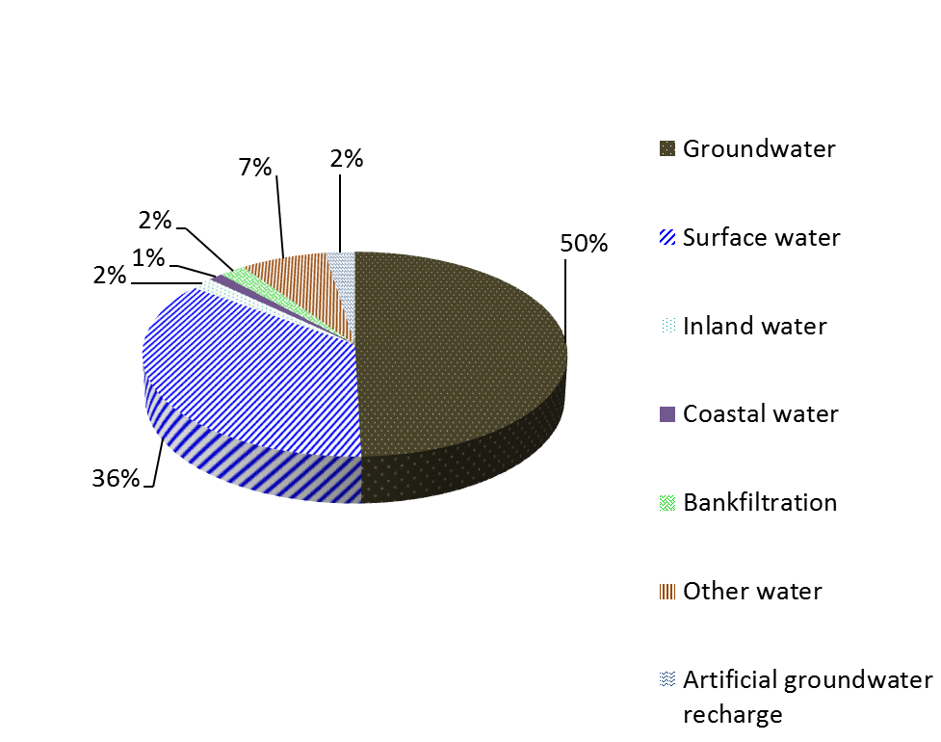

The distribution of water sources in Member States is shown in ..

Figure 2 Sources for drinking water in Member States (2011 to 2013)
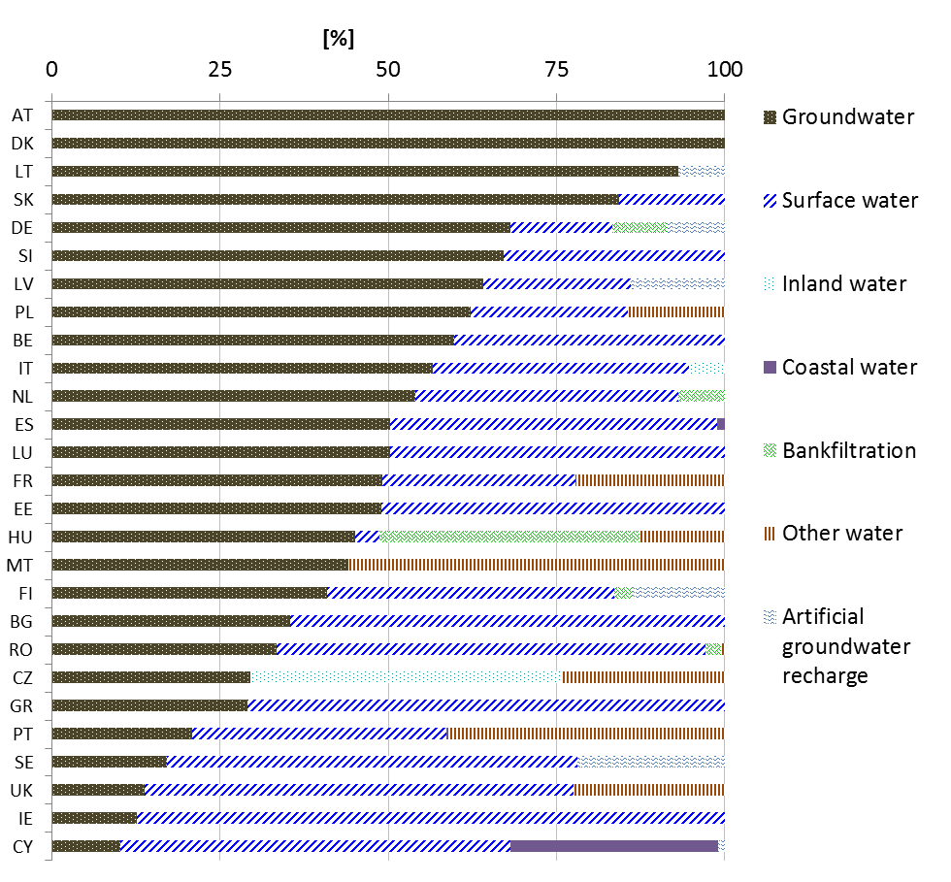
*In CZ, inland water is synonymous with surface water

In the EU, no official statistical data is collected about how many people are connected to the public water supply. Figure 3 shows the percentage of resident population served by large water supply zones (>1,000m³/day and/or supplying more than 5,000 people).

Figure 3 Resident population in large water supply zones in Member States (2011 to 2013)

The Netherlands and Luxembourg serve 100 % of their resident population by large supplies. A considerable part of EU population not served by large supplies is served by small supplies which have to comply with the requirements of the Directive. Considering both large and small supplies, Malta, Slovakia, Portugal, France, Bulgaria and Hungary, reach also 100 % resident population and most other Member States reach most of the population apart from Romania where only 66% of the population is served by both supplies. As only 15 Member States reported on small water supplies, this additional information is not displayed in Figure 3.

Drinking water quality - Compliance
To assess drinking water quality in a water supply zone, a very large number of analyses have been carried out within the 2011-2013 reporting period in Member States: 4.1 million on microbiological parameters, 7.1 million on chemical parameters and 17.5 million on indicator parameters.

For each parameter, information on compliance was available. The percentage of compliance reflects the ratio of the number of samples analysed and the number of exceedances observed. If at least 99 % of all analyses done in a given year meet the given standard, the Member State is considered to be compliant with the Directive for the parameter concerned. Exceedances of indicator parameters do not necessarily mean a non-compliance with the Directive because of the above-mentioned reasons (if there is no direct threat to human health).

Figure 4 shows the percentage of compliance for the different parameter groups in the EU. The results show high compliance of over 99 % for microbiological and chemical parameters. The presence of the two microbiological parameters E.coli and enterococci in a drinking water sample may indicate that contamination may have occurred either at a water source or within the water distribution network. Any detection of E. coli or enterococci in a drinking water sample is seen as an exceedance. Indicator parameters (except colour, odour, taste and turbidity) reach almost 99% of compliance in the reporting years 2011 to 2013.

Figure 4 Percentage of compliance for the parameter groups microbiological parameters, chemical parameters and indicator parameters for the reporting period 2011-2013 in the EU

Figure 5 shows the information on compliance for the individual chemical parameters in the EU.
Figure 5 Compliance rates for the chemical parameters in the EU (2011-2013)
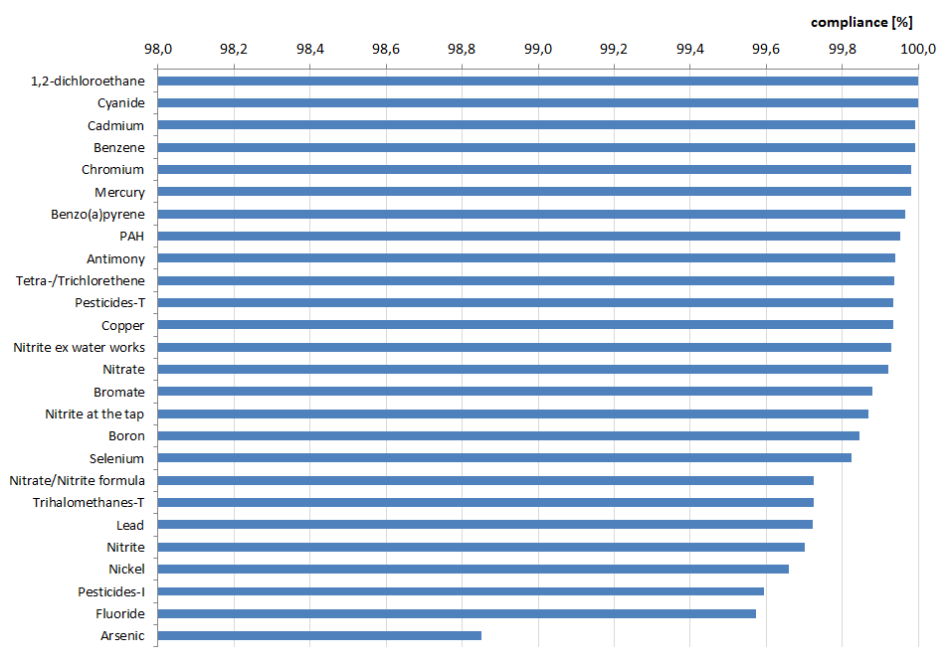
Arsenic shows, in contrast to nearly all other parameters, the lowest compliance rate with 98.83 %. This relatively lower compliance rate (but still higher than 98,8 %) is mainly caused by catchment characteristics and is due to geological background concentration that can be found in Hungary or Italy for example.

Figure 6 shows the information on exceedances for individual indicator parameters. The figure just gives an overview of the exceedances and does not reflect non-compliance with the Directive, because a number of indicator parameters do not have a numeric value, such as colour, taste, odour, or turbidity. Nevertheless, parameters that most frequently showed exceedances in this indicator parameter group are total organic carbon (TOC) and iron. TOC, alone is not harmful. It represents an indirect measure of organic molecules present in water measured as carbon. It is an indicator of the health and safety of source water and distribution system water quality, and has a link to disinfection byproducts. Upon its reaction with a disinfectant it can produce harmful byproducts. TOC is also important for optimizing and thereby reducing costs associated with a treatment process. The issue of naturally iron/manganese-bearing water is that the dissolved iron and manganese are oxidized and change from colorless, dissolved forms to colored, solid forms.

Figure 6 Compliance rates for the indicator parameters in the EU (2011-2013).

Box 1 Pesticides in drinking water
The DWD sets a concentration limit of 0.1μg/l for individual pesticides, and of 0.5μg/l for the total sum of pesticides. Member States monitor a considerable number of pesticides and metabolites (degradation and reaction products) in drinking water that are chosen at national level and are thus specific for each Member State. However, only those pesticides that are likely to be present in a given supply need to be monitored. For reporting purposes a short list of 13 pesticides was agreed between European Commission and Member States. For these, monitoring frequency and information on non-compliance were reported for 2011-2013. Even though the reporting of pesticides’ short list is a harmonized approach and comparable, it does not show the full picture of all pesticides and all relevant metabolites occurring in a country.
The following figure shows the percentage of large water supply zones monitored for occurrence and exceedance of pesticides of the short list in the EU during the 2011-2013 reporting period.
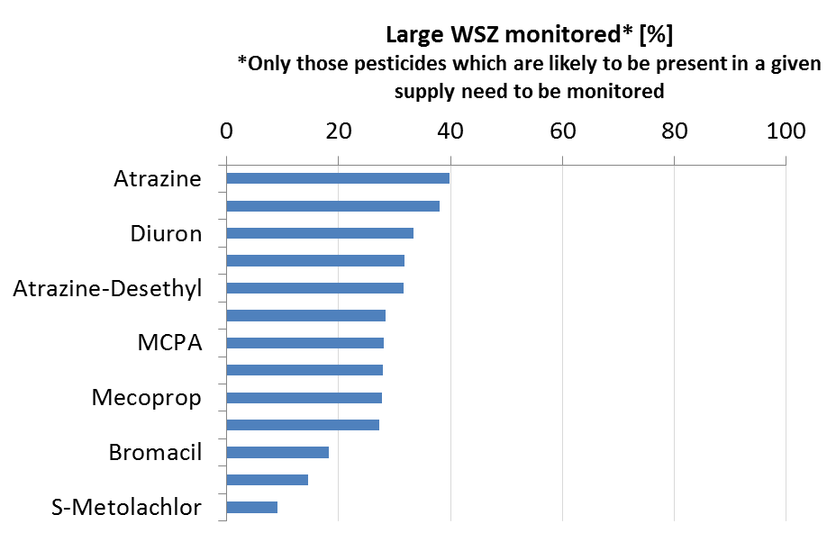
The low monitoring values (mean 27.4%) illustrate that the monitoring approach foreseen in the DWD does not allow a comprehensive EU assessment of pesticide contamination in drinking water, although the reported compliance rates are consistently high (total of more than 99.9%, see Figure 5). Based on a survey carried out in the Member States, the Commission has made an updated list of pesticides and metabolites of concern available, for consideration in monitoring programmes.

Causes of non-compliance
The Drinking Water Directive requires Member States to report the causes and remedial actions for non-compliances detected in a water supply zone. The causes of exceedances are classified in the reporting formats as "catchment related", "treatment related" and "distribution related" (public network and domestic network).

Figure 7 shows the number of number of analyses that caused exceedances for main parameters. During the 2011-2013 reporting period, the most exceedances were reported for coliform bacteria, followed by Iron, total organic carbon, and ammonium. Most of these parameters are indicator parameters without direct threat to human health.

Figure 7 Number of analyses that caused exceedances for the parameters of the Drinking Water Directive in the EU (2011-2013).
shows the different causes for the most reported parameters. While causes for exceedances due to biological parameters (coliform bacteria, colony count, E-coli, Enterococci, Clostridium) and iron cannot be exactly specified, exceedances of ammonium, manganese, pH, chloride, sulphate, arsenic and nitrite are mainly catchment related. Total organic carbon and aluminium are mainly treatment related, whereas lead is clearly associated with problems in domestic distribution network.

Figure 8 Causes of non-compliance for the most reported parameters
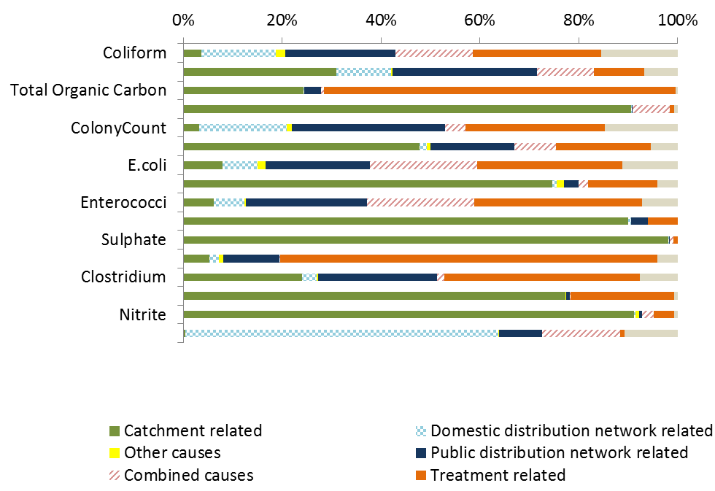

Country comparison
Non-compliance of parameter groups is presented in Table 1 at national level in Member States. The assessment is based on the mean compliance rate for each parameter group of the years 2011 to 2013.

Table 1 Compliance rates at national level in the Member States (2011-2013)
Country | Microbiological parameters | Chemical parameters | Indicator parameters*
AT | 99,84 | 99,9 | 99,6
BE | 99,75 | 99,9 | 99,1
BG | 99,25 | 99,5 | 99,3
CY | 99,01 | 99,9 | 96,3
CZ | 99,91 | 99,9 | 99,2
DE | 99,88 | 99,9 | 99,7
DK | 99,80 | 99,8 | 98,6
EE | 99,99 | 99,8 | 99,1
ES | 99,62 | 99,8 | 99,4
FI | 100,00 | 99,9 | 99,6
FR | 99,84 | 99,8 | 99,4
GR | 99,64 | 99,9 | 99,5
HU | 99,71 | 98,6 | 97,1
IE | 99,97 | 99,5 | 99,3
IT | 99,20 | 99,6 | 99,6
LT | 100,00 | 99,3 | 99,0
LU | 99,77 | 100,0 | 99,5
LV | 99,92 | 100,0 | 98,7
MT | 100,00 | 99,9 | 90,1
NL | 99,97 | 100,0 | 100,0
PL | 100,00 | 100,0 | 99,8
PT | 99,57 | 99,9 | 99,3
RO | 99,69 | 99,7 | 99,2
SE | 99,94 | 100,0 | 99,1
SI | 99,25 | 100,0 | 98,7
SK | 99,52 | 100,0 | 99,4
UK | 99,98 | 99,9 | 99,9
 | 99-100% rate of compliance
 | 98-100% rate of compliance
 | < 98% rate of compliance

*except odour, taste, colour and turbidity

As regards the microbiological parameters, all Member States reported between 99-100 % rate of compliance. Concerning the chemical parameters, 26 Member States reported compliance of between 99-100 %, and only Hungary reported compliance just below 99 %.
For the indicator parameters, three Member States had a compliance rate between 98 % and 100 %, three Member States show a compliance rate of less than 98 % and 21 Member States reached a compliance level of over 99 %. For indicator parameters, Malta reported a rather low mean compliance rate of 90.1 % because of very low compliance rates on chloride. Overall no major differences between Member States have been observed.

Figure 9 shows the percentage of the different types of remedial actions taken (for example source measures, source replacement, repair, cleaning, and disinfection). The actions are displayed in pie charts for three important parameters coliform bacteria, arsenic, and lead.

Figure 9 Percentage of remedial actions for selected water quality parameters in Europe (2011-2013)
Coliform bacteria | Arsenic | Lead
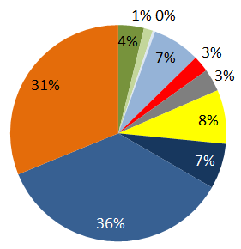 | 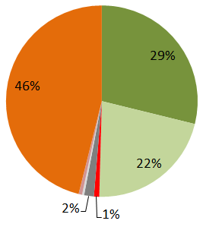 | 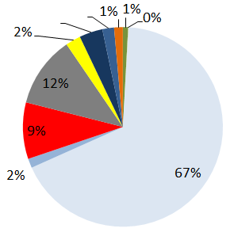
(C=catchment; D=domestic distribution network; E=emergency; P=public distribution network; T=treatment)

For coliform bacteria contaminations detected, the majority of the remedial actions taken (67 %) were related to the public distribution network or treatment infrastructure and operation (i.e through better disinfection). Remedial actions to minimise high concentrations of arsenic in drinking water were mostly related to treatment (46 %) or catchment (29 %). In the case concentration of lead exceeds the parametric value, 67 % of all reported remedial actions consisted of the replacement or disconnection of lead pipes in the domestic distribution network.

To summarize, it can be noted that problems in relation to specific drinking water quality parameters or groups of parameters find their cause at different points of the drinking water supply chain: water source, treatment, distribution and end of pipe - the consumer. This suggests that useful monitoring programmes should be set up considering these different causes of non-compliance at different points, with the aim to take prompt remedial action to maintain a healthy supply of drinking water in Europe.

The choice of the means and measures to deliver compliance is left to the Member States, because they should understand best the local water quality situation and can provide appropriate answers to local real problem. However, when continuing non-compliance due to structural problems is observed, and remedial action was not sufficient to restore the quality of drinking water, the Commission can take action on a potential case of violation of Union law. The Commission attempts to quickly resolve the underlying problem with the Member State concerned by means of a structured dialogue, and if the Member State concerned fails to implement a solution to rectify the suspected violation of EU law, the Commission may launch a formal infringement procedure. Due to the overall high compliance this has been necessary in only a few cases so far.
- Conclusion
This synthesis report shows that compliance rates for parameters directly reflecting the quality of the drinking water supplied to consumers reached with one exemption at least 99 % for the first time in all Member States during the 2011-2013 reporting period. This is a positive achievement that reflects the efforts made by all concerned for the correct implementation of the Drinking Water Directive.
At the time of publication of this report, a detailed Evaluation Report on the DWD is being drafted, which assesses inter alia also the reporting system. In parallel, a Fitness Check of EU environmental monitoring and reporting is being carried out. Both these initiatives are likely to include further conclusions and follow-up to improve the reporting process under the Drinking Water Directive.

Annex I: Links to national drinking water reports and information (2011-2013).

MS | Member State (MS) report location
AT | http://bmg.gv.at/home/Schwerpunkte/VerbraucherInnengesundheit/Lebensmittel/Trinkwasser/
BE | http://www.leefmilieu.brussels/themas/water
BG | http://eea.government.bg/bg/output/soe-report/index.html
CY | http://www.moh.gov.cy/moh/mphs/phs.nsf/DMLwater2_archive_gr?OpenForm&Start=1&Count=1000&Expand=1&Seq=1
CZ | http://www.szu.cz/tema/zivotni-prostredi/pitna-voda
DE | http://www.umweltbundesamt.de/themen/wasser/trinkwasser/trinkwasserqualitaet
DK | http://cdr.eionet.europa.eu/dk/eu/dwd/envvnnugw/National%20report%20on%20drinking%20water%202011-2013.pdf/manage_document
EE | http://cdr.eionet.europa.eu/ee/eu/dwd/refvlizg/
ES | http://www.msssi.gob.es/profesionales/saludPublica/saludAmbLaboral/calidadAguas/publicaciones.htm
FI | http://cdr.eionet.europa.eu/fi/eu/dwd/envvlix7g/
FR | http://www.sante.gouv.fr/IMG/pdf/Rapport_qualite_eau_du_robinet_2012_DGS.pdf
GR | www.moh.gov.gr
HU | http://oki.antsz.hu/files/dokumentumtar/Ivovizminoseg2011.pdf
IE | www.epa.ie
IT | http://www.cheacquabeviamo.it/main.htm
LT | http://vmvt.lt/maisto-sauga/kontrole/valstybine-maisto-kontrole/geriamojo-vandens-kontrole
LU | http://www.eau.public.lu/publications/index.html
LV | http://cdr.eionet.europa.eu/lv/eu/dwd/envvpbw_w/
MT | http://cdr.eionet.europa.eu/mt/eu/dwd/envvowj9q/index_html?&page=3
NL | https://www.rijksoverheid.nl/documenten/rapporten/2014/12/08/de-kwaliteit-van-het-drinkwater-in-nederland-in-2013
PL | http://www.gis.gov.pl/?lang=pl&go=content&id=30
PT | http://www.ersar.pt/website/ViewContent.aspx?SubFolderPath=%5cRoot%5cContents%5cSitio%5cMenuPrincipal%5cDocumentacao%5cPublicacoesIRAR&Section=MenuPrincipal&FolderPath=%5cRoot%5cContents%5cSitio%5cMenuPrincipal%5cDocumentacao&BookTypeID=3&BookCategoryID=1
RO | https://www.insp.gov.ro/cnmrmc/images/rapoarte/Raport-sintetic-2013.pdf
SE | www.livsmedelsverket.se
SI | http://www.mpv.si/porocila
SK | http://www.uvzsr.sk/index.php?option=com_content&view=category&layout=blog&id=156&Itemid=65
UK | http://www.dwi.gov.uk/

Council Directive 98/83/EC of 3 November 1998 on the quality of water intended for human consumption, OJ L 330, 5.12.1998
http://ec.europa.eu/environment/water/water-drink/reporting_en.html
Commission Directive (EU) 2015/1787 of 6 October 2015 amending Annexes II and III to Council Directive 98/83/EC on the quality of water intended for human consumption
Abbreviations in Figure 5: T= Total, I= Individual
https://circabc.europa.eu/w/browse/309b29d1-b8f8-4809-a044-6a9cca1cbabf
Reference to be included when ready
Reference to be included when ready

