

**ANNEX**

**REFORM OF THE LESSER DUTY RULE: THE BACKGROUND**

**1. Countries applying the lesser duty rule**

The EU's systematic application of the lesser duty rule goes beyond the basic obligations set out in the WTO Anti-Dumping Agreement. The vast majority of other WTO Members (including the United States) do not exercise this type of self-restraint. Among the countries that use trade defence instruments, only India, Turkey, Brazil and Australia are users of some form of lesser duty rule.

**2. Comparison of number of Anti-Dumping measures/share in world imports**

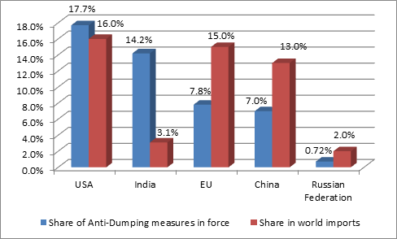

*Source: WTO, World Trade Report 2015*

**3. EU - US comparison**

Comparison of duties EU and US duties on imports from China[1].

|  |  |  |  |
| --- | --- | --- | --- |
| EU / US (comparable products) | EU average duty (in %) | US average duty (in %) | Difference |
|
| High fatigue performance steel concrete reinforcement bars /  Steel concrete reinforcing bars | 21,3% | 133% | 111,7% |
| Stainless steel cold rolled flat products / Certain corrosion resistant products | 24,9% | 255,8% | 230,9% |
| Cold rolled flat steel products / Certain cold rolled flat steel products | 21,1% | 265,8% | 244,7% |

1. Product scope might not be fully identical