ANNEX I

Summary table

Total number of coins processed in 2014 for the three highest denomination | 17 289 466 446
Total number of on-the-spot controls carried out | 318
Total number of coin-processing machines checked | 471
Total volume of coins processed by coin-processing machines checked | 6 848 630 012
Total number of suspect counterfeit coins analysed | 1 431 017
Total number of unfit coins reimbursed | 7 834 881

ANNEX II

Country | Number of coins processed in 2015 for three highest denomination |  | Number of controls carried out | Number of coin processing machines checked |  | Volume of coins processed by those machines | Number of suspect counterfeits analysed | Number of unfit coins reimbursed
BELGIUM | Total | 473371487 | 8 | Total | 31 | 1168768106 | 8748 | 562545
BELGIUM | 50 eurocent | 149798585
BELGIUM | 1 euro | 163443856 | 8 | Conforming | 30 | 1168768106 | 8748 | 562545
BELGIUM | 2 euro | 160129046 | 8 | Not conforming | 1 | 1168768106 | 8748 | 562545
GERMANY | Total | 5528237524 | 72 | Total | 118 | 1274972923 | 44764 | 4333150
GERMANY | 50 eurocent | 1505311699
GERMANY | 1 euro | 1889001035 | 72 | Conforming | 105 | 1274972923 | 44764 | 4333150
GERMANY | 2 euro | 2133924790 | 72 | Not conforming | 13 | 1274972923 | 44764 | 4333150
ESTONIA | Total | N.R. | 1 | Total | 2 | 104840291 | 105 | 9422
ESTONIA | 50 eurocent
ESTONIA | 1 euro | N.R. | 1 | Conforming | 2 | 104840291 | 105 | 9422
ESTONIA | 2 euro | N.R. | 1 | Not conforming | 0 | 104840291 | 105 | 9422
IRELAND | Total | 478280191 | 20 | Total | 33 | 478280190 | 8550 | 4434
IRELAND | 50 eurocent | 148430951
IRELAND | 1 euro | 159797747 | 20 | Conforming | 30 | 478280190 | 8550 | 4434
IRELAND | 2 euro | 170051493 | 20 | Not conforming | 3 | 478280190 | 8550 | 4434
GREECE | Total | 145162000 | 4 | Total | 13 | 194459000 | 6471 | 317
GREECE | 50 eurocent | 35316000
GREECE | 1 euro | 53628000 | 4 | Conforming | 13 | 194459000 | 6471 | 317
GREECE | 2 euro | 56218000 | 4 | Not conforming | 0 | 194459000 | 6471 | 317
SPAIN | Total | 2832159352 | 25 | Total | 48 | 863975894 | 31213 | 1058326
SPAIN | 50 eurocent | 771025313
SPAIN | 1 euro | 1570840999 | 25 | Conforming | 43 | 863975894 | 31213 | 1058326
SPAIN | 2 euro | 490293040 | 25 | Not conforming | 5 | 863975894 | 31213 | 1058326
FRANCE | Total | 2453182777 | 43 | Total | 71 | 714146358 | 833467 | 288256
FRANCE | 50 eurocent | 700250254
FRANCE | 1 euro | 964581226 | 43 | Conforming | 27 | 714146358 | 833467 | 288256
FRANCE | 2 euro | 788351297 | 43 | Not conforming | 44 | 714146358 | 833467 | 288256
ITALY | Total | 2380000000 | 0 | Total | 0 | N.R. | 61140 | 635159
ITALY | 50 eurocent | 780000000
ITALY | 1 euro | 1100000000 | 0 | Conforming | 0 | N.R. | 61140 | 635159
ITALY | 2 euro | 500000000 | 0 | Not conforming | 0 | N.R. | 61140 | 635159
CYPRUS | Total | 47927255 | 49 | Total | 41 | 23429981 | 396 | 6594
CYPRUS | 50 eurocent | 14716027
CYPRUS | 1 euro | 17061262 | 49 | Conforming | 28 | 23429981 | 396 | 6594
CYPRUS | 2 euro | 16149966 | 49 | Not conforming | 13 | 23429981 | 396 | 6594
LATVIA | Total | 67900000 | 4 | Total | 10 | 95820000 | 5599 | N.R.
LATVIA | 50 eurocent | 16500000
LATVIA | 1 euro | 34000000 | 4 | Conforming | 10 | 95820000 | 5599 | N.R.
LATVIA | 2 euro | 17400000 | 4 | Not conforming | 0 | 95820000 | 5599 | N.R.

Country | Number of coins processed in 2015 for three highest denomination |  | Number of controls carried out | Number of coin processing machines checked |  | Volume of coins processed by those machines | Number of suspect counterfeits analysed | Number of unfit coins reimbursed
LITHUANIA | Total | 87592783 | 6 | Total | 9 | 274140359 | N.R. | N.R.
LITHUANIA | 50 eurocent | 24654295
LITHUANIA | 1 euro | 37592715 | 6 | Conforming | 1 | 274140359 | N.R. | N.R.
LITHUANIA | 2 euro | 25345773 | 6 | Not conforming | 8 | 274140359 | N.R. | N.R.
LUXEMBOURG | Total | N.R. | 0 | Total | N.R. | N.R. | 11 | 1541
LUXEMBOURG | 50 eurocent
LUXEMBOURG | 1 euro | N.R. | 0 | Conforming
LUXEMBOURG | 2 euro | N.R. | 0 | Not conforming
MALTA | Total | 28146570 | 1 | Total | 2 | 62642770 | 714 | 161167
MALTA | 50 eurocent | 7992800
MALTA | 1 euro | 10716270 | 1 | Conforming | 2 | 62642770 | 714 | 161167
MALTA | 2 euro | 9437500 | 1 | Not conforming | 0 | 62642770 | 714 | 161167
NETHERLANDS | Total | 581531302 | 6 | Total | 26 | 581531302 | 389644 | 385137
NETHERLANDS | 50 eurocent | 203680185
NETHERLANDS | 1 euro | 186256703 | 6 | Conforming | 25 | 581531302 | 389644 | 385137
NETHERLANDS | 2 euro | 191594414 | 6 | Not conforming | 1 | 581531302 | 389644 | 385137
AUSTRIA | Total | 908738493 | 2 | Total | 5 | 213304794 | 13399 | 307579
AUSTRIA | 50 eurocent | 213963419
AUSTRIA | 1 euro | 374363128 | 2 | Conforming | 5 | 213304794 | 13399 | 307579
AUSTRIA | 2 euro | 320411946 | 2 | Not conforming | 0 | 213304794 | 13399 | 307579
PORTUGAL | Total | 609546880 | 69 | Total | 25 | 246168367 | 21921 | 18497
PORTUGAL | 50 eurocent | 249743489
PORTUGAL | 1 euro | 276650764 | 69 | Conforming | 12 | 246168367 | 21921 | 18497
PORTUGAL | 2 euro | 83152627 | 69 | Not conforming | 13 | 246168367 | 21921 | 18497
SLOVENIA | Total | 61413553 | 2 | Total | 4 | 40714819 | 1092 | 36250
SLOVENIA | 50 eurocent | 21685761
SLOVENIA | 1 euro | 21953909 | 2 | Conforming | 4 | 40714819 | 1092 | 36250
SLOVENIA | 2 euro | 17773883 | 2 | Not conforming | 0 | 40714819 | 1092 | 36250
SLOVAKIA | Total | 192840352 | 3 | Total | 24 | 36734294 | 1856 | 796
SLOVAKIA | 50 eurocent | 63596833
SLOVAKIA | 1 euro | 65637205 | 3 | Conforming | 23 | 36734294 | 1856 | 796
SLOVAKIA | 2 euro | 63606314 | 3 | Not conforming | 1 | 36734294 | 1856 | 796
FINLAND | Total | 413435927 | 3 | Total | 9 | 128165137 | 1927 | 25711
FINLAND | 50 eurocent | 121841419
FINLAND | 1 euro | 141096140 | 3 | Conforming | 9 | 128165137 | 1927 | 25711
FINLAND | 2 euro | 150498638 | 3 | Not conforming | 0 | 128165137 | 1927 | 25711
TOTAL | Total | 17289466446 | 318 | Total | 471 | 6848630012 | 1431017 | 7834881
TOTAL | 50 eurocent
TOTAL | 1 euro | 17289466446 | 318 | Conforming | 369 | 6848630012 | 1431017 | 7834881
TOTAL | 2 euro | 17289466446 | 318 | Not conforming | 102 | 6848630012 | 1431017 | 7834881

N.R. = not reported
ANNEX III

 | TOTAL CUMULATED NET VOLUME OF COIN ISSUED  (01/01/2002 – 31/12/2014) | VOLUME OF COINS PROCESSED BY COIN-PROCESSING MACHINES CHECKED IN 2015 | PERCENTAGE OF COINS CHECKED vs ISSUED COINS | IN COMPLIANCE  (25%)
Belgium | 954680000 | 1168768106 | 122.42% | YES
Germany | 4903510000 | 1274972923 | 26.00% | YES
Estonia | 25190000 | 104840291 | 416.20% | YES
Ireland | 419182000 | 478280190 | 114.09% | YES
Greece | 473255000 | 194459000 | 41.08% | YES
Spain | 2945920000 | 863975894 | 29.32% | YES
France | 1910525000 | 714146358 | 37.37% | YES
Italy | 3399696000 | N.R. | N.A. | /
Cyprus | 70155000 | 23429981 | 33.39% | YES
Latvia | 35186000 | 95820000 | 272.32% | YES
Lithuania | N.A. | 274140359 | N.A. | /
Luxembourg | 184718000 | N.R. | N.A. | /
Malta | 41409000 | 62642770 | 151.27% | YES
Netherlands | 295472000 | 581531302 | 196.81% | YES
Austria | 908738000 | 213304794 | 23.47% | NO
Portugal | 460398000 | 592703794 | 128.73% | YES
Slovenia | 33070000 | 40714819 | 123.11% | YES
Slovakia | 87817000 | 36734294 | 41.83% | YES
Finland | 368760000 | 128165137 | 34.75%
TOTAL | 17517681000 | 6848630012
N.R. = not reported
N.A. = not applicable

ANNEX IV
Chart 1
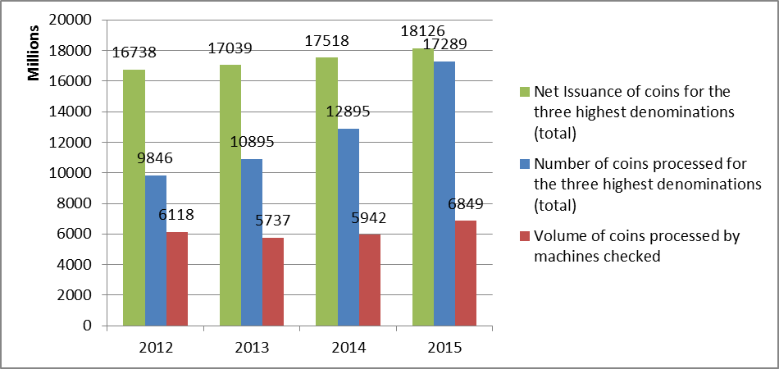
Chart 2
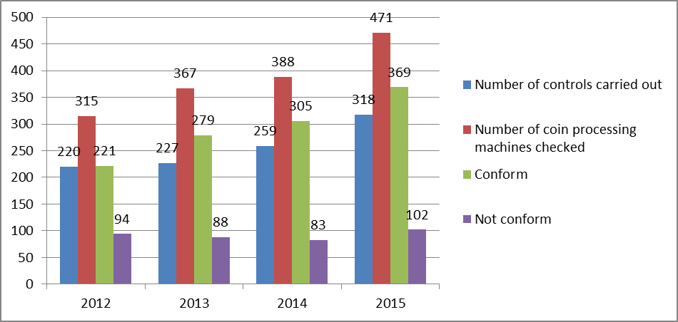
Chart 3
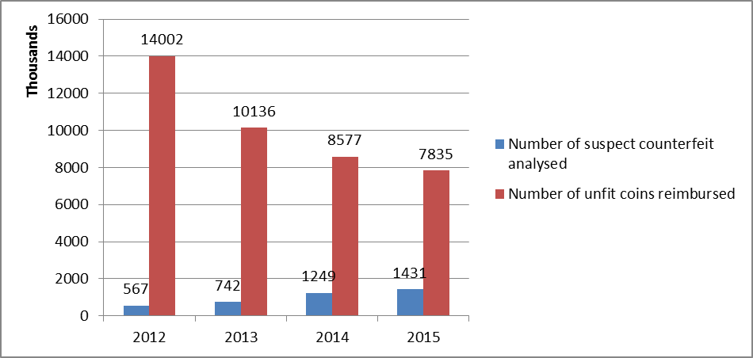

Source: ECB Currency information system report of December 2014. Only positive net issuance is taken into account.
The number of coin-processing machines to be checked annually in each Member States shall be such that the volume of euro coins processed by those machines during that year represents at least 25% of the total cumulated volume of coin issued by that Member States from the introduction of euro coins until the end of the previous year.

