

**REPORT FROM THE COMMISSION TO THE COUNCIL AND PARLIAMENT**

**2009-2015 report on the financial situation of the unemployment benefit scheme for former members of the temporary or contract staff and accredited parliamentary assistants who are unemployed after the termination of their service in a European Union institution**

SUMMARY

In accordance with the Regulations relating to the Conditions of Employment of Other Servants (CEOS), the Community unemployment allowance is intended for former members of the contract staff (CAs), parliamentary assistants (APAs) or temporary staff (TAs) who are involuntarily unemployed (thus excluding, for example, staff who have resigned). It is paid in addition to any national unemployment benefit.

The allowances are paid from the Special Unemployment Fund, which is financed partly by contributions from the staff who would be eligible to benefit from the allowance and partly by contributions from the employer.

The eligibility conditions for the allowance, categories of beneficiaries and contribution rates have undergone significant changes which have rocked the foundations of the original system, in particular the Fund’s cash balance.

2004 reform:

The reform of the Staff Regulations of Officials and the Conditions of Employment of Other Servants (CEOS) of the European Union, which entered into force on 1 May 2004, brought into the CEOS a new category of staff engaged under contract (i.e. contract staff - CA) along with new rules governing contributions to the Unemployment Fund (in particular an increase in the personal share of the contribution from 0.4 % to 0.81 %).

Period from 2009-2015:

Council Regulation No 160/2009 of 23 February 2009 (OJ L 55 of 27 February 2009) extended Unemployment Fund cover to accredited parliamentary assistants (APAs). On this occasion no changes were made to the arrangements governing the Unemployment Fund or to the amount of the contribution.

In 2009, the Unemployment Fund reported a deficit of EUR 4.3 million, which fell to EUR 2.6 million in 2010. Between 2011 and 2013 the deficit shrank significantly, falling to EUR 1 million by the end of 2013. During that period, the Unemployment Fund’s accumulated reserves dropped from EUR 16.1 million at the beginning of 2009 to EUR 2 million at the end of 2015. The reasons for this volatility are numerous and include the:

* Increase in the number of members (+ 42 %)
* Increase in the number of monthly unemployment allowances paid (+ 9 %)
* Increase in the number of temporary staff (TAs) receiving the allowance in relation to the number of TA staff in active employment (up from 2.56 % in 2009 to 2.90 % in 2015)
* Reduction in the number of contract staff (CAs) receiving the allowance in relation to the number of CA staff in active employment (down from 5.86 % in 2009 to 1.83 % in 2015)
* Introduction of the APA category (share of APA beneficiaries in 2015: 8.4 %)
* Increase of the average monthly allowance from EUR 1 980 in 2009 to EUR 2 063 in 2010. This upward trend was reversed in 2011 and 2012, bottoming out at EUR 1 908. The trend reversed again from 2013, with the average allowance rising to EUR 2 551 in 2015, having peaked at EUR 2 582 in 2014. Sharp increases in the average APA allowance can be seen between 2011 and 2015. It rose from EUR 2 096 in 2011 to EUR 2 898 in 2014 before dropping back to EUR 2 525 in 2015.
* Increase in the average number of months in which recipients received the allowance, up from 6.9 months in 2009 to 10 months in 2015, which translates as a 45 % increase in the duration of payment of the benefit.
* Significant reduction in the deficit in 2012 thanks to exceptional revenue from the EUIPO Agency, which repaid EUR 1.2 million following the reinstatement of some twenty members of staff following a court order.

2014 reform and outlook:

The reform of the Staff Regulations of Officials and Conditions of Employment of Other Servants (CEOS) of the European Union, which entered into force on 1 January 2014, increased the maximum duration of contracts of employment of Article 3b contract staff from 3 years to 6.

This change to the maximum contract duration led to a drop in the number of Unemployment Fund beneficiaries in 2014. The moderating impact will, however, start to wear off from 2017.

Furthermore, it was not enough to counterbalance the significant increase in the number of European Parliament beneficiaries following the start of the new legislative term in 2014. More than 600 parliamentary assistants (APAs) and 200 temporary staff (TAs) swelled the numbers of unemployment insurance recipients in July 2014.

_____________________________

Article 28a(11) and Article 96(11) of the Conditions of Employment of Other Servants of the European Union (CEOS), as amended in 2013, provide for the submission of a report by the Commission every two years on the financial situation of the unemployment insurance scheme. Moreover, independently of this report, the Commission may, by means of delegated acts in accordance with Articles 111 and 112 of the Staff Regulations, adjust the contributions provided for in Article 28a(7) and Article 96(7) of the CEOS if this is necessary in the interests of the balance of the scheme.

1 Regulatory framework

1.1 Description of the scheme

The reform of the Staff Regulations of Officials and Conditions of Employment of Other Servants (CEOS) of the European Union, which entered into force on 1 May 2004, amended the legal texts governing eligibility for the Unemployment Fund and the rules on contributing to the Fund that had applied since 1985. The changes can be summarised as follows:

|  |  |
| --- | --- |
| **Before May 2004** | **After May 2004** |
| cover against the risk of unemployment solely for temporary staff (TA) leaving the service. | a new category of staff engaged under contract (i.e. contract staff (CA)) benefitting from cover against the risk of unemployment. |
| a 0.4 % personal contribution and 0.8 % employer’s contribution. | new rules on contributions to the Unemployment Fund (i.e. a 0.81 % personal contribution and 1.62 % employer’s contribution and a lump-sum allowance of EUR 919.02 for contract staff and EUR 1 254.77 for temporary staff). |
| entitlement to unemployment benefits limited to a maximum of 24 months. | entitlement to unemployment benefit is limited to a third of the period spent in active employment as a member of the temporary staff (AT), contract staff (AC) or as a parliamentary assistant (APA), and may not exceed 36 months. The allowance is capped from the 7th month of unemployment and the minimum allowance has been increased. |

The table below shows the maximum and minimum amounts payable to the different categories of staff:

*amounts in EUR on 1 January 2016*

|  |  |  |  |
| --- | --- | --- | --- |
|  | **TA** | **CA** | **APA** |
| Maximum (as from the 7th month) | 2 760.49 | 2 070.35 | 2 142.90 |
| Minimum | 1 380.24 | 1 035.18 | 910.74 |

Abatements and maximum and minimum amounts payable are updated in the same way as salaries.

Any family allowances due are paid in addition to the unemployment benefit. The contribution to the Joint Sickness Insurance Scheme (JSIS) of the European Union (5.1 % of the beneficiary's basic reference salary) is paid by the Unemployment Fund.

1.2 Legal references

* Article 28a of the Conditions of Employment of Other Servants of the European Union (CEOS) as amended by Regulation No 1023/2013 of the European Parliament and of the Council of 22 October 2013.
* Article 96 of the Conditions of Employment of Other Servants of the European Union (CEOS) and Article 5 of the Annex to the CEOS as amended by Regulation No 1023/2013 of the European Parliament and of the Council of 22 October 2013.
* Articles 135 and 136 of the CEOS as amended by Regulation No 1239/2010 of the European Parliament and of the Council of 20 December 2010 (OJ L 338, 22.12.2010).
* Article 65(1) of the Staff Regulations on the adjustment of remuneration and other amounts.
* Commission Regulation No 91/88 of 13 January 1988 laying down provisions for implementing Article 28a of the Conditions of Employment of Other Servants of the European Union (OJ L 11, 15.1.1989).
* Commission Rules of 14 July 1988, common accord having been recorded by the President of the Court of Justice of the European Communities on 4 July 1989, laying down the detailed arrangements for applying the provisions relating to the grant of the unemployment allowance to members of the temporary staff, implementing Article 28a (10) of the Conditions of Employment of Other Servants of the European Union.

2 Financial position and cash balance of the Unemployment Fund 2009-2015

The two sections below show how the Unemployment Fund has evolved, specifically as regards expenditure and revenue.

The amounts entered under the heading ‘unemployment allowances’ systematically include the basic unemployment allowance, any family allowances and the effect of the weighting (for the original scheme only). Any social benefits received at national level (including unemployment benefits, family allowances, sickness benefits, maternity benefits, etc.) are deducted. Since the contribution to the JSIS, as indicated under point ‘1.1 Description of the scheme’, is not charged to the recipient of the unemployment allowance, it is financed by the Unemployment Fund (5.1 % of the basic reference salary of the beneficiary).

The Unemployment Fund uses two management instruments for its revenue and expenditure:

* a current account for collecting revenue and paying allowances;
* term accounts for investing accumulated surpluses.

2.1 Cash balance: operating results and accumulated balances 2009-2015

With cash-based accounting, revenue and expenditure are recorded when revenue is earned or expenditure incurred.

Table 1 provides a summary of revenue and expenditure as entered in the accounts and the resulting current account balance. Note that adjustments were made in 2014 to the JSIS contributions due in the period 2009-2013.



Table 2 shows the evolution of the Unemployment Fund's financial assets both in the current account incorporated in the European Commission’s accounting system (part I) and in the investment accounts managed by DG ECFIN (part II). The third part shows the total accumulated surpluses for the two accounts (part III).



Compared to the reference year (2009), it is evident that the accumulated surplus has been declining year-on-year. The relative stability of the Fund in 2012 is due to the reimbursement by EUIPO of the unemployment benefits received by the staff who were reinstated.

Between 2009 and 2015, the accumulated surplus fell by 87 %.

Table 3 presents an overview of the accumulated balance between 2008 and 2015.



2.2 Financial position: operating results 2009-2015

With accrual accounting, transactions are recorded so that they can be attached to the year to which they relate. Thus, some of the receipts entered in the accounts at the start of year N are amounts deducted from salaries at the end of year N-1, and some of the unemployment allowance payments made and entered at the start of year N cover periods of unemployment at the end of year N-1. For accounting purposes, these transactions are booked against the budget year N-1.

Table 4 sets out the revenue and expenditure according to this principle and therefore depicts the Unemployment Fund’s financial position on an accrual basis.



Revenue and expenditure have increased significantly since 2009. This upward trend is mainly due to:

* the establishment of new agencies and an overall increase in staff numbers in the agencies;
* the introduction of a new category of staff (contract staff (CA)) in 2004;
* the inclusion of parliamentary assistants in the scheme in 2009.

The impact on expenditure is significant only from 2007, when the first contract staff contracts expired, rendering the individuals concerned eligible for unemployment benefit. Expenditure then increased steadily until 2014 before dipping slightly in 2015.

The Fund’s deficit reached EUR 4.3 million in 2009 and gradually decreased in subsequent years to: EUR 2.6 million in 2010, EUR 1.5 million in 2011, EUR 1.2 million in 2012 and EUR 1 million in 2013. In 2014, the deficit soared to EUR 4.8 million. This was due to the increase in the number of APAs receiving unemployment benefit. This effect tailed off in 2015, when the deficit fell to EUR 3 million.

The graph below sets out the situation described above.

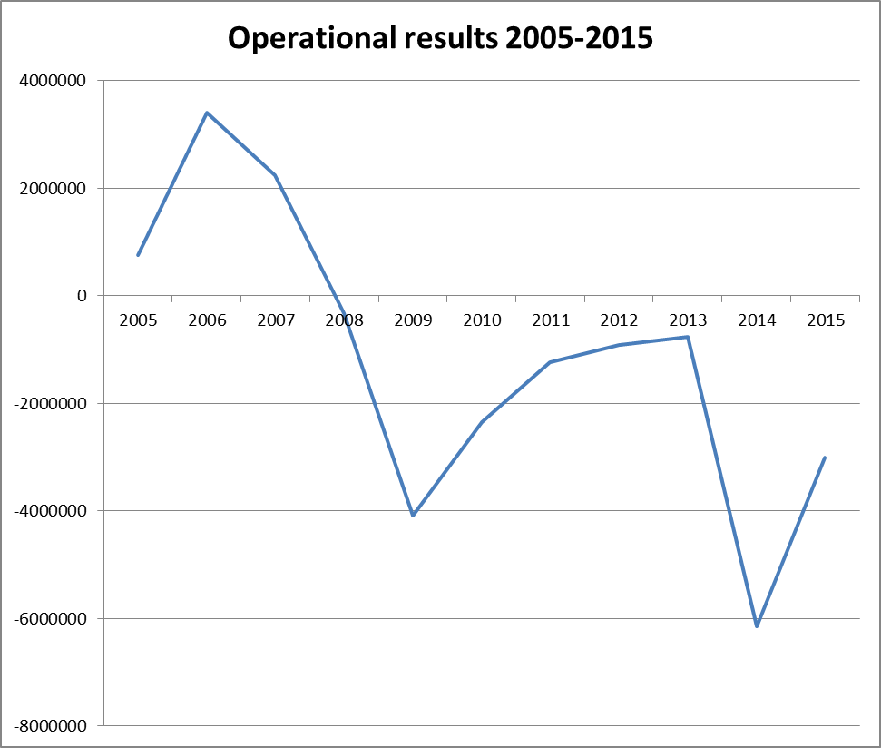

2.3 Financial position: breakdown of expenditure and revenue by institution and for all the agencies 2009-2015

Table 5 provides a breakdown of expenditure and revenue by institution and for all the agencies and Offices. The first part of the table provides the absolute amounts, while the second part shows the amounts as percentages of total expenditure and revenue. The effect of the end of the EP's parliamentary term is particularly visible, with a substantial increase in expenditure relating to the EP of over EUR 8 million between 2013 and 2014. In 2015, expenditure remained high but was nevertheless lower than in 2014.

Leaving aside the European External Action Service (EEAS), for which it remains difficult to carry out a detailed analysis owing to a lack of data over time, only the agencies have contributions exceeding expenditure. This situation is mainly attributable to the fact that most staff members have indefinite term contracts. However, it should be noted that expenditure on agency staff increased significantly over the period 2013-2015.



3 Study of members, beneficiaries and allowances paid

3.1 Number of members and average contribution

Table 6 shows the number of TA and CA staff paying into the Unemployment Fund who were in active service on 31 December of each year.

The number of CA and TA staff increased by 40 % and by 23 % respectively from 2009 to 2015. The first APA beneficiaries appeared in 2011.

Between 2009 and 2015, the number of members in all three staff categories combined rose by 43 %.



3.2 Number of persons receiving unemployment allowance in absolute terms and as a percentage of the number of members: unemployment rate at 31 December of the year in question

Table 7 shows the number of unemployed persons who received the unemployment allowance in full or as a top-up to benefit received under the national system for the month of December each year.

By combining the data on the TA and CA staff in service on 31 December in Table 6 and the number of beneficiaries who received an unemployment allowance in Table 7, it is possible to calculate the ratio of beneficiaries of the Unemployment Fund in relation to the number of members of that Fund. The results are set out in Table 8.







Overall, the number of temporary staff is increasing slightly, although the number of TA staff in the Commission has fallen sharply. The effect of this fall is offset by a sharp increase in TA staff in the agencies. The percentage of recipients compared to members remains constant.

The number of contract staff has been increasing steadily, particularly in the agencies and in the European Parliament. The percentage of beneficiaries compared to members is falling steadily. This fall is linked to the possibility of extending contracts concluded between 2010 and 2013 from 3 to 6 years.

A large number of former parliamentary assistants (APAs) received the unemployment allowance in 2014 since that year marked the end of the parliamentary term.

**Number of monthly unemployment allowances, average amount, beneficiaries and country of residence of beneficiaries**

An unemployment allowance can be paid for several months. Table 9 shows the number of monthly unemployment allowances paid each year.



Total annual payments by type of beneficiary (TA staff under the old system, TA staff under the new system, and CA staff) divided by the number of monthly payments made gives the average amount of the unemployment allowance for each category of beneficiary. The results are set out in Table 10. It should be noted that in any given month the allowance paid may be the full amount or a pro rata amount based on the number of days on which the person was actually unemployed.



From 2009 to 2010 the average monthly allowance increased from EUR 1 980 to EUR 2 063. This upward trend was reversed in 2011, bottoming out at EUR 1 908 in 2012. The trend reversed again from 2013, with the average allowance rising to EUR 2 551 in 2015, having peaked at EUR 2 582 in 2014. Based on contract and temporary staff alone, the average monthly allowance stood at EUR 2 562.30 in 2015.

The amounts paid out for APAs also rose significantly in 2014, reaching an average of EUR 2 897.99 - an increase of almost 50 % compared with 2013. The average monthly allowance fell sharply in 2015 to 2 550.67.

The four most important elements of the table are:

* the increase in the average monthly amount paid to temporary and contract staff between 2013 and 2015: + 31 %;
* the increase in the average monthly amount paid to APAs between 2013 and 2015: + 28 %;
* the increase in the monthly amounts paid to APAs between 2013 and 2015: + 385 %;
* the increase in the share of expenditure on APAs as a percentage of total expenditure between 2013 and 2015: from 6 % to 31 %.

Table 11 shows the average time (in months) for which unemployment benefit was paid. This period is calculated by combining the total number of days for which the allowance was paid up to 31 December of the year in question and dividing that total by the number of recipients of the unemployment allowance. The result obtained is divided by 30 to obtain the average period in months for which unemployment benefit was paid.



It can be seen that the average period for which unemployment benefit was paid rose from 6.9 months in 2009 to 10 months in 2015, i.e. a 45 % increase, due in the main to the impact of the APAs.

However, the number of beneficiaries who received an allowance for at least one month of the year dropped slightly by 7.6 % between 2009 and 2015 (from 701 to 648, see table 7).

The following tables show the duration of payments by staff category (temporary and contract staff and accredited parliamentary assistants).

**CA/TA:**



**APA:**



The high share of expenditure relating to the APAs compared to overall expenditure in 2015 (31 %) is due both to the large numbers of staff in this category and to the high average amount of the monthly allowance paid to these individuals. The average length of the period covered by unemployment benefit for APAs rose sharply in 2015 and exceeded the average duration of the unemployment allowance for temporary and contract staff. This is a direct consequence of the substantial increase in the number of APAs receiving unemployment benefit because of the end of the parliamentary term at the end of 2014.

Having regard to the principle of complementarity as applied to the unemployment insurance scheme, the country of residence of the recipient of the unemployment allowance is significant, particularly in view of the very wide range of eligibility criteria governing national unemployment benefit in the different Member States.

Table 12 shows the number of beneficiaries who received at least one monthly allowance during the year, by country of residence.



This table on the place of residence of beneficiaries shows that in 2015 more than 44 % were registered as jobseekers in Belgium.

4 CONCLUSIONS

4.1 2009-2015

This report shows that the Unemployment Fund has been in constant deficit since 2008. The deficit was particularly large in 2009 when it reached EUR 4.2 million, before gradually falling to EUR 1 million in 2013.

In 2014 the Unemployment Fund suffered another serious downturn when the deficit rose to over EUR 4.8 million. It eased off somewhat in 2015, dropping to EUR 3 million.

Following these successive deficits from 2009-2015, the accumulated surplus (i.e. reserves + annual income) at 31 December 2015 amounted to a mere EUR 2 million compared with EUR 16.15 million on 1 January 2009.

4.2 Evolution of the Unemployment Fund in the short and medium term:

The high level of expenditure in 2015 served to deplete the reserve.

However, the year 2016 is expected to show a surplus thanks to a sharp drop in the numbers of beneficiaries in the APA category (which is set to continue in 2017 and 2018) and the moderating effect of the extension to 6 years of the maximum duration of the contracts of contract staff provided for in Article 3b of the CEOS. This could make it possible to reconstitute significant reserves.

In any event, the medium-term situation is very uncertain - alarming even - because of the following risk factors:

1. The very substantial increase in the average monthly allowance paid in 2015 compared to 2013 (+ 30 %);
2. The substantial increase in the number of CA beneficiaries from 2017 onwards, when the first batch of new 6 year contracts come to an end;
3. The possible continuation of the steady increase, since 2013, of TA beneficiaries from the agencies;
4. A new peak expected in 2019-2020 in connection with the end of the 2014-2019 term of the European Parliament;
5. It should also be noted that the introduction of accredited parliamentary assistants in 2009 was not accompanied by a higher contribution, unlike in 2004 when contract staff were introduced. Over the period 2011-2015, the net balance of contributions and benefits paid out for the APA category was a deficit of around EUR 11.4 million.

In light of the foregoing, the Commission is considering, as a first step, a limited increase (around 0.1 % of basic salary, taking specific account of the accumulated balance of the Fund during the period examined in this Report) in the contributions to the unemployment insurance scheme by means of a delegated act, in accordance with Article 28a(11) and Article 96(11) of the CEOS, in order to ensure its financial equilibrium.

The Commission will also establish a working group to ensure, as a second step, regular monitoring of the scheme's financial position.