ANNEX
FINANCIAL EXECUTION POSEI (2006-2009)
- Overview by Member State -
 | 2006  (financial year 2007) |  |  | 2007  (financial year 2008) |  |  | 2008  (financial year 2009) |  |  | 2009  (financial year 2010)
Measure | Budget  in € | Expenditure  in € | Budget execution in % | Budget  in € | Expenditure  in € | Budget execution in % | Budget  in € | Expenditure  in € | Budget execution in % | Budget  in € | Expenditure  in € | Budget execution in %
SPECIFIC SUPPLY ARRANGEMENTS (SSA)
POSEI Spain - SSA | 67.1 | 53.5 | 80% | 68.7 | 69.6 | 101% | 68.4 | 69.1 | 101% | 68.4 | 65.3 | 95%
POSEI France – SSA | 20.7 | 15.4 | 74% | 20.7 | 19.6 | 95% | 20.7 | 19.9 | 96% | 20.6 | 19.6 | 95%
POSEI Portugal – SSA | 17.7 | - | - | 17.7 | 13.98 | 79,6% | 17.7 | 16.86 | 95% | 17.7 | 16.64 | 94%
TOTAL SSA | 105.5 | 68.9 | - | 107.1 | 103.18 | 96% | 106.8 | 105.86 | 99% | 106.7 | 101.54 | 95%
MEASURES TO SUPPORT LOCAL AGRICULTURAL PRODUCTION (SLP)
POSEI Spain – SLP | 60.2 | 38.7 | 64% | 199.7 | 186.6 | 93% | 200 | 189.5 | 95% | 200 | 192.7 | 96%
POSEI France – SLP | 105.9 | 93.29 | 88% | 241.9 | 238.94 | 99% | 248.7 | 246.04 | 99% | 252.84 | 249.54 | 99%
POSEI Portugal – SLP | 60.2 | - | - | 69.28 | 69.28 | 100% | 69.28 | 69.38 | 100% | 69.38 | 68.18 | 98%
TOTAL SLP | 226.3 | 131.99 | - | 510.88 | 494.82 | 97% | 517.98 | 504.92 | 97% | 522.22 | 510.42 | 98%
TOTAL POSEI PROGRAMMES (SSA + SLP)
POSEI Spain – Total | 127.3 | 92.2 | 72% | 268.4 | 256.2 | 95% | 268.4 | 258.6 | 96% | 268.4 | 258 | 96%
POSEI France – Total | 126.6 | 108.69 | 86% | 262.6 | 258.54 | 98% | 269.4 | 265.94 | 99% | 273.44 | 269.14 | 98%
POSEI Portugal–Total | 77.9 | * | * | 86.98 | 83.26 | 96% | 86.98 | 86.24 | 99% | 87.08 | 84.82 | 97%
TOTAL POSEI | 331.8 | 200.89 | 61% | 617.98 | 598 | 97% | 624.78 | 610.78 | 98% | 628.92 | 611.96 | 97%
Table 1: Financial allocation and execution by MS for the 2006-2014 period (source: ADE based on Annual implementation report; minor differences with the financial data execution of the relevant budget lines could be explained by various reasons such as possible small recoveries, late payments, financial discipline, clearance, litigations, additional controls, etc.)
* not executed in 2006
FINANCIAL EXECUTION POSEI (2010-2014)
- Overview by Member State -
 | 2010 |  |  |  |  |  | 2011 |  |  |  |  |  | 2012 |  |  |  | 2013 |  |  |  |  | 2014
 | (financial year 2011) |  |  |  |  |  | (financial year 2012) |  |  |  |  |  | (financial year 2013) |  |  |  | (financial year 2014) |  |  |  |  | (financial year 2015)
Measure | Budget  in € |  | Expenditure  in € |  | Budget execution in % |  | Budget  in € | Expenditure  in € | Budget execution in % |  |  |  | Budget  in € |  | Expenditure  in € | Budget execution in % | Budget  in € | Expenditure  in € |  | Budget execution in % |  | Budget  in € |  | Expenditure  in € | Budget execution in %
SPECIFIC SUPPLY ARRANGEMENTS (SSA)
POSEI Spain - SSA | 68.4 |  | 63.6 |  | 93% |  | 68.4 | 61.1 | 89% |  | 68.4 |  |  |  | 60.4 | 88% | 68.4 | 61.3 |  | 89.62% |  |  | 66.9 | 65.05 | 97.23%
POSEI France – SSA | 20.7 |  | 20.38 |  | 98% |  | 20.7 | 20.21 | 98% |  | 26.9 |  |  |  | 20.58 | 77% | 26.5 | 26.47 |  | 99.89% |  | 26.9 |  | 26.09 | 96.99%
POSEI Portugal–SSA | 17.7 |  | 15.32 |  | 87% |  | 17.7 | 15.62 | 88% |  | 17.42 |  |  |  | 15.19 | 87% | 16.85 | 15.38 |  | 91.28% |  | 16.32 |  | 15.47 | 94.79%
TOTAL SSA | 106.8 |  | 99.3 |  | 93% |  | 106.8 | 96.93 | 91% |  | 112.72 |  |  |  | 96.17 | 85% | 111.75 | 103.15 |  | 92% |  | 110.12 |  | 106.61 | 97%
MEASURES TO SUPPORT LOCAL AGRICULTURAL PRODUCTION (SLP)
POSEI Spain – SLP | 200 |  | 195.6 | 98% |  | 200 |  | 196.6 | 98% | 220.2 |  |  |  | 223 |  | 101% | 200 | 203.3 |  | 102% |  | 201.5 |  | 200.33 | 99%
POSEI France – SLP | 257.71 |  | 254.82 | 99% |  | 257.71 |  | 250.99 | 97% | 270.03 |  |  |  | 268.09 |  | 99% | 251.91 | 246.67 |  | 98% |  | 251.51 |  | 247.03 | 98%
POSEI Portugal–SLP | 88.51 |  | 88.51 | 100% |  | 88.51 |  | 89.04 | 101% | 88.72 |  |  |  | 89.96 |  | 101% | 89.3 | 88.44 |  | 99% |  | 89.6 |  | 88.69 | 99%
TOTAL SLP | 546.22 |  | 538.93 | 99% |  | 546.22 |  | 536.63 | 98% | 578.95 |  |  |  | 581.05 |  | 100% | 541.21 | 538.41 |  | 99% |  | 542.61 |  | 536.05 | 99%
TOTAL POSEI PROGRAMMES (SSA + SLP)
POSEI Spain – Total |  | 268.4 | 259.2 |  | 97% |  | 268.4 | 257.7 | 96% |  |  | 288.6 |  |  | 283.4 | 98% | 268.4 |  | 264.6 |  | 99% | 268.4 |  | 265.38 | 99%
POSEI France – Total |  | 278.41 | 275.2 |  | 99% |  | 278.41 | 271.2 | 97% |  |  | 296.93 |  |  | 288.67 | 97% | 278.41 |  | 273.14 |  | 98% | 278.41 |  | 273.12 | 98%
POSEI Portugal–Total |  | 106.21 | 103.83 |  | 98% |  | 106.21 | 104.66 | 99% |  |  | 106.14 |  |  | 105.15 | 99% | 106.15 |  | 103.82 |  | 98% | 105.92 |  | 104.16 | 98%
TOTAL POSEI |  | 653.02 | 638.23 |  | 98% |  | 653.02 | 633.56 | 97% |  |  | 691.67 |  |  | 677.22 | 98% | 652.96 |  | 641.56 |  | 98% | 652.73 |  | 642.66 | 98%

In EUR million

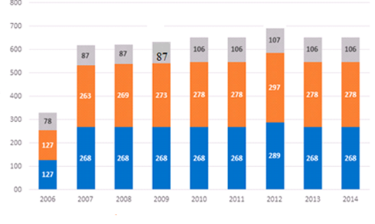
□ POSEI Spain □ POSEI France □ POSEI Portugal

Figure 1: Financial allocations for the different support programmes in € million (source: ADE, based on the Annual implementation reports)

Madeira  Azores  Canary Islands  Total 4 French OR | 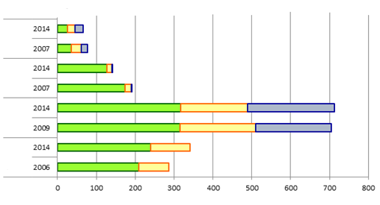
□ as agricultural inputs □ for food processing □ for human consumption

Figure 2: SSA tonnage granted and distribution by OR and by type of final use. Comparison begin/end of period (in kt) (source: ADE, based on the Annual implementation reports)

In EUR million
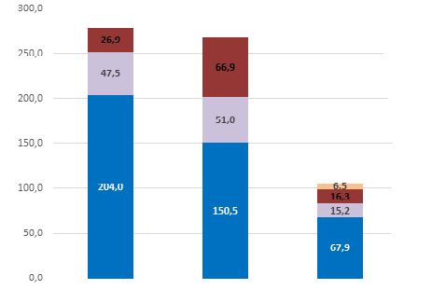
France Spain Portugal

□ SLP Traditional sectors □ Diversification sectors □ SSA □ Basic support to farmers

Figure 3: Distribution of financial allocations by objective at MS level for POSEI programmes in 2014 in € million (source: ADE, based on the Annual implementation reports)

