

**I. Introduction**

For the Energy Union, **2016 was the** **year of delivery**. It was a year in which the vision of the Energy Union Framework Strategy[1] was further translated into concrete legislative and non-legislative initiatives, most recently with the "Clean Energy for all Europeans" package presented on 30 November 2016. As a next step, the low emission mobility strategy[2] will also be translated into concrete initiatives, in line with the Commission Work Programme for 2017.[3] It is important that the co-legislators work towards the adoption of the proposed initiatives without delay and in line with the Joint Declaration of the three institutions on the European Union's legislative priorities for 2017[4], to allow for a swift energy transition on the ground.

The Energy Union is a European priority project, identified by the Juncker Commission as one of the 10 political priorities[5], in which five dimensions are closely interlinked: energy security, solidarity and trust; a fully integrated European energy market; energy efficiency contributing to moderation of demand; decarbonising the economy; and research, innovation and competitiveness. Progress has been made on all these dimensions.

The Energy Union is part of the positive agenda for the European Union as set out in the Bratislava Declaration[6], and cannot be separated from other key European policies. It contributes to meeting the Sustainable Development Goals[7] and the implementation of the Circular Economy agenda[8], and relies on close interaction with the Capitals Market Union, the Digital Single Market, the New Skills Agenda for Europe, the Investment Plan for Europe and the Security Union. By reviewing existing legislation and making sure it is kept fit for purpose, the Energy Union agenda also contributes to the Commission's Regulatory Fitness and Performance (REFIT) agenda.

The Energy Union is about more than energy and climate alone: it is about accelerating the modernisation of Europe’s entire economy, making it low carbon and efficient in energy and resources, in a socially fair manner. Its ultimate goal is to make sure that Europe's consumers, workers and businesses benefit from it. European companies should be at the forefront of the necessary investments, since this would create an early mover advantage for new technologies and business models. There is, in other words, a strong business case for the transition to a more modern, low carbon economy.

This also requires a strong external dimension. In a fast-changing geopolitical environment, a successful Energy Union is crucial to protect the long term economic interests and well-being of Europe and its citizens.[9] Work on the internal agenda has therefore been complemented by a reinforced energy diplomacy, designed to strengthen security of energy supply, to expand exports of European low carbon technology solutions and boost industrial competitiveness. More generally, energy diplomacy should increase Europe’s room-of-manoeuvre, together with its international partners, in a more volatile world. This is the area where Europe has solid potential to show global leadership.

A strong external dimension includes a robust climate diplomacy, showing leadership in steering the world towards a global clean energy transition and contributing to achieving the Sustainable Development Goals, in particular ensuring sustainable energy for all. Following the adoption of the Paris Agreement[10] in December 2015, it was the swift ratification by the European Union that enabled the entry into force of the first-ever universal, legally binding global climate deal on 4 November 2016.

In 2016, the European Union demonstrated that it is also at the forefront of implementing the Paris Agreement at home. The Commission has adopted all the legislative proposals necessary to deliver the European Union's ambitious commitments under the Agreement. These proposals and the facilitating measures accompanying them contribute fundamentally to the Commission's overall agenda to create jobs, growth and related investments.

At the same time, the Commission proposals should ensure that this transition remains affordable for European citizens and businesses alike, and that it leads to new jobs, skills and opportunities, boosting growth and ensuring high quality of life in the European Union. This is what also young Europeans expect from the European Union.

**For all these reasons, the focus now turns to implementation**. Agreement with the European Parliament and the Council should be reached on the legislative initiatives, existing legislation should be implemented and the Treaty’s competition and state aid rules should be strictly enforced. At the same time non-legislative action at Union, national and local level should continue and be reinforced.

**II. trends and policy observations**

Since the first report on the State of the Energy Union published in November 2015[11], a number of trends in the European Union's transition to a low-carbon economy were continued and even strengthened.[12] The main observations which can be drawn from national developments during 2016 are summarised in policy observations in Annex 2. They are the basis for a more in-depth analysis of Member States’ policies which the Commission intends to carry out in 2017.

The European Union as a whole has continued to make good progress on delivering the Energy Union objectives, in particular on the 2020 energy and climate targets. It has already achieved considerable reductions in energy consumption. If Member States' efforts continue, the European Union is on track to reach its 2020 energy efficiency targets.[13]

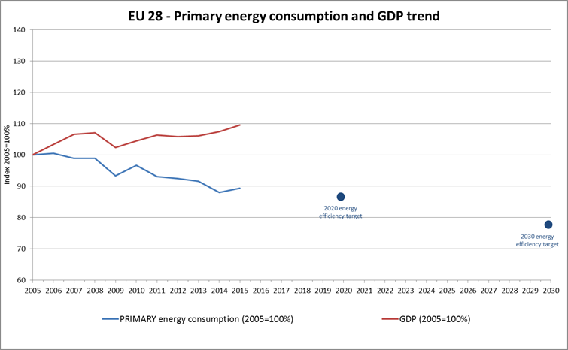

Figure 1: Primary energy consumption and GDP developments[14]

In 2015, greenhouse gas emissions in the European Union were 22% below the 1990 level.[15] Despite a temporary limited increase in 2015, emissions remain on a decreasing trend.[16] The emissions in the sectors covered by the European Union Emissions Trading System (ETS) continued to fall in 2015.[17]

The European Union is also on track in the renewable sector where – based on 2014 data – the share of renewables reached 16% of the gross final energy consumption of the European Union[18]. As the trajectory becomes steeper closer to 2020, further efforts should be made.

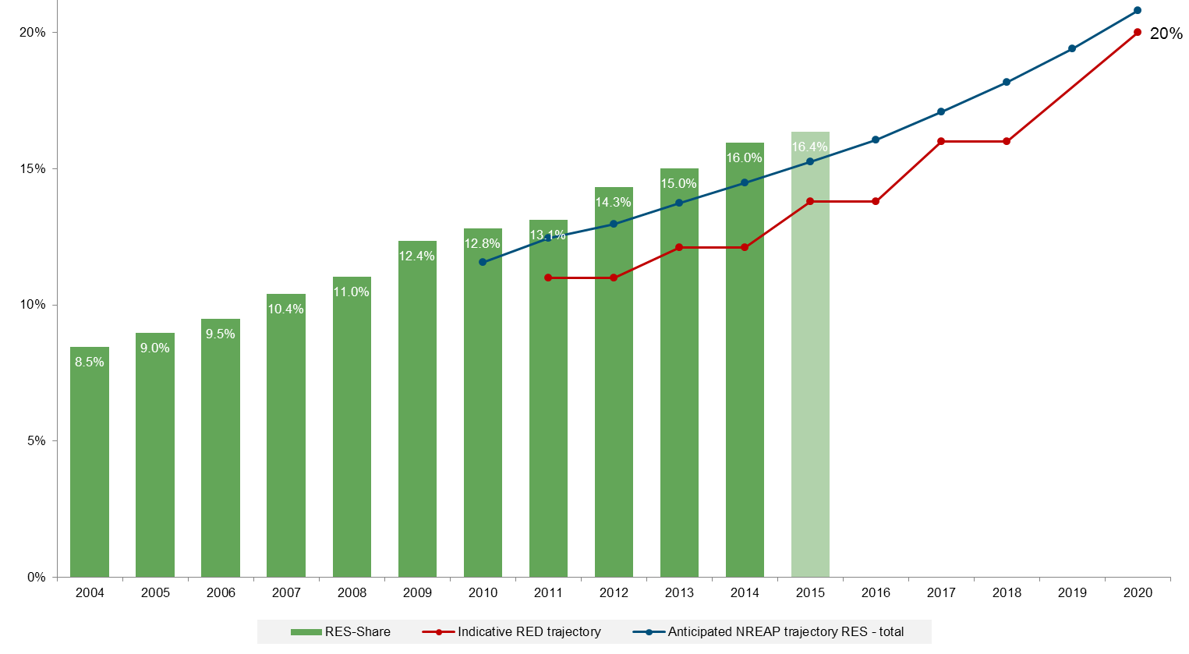

Figure 2: Renewable energy shares in the European Union vs. Renewable Energy Directive and National Renewable Energy Action Plan Trajectories[19]

Another important trend is that the European Union continues to successfully decouple its economic growth from its greenhouse gas emissions. During the 1990-2015 period, the European Union's combined Gross Domestic Product (GDP) grew by 50 %, while emissions decreased by 22 %. This decoupling is expected to continue under current trends and projections.

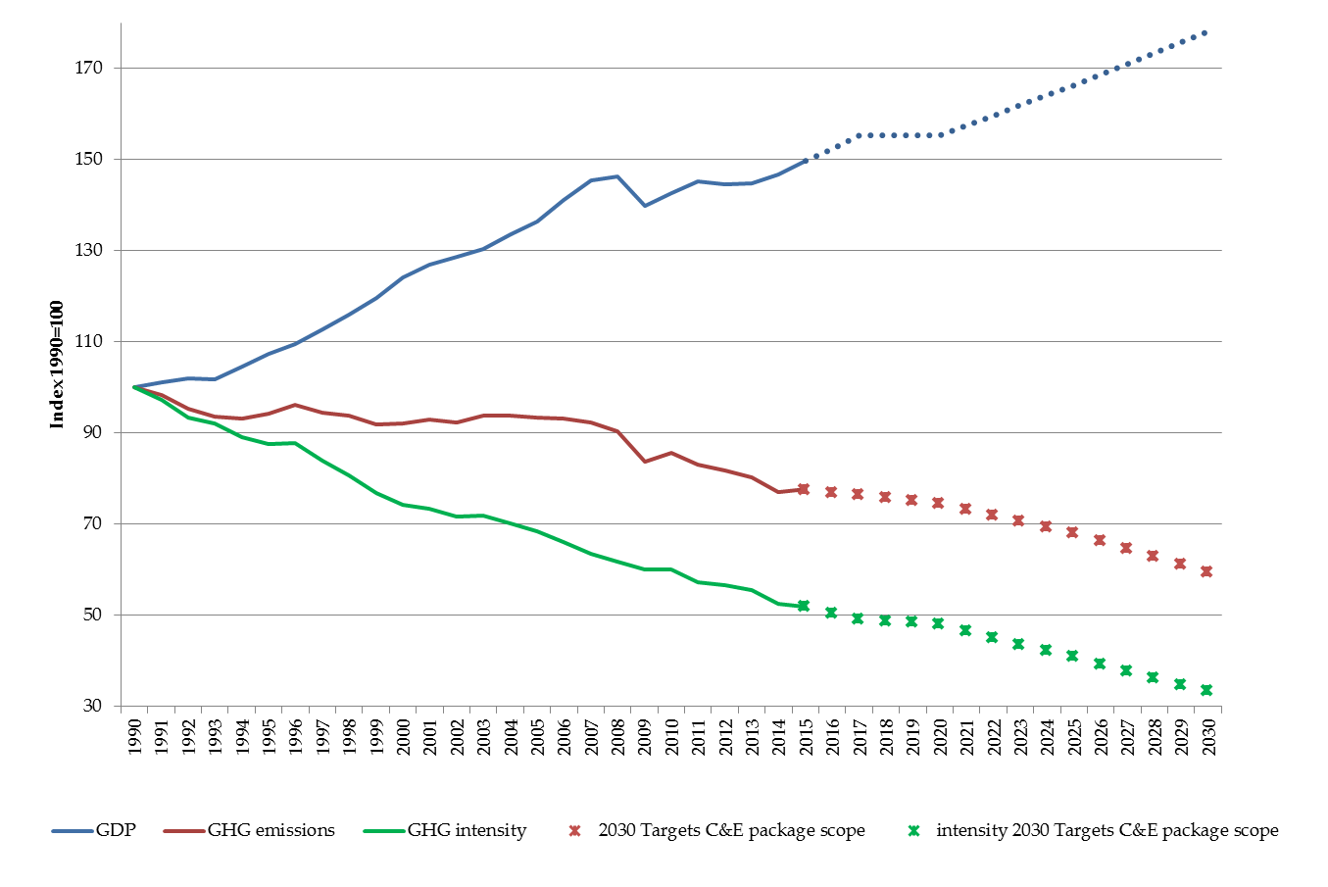

Figure 3: Historic and projected changes in GDP (in real terms), greenhouse gas (GHG) emissions, and emissions intensity of the economy (ratio between emissions and GDP) Index (1990 = 100)[20]

The European Union has also managed to significantly reduce the greenhouse gas intensity of its economy. It is presently one of the most greenhouse gas efficient major economies, and is set to become the most greenhouse gas efficient economy in the G20 through the implementation of the 2030 climate and energy targets. However, other regions are also significantly reducing their greenhouse gas intensity, based on their climate plans under the Paris Agreement. In other words, despite these positive trends, there is no time for complacency if Europe wants to remain a global leader.

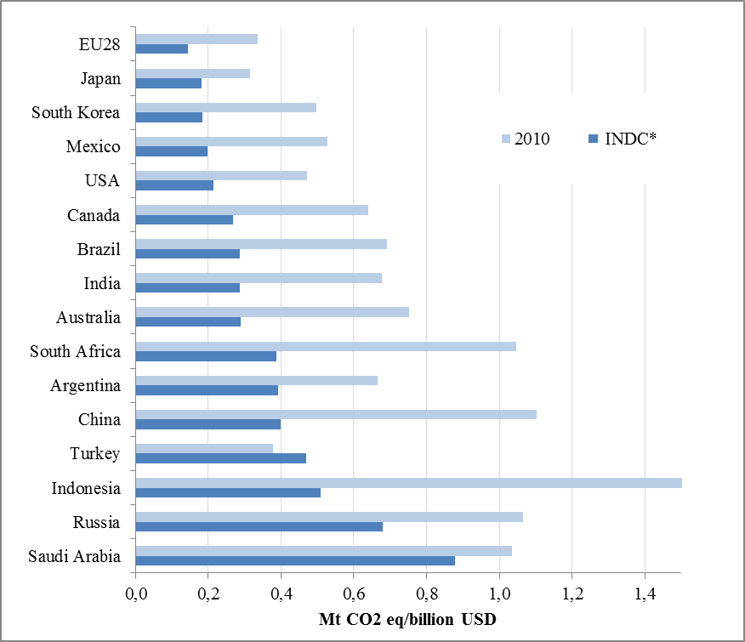

Figure 4: GHG emissions intensity (MtCO2 eq/billion USD)[21]

**III. assessment of progress and challenges**

The transition to a modern, low-carbon economy is happening

The Energy Union Framework Strategy set out the ambition to move away from an economy dependent on fossil fuels. The decarbonisation of the European economy is well under way. Co-legislators agreed in record speed on the European Union’s ratification of the Paris Agreement. To implement the European Union's commitments, the Commission adopted the proposals necessary to deliver on the 2030 climate and energy framework, for the European Union Emissions Trading System[22] already in July 2015 and for the sectors outside of the Emissions Trading System[23], covering also the integration of land use, land use change and forestry (LULUCF) [24], in July 2016. As a next step, attention will turn to preparing the European Union's participation in the first "facilitative dialogue" in 2018, where the parties should take stock of the collective ambition and progress in implementing the Paris Agreement.

In 2016, the Commission also presented a European low emission mobility strategy with an equally clear ambition: by mid-century, greenhouse gas emissions from transport should be at least 60% lower than in 1990 and be firmly on the path towards zero, while ensuring the mobility needs of people and goods as well as global connectivity. Emissions of air pollutants from transport that harm public health should also be drastically reduced without delay. It focused in particular on road transport, which is responsible for over 70% of transport greenhouse gas emissions.

Just after the entry into force of the Paris Agreement, the Commission adopted the Clean Energy package, which sets the regulatory framework for the post-2020 period, but also gives a strong push to the transition towards a cleaner economy. Around the same time, the revised National Emissions Ceilings (NEC) Directive[25] was adopted. By setting tougher emission limits for key air pollutants, the European Union contributes to improving the health of its citizens and avoiding premature deaths, while at the same time cutting down the huge economic costs for society.[26] In a modern economy, citizens should benefit from investment in health.

Progress towards an innovative energy- and resource-efficient economy

The Commission delivered on its promise of treating energy efficiency as a source in its own right. The Commission proposed a binding European Union level target of 30% for improving energy efficiency by 2030. A series of accompanying initiatives on energy efficiency will ensure that the target can be delivered cost-efficiently, by adapting the relevant legislation to a 2030 context and tackling the multiple barriers holding back investments in energy efficiency and, in particular, in the renovation of buildings.

A modern economy should not only be efficient in its energy use, but also in its use of resources throughout their life-cycle. The energy transition should go hand in hand with a transition to a circular economy as great energy savings can be achieved through more waste prevention and recycling. As set out in the recently adopted Communication on the role of Waste-to-Energy[27] for instance, whilst respecting the waste hierarchy principle, the amount of energy recovered from waste could rise by 29% if proved techniques and supporting measures were properly implemented in order to play its part in meeting the objectives set out in the Energy Union Framework Strategy and in the Paris Agreement. Europe is a leader in the green technologies sector. The output of environmental goods and services per unit of Gross Domestic Product (GDP) has grown by more than 50% over the last decade and the employment linked to this ‘green economy’ has risen to more than 4 million full-time equivalents. In this area too, there is a compelling business case and a proven economic potential.

The modernisation of Europe’s economy requires effective competition and a stable regulatory framework in the energy markets to encourage innovation and competitiveness. The Communication "Accelerating Clean Energy Innovation"[28] presents a European Union strategy to enable European companies and new businesses to boost research and innovation in clean energy solutions and should ensure that their results are quickly and successfully brought to the marketplace. Considerable progress[29] was made in all of the priority areas of the Strategic Energy Technology (SET) Plan with the aim to integrate cost-efficient low-carbon technologies into the energy system.

The strong support to research and innovation in clean energy technologies also led to the European Union joining the global Mission Innovation.[30] The European Union will fulfil its leadership role by ensuring that this initiative delivers transformative results, in close cooperation with investors. Improved and additional indicators, for instance on imports, exports and market shares of clean energy technologies, will lead to a better assessment of the European Union's global performance and competitiveness in this field, and to an update of our research and innovation targets. To this end, the Commission will work with Member States, the industry, the research and innovation community and other key stakeholders, in the framework of a Clean Energy Industrial Competitiveness Forum which is planned to be covened in close coordination with already existing fora before the end of this year.

Consumer empowerment

The Energy Union should offer tangible benefits for consumers, who are at the centre of the energy transition. More and more consumers are active in the energy market, as can be seen for example by increasing solar photovoltaic capacities on private houses, by more renewable energy cooperatives emerging or by higher switching rates in both the electricity and gas markets. However, action is still needed to support the many consumers who do not yet have the possibility to participate.

As the energy prices and costs report[31] has shown, prices on the retail market have increased in recent years despite lower wholesale prices. The electricity market design proposals[32] and the new renewables directive[33] will empower consumers further to participate fully in the market and provide additional measures to protect vulnerable consumers, avoid disconnections and address energy poverty in the European Union. Strict competition enforcement will also contribute to the enhancement of consumer welfare through lower prices, more choice and more innovation.

The Commission plans to launch an awareness raising campaign in 2017 to encourage more consumers to participate in and benefit from energy market developments. The campaign aims to highlight the benefits of energy efficiency and switching. It will start as a pilot in several Member States and may be rolled out to other Member States once results from the pilot are available.

In addition, the Observatory of Energy Poverty starts operating at the end of 2017, helping Member States to monitor energy poverty and set up measures to tackle this growing problem. Its aim is to produce energy poverty statistics, to serve as a hub to disseminate good practices to key stakeholders and to be a source of information on energy poverty for the wider public.

The clean energy transition should be fair and take into account its transformative impact on stakeholders, including industries and workers. The Commission is therefore examining how it can optimise its support to the structural transition in coal and carbon-intensive regions, in compliance with competition rules. To this end, it intends to work in partnership with the stakeholders of these regions, to better target European Union support, encouraging exchange of good practices, including discussions on industrial roadmaps and re-skilling needs and promoting synergies / joint cooperation.

Future-proof infrastructure for the Energy Union

A resilient infrastructure is the backbone of the Energy Union. Last year, important interconnection projects were put in operation and regional cooperation was considerably strengthened.

Work on new interconnectors was launched, such as for the Trans Adriatic Pipeline (TAP), part of the Southern Gas Corridor; financing agreements were signed, such as a grant agreement for an investment of EUR 187 million from the Connecting Europe Facility to the Balticconnector, a gas interconnector between Finland and Estonia, and a EUR 179 million grant agreement for the BRUA gas pipeline through Bulgaria, Romania, Hungary and Austria[34]. As regards the Central East South Europe Gas Connectivity group (CESEC), its mandate should be extended to electricity, renewables and energy efficiency.

A new High-Level Group was set up on energy cooperation between the Northern Seas countries[35], focussing on better integration of offshore wind and enhanced interconnections. Tenders for offshore wind projects in 2016 delivered record low bids, showing that prices for offshore wind are also reducing and electricity from offshore production is becoming cheaper[36].

New Liquefied Natural Gas (LNG) terminals in Świnoujście (Poland)[37], Dunkerque (France) and Pori (Finland) entered in operation in recent months, providing new market opportunities, but also improving security of gas supply of the Member States and their neighbours. The East Mediterranean is also a promising source of gas supply for the European Union. This increases the diversification opportunities and reduces import dependency on a single supplier, a key objective of the Energy Union.

However, bottlenecks still exist due to missing or underused infrastructure. Interconnections and, where relevant, internal lines are still needed to further integrate the internal electricity market in South Western Europe and in Northern and Eastern Europe (e.g. Germany, Poland and the Czech Republic) and the management of these interconnections must be improved. Work towards the synchronisation of the Baltic States with the European electricity system should continue. The 15% electricity interconnection target for 2030 should ensure, provided that this capacity is made available to the market, that the European Union can make optimal use of its renewable resources, ensure security of supply and market integration.

Efforts on infrastructure should be stepped up in 2017. The third list of Projects of Common Interest (PCIs) intends to identify those projects which are most urgently needed to contribute to market integration, sustainability, security of supply and competition. The new list should be accompanied by a communication on energy infrastructure. The next State of the Energy Union will single out those projects of common interest where insufficient progress has been made, so that no Member State will be left behind in the energy transition. At the same time, existing infrastructure should be made fully available to market players by transmission system operators and market rules should promote an efficient use of infrastructure before building new infrastructure.

In view of scarce resources in the Member States, public resources should be used smartly. Member States should make sure that their support to energy infrastructure in the widest sense is in line with the principles of the Energy Union. Support should only be given if in line with the long-term energy policy of the European Union, avoiding stranded assets and carbon lock-in.[38] Greater efforts are needed to provide infrastrucuture for clean energy in transport.

Protection of critical infrastructures in energy and transport sectors is a topic of growing importance in light of recent terrorist attacks and other geopolitical threats. Legislation is already in place to assess the relevant needs and improve the protection of critical infrastructure.[39] Future work in the energy sector should focus on strengthening the physical protection of installations as well as measures to keep services running. Digitalisation of the energy sector increases its exposure to cyber-attack and the need for strong data protection rules. In order to implement the Network and Information Security (NIS) Directive[40] and to promote synergies between the Energy Union and the Digital Single Market, an expert group is analysing the specific cybersecurity needs of the energy sector. This is also crucial from a consumers’ perspective.

The investment challenge

To reach the European Union's 2030 climate and energy targets, about EUR 379 billion investments are needed each year over the 2020-2030 period.[41] Therefore, work on investments will be intensified in 2017, using all available instruments in a coherent way.

The European Fund for Strategic Investments (EFSI) continues to play a crucial role in this by helping to unlock private financing. Until now, more than 20% of investment supported by the European Fund for Strategic Investments was related to the energy field. While extending the Fund, the Commission proposed that at least 40% of projects in the Fund's infrastructure and innovation window should contribute to climate, energy and environment action in line with the objectives of the Paris Agreement.[42] Blending of the European Fund for Strategic Investments with other European Union funds and funding instruments will further increase the opportunity for deploying funds to higher-risk investments in the future.[43]

The European Structural and Investment Funds (ESIF) also provide substantial support through a variety of projects. Between 2014 and 2020, the support amounts to in total around EUR 98 billion with national public and private co-financing. Investment in research and innovation through Horizon 2020, including the InnovFin Energy Demo Projects financial instruments[44], is equally instrumental in developing clean energy solutions. Research and innovation projects supporting cutting edge technologies already produced significant results in 2016 in areas such as photovoltaic, hydrogen and zero emission fuel cell buses.[45]

Additional funding instruments will be put in place. In its proposal to revise the European Union Emissions Trading System for the period after 2020, the Commission proposed an Innovation Fund to support innovation in the power sector and industry. To appropriately scope this fund, the Commission intends to launch in 2017 a series of sector-specific expert roundtables with representatives of energy intensive industries, renewable energy project promoters, innovators and investors. Moreover the proposal includes the setting up of a Modernisation Fund, to support lower-income Member States to modernise their energy systems.

In 2017, particular attention will be paid to implementing the Smart Finance for Smart Buildings initiative[46], in cooperation with the European Investment Bank (EIB) and Member States. One element therein is the development of flexible financing platforms to accelerate buildings renovation. It is equally important to address obstacles that slow down renovation. The Commission is therefore analysing, in close cooperation with the Member States, the impact of public accounting rules on the market for energy performance contracting. It plans to update its guidance on the statistical treatment of such partnerships before late spring 2017.

Financing should be sustainable. With that goal in mind, the High-Level Expert Group on Sustainable Finance[47] plans to present, in the course of 2017, policy recommendations to the Commission aimed at facilitating the flow of public and private capital towards sustainable investments and minimising possible risks to the European Union financial system due to its exposure to carbon intensive assets.

In the same logic, technologies and resources which are being phased out or might not be sustainable in the long term should not be supported through public money. The Clean Energy package made it clear that the European Union is stepping up its efforts towards phasing out fossil fuel subsidies. Future reports on the State of the Energy Union will monitor developments on this commitment made under the G7 and G20.

A strong Energy Union external dimension

The changing international environment leads to new challenges but also brings new opportunities. As an importer of energy, the European Union has a significant interest in well-functioning and rule-based international energy markets and is working actively to strengthen governance in multilateral fora such as the G7, the G20 and the International Energy Agency, among others. The European Union also works in regional and bilateral formats to promote the functioning, integration and reform of energy markets, such as the reform process of the Energy Community or a reinvigorated dialogue with Algeria, and to promote diversification projects of strategic importance, such as the Southern Gas Corridor. In the enlargement and neighbourhood regions of Europe, the Commission has launched an initiative with International Financial Institutions to jointly promote energy sector reforms and scale up investments in energy efficiency in buildings, public and private.[48]

The European Union continued to promote energy reforms in Ukraine. Tangible progress was achieved with respect to the gas market and important decisions were taken to improve energy efficiency. The Commission conducted a series of bilateral and trilateral meetings with Russia and Ukraine to ensure stable domestic supplies to Ukraine and gas transit from Russia via Ukraine to the European Union. Reforms need to continue, including in the electricity sector.

The political agreement reached between the European Parliament and the Council on the proposal on energy-related intergovernmental agreements[49], which was part of the February 2016 security of supply package, was an important achievement. This will lead to more transparency and compliance of intergovernmental agreements with Union law. Progress has also been made on the legislative proposal on the security of gas supply[50], with a position established by the European Parliament and a political orientation by the Energy Council in early December 2016.

Global leadership of the European Union on the clean energy transition is required. As a global market place for clean technologies is being unlocked at an unprecedented scale, the European Union is using its external policies to share its experiences in this area and to mainstream the shift to a low-carbon global economy, first and foremost by developing strong partnerships with countries and regions.

This is notably the case in Africa as well as in the neighbourhood, through the Energy Community. The importance of the issue was also recognised in the Global Strategy,[51] which has specifically called for building greater synergies between energy and climate diplomacies. In the climate field, cooperation on emission trading with China, for instance, is working well and both sides agreed to intensify it further through another bilateral project aimed at supporting the implementation of a nation-wide Emission Trading Scheme in China that should start operating in 2017.

International action on climate change delivered in 2016 an agreement at the International Civil Aviation Organization (ICAO) to start addressing fast-growing international aviation emissions. Following this agreement, the Commission intends to make a legislative proposal on the scope of the European Union emissions trading system for aviation shortly. In addition, international diplomacy led to the adoption of the Kigali Amendment to the Montreal Protocol on a global phase-down of highly global warming hydrofluorocarbons (HFCs) and in the International Maritime Organization (IMO) to an agreement towards an emission reduction strategy for the international shipping sector. These outcomes represent timely steps forward in tackling climate change in fast growing emission sectors.

2016 also saw the reinforcement of the Energy Council between the European Union and the United States, which continued to serve as the prime example of high-level bilateral cooperation on energy and climate issues, including in the areas of energy security, energy policy and energy technology development and deployment.

Africa is and will remain a privileged partner for the European Union. Millions of people in Africa do not yet have access to modern forms of energy. However, universal access to sustainable energy is key to underpin the required pace of economic growth and the creation of a decent work environment, including for women and youth. The Joint European Union-Africa Strategic Partnership provides the framework for further cooperation between these two continents. The European Union is also strongly supporting the African Renewable Energy Initiative (AREI)[52], an Africa-led initiative with the objective to increase Africa’s renewable energy capacity, since its establishment at the 2015 Paris Climate Conference (COP21). Energy will also be pivotal in investments through the future European External Investment Plan and other already existing instruments.[53]

The European Union's active energy and climate diplomacy is reinforced by support for action by cities and regions in all parts of the world through the Global Covenant of Mayors. The alliance set up between the European Union's Covenant of Mayors and the Compact of Mayors starts full operation in 2017 and brings together more than 7,100 cities across 6 continents. Equally, the implementation of the New Urban Agenda, adopted during the Habitat III conference, remains a priority for the European Union, including in view of its wider sustainability dimension.

**IV. A NEW ENERGY UNION TOUR TO DRIVE JOBS, GROWTH AND INVESTMENTS**

To boost the clean energy transition and modernise Europe’s economy, implementation has to start now. [54] With that goal in mind, the Commission is launching another Energy Union tour. It is a good opportunity to engage with national and other stakeholders and help to resolve obstacles together. Therefore, the tour is targeted at the specific needs of the Member States, e.g. to support the transition of carbon-intensive regions or to bring the energy transition to islands.[55] It will also bring the Energy Union closer to European citizens through dialogue with all levels of society, in particular with the European youth. To succeed, Europe needs the full engagement of a generation of young people, equipped with the right skills and convinced of the need to participate in the energy transition.

As part of the implementation agenda, the tour will in particular focus on the integrated national energy and climate plans and on action at the local level.

Governance and planning for a successful Energy Union on the ground

As part of the Clean Energy package, the Commission proposed a new governance system for the Energy Union[56], based on a more streamlined planning, reporting and monitoring of its implementation. Now that most of the Energy Union proposals are on the table, Member States have all key elements to start preparing their integrated national energy and climate plan. These plans will be a crucial instrument for Member States to ensure certainty and predictability for businesses, employees and investors and facilitate much-needed investments in the low-carbon economy.

Most European Union Member States still need to start developing their National Plan. In order to deliver on the commitment of having plans ready well before 2021, as agreed by the Council[57], work should be accelerated. Even though it will be challenging, the Commission calls on Member States to present their draft by 1 January 2018. The technical working group on national energy and climate plans will continue providing support to the Member States. To be inclusive, the draft plans should be based on consultations with investors, social partners, local and regional authorities, including those with specific needs, and other relevant stakeholders in the Member States. Regional cooperation at an early stage is also key in putting the plans together. The national energy and climate plans should be developed, whenever possible, in parallel with air pollution control programmes to ensure synergies and reduce costs since these plans rely to a large extent on similar measures and actions.

The importance of the local level for delivering the Energy Union

Cities and rural areas are crucial for the modernisation and decarbonisation of the European economy. Urban areas are a major source of greenhouse gases, with urban energy consumption generating about three quarters of global carbon emissions. Cities and rural areas are particularly vulnerable to climate change impacts. At the same time, rural areas, as suppliers of renewable resourcs for the bioeconomy, and cities, as centres of innovation and growth and engines of economic development, are also – and increasingly so – part of the solution. Cities are responsible for a quarter of all public expenditure and almost half of public investment.[58] They produce 68% of the Gross Domestic Product (GDP) of the European Union with 62% of the jobs, are key players in the effort to decouple greenhouse gas emissions and resource consumption from economic growth[59] and help national economies become more knowledge-based and competitive. This is where the modernisation of Europe's economy starts.

The adoption of the Pact of Amsterdam establishing the Urban Agenda for the European Union, the European Summit of Regions and Cities in Bratislava and the launch of the one-stop-shop for cities gave a strong boost to city action. The Urban Agenda is implemented through partnerships on a wide range of areas with a direct impact on Europe’s economy. They involve the Commission, Member States, cities and relevant stakeholders.

Across the European Union, city-based projects are being launched, looking for synergies between areas such as energy, mobility, digital, water, air and waste management and the circular economy. Successful projects such as the ones for smart cities produce savings for citizens and industry, improve air quality and create local jobs. The Energy Union tour is a timely opportunity to highlight such projects so that they can be scaled-up and replicated all across Europe, and better link them to the European investment agenda.

**V. Conclusion**

The European Commission is strongly committed to continue its work on projects which show real European added value and bring tangible benefits to European citizens. The modernisation of Europe’s economy is such a project, and is what the Energy Union is all about. To be successful, the Energy Union related legislative proposals presented by the Commission in 2015 and 2016 need to be addressed with urgency, in line with the Joint Declaration of the three institutions on the European Union's legislative priorities for 2017.

It is important to maintain the overall coherence and ambition of the Energy Union related proposals, as well as the political momentum of the Energy Union project. Therefore, progress should be reviewed on a regular basis at a more political level, including by the European Council. In line with the Bratislava Declaration, the European Council will revert to the energy and climate issues when appropriate.

As important as making progress on the legislative files is speeding up the implementation of the Energy Union’s facilitating measures and ensuring full compliance with the existing rules. The European Union and its Member States need to reinforce, for instance, the implementation of energy and climate diplomacy priorities and work on synergies between them, and set up, before the end of the year, the investment platforms which will facilitate financing energy efficiency and renewable energy projects.

Implementation of these and others measures is needed to make progress on the ground already now, to deliver on the jobs, growth and investments. Only when concrete progress on the ground is made, the multiple benefits of the clean energy transition will become visible in Member States, regions and communities, a key condition for the Energy Union’s lasting success.

1. COM(2015) 80.
2. COM(2016) 501.
3. COM(2016) 710.
4. http://eur-lex.europa.eu/legal-content/EN/TXT/PDF/?uri=CELEX:32016C1224(01)&from=EN.
5. <https://ec.europa.eu/priorities/sites/beta-political/files/juncker-political-guidelines-speech_en_0.pdf>; see also the European Council's Strategic Agenda for the Union in the times of change, Annex I to the European Council conclusions of 26/27 June 2014.
6. Declaration and Roadmap following the Bratislava Summit of 27 Member States devoted to diagnose the present state of the European Union and discuss a common future, 16 September 2016.
7. Communication "Next steps for a sustainable European future", COM(2016) 739.
8. Communication "Closing the loop - An EU action plan for the Circular Economy", COM(2015) 614.
9. In accordance with, among others, the “Joint Framework of Countering Hybrid Threats”, JOIN(2016) 18.
10. See <http://unfccc.int/files/essential_background/convention/application/pdf/english_paris_agreement.pdf>.
11. COM(2015) 572.
12. For details see the Commission Staff Working Document "Monitoring progress towards the Energy Union objectives – key indicators" (SWD(2017) 32) and the European Environment Agency's "Trends and projections in Europe 2016 – Tracking progress towards Europe's climate and energy targets" (http://www.eea.europa.eu/publications/trends-and-projections-in-europe).
13. COM(2017) 56; the European Union already achieved its 2020 final energy consumption target. In 2014, its primary energy consumption was only 1.6% above its 2020 primary energy consumption target.
14. Based on Eurostat data.
15. According to the approximated inventory for 2015.
16. COM(2016) 707.
17. COM(2017) 48.
18. COM(2017) 57.
19. Öko-Institut report on renewable energy; published on the Commission website (http://ec.europa.eu/energy/en/studies).
20. European Commission, European Environment Agency.
21. Source: The emissions Gap Report 2016-2030 trends and ambition. UNEP, November 2016. INDC = Intended Nationally Determined Contribution; USA's assessed INDC is for 2025; all are unconditional INDC except for Indonesia, South Africa, Argentina, India and Mexico conditional INDC.
22. COM(2015) 337.
23. COM(2016) 482.
24. COM(2016) 479.
25. Directive (EU) 2016/2284 on the reduction of national emissions of certain atmospheric pollutants.
26. In 2013, more than 450.000 people are estimated to have died prematurely from air pollution in the European Union. Direct economic damages amount to EUR 15 billion from lost work days and reduced productivity from respiratory diseases, and EUR 4 billion from healthcare costs. See the European Environment Agency's 2016 Air Quality in Europe report: <http://www.eea.europa.eu/publications/air-quality-in-europe-2016>
27. COM(2017) 34.
28. COM(2016) 763.
29. See: <https://ec.europa.eu/energy/sites/ener/files/documents/set-plan_progress_2016.pdf>
30. Mission Innovation is a global initiative of 22 governments which have pledged to double their public clean energy research and development investment over five years.
31. COM(2016) 769.
32. See in particular COM(2016) 864 (Electricity Directive) and COM(2016) 861 (Electricity Regulation).
33. COM(2016) 767.
34. Since its start in 2014, the Connecting Europe Facility has provided funding for 75 actions, totalling EUR 1.2 billion, among which 12 grants for works.
35. <https://ec.europa.eu/energy/en/news/north-seas-countries-agree-closer-energy-cooperation>.
36. E.g. EUR 64/MWh (Denmark) and EUR 54.50/MWh (Netherlands).
37. Co-financed with EUR 223 million from the European Regional Development Fund.
38. On stranded assets in the power sector see the European Environment Agency report 19/2016. "Transforming the EU power sector: avoiding a carbon lock-in".
39. Council Directive 2008/114/EC on the identification and designation of European critical infrastructures and the assessment of the need to improve their protection.
40. Directive (EU) 2016/1148 on measures to ensure a high common level of network and information security across the Union.
41. Impact Assessment for the amendment of the Energy Efficiency Directive, SWD(2016) 405 (investment figures excluding transport sector).
42. So far around half of all approved transactions under the Infrastructure and Innovation window are in the energy and climate sector. The Investment Plan for Europe, State of Play, May 2016. See also Communication "Europe investing again – Taking stock of the Investment Plan for Europe and next steps", COM(2016) 359.
43. This includes a blending call under the Connecting Europe Facility in February, with an envelope of EUR 150 million.
44. http://www.eib.org/products/blending/innovfin/products/energy-demo-projects.htm.
45. In photovoltaics, the R2M-Si project spin-off company is moving from demonstration to commissioning to producing highly efficient photovoltaic modules. The Fuel Cells and Hydrogen public-private partnership delivered the first publicly accessible hydrogen refuelling station in Belgium, the world's first proton exchange membrane 2MW fuel cell power plant, and the initiation of the roll-out of some 140 zero emission fuel cell buses across Europe.
46. Annex 1 to COM(2016) 860.
47. Commission Decision of 28.10.2016, C(2016) 6912.
48. https://ec.europa.eu/commission/2014-2019/hahn/announcements/1st-high-level-meeting-enhanced-cooperation-enlargement-and-neighbourhood-regions-europe_en.
49. COM(2016) 53.
50. COM(2016) 52.
51. Communication “Shared Vision, Common Action: A Stronger Europe – A Global Strategy for the European Union’s foreign and Security Policy", <http://www.eeas.europa.eu/top_stories/pdf/eugs_review_web.pdf>
52. http://www.arei.org/.
53. Communication "Strengthening European Investments for jobs and growth: Towards a second phase of the European Fund for Strategic Investments and a new European External Investment Plan", COM(2016) 581.
54. Annexes 1 and 2 to COM(2016) 860.
55. In 2017, the Commission intends to launch a process bringing European islands together to accelerate the development and adoption of best available technologies on islands and in island regions.
56. COM(2016) 759.
57. Council conclusions on the governance of the Energy Union, 26 November 2015.
58. Report "The State of European Cities 2016 – Cities leading the way to a better future", SWD(2016) 325, <http://ec.europa.eu/regional_policy/sources/policy/themes/cities-report/state_eu_cities2016_en.pdf>.
59. See the UNEP City-level decoupling report, <http://www.unep.org/resourcepanel/Publications/City-Leveldecoupling/tabid/106135/Default.aspx>.