This report has been written by the staff of the Directorate-General for Environment, European Commission. Any comments are welcome to the following e-mail address: ENV-EIR@ec.europa.eu

More information on the European Union is available on the internet (http://europa.eu).

Photographs: p.9 – ©LIFE08 ENV/E/000135, p.12 – ©Juergen Sack/iStock, p.15 – ©LIFE07 NAT/E/000732//OCEANA/Juan Cuetos/, p.22 – ©Scott Hortop/iStock, p.28 – ©1amgreen/iStock

For reproduction or use of these photos, permission must be sought directly from the copyright holder.

©European Union, 2017
Reproduction is authorised provided the source is acknowledged.
Table of Content
Executive summary 4
Part I: Thematic Areas 6
1. Turning the EU into a circular, resource-efficient, green and competitive low-carbon economy 6
Developing a circular economy and improving resource efficiency 6
Waste management 8
2. Protecting, conserving and enhancing natural capital 10
Nature and Biodiversity 10
Green Infrastructure 13
Soil protection 14
Marine protection 15
3. Ensuring citizens' health and quality of life 17
Air quality 17
Noise 18
Water quality and management 18
Enhancing the sustainability of cities 21
International agreements 22
Part II: Enabling Framework: Implementation Tools 23
4. Market based instruments and investment 23
Green taxation and environmentally harmful subsidies 23
Green Public Procurement 24
Investments: the contribution of EU funds 25
5. Effective governance and knowledge 28
Effective governance within central, regional and local government 28
Compliance assurance 30
Access to Information, knowledge and evidence 32

Executive summary

About the Environmental Implementation Review
In May 2016, the Commission launched the Environmental Implementation Review (EIR), a two-year cycle of analysis, dialogue and collaboration to improve the implementation of existing EU environmental policy and legislation. As a first step, the Commission drafted 28 reports describing the main challenges and opportunities on environmental implementation for each Member State. These reports are meant to stimulate a positive debate both on shared environmental challenges for the EU, as well as on the most effective ways to address the key implementation gaps. The reports rely on the detailed sectoral implementation reports collected or issued by the Commission under specific environmental legislation as well as the 2015 State of the Environment Report and other reports by the European Environment Agency. These reports will not replace the specific instruments to ensure compliance with the EU legal obligations.
The reports will broadly follow the outline of the 7th Environmental Action Programme and refer to the 2030 Agenda for Sustainable development and related Sustainable Development Goals (SDGs) to the extent to which they reflect the existing obligations and policy objectives of EU environmental law.
The main challenges have been selected by taking into account factors such as the importance or the gravity of the environmental implementation issue in the light of the impact on the quality of life of the citizens, the distance to target, and financial implications.
The reports accompany the Communication "The EU Environmental Implementation Review 2016: Common challenges and how to combine efforts to deliver better results", which identifies challenges that are common to several Member States, provides preliminary conclusions on possible root causes of implementation gaps and proposes joint actions to deliver better results. It also groups in its Annex the actions proposed in each country report to improve implementation at national level.
General profile
During the last decades, the implementation of the EU environmental law and policy has contributed to preserve and to improve the environment in Spain, thanks also to the significant assistance from EU funding. Nevertheless, overall environmental implementation and enforcement represent a challenge for this Member State. Spain is an outstanding reference within the EU in terms of natural capital, which provides opportunities but implies a special responsibility too. Spain faces considerable challenges in the areas of water and waste management and air quality. The coordination and cooperation among the different competent public administrations could be strengthened and sustainable development could be further mainstreamed into other policy areas. The green growth might also rank higher on the political agenda.
Main Challenges
The three main challenges with regard to implementation of EU environmental policy and law in Spain are:
- Improving water management, including complete the urban wastewater treatment.
- Improving waste management and developing the potential of the circular economy.
- Increasing environmental taxation, as well as reducing environmentally harmful subsidies.
Main Opportunities
Spain could perform better on topics where there is already a good knowledge base and good practices. This applies in particular to:
- Use the potential of its very valuable natural capital.
- Strengthen eco-innovation and resource efficiency.
- Spread good practices used in areas suffering of water scarcity and promote further wastewater reuse.
Points of Excellence
Where Spain leads in environmental implementation, it could share its innovative approaches more widely among other countries. Good examples are:
- The experience and performance of Spain preparing and managing projects co-financed by the LIFE Programme.
- The Spanish Network of Environmental Authorities, created in 1997, as a technical forum to foster environmental integration into the EU Cohesion Policy.
- The sustainable urban model established in cities like Vitoria-Gasteiz, European Green Capital in 2012.
- The significant use of EMAS and Ecolabel licences.
- The portal of the Ministry for the Environment on the Environmental Impact Assessment (EIA) and Strategic Environmental Assessment (SEA) for projects and plans authorized by the central administration.

Part I: Thematic Areas
- Turning the EU into a circular, resource-efficient, green and competitive low-carbon economy

Developing a circular economy and improving resource efficiency
The 2015 Circular Economy Package emphasizes the need to move towards a lifecycle-driven ‘circular’ economy, with a cascading use of resources and residual waste that is close to zero. This can be facilitated by the development of, and access to, innovative financial instruments and funding for eco-innovation.
SDG 8 invites countries to promote sustained, inclusive and sustainable economic growth, full and productive employment and decent work for all. SDG 9 highlights the need to build resilient infrastructure, promote inclusive and sustainable industrialization and foster innovation. SDG 12 encourages countries to achieve the sustainable management and efficient use of natural resources by 2030.

Measures towards a circular economy
Transforming our economies from linear to circular offers an opportunity to reinvent them and make them more sustainable and competitive. This will stimulate investments and bring both short and long-term benefits for the economy, environment and citizens alike.
Public policy support for circular economy in Spain is a mix of policies and measures addressing technologies and resources for pollution control and energy efficiency. The circular economy and eco-innovation are generally embedded in national and regional policies targeting resource efficiency, environmental innovations, clean technologies, and sustainable development. However, as yet there is no specific and comprehensive national strategy on circular economy.
Pressure on material resources is one of the long-term trends affecting job creation and growth in the EU.
Figure 1 shows that in terms of resource productivity (how efficiently the economy uses material resources to produce wealth), Spain is performing better than average in the EU, with 2.77 EUR/kg (EU average is 2) in 2015; having the 5th best resource productivity indicator in the EU. Spain's resource efficiency has significantly increased since 2007. However, there is still room for improvement.
Figure 1: Resource productivity 2003-15
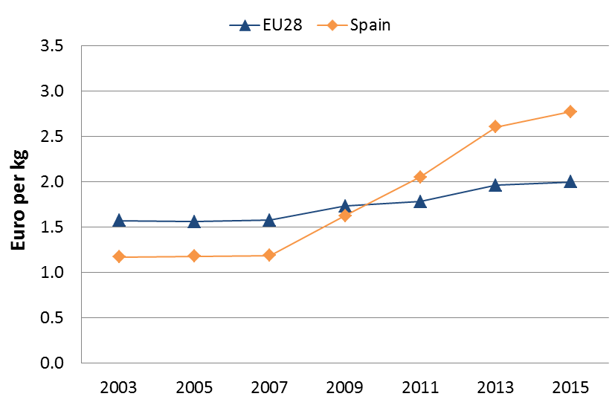
Boosting employment and greening the economy go hand in hand. The shift to a green and resource efficient economy is an opportunity to support sustainable and high quality employment. In addition, shifting taxation away from the labour towards environment taxation, green procurement and green entrepreneurship are equally important areas to support green job creation.
A number of studies have shown at European level the positive link between environmental performance and job creation. Spain has the potential to explore it by designing and implementing labour market, education and training measures supporting the green economy. The number of green jobs in new sources of employment could multiply with a shift towards a sustainable economy model.
Some interesting reports show the features and the state of play of Green Jobs in Spain.
In a Member State like Spain where unemployment is one of the most serious problems, greening the economy can boost job creation in areas directly connected to the environment such as nature conservation, waste, water and air quality, often referred to as eco-industries, but it can benefit other sectors as well.
The creation of green jobs has received political attention in light of the economic crisis hitting Spain harshly in the last years, reflecting a positive trend during the recession in comparison with other sectors. Employment in the environmental sector is slightly above the EU average and waste management and renewable energy are the main generators of employment in Spain. However, these activities have not exhausted their growth potential, as well as others sectors like wastewater treatment, environmental R&D+I, ecological farming and stock breeding, forestry management and biodiversity protection.

SMEs and resource efficiency
Investments in innovative, cost-saving measures by SMEs to reduce resource and energy use have the potential to result in high cost savings. Thus, according to a study, for only four SME sectors (food & beverages; energy, power & utilities; environmental technologies; construction) the savings that would strengthen their competitiveness could already amount to EUR 3.7 billion in Spain.
The EU Roadmap on Resource Efficiency outlines how we can transform Europe's economy into a sustainable one by 2050.
The performance of Spanish SMEs is above EU average on several indicators on resource efficiency and green markets. Boosting resource efficiency in the business environment helps increasing Spanish competitiveness.
Another recent study offers a detailed analysis of the level of application of business support measures to improve resource efficiency applied in the EU Member States. This study shows that in Spain the most widespread instruments for the promotion of resource efficiency principles are being driven by initiatives and regulations at the national level. Only four of the ten support measures analysed are widely used in Spain: voluntary agreements, development of non-legal standards, measures supporting EPR, and building resource efficiency related skills.

Eco-innovation
Eco-innovation brings financial benefits through the improved resource productivity and reduced costs of material and energy. Spain remains an eco-innovation follower. However, the economic crisis has posed additional eco-innovation needs and challenges in Spain.
Figure 2: Eco-Innovation Index 2015 (EU=100)
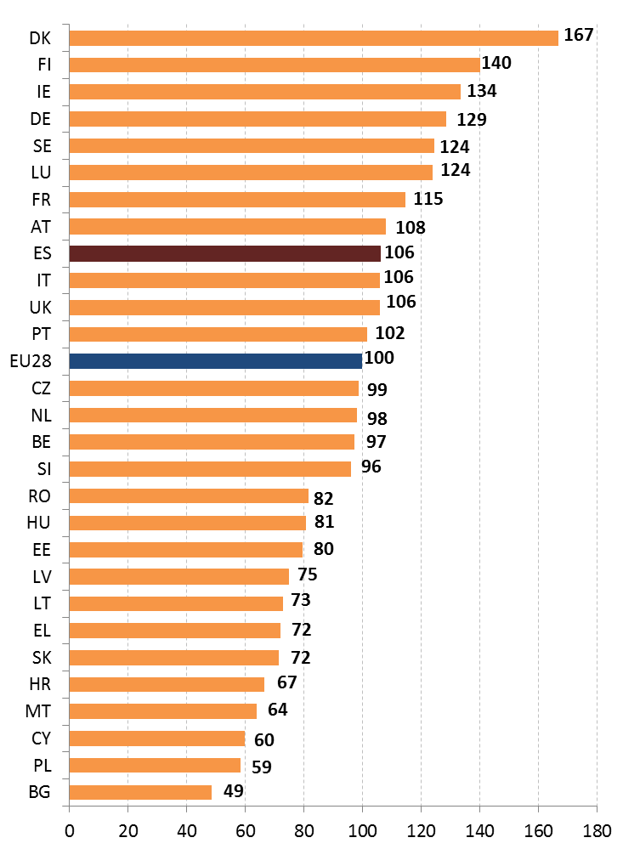
Spain is ranked number 9 in the Eco-IS 2015 as shown in Figure 2. As it was in the case in all previous editions of the Scoreboard, the country has above-average overall performance (score of 106). The leading Spanish eco-innovation areas have not changed substantially: waste management, eco-design, energy efficiency, sustainable construction and water efficiency. In any case, large potential rests in the eco-innovations sectors.
However, despite keeping its performance high, Spain lost three positions and four score-points in comparison to its rank in the Eco-IS 2013. Apart from the financial crisis that led to heavy cuts in public funds affecting eco-innovation and innovation in general, research and innovation policy in Spain face overall several challenges.
The strong level of decentralisation and high margin of manoeuver of the Autonomous Communities in Spain is a major influencer on the country's performance. A decentralised management of eco-innovation policies has the advantage of offering greater flexibility and adaptability to local needs. However, so far a great level of heterogeneity, both legislative and organizational, has been observed in the regional strategies in support of eco-innovation and circular economy with regards to objectives, instruments and environmental standards. This generates uneven administrative and environmental regimes and burden across regions, leading to market distortions.
As a positive point, it can be highlighted that Spain has 942 EMAS registered organisations, which is a very high number with respect to the total of 4034 organisations that hold a registration. Spain is the second European country gathering the most EMAS registered organisations (after Germany).
Concerning the EU Ecolabel, Spain has 197 licenses, which is quite a big number with respect to the 1875 total number of licenses. It is the fourth biggest gatherers of EU Ecolabel licenses.
Suggested action
- Further develop circular economy and eco-innovation policies, by better cooperation between all level of governances, as well as with the private sector.
- Integrate circular economy and resource efficiency principles in the SMEs policies, e.g. incentive energy and water savings, emphasise the use of eco-design, and by investing further in education and training.
- Facilitate green investments and ease the access to funding.

Waste management
Turning waste into a resource requires:
- Full implementation of Union waste legislation, which includes the waste hierarchy; the need to ensure separate collection of waste; the landfill diversion targets etc.
- Reducing per capita waste generation and waste generation in absolute terms.
- Limiting energy recovery to non-recyclable materials and phasing out landfilling of recyclable or recoverable waste.
SDG 12 invites countries to substantially reduce waste generation through prevention, reduction, recycling and reuse by 2030.
The EU's approach to waste management is based on the "waste hierarchy" which sets out an order of priority when shaping waste policy and managing waste at the operational level: prevention, (preparing for) reuse, recycling, recovery and, as the least preferred option, disposal (which includes landfilling and incineration without energy recovery).
The progress towards reaching recycling targets and the adoption of adequate WMP/WPP should be the key items to measure the performance of Member States. This section focuses on management of municipal waste for which EU law sets mandatory recycling targets.
There has been a reduction in terms of municipal waste generation in the last years and now the average amount in Spain (435 kg/y/inhabitant) is below the EU average (475 kg/y/inhabitant).
Figure 3 depicts the municipal waste by treatment in Spain in terms of kg per capita, which shows a slightly increase in composting and slightly increase in incineration and a decrease in recycling and landfilling. According to 2014 data, 55% of municipal waste in Spain is landfilled (much greater than the EU average of 28%).
Figure 3: Municipal waste by treatment in Spain 2007-14
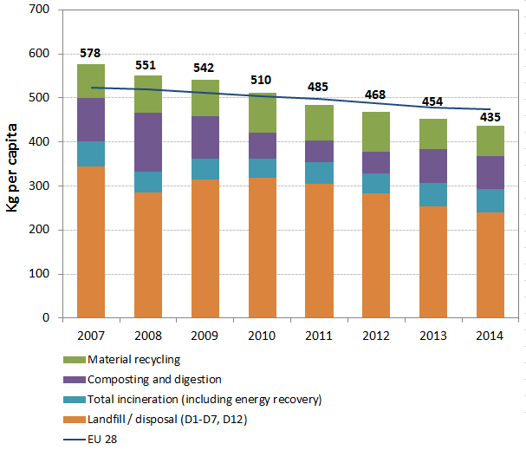
The opportunities of prevention and recycling are not fully tapped into. Figure 4 shows that although Spain has increased its recycling rate since 2011, it must strongly invest in recycling and divert from landfilling in the next coming years in order to reach the 2020 recycling target.
At the current pace (16% recycled and 17% composted), Spain needs to make significant further efforts to reach the EU recycling target of 50% of municipal waste by 2020. This can only be achieved by the systematic and concentrated effort of all stakeholders involved in urban waste management at national, regional and local level.
Figure 4: Recycling rate of municipal waste 2007-14
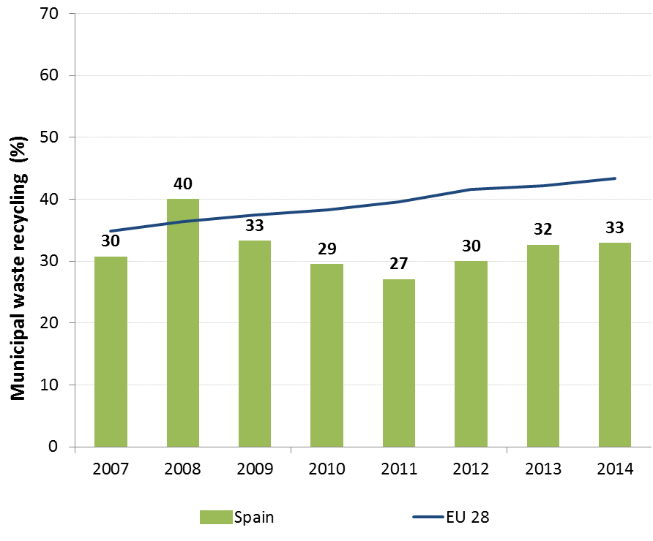
In addition, illegal or subs-standard landfilling is still an important problem in Spain, and is closely followed by the Commission. To help bridge the implementation gap in Spain, the Commission has delivered a roadmap for compliance.
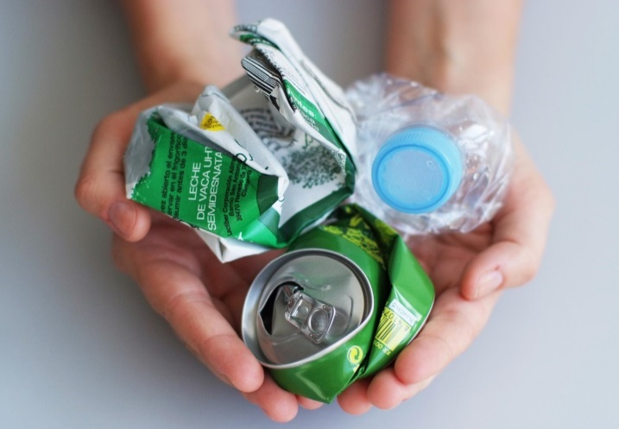
The underlying causes for the current distance to EU waste targets are: lack of incentives to manage waste according to the waste hierarchy; insufficient (door-to-door) separate collection of waste; lack of co-ordination between the different administrative levels; insufficient extended producer responsibility (EPR) systems; insufficient management of bio-waste.
Spain has adopted a national Waste Prevention Programme 2014-2020 in 2013 as well as a new national Waste Management Plan 2016-2022 in 2015, pursuant to the Waste Framework Directive. However, some regional waste management plans have still to be updated.
The National Framework Plan for Waste Management 2016-2022 (PEMAR), approved in November 2015, sets up the strategic guidelines for waste management in the next six years and the measures necessary to meet EU targets. The final objective is to substitute linear models of production by circular models that reintegrate waste materials into the production line.
The PEMAR applies the waste hierarchy that underlies EU waste legislation. The Plan introduces an obligation of result on the Autonomous Communities, imposing on regions to align and review their regional strategies so as to achieve the specific objectives of the national Plan.
Full implementation of EU waste legislation could create more than 54,200 jobs in Spain and increase annual turnover of the waste sector by over EUR 5690 million. Moving towards the targets of the Roadmap on resource efficiency could create over 69,500 additional jobs and increase the annual turnover of the waste sector by over EUR 7,300 million.
Therefore, Spain has to intensify its efforts to improve the performance on its waste management system and to meet the targets, especially to reduce landfilling and increase recycling.
Suggested action
- Introduce a national landfill tax or harmonise the regional taxes to phase-out landfilling of recyclable and recoverable waste. Use the revenues to support the separate collection and alternative infrastructure but avoid building excessive infrastructure for the treatment of residual waste.
- Focus on improving the effectiveness of the separate collection to increase recycling rates (including specific plans for bio-waste management).
- Extend and improve the cost-effectiveness, monitoring and transparency of existing EPR schemes and eliminate free-riding.
- Intensify co-operation between the regions to use waste treatment capacity more efficiently and to achieve the national recycling targets.
- Complete missing regional Waste Management Plans in order to cover the whole territory.

- Protecting, conserving and enhancing natural capital

Nature and Biodiversity
The EU Biodiversity Strategy aims to halt the loss of biodiversity in the EU by 2020, restore ecosystems and their services in so far as feasible, and step up efforts to avert global biodiversity loss. The EU Birds and Habitats Directives aim at achieving favourable conservation status of protected species and habitats.
SDG 14 requires countries to conserve and sustainably use the oceans, seas and marine resources, while SDG 15 requires countries to protect, restore and promote the sustainable use of terrestrial ecosystems, sustainably manage forests, combat desertification, and halt and reverse land degradation and halt biodiversity loss.
The 1992 EU Habitats Directive and the 1979 Birds Directive are the cornerstone of the European legislation aimed at the conservation of the EU's wildlife. Natura 2000, the largest coordinated network of protected areas in the world, is the key instrument to achieve and implement the Directives' objectives to ensure the long-term protection, conservation and survival of Europe's most valuable and threatened species and habitats and the ecosystems they underpin.
The adequate designation of protected sites as Special Ares of Conservation (SAC) under the Habitats Directive and as Special Protection Areas (SPA) under the Birds Directive is a key milestone towards meeting the objectives of the Directives. The results of Habitats Directive Article 17 and Birds Directive Article 12 reports and the progress towards adequate Sites of Community Importance (SCI)-SPA and SAC designation both in land and at sea, should be the key items to measure the performance of Member States.
Spain boasts a very rich biodiversity. It covers four out of the nine bio-geographical regions defined for the implementation of the Habitats Directive: Alpine, Atlantic, Mediterranean and Macaronesian, and three out of the five marine regions: Atlantic, Mediterranean and Macaronesian. 117 natural habitats and 429 species of wild fauna and flora of Community interest protected under the Habitats Directive occur in the Spanish territory. Spain is also the Member State with a higher number of breeding birds, with a total of 285 bird species reported in its territory.

With 1.863 Natura 2000 sites, 644 Birds Directive SPAs and 1.467 Habitats Directive SCIs, covering 27.2% of its land territory (EU average 18.1 %), Spain is the Member State providing the largest terrestrial surface contribution to the Natura 2000 Network (more than 137,000 Km²).
Significant advances have been recently achieved in the completion of the network in Spain, particularly as an important surface of new marine SCIs has been proposed for its inclusion in the updated list of sites what also puts Spain at the forefront of marine contribution to the Natura 2000 network (more than 86,000 Km²).
However, several terrestrial and marine habitats and species are still insufficiently covered by the Spanish SCIs network, as shown in Figure 5.
Figure 5: Sufficiency assessment of SCI networks in Spain based on the situation until December 2013 (%)
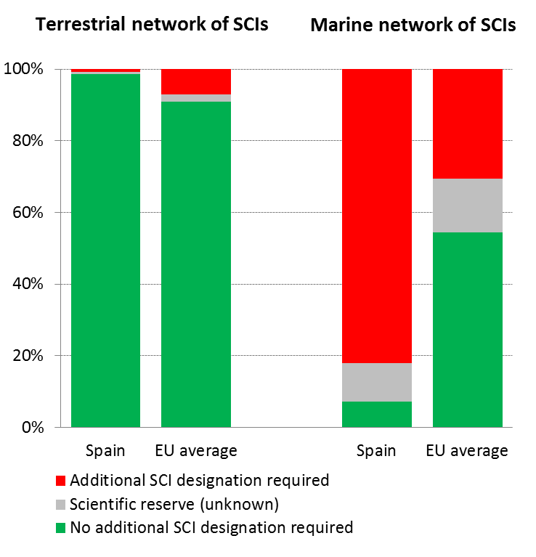
While the 6-year deadline required by the Habitats Directive to designate Special Areas of Conservation (SAC) and to establish appropriate conservation objectives and measures has expired for more than 1,400 sites in Spain, as of January 2016 Spain had completed these obligations only for around 68% of the sites concerned.
Figure 6: Conservation status of habitats and species in Spain in 2007/2013 (%)
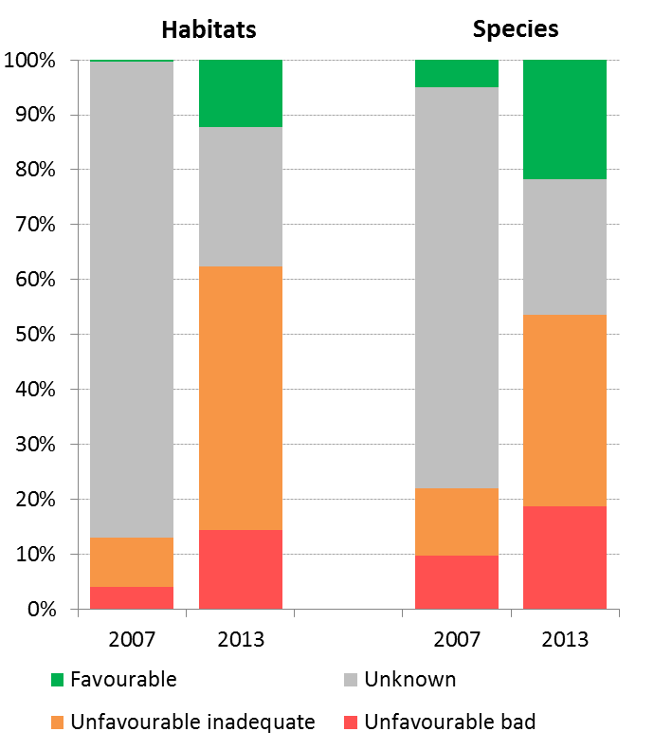
According to the latest report on the conservation status of habitats and species covered by the Habitats Directive, only 12% of the habitats' biogeographic assessments were favourable in 2013 (EU 27: 16 %). On the other hand, 48 % are considered to be unfavourable–inadequate (EU27: 47%) and 14 % are unfavourable – bad (EU27: 30%). As for the species, 22 % of the assessments were favourable in 2013 (EU 27: 23%) 35 % at unfavourable-inadequate (EU27: 42%) and 19% unfavourable-bad status (EU27: 18%). This is depicted in Figure 6. Less than 10% of the habitat types and 20% of the species assessed in unfavourable conservation status are improving.
Spain has the highest share of unknown assessments (at approximately 25%) among EU Member States, even if important improvements have been achieved since the previous reporting period, which indicates important knowledge gaps for the implementation of the Nature Directives.
The most frequent pressures and threats so far reported are natural system modifications (more than 20% of species and more than 40% of habitat types) and agriculture (reported for over 20% of the habitats and over 10% for the species assessed), followed by pollution and urbanization.
Figure 7 shows that the short-term population trend of 28% of the breeding bird species assessed under Article 12 reporting is increasing, while 27% are decreasing and 33% stable. On the long term, the population trend of 30% of the species assessed is decreasing and 33% is increasing and 27% stable.
Figure 7: Short-term population trend of breeding and wintering bird species in Spain in 2012 (%)
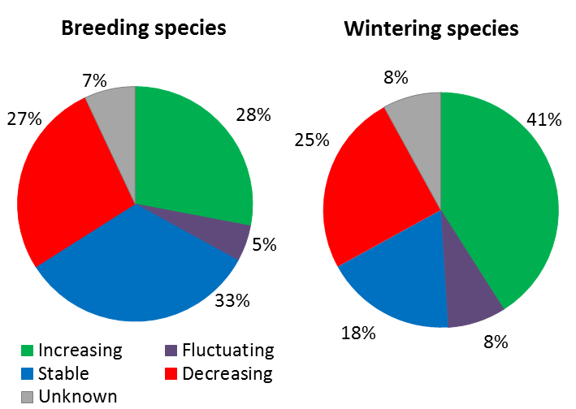
Natura 2000 management and nature protection is mainly a regional competence in Spain, except for the marine sites, which are under the competence of the national Administration, if they do not have ecological continuity with adjacent terrestrial sites.
The Spanish National Plan for Biodiversity and Natural Heritage, together with the basic legislation, is a good overall framework for the protection of biodiversity in Spain. The Spanish basic legislation transposing the Habitats Directive - which has been recently updated - is overall appropriate. It requires the establishment of management plans before designating sites as SACs, therefore ensuring that SAC designation triggers the establishment of conservation measures, as required under Article 6(1) of the Habitats Directive.
The Commission receives a high number of complaints regarding the implementation of the Nature Directives in Spain, mainly on degradation of designated sites, inadequate management and bad quality of Appropriate Assessments under Article 6(3) of the Habitats Directive. The degradation of protected water dependent habitats within Natura 2000 is also a frequent concern.
There are also concerns regarding the implementation of the Birds Directive in Spain, in particular in relation to the extensive use of trapping derogations for finches in several regions.
The lack of adequate financial resources and scientific knowledge for some species and habitat types to support appropriate management are recognized as the most relevant limiting factors to achieve the objectives of the Nature Directives. There is a low use of the potential financing under the ERDF and for nature conservation measures and Natura 2000 priorities, notably due to an insufficient coordination between the relevant competent administrative authorities.
The Priority Action Framework (PAF) for the financing of the Natura 2000 Network, prepared by Spain in 2014 at the request of the Commission, is a good basis to address the above-mentioned limiting factors.
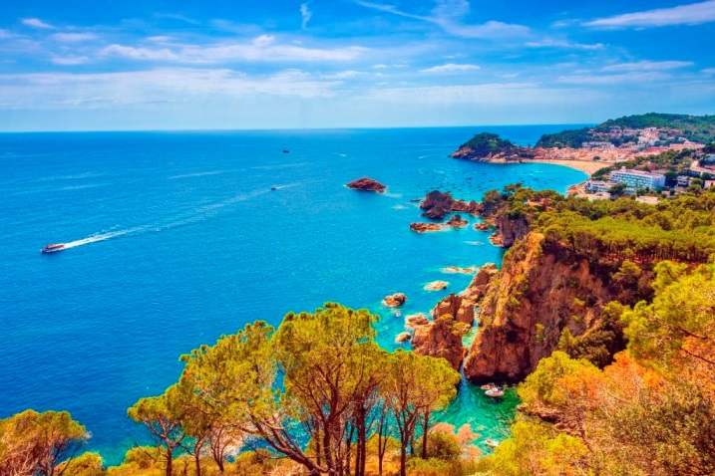
A recent study carried out by the Ministry for Agriculture, Food and Environment (Economic Benefits of the Natura 2000 Network in Spain, still unpublished) assesses these benefits through use values calculated from direct and indirect real market prices for a limited array of ecosystem services. According to this study, the estimated economic benefits of Natura 2000 (and this is a very conservative estimate) amount to 9.8 billion EUR/year –i.e. 7.5 times the theoretical annual cost of maintenance of the network.
The last changes to the national legislation on Natural Heritage and Biodiversity have introduced new possible ways to promote actions on nature conservation, including the declaration of these type of activities as actions of general interest for the State, as well as the possible establishment of economic incentives (like subsidies prioritization, tax reduction, etc.) for activities contributing to Natura 2000 objectives.
The possibilities to develop sustainable or nature tourism should be highlighted, as tourism is one of the most important economic sectors in Spain that however needs diversification and seasonal adjustment, promoting other modalities different to the traditional "sun and beach" focus. There is also scope for making the tourist infrastructure more sustainable.
In this sense, the Spanish Government approved in 2014 the Spanish strategic plan on nature and biodiversity tourism 2014-2020, which is a positive step, but there is a clear scope for further growth.
Indeed, special attention should be paid to the potential for Spain to capitalise its very valuable natural capital to create jobs. Spain makes the largest contribution to the Natura 2000 network in the EU. Therefore, jobs related to protection of biodiversity, reforestation, green infrastructure and ecosystem services have an enormous potential in Spain that should not be ignored.
Suggested action
- Complete the designation process and put in place clearly defined conservation objectives and the necessary conservation measures for the sites and provide adequate resources for their implementation in order to maintain/restore species and habitats of community interest to a favourable conservation status across their natural range.
- Improve the availability to the necessary financial resources for nature conservation, particularly through an enhanced use of the ERDF and EARDF funds and the further development of the financial incentives for the promotion of nature conservation activities foreseen in the basic legislation.
- Capitalise the very valuable natural capital to create jobs. In this context, promoting further the sustainable tourism would be a good focus for Spain.
- Develop and promote smart and streamlined implementation approaches, in particular as regards site and species permitting procedures, ensuring the necessary knowledge and data availability. Strengthen communication with stakeholders.

Estimating Natural Capital
The EU Biodiversity Strategy to 2020 calls on the Member States to map and asses the state of ecosystems and their services in their national territory by 2014, assess the economic value of such services, and promote the integration of these values into accounting and reporting systems at EU and national level by 2020.
The National Ecosystem Assessment of Spain evaluation was completed in 2012 and was followed up by an in-depth analysis of the economic and social value of Spanish ecosystem services. The project run by scientists is supported by the government and involves multiple parties and interest groups.
Suggested action
- Continue supporting the mapping and assessment of ecosystems and their services, and enhance its use for policy and decision-making (e.g. Spanish strategy on Green Infrastructure) and develop natural capital accounting systems.

Green Infrastructure
The EU strategy on green infrastructure promotes the incorporation of green infrastructure into related plans and programmes to help overcome fragmentation of habitats and preserve or restore ecological connectivity, enhance ecosystem resilience and thereby ensure the continued provision of ecosystem services.
Green Infrastructure provides ecological, economic and social benefits through natural solutions. It helps to understand the value of the benefits that nature provides to human society and to mobilise investments to sustain and enhance them.
Spain has no Green Infrastructure Strategy as such, but the last changes to the basic national legislation include provisions for the establishment of a national Strategy on Green Infrastructure, Connectivity and Ecological Restoration. The elaboration of this national strategy is on-going. Law 33/2015 also imposes a general obligation onto the Autonomous Communities to draft Green Infrastructure Strategies. There are also some national plans and initiatives related to this topic.
Law 42/2007 (Natural Heritage and Biodiversity) already imposed a general obligation onto the Autonomous Communities to take measures aimed at ensuring environmental connectivity, while various regional laws also focus on the connectivity of natural areas. Prior to this law, some Autonomous Communities had already introduced initiatives to develop corridors.
Transport infrastructure has been identified as one of the main drivers of habitat fragmentation and a working group has been set up to address this issue specifically.
The focus of the Spanish policy so far is to implement measures ensuring connectivity between existing protected areas rather than promoting the development of a comprehensive and coherent ecological network.
The Ministry for Agriculture, Food and Environment is implementing the National Strategy for River Restoration, which connects Green Infrastructure to the Water Framework and Flood Directives and correlates positively with ecosystem service areas and green urban areas.
The Spanish Strategy for the Coastal Zones also relates to Green Infrastructure through restoring physical functionality in the natural coastal zone and adapting to climate change.
The Spanish Strategic Plan for the conservation and rational use of the Wetlands promotes the restauration of wetlands that have been destroyed or degraded. Focus has also been given to the restoration of dunes and coastal habitats.
The national Plan of priority actions of hydrological-forestry restauration included in the Spanish Forestry Plan 2002-2030 sets a national plan for restoration of forestry in Spain, with focus on restoration, conservation and enhancement of the forest ecosystem.
The main challenges of Green Infrastructure for the future include:
- better integration of biodiversity into economic sectors, e.g., tourism, to promote the development of multifunctional Green Infrastructure areas;
- integration of sustainable agriculture and a network of protected areas within broader production landscapes to promote the development of Multi-functional, Green Infrastructure areas;
- further integration of the Green Infrastructure approach into landscape and urban planning processes;
One of the outstanding examples of Green Infrastructure development in the EU can be seen in the Basque capital of Vitoria-Gasteiz. In the 1990's the city authorities started a project to restore and recover the outlying areas of the city, creating a Green-Belt: a group of peri-urban parks of high ecological and landscape value strategically linked by eco-recreational corridors. The development of Green Infrastructure in the city has generated significant economic (reduced risks of floods, tourism), social (better air quality and general wellbeing) and environmental (biodiversity) benefits.
It would be an important and positive step to complete, adopt and implement the Spanish national Strategy on Green Infrastructure, Connectivity and Ecological Restoration.

Soil protection
The EU Soil Thematic Strategy highlights the need to ensure a sustainable use of soils. This requires the prevention of further soil degradation and the preservation of its functions, as well as the restoration of degraded soils. The 2011 Road Map for Resource-Efficient Europe, part of Europe 2020 Strategy provides that by 2020, EU policies take into account their direct and indirect impact on land use in the EU and globally, and the rate of land take is on track with an aim to achieve no net land take by 2050.
SDG 15 requires countries to combat desertification, restore degraded land and soil, including land affected by desertification, drought and floods, and strive to achieve a land-degradation-neutral world by 2030.
Soil is an important resource for life and the economy. It provides key ecosystem services including the provision of food, fibre and biomass for renewable energy, carbon sequestration, water purification and flood regulation, the provision of raw and building material. Soil is a finite and extremely fragile resource and increasingly degrading in the EU. Land taken by urban development and infrastructure is highly unlikely to be reverted to its natural state; it consumes mostly agricultural land and increases fragmentation of habitats. Soil protection is indirectly addressed in existing EU policies in areas such as agriculture, water, waste, chemicals, and prevention of industrial pollution.
As in many EU countries the main threats to the soil in Spain include pollution, erosion, salinization and to a certain degree the loss of organic matter and biodiversity.
In 2005 it was regulated to identify those soils in which the presence of pollutants above certain levels may involve a risk to human health and terrestrial ecosystems. These soils have been included in a national inventory, implying obligations to decontaminate them. Thus, decontamination works have been carried out in more than 250 sites, suggesting that most of these contaminations are related to industrial activities.
The National Inventory of Soil Erosion (INES) was produced to detect and quantify main erosion processes and threatened areas. INES also permits to assess time evolution providing valuable information to design actions and priorities. Loss of soil by erosion has been estimated in a range of 5-25 t/ha.
Irrigation of agricultural soils poorly drained and under certain climatic conditions has led to the salinization of considerable areas of land regardless of water quality. According to the available information, 3% of the irrigated lands would be seriously affected.
Figure 8 shows the different land cover types in Spain in 2012.
Figure 8: Land Cover types in Spain in 2012
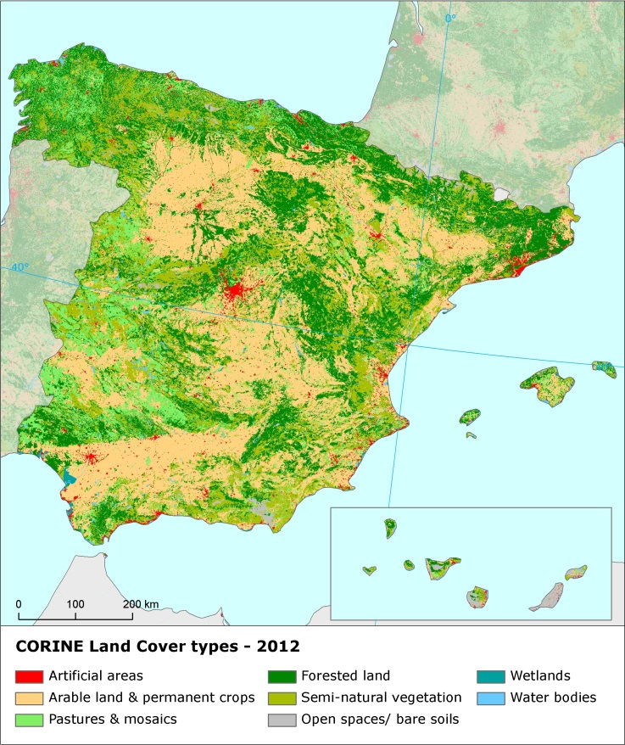
Artificial land cover is used for settlements, production systems and infrastructure. It may itself be split between built-up areas (buildings) and non-built-up areas (such as linear transport networks and associated areas).
The annual land take rate (growth of artificial areas) as provided by CORINE Land Cover was 1.48% in Spain over the period 2006-12, the highest in the EU (EU average 0.41%). It represented 18,298 hectares per year and was mainly driven by housing, services and recreation as well as industrial and commercial sites.
As the OECD highlights, important environmental pressures remain in Spain driven by land conversion during the construction boom of the early 2000s and the population increase which has been significant in some coastal areas.
The soil water erosion rate in 2010 was 3.94 tonnes per ha per year, above EU-28 average (2.46 tonnes).
There are still not EU-wide datasets enabling the provision of benchmark indicators for soil organic matter decline, contaminated sites, pressures on soil biology and diffuse pollution.
An updated inventory and assessment of soil protection policy instruments in Spain and other EU Member States is being performed by the EU Expert Group on Soil Protection.

Marine protection
The EU Coastal and Marine Policy and legislation require that by 2020 the impact of pressures on marine waters is reduced to achieve or maintain good environmental status and coastal zones are managed sustainably.
SDG 14 requires countries to conserve and sustainably use the oceans, seas and marine resources for sustainable development.
The Marine Strategy Framework Directive (MSFD) aims to achieve Good Environmental Status (GES) of the EU's marine waters by 2020 by providing an ecosystem approach to the management of human activities with impact on the marine environment. The Directive requires Member States to develop and implement a marine strategy for their marine waters, and cooperate with Member States sharing the same marine region or subregion.
As part of their marine strategies, Member States had to make an initial assessment of their marine waters, determine GES and establish environmental targets by July 2012. They also had to establish monitoring programmes for the on-going assessment of their marine waters by July 2014. The next element of their marine strategy is to establish a Programme of Measures (2016). The Commission assesses whether these elements constitute an appropriate framework to meet the requirements of the MSFD.
Spanish marine waters are part of two marine regions: the North-East Atlantic (covering several subregions: the Bay of Biscay and the Iberian coast and Macaronesia for the Canaries islands) and the Mediterranean Sea. Spain is therefore party to both the Convention for the Protection of the Marine Environment and the Coastal Region of the Mediterranean (Barcelona Convention) and the Convention for the protection of the marine environment of the North-East Atlantic (OSPAR Convention). In the open ocean areas of the Atlantic, the main threats to biodiversity are potentially overfishing, bottom trawling, discards, and pollution resulting from accidents (e.g. oil spills). The Mediterranean Sea region has been identified by the EEA in its 2015 State of the Environment report as one of the main climate change hotspots (i.e. one of the areas most responsive to climate change). The biodiversity of the Mediterranean Sea Region is also threatened by pollution from land-based sources such as discharges of excess nutrients and hazardous substances, marine litter, over-fishing, and degradation of critical habitats.
With regards to the specificities of implementation of the MSFD, in 2012, Spain reported on its determination of GES often in a very detailed manner. Strong links were created with existing EU and Regional Sea Conventions standards. Spain assessed the state of its marine waters in a comprehensive manner identifying almost all pressures on its marine environment. However, there are a few aspects which merit further attention, such as the aggregation of GES for the different species, habitats and ecosystems was not defined. For certain descriptors, threshold values or baselines were missing and some lacked specifications. It is therefore too early to say whether Spain waters are in good status.
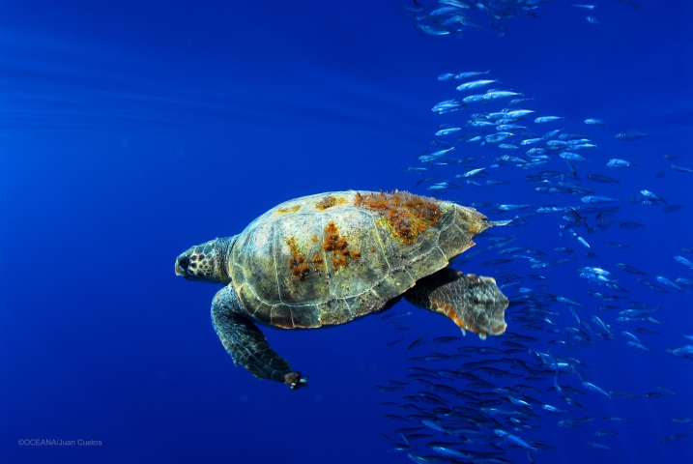
Spain established a monitoring programme of its marine waters in 2014. However it seems that its monitoring sub-programme for biodiversity, non-indigenous species, contaminants in seafood, marine litter and underwater noise need further refinement to constitute an appropriate framework to monitor progress towards GES, especially since full coverage for those descriptors will not be in place before 2020.
In 2012 Spanish marine protected areas covered 11515.5 km². More specifically, 3735.01 km² of the 0-1 nm zone, 5242.84 km² of the 1-12 nm zone and 2537.67 km² of the 12- end of assessment area zone were covered by MPAs.
The Commission's report on the implementation of the MSFD provides guidance to assist Spain.
Suggested action
- Continue work to improve the definitions of Good Environmental Status (GES) including through regional cooperation by using the work of the relevant Regional Sea Conventions.
- Continue integrating monitoring programmes with relevant EU legislation and implement other joint monitoring programmes where they exist at regional or sub-regional level.
- Continue to enhance comparability and consistency of monitoring methods within the country's marine regions.
- Ensure that all of its monitoring programme is implemented without delay and is fully appropriate to monitor progress towards its GES.

- Ensuring citizens' health and quality of life

Air quality
Figure 9: Attainment situation for PM10, NO2 and O3 in 2014
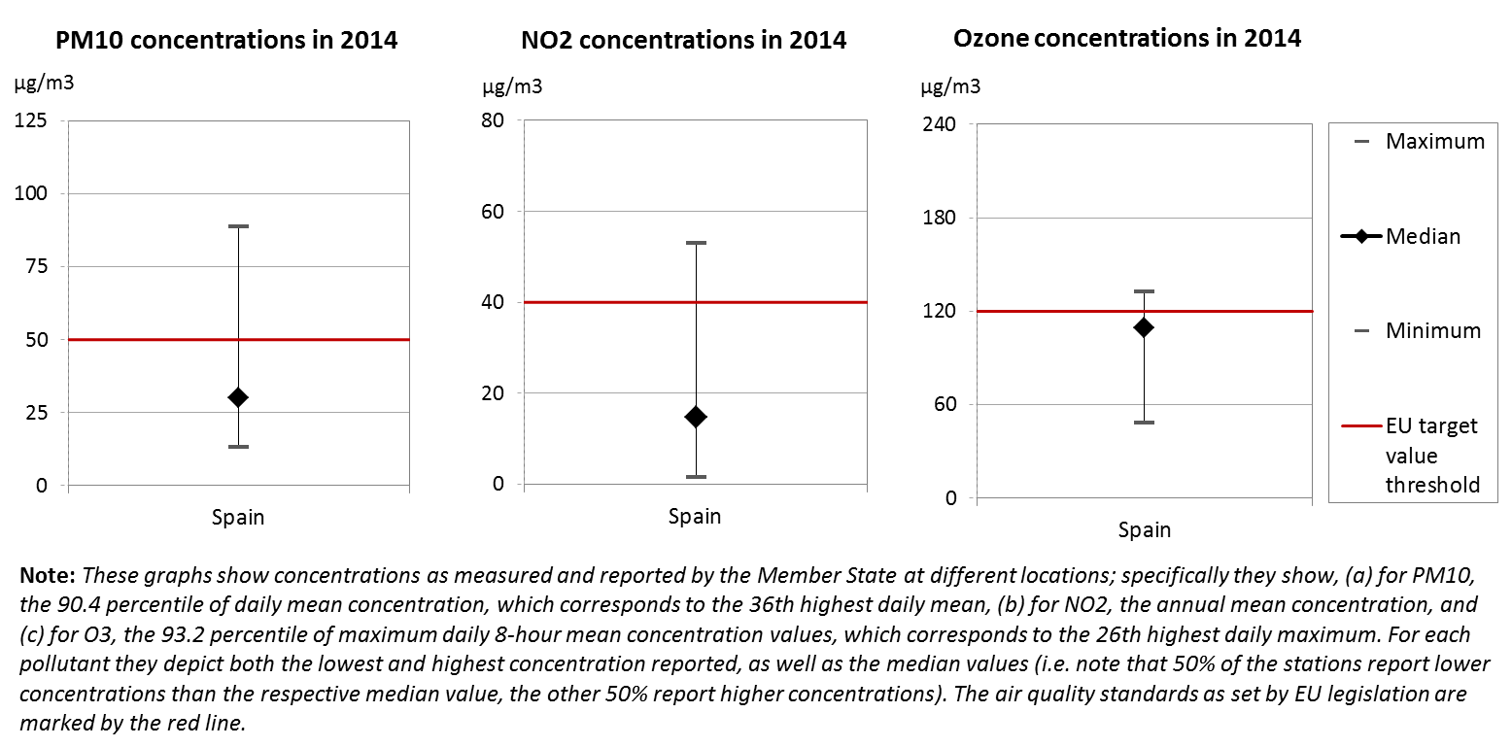
The EU Clean Air Policy and legislation require that air quality in the Union is significantly improved, moving closer to the WHO recommended levels. Air pollution and its impacts on ecosystems and biodiversity should be further reduced with the long-term aim of not exceeding critical loads and levels. This requires strengthening efforts to reach full compliance with Union air quality legislation and defining strategic targets and actions beyond 2020.
The EU has developed an extensive body of legislation, which establishes health-based standards and objectives for a number of air pollutants. As part of this, Member States are also required to ensure that up-to-date information on ambient concentrations of different air pollutants is routinely made available to the public. In addition, the National Emission Ceilings Directive provides for emission reductions at national level that should be achieved for main pollutants.
Most of the emissions of several air pollutants have decreased significantly in Spain. Reductions between 1990 and 2014 for sulphur oxides (-88%), nitrogen oxides (-40%), as well as volatile organic compounds (-42%) ensure air emissions for these pollutants are within the currently applicable national emission ceilings. For ammonia however, recorded emissions have increased (+3%), keeping them above current ceilings.
At the same time, air quality in Spain continues to give cause for concern. For the year 2013, the European Environment Agency estimated that about 23 940 premature deaths were attributable to fine particulate matter concentrations, 1 760 to ozone concentration and over 4 280 to nitrogen dioxide concentrations. This is due also to exceedances above the EU air quality standards such as shown in Figure 9.
For 2014, exceedances above the EU air quality standards have been registered for nitrogen dioxide (NO₂) in five air quality zones (Madrid, Barcelona, Murcia, Valencia, and Vallés-Baix Llobregat) and particulate matter (PM10) in three air quality zones (Oviedo, Terres de l’Ebre, and La Coruña). Furthermore, the target values regarding ozone concentrations are exceeded in many air quality zones. In addition, target values for annual mean concentration have been exceeded in one air quality zone for nickel.
The persistent breaches of air quality requirements (for PM₁₀ and NO₂), which have severe negative effects on health and environment, are being followed up by the European Commission through infringement procedures covering all the Member States concerned, including Spain. The aim is that adequate measures are put in place to bring all zones into compliance.
It is estimated that the health-related external costs from air pollution in Spain are above EUR 22 billion/year (income adjusted, 2010), which include not only the intrinsic value of living a full health life but also direct costs to the economy. These direct economic costs relate to 8 million workdays lost each year due to sickness related to air pollution, with associated costs for employers of EUR 1056 million/year (income adjusted, 2010), for healthcare of above EUR 82 million/year (income adjusted, 2010), and for agriculture (crop losses) of EUR 367 million/year (2010).
Suggested action
- Maintain downward emissions trends of air pollutants in order to achieve full compliance with currently applicable national emission ceilings and air quality limit values - and reduce adverse air pollution impacts on health, environment and economy.
- Reduce ammonia (NH₃) emissions to comply with currently applicable national emission ceilings, for example by introducing or expanding the use of low-emission agricultural techniques.
- Reduce nitrogen oxide (NO_{x}) emissions to comply with currently applicable national emission ceilings and/or to reduce nitrogen dioxide (NO₂) (and ozone concentrations), inter alia, by reducing transport related emissions - in particular in urban areas.
- Reduce PM₁₀ emission and concentration, inter alia, by reducing emissions related to energy and heat generation using solid fuels, to transport and to agriculture.

Noise
The Environmental Noise Directive provides for a common approach for the avoidance, prevention and reduction of harmful effects due to exposure to environmental noise.
Excessive noise is one of the main causes of health issues. To alleviate this, the EU acquis sets out several requirements, including assessing the exposure to environmental noise through noise mapping, ensuring that information on environmental noise and its effects is made available to the public, and adopting action plans with a view to preventing and reducing environmental noise where necessary and to preserving the acoustic environment quality where it is good.
Spain's implementation of the Environmental Noise Directive is significantly delayed. There have been delays in both noise mapping for the most recent reporting round, for the reference year 2011, and the adoption of action plans for noise management in the current period. The Commission is following up on this matter.
Suggested action
- Complete noise mapping and action plans for noise management.

Water quality and management
The EU water policy and legislation require that the impact of pressures on transitional, coastal and fresh waters (including surface and ground waters) is significantly reduced to achieve, maintain or enhance good status of water bodies, as defined by the Water Framework Directive; that citizens throughout the Union benefit from high standards for safe drinking and bathing water; and that the nutrient cycle (nitrogen and phosphorus) is managed in a more sustainable and resource-efficient way.
SDG 6 encourages countries to ensure availability and sustainable management of water and sanitation for all.
The main overall objective of EU water policy and legislation is to ensure access to good quality water in sufficient quantity for all Europeans. The EU water acquis seeks to ensure good status of all water bodies across Europe by addressing pollution sources (from e.g. agriculture, urban areas and industrial activities), physical and hydrological modifications to water bodies) and the management of risks of flooding.
River Basin Management Plans (RBMPs) are a requirement of the Water Framework Directive and a means of achieving the protection, improvement and sustainable use of the water environment across Europe. This includes surface freshwaters such as lakes and rivers, groundwater, estuaries and coastal waters up to one nautical mile.
Spain has provided information to the Commission from its second generation of RBMPs. However, as the Commission has not yet been able to validate this information for all Member States, it is not reported here.
In its first generation of RBMPs Spain reported the status of 4381 rivers, 329 lakes, 180 transitional, 260 coastal and 748 groundwater bodies.
Only 43% of natural surface water bodies achieve a good or high ecological status and 32% of heavily modified or artificial water bodies achieve a good or high ecological potential. 57% of surface water bodies (while the status of 39% is unknown), 61% of heavily modified and artificial water bodies (29% unknown) and 66% of groundwater bodies achieve good chemical status. 71% of groundwater bodies are in good quantitative status.
The main pressure on the Spanish surface waters is point source pollution that affects 35% of water bodies. Flow modification and morphological alterations affect 30% of water bodies followed by diffuse pollution that affects 23% and abstraction that affects 21% of water bodies. There are significant regional differences, e.g. point sources of pollution affect 68% of water bodies in the Andalusian Mediterranean river basin district but only 18% in the Ebro river basin district.
The first Spanish RBMPs had some deficiencies that result in uncertainties about the status and effectiveness of Programmes of Measures (PoMs). In particular, there are weaknesses in monitoring, methodologies for status assessment and the link between pressures and PoMs. The planned measures are expected to result in improvement of ecological and chemical status of surface water bodies by 11% and 3% respectively. The measures should also bring improvement of ecological potential of artificial and heavily modified water bodies by 8% and chemical status by 3%. Furthermore, there is a need of better considering modernisation of irrigation in the PoMs; established ecological flows should guarantee good ecological status and exemptions reflected in RBMPs should be better justified.
The Commission is assessing on a regular basis the implementation of the Water Framework Directive by the Member States.
Spain has already adopted and notified to the Commission most of the second generation 25 RBMPs. The Commission is currently assessing the content of these second RBMPs.
Regarding the implementation of the Nitrates Directive, following a horizontal monitoring based on the 2008-2011 water quality data, the regional Action Programmes and the current Nitrates Vulnerable Zones designation showed possible insufficiencies. In certain regions (e.g.: Cataluña), intensive livestock production, and in particular pig farming, puts additional pressure on water resources quality.
Regarding drinking water, Spain reaches very high compliance rates of 99-100 % for microbiological, chemical and indicator parameters laid down in the Drinking Water Directive.
Figure 10 shows that in 2015 in Spain out of 2189 bathing waters, 83.2 % were of excellent quality, 9.5 %of good quality, 3.3 % of sufficient quality. 58 bathing waters were of poor quality or non-compliant while it was not possible to assess the remaining 31 bathing waters.

Figure 10: Bathing water quality 2012 – 2015
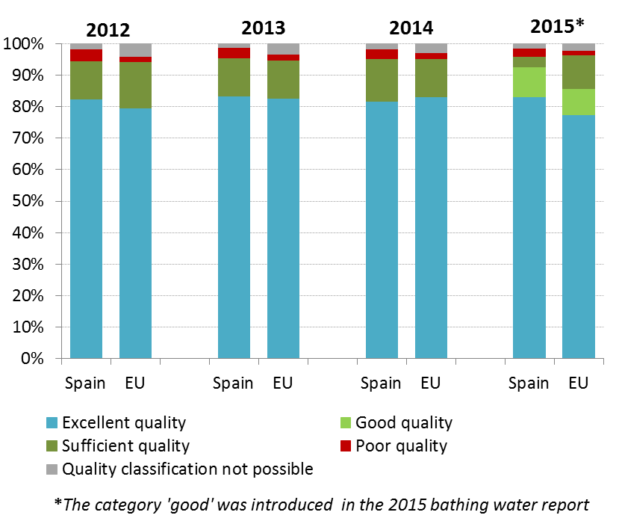
Regarding the implementation of the Urban Waste Water Treatment Directive, Spain demonstrates some high compliance rates: 99.7% of the waste water load is collected and 86.2 % is subject to secondary treatment as shown in Figure 11. However, only 38% of the waste water load which should have been subject to more stringent treatment is actually treated as such.
It is important to note that there are still a certain number of agglomerations that do not comply with the requirements and deadlines of the UWWT Directive. Therefore further efforts are needed in this regard. Consequently, the Commission has opened various infringement procedures against Spain regarding sensitive, normal areas and small agglomerations. These cases of non-compliance are closely followed by the Commission.
Figure 11 shows the total generated load at Member State level (in population equivalent and regardless of agglomerations) and the load that remains to be addressed by Spain.
The estimated investment needs (reported under Article 17 of the Urban Waste Water Treatment Directive) to reach full compliance with the Directive in Spain are of EUR 2944 million.

Figure 11: Urban waste water Spanish situation 2012 – Final deadline 2005
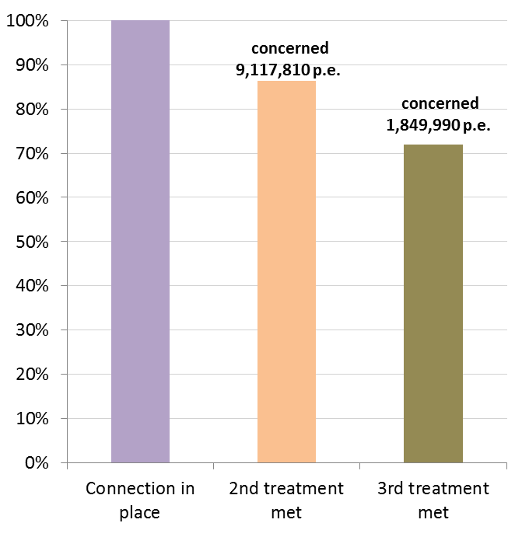
Certain areas of Spain are water-stressed, meaning that water demand exceeds the available water resources under sustainable conditions. Spanish RBMPs include, by legal requirement, water balances at the scale of water exploitation systems which allow assessing the reliability of water supply for all uses and ensuring that the environmental objectives will be met once accounting for the previous restriction of e-flows. In water-stressed areas, water reuse and desalination are part of the mix of resources on which the system relies to meet water demands.
Decoupling economic growth from water use remains a challenge in Spain. Sectors like agriculture, tourism and energy are heavily dependent on water supply. At the same time, tariffs for supplied water are slightly lower than the EU average and there are large variations between cities and regions. In addition, there is a lack of transparency in subsidies for water used in agriculture, and environmental costs (e.g. related to diffuse pollution) are rarely applied. Furthermore, there is a need to ensure sustainability of irrigation projects, the established ecological flows should guarantee good ecological status and exemptions linked to new infrastructure need to be better justified in the RBMPs.
An adequate water-pricing policy to recover the cost of water services, together with greater transparency of prices and subsides, promotion of wastewater reuse, modernisation of irrigation systems, as well as better control of water abstraction, could all harness water saving potential, especially in the agriculture sector, the major consumer of water.
There is scope for a more efficient use of water supply infrastructures, e.g.: desalinisation plants built primarily on the Mediterranean coast some of them with EU funding support have been underused; reduction of leakages in the water supply networks should be a priority. Measures to improve the water governance could also be envisaged.
Finally, flooding is a recurrent problem in Spain but natural water retention measures for flood prevention are often disregarded, despite being sometimes more cost-effective than hard infrastructure for flood prevention, as well as being cheaper than the costs of flood recovery.
Suggested action
- Spain should continue improving its water policy in line with the intervention logic of the Water Framework Directive (WFD).
- The methods for the assessment of status should be fully developed to improve certainty about the water status and monitoring programmes should be adequately funded. This will provide better information basis for decision making.
- New physical modifications of water bodies should be assessed in line with article 4(7) of the WFD, after considering alternative options and adequate mitigation measures.
- Control of water abstraction both for surface and ground waters should improve. An effective water pricing policy including recovery of environmental and resource costs should be put in place, in particular for agriculture, in order to provide adequate incentive for efficient use of water. The setup of a national regulator or supervisor body to ensure consistency and the adequate cost-recovery in the urban tariffs would be also advisable.
- Spain shall ensure appropriate designation of nitrate vulnerable zones and reinforce action in order to address nutrients pollution and improve water quality over time (groundwater, fresh and saline surface waters) in these zones.
- Complete implementation of the Urban Waste Water Treatment Directive for all agglomerations, by building up the necessary infrastructure.

Enhancing the sustainability of cities
The EU Policy on the urban environment encourages cities to implement policies for sustainable urban planning and design, including innovative approaches for urban public transport and mobility, sustainable buildings, energy efficiency and urban biodiversity conservation.
SDG11 aims at making cities and human settlements inclusive, safe, resilient and sustainable.
Europe is a Union of cities and towns; around 75% of the EU population are living in urban areas. The urban environment poses particular challenges for the environment and human health, whilst also providing opportunities and efficiency gains in the use of resources.
The Member States, European institutions, cities and stakeholders have prepared a new Urban Agenda for the EU (incorporating the Smart Cities initiative) to tackle these issues in a comprehensive way, including their connections with social and economic challenges. At the heart of this Urban Agenda will be the development of twelve partnerships on the identified urban challenges, including air quality and housing.
The European Commission will launch a new EU benchmark system in 2017.
The EU stimulates green cities through awards and funding, such as the EU Green Capital Award aimed at cities with more than 100,000 inhabitants and the EU Green Leaf initiative aimed at cities and towns, with between 20,000 and 100,000 inhabitants.
In the case of Spain, it should be highlighted that Vitoria-Gasteiz (in the region of País Vasco) received the EU Green Capital Award in 2012. Moreover, Mollet del Vallès (in the region of Cataluña) was one of the two cities winning the inaugural EU Green Leaf in 2015.
It should be highlighted that with the support of the ERDF during the last programming periods Spain has developed important and outstanding initiatives in terms of sustainable urban development as well as urban regeneration across many cities and towns. In the current period 2014-2020, Spain has also launched an ambitious and comprehensive initiative in favour of the local administrations to promote Strategies on Sustainable and Integrated Urban Development.
Personal transport exacerbates seasonal problems with air quality and traffic congestion in the major metropolitan areas in Spain, leading to health and economic costs. Recent events in Madrid clearly show this issue and its consequences. A comprehensive approach is needed to tackle this matter, bringing environmental as well as economic and social benefits.
In the framework of the National Plan of Air Quality and Protection of the Atmosphere 2013-2016, one of the measures envisaged by the Spanish authorities in this direction is the distribution of eco-labels for 50% of the vehicles in Spain, accounting for 16 million vehicles that will be classified into “Cero”, “Eco”, “C” and “B” according to their potential pollutants .


International agreements
The EU Treaties require that the Union policy on the environment promotes measures at the international level to deal with regional or worldwide environmental problems.
Most environmental problems have a transboundary nature and often a global scope and they can only be addressed effectively through international co-operation. International environmental agreements concluded by the Union are binding upon the institutions of the Union and on its Member States. This requires the EU and the Member States to sign, ratify and effectively implement all relevant multilateral environmental agreements (MEAs) in a timely manner. This will also be an important contribution towards the achievement of the SDGs, which Member States committed to in 2015 and include many commitments contained already in legally binding agreements.
The fact that some Member States did not sign and/or ratify a number of MEAs compromises environmental implementation, including within the Union, as well as the Union’s credibility in related negotiations and international meetings where supporting the participation of third countries to such agreements is an established EU policy objective. In agreements where voting takes place it has a direct impact on the number of votes to be cast by the EU.
Spain has signed and ratified almost all MEAs. It has signed but not yet ratified the Offshore Protocol of the Barcelona Convention.

Part II: Enabling Framework: Implementation Tools

- Market based instruments and investment

Green taxation and environmentally harmful subsidies
The Circular Economy Action Plan encourages the use of financial incentives and economic instruments, such as taxation to ensure that product prices better reflect environmental costs. The phasing out of environmentally harmful subsidies is monitored in the context of the European Semester and in national reform programmes submitted by Member States.
Taxing pollution and resource use can generate increased revenue and brings important social and environmental benefits. Moreover, environmentally-related taxation is one of the few taxes that are generally not detrimental to growth.
Green taxes have been a tool commonly used to pursue environmental objectives in the various policy sectors in Spain. However, there was an overall decline in environmental tax collection as percentage of total tax revenue in the last decade. There is also a normative dispersion and for certain taxes a heterogeneous approach at regional and even at local level.
In Spain revenues from environmental taxes as a proportion of GDP are among the lowest in the EU. It should be noted that in 2012 Spain was the Member State with the lowest rate: 1.6 % of the GDP, far below EU average of 2.4%. This share represented a 10 year low for Spain, fallen from 2.08% of GDP in 2002.
According to 2014 data, Spain is the third lowest in the EU (after Lithuania and Slovakia). Revenues from environmentally related taxes amounted to only 1.85% of GDP against an EU average of 2.46%. Moreover, Spain is one of the countries with the lowest share of environmental taxation in revenues from taxes and social contributions (5.5% of GDP in 2014, EU average 6.35%), as shown in Figure 12.
As in most Member States, the biggest chunk of revenues from the environmentally-related taxes comes from energy taxes.
Environmental tax reform can play an important part in sustaining economic growth. Taxing pollution and resource use would bring in additional revenues, and at the same time it would help discouraging activities that will bring additional cost in the future in terms of clean up, health costs, etc. This additional revenue could also substitute for cuts in spending.

Figure 12: Environmental tax revenues as a share of total revenues from taxes and social contributions (excluding imputed social contributions) in 2014
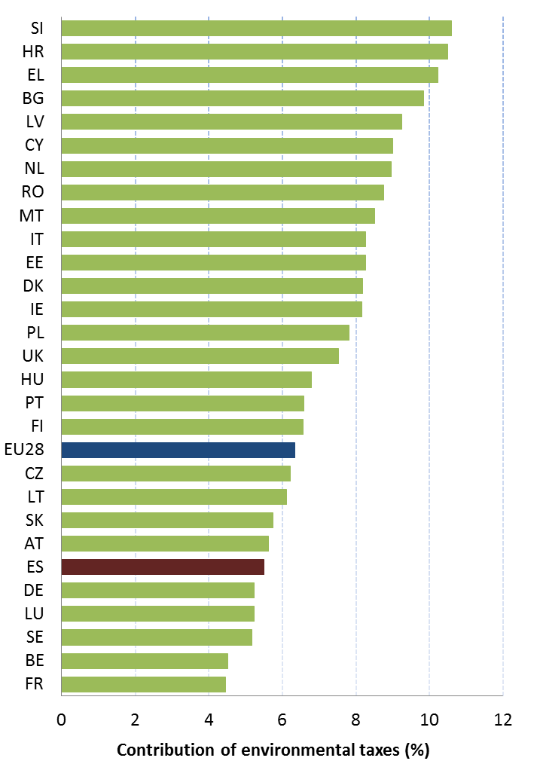
Shifting taxation away from labour towards taxes less harmful to growth remains a key challenge in Spain, and has been proposed as Country Specific Recommendation (CSR) between 2012 and 2014 in the framework of the European Semester.
Some measures have been taken in Spain in the last years, mainly in the energy sector. A tax on fluorinated greenhouse gases has been introduced (Law 16/2013) and is being phased-in gradually from 2014 to be fully applicable in 2016. Since 2013 (Law 15/2012), Spain has implemented taxes on the production of electric energy, on the production of radioactive fuel and on the storage of radioactive waste. These taxes have contributed to slightly increase the above-mentioned Spanish rate. Moreover, Spain approved in 2015 a new tax regarding the extraction of hydrocarbons (gas and oil). However, the practical effects of this new tax are likely insignificants.
There is clearly room to review environmental taxes, mainly in the transport and energy sectors, but also in the pollution and resources use fields. For instance, the municipal vehicle circulation taxes do not always reflect the environmental performance of the vehicles. In addition, new options in the waste and water sectors could be explored. Landfill taxes may be a supportive tool on treatment of municipal waste. The water pricing policy needs a revision and a new approach, being a key issue to improve water management in Spain.
In this respect, a 2016 study suggests that there is considerable potential for additional revenue from environmental taxes in Spain. Under a good practice scenario these taxes could generate an additional EUR 3.45 billion by 2018, rising to EUR 6.96 billion by 2030 (both in real 2015 terms). This is equivalent to an increase by 1.11% and 1.82% of GDP in 2018 and 2030, respectively.
In the same vein, the Report issued in February 2014 by the Committee of Experts on the reform of the Spanish tax system (Lagares report) made a complete analysis of this matter, proposing specific recommendations to harmonize and to improve the performance of environmental taxes in Spain, increasing the revenues in a more logic and sustainable way. However, although this work was commissioned by the Spanish Government, these measures are not part of the national tax reform approved in Spain at the end of 2014 (Law 26/2014).
This report and the above-mentioned study also show that many environmental taxes for example concerning waste management, water abstraction, water pollution, wastewater, and air pollution are adopted and implemented at regional and even at local level, with a high normative dispersion and different approaches. This heterogeneous situation may lead to market fragmentation and economic inefficiencies.
Therefore, Spain should consider the full potential of environmental taxation, as well as to implement a consistent approach across the country, to harvest environmental, economic and social (jobs) benefits.
The reduction of environmentally harmful subsidies (EHS) is another key challenge. Spain is still subsidising fossil fuels, local coal, company cars, and diesel compared to petrol when the policy objectives could be achieved in a less environmentally harmful way.
Spain has no overall strategy to eliminate EHS, although moving away from EHS can deliver economic, social and environmental benefits, allow for improved competitiveness and support budget consolidation. It is important to ensure that energy tax rates become more consistent across fuels and uses, and that the tax system does not unduly favour fossil-based solutions.
Spain is one of the main Member States using fossil fuel subsidies (FFS). The diesel-petrol differential is not justified from an environmental perspective: diesel emits higher levels of several air pollutants and should be taxed higher. The diesel differential in Spain is 26% (a figure of 0% means the same level of taxation for petrol and diesel cars, i.e. no diesel differential). Lower diesel tax led to "dieselisation" of the fleet in Europe. Currently in the EU more than 55% of new registrations are diesel cars; while in Spain this goes up to 63%. Furthermore, exemptions from the coal tax should be also reconsidered.
Therefore, developing a national strategy for phasing out environmentally harmful subsidies would be a positive approach for Spain.

Green Public Procurement
The EU green public procurement policies encourage Member States to take further steps to reach the target of applying green procurement criteria to at least 50% of public tenders.
Green Public Procurement (GPP) is a process whereby public authorities seek to procure goods, services and works with a reduced environmental impact throughout their life-cycle when compared to goods, services and works with the same primary function that would otherwise be procured.
The purchasing power of public procurement equals to approximately 14% of GDP. A substantial part of this money is spent on sectors with high environmental impact such as construction or transport, so GPP can help to significantly lower the impact of public spending and foster sustainable innovative businesses. The Commission has proposed EU GPP criteria.
Overall, there is no horizontal and coherent nation-wide public procurement policy in Spain, neither are there sufficient controls on the proper implementation of public procurement rules, especially at sub-central government level.
The Green Public Procurement Plan of the State General Administration and its Public Entities and the Managing Bodies of the Social Security is the national strategy on Green Public Procurement (GPP) of Spain. It was approved in January 2008.
GPP criteria are developed at the national level for the following product groups: construction and maintenance, energy, transport, office equipment, paper and publications, furniture, cleaning products and services, and events. Some regions have also implemented measures in this respect, e.g.: in Catalonia, the Government Agreement on Public Procurement is based on the EU GPP criteria and in the Basque Country GPP criteria are developed based on market consultation mainly based on EU GPP criteria.
The GPP targets are to have levels of green purchase between 25% and 100% depending on the product group and implementation phase. Eight product groups have been included, according to the priority groups of the EU Commission, along with a timescale for achieving specific targets. Targets for consumption reduction and energy mix have also been set.
Spain has adopted two reports on the state of green public procurement in the State General Administration. The first report in November 2011 and the last one in July 2015.
The Second Report was produced in accordance with the provisions of the abovementioned Green Public Procurement Plan, reflecting new progress since the adoption of the first report on the implementation of measures in favour of green public procurement.
The Report reflects overall the achievement of broad levels of compliance, with practically total implementation of results in most of the above-mentioned eight product groups for which the Plan prioritizes the inclusion of environmental criteria. The wide replacement of paper publications by electronic publications should be highlighted.

Investments: the contribution of EU funds
European Structural and Investment Funds Regulations provide that Member States promote environment and climate objectives in their funding strategies and programmes for economic, social and territorial cohesion, rural development and maritime policy, and reinforce the capacity of implementing bodies to deliver cost-effective and sustainable investments in these areas.
Making good use of the European Structural and Investment Funds (ESIF) is essential to achieve the environmental goals and integrate these into other policy areas. Other instruments such as the Horizon 2020, the LIFE programme and the EFSI may also support implementation and spread of best practice.
In absolute terms, Spain is traditionally a very relevant beneficiary of the EU Cohesion Policy.
The EU funding received by Spain during the last programming periods has significantly contributed to reach the environmental standards as well as to improve the implementation of EU environmental policy and law in many sectors, e.g.: water and waste.
Current data suggest that the EU funds for the 2007-2013 period were almost fully spent.
Spain will receive EUR 28.56 billion in total from the EU Cohesion Policy funding over the programming period 2014-2020 (ERDF and ESF, including European Territorial Cooperation funding and the allocation for the Youth Employment Initiative).
Spain will also receive EUR 8.29 billion for rural development (EARDF) and EUR 1.16 billion for fisheries and the maritime sector (EMFF).
In the period 2014-2020, 13 out of the 19 Spanish regions are reaching the status of "more developed" and therefore receiving less EU funding, whereas the Cohesion Fund is no longer available to Spain. Environmental investments have also to follow the new design of the EU Cohesion Policy and the main priorities reflected in the thematic concentration (Innovation, TICs, SMEs and Low Carbon Economy). Nevertheless, the direct environmental investments are still significant and represent around 11.8% of the ERDF (EUR 2.3 billion).
Figure 13: European Structural and Investment Funds 2014-2020: Budget Spain by theme, EUR billion
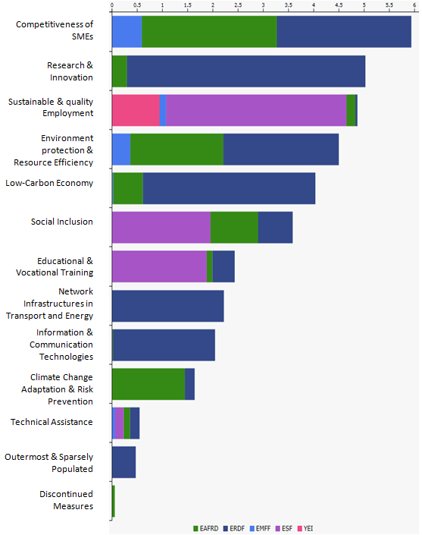
In terms of environmental sectors, the main priorities in Spain for ERDF 2014-2020 are: wastewater (around EUR 1.1 billion), rehabilitation of industrial sites and contaminated land (EUR 265 million), biodiversity and Natura 2000 (EUR 225 million) and adaptation to climate change (EUR 195 million).
There is a national OP on Sustainable Growth, with the largest ERDF allocation (around EUR 5.5 billion) with 4 priority axes: Low carbon economy, Sustainable urban development, Water quality, and Sustainable transport. This OP concentrates a high part of the environmental investments, although they are also present in many regional ERDF OPs.
Moreover, it should be highlighted the various territorial cooperation ERDF OPs (transnational and cross-border cooperation) with the participation of Spain where the environmental investments have a considerable weight.
The environmental integration has been ensured in the Partnership Agreement 2014-2020 and the different Operational Programmes for the four ESIF through the application of the SEA Directive and by other means. The Spanish Network of Environmental Authorities, with the participation of DG ENV and DG REGIO, plays an important role to promote environmental integration into the EU funding.
The thematic environmental ex-ante conditionalities (EAC) on Water and Waste have been only partially fulfilled by Spain. Therefore, Action Plans have been agreed with the Spanish authorities to comply with all the criteria by end-2016. These action plans play a major role in accelerating the implementation of the EU environmental policy, and foster a dialogue with the national competent authorities.
The general environmental EAC on EIA/SEA (looking into the legal framework and the effective arrangements to comply with the environmental impact assessment rules) was considered as fulfilled, also considering the commitments undertaken by the Spanish authorities.
Spain should take advantage of the ESIF available for the programming period 2014-2020 in order to improve the compliance with the EU environmental law and policy, as well as to use the potential of the green economy for competitiveness and job creation.
It is too early to draw conclusions about the use and result of ESIF for the period 2014-2020, as the relevant programmes are still in an early stage of their implementation.
Regarding the integration of environmental concerns into the Common Agricultural Policy (CAP), the two key areas for Spain (as for all Member States) are, first, using Rural Development funds to pay for environmental land management and other environmental measures, while avoiding financing measures which could damage the environment; and second, to, ensuring an effective implementation of the first pillar of the CAP with regard to cross compliance and 1st pillar 'greening'. 30 % of direct payment envelope is allocated to greening practices beneficial for the environment. An environmentally ambitious implementation of 1st pillar greening would clearly help to improve the environmental situation in areas not covered by rural development, including intensive area.
It should be noted that the implementation of the eligibility of land for Pillar I of the CAP (direct payments) by Spain is very restrictive and lists elements with reduction power (lowering number of hectares for which direct payments are received) which are not standard elements (e.g. slope). High number of hectares of silvopastoral systems found themselves ineligible for CAP payments, or their eligibility (number of hectares eligible) got significantly decreased. This is also due to the fact that under Rural Development Programmes (fund EAFRD) in the agri-environment-climate measure only parcels that are eligible under Pillar I of the CAP can receive per hectare support for e.g. extensive management, biodiversity- related actions- in a way that Spain implements it. This is very problematic and potentially affects huge areas of Natura 2000 habitats dependant on (some level of) grazing. It is of crucial importance that land managers, farmers, who provide public goods via traditional farming, supporting number of ecosystem services, find their parcels eligible for funding under CAP as far as there is an active management of land.
Spain is suggested to improve the rules, via constructive dialogue with the European Commission, including DG ENV, in order not to disadvantage land managers who practice active agricultural land management.
Regarding a pure environmental financial instrument like the LIFE programme, it should be noted that since the launch of the LIFE programme by the European Commission in 1992, a total of 738 projects have been financed in Spain. Of these, 458 focus on environmental innovation and demonstration, 261 on nature conservation and wildlife biodiversity and 9 on information and communication. As of 2014, 8 Climate Action projects are also being co-funded by LIFE. These projects represent a total investment of EUR 1.2 billion, of which EUR 573 million has been contributed by the European Union.
For the period 2014-2017 some EUR 75 million have been indicatively earmarked for Spain through a national allocation. It is expected that the success rate of Spanish projects will not be affected by the abandonment of national allocations as of 2018, since there have always been sufficient Spanish applications with a high merit.
Spain has always been one of the countries with the highest number of proposals submitted to the LIFE programme and Spanish projects have traditionally been successful in achieving their objectives. Thus, LIFE projects in Spain have, e.g., achieved the increase of the Spanish marine protected areas from less than 1% to more than 8% of the marine territory, improved the status of the most endangered feline worldwide, the Iberian lynx, from critically endangered' to 'endangered', and substantially raised the awareness in Spain regarding the socio-economic advantages of Natura2000 and of sustainable resource management.

- Effective governance and knowledge

SDG 16 aims at providing access to justice and building effective, accountable and inclusive institutions at all levels. SDG 17 aims at better implementation, improving policy coordination and policy coherence, stimulating science, technology and innovation, establishing partnerships and developing measurements of progress.
Effective governance of EU environmental legislation and policies requires having an appropriate institutional framework, policy coherence and coordination, applying legal and non-legal instruments, engaging with non-governmental stakeholders, and having adequate levels of knowledge and skills. Successful implementation depends, to a large extent, on central, regional and local government fulfilling key legislative and administrative tasks, notably adoption of sound implementing legislation, co-ordinated action to meet environmental objectives and correct decision-making on matters such as industrial permits. Beyond fulfilment of these tasks, government must intervene to ensure day-to-day compliance by economic operators, utilities and individuals ("compliance assurance"). Civil society also has a role to play, including through legal action. To underpin the roles of all actors, it is crucial to collect and share knowledge and evidence on the state of the environment and on environmental pressures, drivers and impacts.
Equally, effective governance of EU environmental legislation and policies benefits from a dialogue within Member States and between Member States and the Commission on whether the current EU environmental legislation is fit for purpose. Legislation can only be properly implemented when it takes into account experiences at Member State level with putting EU commitments into effect. The Make it Work initiative, a Member State driven project, established in 2014, organizes a discussion on how the clarity, coherence and structure of EU environmental legislation can be improved without lowering existing protection standards.

Effective governance within central, regional and local government
Those involved in implementing environment legislation at Union, national, regional and local levels need to be equipped with the knowledge, tools and capacity to improve the delivery of benefits from that legislation, and the governance of the enforcement process.

Capacity to implement rules
It is crucial that central, regional and local administrations have the necessary capacities and skills and training to carry out their own tasks and co-operate and co-ordinate effectively with each other, within a system of multi-level governance.
The 2013 European Quality of Government Index puts Spain in 15th place out of the 28 Member States.
According to the World Bank 2015 Worldwide Governance Indicators, Spain scores well below the EU average for the government effectiveness indicator, which captures the perceptions of the quality of public services, the capacity of the civil service and its independence from political pressures, and the quality of policy formulation.
During the last years, there has been some progress in Spain in order to streamline and to improve the efficiency of the different public administrations. At the same time, due to the economic crisis, the public sector has suffered of important resource cutbacks, affecting the environmental sector as well.
Spain's public administration is highly decentralised. This is illustrated by the share of spending managed by the regional and local government levels (39% of total non-consolidated expenditure over 2018-2014). This is even more accentuated in the field of the environment.
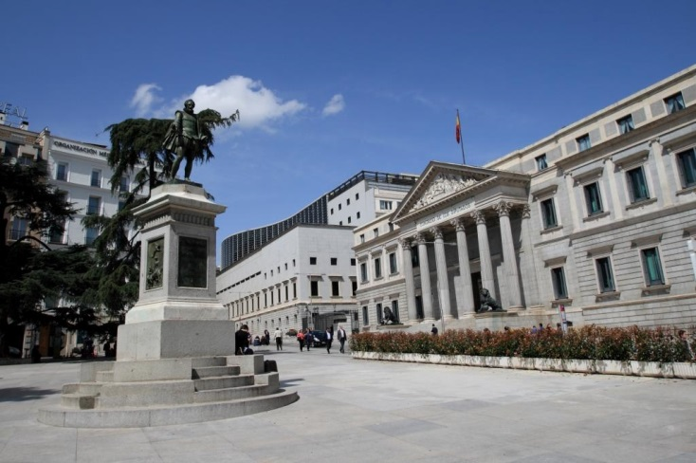
The Spanish Constitution (1978) provides for the exclusive competence of the State (national Parliament and Government) to approve basic legislation for environmental protection without detriment to the competence of the Autonomous Communities to establish additional protection measures and to develop the basis legislation.
Most of the environmental implementation competences belong to the regions, although the central administration has still important powers in fields like water management in rivers that flow through different regions and coastal protection. The local authorities have also an important role in fields like waste management, air quality or sustainable urban development.
The various public administrations involved in the implementation of environmental law have a different level of financial and human resources available to undertake their tasks.
The Spanish Government approved the Spanish Sustainable Development Strategy (SDS) in 2007. A periodic review and monitor of this SDS has not been carried-out, namely after the economic crisis started in 2008. In addition, various Autonomous Communities have also approved their regional SDS.
The idea of sustainability re-emerged with the Sustainable Economy Law, adopted in 2011. While a welcome articulation of what a sustainable economy might mean in the Spanish context, the Sustainable Economy Law generally reaffirms previously existing commitments, with environmental actions implemented separately from other action areas covered by the law. Furthermore, this Law provided for a periodic report on its implementation and results, which however has not been undertook.
Environmental policy developments in Spain are mainly driven by EU Directives and Regulations. During the last decade, there has been a progress regarding the transposition in time of EU environmental Directives. The Commission has traditionally received a very high number of complaints against Spain in the field of the environment. Overall, the Spanish authorities have a smooth cooperation with the Commission services to solve the pending issues on implementation of environmental law. The number of infringements has decreased during the last years. However, important implementation gaps remain, e.g.: in the wastewater and waste sectors. Several cases brought to the attention of the Commission also indicate that enforcement of environmental legislation is not always effective, i.e. unlawful activities continue or the environmental damage is not addressed for years despite the intervention of the competent authorities.
Coordination and integration
Impact assessments are important tools to ensure environmental integration in all government policies.
The transposition of the revised EIA Directive will be an opportunity to streamline the regulatory framework on environmental assessments.
The Commission encourages the streamlining of the environmental assessments to avoid overlaps in environmental assessments and accelerate decision-making, without compromising the quality of the environmental assessment procedure. The Commission has issued a guidance document in 2016 regarding the setting up of coordinated and/or joint procedures that are simultaneously subject to assessments under the EIA Directive, Habitats Directive, Water Framework Directive, and the Industrial Emissions Directive.
Over the last years, Spain has taken different measures to streamline the EIA process, like the new national basic legislation on EIA & SEA.
Spain's highly decentralised administration creates coordination challenges, namely in various policy areas, such as the environment.
The Spanish legal system foresees some mechanisms of cooperation and coordination at political and technical level, mainly between the State administration and the Autonomous Communities, like the Sectoral Conference on Environment and some technical and participatory committees, like the National Council on Water and the Environment Advisory Council. However, there is clear room to improve and strengthen these cooperative actions.
As a good practice, it is worth to highlight the experience of the Spanish Network of Environmental Authorities, which is a purely technical forum of managing and environmental authorities to foster environmental integration into the implementation of the EU Cohesion Policy in Spain. This network created in 1997 has served as inspiration for similar environmental integration networks in other Member States and even for the European Network of Managing and Environmental Authorities (ENEA-MA).
Suggested action
- Spain should address the fragmentation at regional and local levels by developing better coordination mechanisms for environment.

Compliance assurance
EU law generally and specific provisions on inspections, other checks, penalties and environmental liability help lay the basis for the systems Member States need to have in place to secure compliance with EU environmental rules.
Public authorities help ensure accountability of duty-holders by monitoring and promoting compliance and by taking credible follow-up action (i.e. enforcement) when breaches occur or liabilities arise. Compliance monitoring can be done both on the initiative of authorities themselves and in response to citizen complaints. It can involve using various kinds of checks, including inspections for permitted activities, surveillance for possible illegal activities, investigations for crimes and audits for systemic weaknesses. Similarly, there is a range of means to promote compliance, including awareness-raising campaigns and use of guidance documents and online information tools. Follow-up to breaches and liabilities can include administrative action (e.g. withdrawal of a permit), use of criminal law and action under liability law (e.g. required remediation after damage from an accident using liability rules) and contractual law (e.g. measures to require compliance with nature conservation contracts). Taken together, all of these interventions represent "compliance assurance" as shown in Figure 14.
Figure 14: Environmental compliance assurance
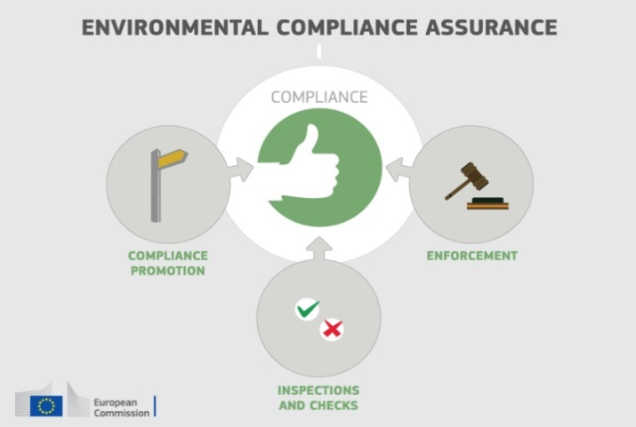
Best practice has moved towards a risk-based approach at strategic and operational levels in which the best mix of compliance monitoring, promotion and enforcement is directed at the most serious problems. Best practice also recognises the need for coordination and cooperation between different authorities to ensure consistency, avoid duplication of work and reduce administrative burden. Active participation in established pan-European networks of inspectors, police, prosecutors and judges, such as IMPEL, EUFJE, ENPE and EnviCrimeNet, is a valuable tool for sharing experience and good practices.
Currently, there exist a number of sectoral obligations on inspections and the EU directive on environmental liability (ELD) provides a means of ensuring that the "polluter-pays principle" is applied when there are accidents and incidents that harm the environment. There is also publicly available information giving insights into existing strengths and weaknesses in each Member State.
For each Member State, the following were therefore reviewed: use of risk-based compliance assurance; coordination and co-operation between authorities and participation in pan-European networks; and key aspects of implementation of the ELD based on the Commission's recently published implementation report and REFIT evaluation.
Spain has taken some significant steps to underpin risk-based compliance assurance:
- in 2008, on the initiative of the Spanish Autonomous Communities, the Environmental Inspection Network was established (Red de Inspección Ambiental - REDIA) with the aim of improving cooperation and achieving greater consistency of inspection work across the country through production of guidelines and common standards and training facilitation.
- recognising the need for professional specialisation to effectively tackle environmental crime, Spain has created a police unit (SEPRONA) to combat environmental crime as well as a specialised Environmental Prosecution Authority which has already impressive successes in investigation and prosecution of organised environmental crime. It publishes an annual report on its activities, setting out the key issues investigated during the year as well as providing statistics.
- a LIFE+ funded project to address a problem of poisoning of rare birds of prey through illegal use of poisons illustrates the use of risk-based compliance assurance, with compliance promotion, compliance monitoring and enforcement all combined in an overall strategy.
However, there are significant differences between regions in terms of available resources and the used tools and instruments, such as inspection plans, inspections reports and performance monitoring.
Up-to-date information is lacking in relation to the following:
- data-collection arrangements to track the use and effectiveness of different compliance assurance interventions;
- the extent to which risk-based methods are used to direct compliance assurance both at the strategic level and in specific problem-areas highlighted elsewhere in this Country Report, i.e. the threats to protected habitat types and species, air quality problems, the pressures on water quality from diffuse and point water pollution and the problem of over-abstraction of water.
Spanish regional inspection authorities and the Spanish Environmental Prosecution Authority actively contribute to the work of IMPEL and ENPE.
The Aznalcóllar accident in 1998 sensitized Spain to the importance of environmental liability. For the period 2007-2013, it reported eleven confirmed and one pending case of environmental damage under the Environmental Liability Directive. To ensure an effective implementation of the Directive, it established a Technical Commission on the Prevention and Remediation of Environmental Damage for facilitate cooperation between the central Government and the Autonomous Communities. The Technical Commission has undertaken work through sub-groups on environmental liability supply models, technical advice and analysis, sectorial tools for environmental risk assessment, and the priority calendar for phasing in gradually mandatory financial security. The mandatory financial security is backed up with cost-free electronic support tools aimed at helping operators to better calculate their risks. Spain also has an insurance pool (Pool Español de Riesgos Medioambientales), which works closely with both government and industry.
Suggested action
- Improve transparency on organisation and functioning of compliance assurance system and on how significant risks are addressed.

Public participation and access to justice
The Aarhus Convention, related EU legislation on public participation and environmental impact assessment, and the case-law of the Court of Justice require that citizens and their associations should be able to participate in decision-making on projects and plans and should enjoy effective environmental access to justice.
Citizens can more effectively protect the environment if they can rely on the three "pillars" of the Convention on Access to Information, Public Participation in Decision-making and Access to Justice in Environmental Matters ("the Aarhus Convention"). Public participation in the administrative decision making process is an important element to ensure that the authority takes its decision on the best possible basis. The Commission intends to examine compliance with mandatory public participation requirements more systematically at a later stage.
Access to justice in environmental matters is a set of guarantees that allows citizens and their associations to challenge acts or omissions of the public administration before a court. It is a tool for decentralised implementation of EU environmental law.
For each Member State, two crucial elements for effective access to justice have been systematically reviewed: the legal standing for the public, including NGOs and the extent to which prohibitive costs represent a barrier.
The Spanish legal system grants the public the possibility to bring environmental cases to the courts. However, in case of omissions and inactivity on behalf of the public administration, the public seems to have difficulties in obtaining legal standing to challenge the situation. Furthermore, bringing administrative cases to the courts seems to be expensive. The expected cost may prevent the public to bring cases to the court. The existing legal assistance program does not seem to be sufficient to compensate for the expensive costs.
Suggested action
- Take the necessary measures to ensure that the costs of legal challenges involving EU environmental law are not prohibitively expensive, and in line with the requirements of EU law as well as the Aarhus Convention.

Access to Information, knowledge and evidence
The Aarhus Convention and related EU legislation on access to information and the sharing of spatial data require that the public has access to clear information on the environment, including on how Union environmental law is being implemented.
It is of crucial importance to public authorities, the public and business that environmental information is shared in an efficient and effective way. This covers reporting by businesses and public authorities and active dissemination to the public, increasingly through electronic means.
The Aarhus Convention, the Access to Environmental Information Directive and the INSPIRE Directive together create a legal foundation for the sharing of environmental information between public authorities and with the public. They also represent the green part of the ongoing EU e-Government Action Plan. The first two instruments create obligations to provide information to the public, both on request and actively. The INSPIRE Directive is a pioneering instrument for electronic data-sharing between public authorities who can vary in their data-sharing policies, e.g. on whether access to data is for free. The INSPIRE Directive sets up a geoportal which indicates the level of shared spatial data in each Member State – i.e. data related to specific locations, such as air quality monitoring data. Amongst other benefits it facilitates the public authorities' reporting obligations.
For each Member State, the accessibility of environmental data (based on what the INSPIRE Directive envisages) as well as data-sharing policies ('open data') have been systematically reviewed.
Spain's performance on the implementation of the INSPIRE Directive as enabling framework to actively disseminate environmental information to the public is good. Spain has indicated in the 3-yearly INSPIRE implementation report that the necessary data-sharing policies allowing access and use of spatial data by national administrations, other Member States' administrations and EU institutions without procedural obstacles are available and implemented. In Spain, sharing of information between public bodies is well defined by law. In case of environmental information, data is made available under Law 27/2006 of 18 July, which incorporates Directives 2003/4/EC and 2003/35/EC. More than 30% of the Spanish administrations have already released and published their spatial data as open data.
Assessments of monitoring reports issued by Spain and the spatial information that Spain has published on the INSPIRE geoportal indicate that not all spatial information needed for the evaluation and implementation of EU environmental law has been made available or is accessible. The larger part of this missing spatial information consists of the environmental data required to be made available under the existing reporting and monitoring regulations of EU environmental law, though some elements are available.
Suggested action
- Identify and document all spatial data sets required for the implementation of environmental law, and make the data and documentation at least accessible 'as is' to other public authorities and the public through the digital services foreseen in the INSPIRE Directive.

Communication "Delivering the benefits of EU environmental policies through a regular Environmental Implementation Review" (COM/2016/ 316 final).
Decision No. 1386/2013/EU of 20 November 2013 on a General Union Environmental Action Programme to 2020 "Living well, within the limits of our planet".
United Nations, 2015. The Sustainable Development Goals
This EIR report does not cover climate change, chemicals and energy.
European Commission, 2015. Proposed Circular Economy Package
Resource productivity is defined as the ratio between gross domestic product (GDP) and domestic material consumption (DMC).
Eurostat, Resource productivity, accessed July 2016.
Eurostat, Resource productivity, accessed October 2016
COM(2014) 446 final: Communication Green Employment Initiative: Tapping into the job creation potential of the green economy.
http://ec.europa.eu/environment/enveco/studies.htm
"Green jobs in a sustainable economy" (OSE & Biodiversity Foundation, 2010); "Green Jobs for a sustainable development. A case study of Spain", (Sustainlabour/ILO & Biodiversity Foundation, 2012); and "Green Jobs: concept and trends" (MAGRAMA, 2013).
RPA, 2015. Assessing the Potential Cost Savings and Resource Savings of Investments in 4 SME sectors, study for the European Commission.
Communication COM(2011) 571. The Resource Efficiency Roadmap is part of the Resource Efficiency Flagship of the Europe 2020 Strategy.
European Commission, 2015. Flash 426 Eurobarometer "SMEs, resource efficiency and green markets
Ecologic Institute, IEEP, BIO by Deloitte, 2015. A framework for Member States to support business in improving its resource efficiency. Study for the European Commission.
Eco-innovation Observatory: Eco-Innovation scoreboard 2015.
See Country Specific Recommendations for Spain in the framework of the European Semester 2016.
Waste Management Plans/Waste Prevention Programmes
Municipal waste consists of waste collected by or on behalf of municipal authorities, or directly by the private sector (business or private non-profit institutions) not on behalf of municipalities.
Eurostat, Municipal waste and treatment, by type of treatment method, accessed October 2016
Member States may choose a different method than the one used by ESTAT (and referred to in this report) to calculate their recycling rates and track compliance with the 2020 target of 50% recycling of municipal waste.
Eurostat, Recycling rate of municipal waste, accessed October 2016
European Commission, 2016. Support to Implementation – The Commission helps 8 Member States to improve their municipal waste management. Fact sheet for Spain.
Plan Estatal Marco de Gestión de Residuos (PEMAR) 2016-2022.
Bio Intelligence service, 2011. Implementing EU Waste legislation for Green Growth, study for European Commission. The breakdown per country on job creation was made by the consultant on Commission demand but was not included in the published document.
Sites of Community Importance (SCIs) are designated pursuant to the Habitats Directive whereas Special Areas of Protection (SPAs) are designated pursuant to the Birds Directive; figures of coverage do not add up due to the fact that some SCIs and SPAs overlap. Special Areas of Conservation (SACs) means a SCI designated by the Member States.
For each Member State, the Commission assesses whether the species and habitat types on Annexes I and II of the Habitats Directive, are sufficiently represented by the sites designated to date. This is expressed as a percentage of species and habitats for which further areas need to be designated in order to complete the network in that country. The current data, which were assessed in 2014-2015, reflect the situation up until December 2013.
The percentages in Figure 5 refer to percentages of the total number of assessments (one assessment covering 1 species or 1 habitat in a given biographical region with the Member State); if a habitat type or a species occurs in more than 1 Biogeographic region within a given Member State, there will be as many individual assessments as there are Biogeographic regions with an occurrence of that species or habitat in this Member State.
European Commission, internal assessment.
Source: Information provided by the Spanish authorities in the framework of the ongoing infringement case 2015/2003, and information in the Natura 2000 database provided by Spain.
These figures show the percentage of biogeographical assessments in each category of conservation status for habitats and species (one assessment covering 1 species or 1 habitat in a given biographical region with the Member State), respectively. The information is based on Article 17 of the Habitats Directive reporting - national summary of Spain
Conservation status is assessed using a standard methodology as being either ‘favourable’, ‘unfavourable-inadequate’ and ‘unfavourable-bad’, based on four parameters as defined in Article 1 of the Habitats Directive.
The core of the ‘Article 17’ report is the assessment of conservation status of the habitats and species targeted by the Habitats Directive.
Please note that a direct comparison between 2007 and 2013 data is complicated by the fact that Bulgaria and Romania were not covered by the 2007 reporting cycle, that the ‘unknown’ assessments have strongly diminished particularly for species, and that some reported changes are not genuine as they result from improved data / monitoring methods.
State of Nature report
Article 12 of the Birds Directive reporting - national summary of Spain
Evaluación del grado de inclusión de las prioridades del MAP para la Red Natura 2000 en los programas de desarrollo rural 2014-2020 de España.
Source: Spanish Natura 2000 Priority Action Framework (PAF).
Ley 33/2015 por la que se modifica la Ley 42/2007.
Tourism accounts 11% of GDP and 12% of employment in Spain, and it is a key sector in certain regions.
Real Decreto 416/2014, de 6 de junio, por el que se aprueba el Plan sectorial de turismo de naturaleza y biodiversidad 2014-2020.
Ecosystem services are benefits provided by nature such as food, clean water and pollination on which human society depends.
http://www.ecomilenio.es
European Union, Green Infrastructure — Enhancing Europe’s Natural Capital, COM/2013/0249
Law 33/2015 of 21 September, amending Law 42/2007.
European Environment Agency, Land cover 2012 and changes country analysis [forthcoming]
European Environment Agency Draft results of CORINE Land Cover (CLC) inventory 2012; mean annual land take 2006-12 as a % of 2006 artificial land.
OECD Environmental Performance Review: Spain 2015
Eurostat, Soil water erosion rate, Figure 2, accessed November 2016
European Union, Marine Strategy Framework Directive 2008/56/EC
The MSFD defines Good Environmental Status (GES) in Article 3 as: “The environmental status of marine waters where these provide ecologically diverse and dynamic oceans and seas which are clean, healthy and productive”
Commission Staff Working Document Accompanying the Commission Report on "The first phase of implementation of the Marine Strategy Framework Directive (2008/56/EC) - The European Commission's assessment and guidance" (SWD(21014) 049 final and COM(2014)097 final)
Commission Staff Working Document Accompanying the Commission Report assessing Member States' monitoring programmes under the Marine Strategy Framework Directive (COM(2017)3 and SWD(2017)1 final)
2012 Data provided by the European Environmental Agency – Not published
Report from the Commission "The first phase of implementation of the Marine Strategy Framework Directive (2008/56/EC) - The European Commission's assessment and guidance" COM(2014)097 &. Commission Staff Working Document Accompanying the Commission Report assessing Member States' monitoring programmes under the Marine Strategy Framework Directive (COM(2017)3 and SWD(2017)1 final)
European Commission, 2016. Air Quality Standards
See EIONET Central Data Repository and Air pollutant emissions data viewer (NEC Directive)
The current national emission ceilings apply since 2010 (Directive 2001/81/EC); revised ceilings for 2020 and 2030 have been set by Directive (EU) 2016/2284 on the reduction of national emissions of certain atmospheric pollutants, amending Directive 2003/35/EC and repealing Directive 2001/81/EC.
European Environment Agency, 2016. Air Quality in Europe – 2016 Report. (Table 10.2, please see details in this report as regards the underpinning methodology)
Based on European Environment Agency, 2016. Air Quality in Europe – 2016 Report. (Figures 4.1, 5.1 and 6.1)
NOx is emitted during fuel combustion e.g. from industrial facilities and the road transport sector. NOx is a group of gases comprising nitrogen monoxide (NO) and nitrogen dioxide (NO2).
Particulate matter (PM) is a mixture of aerosol particles (solid and liquid) covering a wide range of sizes and chemical compositions. PM10 (PM2.5) refers to particles with a diameter of 10 (2.5) micrometres or less. PM is emitted from many anthropogenic sources, including combustion.
Low level ozone is produced by photochemical action on pollution and it is also a greenhouse gas.
See The EEA/Eionet Air Quality Portal and the related Central Data Repository
These figures are based on the Impact Assessment for the European Commission Integrated Clean Air Package (2013).
Under the provisions of the revised National Emission Ceilings Directive, Member States now may apply for emission inventory adjustments. Pending evaluation of any adjustment application, Member States should keep emissions under close control with a view to further reductions.
Ibid.
WHO/JRC, 2011, Burden of disease from environmental noise, Fritschi, L., Brown, A.L., Kim, R., Schwela, D., Kephalopoulos, S. (eds), World Health Organization, Regional Office for Europe, Copenhagen, Denmark
The Noise Directive requires Member States to prepare and publish, every 5 years, noise maps and noise management action plans for agglomerations with more than 100,000 inhabitants, and for major roads, railways and airports.
This includes the Bathing Waters Directive (2006/7/EC); the Urban Waste Water Treatment Directive (91/271/EEC) concerning discharges of municipal and some industrial waste waters; the Drinking Water Directive (98/83/EC) concerning potable water quality; the Water Framework Directive (2000/60/EC) concerning water resources management; the Nitrates Directive (91/676/EEC) and the Floods Directive (2007/60/EC)
Good ecological status is defined in the Water Framework Directive referring to the quality of the biological community, the hydrological characteristics and the chemical characteristics.
Good chemical status is defined in the Water Framework Directive referring to compliance with all the quality standards established for chemical substances at European level.
For groundwater, a precautionary approach has been taken that comprises a prohibition on direct discharges to groundwater, and a requirement to monitor groundwater bodies.
Diffuse pollution comes from widespread activities with no one discrete source.
Many European river basins and waters have been altered by human activities, such as land drainage, flood protection and building of dams to create reservoirs.
More information on the implementation status of the WFD can be found here.
17 out of 25, with the exception of the RBMP for Catalonia inner waters and the seven RBMPs for the Canary Islands.
Commission's Synthesis Report on the Quality of Drinking Water in the Union examining Member States' reports for the 2011-2013 period, foreseen under Article 13(5) of Directive 98/83/EC; COM(2016)666.
European Bathing Water quality in 2015, EEA Report No 9/2016, p.26.
European Environment Agency, State of bathing water, 2016
European Commission, 2016. Urban waste water, 8th implementation reports
European Commission, 2016. EU Resource Efficiency Scoreboard 2015
Study "Potential for Growth and Job Creation through the Protection of Water Resources". DG ENV 2015.
RPA, 2014. Study on Economic and Social Benefits of Environmental Protection and Resource Efficiency Related to the European Semester. Study for the European Commission, Annex 1: Country fiches
European Environment Agency, Urban environment
http://urbanagendaforthe.eu/
The Commission is developing an Urban Benchmarking and Monitoring ('UBaM') tool to be launched in 2017. Best practices emerge and these will be better disseminated via the app featuring the UBaM tool, and increasingly via e.g. EUROCITIES, ICLEI, CEMR, Committee of the Regions, Covenant of Mayors and others.
European Commission, Green Capital
European Commission, 2015. Mollet del Vallès wins inaugural European Green Leaf 2015
Under the national ERDF OP Sustainable Growth 2014-2020, the EDUSI (Estrategias de Desarrollo Urbano Sostenible e Integrado)
INRIX, 2015. Key Findings: INRIX 2015 Traffic Scoreboard
See http://www.dgt.es/es/prensa/notas-de-prensa/2016/20160414-dgt-clasifica-parque-vehiculos-funcion-potencial-contaminante.shtml.
Eurostat, Environmental tax revenues, accessed October 2016
Eunomia Research and Consulting, IEEP, Aarhus University, ENT, 2016. Study on Assessing the Environmental Fiscal Reform Potential for the EU28. N.B. National governments are responsible for setting tax rates within the EU Single Market rules and this report is not suggesting concrete changes as to the level of environmental taxation. It merely presents the findings of the 2016 study by Eunomia et al on the potential benefits various environmental taxes could bring. It is then for the national authorities to assess this study and their concrete impacts in the national context. A first step in this respect, already done by a number of Member States, is to set up expert groups to assess these and make specific proposals.
The good practice scenario means benchmarking to a successful taxation practice in another Member State.
2020 Milestone on phasing out EHS in the Roadmap to a Resource Efficient Europe (COM(2011) 571 final).
http://www.oecd.org/site/tadffss/publication/
European Environment Agency 2016, Environmental taxation and EU environmental policies, Table 4.3, p.24.
European Commission, 2015. Public procurement
In the Communication “Public procurement for a better environment” (COM (2008)400) the Commission recommended the creation of a process for setting common GPP criteria. The basic concept of GPP relies on having clear, verifiable, justifiable and ambitious environmental criteria for products and services, based on a life-cycle approach and scientific evidence base.
Commission Staff Working Document: Country Report Spain 2016 in the framework of the European Semester (SWD(2016) 78 final, of 26.2.2016.
State Official Journal (BOE) of 31.01.2008:
European Commission, 2015 Documentation on National GPP Action Plans
European Commission, 2015 Documentation on National GPP Action Plans
ESIF comprises five funds – the European Regional Development Funds (ERDF), the Cohesion Fund (CF), the European Social Fund (ESF), the European Agricultural Fund for Rural Development (EAFRD), and the European Maritime and Fisheries Fund (EMFF). The ERDF, the CF and the ESF together form the Cohesion Policy funds.
European Investment Bank, 2016 European Fund for Strategic Investments
In absolute terms, Spain was the main beneficiary until the period 2000-2006; the second in 2007-2013 and the third in 2014-2020.
Final data for the period 2007-2013 will only be available at the end of 2017.
Current prices, November 2011. These figures do not include the results of the MFF mid-term review.
European Commission, European Structural and Investment Funds Data By Country
The Commission has work ongoing to improve the country-specific knowledge about quality and functioning of the administrative systems of Member States.
Charron N., 2013. European Quality of Government Index (EQI)
World Bank - Worldwide Governance Indicators 2015
OECD Environmental Performance Review: Spain 2015
Such as the Seseña waste tyres dump site in the province of Toledo, near Madrid, that eventually caught fire in May 2016.
Article 11 of the TFEU provides that "Environmental protection requirements must be integrated into the definition and implementation of the Union's policies and activities, in particular with a view to promoting sustainable development."
The transposition of Directive 2014/52/EU is due in May 2017.
European Commission, 2016. Commission notice — Commission guidance document on streamlining environmental assessments conducted under Article 2(3) of the Environmental Impact Assessment Directive (Directive 2011/92/EU of the European Parliament and of the Council, as amended by Directive 2014/52/EU).
Law 21/2013, of 9 December 2013, on environmental impact assessments.
European Union, Environmental Crime Directive 2008/99/EC
European Union Network for the Implementation and Enforcement of Environmental Law
European Union Forum of judges for the environment
The European Network of Prosecutors for the Environment
EnviCrimeNet
European Union, Environmental Liability Directive 2004/35/CE, p.56
COM(2016)204 final and COM(2016)121 final of 14.4.2016. This highlighted the need for better evidence on how the directive is used in practice; for tools to support its implementation, such as guidance, training and ELD registers; and for financial security to be available in case events or incidents generate remediation costs.
http://www.magrama.gob.es/en/calidad-y-evaluacion-ambiental/temas/medio-ambiente-industrial/inspeccion-ambiental/redia/.
According to a study prepared for the Commission, Spain belongs to the Member States where poisoning is widespread and has at least a moderate conservation impact on bird species (Bio Intelligence 2011 Report, p. 22).
The VENENO project team has, inter alia, drawn up the Action Plan for Eradication of the Illegal Use of Poison in the Countryside (Plan de Acción para la erradicación del uso ilegal de veneno en el Medio Natural) and four procedural protocols (for dealing with cases of poisoning in wildlife rescue centres and toxicology laboratories; for law enforcement officials in charge of collecting presumably poisoned fauna or bait and the preliminary investigation; general legal protocol for administrative action and liaison with criminal proceedings deriving from the use of poisoned bait in the countryside; and a protocol for law enforcement officials in charge of surveillance and preventive action) recognising that enforcement work involves a chain that extends from surveillance through to the choice and application of remedies and sanctions. It should be noted that the project related work led to cases being brought court and that it provided assistance in poison-related cases in criminal and administrative proceedings with impressive outcomes. See for details at: http://www.venenono.org/?page_id=289.
Mazur, E. (2011), 'Environmental Enforcement in Decentralised Governance Systems: Toward a Nationwide Level Playing Field', OECD Environment Working Papers No 34, p. 20 and 27; Impact Assessment study into possible options for revising recommendation 2001/331/EC providing for minimum criteria for environmental inspections (RMCEI), p. 198f. (see pp. 203-205).
Illegal water abstraction represents in Spain a major threat particularly at times of drought. While Drought Management Plans curtail irrigation to ensure that priority needs are met, farmers resort to illegal groundwater abstractions to protect their crop against drought. See EEA Report No 1/2012. Towards efficient use of water resources in Europe, p. 15. The checklists used by cross-compliance inspectors in Spain indicate the actual volume of water abstracted is currently not checked against permits undermining the effectiveness of compliance assurance, see European Court of Auditors, Special report 2014/04, Integration of water policy objectives with the CAP: a partial success, p. 31.
See study on access to justice in environmental matters in 2012/2013
European Union, Directive 2003/4/EC on public access to environmental information
European Union, INSPIRE Directive 2007/2/EC
European Commission, 2016. INSPIRE Directive
European Union, EU eGovernment Action Plan 2016-2020 Accelerating the digital transformation of government COM(2016) 179 final
Upon request by the Commission, most Member States provided an INSPIRE Action Plan addressing implementation issues. These plans are currently being assessed by the Commission.
European Commission, INSPIRE reports
https://www.boe.es/buscar/doc.php?id=BOE-A-2006-13010
European Union, Directive 2003/4/EC on public access to environmental information
Directive 2003/35/EC
Inspire indicator trends
Inspire Resources Summary Report

