This report has been written by the staff of the Directorate-General for Environment, European Commission. Any comments are welcome to the following e-mail address: ENV-EIR@ec.europa.eu

More information on the European Union is available on the internet (http://europa.eu).

Photographs: p.9 – ©LIFE06 NAT/F/000143/Larrey Frédéric/Roger Thomas, p.13 – ©Igor Plotnikov/iStock, p.17 – ©LIFE10 ENV/FR/000211/Julie Bourges, p.20 – ©Dennis van de Water/iStock, p.26 – ©Livinus/iStock
For reproduction or use of these photos, permission must be sought directly from the copyright holder.

©European Union, 2017
Reproduction is authorised provided the source is acknowledged.
Table of Contents
Executive summary 4
Part I: Thematic Areas 5
1. Turning the EU into a circular, resource-efficient, green and competitive low-carbon economy 5
Developing a circular economy and improving resource efficiency 5
Waste management 8
2. Protecting, conserving and enhancing natural capital 10
Nature and Biodiversity 10
Estimating Natural Capital 12
Green Infrastructure 13
Soil protection 13
Marine protection 14
3. Ensuring citizens' health and quality of life 16
Air quality 16
Noise 17
Water quality and management 17
Enhancing the sustainability of cities 19
International agreements 20
4. Market based instruments and investment 22
Green taxation and environmentally harmful subsidies 22
Green Public Procurement 23
Investments: the contribution of EU funds 23
5. Effective governance and knowledge 26
Effective governance within central, regional and local government 26
Compliance assurance 27
Public participation and access to justice 29
Access to information and knowledge 29

Executive summary

About the Environmental Implementation Review
In May 2016, the Commission launched the Environmental Implementation Review (EIR), a two-year cycle of analysis, dialogue and collaboration to improve the implementation of existing EU environmental policy and legislation. As a first step, the Commission drafted 28 reports describing the main challenges and opportunities on environmental implementation for each Member State. These reports are meant to stimulate a positive debate both on shared environmental challenges for the EU, as well as on the most effective ways to address the key implementation gaps. The reports rely on the detailed sectoral implementation reports collected or issued by the Commission under specific environmental legislation as well as the 2015 State of the Environment Report and other reports by the European Environment Agency. These reports will not replace the specific instruments to ensure compliance with the EU legal obligations.
The reports will broadly follow the outline of the 7th Environmental Action Programme and refer to the 2030 Agenda for Sustainable development and related Sustainable Development Goals (SDGs) to the extent to which they reflect the existing obligations and policy objectives of EU environmental law.
The main challenges have been selected by taking into account factors such as the importance or the gravity of the environmental implementation issue in the light of the impact on the quality of life of the citizens, the distance to target, and financial implications.
The reports accompany the Communication "The EU Environmental Implementation Review 2016: Common challenges and how to combine efforts to deliver better results", which identifies challenges that are common to several Member States, provides preliminary conclusions on possible root causes of implementation gaps and proposes joint actions to deliver better results. It also groups in its Annex the actions proposed in each country report to improve implementation at national level.
General profile
France is a politically centralised country which has delegated several environmental competences at regional and local level while keeping the assessment of environmental impact at national level. Recently (August 2015), the loi "NOTRe" (Act on the new territorial organisation of the French republic) has allocated more competences on sustainable development to regional level (waste, renewable energies, mobility, land-use planning…).

Main Challenges
The three main challenges with regard to implementation of EU environmental policy and law in France are:
- Improving air quality by taking forward-looking, speedy and effective action to reach EU based air pollution limit values
- Implementing the necessary measures for improving the water quality, notably by reducing the pollution by nitrates
- Effectively protecting biodiversity by ensuring the enforcement of the law to ensure the protection of habitats and species

Main Opportunities
France could perform better on topics where there is already a good knowledge base and good practices. This applies in particular to:
- Incentivising a shift from diesel fuel for motor vehicles, notably through taxation
- Achieving the territorial coverage of its territory with waste management plans
- Reducing the percentage of incinerated and landfilled waste and increasing re-use and recycling in order to create more business opportunities
Points of Excellence
Where France is a leader on environmental implementation, innovative approaches could be shared more widely with other countries. Good examples are:
- Good administrative capacity (e.g. inspection bodies specially dedicated to environment protection, ICPE, ONCFS…) and an Environmental Authority involved in the assessment of plans and projects
- The Green and Blue belt network ("Trame Verte et Bleue") aiming at constituting a network of corridors and reservoirs of biodiversity.
- Innovative and participative governance tools to protect biodiversity such as dedicated structures for Natura 2000 (a Steering Committee with local stakeholders and a dedicated management plan) and Regional Nature Park Policy for protecting environment while ensuring a sustainable development of human activities (Parcs Naturels Régionaux - PNR).

Part I: Thematic Areas

- Turning the EU into a circular, resource-efficient, green and competitive low-carbon economy

Developing a circular economy and improving resource efficiency
The 2015 Circular Economy Package emphasizes the need to move towards a lifecycle-driven ‘circular’ economy, with a cascading use of resources and residual waste that is close to zero. This can be facilitated by the development of, and access to, innovative financial instruments and funding for eco-innovation.
SDG 8 invites countries to promote sustained, inclusive and sustainable economic growth, full and productive employment and decent work for all. SDG 9 highlights the need to build resilient infrastructure, promote inclusive and sustainable industrialization and foster innovation. SDG 12 encourages countries to achieve the sustainable management and efficient use of natural resources by 2030.

Measures towards a circular economy
Transforming our economies from linear to circular offers an opportunity to reinvent them and make them more sustainable and competitive. This will stimulate investments and bring both short and long-term benefits for the economy, environment and citizens alike.
France is performing above the EU average in terms of resource productivity (how efficiently the economy uses material resources to produce wealth), with 2.8 EUR/kg (EU average is 2 EUR/kg) in 2015. As shown in Figure 1, France has had a modest but stable increase in resource productivity since 2007.
The French central government has strongly supported the development of eco-industries, eco-innovation and the circular economy over the last decades, by deploying a number of policy initiatives and programmes to support to eco-innovation and R&D programmes, including circular economy. These policy measures complement existing support schemes, including schemes that are not fully dedicated to eco-innovation but target innovation as a whole.
Figure 1: Resource productivity 2003-15
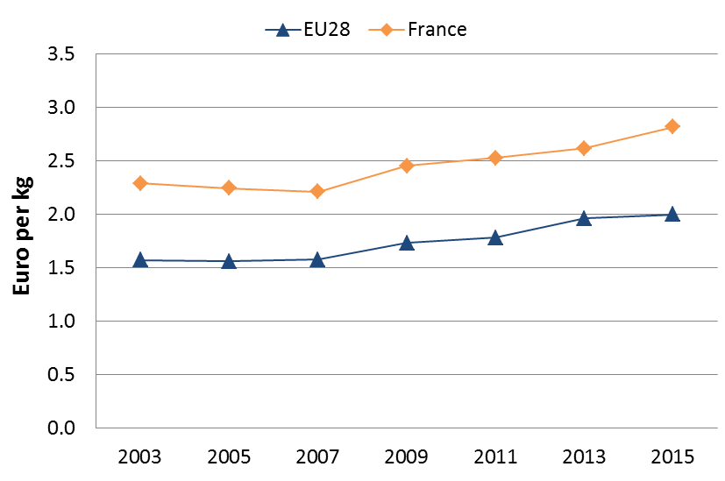
At the regional level, local authorities are also supporting eco-innovation and circular economy.
France has recently launched interesting initiatives on circular economy such as:
- The “Investment for the Future” Programme (PIA): one of the main priorities of the PIA is the energy and ecological transition. The PIA finances RDI programmes (including demonstrators), infrastructures and institutes as well as financial instruments (mainly equity and loans) for innovative projects that target different eco-industry-related issues, with the objective of supporting companies’ growth. By 2015, the PIA had dedicated €2,850 million to clean energy and the circular economy (CGI, 2015). Half of the total amount of the second PIA, which is currently active, is dedicated to various programs which consider eco-conditionality criteria.
- France has created a network of competitiveness clusters to promote public-private R&I projects, through cooperation between public research, SMEs and large firms, leaders of their sector, in order to disseminate in the society and the economy, in the short and medium term, innovative products addressing, in particular, eco-innovation issues. In 2010, new clusters were added, dedicated to eco-industries, all of them currently reaching maturity. At the time being, about half of those clusters are dealing with or focusing on efficient use of resources, sustainable city and mobility, renewable energy, green chemistry…
- Among other things, the PIA has also supported the establishment of several Institutes for Energy Transition (ITE) and Institutes for Technological Research (IRT). They gather a limited number of (mostly large) companies and public laboratories on a specific subject related to eco-innovation: bio-sourced materials, eco-buildings, energy efficiency, eco-technologies and biomass-based plant chemistry. They complement competitiveness clusters as they target more long-term innovation.
- The New Industrial France (Nouvelle France Industrielle): in May 2015, the government announced nine “French Industrial Solutions”, which conformed to France’s industrial policy priorities. Among these, some focus on new resources (new bio-based and recycled materials for industrial productions), sustainable cities (smart grids, building renovation, circular economy), green mobility (including electric cars, cars consuming less than 2 l/100km, electric charging stations, life-long batteries), transport for the future (faster trains, ecological ships and hybrid planes), etc. (DGE, 2015).
- The “Energy Transition for Green Growth” Act: in 2015, the French Parliament passed the “Energy Transition for Green Growth” Law (2015b). This Act set ambitious goals for cutting CO2 emissions, reducing energy consumption, improving material resources efficiency reducing fossil energy consumption and increasing the use of renewable energy. It targets the following sectors: (eco) buildings, clean public and private transport, circular economy and renewable energies. It includes a mix of regulations, tax incentives (e.g. a tax break for energy-related improvements in households), support to RDI programmes and dedicated green financial instruments (e.g. green private equity funds). This Act does not only target companies, but also citizens (e.g. tax break for retrofitting activities at individual level) and public bodies (support to the development of green public procurement). This Act also introduces the national low-carbon strategy which defines how to reduce greenhouse gas (GHG) emissions at the national level. This strategy orchestrates the implementation of the transition towards a low-carbon economy.

SMEs and resource efficiency
Since 2010, a group of clusters, focusing on environmental technologies, have supported the creation of innovative local networks of small and medium-sized enterprises (SMEs) and large companies based around different eco-innovation-related issues, such as water management, waste management, energy efficiency, renewable energies, smart cities and smart transport. These clusters act as a major testbed for the emergence of eco-innovations, and help bring together public and private partners around common issues. However, despite the fact that these sectors are structured around a small number of very large players, eco-innovation appears to come from a much broader range of both large and small firms. Indeed, large companies often rely on a strong network of SMEs as a source of innovation. These networks tend to be organised around national “competitiveness” clusters or regional clusters.
In addition to water management and sanitation, waste management and environmental engineering, additional noteworthy innovation trends include the following:
The sector of low-impact buildings is also strong in France, and develops new solutions for low-impact building and retrofitting activities. The 2015 “Energy Transition for Green Growth” Act has set very ambitious objectives in this area. In this context, the newly created RDI Institute for Energy Transition (INEF4 (Institut pour la transition énergétique)) is supporting open-innovation programmes in the field of eco-building and retrofitting activities and should support the development of these eco-activities and eco-companies (INEF4, 2016).
Equity investments in clean technologies show emerging new trends in France: between 2010 and 2015, investments have shifted from the renewable energy sector to the circular economy (industrial biotechnologies, waste and industrial ecology, and water and biodiversity) and energy efficiency (AFIC (Association Francais des Investisseurs pour la Croissance), 2015).
In 2012, France had 136,444 SMEs (excluding microenterprises) employing 4.1 million persons and producing 23% of the total added value. In the Flash 426 Eurobarometer "SMEs, resource efficiency and green markets" it is shown that 49% of France's SMEs have invested up to 5% of their annual turnover in their resource efficiency actions (EU28 average 50% of SMEs), 34% of them are currently offering green products and services, 70% took measures to save energy (EU28 average 59%), 77% to minimise waste (EU28 average 60%), 67% to save water (EU28 average 44%), and 66% to save materials (EU28 average 54%). From a circular economy perspective, 36% took measures to recycle by reusing material or waste within the company, 40% to design products that are easier to maintain, repair or reuse and 23% were able to sell their scrap material to another company.
According to the Flash 426 Eurobarometer, the resource efficiency actions undertaken allowed the reduction of production costs in 39% of France's SMEs.
The Flash Eurobarometer shows that 28% of the SMEs in France have one or more full time employee working in a green job at least some of the time. France has an average number of 7,6 full time green employees per SME.

Eco-Innovation
France is a major European player in the field of eco-innovation, and possesses a strong track record in environmental regulation and support schemes – targeting both public and private actors (including individuals). This is illustrated by its strong ranking in the 2015 Eco-Innovation Scoreboard. France ranks seventh overall in the ranking of eco-innovative countries (scoring 115, with 100 representing the European average) as shown in Figure 2.
Figure 2: Eco-Innovation Index 2015 (EU=100)
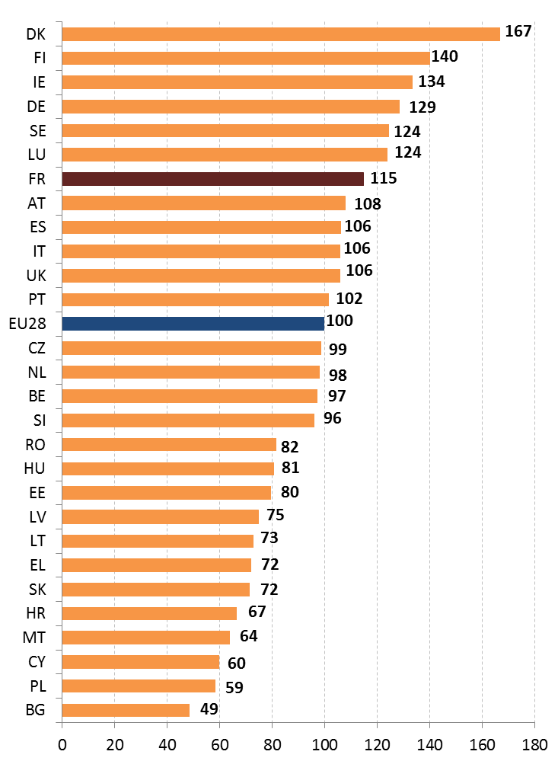
Compared to the 2013 Eco-IS results (a score of 108), France has gained ground. This can be interpreted as a reflection of the priority that is given to eco-innovation in France in terms of regulation, policy and support measures. However, France still falls considerably behind the top 3 EU-28 eco-innovative players, namely Denmark, Finland and Ireland, due to limited energy and water productivity and limited green early-stage investments.
France benefits from a substantial regulatory and policy framework that supports and promotes eco-industries and eco-innovation. For instance, the 2015 “Energy Transition for Green Growth” Law complements existing support instruments (including RDI-support instruments) and regulations regarding environmental protection, in order to i) accelerate the reduction of France’s energy needs and ii) increase the share of renewable energy in the national energy mix. This law specifically targets eco-innovation, with measures aimed at increasing innovative green public procurements and taking into account eco-innovation in different public policy areas (transport, construction, etc.).
In recent years, France has heavily invested in RDI programmes, infrastructures and institutes with the intention of supporting the development of eco-innovative companies and solutions. The PIA programme, for example, has also put in place dedicated financial instruments in support of companies engaging in eco-activities, such as the Ecotechnology Fund, run by the French Public Investment Bank, Bpifrance. Competitiveness clusters and other public-private partnerships allow companies to join strong local networks to develop innovative products and gain access to international markets. The country also benefits from a mature R&D system, with leading PROs, a good level of public and business R&D expenditures and large numbers of qualified experts (OECD, 2014). Private R&D comes from leading international firms with high innovation capacities (see Section 2), as well as from smaller high-growth firms. These companies use eco-innovative solutions both in France and internationally (COSEI, 2012).
In the field of the circular economy, the main drivers for innovation are public RDI programmes (such as PIA and competitiveness clusters). These programmes mostly focus on technology-related issues, and less on the other aspects of innovation (regulation, acceptability, new business models, etc.), even though these dimensions are considered as central for the development of the circular economy (Barthelemy & Franz, 2016).
In the context of the strong reliance of eco-industries on public procurement and the public sector as the final destination of their products and services (waste management, water and other resource management, etc.), the French Ministry in charge of the environment published in 2015 a national action plan for sustainable public procurement for 2015-2020 which should enhance the sustainability of public activities and relevant economic actors. Public stakeholders are working on solutions that would provide legal security for public procurers to purchase innovative solutions and for solution providers to gain access to major public markets. The new public procurement reform (July 2015) has explicitly inserted new provisions on environmental clauses in public procurements specifications.
France has 37 EMAS registered organisations, which is quite low with respect to its size and to the total of 4034 organisations that hold a registration. However, France has slightly increased its number of registrations since October 2015 (from 35 to 37). Furthermore, when it comes to EU Ecolabel licenses, France is the highest achieving country. Indeed, it has 486 EU Ecolabel licenses, which represents 25.9% of all EU Ecolabel licenses.

Waste management
Turning waste into a resource requires:
- Full implementation of Union waste legislation, which includes the waste hierarchy; the need to ensure separate collection of waste; the landfill diversion targets etc.
- Reducing per capita waste generation and waste generation in absolute terms.
- Limiting energy recovery to non-recyclable materials and phasing out landfilling of recyclable or recoverable waste.
SDG 12 invites countries to substantially reduce waste generation through prevention, reduction, recycling and reuse, by 2030.
The EU's approach to waste management is based on the "waste hierarchy" which sets out an order of priority when shaping waste policy and managing waste at the operational level: prevention, (preparing for) reuse, recycling, recovery and, as the least preferred option, disposal (which includes landfilling and incineration without energy recovery). The progress towards reaching recycling targets and the adoption of adequate WMP/WPP should be the key items to measure the performance of Member States. This section focuses on management of municipal waste for which EU law sets mandatory recycling targets.
Generation of municipal waste in France has been decreasing slightly in the past years, before a more noticeable drop in 2014, down to 509 kg/inhabitant as shown in Figure 3. That level still puts France a solid 8% above the EU average of 475kg/inhabitant. Only in 2014 did France reach the level where Europe was at in 2009.
Figure 3 depicts the municipal waste by treatment in France in terms of kg per capita, which shows that France is gradually improving both waste generation and waste treatment methods. Only incineration/energy recovery has remained a constant in absolute terms (and has therefore increased percentage-wise).

Figure 3: Municipal waste by treatment in France 2007-14
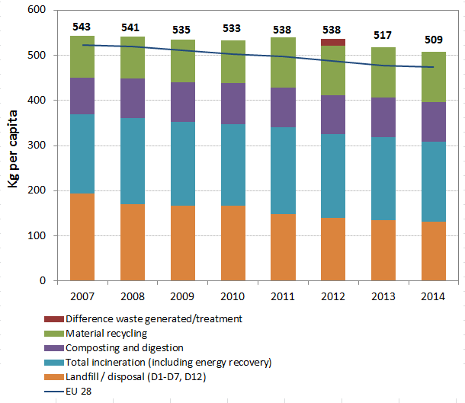
Figure 4 shows that recycling of municipal waste, while still being below EU average (44% in 2014), has consistently improved since 2007, reaching a level of 39% in 2014. For the time being, the strict comparison is difficult as Member states do not report exactly the same waste as municipal waste.
Figure 4: Recycling rate of municipal waste 2007-14
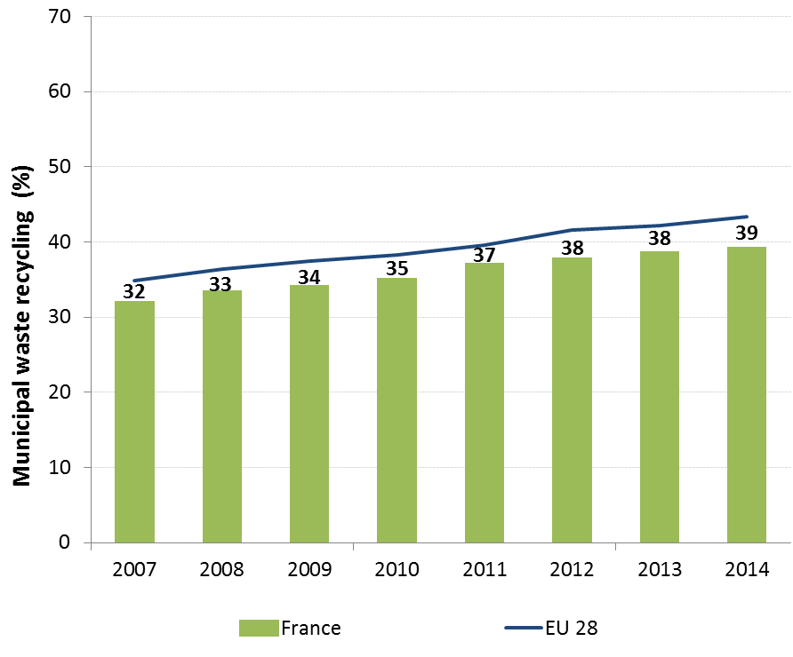
Yet that proportion puts France far behind leading recycling countries. With a recycling rate of 38% in 2013 and a progression of 2.5% since 2010, France should reach its European objective of 50%. However, France is still over-reliant on incineration. Similarly, landfilling still accounts for a troubling 26% of all municipal waste, despite a remarkable 32% decrease in absolute quantities landfilled between 2007 and 2014.
Despite a number of innovative and far-reaching policies (e.g. on Extended Producer Responsibility) there is still a significant and a large reliance on technology (e.g. incinerators). Finally, there are still some illegal dumpsites in France.
A 2016 report by the French Court of Auditors noted that separate collection is reaching a plateau in the country. The report recommends that both waste producers and the authorities take a number of steps to reinvigorate separate collection, starting with the rationalization and modernization of separation and treatment plants, i.e. doing more with fewer plants.
A 2015 study by the French Environment and Energy Management Agency (ADEME) building on a 2012 study by the European Commission has assessed that the circular economy sector could create from 200,000 to 400,000 additional jobs on top of the 600,000 jobs existing jobs.
In this context, France adopted in August 2015 the Energy Transition for Green Growth Act that promotes the transition towards a circular economy, boosting waste prevention and recycling.
This Act establishes a waste prevention target, namely to reduce household waste production by 10% % by 2020 compared to 2010 levels. It features a number of actions to build momentum towards this target – including a definition of the legal notion of “planned obsolescence”, which becomes a crime, promotion of deposit and return schemes, obligations for food retailers to donate their unsold goods to charities to reduce food waste, and a “resource use hierarchy” inspired by the waste hierarchy, and fostering waste prevention.
The Act also promotes recycling, establishing waste recovery target for 2020-25 (respectively 55% and 65% of all non-hazardous non-inert waste) and the extension of separate collection to all organic waste before 2025. The Act also provides that, considering the action on separate collection, mechanical biological treatment (MBT) of waste is no longer relevant and excludes any new public financing for these installations. The national focus on EPR schemes as a powerful tool to address recycling in a specific sector continues to be put forward, including through the creation of a new EPR scheme on leisure boats.
In addition, France has recently adopted a decree mandating source separation by businesses of paper, glass, plastic, metal and wood. The separate collection of bio-waste has been mandatory for big producers since 2012 and the Green Growth Act has extended it to all companies.
France also adopted recently a decree foreseeing that landfilling capacities should be reduced by 30% in 2020 compared to 2010, and from 50% in 2025. As far as incineration is concerned the capacity should be reduced by 25% and 50% in the same time frame.
The decree also requires that the waste management plans should identify shared facilities for the collection and treatment of bio-waste from household, undertakings and agriculture.
To fight illegal dumpsites, France has taken several measures through the Energy Transition Act to prevent their proliferation by putting in place a network for waste collection for the construction sector imposing key obligations on distributors of construction products. On the enforcement aspect, traceability of such materials has been reinforced as well as human resources appointed to inspections and legal proceedings. Finally, a special awareness should be dedicated by the French authorities to the revision and adoption of waste management plans in the context of the regional administration reform.
Suggested action
- Focus on improving the effectiveness of separate collection to increase recycling rates and reach the targets set at EU level.
- Introduce new economic instruments to implement further the waste hierarchy, i.e. promote prevention, make reuse and recycling more economically attractive, and shift reusable and recyclable waste away from incineration and landfill.
- Complete missing Waste Management Plans in order to cover the whole territory.

- Protecting, conserving and enhancing natural capital

Nature and Biodiversity
The EU Biodiversity Strategy aims to halt the loss of biodiversity in the EU by 2020, restore ecosystems and their services in so far as feasible, and step up efforts to avert global biodiversity loss. The EU Birds and Habitats Directives aim at achieving favourable conservation status of protected species and habitats.
SDG 14 requires countries to conserve and sustainably use the oceans, seas and marine resources, while SDG 15 requires countries to protect, restore and promote the sustainable use of terrestrial ecosystems, sustainably manage forests, combat desertification, and halt and reverse land degradation and halt biodiversity loss.
The 1992 EU Habitats Directive and the 1979 Birds Directive are the cornerstone of the European legislation aimed at the conservation of the EU's wildlife. Natura 2000, the largest coordinated network of protected areas in the world, is the key instrument to achieve and implement the Directives' objectives to ensure the long-term protection, conservation and survival of Europe's most valuable and threatened species and habitats and the ecosystems they underpin.
The adequate designation of protected sites as Special Ares of Conservation (SAC) under the Habitats Directive and as Special Protection Areas (SPA) under the Birds Directive is a key milestone towards meeting the objectives of the Directives. The results of Habitats Directive Article 17 and Birds Directive Article 12 reports and the progress towards adequate Sites of Community Importance (SCI)-SPA and SAC designation both in land and at sea, should be the key items to measure the performance of Member States.
In France, there are 1758 Natura 2000 sites, divided in 1.366 sites under the Habitats Directive and 392 under the Birds Directive. By early 2016, 12.7 % of the national land area of France is covered by Natura 2000 (EU average 18.1 %), with Birds Directive SPAs covering ca. 8 % (EU average 12.3 %) and Habitats Directive SCIs covering ca. 9 % (EU average 13.8 %).
The latest assessment of the SCIs part of the Natura 2000 network shows that there are inadequacies in designation, especially for the marine components of the network (see Figure 5.)
Figure 5: Sufficiency assessment of SCI networks in France based on the situation until December 2013 (%)
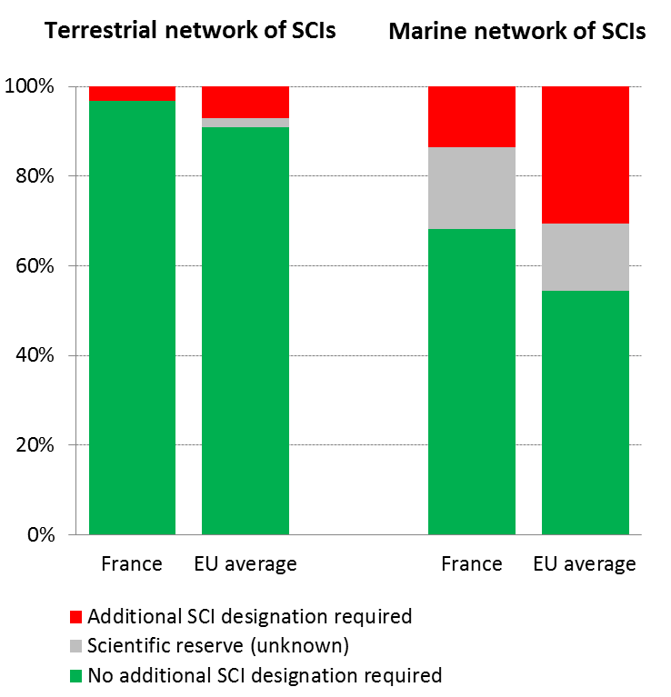
France has designated almost all sites as Special Areas of Conservation (SACs) and it has defined management plans for almost all of them. France has committed itself to designate the remaining sites by mid-2016.
Although a range of species and habitats show a general stabilisation of their status of conservation – even some improvements – many of them are still declining and endangered. Coastal habitats, wetlands and water-related ecosystems as well as agriculture-related habitats are the main threatened ecosystems. The key threats to biodiversity are habitat loss and degradation (in particular through urban sprawl, agricultural intensification, land abandonment, and intensively managed forests), pollution, over-exploitation (in particular fisheries), invasive alien species and climate change. The lack of integration between nature and other policies , in particular in agricultural sector but also, to a lesser extent in urbanisation, transport, energy and forestry does not help to tackle the issue, in particular in a context of global warming and of a spread of Invasive Alien Species.
According to the latest report on the conservation status of habitats and species covered by the Habitats Directive in France, 28% of the species of community interest are in a Favourable Conservation Status (EU 27: 23%) whereas 32% (EU27: 42%) and 24% (EU27: 18%) are respectively in an unfavourable-inadequate and in a unfavourable-bad status. Therefore, 16% remains unknown. As regards the habitats, about 22% of the habitat types of community interest are in a Favourable Conservation Status (EU 27: 16 %) whereas 38% (EU27: 47%) and 36% (EU27: 30%) are respectively in an unfavourable-inadequate and in an unfavourable-bad status. Only 4% remains unknown.
Figure 6: Conservation status of habitats and species in France in 2007/2013 (%)
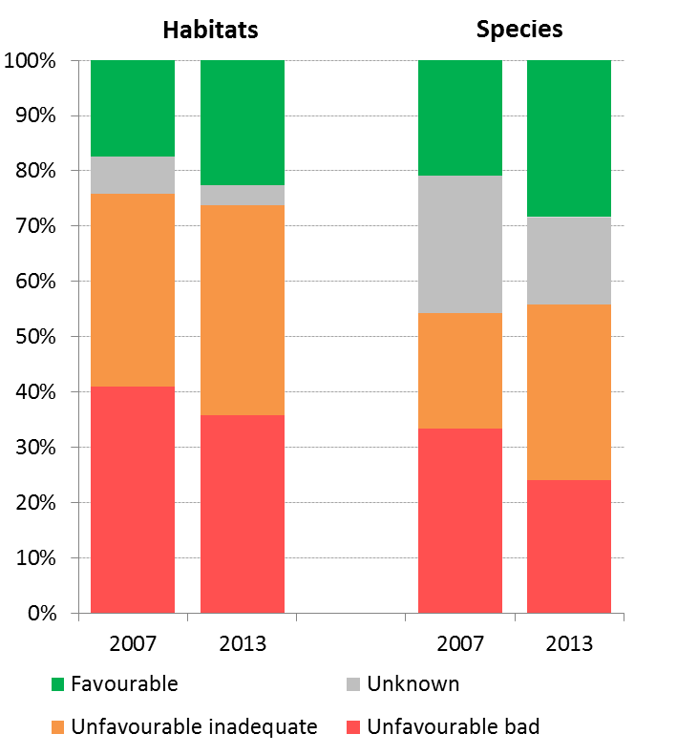
This is depicted in Figure 6, which shows a general stabilisation of the status of conservation although some species and habitats in unfavourable-bad status tend to degrade again, due to the aforementioned main threats and pressures.
As far as birds are concerned, 56% of the breeding species showed short-term increasing or stable population trends (for wintering species this figure was also 56%) as shown in Figure 7.
Figure 7: Short-term population trend of breeding and wintering bird species in France in 2012 (%)
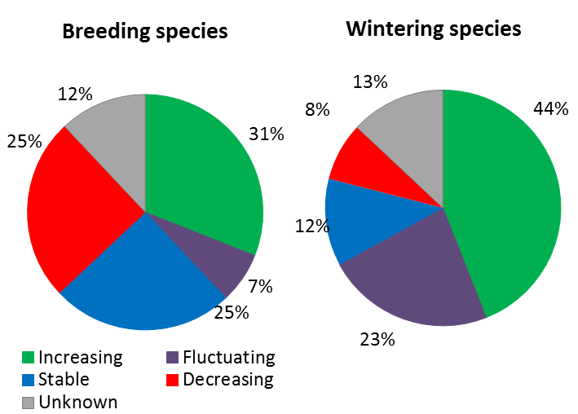
In France, the Nature directives are overall well implemented and have reinforced the protection of nature. Indeed:
- The Nature directives have reinforced the legal protection regime in particular by strengthening the French Nature law dated of 1976. The derogation system is correctly used, associating the public where needed, although some reporting problems remain;
- The nature directives have created the Natura 2000 network which is, in France, a dedicated and well-structured policy as well as a means to mobilise the public on biodiversity as the French system well involves the public and stakeholders. Indeed, in France each Natura 2000 site has one so-called "COPIL" (= dedicated ad-hoc steering committee) which is the governance body responsible for establishing conservation objectives (CO) and conservation measures (CM) through the so-called "DOCOB" (= dedicated ad-hoc Natura 2000 management plan). All of this is run by local authorities under the supervision of the State and it is implemented through a dedicated Natura 2000 site manager, financed by European and national funds. So far in France, Natura 2000 has created around 800 full-time job equivalents.
Beyond the legal obligations under the nature directives, France has initiated a range of initiatives in line with the EU nature and biodiversity agenda such as: "Trame verte et bleue (Green and Blue Trail (GBT)", "séquence 'éviter, réduire, compenser'" (a kind of No Net Loss initiative), "Grands Prix Natura 2000", etc. For Natura 2000, it has also established many tools and material helping to streamline the approach on the national territory such as dedicated sectorial assessment methodologies for habitats and species at site level, national guidance document for establishing the Natura 2000 management plans, dedicated Natura 2000 training sessions and "technical exchanges days" (a national equivalent to the Natura 2000 biogeographical process).
The main challenge in France with regard to the implementation of Natura 2000 is to ensure an appropriate financing, both from national and EU funds as well as to work for a better integration between nature and agriculture policies. The recent territorial reshuffle in France, together with the fact that the regions will be leading on biodiversity matters and are now responsible for implementing the European funds, will constitute challenges and opportunities, in the context of the bill on recapture of biodiversity, nature and landscapes (adoption on 20th July 2016).
Illegal hunting and the determination of hunting period for bird species protected by the Birds Directive remain a concern. In particular, for some species (i.e. Ortolan bunting and geese), the information through complaints and infringements seem to suggest that the French authorities have lowered the intensity of their control, putting at risk the conservation status of these species.
With respect to agriculture, the intensification of agriculture has significant negative impacts on a number of habitats and species. However, recent environmental initiatives taken by the agriculture ministry i.e. the introduction of an agro-ecology project (national and regional) sets significant measures, and plans. For example, this project includes: the implementation of the Ecophyto II plan aiming to reduce the use of pesticides (EUR 41 million each year from 2008 to 2015), the prolongation in 2016 of the 2013 plan for sustainable bee keeping, the launching of a new plan to develop agroforestry and the promotion of sustainable and collective action among groups of farmers through new organizations called "groupements d'intérêt économique et environnemental" (GIEE). All those initiatives aiming at promoting more sustainable and environmentally friendly agricultural practices.
The rich and unique fauna and flora in the French Outermost Regions (ORs) and Overseas Countries and Territories (OCTs) are not covered by Natura 2000. The European Parliament adopted a financing decision to implement a pilot project on Inventories of Species and Habitats in French ORs (EUR 1 million) and adopted another on Mapping and assessing of ecosystem services which would cover all the ORs and OCTs. Targeted protection measures and adequate financial resources should be devoted to conserving the exceptional wealth of biodiversity in the overseas départements. In its conclusion of 16 December 2015 Environment Council noted the results of the preparatory action on Biodiversity and Ecosystem Services in Territories of European Overseas (BEST), the funding available under the Commission's Best 2.0 Programme, and urged the Commission and the Member States to move forward on sustainable partnerships dedicated to mobilising resources to protect the unique ecosystems and the services they provide in the EU Outermost Regions and Overseas Countries and Territories.

Suggested action
- Complete the Natura 2000 designation process and ensure that the necessary conservation measures for the sites maintain/restore species and habitats of community interest to a favourable conservation status across their natural range.
- Strengthen the integration of biodiversity concerns into other policies (in particular in agriculture, but also in forestry, urban and infrastructure planning and tourism) and the promotion of concertation between actors.
- Ensure the appropriate enforcement of hunting bans for protected bird species.
- Continue to support the ongoing work for the establishment of a sustainable partnership for biodiversity protection, sustainable development and climate change adaptation and mitigation measures in the ORs and the OCTs.

Estimating Natural Capital
The EU Biodiversity Strategy to 2020 calls on the Member States to map and asses the state of ecosystems and their services in their national territory by 2014, assess the economic value of such services, and promote the integration of these values into accounting and reporting systems at EU and national level by 2020.
The French national ecosystem assessment, the EFESE project ("L'Évaluation Française des Écosystèmes et des Services Écosystémiques") has carried out work on physical and ecological assessment of ecosystems services, the ongoing exploratory works for the development of accounts and a valuation of ecosystem services. Working groups have been set up in the framework of the Mapping and Assessment of Ecosystems and their Services (MAES) focusing on different ecosystems (forest, wetlands, urban, agro-ecosystems, marine, rocks and mountains).
The EFESE project gathers different communities. For instance, business is interested in ecosystem services in particular for green infrastructure.
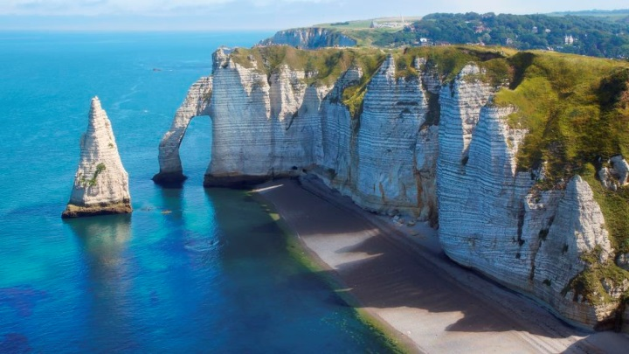A whole governance structure has been set up to deal with the mapping and assessment of ecosystems and their services in France. Current work is focusing on different ecosystems (forest, wetlands, urban, agro-ecosystems, and marine ecosystems, rocks and mountains). Business is interested in ecosystem services for green infrastructure. An economic assessment has delivered a conceptual framework and the assessment of pollination service. Other values are being explored and concern less tangible benefits such as spiritual and mental wellbeing.
Aside from the EFESE project, ecosystem accounting approaches are already implemented for some ecosystems (e.g. forests) and a reflection has been initiated about natural capital accounting approaches (e.g. : test of the Quick Start Package developed by the CDB). For instance, options for marine natural capital accounting was discussed in a workshop co-organized with the EEA in the context of the EU KIP-INCA initiative
Suggested action
- Continue support to the mapping and assessment of ecosystems and their services, valuation and development of natural capital accounting systems.

Green Infrastructure
The EU strategy on green infrastructure promotes the incorporation of green infrastructure into related plans and programmes to help overcome fragmentation of habitats and preserve or restore ecological connectivity, enhance ecosystem resilience and thereby ensure the continued provision of ecosystem services.
Green Infrastructure provides ecological, economic and social benefits through natural solutions. It helps to understand the value of the benefits that nature provides to human society and to mobilise investments to sustain and enhance them.
The French Green and Blue Trail (GBT) is a regional planning tool that aims to maintain and restore an interconnected network allowing animal and plant species to move and complete their life cycle. While the main objective of the GBT is to create a network of ecological continuities, made of ecological corridors and biodiversity reservoirs, they can indirectly contribute to improved ecosystem services and socio-economic benefits. A 2010 law specifies the consequences of GBT registration on environmental management and urban planning in the pursuit of the objective of preserving and restoring good ecological continuity.
Many actors are already implementing the GBT at different levels: national, regional, departmental and local. The state sets the framework and ensures consistency across the territory. The state and the regions develop together the "regional ecological coherence schemes", which are put to public consultation. The departments are piloting the policy in sensitive natural areas that contribute to the GBT. They can also carry out ecological connectivity restoration projects. Local authorities take into account ecological continuity in spatial planning documents and projects, in particular in urban development planning. Companies can act by managing their sites to preserve ecological continuity, as well as by reducing their environmental impact. Farmers and foresters play a positive role in maintaining ecological continuity. Citizens have the possibility to act at their level, individually in their gardens or as part of an association.

Soil protection
The EU Soil Thematic Strategy highlights the need to ensure a sustainable use of soils. This requires the prevention of further soil degradation and the preservation of its functions, as well as the restoration of degraded soils. The 2011 Road Map for Resource-Efficient Europe, part of Europe 2020 Strategy provides that by 2020, EU policies take into account their direct and indirect impact on land use in the EU and globally, and the rate of land take is on track with an aim to achieve no net land take by 2050.
SDG 15 requires countries to combat desertification, restore degraded land and soil, including land affected by desertification, drought and floods, and strive to achieve a land-degradation-neutral world by 2030.
Soil is an important resource for life and the economy. It provides key ecosystem services including the provision of food, fibre and biomass for renewable energy, carbon sequestration, water purification and flood regulation, the provision of raw and building material. Soil is a finite and extremely fragile resource and increasingly degrading in the EU. Land taken by urban development and infrastructure is highly unlikely to be reverted to its natural state; it consumes mostly agricultural land and increases fragmentation of habitats. Soil protection is indirectly addressed in existing EU policies in areas such as agriculture, water, waste, chemicals, and prevention of industrial pollution.
Artificial land cover is used for settlements, production systems and infrastructure. It may itself be split between built-up areas (buildings) and non-built-up areas (such as linear transport networks and associated areas).
The annual land take rate (growth of artificial areas) as provided by CORINE Land Cover was 0.47% in France over the period 2006-12, well below the EU average (0.41%). It represented 14,117 hectares per year and was mainly driven by industrial and commercial sites as well as housing, services and recreation.
The percentage of built up land in 2009 was 2.79%, below the EU average (3.23%).
The soil water erosion rate in 2010 was 2.25 tonnes per ha per year, close to EU-28 average (2.46 tonnes).
There are still no EU-wide datasets enabling the provision of benchmark indicators for soil organic matter decline, contaminated sites, pressures on soil biology and diffuse pollution. 15 years ago France set up a scientific interest group on soil (GIS sol). This group manages an harmonised soil information system providing such information on French territory (contaminated sites are not in the GIS's scope but are available within another national network).
An updated inventory and assessment of soil protection policy instruments in France and other EU Member States is being performed by the EU Expert Group on Soil Protection.
Figure 8 shows the different land cover types in France in 2012.
Figure 8: Land Cover types in France in 2012
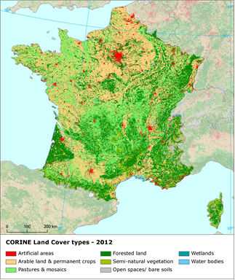

Marine protection
The EU Coastal and Marine Policy and legislation require that by 2020 the impact of pressures on marine waters is reduced to achieve or maintain good environmental status and coastal zones are managed sustainably.
SDG 14 requires countries to conserve and sustainably use the oceans, seas and marine resources for sustainable development.
The Marine Strategy Framework Directive (MSFD) aims to achieve Good Environmental Status (GES) of the EU's marine waters by 2020 by providing an ecosystem approach to the management of human activities with impact on the marine environment. The Directive requires Member States to develop and implement a marine strategy for their marine waters, and cooperate with Member States sharing the same marine region or subregion.
As part of their marine strategies, Member States had to make an initial assessment of their marine waters, determine GES and establish environmental targets by July 2012. They also had to establish monitoring programmes for the on-going assessment of their marine waters by July 2014. The next element of their marine strategy is to establish a Programme of Measures (2016). The Commission assesses whether these elements constitute an appropriate framework to meet the requirements of the MSFD.
French marine waters are part of two marine regions, the North East Atlantic Ocean and the Mediterranean Sea and of four marine sub-regions: the Celtic Seas, the Greater North Sea, the Bay of Biscay and Iberian Coast, and the Western Mediterranean Sea. France is therefore party to both the Convention for the Protection of the Marine Environment and the Coastal Region of the Mediterranean (Barcelona Convention) and the Convention for the protection of the marine environment of the North-East Atlantic (OSPAR Convention). In the open ocean areas of the Atlantic, the main threats to biodiversity are potentially overfishing, bottom trawling, discards, and pollution resulting from accidents (e.g. oil spills). The Mediterranean Sea region was identified by the EEA in its 2015 State of the Environment report as one of the main climate change hotspots (i.e. one of the areas most responsive to climate change). The biodiversity of the Mediterranean Sea Region is also threatened by pollution from land-based sources such as discharges of excess nutrients and hazardous substances, marine litter, over-fishing, and degradation of critical habitats.
The determinations of GES adopted by France are mostly in line with the MSFD. They cover most of the indicators and for some descriptors even more, and EU requirements and standards have been systematically used. However, GES is defined qualitatively and not quantitatively. This choice, combined with a lack of baseline and reference conditions, leads to a general lack of clarity about GES. All pressures and impacts on the marine environment are often not clearly and efficiently covered, which can pose problems in terms of environmental targets definition, of monitoring and of establishing a programme of measures.
It is therefore too early to say whether French waters are in good status as there were weaknesses in identifying what "good environmental status" is in the first place.
France also established a monitoring programme of its marine waters in 2014. However, this monitoring, except for marine litter and underwater noise, needs further refinement and development to constitute an appropriate framework to monitor progress towards Good Environmental Status and environmental targets. More specifically, non-indigenous species monitoring programme needs to be developed and in place before 2020.
In 2012, French marine protected areas covered 47,112.4 square kilometres of its marine waters, with 11,668.5 square kilometres in the North Sea, 1,693.9 square kilometres in the Celtic Sea, 20,183.8 square kilometres in the Bay of Biscay and Iberian coast and 13,566.2 square kilometres in the Western Mediterranean Sea.
In its reports on the implementation of the MSFD, the Commission provided guidance to assist France in its implementation of the Marine Strategy Framework Directive.
Suggested action
- Continue work to improve the definitions of GES including through regional cooperation by using the work of the relevant Regional Sea Conventions.
- Address knowledge gaps.
- Continue to integrate already existing monitoring programme required under EU legislation and to implement, where they exist, joint monitoring programmes developed at (sub)regional level, for instance by OSPAR and the Barcelona Convention.
- Enhance comparability and consistency of monitoring methods within its marine regions.
- Enhance the cohesion between approaches in the Member State's two marine regions.
- Ensure that the monitoring programme is appropriate to monitor progress towards GES.

- Ensuring citizens' health and quality of life

Air quality
The EU Clean Air Policy and legislation require The EU Clean Air Policy and legislation require that air quality in the Union is significantly improved, moving closer to the WHO recommended levels. Air pollution and its impacts on ecosystems and biodiversity should be further reduced with the long-term aim of not exceeding critical loads and levels. This requires strengthening efforts to reach full compliance with Union air quality legislation and defining strategic targets and actions beyond 2020.
Figure 9: Attainment situation for PM10, NO2 and O3 in 2014
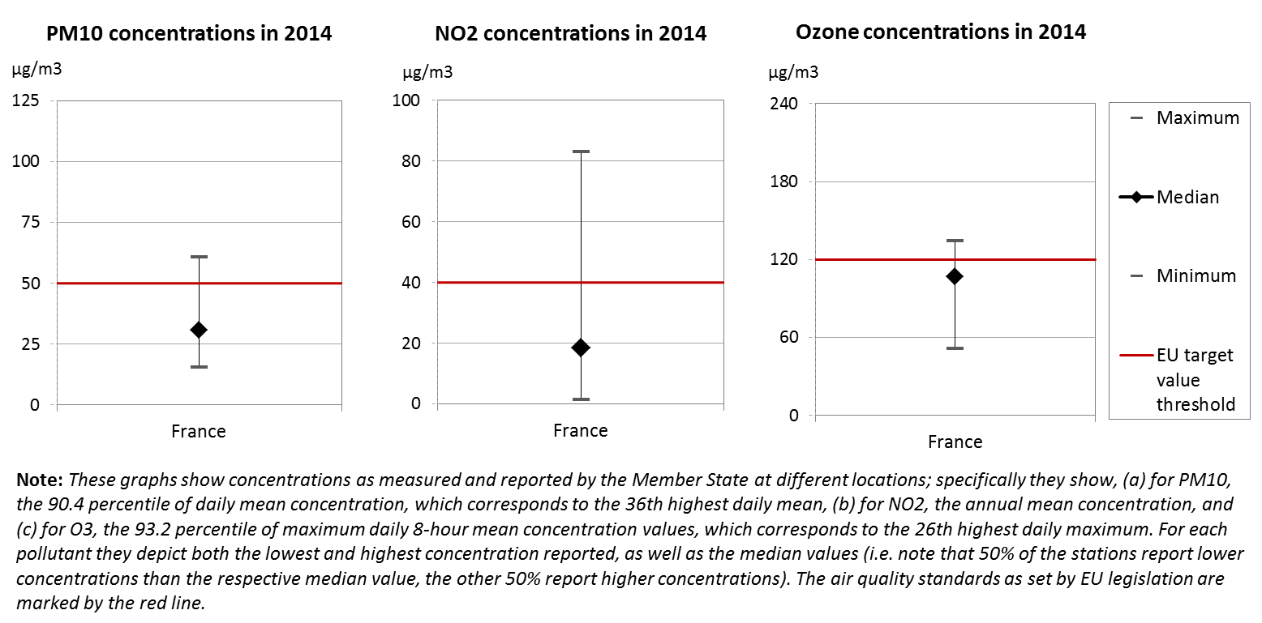
The EU has developed a comprehensive suite of air quality legislation, which establishes health-based standards and objectives for a number of air pollutants. As part of this, Member States are also required to ensure that up-to-date information on ambient concentrations of different air pollutants is routinely made available to the public. In addition, the National Emission Ceilings Directive provides for emission reductions at national level that should be achieved for main pollutants.
The emission of several air pollutants has decreased in France. Reductions between 1990 and 2014 for sulphur oxides (-87%) and volatile organic compounds (-73%) ensure air emissions for these pollutants are within the currently applicable national emission ceilings. Although ammonia emissions increased by 1%, the total emissions are still within the currently applicable ceiling. Significant emission reductions for nitrogen oxides (-55%) have also been recorded; nevertheless emissions for this pollutant are still 9% above current ceiling. It should be noted that the exceedance of the current ceilings for nitrogen oxides is partly due to the actual driving emissions of these pollutants from diesel vehicles.
At the same time, air quality in France continues to give cause for severe concern. For the year 2013, the European Environment Agency estimated that about 45 120 premature deaths were attributable to fine particulate matter concentrations, 1 780 to ozone concentration and 8 230 to nitrogen dioxide concentrations. This is due also to exceedances above the EU air quality standards such as shown in Figure 9.
For 2014, exceedances above the EU air quality standards have been registered related to concentrations of nitrogen dioxide (NO₂) in 19 air quality zones and related to particulate matter (PM₁₀) in 17 air quality zones. Furthermore, one air quality zone have indicated exceedances regarding fine particulate matter (PM_{2.5}), for which the limit value has become binding only in 2015. Target values are also exceeded for ozone concentrations in several air quality zones.
The persistent breaches of air quality requirements (for PM₁₀ and NO₂), which have severe negative effects on health and environment, are being followed up by the European Commission through infringement procedures covering all the Member States concerned, including France. The aim is that adequate measures are put in place to bring all zones into compliance.
It is estimated that the external costs from air pollution in France are above EUR 37 billion/year (income adjusted, 2010), which include not only the intrinsic value of living a full health life but also direct costs to the economy. These direct economic costs relate to 12 million workdays lost each year due to sickness related to air pollution, with associated costs for employers of EUR 1,685 million/year (income adjusted, 2010), for healthcare of above EUR 143 million/year (income adjusted, 2010), and for agriculture (crop losses) of EUR 763 million/year (2010).
In 2017, the city of Paris has unveiled plans to restrict traffic in the French capital and pedestrianize the city centre in an attempt to halve the number of private cars on the roads.
Suggested action
- Maintain downward emissions trends of air pollutants in order to achieve full compliance with currently applicable national emission ceilings and air quality limit values - and reduce adverse air pollution impacts on health, environment and economy.
- Reduce nitrogen oxide (NO_{x}) emissions to comply with currently applicable national emission ceilings and/or to reduce nitrogen dioxide (NO₂) (and ozone concentrations), inter alia, by reducing transport related emissions - in particular in urban areas.
- Reduce PM₁₀ emission and concentration, inter alia, by reducing emissions related to energy and heat generation using solid fuels, to transport and to agriculture.

Noise
The Environmental Noise Directive provides for a common approach for the avoidance, prevention and reduction of harmful effects due to exposure to environmental noise.
Excessive noise is one of the main causes of health issues. To alleviate this, the EU acquis sets out several requirements, including assessing the exposure to environmental noise through noise mapping, ensuring that information on environmental noise and its effects is made available to the public, and adopting action plans with a view to preventing and reducing environmental noise where necessary and to preserving the acoustic environment quality where it is good.

France's implementation of the Environmental Noise Directive is significantly delayed. There have been delays in developing strategic noise maps and action plans for noise management in both reporting rounds (for the reference years 2006 and 2011).
Suggested action
- Accelerate the completion of the missing noise maps and action plans.

Water quality and management
The EU water policy and legislation require that the impact of pressures on transitional, coastal and fresh waters (including surface and ground waters) is significantly reduced to achieve, maintain or enhance good status of water bodies, as defined by the Water Framework Directive; that citizens throughout the Union benefit from high standards for safe drinking and bathing water; and that the nutrient cycle (nitrogen and phosphorus) is managed in a more sustainable and resource-efficient way.
SDG 6 encourages countries to ensure availability and sustainable management of water and sanitation for all.
The main overall objective of EU water policy and legislation is to ensure access to good quality water in sufficient quantity for all Europeans. The EU water acquis seeks to ensure good status of all water bodies across Europe by addressing pollution sources (from e.g. agriculture, urban areas and industrial activities), physical and hydrological modifications to water bodies) and the management of risks of flooding.
River Basin Management Plans (RBMPs) are a requirement of the Water Framework Directive and a means of achieving the protection, improvement and sustainable use of the water environment across Europe. This includes surface freshwaters such as lakes and rivers, groundwater, estuaries and coastal waters up to one nautical mile.
France has provided information to the Commission from its second generation of RBMPs. However, as the Commission has not yet been able to validate this information for all Member States, it is not reported here.
In its 2010-2015 RBMPs France reported the status of 10,824 rivers, 439 lakes, 96 transitional, 164 coastal and 574 groundwater bodies. Only 44% of natural surface water bodies achieve a good or high ecological status and 13% of heavily modified or artificial water bodies achieve a good or high ecological potential (25% unknown). Only 44% of surface water bodies (33% unknown), 28% of heavily modified and artificial water bodies (47% unknown) and 59% of groundwater bodies achieve good chemical status. 89% of groundwater bodies are in good quantitative status
A number of pressures affect water bodies in France – in the case of surface waters, 39% are affected by diffuse source of pollution, 30% by point sources of pollution, 27% by river management, 25% by flow regulation and morphological changes and 20% by abstraction. There are significant regional differences and in some river basin districts these pressures affect much higher proportions of water bodies, e.g. diffuse sources affect 93% of surface water bodies in the Scheldt, Somme and coastal waters of the Channel and the North Sea district and 67% in the Seine and Normandy coastal waters district and water abstraction affects 38% of surface water bodies in the Loire, Brittany and Vendee coastal waters district.
There are certain deficiencies in French River Basin Management Plans concerning the assessment of status. Programmes of Measures are expected to result in significant improvement of the ecological status of natural surface water bodies as well as artificial and heavily modified bodies – by 21% and 27% respectively and in improvement of chemical status by 8% and 3% respectively. The chemical status of groundwater is expected to improve by 5% and the quantitative status by 6%.
Diffuse pollution from agriculture is the most widespread significant pressure on water bodies (affecting 39% of water bodies at national level, much more in some river basins), resulting in eutrophication and increased costs of water treatment. The current system of water charging and nitrogen/pesticide taxation provides little incentive to improve farming practices. Enhanced measures should be taken to more effectively tackle pollution by nutrients (nitrogen and phosphorus) with full consideration for the basin-wide impacts and ensuring consistency in actions under the WFD, Nitrates Directive and the CAP.
In the case of pesticides, measured concentrations across the country are generally low. But pesticides are present in a large number of aquatic ecosystems. In 2013, pesticides were found in 92% of monitoring points of surface water bodies, with different pesticides being often reported for one monitoring station. Around 30% of all monitoring points of surface water bodies showed a sum of pesticide concentration higher than 0.5 μg/l (annual average).
Some progress has been made in addressing water pollution by nitrates from agricultural sources and eutrophication but nutrient pollution remains a challenge especially in area with intensive animal rearing (e.g. Loire Bretagne basin) and intensive arable farming (e.g. Parisian basin).
Following two recent court rulings from the ECJ on the implementation of the Nitrates Directive, France is revising its legal framework and has announced the extension of the areas designated as vulnerable to nitrates pollution and the reinforcement of the measures in the Action Programmes. A sound and effective legal framework is a necessary step towards water quality objective and the challenge of further developments in agricultural pressures.
As regards drinking water, France reaches very high compliance rates of 99-100 % for microbiological, chemical and indicator parameters laid down in the Drinking Water Directive.
As shown in Figure 10, in 2015, in France, out of 3,355 bathing waters, 76.0% were of excellent quality, 15.1 % of good quality, 4.2 % of sufficient quality. 95 bathing waters were of poor quality or non-compliant while it was not possible to assess the remaining 63 bathing waters. France is one of the countries that have bathing waters in rivers where it is more difficult to maintain the good and excellent quality.
Figure 10: Bathing water quality 2012 – 2015
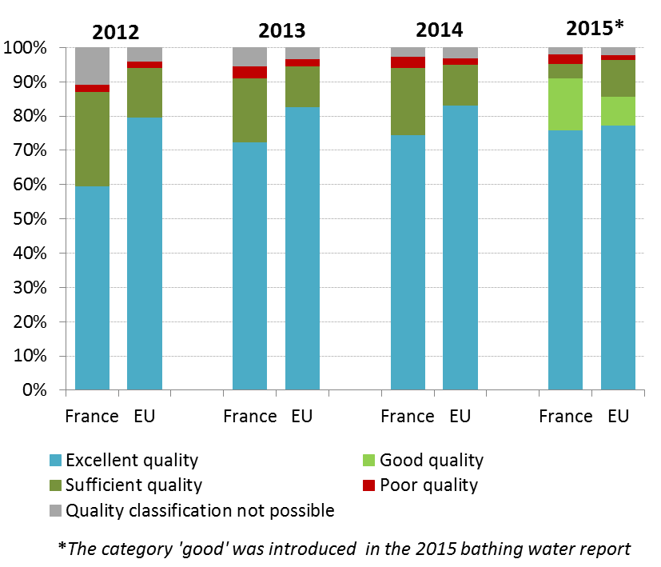
The implementation of the Urban Waste Water Treatment Directive is overall satisfactory in France. In 2012, in France, 100% of the waste water load was connected to a collecting system. Thus, 100% of the load was compliant in accordance with Article 3 of the Directive. 99.5% of the load collected is entering the treatment plants and 87.6% of this load was correctly treated as regards the secondary treatment requirement. As regards the more stringent treatment that concerned 45.6% of the collected load, 98.6% of this load collected was correctly treated in accordance with Article 5 of the Urban Waste Water Treatment Directive. The Commission was following-up on a little number of non-compliances in specific (small and large) agglomerations. The estimated investment needs (reported by France under Article 17 of the Urban Waste Water Treatment Directive) to reach full compliance with the Directive are of EUR 817 million .
France has established a transparent waste water policy (accessible here), it has also established a well-organised water governance system, based on river basin agencies with local representation and their own funding. The above ensures that decisions relative to water management are taken at a level close to the users, but also that all water users contribute to the cost of mitigation and restoration measures. Even if improvements are possible in terms of implementation, the system in place is, in many respects, a good example at European level.
Flood risk areas have already been identified and mapped in France. France is hit regularly by flooding incidents with serious economic damage costs.
Management and prevention of floods is an area where potentially more economical nature-based solutions could improve resource efficiency through reducing costs and delivering multiple benefits.
Suggested action
- Improve monitoring and assessment methods to resolve some uncertainties about the water status.
- Use feedback from the first RBMP and Programmes of measures to improve effectiveness of measures.
- Enhance measures to tackle the diffuse pollution from agriculture (nitrates).

Enhancing the sustainability of cities
The EU Policy on the urban environment encourages cities to implement policies for sustainable urban planning and design, including innovative approaches for urban public transport and mobility, sustainable buildings, energy efficiency and urban biodiversity conservation.
SDG11 aims at making cities and human settlements inclusive, safe, resilient and sustainable.
Europe is a Union of cities and towns; around 75% of the EU population are living in urban areas. The urban environment poses particular challenges for the environment and human health, whilst also providing opportunities and efficiency gains in the use of resources.
The Member States, European institutions, cities and stakeholders have prepared a new Urban Agenda for the EU (incorporating the Smart Cities initiative) to tackle these issues in a comprehensive way, including their connections with social and economic challenges. At the heart of this Urban Agenda will be the development of twelve partnerships on the identified urban challenges, including air quality and housing.
The European Commission will launch a new EU benchmark system in 2017.
The EU stimulates green cities through awards and funding, such as the EU Green Capital Award aimed at cities with more than 100,000 inhabitants and the EU Green Leaf initiative aimed at cities and towns, with between 20,000 and 100,000 inhabitants.
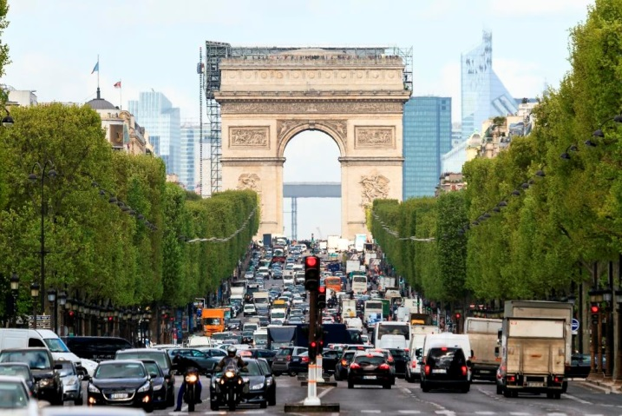France has allocated EUR 881 million under the European Regional Development Fund (ERDF) to sustainable urban development (SUD), on which the share dedicated to environmental issues is predominant. 250 cities have taken engagements on sustainable strategies for urban development. For example, Ile-de-France Region (which includes Greater Paris) will dedicate 20% of its whole operational program to SUD.
In its Energy Transition act of 2015, France has put up an objective of zero pesticide in all the public spaces of urban areas in France. This will forbid the use of phytosanitary products by public authorities on the road network and on public spaces from the 1 January 2017.
In 2015, an Institute for sustainable city (Vivapolis) has been created composed of a network of actors putting in common disciplines, expertise, and means to bring systemic sustainable solutions for cities by combining different approaches and fostering interdisciplinary solutions among the industry and public actors. This integrated approach will also focus on research and training.
France has put in place a label (EcoQuartier) that certifies the sustainability of city areas by the quality of governance (associating citizens, representatives, NGOs with tools for guaranteeing quality follow-up of projects) and promoting responsible management of resources and adaptation to climate change. 49 areas have been labelled at this stage.
As from 1st July 2016, Paris has forbidden circulation between 8am and 8pm to a large range of 4 wheeled motor vehicles entered into service before 1997 and 2 wheels vehicles entered into service before 1999; other diesel oriented restrictions will be implemented progressively by 2020.

International agreements
The EU Treaties require that the Union policy on the environment promotes measures at the international level to deal with regional or worldwide environmental problems.
Most environmental problems have a transboundary nature and often a global scope and they can only be addressed effectively through international co-operation. International environmental agreements concluded by the Union are binding upon the institutions of the Union and on its Member States. This requires the EU and the Member States to sign, ratify and effectively implement all relevant multilateral environmental agreements (MEAs) in a timely manner. This will also be an important contribution towards the achievement of the SDGs, which Member States committed to in 2015 and include many commitments contained already in legally binding agreements.
The fact that some Member States did not sign and/or ratify a number of MEAs compromises environmental implementation, including within the Union, as well as the Union’s credibility in related negotiations and international meetings where supporting the participation of third countries to such agreements is an established EU policy objective. In agreements where voting takes place it has a direct impact on the number of votes to be cast by the EU.
France has signed and ratified almost all MEAs. It has signed but not yet ratified the Protocol on Strategic Environmental Assessment to the Espoo Convention and the Nagoya Protocol.
France, a diverse country in particular thanks to its overseas and Mediterranean area, has included a chapter on the Nagoya Protocol in its Biodiversity Act that has been adopted in July 2016. This chapter contains national access measures to French genetic resources and traditional knowledge, compliance measures with the Nagoya Protocol (implementation of the EU Regulation 511/2014) and an article allowing the Government to ratify the Nagoya Protocol.

Part II: Enabling Framework: Implementation Tools

4. Market based instruments and investment

Green taxation and environmentally harmful subsidies
The Circular Economy Action Plan encourages the use of financial incentives and economic instruments, such as taxation to ensure that product prices better reflect environmental costs. The phasing out of environmentally harmful subsidies is monitored in the context of the European Semester and in national reform programmes submitted by Member States.
Taxing pollution and resource use can generate increased revenue and bring important social and environmental benefits.
In 2014, revenue from environmental taxes in France was equivalent to 2.05% of GDP. This has increased over the past decade almost matching the previous 11 year high of 2.06% in 2003. It is still below the EU average (2.46%). In the same year environmental tax revenues accounted for 4.47% of total revenues from taxes (excluding social-security contributions) (EU 28 average: 6.35%) as shown in Figure 11. The largest proportion of environmental tax revenues were collected through taxes on energy, at 1.63% of GDP. This has risen slightly since 2012, but is still below the level for the EU-28. Transport taxes (excl. transport fuels) comprised 0.28% of GDP in the same year, again, well below the level for the EU-28. Taxes on pollution and resources made up 0.15% of GDP. This has stayed relatively constant over the past decade, and is slightly higher than the level for the EU-28.
A 2016 study shows that there is considerable potential for shifting taxes from labour to environmental taxes in France. Under a good practice scenario, the amount could be as much as EUR 19.31 billion in 2018, rising to EUR 40.21 billion in 2030 (both in real 2015 terms). This is equivalent to an additional 0.84% and 1.43 % of GDP in 2018 and 2030, respectively.
The largest potential source of revenue would come from the suggested increase in vehicle taxes. This would account for EUR 26.75 billion in 2030 (real 2015 terms), equivalent to 0.95% of GDP.
The next largest contribution to revenue would come from the proposed amendments to the taxes on transport fuels. This would make EUR 7.06 billion in 2030 (real 2015 terms), equivalent to 0.25% of GDP.
The suggested passenger aviation tax would account for EUR 2.57 billion in 2030 (real 2015 terms), equivalent to 0.09% of GDP.
Figure 11: Environmental tax revenues as a share of total revenues from taxes and social contributions (excluding imputed social contributions) in 2014
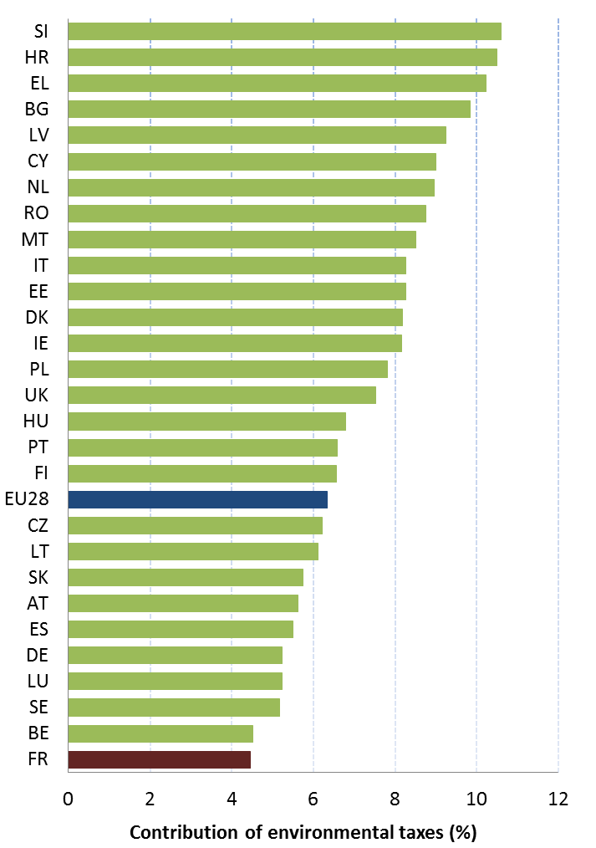
In its 2016 budget, the country continues to increase environmental taxation. The carbon tax will be raised from 14.5 to 22 EUR /tCO2 in 2016 and 30,5 EUR /tCO2 in 2017 with the objective to reach 56 EUR /tCO2 in 2020 and 100 EUR /tCO2 in 2030. In addition, the taxation gap between diesel and petrol will be further reduced (this has also been underlined by the OECD).
As a result of these two measures, excise duties on diesel has increased more than for unleaded petrol in 2016 (0.0299 EUR /litre and 0.0171 EUR /litre respectively). The gap between petrol (E10 quality) and diesel fuel was reduced by 0,02 EUR/L in 2015 and by 0,03 EUR/L in 2016. Including the carbon component, excise duties on diesel thus rose from 0,4284 EUR/L in 2014 to 0,4981 EUR/L in 2016 whereas excise duties on petrol rose from 0,6069 EUR/L in 2014 to 0,6212 EUR/L in 2016. The gap will be further reduced in 2017 to only 0,10 EUR/L (with 0,5307 EUR/L for diesel and 0,6307EUR/L for petrol.
The diesel/petrol tax ratio is currently standing at 80% (84% in 2014). In 2015, France was one of the few EU Member States without circulation tax for passenger cars. However it should be noted that France implements motorway charges whereas in some European countries motorways are free.
France is closing the gap with the EU average in terms of environmental taxation but scope for improvement remains, such as removing the taxation gap between diesel and petrol fuel.
In order to accelerate the phasing out of coal in France, a carbon price floor will be implemented in the French power sector in 2017. This national initiative is meant to have a political ripple effect on other European governments that would facilitate the introduction of soft price collar on the European carbon market as recommended in the Canfin-Grandjean-Mestrallet report - Aligning carbon pricing with the Paris Agreement (2016). Enhancing carbon pricing at the EU level, by fixing the price signal on the EU-ETS in particular, is critical to trigger low-carbon investments and meet the ambitious EU climate commitments.
Revenues from transport taxes are significantly lower in France than average in the EU (at 0.28% of GDP compared with the EU-28 level of 0.49% GDP).

Green Public Procurement
The EU green public procurement policies encourage Member States to take further steps to reach the target of applying green procurement criteria to at least 50% of public tenders.
Green Public Procurement (GPP) is a process whereby public authorities seek to procure goods, services and works with a reduced environmental impact throughout their life-cycle when compared to goods, services and works with the same primary function that would otherwise be procured.
The purchasing power of public procurement equals to approximately 14% of GDP. A substantial part of this money is spent on sectors with high environmental impact such as construction or transport, so GPP can help to significantly lower the impact of public spending and foster sustainable innovative businesses. The Commission has proposed EU GPP criteria.
The National Action Plan on Sustainable Public Procurement is the national strategy on GPP of France. This action plan was adopted and published in March 2015. At the national level the Action Plan aim to increase the share of environmental aspects in public procurement (6.7 % in 2013 in tenders above EUR 90,000 ex tax). The objective of the Action Plan is to reach 30 % in the whole public procurement.
There are legal objectives concerning: vehicles, dematerialized communication technology, sustainably managed wood, organic and sustainably-made food, the development of car-sharing transportation, and the making of a carbon footprint on the State buildings.

Investments: the contribution of EU funds
European Structural and Investment Funds Regulations provide that Member States promote environment and climate objectives in their funding strategies and programmes for economic, social and territorial cohesion, rural development and maritime policy, and reinforce the capacity of implementing bodies to deliver cost-effective and sustainable investments in these areas.
Making good use of the European Structural and Investment Funds (ESIF) is essential to achieve the environmental goals and integrate these into other policy areas. Other instruments such as the Horizon 2020, the LIFE programme and the EFSI may also support implementation and spread of best practice.
France has ERDF funding of EUR 8,426 million over the 2014-2020 programming period, and plans to use over EUR 1 billion or 15.0% to support directly environmental projects (under the "thematic objective n°6", see figure 12). The spending will come mainly in the areas of:
- Protection and enhancement of biodiversity and nature protection.
- Adaptation to climate change measures and prevention of climate change,
- Rehabilitation of industrial sites and contaminated land
- Household waste management: thermal treatment and incineration (in the overseas departments),
- Waste water treatment (in the overseas departments).

It is too early to draw conclusions as regards the use and results of ESIF for the period 2014-2020, as the relevant programmes are still in an early stage of their implementation.
During the previous planning period 2007-2013 in France, a similar sum was devoted to environmental projects, but a much smaller percentage (8.5%). Current data suggest that the EU funds for the 2007-2013 period were almost fully spent.
France has EARDF funding of EUR 9,909 million over the period 2014-2020 (before the first modification and before flexibility between the two pillars of the CAP which is reported to be 3-3.3% per year). The budget for agro-environmental-climate measures AECM represents 10% of the total EAFRD and is one of the ten lowest % allocations (EU average is 16.51%). However AEC measures receive the third largest share of the total EAFRD in France, and the forecasted national budget will be doubled in comparison with the previous programming period 2007-2013. Taking into account the budget dedicated to measures in favour of organic farming (which are now implemented according to a dedicated article of the regulation 1305/2013), the total budget dedicated to these measures is expected to increase from 180 M€/year during the period 2007-2013 to 360 M€/year on the current programming period. Besides, the 55.87% rate for P4 (one of the 6 priorities of EAFRD focused on water, biodiversity and soil protection,) includes the high contribution for less favoured areas LFA under measure 13: P4 should be reduced at 20% without LFA. France faces environmental pressures on air (in particular ammonia emissions from agriculture), biodiversity (by ensuring consistency with the prioritised action framework PAF at regional level) and soil (25% of the territory likely to be affected by landslides). Irrigation represents a significant pressure on the water resource in the southern part of the country.
Figure 12: European Structural and Investment Funds 2014-2020: Budget France by theme, EUR billion
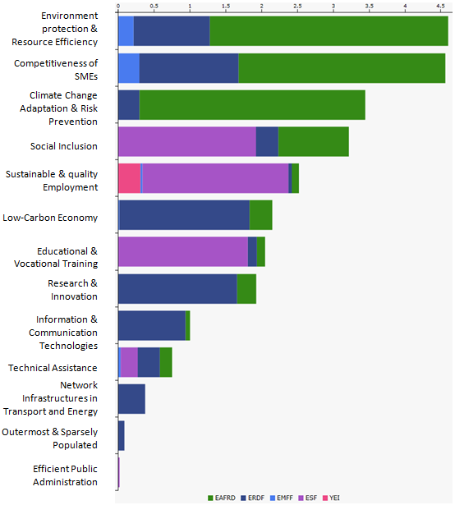
The contribution of the 30 regional development plans (RDPs), for the first time at regional level and first time steered by regional councils, including three national RDPs and 27 regional, is very diverse to cover environmental pressures.
A large part of the funds is managed at national level so there is little latitude to manoeuvre with regard to measures dedicated to young farmers, organic production, or natural constraints (which represents up to 2/.3 of total funds in some regions).
As regards to AEC measures, the national framework contains around 70 types of operation (TOs) validated by the European Commission, addressing various environmental issues. The content of the measures has been discussed since 2012 in partnership with all stakeholders involved (ministries of agriculture and environment, managing authorities, representatives of farmers, NGOs, scientists and technical experts).
Each managing authority specifies the strategy of intervention for its region in the Rural Development Program (according to the needs identified by a SWOT analysis), by identifying the areas with environmental issues and the TOs that can be used in these areas to address the issues. In addition, the content of some TOs of the national framework can be adjusted according to regional or sub-regional specificities.
Within each region, local operators submit agri-environmental-climate projects within the areas identified by the managing authority, in response to call for projects. The managing authority selects the projects which are the most relevant as regards to the environmental issues of the territory. .
In southern regions, where water resources are limited in summer, a number of water storage projects (in particular to reduce water withdrawals in summer) and possibly new irrigated areas are being considered. Their implementation will depend on dialogue with local populations and institutions and the projects will have to comply with the environmental regulations and financing rules in place in particular water framework Directive (WFD) and art 46 of EAFRD Regulation. Additional measures going beyond the obligations under the Nitrates Directive and the WFD need to be considered, in particular in the course of RDP modifications As in others EU countries, direct payments represent most of French farmers support (except on less favoured areas). The issue of the environment has progressively been introduced for direct payment by conditionality and greening. However the large choice for EFA with no indication whether inputs are allowed and the equivalence with maize monoculture for diversification, might undermine the environment impact of the greening.

5. Effective governance and knowledge

SDG 16 aims at providing access to justice and building effective, accountable and inclusive institutions at all levels. SDG 17 aims at better implementation, improving policy coordination and policy coherence, stimulating science, technology and innovation, establishing partnerships and developing measurements of progress.
Effective governance of EU environmental legislation and policies requires having an appropriate institutional framework, policy coherence and coordination, applying legal and non-legal instruments, engaging with non-governmental stakeholders, and having adequate levels of knowledge and skills. Successful implementation depends, to a large extent, on central, regional and local government fulfilling key legislative and administrative tasks, notably adoption of sound implementing legislation, co-ordinated action to meet environmental objectives and correct decision-making on matters such as industrial permits. Beyond fulfilment of these tasks, government must intervene to ensure day-to-day compliance by economic operators, utilities and individuals ("compliance assurance"). Civil society also has a role to play, including through legal action. To underpin the roles of all actors, it is crucial to collect and share knowledge and evidence on the state of the environment and on environmental pressures, drivers and impacts.
Equally, effective governance of EU environmental legislation and policies benefits from a dialogue within Member States and between Member States and the Commission on whether the current EU environmental legislation is fit for purpose. Legislation can only be properly implemented when it takes into account experiences at Member State level with putting EU commitments into effect. The Make it Work initiative, a Member State driven project, established in 2014, organizes a discussion on how the clarity, coherence and structure of EU environmental legislation can be improved, without lowering existing protection standards.

Effective governance within central, regional and local government
Those involved in implementing environment legislation at Union, national, regional and local levels need to be equipped with the knowledge, tools and capacity to improve the delivery of benefits from that legislation, and the governance of the enforcement process.

Capacity to implement rules
It is crucial that central, regional and local administrations have the necessary capacities and skills and training to carry out their own tasks and co-operate and co-ordinate effectively with each other, within a system of multi-level governance.
The 2013 European Quality of Government Index (EQI) puts France in 10th place out of the 28 Member States. The EQI shows notable cross-regional variation in France: with high performing regions (e.g. Brittany) ranking amongst the top EU regions, whilst others perform below the EU average.
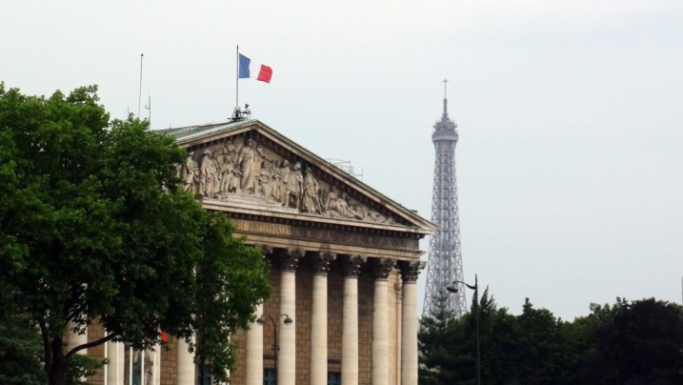
Impact assessments are important tools to ensure environmental integration in all government policies. The transposition of the revised EIA Directive will be an opportunity to streamline the regulatory framework on environmental assessments. The Commission encourages the streamlining of the environmental assessments because this approach reduces duplication and avoids unnecessary overlaps in environmental assessments applicable for a particular project. Moreover, streamlining helps reducing unnecessary administrative burden and accelerates decision-making, without compromising the quality of the environmental assessment procedure. The Commission has issued a guidance document in 2016 regarding the setting up of coordinated and/or joint procedures that are simultaneously subject to assessments under the EIA Directive, Habitats Directive, Water Framework Directive, and the Industrial Emissions Directive.

Coordination and integration
Priority Goal no. 7 of the 7th Environment Action Programme aims to "improve environmental integration and policy coherence". This objective underlines the challenge of a more effective integration of environmental and climate issues in other policies, and more consistent strategic and coordinated approaches. It is further stated that this requires:
"(i) integrating environmental and climate-related conditionalities and incentives in policy initiatives, including reviews and reforms of existing policy, as well as new initiatives, at Union and Member State level; […]
(v) addressing potential trade-offs in all policies in order to maximise synergies and avoid, reduce and, if possible, remedy unintended negative effects on the environment."
This is an important aspect of French policy.
To ensure the coherence and integration of environmental issues into all government policies, France has set up a system involving all ministries and stakeholders in society. The National Ecological Transition Council (CNTE) includes representatives of environmental protection associations, trades unions, employers' organizations, and associations representing civil society, local authorities and parliamentarians. The CNTE is consulted on national legislation and strategies on sustainable development.
Its task is also to prepare and follow environmental conferences. These annual conferences are an opportunity for stakeholders to discuss directly with Ministers the Government's work program on ecological transition. The implementation of the roadmaps it produces are subject to regular monitoring by the members of the CNTE, for which each department is accountable for the progress of commitments. More generally, the Interministerial Delegate for Sustainable Development coordinates public policy for ecological transition through the network of Senior Officials for Sustainable Development in each ministry. Impact assessments are important tools to ensure environmental integration in all government policies.
An autonomous national environmental authority provides opinions on the environmental impact assessment of major public plans and projects at national level (CGEDD). The OECD has highlighted the importance of this body.
France has recently revised its legislation relating to the regional organisation of the consultative authority having environmental responsibilities in order to align it to Directive 2001/42/EC (SEA). A body representing the national environmental authority will be set up in each of the 13 Regions. These bodies will be functionally separated from the public authorities in charge of approving plans and programmes with environmental effects.
Such a step should be taken regarding the 2011/92 EIA Directive in the framework of the transposition of its amending Directive (2014/52).
Suggested action
- Ensure that the opinion on the assessment of the effects of certain public and private projects on the environment referred to in Article 6 of the EIA Directive as amended is delivered by a functionally independent authority.

Compliance assurance
EU law generally and specific provisions on inspections, other checks, penalties and environmental liability help lay the basis for the systems Member States need to have in place to secure compliance with EU environmental rules.
Public authorities help ensure accountability of duty-holders by monitoring and promoting compliance and by taking credible follow-up action (i.e. enforcement) when breaches occur or liabilities arise. Compliance monitoring can be done both on the initiative of authorities themselves and in response to citizen complaints. It can involve using various kinds of checks, including inspections for permitted activities, surveillance for possible illegal activities, investigations for crimes and audits for systemic weaknesses. Similarly, there is a range of means to promote compliance, including awareness-raising campaigns and use of guidance documents and online information tools. Follow-up to breaches and liabilities can include administrative action (e.g. withdrawal of a permit), use of criminal law and action under liability law (e.g. required remediation after damage from an accident using liability rules) and contractual law (e.g. measures to require compliance with nature conservation contracts). Taken together, all of these interventions represent "compliance assurance" as shown in Figure 13.
Best practice has moved towards a risk-based approach at strategic and operational levels in which the best mix of compliance monitoring, promotion and enforcement is directed at the most serious problems. Best practice also recognises the need for coordination and cooperation between different authorities to ensure consistency, avoid duplication of work and reduce administrative burden. Active participation in established pan-European networks of inspectors, police, prosecutors and judges, such as IMPEL, EUFJE, ENPE and EnviCrimeNet, is a valuable tool for sharing experience and good practices.
Figure 13: Environmental compliance assurance
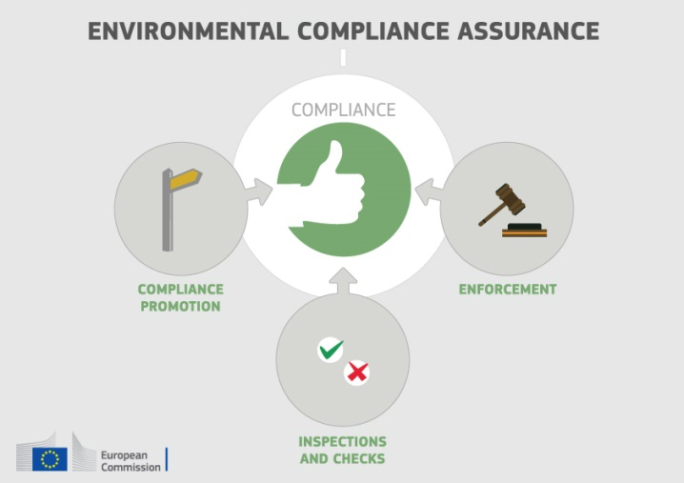
Currently, there exist a number of sectoral obligations on inspections and the EU directive on environmental liability (ELD) provides a means of ensuring that the "polluter-pays principle" is applied when there are accidents and incidents that harm the environment. There is also publically available information giving insights into existing strengths and weaknesses in each Member State.
For each Member State, the following were therefore reviewed: use of risk-based compliance assurance; coordination and co-operation between authorities and participation in pan-European networks; and key aspects of implementation of the ELD based on the Commission's recently published implementation report and REFIT evaluation.
France has established a range of positive measures to underpin compliance assurance, exemplified by the following:
- Preparation of annual national action plans with thematic priorities and multiannual strategic programmes for individual industrial sectors;
- Use of electronic databases at national and regional level for sharing inspections reports and measures taken to ensure compliance;
- Moves towards standardisation of tools for industrial inspections, such as methodologies for site visits, checklists and formal internal procedures for response to accidents and complaints;
- Use of a set of performance indicators for evaluation of effectiveness of inspection services which include parameters related not only to classic inspection work but also to enforcement activities and compliant handling
- Support for technical specialisation, including training for police officers dealing with environmental crime.
Up-to-date information is lacking in relation to the following:
- the extent to which risk-based methods are used to direct compliance assurance relation to specific problem-areas highlighted elsewhere in this Country Report, i.e. illegal landfills, the threats to protected habitat types and species, air quality breaches and the pressures on water quality from point and diffuse pollution, including deficient urban waste-water treatment infrastructure.
France has recognised the added value of structured mechanisms for inter-agency coordination. For instance, the OCLAESP, a national office located within the Gendarmerie, was established to co-ordinate enforcement on environmental and public health crime across enforcement agencies, including Customs and the National Hunting and Wildlife Agency (ONCFS). France is active within IMPEL and was amongst the founders of ENPE.
For the reporting period 2007-2013, France has not reported one single incident of environmental damage dealt with under the Environmental Liability Directive. The country has developed guidance for the application of the Directive with a strong focus on how to achieve effective remediation, but it applies a very high threshold of damage before the Directive is considered to apply. There is no mandatory financial security and, while the availability of environmental liability insurance schemes continues to grow, evidence of take-up by operators is lacking.
Suggested action
- Improve transparency on the organisation and functioning of compliance assurance and on how significant risks are addressed, as outlined above.
- The implementation of the Environmental Liability Directive (ELD) should be linked to the establishment of a national register of ELD incidents. It should moreover take further steps to ensure that the environmental liability insurance schemes keep growing in terms of offer and demand.

Public participation and access to justice
The Aarhus Convention, related EU legislation on public participation and environmental impact assessment, and the case-law of the Court of Justice require that citizens and their associations should be able to participate in decision-making on projects and plans and should enjoy effective environmental access to justice.
Citizens can more effectively protect the environment if they can rely on the three "pillars" of the Convention on Access to Information, Public Participation in Decision-making and Access to Justice in Environmental Matters ("the Aarhus Convention"). Public participation in the administrative decision making process is an important element to ensure that the authority takes its decision on the best possible basis. The Commission intends to examine compliance with mandatory public participation requirements more systematically at a later stage.
Access to justice in environmental matters is a set of guarantees that allows citizens and their associations to challenge acts or omissions of the public administration before a court. It is a tool for decentralised implementation of EU environmental law.
For each Member State, two crucial elements for effective access to justice have been systematically reviewed: the legal standing for the public, including NGOs and the extent to which prohibitive costs represent a barrier.
The French system of administrative appeal/judicial review in the environmental area is based on a clear set of rules that ensure legal certainty for all potential litigants in terms of predictability and transparency of rules related to access to justice. However, the costs for court procedures remain high in particular due to mandatory legal representation before the courts of major jurisdiction. These costs may constitute a barrier to access to the court in particular for small NGO, in case they do not qualify for legal aid .
Suggested action
- Evaluate the costs of legal challenges involving EU environmental law and pursue efforts in order to ensure that they are not prohibitively expensive.

Access to information and knowledge
The Aarhus Convention and related EU legislation on access to information and the sharing of spatial data require that the public has access to clear information on the environment, including on how Union environmental law is being implemented.
It is of crucial importance to public authorities, the public and business that environmental information is shared in an efficient and effective way. This covers reporting by businesses and public authorities and active dissemination to the public, increasingly through electronic means.
The Aarhus Convention, the Access to Environmental Information Directive and the INSPIRE Directive together create a legal foundation for the sharing of environmental information between public authorities and with the public. They also represent the green part of the ongoing EU e-Government Action Plan. The first two instruments create obligations to provide information to the public, both on request and actively. The INSPIRE Directive is a pioneering instrument for electronic data-sharing between public authorities who can vary in their data-sharing policies, e.g. on whether access to data is for free. The INSPIRE Directive sets up a geoportal which indicates the level of shared spatial data in each Member State – i.e. data related to specific locations, such as air quality monitoring data. Amongst other benefits it facilitates the public authorities' reporting obligations.
For each Member State, the accessibility of environmental data (based on what the INSPIRE Directive envisages) as well as data-sharing policies ('open data') have been systematically reviewed.
The 2016 OECD Environmental Performance Reviews states that "access to environmental information is of good quality: it is supported both by the role played by MEEM’s [ministry in charge of environment] Observation and Statistics Department in circulating information and by the many online data portals set up in recent years
France's performance on the implementation of the INSPIRE Directive as enabling framework to actively disseminate environmental information to the public is good. France has indicated in the 3-yearly INSPIRE implementation report that the necessary data-sharing policies allowing access and use of spatial data by national administrations, other Member States' administrations and EU institutions without procedural obstacles are available and implemented. No fundamental obstacles have been identified that impede data-sharing between authorities. The coming years France is likely to adopt an open data policy as part of "Towards a digital Republic" project that is currently under debate in the French Parliament.
Assessments of monitoring reports issued by France and the spatial information that France has published on the INSPIRE geoportal indicate that not all spatial information needed for the evaluation and implementation of EU environmental law has been made available or is accessible. The larger part of this missing spatial information consists of the environmental data required to be made available under the existing reporting and monitoring regulations of EU environmental law.
Suggested action
- Identify and document all spatial data sets required for the implementation of environmental law, and make the data and documentation at least accessible 'as is' to other public authorities and the public through the digital services foreseen in the INSPIRE Directive.

Communication "Delivering the benefits of EU environmental policies through a regular Environmental Implementation Review".COM(2016) 316 final:
Decision No. 1386/2013/EU of 20 November 2013 on a General Union Environmental Action Programme to 2020 "Living well, within the limits of our planet".
United Nations, 2015. The Sustainable Development Goals
This EIR report does not cover climate change, chemicals and energy.
European Commission, 2015. Proposed Circular Economy Package
Resource productivity is defined as the ratio between gross domestic product (GDP) and domestic material consumption (DMC).
Eurostat, Resource productivity, accessed October 2016
Eurostat, Resource productivity, accessed October 2016
The Flash 426 Eurobarometer defines "green job" as a job that directly deals with information, technologies, or materials that preserves or restores environmental quality. This requires specialised skills, knowledge, training, or experience (e.g. verifying compliance with environmental legislation, monitoring resource efficiency within the company, promoting and selling green products and services).
http://ec.europa.eu/COMMFrontOffice/publicopinion/index.cfm/Survey/getSurveyDetail/instruments/FLASH/surveyKy/2088 report page 126
Eco-innovation Observatory: Eco-Innovation scoreboard 2015
Waste Management Plans/Waste Prevention Programmes
Municipal waste consists of waste collected by or on behalf of municipal authorities, or directly by the private sector (business or private non-profit institutions) not on behalf of municipalities.
Eurostat, Municipal waste and treatment, by type of treatment method, accessed October 2016
Eurostat, Municipal waste and treatment, by type of treatment method, accessed October 2016
Eurostat, Recycling rate of municipal waste, accessed October 2016
Commissariat Général au Developpement Durable : "Indicateurs nationaux de la transition écologique vers un développement durable 2015-2020 : premier état des lieux, Etudes et documents n°142, mars 2016, p.17.
Member States may choose a different method than the one used by ESTAT (and referred to in this report) to calculate their recycling rates and track compliance with the 2020 target of 50% recycling of municipal waste.
Les éco-organismes: un dispositif original à consolider (2016) report by the French Court of Auditors.
Quel potential d'emplois pour une économie circulaire? (2015), study by Institut de l'Economie Circulaire.
Décret n° 2016-811 du 17 juin 2016 relatif au plan régional de prévention et de gestion des déchets
Sites of Community Importance (SCIs) are designated pursuant to the Habitats Directive whereas Special Areas of Protection (SPAs) are designated pursuant to the Birds Directive; figures of coverage do not add up due to the fact that some SCIs and SPAs overlap. Special Areas of Conservation (SACs) means a SCI designated by the Member States.
For each Member State, the Commission assesses whether the species and habitat types on Annexes I and II of the Habitats Directive, are sufficiently represented by the sites designated to date. This is expressed as a percentage of species and habitats for which further areas need to be designated in order to complete the network in that country. The current data, which were assessed in 2014-2015, reflect the situation up until December 2013.
The percentages in Figure 5 refer to percentages of the total number of assessments (one assessment covering 1 species or 1 habitat in a given biographical region with the Member State); if a habitat type or a species occurs in more than 1 Biogeographic region within a given Member State, there will be as many individual assessments as there are Biogeographic regions with an occurrence of that species or habitat in this Member State.
European Commission internal assessment.
The core of the ‘Article 17’ report is the assessment of conservation status of the habitats and species targeted by the Habitats Directive.
These figures show the percentage of biogeographical assessments in each category of conservation status for habitats and species (one assessment covering 1 species or 1 habitat in a given biographical region with the Member State), respectively. The information is based on Article 17 of the Habitats Directive reporting - national summary of France
Please note that a direct comparison between 2007 and 2013 data is complicated by the fact that Bulgaria and Romania were not covered by the 2007 reporting cycle, that the ‘unknown’ assessments have strongly diminished particularly for species, and that some reported changes are not genuine as they result from improved data/ monitoring methods.
Article 12 of the Birds Directive reporting - national summary of France
See http://agriculture.gouv.fr/sites/minagri/files/1608-ae-synthese-agroforesterie-gb-bd.pdf
Ecosystem services are benefits provided by nature such as food, clean water and pollination on which human society depends.
European Union, Green Infrastructure — Enhancing Europe’s Natural Capital, COM/2013/0249
European Environment Agency Draft results of CORINE Land Cover (CLC) inventory 2012; mean annual land take 2006-12 as a % of 2006 artificial land.
European Environment Agency, 2016. Imperviousness and imperviousness change, Figure 1
Eurostat, Soil water erosion rate, Figure 2, accessed November 2016
European Environment Agency, 2016. Land cover 2012 and changes country analysis [publication forthcoming]
European Union, Marine Strategy Framework Directive 2008/56/EC
The MSFD defines Good Environmental Status (GES) in Article 3 as: “The environmental status of marine waters where these provide ecologically diverse and dynamic oceans and seas which are clean, healthy and productive”
For 2016, France has indicated that In 2016 its French marine protected areas covered 88133 square kilometres of its marine waters, with 13650 square kilometres in the North Sea, 1695 square kilometres in the Celtic Sea, 21938 square kilometres in the Bay of Biscay and Iberian coast and 50850 square kilometres in the Western Mediterranean Sea.
Commission Staff Working Document Accompanying the Commission Report on "The first phase of implementation of the Marine Strategy Framework Directive (2008/56/EC) - The European Commission's assessment and guidance" (SWD(21014) 049 final and COM(2014)097 final)SWD(21014) 049 final and COM(2014)097 final)
European Commission, 2016. Air Quality Standards
See EIONET Central Data Repository and Air pollutant emissions data viewer (NEC Directive)
The current national emission ceilings apply since 2010 (Directive 2001/81/EC); revised ceilings for 2020 and 2030 have been set by Directive (EU) 2016/2284 on the reduction of national emissions of certain atmospheric pollutants, amending Directive 2003/35/EC and repealing Directive 2001/81/EC.
Particulate matter (PM) is a mixture of aerosol particles (solid and liquid) covering a wide range of sizes and chemical compositions. PM10 (PM2.5) refers to particles with a diameter of 10 (2.5) micrometres or less. PM is emitted from many human sources, including combustion.
Low level ozone is produced by photochemical action and it is also a greenhouse gas.
NOx is emitted during fuel combustion e.g. from industrial facilities and the road transport sector. NOx is a group of gases comprising nitrogen monoxide (NO) and nitrogen dioxide (NO2).
European Environment Agency, 2016. Air Quality in Europe – 2016 Report. (Table 10.2, please see details in this report as regards the underpinning methodology)
Based on European Environment Agency, 2016. Air Quality in Europe – 2016 Report. (Figures 4.1, 5.1 and 6.1)
See The EEA/Eionet Air Quality Portal and the related Central Data Repository
These figures are based on the Impact Assessment for the European Commission Integrated Clean Air Package (2013)
Under the provisions of the revised National Emission Ceilings Directive, Member States now may apply for emission inventory adjustments. Pending evaluation of any adjustment application, Member States should keep emissions under close control with a view to further reductions.
WHO/JRC, 2011, Burden of disease from environmental noise, Fritschi, L., Brown, A.L., Kim, R., Schwela, D., Kephalopoulos, S. (eds), World Health Organization, Regional Office for Europe, Copenhagen, Denmark
The Noise Directive requires Member States to prepare and publish, every 5 years, noise maps and noise management action plans for agglomerations with more than 100,000 inhabitants, and for major roads, railways and airports.
This includes the Bathing Waters Directive (2006/7/EC); the Urban Waste Water Treatment Directive (91/271/EEC) concerning discharges of municipal and some industrial waste waters; the Drinking Water Directive (98/83/EC) concerning potable water quality; the Water Framework Directive (2000/60/EC) concerning water resources management; the Nitrates Directive (91/676/EEC) and the Floods Directive (2007/60/EC)
Good ecological status is defined in the Water Framework Directive, in terms of the quality of the biological community, the hydrological characteristics and the chemical characteristics.
For groundwater, a precautionary approach has been taken that comprises a prohibition on direct discharges to groundwater, and a requirement to monitor groundwater bodies
Diffuse pollution comes from widespread activities with no one discrete source, e.g. acid rain, pesticides, urban run-off, etc.
Many European river basins and waters have been altered by human activities, such as land drainage, flood protection and building of dams to create reservoirs.
Good chemical status is defined in the Water Framework Directive in terms of compliance with all the quality standards established for chemical substances at European level.
ECJ ruling C-193/12 of 13/06/2013 on NVZ designation in France and ECJ ruling C-237/12 of 4/09/2014 on the Action programmes.
Commission's Synthesis Report on the Quality of Drinking Water in the Union examining Member States' reports for the 2011-2013 period, foreseen under Article 13(5) of Directive 98/83/EC; COM(2016)666
European Environment Agency, 2016. European bathing water quality in 2015
See footnote 55.
European Commission, Eighth Report on the Implementation Status and the Programmes for Implementation of the Urban Waste Water Directive (COM (2016)105 final) and Commission Staff Working Document accompanying the report (SWD(2016)45 final).
See footnote 57.
European Environment Agency, Urban environment
http://urbanagendaforthe.eu/
The Commission is developing an Urban Benchmarking and Monitoring ('UBaM') tool to be launched in 2017. Best practices emerge and these will be better disseminated via the app featuring the UBaM tool, and increasingly via e.g. EUROCITIES, ICLEI, CEMR, Committee of the Regions, Covenant of Mayors and others.
Protocol on Access to Genetic Resources and the Fair and Equitable Sharing of Benefits Arising from their Utilization to the Convention on Biological Diversity.
Eunomia Research and Consulting, IEEP, Aarhus University, ENT, 2016. Study on Assessing the Environmental Fiscal Reform Potential for the EU28. N.B. National governments are responsible for setting tax rates within the EU Single Market rules and this report is not suggesting concrete changes as to the level of environmental taxation. It merely presents the findings of the 2016 study by Eunomia et al on the potential benefits various environmental taxes could bring. It is then for the national authorities to assess this study and their concrete impacts in the national context. A first step in this respect, already done by a number of Member States, is to set up expert groups to assess these and make specific proposals.
The good practice scenario means benchmarking to a successful taxation practice in another Member State.
Eurostat, Environmental tax revenues, accessed October 2016
Examen environnementaux de l'OCDE, France, 2016, p. 147.
Eurostat, Environmental tax revenues, accessed June 2016
European Commission, 2015. Public procurement
In the Communication “Public procurement for a better environment” (COM /2008/400) the Commission recommended the creation of a process for setting common GPP criteria. The basic concept of GPP relies on having clear, verifiable, justifiable and ambitious environmental criteria for products and services, based on a life-cycle approach and scientific evidence base.
ESIF comprises five funds – the European Regional Development Funds (ERDF), the Cohesion Fund (CF), the European Social Fund (ESF), the European Agricultural Fund for Rural Development (EAFRD), and the European Maritime and Fisheries Fund (EMFF). The ERDF, the CF and the ESF together form the Cohesion Policy funds.
European Investment Bank, 2016 European Fund for Strategic Investments
Final data for the period 2007-2013 will only be available at the end of 2017.
European Commission, European Structural and Investment Funds Data By Country
The Commission has work ongoing to improve the country-specific knowledge about quality and functioning of the administrative systems of Member States.
Charron N., 2013. European Quality of Government Index (EQI)
Article 11 of the TFEU provides that "Environmental protection requirements must be integrated into the definition and implementation of the Union's policies and activities, in particular with a view to promoting sustainable development."
The transposition of Directive 2014/52/EU is due in May 2017.
European Commission, 2016. Commission notice — Commission guidance document on streamlining environmental assessments conducted under Article 2(3) of the Environmental Impact Assessment Directive (Directive 2011/92/EU of the European Parliament and of the Council, as amended by Directive 2014/52/EU).
Examen environnementaux de l'OCDE, France, 2016, p. 17.
European Union. Environmental Crime Directive 2008/99/EC .
European Union Network for the Implementation and Enforcement of Environmental Law
European Union Forum of judges for the environment
The European Network of Prosecutors for the Environment
EnviCrimeNet
European Union, Environmental Liability Directive 2004/35/CE
COM(2016)204 final and COM(2016)121 final of 14.4.2016. This highlighted the need for better evidence on how the directive is used in practice; for tools to support its implementation, such as guidance, training and ELD registers; and for financial security to be available in case events or incidents generate remediation costs.
See for details, 'Ensuring Environmental Compliance. Trends and Good Practices', OECD 2009, p. 113f.
For instance, within the Gendarmerie itself, about 800 officers across the country have received specialised training on wildlife crime. See 'Ensuring Environmental Compliance. Trends and Good Practices', OECD 2009, p. 115 and 123.
See study on access to justice in environmental matters: http://ec.europa.eu/environment/aarhus/access_studies.htm#
European Union, Directive 2003/4/EC on public access to environmental information
European Union, INSPIRE Directive 2007/2/EC
http://inspire.ec.europa.eu
European Union, EU eGovernment Action Plan 2016-2020 Accelerating the digital transformation of government COM(2016) 179 final
European Commission, INSPIRE reports
Inspire indicator trends
Inspire Resources Summary Report

