This report has been written by the staff of the Directorate-General for Environment, European Commission. Any comments are welcome to the following e-mail address: ENV-EIR@ec.europa.eu

More information on the European Union is available on the internet (http://europa.eu).

Photographs: p.10 ©LIFE09 ENV/SE/000348/Daniel Skog; p.13 ©ArtesiaWellsChristinaRahmArtesiaWell; p.15 ©Mikael_Broms/iStock; p.20 ©Marek SLUSARCZYK/iStock

For reproduction or use of these photos, permission must be sought directly from the copyright holder.

©European Union, 2017
Reproduction is authorised provided the source is acknowledged.
Table of Content
Executive summary 4
Part I: Thematic Areas 5
1. Turning the EU into a circular, resource-efficient, green and competitive low-carbon economy 5
Developing a circular economy and improving resource efficiency 5
Waste management 9
2. Protecting, conserving and enhancing natural capital 11
Nature and Biodiversity 11
Estimating natural capital 13
Green Infrastructure 13
Soil protection 13
Marine protection 14
3. Ensuring citizens' health and quality of life 16
Air quality 16
Noise 16
Water quality and management 17
Enhancing the sustainability of cities 19
International agreements 20
Part II: Enabling Framework: Implementation Tools 21
4. Market based instruments and investment 21
Green taxation and environmentally harmful subsidies 21
Green Public Procurement 22
Investments: the contribution of EU funds 22
5. Effective governance and knowledge 24
Effective governance within central, regional and local government 24
Compliance assurance 25
Public participation and access to justice 26
Access to information, knowledge and evidence 27

Executive summary

About the Environmental Implementation Review
In May 2016, the Commission launched the Environmental Implementation Review (EIR), a two-year cycle of analysis, dialogue and collaboration to improve the implementation of existing EU environmental policy and legislation. As a first step, the Commission drafted 28 reports describing the main challenges and opportunities on environmental implementation for each Member State. These reports are meant to stimulate a positive debate both on shared environmental challenges for the EU, as well as on the most effective ways to address the key implementation gaps. The reports rely on the detailed sectoral implementation reports collected or issued by the Commission under specific environmental legislation as well as the 2015 State of the Environment Report and other reports by the European Environment Agency. These reports will not replace the specific instruments to ensure compliance with the EU legal obligations.
The reports will broadly follow the outline of the 7th Environmental Action Programme and refer to the 2030 Agenda for Sustainable development and related Sustainable Development Goals (SDGs) to the extent to which they reflect the existing obligations and policy objectives of EU environmental law.
The main challenges have been selected by taking into account factors such as the importance or the gravity of the environmental implementation issue in the light of the impact on the quality of life of the citizens, the distance to target, and financial implications.
The reports accompany the Communication "The EU Environmental Implementation Review 2016: Common challenges and how to combine efforts to deliver better results", which identifies challenges that are common to several Member States, provides preliminary conclusions on possible root causes of implementation gaps and proposes joint actions to deliver better results. It also groups in its Annex the actions proposed in each country report to improve implementation at national level.
General profile
Sweden is a country with long coastlines, thousands of lakes, freshwater streams, mountains and deep forests. Sweden is an export-oriented mixed economy. Timber, hydropower and iron ore constitute the natural resource base of its economy, therefore sustainable management and use of these resources is crucial for sustainable development of Swedish economy. Certain aspects of the environmental status of seas, lakes, watercourses and ground waters, and of several terrestrial ecosystems, remain problematic, not least as regards eutrophication and biodiversity.
Main Challenges
The three main challenges with regard to implementation of EU environmental policy and law in Sweden are:
- Improving the status of habitats, in particular grassland, for which all types are in unfavourable conservation status.
- Improving the quality of the monitoring programme of SE marine waters.
- Reducing emissions of air pollutants.
Main Opportunities
Sweden could perform better on topics where there is already a good knowledge base and good practices. This applies in particular to:
- Reducing pressures from agriculture and natural systems modification, which would help move towards favourable status of birds and habitats.
Points of Excellence
Where Sweden is a leader on environmental implementation, innovative approaches could be shared more widely with other countries. Good examples are:
- The very good performance of Sweden on waste recycling; Sweden has reached the EU 2020 recycling rate target of 50% in 2014 (49.9%), being well ahead of the EU average (43%).
- In 2015 the government established an Environmental Objectives Council to strengthen the implementation of environmental policies. The Council is a platform for Heads of agencies that are strategically important for achieving environmental objectives.
- In 2014 the government adopted a strategy for biodiversity and ecosystem services. The strategy has significance not only for many of its own objectives and its generational goal but also for the international Aichi targets adopted under the Convention on Biological Diversity, as well as the objectives of the EU's biodiversity strategy.

Part I: Thematic Areas
- Turning the EU into a circular, resource-efficient, green and competitive low-carbon economy

Developing a circular economy and improving resource efficiency
The 2015 Circular Economy Package emphasizes the need to move towards a lifecycle-driven ‘circular’ economy, with a cascading use of resources and residual waste that is close to zero. This can be facilitated by the development of, and access to, innovative financial instruments and funding for eco-innovation.
SDG 8 invites countries to promote sustained, inclusive and sustainable economic growth, full and productive employment and decent work for all. SDG 9 highlights the need to build resilient infrastructure, promote inclusive and sustainable industrialization and foster innovation. SDG 12 encourages countries to achieve the sustainable management and efficient use of natural resources by 2030.

Measures towards a circular economy
Transforming our economies from linear to circular offers an opportunity to reinvent them and make them more sustainable and competitive. This will stimulate investments and bring both short and long-term benefits for the economy, environment and citizens alike.
As shown in Figure 1, Sweden has a level of resource productivity (how efficiently the economy uses material resources to produce wealth) that is below the EU average, with 1.74 EUR/kg (EU average is 2.0 EUR/kg) in 2015. This is largely due to the structure of the Swedish economy and its large primary sector. More significant is that Sweden's resource productivity has decreased modestly since 2010.
The context for the policies relating to eco-innovation and circular economy is the generational goal adopted by the Swedish Parliament, which is the overarching objective of environment policy and guides environmental action at every level of society, from the national level up to engagement at the EU and global levels. The goal is to pass on to the next generation a society in which the major environmental problems have been solved, without increasing environmental and health problems beyond Sweden’s borders. To attain the generational goal, national Environmental Quality Objectives (EQOs) have been formulated for 16 areas (Ministry of Environment). The objectives are related to climate, air quality, acidification, forest, wetlands, oceans and coasts, lakes, mountains, urban environment, agriculture, toxic substances, radiation, ozone, groundwater and biodiversity.
Figure 1: Resource productivity 2003-15
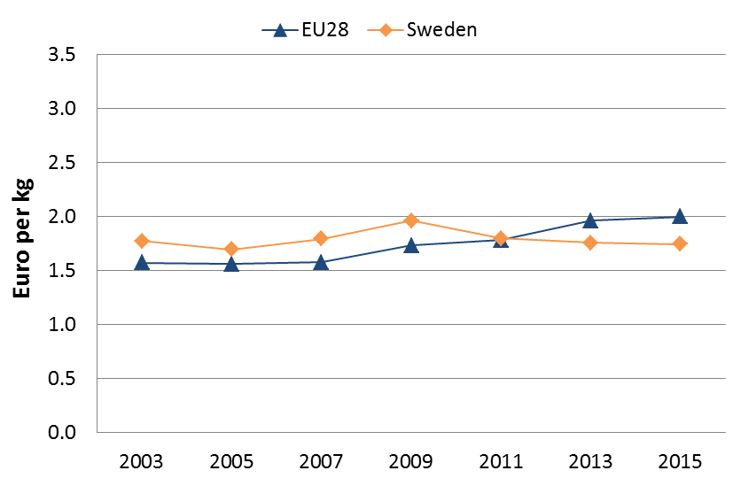
The National Environmental Technology Strategy, in use between 2011 and 2014, has been evaluated by the agency Growth Analysis. The evaluation concludes that the majority of the measures in the strategy can be considered to contribute, to some extent, to achieving the strategy goals, because these measures reached the target group identified by the government.
The government established a new agency for public procurement in September 2015. This agency is assigned to give support through consultation, practical tools and methods within the area of public procurement in general. The objective of the agency is to develop the idea of a good public deal with a focus on sustainable, innovative and efficient procurement. The agency puts extra emphasis on environmentally friendly procurement as an instrument to achieve the policy objectives in the environmental area. This is considered to contribute to sustainability in the wider sense, including social and economic dimensions.
A study from 2014 by the Swedish Agency for Growth Policy Analysis benchmarked the manufacturing sector of Sweden with other countries. The highest performing sectors in terms of the green innovation index and comparative advantage are motor vehicles, special-purpose machinery and furniture with 26%, 5% and 2% shares of green inventions, respectively, far above the world average in these sectors. These sectors also perform well in comparative advantage terms. They are clear strengths in green competitiveness terms and are well positioned to prosper in the future green economy.
The non-metallic mineral products sector also has remarkable performance in terms of green innovation activity, but does not currently enjoy a comparative advantage. This sector presents a clear opportunity to maintain and expand market share in the future through greening. Parts and accessories for motor vehicles and structural metal products, tanks, reservoirs and steam generators, are lagging behind competitor countries. However, they have high green patenting activity overall (7% and 8% green patents, respectively), which means they are probably not at risk.
Several sectors that fall into the ‘threats’ quadrant in the analysis are: telecommunication, paper and paper products, general-purpose machinery, and other chemical products.
The Swedish eco-tech industry has developed a strong position in waste management and processing technologies, including reuse and recycling, waste water purification, biogas and other renewable energy sources, indoor air quality (energy-saving ventilation and air filtration), heating and cooling technologies (district heating/cooling and heat pumps), power transmission and the automation of technical systems in buildings.
Start-ups are also important in an innovative society and the types of SMEs emerging can be an indicator of trends as they often depend in finance from organisations or people who are interested in investing in a particular business sector.
Being among the best achieving actors in Europe regarding the environment, Sweden has many good practices to share in a number of different sectors such as textiles and construction. SE is eager to exploit the new concepts of a sharing economy, industrial symbiosis, collaborative consumption, etc.

SMEs and resource efficiency
In 2010, Small and Medium-sized enterprises (SMEs) had already recovered from the crisis lows of 2009. In 2008-2014, their value added increased by 22%. Recovery in employment was not as strong, though SME employment was still 5% higher than in 2008.
Sweden's small business administration (SBA) profile stands well above the EU average in most areas. Better focused public support strategies to encourage SMEs to invest in resource-efficient measures and the production of green products will improve Swedish SMEs’ ability to face environmental challenges.
In the Flash 426 Eurobarometer "SMEs, resource efficiency and green markets", it is shown that 56% of Sweden's SMEs have invested up to 5% of their annual turnover in their resource efficiency actions (EU28 average 50%), 38% of them are currently offering green products and services (EU28 average 26%), 67% took measures to save energy (EU28 average 59%), 68% to minimise waste (EU28 average 60%), 43% to save water (EU28 average 44%), and 65% to save materials (EU28 average 54%). From a circular economy perspective, 60% took measures to recycle by reusing material or waste within the company (EU28 average 40%), 32% to design products that are easier to maintain, repair or reuse (EU28 average 22%) and 40% were able to sell their scrap material to another company (EU28 average 25%).
According to the Flash 426 Eurobarometer, the resource efficiency actions undertaken allowed the reduction of production costs in a 35% of the Sweden' SMEs (EU28 average 45%).
The number of SMEs in the Swedish ‘non-financial business economy’ is average for Europe. They account for 5% of value added and 66% of employment.
The Flash 426 Eurobarometer "SMEs, resource efficiency and green markets" shows that 39% of the SMEs in the Sweden have one or more full time employee working in a green job at least some of the time (EU28 average 35%). Sweden has an average number of 2.0 full time green employees per SME (EU28 average 1.7%).

Eco-innovation
With an overall score of 124.5, Sweden is fifth in the ranking on the Eco-Innovation Scoreboard. This is lower than the results of 2013, when Sweden held first place with 138.3 points. The Nordic countries have been successful in eco-innovation throughout 2010-2015. They have held rankings within the top five, and Sweden has been in the top three during 2011-2013, peaking in 2013 at first place. But the scores from 2015 are pointing at a trend where Sweden is losing at least some of its leading edge. In 2015, Denmark, Finland, Ireland and Germany have all overtaken Sweden.
This seems to be a result of a decline of Sweden’s eco-innovation performance, combined with an increase in absolute scores. In first place is Denmark, with a score of 166.5 (compared to Sweden’s leading score of 138.3 in 2013). Runner-up is Finland with a score of 140.2, with Ireland in the third place and Germany in the fourth.
Figure 2: Eco-Innovation Index 2015 (EU=100)
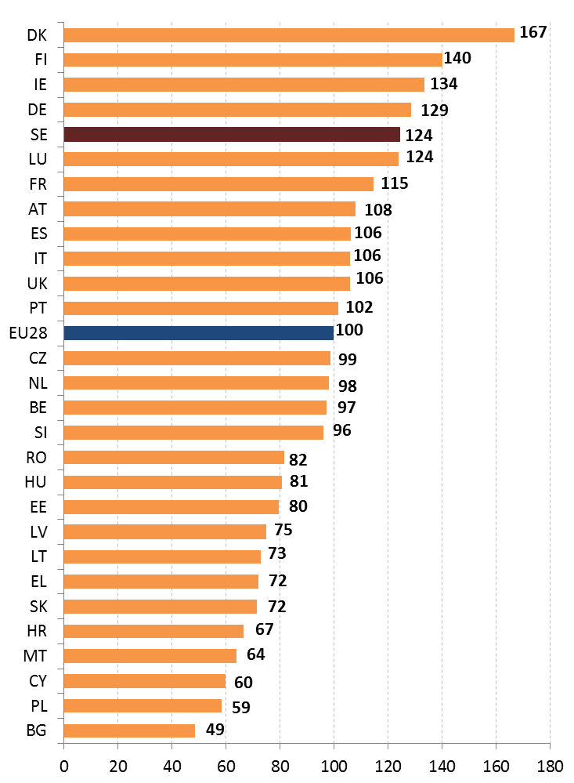
The most important driver is the overarching political ambition in Sweden to create green structural change by focusing on sustainable growth and eco-innovation. This is clearly manifested in the ‘generational goal’ – the overall goal of Swedish environmental policy – which defines the direction of the changes in society that need to occur within one generation if the country’s environmental quality objectives are to be achieved. With that as a starting point, the generational goal is intended to guide environmental action at every level in society. A number of important points have been added to it. One is that efforts to solve Sweden’s environmental problems must not come at the price of environmental and health problems being exported to other countries.
An All Party Committee on Environmental Objectives has been set up to secure broad political consensus on environmental issues. Its role is to advise the government on how the generational goal and the environmental quality objectives can be achieved in a way that is cost-effective in economic terms. The committee is made up of Members of Parliament, together with advisers and experts from non-governmental organisations and government ministries. Its overall remit runs to the end of 2020.
There is an explicit political ambition that by focusing on sustainable growth and eco-innovation at home Sweden will be able to contribute both to creating new jobs and to reducing the environmental burden in other countries. The great challenge to implement a green structural change is not limited to the environmental technology sector, but affects all industry sectors and thereby the whole economy. Even companies that deliver solutions in completely different areas of society will need to be environmentally sustainable. This is expressed in a recent report from EPA, which is already being used as a basis for new policy initiatives. This indicates that all industries and sectors will need to shift to a more environmentally driven business model.
Swedish companies have historically been able to respond and adapt quickly to new international market and economic circumstances – green structural change is actually nothing new but rather a desired continuation of the continuous transformation of the economy. Potentially, this is a great long-term driver for eco-innovation in Sweden.
There are some 30 national public stakeholders with connections to the environmental technology field. This constitutes a challenge to companies to find the right one(s), and also involves a risk of unnecessary work duplication and suboptimal use of public funds. The idea to involve all governmental stakeholders is to create as many channels as possible into the system of green structural change. The website Swedishcleantech.se is the official business-to-business (B2B) platform for Swedish companies, with the purpose of contributing to the development, commercialisation and export of Swedish environmental technology. It also aims to lead the company to the appropriate public actor. The website is operated and developed by the Swedish Agency for Economic and Regional Growth (Tillväxtverket) in cooperation with the authorities, industry and stakeholder associations, as well as regional environmental technology actors. The Association of Swedish Environmental Technology Industries (ASSET) is the umbrella organisation for the regional actors in the Swedish environmental technology sector. The organisation´s aim is to strengthen Swedish cleantech companies through business driven collaboration.
Studies show that Swedish companies have previously responded to regulatory drivers of eco-innovation. One study on eco-innovative measures in large Swedish companies found that – in addition to regulations – consumer demands and business opportunities (via cost reductions, for example) are presently considered as drivers .
According to a survey published by the European Commission, companies stated that the biggest obstacles to more investment in eco-innovation were uncertain market demand and uncertain return on investment, and almost the same number stated that obstacles connected with funding (such as access to own funding, insufficient availability of subsidies or tax relief) were serious obstacles . Swedish companies in the survey generally made the same assessment of the obstacles as other European companies. The most important driving forces for more investment in eco-innovation for both Swedish and European companies were expected and current energy prices and material prices. Furthermore, Swedish companies thought greater demand for green products, good business partners, and the availability of technology and leadership were important driving forces for investment in eco-innovation.
The main challenge identified is that there is no money for the early stages of business development and for companies that want to grow. The biggest obstacles to more venture capital investment in the cleantech sector are stated to be that measures are too capital-intensive, long-term and difficult to scale up, and that the risks related to both technology and policy are considered to be higher. All in all, this leads to environmental technology, and first and foremost the energy sector, becoming less attractive to private venture capital, which then tends to prefer small capital-intensive investments with lower risk and faster return on investment. Venture capital investments have decreased continuously in recent years, from close to 0.07% of GDP in 2007 to about 0.025% in 2014. The shortcomings in the state's venture capital activities consist in them not being active enough, being governed by sectoral and regional lock-ins, and being inefficient (Ministry of Industry, Employment and Communications, 2016).
To tackle this, Sweden has included the establishment of a green investment fund in the programmes for the Swedish use of EU regional funds 2014–2020, with the purpose of strengthening the supply of venture capital early stage funding to businesses in the climate and energy technologies and service sectors. The managing authority, the Swedish Agency for Economic and Regional Growth, is in the process of starting up this green fund.
The government also presented a bill in March 2016 with a proposal on a new structure to finance innovation and sustainable growth. This new structure was decided by the parliament in June 2016 and is now partly established.
The Swedish Environmental Technology Strategy and Growth Analysis evaluation
From 2011 to 2014, the Government of Sweden implemented an Environmental Technology Strategy with the following goals: increased commercialisation of innovative environmental technology, higher firm growth and increased exports from the environmental technology sector. SEK 400 million (about EUR 43 million) were allocated to the strategy. The Environmental Technology Strategy included 26 different measures that were carried out by 10 publicly funded agencies. Firms, and in some cases research institutes, have directly received 28% of the resources allocated. The remaining resources reached companies indirectly through the activities carried out by the authorities, such as cooperation projects, information, education, support in connection with international cooperation, etc. The strategy was very broad, and did not focus on any one specific area. The actual support that firms have received has also been small in relation to the factors that are known to affect environmental technology firms’ growth potential.
The Swedish Agency for Growth Policy Analysis (Growth Analysis) conducted a comprehensive evaluation of this strategy and its implementation. The report was published in March 2015, in which Growth Analysis concluded that it is unlikely that these goals will be achieved. For future initiatives to lead to a high level of growth in the environmental technology sector, Growth Analysis recommended that they include: (1) a clear focus on a limited area, (2) a greater reliance on evidence-based measures, and, (3) a balance between supply-side focused and demand-side focused measures. Additionally, further efforts need to be undertaken to identify and evaluate the types of activities that many of the measures in the strategy include, such as export promotion activities, in order to gather evidence on what effects they have on firms.
After the completion of the Environmental Technology Strategy, other measures have been integrated into other policy areas, for example in export policy and innovation policy. The Swedish government has decided on an export strategy in which environmental technology is an important component. The Government has also appointed a National Innovation Council which focuses on environmental and climate technology as one of three priorities. As an extension of the Innovation Council, five innovation partnership programmes have started, for example one on smart cities and one on circular bio-based economy.
Sweden has 18 EMAS registered organisation, which is a quite low with respect to the total of 4034 organisations that hold a registration. Sweden has not seen any changes in the number of registered organisation since October 2015.
Concerning the EU Ecolabel, Sweden has 24 licenses, which is quite a low number with respect to the 1875 total number of licenses.
Suggested action
- Strengthen the existing circular economy policy actions.
- Further facilitate green investments.

Waste management
Turning waste into a resource requires:
- Full implementation of Union waste legislation, which includes the waste hierarchy; the need to ensure separate collection of waste; the landfill diversion targets etc.
- Reducing per capita waste generation and waste generation in absolute terms.
- Limiting energy recovery to non-recyclable materials and phasing out landfilling of recyclable or recoverable waste.
SDG 12 invites countries to substantially reduce waste generation through prevention, reduction, recycling and reuse, by 2030.
The EU's approach to waste management is based on the "waste hierarchy" which sets out an order of priority when shaping waste policy and managing waste at the operational level: prevention, (preparing for) reuse, recycling, recovery and, as the least preferred option, disposal (which includes landfilling and incineration without energy recovery). The progress towards reaching recycling targets and the adoption of adequate WMP/WPP should be the key items to measure the performance of Member States. This section focuses on management of municipal waste for which EU law sets mandatory recycling targets.
Municipal waste generation has decreased in Sweden in 2014 (438 kg/y/inhabitant) and it remains below the EU average (475 kg/y/inhabitant).
Figure 3 depicts the municipal waste by treatment in Sweden in terms of kg per capita. Incineration accounts for 50% and landfilling only 1%. Sweden has taken appropriate steps to implement and to perform even better than the current European minimum targets.
Figure 3: Municipal waste by treatment in Sweden 2007-14
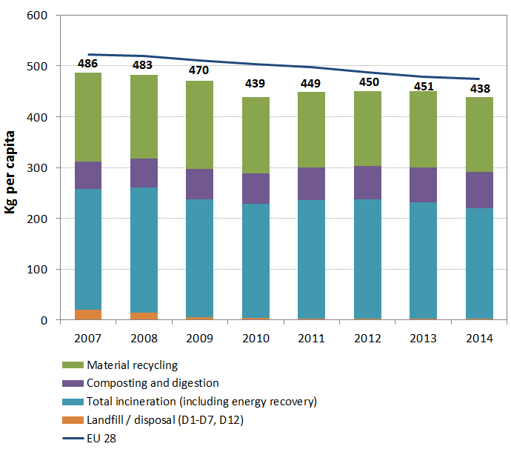
Figure 4 shows that Sweden has reached the EU 2020 recycling rate target of 50% in 2014 (49.9%), being well ahead of the EU average (43%).
Figure 4: Recycling rate of municipal waste 2007-14
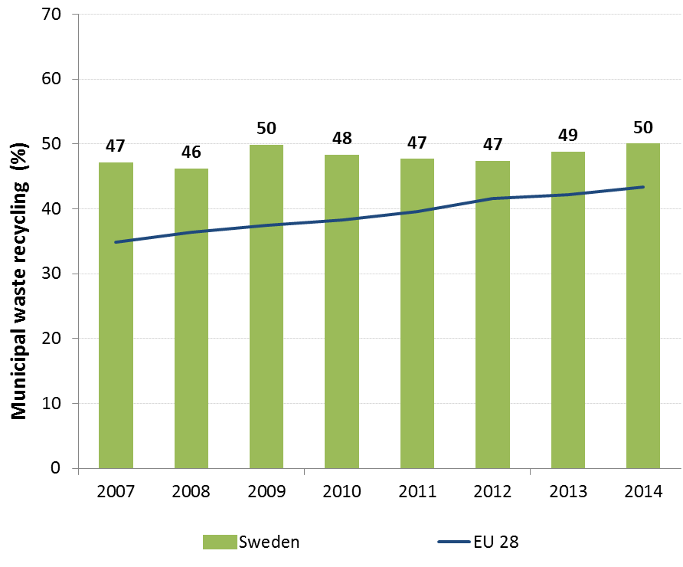
The Swedish waste management plan for the years 2012-2017 includes measures to promote material recycling and additional steps may be needed to meet future EU recycling targets.
Moving towards the targets of the Roadmap on Resource Efficiency, which outlines how we can transform Europe's economy into a sustainable one by 2050, could create over 2,300 additional jobs and increase the annual turnover of the waste sector by over EUR 240 million.
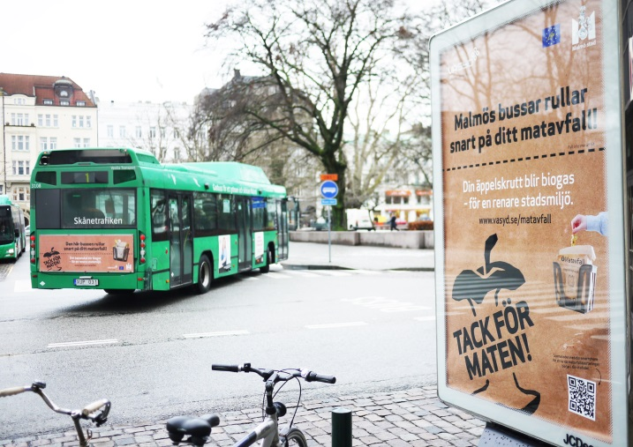Sweden has two official investigations working in the waste area: one on economic instruments and incineration and one on promoting reuse in order to prevent waste.
The Swedish EPA has different missions on waste, on better collection and treatment of waste textiles, on waste statistics and traceability, and on updating and revision of the waste management plan and the prevention programme. The Swedish government has decided to use economic instruments through taxation to stimulate repair and reuse.
Suggested action
- Introduce new policies, including economic instruments, to further reduce waste generation, and promote prevention, reuse and recycling.
- Shift reusable and recyclable waste away from incineration e.g. by gradually phasing out subsidies to incineration / introducing incineration taxes.

- Protecting, conserving and enhancing natural capital

Nature and Biodiversity
The EU Biodiversity Strategy aims to halt the loss of biodiversity in the EU by 2020, restore ecosystems and their services in so far as feasible, and step up efforts to avert global biodiversity loss. The EU Birds and Habitats Directives aim at achieving favourable conservation status of protected species and habitats.
SDG 14 requires countries to conserve and sustainably use the oceans, seas and marine resources, while SDG 15 requires countries to protect, restore and promote the sustainable use of terrestrial ecosystems, sustainably manage forests, combat desertification, and halt and reverse land degradation and halt biodiversity loss.
The 1992 EU Habitats Directive and the 1979 Birds Directive are the cornerstone of the European legislation aimed at the conservation of the EU's wildlife. Natura 2000, the largest coordinated network of protected areas in the world, is the key instrument to achieve and implement the Directives' objectives to ensure the long-term protection, conservation and survival of Europe's most valuable and threatened species and habitats and the ecosystems they underpin.
The adequate designation of protected sites as Special Ares of Conservation (SAC) under the Habitats Directive and as Special Protection Areas (SPA) under the Birds Directive is a key milestone towards meeting the objectives of the Directives. The results of Habitats Directive Article 17 and Birds Directive Article 12 reports and the progress towards adequate Sites of Community Importance (SCI)-SPA and SAC designation both in land and at sea, should be the key items to measure the performance of Member States.
The area covered by old forest and of protected forest is increasing. The conservation status of many forest types is still inadequate and many forest species are threatened.
The latest Red List of Sweden (2015) shows that the rate of biodiversity loss has neither increased nor decreased over the past 15 years. Logging in old-growth forests and overgrowth of habitats including meadows, pastures forests and wetlands pose a threat to majority of the species. However, positive trends can be seen e.g. with large carnivores.
By early 2016, 13.3% of the Swedish national territory was covered by Natura 2000 (EU average 18.1%), with Birds Directive SPAs covering 6.1% (EU average 12.3%) and Habitats Directive SCIs covering 13.2% (EU average 13.8%). There are altogether 4,082 Natura 2000 sites in Sweden.
Assessment of the SCI part of the Natura 2000 network shows that there are insufficiencies in designation, especially for the marine components of the network (see Figure 5).
Figure 5: Sufficiency assessment of SCI networks in Sweden based on the situation until December 2013 (%)
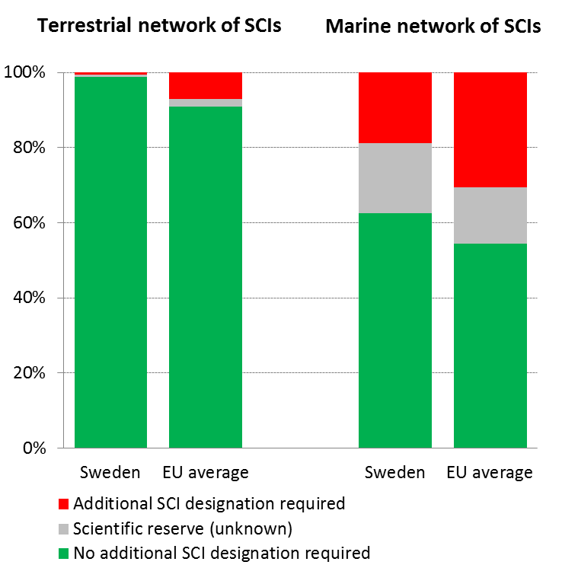
The process for the designation of the sites as special areas of conservation (SAC) is complete and all sites have a management plan.
Organisation of the Natura 2000 network in Sweden is good and their funding is not currently a critical issue. Sweden has good expertise on restoration of habitats and various restoration activities show good results e.g. on grasslands, bogs and sand dunes.
The level of nature-related complaints and infringements in Sweden is not very high. Main topics are about hunting of wolves (use of derogations), wind farms and other land use activities e.g. quarries and access to justice.
According to the Swedish report under Article 17 Habitats Directive, based on expert assessment, 26% of habitat assessments show favourable status (16% at EU27-level). Furthermore, 25% are considered to be unfavourable–inadequate (EU27: 47%) and 48% are unfavourable – bad (EU27 is 30%). Alarming is that 70-80% of forest, grassland and dune habitats' assessments are Unfavourable-Bad.

Figure 6: Conservation status of habitats and species in Sweden in 2007/2013 (%)
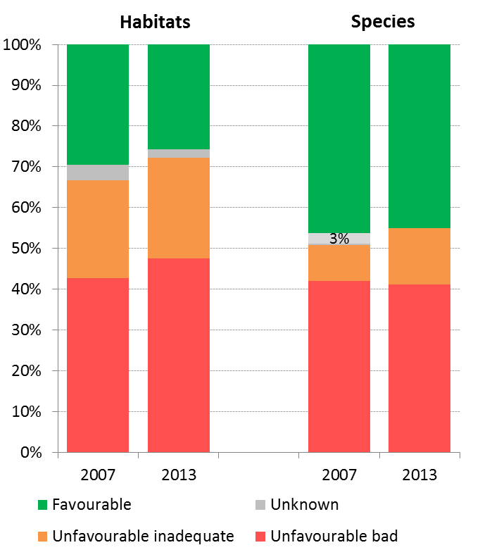
Concerning species assessments (other than birds) 45% are at favourable status (EU27: 23%), 14% at unfavourable-inadequate (EU27: 42%) and 41% unfavourable-bad status (EU27: 18%). This is depicted in Figure 6.
In addition, considerable part of the unfavourable assessments for species and habitats are reported to have further declining trend. Agriculture, natural systems modification, forestry (birds) and natural biotic/abiotic processes are the most frequently reported pressure categories of high importance. The same main pressure categories apply also for birds. However, animal farming is a necessary main factor when protecting grasslands and birds nesting in well grazed wetlands.
The results from the Article 12 report under Birds Directive show that short-term trends of breeding birds are improving for 22% of the species and stable for 26%, however decreasing even for 48% of the species. This is depicted in Figure 7. The same categories for long-term trends are 33%, 28% and 38%.
Figure 7: Short-term population trend of breeding and wintering bird species in Sweden in 2012 (%)
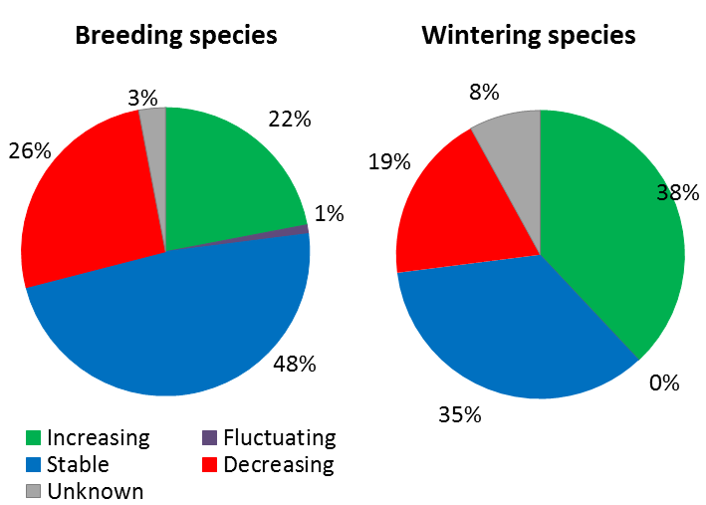

All grassland habitats and many of their associated species suffer from an unfavourable conservation status which indicates a substantial need for management and restoration of those habitats as well as a need to enlarge nationally protected areas.
Although Sweden has substantially invested in land purchase and compensation payments over the years to protect its forests (including use of LIFE funding), mainly in high latitude and high-altitude areas in Sweden, the expert based assessment of the Article 17 reporting clearly recognises further need to increase protection of the various forest habitats, if to achieve targets related to a favourable conservation status.
Suggested action
- Complete the SAC designation process especially the marine component and put in place clearly defined conservation objectives and the necessary conservation measures for the sites and provide adequate resources for their implementation in order to maintain/restore species and habitats of community interest to a favourable conservation status across their natural range.
- Improve the conservation status of forest, grassland and dune habitats.

Estimating natural capital
The EU Biodiversity Strategy to 2020 calls on the Member States to map and asses the state of ecosystems and their services in their national territory by 2014, assess the economic value of such services, and promote the integration of these values into accounting and reporting systems at EU and national level by 2020.
Sweden has produced a preliminary report on its most important ecosystem services. The inventory also considered pressures and driving forces that have an impact on the ecosystem services. Sweden will incorporate the ecosystem services assessments within the regional action plans for Green Infrastructure. There are ongoing projects on capacity building and awareness raising about the value of ecosystem services, and a research programme “The value of ecosystems and their services”. Statistics Sweden has been assigned to develop methods for including the value of ecosystem services in environmental accounting. These projects aim to contribute to one of the milestone targets of Sweden’s system of environmental objectives: "by 2018, the importance of biodiversity and the value of ecosystem services are to be generally known and integrated into economic positions, political considerations and other decisions in society where it is relevant and reasonable to do so".
Suggested action
Continue support to the mapping and assessment of ecosystems and their services, valuation and development of natural capital accounting systems.
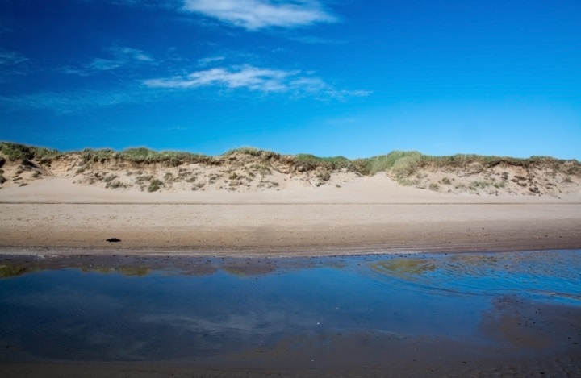

Green Infrastructure
The EU strategy on green infrastructure promotes the incorporation of green infrastructure into related plans and programmes to help overcome fragmentation of habitats and preserve or restore ecological connectivity, enhance ecosystem resilience and thereby ensure the continued provision of ecosystem services.
Green Infrastructure provides ecological, economic and social benefits through natural solutions. It helps to understand the value of the benefits that nature provides to human society and to mobilise investments to sustain and enhance them.
A planned national strategy for the building of a green infrastructure will constitute a tool for a more detailed identification of ecosystem services, and for the management of landscape structure and function that will promote the continued delivery of ecosystem services. The proposed strategy includes a landscape analysis of the spatial distribution and connectivity of important habitats, with the aim to maintain and restore sufficient natural habitats for the conservation of biodiversity and ecosystem services.
The Swedish Environmental Protection Agency (together with other government agencies) performed a review of policy instruments in the context of the preparation of the national strategy for the building of a green infrastructure. The report reviewed about a hundred different relevant existing policy instruments. There is a need to revise some instruments, as well as to create new instruments. Policy instruments that regulate the current use of land and water bodies need to be strengthened to achieve sustainable use in a landscape perspective.

Soil protection
The EU Soil Thematic Strategy highlights the need to ensure a sustainable use of soils. This requires the prevention of further soil degradation and the preservation of its functions, as well as the restoration of degraded soils. The 2011 Road Map for Resource-Efficient Europe, part of Europe 2020 Strategy provides that by 2020, EU policies take into account their direct and indirect impact on land use in the EU and globally, and the rate of land take is on track with an aim to achieve no net land take by 2050.
SDG 15 requires countries to combat desertification, restore degraded land and soil, including land affected by desertification, drought and floods, and strive to achieve a land-degradation-neutral world by 2030.
Soil is an important resource for life and the economy. It provides key ecosystem services including the provision of food, fibre and biomass for renewable energy, carbon sequestration, water purification and flood regulation, the provision of raw and building material. Soil is a finite and extremely fragile resource and increasingly degrading in the EU. Land taken by urban development and infrastructure is highly unlikely to be reverted to its natural state; it consumes mostly agricultural land and increases fragmentation of habitats. Soil protection is indirectly addressed in existing EU policies in areas such as agriculture, water, waste, chemicals, and prevention of industrial pollution.
The annual land take rate (growth of artificial areas) as provided by CORINE Land Cover was 0.36% in Sweden over the period 2006-12, well below the EU average (0.41%). It represented 2328 hectares per year mainly driven by housing, services and recreation as well as transport and infrastructures.
Artificial land cover is used for settlements, production systems and infrastructure. It may itself be split between built-up areas (buildings) and non-built-up areas (such as linear transport networks and associated areas). The percentage of built up land in 2009 was 0.48%, well below the EU average (3.23%).
The soil water erosion rate in 2010 was 0.41 tonnes per ha per year, well below EU28 average (2.46 tonnes) .
Figure 8 shows the different land cover types in Sweden in 2012.
Figure 8: Land Cover types in Sweden in 2012
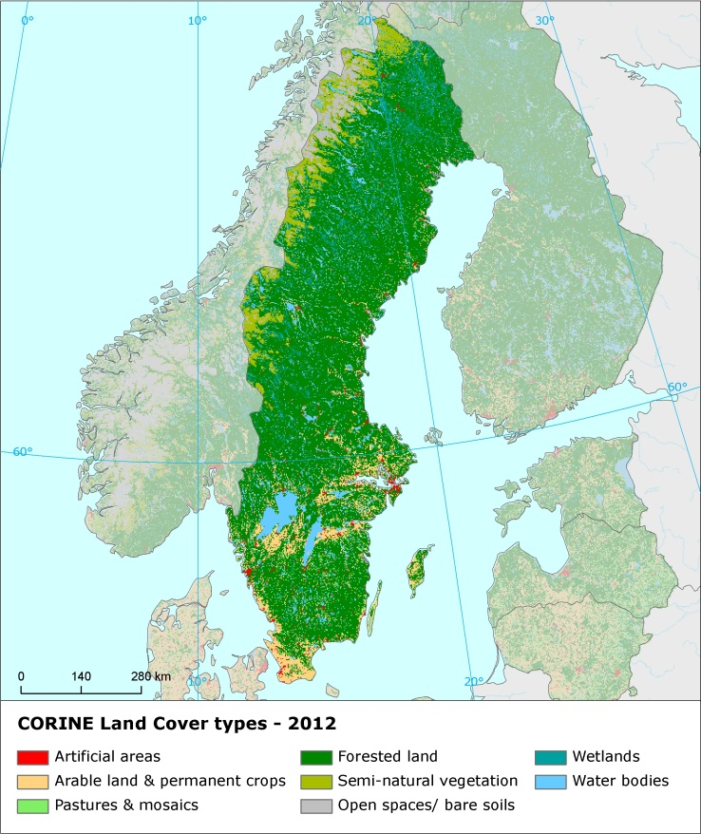
There are still not EU-wide datasets enabling the provision of benchmark indicators for soil organic matter decline, contaminated sites, pressures on soil biology and diffuse pollution. An updated inventory and assessment of soil protection policy instruments in Sweden and other EU Member States is being performed by the EU Expert Group on Soil Protection.

Marine protection
The EU Coastal and Marine Policy and legislation require that by 2020 the impact of pressures on marine waters is reduced to achieve or maintain good environmental status and coastal zones are managed sustainably.
SDG 14 requires countries to conserve and sustainably use the oceans, seas and marine resources for sustainable development.
The Marine Strategy Framework Directive (MSFD) aims to achieve Good Environmental Status (GES) of the EU's marine waters by 2020 by providing an ecosystem approach to the management of human activities with impact on the marine environment. The Directive requires Member States to develop and implement a marine strategy for their marine waters, and cooperate with Member States sharing the same marine region or subregion.
As part of their marine strategies, Member States had to make an initial assessment of their marine waters, determine GES and establish environmental targets by July 2012. They also had to establish monitoring programmes for the on-going assessment of their marine waters by July 2014. The next element of their marine strategy is to establish a Programme of Measures (2016). The Commission assesses whether these elements constitute an appropriate framework to meet the requirements of the MSFD.
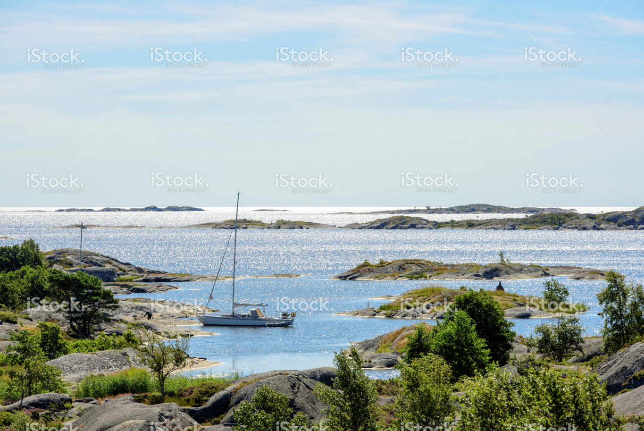The Swedish marine waters are part of two marine regions, the North-East Atlantic Ocean and the Baltic Sea. Sweden is therefore party to both the Convention for the protection of the marine environment of the North-East Atlantic (OSPAR Convention) and the Convention on the Protection of the Marine Environment of the Baltic Sea (HELCOM). The North Sea is one of the busiest maritime areas, also subject to eutrophication, and the coastal zone is used intensively for recreation. In addition, there is extensive fishing by bottom trawling which causes damage to the sea-floor and is a threat to its biodiversity, particularly in open sea areas. In the Baltic Sea, the main risks for biodiversity relate to eutrophication, fishing pressure, pollution by contaminants and oil, and introduction of non-indigenous species.
With regard to the implementation of the MSFD, Sweden has given a robust legal status to its GES definition by incorporating it in legislation, which is a good practice. Sweden’s GES are set in comprehensive manner, covering all descriptors, and taking into account existing EU law and other standards from the relevant Regional Sea Conventions. However, despite an ambitious determination of the GES, all too often, the GES set remain difficult to measure. Sweden is currently working both at a national and at a regional level to develop the GES. For example, the GES is currently being reviewed by the Swedish Agency for Marine and Water Management and Sweden participates in regional cooperation under both HELCOM and OSPAR with a view to improve the GES definition.
Sweden established a monitoring programme of its marine waters in 2014, however it seems that its monitoring programme needs further refinement except for commercial fisheries and eutrophication, to constitute an appropriate framework to monitor progress towards GES and targets.
In its reports on the implementation of the MSFD, the Commission provided guidance to assist Sweden in its implementation of the Marine Strategy Framework Directive.
In 2012, Swedish marine protected areas covered 12,710.4 square kilometers of its marine waters, with 9,644.6 square kilometers in the Baltic Sea and 3,065.8 square kilometers in the North Sea.
Suggested action
- Continue work to improve the definitions of GES in particular for biodiversity descriptors, including through regional cooperation by using the work of the relevant Regional Sea Conventions.
- Further develop approaches assessing (and quantifying) impacts from the main pressures in order to lead to improved and more conclusive assessment results for 2018 reporting.
- Continue to integrate already existing monitoring programmes under EU legislation and continue to implement, where they exist, coordinated and joint monitoring programmes developed at subregional level, for instance by OSPAR and HELCOM.
- Continue to enhance comparability and consistency of monitoring methods within the country's marine regions.
- Ensure that all of its monitoring programme is implemented without delay, and is appropriate to monitor progress towards its GES.

- Ensuring citizens' health and quality of life

Air quality
Figure 9: Attainment situation for PM10, NO2 and O3 in 2014 in Sweden
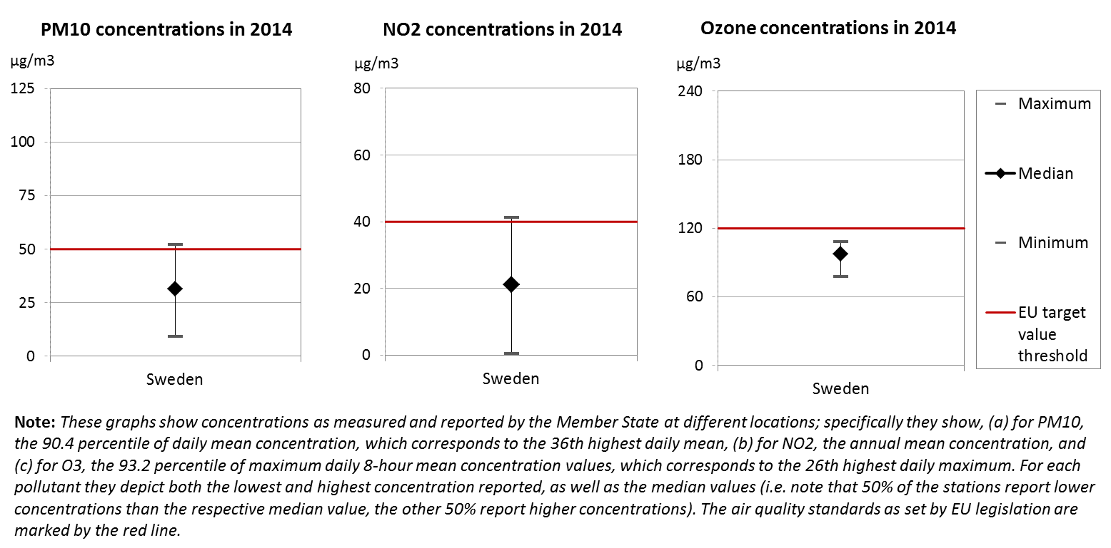
The EU Clean Air Policy and legislation require that air quality in the Union is significantly improved, moving closer to the WHO recommended levels. Air pollution and its impacts on ecosystems and biodiversity should be further reduced with the long-term aim of not exceeding critical loads and levels. This requires strengthening efforts to reach full compliance with Union air quality legislation and defining strategic targets and actions beyond 2020.
The EU has developed a comprehensive suite of air quality legislation, which establishes health-based standards and objectives for a number of air pollutants. As part of this, Member States are also required to ensure that up-to-date information on ambient concentrations of different air pollutants is routinely made available to the public. In addition, the National Emission Ceilings Directive provides for emission reductions at national level that should be achieved for main pollutants.
The emission of several air pollutants has decreased significantly in Sweden. Reductions between 1990 and 2014 for sulphur oxides (-77%), nitrogen oxides (-51%), ammonia (-5%) as well as volatile organic compounds (-50%) ensure air emissions for these pollutants are within the currently applicable national emission ceilings.
At the same time, air quality in Sweden continues to give cause for concern. For the year 2013, the European Environment Agency estimated that about 3 020 premature deaths were attributable to fine particulate matter concentrations, 160 to ozone concentration and less than five to nitrogen dioxide concentrations. This is due also to exceedances above the EU air quality standards such as shown in Figure 9.
For 2014, exceedances above the EU air quality standards have been registered related to annual mean concentration of nitrogen dioxide (NO₂) in two air quality zones (Gothenburg, and Stockholm) and related to daily concentration of particulate matter (PM₁₀) in two air quality zones (Stockholm, and Middle Sweden). Furthermore, for several air quality zones the long-term objectives regarding ozone concentration are not being met.
The persistent breaches of air quality requirements (for PM₁₀ and NO₂), which have severe negative effects on health and environment, are being followed up by the European Commission through infringement procedures covering all the Member States concerned, including Sweden. The aim is that adequate measures are put in place to bring all zones into compliance.
It is estimated that the health-related external costs from air pollution in Sweden are above EUR 3 billion/year (income adjusted, 2010), which include not only the intrinsic value of living a full health life but also direct costs to the economy. These direct economic costs relate to 803 thousand workdays lost each year due to sickness related to air pollution, with associated costs for employers of EUR 111 million/year (income adjusted, 2010), for healthcare of above EUR 11 million/year (income adjusted, 2010), and for agriculture (crop losses) of EUR 48 million/year (2010).
Suggested action
- Maintain downward emissions trends of air pollutants in order to achieve full compliance with air quality limit values - and reduce adverse air pollution impacts on health, environment and economy.
- Reduce nitrogen oxide (NO_{x}) emissions to comply with currently applicable national emission ceilings and/or to reduce nitrogen dioxide (NO₂) (and ozone concentrations), inter alia, by reducing transport related emissions - in particular in urban areas.
- Reduce PM₁₀ emission and concentration, inter alia, by reducing emissions related to energy and heat generation using solid fuels, to transport and to agriculture.
Noise
The Environmental Noise Directive provides for a common approach for the avoidance, prevention and reduction of harmful effects due to exposure to environmental noise.
Excessive noise is one of the main causes of health issues. To alleviate this, the EU acquis sets out several requirements, including assessing the exposure to environmental noise through noise mapping, ensuring that information on environmental noise and its effects is made available to the public, and adopting action plans with a view to preventing and reducing environmental noise where necessary and to preserving the acoustic environment quality where it is good.
Swedish authorities have fulfilled all their obligations with regards to noise mapping for the most recent reporting round, for the reference year 2011 in the Environmental Noise Directive. Action plans for noise management in the current period have been adopted for all major roads, major railways and major airports. For agglomerations, the action plan for one agglomeration is still outstanding.
Suggested action
- Complete action plan for noise management for the last outstanding agglomeration.

Water quality and management
The EU water policy and legislation require that the impact of pressures on transitional, coastal and fresh waters (including surface and ground waters) is significantly reduced to achieve, maintain or enhance good status of water bodies, as defined by the Water Framework Directive; that citizens throughout the Union benefit from high standards for safe drinking and bathing water; and that the nutrient cycle (nitrogen and phosphorus) is managed in a more sustainable and resource-efficient way.
SDG 6 encourages countries to ensure availability and sustainable management of water and sanitation for all.
The main overall objective of EU water policy and legislation is to ensure access to good quality water in sufficient quantity for all Europeans. The EU water acquis seeks to ensure good status of all water bodies across Europe by addressing pollution sources (from e.g. agriculture, urban areas and industrial activities), physical and hydrological modifications to water bodies) and the management of risks of flooding.
River Basin Management Plans (RBMPs) are a requirement of the Water Framework Directive and a means of achieving the protection, improvement and sustainable use of the water environment across Europe. This includes surface freshwaters such as lakes and rivers, groundwater, estuaries and coastal waters up to one nautical mile.
In its first generation of RBMPs Sweden reported the status of 15,563 rivers, 7,232 lakes, 21 transitional, 602 coastal and 3,021 groundwater bodies. 58% of natural surface water bodies achieve a good or high ecological status and only 2% of heavily modified or artificial water bodies achieve a good or high ecological potential (while the status of 20% is unknown). None of surface water bodies, none of heavily modified and artificial water bodies and 98% of groundwater bodies achieve good chemical status. 87% of groundwater bodies are in good quantitative status.
The main pressure on Swedish surface waters is diffuse pollution, especially long range transported mercury, which affects 100% of water bodies. Flow regulation and morphological alterations affect 29% and river management affects negatively 8% of water bodies. There are some regional differences, e.g. low regulation and morphological alterations affect 42% in the North Baltic river basin district but much smaller proportion of water bodies in the North and West of the country.
The Swedish River Basin Management Plans have some deficiencies that result in uncertainties about the status and effectiveness of Programmes of Measures. In particular there are weaknesses in monitoring. A number of exemptions were applied. The planned measures are expected to result in improvement of ecological status of surface water bodies by 6%. The measures should also bring improvement of ecological potential of artificial and heavily modified water bodies by 4%⁶².
The Nitrates Directive 2008-2011 reporting showed positive results in terms of nitrates concentrations; however data on eutrophication of inland waters showed the need for further improvements. Additionally, Sweden is one of the countries bordering the Baltic Sea, which is heavily affected by nutrients pollution.
As regards drinking water, Sweden reaches very high compliance rates of 99-100% for microbiological, chemical and indicator parameters laid down in the Drinking Water Directive.
As shown in Figure 10, in 2015, in Sweden, out of 445 bathing waters, 62.2% were of excellent quality, 17.3% of good quality, 3.6% of sufficient quality. 10 bathing waters were of poor quality or non-compliant while it was not possible to assess the remaining 64 bathing waters. Overall, Sweden's bathing water quality has improved since 2014.
Figure 10: Bathing water quality 2012 – 2015
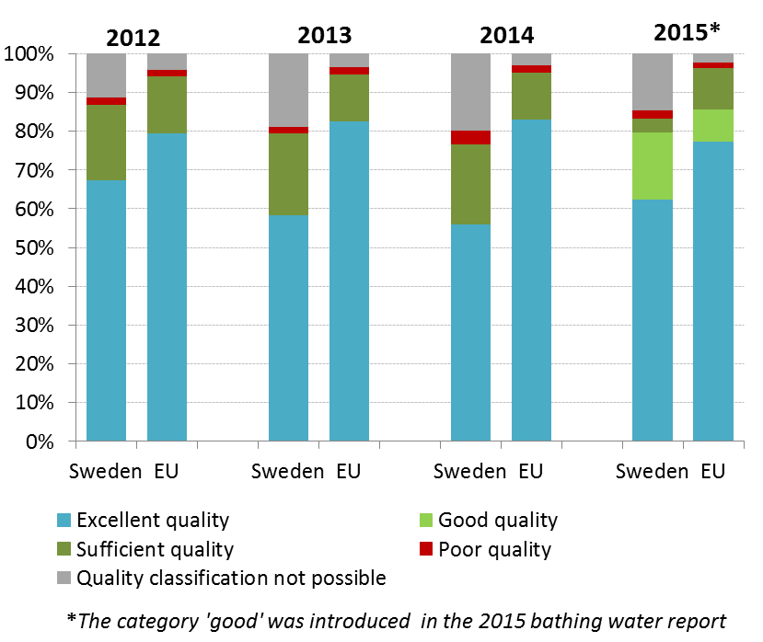
With regard to the implementation of the Urban Waste Water Treatment Directive, in the latest reporting exercise (data from 2012) Sweden reported 367 relevant agglomerations which represents an increase from 327 agglomerations in the year 2010.Following information by Swedish authorities, the generated waste water load changed due to a new calculation methodology. This reporting and calculation issue needs to be resolved by the Swedish authorities to ensure certainty in the figures that are communicated to the Commission.
Sweden also reported that in 2012, 88.9% of the waste water load collected is subject to more stringent treatment in accordance with Article 5 of the Urban Waste Treatment Directive – amounting to 116 agglomerations out of 155 subject to those obligations.
The Commission is following-up on a number of issues in Sweden, as regards the urban waste water treatment in both small and large agglomerations, by means of infringements.
Sweden undertook a preliminary assessment of the risk of flooding from rivers and lakes only as the majority of historical floods are of this type. Sweden has up to now been relatively spared from serious flooding. However, with increasing temperatures above global average, and changing precipitation patterns the risk of flooding in parts of the country will increase.
Between 2002 and 2013, for the one flood recorded the total direct costs were EUR 320 million. The average cost per flood was EUR 320 million, close to the EU average of EUR 370 million. Between 2002 and 2013, EUR 289 million was invested in flood risk management measures, equivalent to EUR 26 million per year on average. EUR 183 million was from EU funds (but not all of this total may have been used for flood risk management).
Suggested action
- Improve the water monitoring system and status assessment.
- Cover all identified pressures and implementation gaps with Programmes of Measures that should be adequately funded.
- Review and improve measures to reduce hydromorphological pressure in river basins. Also, licencing policy to allow or maintain hydropower plants should be reviewed and updated.

Enhancing the sustainability of cities
The EU Policy on the urban environment encourages cities to implement policies for sustainable urban planning and design, including innovative approaches for urban public transport and mobility, sustainable buildings, energy efficiency and urban biodiversity conservation.
SDG11 aims at making cities and human settlements inclusive, safe, resilient and sustainable.
Europe is a Union of cities and towns; around 75% of the EU population are living in urban areas. The urban environment poses particular challenges for the environment and human health, whilst also providing opportunities and efficiency gains in the use of resources.
The Member States, European institutions, cities and stakeholders have prepared a new Urban Agenda for the EU (incorporating the Smart Cities initiative) to tackle these issues in a comprehensive way, including their connections with social and economic challenges. At the heart of this Urban Agenda will be the development of twelve partnerships on the identified urban challenges, including air quality and housing.
The European Commission will launch a new EU benchmark system in 2017.
The EU stimulates green cities through awards and funding, such as the EU Green Capital Award aimed at cities with more than 100,000 inhabitants and the EU Green Leaf initiative aimed at cities and towns, with between 20,000 and 100,000 inhabitants.
Stockholm was the first winner of the European Green Capital Award in 2010. Stockholm introduced a number of measures to make local transport more sustainable, including the promotion of bicycle lanes and public transport, use of alternative fuels and road pricing. Road pricing was introduced in 2006 in the form of a congestion tax. The tax is imposed on Swedish registered vehicles driving in and out of the Stockholm inner city zone on weekdays. Consequently, traffic work and emissions in the city centre are down by 10-15%. The city has taken action to reduce traffic noise: Proactive actions, regulations, planning and reduction of noise at the source. Furthermore, Stockholm has adopted an ambitious planning strategy, aimed at building the city inwards.
In Malmö, the SYSAV Waste to Energy plant in Malmö is the most energy efficient plant in Sweden producing district heating. The Traffic Environment Programme aims to foresee Malmö to become quieter, more efficient, cleaner, as well as to reduce its impact on the health of Malmö inhabitants. Measures aim to: reduce fossil fuels; improve air quality; reduce noise; and increase cycling, walking and public transport. Malmö’s large‐scale new development area, the Western Harbour (or Västra Hamnen), since initial planning stages, transport strategies were incorporated to prioritise collective transport, cycles and pedestrians ahead of cars to reduce the environmental impact. The world’s first botanical roof garden was launched in 1999 in Malmo co-financed by the LIFE programme. It cover almost one hectare, and is a unique attraction for Malmö and Sweden.
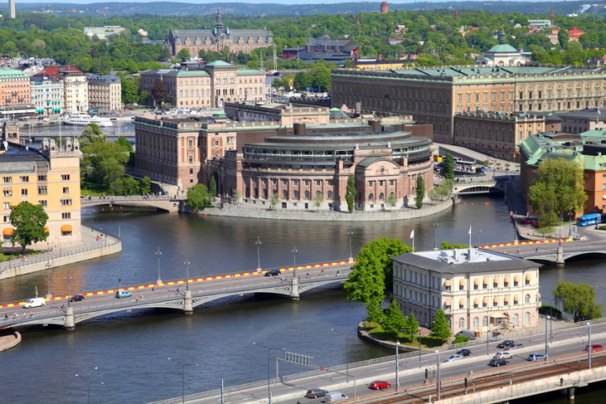Umea has developed an impressive tool called the ‘Green Target’ that is used as a quality control in the planning process. It is the objective of Umea to ensure that all citizens have access to facilities including playgrounds, small groves, lawns etc. within 250m of their homes. In 2015 approximately 89% of citizens were living within 300m of green urban areas larger than 5,000m² in inner city. The town is pioneering the use of ultra-fast charged electric full-size urban buses with hybrid back-up with benefit for air quality, noise and climate.

International agreements
The EU Treaties require that the Union policy on the environment promotes measures at the international level to deal with regional or worldwide environmental problems.
Most environmental problems have a transboundary nature and often a global scope and they can only be addressed effectively through international co-operation. International environmental agreements concluded by the Union are binding upon the institutions of the Union and on its Member States. This requires the EU and the Member States to sign, ratify and effectively implement all relevant multilateral environmental agreements (MEAs) in a timely manner. This will also be an important contribution towards the achievement of the SDGs, which Member States committed to in 2015 and include many commitments contained already in legally binding agreements.
The fact that some Member States did not sign and/or ratify a number of MEAs compromises environmental implementation, including within the Union, as well as the Union’s credibility in related negotiations and international meetings where supporting the participation of third countries to such agreements is an established EU policy objective. In agreements where voting takes place it has a direct impact on the number of votes to be cast by the EU.
Sweden has signed and ratified almost all MEAs.

Part II: Enabling Framework: Implementation Tools

- Market based instruments and investment

Green taxation and environmentally harmful subsidies
The Circular Economy Action Plan encourages the use of financial incentives and economic instruments, such as taxation to ensure that product prices better reflect environmental costs. The phasing out of environmentally harmful subsidies is monitored in the context of the European Semester and in national reform programmes submitted by Member States.
Taxing pollution and resource use can generate increased revenue and bring important social and environmental benefits.
Expressed in terms of percentage share of GDP, Sweden’s environmental tax revenue for 2014 was below the EU28 average of 2.46% with 2.21%. In the same year environmental tax revenues accounted for 5.18% of total revenues from taxes and social-security contributions (EU28 average: 6.35%). As shown in Figure 11, Sweden is among the countries with the least environmental tax revenues as a percentage of total tax revenues.
A 2016 study based on levels of environmental taxes that already exist in similar countries, shows there might be considerable potential for shifting taxes from labour to environmental taxes in Sweden, which could be used to increase revenues or reduce other taxes. Under a good practice scenario, these taxes could generate an additional SEK 30.84 billion (EUR 3.36 billion) in 2018, rising to SEK 79.34 billion (EUR 8.64 billion) in 2030 (both in real 2015 terms). This is equivalent to an increase by 0.68% and 1.26% of GDP in 2018 and 2030, respectively.
The largest additional contribution would come from the amendments to vehicle taxes generating SEK 68.51 billion in 2030 (EUR 7.46 billion) (real 2015 terms), equivalent to 1.09% of GDP⁸¹, although this might imply a different tax structure in SE and does not take into account the indexation of the CO2 tax.
From 2001 to 2006 a Green Tax Shift reform programme was undertaken to reallocate taxes from labour to environmentally harmful activities. The main change as regards environmental taxes was that the carbon tax was increased, but other taxes were adjusted too, including those for vehicles, waste and pesticides. Despite the ambitious reform programme, revenues from environmentally-related taxes have not kept pace with increases in GDP. Hence, since 2001, in Sweden, environment-related taxes as a share of GDP have not increased. Partly this has been due to the intended behavioral impacts of taxes, and an increased substitution to biofuels in the transport sector. Also the relative advantage for diesel vehicles has eroded revenues from the higher-taxed petrol vehicles as the vehicle stock changed.
Figure 11: Environmental tax revenues as a share of total revenues from taxes and social contributions (excluding imputed social contributions) in 2014
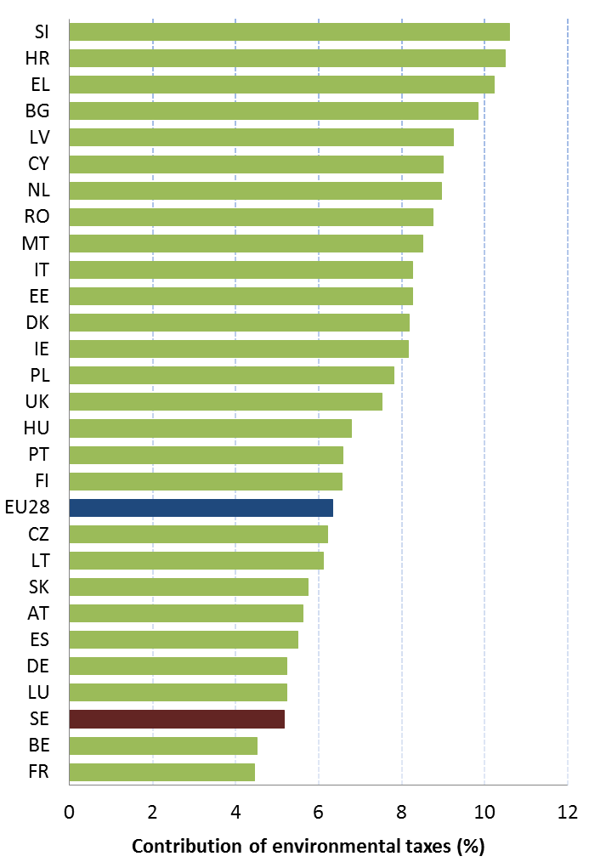
There has been a focus on removing, or limiting, exemptions, and reductions in tax rates for carbon and energy. A package agreed in 2009 aims at limiting these, stepwise, up to 2015, with the biggest reductions to materialize in the final year. Further, discounts in carbon tax on heating fuels in the non-ETS sectors have been progressively reduced and will be totally abolished in 2018. From 2017 an additional annual appreciation rule for taxes on petrol and diesel is has been introduced. The energy and carbon taxes on fossil fuels have been adjusted annually in line with the consumer price index since the 1990’s, and for taxes on petrol and diesel a link to GDP growth has been introduced from 2017 by an annual adjustment at the rate of GDP growth plus two percentage points.
Sweden’s move towards environmental taxes seems to have lost some momentum, since the end of the Green Tax Shift in 2006. The shares of taxes related to transport remain fairly modest and so are the taxes related to pollution and resources.

Green Public Procurement
The EU green public procurement policies encourage Member States to take further steps to reach the target of applying green procurement criteria to at least 50% of public tenders.
Green Public Procurement (GPP) is a process whereby public authorities seek to procure goods, services and works with a reduced environmental impact throughout their life-cycle when compared to goods, services and works with the same primary function that would otherwise be procured.
The purchasing power of public procurement equals to approximately 14% of GDP. A substantial part of this money is spent on sectors with high environmental impact such as construction or transport, so GPP can help to significantly lower the impact of public spending and foster sustainable innovative businesses. The Commission has proposed EU GPP criteria.
Sweden is one of the forerunners on GPP. A national strategy on public procurement, including GPP, was endorsed by government on 30 June 2016 GPP criteria are developed at the national level for construction and real estate, cleaning and chemicals, vehicles and transportation, office and textiles, electricity and lighting, food, health and care, services, and toxic free child care.
Since 2013, green and sustainable public procurement have been at the forefront of government initiatives to strengthen public procurement. To this end, the financial envelope dedicated to GPP support actions was increased.
In September 2016 the Swedish National Agency for Public Procurement (UHM) was founded. The agency has an overall responsibility for developing and supporting the procurement carried out by the contracting authorities and entities. Sweden has adopted a voluntary GPP approach and UHM’s criteria library consists of a comprehensive database of sustainability standards. With the help of an online wizard, contracting authorities are guided through the different environmental criteria available for a number of products. The wizard allows the selection of three levels of criteria: basic, advanced and frontrunner.
In addition to the ready-to-use criteria, contracting authorities are able to ‘design’ their own GPP criteria with the support available on the website of the UHM. In this case, criteria consist predominantly of Eco-labels and environmental management systems.
According to a GPP monitoring survey from 2013 carried out by the Swedish Environmental Protection Agency 53% of organisations have internal environmental objectives and/or internal GPP policies, in case internal environmental objectives are set up, these are monitored in 56% of cases, environmental requirements are applied by respondents in transportation: 74%, energy: 69%, IT equipment: 66%, food products: 58%, and construction: 52%.

Investments: the contribution of EU funds
European Structural and Investment Funds Regulations provide that Member States promote environment and climate objectives in their funding strategies and programmes for economic, social and territorial cohesion, rural development and maritime policy, and reinforce the capacity of implementing bodies to deliver cost-effective and sustainable investments in these areas.
Making good use of the European Structural and Investment Funds (ESIF) is essential to achieve the environmental goals and integrate these into other policy areas. Other instruments such as the Horizon 2020, the LIFE programme and European Fund for Strategic Investment (EFSI) may also support implementation and spread of best practice.
Sweden has ERDF funding of EUR 945m over the 2014-2020 programming period (see Figure 12), and focuses this limited allocation on smart and sustainable growth areas which explicitly or not – contribute to the improvement of the environment or address climate change.
The Swedish priorities in EAFRD where SE has EUR 1 764m European funding over the 2014-2020 programming period are 63% for measures that support environment and climate (including investments).
Figure 12: European Structural and Investment Funds 2014-2020: Budget Sweden by theme, EUR billion
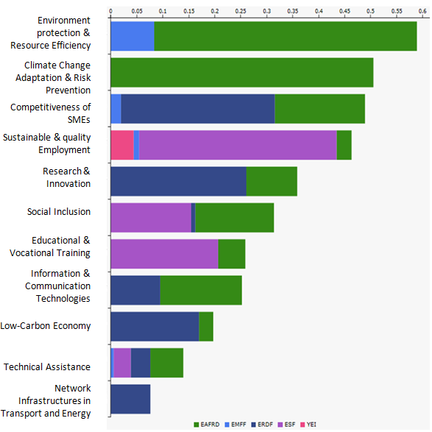
It is too early to draw conclusions as regards the use and results of ESIF funds for the period 2014-2020, as the relevant programmes are still in an early stage of their implementation.
To address the venture capital gap in the green sector, a Green fund with a total budget of SEK 1 300m has been set up within the National ERDF programme. The green sector is a high risk market as there is a long time to market and large investments required in the early stages. The managing authority is therefore setting up a Green fund to provide venture capital to companies in the clean energy sector (50% ERDF and 50% financial intermediary) which will then co-finance (pari-passu with private capital) portfolio companies.

- Effective governance and knowledge

SDG 16 aims at providing access to justice and building effective, accountable and inclusive institutions at all levels. SDG 17 aims at better implementation, improving policy coordination and policy coherence, stimulating science, technology and innovation, establishing partnerships and developing measurements of progress.
Effective governance of EU environmental legislation and policies requires having an appropriate institutional framework, policy coherence and coordination, applying legal and non-legal instruments, engaging with non-governmental stakeholders, and having adequate levels of knowledge and skills. Successful implementation depends, to a large extent, on central, regional and local government fulfilling key legislative and administrative tasks, notably adoption of sound implementing legislation, co-ordinated action to meet environmental objectives and correct decision-making on matters such as industrial permits. Beyond fulfilment of these tasks, government must intervene to ensure day-to-day compliance by economic operators, utilities and individuals ("compliance assurance"). Civil society also has a role to play, including through legal action. To underpin the roles of all actors, it is crucial to collect and share knowledge and evidence on the state of the environment and on environmental pressures, drivers and impacts.
Equally, effective governance of EU environmental legislation and policies benefits from a dialogue within Member States and between Member States and the Commission on whether the current EU environmental legislation is fit for purpose. Legislation can only be properly implemented when it takes into account experiences at Member State level with putting EU commitments into effect. The Make it Work initiative, a Member State driven project, established in 2014, organizes a discussion on how the clarity, coherence and structure of EU environmental legislation can be improved without lowering existing protection standards.

Effective governance within central, regional and local government
Those involved in implementing environment legislation at Union, national, regional and local levels need to be equipped with the knowledge, tools and capacity to improve the delivery of benefits from that legislation, and the governance of the enforcement process.

Capacity to implement rules
It is crucial that central, regional and local administrations have the necessary capacities and skills and training to carry out their own tasks and co-operate and co-ordinate effectively with each other, within a system of multi-level governance.
While environmental policy is highly integrated in other policy areas and in the work of sectoral policy areas, it is the Ministry of the Environment and Energy that is responsible for establishing environmental policies regarding chemicals, natural environment and biological diversity. The Swedish Environmental Protection Agency founded in 1967 reports to the Ministry. There is also IVL the Swedish Environmental Research Institute which is an independent, non-profit research institute, owned by a foundation jointly established by the Swedish Government and Swedish industry. The 2013 European Quality of Government Index puts Sweden in third place out of the 28 Member States.
Transposition and implementation of EU environmental legislation by Sweden has traditionally been good. In general, Sweden communicates the transposition legislation fast and the overall conformity of Swedish environmental legislation with the EU legislation is good. The number of infringements and complaints is low. However, lodged complaints are often very well-reasoned and serious.
The implementation of the urban waste water treatment Directive is currently the issue of with two ongoing infringement cases related to agglomerations which do not meet the EU law standards. Licensed wolf hunting, initiated in 2010 and still pursued, is also a major issue of implementation of the nature protection legislation.

Coordination and integration
It is crucial that the Ministry of Environment and the Agency have the necessary capacities and skills and training to carry out their own tasks and co-operate and co-ordinate effectively with each other, within a system of multi-level governance.
Impact assessments are important tools to ensure environmental integration in all government policies.
The Commission issued a guidance document in 2016 regarding the setting up of coordinated and/or joint procedures that are simultaneously subject to assessments under the EIA Directive, Habitats Directive, Water Framework Directive, and the Industrial Emissions Directive.

Compliance assurance
EU law generally and specific provisions on inspections, other checks, penalties and environmental liability help lay the basis for the systems Member States need to have in place to secure compliance with EU environmental rules.
Public authorities help ensure accountability of duty-holders by monitoring and promoting compliance and by taking credible follow-up action (i.e. enforcement) when breaches occur or liabilities arise. Compliance monitoring can be done both on the initiative of authorities themselves and in response to citizen complaints. It can involve using various kinds of checks, including inspections for permitted activities, surveillance for possible illegal activities, investigations for crimes and audits for systemic weaknesses. Similarly, there is a range of means to promote compliance, including awareness-raising campaigns and use of guidance documents and online information tools. Follow-up to breaches and liabilities can include administrative action (e.g. withdrawal of a permit), use of criminal law and action under liability law (e.g. required remediation after damage from an accident using liability rules) and contractual law (e.g. measures to require compliance with nature conservation contracts). Taken together, all of these interventions represent "compliance assurance" as shown in Figure 13.
Best practice has moved towards a risk-based approach at strategic and operational levels in which the best mix of compliance monitoring, promotion and enforcement is directed at the most serious problems. Best practice also recognises the need for coordination and cooperation between different authorities to ensure consistency, avoid duplication of work and reduce administrative burden. Active participation in established pan-European networks of inspectors, police, prosecutors and judges, such as IMPEL, EUFJE, ENPE and EnviCrimeNet, is a valuable tool for sharing experience and good practices.
Figure 13: Environmental compliance assurance
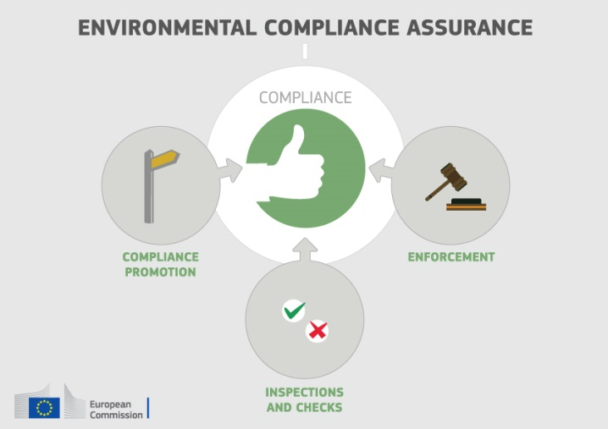
Currently, there exist a number of sectoral obligations on inspections and the EU directive on environmental liability (ELD) provides a means of ensuring that the "polluter-pays principle" is applied when there are accidents and incidents that harm the environment. There is also publically available information giving insights into existing strengths and weaknesses in each Member State.
For each Member State, the following were therefore reviewed: use of risk-based compliance assurance; coordination and co-operation between authorities and participation in pan-European networks; and key aspects of implementation of the ELD based on the Commission's recently published implementation report and REFIT evaluation.
In Sweden, compliance promotion activities are conducted at regional and local level but there is evidence that these could be improved. Planning of environmental compliance monitoring based on risk-based approaches is widely used in Sweden and thematic inspection campaigns based on standard inspection manuals and checklists are regularly conducted in attempts to establish a tailored approach to individual economic sectors. However, variations still exist, reflecting factors such as resource constraints. As regards enforcement, , the use of conditional fines (that are linked to compliance order and determined on the basis of the estimated costs for the prescribed corrective actions) seems to be a useful tool for bringing duty-holders back to compliance. However, the set of sanctions applicable to environmental offences is not flexible enough to respond to different types of non-compliance behaviour, there are significant differences in sanctions application across the country have been observed, and there is evidence of scope for improvement in how inspectors and prosecutors work together, given low prosecution rates in serious cases.
Since 2011, the Swedish Environmental Protection Agency (SEPA) has produced annual compliance monitoring and enforcement reports which include in- and output statistics and SEPA has commissioned a big research project to explore tools for more effective inspection work and better performance evaluation and to tackle the problem of insufficient data on compliance assurance.
Up-to-date information is lacking in relation to the following:
- data-collection arrangements to track the use and effectiveness of different compliance assurance interventions, in particular the results of the SEPA research project;
- the extent to which risk-based methods are used to direct compliance assurance at the strategic level and in relation to specific problem-areas highlighted elsewhere in this Country Report, i.e. the threats to protected habitat types and species, air quality breaches and the pressures on water quality from diffuse pollution.
Sweden reported five incidents of environmental damage in the period 2007 – 2013, of which two were initiated by requests for action. One of the five involved remediation costs exceeding EUR 1 million. There is a lack of information on the take-up of financial security provided by the insurance industry (to cover remediation costs where the operator cannot pay) following Sweden's abolition in 2010 of mandatory financial security.
Suggested action
- Improve transparency on the organisation and functioning of compliance assurance and on how significant risks are addressed, as outlined above.
- Encourage greater participation of competent authorities in the activities of the European environmental enforcement networks.
- Step up efforts in the implementation of the Environmental Liability Directive (ELD) with proactive initiatives, in particular by setting up a national register of ELD incidents. It should moreover take further steps to ensure an effective system of financial security for environmental liabilities (so that operators not only have insurance cover available to them but actually take it up). The Swedish government has already started to investigate if actions or measures need to be taken in order to improve the current system for financial securities to ensure sufficient financial security when needed.

Public participation and access to justice
The Aarhus Convention, related EU legislation on public participation and environmental impact assessment, and the case-law of the Court of Justice require that citizens and their associations should be able to participate in decision-making on projects and plans and should enjoy effective environmental access to justice.
Citizens can more effectively protect the environment if they can rely on the three "pillars" of the Convention on Access to Information, Public Participation in Decision-making and Access to Justice in Environmental Matters ("the Aarhus Convention"). Public participation in the administrative decision making process is an important element to ensure that the authority takes its decision on the best possible basis. The Commission intends to examine compliance with mandatory public participation requirements more systematically at a later stage.
Access to justice in environmental matters is a set of guarantees that allows citizens and their associations to challenge acts or omissions of the public administration before a court. It is a tool for decentralised implementation of EU environmental law.
For each Member State, two crucial elements for effective access to justice have been systematically reviewed: the legal standing for the public, including NGOs and the extent to which prohibitive costs represent a barrier.
In general, the existing rules and provisions in Sweden concerning access to administrative appeal and to judicial review are predictable and transparent. However, environmental NGOs still do not have legal standing in all environmental sectors. Also the conditions to be recognised as an environmental NGOs are partly too restricted. The costs of administrative court procedure, however, are not considered as being prohibitively high.
The Swedish government has assigned a government committee (Dir. 2015:121) with the task of investigating, among other things, whether further measures are necessary in order for Sweden to comply with the Aarhus Convention with regard to legal standing for environmental NGOs in the forestry sector.
Suggested action
- Take the necessary measures to ensure standing of environmental NGOs to challenge acts or omissions of a public authority in all sectoral EU environmental laws, in full compliance with EU law as well as the Convention on Access to Information, Public Participation in Decision-making and Access to Justice in environmental matters (Aarhus Convention).

Access to information, knowledge and evidence
The Aarhus Convention and related EU legislation on access to information and the sharing of spatial data require that the public has access to clear information on the environment, including on how Union environmental law is being implemented.
It is of crucial importance to public authorities, the public and business that environmental information is shared in an efficient and effective way. This covers reporting by businesses and public authorities and active dissemination to the public, increasingly through electronic means.
The Aarhus Convention, the Access to Environmental Information Directive and the INSPIRE Directive together create a legal foundation for the sharing of environmental information between public authorities and with the public. They also represent the green part of the ongoing EU e-Government Action Plan. The first two instruments create obligations to provide information to the public, both on request and actively. The INSPIRE Directive is a pioneering instrument for electronic data-sharing between public authorities who can vary in their data-sharing policies, e.g. on whether access to data is for free. The INSPIRE Directive sets up a geoportal which indicates the level of shared spatial data in each Member State – i.e. data related to specific locations, such as air quality monitoring data. Amongst other benefits it facilitates the public authorities' reporting obligations.
For each Member State, the accessibility of environmental data (based on what the INSPIRE Directive envisages) as well as data-sharing policies ('open data') have been systematically reviewed.
Sweden's performance on the implementation of the INSPIRE Directive as enabling framework to actively disseminate environmental information to the public is good, but leaves room for improvement. Sweden has indicated in the 3-yearly INSPIRE implementation report that the necessary data-sharing policies allowing access and use of spatial data by national administrations, other Member States' administrations and EU institutions without procedural obstacles are available and implemented. Sweden has currently no common digital licence administration regarding access to data and services infrastructure, but the data-sharing policies in place provide the essential conditions necessary for sharing spatial data sets and services. It is still common that the access to spatial data requires registration and that fees are asked for downloading data. The general trend towards open and free data in Sweden will in the long term remove the need to register and the payment of fees.
Assessments of monitoring reports issued by Sweden and the spatial information that Sweden has published on the INSPIRE geoportal indicate that not all spatial information needed for the evaluation and implementation of EU environmental law has been made available or is accessible. Some of this missing spatial information consists of the environmental data required to be made available under the existing reporting and monitoring regulations of EU environmental law.
Suggested action
- Identify and document all spatial data sets required for the implementation of environmental law, and make the data and documentation at least accessible 'as is' to other public authorities and the public through the digital services foreseen in the INSPIRE Directive.

Communication "Delivering the benefits of EU environmental policies through a regular Environmental Implementation Review" (COM/2016/ 316 final).
Decision No. 1386/2013/EU of 20 November 2013 on a General Union Environmental Action Programme to 2020 "Living well, within the limits of our planet".
United Nations, 2015. The Sustainable Development Goals
This EIR report does not cover climate change, chemicals and energy.
http://www.government.se/articles/2015/08/swedish-strategy-for-biodiversity-and-ecosystem-services/
European Commission, 2015. Proposed Circular Economy Package
Resource productivity is defined as the ratio between gross domestic product (GDP) and domestic material consumption (DMC).
Eurostat, Resource productivity, accessed October 2016
Eurostat, Resource productivity, accessed October 2016
The National Agency for Public Procurement, 2016.
European Commission, 2015. Flash 426 Eurobarometer
The Flash 426 Eurobarometer "SMEs, resource efficiency and green markets" defines "green job" as a job that directly deals with information, technologies, or materials that preserves or restores environmental quality. This requires specialised skills, knowledge, training, or experience (e.g. verifying compliance with environmental legislation, monitoring resource efficiency within the company, promoting and selling green products and services).
Eco-innovation Observatory: Eco-Innovation scoreboard 2015
Swedish Environmental Protection Agency, 2016. All Party Committee on Environmental Objectives
Growth Analysis, Growth Facts, 2013
http://asset.nu/en/
www.saminvest.se
http://www.government.se/articles/2016/07/innovation-partnership-programmes--mobilising-new-ways-to-meet-societal-challenges/
Waste Management Plans/Waste Prevention Programmes
Municipal waste consists of waste collected by or on behalf of municipal authorities, or directly by the private sector (business or private non-profit institutions) not on behalf of municipalities.
Eurostat, Municipal waste and treatment, by type of treatment method, accessed October 2016
Eurostat, Municipal waste and treatment, by type of treatment method, accessed October 2016
Member States may choose a different method than the one used by ESTAT (and referred to in this report) to calculate their recycling rates and track compliance with the 2020 target of 50% recycling of municipal waste.
Eurostat, Recycling rate of municipal waste, accessed October 2016
Bio Intelligence service, 2011. Implementing EU Waste legislation for Green Growth, study for European Commission. The breakdown per country on job creation was made by the consultant on Commission demand but was not included in the published document.
Sites of Community Importance (SCIs) are designated pursuant to the Habitats Directive whereas Special Areas of Protection (SPAs) are designated pursuant to the Birds Directive; figures of coverage do not add up due to the fact that some SCIs and SPAs overlap. Special Areas of Conservation (SACs) means a SCI designated by the Member States.
SLU, Red List.
For each Member State, the Commission assesses whether the species and habitat types on Annexes I and II of the Habitats Directive, are sufficiently represented by the sites designated to date. This is expressed as a percentage of species and habitats for which further areas need to be designated in order to complete the network in that country. A scientific reserve is given when further research is needed to identify the most appropriate sites to be added for a species or habitat. The current data, which were assessed in 2014-2015, reflect the situation up until December 2013.
The percentages in Figure 5 refer to percentages of the total number of assessments (one assessment covering 1 species or 1 habitat in a given biographical region with the Member State); if a habitat type or a species occurs in more than 1 Biogeographic region within a given Member State, there will be as many individual assessments as there are Biogeographic regions with an occurrence of that species or habitat in this Member State.
European Commission, internal assessment.
The core of the ‘Article 17’ report is assessment of conservation status of the habitats and species targeted by the Habitats Directive.
Article 17 of the Habitats Directive reporting - national summary of Sweden
Conservation status is assessed using a standard methodology as being either ‘favourable’, ‘unfavourable-inadequate’ and ‘unfavourable-bad’, based on four parameters as defined in Article 1 of the Habitats Directive.
These figures show the percentage of biogeographical assessments in each category of conservation status for habitats and species (one assessment covering 1 species or 1 habitat in a given biographical region with the Member State), respectively. The information is based on Article 17 of the Habitats Directive reporting - national summary of Sweden - expert-based assessment.
Please note that a direct comparison between 2007 and 2013 data is complicated by the fact that Bulgaria and Romania were not covered by the 2007 reporting cycle, that the ‘unknown’ assessments have strongly diminished particularly for species, and that some reported changes are not genuine as they result from improved data / monitoring methods.
Article 12 of the Birds Directive requires Member States to report about the progress made with the implementation of the Birds Directive.
Article 12 of the Birds Directive reporting - national summary of Sweden
Ecosystem services are benefits provided by nature such as food, clean water and pollination on which human society depends.
European Union, Green Infrastructure — Enhancing Europe’s Natural Capital, COM/2013/0249
Ecosystem services are benefits provided by nature such as food, clean water and pollination on which human society depends.
European Environment Agency Draft results of CORINE Land Cover (CLC) inventory 2012; mean annual land take 2006-12 as a % of 2006 artificial land.
European Environment Agency, 2016. Imperviousness and imperviousness change
Eurostat, Soil water erosion rate, Figure 2, accessed November 2016
European Environment Agency. Land cover 2012 and changes country analysis [publication forthcoming]
European Union, Marine Strategy Framework Directive 2008/56/EC
The MSFD defines Good Environmental Status (GES) in Article 3 as: “The environmental status of marine waters where these provide ecologically diverse and dynamic oceans and seas which are clean, healthy and productive”.
EEA, 2016, The Baltic Sea.
Commission Staff Working Document Accompanying the Commission Report on "The first phase of implementation of the Marine Strategy Commission Staff Working Document Accompanying the Commission Report assessing Member States' monitoring programmes under the Marine Strategy Framework Directive (COM(2017)3 and SWD(2017)1 final)Framework Directive (2008/56/EC) - The European Commission's assessment and guidance" (SWD(21014) 049 final and COM(2014)097 final)
2012 Data provided by the European Environmental Agency– Not published
European Commission, 2016. Air Quality Standards
See EIONET Central Data Repository and Air pollutant emissions data viewer (NEC Directive)
The current national emission ceilings apply since 2010 (Directive 2001/81/EC); revised ceilings for 2020 and 2030 have been set by Directive (EU) 2016/2284 on the reduction of national emissions of certain atmospheric pollutants, amending Directive 2003/35/EC and repealing Directive 2001/81/EC.
Particulate matter (PM) is a mixture of aerosol particles (solid and liquid) covering a wide range of sizes and chemical compositions. PM10 (PM2.5) refers to particles with a diameter of 10 (2.5) micrometres or less. PM is emitted from many anthropogenic sources, including combustion.
Low level ozone is produced by photochemical action on pollution and it is also a greenhouse gas.
NOx is emitted during fuel combustion e.g. from industrial facilities and the road transport sector. NOx is a group of gases comprising nitrogen monoxide (NO) and nitrogen dioxide (NO2).
European Environment Agency, 2016. Air Quality in Europe – 2016 Report. (Table 10.2, please see details in this report as regards the underpinning methodology)
Based on European Environment Agency, 2016. Air Quality in Europe – 2016 Report. (Figures 4.1, 5.1 and 6.1)
See The EEA/Eionet Air Quality Portal and the related Central Data Repository
These figures are based on the Impact Assessment for the European Commission Integrated Clean Air Package (2013)
Under the provisions of the revised National Emission Ceilings Directive Member States now may apply for emission inventory adjustments. Pending evaluation of any adjustment application, Member States should keep emissions under close control with a view to further reductions.
Burden of disease from environmental noise; WHO/JRC, 2011, Burden of disease from environmental noise, Fritschi, L., Brown, A.L., Kim, R., Schwela, D., Kephalopoulos, S. (eds), World Health Organization, Regional Office for Europe, Copenhagen, Denmark
The Noise Directive requires Member States to prepare and publish, every 5 years, noise maps and noise management action plans for agglomerations with more than 100,000 inhabitants, and for major roads, railways and airports.
This includes the Bathing Waters Directive (2006/7/EC); the Urban Waste Water Treatment Directive (91/271/EEC) concerning discharges of municipal and some industrial waste waters; the Drinking Water Directive (98/83/EC) concerning potable water quality; the Water Framework Directive (2000/60/EC) concerning water resources management; the Nitrates Directive (91/676/EEC) and the Floods Directive (2007/60/EC)
Good ecological status is defined in the Water Framework Directive, referring to the quality of the biological community, the hydrological characteristics and the chemical characteristics.
Many European river basins and waters have been altered by human activities, such as land drainage, flood protection and, building of dams to create reservoirs.
Good chemical status is defined in the Water Framework Directive referring to compliance with all the quality standards established for chemical substances at European level.
Diffuse pollution comes from widespread activities with no one discrete source.
See tables 6.8 and 6.12 from the COM working staff document (SE) accompanying the report from the Commission on the implementation of the WFD RBMPs (2012).
Commission's Synthesis Report on the Quality of Drinking Water in the Union examining Member States' reports for the 2011-2013 period, foreseen under Article 13(5) of Directive 98/83/EC; COM(2016)666.
European Environment Agency, 2016. European bathing water quality in 2015, p. 26
European Environment Agency, State of bathing water, 2016
European Commission, Eighth Report on the Implementation Status and the Programmes for Implementation of the Urban Waste Water Directive (COM (2016)105 final) and Commission Staff Working Document accompanying the report (SWD(2016)45 final).
European Commission, Eighth Report on the Implementation Status and the Programmes for Implementation of the Urban Waste Water Directive (COM (2016)105 final) and Commission Staff Working Document accompanying the report (SWD(2016)45 final).
Commission Staff Working Document, report on the progress in implementation of the Floods Directive SDG(2015)51 final p. 55
RPA, 2014. Study on Economic and Social Benefits of Environmental Protection and Resource Efficiency Related to the European Semester. Study for the European Commission, Annex 1: Country fiches
European Environment Agency, Urban environment
http://urbanagendaforthe.eu/
The Commission is developing an Urban Benchmarking and Monitoring ('UBaM') tool to be launched in 2017. Best practices emerge and these will be better disseminated via the app featuring the UBaM tool, and increasingly via e.g. EUROCITIES, ICLEI, CEMR, Committee of the Regions, Covenant of Mayors and others.
European Commission, European Green Capital Award 2010 & 2011, Catalogue of Best Practice, p.10
European Commission, European Green Capital Award 2010 & 2011, Catalogue of Best Practice, p.1
European Commission, European Green Capital Award 2010 & 2011, Catalogue of Best Practicep.30
European Commission, Good Practice & Benchmarking Report European Green Capital Award 2012 & 2013, p.16
European Commission, Good Practice & Benchmarking Report European Green Capital Award 2012 & 2013, p.44
European Commission, Good Practice & Benchmarking Report European Green Capital Award 2012 & 2013, p.22
European Commission, Urban Environment Good Practice & Benchmarking Report European Green Capital Award 2017, p.18
European Commission, Urban Environment Good Practice & Benchmarking Report European Green Capital Award 2017, p.60
Eunomia Research and Consulting, IEEP, Aarhus University, ENT, 2016. Study on Assessing the Environmental Fiscal Reform Potential for the EU28 N.B. National governments are responsible for setting tax rates within the EU Single Market rules and this report is not suggesting concrete changes as to the level of environmental taxation. It merely presents the findings of the 2016 study by Eunomia et al on the potential benefits various environmental taxes could bring. It is then for the national authorities to assess this study and their concrete impacts in the national context. A first step in this respect, already done by a number of Member States, is to set up expert groups to assess these and make specific proposals.
The good practice scenario means benchmarking to a successful taxation practice in another Member State.
Eunomia Research and Consulting, IEEP, Aarhus University, ENT, 2016. Study on Assessing the Environmental Fiscal Reform Potential for the EU28
Eurostat, Environmental tax revenues, accessed October 2016
European Commission, 2015. Public Procurement
In the Communication “Public procurement for a better environment” (COM /2008/400) the Commission recommended the creation of a process for setting common GPP criteria. The basic concept of GPP relies on having clear, verifiable, justifiable and ambitious environmental criteria for products and services, based on a life-cycle approach and scientific evidence base.
PwC, 2015. Strategic use of public procurement in promoting green, social and innovative policies, study for the European Commission
PwC, 2015. Strategic use of public procurement in promoting green, social and innovative policies, study for the European Commission
ESIF comprises five funds – the European Regional Development Funds (ERDF), the Cohesion Fund (CF), the European Social Fund (ESF), the European Agricultural Fund for Rural Development (EAFRD), and the European Maritime and Fisheries Fund (EMFF). The ERDF, the CF and the ESF together form the Cohesion Policy funds.
EIB: European Fund for Strategic Investments
European Commission, European Structural and Investment Funds Data By Country
The Commission has work ongoing to improve the country-specific knowledge about quality and functioning of the administrative systems of Member States.
Charron N., 2013. European Quality of Government Index (EQI)
Article 11 of the TFEU provides that "Environmental protection requirements must be integrated into the definition and implementation of the Union's policies and activities, in particular with a view to promoting sustainable development."
European Commission, 2016. Commission notice — Commission guidance document on streamlining environmental assessments conducted under Article 2(3) of the Environmental Impact Assessment Directive (Directive 2011/92/EU of the European Parliament and of the Council, as amended by Directive 2014/52/EU).
European Commission, 2016. Commission notice — Commission guidance document on streamlining environmental assessments conducted under Article 2(3) of the Environmental Impact Assessment Directive (Directive 2011/92/EU of the European Parliament and of the Council, as amended by Directive 2014/52/EU).
European Union, Environmental Crime Directive 2008/99/EC
European Union Network for the Implementation and Enforcement of Environmental Law
European Union Forum of judges for the environment
The European Network of Prosecutors for the Environment
EnviCrimeNet
European Union, Environmental Liability Directive 2004/35/CE
COM(2016)204 final and COM(2016)121 final of 14.4.2016. This highlighted the need for better evidence on how the directive is used in practice; for tools to support its implementation, such as guidance, training and ELD registers; and for financial security to be available in case events or incidents generate remediation costs.
OECD, Environmental Performance Reviews: Sweden 2014, p. 53f. It notes that practices vary significantly and the perception of businesses seems to be that it is difficult to find information on new regulatory requirements and how at best to comply with them
Mazur E., 2011. Environmental Enforcement in Decentralised Governance Systems: Towards a Nationwide Level Playing Field, OECD Environment Working Papers, No 34, p. 19.
OECD, Environmental Performance Reviews: Sweden 2014, p. 54-55. Mazur E., 2011. Environmental Enforcement in Decentralised Governance Systems: Towards a Nationwide Level Playing Field, OECD Environment Working Papers, No 34, p. 19; Study on 'Information collection and impact assessment of possible requirements for environmental inspections in the area of EU legislation on water, nature protection and trade in certain environmentally sensitive goods', 2013 IEEP/BioIntelligence/Ecologic, p. 292 (referring to a 2013 study examining effectiveness of environmental inspection authorities - Holstein, F. and Gren, I. 2013, Violation of environmental regulations in Sweden: Economic motives, environmental attitudes, and social capital, Swedish University of Agricultural Sciences, Department of Economics, Working Paper 03/2013).
Mazur E., 2011. Environmental Enforcement in Decentralised Governance Systems: Towards a Nationwide Level Playing Field, OECD Environment Working Papers, No 34, p. 22; OECD, Environmental Performance Reviews: Sweden 2014, p. 56.
According to the OECD, Environmental Performance Reviews: Sweden 2014, p. 56, inspection authorities do not have discretion in determining monetary sanctions and the administrative fines imposed do not take sufficient account of the causes for the occurred breaches and the environmental damage caused.
Sjoberg E., 2013. Decentralized enforcement of national legislation: Political influence on environmental fines in Swedish municipalities
Sweden has indicated that a government committee was established (Dir. 2016:32) with the task of exploring, among other things, ways of improving the cooperation between inspectors on one hand and police and prosecutors on the other. This committee will also analyse the system for financing of inspections and compliance assurance as well as the system for compliance assurance cooperation at national, regional and the municipality level. The committee will present the outcome of its work in April 2017.
OECD, Environmental Performance Reviews: Sweden 2014, p. 56.
See Study on 'Information collection and impact assessment of possible requirements for environmental inspections in the area of EU legislation on water, nature protection and trade in certain environmentally sensitive goods', 2013 IEEP/BioIntelligence/Ecologic, p. 293; OECD Environmental Performance Reviews: Sweden 2014, p. 48, 55.
European Commission, 2012/2013 access to justice in environmental matters
The committee will present the investigation 31 March 2017. Regarding the conditions for being recognised as an environmental NGO, a proposal by the Ministry of the Environment and Energy to change the conditions, including the removal of the condition which only grants NGOs that have been active for at least three years in Sweden legal standing, is currently being circulated for referral.
European Commission, The Aarhus Convention
European Union, Directive 2003/4/EC on public access to environmental information
European Commission, 2016. INSPIRE Directive
European Union, EU eGovernment Action Plan 2016-2020 - Accelerating the digital transformation of government COM(2016) 179 final
European Commission, 2016. Inspire – Monitoring and Reporting
Inspire indicator trends
Inspire Resources Summary Report

