This report has been written by the staff of the Directorate-General for Environment, European Commission. Any comments are welcome to the following e-mail address: ENV-EIR@ec.europa.eu

More information on the European Union is available on the internet (http://europa.eu).

Photographs: p.11 – © Kaycco/iStock; p.17 – © Ken Wiedemann/iStock; p.22 – © Matej Krajcovic/iStock

For reproduction or use of these photos, permission must be sought directly from the copyright holder.

©European Union, 2017
Reproduction is authorised provided the source is acknowledged.
Table of Content
Executive summary 4
Part I: Thematic Areas 5
1. Turning the EU into a circular, resource-efficient, green and competitive low-carbon economy 5
Developing a circular economy and improving resource efficiency 5
Waste management 7
2. Protecting, conserving and enhancing natural capital 9
Nature and Biodiversity 9
Estimating Natural Capital 11
Green Infrastructure 11
Soil protection 12
3. Ensuring citizens' health and quality of life 13
Air quality 13
Noise 14
Water quality and management 14
Enhancing the sustainability of cities 17
International agreements 17
Part II: Enabling Framework: Implementation Tools 19
4. Market based instruments and investment 19
Green taxation and environmentally harmful subsidies 19
Green Public Procurement 20
Investments: the contribution of EU funds 20
5. Effective governance and knowledge 22
Effective governance within central, regional and local government 22
Compliance assurance 23
Public participation and access to justice 25
Access to information, knowledge and evidence 26

Executive summary

About the Environmental Implementation Review
In May 2016, the Commission launched the Environmental Implementation Review (EIR), a two-year cycle of analysis, dialogue and collaboration to improve the implementation of existing EU environmental policy and legislation. As a first step, the Commission drafted 28 reports describing the main challenges and opportunities on environmental implementation for each Member State. These reports are meant to stimulate a positive debate both on shared environmental challenges for the EU, as well as on the most effective ways to address the key implementation gaps. The reports rely on the detailed sectoral implementation reports collected or issued by the Commission under specific environmental legislation as well as the 2015 State of the Environment Report and other reports by the European Environment Agency. These reports will not replace the specific instruments to ensure compliance with the EU legal obligations.
The reports will broadly follow the outline of the 7th Environmental Action Programme and refer to the 2030 Agenda for Sustainable development and related Sustainable Development Goals (SDGs) to the extent to which they reflect the existing obligations and policy objectives of EU environmental law.
The main challenges have been selected by taking into account factors such as the importance or the gravity of the environmental implementation issue in the light of the impact on the quality of life of the citizens, the distance to target, and financial implications.
The reports accompany the Communication "The EU Environmental Implementation Review 2016: Common challenges and how to combine efforts to deliver better results", which identifies challenges that are common to several Member States, provides preliminary conclusions on possible root causes of implementation gaps and proposes joint actions to deliver better results. It also groups in its Annex the actions proposed in each country report to improve implementation at national level.
General profile
Environmental implementation represents a challenge for Slovakia. Poor waste management performance, with low recycling rates and a strong dependence on landfilling is one of the main concerns. Improving water management policy in the context of the EU water framework Directive is a major concern. Its rich natural environment and biodiversity - with one of the largest NATURA 2000 networks - is one of the country's strongest assets. On the other hand, an effort is needed to preserve this potential by balancing the different interests and needs through transparent and efficient development consent and SEA/EIA processes.
Main Challenges
The three main challenges with regard to implementation of EU environmental policy and law in Slovakia are:
- Improving waste management, particularly increasing recycling, rolling-out separate collection and reducing landfilling
- Improving air quality in critical regions of the country, notably in urban areas, like Bratislava and Kosice. Phasing out environmentally harmful subsidies to brown coal.
- Improving water management, notably in terms of infrastructure projects, but also in approaches to agricultural use and landscape management (drainage systems and nitrates pollution as well as forest management) and more advanced treatment of urban waste water
Main Opportunities
Slovakia could perform better on topics where there is already a good knowledge base and good practices. This applies in particular to:
- Building on experiences in nature protection including the traditional landscape territorial system approach, working towards a complete and well managed Natura 2000 network
- Preserving important sources of drinking water by application of ecosystem based approaches and preventing negative impacts
Points of Excellence
Where Slovakia is a leader on environmental implementation, innovative approaches could be shared more widely with other countries. Good examples are:
- Territorial System of Ecological Stability of the Landscape (TSES), a system of landscape and nature protection is a good practise developed already in late 1970s in the former Czechoslovakia.

Part I: Thematic Areas

Turning the EU into a circular, resource-efficient, green and competitive low-carbon economy

Developing a circular economy and improving resource efficiency
The 2015 Circular Economy Package emphasizes the need to move towards a lifecycle-driven ‘circular’ economy, with a cascading use of resources and residual waste that is close to zero. This can be facilitated by the development of, and access to, innovative financial instruments and funding for eco-innovation.
SDG 8 invites countries to promote sustained, inclusive and sustainable economic growth, full and productive employment and decent work for all. SDG 9 highlights the need to build resilient infrastructure, promote inclusive and sustainable industrialization and foster innovation. SDG 12 encourages countries to achieve the sustainable management and efficient use of natural resources by 2030.

Measures towards a circular economy
Transforming our economies from linear to circular offers an opportunity to reinvent them and make them more sustainable and competitive. This will stimulate investments and bring both short and long-term benefits for the economy, environment and citizens alike.
With the upcoming Slovakian Presidency of the EU in July 2016, the circular economy in Slovakia should progress, from the policy perspective as it has been listed as one of the priorities. Policy makers are focussed on trying to decrease the energy intensity of the Slovakian economy (as it is double the EU average) as well as improving waste management and decreasing the high landfill rate. This will help with resource productivity where Slovakia is currently below the EU average.
To date, there is no national policy outlining a coherent approach towards eco-innovation and the circular economy. A national-level working group has been set up to discuss the measures in the European Commission’s Circular Economy Package, however, no concrete strategies or action plans have yet been agreed upon.
The Government manifesto adopted by new Government in April 2016 includes as one of its main objectives in the environmental agenda to prepare the conditions for steady transition towards the competitive and resource efficient low-carbon economy. However, this is formulated without clear time-tables for implementation and/or with unclear financial backing apart from the priorities agreed also in the Slovak Partnership Agreement or Operational Programmes 2014-2020. This means a high degree of reliance on EU funds for public investments in general.
As regards the instruments in Slovakia, the focus appears to remain on traditional environmental approaches, such as environmental management systems, environmental labelling and green public procurement (GPP). However, even these voluntary instruments are implemented and promoted by the public administration bodies mainly, and in particular by the Ministry of Environment.
Figure 1: Resource productivity 2003-15
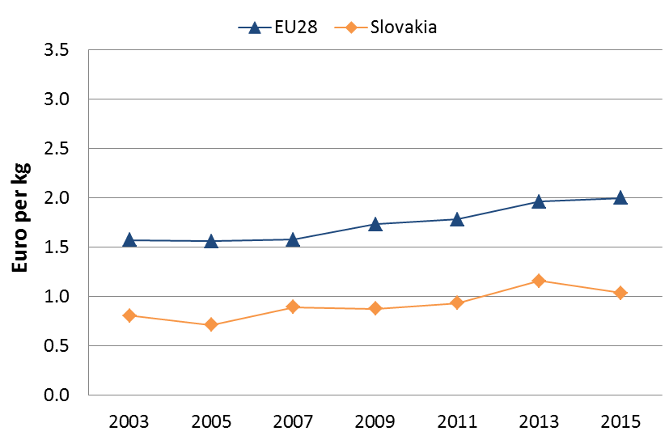
Figure 1 shows trends over time and indicates a modest but overall stable increase of resource productivity (how efficiently the economy uses material resources to produce wealth) since 2004 in Slovakia. However, since 2014 a slight decrease can be observed. In 2015, Slovakia performed below the EU average in terms of resource productivity, with 1.0 EUR/kg (EU average is 2.0).

SMEs and resource efficiency
In the Flash 426 Eurobarometer "SMEs, resource efficiency and green markets" it is shown that 36% of Slovakia's SMEs have invested up to 5% of their annual turnover in their resource efficiency actions (EU28 average 50%), 34 % of them are currently offering green products and services, 62% took measures to save energy (EU28 average 59%), 57% to minimise waste (EU28 average 60%), 62% to save water (EU28 average 44%), and 56% to save materials (EU28 average 54%). From a circular economy perspective, 30% took measures to recycle by reusing material or waste within the company, 21% to design products that are easier to maintain, repair or reuse and 20% were able to sell their scrap material to another company.
According to the Flash 426 Eurobarometer, the resource efficiency actions undertaken allowed the reduction of production costs in a 37% of the Slovakia's SMEs.
The Flash 426 Eurobarometer "SMEs, resource efficiency and green markets" shows that 52% of the SMEs in Slovakia have one or more full time employee working in a green job at least some of the time. Slovakia has an average number of 2.4 full time green employees per SME.
Eco-innovation
The results of the scoreboard depicted in Figure 2 show that the overall eco-innovation performance of Slovakia for the year 2015 has improved compared to 2013 and 2014, with an overall index score of 72 (compared to a score of 54 in 2013), ranking Slovakia 23rd among EU28. This reflects the challenges Slovakia faces in terms of a lack of a coherent eco-innovation policy framework as well as low investment in R&D.
One of the main drivers to support eco-innovation and the circular economy could be the automotive industry, as it is one of the main industries in Slovakia. Another driver could be an incentive framework to promote innovation among companies and academics. A National technology transfer portal was established in the Centre of Scientific and Technical Information and will now work more intensively with offices located within universities.
There are several barriers to circular economy and eco-innovation in Slovakia.
On the one hand, there are economic and financial barriers, i.e. lack of financial resources and high costs of innovation (RIS3). In particular, there is still a significant lack of funding for research and innovation in Slovakia. Public sector and EU structural funds are the main sources of R&D funding in Slovakia, rather than companies (RIS3). Certain regions, i.e. Slovakia's central and eastern regions, do not attract private investment at all, mainly due to infrastructure problems.
Figure 2: Eco-Innovation Index 2015 (EU=100)
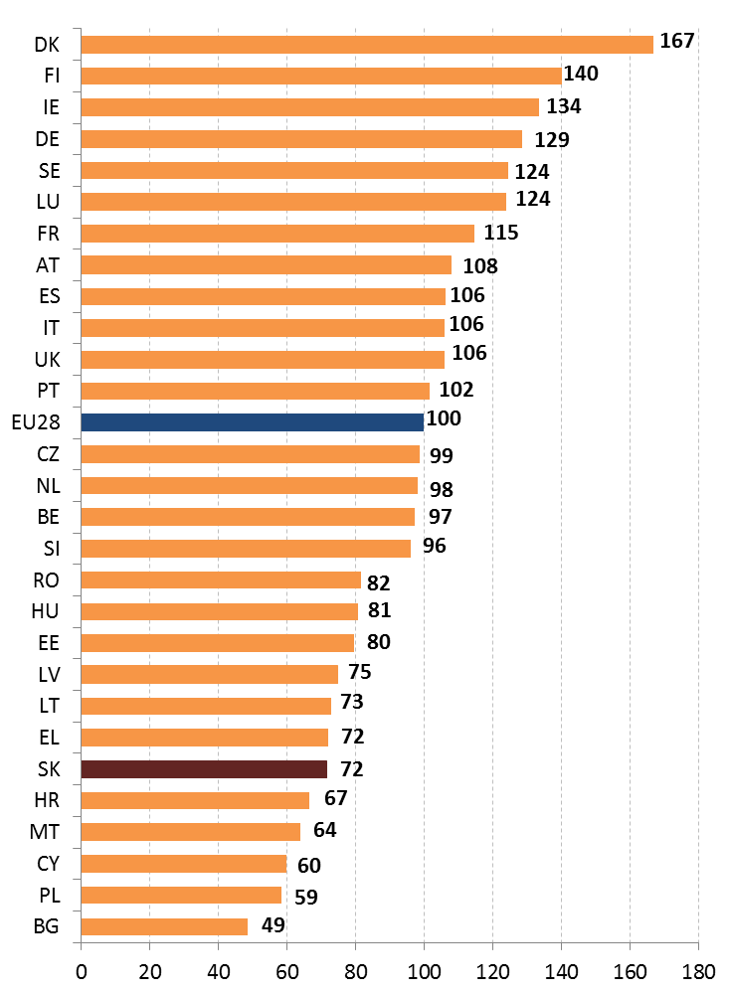
The lack of market demand for innovation and low level of public awareness on this topic are also barriers.
Suggested action
- Develop an overarching policy framework with respect to circular economy and eco-innovation.
- Establish a policy framework that would enable the uptake of circular economy measures.
- Increase the funding opportunities for SMEs in Slovakia. Foster the development of a secondary raw materials market. Incentivise investments in green products and services.
- Raise awareness among the population of circular economy to increase the market demand.

Waste management
Turning waste into a resource requires:
- Full implementation of Union waste legislation, which includes the waste hierarchy; the need to ensure separate collection of waste; the landfill diversion targets etc.
- Reducing per capita waste generation and waste generation in absolute terms.
- Limiting energy recovery to non-recyclable materials and phasing out landfilling of recyclable or recoverable waste.
SDG 12 invites countries to substantially reduce waste generation through prevention, reduction, recycling and reuse, by 2030.
The EU's approach to waste management is based on the "waste hierarchy" which sets out an order of priority when shaping waste policy and managing waste at the operational level: prevention, (preparing for) reuse, recycling, recovery and, as the least preferred option, disposal (which includes landfilling and incineration without energy recovery). The progress towards reaching recycling targets and the adoption of adequate WMP/WPP should be the key items to measure the performance of Member States. This section focuses on management of municipal waste for which EU law sets mandatory recycling targets.
Municipal waste generation in Slovakia has increased in 2014 breaking the downward trend since 2010 and remaining considerably below the EU average (321 kg/y/inhabitant compared to around 475 kg/y/inhabitant) as shown in Figure 3. There are still differences in national and Eurostat statistics.
Figure 3 depicts the municipal waste by treatment in Slovakia in terms of kg per capita which shows a high landfilling of municipal waste and still a very low recycling rate. Slovakia has one of the lowest landfill gate fees among the EU MSs. The number of illegal dumpsites is also a huge problem, mainly in Bratislava region.
Recycling of municipal waste (including composting) remains relatively low (12% compared to the EU average of 44%). Therefore, significant efforts will be needed to meet the 50% recycling target by 2020 as shown in Figure 4.
Figure 3: Municipal waste by treatment in Slovakia 2007-14
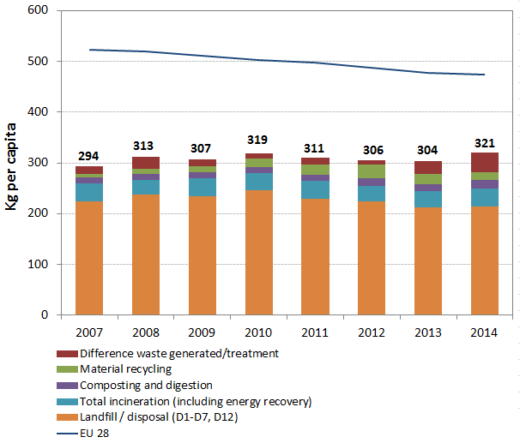

Figure 4: Recycling rate of municipal waste 2007-14
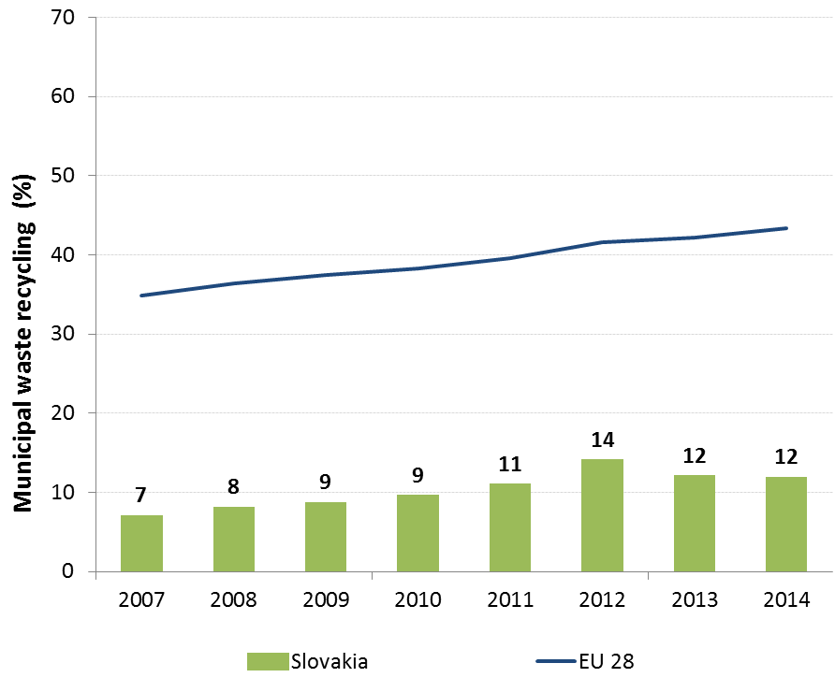
Slovakia still has high landfilling rate of municipal waste (76% in 2014). Incineration accounts for 12%. In order to help bridging the implementation gap in Slovakia, the Commission has delivered a roadmap for compliance. The main recommendations included progressive increase of landfill tax and use of the revenues to the first steps of the waste hierarchy; improvement of the performance of the Extended Producer Responsibility schemes for the main waste streams to ensure the appropriate and sustainable funding of separate collection, sorting and recycling. As soon as separate collections are in place, Pay-as-You-Throw (PAYT) schemes should be encouraged and harmonised at local level. The PAYT schemes introduced in some regions in Slovakia impose a very low fee and thus do not incentivise separate collection. Incentives for municipalities to encourage separate collection and reuse/recycling should be harmonised.
On 1 January 2016, a new legal act on waste entered into force, which governs several aspects of waste management, including waste prevention, extended producer responsibility, management of municipal waste, and the ceasing of the former Recycling Fund' operation. Parts of this act are relevant to improving circular economy, in particular the extended producer responsibility scheme. It is not clear whether the act itself would allow Slovakia to achieve the 2020 objectives of Waste FD and more ambitious objectives of the Circular Economy package. The Waste management plan of the Slovak Republic for 2016-2020 was also adopted in 2015. It evaluated performance between 2011 and 2015 up to 2013. The results showed that several objectives had not been reached, including the targets set for municipal waste – in particular recycling targets.
Full implementation of the existing waste legislation could create more than 5900 jobs in Slovakia and increase the annual turnover of the waste sector by over EUR 620 million. Moving toward the targets of the Roadmap resource efficiency could create over 7000 additional jobs and increase the annual turnover of the waste sector by over EUR 740 million.
Suggested action
- Gradually increase landfill taxes to phase-out landfilling of recyclable and recoverable waste. Use the revenues to support the separate collection and alternative infrastructure to support the first steps of waste hierarchy. Avoid building excessive infrastructure for the treatment of residual waste.
- Focus on implementation of the separate collection obligation to increase recycling rates. As soon as an efficient separate collection scheme is in place, PAYT schemes should be encouraged and harmonised at local level.
- Extend and improve the cost-effectiveness, monitoring and transparency of existing EPR schemes.

Protecting, conserving and enhancing natural capital

Nature and Biodiversity
The EU Biodiversity Strategy aims to halt the loss of biodiversity in the EU by 2020, restore ecosystems and their services in so far as feasible, and step up efforts to avert global biodiversity loss. The EU Birds and Habitats Directives aim at achieving favourable conservation status of protected species and habitats.
SDG 14 requires countries to conserve and sustainably use the oceans, seas and marine resources, while SDG 15 requires countries to protect, restore and promote the sustainable use of terrestrial ecosystems, sustainably manage forests, combat desertification, and halt and reverse land degradation and halt biodiversity loss.
The 1992 EU Habitats Directive and the 1979 Birds Directive are the cornerstone of the European legislation aimed at the conservation of the EU's wildlife. Natura 2000, the largest coordinated network of protected areas in the world, is the key instrument to achieve and implement the Directives' objectives to ensure the long-term protection, conservation and survival of Europe's most valuable and threatened species and habitats and the ecosystems they underpin.
The adequate designation of protected sites as Special Ares of Conservation (SAC) under the Habitats Directive and as Special Protection Areas (SPA) under the Birds Directive is a key milestone towards meeting the objectives of the Directives. The results of Habitats Directive Article 17 and Birds Directive Article 12 reports and the progress towards adequate Sites of Community Importance (SCI)-SPA and SAC designation both in land and at sea, should be the key items to measure the performance of Member States.
By early 2016, 29.57% of the national land area of Slovakia is covered by Natura 2000 (EU average 18.1 %), with Birds Directive SPAs covering 26.83 % (EU average 12.3%) and Habitats Directive SCIs covering 11.95 % (EU average 13.8 %). There are 514 Natura 2000 sites in Slovakia - 41 SPAs and 473 SCIs.
Natura 2000 is considered integrated into the national system of protected areas, which provides for conservation measures for Natura 2000 sites because of a high overlap between Natura 2000 and nationally protected areas. The same Act on Nature and Landscape Protection, governs both networks (Act 543/2002 Coll as amended).
While the designation of the SPAs was completed, the SCI network is still incomplete as shown in Figure 5.
Figure 5: Sufficiency assessment of SCI network in Slovakia based on the situation until December 2013 (%)
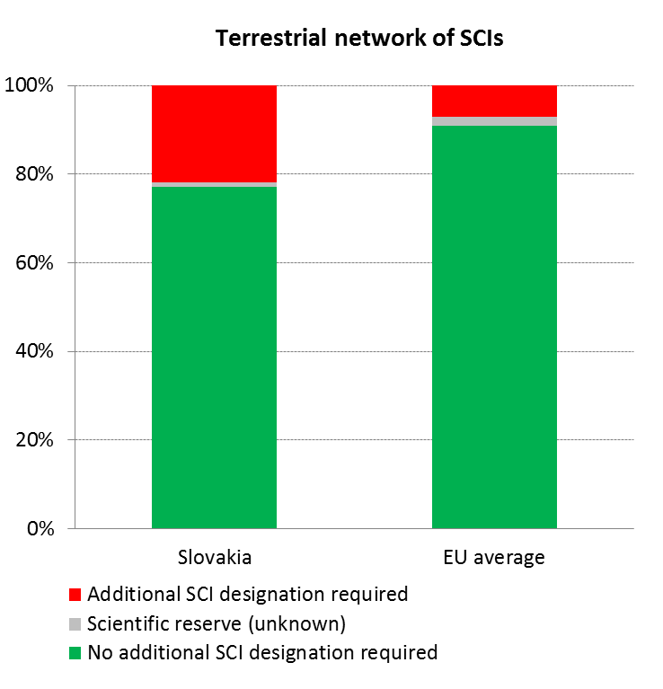
By February 2016, Slovakia had established 209 Special Areas of Conservation (SAC).
Complaints usually address conflicts between nature protection and socio-economic developments, in particular constructions of motorways, new water reservoirs and hydropower plants conflicting with Natura 2000. A significant part of complaints raises alleged mismanagement or lack of management of Natura 2000 sites or specific protected features (species or habitats), in particular clearcutting of forest habitats in Natura 2000, hunting of wolves, lack of protection of particular bird species, etc.
Slovak Natura 2000 sites are managed by land owners and users, scientific/methodical support and in some sites also management is provided by the Slovak State Nature Conservancy. The Slovak Ministry of the Environment bears the overall responsibility for Natura 2000 in Slovakia. In addition to the sites designated by the state administration bodies there are also 2 private protected areas (designated by the Wolf Forest Conservation Association) and 2 municipal protected areas
Figure 6: Conservation status of habitats and species in Slovakia in 2007/2013 (%)
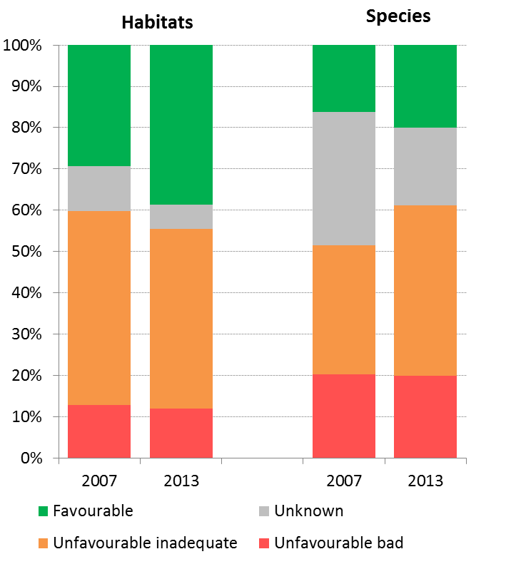
According to the latest report on the conservation status of habitats and species covered by the Habitats Directive, 38.6 % of the habitats' biogeographic assessments were favourable in 2013 (EU27: 16 %). Furthermore, 44 % are considered to be unfavourable–inadequate (EU27: 47 %) and 12 % are unfavourable – bad (EU27: 30 %). As for the species, 20 % of the assessments were favourable in 2013 (EU27: 23 %) 41 % at unfavourable-inadequate (EU27: 42 %) and 20 % unfavourable-bad status (EU27: 18 %). This is depicted in Figure 6.
Only 5 % and 1.7 % of the unfavourable assessments respectively for species and habitats were showing a positive trend in 2013.
A comparison of the results of Article 17 reports shows an overall improvement as concerns knowledge of data and a considerable improvement as concerns the conservation status of habitats. While in the period of 2007-2012 the conservation status of 6 habitat types and 60 species was found unknown in 2001-2006 it was 11 habitat types and 103 species. According to the official report submitted under Article 12 of the Birds Directive, 76 % of the breeding species showed short-term increasing or stable population trends (for wintering species this figure was 69 %) as shown in Figure 7.
Figure 7: Short-term population trend of breeding and wintering bird species in Slovakia in 2012 (%)
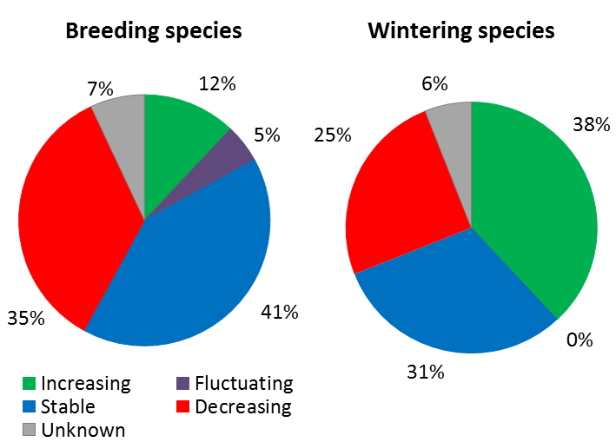
As regards the management of forest and support from EU funds, Slovak NRDP 2014-2020 includes the measure on prevention of risk of forest fires which according to the ECA finding were misused in the period 2007-2013. To overcome the problem, new delineation of areas at medium and high risk of forest fires was proposed, however without any robust methodology behind this.
Almost 41 % of the total area of Slovakia is afforested (the EU average is 42 %); while around 48% of the forest overlaps with Natura2000. This generates contradictions between different approaches in the forest management which was identified as one of the three most important challenges for the environment in Slovakia. The intensity of the forest exploitation according to certain indicators was growing during the last decade and the clear cutting is heavily used. The majority of the forest belongs to the state but some parts are privately owned and managed e.g. by NGOs. The management of the state forest follows the Forest Management Plans focusing on the production function of the forest. As regards the health of forest, though the trend has stabilised since the 90s, the weakened ecosystems stability over decades caused that forest ecosystems have suffered from strong storms (such as Ticha and Koprova valleys in High Tatras in 2004).
Thanks to this relatively high share of forests, Slovakia is promoting the use of biomass through EU funds as the contribution to the renewable policy objectives. However, the sustainable use of (woody) biomass is of a concern in certain regions of Slovakia due to the cutting and burning high quality wood for energy purposes. Trends already shows that the forest stock and landscape features in the urban areas and around rivers and roads are being depleted. In order to prevent further deterioration, Slovakia was asked to elaborate an analysis for sustainable use of biomass sources in the context of EU funding. Unlawful use of quality wood for the purpose of biomass combustion was also reported.
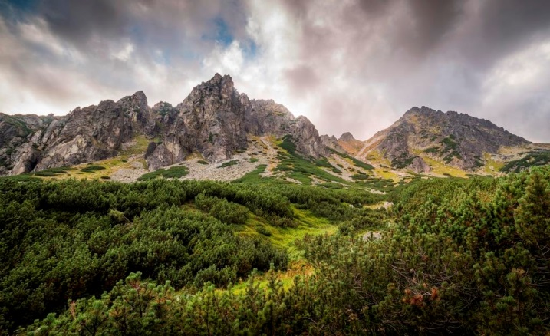Suggested action
- Complete the Natura 2000 designation process and put in place clearly defined conservation objectives and the necessary conservation measures for the sites and provide adequate resources for their implementation in order to maintain/restore species and habitats of community interest to a favourable conservation status across their natural range.
- Strengthen capacity building in order to improve management of Natura 2000 sites and species protection regimes and to ensure full integration with other policies and their associated funds. Strengthen communication with stakeholders.
- Ensure the sustainable forest management and promote efficient use of biomass.

Estimating Natural Capital
The EU Biodiversity Strategy to 2020 calls on the Member States to map and asses the state of ecosystems and their services in their national territory by 2014, assess the economic value of such services, and promote the integration of these values into accounting and reporting systems at EU and national level by 2020.
Activities are ongoing on mapping and assessment of ecosystems and their services at local/regional levels (assessment of ecosystem services for selected ecosystems have been performed in four national parks – Slovenský raj, Tatra, Veľká Fatra and Muránska planina). According to the Action Plan for the implementation of the updated National Biodiversity Strategy to 2020, Slovakia is to develop a methodology for the assessment of ecosystem services and implement it in model areas in 2016, with a view to a national assessment in 2018 and a national report with related communication events in 2019.
Suggested action
- Continue working and provide government support to the mapping and assessment of ecosystems and their services, valuation and development of natural capital accounting systems.

Green Infrastructure
The EU strategy on green infrastructure promotes the incorporation of green infrastructure into related plans and programmes to help overcome fragmentation of habitats and preserve or restore ecological connectivity, enhance ecosystem resilience and thereby ensure the continued provision of ecosystem services.
Green Infrastructure provides ecological, economic and social benefits through natural solutions. It helps to understand the value of the benefits that nature provides to human society and to mobilise investments to sustain and enhance them.
A number of projects have been designed to restore ecosystems - for example, grasslands, saltmarshes and wetlands. However, these are rather individual actions, and a strategic policy framework still needs to be developed.
A National programme for small scale projects Land Revitalisation and Integrated River Basin Management was implemented in 2010-2012. However, the programme was cancelled by the subsequent Government without robust evaluation of its impact.
Support of green infrastructure type of projects from EU funds was inadequate so far. Despite that these were eligible in PP 2007-2013, no project was co-financed over the whole period and funds were reallocated towards the end of programming period to flood risk management and the response capacity. PP 2014-2020 provides for support to green measures again.
Barriers to the effective integration of green infrastructure include limited understanding of ecosystems, lack of data and information on benefits, planning weaknesses, poor use of integrated spatial planning processes and conflicts with economic and development interests.

Soil protection
The EU Soil Thematic Strategy highlights the need to ensure a sustainable use of soils. This requires the prevention of further soil degradation and the preservation of its functions, as well as the restoration of degraded soils. The 2011 Road Map for Resource-Efficient Europe, part of Europe 2020 Strategy provides that by 2020, EU policies take into account their direct and indirect impact on land use in the EU and globally, and the rate of land take is on track with an aim to achieve no net land take by 2050.
SDG 15 requires countries to combat desertification, restore degraded land and soil, including land affected by desertification, drought and floods, and strive to achieve a land-degradation-neutral world by 2030.
Soil is an important resource for life and the economy. It provides key ecosystem services including the provision of food, fibre and biomass for renewable energy, carbon sequestration, water purification and flood regulation, the provision of raw and building material. Soil is a finite and extremely fragile resource and increasingly degrading in the EU. Land taken by urban development and infrastructure is highly unlikely to be reverted to its natural state; it consumes mostly agricultural land and increases fragmentation of habitats. Soil protection is indirectly addressed in existing EU policies in areas such as agriculture, water, waste, chemicals, and prevention of industrial pollution.
Artificial land cover is used for settlements, production systems and infrastructure. It may itself be split between built-up areas (buildings) and non-built-up areas (such as linear transport networks and associated areas).
The annual land take rate (growth of artificial areas) as provided by CORINE Land Cover was 0.40% in Slovakia over the period 2006-12, around the EU average (0.41%). It represented 1147 hectares per year (in the period 2000 – 2006 it was 486 hectares) mainly driven by industrial and commercial sites, as well as housing, services and recreation.
The percentage of built up land in 2009 was 2.54 %, below the EU average (3.23 %). The soil water erosion rate in 2010 was 2.18 tonnes per ha per year, close to EU28 average (2.46 tonnes).
There are still no EU-wide datasets enabling the provision of benchmark indicators for soil organic matter decline, contaminated sites, pressures on soil biology and diffuse pollution. An updated inventory and assessment of soil protection policy instruments in Slovakia and other EU Member States is being performed by the EU Expert Group on Soil Protection. Figure 8 shows the concise characterization of land cover changes in Slovakia in 2012.
Figure 8: Land Cover types in Slovakia in 2012
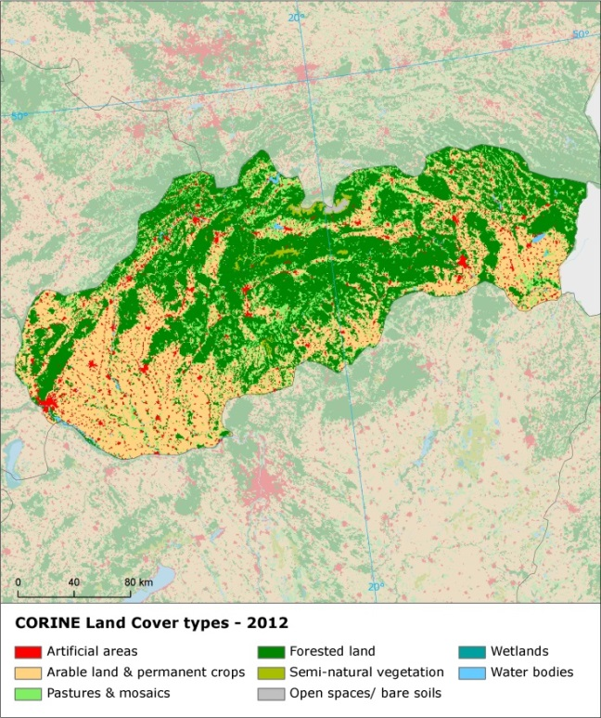

Ensuring citizens' health and quality of life

Air quality
Figure 9: Attainment situation for PM10, NO2 and O3 in 2014
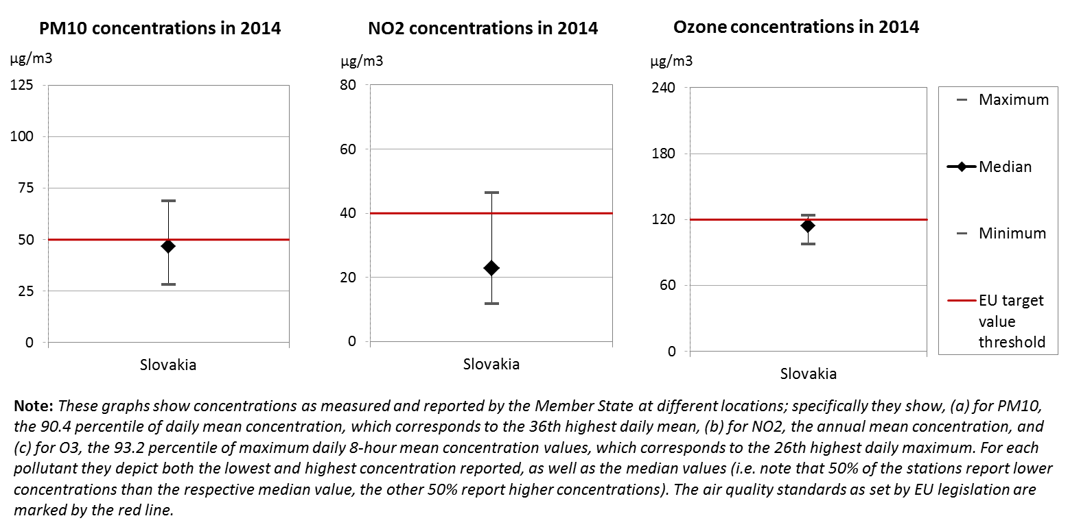
The EU Clean Air Policy and legislation require that air quality in the Union is significantly improved, moving closer to the WHO recommended levels. Air pollution and its impacts on ecosystems and biodiversity should be further reduced with the long-term aim of not exceeding critical loads and levels. This requires strengthening efforts to reach full compliance with Union air quality legislation and defining strategic targets and actions beyond 2020.
The EU has developed a comprehensive suite of air quality legislation, which establishes health-based standards and objectives for a number of air pollutants. As part of this, Member States are also required to ensure that up-to-date information on ambient concentrations of different air pollutants is routinely made available to the public. In addition, the National Emission Ceilings Directive provides for emission reductions at national level that should be achieved for main pollutants.
The emission of several air pollutants has decreased significantly in Slovakia. Reductions between 1990 and 2014 for sulphur oxides (-91%), ammonia (-43%), non-methane volatile organic compounds (-15%) as well as nitrogen oxides (-63%) ensure air emissions for these pollutants are within the currently applicable national emission ceiling.
At the same time, air quality in Slovakia continues to give cause for concern. For the year 2013, the European Environment Agency estimated that about 5 620 premature deaths were attributable to fine particulate matter concentrations, and 200 to ozone concentration. This is due also to exceedances above the EU air quality standards such as shown in Figure 9.
For 2014, the Slovak authorities have communicated exceedances above EU air quality standards that have been registered for nitrogen dioxide (NO₂) and particulate matter (PM₁₀) in several air quality zones. Furthermore, the target values and long-term objectives regarding ozone concentrations are exceeded in two air quality zones.
The persistent breaches of air quality requirements (for PM₁₀ and NO₂), which have severe negative effects on health and environment, are being followed up by the European Commission through infringement procedures covering all the Member States concerned, including Slovakia. The aim is that adequate measures are put in place to bring all zones into compliance.
It has been estimated that the health-related external costs from air pollution in Slovakia are above EUR 3 billion/year (income adjusted, 2010), which include not only the intrinsic value of living a full health life but also direct costs to the economy. These direct economic costs relate to 1.3 million workdays lost each year due to sickness related to air pollution, with associated costs for employers of EUR 123 million/year (income adjusted, 2010), for healthcare of above EUR 10 million/year (income adjusted, 2010), and for agriculture (crop losses) of EUR 35 million/year (2010).
Suggested action
- Maintain downward emissions trends of air pollutants in order to achieve full compliance with air quality limit values - and reduce adverse air pollution impacts on health, environment and economy.
- Reduce nitrogen oxide (NO_{x}) emissions to comply with currently applicable national emission ceilings and/or to reduce nitrogen dioxide (NO₂) (and ozone concentrations), inter alia, by reducing transport related emissions - in particular in urban areas.
- Reduce PM₁₀ emission and concentration, inter alia, by reducing emissions related to energy and heat generation using solid fuels, to transport and to agriculture.

Noise
The Environmental Noise Directive provides for a common approach for the avoidance, prevention and reduction of harmful effects due to exposure to environmental noise.
Excessive noise is one of the main causes of health issues. To alleviate this, the EU acquis sets out several requirements, including assessing the exposure to environmental noise through noise mapping, ensuring that information on environmental noise and its effects is made available to the public, and adopting action plans with a view to preventing and reducing environmental noise where necessary and to preserving the acoustic environment quality where it is good.
Slovakia's implementation of the Environmental Noise Directive is significantly delayed. The noise mapping for the most recent reporting round, for the reference year 2011, is only 50% complete for agglomerations and 28% for major roads. The noise mapping for major railways is complete. Action plans for noise management in the current period have been adopted for only 25% of major roads. Action plans for agglomerations and major railways have not been completed. The Commission contacted the Slovakian authorities with regard to the missing noise maps and action plans, and continues to follow up on the situation.
Suggested action
- Complete noise mapping and action plans for noise management and use them in planning praxis

Water quality and management
The EU water policy and legislation require that the impact of pressures on transitional, coastal and fresh waters (including surface and ground waters) is significantly reduced to achieve, maintain or enhance good status of water bodies, as defined by the Water Framework Directive; that citizens throughout the Union benefit from high standards for safe drinking and bathing water; and that the nutrient cycle (nitrogen and phosphorus) is managed in a more sustainable and resource-efficient way.
SDG 6 encourages countries to ensure availability and sustainable management of water and sanitation for all.
The main overall objective of EU water policy and legislation is to ensure access to good quality water in sufficient quantity for all Europeans. The EU water acquis seeks to ensure good status of all water bodies across Europe by addressing pollution sources (from e.g. agriculture, urban areas and industrial activities), physical and hydrological modifications to water bodies) and the management of risks of flooding.
River Basin Management Plans (RBMPs) are a requirement of the Water Framework Directive and a means of achieving the protection, improvement and sustainable use of the water environment across Europe. This includes surface freshwaters such as lakes and rivers, groundwater, estuaries and coastal waters up to one nautical mile.
Slovakia has provided information to the Commission from its second generation of RBMPs. However, as the Commission has not yet been able to validate this information for all Member States, it is not reported here.
In its first generation of RBMPs under the WFD the Slovak Republic reported the status of 1760 surface water bodies and 101 groundwater bodies. 65% of natural surface water bodies achieve a good or high ecological status and only 42% of heavily modified or artificial water bodies achieve a high or ecological potential. 96% of surface water bodies, 72% of heavily modified and artificial water bodies and 61% of groundwater bodies achieve good chemical status (while the status of 26% is unknown). 69% of groundwater bodies (26% unknown) are in good quantitative status.
Slovakia identified that organic pollution, nutrients pollution, pollution by hazardous substances from both diffuse and point sources, and hydromorphological alterations are the main causes of non-attainment of good status.
The Slovak RBMPs have some deficiencies that result in uncertainties about the status and effectiveness of Programmes of Measures. In particular there are weaknesses in monitoring, methodologies for status assessment and the link between pressures and Programmes of Measures. A number of exemptions were applied. The planned measures are expected to result in improvement of chemical status of surface water bodies by 4%. The measures should also bring improvement of ecological potential of artificial and heavily modified water bodies by 2% and chemical status by 28%. The quantitative status of groundwater is expected to improve by 5%.
Slovakia has designated around 30% of the territory as Nitrate Vulnerable Zone. The action programme has differentiated measures per areas depending of farming restrictions that apply. Discussions on the implementation of the Directive are on-going between the Commission and Slovakia in the context of an infringement procedure launched in 2012. A recent Court of Auditors report "Danube river basin II: Quality of water" stated there is a lack of ambition in the Member States concerned including Slovakia to address causes of pollution. It stated that Member States are not using all the possibilities offered by the Nitrates Directive
As regards drinking water, Slovakia reaches very high compliance rates of 99.52% % for microbiological, 100 % for chemical, and 99.4% for indicator parameters laid down in the Drinking Water Directive. More than 80% of drinking water sources in Slovakia are underground, and are concentrated in the south- western part of Slovakia (Zitny ostrov belongs to the biggest sources of drinking water in Central Europe). There are several pressures.
As shown in Figure 10, in 2015 in Slovakia, out of 33 bathing waters, 48.5 % were of excellent quality, 30.3% of good quality, 3.0% of sufficient quality. 1 bathing waters was of poor quality or non- compliant while it was not possible to assess the remaining 5 bathing waters because of their reconstruction. The figure shows a decrease of bathing waters having excellent quality.

Figure 10: Bathing water quality 2012 – 2015
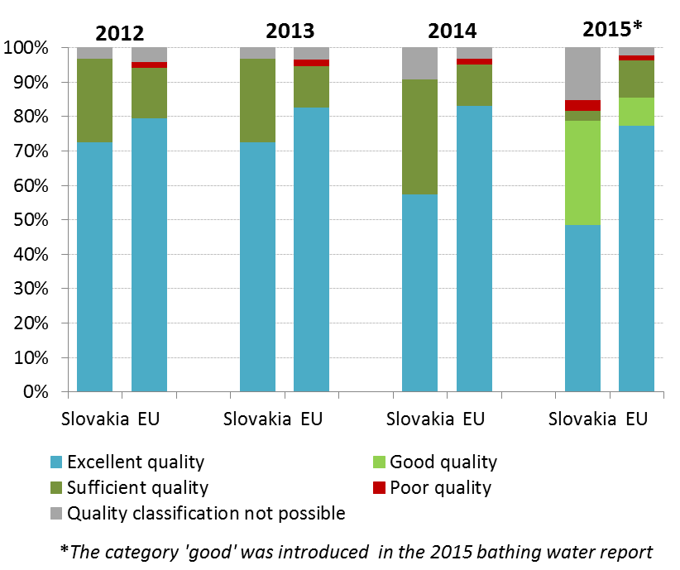
With regard to the implementation of the Urban Waste Water Treatment Directive, in accordance with its Accession treaty, Slovakia had until 31 December 2015 to comply, with a number of transitional deadlines in 2004, 2008 and 2010. In 2012, all agglomerations due to comply with Article 3 (collection of waste water) met the requirements of the Directive. 97.9% of the waste water load collected was subject to secondary treatment in accordance with Article 4 of the Directive. However, as regards Article 5, only 43.3 % of the waste water load collected was subject to more stringent treatment. The Commission is following-up on the above-mentioned non-compliance by means of a pilot exchange.
Figure 11 shows the total generated load at Member State level (in population equivalent and regardless of agglomerations) and the load that remains to be addressed by Slovakia.
The estimated investment needs (reported by Slovakia under Article 17 of the Urban Waste Water Treatment Directive) to reach full compliance with the Directive in are of 807 MEUR. The Majority of investments are supported by EU funds due to the limited availability of sources at the national level. This has been reported as distorting element in setting the balanced water pricing policy.

Figure 11: Urban waste water Slovakian situation 2012 – Final deadline 2015
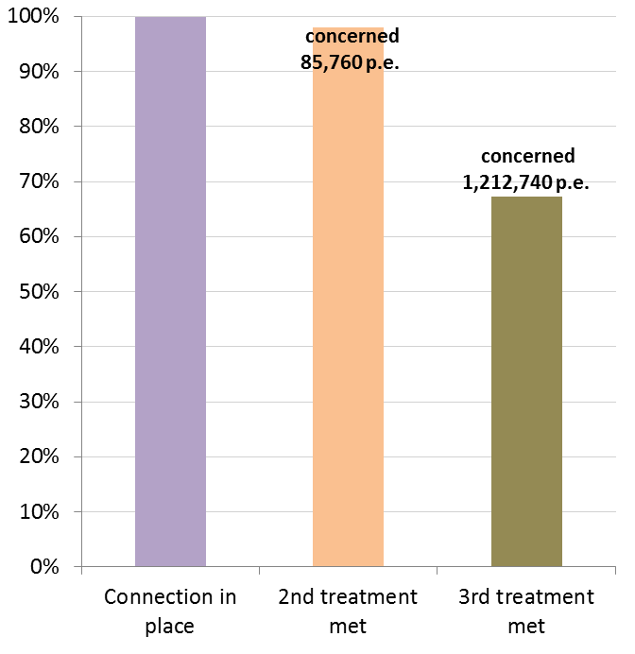
Flood risk areas have started to been identified and mapped in the Slovak Republic in the context of Flood Risk Management and the Plans were prepared together with 2nd RBMPs. Slovak Republic was hit by flooding incidents with serious economic damage costs for last time in 2013 (total direct costs estimated for 24 floods recorded between 2002 and 2013 is EURO 790 mill.)
Management and prevention of floods is an area where potentially more economical nature-based solutions could improve resource efficiency through reducing costs and delivering multiple benefits. In its 2014-20 operational programmes the Slovak Republic is planning to invest also in nature-based solutions. However, their effectiveness can be contradicted by the recent plans to invest in grey infrastructure projects in the context of national Strategy to fight with climate change.
Suggested action
- Slovakia should do a more detailed assessment of pressures and improve monitoring in order to know the status of water bodies and design effective Programmes of Measures.
- The assessment methods should improve to provide more certainty about the water status. Programmes of Measures should cover all identified pressures and implementation gaps and should be adequately funded and should take into account the conclusions of the Court of Auditors report.
- New physical modifications of water bodies (including anti-flood measures) should be assessed in line with article 4(7). In these assessments alternative options and adequate mitigation measures have to be considered. This is particularly relevant for new dams (like Slatinka, Tichy potok, Sered-Hlohovec) planned outside the intervention logic of Water Framework Directive decades ago or small hydropower stations (like on river Hron). Similar concerns apply to drainage channels maintenance and development.
- Slovakia should improve its water pricing policy based on an analysis of environmental and resource costs and covering a broad range of water services.

Enhancing the sustainability of cities
The EU Policy on the urban environment encourages cities to implement policies for sustainable urban planning and design, including innovative approaches for urban public transport and mobility, sustainable buildings, energy efficiency and urban biodiversity conservation.
SDG11 aims at making cities and human settlements inclusive, safe, resilient and sustainable.
Europe is a Union of cities and towns; around 75% of the EU population are living in urban areas. The urban environment poses particular challenges for the environment and human health, whilst also providing opportunities and efficiency gains in the use of resources.
The Member States, European institutions, cities and stakeholders have prepared a new Urban Agenda for the EU (incorporating the Smart Cities initiative) to tackle these issues in a comprehensive way, including their connections with social and economic challenges. At the heart of this Urban Agenda will be the development of twelve partnerships on the identified urban challenges, including air quality and housing.
The European Commission will launch a new EU benchmark system in 2017.
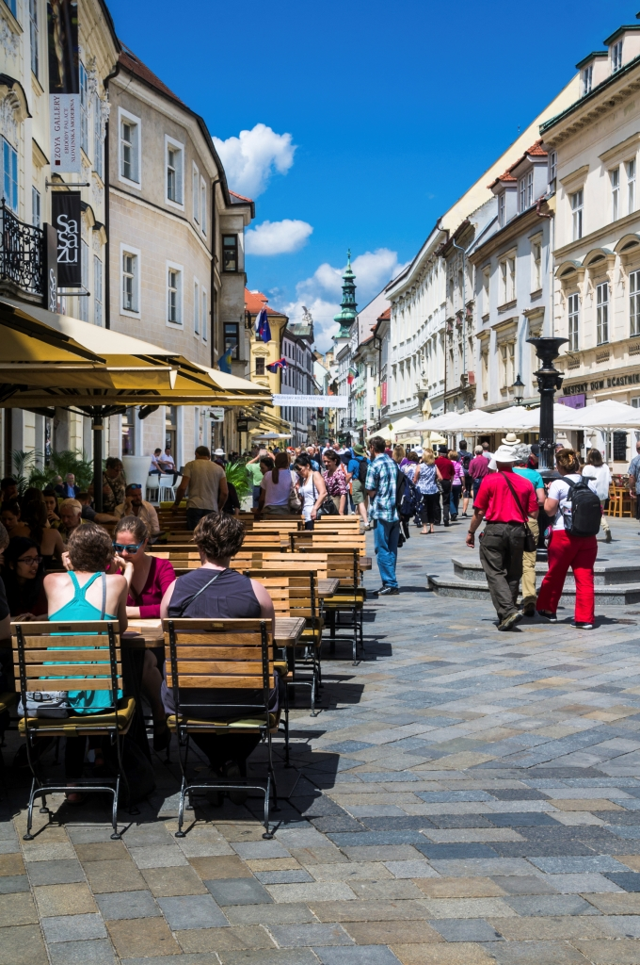The EU stimulates green cities through awards and funding, such as the EU Green Capital Award aimed at cities with more than 100,000 inhabitants and the EU Green Leaf initiative aimed at cities and towns, with between 20,000 and 100,000 inhabitants.
Some local initiatives such as Agenda 21 were established in the past; however the institutional support is very weak.

International agreements
The EU Treaties require that the Union policy on the environment promotes measures at the international level to deal with regional or worldwide environmental problems.
Most environmental problems have a transboundary nature and often a global scope and they can only be addressed effectively through international co-operation. International environmental agreements concluded by the Union are binding upon the institutions of the Union and on its Member States. This requires the EU and the Member States to sign, ratify and effectively implement all relevant multilateral environmental agreements (MEAs) in a timely manner. This will also be an important contribution towards the achievement of the SDGs, which Member States committed to in 2015 and include many commitments contained already in legally binding agreements.
The fact that some Member States did not sign and/or ratify a number of MEAs compromises environmental implementation, including within the Union, as well as the Union’s credibility in related negotiations and international meetings where supporting the participation of third countries to such agreements is an established EU policy objective. In agreements where voting takes place it has a direct impact on the number of votes to be cast by the EU.
Slovakia has signed and ratified almost all MEAs. It has signed but not yet ratified the MARPOL Annex VI on Prevention of Air Pollution from Ships.

Part II: Enabling Framework: Implementation Tools

Market based instruments and investment

Green taxation and environmentally harmful subsidies
The Circular Economy Action Plan encourages the use of financial incentives and economic instruments, such as taxation to ensure that product prices better reflect environmental costs. The phasing out of environmentally harmful subsidies is monitored in the context of the European Semester and in national reform programmes submitted by Member States.
Taxing pollution and resource use can generate increased revenue and bring important social and environmental benefits.
In 2014, environmental taxes amounted to 1.79% of GDP and remain much below the early 2000 (2.45% in 2004). The largest proportion of environmentally-related taxation in 2014 was from energy taxes, which generated revenue equivalent to 1.48% of GDP (EU average 1.88%). The implicit tax rate on energy is one of the lowest in the EU (108 vs 234 EU28 average). Taxes on transport (excl. transport fuels) accounted for 0.21% of GDP, whilst taxes on pollution and resources accounted for just 0.03% of GDP. The support to production of electricity from low quality brown coal extracted in Slovakia is an example of environmentally harmful subsidies.
In the same year environmental tax revenues accounted for 5.77% (up from 5.72%) of total revenues from taxes and social-security contributions (EU28 average: 6.35%) as depicted in Figure 12.
The headline figures from the 2016 study suggest that there is considerable potential for shifting taxes from labour to environmental taxes in Slovakia. Under a good practice scenario, the amount could be as much as EUR 0.69 billion in 2018, rising to EUR 1.46 billion in 2030 (both in real 2015 terms). This is equivalent to an additional 0.78% and 1.10% of GDP in 2018 and 2030, respectively. The biggest share could potentially come from increasing vehicle taxation, which will also serve as the means to influence the environmental performance of vehicles in use in future. Suggested increase in vehicle taxes could account for EUR 0.64 billion in 2030 (real 2015 terms), equivalent to 0.49% of GDP.
The next largest potential contribution to revenue comes from the proposed amendments to the taxes on transport fuels. This accounts for EUR 0.41 billion in 2030 (real 2015 terms),
Figure 12: Environmental tax revenues as a share of total revenues from taxes and social contributions (excluding imputed social contributions) in 2014
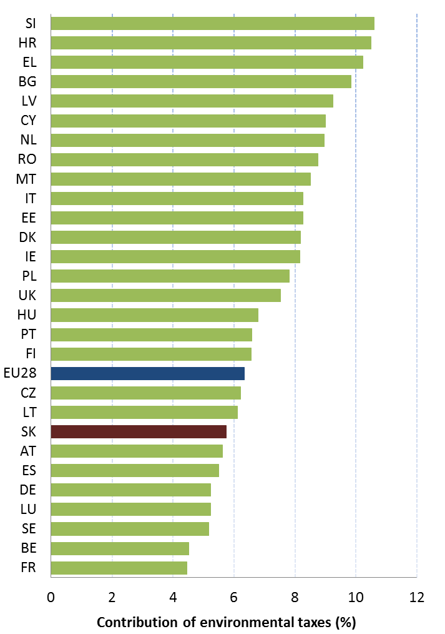
equivalent to 0.31% of GDP Low implicit tax rate on energy and lower than average energy taxes share in GDP indicate that there is a scope to increase taxation levels in energy: diesel fuel is taxed much lower than petrol (both in per volume and in per energy content).

Green Public Procurement
The EU green public procurement policies encourage Member States to take further steps to reach the target of applying green procurement criteria to at least 50% of public tenders.
Green Public Procurement (GPP) is a process whereby public authorities seek to procure goods, services and works with a reduced environmental impact throughout their life-cycle when compared to goods, services and works with the same primary function that would otherwise be procured.
The purchasing power of public procurement equals to approximately 14% of GDP. A substantial part of this money is spent on sectors with high environmental impact such as construction or transport, so GPP can help to significantly lower the impact of public spending and foster sustainable innovative businesses.
A National Action Plan (NAP) was in place for the period 2011-2015. GPP criteria are not developed at the national level. However the EU GPP criteria are recommended for several product groups, like cleaning products and services, IT Office equipment, transport, copy and graphic paper, furniture, food and catering services, textiles, electricity, display device, garden products and services, and construction. The target was to achieve 65 % of GPP at central government level by the end of 2015, and 50 % of GPP for regional and local level by the end of 2015., NAP 2011-2015 (NAP GPP II) will be replaced by NAP GPP III (2016-2020).
Slovak authorities monitored the uptake of GPP policies in 2009 and 2010 and 2015.

Investments: the contribution of EU funds
European Structural and Investment Funds Regulations provide that Member States promote environment and climate objectives in their funding strategies and programmes for economic, social and territorial cohesion, rural development and maritime policy, and reinforce the capacity of implementing bodies to deliver cost-effective and sustainable investments in these areas.
Making good use of the European Structural and Investment Funds (ESIF) is essential to achieve the environmental goals and integrate these into other policy areas. Other instruments such as the Horizon 2020, the LIFE programme and European Fund for Strategic Investment (EFSI) may also support implementation and spread off best practice.
The funding allocation to Slovakia for PP 2014-2020 (see Figure 13), in comparison to PP 2007-2013, increased by almost 14% to overall EURO 15,3 billion in terms of EU sources and by around 24% in terms of the total funding to overall 20,0 billion (mainly due to the growth of the national economy). The public investments are heavily dependent on the EU funds including the environmental sector. There is a lack of other public sources to support the implementation of environmental policies.
Number of programmes has decreased to 8 for ERDF, ESF and CF (plus RDP for EARDF and ETC OPs).
The main programme for implementation of environmental policies is Operational Programme Quality of Environment. It is planned that implementation of the programme will result inter alia in increasing the surface area of rehabilitated land by 452 hectares, increasing the surface area of habitats supported to attain a better conservation status by 20 131 hectares, enhancing waste recycling capacity by 197 466 tonnes/year and waste recovery capacity by 329 676 tonnes/year, increasing the population served by improved wastewater treatment by 212 411 persons, as well as implementing 390 green infrastructure elements, The programme is also expected to contribute to the reduction of PM emission by 6 960 tonnes/year and selected pollutant emissions by 38 083 tonnes/year.
Current data suggest that the EU funds for the 2007-2013 period were almost fully spent .
Figure 13: European Structural and Investment Funds 2014-2020: Budget Slovakia by theme, EUR billion
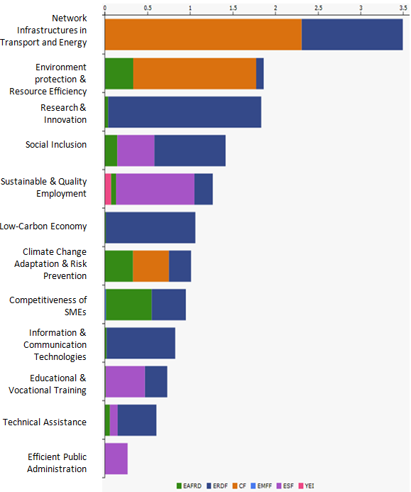
The general problem of EU programmes in Slovakia is with targeted use of funds, including environmental sector. Changes in the investment strategy of the
OPE 2007-2013 were caused by the delays in project preparation in waste and water sectors and lack of appropriate capacities in project design and preparation. This created a serious risk of a substantial funds decommitment and resulted in several modification of programme. Another challenge is the integration of environmental priorities. In on-going PP 2014-2020, this would largely depend on the progress in implementation in the programmes outside the Operational Programme Quality of Environment. However, more stringent regulatory and enforcement steps are needed leading to creation of credible plans to adopt measures designed by different strategies to this end.
The National Rural Development Program (NRDP) of Slovakia, its EARDF part, amounts to EUR 1,560 million. The budget for agri-environmental-climate measure represents 6.8% of the total EAFRD and is one of the lowest percentages among the MSs.
Slovakia used option of transfer part of budget of Pillar II to Pillar I for direct payments (21.3% for allocations for every budgetary year 2015-2020, subject to amendments).
Contribution of RDP towards environmental objectives inadequately covers the needs. Slovak NRDP includes only two measures for support of biodiversity (apart from agri-environment-climate measure), namely Natura 2000 compensation measure and forest-environment measure, with rather limited allocation. Around half of the contribution accounted under environmental objectives is related to the measure on natural constraints (however, as in other MSs, no conditions are linked to this measure).
Some of the needs such as cohabitation of rural areas and agriculture with large carnivores are out of the programme. On the other hand, reconstructing of drainage channels have been included in significant scope but with questionable benefits as well as fire forest prevention measures, which are problematic as according to the ECA audit.
With regard to the integration of environmental concerns into the Common Agricultural Policy (CAP), the two key areas for Slovakia (as for all Member States) are relevant. First, using Rural Development funds to pay for environmentally friendly land management and other environmental measures, and secondly, ensuring an effective implementation of the first pillar of the CAP with regard to cross compliance and 1st pillar - 'greening' where almost 30 % of direct payment envelope could be allocated to greening practices beneficial for the environment. An environmentally ambitious implementation of 1st pillar greening would clearly help to improve the environmental situation in areas not covered by rural development, including intensive area, and Slovakia still could make improvements in this regards.
A critical review of the programming logic of the Rural Development Programme (RDP) towards more environmental objectives and effective implementation of 'greening' is crucial for 2014-2020.

Effective governance and knowledge
SDG 16 aims at providing access to justice and building effective, accountable and inclusive institutions at all levels. SDG 17 aims at better implementation, improving policy coordination and policy coherence, stimulating science, technology and innovation, establishing partnerships and developing measurements of progress.
Effective governance of EU environmental legislation and policies requires having an appropriate institutional framework, policy coherence and coordination, applying legal and non-legal instruments, engaging with non-governmental stakeholders, and having adequate levels of knowledge and skills. Successful implementation depends, to a large extent, on central, regional and local government fulfilling key legislative and administrative tasks, notably adoption of sound implementing legislation, co-ordinated action to meet environmental objectives and correct decision-making on matters such as industrial permits. Beyond fulfilment of these tasks, government must intervene to ensure day-to-day compliance by economic operators, utilities and individuals ("compliance assurance"). Civil society also has a role to play, including through legal action. To underpin the roles of all actors, it is crucial to collect and share knowledge and evidence on the state of the environment and on environmental pressures, drivers and impacts.
Equally, effective governance of EU environmental legislation and policies benefits from a dialogue within Member States and between Member States and the Commission on whether the current EU environmental legislation is fit for purpose. Legislation can only be properly implemented when it takes into account experiences at Member State level with putting EU commitments into effect. The Make it Work initiative, a Member State driven project, established in 2014, organizes a discussion on how the clarity, coherence and structure of EU environmental legislation can be improved without lowering existing protection standards.

Effective governance within central, regional and local government
Those involved in implementing environment legislation at Union, national, regional and local levels need to be equipped with the knowledge, tools and capacity to improve the delivery of benefits from that legislation, and the governance of the enforcement process.

Capacity to implement rules
It is crucial that central, regional and local administrations have the necessary capacities and skills and training to carry out their own tasks and co-operate and co-ordinate effectively with each other, within a system of multi-level governance.
Administrative capacities are in general not sufficient and the enforcement of the environmental laws and policies is suffering in long-term run from turn-over with every election round. Water management sector suffers from weak administrative capacities for example.
The responsibility for environmental matters lies with the Ministry of Environment or Regional Authorities. Local authorities are typically responsible for sectorial policies, like waste management, which is a source of tension. The Ministry has also general supervisory and controlling role.
In 2013, a partial public administration reform took place which resulted in creation of integrated local bodies, district offices, to which the powers and responsibilities of regional environmental offices, regional bodies for transportation and forestry management, and regional cadastral offices was transferred to. While there is no evaluation of the impact of this partial reform available a risk of loss of skills was reported.
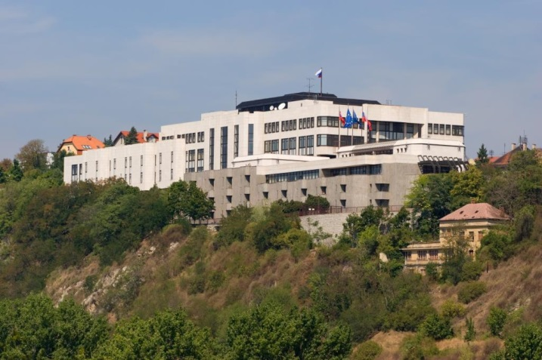
The ownership of environmental agenda is weak, prevailed by social topics. Environmental authorities are subject to numerous pressures. While the environmental legislation is relatively strict, their enforcement is low.
Public trust in and among administrative levels is low.
There are approx. 25 environmental NGOs in Slovakia operating at national or local level, organised since 2007 in an open network "Ekoforum", while several of these NGOs are also members of new "Green Coalition", created in 2014. The Slovak environmental NGOs operate in generally unfavourable environment with a shortage of financing. This is mirrored e.g. by a low number of the cases being addressed to the national courts in environmental matters.
Slovakia has an average number of infringements concerning mainly non-conformity and bad-application of EU environmental acquis. The main shares of infringements are in water (29%), waste (21%) and impact (22%) sector (data of 2015). The gaps in transposition of the EIA/SEA Directives were already addressed by three infringement proceedings since the Slovak accession into EU. This has an impact on the legality of the projects which fall under the EIA Directive and were subject to the development consent procedures during this period.
Slovakia adopted an amendment of the EIA law in April 2015 in response to the second horizontal EIA infringement to avoid a risk of interruption of EU funds. This amendment introduced several changes to the system established until then, like binding and appealable EIA Statement.
A pipeline of projects with old/pre-accession EIAs which are to be co-financed in PP 2014-2020 still exist in transport sector and the compliance of these projects with the EU acquis has to be ensured by doing new EIAs where necessary.
In some of the environmental cases where individuals or NGOs have gained access before the national courts over the past years, the Slovakian judges referred several requests for preliminary rulings to the Court of Justice of the EU. This represented a valuable contribution to the development of EU environment law, since preliminary rulings enable the Court of Justice to give a coherent interpretation of the EU law.
Environmental policy is traditionally linked to the planning instruments (territorial plans). These however suffer from formalistic application of the strategic environmental assessment. Slovakia has in place a multi-stage development consent system, in which the EIA process is followed by the zoning decisions and building permit stages. There are discussions on-going for last decades on the complete reform of permitting system, (based on 1976 Construction Act, amended for numerous times since then), however these have not materialised yet.
Suggested action
- Improve the application of EIA and SEA as important tools to ensure environmental integration.

Coordination and integration
The Slovak Republic has a national SDP Strategy. The implementation of environmental policies is fragmented by the competences allocation. Long-term thinking is often prevailed by political decisions.
The transposition of the revised EIA Directive will be an opportunity to streamline the regulatory framework on environmental assessments. The Commission encourages the streamlining of the environmental assessments because this approach reduces duplication and avoids unnecessary overlaps in environmental assessments applicable for a particular project. Moreover, streamlining helps reducing unnecessary administrative burden and accelerates decision-making, without compromising the quality of the environmental assessment procedure. The Commission has issued a guidance document in 2016 regarding the setting up of coordinated and/or joint procedures that are simultaneously subject to assessments under the EIA Directive, Habitats Directive, Water Framework Directive, and the Industrial Emissions Directive.

Compliance assurance
EU law generally and specific provisions on inspections, other checks, penalties and environmental liability help lay the basis for the systems Member States need to have in place to secure compliance with EU environmental rules.
Public authorities help ensure accountability of duty-holders by monitoring and promoting compliance and by taking credible follow-up action (i.e. enforcement) when breaches occur or liabilities arise. Compliance monitoring can be done both on the initiative of authorities themselves and in response to citizen complaints. It can involve using various kinds of checks, including inspections for permitted activities, surveillance for possible illegal activities, investigations for crimes and audits for systemic weaknesses. Similarly, there is a range of means to promote compliance, including awareness-raising campaigns and use of guidance documents and online information tools. Follow-up to breaches and liabilities can include administrative action (e.g. withdrawal of a permit), use of criminal law and action under liability law (e.g. required remediation after damage from an accident using liability rules) and contractual law (e.g. measures to require compliance with nature conservation contracts). Taken together, all of these interventions represent "compliance assurance" as shown in Figure 14.
Best practice has moved towards a risk-based approach at strategic and operational levels in which the best mix of compliance monitoring, promotion and enforcement is directed at the most serious problems. Best practice also recognises the need for coordination and cooperation between different authorities to ensure consistency, avoid duplication of work and reduce administrative burden. Active participation in established pan-European networks of inspectors, police, prosecutors and judges, such as IMPEL, EUFJE, ENPE and EnviCrimeNet, is a valuable tool for sharing experience and good practices.
Figure 14: Environmental compliance assurance
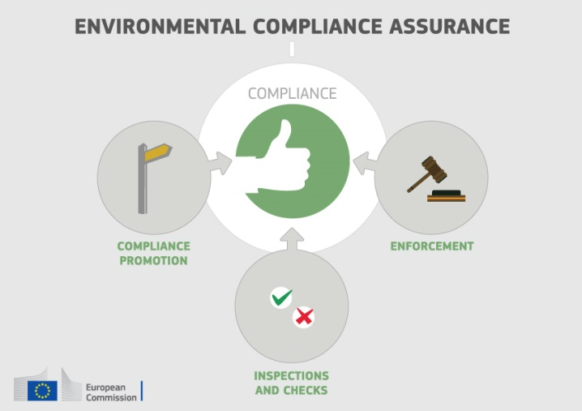
Currently, there exist a number of sectoral obligations on inspections and the EU directive on environmental liability (ELD) provides a means of ensuring that the "polluter-pays principle" is applied when there are accidents and incidents that harm the environment. There is also publically available information giving insights into existing strengths and weaknesses in each Member State.
For each Member State, the following were therefore reviewed: use of risk-based compliance assurance; coordination and co-operation between authorities and participation in pan-European networks; and key aspects of implementation of the ELD based on the Commission's recently published implementation report and REFIT evaluation.
Over the last decade, Slovakia has made efforts to improve its system of inspections of industrial facilities. Some good practices have been identified in terms of compliance promotion activities and involvement of NGOs in compliance assurance work.
Risk-based approaches to target compliance assurance work seem to be used only to a limited extent. Relevant inspection plans are in place, which however are not made publicly available. Weaknesses have been identified concerning strategic planning and the organisation and effectiveness of compliance assurance work in individual environmental policy subject-areas, e.g. concerning controls of water abstraction and concerning illegal killing of birds.
Up-to-date information is lacking in relation to the following:
- data-collection arrangements to track the use and effectiveness of different compliance assurance interventions;
- the extent to which risk-based methods are used to direct compliance assurance at the strategic level and in relation to critical activities outside of industrial installations, especially specific problem-areas highlighted elsewhere in this Country Report, i.e. threats to protected habitat types and species, air quality breaches and the pressures on groundwater resources.
- arrangements for structured coordination and cooperation between different relevant competent authorities; in particular between inspectors on the one hand and prosecutors on the other hand
- how the competent authorities ensure a targeted and proportionate response to different types of non-compliant behaviour, in particular in relation to serious breaches detected, given indications that there is a low level of detection of breaches and low probability of being criminally prosecuted and sentenced for environmental offences.
Slovakia participate in the activities of IMPEL and EnviCrimeNet.
For the period 2007-2013, Slovakia reported no cases of environmental damage handled under the Environmental Liability Directive. The Ministry of Environment has organised training events and conferences, and produced information material to raise awareness. It has also created a methodology for spatial risk differentiation and an information system for the prevention and remedying of environmental damage as well as an environmental damage register. However, there remains scope for additional measures to improve the Directive's implementation. Since 2012, Slovakia operates a mandatory financial security for operators carrying out dangerous activities (to pay for remediation where the operator cannot).
Suggested action
- Improve transparency on the organisation and functioning of compliance assurance and on how significant risks are addressed, as outlined above.
- Encourage greater participation of competent authorities in all environmental compliance networks.
- Step up efforts in the implementation of the Environmental Liability Directive (ELD) with proactive initiatives, in particular by drafting national guidance.

Public participation and access to justice
The Aarhus Convention, related EU legislation on public participation and environmental impact assessment, and the case-law of the Court of Justice require that citizens and their associations should be able to participate in decision-making on projects and plans and should enjoy effective environmental access to justice.
Citizens can more effectively protect the environment if they can rely on the three "pillars" of the Convention on Access to Information, Public Participation in Decision-making and Access to Justice in Environmental Matters ("the Aarhus Convention"). Public participation in the administrative decision making process is an important element to ensure that the authority takes its decision on the best possible basis. The Commission intends to examine compliance with mandatory public participation requirements more systematically at a later stage.
Access to justice in environmental matters is a set of guarantees that allows citizens and their associations to challenge acts or omissions of the public administration before a court. It is a tool for decentralised implementation of EU environmental law.
For each Member State, two crucial elements for effective access to justice have been systematically reviewed: the legal standing for the public, including NGOs and the extent to which prohibitive costs represent a barrier.
The costs of court procedures in Slovakia are not considered as being prohibitively high.
A major challenge to bring environmental cases to the court was the lack of legal standing for the public, including environmental NGOs, for asking for a judicial review of administrative decisions involving environmental matters. In several areas of environmental law the public was not entitled to bring a case to court, mainly because it is not admitted to the administrative procedure which is a precondition for taking a court action. Slovakia has partly addressed the issue by adopting legislation introducing access to justice requirements for NGOs in several sectors, such as in the area of projects requiring an environmental impact assessment.
Suggested action
- Take the necessary measures to ensure standing of environmental NGOs to challenge acts or omissions of a public authority in all sectoral EU environmental laws, in full compliance with EU law as well as the Convention on Access to Information, Public Participation in Decision-making and Access to Justice in environmental matters (Aarhus Convention).

Access to information, knowledge and evidence
The Aarhus Convention and related EU legislation on access to information and the sharing of spatial data require that the public has access to clear information on the environment, including on how Union environmental law is being implemented.
It is of crucial importance to public authorities, the public and business that environmental information is shared in an efficient and effective way. This covers reporting by businesses and public authorities and active dissemination to the public, increasingly through electronic means.
The Aarhus Convention, the Access to Environmental Information Directive and the INSPIRE Directive together create a legal foundation for the sharing of environmental information between public authorities and with the public. They also represent the green part of the ongoing EU e-Government Action Plan. The first two instruments create obligations to provide information to the public, both on request and actively. The INSPIRE Directive is a pioneering instrument for electronic data-sharing between public authorities who can vary in their data-sharing policies, e.g. on whether access to data is for free. The INSPIRE Directive sets up a an infrastructure, allowing harmonised spatial data and services exchange. In order to facilitate access to the services, concept of INSPIRE geoportal has been introduced. Spatial data and services are described to be searchable via metadata, which indicates among the other parameters, also level of public access to the to the level of shared spatial data and conditions applying to access an use in each Member State – i.e. data related to specific locations, such as air quality monitoring data. Amongst other benefits it facilitates the public authorities' reporting obligations.
For each Member State, the accessibility of environmental data (based on what the INSPIRE Directive envisages) as well as data-sharing policies ('open data') have been systematically reviewed.
Slovakia's performance on the implementation of the INSPIRE Directive as enabling framework to actively disseminate environmental information to the public leaves room for improvement. Slovakia has indicated in the 3-yearly INSPIRE implementation report that the necessary data-sharing policies allowing access and use of spatial data by national administrations, other Member States' administrations and EU institutions without procedural obstacles are only partially available and lack consistency. Slovakia has no common data-policy or harmonized conditions for access and use. Although there is legislation in place, the implementation lags behind and the current data-sharing landscape remains very heterogeneous. Different licenses and bilateral data-sharing agreements are being used for exchanging spatial data between public authorities. There is currently ongoing legislation amendment process aiming to improve the situation and address the identified gaps foreseen to by adopted by the end of 2016.
Assessments of monitoring reports issued by Slovakia and the spatial information that Slovakia has published on the INSPIRE geoportal indicate that not all spatial information needed for the evaluation and implementation of EU environmental law has been made available or is accessible. The larger part of this missing spatial information consists of the environmental data required to be made available under the existing reporting and monitoring regulations of EU environmental law. With respect to the proposed INSPIRE priority list of the datasets linked to the reporting obligations in EU environment legislation, Slovakia has initiated activities to create closer alignment between INSPIRE and environmental reporting.
Suggested action
- Critically review the effectiveness of its data policies and amend them, taking 'best practices' into consideration. Provide the sufficient support for the implementation of the amended legislation and ensure the consistency with the eGovernment activities.
- Identify and document all spatial data sets required for the implementation of environmental law, and make the data and documentation at least accessible 'as is' to other public authorities and the public through the digital services foreseen in the INSPIRE Directive. Create sufficient conditions to meet the objectives of the actions defined in the national INSPIRE Action plan 2016 - 2021.

Communication "Delivering the benefits of EU environmental policies through a regular Environmental Implementation Review" (COM/2016/ 316 final).
Decision No. 1386/2013/EU of 20 November 2013 on a General Union Environmental Action Programme to 2020 "Living well, within the limits of our planet".
United Nations, 2015. The Sustainable Development Goals
This EIR report does not cover climate change, chemicals and energy.
European Commission, 2015. Proposed Circular Economy Package
European Environment Agency, 2016. More from less – material resource efficiency in Europe. Slovakia Report
The EU Eco-Management and Audit Scheme (EMAS) and Environmental Management System under ISO 14001 (EMS);
Environmental labelling of products, implemented through the European and national eco-labelling schemes EU Ecolabel and Environmentally Friendly Products
Section 5
Eurostat, Resource productivity, accessed October 2016
Resource productivity is defined as the ratio between gross domestic product (GDP) and domestic material consumption (DMC).
Small and medium enterprises
The Flash 426 Eurobarometer "SMEs, resource efficiency and green markets" defines "green job" as job that directly deals with information, technologies, or materials that preserves or restores environmental quality. This requires specialised skills, knowledge, training, or experience (e.g. verifying compliance with environmental legislation, monitoring resource efficiency within the company, promoting and selling green products and services).
Research and Innovation Strategies for Smart Specialisation: The Smart Specialisation Strategy for the Slovak Republic for period 2014-2020
European Commission, SWD(2016) 93 final
Eco-innovation Observatory: Eco-Innovation scoreboard 2015
Waste Management Plans/Waste Prevention Programmes
http://www.eea.europa.eu/data-and-maps/figures/typical-charge-gate-fee-and
Member States may choose a different method than the one used by ESTAT (and referred to in this report) to calculate their recycling rates and track compliance with the 2020 target of 50% recycling of municipal waste.
Eurostat, Municipal waste and treatment, by type of treatment method, accessed October 2016
Eurostat, Recycling rate of municipal waste, accessed October 2016
European Commission, Roadmap Slovakia
Implementing EU legislation for Green Growth (2011), study by Bio Intelligence service, breakdown per country on job creation was made by the consultant on Commission demand but was not included in the published document
Sites of Community Importance (SCIs) are designated pursuant to the Habitats Directive whereas Special Areas of Protection (SPAs) are designated pursuant to the Birds Directive; figures of coverage do not add up due to the fact that some SCIs and SPAs overlap. Special Areas of Conservation (SACs) means a SCI designated by the Member States.
For each Member State, the Commission assesses whether the species and habitat types on Annexes I and II of the Habitats Directive, are sufficiently represented by the sites designated to date. This is expressed as a percentage of species and habitats for which further areas need to be designated in order to complete the network in that country. The current data, which were accessed in 2014-2015, reflect the situation up until December 2013.
The percentages in Figure 5 refer to percentages of the total number of assessments (one assessment covering 1 species or 1 habitat in a given biographical region with the Member State); if a habitat type or a species occurs in more than 1 Biogeographic region within a given Member State, there will be as many individual assessments as there are Biogeographic regions with an occurrence of that species or habitat in this Member State.
European Commission, internal assessment.
http://domov.sme.sk/c/20374539/lesoochranarom-sa-nepaci-plan-lovu-vlka-obratili-sa-na-brusel.html
These figures show the percentage of biogeographical assessments in each category of conservation status for habitats and species (one assessment covering 1 species or 1 habitat in a given biographical region with the Member State), respectively. The information is based on Article 17 of the Habitats Directive reporting - national summary of Slovakia
The core of the ‘Article 17’ report is the assessment of conservation status of the habitats and species targeted by the Habitats Directive.
Conservation status is assessed using a standard methodology as being either ‘favourable’, ‘unfavourable-inadequate’ and ‘unfavourable-bad’, based on four parameters as defined in Article 1 of the Habitats Directive.
Please note that a direct comparison between 2007 and 2013 data is complicated by the fact that Bulgaria and Romania were not covered by the 2007 reporting cycle, that the ‘unknown’ assessments have strongly diminished particularly for species, and that some reported changes are not genuine as they result from improved data / monitoring methods.
Article 12 of the Birds Directive requires Member States to report about the progress made
Article 12 Birds Directive reporting - national summary of Slovakia
The fire protection forest roads are eligible only for investments in sections which are needed to be linked to the existing forest roads network, and reconstruction of forest roads network are to be considered, based on the principles of cost-effectiveness and sustainability. It would be subject to the further analysis
The Institute of the environmental policy in Slovakia: The three most important challenges for the environment in Slovakia
According to SK authorities, there is a need for harmonisation of EU energy, water and biodiversity policies.
OP Quality of Environment and the Rural Development Programme contain provision to prepare Criteria for the sustainable use of the biomass in the regions of Slovakia will be prepared at the national level before granting any support for use of biomass. The document was presented in September 2016, however the stakeholders criticised the analysis when it comes to the existing stock of woody biomass and calculation of its future potential as it significantly diffesr to other sources, please see: http://www.ekoforum.sk/peticia/biomasa
Ecosystem services are benefits provided by nature such as food, clean water and pollination on which human society depends.
European Union, Green Infrastructure — Enhancing Europe’s Natural Capital, COM/2013/0249
European Environment Agency Draft results of CORINE Land Cover (CLC) inventory 2012; mean annual land take 2006-12 as a % of 2006 artificial land.
European Environment Agency, 2016. Imperviousness and imperviousness change
Eurostat, Soil water erosion rate, Figure 2, accessed November 2016
European Environment Agency, Land cover 2012 and changes country analysis [publication forthcoming].
European Commission, 2016. Air Quality Standards
See EIONET Central Data Repository and Air pollutant emissions data viewer (NEC Directive)
2013 is used as a reference period for all MSs
The current national emission ceilings apply since 2010 (Directive 2001/81/EC); revised ceilings for 2020 and 2030 have been set by Directive (EU) 2016/2284 on the reduction of national emissions of certain atmospheric pollutants, amending Directive 2003/35/EC and repealing Directive 2001/81/EC.
Particulate matter (PM) is a mixture of aerosol particles (solid and liquid) covering a wide range of sizes and chemical compositions. PM10 (PM2.5) refers to particles with a diameter of 10 (2.5) micrometres or less. PM is emitted from many anthropogenic sources, including combustion.
Low level ozone is produced by photochemical action on pollution and it is also a greenhouse gas
European Environment Agency, 2016. Air Quality in Europe – 2016 Report. (Table 10.2, please see details in this report as regards the underpinning methodology).
Based on European Environment Agency, 2016. Air Quality in Europe – 2016 Report. (Figures 4.1, 5.1 and 6.1)
See The EEA/Eionet Air Quality Portal and the related Central Data Repository
These figures are based on the Impact Assessment for the European Commission Integrated Clean Air Package (2013)
Under the provisions of the revised National Emission Ceilings Directive, Member States now may apply for emission inventory adjustments. Pending evaluation of any adjustment application, Member States should keep emissions under close control with a view to further reductions.
WHO/JRC, 2011, Burden of disease from environmental noise, Fritschi, L., Brown, A.L., Kim, R., Schwela, D., Kephalopoulos, S. (eds), World Health Organization, Regional Office for Europe, Copenhagen, Denmark
The Noise Directive requires Member States to prepare and publish, every 5 years, noise maps and noise management action plans for agglomerations with more than 100,000 inhabitants, and for major roads, railways and airports.
This includes the Bathing Waters Directive (2006/7/EC); the Urban Waste Water Treatment Directive (91/271/EEC) concerning discharges of municipal and some industrial waste waters; the Drinking Water Directive (98/83/EC) concerning potable water quality; the Water Framework Directive (2000/60/EC) concerning water resources management; the Nitrates Directive (91/676/EEC) and the Floods Directive (2007/60/EC)
Disclaimer: "According to SK authorities, the percentage of groundwater bodies (GWBs) achieving good chemical status raised to 82,7%, as well as the % of GWBs in good quantitative status stands now at 93,3%."
In the 1st RBMPs SK reported only rivers as surface water bodies
Good ecological status is defined in the Water Framework Directive referring to the quality of the biological community, the hydrological characteristics and the chemical characteristics.
Good chemical status is defined in the Water Framework Directive referring to compliance with all the quality standards established for chemical substances at European level.
According to SK authorities, out of 101 groundwater bodies 26 bodies have been identified as geothermal water bodies/geothermal structures with a deep circulation of ground waters (their aquifers outside discharge area are at the depth of 200 – 500 meters) for which their chemical and quantitative status was not assessed
For groundwater, a precautionary approach has been taken that comprises a prohibition on direct discharges to groundwater, and a requirement to monitor groundwater bodies.
Diffuse pollution comes from widespread activities with no one discrete source.
Disclaimer: "According to the SK authorities, a large part of deficiencies/uncertainties identified in the 1st RBMPs have been addressed in the 2nd RBMPs"
Many European river basins and waters have been altered by human activities, such as land drainage, flood protection, and, building of dams to create reservoirs
25/1/2016: http://www.eca.europa.eu/en/Pages/DocItem.aspx?did=35001
Commission's Synthesis Report on the Quality of Drinking Water in the Union examining Member States' reports for the 2011-2013 period, foreseen under Article 13(5) of Directive 98/83/EC; COM(2016)666
https://www.minzp.sk/oblasti/voda/
European Environment Agency, 2016. European bathing water quality in 2015, p. 26
European Environment Agency, State of bathing water, 2016
European Commission, Eighth Report on the Implementation Status and the Programmes for Implementation of the Urban Waste Water Directive (COM (2016)105 final) and Commission Staff Working Document accompanying the report (SWD(2016)45 final).
European Commission, Eighth Report on the Implementation Status and the Programmes for Implementation of the Urban Waste Water Directive (COM (2016)105 final) and Commission Staff Working Document accompanying the report (SWD(2016)45 final).
European Commission, 2016. Urban waste water, 8th implementation reports. Note: graph illustrates the distance to compliance (is not based on the legal compliance assessment methodology) while the text above graph refers to the legal compliance with UWWTD.
Suggested actions are based on the EC assessment of 1st round of RBMPs.
Disclaimer: According to SK authorities, implementation of Nitrate Directive should be improved by amendments to Act No 136/2000 Coll. on fertilizers, as amended, in force as of 1 January 2016. EC has not validated yet this information.
European Environment Agency, Urban environment
http://urbanagendaforthe.eu/
The Commission is developing an Urban Benchmarking and Monitoring ('UBaM') tool to be launched in 2017. Best practices emerge and these will be better disseminated via the app featuring the UBaM tool, and increasingly via e.g. EUROCITIES, ICLEI, CEMR, Committee of the Regions, Covenant of Mayors and others.
The issue has attracted attention at the end of 2016 when one the blocks of the Novaky thermal power, shut down on 1 January 2016 due to the non-compliance with emission limits, has resumed service. The production of electricity from domestically produced lignite from Novaky´s mine is heavily subsidised in Slovakia (cca 100 mil. annually paid by electricity consumers in form of feed-in tariff) while being the second biggest emitter of GHG in Slovakia.
Eunomia Research and Consulting, IEEP, Aarhus University, ENT, 2016. Study on Assessing the Environmental Fiscal Reform Potential for the EU28. N.B. National governments are responsible for setting tax rates within the EU Single Market rules and this report is not suggesting concrete changes as to the level of environmental taxation. It merely presents the findings of the 2016 study by Eunomia et al on the potential benefits various environmental taxes could bring. It is then for the national authorities to assess this study and their concrete impacts in the national context. A first step in this respect, already done by a number of Member States, is to set up expert groups to assess these and make specific proposals.
The good practice scenario means benchmarking to a successful taxation practice in another Member State.
Eurostat, Environmental tax revenues, accessed October 2016
European Commission, 2015. Public procurement
European Commission, 2015. Documentation on National GPP Action Plans
In the Communication “Public procurement for a better environment” (COM /2008/400) the Commission recommended the creation of a process for setting common GPP criteria. The basic concept of GPP relies on having clear, verifiable, justifiable and ambitious environmental criteria for products and services, based on a life-cycle approach and scientific evidence base.
PwC (2015), Final report "Strategic use of public procurement in promoting green, social and innovative policies
European Commission, 2015. Documentation on National GPP Action Plans
PwC (2015), Final report "Strategic use of public procurement in promoting green, social and innovative policies
CEPS (2012), “Monitoring the Uptake of GPP in the EU” In 2010, green tenders represented 10% of the sample in terms of number of contracts, and 51% in terms of monetary value. In 2009, green tenders represented 11% of the sample in terms of number of contracts, and 28% in terms of monetary value
The results from 2015 reached 20,7% green tenders from all tendering procedures in terms of number of contracts and 25,8% in terms of monetary value.
ESIF 2014-2020 comprises five funds – the European Regional Development Funds (ERDF), the Cohesion Fund (CF), the European Social Fund (ESF), the European Agricultural Fund for Rural Development (EAFRD), and the European Maritime and Fisheries Fund (EMFF). The ERDF, the CF and the ESF together form the Cohesion Policy funds.
EIB: European Fund for Strategic Investments
Sources: ERDF/CF/ESF in 2007-2013 EAFRD in 2007-2013 EMFF in 2007-2013 ERDF/CF/ESF/ EAFRD/EMFF in 2014-2020
Final data for the period 2007-2013 will only be available at the end of 2017.
European Commission, European Structural and Investment Funds Data By Country
May 2015
Special report no 24/2014: Is EU support for preventing and restoring damage to forests caused by fire and natural disasters well managed?
For the purpose of greening implementation (Regulation (EU) 1307/2013) in 2015 Slovakia made it possible to use 10 as ecological focus areas (EFA), out of possible 19 elements. Neither use of fertilisers, nor use of plant protection products is allowed for EFA short rotation coppice. Soybean is eligible as EFA nitrogen fixing crop (thought there is divergence of views on its biodiversity benefits). 100% of Natura 2000 grasslands were designated as environmentally sensitive, 0 ha designated outside Natura 2000.
The Commission has work ongoing to improve the country-specific knowledge about quality and functioning of the administrative systems of Member States.
The corruption level and its trend, including the public administration, is of concern in Slovakia as highlighted by the EU Semester - Country Specific Recommendations 2014 and 2015 and The 2016 EU Justice Scoreboard.
http://www.minzp.sk/dokumenty/strategicke-dokumenty/
The transposition of Directive 2014/52/EU is due in May 2017
European Commission, 2016. Commission notice — Commission guidance document on streamlining environmental assessments conducted under Article 2(3) of the Environmental Impact Assessment Directive (Directive 2011/92/EU of the European Parliament and of the Council, as amended by Directive 2014/52/EU).
European Commission, [forthcoming 2016]
Directive 2008/99/EC of The European Parliament and of the Council of 19 November 2008 on the protection of the environment through criminal law.
European Union Network for the Implementation and Enforcement of Environmental Law
European Union Forum of judges for the environment
The European Network of Prosecutors for the Environment
EnviCrimeNet
European Union, Environmental Liability Directive 2004/35/CE and remedying of environmental damage (OJ L 143, 30.4.2004, p.56)
COM(2016) 204 final and COM(2016) 121 final of 14.4.2016. This highlighted the need for better evidence on how the directive is used in practice; for tools to support its implementation, such as guidance, training and ELD registers; and for financial security to be available in case events or incidents generate remediation costs.
Study on 'Assessment and summary of the Member States' implementation reports for the IED, IPPCD, SED and WID. Industrial Emissions Directive, 2016, Amec Foster Wheeler Environment&Infrastructure UK Ltd in collaboration with Milieu Ltd, p. 352f.
European Court of Auditors, Special Report No 4, 2014, Integration of EU water policy objectives with the CAP: a partial success, p. 31-35.
'Stocktaking of the main problems and review of national enforcement mechanisms for tackling illegal killing, trapping and trade of birds in the EU', BioIntelligence, 2012, p. 141.
See for instance in relation to illegal killing of birds 'Stocktaking of the main problems and review of national enforcement mechanisms for tackling illegal killing, trapping and trade of birds in the EU', BioIntelligence, 2012, p. 136f.
The Slovak Environmental Inspectorate is running inspections. However, according to SK authorities, for successful environmental compliance assurance a change in a complex system would be needed. The environmental prosecutors and judges are missing in the Slovak Republic.
Amendment 314/2014 to the EIA Act 100/2001 Coll. as applicable as of 01.01.2015 or amendment No. 408/2011 Coll. to Nature and Landscape protection Act No. 543/2002 Coll. as applicable as of 01/12/2011 and adoption of the Administrative Judicial Procedure Act No. 162/2015 Coll. in force as of 01/07/2016
UNECE, 1998. Convention on Access to Information, Public Participation in Decision-Making and Access to Justice in Environmental Matters
European Union, Directive 2003/4/EC on public access to environmental information
European Union, INSPIRE Directive 2007/2/EC
European Union, EU eGovernment Action Plan 2016-2020 - Accelerating the digital transformation of government COM(2016) 179 final
European Commission, INSPIRE reports
Inspire indicator trends
Inspire Resources Summary Report
https://ies-svn.jrc.ec.europa.eu/attachments/download/1735/INSPIRE%20List%20of%20priority%20data%20sets%20%5BDOC10%5D.pdf
http://inspire.enviroportal.sk/Upload/documents/20160426_SK_INSPIRE_Action_Plan/SK_INSPIRE_Action_Plan_2016_2021_20160515.doc

