This report has been written by the staff of the Directorate-General for Environment, European Commission. Any comments are welcome to the following e-mail address: ENV-EIR@ec.europa.eu

More information on the European Union is available on the internet (http://europa.eu).

Photographs: p.9 – © subtik/iStock; p.10 – ©LIFE04 NAT/CZ/000015/Libor Kotouc; p.17 – ©Oleksiy Mark/iStock; p.22 – ©matteusus/iStock

For reproduction or use of these photos, permission must be sought directly from the copyright holder.

©European Union, 2017
Reproduction is authorised provided the source is acknowledged.
Table of Content
Executive summary 4
Part I: Thematic Areas 5
1. Turning the EU into a circular, resource-efficient, green and competitive low-carbon economy 5
Developing a circular economy and improving resource efficiency 5
Waste management 6
2. Protecting, conserving and enhancing natural capital 9
Nature and Biodiversity 9
Estimating Natural Capital 11
Green Infrastructure 11
Soil protection 12
3. Ensuring citizens' health and quality of life 13
Air quality 13
Noise 14
Water quality and management 14
Enhancing the sustainability of cities 17
International agreements 17
Part II: Enabling Framework: Implementation Tools 18
4. Market based instruments and investment 18
Green taxation and environmentally harmful subsidies 18
Green Public Procurement 19
Investments: the contribution of EU funds 19
5. Effective governance and knowledge 21
Effective governance within central, regional and local government 21
Compliance assurance 22
Public participation and access to justice 24
Access to information, knowledge and evidence 24

Executive summary

About the Environmental Implementation Review
In May 2016, the Commission launched the Environmental Implementation Review (EIR), a two-year cycle of analysis, dialogue and collaboration to improve the implementation of existing EU environmental policy and legislation. As a first step, the Commission drafted 28 reports describing the main challenges and opportunities on environmental implementation for each Member State. These reports are meant to stimulate a positive debate both on shared environmental challenges for the EU, as well as on the most effective ways to address the key implementation gaps. The reports rely on the detailed sectoral implementation reports collected or issued by the Commission under specific environmental legislation as well as the 2015 State of the Environment Report and other reports by the European Environment Agency. These reports will not replace the specific instruments to ensure compliance with the EU legal obligations.
The reports will broadly follow the outline of the 7th Environmental Action Programme and refer to the 2030 Agenda for Sustainable development and related Sustainable Development Goals (SDGs) to the extent to which they reflect the existing obligations and policy objectives of EU environmental law.
The main challenges have been selected by taking into account factors such as the importance or the gravity of the environmental implementation issue in the light of the impact on the quality of life of the citizens, the distance to target, and financial implications.
The reports accompany the Communication "The EU Environmental Implementation Review 2016: Common challenges and how to combine efforts to deliver better results", which identifies challenges that are common to several Member States, provides preliminary conclusions on possible root causes of implementation gaps and proposes joint actions to deliver better results. It also groups in its Annex the actions proposed in each country report to improve implementation at national level.
General profile
The Czech Republic has a varied performance when it comes to the effectiveness in the implementation of environmental policies.
Though there are more opportunities to move towards circular economy than in other similar MS, these are not fully exploited yet. Air quality remains a significant problem in some areas of the country. Water scarcity is giving a rise to growing concerns over the implementation of a right mix of measures to combat it. Nature protection benefits from a long tradition but conflicts remain with other sectors as a continuous challenge. The EIA and development consent processes suffer from the legacy of non-compliance with EU law.
Main Challenges
The three main challenges with regard to implementation of EU environmental policy and law in Czech Republic are:
- Moving towards an effective and legally compliant EIA process, including other environmental assessments, which would build societal acceptance and use best practices
- Putting in place the infrastructures and conditions (including reliable statistics in the waste sector) to move towards a recycling economy
- Improving air quality in critical regions of the country, notably in urban areas, while promoting the right set of measures
Main Opportunities
Czech Republic could perform better on topics where there is already a good knowledge base and good practices. This applies in particular to:
- Building on experiences in nature protection including the comprehensive nation-wide species and habitat monitoring system towards a complete and well managed Natura 2000 network
- Working in water and climate change policy more within the framework of EU Water Framework Directive, and notably integrating RBMPs better into planning and decision making in the water sector
- More ambitious use of the opportunities provided by the ESIF (and ESFI) to enhance environmental integration
Points of Excellence
Where Czech Republic is a leader on environmental implementation, innovative approaches could be shared more widely with other countries. Good examples are:
- The monitoring of habitats and species under the Habitats Directive is very well established and organized in the Czech Republic.
- The Czech Republic has a well-established EPR scheme for municipal waste packaging.
- Czech Republic is an advanced player in the field of international cooperation (e.g. CITES)

Part I: Thematic Areas

- Turning the EU into a circular, resource-efficient, green and competitive low-carbon economy

Developing a circular economy and improving resource efficiency
The 2015 Circular Economy Package emphasizes the need to move towards a lifecycle-driven ‘circular’ economy, with a cascading use of resources and residual waste that is close to zero. This can be facilitated by the development of, and access to, innovative financial instruments and funding for eco-innovation.
SDG 8 invites countries to promote sustained, inclusive and sustainable economic growth, full and productive employment and decent work for all. SDG 9 highlights the need to build resilient infrastructure, promote inclusive and sustainable industrialization and foster innovation. SDG 12 encourages countries to achieve the sustainable management and efficient use of natural resources by 2030.

Measures towards a circular economy
Transforming our economies from linear to circular offers an opportunity to reinvent them and make them more sustainable and competitive. This will stimulate investments and bring both short and long-term benefits for the economy, environment and citizens alike.
The Czech Republic is performing below the EU average in terms of resource productivity (how efficiently the economy uses material resources to produce wealth), with 1.0 EUR/kg (EU average is 2 EUR/kg) in 2015. Figure 1 shows a modest but stable increase since 2003, remaining stable since 2013.
To date, there is no national policy outlining a coherent approach towards eco-innovation and the circular economy.
The new Waste Management Plan of the Czech Republic for the period 2015-2024 has proposed the transition to a circular economy as an objective.
There are some circular economy initiatives in the Czech Republic, but these are rather scarce.

The main challenges the Czech Republic faces with respect to eco-innovation and circular economy are related to the research and innovation system. The education and public research systems also need to be stepped up to address this challenge.
Figure 1: Resource productivity 2003-15
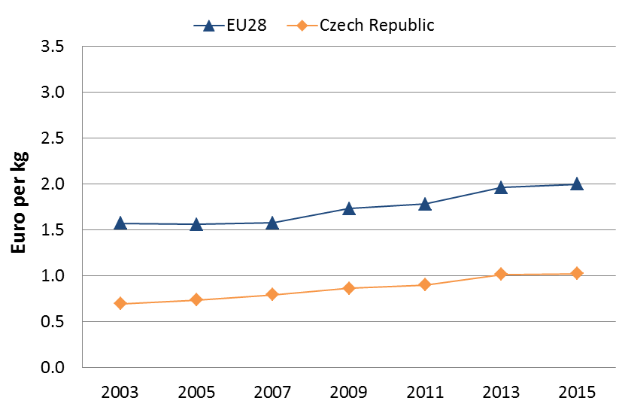
Eco-innovation and circular economy developments in the Czech Republic are primarily focused on energy efficiency in buildings and infrastructure, sustainable transport, and several environmental topics – such as water efficiency and wastewater treatment, waste management (e.g. municipal and food waste) and resource efficiency (e.g. reuse and recycling of construction and demolition waste, and reduced resource consumption). In recent years, there appears to have been rapid growth in innovation in bio- and nanotechnologies.
The Czech Republic employed 96,381 people in the environmental goods and services sector in 2013 (96.875 in 2012).

SMEs and resource efficiency
In the Flash 426 Eurobarometer "SMEs, resource efficiency and green markets" it is shown that 56% of Czech Republic's SMEs have invested up to 5% of their annual turnover in their resource efficiency actions (EU28 average 50%), 22 % of them are currently offering green products and services (EU28 average 26%), 67% took measures to save energy (EU28 average 59%), 65% to minimise waste (EU28 average 60%), 46% to save water (EU28 average 44%), and 51% to save materials (EU28 average 54%). From a circular economy perspective, 42% took measures to recycle by reusing material or waste within the company (EU28 average 40%), 26% to design products that are easier to maintain, repair or reuse (EU28 average 22%) and 32% were able to sell their scrap material to another company (EU28 average 25%).
According to the Flash 426 Eurobarometer, the resource efficiency actions undertaken allowed the reduction of production costs in a 45% of the Czech Republic's SMEs (EU28 average 45%). The Flash 426 Eurobarometer "SMEs, resource efficiency and green markets" shows that 20% of the SMEs in Czech Republic have one or more full time employee working in a green job at least some of the time (EU28 average 35%). Czech Republic has an average number of 1.2 full time green employees per SME (EU28 average 1.7)

Eco-innovation
The scoreboard shows that the overall 2015 eco-innovation performance of the Czech Republic has improved compared to 2013, with an overall index score of 99 (compared to a score of 71 in 2013), ranking as 13th among the 28 EU Member States (compared to 17th place in 2013). The significant improvement in ranking and the overall score could have been caused by a data source change and hence the results for these indicators are not fully comparable with the data for 2013.
Existing barriers in R&D are relevant also for eco-innovation sector. The examples can be summarised as follows:
Weak outcomes and results of Czech R&D activities, limited cooperation between academia and business. R&D policy and funding framework remains fragmented
High dependence of the Czech Republic’s economic development on the activities of foreign-owned companies that only use the Czech Republic as a manufacturing base
The instability of the regulatory framework and the administrative burden associated with complying with the regulatory rules.
Figure 2: Eco-Innovation Index 2015 (EU=100)
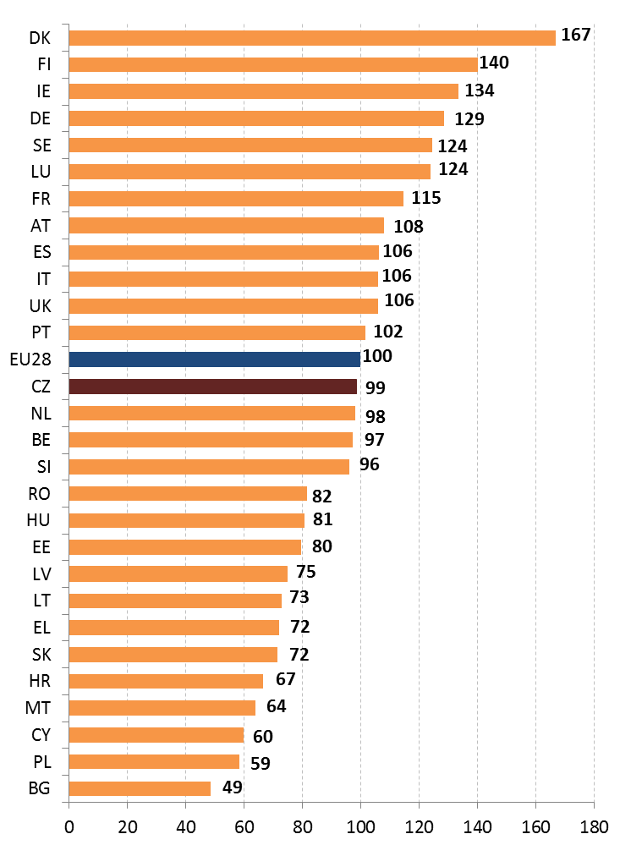
Suggested action
- Strengthen the policy framework to speed up the uptake of the circular economy providing further support to local businesses and increasing investments in the public research and education systems.
- Incentivise investments in green products and services.
- Foster R&D funding among SMEs.

Waste management
Turning waste into a resource requires:
- Full implementation of Union waste legislation, which includes the waste hierarchy; the need to ensure separate collection of waste; the landfill diversion targets etc.
- Reducing per capita waste generation and waste generation in absolute terms.
- Limiting energy recovery to non-recyclable materials and phasing out landfilling of recyclable or recoverable waste.
SDG 12 invites countries to substantially reduce waste generation through prevention, reduction, recycling and reuse, by 2030.
The EU's approach to waste management is based on the "waste hierarchy" which sets out an order of priority when shaping waste policy and managing waste at the operational level: prevention, (preparing for) reuse, recycling, recovery and, as the least preferred option, disposal (which includes landfilling and incineration without energy recovery). The progress towards reaching recycling targets and the adoption of adequate WMP/WPP should be the key items to measure the performance of Member States. This section focuses on management of municipal waste for which EU law sets mandatory recycling targets.
Figure 3: Municipal waste by treatment in Czech Republic 2007-14
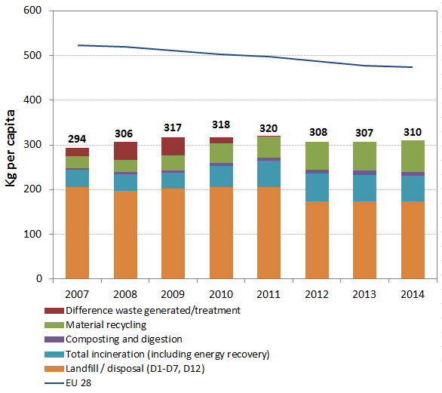
Municipal waste generation in Czech Republic remains much lower compared to the EU average (310 kg/y/inhabitant compared to around 475 kg/y/inhabitant on average).
Figure 3 depicts the municipal waste by treatment in Czech Republic in terms of kg per capita, which shows a slightly increase of the recycling rates compared to 2013.
Recycling of municipal waste accounts for 25% being below the EU average (44%) as shown in Figure 4. Figure 4 also shows that Czech Republic, while having a steady increase in recycling rate, must invest further in recycling in the next coming years in order to reach the 2020 recycling target.
Figure 4: Recycling rate of municipal waste 2007-14
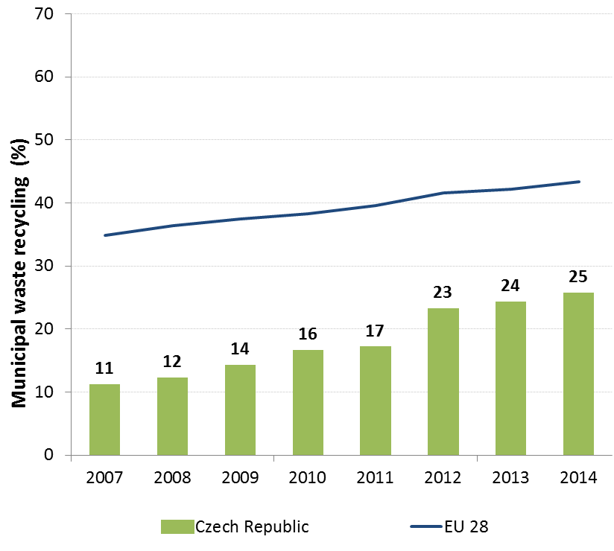
The main treatment option for municipal waste is still landfilling. It accounts for 56% and it is above the EU average of 28%.
Currently, a number of flaws in waste management policy make it difficult for Czech Republic to comply with EU targets: a high share of biodegradable waste goes to landfills. Waste treatment is not fully in line with the waste hierarchy, there is a non-harmonised national waste data base and insufficient reporting structures.
In order to help bridge the implementation gap in Czech Republic, the Commission has delivered a roadmap for compliance in which economic instruments play a crucial role. The Czech Republic adopted the revision of the Waste Act mandating separate collection of biodegradable waste in all municipalities since 2015, and announcing a ban on landfilling of recyclable, recoverable and mixed municipal waste since 2024. These changes in the Waste Act lead explicitly to divert waste from landfills towards treatments higher in the waste hierarchy.
However, an objective assessment of the performance of Czech Republic in the area of municipal waste management is hampered by large discrepancies between the Ministry of Environment data used e.g. in the national WMP and the official waste statistics of the Czech Statistical Office, while only the latter was validated by Eurostat.
The discrepancies are quite relevant in magnitude and lead to different projections. The most visible aspect is, that according to the new Waste management plan, additional waste to energy capacity is foreseen (of 18% in 2020 and 28% in 2024) claiming that only 11% of waste is incinerated when, according to Eurostat, almost 20% of the municipal waste was incinerated in 2014.
In August 2016, the Ministry of Environment and the Czech Statistical Office agreed to reduce discrepancies between data of both institutions on municipal waste generation. The agreement includes short-term and long-term objectives needed for a full consolidation of data. Its implementation is still outstanding.
The National Waste Management Plan 2015-2024 was adopted on 22 December 2014 by the Czech Government (together with the National Waste Prevention Programme). The Regional Waste Management Plans were adopted by June 2016. The plans include policy measures which should help the Czech Republic achieve its recycling targets; there are however concerns as regards planned capacity for residual waste treatment, namely waste to energy. The issue is directly linked with the problem of data escribed above.
The Czech Republic has a well-functioning EPR scheme for packaging and overachieves the relevant packaging targets.
Estimates show that full implementation of the existing legislation could create more than 8,800 jobs in Czech Republic and increase the annual turnover of the waste sector by EUR 930 million. Moving towards the targets of the roadmap on resource efficiency could create additional 10,788 jobs and increase the annual turnover of the waste sector over EUR 1.1 billion.
Suggested action
- Increase progressively the existing landfill tax to divert waste from landfill. Use the revenues to support the separate collection and alternative infrastructure in conjunction with a better allocation of the cohesion policy funds to the first steps of waste hierarchy.
- Focus on improving the effectiveness of separate collection to increase recycling rates.
- Shift reusable and recyclable waste away from incineration by introducing incineration taxes. Avoid building overcapacities for residual waste treatment.
- It is imperative that the Czech Republic uses waste statistics that are compatible with the Eurostat Guidelines.
- Protecting, conserving and enhancing natural capital

Nature and Biodiversity
The EU Biodiversity Strategy aims to halt the loss of biodiversity in the EU by 2020, restore ecosystems and their services in so far as feasible, and step up efforts to avert global biodiversity loss. The EU Birds and Habitats Directives aim at achieving favourable conservation status of protected species and habitats.
SDG 14 requires countries to conserve and sustainably use the oceans, seas and marine resources, while SDG 15 requires countries to protect, restore and promote the sustainable use of terrestrial ecosystems, sustainably manage forests, combat desertification, and halt and reverse land degradation and halt biodiversity loss.
The 1992 EU Habitats Directive and the 1979 Birds Directive are the cornerstone of the European legislation aimed at the conservation of the EU's wildlife. Natura 2000, the largest coordinated network of protected areas in the world, is the key instrument to achieve and implement the Directives' objectives to ensure the long-term protection, conservation and survival of Europe's most valuable and threatened species and habitats and the ecosystems they underpin.
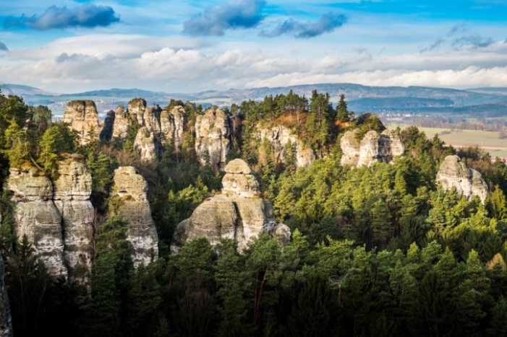The adequate designation of protected sites as Special Ares of Conservation (SAC) under the Habitats Directive and as Special Protection Areas (SPA) under the Birds Directive is a key milestone towards meeting the objectives of the Directives. The results of Habitats Directive Article 17 and Birds Directive Article 12 reports and the progress towards adequate Sites of Community Importance (SCI)-SPA and SAC designation both in land and at sea, should be the key items to measure the performance of Member States.
By early 2016, 14% of the national area of Czech Republic is covered by Natura 2000 (EU average 18.1%), with Birds Directive SPAs covering 8.9% (EU average 12.3%) and Habitats Directive SCIs covering 9.9% (EU average 13.8%). There are 1116 Natura 2000 sites, including 41 SPAs and 1075 SCIs.
While the designation of the SPAs is considered sufficient, the assessment of the SCIs conducted in previous years shows insufficiencies (see Figure 5).
Figure 5: Sufficiency assessment of SCI networks in Czech Republic based on the situation until December 2013 (%)
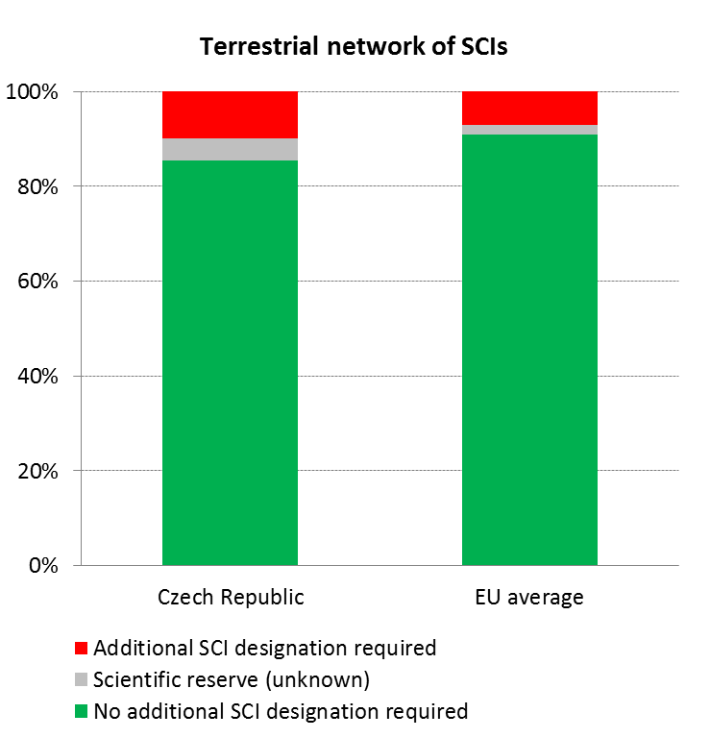
New sites were officially proposed by the Czech Republic in February and June 2016; with spatial data submitted in September 2016. The issue of sufficiency of the SCIs in the Czech Republic is currently being addressed by the European Commission in the infringement procedure initiated in February 2016.
SAC designation is still in process. A compliance check with provisions of the Habitats Directive will be done in 2016/2017.
The Natura 2000 sites are managed by professional state administration bodies including National Parks as independent entities devoted to nature conservation, Regional Offices of Nature Conservation Agency of the Czech Republic and Environmental Units of Regional Administrative Authorities (a few sites are also managed by Military area offices). Scientific support is provided by the Nature Conservation Agency of the Czech Republic. The Ministry of the Environment of the Czech Republic bears the overall responsibility for Natura 2000 (including methodological guidance for authorised AA experts). The monitoring of habitats and species is based on long-term experience of extensive expert base which provides variety of quality data on occurrence, conservation status, future perspective and threats for habitats and species building on traditional approach of landscape and nature protection.
Natura 2000 is regarded as complementary to the national nature protection system in the Czech Republic. This principle establishes a protection regime of majority Natura 2000 sites that is derived from a parallel regime of the Czech nationally protected areas.
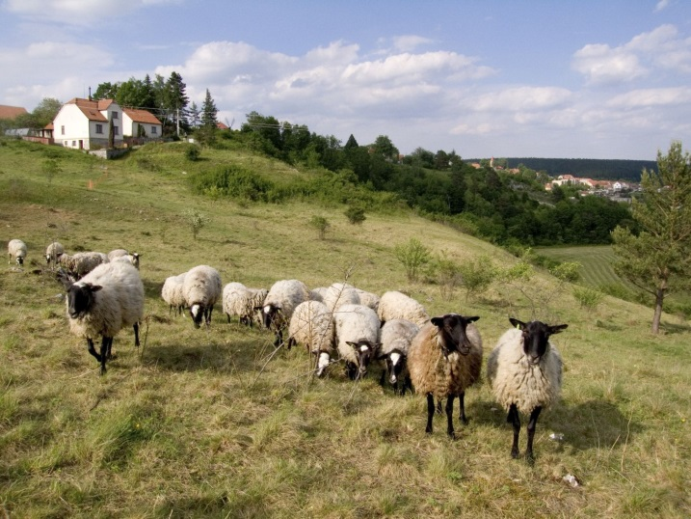According to the latest report on the conservation status of habitats and species covered by the Habitats Directive, 16% of the habitats' biogeographic assessments were favourable in 2013 (EU27: 16%). Furthermore, 56% are considered to be unfavourable–inadequate (EU27: 47%) and 27% are unfavourable – bad (EU27: 30%). As for the species, 27% of the assessments were favourable in 2013 (EU27: 23%) 39% at unfavourable-inadequate (EU27: 42%) and 30% unfavourable-bad status (EU27: 18%). This is depicted in Figure 6. 5% and 22% of the unfavourable assessments respectively for species and habitats were showing a positive trend in 2013.
A comparison of the results of Article 17 reports enables to claim an overall improvement as concerns conservation status of habitats and species of EU importance. While in the period of 2007-2012 25.3 % was found favourable only 18.9 % was found favourable in the preceding reporting period.
Figure 6: Conservation status of habitats and species in Czech Republic in 2007/2013 (%)
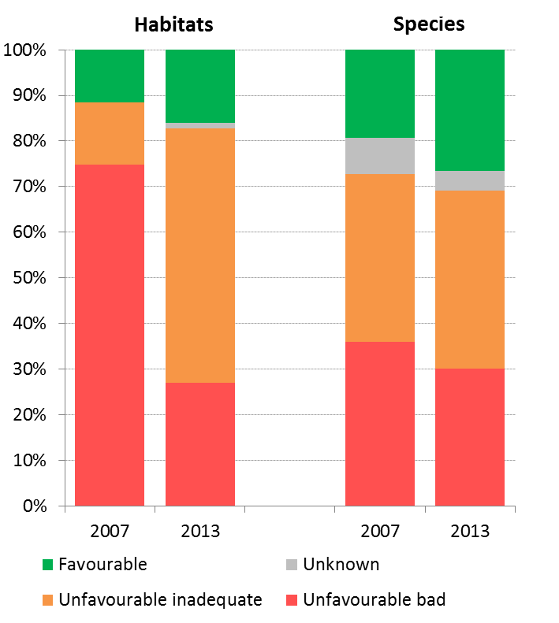
According to the official report submitted under Art. 12 of the Birds Directive, 82% of the breeding species showed short-term increasing or stable population trends (for wintering species this figure was 20%).

Figure 7: Short-term population trend of breeding and wintering bird species in Czech Republic in 2012 (%)
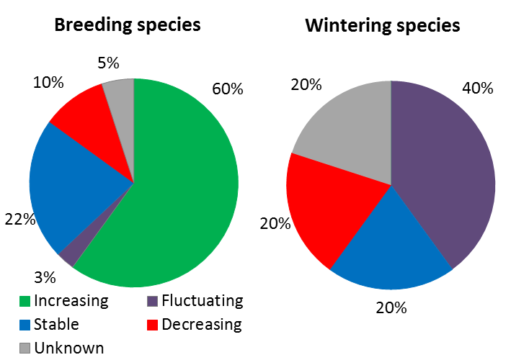
Most natural and near-natural habitats occur in areas with limited or less intensive agricultural production.
Problematic aspects of implementation of the national and EU legislation are usually connected with general nature protection issues. These are conflicts between nature conservation and other socioeconomic interests such as river navigation or forest management in the national parks and Natura 2000.
Forest areas account for around 34% of the total area of the Czech Republic which is below the EU average (42%). Afforested area is steadily growing. 15% of the forest benefits from a protection regime. Almost 60% of the forest belongs to the state. The management of the forest is done by the forest authorities, in accordance with the Forest Management Plans focusing on the production function of the forest (representing 75% of the total forest area). As regards the health of forest, though the trend has stabilised over last years, the forest ecosystems suffer from a high level of defoliation compared to other European countries.
Suggested action
- Complete the Natura 2000 designation process and put in place clearly defined conservation objectives and the necessary conservation measures for the sites and provide adequate resources for their implementation in order to maintain/restore species and habitats of community interest to a favourable conservation status across their natural range.
- Develop and promote smart and streamlined implementation approaches, in particular as regards site and species permitting procedures (i.e. beyond EIA procedures) and strengthen communication with stakeholders.

Estimating Natural Capital
The EU Biodiversity Strategy to 2020 calls on the Member States to map and asses the state of ecosystems and their services in their national territory by 2014, assess the economic value of such services, and promote the integration of these values into accounting and reporting systems at EU and national level by 2020.
As part of knowledge development efforts, the Czech Republic has completed ecosystem mapping by field survey complemented with remote sensing data. Information on structure and functions of semi-natural habitats together with other data sources (agro-environmental schemes, WFD etc.) can be utilised in order to estimate the condition of ecosystems. A scientific study on ecosystem services was completed in 2013 but its results have not been integrated into policy-making. Policy support is also needed to get data from other sectors.
Suggested action
- Provide government support to the mapping and assessment of ecosystems and their services, valuation and development of natural capital accounting systems, and use it for policy and decision-making.

Green Infrastructure
The EU strategy on green infrastructure promotes the incorporation of green infrastructure into related plans and programmes to help overcome fragmentation of habitats and preserve or restore ecological connectivity, enhance ecosystem resilience and thereby ensure the continued provision of ecosystem services.
Green Infrastructure provides ecological, economic and social benefits through natural solutions. It helps to understand the value of the benefits that nature provides to human society and to mobilise investments to sustain and enhance them.
The restoration and safeguarding of ecosystems has a long background in the academic world in the Czech Republic and is incorporated in the planning system. However, the results of this work are not well implemented.
In order to monitor landscape fragmentation, work is underway to set indicators for the extent and rate of fragmentation/connectivity of natural and semi-natural ecosystems, allowing more efficient monitoring of trend changes and comparison of larger territorial units.
Landscape connectivity is tackled by the national multi-level ecological network called the Territorial System of Ecological Stability of the Landscape. TSES is included in the Nature and Landscape Protection Act, which cites TSES as one of the main tools for landscape and nature protection.
However, the mechanisms for practical protection and restoration of its elements (core areas, ecological corridors and stepping stones which overlap with Natura 2000 areas) are not always sufficient.

Soil protection
The EU Soil Thematic Strategy highlights the need to ensure a sustainable use of soils. This requires the prevention of further soil degradation and the preservation of its functions, as well as the restoration of degraded soils. The 2011 Road Map for Resource-Efficient Europe, part of Europe 2020 Strategy provides that by 2020, EU policies take into account their direct and indirect impact on land use in the EU and globally, and the rate of land take is on track with an aim to achieve no net land take by 2050.
SDG 15 requires countries to combat desertification, restore degraded land and soil, including land affected by desertification, drought and floods, and strive to achieve a land-degradation-neutral world by 2030.
Soil is an important resource for life and the economy. It provides key ecosystem services including the provision of food, fibre and biomass for renewable energy, carbon sequestration, water purification and flood regulation, the provision of raw and building material. Soil is a finite and extremely fragile resource and increasingly degrading in the EU. Land taken by urban development and infrastructure is highly unlikely to be reverted to its natural state; it consumes mostly agricultural land and increases fragmentation of habitats. Soil protection is indirectly addressed in existing EU policies in areas such as agriculture, water, waste, chemicals, and prevention of industrial pollution.
Artificial land cover is used for settlements, production systems and infrastructure. It may itself be split between built-up areas (buildings) and non-built-up areas (such as linear transport networks and associated areas).
The annual land take rate (growth of artificial areas) as provided by CORINE Land Cover was 0.43% in the Czech Republic over the period 2006-12, around the EU average (0.41%). It represented 2159 hectares per year (in the previous period 2000-2006 it was 1944 hectares) and was mainly driven by housing, services and recreation as well as industrial and commercial sites.
The percentage of built up land in 2009 was 3.28%, close to the EU average (3.23%). The soil water erosion rate in 2010 was 1.65 tonnes per ha per year, below EU28 average (2.46 tonnes). Figure 8 shows the different land cover types in Czech Republic in 2012.
Figure 8: Land Cover types in Czech Republic in 2012
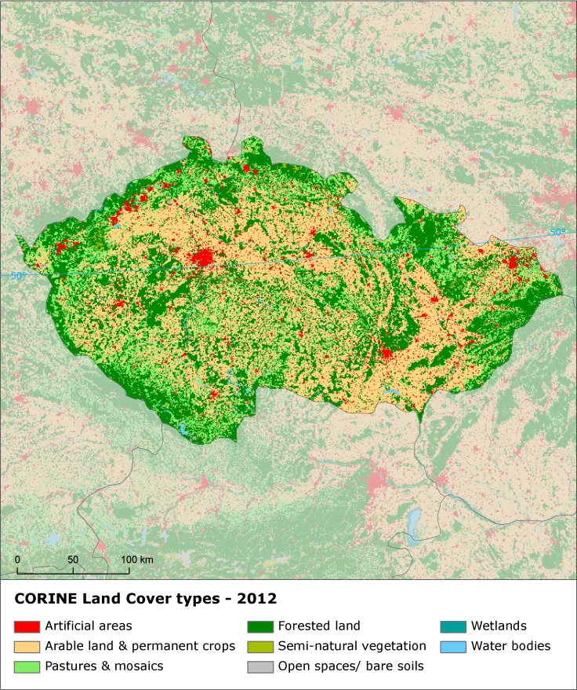
There are still not EU-wide datasets enabling the provision of benchmark indicators for soil organic matter decline, contaminated sites, pressures on soil biology and diffuse pollution.
An updated inventory and assessment of soil protection policy instruments in Czech Republic and other EU Member States is being performed by the EU Expert Group on Soil Protection.
In 2015 the Czech Republic adopted an amendment to the Nature and Landscape Conservation Act which can strengthens the protection of agricultural soil.

- Ensuring citizens' health and quality of life

Air quality
Figure 9: Attainment situation for PM10, NO2 and O3 in 2014
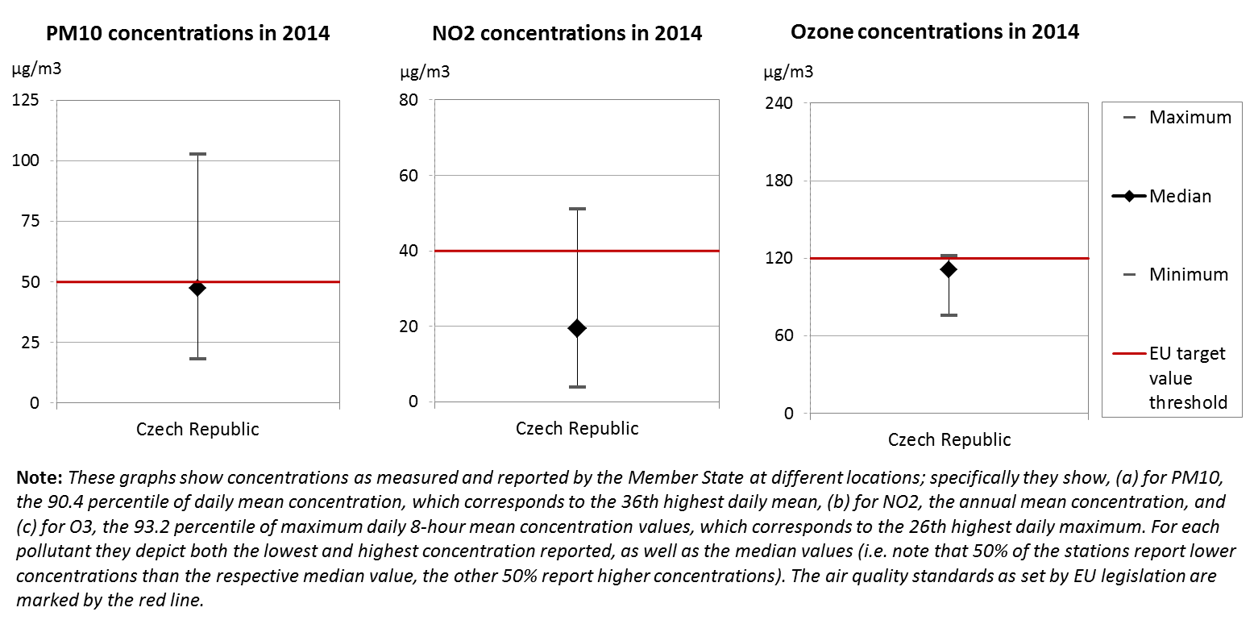
The EU Clean Air Policy and legislation require that air quality in the Union is significantly improved, moving closer to the WHO recommended levels. Air pollution and its impacts on ecosystems and biodiversity should be further reduced with the long-term aim of not exceeding critical loads and levels. This requires strengthening efforts to reach full compliance with Union air quality legislation and defining strategic targets and actions beyond 2020.
The EU has developed a comprehensive suite of air quality legislation, which establishes health-based standards and objectives for a number of air pollutants. As part of this, Member States are also required to ensure that up-to-date information on ambient concentrations of different air pollutants is routinely made available to the public. In addition, the National Emission Ceilings Directive provides for emission reductions at national level that should be achieved for main pollutants.
The emission of several air pollutants has decreased significantly in the Czech Republic . Reductions between 1990 and 2014 for sulphur oxides (-93%), nitrogen oxides (-77%), ammonia (-56%) as well as volatile organic compounds (-54%) ensure air emissions for these pollutants are within the currently applicable national emission ceilings.
At the same time, air quality in Czech Republic continues to give cause for concern. For the year 2013, the European Environment Agency estimated that about 12,030 premature deaths were attributable to fine particulate matter concentrations, 370 to ozone concentration and 330 to nitrogen dioxide concentrations. This is due also to exceedances above the EU air quality standards such as shown in Figure 9.
For 2014, exceedances above the EU air quality standards have been registered related to particulate matter (PM₁₀) in ten air quality zones, and annual mean concentration of nitrogen dioxide (NO₂) in one air quality zone (Prague). Furthermore, four air quality zones have indicated exceedances regarding fine particulate matter (PM_{2.5}), for which the limit value has become binding only in 2015. Target values for annual mean concentrations have been exceeded in at least one air quality zone for cadmium, benzo(a)pyrene, nitrogen oxides, sulphur dioxide as well as ozone.
The persistent breaches of air quality requirements (for PM₁₀ and NO₂), which have severe negative effects on health and environment, are being followed up by the European Commission through infringement procedures covering all the Member States concerned, including Czech Republic. The aim is that adequate measures are put in place to bring all zones into compliance.
It has been estimated that the health-related external costs from air pollution in Czech Republic are above EUR 6 billion/year (income adjusted, 2010), which include not only the intrinsic value of living a full health life but also direct costs to the economy. These direct economic costs relate to 4 million workdays lost each year due to sickness related to air pollution, with associated costs for employers of EUR 388 million/year (income adjusted, 2010), for healthcare of above EUR 21 million/year (income adjusted, 2010), and for agriculture (crop losses) of EUR 102 million/year (2010).
Suggested action
Maintain downward emissions trends of air pollutants in order to achieve full compliance with air quality limit values - and reduce adverse air pollution impacts on health, environment and economy.
Reduce nitrogen oxide (NO_{x}) emissions to comply with currently applicable national emission ceilings and/or to reduce nitrogen dioxide (NO₂) (and ozone concentrations), inter alia, by reducing transport related emissions - in particular in urban areas.
Reduce PM₁₀ emission and concentration, inter alia, by reducing emissions related to energy and heat generation using solid fuels, to transport and to agriculture.

Noise
The Environmental Noise Directive provides for a common approach for the avoidance, prevention and reduction of harmful effects due to exposure to environmental noise.
Excessive noise is one of the main causes of health issues. To alleviate this, the EU acquis sets out several requirements, including assessing the exposure to environmental noise through noise mapping, ensuring that information on environmental noise and its effects is made available to the public, and adopting action plans with a view to preventing and reducing environmental noise where necessary and to preserving the acoustic environment quality where it is good.
The Czech Republic’s implementation of the Environmental Noise Directive is delayed. The noise mapping for the most recent reporting round, for the reference year 2011, is complete. However, action plans for noise management in the current period have not been adopted for any of the agglomerations, major roads, major railways or major airports within the scope of the Directive. The Commission contacted the Czech authorities with regard to the missing action plans, and continues to follow up on the situation. Complaints on infrastructure development are often related to noise issues, especially for infrastructure projects with outdated EIA assessments.
Suggested action
- Complete action plans for noise management and use them in planning.

Water quality and management
The EU water policy and legislation require that the impact of pressures on transitional, coastal and fresh waters (including surface and ground waters) is significantly reduced to achieve, maintain or enhance good status of water bodies, as defined by the Water Framework Directive; that citizens throughout the Union benefit from high standards for safe drinking and bathing water; and that the nutrient cycle (nitrogen and phosphorus) is managed in a more sustainable and resource-efficient way.
SDG 6 encourages countries to ensure availability and sustainable management of water and sanitation for all.
The main overall objective of EU water policy and legislation is to ensure access to good quality water in sufficient quantity for all Europeans. The EU water acquis seeks to ensure good status of all water bodies across Europe by addressing pollution sources (from e.g. agriculture, urban areas and industrial activities), physical and hydrological modifications to water bodies) and the management of risks of flooding.
River Basin Management Plans (RBMPs) are a requirement of the Water Framework Directive and a means of achieving the protection, improvement and sustainable use of the water environment across Europe. This includes surface freshwaters such as lakes and rivers, groundwater, estuaries and coastal waters up to one nautical mile.
The Czech Republic has provided information to the Commission from its second generation of RBMPs. However, as the Commission has not yet been able to validate this information for all Member States, it is not reported here.
In its first generation of RBMPs under the WFD Czech Republic reported the status of 1069 rivers, 71 lakes and 173 groundwater bodies. Only 20% of natural surface water bodies achieve a good or high ecological status and 7% of heavily modified or artificial water bodies achieve a good or high ecological potential. 72% of surface water bodies, 67% of heavily modified and artificial water bodies and only 21% of groundwater bodies achieve good chemical status. 65% of groundwater bodies are in good quantitative status.
The main pressure on Czech waters is flow regulation and hydromorphological alteration that affect 67% of surface water bodies. 51% of water bodies are affected by diffuse sources of pollution sources, 44% by point sources. There are not large differences in pressures between river basin districts. Abstraction is not identified as a pressure to water status.
There were significant deficiencies identified in the 1st River Basin Management Plans that present gaps in the monitoring system, assessment of pressures, methodologies for classification of status of water bodies. This results in high level of uncertainties concerning the pressures, status of water bodies and effectiveness of Programmes of Measures. Planning of new physical modifications and application of exemptions is not transparent. Programmes of measures are expected to result only in a slight improvement of the status, with the highest improvement is expected in chemical status of groundwater (8%).
Nitrate levels in a number of monitoring points, as well as eutrophication, remain an issue. A recent Court of Auditors report "Danube river basin II: Quality of water" stated there is a lack of ambition in the Member States concerned including the Czech Republic to address causes of pollution. It stated that Member States are not using all the possibilities offered by the Nitrates Directive. The Czech Nitrates Action Programme is being reviewed in 2016 and it is an opportunity to adjust its measures taking into account the developments of agricultural pressures and water quality, as well as the recommendations of the Court of Auditors report.
As regards drinking water, Czech Republic reaches very high compliance rates of 99.91 % for microbiological, 99.9 % for chemical and 99.2% for indicator parameters laid down in the Drinking Water Directive.
Figure 10 shows that in 2015, in Czech Republic, out of 153 bathing waters, 79.1 % were of excellent quality, 12.4 % of good quality, 1.3 % of sufficient quality. 3 bathing waters were of poor quality or non-compliant while it was not possible to assess the remaining 8 bathing waters. The Czech Republic has a modest but constant increase in excellent bathing water quality in the past years.
The Czech Republic is subject to full compliance obligations with the Urban Waste Water Treatment Directive since 2010. However, in Czech Republic, according to the 2012 data, only 87.4% of the load collected was subject to secondary treatment (in accordance with Article 4 of the Urban Waste Water Treatment Directive) and 53.7% of the waste water load collected is subject to more stringent treatment in accordance with Article 5 of the Urban Waste Water Treatment Directive (target: 75.4%). The use of EU funds over last two programming periods 2004-2006 and 2007-2013 helped significantly to build or modernise the waste water treatment infrastructure. The 2015 special ECA report showed that some of the investments were, however, oversized or inappropriate. Despite the availability of the EU funds, the Prague agglomeration with the biggest waste water treatment plant in the Czech Republic has not met the 2010 compliance deadline in one parameter. The reconstruction of the Prague Waste Water Treatment Plant has finally started in 2015 from national funds.
The whole territory of the Czech Republic is delimited as a sensitive area.
Figure 10: Bathing water quality 2012 – 2015
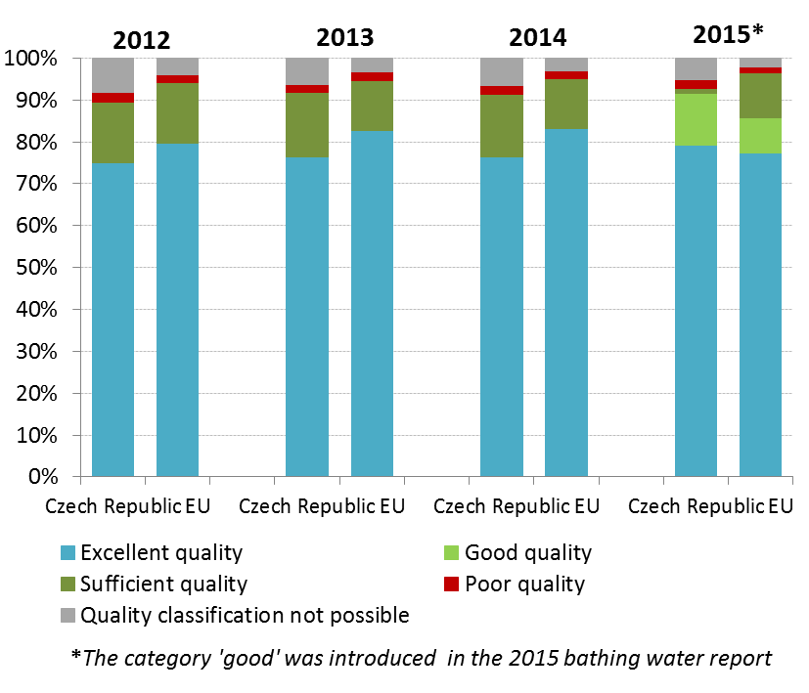
The estimated investment needs (reported by Czech Republic under Article 17 of the Urban Waste Water Treatment Directive) to reach full compliance with the Directive are of EUR 95 million.
According to the Czech 2014 Report on the Environment the following information on water management and water quality is available:
- Total water abstraction as well as water consumption in households is stable.
- The water abstraction for public water supply systems is decreasing due to the reduction of water loss in the pipe network (16.6% in 2014 compared to 17.9% in 2013)
- The proportion of the population connected to water supply systems and to public sewerage systems continued to increase
- The amount of pollution discharged from point sources has decreased every year
- Surface water quality is improving only slowly
- As a result of agricultural activities, water resources are still exposed to considerable pressure

Flood risk areas have started to be identified and mapped in the Czech Republic in the context of Flood Risk Management Plans which were prepared together with 2nd RBMPs as outstanding conceptual documents based on FD (2007/60/EC) requirements. The Czech Republic was hit by flooding incidents with serious economic damage in 2010 and 2013.
Management and prevention of floods is an area where potentially more economical nature-based solutions could improve resource efficiency through reducing costs and delivering multiple benefits. In its 2014-20 operational programmes, namely the Operational Programme Environment, the Czech Republic is planning to invest also in nature-based solutions.
Water scarcity is giving a rise to growing concerns over the implementation of a right mix of measures to combat it.
Suggested action
- The Czech Republic should improve its water policy in line with the intervention logic of the Water Framework Directive, i.e. do a more detailed assessment of pressures to know the status of water bodies and design effective Programmes of Measures that address the main pressures identified.
- In relation to diffuse pollution the Czech Republic should implement measures to comply with the Nitrate Directive taking into account agricultural developments and the recommendations of the Court of Auditors report.
- New physical modifications of water bodies should be assessed in line with article 4(7). In these assessments alternative options and adequate mitigation measures have to be considered. This particularly applies to large scale infrastructure projects not built yet, but which were designed decades ago outside the intervention logic of Water FD, like dams or infrastructure to combat floods or drought.
- The Czech Republic should improve their water pricing policy based on an analysis of environmental and resource costs and covering a broad range of water services. Exemptions from water fees should be reconsidered. As the first step, 2nd River Basin Managements plans include the Economic analysis

Enhancing the sustainability of cities
The EU Policy on the urban environment encourages cities to implement policies for sustainable urban planning and design, including innovative approaches for urban public transport and mobility, sustainable buildings, energy efficiency and urban biodiversity conservation.
SDG11 aims at making cities and human settlements inclusive, safe, resilient and sustainable.
Europe is a Union of cities and towns; around 75% of the EU population are living in urban areas. The urban environment poses particular challenges for the environment and human health, whilst also providing opportunities and efficiency gains in the use of resources.
The Member States, European institutions, cities and stakeholders have prepared a new Urban Agenda for the EU (incorporating the Smart Cities initiative) to tackle these issues in a comprehensive way, including their connections with social and economic challenges. At the heart of this Urban Agenda will be the development of twelve partnerships on the identified urban challenges, including air quality and housing.
The European Commission will launch a new EU benchmark system in 2017.
The EU stimulates green cities through awards and funding, such as the EU Green Capital Award aimed at cities with more than 100,000 inhabitants and the EU Green Leaf initiative aimed at cities and towns, with between 20,000 and 100,000 inhabitants.
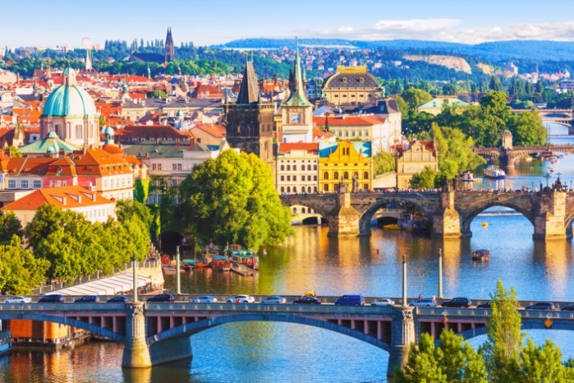
Czech Republic widely promotes several initiatives. National “Strategy of support Agenda 21 2020” has been adopted in 2012 followed by Action plan in 2016. Until present, 215 Czech cities are in UN MA21 database (of which 82 cities fulfil requirements for categories A-D).
Czech Republic has currently also 9 signatories with commitments to mitigate and adapt to climate change under Covenant of Mayors for Climate and Energy, supported by European Commission. Ministry of Environment runs yearly dotation programme Village of the Year – Green Ribbon, awarding villages or rural towns for good practice in green area, water and urban nature management.

International agreements
The EU Treaties require that the Union policy on the environment promotes measures at the international level to deal with regional or worldwide environmental problems.
Most environmental problems have a transboundary nature and often a global scope and they can only be addressed effectively through international co-operation. International environmental agreements concluded by the Union are binding upon the institutions of the Union and on its Member States. This requires the EU and the Member States to sign, ratify and effectively implement all relevant multilateral environmental agreements (MEAs) in a timely manner. This will also be an important contribution towards the achievement of the SDGs, which Member States committed to in 2015 and include many commitments contained already in legally binding agreements.
The fact that some Member States did not sign and/or ratify a number of MEAs compromises environmental implementation, including within the Union, as well as the Union’s credibility in related negotiations and international meetings where supporting the participation of third countries to such agreements is an established EU policy objective. In agreements where voting takes place it has a direct impact on the number of votes to be cast by the EU.
The Czech Republic has signed and ratified almost all MEAs. The Czech Republic is an advanced player in the field of international cooperation in water protection based on long term experience. There are bilateral agreements signed with all 4 neighbouring countries and CZ is a party to International Commissions for protection of rivers Elbe, Danube and Oder, which cover all Czech river basins. Implementation and enforcement of Convention on International Trade in Endangered Species of Wild Fauns and Flora (CITES) and the EU Wildlife Trade Regulations could be regarded as another example.

Part II: Enabling Framework: Implementation Tools

- Market based instruments and investment

Green taxation and environmentally harmful subsidies
The Circular Economy Action Plan encourages the use of financial incentives and economic instruments, such as taxation to ensure that product prices better reflect environmental costs. The phasing out of environmentally harmful subsidies is monitored in the context of the European Semester and in national reform programmes submitted by Member States.
Taxing pollution and resource use can generate increased revenue and brings important social and environmental benefits.
Czech Republic's revenues from environmentally related taxes and fees continued to decline across the last 10 years and reached 2.12% of GDP in 2014 against an EU average of 2.46%. Energy taxes constitute 1.96% of GDP, slightly above the EU average of 1.88%. Taxes on transport (excluding fuel) in the Czech Republic are among the lowest in the EU (0.14% of GDP compared to the EU28 level of 0.49% GDP). As shown in Figure 11, in 2014 environmental tax revenues accounted for 6.22% (up from 6.15% in 2013) of total revenues from taxes and social-security contributions (EU28 average: 6.35%).
A 2016 study suggests that there is considerable potential for shifting taxes from labour to environmental taxes in Czech Republic. Under a good practice scenario the amount could be as much as CZK 30.29 billion in 2018 (EUR 1.09 billion), rising to CZK 55.32 billion in 2030 (EUR 1.99 billion) (both in real 2015 terms). This is equivalent to an additional 0.62% and 0.83% of GDP in 2018 and 2030, respectively. Given the low level of transport taxes (excluding fuel), there is a potentially considerable scope for generating additional revenue form this source: it accounts for CZK 14.45 billion in 2030 (EUR 0.52 billion in real 2015 terms), equivalent to 0.22% of GDP. An increase in the existing circulation tax, with the tax base potentially including particulate matter (as well as CO₂ emissions) will help foster improvements in air quality. The next largest potential contribution to revenue comes from the proposed amendments to taxes on transport fuels. This accounts for CZK 12.48 billion in 2030 (EUR 0.45 billion) (real 2015 terms), equivalent to 0.19% of GDP (real 2015 terms), equivalent to 0.42% of GDP.
Figure 11: Environmental tax revenues as a share of total revenues from taxes and social contributions (excluding imputed social contributions) in 2014
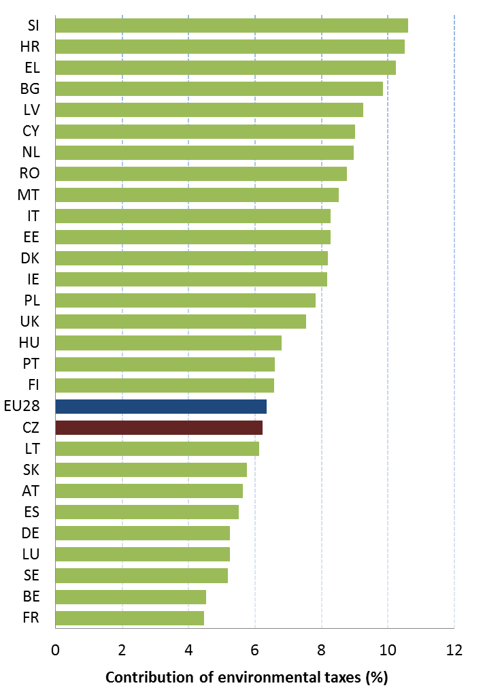

Green Public Procurement
The EU green public procurement policies encourage Member States to take further steps to reach the target of applying green procurement criteria to at least 50% of public tenders.
Green Public Procurement (GPP) is a process whereby public authorities seek to procure goods, services and works with a reduced environmental impact throughout their life-cycle when compared to goods, services and works with the same primary function that would otherwise be procured.
The purchasing power of public procurement equals to approximately 14% of GDP. A substantial part of this money is spent on sectors with high environmental impact such as construction or transport, so GPP can help to significantly lower the impact of public spending and foster sustainable innovative businesses. The Commission has proposed EU GPP criteria.
The Ministry of Environment has prepared “Rules for implementing environmental requirements in public procurement of state administration and self-administration”, which is based on European Commission’s toolkits and is developed instead of a National Action Plan (NAP) or a National Strategy on GPP.
GPP criteria are partially developed at the national level and include the product groups for furniture and IT office equipment. Toolkits for other product groups will be introduced subsequently.
In a 2010 study, the share of Czech authorities that included GPP requirements in between 50% and 100% of their contracts was estimated between 10 and 20%.

Investments: the contribution of EU funds
European Structural and Investment Funds Regulations provide that Member States promote environment and climate objectives in their funding strategies and programmes for economic, social and territorial cohesion, rural development and maritime policy, and reinforce the capacity of implementing bodies to deliver cost-effective and sustainable investments in these areas.
Making good use of the European Structural and Investments Funds (ESIF) is essential to achieve the environmental goals and integrate these into other policy areas. Other instruments such as the Horizon 2020, the LIFE programme and EFSI may also support implementation and spread off best practice.
Global budget for the implementation of Cohesion Policy in the Czech Republic in 2014-2020 is EUR 24.2 billion (see Figure 12). The Czech Republic will receive about 20% less funds in 2014-2020 period compared to 2007-13 period (EUR 22 billion, excl. CEF, in current prices). Despite this reduction, it will continue to benefit from high rate investment intensity, well above the Member States average per capita.
Figure 12: European Structural and Investment Funds 2014-2020: Budget Czech Republic by theme, EUR billion
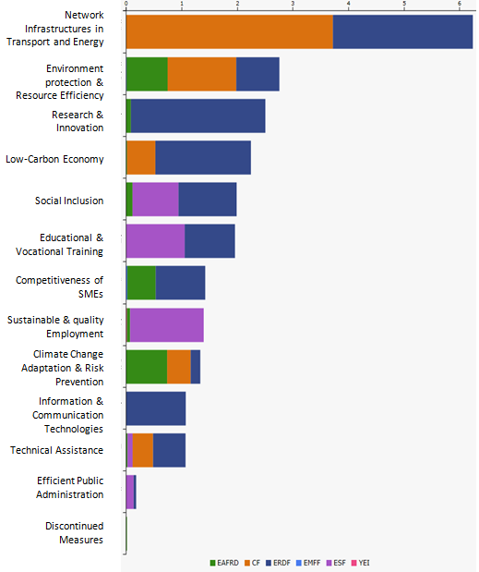
As regards the planned investments per environmental sector, these target water, waste, air, floods protection and nature. It is too early to draw conclusions as regards the use and results of ESIF for the period 2014-2020, as the relevant programmes are still in an early stage of their implementation.
There are 9 programmes for ESIF in 2014-2020. The main programme for implementation of environmental policies is Operational Programme Environment.
The environmental expenditure (ERDF +CF) estimates to 10.3% (based on specific environmental related categories of expenditure), which, in 2007-2013 period corresponded to 18.1%.
The interventions in the period 2014-2020 should lead to additional waste recycling capacities of 700,000 t/year or additional population of 150,000 citizens and 60,000 citizens served by improved water supply and wastewater treatment, respectively.
For the period 2007-2013, the total funds used as of April 2016 for the Czech Republic are 95% for all investment categories; for OP Environment the total funds used amount to 94%. The challenge for Czech Republic in programming period 2014-20 is to make good use of EU funds for targeted investments and to enhance the environmental integration as well as to use the potential of the green economy for competitiveness and job creation.
The National Rural Development Program of the Czech Republic, its European Agriculture and Rural Development Fund part, amounts to EUR 2,500 million.
Budget for agri-environmental-climate measures represents 29,4% of the total EAFRD budget. Measure on compensation for legal restrictions emanating from implementation of Natura 2000 in the RDP takes up 0,1% of the budget, while the implementation area is very limited (the only limitation in agricultural areas in first zone of National Parks is ban on fertilisation). Measure on natural constraints represents 22% of the whole budget accounted under environmental objectives (but is, like for other countries, without any environmental condition).
The Czech Republic proposes targeted sub-measures for natural values in agricultural areas, and very limited, but as well targeted approach for forestry measures - replacement of stands of site inappropriate species of trees in zones with high depositions, other on restoration by planting exclusively pioneering species of trees, of non-productive investments in forests etc. Anti-flood measures in forests are also foreseen. There is a high potential of RDP to address environmental pressures and to finance also investments with higher added value (e.g. forest machinery eligible only in case of them having soil conservation attributes).
With regard to the integration of environmental concerns into the Common Agricultural Policy (CAP), the two key areas for the Czech Republic (as for all Member States) remain as challenges: firstly, using Rural Development funds to pay for environmental land management and other environmental measures, while avoiding financing measures which could damage the environment; secondly, ensuring an effective implementation of the first pillar of the CAP with regard to cross compliance and 'greening' of 1st pillar. A more environmentally ambitious implementation of 1st pillar greening would clearly help to improve the environmental situation in areas not covered by rural development, including intensive areas, and if appropriate, the Czech Republic could review its implementation of this still during the period 2014-2020.

- Effective governance and knowledge
SDG 16 aims at providing access to justice and building effective, accountable and inclusive institutions at all levels. SDG 17 aims at better implementation, improving policy coordination and policy coherence, stimulating science, technology and innovation, establishing partnerships and developing measurements of progress.
Effective governance of EU environmental legislation and policies requires having an appropriate institutional framework, policy coherence and coordination, applying legal and non-legal instruments, engaging with non-governmental stakeholders, and having adequate levels of knowledge and skills. Successful implementation depends, to a large extent, on central, regional and local government fulfilling key legislative and administrative tasks, notably adoption of sound implementing legislation, co-ordinated action to meet environmental objectives and correct decision-making on matters such as industrial permits. Beyond fulfilment of these tasks, government must intervene to ensure day-to-day compliance by economic operators, utilities and individuals ("compliance assurance"). Civil society also has a role to play, including through legal action. To underpin the roles of all actors, it is crucial to collect and share knowledge and evidence on the state of the environment and on environmental pressures, drivers and impacts.
Equally, effective governance of EU environmental legislation and policies benefits from a dialogue within Member States and between Member States and the Commission on whether the current EU environmental legislation is fit for purpose. Legislation can only be properly implemented when it takes into account experiences at Member State level with putting EU commitments into effect. The Czech Republic is following the Make it Work initiative.

Effective governance within central, regional and local government
Those involved in implementing environment legislation at Union, national, regional and local levels need to be equipped with the knowledge, tools and capacity to improve the delivery of benefits from that legislation, and the governance of the enforcement process.

Capacity to implement rules
It is crucial that central, regional and local administrations have the necessary capacities and skills and training to carry out their own tasks and co-operate and co-ordinate effectively with each other, within a system of multi-level governance.
The administrative capacity is in general sufficient; however the high turnover of the staff with every election has been generating a negative impact on implementation of environmental law and policies. The Civil Service Act adopted in 2015 (precondition for the adoption of the Czech operational programmes for PP 2014-2020) should allow the necessary reform and bring the stability, however it is difficult to judge whether this is the case yet.
Although the fall of the former Soviet bloc allowed for environmental awareness and the preparation for the accession to the EU helped to form the environmental agenda, environmental policies lacked ownership at political and administrative levels over the last decade. This is mirrored in the difficulties not only with the adoption of environmental legislation but also in its effective application. On the other hand, the Czech Republic has a wide pool of excellent environmental experts available, but often beyond the national or regional administration.
The responsibility for environmental laws and policies lies with the Ministry of Environment or Regional Authorities (e.g. environmental departments of regional authorities). Local authorities are typically in charge of sectorial policies, like waste management. The Ministry has also general supervisory and controlling role. Legislative competences are with the Parliament; however the central government has also a strong role submitting in general drafts laws.
There are approximately 120 environmental NGOs operating at national or local level in the Czech Republic. The role of NGOs in environmental education, nature conservation and support of sustainable living is traditionally very important, since 1960s. Around 30 NGOs are organised since 1989 in the platform "Green Circle". The impact of NGOs varies.
The Czech Republic has an average number of infringements concerning mainly non-conformity and bad-application of EU environmental acquis, in particular delayed transposition of the EIA Directive. The sectors with the main shares of cases were waste, water, air, impact assessment.
The environmental agenda is narrowly linked to the planning and permitting, which is in hands of the Ministry of Regional Development and Construction authorities. The Czech development system is multistage – the EIA process is followed by the zoning decision and building permit stages. The current system is often regarded as too slow and complex; however a unified opinion on its reform does not exist.
The Czech Republic's legislation has been found not to be in conformity with the Environmental Impact Assessment (EIA) Directive and therefore it was twice subject to an EU infringement procedure since the accession of the Czech Republic into the EU. This had an impact on the legality of the projects which fall under the EIA Directive and which were subject to the development consent procedures during this period. The amendment to EIA Act (and other relevant Acts), should in principle provide for rectification of identified deficiencies. However, a long pipeline of projects with old/pre-accession EIAs which are to be co-financed in PP 2014-2020 exist in transport sector. This situation also led to the number of individual complaints increasing in 2016 for the issues of bad-application of the EIA Directive.

Coordination and integration
The Czech Republic has adopted its national SD Strategy already in 2004, the currently valid dates to 2010. Though several other strategies have been developed the integration of environmental policies has only slightly improved over the last decade, being fragmented also by the competences allocation. Long-term thinking is often prevailed by political decisions.
The transposition of the revised EIA Directive will be an opportunity to streamline the regulatory framework on environmental assessments. The Commission encourages the streamlining of the environmental assessments because this approach reduces duplication and avoids unnecessary overlaps in environmental assessments applicable for a particular project. Moreover, streamlining helps reducing unnecessary administrative burden and accelerates decision-making, without compromising the quality of the environmental assessment procedure. The Commission has issued a guidance document in 2016 regarding the setting up of coordinated and/or joint procedures that are simultaneously subject to assessments under the EIA Directive, Habitats Directive, Water Framework Directive, and the Industrial Emissions Directive.
Suggested action
- Improve the application of EIA and SEA as important tools to ensure environmental integration.

Compliance assurance
EU law generally and specific provisions on inspections, other checks, penalties and environmental liability help lay the basis for the systems Member States need to have in place to secure compliance with EU environmental rules.
Public authorities help ensure accountability of duty-holders by monitoring and promoting compliance and by taking credible follow-up action (i.e. enforcement) when breaches occur or liabilities arise. Compliance monitoring can be done both on the initiative of authorities themselves and in response to citizen complaints. It can involve using various kinds of checks, including inspections for permitted activities, surveillance for possible illegal activities, investigations for crimes and audits for systemic weaknesses. Similarly, there is a range of means to promote compliance, including awareness-raising campaigns and use of guidance documents and online information tools. Follow-up to breaches and liabilities can include administrative action (e.g. withdrawal of a permit), use of criminal law and action under liability law (e.g. required remediation after damage from an accident using liability rules) and contractual law (e.g. measures to require compliance with nature conservation contracts). Taken together, all of these interventions represent "compliance assurance" as shown in Figure 13.
Best practice has moved towards a risk-based approach at strategic and operational levels in which the best mix of compliance monitoring, promotion and enforcement is directed at the most serious problems. Best practice also recognises the need for coordination and cooperation between different authorities to ensure consistency, avoid duplication of work and reduce administrative burden. Active participation in established pan-European networks of inspectors, police, prosecutors and judges, such as IMPEL, EUFJE, ENPE and EnviCrimeNet, is a valuable tool for sharing experience and good practices.
Figure 13: Environmental compliance assurance
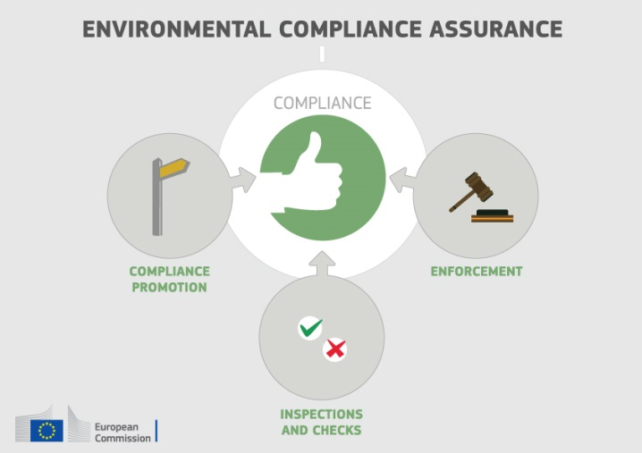
Currently, there exist a number of sectoral obligations on inspections and the EU directive on environmental liability (ELD) provides a means of ensuring that the "polluter-pays principle" is applied when there are accidents and incidents that harm the environment. There is also publically available information giving insights into existing strengths and weaknesses in each Member State.
For each Member State, the following were therefore reviewed: use of risk-based compliance assurance; coordination and co-operation between authorities and participation in pan-European networks; and key aspects of implementation of the ELD based on the Commission's recently published implementation report and REFIT evaluation.
The responsibilities it exercises across different environmental policy areas should put the Czech Environmental Inspectorate (CEI) in a good position to undertake both strategic and operational risk-based compliance assurance. The CEI operates an informative web-site on which annual activities reports are published, including statistical information. Evidence was found of use of risk-based approaches to target environmental inspections for industrial installations, but with certain limitations.
The CEI has established cooperation with other authorities with relevant functions but the cooperation is not based on formal agreements. The Czech Republic is active within IMPEL and EnviCrimeNet and hosted an IMPEL peer review in 2015 and the 2016 EnviCrimeNet annual conference.
Up-to-date information is nevertheless lacking in relation to the following:
- data-collection arrangements to track the use and effectiveness of different compliance assurance interventions;
- the extent to which risk-based methods are used to direct compliance assurance at the strategic level and in relation to critical activities outside of industrial installations, in particular in specific problem-areas highlighted elsewhere in this Country Report, i.e. the threats to protected habitat types and species, air quality breaches and the pressures on water quality from diffuse water pollution;
- how the Czech authorities ensure a targeted and proportionate response to different types of non-compliant behaviour, given that environmental inspectors have a limited set of enforcement tools.
The Czech Republic has established mandatory financial security for liabilities under the Environmental Liability Directive (ELD) from 2013 on. There have been no cases of confirmed environmental damage under the Directive, but 15 cases were reported as dismissed in the period between 2007 and 2013, and a few cases were initiated upon public requests.
Suggested action
- Improve transparency on the organisation and functioning of compliance assurance and on how significant risks are addressed, as outlined above.
- Encourage greater participation of competent authorities in the activities of ENPE, EUFJE and EnviCrimeNet.
- Step up efforts in the implementation of the Environmental Liability Directive (ELD) with proactive initiatives, in particular by drafting national guidance.

Public participation and access to justice
The Aarhus Convention, related EU legislation on public participation and environmental impact assessment, and the case-law of the Court of Justice require that citizens and their associations should be able to participate in decision-making on projects and plans and should enjoy effective environmental access to justice.
Citizens can more effectively protect the environment if they can rely on the three "pillars" of the Convention on Access to Information, Public Participation in Decision-making and Access to Justice in Environmental Matters ("the Aarhus Convention"). Public participation in the administrative decision making process is an important element to ensure that the authority takes its decision on the best possible basis. The Commission intends to examine compliance with mandatory public participation requirements more systematically at a later stage.
Access to justice in environmental matters is a set of guarantees that allows citizens and their associations to challenge acts or omissions of the public administration before a court. It is a tool for decentralised implementation of EU environmental law.
For each Member State, two crucial elements for effective access to justice have been systematically reviewed: the legal standing for the public, including NGOs and the extent to which prohibitive costs represent a barrier.
In the Czech Republic the costs to bring an environmental case to the national courts are not considered as being prohibitively high. However, the Czech Republic had for long period shortcomings in providing the public, notably individuals and NGOs, with legal standing which would allow them to initiate court actions in environmental matters and to challenge the substantial breaches of their rights. For the EIA, the situation was in principle addressed with the amendment of the EIA Act, which came into force in April 2015, while access to justice is applicable also outside the EIA context and has to be ensured in multi-stage system.
Suggested action
- Take the necessary measures to ensure standing of environmental NGOs to challenge acts or omissions of a public authority in all sectoral EU environmental laws, in full compliance with EU law as well as the Convention on Access to Information, Public Participation in Decision-making and Access to Justice in environmental matters (Aarhus Convention).

Access to information, knowledge and evidence
The Aarhus Convention and related EU legislation on access to information and the sharing of spatial data require that the public has access to clear information on the environment, including on how Union environmental law is being implemented.
It is of crucial importance to public authorities, the public and business that environmental information is shared in an efficient and effective way. This covers reporting by businesses and public authorities and active dissemination to the public, increasingly through electronic means.
The Aarhus Convention, the Access to Environmental Information Directive and the INSPIRE Directive together create a legal foundation for the sharing of environmental information between public authorities and with the public. They also represent the green part of the ongoing EU e-Government Action Plan. The first two instruments create obligations to provide information to the public, both on request and actively. The INSPIRE Directive is a pioneering instrument for electronic data-sharing between public authorities who can vary in their data-sharing policies, e.g. on whether access to data is for free. The INSPIRE Directive sets up a geoportal which indicates the level of shared spatial data in each Member State – i.e. data related to specific locations, such as air quality monitoring data. Amongst other benefits it facilitates the public authorities' reporting obligations.
For each Member State, the accessibility of environmental data (based on what the INSPIRE Directive envisages) as well as data-sharing policies ('open data') have been systematically reviewed.
Czech Republic's performance on the implementation of the INSPIRE Directive as enabling framework to actively disseminate environmental information to the public is good, but leaves room for further improvement.
Czech Republic has indicated in the 3-yearly INSPIRE implementation report that the necessary data-sharing policies allowing access and use of spatial data by national administrations, other Member States' administrations and EU institutions without procedural obstacles are not yet fully available and implemented. The use and sharing of data has improved, but different licensing approaches still pose a major barrier. The Czech Republic aims at solving existing licensing issues for spatial information by 2020. In this respect, INSPIRE Coordination Committee of the Czech Republic has approved a set of actions aiming at unique licence approach applied on INSPIRE data.
Assessments of monitoring reports issued by Czech Republic and the spatial information that Czech Republic has published on the INSPIRE geoportal indicate that not all spatial information needed for the evaluation and implementation of EU environmental law has been made available or is accessible. So far, 84 % (27 out of 32 themes relevant for the Czech Republic) of information has been published and the Czech Republic has been constantly working on its commitment to make all necessary data themes available before the end of 2016.
Suggested action
- Critically review the effectiveness of its data policies and amend them, taking 'best practices' into consideration.
- Identify and document all spatial data sets required for the implementation of environmental law, and make the data and documentation at least accessible 'as is' to other public authorities and the public through the digital services foreseen in the INSPIRE Directive.

Communication "Delivering the benefits of EU environmental policies through a regular Environmental Implementation Review" (COM/2016/ 316 final).
Decision No. 1386/2013/EU of 20 November 2013 on a General Union Environmental Action Programme to 2020 "Living well, within the limits of our planet".
United Nations, 2015. The Sustainable Development Goals
This EIR report does not cover climate change, chemicals and energy.
European Commission, 2015. Proposed Circular Economy Package.
Resource productivity is defined as the ratio between gross domestic product (GDP) and domestic material consumption (DMC).
Eurostat, Resource productivity, accessed October 2016
European Environment Agency, 2016. More from less – material resource efficiency in Europe. Czech Republic Report
For example, the Epsilon programme managed by the Technology Agency of the Czech Republic (TACR), supports projects that develop industrial applications using new technologies and new materials in the energy, environment and transport sectors, like project NANOBIOWAT as a good practise, ; in September 2014, the Action Plan for secondary raw materials strategy was adopted by the Decision of the Government of the Czech Republic; the goal of the mentioned document is the effective extraction and utilization of secondary raw materials for the purpose of saving non-renewable resources (energy and non-energy raw materials).
Eurostat, Resource productivity, accessed October 2016
The Flash 426 Eurobarometer "SMEs, resource efficiency and green markets" defines "green job" as a job that directly deals with information, technologies, or materials that preserves or restores environmental quality. This requires specialised skills, knowledge, training, or experience (e.g. verifying compliance with environmental legislation, monitoring resource efficiency within the company, promoting and selling green products and services).
Commission, (SWD(2016) 73 final)
Eco-innovation Observatory: Eco-Innovation scoreboard 2015
Waste Management Plans/Waste Prevention Programmes
Eurostat, Municipal waste and treatment, by type of treatment method, accessed October 2016
Municipal waste consists of waste collected by or on behalf of municipal authorities, or directly by the private sector (business or private non-profit institutions) not on behalf of municipalities.
The Czech Ministry of Environment uses data collected by the Czech Environment Agency CENIA which diverge significantly from the data reported to ESTAT by the Czech Statistical (i.e. the waste generation is around 40% higher, recycling rates are 10% higher and incineration rates lower). This data is used in the national and regional Waste Management Plans as well as ESIF Operational programmes.
Member States may choose a different method than the one used by ESTAT (and referred to in this report) to calculate their recycling rates and track compliance with the 2020 target of 50% recycling of municipal waste.
Eurostat, Recycling rate of municipal waste, accessed October 2016
European Commission, Roadmap Czech Republic
Act No. 229/2014 Coll., in force as of 01/01/2015 as amending the Waste Act No. 185/2001 Coll.
The difference is in the reported generation of municipal waste to Eurostat by Czech Statistical Office (3.228 mil. t, 2013 and 3.260 mil. t, 2014) while generation on municipal waste by MoE is much higher (5.168 mil. t, 2013 and 5.324 mil. t, 2014).
According to data for 2015 provided by the national authorities, more than 270 000 containers for separate streams of municipal waste (plastics, glass, paper, metal, cardboard) are available for citizens.
Bio Intelligence service, 2011. Implementing EU Waste legislation for Green Growth, study for European Commission. The breakdown per country on job creation was made by the consultant on Commission demand but was not included in the published document.
In the proposal for new Waste Act from 2015 it is suggested that landfill tax to be gradually increased as of 2018. It also contains explicit possibility for municipalities to implement PAYT system. This proposal is pending the Government approval yet.
Sites of Community Importance (SCIs) are designated pursuant to the Habitats Directive whereas Special Areas of Protection (SPAs) are designated pursuant to the Birds Directive; figures of coverage do not add up due to the fact that some SCIs and SPAs overlap. Special Areas of Conservation (SACs) means a SCI designated by the Member States.
2016 submission is not reflected yet in the European list of SCIs.
For each Member State, the Commission assesses whether the species and habitat types on Annexes I and II of the Habitats Directive, are sufficiently represented by the sites designated to date. This is expressed as a percentage of species and habitats for which further areas need to be designated in order to complete the network in that country. The current data, which were assessed in 2014-2015, reflect the situation up until December 2013.
The percentages in Figure 5 refer to percentages of the total number of assessments (one assessment covering 1 species or 1 habitat in a given biographical region with the Member State); if a habitat type or a species occurs in more than 1 Biogeographic region within a given Member State, there will be as many individual assessments as there are Biogeographic regions with an occurrence of that species or habitat in this Member State.
European Commission internal assessment, in CZ case does not take into account the 2016 submission
(51 sites) and the target feature added into existing sites (70 sites)
Another example is also The Territorial System of Ecological Stability of the Landscape (TSES) – good practise developed already in late 1970s, tackles the landscape connectivity by the national multi-level ecological network
The core of the ‘Article 17’ report is the assessment of conservation status of the habitats and species targeted by the Habitats Directive.
Conservation status is assessed using a standard methodology as being either ‘favourable’, ‘unfavourable-inadequate’ and ‘unfavourable-bad’, based on four parameters as defined in Article 1 of the Habitats Directive.
Please note that a direct comparison between 2007 and 2013 data is complicated by the fact that Bulgaria and Romania were not covered by the 2007 reporting cycle, that the ‘unknown’ assessments have strongly diminished particularly for species, and that some reported changes are not genuine as they result from improved data / monitoring methods.
According to data of Nature Conservation Agency of the Czech Republic, it was 22.95 % in the period of 2007-2012 and 17.05 % was found favourable in the reporting period 2001(4)-2006
These figures show the percentage of biogeographical assessments in each category of conservation status for habitats and species (one assessment covering 1 species or 1 habitat in a given biographical region with the Member State), respectively. The information is based on Article 17 of the Habitats Directive reporting - national summary of Czech Republic
Article 12 of the Birds Directive requires Member States to report about the progress made with the implementation of the Birds Directive.
Article 12 of the Birds Directive reporting - national summary of Czech Republic
http://eagri.cz/public/web/file/426635/ZZ2014.pdf
Ecosystem services are benefits provided by nature such as food, clean water and pollination on which human society depends.
European Union, Green Infrastructure — Enhancing Europe’s Natural Capital, COM/2013/0249
European Environment Agency Draft results of CORINE Land Cover (CLC) inventory 2012; mean annual land take 2006-12 as a % of 2006 artificial land. In the period 2000-2006
European Environment Agency, 2016. Imperviousness and imperviousness change
Eurostat, Soil water erosion rate, Figure 2, accessed November 2016
European Environment Agency, Land cover 2012 and changes country analysis [publication forthcoming]
It makes the protection of best quality soil from sealing considerably stricter, it focuses on reclamation of agricultural land after temporary land claims, and regulates soil protection from erosion.
European Commission, 2016. Air Quality Standards
See EIONET Central Data Repository and Air pollutant emissions data viewer (NEC Directive)
The current national emission ceilings apply since 2010 (Directive 2001/81/EC); revised ceilings for 2020 and 2030 have been set by Directive (EU) 2016/2284 on the reduction of national emissions of certain atmospheric pollutants, amending Directive 2003/35/EC and repealing Directive 2001/81/EC.
Particulate matter (PM) is a mixture of aerosol particles (solid and liquid) covering a wide range of sizes and chemical compositions. PM10 (PM2.5) refers to particles with a diameter of 10 (2.5) micrometres or less. PM is emitted from many human sources, including combustion.
Low level ozone is produced by photochemical action on pollution and it is also a greenhouse gas.
NOx is emitted during fuel combustion e.g. from industrial facilities and the road transport sector. NOx is a group of gases comprising nitrogen monoxide (NO) and nitrogen dioxide (NO2).
European Environment Agency, 2016. Air Quality in Europe – 2016 Report. (Table 10.2, please see details in this report as regards the underpinning methodology).
Based on European Environment Agency, 2016. Air Quality in Europe – 2016 Report. (Figures 4.1, 5.1 and 6.1)
See The EEA/Eionet Air Quality Portal and the related Central Data Repository
These figures are based on the Impact Assessment for the European Commission Integrated Clean Air Package (2013)
Under the provisions of the revised National Emission Ceilings Directive, Member States now may apply for emission inventory adjustments. Pending evaluation of any adjustment application, Member States should keep emissions under close control with a view to further reductions.
WHO/JRC, 2011, Burden of disease from environmental noise, Fritschi, L., Brown, A.L., Kim, R., Schwela, D., Kephalopoulos, S. (eds), World Health Organization, Regional Office for Europe, Copenhagen, Denmark
The Noise Directive requires Member States to prepare and publish, every 5 years, noise maps and noise management action plans for agglomerations with more than 100,000 inhabitants, and for major roads, railways and airports.
This includes the Bathing Waters Directive (2006/7/EC); the Urban Waste Water Treatment Directive (91/271/EEC) concerning discharges of municipal and some industrial waste waters; the Drinking Water Directive (98/83/EC) concerning potable water quality; the Water Framework Directive (2000/60/EC) concerning water resources management; the Nitrates Directive (91/676/EEC) and the Floods Directive (2007/60/EC)
Good ecological status is defined in the Water Framework Directive referring to the quality of the biological community, the hydrological characteristics and the chemical characteristics.
Many European river basins and waters have been altered by human activities, such as land drainage, flood protection, and, building of dams to create reservoirs...
Good chemical status is defined in the Water Framework Directive referring to compliance with all the quality standards established for chemical substances at European level.
For groundwater, a precautionary approach has been taken that comprises a prohibition on direct discharges to groundwater, and a requirement to monitor groundwater bodies.
Diffuse pollution comes from widespread activities with no one discrete source.
The Czech Republic transposed the requirements of Directive 2000/60/EC (Water Framework Directive) into Czech national legislation in 2010 and it still necessary to amend the relevant Czech legislation to ensure full compliance with Article 4(7) thereof.
Commission's Synthesis Report on the Quality of Drinking Water in the Union examining Member States' reports for the 2011-2013 period, foreseen under Article 13(5) of Directive 98/83/EC; COM(2016)666
European Environment Agency, 2016. European bathing water quality in 2015, p. 26
European Commission, Eighth Report on the Implementation Status and the Programmes for Implementation of the Urban Waste Water Directive (COM (2016)105 final) and Commission Staff Working Document accompanying the report (SWD (2016)45 final).
Special report No 2/2015: EU-funding of Urban Waste Water. The report focus on 1 out of 3 river basins covering 27,5% of the territory of the Czech Republic. Treatment plants in the Danube river basin: further efforts needed in helping Member States to achieve EU waste water policy objectives
European Environment Agency, State of bathing water, 2016
European Commission, Eighth Report on the Implementation Status and the Programmes for Implementation of the Urban Waste Water Directive (COM (2016)105 final) and Commission Staff Working Document accompanying the report (SWD(2016)45 final).
The full set of recommendations relevant to the WFD is here
European Environment Agency, Urban environment
http://urbanagendaforthe.eu/
The Commission is developing an Urban Benchmarking and Monitoring ('UBaM') tool to be launched in 2017. Best practices emerge and these will be better disseminated via the app featuring the UBaM tool, and increasingly via e.g. EUROCITIES, ICLEI, CEMR, Committee of the Regions, Covenant of Mayors and others.
The Czech Republic has been awarded with the prestigious “Certificate of Commendation“ by the General Secretary CITES for its exemplary efforts in the fight against illegal wildlife trade.
With the exception of 2009 and 2011
http://ec.europa.eu/eurostat/documents/3859598/5936129/KS-GQ-13-005-EN.PDF/706eda9f-93a8-44ab-900c-ba8c2557ddb0?version=1.0
Eunomia Research and Consulting, IEEP, Aarhus University, ENT, 2016. Study on Assessing the Environmental Fiscal Reform Potential for the EU28. N.B. National governments are responsible for setting tax rates within the EU Single Market rules and this report is not suggesting concrete changes as to the level of environmental taxation. It merely presents the findings of the 2016 study by Eunomia et al on the potential benefits various environmental taxes could bring. It is then for the national authorities to assess this study and their concrete impacts in the national context. A first step in this respect, already done by a number of Member States, is to set up expert groups to assess these and make specific proposals.
The good practice scenario means benchmarking to a successful taxation practice in another Member State.
Eurostat, Environmental tax revenues, accessed October 2016
European Commission, 2015. Public procurement
In the Communication “Public procurement for a better environment” (COM /2008/400) the Commission recommended the creation of a process for setting common GPP criteria. The basic concept of GPP relies on having clear, verifiable, justifiable and ambitious environmental criteria for products and services, based on a life-cycle approach and scientific evidence base.
European Commission, 2015. Documentation on National GPP Action Plans
Adelphi et al. 2011. Strategic Use of Public Procurement in Europe
ESIF comprises five funds – the European Regional Development Funds (ERDF), the Cohesion Fund (CF), the European Social Fund (ESF), the European Agricultural Fund for Rural Development (EAFRD), and the European Maritime and Fisheries Fund (EMFF). The ERDF, the CF and the ESF together form the Cohesion Policy funds.
European Commission, Regional policy Atlas Czech Republic
European Commission, European Structural and Investment Funds Data By Country
Final data for the period 2007-2013 will only be available at the end of 2017.
30 % of direct payment envelope could be allocated to greening practices beneficial for the environment.
For the purpose of greening implementation in 2015 (Regulation (EU) 1307/2013), the Czech Republic made it possible to use 12 elements as ecological focus areas (EFA), out of possible 19 elements. Neither fertilisers nor plant protection products are allowed on short rotation coppice as EFA. Implementation of EFA in form of nitrogen fixing crops can be done via soybean (though divergences of views exist on the biodiversity benefits of soya). 100% of Natura 2000 grasslands were designated as environmentally sensitive, in total 410,595 ha (33% of those inside Natura 2000) 273,211 ha were designated outside Natura 2000. At the same time it is allowed to convert these grasslands to forested areas via RDP measure.
The Commission has work ongoing to improve the country-specific knowledge about quality and functioning of the administrative systems of Member States.
a Member State driven project, established in 2014, organizes a discussion on how the clarity, coherence and structure of EU environmental legislation can be improved, without lowering existing protection standards
The Czech Republic was the only Member State in a considerable risk of interruption of EU funds 2014-2020 for the ex-ante conditionality related to the Environmental Impact Assessment. The risk was eliminated by the adoption of the amendment of the EIA law in April 2015 in response to second horizontal EIA infringement
The amended EIA Act introduces e.g. coherence check, however only projects with "full" EIAs are covered. Also, it requires the verification of old non-binding EIA Statements, for which new EIA process is inevitable in cases of some projects (projects with EIAs pursuant to the 1992 EIA Act)
In order to allow key transport projects to be early implemented, nine infrastructure projects with EIAs pursuant to 1992 EIA Act will be subject to an accelerated procedure provided by the Government Resolution adopted in June 2016, while almost 90 would undergo an updated EIA.
http://www.mzp.cz/cz/udrzitelny_rozvoj
Regional Development Strategy of the CZ (2013) Secondary Raw Materials Policy of the CZ (2014) National Action Plan for Clean Mobility (2015) Strategy of Ministry of Agriculture with prospect of 2030 (2016) Strategy on Adaptation to Climate Change in the CZ (2015)
The transposition of Directive 2014/52/EU is due in May 2017
European Commission, 2016. Commission notice — Commission guidance document on streamlining environmental assessments conducted under Article 2(3) of the Environmental Impact Assessment Directive (Directive 2011/92/EU of the European Parliament and of the Council, as amended by Directive 2014/52/EU).
European Commission, [forthcoming 2016]
European Union, Environmental Crime Directive 2008/99/EC
European Union Network for the Implementation and Enforcement of Environmental Law
European Union Forum of judges for the environment
The European Network of Prosecutors for the Environment
EnviCrimeNet
European Union, Environmental Liability Directive 2004/35/CE
COM(2016)204 final and COM(2016)121 final of 14.4.2016. This highlighted the need for better evidence on how the directive is used in practice; for tools to support its implementation, such as guidance, training and ELD registers; and for financial security to be available in case events or incidents generate remediation costs.
. See for details http://www.cizp.cz/lang/l2
http://www.cizp.cz/Annual-Report. The reports are structured per environmental policy-subject areas and include, inter alia, information on number of inspections undertaken, penalties imposed and a more detailed description of major cases with naming the non-compliant duty-holders. The data covers mostly output parameters rather than information and analysis of the outcomes of compliance assurance work.
http://www.cizp.cz/file/Ot3/Czech-IRI-Report-Final-v-14-01-16.pdf
The IMPEL 2015 IRI report (p. 3 and 34-35) observes that fines are the most commonly used instrument which however are often low and have little deterrent effect.
See study on access to justice in environmental matters in 2012/2013
UNECE, 1998. Convention on Access to Information, Public Participation in Decision-Making and Access to Justice in Environmental Matters
European Union, Directive 2003/4/EC on public access to environmental information
European Union, INSPIRE Directive 2007/2/EC
European Union, EU eGovernment Action Plan 2016-2020 - Accelerating the digital transformation of government COM(2016) 179 final
Upon request by the Commission, most Member States provided an INSPIRE Action Plan addressing implementation issues. These plans are currently being assessed by the Commission.
European Commission, INSPIRE reports
Inspire indicator trends
Inspire Resources Summary Report
As of August 2016

