

# INTRODUCTION

Renewable Energy is at the core of the Energy Union's priorities. The Renewable Energy Directive[1] has been and will continue being a central element of the Energy Union policy and a key driver for providing clean energy for all Europeans, in view of making the EU world number one in renewables while contributing to the five dimensions of the Energy Union.

First, renewables have played a major role in **energy security**. Their estimated contribution to fossil fuel import savings in 2015 was €16bn and it is projected to be €58bn in 2030[2]. Second, thanks to fast decreasing costs owing to technological advancement, especially in the power sector, renewables can also be gradually further **integrated in the market**. The recast of the Renewables Directive for the period after 2020 together with the Market Design proposals[3] as part of the *Clean Energy for all Europeans* package will further enable renewables participation on equal footing with other energy sources. Third, renewables also walk hand and hand with **energy efficiency**. In the electricity sector, fuel-switching from combustible fossil fuels to non-combustible renewables could reduce primary energy consumption[4]. In the building sector, renewables solutions can improve the energy performance of building in a cost-effective way. Fourth, renewables are also a crucial driver for the **decarbonization** of the Union's energy system. In 2015, renewables contributed to gross avoided greenhouse gases (GHG) emissions of the equivalent of the emissions of Italy[5]. Last but not least, renewables play a major role in making the EU a global leader on **innovation**. With 30% of global patents in renewables, the EU has been a pioneer in this field, and is committed to prioritise research and innovation to further drive the energy transition[6].

In addition, the benefits of renewables expand well beyond the above. Renewable energies are source of economic growth and jobs for Europeans[7]. They also contribute to lowering air pollution and helping developing countries with access to affordable and clean energy.

In 2014, the EU and a vast majority of Member States were on track to their 2020 binding targets. Progress has been fastest in the electricity sector, while the largest absolute contribution continues to be provided in the heating and cooling sector. Progress in transport has been slowest so far. The existence of a large untapped potential in the heating and cooling and transport sectors calls for further action as set out in the proposal for a recast of the Renewable Energy Directive for the period after 2020, as part of the *Clean Energy for all Europeans* package presented in November 2016. This package confirms the commitment of the European Commission to make the **European Union the world number one in renewables** and provide a fair deal for energy consumers.

In accordance with the requirements set out in the Renewable Energy Directive, this report provides a comprehensive overview of renewable energy deployment in the EU. It also includes an assessment of administrative barriers, as well as biofuel sustainability. Unless otherwise specified, data from 2004 to 2014 is based on Eurostat Shares and 2015 data from early estimates[8]. Overarching progress is assessed versus trajectories set out in Annex I of the Renewable Energy Directive, while sector- and technology-specific assessments are performed versus the trajectories from Member States' National Renewable Energy Action Plans (NREAPs)[9]. 2020 projections are based on PRIMES Ref2016 scenario[10].

# 1. PROGRESS IN DEPLOYING RENEWABLE ENERGY

## EU28 progress in deploying renewable energy

In 2014, the share of renewable energy sources (RES share) reached 16% of gross final energy consumption. The average RES share of the EU-28 in 2013/2014 amounted to 15.5%, substantially above the indicative trajectory (2013/2014) for the EU-28 of 12.1%[11]. In 2015, RES shares are estimated to be around 16.4% of gross final energy consumption, while the indicative trajectory for 2015/2016 is 13.8%. However, as the trajectory becomes steeper in the years ahead, efforts to keep on track will need to intensify, as shown in Figure 1.

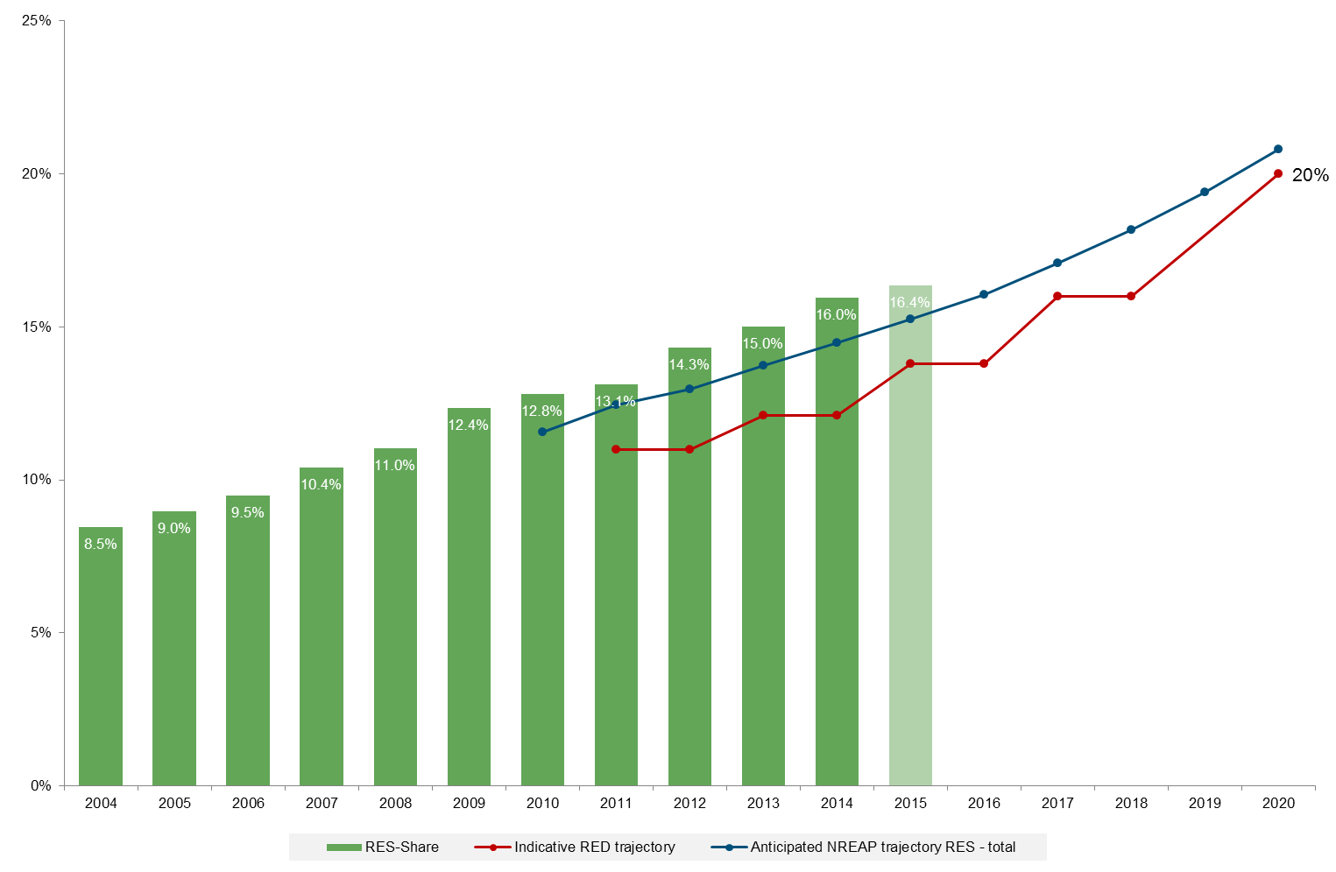

Figure 1: Renewable energy shares in the EU vs. Renewable Energy Directive (RED) and National Renewable Energy Action Plan (NREAP) trajectories (based on EUROSTAT, Öko-Institut)

As shown in Figure 2, **heating and cooling** remains the largest sector in terms of absolute renewable energy deployment. The highest RES share and the largest growth are however in the electricity sector, where the RES share grew by 1.4 percentage points per year between 2004 and 2014. The RES share in the heating and cooling sector grew by 0.8 percentage points per year over the same period of time, while the transport sector showed the slowest growth, with 0.5 percentage points on average per year.

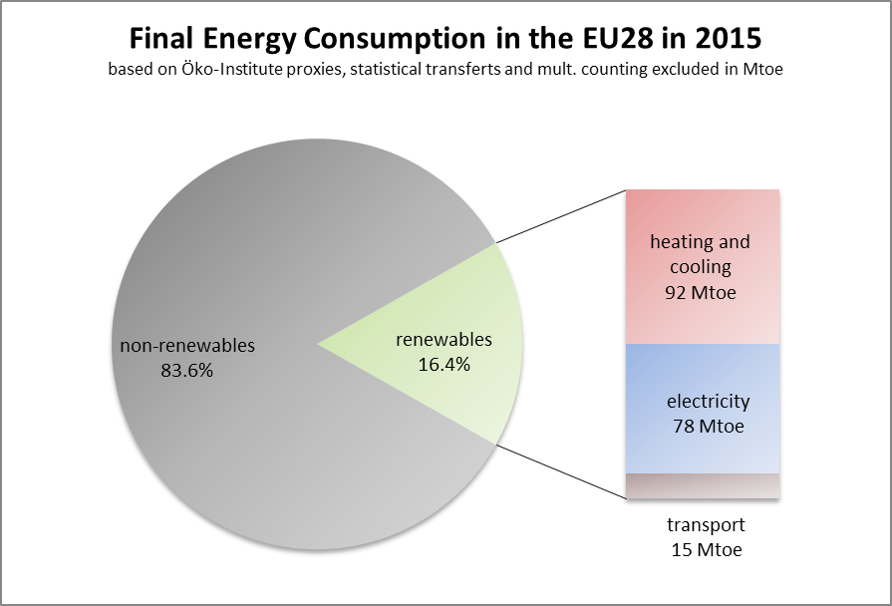

Figure 2: final energy consumption in the EU28 in 2015 (source: Öko-Institut)

### Heating and cooling

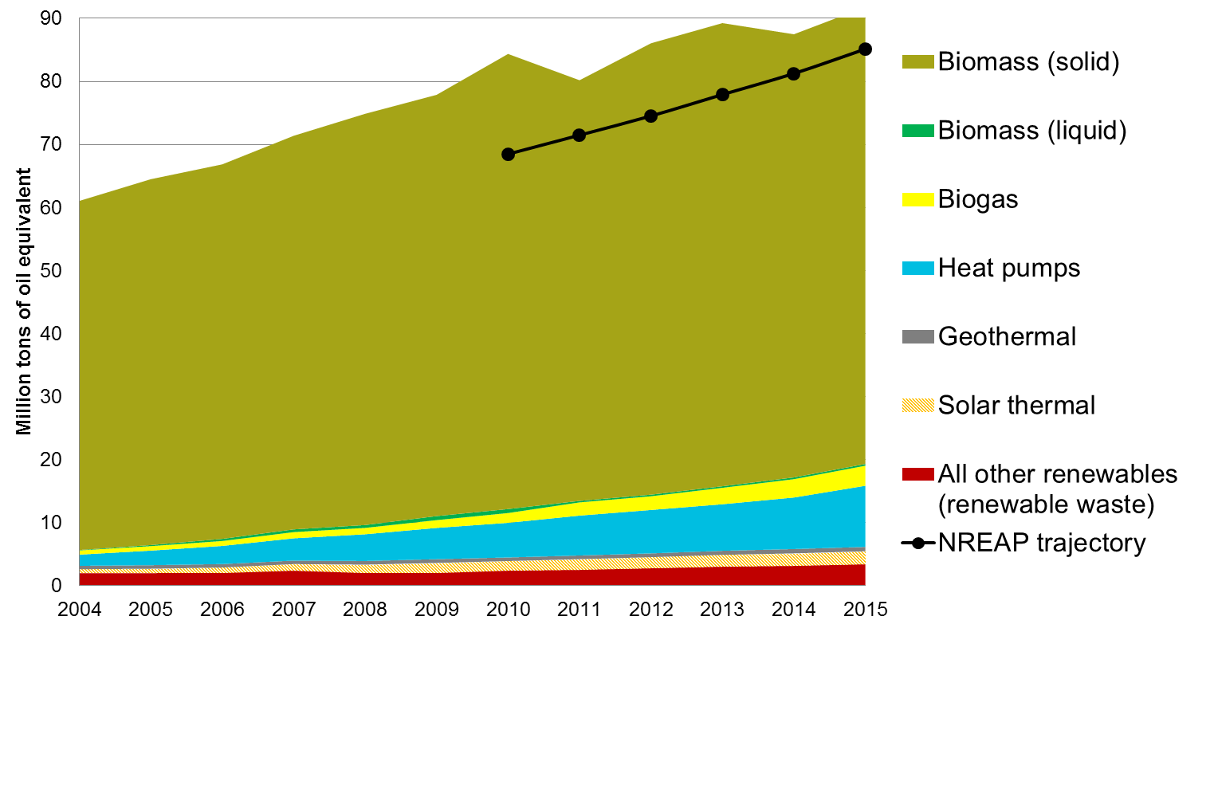

Figure 3 : EU-28 renewable heating and cooling production by source (source: EUROSTAT, Öko-Institut)

With an estimated renewable share of 18.1% in 2015, the EU as a whole is above its aggregated NREAP trajectory when it comes to heating and cooling[12]. As shown in Figure 3, **solid biomass** continues to remain by far the largest contributor (82%) to renewable heat production (72 Mtoe).

The production from **heat pumps** steadily increased from 1.8 Mtoe in 2004 to 9.7 Mtoe in 2015, exceeding the indicative trajectory from NREAPs (7.3 Mtoe). Italy is the leading country in its deployment, with most heat pumps however primarily used for cooling. Although the EU market of heat pumps has been slowing down since 2013, has potential to increase in the coming years[13].

**Renewable waste[14]** deployment amounted to 3.4 Mtoe in 2015. While the share of **biogas** in heating and cooling was negligible in 2004 (0.7 Mtoe), in 2015 it surpassed the projected values with 3.2 Mtoe.

**Solar thermal heat** production, with 2.0 Mtoe in 2015, failed to keep up with the projections included in the NREAPs (3 Mtoe). The annual capacity installed in 2015 was below what had been installed in 2006, influenced by warm winters, low fossil prices, but also the competition of other renewable technologies such as heat pumps or solar photovoltaic.

With output approximated at 0.7 Mtoe in 2015, **geothermal** deployment is below the NREAPs anticipated trajectory. Due to their high natural potential, three countries (Italy, France and Hungary)are leading the European geothermal production. The slow deployment of this technology is mainly due to very high capital expenditures.

### Electricity

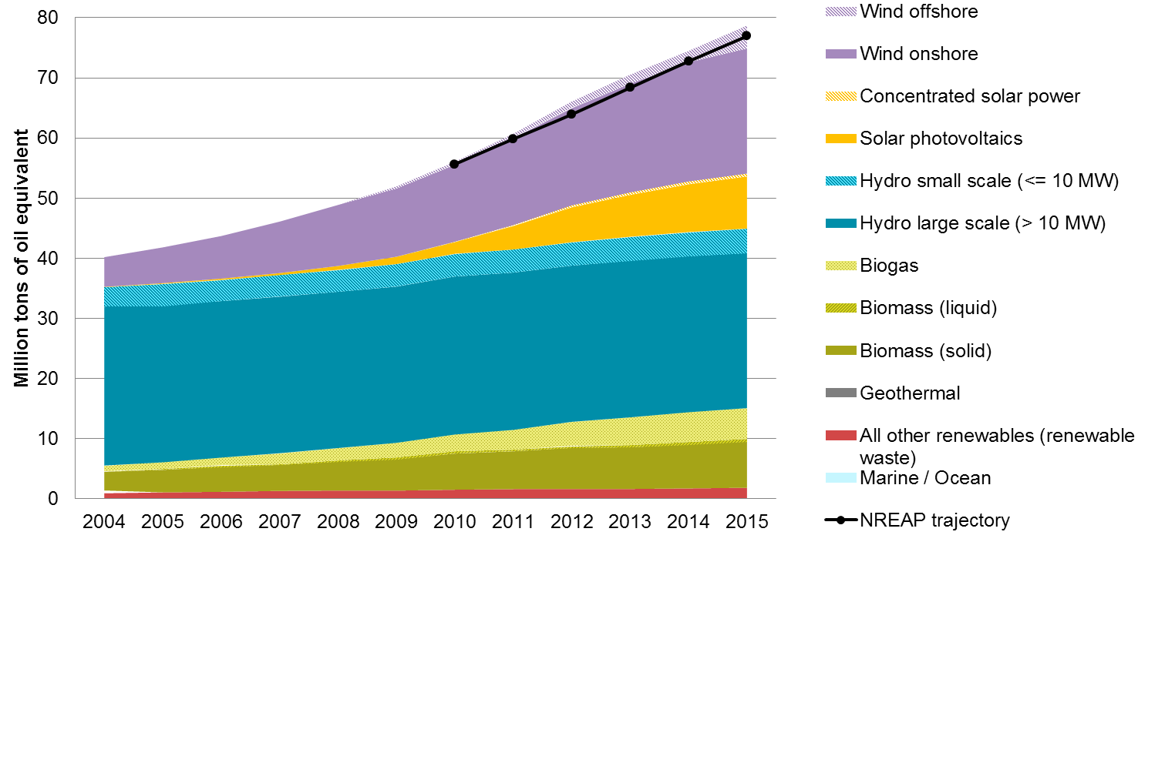Figure 4 : EU-28 renewable electricity production by source (source: EUROSTAT, Öko-Institut)

With an estimated 28.3% RES-E in 2015, the EU is well ahead of its aggregated NREAP trajectory for renewable shares in electricity.

National support schemes vary across the Union and have been subject to numerous changes[15]. The proposal for a recast of this Directive contains several provisions aiming at increasing investor confidence by having a more Europeanised and market-based approach and preventing retroactive changes that compromise the economics of the supported projects.

**Hydropower** still generates the largest share of renewable electricity, while its share declined from 74 % in 2004 to 38% in 2015. In 2015, the EU-28 was on track with its aggregated planned NREAPs trajectory. Sweden, France, Italy, Austria and Spain have around 70 % of all hydropower in the EU-28.

The deployment of **wind power** more than quadrupled over the period 2004-2015, and currently accounts for around one third of renewable electricity. Onshore wind deployment is rather close to the anticipated trajectory throughout the years. The largest contributions have come from Germany and Spain. Regarding offshore wind, four countries (Sweden, Germany, the United Kingdom and Denmark) are also estimated to be above their anticipated 2015 trajectory. However, at EU level, offshore wind has shown a slower progress than expected, with a -12% deviation from the NREAP trajectory in 2015, mostly due to initially high costs (now substantially decreasing) and grid connections issues. The development has nevertheless accelerated significantly in recent years.

**Solar photovoltaic (solar-PV)** increased rapidly and in 2015 accounted for 12% of all renewable electricity. In 2013 its deployment had surpassed that of solid biomass for the first time. In 2015, 38 % of the solar-PV electricity in the EU-28 was produced in Germany, Italy and Spain. The considerable growth in solar-PV electricity has been driven by rapid technological progress, cost reductions and relatively short project development times. This has not only enabled a rapid and cost-efficient deployment, it has also contributed to putting the consumer at the centre of the energy transition. This ambition regarding consumer empowerment has been confirmed by the proposal for a recast of the Renewable Energy Directive and the Market Design proposals. Regarding regional cooperation, in July 2016, Denmark and Germany signed a cooperation agreement on the mutual opening of auctions for solar-PV installations. This agreement goes in the direction of the opening up of support schemes to cross-border participation that the recast of the Renewable Energy Directive proposes.

Electricity generation from **biomass** on EU-28 level grew from around 9 Mtoe in 2010 to 13 Mtoe in 2015. However, this technology did not reach the level planned for that year. The deployment of **biogas and bioliquids** combined, both at negligible levels in 2004, reached 7% of renewable electricity in 2015. For what concerns biogas, its use has grown faster than expected, especially in Germany and Italy.

### Transport

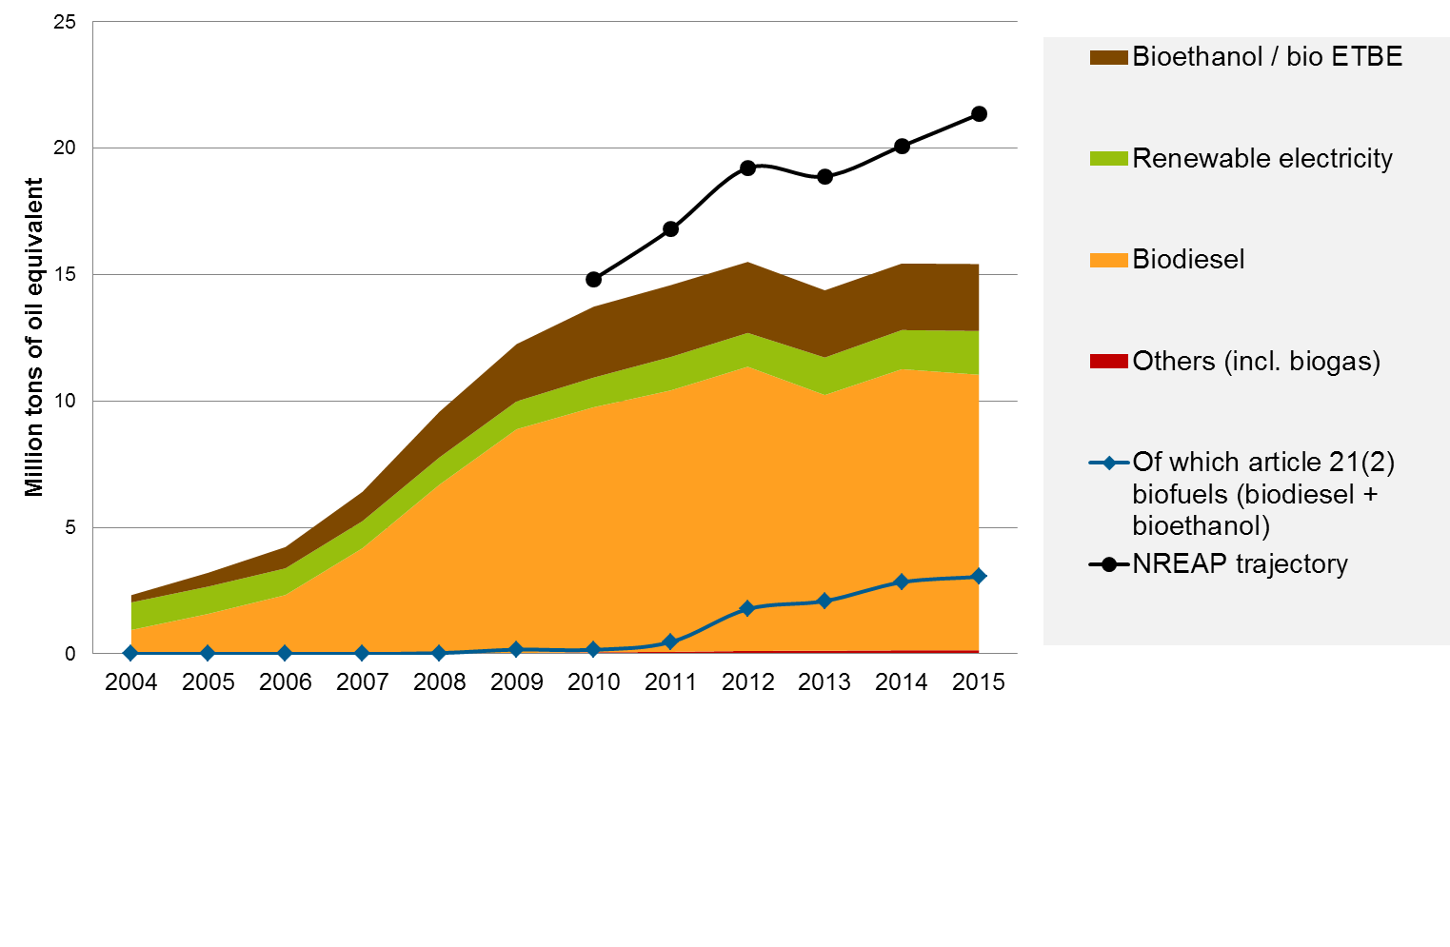

Figure 5: EU-28 renewable energy in transport, by source (source: EUROSTAT, Öko-Institut)

Transport is the only sector which is currently below aggregated NREAP trajectories at EU level, with a 6 % share of renewable energy in 2015[16]. This confirms a rather slow progress to the mandatory 10% target in transport, due to various difficulties including relatively high GHG mitigation costs and regulatory uncertainty[17]. Renewable energy in this sector comes largely from biofuels (88%), with electricity playing a more limited role at this stage.

**Biodiesel** is the main biofuel used for transport in the EU, representing 79% of total use of biofuels in 2015. Despite this leading position, biodiesel did not reach the expected deployment anticipated by the NREAPs trajectory for 2015 (10.9 Mtoe instead of 14.4 Mtoe). The main consumers of biodiesel are France, Germany and Italy.

**Bioethanol** is the second largest contributor of renewable energy sources to the transport sector and represents 20% of biofuels. However, its use did not reach by far the level expected in NREAPs in 2015 (2.6 Mtoe instead of 4.9 Mtoe). Main consumers in 2015 were Germany, the United Kingdom and France, followed by Spain, Sweden, Poland and the Netherlands.

**Renewable electricity** contributed 1.7 Mtoe to gross final energy consumption in transport in 2015[18], which is 13% lower than the expected aggregated NREAP trajectory.

**Other renewable energy sources (including biogas)** do not play a prominent role in the transport sector at EU-28 level, but are deployed in some Member States (e.g. in Sweden and Finland).

The share of **biofuels produced from wastes, residues, ligno-cellulosic and non-food cellulosic material**[19] in the EU biofuel mix[20] has increased from 1% in 2009 to 23% in 2015[21], mostly driven by Sweden, the United Kingdom and Germany. At EU level, these biofuels exceeded by three times the planned trajectory, with around 3 Mtoe in 2015, mainly because of the utilization of used cooking oil.

## Detailed assessment by Member State and projections

All but one Member State (the Netherlands[22]) showed average 2013/2014 RES shares which were equal or higher than their corresponding indicative RED trajectory. According to 2015 estimates, 25 Member States already exceeded their 2015/2016 indicative RED trajectories in 2015. Three Member States (the Netherlands, France and Luxembourg) had 2015 RES estimated shares below their 2015/2016 indicative RED trajectory (see Figure 6).

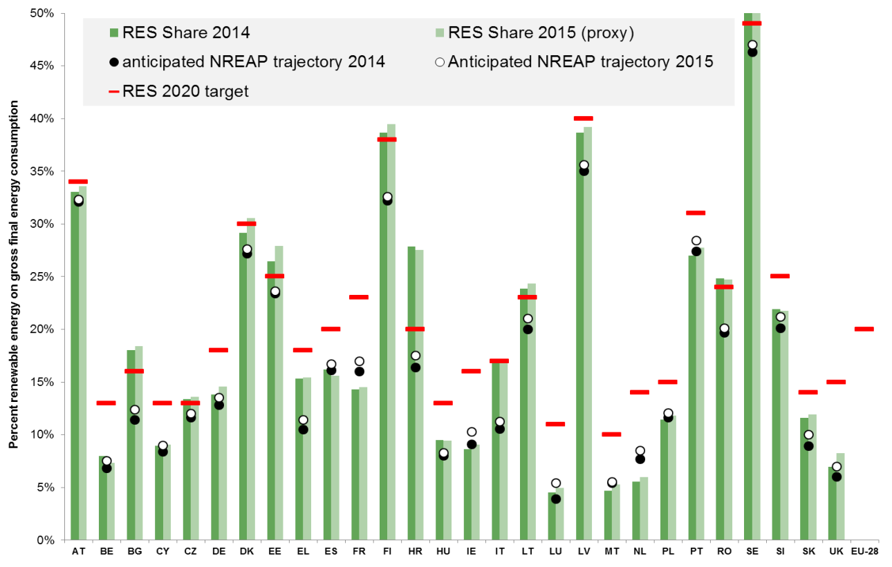

Figure 6 : Member States current progress towards their 2013/2014 and 2015/2016 indicative RED targets. (source: Öko-Institut, EUROSTAT)

The PRIMES Reference Scenario 2016 assumes that the EU as a whole and a majority of Member States will take sufficient action up to 2020 to achieve their targets. Member States which are currently projected not to meet their national RES binding targets by 2020[23] will have the possibility to use cooperation mechanisms. Table 1 summarizes past, current and expected renewable deployment at Member States level, including current trajectory in the transport sector compared with the 10% specific target.



Table 1: Overview of Member States' progress towards 2020 targets in renewable energy (source: Öko-Institut, EUROSTAT)

# 2. OVERVIEW OF ADMINISTRATIVE PROCEDURES

Administrative barriers entail additional development costs stemming from uncertainty, which especially impacts renewable projects with higher capital costs compared to conventional energy projects. Such barriers can lead to delays in deployment or even prevent projects from being realised. With rapidly decreasing technology costs, administrative procedures are proportionally gaining weight in the overall cost of renewable projects[24]. The Renewable Energy Directive requires Member States’ permitting procedures for renewable energy projects to be proportionate and necessary. It also includes the obligation for Member States to outline, in their first progress report, whether they intended to (i) establish a single administrative body for applications for renewable energy installations; (ii) provide for automatic approval of permit applications where the authorizing body has not responded within the set time limits; (iii) and indicate geographical locations suitable for exploitation of energy from renewable sources.

Member States have made progress on reducing administrative burden since the entry into force of the Renewable Energy Directive. The majority of them have established maximum time limits for permitting procedures as well as facilitated procedures for small-scale projects, and most of them identify geographical sites for renewable projects. Furthermore, an increasing number of Member States offer project developers the possibility to submit online applications. However, as shown in Figure 7, barriers remain, e.g. for one-stop shops or automatic permission granting after the deadline.

In comparison to 2012, in 2014 the situation hardly changed regarding the implementation of a one-stop shop. Only a few countries like France, Belgium and Luxemburg adopted this measure. A slight improvement took also place regarding online applications, which Austria and Bulgaria started to implement. Furthermore, the application of maximum time limits did extend to almost all Member States. However, the number of Member States applying facilitated procedures for small scale projects decreased. Table 2 provides a comprehensive overview of facilitated procedures at Member State level.

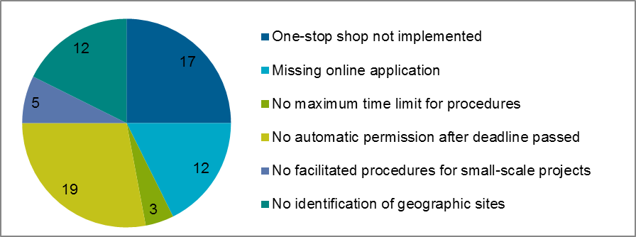

Figure 7: Administrative barriers in the EU in 2014 (number of Member States concerned) (source: Öko-Institut)



Table 2: State of play of the availability of facilitated administrative procedures in EU Member States in 2014 (source: Öko-Institut)

# 3. ASSESSMENT OF SUSTAINABILITY OF EU BIOFUELS

## GHG emission performance

The Member States reported net savings in greenhouse gas emissions resulting from the use of renewable energy in transport of around 35 Mt CO2-equivalent in 2014.Most of these reported savings came from the use of biofuels, with a small but growing role of renewable electricity. These savings cover only direct emissions and do not include emissions from Indirect Land Use Change (ILUC).

ILUC emissions associated to biofuels consumed in the EU are estimated to be 23 Mt CO2-equivalent, leaving a net saving of 12 Mt CO2-equivalent[25]. Applying the associated sensitivity range as set out in Annex VIII of the Renewable Energy Directive, ILUC emissions would range between 14 and 28 Mt CO2-equivalent and the corresponding net savings between 7 and 21 Mt CO2-equivalent.

Recent modelling work[26] of the ILUC impacts of individual biofuel feedstock confirms that ILUC emissions can be much higher for biofuels produced from vegetable oils compared to biofuels produced from starch or sugar. Advanced biofuels from non-food crops have generally very low or no ILUC emissions.

## Trade and main supplier countries

In 2014, around 10% of bioethanol and around 26% of biodiesel consumed in the EU was imported. The main exporting countries were Malaysia for biodiesel and Guatemala, Bolivia, Pakistan, Russia, Peru for bioethanol[27]. Three of them[28] participate in the EU Special Incentive Arrangement for Sustainable Development and Good Governance ("GSP+"). The first Report on the Generalized Scheme of Preferences for the period 2014-2015[29] provides an analysis of the situation on human and labor rights, environmental protection and good governance in these countries. In 2015, imports of bioethanol and biodiesel decreased with largest decrease of ethanol imports from GSP+ countries.

Data regarding the disaggregation by feedstock for production of bioethanol and biodiesel consumed in the EU differs depending on information source[30]. All available sources however confirm that EU ethanol is mainly produced from wheat, maize and sugar beet, and that in 2014, more than 50% of biodiesel consumed in the EU was produced from rapeseed while the use of waste oils and fats but also of palm oil has significantly increased since 2010[31]. In accordance with industry data, more than 60% of biodiesel and more than 90% of bioethanol consumed in the EU was produced from the EU feedstock[32].

Non –EU bioethanol feedstock is imported from Ukraine (maize, wheat), Canada (wheat), Russia and Moldova (barley, ray), and Serbia (sugar beet).[33] The largest exporters of biodiesel feedstock to the EU were Indonesia and Malaysia (palm oil), Brazil and the US (soybean)[34]. The majority of rapeseed oil is of EU origin[35]. Feedstock potential for advanced renewable fuels is very large, but production facilities at commercial scale are still limited.



Table 3 : Feedstock base of the EU-28 bioethanol and biodiesel production in 2014 (source: USDA FAS 2016)

## Land use and land use change

While the forest area, natural area and artificial area increased in the EU between 2000 and 2016, grassland decreased. In 2015, the ratio of grassland to agricultural land declined by 2.01% as compared to the reference ratio calculated on the basis of 2005 data[36]. The loss of permanent grassland between 2006 and 2016 amounted to 3 Mha (-4.9%)[37]. While a direct causal relationship between the loss of grassland area and an increase in the area of cropland used for the production of biofuels could not be found in the Union as a whole, it has been reported by one Member State[38].

The most recent ILUC modelling[39] indicates that, by 2020, the EU biofuel policy could lead to an expansion of 1.8 Mha of cropland in the EU and to 0.6 Mha in the rest of the world, with 0.1 Mha at the expense of forest. Expansion of cropland at global level would occur at the expense of grassland (-1.1 Mha), abandoned land (-0.9 Mha) and other natural vegetation (-0.4 Mha).

## Environment, economic and development issues

No significant negative effects from the production of biofuels and bioliquids on biodiversity, water resources, water quality and soil quality were found in the EU[40]. However, indirect land use change can cause biodiversity losses if additional land expansion takes place in sensitive areas, such as forests and highly biodiverse grassland.

As regards **soil quality**, in the EU these risks are addressed by the Common Agricultural Policy and European and national environmental legislation. Concerning third countries, soil degradation could occur when biofuel expansion takes place on land which is not well-suited for agricultural use. Research shows that a number of EU biofuel feedstock trading partners (e.g. Russia, Ukraine, Canada, Peru and Brazil) have cropland areas characterized by low suitability for cropping (irrespectively of the final use of crops), hence leading to soil impacts[41].

No impacts of biofuel production on the availability of **water** in the EU were reported. As regards water quality, Germany has reported negative impacts due to nitrates in areas with high livestock intensity and more than 50% of arable land used for maize production for biogas, which however is mainly used for electricity generation. In third countries, no evidence of direct linkages between biofuel production and water stress were identified in the biofuel exporting partners to the EU.

Concerning **food prices**, it should be noted that between 2012 and 2015, prices of agriculture commodities decreased. In 2015, the price of vegetable oils reached its lowest level since 2005 (in USD)[42], while prices for oilseed based meals and cakes for feed increased. Lower biofuel demand for vegetable oils was among the factors contributing to the fall in oils/fats prices[43]. Other factors include: high supply and stocks of grains, substitution of meals with cereals, and low crude oil prices.

The EU ethanol consumption had negligible impact on cereal prices given that the EU share in the global ethanol market did not exceed 7%, and the global cereal market is driven mainly by demand for feed. In the future, the strongest biofuel consumption growth is expected in developing countries, while the increased demand for food and feed for a growing and more affluent population is projected to be mostly met through productivity gains, with yield improvements expected to account for about 80% of the increase in crop output[44].

Regarding **land use right**, the most recent reports on large-scale land deals confirm the finding of the 2015 Commission progress report on renewable energy that only very small share of biofuel projects outside the EU have been developed with the EU market in mind. And many land acquisition projects launched in early 2000s failed and did not materialise in real biofuel production projects. The interest of investors was low in 2014 – 2015, with just over half (51%) of the acquired land left idle (67% in sub-Saharan Africa)**[45].** Clear attribution of deals to biofuels is difficult as the agriculture crops may end up in the food chain depending on commodity prices at harvest time or other factors[46]. It should be also noted that, in order to address the concerns related to impacts on local communities and land use rights in developing countries, the Food and Agriculture Organization (FAO) has adopted in 2012 the Guidelines on Responsible Governance of Tenure and in 2014 the Guidelines for Responsible Investments in Agriculture. In developing countries, the multi-stakeholder EU sustainability certification schemes (e.g. ISCC, RSPO RED, RSB EU RED) cover also social, economic and environmental sustainability aspects that go beyond the EU mandatory sustainability criteria.

# 4. CONCLUSIONS

The promotion of renewable energy is an essential part of EU energy policy, as recognised in Article 194 TFEU, and largely contributes to the implementation of the Energy Union Framework strategy. The new regulatory framework for after 2020 proposed by the Commission as part of the '*Clean Energy for All* *Europeans'* package in November 2016 builds upon the experience accumulated under the existing Renewable Energy Directive. It aims at further Europeanising renewable energy policy and maximising its use in buildings, transport and industry sectors. The Commission has proposed reinforced provisions to set the conditions right for investments, including progressive cross-border opening of support, the principle of non-retroactivity and accelerated administrative procedures, as well consumers' empowerment. Electricity, transport and heating and cooling sectors are all targeted with a number of concrete measures, while it is proposed to use 2020 national targets as baseline for Member States' further progress after 2020. In relation to bioenergy, the Commission has proposed to strengthen the EU sustainability framework for bioenergy by extending it to cover also biomass and biogas used for heat and power in large energy installations.

With a 16% share in final energy consumption in 2014, the EU and the vast majority of Member States[47] are well on track in terms of renewable energy deployment[48]. However, 2015 estimates show that Member States will have to continue their efforts to reach their 2020 binding targets, as the trajectory becomes steeper. This especially applies for France, Luxembourg and the Netherlands, which will have to substantially increase their shares in 2016 in order to keep on track with their respective trajectories. On a more forward-looking perspective, projections show that the EU as a whole would reach its 20% target by 2020. However, some Member States such as Ireland, Luxembourg, the Netherlands and the United Kingdom might have to reinforce cooperation with other Member States by using cooperation mechanisms such as statistical transfers to timely reach their national binding targets.

Representing around half[49] of the final energy consumption at EU level, **heating and cooling** remains the largest sector in terms of energy consumption[50]. It is also the largest contributor to the renewable energy target, with half of the renewable energy consumption[51], even if its growth rate has been slower than in the electricity sector. In 2015, around 18.1% of EU heating and cooling was renewable, with biomass representing, by a wide margin, the largest contribution.

The **electricity** sector has seen the fastest growth in renewable share, which currently reaches 28.3% of total electricity production. In 2015, the largest contributor to renewable electricity remained hydropower. The strongest performer in terms of growth is onshore wind. Solar photovoltaic development has been uneven, with a growth peak in 2011 and 2012, but lower growth rates each year since. Together, variable renewables[52] represent 12% of the EU gross electricity generation.

**Transport** is the sector which continues to show the slowest growth of renewables, with 0.5 percentage points on average per year from 2005-2014 and a marked slowdown after 2011[53]. Its renewable energy share was 5.9 % in 2014 (and estimated at only 6.0 % in 2015) out of a sector specific target of 10 % for 2020. This slow progress is due to various difficulties, including regulatory uncertainty and a late uptake of advanced biofuels

On administrative barriers, Member States have made progress on removing them, but this progress have not been uniform across the Union and there is still ample room for improvement, especially for automatically granting the permit after the administrative procedure's deadline and for establishing one-stop shops.

On biofuel sustainability, the majority of biofuels consumed in the EU are produced within the Union from domestic feedstock. No significant direct adverse effects on biodiversity, soil and water, food security nor on developing countries have been identified. However, risks of indirect land use change impacts remain of concern. Modelling analysis has found risks of indirect land use change (ILUC) resulting from food based biofuels. This is why, with the adoption of the ILUC Directive, the EU has limited the contribution of these biofuels to the 10% renewables transport target. Furthermore the Commission has recently made proposals to gradually reduce the share of food-based biofuels after 2020, while promoting their progressive replacement through advanced biofuels and renewable electricity.

In conclusion, the proposal for a recast of the Renewables Directive together with the other proposals of the "*Clean Energy for all Europeans*" package, now under examination of both the European Parliament and Council, aims to tackle the above-mentioned barriers limiting further renewable energy growth, confirming the determination of the European Commission to make the European Union the world number one in renewables.

1. [Directive 2009/28/EC on the promotion of the use of energy from renewable sources, OJ L 140, 5.6.2009](http://eur-lex.europa.eu/legal-content/EN/ALL/?uri=CELEX%3A32009L0028)
2. Compared with 2005 baseline, source: Öko-Institut, Study on Technical Assistance in Realisation of the 2016 Report on Renewable Energy, available under: <http://ec.europa.eu/energy/en/studies>
3. as part of the “Clean Energy for All Europeans” package, issued on 30th November 2016
4. assuming a Primary Energy Factor of 2.5, 1 unit of renewable could replace 2.5 units of fossil electricity
5. 436 MtCO2eq compared with 2005 baseline. Source :EEA
6. See Commission Communication “Accelerating Clean Energy Innovation” Com(2016) 763
7. in 2014, above 1million persons were employed in this sector and the combined turnover reached around 144 billion euro (EurObser'ER report)
8. 2015 estimates. source: Öko-Institut, Study on Technical Assistance in Realisation of the 2016 Report on Renewable Energy, available under: <http://ec.europa.eu/energy/en/studies>
9. Aggregated trajectories at EU-level are provided for illustrative purpose and have no legal value
10. detailed description available under : <https://ec.europa.eu/energy/sites/ener/files/documents/20160713%20draft_publication_REF2016_v13.pdf>
11. On its Annex I, the renewable energy directive sets out a formula to calculate indicative trajectory for two years as an average for each Member State. One can derive from the formula an indicative trajectory for the EU-28 as a whole. However, this extrapolation is presented for illustrative purposes only and has no legal value, i.e. the EU as a whole does not have any indicative RES trajectory under the renewable energy directive.
12. NREAP aggregation indicates an expected share of 15.0 % and 16% respectively in 2014 and 2015.
13. based on PRIMES EUCO30 scenario
14. as accounted by Eurostat under "renewable municipal solid waste"
15. National support schemes implemented by Member States are subject to state aid rules, as set out in the Guidelines on State aid for environmental protection and energy 2014 – 2020
16. including multiple counting
17. Influenced by the discussions on the legal framework for biofuels produced from crops grown on agricultural land and ILUC
18. without multiplicators
19. Former Article 21(2) of Directive 2009/28/EC
20. compliant biofuels as accounted towards the renewable energy target
21. in ktoe, without mutiple counting
22. It has informed the Commission on the adoption of new measures to regain its trajectory and ensure compliance with its target.
23. Ireland, Luxembourg, the Netherlands and the United Kingdom. For the UK the expected gap is however very short (around 0.2%). Hungary, with a gap below 0.01%, has not been included here
24. Refit Evaluation of the Renewable energy directive, SWD (2016) 416 final
25. In accordance with Directive (EU) 2015/1513 of 9 September 2015 (so-called ILUC Directive), the Commission is required to report on biofuel GHG emissions, including ILUC emission by using feedstock data from the Member States' reports due by end of 2017. Since the transposition of Directive (EU) 2015/153 is not yet complete and the Member States have not yet started reporting the required data, the Commission based its assessment on data from Eurostat (amounts of biodiesel, other liquid biofuels and biogasoline consumed in the EU) and data from the feedstock mix from USDA FAS 2016 and industry data
26. Ecofys, IIASA, E4Tech, 2015
27. Industry data: see ePUR statistics, published on 22 September 2016.
28. Bolivia, Pakistan and Peru. Since January 2016 Guatemala is no longer beneficiaries of the GSP+ instrument
29. COM(2016) 29 final, 28 January 2016.
30. For EU-28 sources analysed: publicly available data (industry assocaitions and USDA FAS), commercial data
31. Publicly available data indicates that in 2014, the use of waste oils and fats has increased more than 3 times compared to 2010 and the use of palm oil has more than doubled compared to 2010.
32. Fediol, ePure, EurObserver
33. USDA FAS, UN Comtrade data: http://comtrade.un.org/
34. USDA FAS, UN Comtrade data: http://comtrade.un.org/
35. USDA FAS and UN Comtrade data: <http://comtrade.un.org/>
36. SWD(2016) 218 final Review of greening after one year
37. EU Agriculture Outlook 2016
38. Germany, in its progress report
39. GLOBIOM modelling, Valin 2016
40. Member States' reports
41. IIASA (Soils suitability mapping, national assesments)
42. EU Agriculture Outlook 2016
43. FAO Food Outlook October 2015
44. OECD-FAO (2016) Agriculture Outlook 2016 - 2025
45. IMF, World Economic Outlook: subdued demand – symptoms and remedies. October 2016
46. GRAIN report 2016.
47. Except the Netherlands
48. As set ut in Annex I of Directive 2009/28/EC
49. Based on 2015 proxies, Öko Institut. 45% in 2015 based on RES-denominators
50. In terms of CO2 emissions however, electricity remains a major contirbutor with 41% of EU CO2 emissions
51. Based on 2015 proxies, Öko Institut. 50% in 2015, excluding multiple counting for transport
52. Here, wind and solar
53. Mostly due to changes in accounting compliant biofuels