

TABLE OF CONTENTS

**I. Introduction and Executive Summary 4**

**II. General Overview 8**

**1. The context 8**

1.1. The EU budget and how it is implemented 8

1.2. The Commission's oversight of the implementation of the EU budget 8

1.3. Requests from both the European Parliament and the Council in the 2014 Discharge 9

**2. Methodology regarding the analysis of persistently high levels of errors 9**

2.1. Basic definitions and criteria 9

2.2. The Commission's and the Court's approaches to estimating the levels of error 10

a) The Commission's approach to estimating levels of error 10

b) The Court's approach to estimating the levels of error 11

c) Comparison of the results of the Commission's and the Court's approaches 12

**3. Situation for the EU budget as a whole 13**

3.1. The Commission's continuous efforts to decrease the overall level of error: 13

3.2. Error types identified by the Commission and the Court 15

3.3. Consequences of the multi-annual character of a significant part of the EU expenditure 16

3.4. Cost of controls and simplification 17

3.5. The need to further improve existing management and control systems, in particular first level controls in the Member States 18

**III. Situation concerning the various MFF headings 19**

**1. Introduction 19**

**2. MFF Sub-heading 1A) – Competiveness - Research and Innovation (i.e. DGs 'Research and Innovation' – RTD - and Communications Networks, Content & Technology – CNECT) 21**

2.1. Level of error 21

2.2. The root causes of error 22

a) Policy objectives and priorities 22

b) Eligibility 23

c) The cause of non-detection of errors - management and control systems' weaknesses 23

2.3. Remedial action taken 24

a) Simplification 24

b) Strengthening management and control systems 24

c) Legal Framework 2014 – 2020: Further simplification, but also areas with increased risk 25

**3. MFF Sub-heading 1B) – 'Cohesion' 26**

3.1. MFF Sub-heading 1B) – DG 'Regional and Urban Policy' (REGIO) 27

3.1.1. Level of error 27

3.1.2. The root causes of errors 29

3.1.3. Remedial action taken 30

a) Simplification 30

b) Strengthening management and control systems 31

c) Legal Framework 2014 – 2020: Reinforced control and accountability provisions 34

3.2. MFF Sub-heading 1B) – DG 'Employment, Social affairs and Inclusion' (EMPL) 35

3.2.1. Level of errors 35

3.2.2. The root causes of errors 36

3.2.3. Remedial action taken 38

a) Simplification 38

b) Strengthening management and control systems 40

c) Legal Framework 2014 – 2020: Reinforced control and accountability provisions 40

**4. MFF Heading 2 – Natural Resources 40**

4.1. Levels of error 41

4.2. European Agricultural Guarantee Fund (EAGF) 43

4.2.1. The root causes of errors 43

4.2.2. Remedial action taken 43

4.3. European Agricultural Fund for Rural Development (EAFRD) 44

4.3.1. The root causes of errors 44

4.3.2. Remedial actions taken 44

a) Simplification 44

b) Strengthening management and control systems 45

c) Legal Framework 2014 - 2020: Significant improvements 47

**5. MFF Heading 4 – Global Europe 47**

5.1. Levels of error 47

5.2. DG 'International Cooperation and Development' (DEVCO) 48

5.2.1. The root causes of error 48

5.2.2. Remedial actions taken 49

a) Simplification 49

b) Strengthening of management and control systems 49

c) Legal framework 2014 - 2020 50

5.3. DG 'European Neighbourhood Policy and Enlargement Negotiations' (NEAR/ELARG) 50

5.3.1. The root causes of errors 50

5.3.2. Remedial actions taken 51

**IV. Conclusions 52**

1. Financial management improved significantly leading to a decrease in the level of error 52

2. The Commission and the Court concur in their assessment regarding the level and root causes of errors 52

3. The need to consider the multi-annual character of a significant part of the EU expenditure 52

4. Costs of management and controls and the need for further simplification 52

5. The Commission continuously takes actions to address the root causes and the financial impact of errors 53

# Introduction and Executive Summary

The present Communication provides a thorough analysis of the root causes of errors in the context of the implementation of the EU budget and the actions taken, in line with Article 32(5) of the Financial Regulation[1]. It responds to the requests of the European Parliament[2] and the Council[3] to present a report on 'persistently high levels of error and their root causes'. The Communication is based on information available to the Commission mostly covering payments for the 2007 - 2013 programming period.

**According to Article 317 of the Treaty on the Functioning of the European Union** (Treaty), it is primarily the responsibility of the Commission to ensure that the budget is properly spent.

Whereas the Commission is ultimately responsible for the implementation of the EU budget, around 80% of expenditure is actually executed directly by Member States under shared management. This is so notably for the Common Agricultural Policy and Structural and Investment Funds. In order to ensure sound financial management, the regulatory framework requires Member States to appoint implementing authorities (Paying Agencies for Agriculture and Managing Authorities for Cohesion) and external audit bodies (Certification Bodies for Agriculture and Audit Authorities for Cohesion) which perform around 19 000 audits annually on the ground. The remaining 20% of the EU budget is implemented under direct or indirect management, via third parties, notably European or international financial institutions, such as the European Investment Bank or the United Nations Agency for Refugees.

After careful examination of the reliability of the work carried out by external auditors, the Commission applies the 'Single Audit' concept whereby each level of control builds on the preceding one. This approach, which aims to avoid the duplication of control work and reduce the overall administrative cost of control and audit activities as well as the burden for final beneficiaries, results in approximately 250 audits conducted annually by the different departments of the Commission in the areas of Cohesion and Agriculture[4].

For direct and indirect management modes, the Commission's oversight is based on the work of its own ex-post verification/audit units and/or on the results of external auditors under contract (e.g. for the area of 'International Cooperation and Development' and 'European Neighbourhood Policy and Enlargement Negotiations').

The European Commission produces an annual report on the implementation of the budget, the **Annual Management and Performance Report[5]**, as well as detailed Annual Activity Reports in the various Commission services. Together they provide a comprehensive overview based on the information available to the Commission of the annual implementation of the budget and the contribution of public expenditure to results on the ground. Moreover, these reports contain an assessment by the relevant Director General of the functioning of management and control systems, reservations identifying possible weaknesses, and a detailed analysis demonstrating sound financial management.

For management and accountability purposes, the Commission departments provide best estimates of the levels of error in their area of responsibility, taking into account all relevant information, including control and audit results of statistically representative samples, and using professional judgement. This assessment leads to the Commission's estimates of the level of error in the implementation of the EU budget at two points in the process: **estimated amounts at risk at the moment of payment/reporting** and **estimated amounts at risk at closure**, that is once all corrective activities concerning amounts unduly paid have been implemented. Moreover, the Commission publishes an annual **Communication on the Protection of the EU Budget[6]** giving more detail of preventive and corrective measures. These two reports are now included in the **Integrated Financial Reporting Package[7]** thus providing a complete picture of the implementation of the EU budget in the previous year.

Under Article 287 of the Treaty, the **European Court of Auditors** (Court) provides the European Parliament and the Council with an annual **Statement of Assurance (DAS)** on the reliability of the accounts and on the legality and regularity of the transactions underlying them. The Court estimates the levels of error, based on statistical samples, using the Most Likely Rate of Error, the Lower Error Limit and the Upper Error Limit for each Multi-annual Financial Framework (MFF) Heading, and for the spending from the budget as a whole. These estimated errors reflect non-compliance with the legal rules and, therefore, **legality and regularity from the point of view of administrative requirements**, which should not be mistakenly assimilated to fraud or to expenditure which does not correspond to services or goods actually provided or results achieved[8].

**Thanks to this robust system of controls at various levels, financial management has significantly improved in the course of the last decade.** The constant scrutiny by the European Parliament, the Council and the Court resulted in an increased professionalization of the entire chain of control of the EU funds from the Commission to Member States' authorities, Third Countries and International Organisations.

**Moreover, over the last years the Commission and the Court estimates of error have led to increasingly similar conclusions concerning the levels of error. The Commission's estimates for the Multi-annual Financial Framework (MFF) Headings and the most important spending areas are mostly within the Court's range as set by the Upper and Lower Error Limits.**

In line with improvements in the financial management, **the results of both the Commission and the Court indicate that the levels of error are declining** (see Graph 2). These annual estimates went from double digit rates for some policy areas (particularly 'Cohesion') before 2009 to considerably lower levels at present - below 5% in most policy areas and close to or even below 2% in some domains. Moreover, estimated error rates vary greatly depending on the policy area and the aid schemes[9].

Despite the progress made, the Court has not issued a positive Statement of Assurance until now as the annual estimated error rate has not yet fallen below the materiality threshold of 2%**.**

**These improvements, illustrated by the reduction of the error rate, have required a very significant investment in terms of public sector controls.** This has resulted in high **costs of controls[10]** in some areas, which puts into question the appropriateness of further intensification of audits and verifications. Moreover, **the applicable rules are often complex** in order to reach ambitious and targeted policy objectives. Furthermore, they aim to deal with all the possible scenarios and to provide as much certainty as possible on the legality and regularity of expenditure, so as to avoid ex-post corrections.

Moreover, as shown by the analyses of the Commission and the Court, policy areas which are subject to less complex eligibility rules show lower levels of error.

This explains the **growing requests from public authorities and final beneficiaries to improve the proportionality and cost-efficiency of the legal and administrative framework**. Not more, but better controls should be carried out. Furthermore, simplification represents the most effective way of reducing the costs and burden of control and the risk of errors.

To make further progress in this area, the Commission launched the **EU Budget Focused on Results (BFOR) initiative** in 2015. Its key objective is to ensure that a well performing EU budget complies with the rules and contributes to the desired results. In parallel with an **increased integration of performance considerations in the decision-making process** throughout the budgetary cycle, this initiative aims to increase sound financial management via a **more solid reporting framework, a better methodology of estimating the error rates in a multi-annual framework, simpler rules and more efficient and proportionate controls**, to maximize the share of public money actually contributing to positive results on the ground.

In order to target action in this area, thorough analyses are carried out of the actual root causes of errors. Both **the Commission and the Court reach the same conclusions in general about the nature and root causes of persistently high levels of error: weaknesses in management and control systems**, notably in Member States, Third Countries and International Organisations/Agencies. This situation is aggravated by the sometimes **complex legal framework** under which the EU policies are implemented, as illustrated by the error rate being significantly lower for regimes based on Simplified Cost Options[11] or 'entitlement' regimes[12] than for schemes based on full ex-post cost-reimbursement.

It should be noted that the errors do not necessarily mean that the misstated amounts have been misused or that policy objectives have not been attained.

Over the years, the most common error types which result from this combination of factors are:

1. Ineligible expenditure items;
2. Ineligible beneficiaries/projects/implementation periods;
3. Breach of public procurement and State aid rules;
4. Insufficient reliable documentation to back expenditure declarations; and
5. Incorrect declaration of eligible areas in the field of agriculture.

**The Commission continuously takes actions, both preventive** (such as interruptions and suspensions of payments) **and corrective** (financial corrections and recoveries)**, to address the root causes and the impact of persistently high levels of error**. Data available on the amounts approved and implemented as well as estimates of future corrections show that **multi-annual approach ensures an adequate management of risks relating to the legality and regularity of transactions** leading to amounts at risk at closure of around 0.8 – 1.3% of total relevant expenditure[13].

The DGs implement **targeted measures** in order to strengthen the management and control systems at national, European and international levels[14]; lessons learned from the previous programming periods have led to **improvements in the design of successive generations of programmes[15],** and the **Mid-term Revision** of the Multi-annual Financial Framework (MFF) 2014 - 2020 includes a significant package of legislative proposals for **simplifying[16]** the rules applicable to the implementation of the EU budget.

In addition, the Commission coordinates a network of Member State experts on Internal Control allowing for the identification and sharing of good practice to improve general public sector governance systems. In the field of fraud prevention and detection, the European Anti-Fraud Office (OLAF) and the Commission services responsible for shared management cooperate with Member States through workshops, seminars, training and elaboration of practical guidance documents. While the sectorial regulations require the Member States to put in place effective and proportionate anti-fraud measures, the Commission successfully promotes embedding these measures in comprehensive National Anti-Fraud Strategies.

The present Communication contains first a general description of the context under which the EU budget is implemented (including the Commission's supervision) so as to ensure the legality and regularity of expenditure. Then the different MFF Headings are examined in the light of the existence of persistently high levels of errors, their root causes and the remedial actions taken by the Commission services responsible.

# General Overview

## The context

### **The EU budget and how it is implemented**

The EU budget is a significant instrument for achieving policy objectives. Spending totalled EUR 145.2 billion in 2015, or around EUR 285 for every citizen. It represented 2.1 % of the total public spending of the EU Member States.

The EU budget is agreed annually — within the context of the MFFs — by the European Parliament and the Council following Article 322 of the Treaty. Ensuring that the budget is properly spent is primarily the responsibility of the Commission. Nearly 80 % of the budget is implemented under what is known as ‘shared management’, with Member States distributing funds to beneficiaries and managing expenditure in accordance with EU and national law (for example, in the case of expenditure in the area of ‘Economic, social and territorial cohesion’ and spending on ‘Natural resources’). The remaining 20% are implemented under direct (by the Commission services) or indirect (Third Countries/International Organisations) management.

Programmes can also be grouped according to the way spending is being determined:

* *Entitlement programmes*, with payment based on meeting certain conditions, for example student and research fellowships (under competitiveness spending), direct payments to farmers (under ‘Natural resources’), direct budget support (under ‘Global Europe’), or salaries and pensions (under ‘Administration’).
* *Cost reimbursement schemes*, where the EU reimburses eligible costs for eligible activities, for example research projects (under 'Competitiveness' spending), investment schemes in Regional and Rural Development (under 'Cohesion' and ‘Natural Resources’), training schemes (under 'Cohesion') and development projects (under ‘Global Europe’). However, it should be noted that the use of 'Simplified Cost Options' under 'Cohesion' policy, where funding is based on the deliverables or results achieved (for instance, number of people participating in a vocational training operation under ESF), is similar in nature to the notion of "entitlement" since they are not based on actual costs incurred.

### **The Commission's oversight of the implementation of the EU budget**

Under the shared management mode, the Commission exerts a close oversight over the work of national programme authorities via the interventions of its own auditors and via thorough examinations of the information submitted by the Member States. This information falls into two types:

* The first category is provided by national authorities (such as Paying Agencies in the area of agriculture or Managing Authorities in the area of 'Cohesion'), which request and receive EU funds from the Commission and then paying them (partly via Intermediate Bodies) to final beneficiaries.
* The second type is provided by national external auditors, who are independent from programme implementation (such as Certification Bodies in the area of agriculture or Audit Authorities in the area of 'Cohesion') providing assurance on the reliability of the management and control systems and the underlying transactions.

Where the Commission concludes after a careful examination that it can rely on these national external auditors' control work, it applies the 'Single Audit' concept. This concept refers to a system of internal control and audit which is based on the idea that each level of control and audit builds on the preceding one. ’Single Audit’ aims to prevent the duplication of control and audit work and reduce the overall cost of control and audit activities at both Member State and Commission levels. It also aims to decrease the administrative burden on auditees. As the institution ultimately responsible for the implementation of the EU budget, the Commission is at the top of the ‘Single Audit’ pyramid.

Under direct and indirect management, the Commission's oversight is based on the work of its own ex-post verification/audit units and/or on the conclusions of external auditors under contract, who generally perform ex-post controls.

### **Requests from both the European Parliament and the Council in the 2014 Discharge**

The levels of irregular expenditure from the EU budget have been newsworthy for many years. Of particular concern are those areas with persistently high levels of error and their possible causes.

Article 32(5) of the Financial Regulation states: "*If the level of error is persistently high, the Commission shall identify the weaknesses in the control systems, analyse the costs and benefits of possible corrective measures and take or propose appropriate action in terms of simplification, improvement of control systems and redesign of programmes or delivery systems*". In view of this requirement, the European Parliament[17] and the Council[18] called on the Commission in the framework of the 2014 discharge procedure to present a report on 'persistently high levels of error and their root causes'. The present report responds to this request.

## Methodology regarding the analysis of persistently high levels of errors

### **Basic definitions and criteria**

An error occurs when a transaction is not carried out in accordance with the applicable legal, regulatory and contractual provisions, therefore rendering declared (and reimbursed) expenditure irregular[19].

In this context, it is important to consider the following:

* An error does not mean that funds have disappeared, been lost or wasted.
* Despite the existence of errors, funds have been in general used for their intended purposes and for the approved projects. Though there were weaknesses in project implementation or ineligible expenditure were detected, the quality or delivery of the projects were not necessarily affected.
* An error does not necessarily mean fraud. While errors involve breaches of certain conditions for funding, fraud is intentional deception. It is crucial to note that detected fraud constitutes a marginal percentage[20]. Nonetheless, in line with the zero tolerance to fraud and corruption followed by the Commission, all Commission departments have now designed an anti-fraud strategy and are currently further improving their fraud prevention and detection tools.

Therefore, for this report the Commission considered the following basic criteria:

* Levels of error relate to irregular expenditure identified by the Commission, the national authorities and/or by the Court.
* Persistently high means those levels of error for which the financial impact or risks are above the materiality threshold (2%) over a number of years. Three years (2013 to 2015) have been taken in consideration for this report.
* Data is synthesised on the basis of "families" of policies and Commission services following the Headings of the MFF 2014 - 2020.

The following analysis covers primarily the situation of the payments concerning the previous programming period (2007 - 2013). This is because the level of implementation of programmes/projects related to the new programming period 2014 - 2020 does not yet provide the Commission with sufficient data for a meaningful assessment of persistently high levels of error. However, the report does examine whether the lessons learned from the programming period 2007 - 2013 were taken into consideration when the new legal bases for 2014 - 2020 were elaborated. The Commission will closely monitor whether the new systems and/or new eligibility rules effectively address the problems detected in the past by:

* Preventing errors; and/or
* Identifying and correcting them.

### **The Commission's and the Court's approaches to estimating the levels of error**

#### The Commission's approach to estimating levels of error

As explained in the 2015 Annual Management and Performance Report (AMPR), the Commission measures the level of error to assess whether financial operations have been implemented in compliance with the applicable regulatory and contractual provisions. This is to obtain assurance on the legality and regularity of the underlying transactions and to enable the Commission to discharge its budget execution and supervisory responsibilities by implementing preventive and corrective measures whenever serious irregularities are identified. The level of error is defined as the best estimate by the Authorising Officer, taking into account all relevant information available and using professional judgement, of the expenditure or revenue found to be in breach of applicable regulatory and contractual provisions at the time the financial operations were authorised.

The Commission uses three indicators to measure the level of error:

* Amount at risk - the level of error expressed as an absolute amount, in value.
* Error rate - the level of error expressed as a percentage of the expenditure.
* Residual Error Rate - the level of error after corrective measures have been implemented, expressed as a percentage.

The level of error is measured or estimated at various moments in time, depending upon the individual policy area:

* At the time of the payment/reporting; when some corrective measures have been implemented but others will be implemented in successive years.
* At the time of closure (annual or final), when all corrective measures have been implemented. For multi-annual programmes this refers to the end of programme implementation. For annual expenditure or programmes this is calculated at the end of a multi-annual period covering the implementation of corrective measures, depending on the policy area or programme.

The term corrective measures refers to the various controls made after the payment is authorised, aimed at identifying and correcting errors through financial corrections and recoveries[21].

Within this overall framework, each Commission department applies the approach best suited to provide, for management purposes, a realistic estimate of the level of error for the policy areas under its responsibility. The Directorate General for Agriculture and Rural Development (AGRI) and the 'Cohesion' DGs refer in this context to the validated error rates, as the calculation of the rate is largely based on the validated/or adjusted data provided by the Member States' authorities which carry out either management checks, or ex-post controls and audits on the basis of statistically representative samples. DG AGRI and the 'Cohesion' DGs determine to what extent they can rely on national data and, in particular also draw on the conclusions of the work of their own ex-post verification/audit units. The DGs of the Research and External Relations "families" focus their error analysis on a combination of the Detected and/or Residual Error Rates, based on ex-post control audits provided by their own auditors and/or by auditors under contract (for details see Section III "Situation concerning the various MFF Headings").

#### The Court's approach to estimating the levels of error

The Court is the EU’s external auditor. It is required by Article 287 of the Treaty on the Functioning of the European Union to provide the European Parliament and the Council with an 'external' Statement of Assurance (DAS) on the reliability of the accounts and on the legality and regularity of the transactions underlying them.

The Court estimates the level of error, based on statistical samples, using the Most Likely Rate of Error (MLE) for MFF Headings, and for spending from the budget as a whole. Only quantified errors are part of the calculation. The Most Likely Rate of Error percentage is a statistical estimate of the likely percentage of error in the population. Examples of errors are quantifiable breaches of applicable regulations, rules, and contract and grant conditions. The Court also estimates the Lower Error Limit (LEL) and the Upper Error Limit (UEL) (see Graph 1)[22].

**Graph 1 - The Court's estimate of the level of error**

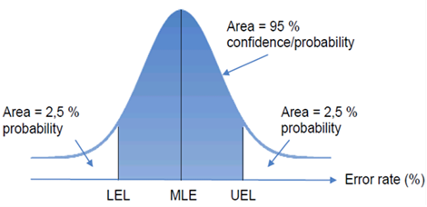

The percentage of the shaded area below the curve indicates the probability that the level of error of the population is between the Lower Error Limit and the Upper Error Limit.

#### Comparison of the results of the Commission's and the Court's approaches

The Commission departments provided the Member States with guidance notes, seminars and training on statistical sampling allowing the Commission to rely on 95 % of the control data provided by stakeholders (such as the Member States' Audit Authorities and Certification Bodies which carried out around 19 000 audits in 2015), which reflects a huge progress compared to the beginning of the 2007-2013 programming period. Nevertheless, there is still room for improvement. This means that the Commission has to use professional judgement in order to adjust some of the received data (for details see Section III "Situation concerning the various MFF Headings").

The Commission considers that, taking into account the relative precision of the respective approaches and results obtained, the levels of error reported in the Annual Activity Reports (AARs) of the Commission DGs as well as the estimates provided in the Annual Management and Performance Report (AMPR – previously designated as Synthesis Report) are broadly in line with the Court's estimated levels of error for 2014 and 2015 (see Graph 2).

**Graph 2 - The Commission's ranges regarding the estimated levels of error at payment and the Court's overall error ranges (2013 to 15)\***

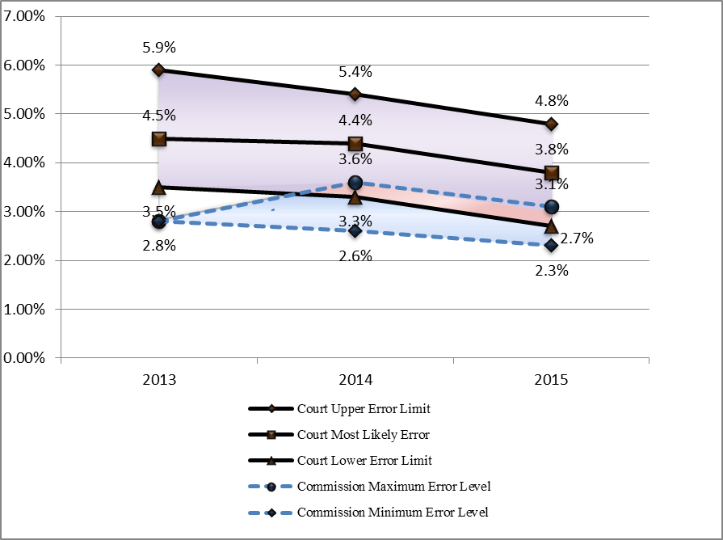

*\* The lines connecting the different error levels should not be seen as a continuous evolution, but rather help to better compare the ranges of error.*

*The Commission's estimation of the levels of error for 2013 and 2014 was cash based (payments made, including pre-financing). In order to have a more conservative approach, estimation of the levels of error for 2015 was changed from cash based to accruals based (i.e. payments made, excluding pre-financing paid and including pre-financing cleared). See also the 2015 AMPR (p. 49).*

*Source: Court's Annual Reports for the financial years 2013 to 2015. Commission Synthesis Report for the financial years 2013 and 2014 and Commission AMPR for 2015.*

Given that the Commission's and the Court's results are similar, the following analyses of persistently high levels of error are based on the entirety of indicators obtained through the two approaches described above. The general term used for these indicators is "estimated levels of error".

## Situation for the EU budget as a whole

### **The Commission's continuous efforts to decrease the overall level of error:**

Even if, due to the different approaches applied by the Commission and the Court, the results are not directly comparable, it is worth underlining that:

* Both methodologies allow for the estimation of an error range[23];
* The Court's range is broader (in 2014 between 3.3% and 5.4% and in 2015 between 2.7% and 4.8%) than the Commission's range (in 2014 between 2.6% and 3.6% and in 2015 between 2.3% and 3.1%); and
* The two ranges overlap for the years 2014 and 2015 (red shaded area in Graph 2 – in 2014 between 3.3% and 3.6% and in 2015 between 2.7% and 3.1%).

Although the methods applied by the Commission and the Court give clear indications that the overall estimated level of error is decreasing, (the Commission minimum error level for 2013 is 2.8%, for 2014 2.6% and for 2015 2.3%; the Court's LEL for 2013 is 3.5%, for 2014 3.3% and for 2015 2.7%), they show too, that the level of error still lies above the materiality threshold of 2%. Therefore, the Court issued a negative DAS. Although this fact appears to suggest otherwise, in reality the level of compliance of the Commission with legal requirements has improved considerably. The levels of error went from double digit rates for some policy areas (particularly 'Cohesion') in the programming periods 2000 – 2006 and before, to considerably lower levels of error at present (lower than 5% for most policy areas and close to or even below 2% in some domains). The constant scrutiny by the European Parliament, the Council and the Court has resulted in further "professionalization" of the entire chain of control of EU funds from the Commission to Member States' authorities, Third Countries and International Organisations.

In particular, the further improvement of the work of the Commission's ex-post verification/audit units, the strengthening of existing and/or the introduction of new systems as well as new simplification measures have been important elements in this continuous effort.

The Commission also facilitates a network of Member State experts on Internal Control. This Public Internal Control (PIC) network allows for good practices in improving public sector governance systems to be the identified and exchanged. The network covers the totality of Member State Internal Control systems and the next PIC conference, foreseen for June 2017, will refer, in part, to governance arrangements for the management of EU funds. To make further progress, in 2015 the Commission Vice-President K. Georgieva launched the EU Budget Focused on Results (BFOR) initiative to maximise the Union's budget effectiveness in supporting growth, jobs and stability in Europe, but also to decrease the levels of error by further simplification measures and better controls. The key objective is to ensure that a well-performing EU Budget complies with the rules and contributes to the desired results. Audit and control costs should be cut, while at the same time reducing errors in spending and better protecting the EU Budget.

Regarding anti-fraud policies, coordinated by the European Anti-Fraud Office (OLAF), the 2014 - 2020 MFF has been strengthened in terms of fraud risk assessment, fraud prevention and detection. For shared management the sectorial regulations require Member States to put in place effective and proportionate anti-fraud measures, taking into account the risks identified, and to take the necessary steps to prevent, detect and sanction fraud and irregularities effectively and to reimburse irregular amounts to the EU budget.

However, going beyond the immediate regulatory requirements, the Commission encourages Member States to embed these anti-fraud measures in a National Anti-Fraud Strategy so as to ensure better monitoring of the fight against fraud detrimental to the financial interests of the EU and that of the Member States, as well as to ensure homogenous and effective practices, especially where the organisational structures are decentralised.

In parallel, OLAF and the DGs REGIO, EMPL, MARE, AGRI and HOME cooperate with the Member States in the field of fraud prevention and detection through workshops, seminars, training and elaboration of practical guidance documents.

Outlining the way forward, the Commission has adopted a package on the Mid-term Review (MTR) / Revision of the MFF 2014 - 2020. It builds on the modernisation efforts and improvements achieved in the current MFF. In this context, further simplification will be key.

The Commission proposes in a single act ('Omnibus') an ambitious revision of the general financial rules[24]. This act also contains corresponding changes to the sectorial financial rules set out in 15 legislative acts concerning multi-annual programmes concerning, for instance, the European Structural and Investment Funds or agriculture. Rather than re-opening the policy debate the proposed changes are technical to allow quick agreement, so that the simplification and increased flexibility benefit spending during the second half of the current MFF.

The following improvements are proposed in the Omnibus revision of the Financial Regulation and sectorial rules:

* Simplification for recipients of EU funds;
* Moving from multiple layers of controls to cross-reliance on audit, assessment or authorisation, and harmonisation of reporting requirements;
* Allowing the application of only one set of rules to hybrid actions, as well as an increased interoperability of different instruments and management modes;
* More effective use of financial instruments, combination of measures or instruments;
* More flexible budget management;
* Focusing on results and streamlining of reporting; and
* A simpler and leaner EU administration.

The measures aiming at reducing the risk of errors include the possibility for output and condition based payments, the removal of the no profit principle, the simplification of the non-cumulative award rule and the increased use of simplified cost options (lump sums, unit costs and flat rates).

The Commission's Communication on the MTR also included some pointers directed towards the next MFF: issues such as its duration and a coherent reform of both the expenditure and financing sides.

### **Error types identified by the Commission and the Court**

The Commission and the Court concur about the most common error types, which are:

1. Ineligible expenditure items;
2. Ineligible beneficiaries/projects/implementation periods;
3. Breaches of public procurement and State aid rules;
4. Insufficient reliable documentation to back expenditure declarations; and
5. Incorrect declaration of eligible areas in the field of agriculture.

**Graph 3 – The estimated contribution of the various error types to the estimated levels of error (average over 2013 - 2015)[25]**

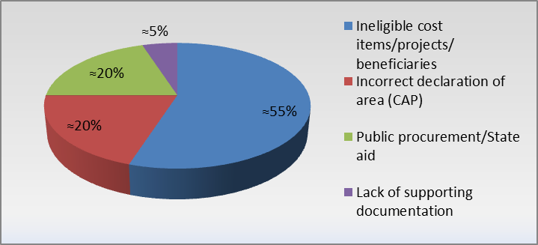

### **Consequences of the multi-annual character of a significant part of the EU expenditure**

According to the Financial Regulation (Article 2(r)), risks have to be managed by applying a multi-annual approach:

*"..control means any measure taken to provide reasonable assurance regarding [.......] the prevention and detection and correction of fraud and irregularities and their follow-up, and the adequate management of the risks relating to the legality and regularity of the underlying transactions, taking into account the multiannual character of programmes as well as the nature of the payments concerned. Controls may involve various checks, as well as the implementation of any policies and procedures to achieve the objectives described in the first sentence; ..."*

Implementing comprehensive, detailed ex-ante controls on all (millions of) payments, carried out by the Commission, Member States, Third Countries etc. in order to prevent errors right from the start, would lead to prohibitive costs in terms of resources and time. Therefore, all systems include ex-post controls during the life-time or at closure of programmes and projects. Furthermore, where errors are detected, the application of corrective mechanisms (i.e. financial corrections and recoveries) protects the EU budget from expenditure incurred in breach of law[26].

In the light of the multi-annual character of a significant part of the EU expenditure, it is evident that a definitive level of error can only be established at the closure of the programmes, when all layers of controls have been applied.

In response to a request by the European Parliament[27], the Commission's departments have complemented for the first time, in the context of the 2015 AMPR, their best estimates of the amounts at risk for the budget under their responsibility with estimates of the corrections they expect to implement in future.

The estimated future corrections are the amounts of expenditure in breach of applicable regulatory and contractual provisions that the DG conservatively estimates. These amounts will be identified and corrected through controls implemented after the payment is authorised, i.e. not only including corrections implemented at the time of reporting but also those that will be implemented in successive years. The DG's estimates are based on the average amount of financial corrections and recoveries in past years, and adjusted where necessary, in particular, to neutralise (i) elements which are no longer valid under the new legal framework and (ii) one-off events.

The estimated future corrections represent between 1.5% and 1.9% of the total relevant expenditure. The estimated amount at risk at closure after the implementation of all corrective measures represents between 0.8% and 1.3% of total expenditure in 2015. Thus, the multi-annual corrective mechanisms adequately protect the EU budget from expenditure in breach of law[28].

### **Cost of controls and simplification**

The non-detection of errors is an inherent risk of a management system. It is widely acknowledged that reducing error-rates to zero would trigger unrealistic high costs for both beneficiaries and the authorities. The Court has set its "materiality threshold" at 2% of the audited amounts. However, this threshold has not been fixed on the basis of the expectations of stakeholders nor on an analysis of the costs and benefits of the controls which are necessary in order to ensure compliance with legal obligations. Instead, the 2% materiality level has been derived from practices developed for the audit of the reliability of the accounts. However, systems ensuring a true and fair view of the financial statements are generally less complex and costly than those which have to be implemented in order to provide assurance regarding the legality and regularity of the transactions underlying the accounts.

Table 1 indicates the overall cost of controls (cost of ex-ante checks, ex-post controls and evaluations by Commission/Member States/Third Countries/International Organisations services) related to the legality/regularity of transactions estimated by DGs in their Annual Activity Reports.

**Table 1 – Cost of controls**

|  |  |
| --- | --- |
| **DGs** | **Cost of controls as a % of 2015 expenditure** |
| AGRI | 4.6%[29] |
| REGIO | 2.3%[30] |
| EMPL | 5%[31] |
| RTD | 2.3%[32] |
| DEVCO | 5.11%[33] |
| NEAR | 3.6%[34] |
| CNECT | 1.75%[35] |

The Commission notes that, despite a decrease of the estimated levels of error, it still remains above the 2% materiality threshold. However, increasing the current levels of controls and audit cannot be considered the way forward. As shown in Table 1, costs (and the administrative burden) of controls are already high. Furthermore, there is a general perception among beneficiaries that they are overwhelmed by the number of controls. Therefore, the reduction of the persistently high levels of error should not be achieved through more, but rather by better controls. In fact, strengthening key controls in existing Member States' systems would allow a reduction in the levels of error without requiring an increase in resources.

In addition, all stakeholders recognize that simplification is the way forward as it reduces the risk of error and has a positive impact on management and control costs, and burden[36]. The simplification measures implemented have led in particular to the introduction of the concept of 'Simplified Cost Options (SCOs)' which prevent errors from the beginning, and the reduction of 'Gold Plating' (see further details in Section III - "Situation in the various MFF Headings").

### **The need to further improve existing management and control systems, in particular first level controls in the Member States**

The Commission's and the Court's analyses concur that in the area of shared management, a significant number of errors could have been prevented or detected and corrected by first level controls by management bodies in the Member States. As shown by the Court's Annual Reports in recent years, for almost half of the irregularities discovered by the Court the national authorities had sufficient information (for example, from the final beneficiaries, external auditors or from their own controls) to prevent or detect and correct the errors before declaring the expenditure to the Commission. In addition, some of the errors reported by the Court were caused by the national authorities themselves. Were all the information available has been used, the levels of error would have been much closer to the materiality threshold of 2% or even below it.

Similar deficiencies have been identified for direct and indirect management (see Table 2).

**Table 2 - Percentage of errors which should have been prevented or identified and corrected by Member States or Third Countries before the declaration of expenditure to and payments by the Commission services\***

|  |  |  |  |  |  |  |  |  |  |
| --- | --- | --- | --- | --- | --- | --- | --- | --- | --- |
| **Heading** | **Annual Report 2013** | | | **Annual Report 2014** | | | **Annual Report 2015** | | |
| **Error rate (1)** | **% of errors that could have been prevented or identified and corrected**  **(2)** | **Minimum error rate**  **(1) - (2)** | **Error rate**  **(3)** | **% of errors that could have been prevented or identified and corrected (4)** | **Minimum error rate**  **(3) - (4)** | **Error rate (5)** | **% of errors that could have been prevented or identified and corrected (6)** | **Minimum error rate**  **(5) – (6)** |
| **Research and other internal policies/Competitiveness / H1A** | 4% |  | **4%** | 5.6% | 2.8% | **2.8%** | 4.4% | 0.6% | **3.8%** |
| **Competitiveness, Regional policy, energy and transport / H1B** | 6.9% | 3% | **3.9%** | 6.1% | 3.3% | **2.8%** | 5.2% | 2.4% | **2.8%** |
| **Competitiveness, Employment and social affairs / H1B** | 3.1% | 1.3% | **1.8%** | 3.7% | 3.2% | **0.5%** |
| **Agriculture: market and direct support / H2** | 3.6% | 1.1% | **2.5%** | 2.9% | 0.6% | **2.3%** | 2.2% | 0.3% | **1.9%** |
| **Rural development, environment, fisheries and health / H2** | 6.7% | 4.7% | **2%** | 6.2% | 3.3% | **2.9%** | 5.3% | 1.7% | **3.6%** |
| **Global Europe / H4** | 2.6% |  | **2.6%** | 2.7% | 0.2% | **2.5%** | 2.8% | 1% | **1.8%** |

*Source: the Court's Annual Reports for the financial years 2013 to 2015.

# Situation concerning the various MFF headings

## Introduction

In line with the results of the Commission's own audit work and the data provided by the Commission in its Annual Activity Reports for the period 2013 to 2015 (see sections below), the areas for which the estimated levels of error were persistently high were:

* Within Heading 1A) of the MFF, Research and Innovation Policy;
* Within Heading 1B) both Regional and Urban Policy and Employment and Social Affairs Policy, (the latter, however, to a lesser extent);
* All Heading 2, Natural Resources, (but EAGF – Market Measures and Direct Support – representing the main part of the expenditure was affected by a level of error close to the materiality threshold);
* All Heading 4, Global Europe (but to a lesser extent than all other Headings).

The same areas were identified by the Court as its yearly reported Most Likely Error Rate stayed persistently above the 2% materiality threshold (see Graph 4) for these Headings and areas[37].

**Graph 4 – The Court's Most Likely Error Rates for the different policy areas over the period 2013 to 2015\***

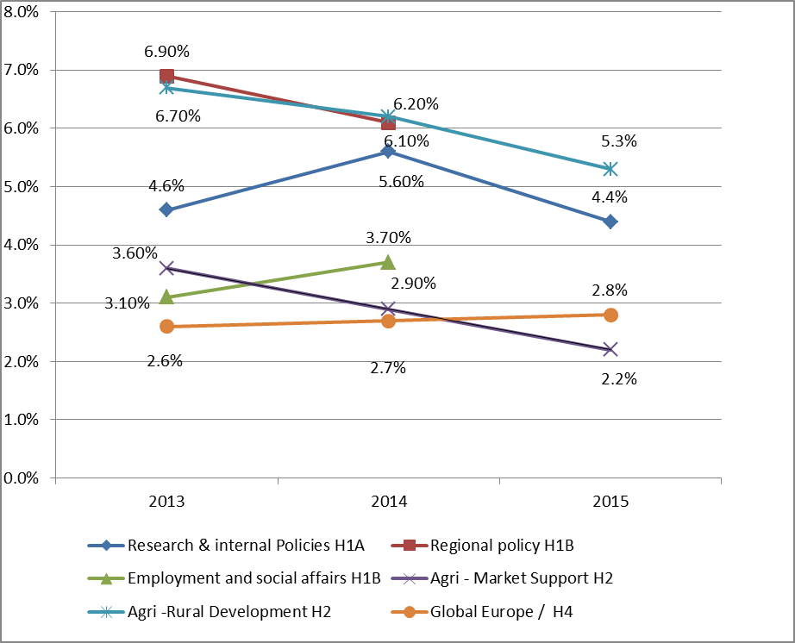

*\* The Court stopped providing specific estimates of levels of error for DGs 'Regional and Urban Policy' - H1B (REGIO) and 'Employment, Social Affairs and Inclusion' (EMPL) – H1B-for 2015.*

*The lines connecting the different error levels should not be seen as a continuous evolution, but rather help to better compare the ranges of error.*

*Source: Court's Annual Reports for the financial years 2013 to 2015*

According to the Court, the different risk patterns of schemes based on reimbursement (where the payment from the EU budget is based on eligible costs for eligible activities) and entitlements (where the payment from the EU budget is based on meeting certain conditions) rather than management modes (shared, direct and indirect) influence the levels of error in the various areas of spending[38]. As the Commission's audits provide similar results, the following sections include an analysis of the possibilities for replacing reimbursements based on eligible costs by payments based on entitlements or, at least, by introducing simplification measures, as for instance 'Simplified Cost Options (SCOs)', lump-sums or flat-rates.

## MFF Sub-heading 1A) – Competiveness - Research and Innovation (i.e. DGs 'Research and Innovation' – RTD - and Communications Networks, Content & Technology – CNECT)[39]

### **Level of error**

As regards FP7, the representative error rate calculated based on the common sample is 4.47%. It is based on 298 closed audits as of 31 December 2015 out of 324 selected transactions.

Following the Commission's own audit work on the Seventh Framework Programme (FP 7), using 3 336 audit results from 2008 to 2015, the overall level of error detected for 2015 ranges between 4.47 - 5%. This is in line with the Court's overall range of 2 – 6.7% for its analysis of the Heading 'Competiveness', with a Most Likely Error Rate of 4.4% (see Graph 5). It has to be noted, however, that the overall figures can disguise differences in certain sub-parts of FP7. In particular, grants under the European Research Council (ERC) and Marie-Curie Schemes contain a number of simplified eligibility criteria, unit costs and flat-rates that reduce the risk of ineligible expenditure and lead to levels of error of below 2%, as for example:

* Flat-rates for some personnel and indirect costs;
* Simplified time recording requirements; and
* Mono-beneficiary grants with a limited range of public sector beneficiaries.

These simplified eligibility criteria are appropriate given the particular aims, and the particular beneficiaries targeted by these measures. However, using them across the board would not allow the research services to meet all the various objectives set out for the research policy.

The FP7 Residual Error Rate is much closer to the materiality threshold (2.88% for DG RTD and 2.58% for DG CNECT). It should be noted that the final residual error for the 6th Framework Programme, after all controls and recoveries were implemented, ended very close or even below to the materiality level, which underlines the importance of a multi-annual perspective.

The overall amount at risk at payment for DG RTD's total 2015 expenditure ranges between EUR 107 and 125 million (2.1 to 2.5%). The conservatively estimated future corrections are EUR 46 million (0.9%). The estimated amount at risk at closure is between EUR 61 and 79 million (1.2 to 1.6%).

The overall amount at risk at payment for DG CNECT's total 2015 expenditure ranges between EUR 63 and 66 million (3.7 to 3.9%). The conservatively estimated future corrections are EUR 22 million (1.3%). The estimated amount at risk at closure is between EUR 40 and 44 million (2.4 to 2.6%).

For the entire "*Research, Industry, Space, Transport & Energy*" policy area, the global estimated amount at risk at payment ranges between EUR 259 to 290 million (2.1 to 2.3%), while the estimated amount at risk at closure ranges between EUR 132 to 163 million, which corresponds to 1.1 to 1.3% of the relevant 2015 expenditure.

**Graph 5 - The Commission's estimated levels of error for FP7 and the Court's error rates for the area of 'Competiveness/Internal Policies' from 2013-15\***

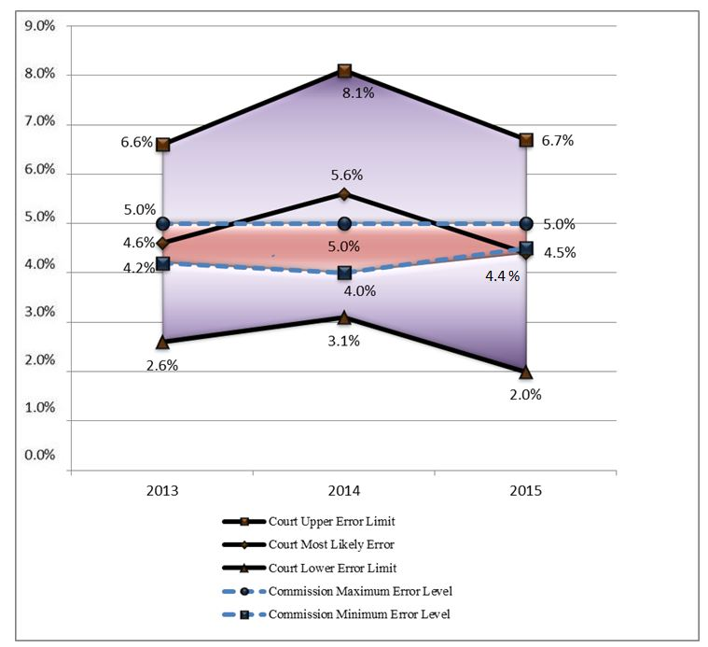

*\* The lines connecting the different error levels should not be seen as a continuous evolution, but rather help to better compare the ranges of error.*

*In the Annual Report for the financial year 2013, the Court examined this policy area in its Chapter 8 'Research and other internal policies'.*

*The "Commission minimum error level" is the point estimate for the year in question; the "Commission Maximum Error Level" is the expected final error level.*

*Source: Court's Annual Reports and DGs RTD and CNECT Annual Activity Reports for the financial years 2013 to 2015*

### **The root causes of error**

#### Policy objectives and priorities

The diverse scope (diverse objectives and diverse population of beneficiaries) of research policy has an impact on the error rate. The Framework Programme is designed to attract large numbers of participants (over 50 000 participations already in Horizon 2020) across the European Union and the world. Small Medium Enterprises (SMEs) and new participants have been particularly encouraged, even though it is known that the error rate for these categories is much higher (2.5 to 3 times) than for other participants. Similarly, most projects have a multi-national and 'multi-beneficiary' character, essential for achieving the policy objectives of the programme, but more prone to error than 'mono-beneficiary' projects.

#### Eligibility

The non-respect of eligibility criteria (ineligible expenditure) is the only substantial cause of error for research programmes. This error type arises in all kinds of expenditure. The biggest contribution to the overall level of error comes from:

* Incorrectly calculated personnel costs;
* Ineligible "other direct costs" due to incorrectly calculated depreciation, or due
* to inadequate documentation of purchases and travel costs etc.;
* Ineligible indirect costs based on erroneous overhead rates; and
* Ineligible cost categories not linked to the project.

According to the Commission's own audit work, these error types account for over 87% of the detected error rate. The Court comes to the same conclusion as it indicates that 86% of errors detected concerned the reimbursement of ineligible personnel and indirect costs declared by beneficiaries.

#### The cause of non-detection of errors - management and control systems' weaknesses

The biggest part of undetected errors comes from the Certificates on the Financial Statements (CFS) provided by external auditors or competent and independent public officials. The variable quality of the CFS is a known issue in the Research "family". Despite this weakness, the research services have calculated that the error rate is on average 50% lower if there is a CFS. Nevertheless, they clearly do not avoid all errors.

In 2014 the Court identified that 2.8% of the 5.6% total error rate should have been detected by control arrangements before payment. In 2015 this error amounted to 0.6% out of 4.4%. In this context, additional efforts have been made to provide guidance and raise awareness, especially for Certifying Auditors.

**Graph 6 – The Commission and Court assessments of the root causes of errors**

1. ***Commission***

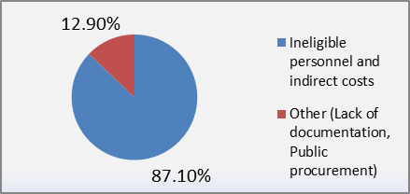

1. ***Court*[40]**

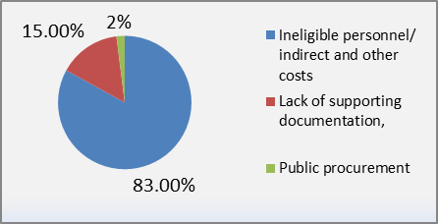

### **Remedial action taken**

#### Simplification

Simplified cost options are already used in several areas of FP7 and Horizon 2020 (see below):

* Unit costs for staff under the Marie Sklowodska-Curie Scheme, extended to SME owner managers from 2011 onwards;
* A flat-rate for indirect costs, an option in FP7, generally applied under Horizon 2020; and
* A lump-sum for the SME phase 1 scheme.

These options will be expanded where they can be useful, in terms of reducing the levels of error and the administrative burden, as well as achieving the policy priorities.

For the cost model, the stakeholder consultation for Horizon 2020 asked stakeholders to consider whether lump-sum (output-based) funding would be an appropriate way to fund research generally. This would represent an entitlement scheme which is based on a fixed price that is agreed upon in advance, for work to be undertaken. Such an output based funding system would avoid any eligibility errors.

The stakeholders were generally not in favour of this option, preferring to keep a "reimbursement" methodology, especially because of concerns that it would not be the best way to support research efforts across the EU. Without questioning that such a scheme could have benefits in lowering the error rate in financial terms, it may have a range of costs and side effects that would not be desirable.

However, following the Court's observations about the lower risks of error in entitlement schemes the Commission will continue exploring possibilities for introducing output-based funding schemes. A pilot scheme is planned for 2018 allowing a better assessment of the costs and benefits of a change of cost model.

As explained above, the Commission has already proposed a number of changes in the general financial rules to reduce the risk of errors, including the extended use of simplified cost options (see section 3.1).

#### Strengthening management and control systems

The management and control systems for research are continually reviewed. The creation of the Common Support Centre covering all the services implementing research will bring advantages in terms of common IT tools and business processes, and a common audit service. However, in line with the cost-effectiveness principle, the assurance model will still be largely based on ex-post audits, with limited detailed ex-ante controls. The reasons are that ex-ante controls are expensive, especially given the large number of participations financed (50 000 already under Horizon 2020), and can only provide partial assurance if there is no visit on the spot. Large numbers of detailed ex-ante controls also create a heavy administrative burden on beneficiaries, the legislation requiring the Commission to minimise such burdens.

For Horizon 2020 a Certificate on the Financial Statements will only be required at the end of the project, and not for the stage of interim payments. This will mean that the positive effect of the Certificates on the Financial Statements will be felt later, which may have a temporary effect on the levels of error. In other words, future analyses of the levels of error in this area will have to take into consideration the multi-annual character of the control system.

#### Legal Framework 2014 – 2020: Further simplification, but also areas with increased risk

Whilst retaining existing simplifications, more have been put in place for Horizon 2020:

* A single funding rate for all grants set in the call for proposal;
* A flat-rate for indirect costs for all grants;
* Extended use of unit costs, flat-rates and lump-sums for some costs in some programmes;
* Simplified time recording requirements, especially for staff working full time on the project;
* Simplified rules for the calculation of productive hours;
* Simpler rules for the use of consultants; and
* Simplified procedures for the recognition of sub-contracting and third party costs.

The financial statement accompanying the proposed legislation estimated that these simplifications would reduce the representative Maximum Error Level from 5% to around 3.5%. The target for the Residual Error Rate or the amount at risk at closure was to be as close to 2% as possible, but not necessarily below it.

The proposed simplifications were generally accepted by the Legislative Authority. However, it included a number of elements that may lead to increased errors:

* A higher participation target for Small and Medium Enterprises (knowing that SMEs are a higher risk than other beneficiaries);
* The possibility to claim costs for large research infrastructures;
* A shortened time period to grant (therefore reduced time for controls); and
* A limit of EUR 8 000 per annum per full time equivalent for "additional remuneration".

Further simplifications to rules and processes will be proposed during the period of the Framework Programme.

## MFF Sub-heading 1B) – 'Cohesion'

In 2015, the Court abandoned its approach of giving in its Chapter on 'Cohesion' separate error rates for the two Structural Funds DGs, 'Regional and Urban Policy' (REGIO) and 'Employment, Social affairs and Inclusion' (EMPL), instead it provided an overall Most Likely Error Rate for the 'Cohesion' area of 5.2%. This compares to the Structural Funds DGs' estimate of an Upper Error Level of 5.1% and a validated error rate of 2.9% (see Graph 7).

The estimated future corrections reported by DGs REGIO and EMPL in 2015 amount to EUR 1 435 million. As a result of this very conservative estimate, the highest value of the amount at risk at closure (EUR 1 267 million or 2.3% of 2015 expenditure in this policy area) may be overestimated. The actual level of future corrections will be determined on the basis of the actual risk identified at closure, so as to ensure that the residual risk for each programme is below materiality (2%).

**Graph 7 – The Commission's and the Court's estimated levels of error for the entire Heading 1B from 2013 to 2015\***

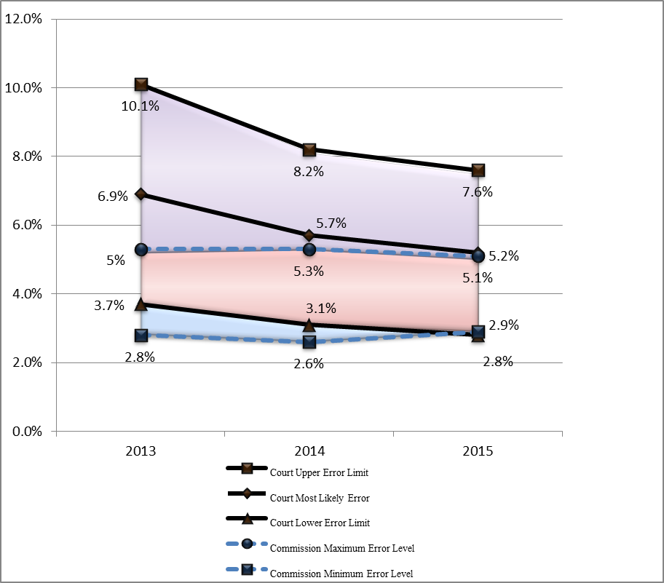

*\* The lines connecting the different error levels should not be seen as a continuous evolution, but rather help to better compare the ranges of error.*

*Source: Court's Annual Reports and DGs REGIO and EMPL Annual Reports for the financial years 2013 to 2015.*

### **MFF Sub-heading 1B) – DG 'Regional and Urban Policy' (REGIO)**

#### **Level of error**

For shared management, DG REGIO stated in 2015 that the estimated average risk rate linked to the 2015 payments for ERDF and the Cohesion Fund (2007 - 2013 programming period) was between 3 - 5.6% on an annual basis, which is broadly in line with the Court's overall assessment (see Graph 7 for the whole 'Cohesion' area).

DG REGIO bases its analysis on its own audit findings and the data provided by the national Audit Authorities in their Annual Control Reports (regarding expenditure declared in 2014, around 7 300 audits of operations were carried out). In order to assure themselves of the reliability of Audit Authorities, DG REGIO's own auditors carried out 58 audit missions. Since 2009 more than 300 audit missions have been carried out covering 51 Audit Authorities responsible for supervising 98.5% of European Regional Development Fund/Cohesion Fund Programmes. In addition DG REGIO auditors perform a comprehensive desk review of the Audit Authorities Annual Control Reports and Audit Opinion complemented by fact finding missions when needed. Furthermore, DG REGIO received from Member States' Audit Authorities 446 reports on system audits carried out, which were carefully analysed by the DG (in 2013 and 2014 DG REGIO had examined more than 540 system audit reports).

Regarding the 'external' data provided by the Member States, DG REGIO notes that 95% of the error rates reported by Audit Authorities were assessed as a reliable source of information for the purpose of calculating the risk to 2015 payments (see Graph 9). For the remaining 5%, DG REGIO re-calculated the error rate provided by the Audit Authorities or estimated the risk at a flat-rate because the reported error rates were considered unreliable or that insufficient/inconclusive audit information had been obtained at the date of the assessment to allow full confirmation of the reported error rates.

**Graph 8 - The Commission's and the Court's estimated levels of error in the area of Regional and Urban Policy (DG REGIO) from 2012 – 2015\***

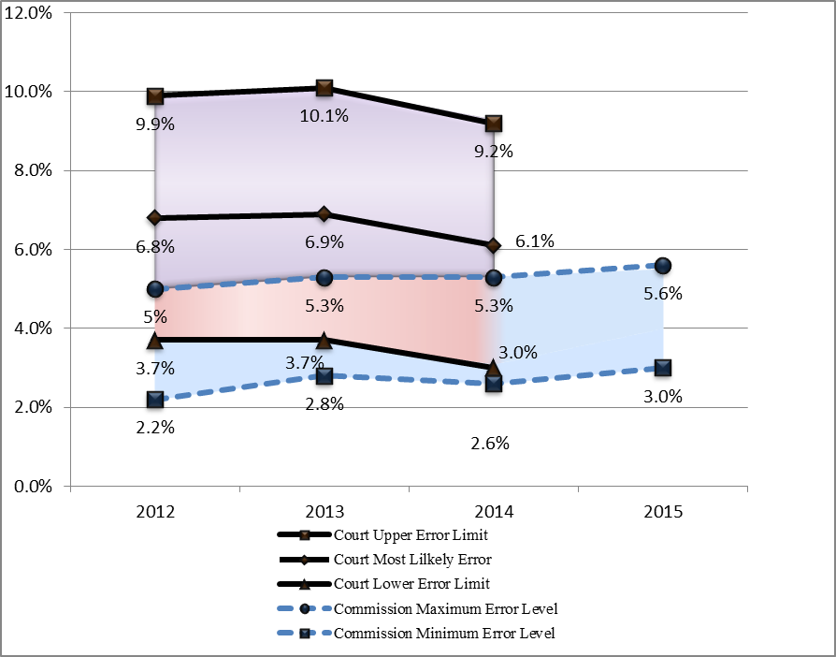

*\* The Court stopped providing specific estimates of levels of error for DG REGIO for 2015. Exceptionally, 2012 is included in order to provide a fuller overview.*

*The lines connecting the different error levels should not be seen as a continuous evolution, but rather help to better compare the ranges of error.*

*Source: Court's Annual Reports for the financial years 2012 to 2014 and DG REGIO Annual Activity Reports for the financial years 2012 to 2015*

**Graph 9 – Reliability of the error rates provided by national Audit Authorities to DG REGIO**

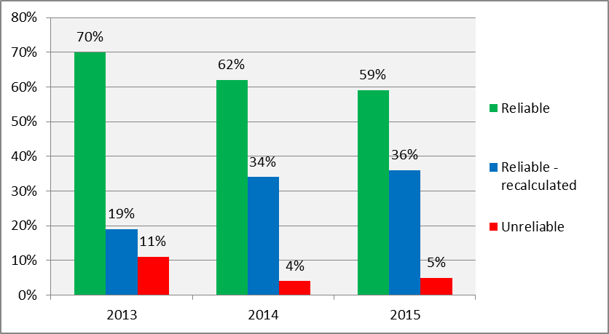

#### **The root causes of errors**

In 2015 DG REGIO identified the main root cause for errors for the 2007 - 2013 period as the serious deficiencies in management and control systems related to 67 programmes in Belgium, Bulgaria, the Czech Republic, France, Germany, Greece, Hungary, Italy, Poland, Romania, Slovakia, Spain, the United Kingdom and for ETC programmes, as detected by the programme Audit Authority and/or the Commission. In particular, these deficiencies concern one or several of the following key elements:

* Management verifications;
* Compliance with rules on public procurement, State aid, revenue generating projects and eligibility;
* Procedures for the selection of operations;
* High error rates following audit of operations;
* Certification activities;
* Audit work (unreliable error rate due to uncompleted work, procurement irregularities not properly detected or quantified for a limited number of Operational Programmes).

Public Procurement, State aid and ineligibility have been the three main sources of errors identified by the Court over the last years.

In particular due to these system deficiencies the validated error rate lies above 5% and/or cumulative residual risk above 2%. System deficiencies are due, among other factors, to the complex management structures in some Member States and high staff turnover in some authorities leading to a loss of expertise or insufficient staff allocation.

They are also caused by the fact that national or regional rules to be applied for implementing programmes may be more demanding than those foreseen in the national legislation for similar expenditure nationally funded or than what would be needed to comply with EU rules (known as 'Gold Plating').

Management verifications conducted by Managing Authorities and their Intermediate Bodies continue to be the main concern as regards the weakness of management and control systems. In particular the formal nature of management verifications, insufficient verifications of public procurement procedures, insufficient structure / organisation of the Managing Authorities or Intermediate Bodies and lack of training and supervision in case of delegation of responsibilities are the main issues. However, it should be noted that there is a significant difference in quality between the management checks carried out by the Managing Authorities and the controls by the Audit Authorities which are considered to be reliable in 95% of cases and whose work is key in relation to the 'Single Audit' concept.

The error types identified by DG REGIO, due to these systems weaknesses, accord with the Court's assessment in its Annual Report 2015 (see Graph 10).

**Graph 10 – The Court's assessment of the root causes of errors concerning DG REGIO[41]**

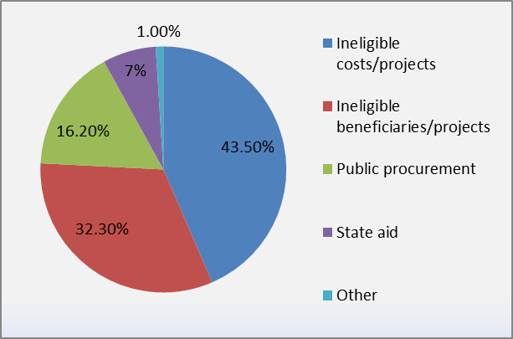

#### **Remedial action taken**

DG REGIO rigorously exercises its supervisory role by ensuring that Member States address the weaknesses in their management and control systems, by:

* Updating its audit risk assessment jointly with DGs EMPL and MARE taking into account all available cumulative audit results and information;
* Ensuring continuous review of the quality of the audits carried out by the Audit Authorities and monitoring the 'Single Audit' status granted to programmes so far; and
* Applying timely payment interruptions as soon as significant deficiencies are detected/reported and proposing to the Commission to decide on suspensions of payments and financial corrections whenever necessary, unless Member States accept to apply the necessary financial corrections first.

In addition, DG REGIO will continue to implement the following initiatives to mitigate the main risks and weaknesses identified:

#### Simplification

Simplification in the implementation of EU funds is a major pillar of the "EU Budget Focused on Results" initiative. The regulations for the 2014 - 2020 programming period offer a broad range of opportunities for simplification and reducing administrative burdens. These include a set of common rules for all ESI Funds, the extended use of Simplified Cost Options, shorter retention periods for documents for beneficiaries and the move towards e-cohesion.

The package of Public Procurement Directives voted by the European Parliament on 15 January 2014 and adopted by the Council on 11 February 2014 will help to further simplify the rules for all actors.

The common rules for ESI Funds for the period 2014 - 2020 have been simplified compared to previous periods. They offer a wider range of simplification opportunities like simplified cost options, simplified ways to take account of revenue-generating projects and financial instruments. The move towards e-cohesion should also simplify the lives of beneficiaries.

DG REGIO is currently assessing how far the new provisions have contributed to reducing administrative burdens for beneficiaries and to simplification. Several studies have been launched to contribute to the assessment of the uptake of the simplification measures. In addition, a 'High Level Group on Simplification' for beneficiaries has been set up, and its objective is to analyse the implementation of simplification opportunities in Member States and regions and make recommendations to improve the uptake of simplification measures for 2014 - 2020 and on the way forward for post 2020. Since 20 October 2015, the High Level Group has held several meetings to discuss various topics in detail: e-Governance, Simplified Cost Options, access to EU funding for SMEs and Financial Instruments and audits. It has already adopted its first conclusions and recommendations on e-Governance and Simplified Cost Options.

Building on these first recommendations, the Commission has recently proposed further and more ambitious simplification in the rules governing ESI Funds, notably the Common Provisions Regulation[42], in particular to expand considerably the scope of simplified cost options and to make their use obligatory for operations below EUR 100 000. In addition, taking up a new possibility proposed in the Financial Regulation, financing based on the fulfilment of conditions related to progress in implementation, rather than based on the costs of operations would be allowed. The Commission has also proposed fewer requirements for the use of Joint Action Plans, simplification measures for revenue-generating operations and major projects, further clarifying the rules for financial instruments and a number of other changes. These proposals are contained in the "Omnibus" regulation adopted by the Commission in September 2016 (section 3.1 above).

The Court made a recommendation in their 2015 Annual report to make out a focused analysis of the national eligibility rules for the 2014 - 2020 programming period and the Commission foresees to carry out such analysis for the programmes that have systematically presented high level of errors thus showing a potential scope for more simplified rules.

#### Strengthening management and control systems

During the 2007 - 2013 programming period, the Commission services put in place targeted actions to improve the administrative capacity in the Member States. This continues under the 2014 - 2020 programming period. In addition to the specific actions defined for each programme, DG REGIO is implementing cross-cutting initiatives to mitigate the main risks and weaknesses identified. The actions already implemented or ongoing include notably:

* A general administrative capacity initiative. In 2015, the activity mainly concerned:
* A peer-to-peer exchange of expertise between authorities managing the programmes 'Technical Assistance and Information Exchange (TAIEX) instrument REGIO PEER 2 PEER'. By November 2016, 109 exchanges have been approved and of these, 70 exchanges involving 1 142 participants have been implemented with positive feedback.
* A strategic training programme for Managing, Certifying and Audit Authorities and Intermediate Bodies on the implementation of the 2014 – 2020 Regulations. Some 540 programme experts and desk officers from all Member States have attended the four different training modules so far.
* Competency Framework for efficient management and implementation of ERDF and the Cohesion Fund, aimed at supporting further professionalization of the management of the funds.
* Specific workshops in cooperation with OLAF in the 15 most affected Member States on implementing effective and proportionate anti-fraud/anti-corruption measures to increase the awareness of risks and greater acceptance that preventive measures are possible. Audit Directorate of DG REGIO also actively promoted, in close cooperation with DG EMPL, the use by relevant national authorities of 'Arachne', a preventive risk-scoring tool developed by the Commission.
* Pilot Integrity Pacts in cooperation with Transparency International. 17 pilot Integrity Pacts are being set up in 11 Member States to run for a period of four years from 2016.
* On public procurement, dedicated action plans for strengthening capacity in this field have been set up by DG REGIO in close cooperation with DG Internal Market, Industry, Entrepreneurship and SMEs, DG Competition and other ESI Funds DGs, and their implementation continued during 2015. The action plans were endorsed by the Commission and include:
* Public Procurement Guidance for Practitioners on the avoidance of errors in ESI- funded projects was published in October 2015 in all EU languages; the guide will be updated to cover the new Public Procurement Directives for which the transposition deadline was 18 April 2016;
* Monitoring of the ex-ante conditionality action plans on public procurement with a focus on those Member States which are still implementing their action plans, including providing customised support to Member States not fulfilling the ex-ante conditionality;
* A public procurement stock-taking study including more than 50 good practice examples in public procurement across the EU, has been widely disseminated. It also contains 28 country profiles with concrete recommendations.
* Promotion of transparency and open data on public procurement, including through the initiative for pilot Integrity Pacts mentioned above.
* A State aid action plan designed by DG REGIO in close cooperation with DG Competition was also adopted in March 2015. It aims at increasing awareness and understanding of the subject, at improving the co-operation between the various actors involved in the monitoring of State aid in the Member States, and providing pro-active support to the EU Member States and regions in the correct application of State aid rules. It includes measures for:
* Reviewing existing good practices and their dissemination;
* Strategic training programmes, including expert and country specific training planned for the second half of 2015 and the beginning of 2016;
* Exchanges between the Commission and Audit Authorities, for further dissemination of audit checklists adapted to the 2014 GBER (General Block Exemption Regulation) revisions[43];
* Customised assistance to Member States not fulfilling the ex-ante conditionality on State aid to help them implement their action plan.

As regards the Audit Authorities, regular administrative capacity building actions (technical meetings, methodology discussions, fora for exchanges of good practices) are in place to ensure a robust joint audit framework. Guidance for Member States is continuously improved and discussed with Audit Authorities in technical meetings.

The main topics concerned by dedicated meetings, workshops or targeted actions are anti-fraud/corruption, audit methodology for public procurement or State aid, recommended statistical sampling techniques for conclusive and reliable audit results and effective implementation of the 2014 - 2020 new regulatory features (such as audit of performance indicators or e-cohesion).

In recent years DG REGIO has reviewed the work of the most important Audit Authorities covering over 98% of the European Regional Development Fund and the Cohesion Fund allocations through on-the-spot audits including re-performance of audits of operations to assess the audit conclusions drawn up by the Audit Authorities. It is continuously monitoring the situation where 'Single Audit' status has been granted. On-the-spot re-performance of audits including beneficiaries, associated with the issue of continuous advice, audit guidelines and methodological tools by the Commission services, has enabled comprehensive capacity-building for Audit Authorities since 2009. As a result, most Audit Authorities are now up to standards and provide DG REGIO with reliable audit results, as demonstrated in 2015 (see Graph 9).

DG REGIO pursued the organisation of fora for exchanges on audit issues and capacity building actions for the benefit of all Audit Authorities through targeted training on request, on issues such as audit of public procurement or State aid, recommended sampling techniques for conclusive and reliable audit results and to ensure good implementation of the new features for 2014 - 2020 such as audit of performance indicators and e-cohesion. Continuous feedback will be given to the Audit Authorities based on the assessment of their 2015 audit results for better understanding of the main weaknesses identified and dissemination of good practices within the audit community.

DG REGIO has already introduced in its audit procedures the identification of gold-plating practices and has encouraged the audit authorities to do the same. In addition, it will implement the Court's recommendation in the 2015 Annual Report to carry out a focused analysis of the national eligibility rules for the 2014 - 2020 programming period.

#### Legal Framework 2014 – 2020: Reinforced control and accountability provisions

The assurance framework for Cohesion policy in 2014 - 2020 has been substantially revised and addresses weaknesses from the previous regulatory framework where the level of assurance could vary according to the stage of the management and control cycle.

The revised control architecture has been reinforced thanks to the new elements introduced i.e.:

* A twelve-month accounting period running from 1 July of year n-1 to 30 June of year n;
* The retention of 10% from each interim payment in relation to the expenditure of the accounting year, in order to protect the EU budget until all national control and verification work is carried out and the related accounts are submitted;
* The submission for each programme of certified accounts for the expenditure declared to the Commission in relation to the accounting period, as well as accompanying documents to give assurance of the accuracy of the accounts, the effective functioning of the system and the legality and regularity of the underlying transactions (Management Declaration, annual summary of controls and audits, Audit Opinion based on Residual Error Rates after all corrections are taken into account at national level and control reports), by 15 February of year n+1;
* The payment or recovery of the annual balance due, following acceptance of the accounts by the Commission by 31 May of year n+1; the accounts should reflect the financial corrections carried out to bring the annual residual risk below the materiality threshold of 2% for each programme each year;
* The obligatory application of net financial corrections where irregularities demonstrating serious system deficiencies are still detected by the Commission (or the Court), unless already identified or corrected by the national authorities.

The acceptance of accounts by the Commission is one new process, separate from the assessment of legality and regularity as foreseen in the regulation (Article 139, Common Provision Regulation). The Commission must accept accounts by 31 May each year based on the Audit Opinion provided by the Audit Authorities, or inform the Member State otherwise. When accounts are accepted, the Commission must calculate, then pay or recover the balance for the year, taking account of the level of expenditure certified in the accounts and confirmed by the audit opinion, yearly advance payment and interim payments made with the retention of 10%.

However, the block of expenditure contained in the programme accounts should not contain any remaining material level of irregularities. If this is not the case (either as reported by the Audit Authority or as identified through EU audits) the Commission can interrupt the payment of the balance and immediately launch financial correction procedures. These corrections will be net if the Member State does not accept the corrections (as for 2007 - 2013) or if they point to serious deficiencies not previously detected / corrected or reported by the Member State (new for 2014 - 2020).

The reinforced assurance process for 2014 - 2020 will continue to take into account the 'Single Audit' concept whereby the Commission may rely principally on previous controls performed by the Audit Authorities, after having verified the reliance it can place on their audit results. Additional possibilities to apply the 'Single Audit' principle are offered in the Regulation (Article 148, Common Provision Regulation). At the final stage, the Commission conformity audits and the resulting application of net financial corrections, where necessary, should allow assurance to be provided that the residual risk of error – after all corrections are applied – is below 2% for each programme, year on year.

Ex-ante conditionalities are a key element of the ESI Funds reform: They aim to ensure that adequate regulatory and policy frameworks are in place and that there is sufficient administrative capacity before investments are made, thus improving the effectiveness and efficiency of investment supported by the ESI Funds as well as other public and private investments. They are pre-conditions to ensure that co-financed investments will be effective and efficient under coherent and well thought-through strategies.

Ex-ante conditionalities also cover issues of administrative capacity, public procurement and State aid, main causes of errors for 'Cohesion' policy.

Where Member States did not comply with ex-ante conditionalities at the moment of the programme adoption, action plans were agreed with the Commission. DG REGIO carefully monitors the situation and provides help to Member States in completing their action plans.

### **MFF Sub-heading 1B) – DG 'Employment, Social affairs and Inclusion' (EMPL)**

#### **Level of errors**

The average error rate calculated by DG EMPL for 2015 ranges from 3.0 - 3.6 %, which is broadly in line with the Court's overall assessment (see Graph 7 related to the whole 'Cohesion' area). Since DG EMPL started estimating its own error rate in 2011, its estimates have been very closely aligned with those of the Court (i.e.: the Minimum Error Level estimated by DG EMPL and the Most Likely Error Rates estimated by Court for the period 2011 to 2014, have been as follows: 2011: 2.0 vs 2.2%; 2012: 2.3 vs 3.2%; 2013: 2.6 vs 3.1% and 2014: 2.8 vs 3.7%, respectively, which shows the soundness of DG EMPL's assurance methodology.

Like DG REGIO, DG EMPL based its estimate on its own audit work (51 audit missions in 2015, covering 89 Audit Authorities out of 92, responsible for supervising 115 out of 118 Operational Programmes) and data provided by the national Audit Authorities who carried out 5 114 audits of operations in 2015. DG EMPL's Audit Directorate thoroughly reviewed the calculations made by the Audit Authorities so as to ensure consistency with the guidance and the availability of representative consolidated figures. The data were considered to be reliable in 95% of cases (see Graph 12).

**Graph 11 – The Commission's and the Court estimated levels of error in the area of Employment and Social Affairs (DG EMPL) from 2012 – 2015\***

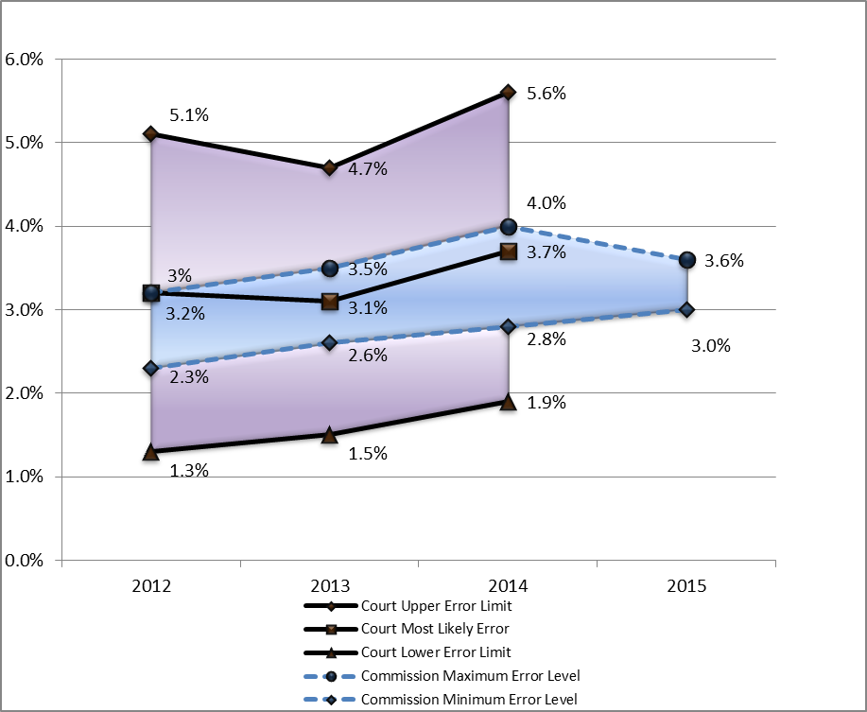

*\* The Court stopped providing specific estimates of levels of error for DG EMPL in 2015. Exceptionally, 2012 is included in order to provide a fuller overview.*

*The lines connecting the different error levels should not be seen as a continuous evolution, but rather help to better compare the ranges of error.*

*Source: Court's Annual Reports for the financial years 2012 to 2014 and DG EMPL Annual Activity Reports for the financial years 2012 to 2015.*

**Graph 12 – Reliability of error rates forwarded by national Audit Authorities to DG EMPL**

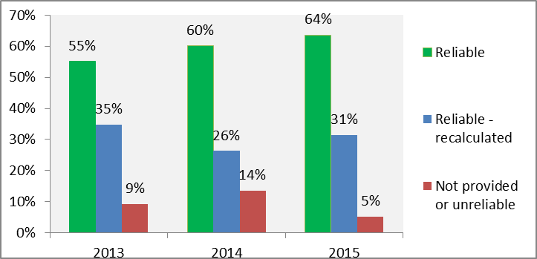

#### **The root causes of errors**

Like DG REGIO, DG EMPL concluded that the main root causes of error were the complexity of the legal framework in the 'Cohesion' area and weaknesses in national management and control systems. In 2015 DG EMPL expressed a reservation regarding the management and control systems for 23 specific ESF Operational Programmes in Belgium, Croatia, France, Germany, Greece, Hungary, Italy, Romania, Slovakia, Spain and the United Kingdom for the programming period 2007 – 2013.

Furthermore, DG EMPL carried out a specific thematic audit on management verifications by Member States' authorities. The overall objective of this thematic audit was to evaluate the extent to which the management and control systems connected with the verification process functioned effectively to prevent, or detect and correct errors and irregularities, and to obtain assurance of the legality and regularity of the expenditure declared to the Commission.

The main results of this audit were:

* In several cases, DG EMPL auditors found that the management verifications were carried out on a merely formal basis apparently respecting the legal requirements, but lacking a critical eye on the expenditure declared;
* Management verifications of projects implementing (part of) their activities through public procurement should be strengthened. In many cases, breaches in public procurement procedures were not identified by the management verifications, although on-the-spot controls were carried out by the Managing Authorities or their Intermediate Bodies;
* The selection and approval of projects very often lacked a critical assessment of the management capacity of the Managing Authorities/Intermediate Bodies. Frequently, an important number of (small value) projects were approved without considering the implications of the guidance and training needed for the beneficiaries, the cost of verifications to be carried out by the Managing Authorities/Intermediate Bodies, the risk management activity required to identify high risk projects and the added value or the impact on the labour market these small value items might have;
* Many Managing Authorities depended on their Intermediate Bodies to carry out the management verifications. These Intermediate Bodies had often more or better experience in dealing with the operational side of the subject matter and hence the Managing Authority's decision to allocate responsibility to these Intermediate Bodies was often justified. It was observed, however, that these Intermediate Bodies got little or no training on the administrative side of the process and hence, the competence and the capacity to carry out effective management verifications were often lacking; and
* There were situations in which management verifications were carried out after expenditure had been certified to the Commission. In many instances, this situation was provoked by a lack of resources or the pressure to meet the requirements of the de-commitment rules.

The error types detected by DG EMPL, due to these system weaknesses, coincide with the root causes of errors identified by the Court in its 2015 Annual Report.

**Graph 13 - The Court's assessment of the root causes of errors concerning DG EMPL[44]**

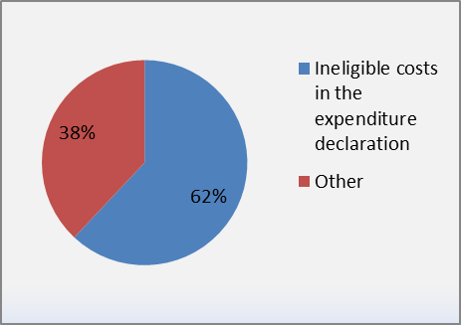

#### **Remedial action taken**

DG EMPL rigorously exercises its supervisory role by ensuring that Member States address the weaknesses in their management and control systems, by:

* Updating its audit risk assessment jointly with DGs REGIO and MARE taking into account all available cumulative audit results and information;
* Continuously reviewing the quality of the audits undertaken by the Audit Authorities; and
* Implementing a strict policy of payment interruptions, suspension of operational programmes and financial corrections whenever serious deficiencies are identified, unless Member States agree to apply the necessary action plan and financial corrections first.

In addition, DG EMPL will continue to implement the following initiatives to mitigate the main risks and weaknesses identified:

#### Simplification

As explained above, the Court indicated that the breaches of the rules on the eligibility of expenditure were the main error source for the ESF. This is in part due to the beneficiaries' obligation to be able to provide documentary evidence to justify all the incurred costs that they claim for reimbursement. An alternative to this traditional system based on reimbursement of real costs is the use of what are known as Simplified Cost Options. Simplified Cost Options represent a way of establishing eligible costs not on the basis of what has actually been spent (and which then needs to be supported by documentary evidence), but on the basis of pre-defined amounts. By making it easier to justify the expenditure, Simplified Cost Options not only reduce bureaucracy, but also the risk of making errors. This has been demonstrated by the Court for four consecutive years, finding no quantifiable errors when examining transactions under Simplified Cost Options in its ESF sample. This has led the Court to conclude that Simplified Cost Options are less error prone than real costs.

Simplified Cost Options also have the advantage of focussing the funding on the outputs or the results achieved, rather than on what has been spent, as with the real costs system. This is in line with the Commission objective to make its budget implementation more result-oriented and to maximise the impact of the money spent.

The purpose of the 2014 - 2020 regulatory framework is to make the previous Simplified Cost Options applicable to all European Structural and Investment (ESI) Funds. In addition, the options offered have been expanded to address some of the limitations identified in the previous programming period.

Simplified Cost Options existing in frameworks other than the ESI Funds can be re-used, subject to conditions:

* One example is Article 67(5)(b) Common Provision Regulation which allows Simplified Cost Options used in another Union policy to be applied to similar types of operations and beneficiaries in the ESF. In particular, this could allow methods defined in Erasmus + to be easily applied to similar ESF-funded operations.
* Similarly, Article 67(5)(c) Common Provision Regulation allows for Simplified Cost Options applied under a scheme funded entirely by the Member State to be used in ESF for similar types of operations and beneficiaries.

These two additional methods present a great opportunity for capitalising on existing simplifications: they are directly applicable to European Structural and Investment (ESI) funded operations (provided that it is for a similar type of operation and beneficiary and that the scheme is still in force) and the value of the Simplified Cost Option will not need to be audited, which reduces the scope and cost of potential control. These two methods can be applied effortlessly by the Member States and bear very little risk of error.

Finally, for the smallest European Social Fund (ESF) operations (below EUR 100 000 of public support) a draft budget can be used to define a Simplified Cost Option. This method was introduced to cater for the obligation for ESF projects below EUR 50 000 of public support to use one type of Simplified Cost Option to cover at least a part of its expenditure (except if fully publicly procured or under a State Aid scheme).

The new ESF legal basis (Article 14 of the ESF Regulation) empowers the Commission to adopt standard scales of unit costs and lump-sums. This provides legal certainty regarding the calculation method for the Simplified Cost Options and addresses one of the main obstacles identified by Member States, i.e. their fear that the methodology for calculating the unit cost or the lump-sum could be challenged by auditors (national or EU), leading to a systemic error. Having the methodology validated ex-ante by the Commission secures and validates the work being done by Member States.

By allowing Member States to claim EU funding on the basis of Simplified Cost Options, while applying a different (national) system for the reimbursement of beneficiaries, the new legal basis also opens the possibility of the use of Simplified Cost Options by Member States where, in normal circumstances, national rules do not allow such techniques.

Given the positive impact and numerous advantages of Simplified Cost Options and taking into account the new opportunities introduced by the 2014 - 2020 legal framework, the Commission has set an ambitious political target to have 50% of ESF expenditure implemented through Simplified Cost Options by 2017. The overview report on simplification submitted to the European Parliament and Council in 2015 showed that Member States' planned level of implementation of Simplified Cost Options in the ESF for the 2014 - 2020 programming period was estimated at around 35%, which is significantly higher than the 7% estimated for the 2007 - 2013 period, but not yet enough. DG EMPL will keep promoting their use and encouraging Member States to further increase their take up in order to achieve the 50% target.

The target is an impetus to greatly increase the use of Simplified Cost Options so as to help reducing administrative burden and the risk of error while increasing the focus on results. It is an encouragement to all sides – Commission, Member States and beneficiaries, to maximise their efforts to reap the potential of Simplified Cost Options. But it should not be viewed as an end in itself.

In view of achieving further simplification, the Commission has introduced the concept of the 'Joint Action Plan' (JAP).

JAP is a completely new and potentially far-reaching way of implementing the ESI funds. A JAP is an operation that is managed entirely on the basis of the outputs and results to be achieved. It may:

* Consist of one project or a group of projects;
* Receive support from one or more priority axes of one or more programmes; and
* Be supported by one or more instruments such as by the European Social Fund, the Youth Employment Initiative (YEI), the European Regional Development Fund and/or the Cohesion Fund.

The projects should produce the outputs and results necessary to achieve the Joint Action Plan objective. Payments will only take the form of unit costs and/or lump-sums linked to the outputs and results of each project.

Building on this simplification the Commission has proposed further improvements in the context of the Omnibus revision (section 3.1 above). In some cases existing provisions under the ESF Regulation are now updated and extended to other ESI Funds (compulsory use of simplified cost options in certain cases, flat rates for certain staff costs). The proposals for the Common Provisions Regulation (removing the upper limit for the use of lump sums, less requirements for the use of a JAP, new possibility for payments based on conditions; section 3.1.3(a) above) are complemented by corresponding changes in the ESF Regulation and measures extending the use of simplified cost options under the Regulation on the Fund for European Aid for the most deprived.

#### Strengthening management and control systems

DG EMPL will keep adapting and revising its procedures and guidance on shared management to ensure the proper functioning of management and control systems in Member States during the current programming period (see also section 3.1.3 b of DG REGIO).

#### Legal Framework 2014 – 2020: Reinforced control and accountability provisions

DG EMPL will benefit from the same improvements made to the legal framework for the Cohesion area for the programming period 2014 - 2020 as DG REGIO (see section 3.1.3 c), to strengthen management and control systems.

## MFF Heading 2 – Natural Resources

The Common Agricultural Policy (CAP) is implemented through two Funds (Pillars): the European Agricultural Guarantee Fund (EAGF, Pillar I) consists of the market support measures and direct payments (EAGF); the European Agricultural Fund for Rural Development (EAFRD, Pillar II) finances Rural Development measures.

The CAP operates under shared management with more than 8 million beneficiaries across the EU and the Directorate General for Agriculture and Rural Development (DG AGRI) works closely with the Member States to ensure that the funds are disbursed in compliance with the EU legislation.

### **Levels of error**

In the framework of its Annual Activity Reports, DG AGRI examines the information submitted by the Member States on the results of the controls performed by the Paying Agencies. Taking into account the opinions of the Certification Bodies, DG AGRI's own ex-post audits (DG AGRI carries out around 140 audit missions every year) and the Court's findings, the DG AGRI auditors use their professional judgement to estimate the amounts and calculate conservatively adjusted error rates for expenditure per Activity Based Budgeting (ABB) activity for each Paying Agency.

Table 3 shows the CAP adjusted error rates, as disclosed in DG AGRI's Annual Activity Reports and the error rates presented in the Court's Annual Reports for the agriculture related expenditure[45].

**Table 3 – The Commission's and the Court's estimated levels of error in the area of Agriculture/ Natural Resources from 2013 – 2015**

|  |  |  |  |  |  |  |
| --- | --- | --- | --- | --- | --- | --- |
|  | **2013** | | **2014** | | **2015** | |
|  | **DG AGRI** | ***Court*[46]** | **DG AGRI** | ***Court*[47]** | **DG AGRI** | ***Court*** |
| **EAGF** | 2.70% | *3.6%* | 2.61% | *2.2%* | 1.47% | *2.2%* |
| **EAFRD** | 5.19% | *6.7%* | 5.09% | *6.0%* | 4.99%[48] | *5.3%* |
| **CAP TOTAL** | 3.26% | *N/A*[49] | 3.10% | *3.0%* | 2.02% | *2.9%* |

A comparison between the levels of error presented by the Commission in the Annual Activity Reports and by the Court in its Annual Reports, shows that the institutions both come to similar conclusions (see Graphs 14 - 15).

**Graph 14 - The Commission's and the Court's estimated levels of error in the area of Natural Resources from 2014 – 2015\***

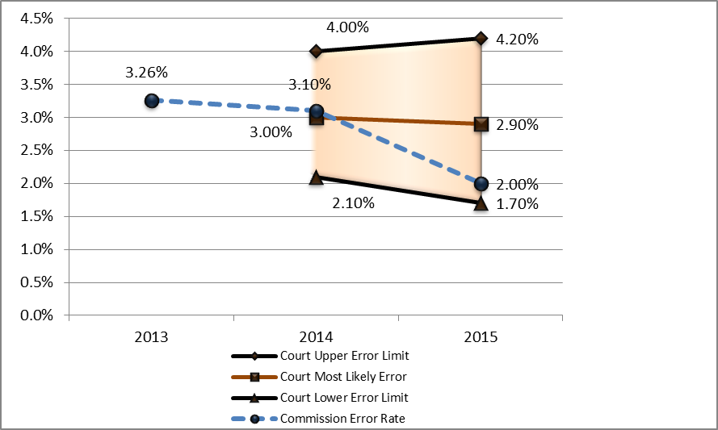

*\*Since 2014, the Court of Auditors discontinued providing error ranges per fund. Instead, it presented error ranges for the whole policy area of 'Natural Resources'.*

*The lines connecting the different error levels should not be seen as a continuous evolution, but rather help to better compare the ranges of error.*

*Source: Court's Annual Reports for the financial years 2014 and 2015 and DG AGRI Annual Activity Reports for the financial years 2013 to 2015.*

For the whole CAP, the adjusted error rate is with 2.02% almost in line with the materiality threshold.

**Graph 15 – The Commission's and the Court's estimated levels of error per Fund ('European Agricultural Guarantee Fund' (EAGF) and 'European Agricultural Fund for Rural Development' (EAFRD)) from 2013 – 2015\***

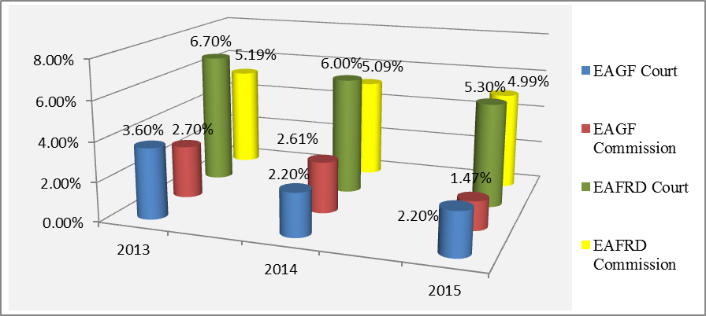

*\*Sources: The Court's Annual Reports and DG AGRI Annual Activity Reports for the financial years 2013 to 2015.*

Over recent years, the level of error for the CAP has been reduced for both Pillars and remains constantly below the EU average. This positive trend comes as a result of the remedial action plans implemented by the Member States. More guidance is being offered to Member States on preventing and detecting errors. Whenever needed, action plans are implemented by Member States to address particular deficiencies in their management and control systems.

For EAGF, the decrease in the level of error is quite impressive, in particular for direct payments, which are subject to less complex eligibility conditions and are governed by the Integrated Administration and Control System (IACS), notably the Land Parcel Identification System (LPIS). As confirmed by the Court, IACS is a good tool to achieve sound financial management and the remedial actions taken by Member States are constantly improving the reliability of the LPIS[50].

The error rate for Rural Development (financed by EAFRD), while on a decreasing trend over the last years, remains, at 4.99%, significantly above the materiality threshold. This has to be further addressed and the Commission is committed to assist the Member States in fighting the root causes of errors. It is also important to go beyond the figures and see the error rate in the perspective of the ambitious policy goals which sometimes lead to a complex design of measures difficult to check and implement.

In this context, it is important to recognise that the Commission disposes of and applies corrective mechanisms that adequately protect the EU budget. Net financial corrections are applied where DG AGRI audits reveal irregularities and/or deficiencies in the control systems. Comparing the ex-post corrective capacity of the Commission with the amounts at risk identified at the level of the payments to the beneficiaries gives a solid indication of the remaining financial risk to the EU budget, when all corrective actions are taken into account. For the CAP, the corrective capacity was estimated at the following levels: in 2013 EUR 802.9 million; in 2014 EUR 863.49 million and in 2015 EUR 1 065.7 million. For 2015, the corrective capacity for the CAP corresponds to 1.87% of the expenditure.

The overall amount at risk at time of payment for DG AGRI's total 2015 expenditure is EUR 1 167 million (2.0%). The conservatively estimated future corrections are EUR 1 066 million (1.8%). The resulting amount at risk at closure is estimated at EUR 101 million, being 0.2% of expenditure in 2015 for this policy domain. This shows that there is solid assurance that the remaining risk to the EU budget is significantly below the materiality threshold of 2%.

### **European Agricultural Guarantee Fund (EAGF)**

#### **The root causes of errors**

The root causes of errors regarding EAGF are the overstatement of the number of eligible hectares (inherent risk) and incorrect Land Parcels Identification System (LPIS) data (deficiencies in the management and controls systems in the Member States).

#### **Remedial action taken**

Around 80% of CAP expenditure is managed under the EAGF. For direct payments (90% of EAGF expenditure) management and control of the expenditure is done through the Integrated Administration and Control System (IACS), which includes the database of eligible land ('Land Parcels Identification System' - LPIS). The reliability of the information in the Integrated Administration and Control System (and in particular of the LPIS database) is therefore crucial to ensuring that only eligible land is paid for. This is why the Commission encourages Member States to perform regular updates of the information in their LPIS. When such updates are not made and deficiencies in IACS/LPIS are found, the Commission asks Member States to develop and implement action plans to address these deficiencies. These action plans have proved successful. In its 2015 Annual Report, the Court confirmed that "Thanks to action plans set up by the Commission and the Member States, the reliability of data in the LPIS has been constantly improving over recent years[51]".

The reliability of IACS coupled with a series of actions covering improvements in monitoring, communication and remedial measures carried out by the Commission means that the level of error for EAGF as a whole is relatively low. According to the Court, it was 3.1% in 2013; 2.2% in 2014 (excluding cross-compliance) and 2.2% in 2015. These figures are comparable to those published by DG AGRI in its Annual Activity Reports.

### **European Agricultural Fund for Rural Development (EAFRD)**

#### **The root causes of errors**

Around 20% of CAP expenditure is managed under the EAFRD, which is co-financed by the EU and national budgets. The management of EAFRD is based on national or regional multi-annual programmes where measures can be tailored at national and regional level in order to meet specific objectives. Eligibility of payment claims is checked by Member States' Paying Agencies, before payments are made to beneficiaries.

DG AGRI has made a reservation in its Annual Activity Reports since 2007 (apart from 2010) in respect of part or all of the expenditure covering Rural Development. It concurs with the Court's assessment regarding the main root causes of errors in this area:

* Ineligible expenditure, due to non-compliance with often complex rules and eligibility conditions in particular for investment measures; and
* The complexity of Rural Development policy itself and Member States’ weak management and control systems.

Other, less risky Rural Development measures are mainly those related to the area or number of animals, such as agri-environment or animal welfare commitments. They are subject to the Integrated Administration and Control System, which enables efficient checks and error prevention (as explained in the EAGF section above).

The high error rates in Rural Development expenditure do not necessarily mean that the misstated amounts have been misused or that policy objectives have not been attained.

#### **Remedial actions taken**

#### Simplification

The Commission has been encouraging the Member States to make use, whenever possible, of the Simplified Cost Options to prevent errors and reduce the level of risk. As in the field of 'Cohesion', the Court recognised that the use of these simplified cost methods was likely to be beneficial for all parties, because it would reduce the administrative formalities and might limit the scope of errors related to preparing and verifying payment claims based on invoices and payment documents[52].

In this context, it should be noted that simplification measures represent a guiding principle for remedial action for both the EAGF and EAFRD: from the beginning of his mandate, the simplification of the CAP has been one of Commissioner Hogan's top priorities.

In early 2015 Commissioner Hogan initiated a thorough screening of the entire agricultural acquis in order to identify the potential for simplification. At the same time, he invited Member States, stakeholders, the European Parliament, the Council, the Committee of the Regions and the European Economic and Social Committee to come forward with simplification proposals. On 11 May 2015 the Council adopted conclusions on 'CAP Simplifications'. More than 1500 simplification proposals have come out of this process. The examination of all resulting proposals with a view to their adoption was based on the following three principles:

* Simplification should be predominantly for the benefit of around 8 million beneficiaries of the CAP;
* The political decisions of the 2013 reform should not be put into question; and
* Simplification should not jeopardise the principle of sound financial management of the CAP.

The Commission followed up this exercise by launching four waves of simplification actions covering the full spectrum of agricultural policies – including both Commission Regulations and related guidance documents.

The Omnibus proposal (section 3.1 above) contains amendments to the four basic regulations of the CAP[53]. It involves technical changes providing for easier access to EU funds and simplification measures that do not change the orientation of the policy. For rural development the changes promote better use of financial instruments, more flexibility to program income stabilisation tools, quicker availability for EU funding and making full use of simplified cost options by aligning the EAFRD rules to common ESIF provisions. For direct payments, the active farmer regime would become voluntary; support to young farmers is reinforced and it would be possible to “decouple” the Voluntary Coupled Support. In terms of market measures coaching would be a new type of eligible action under the crisis measures and National Financial Assistance would not require a case by case analysis by the Commission.

#### Strengthening management and control systems

The Commission has regular exchanges with the Member States on error-rate related issues and has provided a comprehensive set of guidance documents on Rural Development measures and other relevant horizontal topics (e.g. Simplified Cost Options, public procurement rules, verifiability and controllability of the measures).

DG AGRI will keep on monitoring the implementation of the action plans, from both the audit and operational perspectives, through bilateral meetings, monitoring committees, annual review meetings and dedicated seminars.

DG AGRI will continue providing Member States with the recommendations and guidelines, as well as disseminating best practices, to improve the control systems in order to avoid errors. The European Network for Rural Development is already playing a major role in training and in disseminating good practices in the Member States.

Furthermore, DG AGRI has implemented a certain number of actions over time, in particular:

* In 2015, DG AGRI reinforced the existing action plans to address the reservations included in the 2014 Annual Activity Report, on the basis of improved cooperation and analysis within Commission services and intensive dialogue with Member States. Following this approach, an improved system of reporting by all Member States on their national or regional action plans for reducing error rates was put in place. This includes a reinforced focus on regular follow-up of audit findings, as well as improved indicators and milestones for monitoring purposes. A specific IT tool was developed by DG AGRI in 2014, and became fully operational in 2015, to collect and handle the information extracted from national or regional action plans in an efficient and consistent manner, providing an overview and facilitating appropriate follow-up. In paragraph 7.45, the Court found that" While we consider that the action plans are generally a sound tool to address the causes of errors, there is still scope for further improvement in the area of public procurement". The Commission will continue to monitor closely the implementation of the necessary remedial action plans by those Member States concerned and suspend payments when these action plans are not duly implemented.
* Since 2013 six seminars on error rates have been organised, one of which took place in 2015. These present the state of play in implementing action plans, sharing good practices and providing guidance. These seminars are organised jointly in the framework of the Rural Development Committee and the Agricultural Funds Committee, in order to ensure the involvement of both Managing Authorities and Paying Agencies. In the meantime, the geographical desks regularly monitor action plans and the follow-up of issues with Member States in annual and ad-hoc meetings, monitoring committees and, if relevant, in the context of programme amendments.
* In parallel, the audit capacity of DG AGRI has been reinforced. The number of audit missions has been increasing from the level in 2013 and the audits target specific issues related to error rates.
* Finally, DG AGRI is encouraging cross-regional cooperation and promoting training on specific topics related to better implementation of programmes and reduction of errors. The overall goal of such events is to facilitate a constructive and open dialogue between relevant actors, with a view to exchanging good practices and establishing clear guidelines.

#### Legal Framework 2014 - 2020: Significant improvements

The new legal framework 2014 - 2020 for the CAP contains several rules which address the root causes of errors (e.g. limited number of detailed requirements, lump-sum payments, flat-rates or standard costs). The ex-ante analysis of the Rural Development programmes has been reinforced with the Managing Authorities and Paying Agencies undertaking an ex-ante assessment of the verifiability and controllability of the measures programmed. Moreover, for EAFRD, the Commission now has and makes full use of ex-ante preventive tools such as suspensions and interruptions, which effectively protect the EU budget.

In Rural Development, however, as underlined in the introduction to this report, when taking into account the need to balance legality and regularity with the achievements of policy objectives while bearing in mind the delivery costs, it cannot be expected with any real certainty that a remaining financial risk below 2% would be attainable with reasonable efforts.

## MFF Heading 4 – Global Europe

### **Levels of error**

The DGs 'International Cooperation and Development' (DEVCO) and 'European Neighbourhood Policy and Enlargement Negotiations' (NEAR/ELARG) are examined in this report as they are the most important DGs of the External Relations "family" in financial terms.

DG DEVCO focusses its error analysis on the Residual Error Rate (RER) which is the level of error after corrective measures have been implemented. The estimate provided by DG DEVCO is well within the Upper and Lower Error Limits disclosed by the Court in its Annual Reports under the Chapter 'External Relations/Global Europe' for the period 2013 to 2015 (see Graphs 16).

DG DEVCO/NEAR ex-ante and ex-post verifications by its own control capacities or by auditors under contract covered EUR 2 701.98 million in 2015.

The overall amount at risk at payment for DG DEVCO's total 2015 expenditure is EUR 246 million (2.9%). The conservatively estimated future corrections are EUR 50 million (0.6%). The estimated amount at risk at closure is EUR 196 million (2.3%).

For the entire "External Relations" policy area, the global estimated amount at risk at payment is EUR 281 million (2.9%), the conservatively estimated future corrections are EUR 62 million (0.6%), and the estimated amount at risk at closure is EUR 219 million (2.3%).

**Graph 16 - The Commission's (Residual Error Rates disclosed by DG DEVCO) and the Court's estimated levels of error in the area of 'External relations' from 2013 – 2015\***

*\*The lines connecting the different error levels should not be seen as a continuous evolution, but rather help to better compare the ranges of error.*

*Source: Court's Annual Reports and DG DEVCO Annual Activity Reports for the financial years 2013 to 2015.*

### **DG 'International Cooperation and Development' (DEVCO)**

#### **The root causes of error**

DG DEVCO identified the following main root causes of errors:

* Non-respect of eligibility rules (57% of errors detected):

-Expenses incurred outside the project period;

-Expenses declared as direct, but already counted as indirect expenditure.

* Non-respect of public procurement rules (26% of detected errors).
* Insufficient or missing documentation.

This assessment is broadly in line with the Court's findings for the whole chapter on 'Global Europe' (see Graph 17).

**Graph 17 - The Court's assessment of the root causes of errors for Heading 4 in 2015[54]**

#### **Remedial actions taken**

#### Simplification

The root causes of errors are the overly-detailed grant conditions that go beyond what is legally required and with no added value regarding performance and results. The deletion of such unnecessary elements in the Practical Guide (PRAG) has already been undertaken. DG DEVCO is engaged in discussions with its stakeholders and there are regular meetings amongst Finance-Contract-Audit Units in order to discuss the most common sources of errors and ways to avoid them. The financial management toolkit for grant beneficiaries is further promoted and training activities on grants are undertaken and adapted.

As explained above, the Commission has already proposed a number of changes relating to grants under the general financial rules to reduce the risk of errors (see section 3.1).

#### Strengthening of management and control systems

In the following, the actions planned are presented per management mode:

* For grants under direct management, DG DEVCO identified expenditure verifications by beneficiaries of insufficient quality as a root cause of errors. Envisaged measures include:
* Revision of the Terms of Reference for expenditure verifications implemented by beneficiaries and contract services, including the application of quality assessment criteria to the reports;
* Use of the audit framework contract to complete insufficient expenditure verifications carried out by beneficiaries;
* Requesting supporting documents for randomly selected transactions related to requests for payment, and verifying them before approving the disbursement and/or clearing of expenditure; and
* Simplification of procedures and contractual conditions for grants.
* In the spending area under indirect management with International Organisations and Member States' Agencies root causes for recurring errors are insufficient or missing documentation, verification missions of insufficient quality and late clearings. Envisaged measures include:
* In extreme cases, suspension of indirect management where there are repeated errors or non-compliance with the rules for provision of documentation;
* Adaptation of the Terms of Reference for Verification Missions to International Organisations other than the World Bank and the United Nations;
* Raising awareness about and monitoring action for clearing of pre-financing payments made to International Organisations more than two years ago (2013 and before);
* Regular meetings with International Organisations to ensure continued cooperation in the provision of information in the framework of audits by the Court and the Residual Error Rate studies; and
* Creating a focal point unit to coordinate relations with International Organisations at all levels.

All these measures are on-going.

#### Legal framework 2014 - 2020

Some recent changes made it easier for contracting partners of DG DEVCO to respect the rules and therefore potentially decrease the risk of error:

* Procurement procedures within grants: Annex IV of DG DEVCO's grant contracts has been streamlined in 2015, allowing grant beneficiaries to use their own accounting rules while respecting basic principles and award criteria.
* The lack of available supporting documents: The possibility of accepting copies of supporting documents during expenditure verifications was introduced in the 2016 DG DEVCO grant template. This solves the recurrent issue of originals scattered in several countries, not always available when auditors carry out the expenditure verification.
* Exchange rate in grants: Since 2015 it is possible for beneficiaries to use their exchange rate rules for accounting purposes, provided the rules are properly documented.

In general, management and control systems (design and functioning) have been strengthened and some schemes abandoned due to cost-effectiveness considerations.

### **DG 'European Neighbourhood Policy and Enlargement Negotiations' (NEAR/ELARG)**

#### **The root causes of errors**

Most common issues regarding errors in DG NEAR concern:

* Errors linked to clearing of pre-financing:

A key issue identified for NEAR has been errors linked to the clearing of pre-financing. The Court has criticized the system for clearing pre-financing, the supporting documents used for the clearing and the periodicity of the clearing.

* Expenditure verification report:

As for DG DEVCO, a weakness identified by the Court is the expenditure verification reports prepared by external auditors, on which the Commission relies in order to accept certain costs.

* Non-compliance with legal and contractual obligations.

#### **Remedial actions taken**

As far as clearing pre-financing is concerned, DG NEAR has taken a number of actions to resolve this issue:

* A new accounting manual for DG NEAR was adopted in December 2015, further clarifying DG NEAR's policy for the clearing pre-financing;
* Guidance was given to Authorising Officers by Sub-delegation and their staff, explaining the rules for interim cost recognition and clearing of pre-financing; and
* The legal framework for the Instrument for Pre-Accession Assistance II, for 'Indirect Management with Beneficiary Countries' has implemented a clearer procedure and set out reporting obligations for the beneficiaries in relation to the recognition of costs incurred.

For expenditure verification reports, DG NEAR/ELARG has closely collaborated with DG DEVCO: The mitigating measures taken include the development of a quality grid to assess expenditure verification reports and reviewing the terms of reference for expenditure verification. Furthermore, the audit framework contract may be used to perform additional expenditure verifications where needed. All these measures are on-going.

In order to mitigate and reduce the types of errors related to the non-compliance with contractual and legal obligations, a constant effort has been made with DG DEVCO in the lead to review regularly the manuals and instructions in order to make them clearer (revision of the PRAG, Pagoda 2). Moreover, trainings are provided on a regular basis in order to make sure that the relevant actors will apply the correct rules and procedures.

# IV. Conclusions

## Financial management improved significantly leading to a decrease in the level of error

**The level of compliance with legal requirements in the implementation of the EU budget has considerably improved** over recent years. Constant scrutiny by the European Parliament, the Council and the Court has resulted in an increased professionalization of the entire chain of control of the EU funds from the Commission to Member States' authorities, Third Countries and International Organisations. As a consequence, levels of error have been reduced from double digit rates for some policy areas (particularly Cohesion) for the programming period 2000 – 2006 and before, to considerably lower levels at present (lower than 5% in most policy areas and close to or even below 2% in some domains).

## The Commission and the Court concur in their assessment regarding the level and root causes of errors

The Commission and the Court are in accord that **the main root causes for persistently high levels of error are weaknesses in management and control systems, especially in Member States, Third Countries and International Organisations/Agencies, as well as the complex legal framework under which the EU policies are implemented.**

Furthermore, taking into account the relative precision of the various approaches used and the results obtained, **the levels of error reported in the Annual Activity Reports of the Commission departments as well as the estimates provided in the Annual Management and Performance Report are broadly in line with the Court's estimated levels** of error for 2014 and 2015.

## The need to consider the multi-annual character of a significant part of the EU expenditure

In the light of the **multi-annual character of a significant part of the EU expenditure**, a definitive level of error can only be established at the closure of the programmes, when all layers of controls have been applied. The **estimated 'Amount at Risk at Closure'** after the implementation of all corrective measures represents between **0.8% and 1.3% of total expenditure in 2015**. Thus, the multi-annual corrective mechanisms adequately protect the EU budget from expenditure in breach of the law.

## Costs of management and controls and the need for further simplification

The current **high management and control costs** put into question the benefit of further increasing audit intensity and efforts. **Not more, but better controls** should be carried out. Furthermore, **simplification** represents the most effective way of reducing the costs and burden of control and the risk of errors. Policy areas which are subject to sound management and control systems and less complex eligibility rules are also less error prone. Therefore, the further **improvement of management control systems at all levels and the simplification of rules** remain constant tasks. In this context, the Commission proposed in September 2016 an ambitious revision of the Financial Regulation and a number of sectorial financial rules to achieve further simplification, flexibility and focus on results.

## The Commission continuously takes actions to address the root causes and the financial impact of errors

The Commission **continuously takes actions to address the root causes and the financial impact of persistently high levels of error**, some of which are the consequence of ambitious policy objectives and may in practice require a longer period of time to bear fruit, in particular if linked to complex national requirements or delivery mechanisms. Although this analysis has focused on payments for the 2007 - 2013 programming period, **lessons learned from that period** have already been integrated in the legal basis and improved systems for the current 2014 - 2020 period (i.e. the implementation of net financial corrections, and the accounts, which are new in the field of 'Cohesion', but already current practice in agriculture, the reinforced "Audit Opinions" from national Audit Authorities and Certification Bodies, the new Public Procurement Directives, the requirements resulting from the ex-ante conditionalities, the simplified eligibility rules and the significantly enhanced possibilities to use Simplified Cost Options, rather than actual costs as a basis for reimbursement and the 10% retention mechanism for 'Cohesion').

In addition, the Commission has adopted a **package on the Mid-term Review (MTR)/Revision of the MFF 2014 - 2020** which builds on the modernisation efforts and improvements achieved in the current MFF. The **'EU Budget Focused on Results (BFOR)'** initiative begins to show tangible progress towards a more efficient and simple delivery system that provides compliance with the legal framework but also shows positive results on the ground. In this context, **continuous simplification will be key**. Further progress will be made in the next MFF.

Finally, the Commission will continue **protecting the EU budget from the financial impact of persistently high levels of error** by applying preventive measures (such as interruptions to and suspensions of payments) and using corrective mechanisms (financial corrections and recoveries).

1. Regulation (EU, Euratom ) No 966/2012 of the European Parliament and of the Council of 25 October 2012 on the financial rules applicable to the general budget of the Union and repealing Council Regulation (EC, Euratom) No 1605/2002.
2. European Parliament Report on discharge in respect of the implementation of the general budget of the EU for the financial year 2014, Section III (2015/2154(DEC)).
3. Council Recommendation on the discharge to be given to the Commission in respect of the implementation of the general budget of the European Union for the financial year 2014 (Document 5583/16 of 02/02/2016).
4. These controls covered substantive testing (re-performance of the work performed by the external audit bodies) and systems audits (assessment of the functioning of management and control systems in Member States such as for instance conformity clearance audits).
5. COM(2016) 446 final.
6. COM(2016) 486 final.
7. The 'Integrated Financial Reporting Package' contains the Annual Management and Performance Report, the Communication on the Protection of the EU Budget, the Financial Report and the EU Accounts accompanied by the Financial Statement Discussion and Analysis.
8. The Commission Report on the 'Protection of the European Union’s financial interests — Fight against fraud', prepared in cooperation with Member States and adopted under article 325 of the Treaty, for the year 2015 (COM(2016) 472 final) indicates that detected and reported fraudulent cases amount to approximatively 0.4% of payments made (page 22).
9. In the 'Cohesion' area, the Commission and the Court conclude that the levels of error lie above 5%, whereas for 'Natural Resources' they range between 2 and 2.9% for 2015. Furthermore, 'Revenue' and 'Administrative Expenditure' are not affected by a material level of error and the EU accounts have been signed off by the Court. Moreover, the Court concluded that reimbursement schemes were more risk prone than entitlement schemes.
10. See Table 1.
11. The Court did not detect any material level of error for European Social Fund interventions over the last 4 years, when Simplified Cost Options were used.
12. Such as direct payments for the European Agricultural Guarantee Fund (EAGF), European Research Council (ERC) grants or Marie-Curie Schemes.
13. See Annual Management and Performance Report for the 2015 financial year.
14. See section III on the " Situation of persistently high levels of errors concerning the different MFF Headings"
15. As illustrated by the new instruments and measures of the current 2014 – 2020 MFF, such as for instance the retention mechanism for the 'Cohesion' area, the possible implementation of the net financial correction, the new 'Audit Opinion/Management Declarations' by national authorities, the impact of the new Public Procurement Directives, the requirement resulting from the ex-ante conditionalities and simplified eligibility rules.
16. The Commission proposes in a single act an ambitious revision of the general financial rules (COM(2016)605 final of 14.9.2016). This act also contains corresponding changes to the sectorial financial rules set out in 15 legislative acts concerning multi-annual programmes related for instance to the European Structural and Investment Funds (ESI Funds) or Agriculture.
17. European Parliament Report on discharge in respect of the implementation of the general budget of the EU for the financial year 2014, Section III (2015/2154(DEC)).
18. Council Recommendation on the discharge to be given to the Commission in respect of the implementation of the general budget of the European Union for the financial year 2014 (Document 5583/16 of 02/02/2016).
19. The legal definition of irregularity against the EU budget is specified in article 1(2) of Regulation 2988/95.
20. Following the 2015 Commission Report on the 'Protection of the European Union’s financial interests — Fight against fraud' (COM(2016) 472 final), detected and reported fraudulent cases amount to approximatively 0.4% of payments made (page 22).
21. Annex 2 of the 2015 Annual Management and Performance Report for the EU Budget (COM(2016) 446 final).
22. Source: Annex 1.1 of Chapter 1 of the Court's Annual Reports for the financial years 2013 to 2015.
23. For 2013, the Commission provided a point estimate concerning the level of error (2.8%).
24. COM(2016) 605 final of 14.9.2016.
25. Based on the Court's data provided in its Annual Reports for the financial years 2013 to 2015 and, where available, in the Commission departments' Annual Activity Reports.
26. The Commission's 'Communications on the Protection of the EU Budget' provide detailed information on the preventive and corrective mechanisms which protect the EU budget.
27. Request expressed by the 2014 Discharge Rapporteur, Mrs. Martina Dlabajova, in the context of the debate on the 2014 discharge for the Commission in the Committee on Budgetary Control on 23 February 2016. See also paragraph 54 of the Parliament's Discharge Resolution for 2014: EU general budget - European Commission and executive agencies.
28. For details see pages 48 to 51 of the 2015 AMPR.
29. DG AGRI AAR 2015; page 77.
30. DG REGIO AAR 2015; page 88.
31. DG EMPL AAR 2015; page 72.
32. DG RTD AAR 2015; pages 90-91.
33. DG DEVCO AAR 2015; page 61.
34. DG NEAR AAR 2015; page 50.
35. DG CNECT AAR 2015; page 60
36. The upcoming 'Report from the Commission to the European Court of Auditors, the Council and the European Parliament on the Member States' replies to the European Court of Auditors' Annual Report' will provide information on the analysis of the root causes of errors by the individual Member States.
37. Due to its relatively low importance in terms of financial volume and impact on the overall level of error, Heading 3 "Security and Citizenship" is not covered by this report, nor did the Court draw a representative sample for its audit related to the 2014 and 2015 Annual Reports.
38. For details see paragraphs 1.21 to 1.33 of the Court's Annual Report for the financial year 2015.
39. This analysis concentrates on the area of 'Research and Innovation' as it represents above 60% of the budgetary allocations for Heading 1A. Furthermore, the estimated levels of error related to the other areas of Internal Policies are mostly below the materiality threshold of 2%.

    More specifically this section singled out the two most important DGs of the Research "family" in financial terms with the highest estimated amount at risk at payment, the DGs RTD and CNECT.
40. Source: The Court's Annual Report for the financial year 2015, Figure 5.2 for the whole Chapter 5 on "Competiveness".
41. The Court's Annual Report for the financial year 2015, Figure 6.2, excluding 'Employment and Social Affairs' share of overall error.
42. Regulation (EU) No 1303/2013 of the European Parliament and of the Council of 17 December 2013 laying down common provisions on the European Regional Development Fund, the European Social Fund, the Cohesion Fund, the European Agricultural Fund for Rural Development and the European Maritime and Fisheries Fund and laying down general provisions on the European Regional Development Fund, the European Social Fund, the Cohesion Fund and the European Maritime and Fisheries Fund and repealing Council Regulation (EC) No 1083/2006.
43. Commission Regulation n° 651/2014.
44. The Court's Annual Report for the financial year 2015, Figure 6.2, excluding 'Regional and Urban Policy' share of the overall error.
45. The Court includes in its assessment EAGF, EAFRD but also expenditure related to environment, fisheries and health.
46. Including cross – compliance.
47. Excluding cross – compliance.
48. Excluding advances paid as pre-financing for the 2014 - 20 MFF (4.16 % including pre-financing).
49. In its Annual Report for the financial year 2013, the Court reported separately on EAGF and on Rural Development and the other policy areas (environment, fisheries and health).
50. See paragraph 7.17 and 7.41 of the Court's annual report for the financial year 2015.
51. See Court's Annual Report for the financial year 2015, paragraph 7.17
52. See the Court's Annual Report for the 2012 financial year, paragraph 6.23, the Annual Report for the 2013 financial year, paragraph 6.16, and the Annual Report for the 2014 financial year, paragraph 6.29.
53. Regulation (EU) 1305/2013 on rural development, Regulation (EU) 1306/2013 on financing and other horizontal issues of the CAP, Regulation (EU) 1307/2013 on direct payments to farmers and Regulation (EU) 1308/2013 on the single Common Market Organisation (CMO).
54. The Court's Annual Report for the 2015 financial year; Figure 8.2