Chapter 6
A reasonable and balanced free trade agreement with the United States
‘Under my presidency, the Commission will negotiate a reasonable and balanced trade agreement with the United States of America, in a spirit of mutual and reciprocal benefits and transparency … I will also be very clear that I will not sacrifice Europe’s safety, health, social and data protection standards or our cultural diversity on the altar of free trade.’
Jean-Claude Juncker, political guidelines, 15 July 2014
Open trade strengthens the EU’s economy and creates jobs. It also provides consumers in the EU with more choice and buying power and helps firms compete abroad.
In 2016 over 31 million jobs in the EU were supported by exports to non-EU countries.
The EU–United States economic relationship is the world’s biggest. Every day, the two trade goods and services worth €2 billion, so every trade and investment barrier that is removed could bring significant economic gains.
Agreeing on the Transatlantic Trade and Investment Partnership — one of the European Commission’s 10 priorities — will not be a deal at any price, however. The EU will safeguard regulators’ independence, the precautionary principle and governments’ right to regulate to protect their people and the environment.
The EU is ready to engage with the new administration in the United States following the natural pause in negotiations after the presidential elections held in November.
Throughout 2016 the EU sought to maintain the global trading system and to ensure it continued to adapt to a fast-changing world. It played an active role in the World Trade Organisation to keep the global economy open for trade in a way that reflects and respects the needs and concerns of developing countries. EU trade policy also sought to ensure that others respected international trade rules and that trade was a force for sustainable development.
For the EU, free trade must be fair. That is why significant steps were taken in the course of 2016 to have robust trade-defence instruments in place.
Trade as a motor for jobs and growth
The European Union is one of the world’s most open economies. Open trade strengthens its economy, creates jobs, gives citizens more choice and buying power as consumers and helps EU firms compete abroad.
Every day the EU exports hundreds of millions of euros’ worth of goods and imports hundreds of millions more. The EU is the world’s largest exporter of manufactured goods and services, and is itself the biggest export market for around 80 countries. Together the 28 Member States account for 16 % of world imports and exports.
[CH06-PH23]
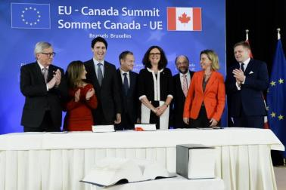
Jean-Claude Juncker, President of the European Commission, Chrystia Freeland, Canadian Minister for International Trade, Justin Trudeau, Prime Minister of Canada, Donald Tusk, President of the European Council, Commissioner Cecilia Malmström, Martin Schulz, President of the European Parliament, High Representative/Commission Vice-President Federica Mogherini and Robert Fico, Prime Minister of Slovakia, at the signing ceremony of the Strategic Partnership Agreement and the Comprehensive Economic and Trade Agreement between the EU and Canada, Brussels, 30 October 2016.
In October the EU’s Comprehensive Economic and Trade Agreement with Canada was signed at the EU–Canada Summit in Brussels. As the EU’s most advanced and progressive trade agreement to date, the Comprehensive Economic and Trade Agreement is a landmark accord that sets the benchmark for future agreements. It includes the most ambitious chapters on sustainable development, labour and the environment ever agreed upon in bilateral trade agreements. The deal will benefit exporters both big and small, creating opportunities for EU and Canadian companies and their employees, as well as for consumers.
[CH06-GR10]
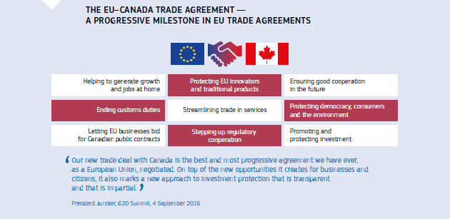
In addition, the EU continued negotiations on several other free trade agreements. The aim was to help create jobs and growth for EU citizens and companies. For example, in 2016 negotiations continued with Japan and began with Indonesia and Tunisia, and the EU was engaged in plurilateral negotiations for an environmental goods agreement and a trade in services agreement negotiated with a number of members of the World Trade Organisation.
Towards a permanent multilateral Investment Court System
The EU wants firms to invest with confidence, knowing they are protected if things go wrong. In the negotiations for a Transatlantic Trade and Investment Partnership the Commission has included a proposal for an Investment Court System of the sort that it has already included in the trade agreements with Canada and Vietnam, and will include in future negotiations. Built around the same key elements as domestic and international courts, the Investment Court System enshrines governments’ right to regulate and ensures transparency and accountability.
Free trade must be fair trade
For the EU, free trade must be fair. Significant steps were therefore taken in the course of the year to have robust trade-defence instruments in place to ensure a level playing field for EU producers and to address the harm from unfair foreign competition that has led to the loss of thousands of jobs, notably in the steel industry.
The Commission has been using these instruments to their fullest extent, putting in place an unprecedented number of anti-dumping and anti-subsidy measures — 41 on steel products, including 18 on products originating in China.
Breaking a deadlock that has lasted for years, the Council finally agreed on its negotiating position on a proposal to modernise the EU’s trade-defence instruments, allowing the final stage of negotiations with the Parliament and the Commission to begin. This proposal, tabled by the Commission, aims to provide the EU’s trade defence instruments with more transparency, faster procedures and more effective enforcement, and in some cases to impose higher duties.
In the same field, another proposal was put forward on a new method for calculating dumping on imports from countries where there are significant market distortions, or where the state has a pervasive influence on the economy. The purpose is to make sure that the EU has trade-defence instruments that are able to deal with the current realities in the international trading environment while fully respecting the EU’s international obligations within the framework of the World Trade Organisation.
What the EU negotiated with the United States
Better access to the US market
In 2016 the EU continued to pursue its aim of negotiating better access for the EU to the US market by removing customs duties and other barriers to trade and by facilitating new trade and investment opportunities in new areas. This would apply to all companies, however large or small.
The Transatlantic Trade and Investment Partnership would help generate jobs and growth, cut prices and give citizens more choice of goods and services. At the same time, it would uphold the high standards of protection existing in the EU. The partnership could also help the EU and the United States to protect and strengthen shared values such as democracy and the rule of law.
With the partnership, firms in the EU could export more to the United States and import more of the goods and services they need to make their final products. Services account for nearly three quarters of the EU’s economy, yet EU firms still face hurdles when they try to sell their services on the US market. According to Eurostat the United States buys 15 % of the EU’s agricultural exports, especially high-value-added products. The EU would like to see the partnership make it possible to increase these exports further. Under the partnership the EU also wants European firms to be able to bid for US government contracts on equal terms with US companies.
Regulatory cooperation — cutting red tape and costs without cutting corners
The EU sought to break new ground for a trade deal by getting regulators in the EU and the United States to work together much more closely than they do now. To export to the United States EU firms must meet Washington’s rules and standards. Often these rules and standards ensure the same level of safety or quality, but differ in their technical details — for example the colour of the wiring in the plugs and sockets used on either side of the Atlantic. In some cases checks on technical requirements unnecessarily repeat those already done on the other side of the Atlantic. These factors can be costly, especially for smaller firms and consumers. Working together on regulations could cut these costs while upholding the EU’s strict levels of protection for people and the environment.
Trade rules to make it easier and fairer to export, import and invest
The EU continued its efforts to put in place new, or further develop, trade rules to help all EU firms benefit fully from the Transatlantic Trade and Investment Partnership.
[CH06-VD14]
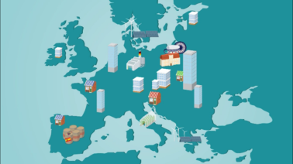
Exporters’ stories: how the EU’s trade agreements benefit companies and communities. (video)
Under the agreement, the EU wants:
- to ensure that smaller companies can benefit from the partnership;
- to promote free and fair competition, including rules to stop firms colluding to fix prices or abusing market power and provisions relating to state-owned enterprises and subsidies;
- to help firms save time and money on paperwork at customs;
- firms to be able to access the sustainable energy and raw materials resources they need;
- to protect EU firms’ intellectual property;
- to put sustainable development at the heart of the agreement.
Under the partnership, as in all its other trade agreements, the EU will protect public utilities at all levels of government, including the local level. The partnership will not require countries to liberalise, deregulate or privatise public services at national or local level. This includes public health, state education, public transport, and water collection, purification, distribution and management.
How the EU negotiated with the United States
The Commission negotiated the Transatlantic Trade and Investment Partnership on the basis of a mandate agreed unanimously by the governments of the EU’s Member States. Negotiations began in June 2013. In 2016 four rounds of talks took place. In an intensification of the negotiations, Trade Commissioner Cecilia Malmström met her US counterpart Michael Froman nine times in the course of the year. Progress continued to be made across a range of areas. However, the EU always made it clear that getting a good agreement was more important than simply concluding negotiations as quickly as possible.
On its dedicated website the Commission continued to publish EU textual proposals — the EU’s initial proposals for legal text on topics in the partnership — in areas such as services and regulatory cooperation. The Commission also published detailed reports of each round of negotiations on its website. In addition, the Commission published dozens of documents about the partnership, some in all of the official EU languages. These included brochures explaining in plain terms the aims and potential content of the agreement. These actions continued as negotiations progressed and, together, made the negotiations the most transparent ever undertaken for an EU trade agreement.
As is usual when negotiating a trade agreement the Commission used the weekly meetings of the Council’s Trade Policy Committee to keep the governments of the Member States informed of progress in the negotiations. The Commission also kept the European Parliament — in particular the International Trade Committee — abreast of the negotiations, with both Trade Commissioner Malmström and partnership negotiators appearing before Parliament and its committees. The Member States and Members of the European Parliament had access to partnership negotiating documents in line with the practices agreed with them.
This ensured democratic oversight throughout the negotiations. It also meant that the governments of the Member States and directly elected Members of the European Parliament were fully informed of the state of play of the negotiations and of the EU’s negotiating positions. The European Parliament continued to follow the talks closely.
The Commission was particularly active in publicising discussions about the proposed agreement and explaining what the EU sought to get out of them. It also addressed concerns about the claimed negative impacts of the partnership. In particular the Commission made significant efforts to ensure that any interested stakeholder could engage directly with negotiators and to publish information about the negotiations online. During each negotiating round EU and US negotiators convened joint meetings with hundreds of stakeholders representing a wide field of interests. The Commission used social media to inform citizens, including a dedicated Twitter account that had over 26 500 followers by the end of 2016.
In the course of the negotiations the Commission continued to draw on the advisory group it had set up to provide additional expert input for EU negotiators. It comprises men and women representing environmental, health, consumer and workers’ interests, along with various business sectors.
After the negotiations
Once a text has been agreed the proposed Transatlantic Trade and Investment Partnership document will be published online. It will then be submitted for ratification through the relevant procedures.
Chapter 7
An area of justice and fundamental rights based on mutual trust
‘I intend to make use of the prerogatives of the Commission to uphold, within our field of competence, our shared values, the rule of law and fundamental rights, while taking due account of the diversity of constitutional and cultural traditions of the 28 Member States.’
Jean-Claude Juncker, political guidelines, 15 July 2014
In 2016 the Security Union gave an urgent and firm response to terrorism, while progress was also made on the rights of citizens and internal market issues in the field of civil justice.
The EU is currently facing a very serious terrorist threat. Attacks on European soil, returning foreign terrorist fighters and the evolving nature of terrorism have presented EU Member States with new and unprecedented challenges.
The European Commission therefore insisted on developing a genuine and effective Security Union. A series of measures were taken in 2016 to address all dimensions of the terrorist threat: the prevention of radicalisation, including online; the criminalisation and detection of travel for terrorist activities and support for terrorists; the exchange of information; tackling terrorism financing; cutting access to firearms and explosives; and supporting partner countries, particularly around the Mediterranean.
Elsewhere, the EU agreed on new Directives to improve the procedural rights of citizens involved in criminal proceedings. In the area of civil justice, legislation was introduced to help families and couples by simplifying family and civil law.
As regards corporate governance, rules were agreed to improve shareholders’ rights. The Commission also proposed more proportionate remuneration rules for credit institutions and investment firms.
The Commission took action to improve the protection of fundamental rights in the areas of data protection, the sharing of personal information and consumers’ rights, and stepped up efforts to boost gender equality, fight discrimination and eradicate human trafficking.
Addressing security threats in the EU
[CH07-PH24]
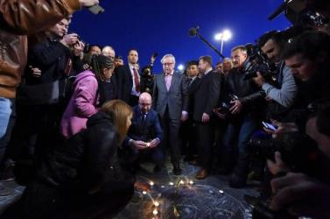
Charles Michel, Prime Minister of Belgium (lighting a candle), and Jean-Claude Juncker, President of the European Commission (centre), pay tribute to the victims of the terrorist attacks in Brussels, 22 March 2016.
In 2016 the EU began a series of initiatives to help counter the threat of terrorism at home and abroad.
The Commission’s proposal to check EU citizens against the relevant databases whenever they cross external borders was the subject of a political agreement between the Parliament and the Council in December. Systematic checks of non-EU nationals are already mandatory.
[CH07-VD15]
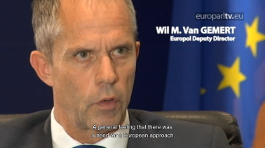
Views on the fight against terrorism. (video)
In January the European Counter Terrorism Centre was launched at Europol’s headquarters in The Hague. The main aim of the centre is to promote more efficient operational cooperation and improve the communication of security information between Member States. In addition, the Commission adopted the Action Plan on Terrorist Financing, designed to cut terrorists off from their sources of revenue and to trace them through their financial activities. In December the Commission adopted a package of measures to strengthen the EU’s capacity to fight the financing of terrorism and organised crime. The proposals presented by the Commission will complete and reinforce the EU’s legal framework in the areas of money laundering, illicit cash flows and the mutual recognition of the freezing and confiscation of assets.
Following the adoption in 2015 of the Directive on the Prevention of the use of the Financial System for the Purposes of Money Laundering or Terrorist Financing, the Commission stepped up its support to Member States for a more efficient transposition of the Directive into their national legislation. In July the Commission adopted a new proposal to amend the Anti-Money Laundering Directive, with the aim of further enhancing the EU legal framework following the terrorist attacks that took place in 2015 and 2016 and the revelations contained in the ‘Panama Papers’. The Commission also stepped up its support to Member States for a more efficient transposition of the fourth Anti-Money Laundering Directive and gave more power to Member States in the fight against terrorism. In July the Commission adopted a list of non-EU countries that have strategic deficiencies in their anti-money laundering and countering terrorist financing regimes.
Another priority was to work towards the improved exchange of information, in particular for law-enforcement purposes. The Commission prioritised the enforcement of the existing Prüm Framework (an information-exchange tool that can offer automated comparison of DNA profiles, fingerprint data and vehicle registration data) and made proposals to improve information exchange on criminal convictions through the European Criminal Records Information System.
[CH07-GR11]
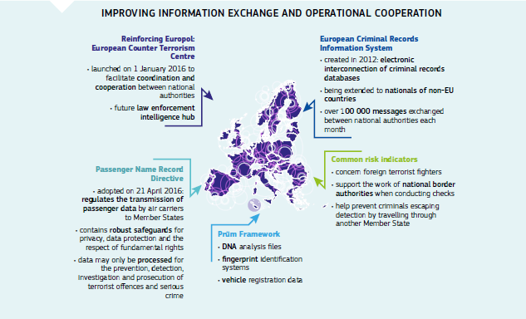
In July the EU Passenger Name Record Directive was adopted. The Directive obliges air carriers to transfer data on passengers on international flights to the Member States of arrival or departure. The data will be analysed and used for the purpose of fighting serious crime and terrorism. The Commission has started working with Member States to ensure its quick implementation.
The final adoption of the revised Europol Regulation took place in autumn 2016. It further increases Europol’s accountability, effectiveness and efficiency and ensures scrutiny of its activities by the European Parliament, together with national parliaments.
The EU Internet Forum held in December provided a framework for joining together the efforts of industry and law-enforcement agencies in tackling terrorist material online, while involving and engaging with civil society in the development of more efficient counter and alternative messages. The EU Internet Referral Unit established at Europol helps to reduce the volume of terrorist material online.
The Radicalisation Awareness Network Centre of Excellence was established to bolster the support provided to practitioners and to provide tailor-made support services to Member States and non-EU countries.
In September the Commission adopted a Communication on enhancing security in a world of mobility. In November it proposed to establish a European Travel Information and Authorisation System to determine the eligibility of all visa-exempt non-EU nationals to travel to the Schengen area, and whether such travel poses security or migration risks. This System will contribute to more efficient management of the EU’s external borders and improve internal security, while facilitating legal travel across Schengen borders.
[CH07-GR12]
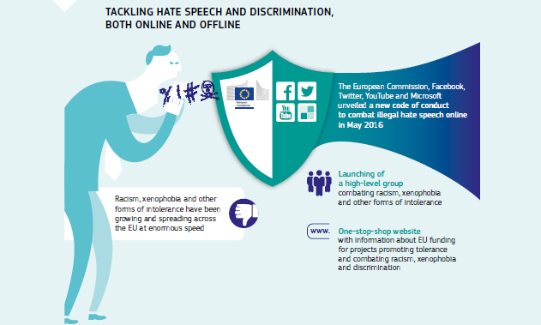
In order to protect minorities and combat the rising wave of racism and xenophobia the Commission reached an agreement in May with Facebook, YouTube, Twitter and Microsoft on a code of conduct to counter the spread of illegal hate speech online.
In April the Commission began work on an effective EU Security Union that would address the need for a common approach to transnational threats. In December the Commission presented its third Progress Report on the Security Union, which outlined the new Terrorist Financing Package, an important step in stemming the financial resources that sustain terrorism. The report also welcomed the adoption of a set of proposals to strengthen the effectiveness and efficiency of the Schengen Information System. The report underlined the significant progress made on key EU legislative files to counter terrorism and organised crime and to reinforce security at the EU’s borders. The Parliament and the Council reached political agreement on the Directive on Combating Terrorism, the revision of the Firearms Directive and the revision of the Schengen Borders Code to allow systematic checks on EU citizens.
Upholding the rule of law
[CH07-PH25]
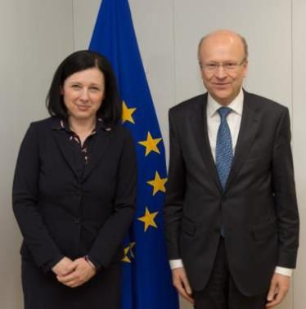
Commissioner Vĕra Jourová receives Koen Lenaerts, President of the Court of Justice of the European Union, Brussels, 28 April 2016.
During the year the Commission pursued its efforts to promote and uphold the respect of the rule of law in the European Union.
The Commission also continued to encourage Member States to improve the quality, independence and efficiency of their national justice systems, as effective justice systems support economic growth and defend fundamental rights. The Commission adopted the 2016 EU Justice Scoreboard, which shows that, despite a positive overall trend, certain Member States are still facing particular challenges in this area.
In July the Commission adopted a Rule-of-Law Recommendation on the situation in Poland, setting out the Commission’s concerns and recommending how these can be addressed. Believing that there is a systemic threat to the rule of law in Poland, the Commission assessed the overall situation and reached the conclusion that important issues of concern regarding the rule of law in Poland remain. The Commission laid out further concrete recommendations to the Polish authorities in December on how to address these concerns.
[CH07-PH26]
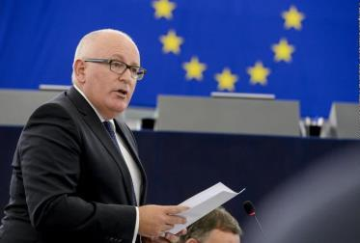
Commission First Vice-President Frans Timmermans addresses the European Parliament on recent developments in Poland and their impact on fundamental rights, Strasbourg, France, 13 September 2016.
Criminal justice
Improving procedural rights and judicial cooperation
The Parliament and the Council adopted three new Directives on procedural rights of suspects and accused persons:
- the Directive on Strengthening the Presumption of Innocence and on the right to be present at the trial in criminal proceedings;
- the Directive on Procedural Safeguards for Children Suspected or accused in criminal proceedings;
- the Directive on Legal Aid for Suspects or accused persons in criminal proceedings and requested persons in European arrest warrant proceedings.
On judicial cooperation in criminal law, the EU concluded a review of the 2010 Mutual Legal Assistance Agreement with the United States, agreeing on actions to improve and speed up cooperation.
[CH07-VD16]
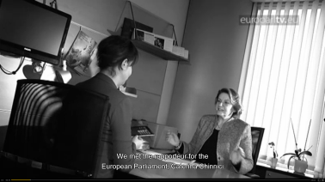
The first EU Regulation protecting minors in criminal proceedings. (video)
Finally, the Member States agreed to begin work on improving access to digital evidence in criminal investigations through the Council conclusions on improving criminal justice in cyberspace adopted in June.
Civil justice
Simplifying family and civil law
In 2016 the EU adopted legislation to help international couples manage their property and share it in case of divorce or the death of one of them.
The EU also adopted legislation simplifying the circulation of certain public documents between Member States. There will be no more need for an apostille stamp on public documents such as birth certificates, and the process for obtaining certified copies and translations will be made simpler.
The Commission proposed improvements to the EU rules that protect children in the context of cross-border parental responsibility disputes related to custody, access rights and child abduction. The new rules will speed up legal and administrative proceedings and ensure that the child’s best interest is always taken into account.
The Commission also presented a legislative proposal on early restructuring and second chance, along with other insolvency-related matters. The initiative addresses the most important barriers to the free flow of capital, building on national regimes.
Improving corporate governance rules
In 2016 negotiations between the Parliament and the Council on the revision of the Shareholder Rights Directive led to a political agreement that will still need to be formally approved by the two institutions.
As regards credit institutions and investment firms, the Commission assessed the remuneration rules in the Capital Requirements Directive and adopted a targeted amendment to take into account proportionality considerations following the assessment of the rules.
Fundamental rights and judicial systems
Standing up for EU fundamental rights
In May the Commission published its 2015 report on the application of the EU Charter of Fundamental Rights, highlighting how fundamental rights were taken into account and promoted in its policy and legislative work.
The report focused on the first Annual Colloquium on Fundamental Rights, on the theme of ‘Tolerance and respect: preventing and combating anti-Semitic and anti-Muslim hatred in Europe’. The Colloquium resulted in a list of concrete actions in the areas of combating racism, xenophobia, hate speech and hate crime and promoting tolerance, diversity and non-discrimination.
The second Annual Colloquium on Fundamental Rights focused on ‘Media pluralism and democracy’ and led the Commission to define follow-up actions aiming to protect media from political pressure and safeguard their financial independence, to support the protection of journalists facing threats and hate speech and to monitor freedom of expression in the Member States.
Improving data protection
[CH07-PH27]
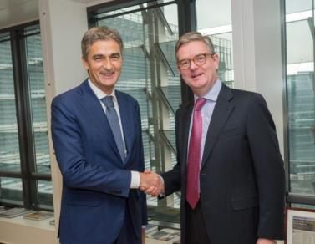
Giovanni Buttarelli, European Data Protection Supervisor, meets with Commissioner Julian King, Brussels, 24 November 2016.
The Data Protection Reform Package was adopted in April 2016. It will become applicable in 2018. The General Data Protection Regulation is an essential step to strengthen citizens’ fundamental rights in the digital age and facilitate business by simplifying rules for companies in the Digital Single Market. A single law will also do away with the current fragmentation and costly administrative burdens, leading to savings for businesses. In addition, a specific Data Protection Directive for the police and criminal justice sector will ensure a consistently high level of data protection and thereby facilitate the exchange of information and cooperation between Member States’ police and judicial authorities.
[CH07-VD17]
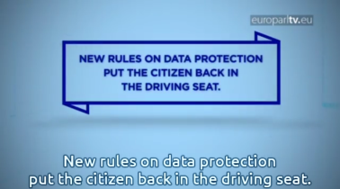
Data protection: problems and solutions. (video)
Protecting EU citizens’ personal data when transferred to US law enforcement
In June the EU–US Data Protection Umbrella Agreement was signed. It sets high standards for the protection of personal data transferred by law-enforcement authorities. The European Parliament gave its consent to the conclusion of the Agreement in December.
Making EU–US data transfers safer
In July the Commission adopted the Decision putting in place the EU–US Privacy Shield, allowing for safe personal data transfers from the EU to companies in the United States. The Privacy Shield puts in place strong obligations on companies’ handling of data, clear safeguards and transparency obligations on United States government access, effective protection of individual rights and an annual joint review mechanism.
Consumers’ rights
Increasing respect for consumer rules in the online world
The Commission proposed to revise the Consumer Protection Cooperation Regulation to bring enforcement of EU consumer laws up to speed with the online world. The European consumer centres regularly inform enforcement authorities about key issues for consumers.
At the trilateral EU–China–US Consumer Product Safety Summit in 2016 the authorities agreed to strengthen product safety cooperation, particularly on products sold online.
New online tool to solve disputes
In 2016 the European Commission launched the Online Dispute Resolution platform. It facilitates the online, out-of-court resolution of disputes between EU consumers and traders related to online shopping.
Keeping EU consumers safe
The Rapid Alert System for Dangerous Non-Food Products allows for the quick exchange at EU level of information on dangerous products found on the market and on the measures taken to prevent them from reaching consumers. In 2016, 2 126 alerts on dangerous products were circulated among the 31 European national authorities participating in the System and the European Commission. This is a slight increase on the 2 072 alerts recorded in 2015. These alerts mostly concerned products posing a risk of injuries (such as motor vehicles) or posing a chemical risk (such as toys containing phthalates).
Protecting consumers against misleading and aggressive commercial practices
To ensure that national enforcement authorities have adequate tools to better protect consumers in the online and offline world the Commission adopted an updated version of the 2009 guidance on the application of the Unfair Commercial Practices Directive. The document aims to make the application of the Directive simpler.
[CH07-PH28]
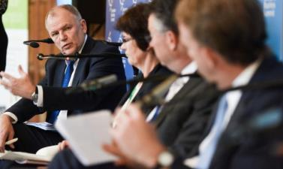
Commissioner Vytenis Andriukaitis addresses the ‘Food and drinks: connecting with the mindful consumer’ session at the 14th European Business Summit, Brussels, 2 June 2016.
Gender equality
Boosting gender equality
In December 2015 the Commission published a Strategic Engagement for Gender Equality, to shape the Commission’s policy on gender equality until 2019. In June 2016 the Council adopted Conclusions on the Commission’s strategic engagement.
In March the Commission also proposed EU accession to the Council of Europe Convention on Preventing and Combating Violence against Women and Domestic Violence, which sets legally binding standards to prevent violence, protect victims and punish perpetrators.
Mapping out actions on gender equality
The Report on equality between women and men 2015 shows some progress in employment and decision-making. Nevertheless, significant gender gaps remain in pay and pensions.
The Commission is committed to addressing the challenges related to work–life balance. Providing a better balance between a person’s family life and their professional responsibilities will encourage better sharing of care responsibilities between women and men, strengthen gender equality, reduce the pay and pension gaps, address the demographic challenges in the EU and enable businesses to fully benefit from all available talents.
In 2016 the Commission awarded funding for awareness-raising and education activities to prevent and combat violence against women, to be carried out by national authorities.
Fighting against discrimination
The Commission started implementing the list of actions to advance lesbian, gay, bisexual, transgender and intersex equality, including activities in areas such as non-discrimination, education, health, hate crime and hate speech.
The 2016 Roma Report revealed serious bottlenecks, such as residential and educational segregation and forced evictions of Roma people.
Rights of people with disabilities
Around 80 million people in the EU have some degree of disability. The adoption of the European Accessibility Act, which started to be discussed in the Parliament and the Council in 2016, would improve the accessibility of everyday products and services, such as mobile phones, transport and banking services. In October the Parliament and the Council formally approved the first EU-wide rules to make the websites and mobile apps of public sector bodies accessible for the blind, deaf and hard of hearing. Public sector bodies include the state, regional and local authorities and bodies governed by public law, such as public hospitals, universities and libraries. As part of the September Copyright Package the Commission proposed legislation to implement the Marrakesh Treaty to facilitate access to published works for people who are blind, have other visual impairments or are otherwise print disabled.
To help people with disabilities travel more easily between Member States the EU launched the EU Disability Card initiative. The card will provide equal access to certain specific benefits, mainly in the areas of culture, leisure, sport and transport, based on a system of mutual recognition.
Addressing trafficking of human beings
In May the Commission presented its first report on the progress in the fight against trafficking of human beings. This is crucial in order to increase the number of investigations and prosecutions, to establish appropriate mechanisms for the early identification and protection of victims and to enhance measures to prevent the trafficking of human beings.
The Commission published a study on the gender dimension of trafficking of human beings, in line with the requirements of the EU legal and policy framework.
The Commission will develop knowledge on the gender dimensions of human trafficking, including the gender consequences of the various forms of trafficking and potential differences in the vulnerability of men and women to victimisation and its impact on them. Its specific objectives and tasks are to address: the gender dimension of vulnerability, recruitment and victimisation; gender issues related to traffickers and to those creating demand; and an examination of law and policy responses to the trafficking of human beings from a gender perspective.
Chapter 8
Towards a new policy on migration
‘The recent terrible events in the Mediterranean have shown us that Europe needs to manage migration better, in all aspects. This is first of all a humanitarian imperative. I am convinced that we must work closely together in a spirit of solidarity.’
Jean-Claude Juncker, political guidelines, 15 July 2014
In 2015 and 2016 the EU experienced an unprecedented influx of refugees and migrants. According to Eurostat, more than 1 million people applied for international protection in the European Union, most of them fleeing from war and terror in Syria and other countries.
Numerous new measures were introduced in 2016 in order to deal with the situation. These included focusing on rescue operations while carrying out border surveillance with the support of European agencies and saving more lives at sea; securing the EU’s external borders, notably through the ‘hotspot’ approach; stepping up efforts in the relocation and resettlement of people in need of protection; and developing new measures in the fight against migrant smuggling. In addition, the Commission proposed revised EU asylum legislation and increased its efforts to ensure the full and correct implementation of the existing EU legislative framework.
The EU also focused on opening new channels for legal migration. The aim was to improve the EU’s ability to attract and retain highly skilled workers and better integrate non-EU nationals, to enhance the competitiveness of the EU’s economy and to cope with demographic challenges.
2016 also saw increasing cooperation with countries of origin and transit to help them effectively address the root causes of irregular migration.
Finally, through the Asylum, Migration and Integration Fund and the Internal Security Fund, the EU increased its financial support to Member States for the development of a common approach to migration and the efficient management of migration flows.
The European Agenda on Migration
In 2016 the European Commission followed up on the European Agenda on Migration, proposing measures to tackle the immediate challenges of the ongoing migration and refugee crisis. It also sought to equip the EU with the tools to better manage migration in the medium and long term, in the areas of irregular migration, borders, asylum and legal migration.
[CH08-VD18]
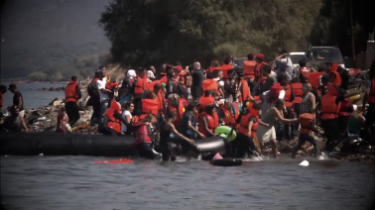
The European Agenda on Migration: 2 years on. (video)
Protecting those in need of international protection
In April the Commission published a Communication presenting options for how to reform the EU’s existing rules on migration and asylum.
Based on the feedback received, in May the Commission presented a first package of legislative proposals on the reform of one aspect of the Common European Asylum System, proposing new rules to reform the Dublin System, which determines which Member State is responsible for an asylum claim. At the same time the Commission proposed to transform the European Asylum Support Office into a fully fledged European Union agency for asylum that will facilitate implementation and improve the functioning of the Common European Asylum System.
[CH08-PH29]
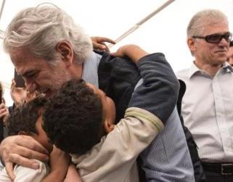
Commissioner Christos Stylianides visits a refugee camp in Elaionas, Greece, 19 April 2016.
In July the Commission completed the proposed overhaul of the Common European Asylum System with a second package of proposals revising the three remaining pieces of legislation making up the EU’s asylum system. The reforms simplify, clarify and shorten the asylum process, creating a fairer and more efficient EU procedure for dealing with asylum claims — one that is generous to the most vulnerable but strict with those who try to abuse it. The reforms will also allow for both the quick identification of people in genuine need of international protection, offering them protection for as long as they need it, and the ability to return those who do not have the right to receive protection in the EU. The reforms will also make sure that, wherever they arrive, asylum seekers can benefit from the same dignified reception standards.
In December the Commission adopted its fourth Recommendation on the specific measures Greece needs to take to fully implement the EU asylum standards under the Dublin Regulation. The Recommendation noted that despite the difficult situation Greece was confronted with it had made significant progress in putting in place the essential institutional and legal structures for a properly functioning asylum system, and there is a good prospect for a fully functioning asylum system to be in place in the near future. It was therefore recommended that transfers to Greece under the Dublin Regulation be resumed gradually after 15 March 2017, based on individual assurances for each applicant and excluding vulnerable categories of migrants. The aim is to encourage relocation efforts and restore a fully functioning Dublin System as a key element re-establishing the normal functioning of the Schengen area, and with a view to the future reform of the System.
[CH08-PH30]
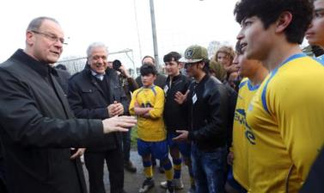
Commissioners Tibor Navracsics and Dimitris Avramopoulos speak with young refugees and football players, Kraainem, Belgium, 2 March 2016.
Relocation and resettlement
In March and October the European Council called for an acceleration in the implementation of relocation in order to alleviate the huge pressure on Greece and Italy.
The temporary emergency relocation scheme was established in 2015, with Member States committing to relocate 98 255 people from Italy and Greece by September 2017. Member States also agreed in 2015 to resettle over 22 000 people in clear need of international protection from outside of the European Union.
By the end of 2016, 9 602 refugees had been relocated — 7 198 from Greece and 2 404 from Italy — to 24 participating states. Moreover, by early December 13 887 people had been provided safe and legal pathways to the EU through resettlement in 21 resettling states.
In March the members of the European Council and their Turkish counterparts agreed to end irregular migration from Turkey to the EU and replace it with legal channels for the resettlement of refugees in the European Union. An EU–Turkey Statement was agreed in which it was announced, among other things, that all new irregular migrants or asylum seekers crossing from Turkey to the Greek islands would be returned to Turkey, after an individual assessment of their asylum claims in line with international and EU law and on the basis that they would receive protection in Turkey. In addition, for every Syrian being returned to Turkey from the Greek islands another Syrian would be resettled in the EU from Turkey directly. By the end of the year 2 672 Syrian refugees had been resettled from Turkey under this provision.
[CH08-GR13]
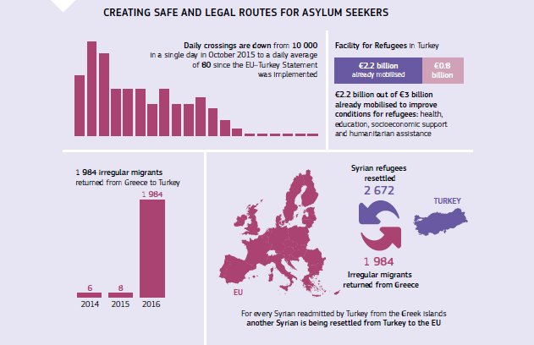
In September the Commission reported on the sharp decrease in the numbers of people crossing irregularly or losing their lives in the Aegean Sea. From June onwards an average of 80 people arrived daily, compared with over 10 000 arriving in a single day in October 2015.
The Commission worked together with Greece and Italy to develop the procedures needed to facilitate relocation, including appropriate security screening of relocation candidates supported by the European Border and Coast Guard Agency and Europol. Both in Greece and in Italy, a Protocol for Relocation was endorsed in June 2016 by all EU Member States, the United Nations High Commissioner for Refugees, the International Organisation for Migration and the European Asylum Support Office.
[CH08-VD19]
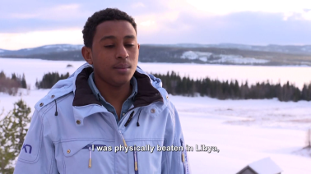
Testimonies from people that have benefited from relocation. (video)
Return and readmission
As part of the Common European Asylum System Reform package the Commission proposed to reinforce the EU’s fingerprint database for identifying asylum seekers and irregular border-crossers. The proposal would allow Member States to store and search data belonging to non-EU nationals or stateless persons who are not applicants for international protection and are found to be staying irregularly in the EU. A new Regulation on the European Border and Coast Guard reinforced the role of the Agency in supporting Member States during return operations. In addition, the Council adopted the Commission’s proposal for a European travel document, introducing a uniform format with enhanced security features to facilitate the return of irregularly staying non-EU nationals.
Within the framework of the Schengen Evaluation Mechanism, the Commission, together with experts from Schengen countries, evaluated the return systems in 10 EU Member States and associated countries between 2015 and 2016. Six evaluation reports were adopted by the Commission, and recommendations were made to the Council to address weaknesses detected in the national return systems.
Enhancing return and readmission is also one of the key objectives of the new Migration Partnership Framework, launched by the Commission in June 2016 to tackle the root causes of irregular migration and to better manage migration in cooperation with non-EU countries. (For more information on the Partnership Framework see Chapter 9).
The fight against migrant smuggling
In February a European Migrant Smuggling Centre was established in Europol and an agreement was reached on closer operational cooperation between the European Border and Coast Guard Agency and Europol. This included the sharing of personal data gathered from voluntary interviews with migrants involved in joint operations coordinated by the European Border and Coast Guard Agency in order to better investigate smugglers.
Saving lives at sea and implementing the ‘hotspot’ approach
The European Border and Coast Guard
The European Border and Coast Guard Agency contributed to the rescue of over 169 000 people in 2016 in the central Mediterranean alone.
By the end of 2016 the European Border and Coast Guard had more than 1 550 officers deployed to support Member States at the external borders, complementing the Member States’ existing national capacities of over 100 000 border guards.
[CH08-PH31]
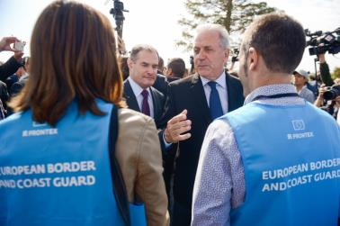
Commissioner Dimitris Avramopoulos at the launch of the European Border and Coast Guard, Kapitan Andreevo, Bulgaria, 6 October 2016.
Building on a proposal from December 2015, political agreement was reached in June 2016 on the Regulation on the European Border and Coast Guard, which entered into force in October. The European Border and Coast Guard comprises two pillars — the strengthened European Border and Coast Guard Agency, built from the ‘old’ Frontex agency, and the border management authorities of the Member States, including coast guards to the extent that they deal with border-control tasks.
Under the new mandate the Agency’s role and activities were significantly expanded. Since October important progress has been made in making the new Agency fully operational, including the setting up of mandatory rapid-reaction pools for border guards and equipment and the launch of new pools for return intervention teams. These can be deployed in support of Member States, which have the primary role and competence in reinforcing controls at the external borders.
Hotspots
As part of the effort to manage the migration crisis the implementation of the ‘hotspot’ approach continued in Greece and Italy. Operational and financial support was provided by the EU and the relevant EU agencies (the European Asylum Support Office, the European Border and Coast Guard Agency and Europol), including through the deployment of Member States’ experts and guest officers.
Located at key arrival points in the most affected Member States, such as Italy and Greece, hotspots are reception areas where all those arriving are identified, registered and properly processed. The hotspot workflow and the relocation process also include integrated and systematic security checks and require the provision of adequate reception conditions to avoid overcrowding, with a specific attention to vulnerable groups including children.
The implementation of the hotspot approach is primarily the responsibility of the Member State concerned. However, since March 2016 Europol personnel have performed secondary security checks in the Greek hotspots. To make the security process at the external borders more robust Europol set up a pool of 116 guest officers — experts seconded by national services — to support Member States in need. The first two groups of guest officers were deployed in the Greek hotspots in order to support Europol personnel. Five hotspots were operational in Greece and four in Italy in 2016, with other ports of disembarkation in Italy performing similar functions.
Better control of the EU’s external borders
Back to Schengen — a roadmap
In March the Commission presented a detailed roadmap with the concrete steps needed to return to a Schengen area that is functioning normally, as the system had been severely tested by the migration and refugee crisis.
Due to the large number of irregular migrants and asylum seekers arriving in Greece, huge pressure was put on the EU external borders in Greece, revealing serious deficiencies and having consequences for the Schengen area as a whole. In view of this Greece was asked to adopt and implement an action plan to respond to the Council and Commission recommendations, while other Member States were asked to assume responsibility and provide immediate support to Greece.
In May the Council adopted a Recommendation to Austria, Germany, Denmark, Sweden and Norway allowing for temporary internal border controls. Despite the progressive stabilisation of the overall situation in the Schengen area, in November the Commission recommended that the Council allow those countries to maintain internal border controls under strict conditions and for a limited period.
The Smart Borders Package
In April the Commission proposed a Smart Borders Package with the aim of modernising the Schengen area’s external border management and helping Member States deal with the increasing traveller flows, while contributing to the fight against terrorism and serious crimes.
At the core of the Package is the establishment of the Entry–Exit System to modernise border control and to provide precise and automated information to border guards during border checks. The System also allows access to assigned national law-enforcement authorities and Europol to contribute to the prevention, detection and investigation of terrorist offences or other serious criminal offences.
At the same time the Commission proposed a Communication on ‘Stronger and smarter information systems for borders and security’, which sets out actions to improve the functioning and interoperability of existing information systems and potential new systems to address information gaps.
In November the Commission proposed to establish a European Travel Information and Authorisation System to strengthen security checks on visa-free travellers.
In December the Commission proposed to strengthen the operational effectiveness and efficiency of the Schengen Information System to enhance the System’s ability to fight terrorism and cross-border crime, improve border and migration management and ensure the effective exchange of information between Member States to increase the security of EU citizens.
Western Balkans leaders’ weekly videoconferences
Weekly videoconferences of the western Balkans leaders led to strong coordination and improved information sharing between EU Member States and their immediate neighbours along another important migratory route.
Improving channels for legal migration
A proposal for a revised Blue Card, presented by the Commission in June, aims to improve the EU’s ability to attract and retain highly skilled workers in order to enhance the competitiveness of its economy and cope with demographic challenges. Blue Card holders will be given more flexible access to highly skilled work across the EU, with the possibility for a self-employed side activity, immediate family reunification and faster access to long-term residence status in the EU.
Integration of non-EU nationals
In the field of integration, the Commission adopted an Action Plan on the Integration of Third-Country Nationals in June. It aims to support Member States in their efforts to integrate non-EU nationals. The Action Plan provides a common policy framework that should help Member States as they further develop and strengthen their national integration. It presents 50 concrete actions in key areas such as pre-departure and pre-arrival integration, education, employment and vocational training, access to basic services, active participation and social inclusion.
Visas
The Commission tabled legislative proposals in early 2016 to transfer Georgia, Kosovo (this designation is without prejudice to positions on status, and is in line with United Nations Security Council Resolution 1244/1999 and the International Court of Justice Opinion on the Kosovo declaration of independence), Turkey and Ukraine to the visa-free list for short stays following the positive assessment of these countries’ visa liberalisation action plans or roadmaps. The proposals for Kosovo and Turkey were made on the understanding that the Kosovan and Turkish authorities would fulfil the outstanding benchmarks of their respective visa liberalisation roadmaps before the adoption of the respective proposals by the Parliament and the Council. The Commission also proposed a legislative amendment to strengthen the suspension mechanism, which will allow the EU to suspend visa-free travel for citizens of a non-EU country in case of a significant increase in migratory or security risks. Political agreement was reached between the Parliament and the Council on the revised suspension mechanism and on visa liberalisation for Georgia.
During the year the EU signed visa waiver agreements with Kiribati, the Marshall Islands, Micronesia, Peru, the Solomon Islands and Tuvalu.
Negotiations were launched with Tunisia in October on an agreement to facilitate the process of issuing short-stay visas and an agreement to establish procedures for the readmission of irregular migrants.
In November negotiations on visa facilitation and readmission were launched with Jordan.
In 2016 the Canadian government announced that it intends to lift the visa requirement for all Bulgarian and Romanian citizens travelling to Canada as from December 2017.
Financial support for the efficient management of migration
The EU also increased its financial support to Member States for the development of a common approach to migration and the efficient management of migration flows, mainly through the Asylum, Migration and Integration Fund and the Internal Security Fund. The emergency assistance component of these funds allowed the EU to provide a swift and flexible response to migration challenges by making available additional funding to those Member States facing huge migratory pressure. In March the Commission proposed an Emergency Assistance Instrument to be used within the EU to provide a faster, more targeted response to major crises, including helping Member States cope with large numbers of refugees. Up to 2018 some €700 million of EU funding will be made available through this instrument via partner organisations, such as UN agencies, the Red Cross and non-governmental organisations. €198 million has already been allocated to organisations for projects carried out in Greece, in close consultation with the Greek authorities.
On top of this, the EU increased the 2015-2016 budgets of the European Asylum Support Office, the European Border and Coast Guard Agency and Europol, reinforcing their capacity to provide on-the-ground responses to migration challenges.
[CH08-GR14]
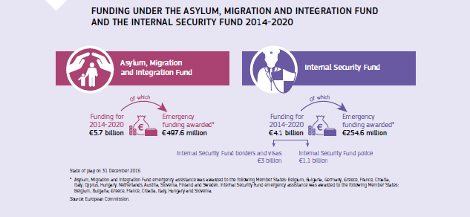
Chapter 9
A stronger global actor
‘We need a stronger Europe when it comes to foreign policy. The Ukraine crisis and the worrying situation in the Middle East show how important it is that Europe is united externally.’
Jean-Claude Juncker, political guidelines, 15 July 2014
The EU needs a strong common foreign policy to respond efficiently to global challenges, including the crises in its neighbourhood, project its values and contribute to peace and prosperity in the world.
With that in mind the EU put promoting international peace and security, development cooperation, human rights and responding to humanitarian crises at the heart of its foreign and security policies throughout 2016.
Internationally, the EU used its diplomatic and economic influence to press for political solutions to conflicts in Syria, Libya and Ukraine. It continued to work intensively to foster the normalisation of relations between Kosovo and Serbia.
In spring 2016 High Representative of the Union for Foreign Affairs and Security Policy/Commission Vice-President Federica Mogherini and several other European Commissioners visited Iran to launch discussions on cooperation on trade, investment, energy and climate change, and human rights.
A Global Strategy for the EU’s Foreign and Security Policy was presented in June by High Representative/Commission Vice-President Federica Mogherini. The strategy outlines priorities and objectives to maximise the EU’s ability to tackle international challenges. The follow-up on security and defence has been particularly swift, leading to the adoption of substantial conclusions by the Council of the European Union in November and proposals for EU–NATO cooperation in December. The European Commission also proposed a European Defence Action Plan in November with the aim of setting up a European Defence Fund. This comprehensive defence package was endorsed by the European Council in December, with concrete follow-up tasks for 2017.
During the year the EU began implementing the UN Sustainable Development Goals. The EU Emergency Trust Fund for Africa was set up and closer cooperation on migration was agreed with five African countries.
Humanitarian crises continued to take a heavy toll, and in 2016 the EU allocated relief assistance of over €2.1 billion for food, shelter, protection and healthcare to 120 million people in over 80 countries.
The EU’s neighbourhood
Relations with countries that lie to the south and east of the EU are crucially important. This relationship is guided by the European neighbourhood policy, which was revised in 2016. The policy offers genuine partnerships between the EU and neighbouring countries based on good governance, political, economic and security issues and migration.
The eastern neighbourhood
The EU’s policies towards countries to its east are comprehensive and tailor-made for the needs of the individual countries. They are therefore wide reaching and focus on a number of priority areas, for example social and economic development, good governance and energy efficiency, and they make it easier for people in the EU and the eastern neighbourhood to meet, work and study in and travel between the regions.
The EU has association agreements, which include deep and comprehensive free trade areas, with Georgia, Moldova and Ukraine. Agreements with Georgia and Moldova came into force in July. Closer relations with Armenia, Azerbaijan and Belarus were also pursued. Significant progress was made in agreeing visa-free travel for Ukrainians and Georgians to visit the EU.
Supporting political and economic reform in Ukraine was an EU priority throughout the year, with substantial financial support being provided under the European Neighbourhood Instrument (€200 million for new programmes focusing on transparent and accountable governance), humanitarian assistance (€22.4 million) and macrofinancial assistance (€2.21 billion). Brussels and Kyiv also held talks on gas deliveries.
The EU continued to insist on the peaceful settlement of the conflict in eastern Ukraine through the full implementation of the Minsk agreements. It continued its sanctions against Russia for its illegal annexation of Crimea and Sevastopol and its role in destabilising Ukraine.
Russia
In early 2016 the EU Member States affirmed the principles guiding the EU’s approach to Russia. These include full implementation of the Minsk agreements, strengthening relations with eastern partners and other neighbours, particularly in central Asia, strengthening internal EU resilience, engaging selectively with Russia on issues of EU interest such as foreign policy and global matters and intensifying the EU’s support for Russian civil society and contacts between EU and Russian citizens. In the absence of the complete implementation of the Minsk agreements the sanctions imposed in 2014 in response to Russian actions in Ukraine remained in place. The further deterioration of the human rights situation in Russia and growing restrictions on civil society continued to be at the top of the EU’s agenda.
The southern neighbourhood
In the EU’s southern neighbourhood region the neighbourhood policy is about supporting individual countries in areas where the EU can make a specific and positive contribution.
Particular attention is given to countries affected by the refugee crisis. The Commission continued to implement the EU Regional Trust Fund in Response to the Syrian Crisis and launched activities under the EU Emergency Trust Fund for Africa to address the migration crisis. Following the Supporting Syria and the Region conference held in London in February, agreements were reached with Jordan and Lebanon to help them cope with the large influx of Syrian refugees. The EU notably increased trade with Jordan to help create jobs, in particular for Syrian refugees inside the country.
Tunisia benefited from particular attention in 2016 as the EU supported its democratic transition.
Syria
The crisis in Syria remained one of the gravest challenges the international community faced in 2016. The EU continued its diplomatic and humanitarian efforts in close coordination with the UN and with UN Special Envoy Staffan de Mistura. The EU scaled up its financial assistance, with over €9 billion in aid since the crisis began. This was reaffirmed when EU leaders met in October to discuss Syria. High Representative/Vice-President Federica Mogherini also tried to facilitate a regional understanding on the future of Syria, leading the EU regional initiative that aims to identify common ground on post-conflict arrangements with regional players, examining the scope for reconciliation and reconstruction once a credible political transition is firmly under way.
Libya
Throughout the year the EU remained fully committed to Libya and the country’s transition towards an inclusive and stable democracy, and to supporting UN mediation efforts in that process. The EU currently provides substantial funding for projects and activities in Libya across six sectors corresponding to the priorities of its bilateral cooperation: civil society; democratic governance; health; youth, active citizenship and socioeconomic integration; migration and protection; and political process, security and mediation.
The western Balkans and enlargement negotiations
The EU’s enlargement process is vital for the stability of the western Balkans. Supporting security and prosperity in the western Balkans is an investment in the future of the region and is in the EU’s interest. Bosnia and Herzegovina applied for EU membership and the Council decided to take the process forward, while Albania, with support from the EU, passed key laws to reform its judiciary. This should improve life for Albanians and help take the country forward on its path towards the EU. The EU and Kosovo concluded a stabilisation and association agreement. In the former Yugoslav Republic of Macedonia mediation from the EU and other international players enabled an agreement that led to calm and orderly parliamentary elections in December.
Talks between Kosovo and Serbia on normalising relations also progressed. Meanwhile, EU membership talks with both Montenegro and Serbia advanced steadily.
Turkey
[CH09-PH32]
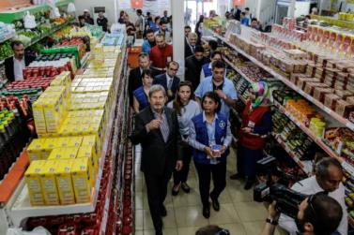
Commissioner Johannes Hahn visits a supermarket for refugees managed by the World Food Programme, Turkey, 26 April 2016.
In 2016 relations between the EU and Turkey developed in many areas, as had been agreed at the EU–Turkey Summit of November 2015. A key development was the EU–Turkey deal in March, in which the EU focused on the handling of the migration flows and on fighting the smuggler model and trafficking in human beings. A Facility for Refugees in Turkey was established to support Syrian refugees and their overstretched communities, coordinating €3 billion in funding for 2016 and 2017. The EU supported Turkish democracy after the coup attempt in July, and called on the authorities to observe the highest standards of the rule of law and fundamental rights in its wake.

[CH09-VD20]
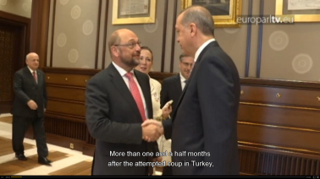
The visit by Martin Schulz, President of the European Parliament, to Turkey. (video)
Western Europe
Non-EU western European countries are closely connected to the EU. Norway and Switzerland are among the EU’s main trade and investment partners and are important partners in research and innovation. However, challenges remain with Switzerland. Although the vote in December by the Swiss Federal Assembly on amendments to the Foreigners Act was a step in the right direction, an institutional framework agreement for managing and updating the complex system of sector-by-sector agreements to fully unlock the potential of the bilateral relations is still missing.
North America
United States
Priorities in the relations between the EU and the United States in 2016 included counterterrorism, strengthening economic growth and addressing the global refugee crisis. This was reflected at the meeting between Barack Obama, President of the United States, Donald Tusk, President of the European Council, and Jean-Claude Juncker, President of the European Commission, in Warsaw in July.
Several rounds of talks on the Transatlantic Trade and Investment Partnership took place.
In June the EU and the United States signed an agreement to ensure a data protection framework for data transfers to the United States within the framework of judicial and law-enforcement cooperation. In December the Council adopted the decision authorising the European Union to conclude the agreement.
In July the EU–United States Privacy Shield was adopted to protect the personal data of citizens and provide clarity for businesses.
Washington and Brussels also cooperated on the European Border and Coast Guard and in tackling the refugee crisis.
In December the United States and the EU signed an acquisition and cross-servicing agreement on logistical support for each other’s military operations.
[CH09-PH33]
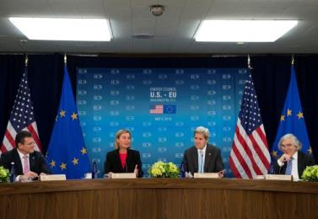
Commission Vice-President Maroš Šefčovič, High Representative/Commission Vice-President Federica Mogherini, John Kerry, US Secretary of State, and Dr Ernest Moniz, US Secretary of Energy, at the US–EU Energy Council meeting at the State Department in Washington DC, United States, 4 May 2016.
Canada
The year was also an important one in the EU’s relations with Canada, with the signature of two ground-breaking agreements — the Strategic Partnership Agreement and the Comprehensive Economic and Trade Agreement. Once in force the two agreements will upgrade the overall cooperation framework between the EU and Canada. The Strategic Partnership Agreement will enhance political dialogue on a broad range of areas, including international peace and security, economic and sustainable development, justice, freedom and security. The Comprehensive Economic and Trade Agreement will promote jobs and growth and bring important economic benefits on both sides of the Atlantic by generating trade and investment, along with setting global standards on the protection of labour rights and the environment.
China
A new EU strategy on China was agreed in July. The EU’s engagement with China will be principled, practical and pragmatic and will stay true to its interests and values — in particular to international rules and norms and respect for human rights.
The EU–China Summit in Beijing in July provided the opportunity for strategic discussions on issues of shared interest, including economic reforms and overcapacity in the steel sector.
The EU–China 2020 Strategic Agenda for Cooperation has been the basis for relations since 2013, and an environment policy dialogue has been ongoing since 2005.
[CH09-PH34]
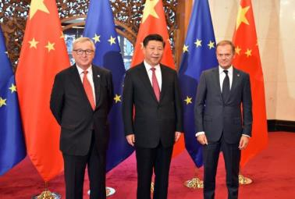
Jean-Claude Juncker, President of the European Commission, Xi Jinping, President of China, and Donald Tusk, President of the European Council, at the 18th EU–China Summit, Beijing, China, 12 July 2016.
The Middle East
Iran
Following the historic nuclear agreement reached in July 2015 between the international community and Iran, High Representative/Vice-President Federica Mogherini visited Tehran in April 2016 with seven European Commissioners to increase cooperation in areas such as economic relations, transport, science, humanitarian issues, energy and human rights.
[CH09-PH35]
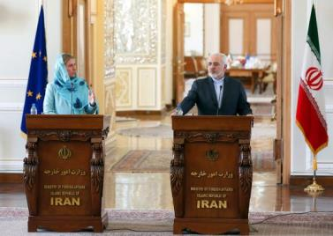
High Representative/Commission Vice-President Federica Mogherini and Mohamad Javad Zarif, Iranian Minister for Foreign Affairs, at a joint press conference in Tehran, Iran, 16 April 2016.
Iraq
The EU’s efforts in Iraq focused on supporting the government in carrying out urgently needed political, economic and human rights reforms, not least within the framework of the EU–Iraq Partnership and Cooperation Agreement. Cooperation with Iraq continued in the battle against ISIL/Da’esh. The EU is providing humanitarian aid to cover the most urgent needs of displaced Iraqis and is supporting the stabilisation of liberated areas.
Latin America
In 2016 the EU strengthened its relations with Latin America and the Caribbean. The EU and Mexico launched negotiations to modernise the global agreement in order to, among other things, enhance the framework of the bilateral dialogue on global issues (notably on climate change, energy, food security, the global economy and security) and adapt EU–Mexico relations to the new realities of global trade and investment policies and flows. The EU and Cuba continued their formal political dialogue, and in December signed a political dialogue and cooperation agreement, which constitutes the new legal framework for the relationship. In May the EU and the Common Market of the South (Mercosur) reinvigorated negotiations for a bi-regional association agreement with the first exchange of offers since 2004.
The EU provided political support to the peace process in Colombia. The EU Trust Fund launched in December 2016 will be a key element in the EU’s efforts to support the implementation of the peace agreement.
A meeting of foreign ministers from the EU and the Community of Latin American and Caribbean States was held in Santo Domingo, Dominican Republic, in October. It contributed to strengthening the strategic partnership and paved the way for a summit to be held between the EU and the Community of Latin American and Caribbean States in 2017.
EU–Africa partnership
[CH09-PH36]
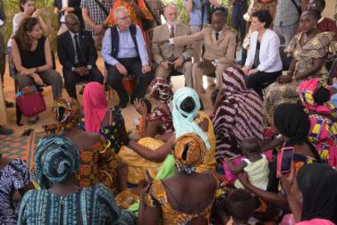
Commissioner Neven Mimica meets with locals in Matam, Senegal, 27 April 2016.
In the Horn of Africa the EU approved a new political and economic agreement with Ethiopia and was a prime supporter of elections in Somalia. The EU continued supporting the fight against terrorism in the region, as well as in the Sahel. The year saw the signature and entry into force of the Economic Partnership Agreement between the EU and the Southern African Development Community.
Migration
In 2016 the EU sought tailor-made partnerships with non-EU countries of origin and transit using all policies at its disposal. In June the European Council adopted the proposal by the High Representative/Vice-President and the Commission to launch a new partnership framework on migration with key partners in Africa to better manage the situation together.
As part of the European Agenda on Migration the priorities are saving lives at sea, increasing returns, enabling migrants and refugees to stay closer to home and, in the long term, helping countries address the root causes of irregular migration.
Under the partnership framework, work was launched with five priority countries — Ethiopia, Mali, Niger, Nigeria and Senegal. In parallel, dialogues on migration with countries of origin and transit continued in order to implement the outcome of the 2015 Valletta Summit.
During the year the EU Emergency Trust Fund for Africa started to deliver on concrete projects, and cooperation with the EU’s partners is showing its first results.
[CH09-GR15]
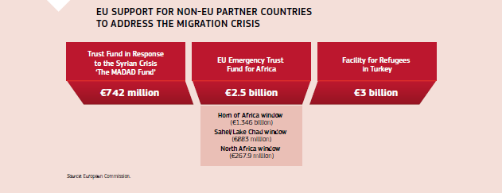
Human rights
[CH09-PH45]
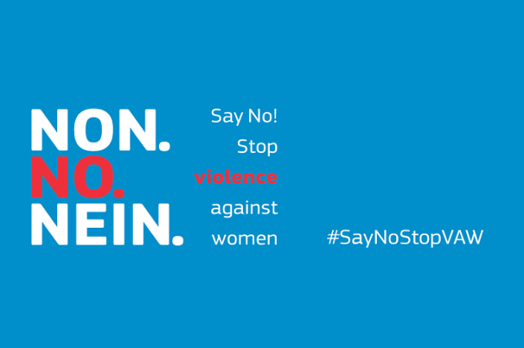
In 2016, on the International Day for the Elimination of Violence against Women (25 November), the European Commission launched a campaign on the elimination of violence against women.
2016 was marked by serious violations of human rights and increasing harassment and attacks on human-rights defenders and non-governmental organisations internationally. The Global Strategy for the EU’s Foreign and Security Policy, launched in June, restated that human rights are at the heart of the EU’s external action and are fully consistent with the EU’s interests. High Representative/Vice-President Federica Mogherini launched the #EU4HumanRights campaign to raise awareness of the EU’s and Member States’ efforts to pursue the priorities identified in the 2015-2019 Action Plan on Human Rights and Democracy. These included advocating, defending and promoting human rights worldwide.
The 2030 Agenda: Sustainable Development Goals
The EU is committed to the 2030 Agenda and to implementing the Sustainable Development Goals. Commissioner Karmenu Vella and Dutch Minister Sharon Dijksma attended the second UN Environment Assembly in May in Kenya. The ministers present agreed to implement the Sustainable Development Goals on issues such as sustainable production, consumption, chemicals, waste, climate change and oceans.
The Commission has set out a strategic approach for achieving sustainable development in the EU and around the world. Proposals were presented on 22 November by High-Representative/Vice-President Federica Mogherini, First Vice-President Frans Timmermans and Commissioner Neven Mimica. In this context the Commission issued a Communication on the next steps for a sustainable European future that joins up the sustainable Development Goals of the 2030 Agenda with the EU policy framework and Commission priorities. This will assess levels of progress, identify the most relevant sustainability concerns and ensure that all actions and policy initiatives, within the EU and globally, take the Sustainable Development Goals on board at the outset.
International development
In 2016 the EU began implementing the Sustainable Development Goals in international cooperation.
In September the EU launched the European External Investment Plan to implement commitments on financing for development and the 2030 Agenda for Sustainable Development.
In November the Commission proposed a revised European Consensus on Development, putting forward a shared vision and framework for action for development cooperation for the EU and its Member States. It proposes a blueprint for aligning the Union’s development policy with the UN 2030 Agenda for Sustainable Development. It forms part of the international community’s agreed response to new trends and challenges posed by globalisation. The European Development Days forum was the first major international gathering to discuss this. The EU also continued its work on a new partnership with the African, Caribbean and Pacific countries after 2020. It has proposed an umbrella agreement, complemented by tailored regional partnerships for Africa, the Caribbean and the Pacific addressing the specific regional opportunities and challenges faced.
To show the EU’s continued support for Afghanistan a major international conference was held in Brussels in October. In November a donors’ conference was held for the Central African Republic at which international donors pledged over €2 billion.
Research and innovation
Science diplomacy is a key part of the EU’s international activities. During the year the joint communication on ‘An integrated EU policy for the Arctic’ included Arctic research and emphasised the role of science in international cooperation.
The Global Research Collaboration for Infectious Disease Preparedness mobilised funders worldwide to implement urgent research into the Zika outbreak. Following a specific call in 2016, Zika research projects worth €30 million were selected for Horizon 2020 funding.
Decent work on the EU global agenda
At the International Labour Conference held in June Jean-Claude Juncker, President of the European Commission, made a pledge prioritising a social Europe, youth employment and social dialogue. He also promoted the Commission initiative on a European pillar of social rights. Together with Commissioner Marianne Thyssen he stressed the importance of International Labour Organisation standards and highlighted the need to reflect on the future of work. The EU made a key contribution to the work and outcomes of the conference. Comprehensive guidance on decent work in global supply chains was adopted, addressing due diligence, cross-border social dialogue, trade and transparency.
Security and defence
[CH09-PH46]
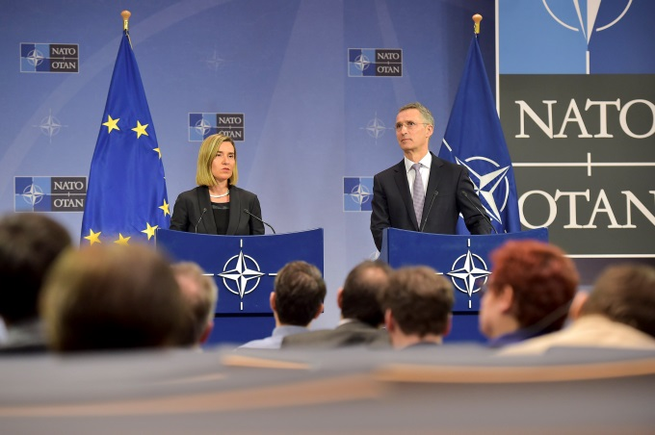
High Representative/Commission Vice-President Federica Mogherini and Jens Stoltenberg, Secretary General of NATO, give a joint press conference following the meeting of NATO Ministers for Foreign Affairs, Brussels, 6 December 2016.
In November EU foreign and defence ministers agreed to implement the Global Strategy for the EU’s Foreign and Security Policy in the area of security and defence. These conclusions were based on an implementation plan on security and defence, which was presented to ministers by the High Representative/Vice-President and Head of the European Defence Agency, Federica Mogherini.
The strategy includes proposals to strengthen civilian and military capabilities, deepen defence cooperation, improve the EU’s rapid response to crises, establish a permanent planning and conduct capability at the strategic level for non-executive military missions, explore the potential for greater cooperation with partner countries on security and defence and further implement the work on capacity-building in support of security and development.
This was the first of three elements of the new EU defence package endorsed by the European Council in December. The second element was the European Defence Action Plan proposed by the Commission, aiming to set up a European Defence Fund to support investment in joint research and the joint development of defence equipment and technologies. It also proposed measures for a strengthened single market for defence. The third element comprised cooperation between the EU and NATO as a follow-up to their joint declaration signed in Warsaw in July 2016.
In April EU Member States agreed on greater coordination to strengthen the EU’s response to hybrid threats such as cyberattacks, the disruption of energy supplies or financial services, the undermining of public trust in government institutions and the exploitation of social tensions.
Responding to humanitarian crises and emergencies
[CH09-VD21]
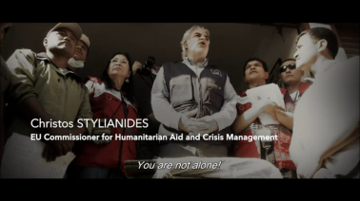
Reshaping aid at the World Humanitarian Summit. (video)
The EU continued to help those caught up in natural disasters and human-made crises around the world by allocating relief assistance of €2.1 billion for food, shelter, protection and healthcare to more than 120 million people in over 80 countries.
The EU is at the forefront in financing humanitarian aid in all major conflict zones where massive numbers of people are displaced, from Iraq and Syria to the Central African Republic, South Sudan and Yemen.
For the first time ever the EU provided humanitarian assistance within its borders, with support for Greece to cope with the flow of refugees. For the period from 2016 to 2018 €700 million of EU funding is being made available through humanitarian partners.
[CH09-GR16]
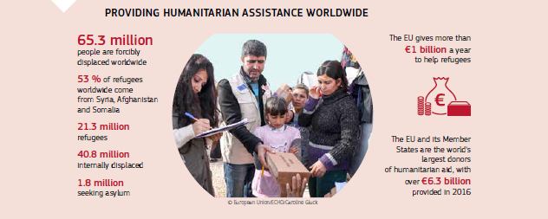
New initiatives also took shape. As a direct follow-up to the lessons learned from the Ebola crisis that hit west Africa in 2014 the EU set up a European Medical Corps, which was deployed to provide a rapid response to emergencies with health consequences both inside and outside the EU.
Some 4 % of the EU’s overall humanitarian budget was dedicated to education for children affected by emergencies, representing one of the most underfunded sectors of humanitarian aid. More than 3.8 million children obtained access to educational activities in 47 countries. Commissioner Stylianides also announced a further increase to 6 % in 2017.
International cooperation
EU–United Nations
[CH09-PH37]
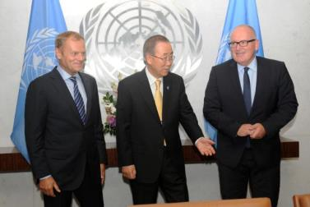
Donald Tusk, President of the European Council, Ban Ki-moon, Secretary-General of the United Nations, and Commission First Vice-President Frans Timmermans at the 71st plenary session of the United Nations General Assembly, New York, United States, 18 September 2016.
A high-level EU delegation participated in the UN General Assembly ministerial week and the summit on large movements of refugees and migrants, where the EU successfully advocated for global responsibility. The Syrian crisis, climate change and the implementation of the 2030 Agenda dominated discussions. Throughout the year United Nations–EU cooperation ensured coordination across a wide area of activities from peace missions to diplomatic efforts, human rights, tackling hunger, building inclusive societies, good governance and fighting criminality. The close ties between the two organisations were also stressed by High Representative/Vice-President Federica Mogherini during her speech at the United Nations Security Council in June.
EU–NATO
In Warsaw in July Donald Tusk, President of the European Council, Jean-Claude Juncker, President of the European Commission, and Jens Stoltenberg, Secretary General of NATO, signed the first ever EU–NATO joint declaration, giving new impetus to their partnership. It underlined their joint commitment to working together on countering hybrid threats; operational cooperation, including maritime issues; cybersecurity and defence; defence industry research; exercises and defence; and security capacity-building. In December, the EU and NATO endorsed, in a parallel process, a common set of proposals for the implementation of the joint declaration.
Cooperating on the international stage
[CH09-PH38]
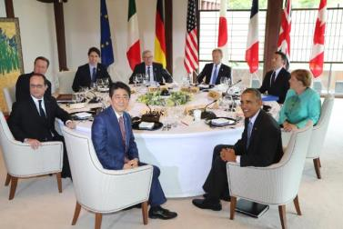
(Clockwise from left) François Hollande, President of France, David Cameron, Prime Minister of the United Kingdom, Justin Trudeau, Prime Minister of Canada, Jean-Claude Juncker, President of the European Commission, Donald Tusk, President of the European Council, Matteo Renzi, Prime Minister of Italy, Angela Merkel, Chancellor of Germany, Barack Obama, President of the United States, and Shinzō Abe, Prime Minister of Japan, at the G7 Summit, Ise, Japan, 26 May 2016.
The EU engaged actively with global partners in forums such as the G7 and the G20 to address global political and economic challenges. In their Hangzhou summit communiqué in September G20 leaders emphasised the need for greater inclusiveness so that economic growth serves the needs of everyone and benefits all countries and all people.
Chapter 10
A Union of democratic change
‘The proposal and election of the President of the European Commission in the light of the outcome of the European Parliament elections is certainly important, but only a first step in making the European Union as a whole more democratic. A European Commission under my leadership will be committed to filling the special partnership with the European Parliament … I am also committed to enhanced transparency when it comes to contact with stakeholders and lobbyists.’
Jean-Claude Juncker, political guidelines, 15 July 2014
In September 2016 President Juncker’s State of the Union address took stock of the achievements of the past year and presented his priorities for the year ahead. He outlined how the Commission will address the most pressing challenges, such as migration, terrorism, economic growth and employment. The doubling of the duration and value of the Investment Plan was at the forefront of the Commission’s proposed actions and was widely supported by the Parliament and the Council.
Two days later, all EU Member States except the United Kingdom gathered in Bratislava, Slovakia, to begin a political reflection on the further development of an EU of 27 Member States. It followed a national referendum on the United Kingdom’s EU membership, held in June, which resulted in a vote to leave the EU.
The Bratislava Declaration and Roadmap, agreed by EU leaders, set out the objectives until March 2017. It included restoring full control of external borders, ensuring internal security and fighting terrorism, strengthening EU cooperation on external security and defence, boosting the Single Market and offering better opportunities for young people.
The European Parliament
[CH10-PH39]
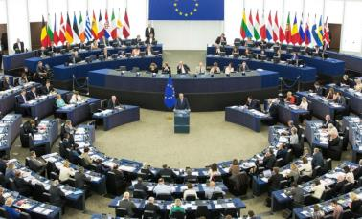
Jean-Claude Juncker, President of the European Commission, delivers his 2016 State of the Union address to the European Parliament, Strasbourg, France, 14 September 2016.
In 2016 the European Parliament addressed all major issues of EU politics and debated topics ranging from the refugee and migration crisis to the referendum in the United Kingdom, and from security and the threat of terrorism to corporate taxation. It took important legislative decisions to enable EU action in areas including passenger name records, data protection and the Digital Single Market. Many high-profile visitors addressed the Parliament during the year, including King Willem-Alexander of the Netherlands, Toomas Hendrik Ilves, President of Estonia, Rosen Plevneliev, President of Bulgaria, Reuven Rivlin, President of Israel, and Mahmoud Abbas, President of the Palestinian Authority, as well as the heads of EU institutions.
[CH10-VD22]
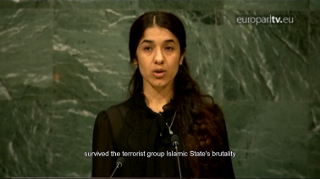
The European Parliament awarded the 2016 Sakharov Prize for Freedom of Thought to Nadia Murad Basee Taha and Lamiya Aji Bashar, two Yazidi victims of ISIL/Da’esh brutality. (video)
The European Council
In 2016 the European Council met in February, March, June, October and December. Heads of State or Government addressed and provided orientations on key issues such as boosting growth, jobs and competitiveness, completing the Single Market, EU trade policy, internal and external aspects of migration policy, security, and energy and climate change. The leaders also met in an informal setting in Bratislava to discuss the state of the Union and their common future in the aftermath of the UK referendum.
[CH10-GR**]
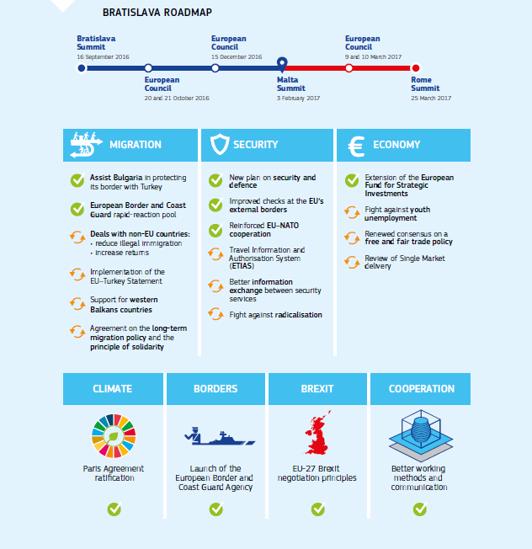
The Council of the European Union
The rotating presidency of the Council was held by the Netherlands and Slovakia in 2016. The ongoing migration crisis, armed conflicts around the world and the fight against terrorism were major topics discussed in the Council during the year. The Council made progress in a number of areas, including taxation, energy and climate change, the financing of the economy and the deepening of the Single Market.
The European Economic and Social Committee and the Committee of the Regions
[CH09-PH40]
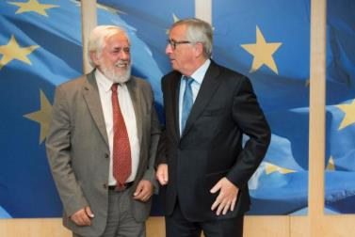
Jean-Claude Juncker, President of the European Commission (right), receives a visit from Georges Dassis, President of the European Economic and Social Committee, Brussels, 26 September 2016.
The European Economic and Social Committee took a significant stance on the refugee crisis in 2016. At the request of the Commission, the Committee also provided an exploratory opinion on the European Pillar of Social Rights. In September the Committee adopted, at the request of the Commission, an exploratory opinion on sustainable development.
The Committee of the Regions organised a European Summit of Regions and Cities in Bratislava, Slovakia, in July. It adopted a declaration calling for a forward-looking vision for Europe based on strengthening investment for promoting cohesion, sustainable growth and job creation in the EU’s cities and regions. The Committee also hosted the European Week of Regions and Cities in October.
[CH09-PH41]
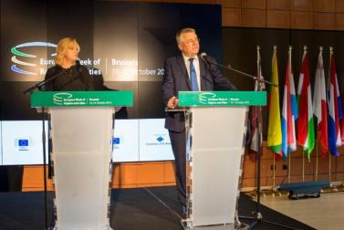
Commissioner Corina Crețu with Markku Markkula, President of the Committee of the Regions of the European Union, at the 14th European Week of Regions and Cities, Brussels, 10 October 2016.
Better regulation
Interinstitutional Agreement on Better Law-making
In April the European Parliament, the Council of the European Union and the European Commission signed a new Interinstitutional Agreement on Better Law-making, based on a Commission proposal, to improve the application of better regulation principles by all institutions. This means taking ambitious action where needed to tackle problems in the EU and designing such action in the most effective, efficient and open manner possible. The Agreement promotes evidence-based policymaking throughout the legislative cycle along with a systematic evaluation of how legislation performs in practice. The Agreement will make the EU legislative process more transparent, open to stakeholder input and easier to follow.
[CH09-GR17]
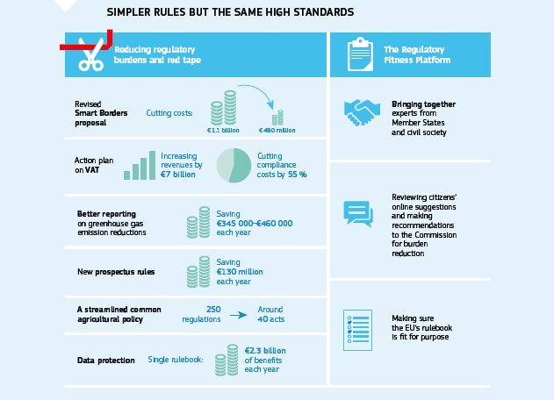
The 2017 European Commission Work Programme
In October the Commission adopted its Annual Work Programme for 2017, setting out a list of actions that it will take in the coming year and identifying where it intends to withdraw already-tabled proposals or review existing legislation. The 2017 Work Programme follows up on the 10 political priorities of the Commission.
REFIT Scoreboard
The Commission’s work on a wide range of actions to evaluate, revise and simplify EU legislation and to reduce regulatory burdens was reflected in the REFIT Scoreboard presented together with the 2017 Work Programme. The REFIT Scoreboard showed the state of play on 231 initiatives for simplifying and reducing administrative burdens in existing legislation. The Commission also published a Scoreboard Summary outlining the key elements of the REFIT Scoreboard and providing detailed information on the first 22 REFIT Platform opinions, along with the way in which the Commission intends to follow up.
REFIT Platform
The REFIT Platform brings together 48 high-level experts from a diversity of stakeholders, the European Economic and Social Committee, the Committee of the Regions and all Member State governments. It advises the Commission on how to make EU Regulations more efficient and effective while reducing administrative burden without undermining policy objectives. Much of the work of the Platform is based on stakeholder input (often communicated through the Lighten the load — Have your say website). Meetings took place in January, April, May, June, September and November, and 24 opinions were adopted across a wide area of EU regulation.
Regulatory Scrutiny Board
The Regulatory Scrutiny Board is an independent body of the Commission that scrutinises the quality of draft impact assessments and of major retrospective evaluations and fitness checks. It was established in July 2015, replacing the Impact Assessment Board. In the course of 2016 the board reviewed and issued opinions on 60 impact assessments and seven evaluations.
New web presence and feedback mechanisms
During the year the Commission took further steps to open up the EU decision-making process to stakeholder and citizen input. Draft delegated and implementing acts were, from the end of June, open for public feedback for a period of 4 weeks. By the end of the year 106 draft delegated and implementing acts had been published.
Roadmaps or inception impact assessments for new initiatives, evaluations and legislative proposals have been open for stakeholder comments and contributions since July 2015. By the end of 2016, 338 roadmaps and inception impact assessments had been published for feedback. During the same period 147 legislative proposals were published for feedback.
Monitoring the application of EU law
In July the Commission adopted its 33rd annual report on monitoring the application of EU law, which reviewed the Member States’ performance in applying EU law and highlighted the main trends in enforcement policy in 2015. The report showed that the total number of infringement procedures was at a consistently lower level compared to 5 years before.
The Commission has reinforced its preventive action to support Member States in the implementation process for Union legislation. When Member States fail to transpose a directive within the agreed deadline the Commission continues to make full use of the financial sanctions system, including the provision introduced by the Treaty of Lisbon for late transposition of directives.
In December the Commission, in its Communication entitled ‘EU law: better results through better application’, set out how it will step up its efforts on the application, implementation and enforcement of EU law for the benefit of all citizens, consumers and businesses in the EU.
Transparency and accountability
Proposal for a mandatory transparency register
In September the Commission proposed to establish a mandatory transparency register, covering the European Parliament, the Commission and, for the first time, the Council.
Access to documents
The right of public access to documents is an important tool in the field of transparency. In August the Commission adopted its 2015 report on requests for access to documents. Requests increased by more than 8 % (6 752 applications in 2015 compared to 6 227 in 2014). The requested documents were fully or partially disclosed in 84 % of cases.
Control of the EU budget
After a positive recommendation from the Council, the Parliament gave its final approval in April to the way the Commission implemented the EU budget in 2014.
In July the Commission presented an Integrated Financial Reporting Package on the EU budget, putting together all of the available information on the EU’s revenue, expenditure, management and performance in 2015. The reports demonstrated that the EU budget delivered results in line with the Commission’s priorities and was implemented properly. They also provided important input into the annual discharge procedure for 2015.
[CH10-PH42]
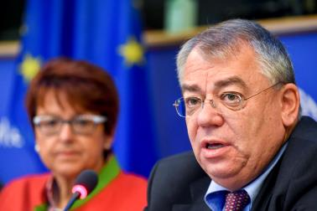
Klaus-Heiner Lehne, President of the European Court of Auditors (right), presents the Court of Auditors’ annual report for 2015 to the Committee on Budgetary Control of the European Parliament, Brussels, 13 October 2016.
When deciding whether to grant, postpone or refuse a discharge the Parliament takes into consideration the annual report of the European Court of Auditors. In October the Court presented its annual report on the implementation of the EU budget in 2015. The external auditor of the Commission gave the EU accounts a clean bill of health for the ninth year in a row, and also confirmed that both the revenue side and administrative expenditure continued to be free from significant errors. Moreover, the Court estimated a decreased overall error rate (3.8 %) for the third consecutive year.
It is important to note that for around 80 % of the EU’s annual budget, notably in the areas of agriculture and cohesion policy, Member States are the ones primarily responsible for the daily management of EU funds, with the Commission exercising an important control function.
National parliaments
In July the Commission adopted two annual reports for 2015 on subsidiarity and proportionality and relations with national parliaments.
Subsidiarity issues in 2016
During the year the Commission received 68 reasoned opinions from national parliaments under the Subsidiarity Review Mechanism, claiming that legislative acts presented by the Commission did not comply with the subsidiarity principle. A total of 14 of these reasoned opinions concerned the Commission proposal to review the Posting of Workers Directive. After careful analysis the Commission concluded that the proposal complied with the subsidiarity principle and decided to maintain it, giving reasons for its decision in July.
Relations with national parliaments
In 2016 the Commission continued to strengthen its relations with national parliaments. The number of opinions received from national parliaments increased from 350 in 2015 to 613 in 2016, an increase of 75 %. Commissioners met with national parliamentarians during their many visits to Member States, at interparliamentary meetings and at other events.
The European Ombudsman
[CH10-PH43]
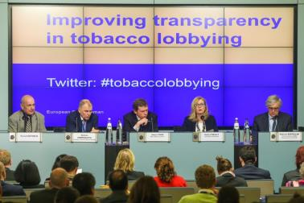
Pascal Diethelm, President of OxyRomandie, Commissioner Vytenis Andriukaitis, James Crisp, News Editor of EurActiv, Emily O’Reilly, European Ombudsman, and Roberto Bertollini, Chief Scientist and World Health Organisation Representative to the EU, participate in the Ombudsman’s event on improving transparency in tobacco lobbying, Brussels, 27 April 2016.
The European Ombudsman investigates complaints about maladministration in the institutions and bodies of the European Union. Inquiries carried out in 2016 covered topics ranging from the composition of Commission expert groups, to rules on access by tobacco lobbyists to the Commission, Commission Special Advisors, the code of conduct for Commissioners and the transparency of trilogues between the European Parliament, the Council and the Commission during the legislative procedure.
The European Citizens’ Initiative
A European Citizens’ Initiative allows 1 million citizens from at least one quarter of EU Member States to invite the Commission to propose a legal act in areas where the Commission has the power to do so. In 2016 the Commission registered three new initiatives, and announced in its 2017 Work Programme plans to legislate on issues raised by an earlier initiative (Right2Water).
Citizens’ dialogues
[CH10-PH44]
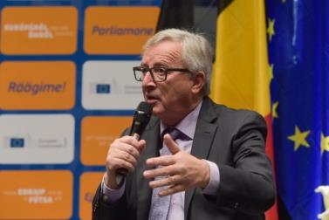
Jean-Claude Juncker, President of the European Commission, addresses a citizens’ dialogue in St. Vith, Belgium, 15 November 2016.
Throughout the year the Commission continued to engage with the public through citizens’ dialogues. The Commission President, Vice-Presidents and Commissioners, along with a number of Members of the European Parliament and national politicians, took part in dialogues during the year. The 73 dialogues provided citizens with a unique opportunity to discuss face-to-face with decision-makers regarding what is happening in the European Union, how the EU is tackling key challenges and how its actions benefit citizens, while enabling EU and national politicians to listen to and learn from citizens from right across the Union on a wide range of topics.

