

The EU in 2016

General Report on the Activities of the European Union

Published in accordance with Article 249(2) of the Treaty on the Functioning of the European Union

Foreword

[CH00-PH01]

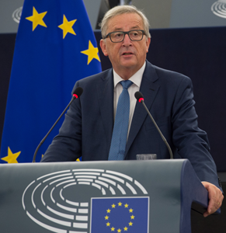

Jean-Claude Juncker, President of the European Commission, gives his State of the Union address for 2016 in the European Parliament, Strasbourg, France, 14 September 2016.

Throughout a year in which the European and global political landscape shifted further than many imagined, the EU remained a source of resilience, stability and forward momentum for its citizens. By focusing on the areas that matter and make most sense for Europeans, no time was lost on delivering on the EU’s most pressing challenges.

That progress was facilitated by a renewed sense of unity and commitment within the EU. September’s Bratislava Declaration and Roadmap saw all 27 Member States present agree on the positive agenda for collective action that I presented in my State of the Union address. Coming just 3 months after the United Kingdom referendum on EU membership, this was a crucial moment for the EU’s members to come together and look forward. Building on that momentum, the European Parliament, the Council and the Commission agreed the first ever [Joint Declaration on the EU’s legislative priorities for 2017](http://eur-lex.europa.eu/legal-content/EN/TXT/PDF/?uri=CELEX:32016C1224(01)&from=EN), signed by the three EU institutions in December.

Only by working together can we tackle our common challenges and build a European Union that protects; that preserves the European way of life; that empowers its citizens; that defends at home and abroad; and that takes responsibility.

Over the last year we have made progress towards that, but we have a lot more to do. Unemployment is now at its lowest in the EU since 2009. Youth unemployment has dropped by 10 % in the last year alone but remains too high, especially in the parts of the EU where the recovery has taken more time.

That is why in 2016 the Commission committed itself to reinforcing the Youth Guarantee, which has already helped 9 million young people take up an offer of work, education or training. To back that up, the Commission proposed to increase funding for the Youth Employment Initiative by €2 billion. This will help support 1 million more young people by 2020.

But when it comes to the young people of the EU — our future — we need to invest more than money. There is one 2016 initiative that is particularly close to my heart: the launch of the European Solidarity Corps. The Corps will enable young people to volunteer for solidarity activities across the EU to help the most vulnerable, develop new skills and forge new bonds. That is an investment in our future. It was only launched in early December but by the end of the month more than 18 000 young Europeans had registered. We are in safe hands!

We need to support those young people by getting our economy working for them. That is why in September I announced a large-scale expansion of the European Fund for Strategic Investments, which was endorsed by the European Council in December.

The numbers speak for themselves: €164 billion of investment has already been triggered across all 28 Member States and €22.4 billion of financing has been secured for infrastructure projects.

It is also an investment in keeping pace with the digitisation of our economy and society. That is why in 2016 the Commission proposed a reform of the EU’s telecommunications markets. If we invest in new networks and services we will create at least 1.3 million new jobs over the next decade.

2016 also saw us make good progress on migration. The EU now has a comprehensive strategy to save lives, secure our borders and enable us to deal with those seeking asylum on our shores. We set up a European Border and Coast Guard in record time. We worked together with Turkey to implement the EU–Turkey Statement to help destroy the business model of people smugglers and traffickers and offer safe and legal ways to the EU for those who need our protection. We are tackling the root causes of illegal migration by working with our African friends through new migration partnerships. And we are reforming our asylum policy to put in place a genuinely Common European Asylum System.

An EU that protects is an EU that defends and empowers — at home and abroad. Last year the Union continued to stand up for its values of openness, freedom, tolerance and solidarity. This is what the rest of the world expects from us as a positive global force. In 2016 we continued to forge links with our partners, and the new trade partnership with Canada shows our commitment to working with like-minded partners to create opportunities in the EU and beyond.

The barbaric terrorist acts on our soil in the past year have shown us again what we are fighting for — the European way of life. In the face of the worst of humanity we have to stay true to our values and to ourselves. It is about defending the beliefs that our society is built on: democracy, openness, tolerance and diversity. And it is about defending ourselves from those who wish us harm.

That is why we have prioritised security — criminalising terrorism and foreign fighters across the EU, cracking down on the use of firearms and on terrorist financing, working with internet companies to get terrorist propaganda offline and fighting radicalisation in the EU’s schools and prisons. We will also defend our borders: for every short-term visitor to the EU, the Commission proposed that there be a record of when and where he or she entered and exited.

But in order to do all this we need to keep the unity shown by the EU-27 and the EU institutions in 2016.

Our ambition now, as the European Union, must not simply be to adapt to a changing world, but to shape it. Our goal is not only to protect what we have today, but to build a better society for tomorrow.

Our children deserve a Europe that preserves their way of life. They deserve a Europe that empowers and defends them. They deserve a Europe that protects. It is time we — the institutions, the governments and the citizens — all took responsibility for building that Europe. Together.

Jean-Claude Juncker

[CH00-VD01]

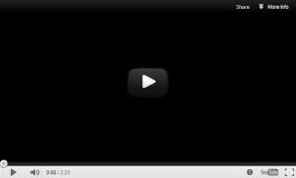

The EU in 2016. (video)

Chapter 1

A new boost for jobs, growth and investment

‘My first priority as Commission President will be to strengthen Europe’s competitiveness and to stimulate investment for the purpose of job creation.’

Jean-Claude Juncker, political guidelines, 15 July 2014

Since the global economic and financial crisis the European Union has been suffering from low levels of investment. Collective and coordinated efforts at Union level are needed to put the EU on the path towards economic recovery. Boosting jobs and growth was a top priority for the EU in 2016, building on what had been achieved the year before.

The Investment Plan for Europe mobilised over €163 billion of new investments across the EU in 2016. The success of the Plan led to the announcement in September by Jean-Claude Juncker, President of the European Commission, of the extension of the Plan’s initial target of €315 billion of new investments by 2020 to at least €500 billion, and beyond that to €630 billion by 2022. The proposal to extend the duration of the European Fund for Strategic Investments was backed in December by the European Council. The Commission also proposed a new European External Investment Plan to encourage investment in Africa and the EU neighbourhood in order to strengthen the EU’s partnerships and contribute to achieving the Sustainable Development Goals.

The Commission simplified the procedure for detecting and assessing macroeconomic imbalances and put greater focus on employment and social considerations in the European Semester (the EU’s economic policy coordination cycle). It also proposed a new set of recommendations for structural reforms, with a greater emphasis on growth-enhancing policies such as research and innovation.

Throughout the year, boosting the EU economy was supported by policies in areas such as research and innovation, regional policy, transport, employment, the environment, agriculture and fisheries. Particular emphasis was placed on providing small businesses with greater access to finance and technical support, with the launch of the new [European Investment Advisory Hub](http://www.eib.org/eiah/), the continued success of the EU’s [programme for small and medium-sized enterprises](http://ec.europa.eu/growth/smes/cosme/) and the increase in funding under the Investment Plan.

The Investment Plan for Europe

[CH01-PH02]

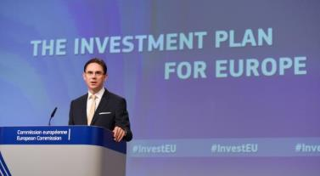

Commission Vice-President Jyrki Katainen answers questions from the press on the progress of the Investment Plan for Europe, Brussels, 1 June 2016.

The Commission, together with the [European Investment Bank](http://www.eib.org/), launched the [Investment Plan for Europe](http://ec.europa.eu/priorities/jobs-growth-and-investment/investment-plan_en) in 2015. The [European Fund for Strategic Investments](http://www.eib.org/efsi/index.htm) was created with an initial €21 billion of EU money.

[CH01-PH03]

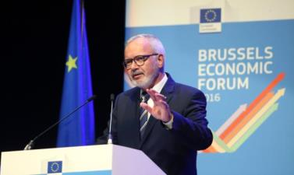

Werner Hoyer, President of the European Investment Bank, addresses the Brussels Economic Forum 2016, Brussels, 9 June 2016.

In 2016 the fund remained firmly on track to deliver on mobilising at least €315 billion in additional investments in the real economy by mid 2018. It was active in all 28 Member States and, as of December 2016, was expected to trigger just under €164 billion in total investment.

By the end of 2016, 175 infrastructure projects representing financing of €22.4 billion had been approved under the fund. In addition, 247 financing agreements, worth €8.2 billion, had been approved for smaller companies. Close to 385 000 small businesses were expected to benefit.

[CH01-GR01]

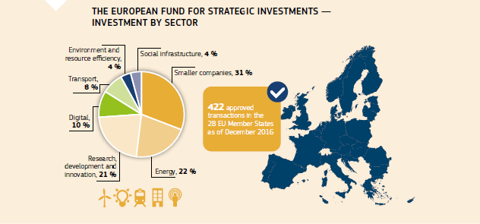

Given the success of the Investment Plan, the Commission proposed in September to extend its duration and financing, targeting at least €500 billion of investments by 2020. The European Council endorsed this in December 2016.

[CH01-VD02]

[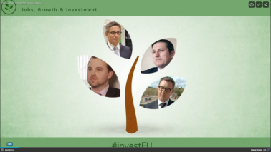](http://ec.europa.eu/avservices/video/player.cfm?ref=I103157&sitelang=en&videolang=INT/EN)

The Investment Plan reaches the real economy. (video)

The EU is reinforcing the social dimension of the fund for both microfinance and social entrepreneurship. Overall, the total amount of support to these areas is expected to increase from €193 million under the Employment and Social Innovation Programme to about €1 billion, mobilising some €3 billion in additional investment. Agreements have been signed with more than 100 microfinance providers to support over 100 000 micro-entrepreneurs in EU Member States.

Helping small and medium-sized companies

Help for small businesses came from many different sources.

In view of its success, the European Fund for Strategic Investments’ allocation for small businesses was increased in July 2016 by an extra €500 million.

In addition to the Investment Plan, the COSME programme, [the EU’s programme for small and medium-sized enterprises](http://ec.europa.eu/growth/smes/cosme/), is running from 2014 to 2020 with a budget of €2.3 billion to help the creation and growth of companies. It helps companies access markets, creates a favourable business environment and promotes entrepreneurship. The mid-term budget review proposed to increase the budget for financial instruments by €200 million.

In 2016 a further €45 million was used to help small and medium-sized companies find business partners, understand EU legislation and access EU funding through the [Enterprise Europe Network](https://een.ec.europa.eu/). About 450 000 companies received services from 625 participating organisations in all EU regions and 35 non-EU countries.

In November the Commission adopted [the Start-up and Scale-up Initiative](http://europa.eu/rapid/press-release_IP-16-3882_en.htm) to give the EU’s many innovative entrepreneurs every opportunity to become world leaders. It pulls together all the possibilities that the EU already offers and adds a new focus on venture capital investment, insolvency law, taxation and intellectual property.

[CH01-GR02]

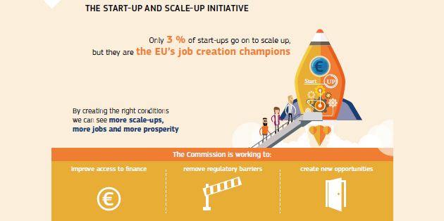

Boosting the EU economy

Throughout the year the creation of jobs and growth was supported by policies in many areas, including regional policy, research and innovation, transport, agriculture, employment and education.

Regional policy

[CH01-PH04]

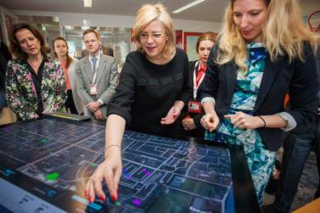

Commissioner Corina Crețu visits the Smart City Experience Lab, Amsterdam, the Netherlands, 22 April 2016.

The European Structural and Investment Funds, with a budget of €454 billion for 2014-2020, continued to invest in the Union’s priority areas. Strategically investing in key growth-generating areas, regional policy is a vital pillar of the EU’s Jobs and Growth Agenda.

In the years 2014-2020 the funds will invest €121 billion in research and innovation, digital technologies and support for small businesses throughout the EU.

Two million businesses and start-ups will be directly supported by the funds to boost their competitiveness and increase their research and innovation capacity.

In 2016 the EU simplified access to the funds for small businesses and cities. It also increased the uptake of financial instruments and ensured that an increased number of combinations could be made with other EU funds, especially the European Fund for Strategic Investments.

The [evaluation of the Regional Development and Cohesion Funds for the 2007-2013 period](http://ec.europa.eu/regional_policy/en/policy/evaluations/ec/2007-2013/#1) was published in September. Key achievements included €2.74 of additional gross domestic product for every €1 invested through cohesion policy, over 1 million jobs created, 5 000 km of new roads and 1 000 km of new railways built.

Research and innovation

[Horizon 2020](https://ec.europa.eu/programmes/horizon2020/en) is the biggest EU research and innovation programme ever, with €77 billion of funding available over the 2014-2020 period. It supports world-class research, builds industrial leadership in the EU and aims to provide solutions to societal challenges in areas such as climate change, energy, health and security.

[CH01-VD03]

[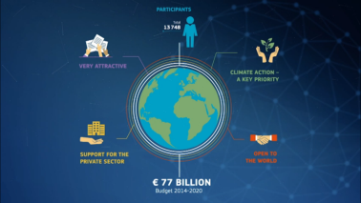](http://ec.europa.eu/avservices/video/player.cfm?sitelang=en&ref=I124578+)

A budget focused on results in research and innovation. (video)

The European Fund for Strategic Investments continued to complement Horizon 2020, in particular through its support for innovative small and medium-sized companies. The fund helped satisfy extraordinary demand for support from the [EU Finance for Innovators](http://www.eib.org/products/blending/innovfin/) initiative, a joint initiative launched by the Commission and the European Investment Bank under Horizon 2020.

EU research and innovation policy was refocused on three strategic objectives: open innovation, open science and open to the world. These were implemented through initiatives at three levels: increasing the recognition of research and innovation as a key driver of economic growth and job creation (notably through the European Semester and the Horizon 2020 Policy Support Facility); improving the framework conditions for research and innovation; and continuing the strategic programming of Horizon 2020. New initiatives included the [Innovation Deals](http://ec.europa.eu/research/index.cfm?pg=newsalert&year=2016&na=na-260516) pilot scheme, which was launched in 2016 with the aim of reducing barriers to innovation and boosting the circular economy, and the [European Open Science Cloud](http://europa.eu/rapid/press-release_IP-16-1408_en.htm). Preparatory work started on longer-term measures to improve the innovation environment in the EU, including a call for ideas on a possible [European Innovation Council](http://ec.europa.eu/research/index.cfm?pg=newsalert&year=2016&na=na-040516).

Space for innovation and investment

In October 2016 the Commission published a [Space Strategy for Europe](http://europa.eu/rapid/press-release_IP-16-3530_en.htm). It aims to maximise the benefits of the European Union’s space programmes to society and to unlock the potential of the space sector to boost innovation, jobs and growth creation in the EU’s economy. It will help the EU space industry to remain a world leader. The Strategy also confirmed the importance of the sector for EU security and in strengthening the EU’s role as a global actor.

The [Galileo programme](http://europa.eu/rapid/press-release_IP-16-4366_en.htm), the EU’s initiative for a state-of-the-art global satellite navigation system, reached a major milestone in 2016 following the successful launch of four additional satellites using the European Ariane 5 rocket. The initial services — navigation, search and rescue and the public regulated service — were announced in December 2016.

Sustainable growth

In 2016 the EU made further progress on the [Circular Economy Package](http://europa.eu/rapid/press-release_IP-15-6203_en.htm) proposed in 2015. Many natural resources are finite, and the EU is a net importer of many raw materials. To ensure sustainable growth it has to use its resources in a smarter, more sustainable way. Waste prevention, better design of products, recycling, reuse and similar measures could bring net savings of €600 billion for businesses in the EU while reducing total annual greenhouse gas emissions by 2-4 %.

In March the Commission proposed a Regulation that will create an internal market for fertilisers from secondary raw materials, thereby turning waste management problems into economic opportunities. This could create about 120 000 jobs thanks to the recycling of bio-waste into organic-based fertilisers.

In November the Commission adopted the Eco-Design Working Plan for 2016-2019 as part of the [Clean Energy for All Europeans](http://europa.eu/rapid/press-release_IP-16-4009_en.htm) package. This will help establish product requirements relevant for the circular economy, increasing the durability of products and making them easier to repair, reuse and recycle.

Protecting Europe’s seas

The EU fishing industry is the world’s fourth largest, supplying some 6.4 million tonnes of fish each year. Fishing and fish processing provide jobs for over 350 000 people. Using the resources of Europe’s oceans sustainably is at the heart of the European Union’s fisheries and maritime policies. In November 2016 the Commission published its proposals for better international ocean governance. This sets out how the EU could contribute to achieving the United Nations Sustainable Development Goals by ensuring that the world’s oceans are managed more wisely. Commissioner Karmenu Vella also launched the [MedFish4Ever](https://ec.europa.eu/fisheries/inseparable/en/medfish4ever) initiative in April 2016, drawing attention to the critical state of fish stocks in the Mediterranean Sea, where more than 90 % of the assessed stocks are currently overfished.

[CH01-PH09]

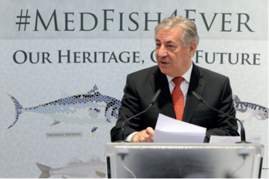

Commissioner Karmenu Vella at the launch of the MedFish4Ever initiative, Brussels, 27 April 2016.

Connecting Europe

[CH01-PH05]

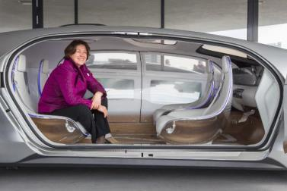

Commissioner Violeta Bulc participates in a demonstration of self-driving cars at the Innovation Expo, Amsterdam, the Netherlands, 14 April 2016.

To contribute to the digitalisation and decarbonisation of transport, in June the Commission put forward a list of [195 transport projects](http://ec.europa.eu/transport/themes/infrastructure/ten-t-guidelines/project-funding/doc/cef/2015-cef-selected-proposals.pdf) that are to receive €6.7 billion of EU funding under the [Connecting Europe Facility](http://ec.europa.eu/transport/themes/infrastructure/ten-t-guidelines/project-funding/cef_en.htm). The investment is expected to create up to 100 000 jobs by 2030.

Selected projects are primarily located within the [core trans-European transport network](http://ec.europa.eu/transport/themes/infrastructure/ten-t-guidelines/corridors/index_en.htm). Among the beneficiaries are initiatives such as the rehabilitation of the Brasov–Sighisoara rail section in Romania, the Aveiro–Vilar Formoso railway connection in Portugal, the development of a standard-gauge railway line on the North Sea-Baltic Corridor and the implementation of the [Single European Sky Air Traffic Management Research Deployment Programme](http://ec.europa.eu/transport/modes/air/sesar/deployment_en.htm). In October 2016 the Commission launched the third round of calls for proposals under the Connecting Europe Facility for transport, making €1.9 billion available to finance key transport projects.

Jobs and growth through agriculture

[CH01-PH07]

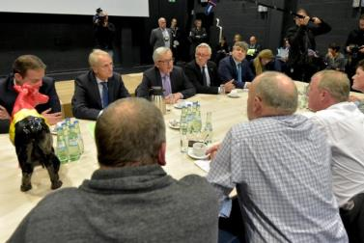

Jean-Claude Juncker, President of the European Commission (centre), meets with a delegation of dairy producers, St. Vith, Belgium, 15 November 2016.

Agriculture in the European Union provides a variety of quality food products and environmental public goods for citizens and contributes to the cultural and social fabric of rural areas. The agri-food sector accounts for [nearly 44 million jobs](http://ec.europa.eu/agriculture/events/2015/outlook-conference/brochure-jobs-growth_en.pdf) in the EU, while [EU agri-food exports](http://europa.eu/rapid/press-release_IP-16-2525_en.htm) are worth over €120 billion per year.

The common agricultural policy supports this with an annual budget of roughly €59 billion, providing support for farm income, for farmers to deliver environmental benefits and for other activities to increase the sector’s competitiveness, resource-efficiency and life in rural areas.

Annual direct payments to farmers provide basic protection of farm income against the specific shocks to which agriculture is exposed.

In March 2016 the Commission [activated exceptional measures](http://europa.eu/rapid/press-release_IP-16-806_en.htm) to strengthen the position of livestock producers. In July it [announced a package](http://europa.eu/rapid/press-release_IP-16-2563_en.htm) worth €500 million to reduce milk production and support milk producers and farmers in other livestock sectors. Further support was made available to the fruit and vegetable sector, which was affected by the Russian import ban.

[CH01-PH08]

Visit of the dairy of Farm Pustotnik in Gorenja vas-Poljane:</br>
From left to right, &Zcaron;u&zcaron;a Brence, owner of the dairy of Farm Pustotnik, Violeta Bulc, Phil Hogan, an interpreter and Dejan &Zcaron;idan, Forestry and Food

Commissioners Violeta Bulc and Phil Hogan, together with Dejan Židan, Slovenian Minister for Agriculture, Forestry and Food (right), visit Pustotnik Farm, a dairy farm promoting the consumption of local products, Gorenja vas-Poljane, Slovenia, 14 July 2016.

In January the Commission created the [Agricultural Markets Task Force](http://ec.europa.eu/agriculture/agri-markets-task-force/index_en.htm) to give recommendations on how to improve the functioning of the food supply chain and offer farmers an attractive perspective for economic stability and growth. It published its [report](https://ec.europa.eu/agriculture/sites/agriculture/files/agri-markets-task-force/improving-markets-outcomes_en.pdf) in November. A [Meat Market Observatory](http://ec.europa.eu/agriculture/market-observatory/meat/index_en.htm) was set up to improve market transparency for the beef, veal and pork sectors, helping operators to read market signals and to cope better with market volatility.

Together with other members of the Commission, Commissioner Phil Hogan ran a concerted campaign to tackle non-tariff barriers to trade in non-EU countries where there is a potential market for EU products. These efforts resulted in the opening up of markets in China, Colombia, Japan and the United States for certain EU exports in 2016. Promising new markets in Indonesia, Mexico and Vietnam were also targeted in high-level trade missions.

New skills, better protection, more jobs for the young

[CH01-PH06]

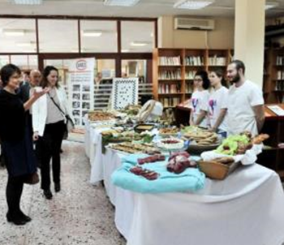

Commissioner Marianne Thyssen meets with students from the Vocational Training School of Athens, Greece, 21 April 2016.

EU funding, in particular through the European Social Fund, is set to support the upskilling of 8 million EU workers between 2014 and 2020. With its budget of €14.7 billion, [Erasmus+](http://ec.europa.eu/programmes/erasmus-plus/node_en) will provide opportunities for over 4 million people to study, train, gain experience and volunteer abroad. The programme also provides support for activities helping Member States modernise and transform their education and training systems.

In May the European Platform Tackling Undeclared Work was launched, the purpose of which is to turn undeclared work into declared work. The Platform ensures social protection for millions of people in the EU who lose out through risky job arrangements, including dependent work relationships hidden as self-employment.

The Commission launched a [New Skills Agenda for Europe](http://ec.europa.eu/social/main.jsp?langId=en&catId=89&newsId=2556&furtherNews=yes) in June with 10 actions to improve the quality of skills and their relevance for the labour market. These include an initiative to help low-skilled adults improve their literacy, numeracy and digital skills and/or help them progress towards an upper secondary education qualification or equivalent.

To combat youth unemployment the EU continued to support the roll out of the Youth Guarantee in Member States. In October a progress report showed how the 2013 Youth Guarantee, backed by the Youth Employment Initiative, the European Social Fund and national funding, has made a difference on the ground. Three years on from its launch in 2013 there are 1.4 million fewer young people unemployed in the EU. Around 9 million young people have taken up an offer for a job, a traineeship or an apprenticeship. It has led to bold structural reforms in many Member States and helped build business-education partnerships. To ensure the full and sustainable implementation of the Youth Guarantee the Commission has proposed the continuation of the Youth Employment Initiative until 2020 and the extension of its resources. Furthermore, the Commission announced a new dedicated long-duration (between 6 and 12 months) mobility scheme for apprentices, Erasmus Pro, within the existing Erasmus+ programme, to support work-based learning abroad.

[CH01-VD04]

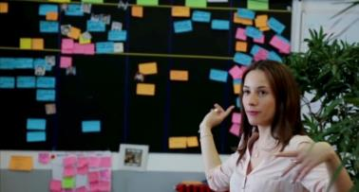

The Youth Guarantee and the Youth Employment Initiative. (video)

Connecting people

In 2016 the [Erasmus+](http://ec.europa.eu/programmes/erasmus-plus/node_en) programme for education, training, youth and sport, with a budget of €2.2 billion, enabled around 497 000 young people to study, train, volunteer and participate in youth exchanges abroad. It also enabled around 141 000 members of staff from educational institutions and youth organisations to improve their competencies by teaching and training abroad. In 2016 the programme made available more than €400 million from the overall budget for cooperation projects, including those prioritising the promotion of citizenship and the common values of freedom, tolerance and non-discrimination through education.

The European Solidarity Corps

In December, 2 months after President Juncker had [announced](https://ec.europa.eu/priorities/state-union-2016_en) it in his State of the Union speech, the Commission launched the European Solidarity Corps. Young people between the ages of 17 and 30 can sign up for new opportunities to make an important contribution to society across the EU, and to gain experience and acquire skills. Participants may be placed with a project either for volunteering or for a traineeship, an apprenticeship or a job for a period of between 2 and 12 months. Participants will be able to engage in activities such as education, health, social integration, assistance in the provision of food, shelter construction, the support and integration of migrants and refugees, environmental protection and the prevention of natural disasters. By the end of December over 18 000 people had registered.

Economic and fiscal policy

Economic policy coordination in the EU is organised annually in a cycle known as the European Semester. It is launched towards the end of each year with the publication of the Annual Growth Survey and a recommendation on the economic policy of the euro area. The Commission published [country reports](http://ec.europa.eu/europe2020/making-it-happen/country-specific-recommendations/index_en.htm) in February 2016 analysing the economic and social challenges in the EU’s Member States individually. They served as the basis for discussion with Member States of their policy choices ahead of their national reform programmes and medium-term budgetary plans in April. In late spring these reports led to the formulation of the Commission’s [country-specific recommendations](http://ec.europa.eu/europe2020/making-it-happen/country-specific-recommendations/index_en.htm).

These recommendations provide guidance to Member States on how to boost jobs and growth, with a renewed focus on growth-enhancing reforms in areas such as research and innovation, while maintaining sound public finances. In 2016 recommendations were also addressed to Cyprus as it rejoined the full economic governance framework in spring after exiting its economic adjustment programme.

On the fiscal front the recommendations made by the Commission in 2016 showed that the Stability and Growth Pact can be applied with intelligent flexibility. The Commission took into account the specificity of expenditure related to unusual events outside the control of the government (such as the refugee crisis and counterterrorism) when assessing Member States’ medium-term budgetary plans. Spain and Portugal were given more time to correct their excessive deficit and the Council followed the recommendation of the Commission to cancel the fine that could have been imposed given their respective past fiscal performance. The year saw further progress concerning excessive deficits, which allowed the number of Member States found in [excessive deficit](http://ec.europa.eu/economy_finance/economic_governance/sgp/corrective_arm/index_en.htm) to be reduced to six, down from 24 in spring 2011. Three Member States corrected their excessive deficits in 2015 and the related excessive deficit procedures were formally closed by the Council in June 2016.

Looking at the euro area in particular, the Commission called for a significantly more [positive fiscal stance](https://ec.europa.eu/info/publications/2017-european-semester-communication-fiscal-stance_en) for the currency area as a whole to overcome the risk of ‘low growth, low inflation’ and to support the monetary policy of the European Central Bank.

The Commission also assessed whether the euro-area Member States’ draft budgetary plans for 2017 complied with the provisions of the Stability and Growth Pact. In several cases the Commission found that the planned fiscal adjustments fell short, or risked doing so, of what is required by the Stability and Growth Pact.

Concerning the monitoring of macroeconomic imbalances, the Commission concluded that 13 Member States still experience either imbalances or excessive imbalances. Along with noting progress in addressing imbalances, the Commission also made the implementation of the procedure clearer and more transparent by [reducing the number of categories for imbalances from six to four](http://ec.europa.eu/economy_finance/graphs/2016-03-09_macroec_imb_gov_deficits_en.htm) and brought a greater focus on employment and social considerations into the European Semester.

[CH01-VD05]

[](http://ec.europa.eu/avservices/play.cfm?ref=I114361&videolang=EN&devurl=http://ec.europa.eu/avservices/video/player/config.cfm%22%20id=%22videoplayerI114361%22%20width=%22670%22%20height=%22378%22%20frameborder=%220%22%20scrolling=%22no%22%20webkitAllowFullScreen=%22true%22%20mozallowfullscreen=%22true%22%20allowFullScreen=%22true%22)

Ensuring healthy public finances. (video)

Continuing support for EU Member States

Negotiations continued in the Parliament and the Council on the Structural Reform Support Programme proposed by the Commission in November 2015.

[Cyprus](http://ec.europa.eu/economy_finance/assistance_eu_ms/cyprus/index_en.htm) successfully completed its 3-year economic adjustment programme at the end of March 2016. The Commission continued to support the Cypriot authorities, through its [Structural Reform Support Service](http://europa.eu/rapid/press-release_MEMO-15-6070_en.htm), in implementing growth-enhancing administrative and structural reforms.

In the course of 2016 good progress was made in implementing the Greek programme, which was designed to create the conditions for the return of confidence and to lay the foundation for a lasting economic recovery in Greece. The first review was concluded, allowing the second tranche of funding from the programme, amounting to €10.3 billion, to be paid. This second tranche was disbursed in several steps, with the last disbursement approved in October. The Commission supported the work of the Eurogroup, which decided on debt measures in May. These measures will be implemented on a gradual basis. A first discussion on short-term debt measures took place in early December. On the programme implementation front, good progress was made towards the completion of the second review.

Greece also received economic support through the Investment Plan for Europe. A first deal backed by the European Fund for Strategic Investments was signed in Greece in May. On this occasion the European Investment Fund signed three deals with Greek intermediary banks and funds to provide additional investment to very small, small and medium-sized companies in Greece.

Extending support beyond EU borders

The Commission supported [Georgia, Kyrgyzstan, Jordan, Tunisia and Ukraine](http://ec.europa.eu/economy_finance/international/neighbourhood_policy/ukraine_en.htm) with macrofinancial assistance programmes. The aim is to help countries geographically, economically and politically close to the EU to restore a sustainable external financial situation, while encouraging economic adjustments and structural reforms. The programmes are a complement to International Monetary Fund financing.

In September the Commission proposed a new European External Investment Plan that would boost investment in African and EU neighbourhood countries and contribute to addressing the root causes of migration. It aims to support social and economic infrastructure and small businesses, with a focus on job creation, by removing obstacles to private investment. With an input of €3.35 billion from the EU budget and the European Development Fund, the Plan would support innovative guarantees and similar instruments in support of private investment.

The Plan enables the mobilisation of up to €44 billion in investments. If Member States and other partners match the EU’s contribution, the total amount could double, reaching €88 billion.

An EU budget focused on results

[CH01-PH10]

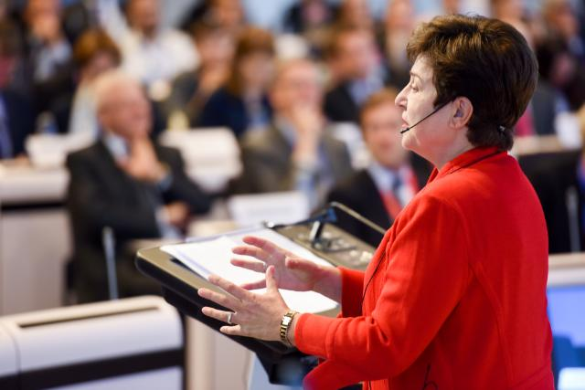

Commission Vice-President Kristalina Georgieva (2014-2016) addresses a conference on an ‘EU budget focused on results’, Brussels, 27 September 2016.

In 2016 the Commission made progress with the EU Budget Focused on Results initiative to ensure that EU resources are put to good use for the benefit of citizens and that all EU-funded projects demonstrate clear benefits and value for money.

The EU budget continued to be invested according to the Commission’s policy priorities, such as stimulating growth, jobs and competitiveness and responding swiftly and effectively to emergencies.

[A database of successful projects funded by the EU budget](http://ec.europa.eu/budget/euprojects/search-projects_en), available on the Commission’s website, displayed more than 1 000 projects in 2016.

On the occasion of President Juncker’s State of the Union address in September, the Commission presented its [Mid-term Review of the Multiannual Financial Framework](http://ec.europa.eu/budget/mff/figures/index_en.cfm#com_2016_603) (2014-2020), including a package of legislative proposals aiming to:

* provide additional financial means for efficiently tackling migration and security risks and foster economic growth, job creation and competitiveness;
* increase the flexibility of the EU budget and its ability to quickly and efficiently address unforeseen circumstances;
* simplify financial rules and thus reduce the administrative burden on recipients of EU funds.

Chapter 2

A connected Digital Single Market

‘We must make much better use of the great opportunities offered by digital technologies, which know no borders. To do so, we will need to have the courage to break down national silos in telecoms regulation, in copyright and data protection legislation, in the management of radio waves and in the application of competition law.’

Jean-Claude Juncker, political guidelines, 15 July 2014

The Digital Single Market Strategy aims to remove online barriers that lead to people in the EU missing out on goods and services. These barriers also mean that internet companies and start-ups cannot take full advantage of digital growth. In 2016 the European Commission presented almost all of its proposals on completing the Digital Single Market, with the adoption of the remaining proposals expected in early 2017. The Commission presented new rules to help people and companies buy and sell products and services online more easily and outlined plans to ensure a fairer and more transparent online market place. It also outlined a strategy to help industry, companies, researchers and public authorities to make the most of new technologies.

To increase trust in the digital world the Commission launched a major partnership with industry on cybersecurity in July. EU artists, creators and cultural diversity were in the spotlight during year-long celebrations of 25 years of the EU MEDIA Programme. In addition, modernisation of the EU’s copyright and broadcasting rules created more opportunities for innovation and creative content online and across borders.

In September’s State of the Union speech, President Juncker announced [WiFi4EU](https://ec.europa.eu/digital-single-market/en/news/factsheet-wifi4eu), a €120 million plan to bring free Wi-Fi to parks, squares, libraries and public buildings in towns and villages across the EU. In addition, the Commission wants all households in the EU to have access to an internet connection of at least 100 megabits per second, which can be upgraded to gigabit speed.

[CH02-GR03]

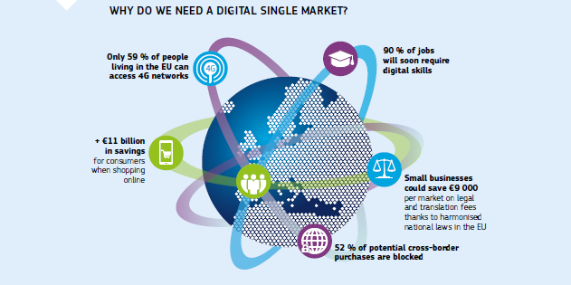

Better access to goods and services

New e-commerce rules to help people and companies

In May 2016 the Commission presented measures to allow consumers and companies to buy and sell products and services online more easily across the EU. The Commission [proposed a Geo-Blocking Regulation](http://ec.europa.eu/DocsRoom/documents/16742) so that people buying products and services in another EU Member State are not discriminated against.

[CH02-VD06]

[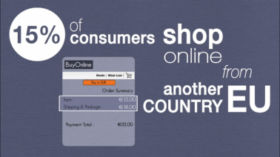](http://ec.europa.eu/avservices/video/player.cfm?sitelang=en&ref=I120668)

The E-commerce package: towards an EU Single Market. (video)

People and small businesses often complain that high charges and [problems with parcel delivery](http://ec.europa.eu/growth/tools-databases/newsroom/cf/itemdetail.cfm?item_id=8610) prevent them from selling or buying more across the EU. The [Regulation](http://ec.europa.eu/DocsRoom/documents/16805) adopted by the Commission in May aims to increase price transparency and regulatory oversight. To boost consumer trust the Commission wants to [update the Consumer Protection Cooperation Regulation](http://ec.europa.eu/consumers/consumer_rights/unfair-trade/docs/CPC-revision-proposal_en.pdf).

Investigating e-commerce

The Commission gathered evidence from nearly 1 800 companies operating in e-commerce for consumer goods and digital content and analysed around 8 000 distribution contracts. In March [initial findings](http://europa.eu/rapid/press-release_IP-16-922_en.htm) revealed that geo-blocking was widespread in e-commerce throughout the EU, especially for digital content. In September the Commission published a [preliminary report](http://ec.europa.eu/competition/antitrust/sector_inquiry_preliminary_report_en.pdf) that confirmed the fast growth of e-commerce in the EU — more than half of adults in the EU ordered goods or services online in 2015. The report identified business practices that might restrict competition and limit consumer choice. The final report is due in 2017.

Simplifying VAT rules

The current VAT system for cross-border e-commerce is complex and costly for Member States and businesses. For businesses the average annual costs of supplying goods to another Member State are estimated at €8 000 per Member State. Moreover, EU businesses are at a competitive disadvantage, as non-EU suppliers can supply VAT-free goods to consumers in the EU under the exemption for imports of small consignments. The complexity of the system also makes it difficult for Member States to ensure compliance, with losses estimated at around €5 billion annually.

As part of the Digital Single Market Strategy the Commission presented a legislative package to modernise and simplify VAT for cross-border e-commerce, in particular for small and medium-sized companies. It will remove the need for businesses selling to consumers in other Member States to register for VAT in any Member State where a customer is located. A further proposal will ensure that electronic publications can benefit from the same reduced rates as physical publications.

Modern EU copyright rules

Today, according to Eurobarometer (the Commission’s public opinion survey service), 73 % of young people in the EU listen to music, watch TV series and films or play games online. Almost 20 % have tried to access services providing content in another Member State, but broadcasters find it complicated to meet this growing demand. To improve choice and access to content the Commission proposed a [Regulation](https://ec.europa.eu/digital-single-market/en/news/proposal-regulation-laying-down-rules-exercise-copyright-and-related-rights-applicable-certain) to make it easier for broadcasters to get clearance from rights holders. The Regulation also simplifies the transmission of online programmes in other Member States and enables channels from other countries to be included in consumer packages.

This is complemented by a proposal for a new [Copyright Directive](https://ec.europa.eu/digital-single-market/news-redirect/34290). The draft Directive will help museums, archives and other institutions to digitise, and make available across borders, books and films that are protected by copyright but no longer available to the public.

Students and teachers want to use digital materials and technologies, but almost a quarter of teachers face copyright-related restrictions in their digital teaching activities. The proposed Copyright Directive will allow educational establishments to use materials to illustrate teaching through digital tools and in online courses across borders. It will make it easier for researchers to use [text- and data-mining](http://ec.europa.eu/research/index.cfm?pg=newsalert&year=2016&na=na-140916.) technologies to analyse large sets of data. The draft Directive also includes a new mandatory EU exception so that cultural heritage institutions can preserve works digitally.

Also according to Eurobarometer, 57 % of people in the EU get their online news from social media, search engines or news aggregators, and 31 % listen to music from online video or music sharing sites. The digital era has brought more consumer choice, broader audiences and fresh opportunities for rights holders, creators and publishers, but many find it difficult to receive fair remuneration or to negotiate with video-sharing and other online platforms. The proposed Copyright Directive aims to create a fairer and more sustainable marketplace by clarifying the obligations of online platforms. It will also strengthen the position of rights holders to negotiate and be remunerated, while recognising the important role press publishers play in investing in and creating quality journalistic content.

Creating the right conditions

Farewell to roaming charges

In April 2016 calling, texting and surfing online from another Member State (roaming) became cheaper, with people only paying a small amount on top of their domestic prices: up to €0.05 per minute for calls made, €0.02 per SMS sent and €0.05 per MB of data used (excluding VAT) from their mobile devices. As of 15 June 2017 people living in the EU will bid farewell to roaming charges when travelling periodically within the Union.

During the year the Commission presented a number of measures to make this happen through a proposal to regulate [wholesale roaming charges](https://ec.europa.eu/digital-single-market/news-redirect/32131) (the prices that operators charge each other for the use of their networks) and [rules to make the end of roaming work for everyone living in the EU](http://europa.eu/rapid/press-release_MEMO-16-4396_en.htm). All EU travellers will enjoy the ‘roam like at home’ opportunity by paying the same price for mobile calls, SMSs and data when they travel away from their home (their country of residence or with which they have stable links). In April new rules took effect that for the first time guarantee the [principle of net neutrality](https://ec.europa.eu/digital-single-market/en/open-internet-net-neutrality) in EU law.

[CH02-VD07]

[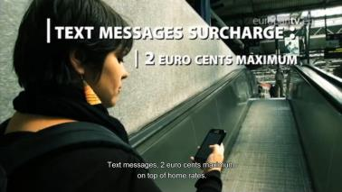](https://www.europarltv.europa.eu/programme/society/roaming-a-big-day-in-a-long-battle)

Roaming: a big day in a long battle. (video)

More and better internet connectivity

By 2020 there will be nearly eight times as much mobile internet traffic as there is today. In 2016 the European Commission set out major legislative and policy initiatives to meet this growing demand. In February [the Commission proposed to better coordinate radio frequencies in the 700 megahertz band](http://europa.eu/rapid/press-release_IP-16-1873_en.htm), to improve mobile internet access and to allow connected cars, remote healthcare and other innovative services to work across the continent.

In September [the Commission proposed an overhaul of EU telecoms rules](https://ec.europa.eu/digital-single-market/en/news/commission-paves-way-more-and-better-internet-connectivity-all-citizens-and-businesses) and further plans to meet the growing connectivity needs of people in the EU. The Commission has the following three objectives.

* All schools, universities, research centres, transport hubs, hospitals, public services and businesses should have access to gigabit connectivity (allowing users to download/upload 1 gigabit of data per second) by 2025.
* All households in the EU should have access to connectivity offering a download speed of at least 100 megabits per second, which can be upgraded to gigabits per second, by 2025.
* All urban areas should have uninterrupted 5G coverage, the fifth generation of wireless communication systems, by 2025. 5G should be commercially available in at least one major city in each Member State by 2020.

These objectives can only be achieved with massive investments. The new [European Electronic Communications Code](https://ec.europa.eu/digital-single-market/en/news/proposed-directive-establishing-european-electronic-communications-code) includes rules that make it more attractive for all companies to invest in new top-quality infrastructure, everywhere in the EU, both locally and across national borders, while maintaining effective competition. The Commission also outlined a plan to deploy [5G](https://ec.europa.eu/digital-single-market/en/towards-5g) across the EU. In his 2016 State of the Union speech President Juncker presented the [WiFi4EU initiative](https://ec.europa.eu/digital-single-market/en/news/factsheet-wifi4eu), a €120 million investment to promote access to wireless connectivity in public places. Free Wi-Fi would then be available in parks, squares, libraries and public buildings to benefit citizens and institutions with a public mission.

[CH02-PH11]

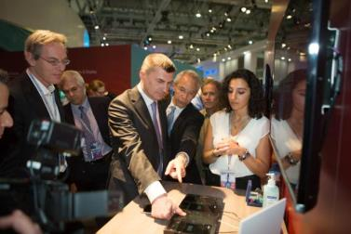

Commission Vice-President Andrus Ansip (centre) tries out next-generation wireless technology at the Mobile World Congress 2016, Barcelona, Spain, 22 February 2016.

In April the need for government and industry to work together to improve data infrastructure for transport was underlined in the [Amsterdam declaration](https://english.eu2016.nl/documents/publications/2016/04/14/declaration-of-amsterdam), discussed by transport ministers from all 28 EU Member States. The Dutch Presidency of the European Council, the European Commission, Member States and the transport industry pledged to draw up rules and regulations that will allow autonomous vehicles to be used on EU roads.

New EU audiovisual rules for cultural diversity

Today, people increasingly view programmes via video-on-demand services (such as Netflix) and video-sharing platforms (such as YouTube), whether on their smartphones or gathered around the family television. To respond to this new reality, the Commission presented a proposal in May for an [updated Audiovisual Media Services Directive](http://europa.eu/rapid/press-release_IP-16-1873_en.htm).

The new legislation aims to achieve a better balance of the rules that today apply to traditional broadcasters, video-on-demand providers and video-sharing platforms, especially when it comes to protecting children. It will strengthen the EU’s cultural diversity — video-on-demand providers will need to ensure at least a 20 % share of European content in their catalogues.

Platforms

In May the Commission presented the results of a [comprehensive assessment](https://ec.europa.eu/digital-single-market/news-redirect/31569) of the social and economic role of platforms such as online marketplaces, search engines, payment systems, social media, video and content-sharing sites. The Commission outlined a principles-based approach to fixing problems flagged during the assessment. This included a commitment that comparable digital services should follow the same or similar rules. Online platforms should behave responsibly, in particular through voluntary efforts by industry such as [the code of conduct on combating hate speech online](http://europa.eu/rapid/press-release_IP-16-1937_en.htm).

Stepping up cybersecurity

According to the [Global State of Information Security Survey 2017](http://www.pwc.com/gx/en/issues/cyber-security/information-security-survey.html) over 80 % of EU companies have experienced at least one cybersecurity incident over the last year. This undermines trust and growth in the Digital Single Market. In July the Commission launched a new [public–private partnership on cybersecurity](https://ec.europa.eu/digital-single-market/en/cybersecurity-industry) to foster cooperation in the early stages of the research and innovation process and to build cybersecurity solutions for various sectors, such as energy, health, transport and finance. This is one of several initiatives to better equip the EU against cyberattacks and to strengthen the competitiveness of its cybersecurity sector. These build on the first EU-wide rules on cybersecurity: the Directive on the Security of Network and Information Systems, which was [adopted by the Parliament and the Council in July](http://europa.eu/rapid/press-release_STATEMENT-16-2424_en.htm).

Improving online privacy

Over the summer the Commission carried out a [public consultation](https://ec.europa.eu/digital-single-market/en/news/summary-report-public-consultation-evaluation-and-review-eprivacy-directive) on reviewing and updating the EU rules on e-privacy, which, together with the General Data Protection Regulation, will ensure better protection of the electronic communications (such as telephone calls, web calls and emails) of citizens in the EU.

Maximising growth potential

Digitising EU industry

According to recent studies the digitisation of products and services could add over €110 billion of revenue per year for industry in the EU over the next 5 years.

In April the Commission unveiled plans to help EU industry, small and medium-sized businesses, researchers and public authorities make the most of new technologies. The Commission aims to support and link up existing national initiatives for the digitisation of industry and to **focus investments in the EU’s** **public–private partnerships. For example, the** Commission will invest **€500 million in a pan-EU network of** [digital innovation hubs](https://ec.europa.eu/digital-single-market/en/digital-innovation-hubs)where businesses can obtain advice and test digital innovations.

Billions of connected devices, including phones, computers and sensors, should communicate safely and seamlessly, regardless of their manufacturer, technical details or country of origin. For this they need a common language. The Commission [wants to speed up the standard setting process](https://ec.europa.eu/digital-single-market/en/standards-digitising-european-industry), for example by focusing on **5G, cloud computing, the internet of things, data technologies** and **cybersecurity.**

People and businesses are still not reaping the full benefit from digital public services that should be available seamlessly across the EU. The [2014-2020 eGovernment Action Plan](https://ec.europa.eu/digital-single-market/en/egovernment-action-plan-digitising-european-industry) outlined 20 measures to modernise digital public services and make the EU a better place to live, work and invest. This includes establishing a single digital gateway to provide user-friendly access to information, e-procedures and advice services throughout the EU. A [public consultation](http://ec.europa.eu/growth/tools-databases/newsroom/cf/itemdetail.cfm?item_id=8896) carried out in 2016 will help to develop this.

The Commission also presented a blueprint for cloud-based services and world-class data infrastructure so that science, businesses and public services can join the big data revolution. The Commission will set up a [European open science cloud](http://europa.eu/rapid/press-release_IP-16-1408_en.htm). This will give the EU’s 1.7 million researchers and 70 million science and technology professionals a virtual environment to store, manage, analyse and reuse a large amount of research data. To kick-start this, the Commission will make all scientific data produced by the Horizon 2020 programme open by default as of 2017. The open science cloud will rely on the [European data infrastructure](https://ec.europa.eu/digital-single-market/en/glossary), which will combine high-bandwidth networks, large-scale storage facilities and supercomputer capacity to access and process large datasets stored in the cloud.

Digital skills

According to studies carried out by the Commission’s Directorate-General for Communications Networks, Content and Technology in 2016, 47 % of the EU population have either no or low digital skills, yet in the near future 90 % of jobs and most of citizens’ day-to-day lives will require some level of digital know-how. As part of the [New Skills Agenda for Europe](http://europa.eu/rapid/press-release_IP-16-2039_en.htm), the Commission called on Member States’ governments to increase their efforts, for example by bringing digital competencies to all levels of education and training. December saw the launch of the [Digital Skills and Jobs Coalition](https://ec.europa.eu/digital-single-market/en/digital-skills-jobs-coalition), bringing together Member States and education, employment and industry stakeholders to develop a large digital talent pool and ensure that individuals and the labour force in the EU are equipped with adequate digital skills.

Stimulating EU culture and creativity in the digital world

The connected Digital Single Market creates huge opportunities for cultural and creative sectors within the EU to grow. However, they also face challenges in this changing environment, such as how to find financing. In June the Commission, together with the European Investment Fund, [launched a €121 million loan guarantee facility](http://www.eif.org/what_we_do/guarantees/cultural_creative_sectors_guarantee_facility/index.htm) to support more than 10 000 small and medium-sized businesses in sectors including audiovisual, festivals, music, cultural heritage, design, performing arts, publishing, radio and visual arts.

[CH02-VD08]



Since 1991 the MEDIA Programme has invested in a strong audiovisual sector, able to convey the EU’s rich cultural diversity. The Programme helps talents in the European Union to work together across borders. (video)

2016 was the 25th anniversary of the EU MEDIA Programme, part of [Creative Europe](https://ec.europa.eu/programmes/creative-europe/), the main EU programme dedicated to the cultural and creative sectors. Since 1991 MEDIA has invested over €2.4 billion in creativity and cultural diversity in the EU. Each year it supports around 2 000 European films, television series and other projects. MEDIA has helped train more than 20 000 producers, directors and screenwriters and enabled them to adapt to new technologies. MEDIA has helped audiences for European cinema to grow. According to a Commission study into the MEDIA Programme, 33 % of all cinema admissions in the EU in 2014 were for European films, up from 25 % in 2010.

Chapter 3

A resilient Energy Union with a forward-looking climate change policy

‘Current geopolitical events have forcefully reminded us that Europe relies too heavily on fuel and gas imports. I therefore want to reform and reorganise Europe’s energy policy into a new European Energy Union.’

Jean-Claude Juncker, political guidelines, 15 July 2014

The EU headed into 2016 with a commitment to deliver secure and affordable energy to its citizens and businesses and to fight the causes of climate change through its Energy Union and forward-looking climate change policies.

Throughout the year the EU focused on maintaining the political momentum of the Paris Agreement, which legally [entered into force](http://europa.eu/rapid/press-release_IP-16-3589_en.htm) in November, 30 days after the EU’s ratification pushed it past the threshold it had to reach to take effect. In July the Commission presented binding greenhouse gas emission targets for the period from 2021 to 2030 for each Member State in the transport, buildings, agriculture, waste and land use, and forestry sectors. The Commission also presented a European Strategy for Low-Emission Mobility and continued work to address international aviation emissions.

In November the Commission presented its Clean Energy for All Europeans package, which includes legislative proposals in the areas of energy efficiency, renewables, internal market and governance to help the transition to clean energy and maximise investment, jobs and growth in the EU.

Clean Energy for All Europeans

The global transition to clean energy is ongoing and irreversible, and the European Union not only wants to adapt, but to lead. It is its global responsibility.

Clean energies in 2015 attracted global investment of over €300 billion. The EU is well placed to use its research, development and innovation policies to turn this transition into a driver for jobs and growth. By mobilising up to €177 billion of public and private investment per year from 2021 the Clean Energy package can generate up to a 1 % increase in gross domestic product over the next decade and create 900 000 new jobs.

[CH03-GR04]

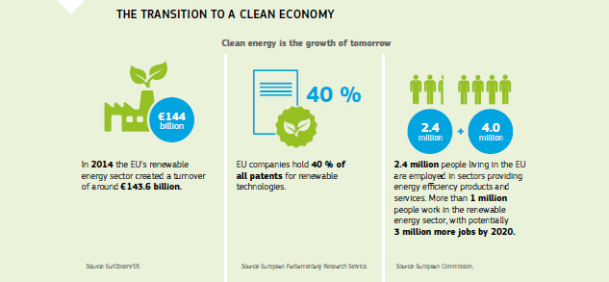

Energy efficiency

The cheapest and cleanest energy is the one that is not used at all. That is why the Commission in 2016 presented new and innovative energy-efficiency measures focused on:

* setting the framework for improving energy efficiency in general;
* improving energy efficiency in buildings;
* improving the energy performance of products (Ecodesign) and informing consumers (energy labelling);
* financing energy efficiency with the Smart Finance for Smart Buildings proposal.

To underpin these proposals the Commission put forward a new binding EU-wide energy-efficiency target of 30 % by 2030. Ambitious energy efficiency targets are designed to reduce Member States’ dependence on energy imports, boost the local economy, increase competitiveness and create additional green jobs.

World leader in renewables

Renewables will play a major role in the transition to a clean energy system. The EU has set itself the target of collectively reaching a share of at least 27 % for renewables in final energy consumption by 2030. The proposal for a new Renewable Energy Directive will provide investor certainty and a level playing field for all technologies. The Commission’s proposals focus on creating the right conditions for renewables to thrive and make the EU a flourishing market for clean energy. The sector already employs more than 1 million people and creates a turnover of around €144 billion every year.

Solar and wind technology prices declined respectively by 80 % and 30-40 % between 2009 and 2015. This cost reduction is enabling consumers increasingly to produce their own renewable energy. With the revised Directive consumers will benefit from stronger rights to produce their own electricity to consume at home or sell back to the grid.

A fair deal for consumers

Consumers are at the centre of the Energy Union. Everyday operations like billing, changing suppliers and getting a new contract when moving house will become easier, quicker and more accurate for consumers thanks to the improved management of digital customer information. Consumers will get access to reliable and clear information on the best deals on the market, using certified online price-comparison tools that assist them in making informed choices.

Consumers will be able to switch suppliers more easily, thanks also to the proposal to restrict the use of switching fees. The average difference between the incumbent supplier’s standard offer and the cheapest offer in the market is more than €50 a year in the EU.

If they wish, consumers will be able to request a smart meter from their energy supplier and benefit from market-based energy prices, and new technologies will allow them to consume more when energy is cheap and reduce consumption when prices are high. This means that consumers will have better control of their spending on energy services.

Energy security, solidarity and trust

The [Energy Security of Supply](http://europa.eu/rapid/press-release_IP-16-307_en.htm) package proposed in February 2016 built on the progress the EU has achieved over recent years in keeping energy-security risks at bay. The package focused on gas, drawing on lessons learnt from the 2014 gas stress tests, but also on intergovernmental energy agreements and on heating and cooling.

The co-legislators adopted the Commission proposal for intergovernmental agreements in December, only 9 months after the initial proposal. The new rules will allow the Commission to guarantee that no energy deal will jeopardise the security of supply in a Member State or hamper the functioning of the EU’s energy market.

In April the EU strengthened its ties with Iran, a major world player and a crucial partner for the EU on energy. The [joint declaration on energy security](http://europa.eu/rapid/press-release_IP-16-1142_en.htm) and fighting climate change goes a long way to building a lasting clean and sustainable energy partnership with one of the fastest-growing major economies.

A fully integrated EU market

2016 was an important year for EU energy infrastructure projects, with €800 million made available through the Connecting Europe Facility. This support is key to unlocking the additional investment needed to eliminate bottlenecks that prevent the free flow of energy.

In spring two grant agreements, amounting to €5.6 million, were signed for studies on the construction of the Midcat gas pipeline. When built this pipeline will contribute to integrating the gas markets of the Iberian peninsula with the rest of Europe. €29.9 million of funding was allocated to the construction of a 140 km electricity line in Bulgaria that will boost grid access for renewables and enhance the capacity of the Bulgarian power grid.

In October a €187 million grant agreement was made for the Balticconnector — the first gas pipeline connecting Estonia and Finland. When the gas starts flowing by 2020 this project will unite the eastern Baltic Sea region with the rest of the EU energy market.

Throughout 2016 the Investment Plan for Europe remained a key instrument for completing the Energy Union. The European Fund for Strategic Investments continued to create jobs and trigger investments in the real economy. The fund continued to strongly support intelligent, forward-looking investments in energy efficiency, renewables, innovation and modern energy infrastructure.

From 2014 to 2020, €69 billion of cohesion policy funds are available for investments supporting the objectives of the Energy Union.

Accelerating clean energy innovation

[CH03-PH12]

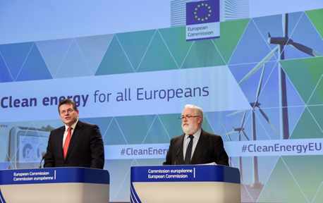

Commission Vice-President Maroš Šefčovič and Commissioner Miguel Arias Cañete give a joint press conference on the Clean Energy package, Brussels, 30 November 2016.

At the end of the year the Commission put forward its ideas on Accelerating Clean Energy Innovation. This strategy proposes a set of concrete measures to step up and scale up energy-efficient and low-carbon innovative solutions with a view to improving the EU’s global competitiveness in this field.

In June the Commission joined [Mission Innovation](http://europa.eu/rapid/press-release_IP-16-2063_en.htm), a global initiative on clean energy, and signed up to the Clean Energy Ministerial Framework on behalf of the EU to facilitate multilateral cooperation on innovation. In addition, a number of action plans were agreed at the G20 Energy Ministerial Meeting in China.

In 2016 four Horizon Prizes were launched to encourage innovation and find solutions to challenges in the area of [energy innovation](http://ec.europa.eu/research/index.cfm?pg=newsalert&year=2016&na=na-050716-2). The prizes are worth a total of €6.75 million and are funded under Horizon 2020, the EU’s research and innovation programme. They will reward innovative approaches to [integrating solar energy into historical buildings](http://ec.europa.eu/research/horizonprize/index.cfm?prize=photovoltaics), [using renewable energy in hospitals](http://ec.europa.eu/research/horizonprize/index.cfm?prize=lowcarbon), developing products that help cut emissions by [reusing carbon dioxide](http://ec.europa.eu/research/horizonprize/index.cfm?prize=co2reuse) and [inventing the cleanest engine of the future](https://ec.europa.eu/research/horizonprize/index.cfm?prize=clean-engine).

Relations with the EU’s key energy partners continued to be high on the agenda throughout the year. In June the Commission participated in the G20 Energy Ministerial Meeting in Beijing. It was an opportunity to discuss energy technology innovation, renewable energy, energy efficiency, energy access and the role of the energy system in the implementation of the Paris Climate Change Agreement with international partners. The agreement on the [EU–China Energy Roadmap](https://ec.europa.eu/energy/en/news/eu-china-agree-boost-energy-cooperation) was signed on the occasion of the EU–China Summit in July.

[CH03-PH13]

Visit of the Extreme Light Infrastructure (ELI) Project:<br>
Nicolae-Victor Zamfir, Director General of the Extreme Light Infrastructure Nuclear Physics (ELI-NP) in Romania, on the left, and Carlos Moedas

Commissioner Carlos Moedas (right) receives a presentation of the ‘Extreme light infrastructure’ project from its director, Nicolae-Victor Zamfir, Măgurele, Romania, 11 October 2016.

Decarbonisation of the economy

Taking the Paris Climate Change Agreement forward

In October 2014 EU leaders agreed to a [binding, economy-wide emissions reduction target of at least 40 % by 2030, compared to 1990 levels](http://ec.europa.eu/clima/news/articles/news_2014102401_en.htm). This became the EU’s contribution to the Paris Climate Change Agreement signed in December 2015.

In April 2016, 175 parties set a new record for the most first-day signatures to an international agreement, underlining the global political will to deliver on the promises made in Paris.

[CH03-PH14]

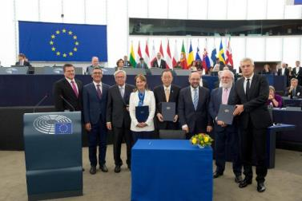

Commission Vice-President Maroš Šefčovič, Giovanni La Via, Member of the European Parliament, Jean-Claude Juncker, President of the European Commission, Ségolène Royal, French Minister for the Environment, Energy and Marine Affairs, Ban Ki-moon, Secretary-General of the United Nations, Martin Schulz, President of the European Parliament, Commissioner Miguel Arias Cañete and Ivan Korčok, Secretary of State at the Slovak Ministry of Foreign and European Affairs, at the signing ceremony for the EU’s ratification of the Paris Climate Change Agreement, Strasbourg, France, 4 October 2016.

Having brokered the first ever legally binding, global climate deal and built the coalition of developed and developing countries that made agreement in Paris possible, it was fitting that the swift ratification of the agreement at EU level in October enabled its global entry into force in November. The EU’s Member States have also already individually ratified or will ratify the agreement.

[CH03-VD09]

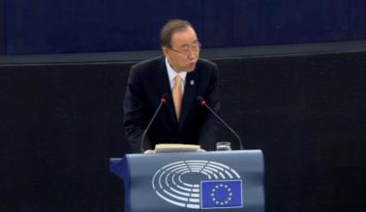

The European Parliament approves the ratification of the Paris Climate Change Agreement. (video)

In November countries met again at the [United Nations Climate Conference in Marrakesh](http://europa.eu/rapid/press-release_IP-16-3841_en.htm) to continue work on the detailed rulebook for the implementation of the Paris Climate Change Agreement. Heads of State or Government issued the [Marrakesh Action Proclamation](http://unfccc.int/files/meetings/marrakech_nov_2016/application/pdf/marrakech_action_proclamation.pdf), a call for the highest political commitment to tackle climate change, which sent a message of global unity and continued resolve to deliver on the Paris objectives and the transition to a global low-carbon economy.

Progress was made on the key elements of the Paris package, including access to finance, assistance with technology and developing and strengthening the skills and processes needed in developing countries to implement their domestic climate plans.

Implementing the Paris Climate Change Agreement in the EU

Work to deliver on the EU’s pledge began even before the Paris conference with a proposal to [revise the EU Emissions Trading System](http://europa.eu/rapid/press-release_IP-15-5358_en.htm), the EU’s main policy instrument for reducing emissions. To complement this proposal, in July 2016 the Commission presented [binding greenhouse gas emission targets for Member States from 2021-2030](http://europa.eu/rapid/press-release_MEMO-16-2499_en.htm)for the transport, building, agriculture, waste and land use, and forestry sectors.

Ambitious climate action creates business opportunities and opens up new markets for innovation and use of low-carbon technologies. The Commission has also [brought land use and forestry into the EU’s 2030 emissions-reduction efforts](http://europa.eu/rapid/press-release_MEMO-16-2496_en.htm). The sector not only emits greenhouse gases but can also remove carbon dioxide from the atmosphere, with EU forests absorbing the equivalent of nearly 10 % of total EU greenhouse gas emissions each year.

In July the Commission published the [European Strategy for Low-Emission Mobility](http://europa.eu/rapid/press-release_MEMO-16-2497_en.htm), setting the course for the development of EU-wide measures on low- and zero-emission vehicles and alternative low-emission fuels. This Strategy sets out the planned initiatives in the coming years and maps the areas in which it is exploring options.

Work continued on strengthening the link between decarbonisation, the transition to a circular economy, the quality of air and the environment. The implementation of the [Circular Economy Action Plan](http://ec.europa.eu/environment/circular-economy/index_en.htm) has the potential to reduce annual greenhouse gas emissions by 2 to 4 % and has already started to deliver. The implementation of the [Clean Air Policy Package](http://ec.europa.eu/environment/air/clean_air_policy.htm), on which interinstitutional agreement was reached in June 2016, will provide significant benefits for tackling climate change. The Investment Plan for Europe has also been mobilised to help to deliver on the transition to a resource-efficient, circular and zero-carbon economy, with 5 % of the European Fund for Strategic Investments covering the environment and resource-efficiency sector.

Building on the momentum of the Paris Climate Change Agreement

In October parties to the Montreal Protocol, which has been successful in phasing out ozone-depleting substances, agreed in Kigali, Rwanda, to bring the control of climate-warming hydrofluorocarbon gases used in refrigeration and air-conditioning systems within its scope. This is a fast and cost-effective way of delivering on the pre-2020 objectives of the Paris Climate Change Agreement. The Kigali Amendment requires developed and developing countries to gradually limit their consumption and production of hydrofluorocarbons, with developed countries moving first. The EU is leading the world in restricting the use of hydrofluorocarbons. By 2030 EU emissions of these gases will be cut by two thirds compared to current levels.

Also in October the International Civil Aviation Organisation, with the active involvement of the EU, reached a [landmark agreement](http://europa.eu/rapid/press-release_IP-16-3326_en.htm) on internationalcarbon dioxide aviation emissions. The so-called global market-based measure aims to stabilise international aviation emissions at 2020 levels and will oblige airlines to offset the growth of their carbon dioxide emissions beyond that threshold. The scheme is due to start in 2021 with a first phase based on voluntary participation. In its second phase (2027-2035) participation will be mandatory, except for countries with low levels of aviation activities. This means that around 80 % of the emissions needed to achieve the objective of carbon neutrality from 2020 will be offset between 2021 and 2035.

[CH03-GR05]

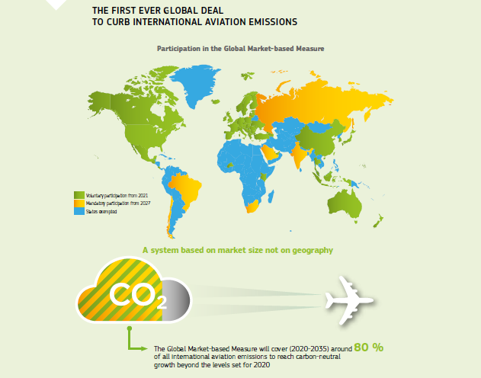

[The EU and its Member States have been among the main advocates](http://europa.eu/rapid/press-release_IP-16-3545_en.htm) of addressing greenhouse gas emissions in the maritime sector. At the [October meeting](http://europa.eu/rapid/press-release_IP-16-3545_en.htm) of the Marine Environment Protection Committee of the International Maritime Organisation a global and mandatory system to collect fuel-consumption data from ships was agreed. In practice, as of 2019 ships over a certain threshold capacity will be required to collect data on fuel consumption and energy efficiency and report it to the flag state.

Chapter 4

A deeper and fairer internal market with a strengthened industrial base

‘Our internal market is Europe’s best asset in times of increasing globalisation. I therefore want the next Commission to build on the strength of our Single Market and to fully exploit its potential in all its dimensions.’

Jean-Claude Juncker, political guidelines, 15 July 2014

The Single Market is one of the EU’s major achievements and its best asset in times of increasing globalisation. By allowing people, goods, services and capital to move more freely it opens up new opportunities for citizens, workers, businesses and consumers, creating the jobs and growth the EU so urgently needs. Work continued in 2016 in line with the 2015 [Single Market Strategy](https://ec.europa.eu/growth/single-market/strategy_en).

In March the Commission presented a [targeted revision of the Posting of Workers Directive](http://europa.eu/rapid/press-release_IP-16-466_en.htm), covering workers sent by their employer to work temporarily in another Member State. In June the Commission expressed its opinion on how existing EU legislation should apply to the [collaborative economy](http://ec.europa.eu/growth/single-market/strategy/collaborative-economy_en). Other initiatives included the Start-Up and Scale-Up Initiative and the [European Professional Card](http://ec.europa.eu/growth/single-market/services/free-movement-professionals/policy/european-professional-card_en).

In April new EU rules came into force that changed the way Member States and public authorities spend a large part of the €1.9 trillion spent on public procurement annually.

Strengthening the EU’s industrial base remained a priority. The Commission tabled legislative proposals to ensure that car manufacturers comply strictly with all EU safety, environmental and production requirements. A new automotive industry high-level group, [GEAR 2030](http://ec.europa.eu/growth/tools-databases/newsroom/cf/itemdetail.cfm?item_id=8640), was created to reinforce the car industry’s competitiveness and technological leadership.

A [Communication](http://ec.europa.eu/DocsRoom/documents/15922) set out how the European steel sector can overcome its challenges with the help of the EU.

The Commission continued to put in place the building blocks of the Capital Markets Union, based on the 2015 Action Plan.

The fight against tax avoidance remained an important priority in 2016. In January the Commission put forward an Anti-Tax Avoidance Package, including two legislative proposals that were adopted by the Council. In April it presented a proposal on public country-by-country reporting by multinational companies, which was followed in October by a major Corporate Tax Reform Package.

The Single Market

In a Communication in June the Commission clarified how existing EU legislation applies to the [collaborative economy](http://ec.europa.eu/growth/single-market/strategy/collaborative-economy_en), covering aspects such as market access requirements, liability and consumer protection.

Standards reduce costs, promote innovation, allow interoperability between different devices and services and help companies to access markets. In June the Commission presented a package of initiatives to modernise and enhance the European Standardisation System in light of technological developments, political priorities and global trends.

Making mobility easier for professionals and workers

One objective of the Single Market Strategy is to enable EU citizens to work wherever they choose in the Member States. The [European Professional Card](http://ec.europa.eu/growth/single-market/services/free-movement-professionals/policy/european-professional-card_en) simplifies the lengthy procedures that professionals face before being allowed to work in another Member State. The Card became available in January 2016 for five professions (general care nurses, physiotherapists, pharmacists, real-estate agents and mountain guides), with a possible extension to other professions in the future.

In March the Commission presented a targeted revision of the Posting of Workers Directive, covering workers sent by their employer to work temporarily in another Member State. The revision introduces changes in three main areas: the remuneration of posted workers, including in situations of subcontracting; the rules applicable to temporary agency workers; and long-term posting.

Higher efficiency of public procurement

[CH04-GR06]

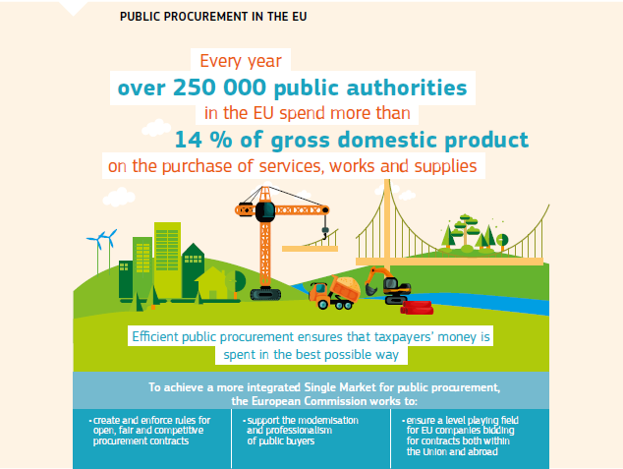

From April new rules changed how public authorities in the EU spend a large part of the €1.9 trillion annual public procurement budget. National legislation must conform to the [three Directives on public procurement and concessions](https://ec.europa.eu/growth/single-market/public-procurement/rules-implementation_en), which make it easier and cheaper for small and medium-sized businesses to bid for public contracts, ensure the best value for public money and respect EU principles of transparency and competition. The rules also allow environmental, social and innovation aspects to be taken into account.

Strengthening the EU’s industrial base

[CH04-PH16]

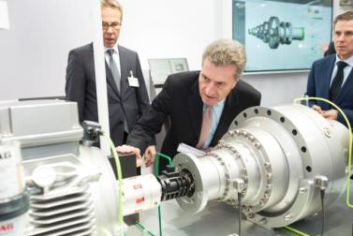

Commissioner Günther Oettinger examines a machine at a trade fair in Hanover, Germany, 25 April 2016.

In April the Commission proposed a [set of measures](http://europa.eu/rapid/press-release_IP-16-1407_en.htm) to support and link national initiatives for the digitisation of industry and related services and to boost investment.

In June an EU-level Smart Specialisation Platform for Industrial Modernisation was set up to support cooperation between regions, clusters of companies, business networks and industrial partners and to develop ambitious investment projects that can benefit from EU programmes, the Investment Plan for Europe and private funds.

More robust and realistic testing methods for both nitrogen oxide and carbon dioxide emissions from cars were introduced. The Commission also tabled legislative proposals to overhaul the system that allows cars to be placed on the market. The proposed [Regulation](http://europa.eu/rapid/press-release_IP-16-167_en.htm) aims to make vehicle testing more independent, increase surveillance of cars in use and introduce more EU oversight.

In June the Commission published the [European Strategy for Low-Emission Mobility](http://europa.eu/rapid/press-release_MEMO-16-2497_en.htm) to develop EU-wide measures on low- and zero-emission vehicles and alternative low-emission fuels.

To help the EU automotive industry remain competitive by meeting the challenges of the future a new high-level group for the automotive industry, [GEAR 2030](http://ec.europa.eu/growth/tools-databases/newsroom/cf/itemdetail.cfm?item_id=8640), was established to work on challenges of the future, such as automated driving, connected cars and zero-emission vehicles.

The steel industry represents 1.3 % of EU gross domestic product and plays a significant role in many other industrial sectors such as the automotive industry. Despite the significant efforts made to innovate and modernise, the EU’s competitive position on the global steel market has deteriorated in recent years. Excess production of steel in non-EU countries such as China has given rise to a wave of unfair trading practices, distorting the global market. In March the Commission presented a Communication addressing the serious challenges the sector faces. The Commission is taking a range of actions such as imposing provisional anti-dumping measures, adopting a prior surveillance system for steel products, providing funds to support the modernisation of the steel industry and fostering a highly skilled workforce.

[CH04-PH17]

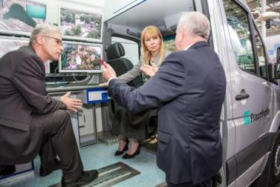

Commissioner Elżbieta Bieńkowska learns about technologies developed by the Fraunhofer Institute of Optronics, System Technologies and Image Exploitation at a trade fair in Hanover, Germany, 25 April 2016.

Protecting intellectual property

The [Single Market Strategy](http://ec.europa.eu/DocsRoom/documents/14007?locale=en) highlighted the role of intellectual property protection in promoting innovation and creativity, which generates jobs and improves competitiveness.

The Commission launched an evaluation of the current legal framework on enforcing intellectual property rights. The Commission’s approach is to ensure that the legal measures and remedies are fit for purpose, in particular across borders and in the online environment. It is putting the focus on commercial-scale abuses and the ‘follow-the-money’ approach to deprive commercial-scale infringers of their revenue flows, rather than pursuing individuals. In June, with the Commission’s support, internet platforms, brand owners and trade associations signed a voluntary agreement on stopping the online sale of counterfeit goods.

EU businesses also benefit from the trade mark reform that entered into force in March, making EU trade mark protection more accessible for EU businesses. It has lower costs, modern requisite standards for filing new types of trade marks, decreased registration time and stronger means for fighting counterfeiting.

In November, with strong support from the European Parliament and Member States, the Commission issued a [clarification](https://ec.europa.eu/growth/industry/intellectual-property/patents/biotechnological-inventions_en) of certain provisions of the Biotech Directive, stating that products deriving from essentially biological processes should not be patented.

Delivering better services to rail passengers

[CH04-VD10]

[](http://ec.europa.eu/avservices/video/player.cfm?ref=I119049&videolang=EN&devurl=http://ec.europa.eu/avservices/video/player/config.cfm)

The Fourth Railway Package. (video)

The Parliament and the Council agreed in April on measures to make railways in the EU more innovative and competitive. The [Fourth Railway Package](http://europa.eu/rapid/press-release_MEMO-16-1383_en.htm) will gradually open domestic passenger rail markets to competition, favouring the emergence of new business models and more choice for consumers (increased frequency, better services and lower fares).

Strengthening ports

[CH04-PH18]

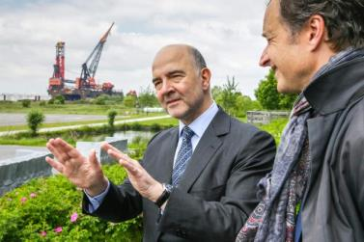

Commissioner Pierre Moscovici visits the customs facilities of the port of Rotterdam with Eric Wiebes, Dutch Secretary of State for Finance, Rotterdam, the Netherlands, 31 May 2016.

In June the Parliament and the Council reached agreement on a [Common European Framework for Seaports](http://ec.europa.eu/transport/modes/maritime/news/2016-06-27-ports_en.htm). The Ports Regulation will guarantee financial transparency and optimal resource use, giving investors more confidence, ensuring fair competition and stimulating investment. More investment will result in more jobs and more prosperity. The sector currently employs 469 000 people directly and helps sustain 3 million jobs. The Regulation will ensure high-quality services at EU ports and give ports more autonomy, for example to define their infrastructure charges.

[CH04-GR07]

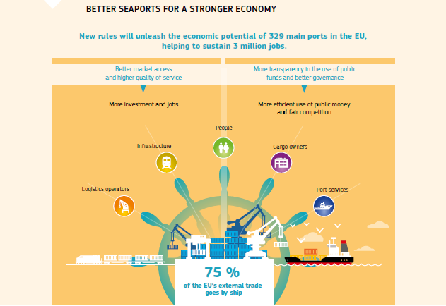

Undistorted competition

Competition policy contributes to a properly functioning Single Market in which companies compete on their merits and efficiencies are passed on to EU consumers. Healthy companies facing strong competition in domestic markets are best equipped to compete in the global market place.

The fight against cartels is one way to keep competition strong. The Commission decided in July that five truck manufacturers had colluded for 14 years on pricing and passing on the costs of compliance with stricter emission rules. They were fined a record €2.9 billion.

Antitrust rules also ensure that the conduct of a dominant company does not distort competition in a specific market. During the year the Commission had three investigations ongoing against Google for alleged abuse of its dominant position.

Close monitoring of state aid fostered competitiveness and innovation in 2016. This aimed to prevent public money from being granted to ailing companies, allowing the development of more innovative companies.

The Commission also published a [notice](http://ec.europa.eu/competition/state_aid/modernisation/notice_aid_en.html) on the scope of EU state aid control of public spending. This will help public authorities and companies know when public support measures do not constitute state aid and are not subject to state aid rules.

In January the Commission concluded that Belgium broke EU state aid rules by giving a select number of multinationals substantial tax advantages worth at least €700 million. This put smaller, non-multinational competitors at a disadvantage. At least 35 multinationals, mainly from the EU, must now return unpaid taxes to Belgium. In August the Commission decided that Ireland had granted undue tax benefits of up to €13 billion to Apple, the equivalent of a substantial subsidy not available to other businesses. Three other cases, involving Luxembourg’s tax treatment of Amazon, McDonald’s and GDF Suez (Engie), were ongoing at the end of the year.

One of the purposes of the Commission’s competition law enforcement is to prevent mergers from harming competitive markets. The vast majority of notified mergers in 2016 posed no competition problems and were cleared after a routine review. However, the Commission decided in May to prohibit the proposed acquisition of Telefónica UK by Hutchison since it had strong concerns that mobile customers in the United Kingdom would have had less choice and paid higher prices as a result of the takeover, and that the deal would have harmed innovation in the mobile sector.

[CH04-PH19]

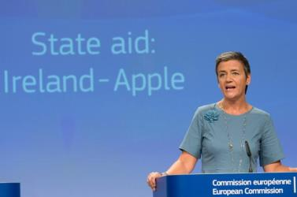

Commissioner Margrethe Vestager addresses members of the press following the EU’s decision that Ireland must recover illegal state aid paid to Apple of up to €13 billion, Brussels, 29 August 2016.

Transparency and the fight against tax avoidance

In January the Commission adopted an [Anti-Tax Avoidance Package](http://europa.eu/rapid/press-release_IP-16-159_en.htm), which calls on Member States to take a stronger and more coordinated stance against companies seeking to avoid paying their fair share of tax and to implement international standards against base erosion and profit shifting. Key features of the proposals are:

* legally binding measures to block the most common methods used by companies to avoid paying tax (the proposal for an Anti-Tax Avoidance Directive);
* a proposal on country-by-country reporting between Member States’ tax authorities of tax-related information on multinationals operating in the EU (amendment to the Directive on Administrative Cooperation);
* a recommendation on preventing tax treaty abuse;
* actions to promote good governance internationally, including a new EU process for listing non-EU jurisdictions that refuse to play fair.

[CH04-VD11]

[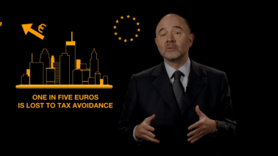](http://ec.europa.eu/avservices/video/player.cfm?sitelang=en&ref=I114823)

Fair taxation: the Commission presents new measures against corporate tax avoidance. (video)

The Anti-Tax Avoidance Directive was adopted by the Council in July. Member States must transpose the rules into their own legislation by the end of 2018 and apply them from January 2019. The new rules on country-by-country reporting between tax authorities were agreed by the Council in March, and Member States must transpose them into national law by mid 2017.

Agreements were signed with Andorra and Monaco under which, from 2018, the EU’s Member States and these two neighbouring countries will automatically exchange information on the financial accounts of each other’s residents.

In April the Commission proposed that large multinational companies active in the EU Single Market with a turnover in excess of €750 million should publicly disclose the corporate income tax they pay, on a country-by-country basis. The proposed rules will ensure greater corporate tax transparency, enabling citizens to assess multinationals’ tax strategies and their contribution to welfare.

[CH04-PH20]

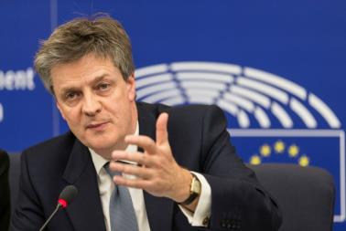

Commissioner Jonathan Hill (2014-2016) outlines proposals on public tax transparency at the European Parliament, Strasbourg, France, 12 April 2016.

Also in April the Commission presented measures to modernise VAT in the EU. The [Action Plan](http://europa.eu/rapid/press-release_IP-16-1022_en.htm) is the first step towards a single EU VAT area equipped to tackle fraud, support business and help the digital economy and e-commerce.

In July the Commission presented the next steps to boost tax transparency and the fight against tax evasion and avoidance at the EU and international levels. Initiatives focused on closing existing gaps in the tax framework that allow cross-border tax abuse and illicit financial flows.

In September the Commission presented a ‘scoreboard of indicators’ (economic, financial, stability and tax good governance indicators) to help Member States identify the non-EU jurisdictions to be prioritised for screening in the common EU listing process. Considerable progress has been made by Member States towards creating a first common EU list of non-EU jurisdictions that refuse to adhere to international tax good governance standards.

In October the Commission adopted a major Corporate Tax Reform Package that includes three new proposals: to create a more modern and fairer tax system for businesses; to close loopholes between EU Member States and non-EU countries; and to provide dispute-resolution rules to relieve problems with double taxation for businesses.

More concretely, the Package included the relaunch of the [Common Consolidated Corporate Tax Base](http://europa.eu/rapid/press-release_IP-16-3471_en.htm), which will overhaul the way companies are taxed in the Single Market, ensuring a fairer, more competitive and more growth-friendly corporate tax system. The Common Consolidated Corporate Tax Base also contains important new elements to improve its anti-avoidance and growth-promoting capacities.

The Commission also proposed an [improved system to resolve double taxation disputes in the EU](http://ec.europa.eu/taxation_customs/business/company-tax/resolution-double-taxation-disputes_en), adjusting current dispute-resolution mechanisms to better meet the needs of businesses for which double taxation is a major obstacle.

The Corporate Tax Reform Package also includes a proposal to extend the already-agreed internal EU rules against hybrid mismatches to those involving non-EU countries.

Financial markets working for consumers

Financial firms should make the most of the economies of scale in a truly integrated EU market, while online services offer new opportunities and innovative solutions.

The Member States should have implemented the [Mortgage Credit Directive](http://eur-lex.europa.eu/legal-content/EN/TXT/?uri=CELEX:32014L0017) by March 2016. By the end of the year, 19 Member States had fully enacted the Directive. The new rules will ensure that consumers who purchase a property or take out a loan secured against their home are adequately informed and protected against risks. The Directive should promote competition in mortgage markets and offer new business opportunities to lenders and intermediaries alike, leading to cost reductions in the future that directly benefit consumers.

By September Member States were also required to implement [the Payment Accounts Directive](http://eur-lex.europa.eu/legal-content/EN/TXT/?uri=CELEX%3A32014L0092), which creates a right for all consumers to access basic payment account services irrespective of their financial situation. Only 14 Member States (Bulgaria, the Czech Republic, Denmark, Germany, Estonia, Ireland, Lithuania, Hungary, Malta, Austria, Poland, Slovenia, Slovakia and the United Kingdom) had done so by the end of the year. France and Finland had notified partial transposition measures.

Building the Capital Markets Union

The Commission continued to build a Capital Markets Union based on the Action Plan on [Capital Markets Union](http://ec.europa.eu/finance/capital-markets-union/index_en.htm) adopted in 2015. It presented a Communication on accelerating the implementation of the Action Plan and developing further priorities, including a pan-EU personal pension product.

The first measure entered into force in April 2016. It makes infrastructure investment more attractive for insurance companies that are well equipped to provide the long-term financing needed.

In July the Commission proposed changes to existing legislation to encourage an increase in the uptake of [European venture capital funds](http://ec.europa.eu/finance/investment/venture_capital/index_en.htm) and [European social entrepreneurship funds](http://ec.europa.eu/finance/investment/social_investment_funds/index_en.htm), making it easier and more attractive for private investors to invest in small and growing companies.

In September the Commission announced a broader strategy on sustainable finance to support investment in clean technologies. In November the Commission made available up to €300 million of co-investment in a large-scale, pan-EU venture capital fund-of-funds. This will help strengthen the EU venture capital industry’s capacity to offer attractive returns to institutional investors and extend the reach of this channel to a wider set of Member States.

Also in November the Commission tabled a [legislative proposal](http://europa.eu/rapid/press-release_IP-16-3802_en.htm) on business restructuring and second chance. The proposal aims to enable honest entrepreneurs to benefit from a second chance after overcoming bankruptcy, contributing to a dynamic business environment and promoting innovation.

Chapter 5

A deeper and fairer Economic and Monetary Union

‘Over the next 5 years, I want to continue with the reform of our Economic and Monetary Union to preserve the stability of our single currency and to enhance the convergence of economic, fiscal and labour market policies between the Member States that share the single currency.’

Jean-Claude Juncker, political guidelines, 15 July 2014

Economic integration through a completed Economic and Monetary Union brings the benefits of greater size, internal efficiency and robustness to the EU economy as a whole and to the economies of the individual Member States. This in turn offers opportunities for economic stability, higher growth and more employment — outcomes of direct benefit to EU citizens. While there is still much progress to be made, work towards completing the Economic and Monetary Union moved ahead apace through many European Commission initiatives in 2016.

The major challenges continued to be further reducing the number of people exposed to the risk of social exclusion and supporting the trend of falling unemployment. Though still too high, unemployment reached a 7-year low of 9.8 % in November in the euro area.

Moreover, the EU continued working towards the completion of the Banking Union as a key building block of Economic and Monetary Union.

Progress was made throughout 2016 on streamlining the procedures of the [European Semester](http://ec.europa.eu/economy_finance/economic_governance/the_european_semester/index_en.htm), the EU’s cycle of economic and fiscal policy coordination. Recommendations adopted during the 2016 semester process provide guidance for all Member States and the euro area as a whole, and aim to promote policies and reforms that create more jobs, increase social fairness and convergence and inspire growth by supporting investment strategies.

The 2017 cycle of the European Semester was launched in mid November. The Commission reiterated its call to Member States to redouble their efforts in line with the principles of the ‘virtuous triangle’ of boosting investment, pursuing structural reforms and ensuring responsible fiscal policies, and, in doing so, to put the focus on a fair and just relationship between the individual and society and delivering more inclusive growth.

The European Semester: a new approach to country-specific recommendations

[CH05-GR09]

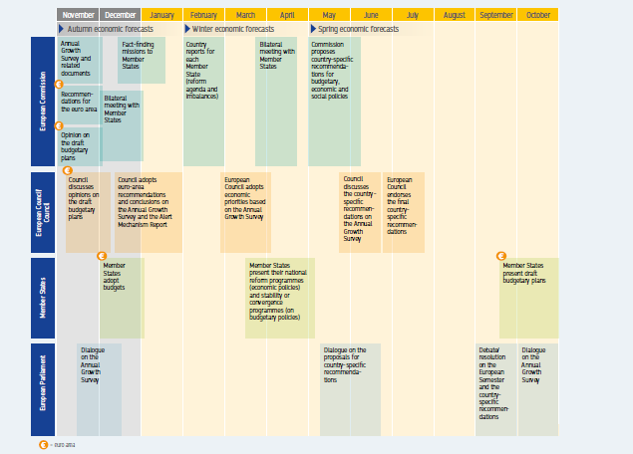

Controlling state aid and ensuring fair competition

State aid control has an important role to play in ensuring a level playing field within the Banking Union. Since the beginning of the financial crisis in 2008, 113 banks in the EU, representing around 30 % of the EU’s banking system by assets, have restructured under state aid conditionality following the receipt of public money. Member States have supported the banks by injecting €655.3 billion in capital (4.5 % of the EU’s gross domestic product in 2015) and providing €1 293.1 billion, or 9.2 % of gross domestic product, in guarantees and other liquidity support. The aid has been given to secure citizens’ savings, avoid uncontrolled bankruptcy and prevent the subsequent collapse of the banking system across the continent. Since then, most banks that received aid during the crisis have returned to viability after implementing a considerable part of their restructuring plans. Those whose business models failed beyond repair (42 out of 113 banks) were wound down in an orderly way.

In July the Commission closed its antitrust investigation into credit derivative swaps by making commitments binding upon data provider Markit and the International Swaps and Derivatives Association. The two entities will, for 10 years, license key data and intellectual property rights to exchanges on fair, reasonable and non-discriminatory terms. This measure will help make credit derivative swaps trading safer and cheaper for investors.

In March the Commission announced its preliminary view that the Insurance Block Exemption Regulation should not be prolonged. This preliminary position was subsequently endorsed in December following an impact assessment. The Regulation will therefore expire in March 2017.

According to the European Central Bank, card payments in 2014 accounted for 46 % of electronic payments in the EU. Multilateral interchange fees, collectively agreed by banks and imposed on retailers for the acceptance of cards, can translate into higher prices for consumers. This is addressed by the Interchange Fees Regulation, which entered into force at the end of 2015 and capped these fees at competitive levels. A second set of rules under the Regulation became applicable in June 2016, making payment costs more transparent to retailers and consumers and allowing them to make efficient choices.

In parallel the Commission continued its antitrust proceedings against multilateral interchange fees agreed by Visa and MasterCard for interregional transactions, which are not covered by the Interchange Fee Regulation. Interregional multilateral interchange fees are the fees that EU merchants pay for accepting payments made with cards issued outside the European Economic Area.

In June the General Court confirmed the Commission’s findings that Groupement des Cartes Bancaires (which manages the ‘CB’ card payment system in France) had restricted competition in the French issuing market by making it difficult for new players to enter. The General Court’s judgment is subject to appeal.

New boards to bolster the deepening process

Economic governance in the EU was strengthened by the establishment of an independent advisory European Fiscal Board. Implementing the proposal contained in the [Five Presidents’ Report](http://ec.europa.eu/priorities/five-presidents-report_en) — a document compiled by the President of the Commission and his counterparts in the European Parliament, the European Central Bank, the Eurogroup and the Euro Summit — and based on the Commission’s Decision of October 2015, the Board became operational in November 2016. Its role is to evaluate the implementation of the EU fiscal framework and to advise the Commission on the fiscal stance appropriate for the euro area as a whole. The Board also cooperates with Member States’ national fiscal councils and provides specialist advice at the request of President Juncker.

The Board is independent and is composed of respected specialists who provide independent expertise in their fields, appointed after consultations with the Member States, the national fiscal councils and the European Central Bank.

In September, as a further step in implementing the Five Presidents’ Report, the Council recommended that euro-area Member States establish or identify national productivity boards. These boards should analyse developments and policies in the field of productivity and competitiveness and contribute to fostering ownership and implementing the necessary reforms at the national level. In this way they will promote sustained economic growth and convergence. The boards will regularly publish reports on their analysis.

[CH05-PH21]

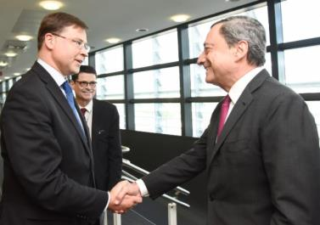

Commission Vice-President Valdis Dombrovskis meets with Mario Draghi, President of the European Central Bank, Brussels, 8 June 2016.

Banking Union

The EU continued working towards the completion of the Banking Union as a key building block of a resilient and dynamic Economic and Monetary Union. The Banking Union was conceived to ensure that banks in the euro area are stronger and better supervised. Should problems arise it will be possible to resolve them more easily and without using taxpayers’ money.

In January another milestone of the Banking Union, the Single Resolution Mechanism, became fully operational. The Single Resolution Mechanism is an essential complement to the European Central Bank-led Single Supervisory Mechanism for more integrated bank oversight and crisis management in the Banking Union. The Single Resolution Mechanism bolsters the resilience of the financial system and helps avoid future crises in the Banking Union by making sure that banks are resolved effectively and on time.

Negotiations also continued in the Parliament and the Council on the third pillar of the Banking Union, the European deposit insurance scheme, which builds on the existing national deposit guarantee schemes. The bank-funded European deposit insurance scheme would ensure an additional safety net for savers across the EU. It would improve risk-sharing within the banking sector across a bigger pool of institutions. Vulnerability to large local shocks would be reduced.

[CH05-VD12]

[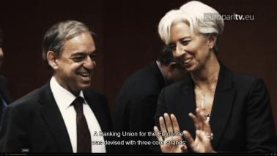](http://europarltv.europa.eu/en/player.aspx?pid=e7cf60c7-15b4-41fe-b8a1-a5bf00dfc4d2)

The final pillar of the Banking Union: building a fund to keep savings secure. (video)

In parallel to the work on the European deposit insurance scheme Member States recognised that further steps have to be taken in terms of reducing and sharing risks in the financial sector in order to address a number of remaining challenges. The Commission’s proposed rules on total loss absorption capacity are designed to help ensure that banks’ creditors, rather than tax payers, pay for problems in banks.

Moreover, by the end of 2016 a majority of Member States had transposed and implemented in national law the relevant legal provisions of the single rulebook, ensuring even more consistent regulation and high-quality supervision in the Banking Union. All but eight Member States had enacted the Bank Recovery and Resolution Directive, setting out harmonised and improved tools for dealing with banking crises, while 20 Member States had also fully implemented the Deposit Guarantee Directive, thus ensuring that EU citizens’ savings in those Member States are protected.

Financial markets

[CH05-PH22]

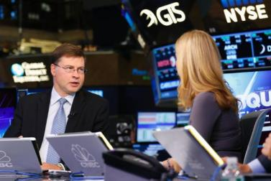

Commission Vice-President Valdis Dombrovskis is interviewed at the New York Stock Exchange, United States, 5 October 2016.

Benchmarks are vital for the functioning of the financial market. The Benchmarks Regulation entered into force in June. It improves the functioning and governance of benchmarks and ensures that they are not subject to manipulation. The new rules will help to protect investors and consumers.

In November the Commission proposed new rules for key players in the financial market to ensure that both central counterparties and national authorities in the EU have the means and are prepared to act decisively if a crisis scenario occurs. Central counterparties act as the counterparty to both sides of a transaction in a financial instrument. The main objective of the proposal is to ensure that central counterparties’ critical functions are preserved while maintaining financial stability and preventing the costs associated with the restructuring and the resolution of failing central counterparties from falling on taxpayers.

In the same month, the Commission proposed amendments to the Capital Requirements Regulation and the Capital Requirements Directive, which spell out prudential requirements for institutions and rules on governance and supervision of institutions respectively. It also proposed the amendment of the Bank Recovery and Resolution Directive and the Single Resolution Mechanism Regulation, which spell out the rules on the recovery and resolution of failing institutions and establish the Single Resolution Mechanism. The amendments contain measures that will strengthen the resilience of the EU banking sector and thereby increase markets’ confidence in it.

Making sure it all works

During the year the Commission announced its EU Regulatory Framework for Financial Services follow-up on the main findings and next steps resulting from the call for evidence. This is an initiative to gather feedback from stakeholders and gauge the cumulative impact and interaction of current financial rules. The Commission plans to focus, among other things, on removing unnecessary regulatory constraints on bank finance and small and medium-sized enterprise financing and on enhancing the proportionality of rules in banking, derivatives markets, insurance asset management and the credit rating sector. Other measures, some of which have already been proposed, will reduce undue regulatory burdens such as supervisory reporting and public disclosure requirements for the EU financial industry. The Commission intends to make rules more consistent and forward looking and address inconsistent interactions and gaps in the EU regulatory framework.

Public consultation on the European Pillar of Social Rights

In March the Commission put forward a first, preliminary outline of what will become the European Pillar of Social Rights. As mentioned by President Juncker in his [State of the Union address](http://europa.eu/rapid/press-release_SPEECH-15-5614_en.htm) in September 2015, ‘We have to step up the work for a fair and truly pan-European labour market … As part of these efforts, I will want to develop a European Pillar of Social Rights, which takes account of the changing realities of Europe’s societies and the world of work. And which can serve as a compass for the renewed convergence within the euro area.’ In his 2016 address President Juncker reiterated his commitment to the European Pillar of Social Rights, saying that the EU is not social enough and that the Commission will continue to work with energy and enthusiasm to change that.

The European Pillar of Social Rights: three priorities

[CH05-GR08]

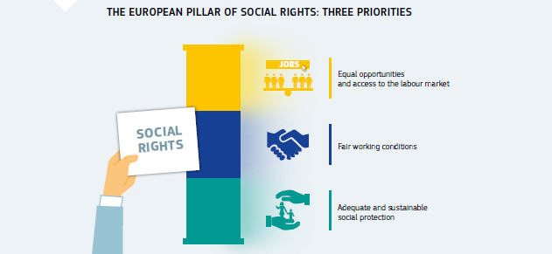

The Pillar will identify a number of essential principles in the areas of access to employment, working conditions and social protection, focusing on new challenges such as ageing, globalisation, technological change and social divergence inside the Economic and Monetary Union.

Throughout 2016 the Commission engaged in a debate with other EU institutions and with national authorities, social partners, civil society, academics and citizens on the content and role of the Pillar to move towards a [deeper and fairer Economic and Monetary Union](http://ec.europa.eu/priorities/deeper-and-fairer-economic-and-monetary-union_en). The outcome of this debate will feed into an initiative that will be published in spring 2017.

The Pillar should build on, and complement, the EU’s social rules in order to guide policies in a number of fields essential for properly functioning and fair labour markets and welfare systems. Once established, the Pillar should become the reference framework to screen the employment and social performance of participating Member States, to drive reforms at national level and, more specifically, to serve as a compass for the renewed process of convergence within the euro area.

A new start for social dialogue

In June the Commission signed a statement on ‘A new start for social dialogue’, together with the Dutch Presidency of the Council of the European Union and the European cross-industry social partners (the European Trade Union Confederation, BusinessEurope, the European Association of Craft, Small and Medium-Sized Enterprises and the European Centre of Employers and Enterprises providing Public Services). The statement is part of the [new start for social dialogue](http://ec.europa.eu/social/BlobServlet?docId=16099&langId=en) initiated by President Juncker at a [high-level conference in March 2015](http://ec.europa.eu/social/main.jsp?catId=88&langId=en&eventsId=1028), together with European, national and sectoral social partners and with the other EU institutions.

The statement underlines the fundamental role of the European social dialogue as a significant component of EU employment and social policymaking.

The Commission will continue to involve social partners in policymaking and lawmaking in the EU, as well as in economic governance and the European Semester. Member States have agreed to closely involve the social partners in the design and implementation of reforms and policies and to improve social dialogue at national level. Member States have also committed to involve the national social partners throughout the European Semester in order to contribute to the successful implementation of country-specific recommendations.

Europe 2020, the European Semester and human capital

Skilled people are one of the main drivers of long-term economic growth, competitiveness and jobs. This important link was further emphasised in the Commission’s [Communication ‘Improving and modernising education](https://ec.europa.eu/education/news/20161202-communication-improving-modernising-education-for-all_en)‘. To compete in a global economy the EU relies on the quality of its human capital. Investing in people via high-performing and efficient education and training systems is a prerequisite for long-term prosperity. The EU’s highly skilled workforce drives research and development and translates new ideas into innovation. Knowledge and skills gained in the education system help guarantee employment and a stable income, reducing the risk of poverty and social exclusion.

[CH05-VD13]

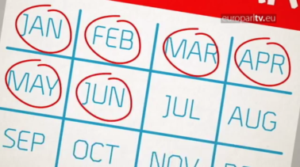

The European Semester: the tool to keep EU Member States in the all-clear. (video)

Consequently, reforms to education and training systems are a high priority in most Member States and also feature prominently in the 2016 [European Semester](http://ec.europa.eu/economy_finance/economic_governance/the_european_semester/index_en.htm). A total of 21 Member States received a country-specific recommendation in the area of education and training.