

# 1. Introduction

The 2013 reform of the common agricultural policy (CAP) introduced a green direct payment scheme[1] (‘greening’). The aim was to further improve sustainable management of natural resources linked to farming through payments for practices beneficial to the environment and the climate. Besides crop diversification and the maintenance of permanent grassland, greening requires farmers to reserve 5 % of their arable land for ecological focus areas (EFAs).

Focusing on 2015 and 2016, this report fulfils a legal requirement for the Commission[2] to examine progress in implementing the EFA obligation. While it also shares preliminary observations on EFAs’ potential environmental effects based on choices made by Member States and farmers, it is important to stress that this is not a measurement of real environmental impacts.

The report updates and expands on some aspects of the 2016 review of greening after one year of application,[3] conducted as part of the Commission’s REFIT programme[4]. The 2016 review examined greening’s impact on production potential, the level playing field and considered various simplification aspects. As a follow-up, the Commission put forward several changes to secondary greening legislation[5], focusing mostly on EFAs[6]. These aimed to streamline and clarify the relevant rules while increasing their environmental effect. They should become applicable at the latest in 2018[7] (as of March 2017[8] the changes are not yet in force).

This report will contribute to the wider evaluation of greening, including the environmental benefits of EFAs, due for completion by the end of 2017 or early 2018[9]. It will also feed into the report on the CAP monitoring and evaluation due in 2018[10]. The observations in Chapter 3 of this report do not prejudge the evaluation of greening, which will be comprehensive on all its aspects, including EFAs.

## The EFA obligation

Many valuable habitats and the biodiversity they encourage rely on farming systems. However, the efforts to safeguard this biodiversity are not recognised by markets and therefore not reflected in the prices farmers receive for their produce. While preserving biodiversity depends on appropriate management practices, these practices — driven by competitive pressures — have experienced change, with increasing specialisation and intensification of production in some areas and land abandonment in others. This creates pressures on biodiversity, has detrimental effects on soil, water and climate but also puts the agricultural sector’s long-term production potential at risk.

The EFA requirement’s objective is *‘in particular, […] to safeguard and improve biodiversity on farms’*[11]. With the other greening obligations, it forms part of the existing CAP and other EU policies dedicated to sustainable management of natural resources, including biodiversity[12]. Part of the CAP’s first pillar, greening aims to ensure that all EU farmers receiving income support deliver environmental and climate benefits as part of their agricultural activity. Practices required under the EFA obligation are meant, like the other greening practices, to be simple, generalised, non-contractual and annual. Farmers are rewarded for undertaking biodiversity-friendly practices, which does not necessarily entail a change in every farm. Where these practices are already applied, the EFA obligation guarantees their maintenance against the competitive pressures facing farmers. Where they are not present, they have to be put in place.

To comply with the EFA requirement, farmers with arable land exceeding 15 ha must ensure that at least 5 % is an ‘ecological focus area’ dedicated to ecologically beneficial elements, selected from a menu of ‘EFA types’ drawn up by their national authorities from a common EU list. This EU list covers a broad range of features or areas targeting biodiversity directly, such as fallow land or landscape features, or indirectly, by reducing the use of inputs and/or improving soil protection, such as catch crops or nitrogen-fixing crops[13]. EFA areas are calculated using weighting factors that reflect each EFA characteristic and its importance for biodiversity. The weighting factors range from 0.3 (e.g. for catch crops) and 0.7 (nitrogen-fixing crops) to 2 (hedges).

Member States have several options to tailor the EFA types: for example, when selecting their national list, they can build on practices that farmers already apply, and/or supplement requirements (e.g. production methods) for some EFAs to ensure or improve their effectiveness. Under certain conditions, they may also offer their farmers several alternative EFAs on the basis of ‘equivalence’. Some farmers are exempted from this requirement based e.g. on their farm’s location (‘forest exemption’), size or land use.

Going beyond cross-compliance, EFA practices can be supplemented by voluntary measures under rural development programmes (RDPs) that finance more demanding activities targeted at specific environmental and climate-related needs.

## Methodology, data sources and limitations

This report is based on the data available on the current implementation of EFA. While it includes preliminary observations of potential environmental effects, it does not constitute an evaluation per se as defined in the Commission’s Better Regulation Guidelines[14].

To assess the state of play on implementation, the report uses the yearly decisions on the choices of EFA types provided to the Commission by Member State authorities[15].   
These decisions are available for 2015, 2016 and 2017. The report also uses data on farmers’ actual EFA choices (‘uptake data’) based on farmers’ declarations (‘declared areas’) for 2015 and 2016 and notified per region by Member States[16].

The quality of the Commission’s analysis depends on timeliness and completeness of the reporting. This is limited as some notifications are incomplete or still lacking. The EFA uptake data for 2015 is available for all Member States except France; data for 2016 has been submitted by just 19 Member States[17].

The observations on potential environmental effects do not aim to measure real impacts, but rather consist of simulations applying pre-determined values assigned to available choices, relying on:

* a study by the Commission’s Joint Research Centre[18] (JRC) using an ‘EFA calculator’, a modelling tool based on scientific literature;
* a review of selected literature.[19]

The EFA calculator considers EFAs’ potential environmental impacts through a scoring system which reflects EFA types’ characteristics and their agronomic context but does not quantify real impacts. Initially designed to be used at farm level, the EFA calculator extrapolates and aggregates farm-level results to regional level based on the actual uptake data provided by Member States for 2015. This limits the results’ accuracy somewhat.

A further key observation is that these potential effects are only considered in the light of EFAs’ main characteristics, without investigating further qualitative criteria such as management practices and retention period. Effects are estimated in relative terms between EFA types and without considering a baseline (reference scenario). The analysis looked at nine categories of EFA compositions aggregated at regional NUTS-3 level,[20] as illustrated in Figure 4. Aspects such as regional context and species composition were also factored in.

In terms of potential impacts, the focus is on **biodiversity**, which is the primary environmental EFA objective; the simulation focuses on the diversity and populations of species using the EUNIS[21] classification of species groups: amphibians, birds, invertebrates, mammals, reptiles and terrestrial plants.

In addition, considering a broader environmental objective of EFA, potential impacts on **ecosystem services** (benefits that people obtain from ecosystems[22]) and **climate** are also considered in order to identify potential co-benefits and trade-offs resulting from implementation of the EFA obligation.

The simulation on ecosystem services uses the Common International Classification of Ecosystem Services and covers pollination and seed dispersal, pest and disease control, chemical condition of fresh water, mass stabilisation and control of erosion rates.

Where relevant, the report also considers input from stakeholders, including in expert group and civil dialogue group format, and in response to the Commission’s public consultation on greening carried out between December 2015 and March 2016[23]. The report also considers   
a study on Member States’ CAP choices[24], while the Eurostat farm structure survey and annual statistics are used as context information.

Member State choices, farmers’ uptake data, methodology and bibliography are presented in greater detail in the accompanying staff working document.

# 2. Implementation — state of play

## 2.1. Member States’ EFA choices

***In 2015, the range of EFA types varied significantly between Member States***

Based on Member States’ decisions for 2015, the following clusters of Member States emerge, as shown in Figure 1:

* 14 Member States offered an extensive list of EFA types (10 to 19). All selected land lying fallow, short-rotation coppice, nitrogen-fixing crops, buffer strips (except the Czech Republic), catch crops/green cover (except Italy) and at least four different types of landscape features out of nine (primarily trees in group and trees in line).
* Another nine Member States opted for an intermediate list. All of them chose land lying fallow, areas with nitrogen-fixing crops (except Denmark) and fewer than five different types of landscape features.
* Five Member States offered a limited selection of EFA types (maximum of four). All of them chose nitrogen-fixing crops, land lying fallow (except the Netherlands) and one or no landscape feature.

The data shows that Member States preferred areas with nitrogen-fixing crops, land lying fallow and landscape features over hectares of agroforestry, strips of eligible hectares along forest edges and terraces.

For short-rotation coppice, catch crops or green cover and nitrogen-fixing crops, Member States were required to list species of trees or crops so as to optimise these EFAs’ contribution to biodiversity. A wide diversity of species was chosen.

***Between 2015 and 2017 a few Member States adapted their choices, mainly for the EFA list and to a limited extent***

Since 2015 nine Member States have changed their decisions, primarily on the selection of EFA types (Figure 1). Of these, six extended their farmers’ choices to other EFA types, seemingly after setting up the necessary administrative system to monitor their application. The remaining three withdrew some EFA types due to very low uptake among farmers.

**Figure 1 — Number of EFA types selected in 2015 per Member State/region and changes in subsequent years**

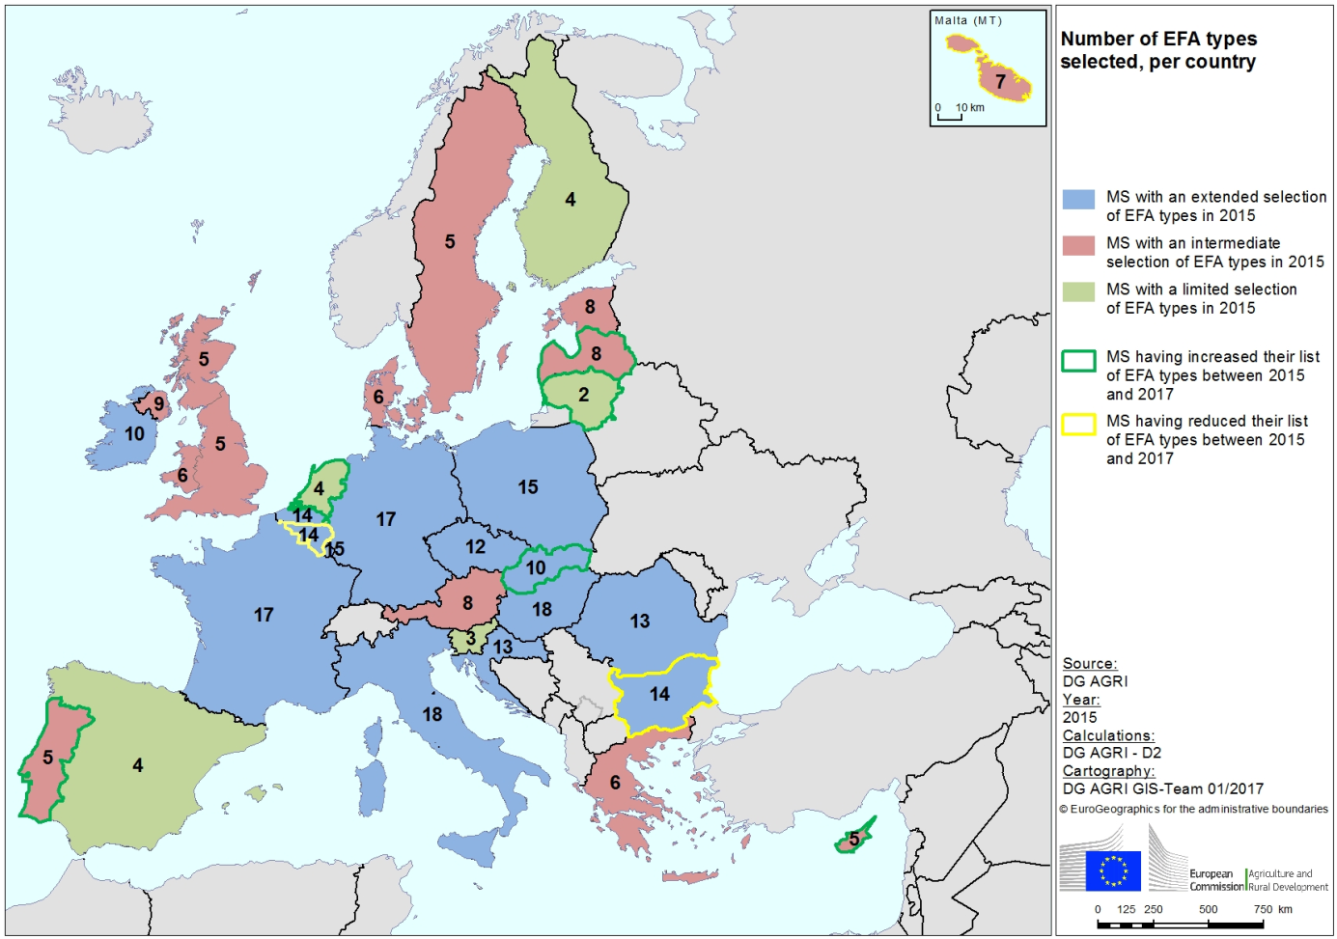

***Most Member States use options aimed at acknowledging other CAP mechanisms’ contribution to biodiversity***

22 Member States designated as EFAs at least one element required or protected by cross-compliance rules, namely buffer strips and/or one or more landscape features protected under those rules. Six decided not to consider any such feature. Likewise, four out of the five Member States that could do so offered farmers the advantage of the EFA forest exemption. As of 2016 only three Member States have started to apply EFA equivalence (Italy, the Netherlands and Austria).

***Options aimed at enhancing the effectiveness of EFA types are rarely chosen***

Although Member States have several ways to enhance the effectiveness of EFAs, these have rarely been used. For example, none of the 13 Member States/regions that selected ponds as an EFA type set criteria for ensuring their natural value. Likewise, only Belgium (Wallonia) out of the 31 Member States/regions placed input restrictions on areas with nitrogen-fixing crops, while just 4 out of 21 (Belgium (Flanders), Belgium (Wallonia), Germany and the Netherlands) did so for catch crops. Only two Member States (the Netherlands and Poland) have allowed farmers to pool their efforts to create adjacent EFAs that would be better for the environment (collective approach).

***Member State choices appear driven by the need to find a balance between maximising flexibility for farmers and minimising administrative complexity***

Based on the evidence collected[25] so far, Member States’ implementation choices appear driven, among others, by the following:

* the desire to offer farmers as many options as possible, enabling them to exploit the usual practices;
* the cost of complying with specific control requirements and of mapping permanent EFA elements in a dedicated layer of the Land Parcel Identification System;
* decisions taken under other CAP instruments (e.g. agroforestry measures supported by RDPs) or resulting from EU environmental legislation (e.g. mandatory establishment of catch crops under Nitrates Action Programmes[26]);
* local circumstances and environmental conditions (e.g. presence of terraces or abundance of semi-natural vegetation).

At this stage, it cannot be established whether any of these elements played a dominant role.

## 2.2. Farmers’ uptake of EFA types

***The EFA obligation covers the vast majority of EU arable land. Land coverage seems to be stable between 2015 and 2016***

In 2015, 70 % of the EU[27] total arable land fell under the EFA obligation. The proportion was 69 % in 2016. The remaining part of the arable land is:

* not covered by the direct payments system (e.g. farmer did not apply for aid);
* exempted because of the farm’s size (less than 15 ha of arable land);
* belongs to organic farms or farms under the small farmers scheme;
* has a high share of grassland; or
* is located in countries that apply the forest exemption.

***At EU level, the percentage of EFA areas declared by farmers is almost twice as much as the required 5 % at farm level. The three main EFAs are linked to productive or potentially productive areas.***

In 2015, 8 million ha of land was declared as EFA, which accounted for 13 % of the arable land falling under the obligation and 10 % after applying the weighting factors (percentages may differ at farm level). This is significantly above the regulatory requirement of 5 % at farm level. In 2016 the figures were 15 % and 10 % respectively, with a slight increase of 130 000 ha.

In 2015, the most frequently declared EFA types were those linked to productive or potentially productive agricultural areas (Figure 2):

* nitrogen-fixing crops (37.4 % of the physical EFA on the ground);
* catch crops (33.2 %);
* land lying fallow (25.9 %).

After applying the weighting factors, nitrogen-fixing crops and catch crops reached 54 % of the total weighted EFAs (39 % and 15 % respectively). This was 5.4 % of the arable land under the obligation and seems to have contributed to overshooting the required 5 % at farm level. Other areas like landscape features and buffer strips reached 1.7 % and 0.7 % respectively.

The above proportion of EFA at EU level remained quite stable in 2016, although with variation across Member States: areas under land lying fallow, landscape features and buffer strips decreased, while those under catch crops and nitrogen-fixing crops increased.

* In addition, the data on EFA types shows in 2015 that land lying fallow declared as EFA accounted for 34 % of the total fallow areas reported in Eurostat statistics for the Member States concerned. Such total areas decreased by 24 % from 2000 to 2014 but increased slightly in 2015.
* EU leguminous crops areas as reported by Eurostat have increased by 20 % since 2013. Nitrogen-fixing crops declared as EFA, which were chosen by all Member States except Denmark, covered 49 % of such areas in 2015. The specific role of EFA in the different factors that influence the trends of leguminous crops areas would need further assessment.

**Figure 2 — Breakdown of declared EFA areas by main EFA type, at EU level, before and after applying weighting factors**

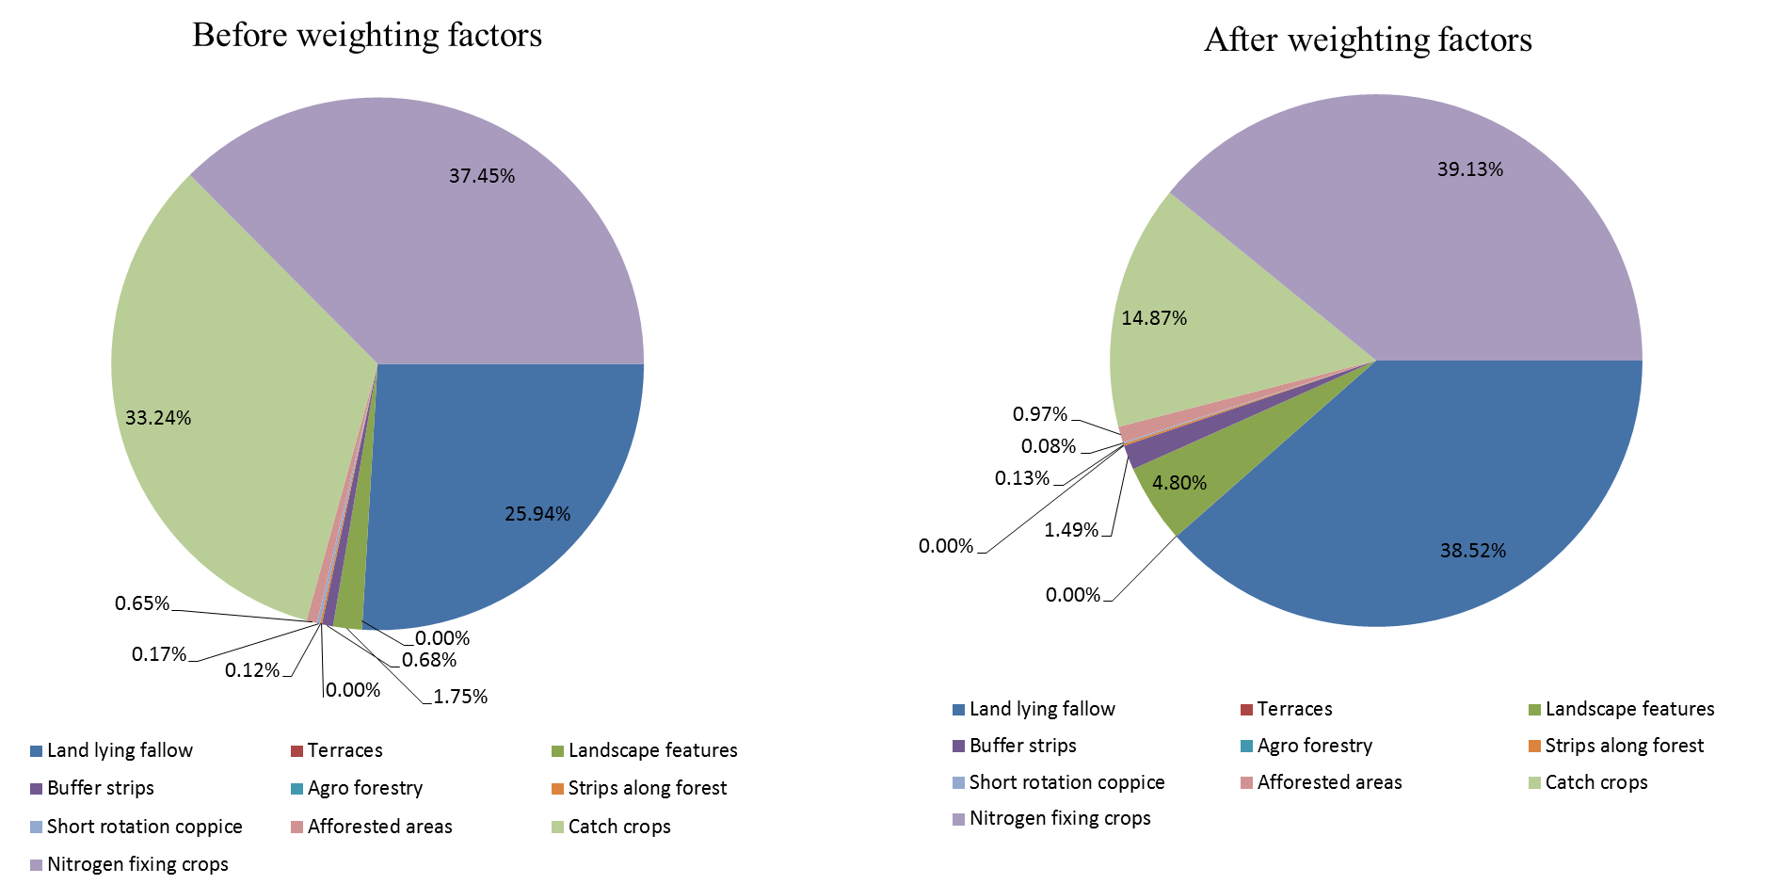

Source: Member States’ uptake data, 2015 (EU-27, data not available for France)

***The distribution of EFA types at Member State and regional level shows clear geographical patterns***

Analysis of EFA composition at Member State level (Figure 3) and at NUTS-3 region level (Figure 4) reveals several patterns:

* A substantial share of landscape features and buffer strips is found only in Ireland, the United Kingdom and Malta.
* Land lying fallow is more present in Mediterranean countries like Spain, Portugal and Cyprus and in Member States located in the boreal biogeographical region, like Finland and Latvia.
* Nitrogen-fixing crops are prevalent in Croatia, the Czech Republic, Italy, Poland and Romania.
* Catch crops are more widespread in Belgium, Denmark, Germany, Luxembourg and the Netherlands.

**Figure 3 — Breakdown of the main types of EFA area, after applying the weighting factors**

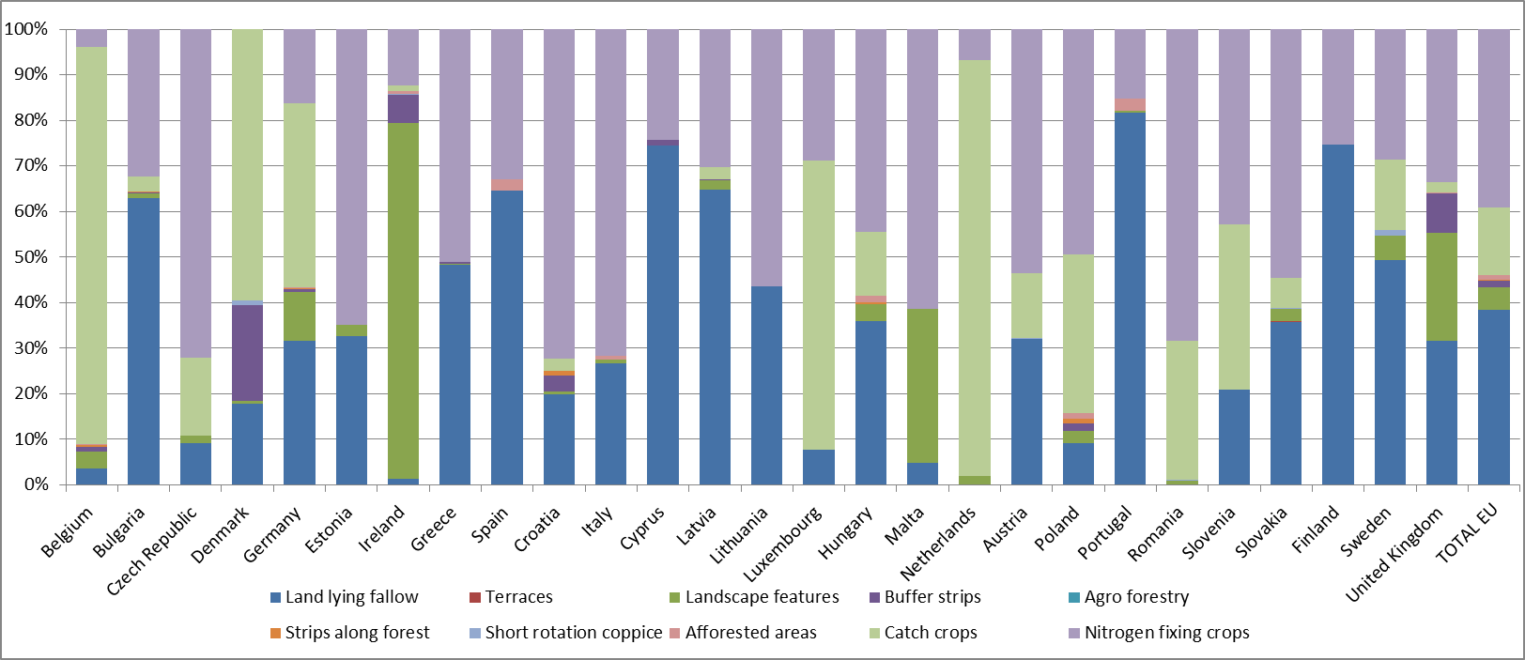

Source: Member States’ uptake data, 2015 (EU-27, data not available for France)

**Figure 4 — Spatial distribution of main EFA type categories for each NUTS 3 region**

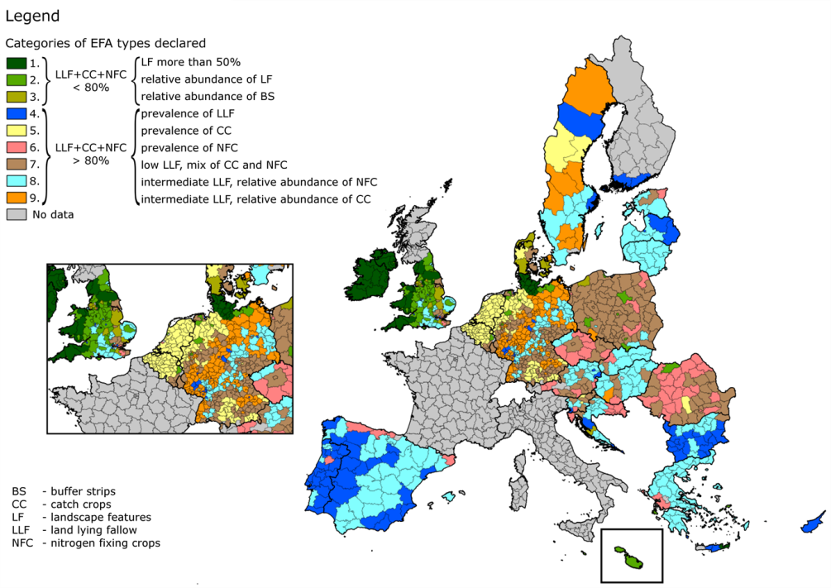

Source: Member States’ uptake data, 2015. Data not available for France and Scotland. Italy’s data still subject to verification. Regions not classified in Finland are under the forest exemption.

***EFA equivalent practices were applied in three Member States***

The introduction of practices equivalent to EFAs in three Member States resulted in 41 000 ha of equivalent EFA areas in 2015, mostly in Austria (almost 39 000 ha based on agri-environment-climate measures, accounting for 65 % of the country’s EFA areas). In the Netherlands, certification schemes covered field margins especially and amounted to 2 700 ha (5 % of the total EFAs in the country) in 2015. Italy has been applying equivalence since 2016 and uptake data is not yet available.

***The key determinants commonly used to explain farmers’ decisions seemingly also apply to their uptake of EFA***

Both the scientific literature and the results of the public consultation suggest that the factors influencing farmers’ decisions about the type of EFA to adopt fall roughly into three categories:

* economic determinants prompting them to choose the least costly and most productive EFA type;
* policy and administrative factors such as:
  + a restricted list of EFA types made available by the national authorities (e.g. countries having selected only three or four EFA types);
  + the level of risk that they will be checked and found to be non-compliant (e.g. if a field margin exceeds the maximum width);
  + the level of administrative burden (e.g. this may be reduced by use of a pre-filled single application form with all landscape features qualifying as EFAs);
* farmers’ perceptions and knowledge of the EFA obligation.

At this stage, it cannot be established whether any of these elements played a dominant role.

# 3. Observations on EFAs’ potential environmental and climate effects

This chapter details the chosen EFA measures’ possible **environmental** effects, as revealed by the EFA calculator presented in Section 1.2 and a review of selected literature. The EFA calculator simulations consider potential impacts of EFA composition at regional NUTS-3 level through aggregated scores which should not be seen as absolute values. The results reflect EFA types’ characteristics and context, but do not quantify real impacts, which also depend on management practices at farm level that the simulations do not cover.

As the EFA calculator only marginally covers possible impacts on **climate mitigation and adaptation**, a qualitative assessment was also carried out for that aspect.

## 3.1. Potential impacts on biodiversity

***Landscape features and land lying fallow appear the most beneficial EFA types for biodiversity***

The EFA calculator suggests that all EFA-type compositions observed at regional NUTS-3 level could have a positive impact on biodiversity, though at various degrees. The lowest score was for regions where catch crops were more than 70 %. The highest potential positive impact was associated with EFA compositions where landscape features were the most prominent (more than 50 % of the region’s total EFA), followed by the composition where land lying fallow was prominent (more than 70 %).

For species groups, the analysis indicates a positive impact of landscape features on invertebrates, birds and terrestrial plants, while for reptiles and amphibians the presence of buffer strips and fallow land gives higher positive impact scores.

Findings from other scientific literature also acknowledge these observations. Moreover, they suggest that among landscape features, the most positive potential impact on biodiversity is associated with hedges, field margins and traditional stone walls since they provide habitats for insects and arthropods, birds and plants.

***EFAs could be more beneficial for biodiversity provided appropriate management practices are in place***

The observations indicate the importance of management practices in enhancing the environmental effects of EFAs.

The EFA calculator’s results suggest that the positive impact on biodiversity is likely to vary depending on different management requirements for each type of EFA. For example, for land lying fallow it depends on coverage and species sown. For biodiversity and in particular pollinators, sowing wildflowers has the highest impact while leaving the soil bare the lowest. Natural regeneration is also a good way to foster biodiversity and pollination.

In addition to the nature of the coverage, the literature also points to the importance of non-intensive ways of managing non-productive EFAs such as keeping land fallow for a long period or not using pesticides because they reduce disturbance of the relevant habitats, in particular over the bird breeding period.

Sowing mixtures of species under catch crops/green cover appears to have a positive impact on biodiversity. Indeed, according to the literature, positive effects can be enhanced if the mixtures comprise plant mixes designed to benefit pollinators and birds, and when they are left to flower and set seed.

Findings on species choice apply also to nitrogen-fixing crops, although the simulations also showed that *Vicia faba* might score slightly better than other species. As for other EFA types, potential positive impacts of nitrogen-fixing crops also hinge on the type of management, such as cultivation frequency and extensive management.

## 3.2. Other potential impacts

### 3.2.1. Potential impacts on ecosystem services

***Landscape features provide best results in terms of their potential positive impact on ecosystem services***

The EFA calculator results suggest that out of the different EFA-type compositions at regional NUTS-3 level, the presence of prevalent landscape features on more than 50 % of the region’s total EFA shows the most positive potential impact on ecosystem services as a whole.

Further analysis of the scientific literature indicates that landscape features’ positive impact on ecosystem services could be enhanced by ensuring their proper floral diversity, vegetation structure and management. For buffer strips, their location and dimensions are key.

***Other EFA types may have some positive impact on some ecosystem services, especially if certain management rules are put in place and if the choice of species sown meets specific requirements***

Catch crops fare well in terms of their impact on the chemical condition of freshwater. Simulations from the EFA calculator show, for example, that their impact can be enhanced by using mixtures of different species. They also show that species most commonly declared by farmers for catch crops (e.g. *Lolium perenne, Lolium multiflorum, Sinapis alba* and *Raphanus sativus*) score better when sown as a mixture rather than as single species. Furthermore, species with different nutrient requirements and rooting systems can be more efficient in reducing the risk of nitrogen leaching.

The positive impact of land lying fallow on ecosystem services appears also to depend on the choice of species sown: wild seed mixes and bare fallow with winter stubbles and naturally regenerated vegetation fare better than grass. However, any coverage on fallow land is welcome, as bare soil scores the lowest on ecosystem services and may have negative impacts due to the higher risk of soil erosion. Land lying fallow also gives better results if left unmanaged for a long period.

The impact of nitrogen-fixing crops may also depend on the choice of species and management: decreasing cultivation frequency reduces nitrogen leaching, phosphate run-off and the risk of soil erosion.

### 3.2.2. Potential impacts on climate

From a climate adaptation perspective, the introduction of EFA could help farms’ climate resilience, for example, through the increased provision of landscape features. Climate mitigation could be enhanced by increased use of leguminous crops and the resulting displacement of nitrogen fertiliser with nitrogen fixation. Also, the benefits on soil carbon stocks through agroforestry and afforestation, when implemented, could improve the carbon sequestration of EU land use.

Soil carbon sequestration is directly dependent on soil biodiversity. This highlights the links and possible synergies between improving biodiversity on farms and climate mitigation.

# 4. Conclusions

2016 was the second year of application of the EFA obligation. The data collected so far from 19 Member States suggests that there was little change in the second year, neither in how national authorities run the system nor from farmers, who generally met the obligation in the same way as in the first year. As a result, there was almost no change in the proportion of land under EFA, the overall areas that farmers declared as EFA and the share of different EFA types in these areas.

The overall percentage of declared EFAs on arable land is nearly double the 5 % required at farm level. This has been achieved by relying mostly on productive and potentially productive EFAs: nitrogen-fixing crops, catch crops and land lying fallow. Other EFAs, including landscape features, contributed only slightly to the overall declared EFAs.

The analysis suggests that EFA types’ environmental benefits depend not only on their quantity but also on their quality, linked to specific conditions and management requirements such as:

* type of soil cover for land lying fallow, different mixtures of crops for catch crops and of crop groups for nitrogen-fixing crops;
* cutting regimes, retention periods and the use of chemical inputs;
* the diversity of vegetation structure for landscape features, the location and dimension for buffer strips.

The changes to secondary greening legislation currently pursued by the Commission are an important step towards better management practices, along with: (i) a ban on the use of plant protection products on (potentially) productive EFAs; (ii) clarifying and setting retention periods for some EFA types; and (iii) streamlining the requirements that might have prevented farmers from using some of the most environmentally beneficial EFAs, namely landscape features and buffer strips.

The Commission will continue its reflection on the subject, including as part of the upcoming evaluation of greening. This report will make a useful contribution to that evaluation, which will look at all aspects of greening, including EFAs. The evaluation will then feed into the next phase of modernising and simplifying the CAP, to maximise its contribution to meeting the Commission’s 10 priorities and the Sustainable Development Goals.

On the basis of the above considerations, the Commission does not propose to amend Regulation (EU) No 1307/2013 by increasing the percentage of EFA.

1. Articles 43 to 47 of Regulation (EU) No 1307/2013.
2. Idem, Article 46(1) third paragraph.
3. SWD (2016) 218 final.
4. Regulatory Fitness and Performance programme.
5. Commission Delegated Regulation (EU) No 639/2014.
6. Commission Delegated Regulation of 15.2.2017, C(2017)735.
7. With an option for Member States to implement them in 2017.
8. European Parliament and Council scrutiny ongoing on the legislative amendments.
9. See the 2017 Management Plan — Agriculture and Rural Development; <https://ec.europa.eu/info/publications/management-plan-2017-agriculture-and-rural-development_en>.
10. Under Article 110(5) of Regulation (EU) No 1306/2013.
11. Recital 44 of Regulation (EU) No 1307/2013.
12. Among others, the Mid-Term review of the EU Biodiversity Strategy to 2020, COM(2015) 478 final.
13. EFA types are stated in Article 46(2) of Regulation (EU) No 1307/2013 and further specified in Article 45 of Commission Delegated Regulation (EU) 639/2014.
14. See COM(2015) 215 final and SWD(2015) 111 final.
15. Choices made by central authorities in all Member States except Belgium and the United Kingdom, where they were made by regional authorities.
16. Based on the EU NUTS-3 classification of regions.
17. 2016 uptake data was received from 18 Member States (Belgium, Bulgaria, Czech Republic, Denmark, Estonia, Spain, Croatia, Latvia, Lithuania, Luxembourg, Hungary, Malta, Austria, Poland, Portugal, Romania, Slovakia, Finland) and two countries of the United Kingdom (Wales and Northern Ireland).
18. Tool developed by the University of Hertfordshire with JRC’s coordination.
19. Most relevant available studies: *Ecological Focus Area choices and their potential impacts on biodiversity* by Evelyn Underwood and Graham Tucker, Institute for European Environmental Policy November 2016. *Adding Some Green to the Greening: Improving the EU’s Ecological Focus Areas for Biodiversity and Farmers,* Guy Pe’er and al, Conservation letters, a Journal of the Society for Conservation Biology, December 2016. A list of all sources can be found in the SWD.
20. See <http://ec.europa.eu/eurostat/web/nuts/overview>.
21. European nature information system.
22.
23. <http://ec.europa.eu/agriculture/consultations/greening/2015_en>.
24. Mapping and analysis of CAP implementation: <https://ec.europa.eu/agriculture/external-studies/mapping-analysis-implementation-cap_en>.
25. See footnote 24.
26. Under Council Directive 91/676/EEC (‘the Nitrates Directive’).
27. For data availability, see Chapter 1.2.