

Contents

ANNEX 11: Available IT building blocks and EU funding 205

ANNEX 12: Outline and project plan of the Single digital gateway 210

ANNEX 13: Good practices from the Member States 214

ANNEX 14: Contents of Your Europe 222

ANNEX 15: Example of product requirements 224

ANNEX 16: Report on the online public consultation 228

ANNEX 17: Visual outline of the single digital gateway 253

ANNEX 18: Financial and human resources of the relevant services 254

ANNEX 19: Methodogy of cost and benefit calculation 259

ANNEX 20: Glossary 274

# Available IT building blocks and EU funding

## Connecting Europe Facility (CEF) building blocks

The CEF building blocks offer basic capabilities (specifications, software and services) that can be used in any European project to facilitate the delivery of digital public services across borders.

At the core the CEF building blocks are interoperability agreements between European Union member states. They ensure interoperability between IT systems so citizens, businesses and administrations can benefit from seamless digital public services wherever they may be in Europe.

The building blocks are based on existing formalised technical specifications and standards. They are intended to facilitate the adoption of common technical specifications by projects across different policy domains with minimal (or no) adaptations by providing services and sometimes sample software. The building blocks can be combined and used in projects in any domain or sector at European, national or local level.

eDelivery

The eDelivery building block helps public administrations to exchange electronic data and documents with other public administrations, businesses and citizens, in an interoperable, secure, reliable and trusted way.

Concretely, eDelivery prescribes technical specifications. Through the use of this building block, every participant becomes a node in a network using standard transport protocols and security policies: these nodes are conformant to the same technical rules and therefore capable of interacting with each other. As a result of this, organisations that have developed their IT systems independently from each other can start to securely communicate with one another once they have connected to an eDelivery node.

This building block could be an option in the single digital gateway for the exchange of documents used as evidence by citizens or businesses when completing procedures online.

eID

In line with the eIDAS Regulation (EU) 910/2014, the eID building block helps citizens of one Member State to access online services provided by public and private organisations from other participating EU Member States, using their own national eID.

It allows cross-border authentication, in a secure, reliable and trusted way, by making national electronic identification systems interoperable thanks to the development of open-source software components, documentation, training and support.

The eID building block could be used to enable cross-border transactionality of online procedures, as foreseen by the single digital gateway proposal.

eSignature

In line with the eIDAS Regulation (EU) 910/2014, the eSignature building block helps public administrations and businesses to accelerate the creation and verification of electronic signatures. The deployment of solutions based on this building block in a Member State facilitates the mutual recognition and cross-border interoperability of eSignatures. This means that public administrations and businesses can trust and use eSignatures that are valid and structured in EU interoperable formats, and that legal value of eSignatures can be recognised in countries other than the country of origin of the signer.

The eSignature building block could be further used to enable cross-border transactionality of online procedures, as foreseen by the single digital gateway proposal.

eInvoicing

*Since 2001, European legislation has given electronic invoices legal equivalence with their* paper counterparts. However, a diversity of eInvoicing standards exists. Directive 2014/55/EU on eInvoicing in public procurement calls for the definition of a common European standard and makes it mandatory for all contracting authorities to accept eInvoices complying with the European standard as of November 2018.

The eInvoicing building block aims at supporting CEN in the definition of the common EU eInvoicing standard and at promoting its use amongst both public and private entities established in the EU.

Use of this building block could be recommended in the frame of procedures covered by the single digital gateway, beginning with public procurement procedures.

eTranslation

The eTranslation / Automated Translation building block helps European and national public administrations exchange information across language barriers in the EU. While eTranslation is mainly intended to be integrated into other digital services, it also offers stand-alone services for translating documents or snippets of text.

This building block builds on the existing Commission Machine Translation Service (MT@EC). The technical implementation of a user interface for this building block guarantees confidentiality and security of all translated data. Unlike general-purpose web translators, the eTranslation building block is adapted to specific terminology and text types that are typical for the usage context (e.g. tender documents, legal texts, medical terminology).

Already used on the Online Dispute Resolution Portal, this building block could help making multilingual the information, services and procedures that are accessible through the single digital gateway.

## Interoperability tools

Costs associated with the digitalisation of procedures are expected to be limited if public authorities use the tools at their disposal for increasing interoperability such as the European Interoperability Framework or the Core Public Services Vocabulary.

European Interoperability Framework (EIF)

The European Interoperability Framework aims at supporting enhanced interoperability between public administrations across Europe.

Foreseen to be reviewed by the end of 2016, this framework provides a set of recommendations / guidelines to improve the interoperability of European public services, as well as an action plan for implementation.

Several of the recommendations made in this Framework could be promoted in the frame of the single digital gateway. Implementation of the European Interoperability Framework will facilitate the achievement of the Single digital gateway objectives by increasing the level of interconnection of public services and thereby reducing solutions costs.

Core Public Services Vocabulary (CPSV) [1]

The Core Public Services Vocabulary is a tool for:

* Providing information on public services in a user-centric way, grouped logically around key business events;
* Mapping different data models to a common model requiring only one single description, with a view to federating and sharing information in a more efficient and interoperable way.

Concretely, it consists of a common data model for describing key business events and public services. It allows for harmonised, machine-readable and interoperable semantic descriptions.

Use by Member States authorities of the Core Public Services Vocabulary when designing or updating their websites would facilitate the development of the search by the single digital gateway's user interface of online information, services and procedures, and thereby help improving their findability. The use of common models and vocabularies would also facilitate translation as well as the reporting and analysis of users' feedback.

## EU funding

The European social and regional development funds provide EU funding to most Member States in the area of e-government (thematic objective (TO) 2 "enhancing access to, and use and quality of information and communication technologies" and thematic objective (TO) 11 "enhancing institutional capacity of public authorities"). All Member States have access to TO2. For TO 11, 18 Member States are eligible, and 17 use it.

The tables below provide an overview. In the past, (some) Member States have made active use of EU funding in order to implement requirements from EU legislation, e.g. the Services Directive 2006/123/EC, the Public Procurement Directive 2014/24/EC, the eIDAS Regulation EU 910/2014, NIS Directive 2016/1148, directive on the Reuse of Public Sector Information 2013/27/EU and Directive on electronic invoicing in public procurement 2014/55/EU[2].

All eligible Member States except Sweden, the UK and the Netherlands have included links to thematic objectives 2 and 11 in their operational programmes, which is the pre-condition for securing EU funding in this area.

***Figure 11.1: Member States with thematic objectives 2 and 11 in operational programmes[3]***



*Source: In-depth analysis of NRP 2016 documents, performed by Wavestone*

***Figure 11.2: ESIF funding for e-government under TO2 for 2014-2020, EUR million***

***Figure 11.3: ESIF support for institutional capacity building in 2014-2020, EUR***

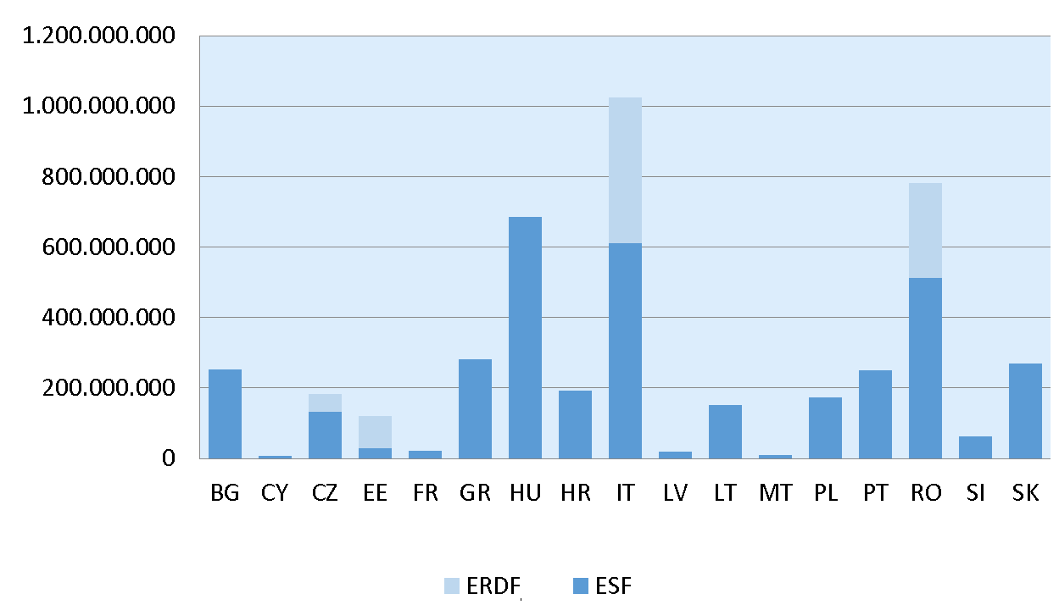

# Outline and project plan of the Single digital gateway

The preferred option follows an EU-coordinated approach, where the Commission covers EU-level information on the Your Europe portal and Member States cover agreed national information in their own different websites and portals, and both access levels (EU and national) are linked. The Your Europe portal will be the EU-level access point to the Single digital gateway, and all national and other EU websites that are part of the gateway will contain links to the central access point site.

The Your Europe portal, which is part of the Commission's Europa site, contains separate sections for citizens and businesses. Both sections have a hierarchical navigation structure according to topic, guiding the user from EU-level information to corresponding information for each Member State, as well as EU-mandated assistance and problem-solving services and contact details of national competent authorities. This general structure will remain, but will be supplemented by further search possibilities and filled with new national content in (usually) English.

1. Information and assistance services

The information areas on Your Europe, as well as the assistance and problem solving services to which it links (supplemented in the future by national - public or private- services where Member States decide to add them to the gateway) will constitute the scope of the gateway in terms of information and assistance services.

1. Findability and awareness

A new common search facility will be added to the Your Europe central page, which will guide the user to the right information pages which Member States will have notified to the Commission as part of the gateway. Member States will need to provide information in the agreed areas in their national as well as a foreign language (most likely English). A common EU-level enquiry form for assistance services will make for additional findability of these services from the Your Europe central page.

1. Quality criteria and feedback

Common quality criteria (e.g. clear, comprehensive and easy-to-understand information, clear descriptions of procedures and assistance services, respect of deadlines) will be introduced to apply to all covered information, assistance services and procedures. These will be monitored via a common user feedback tool that will be available on Your Europe and all linked portals, and through which users can comment on whether they could find what they were looking for, and if so, comment on the quality. This information will be used for quality and compliance monitoring and to further develop and improve the gateway content according to user needs.

1. Procedures

In addition, the gateway seeks to ensure that citizens and businesses can access and carry out the most important administrative procedures fully online. As Member States are on different levels of e-government implementation, this cannot be a one-size-fits-all approach. Instead, it will follow an agreed implementation timetable per Member State. Foreign users should be able to carry out procedures on an equal footing with domestic users. As the transmission of foreign evidence usually constitutes the biggest hurdle to being fully online for foreign users, with Member States usually requiring translation and certification of foreign documents, the Commission will provide a user interface IT tool for the cross-border use of documents and data. The details of this tool will be specified later on.

1. Governance

The single digital gateway is a fully cooperative project between the Commission and the Member States. For this purpose a single digital gateway coordination group will be created to support consistent implementation of the legal requirements. The group will work on the basis of annual programmes to implement the project plan (see below). In addition, since the success of the gateway will depend on how well it meets the needs of it users, we plan to create a stakeholders network group of organisations representing the different user groups. The Commission will also coordinate the networks of EU assistance services and create more synergies.

1. Responsibilities

In general, the responsibilities of the Member States are:

* Getting information about applicable national rules online and make sure it fulfils the quality criteria, including one foreign language;
* Monitoring compliance of national level assistance services with quality criteria;
* Getting the 10+10 key procedures are online and available for foreigners.

The main responsibilities of the Commission is to:

* Provide EU level information online (as in Your Europe portal);
* Coordinate the networks of EU assistance services networks (synergies as compared with current situation);
* Provide common IT tools for the single digital gateway;
* Ensure governance of the single digital gateway.

The detailed responsibilities that the chosen package of options places on the Commission and the Member States are indicated under the description of each option in section 4 of the impact assessment.

The single digital gateway project will require solid preparation, strong coordination, proactive implementation and continuous development over time to make sure that it remains fully aligned with user needs. Careful planning and a clear understanding of who does what are of the essence.

Assuming that the Commission Proposal will be adopted in Q1/2017 and the legal act in Q3/2018, the timetable below presents main actions which need to be undertaken to ensure the successful launch of the gateway in Q3/2020 and its further development.

1. Project plan

| **Timing** | **Commission actions** | **Member States’ actions** |
| --- | --- | --- |
| ***Pre-adoption stage*** | | |
| Q1/2018 | Works with MS on developing synergies for information and assistance services towards the objectives of the single digital gateway | Work with the COM on further convergence of information and assistance services towards the objectives of the single digital gateway |
| Q1/2018 | Analyses different options related to the IT tools and applications listed in the Commission Proposal | Analyse the needs and efforts which have to be done to ensure full compliance with the Regulation |
| Q2/2018 | Establishes a network of stakeholders (Chambers of Commerce, etc.) to discuss with them ideas related to the practical implementation of the single digital gateway |  |
| Q2/2018 | Prepares the draft annual work programme (e.g. to clarify detailed implementation steps per Member State) |  |
| ***Q4/2018*** | ***Adoption of the [single digital gateway] Regulation*** | |
| Q3/2018 | Convenes the first meeting of the single digital gateway Group to discuss the first annual work programme | Appoint national co-ordinators and notify their names to the COM |
| Q3/2018 | Sets up internal governance structure to manage and coordinate all EU level services and portals that are part of the single digital gateway | Ensure that sufficient resources are made available at national level  Put in place the internal structure of co-ordination and monitoring |
| Q1/2019 | Adoption of the first annual work programme | Adoption of the first annual work programme |
| Q1/2019 | Adopts implementing acts | Discuss the draft implementing acts in the single digital gateway Committee |
| Q1/2019 | Starts developing the IT tools required for supporting the single digital gateway:  - user interface  - repository of links  - reporting tool on the functioning of the Single Market  - data collection tool  - user feedback collection tool | Start working on:  - filling the online information coverage gaps  - getting the missing procedures online  - ensuring that existing online procedures are accessible for foreign users |
| Q2/2019 | Organises trainings, workshops, visits in Member States to discuss/advise Member States as regard the use of the ESF, ERDF and other sources of financing, managed by the COM | Re-structuring, tagging of information on their websites |
| Q2/2019 | Issues of interpretative/guidance documents or recommendations, if needed |  |
| Q3/2019 | Preparation of promotion campaigns and discussion within the [single digital gateway] Group |  |
| Q3/2019 | Finalisation of work on the IT tools | Notification of links to the national services to the repository of links |
| Q4/2019 | Implementing act on tool for cross-border use of evidence |  |
| Q4/2019 | Beta-version of the single digital gateway to be put online and tested | Testing together with the COM the tools and applications to ensure that they are ready to use as from Q3 2020 |
| Q3/2020 | All agreed information is offered online  User feedback tools deployed on all single digital gateway related webpages | All agreed information is offered online  User feedback tools deployed on all single digital gateway related webpages |
| Q4/2020 | Launch of tool for cross-border use of evidence |  |
| ***Q4/2020*** | ***Launch of the Single digital gateway*** | |
| Q4/2022 | First report on obstacles in the Single Market based on data gathered through all services within the single digital gateway and the user feedback tool |  |
| Q4/2022 | First report on the functioning of the single digital gateway |  |
| Q1/2024 | Second report on obstacles in the Single Market |  |
| Q3/2024 | Second report on the functioning of the single digital gateway and, if needed, recommendations for improvement |  |

1. Governance structure

The envisaged governance structure for implementation, coordination and development of the gateway would be based on the following elements:

1. Co-ordination within Member States of all tools and services which will be accessible through the gateway, monitoring their quality and ensuring that they comply with the foreseen quality standards on a permanent basis. Each Member State should appoint one **national co-ordinator** who would be entrusted with the co-ordination tasks at the national level and who could act as an interlocutor in discussions with other Member States and the Commission.
2. Co-ordination within the Commission in relation to websites and tools provided by different services of the Commission. The co-ordination can be ensured in the most efficient way if one **central point within the Commission** is appointed to perform the relevant tasks, including monitoring of the quality of linked services, analysing user feedback, ensuring the development, maintenance and the security of IT tools and applications relevant for the gateway.
3. **The single digital gateway Co-ordination Group** bringing together the Member States (their national co-ordinators) and the Commission for coordination, discussion and decision-making on the practical implementation of the gateway and its further development. The work of the group would be prepared by the Commission co-ordination centre. In particular the Group should agree on:

* The annual work programme;
* Promotion activities;
* Steps which should be taken to ensure the consistent implementation of the gateway in all Member States including assistance measures.

1. A **Stakeholder feedback group** including representatives of the main user groups to provide input on planned developments and priorities to ensure regular calibration of the project towards the real needs of its users.

# Good practices from the Member States

|  |
| --- |
| **How to present good quality information** |
| **Austria**  A table presents a list of categories of products which are not subject to harmonisation. For each category, the main pieces of law applicable and their amendments are identified, the competent authority is indicated, together with an e-mail address for questions.  <http://www.en.bmwfw.gv.at/technicalaffairsandsurveying/ProductContactPointOfTechnicalRules/Seiten/default.aspx>  **Denmark**  The Product Contact Point for the Construction website presents general information concerning product categories under the FAQ section. A search tool allows the search for all applicable and soon to be applicable standards in both Danish and English.  <http://danishcprcontactpoint.dk/forside/0/2>  The Product Contact Point website explains the principle of mutual recognition and publishes a list of Danish general rules and technical rules per product, in English.  <https://danishbusinessauthority.dk/product-contact-point>  **Finland**  Finland is making available a common open wiki for public administration IT materials.  <https://wiki.julkict.fi/julkict/>  **France**  The Product Contact Point for the Construction website allows the search for information on standards and construction products both through a free search and through a graphical search. It also has information on other relevant documents and concerned bodies. The FAQ section presents comprehensive overall information on construction products in France.  <http://www.rpcnet.fr/index.php>  The Product Contact Point publishes information sheets by product family, in English, with links to the relevant European and/or French legislation, contact details for the government departments responsible for this legislation and for market surveillance, as well as other useful contacts.  <http://www.entreprises.gouv.fr/libre-circulation-marchandises/free-movement-of-goods-in-europe?language=en-gb>  **Germany**  Many German e-government websites offer the additional facility of "easy language", i.e. the more complicated text on the official website is translated into a more simple language.  **Ireland**  The website of the Department of Housing, Planning, Community and Local Government presents information on all aspects of construction in Ireland, well beyond standards for construction products. Specific thematic documents guide the user to understand what requirements apply.  <http://www.housing.gov.ie/> |
| **Luxembourg**  Citizens and businesses can access the information they need on their rights and obligations through accessing a single website. The website structures the information around topics, and uses a single template for all procedures. The logic of the template is the one of the user, so the information is adapted to it, not the other way round. To that extent, the PSC engages people with specific communication skills and proof-readers without specific expertise in the topic covered. Furthermore, the website also provides a user-friendly and precise search engine through which the user can find the information he needs in a more dynamic manner.  <http://www.guichet.public.lu>  **Sweden**  The PCPC website proposes a good overview of national rules and EU standards, in both Swedish and English. Information goes beyond what is offered by the Product Contact Point for Construction.  <http://www.boverket.se/en/start-in-english/products/construction-products-regulation/cpr-contact-point/>  **United Kingdom**  The Product Contact Point explains the principle of mutual recognition and publishes an exhaustive list of UK technical rules according to product categories.  <https://www.gov.uk/guidance/mutual-recognition-regulation-across-the-eea#technical-rules-for-specific-non-harmonised-products-in-the-uk>  Availability and usability of information provided by the PSC has scored considerably above the EU average (2015 Points of Single Contact Study) and was praised for the good quality of supporting functions (e.g. search, navigation). The portal provides extensive information on business procedures.  <http://www.gov.uk> |
| **Public and private entities working together** |
| **Finland**  The Finnish Building Information Foundation is a private, non-profitmaking Foundation which provides construction information in Finland. The company publishes instructions for building and property management, regulations, contract documents and forms and product information, and promotes good practices.  <https://www.rakennustieto.fi/index/english.html>  **Ireland**  Ireland has chosen a private company, Licences.ie, to provide an Integrated Licensing Application Service. The company provides all the infrastructure and resources necessary to deliver the service at its own expense. It recovers all costs by means of charges levied on the licensing authorities which are using its service. The licensing authorities may decide not to use the Licenses.ie. In such a case, they have to build their own system to enable the access to e-procedures.  **Luxembourg**  The Point of Single Contact cooperates with the Chambers of Commerce to identify and prioritize requirements and procedures relevant for businesses which should be included in the scope of PSC services.  **Poland**  The Ministry of Economic Development shares tasks over PSC with the Polish Chamber of Commerce: when questions from users submitted to the PSC Help Centre require technical knowledge, they are transmitted to the Chamber of Commerce which contacts relevant experts. The answers from experts are verified and sent to users from the Help Centre.  **ProductIP**  Personal Product Compliance Partner is a private company established in the Netherlands that provides on a client's request and for an affordable price a comprehensive requirements list for a given product (the list of requirements for a defined market, from a defined moment, for a defined product, where applicable, for a defined customer, etc.).  <https://www.productip.com>  **Sweden**  The Product Contact Point for Construction displays an overview of links towards Swedish and European private sector organisations that can help with various questions related to selling goods in the EU.  <http://www.boverket.se/contactpoint-cpr>  The PSC has a section on how to find affordable business advisers:  <https://www.verksamt.se/en/web/international/find-advisors> |
| **Quality management for information and assistance services** |
| **France**  Le Référentiel Marianne aims to provide users of national administration services with guarantees on the conditions and performance of these services. It was redesigned in 2016, resulting from a large-scale study on user satisfaction. Administrations have to comply with 12 commitments belonging to five categories: effective guidance; information relating to users' expectations; a warm welcome and attention; clear responses within published deadlines; progress by listening to users; and undertakings of the public agencies.  **Germany**  The PSC of Brandenburg is getting content reviewed and approved by the competent authority staff as well as by the PSC staff, including legal experts, before posting it.  **Malta**  The PSC ensures the accuracy of information through 19 service-level agreements with ministries and competent organisations. These administrative arrangements ensure the updating and reliability of the information.  **SOLVIT**  The 2013 Commission Recommendation on the principles governing **SOLVIT** provides that SOLVIT centres should abide by minimum service obligations and detailed case handling rules, such as time limits for SOLVIT centre replies to applicants and regular quality checks of cases. After a case has been closed, applicants should be invited to give feedback on how the case has been handled by SOLVIT. The general performance of SOLVIT and per Member State is subject to reporting and published online each year in the Single Market Scoreboard.  **United Kingdom**  The central e-government portal "gov.uk" is run according to a published Digital Service Standard, which includes principles such as ongoing user research and usability testing to continuously seek feedback from users to improve the service. The service should be regularly assessed according to pre-identified performance indicators, and performance data reported on a dedicated performance platform. The ministry responsible for the service should test it from the beginning to the end.  The responsible service defines standard criteria for services, develops open source solutions and promotes the exchange of good practices. Multidisciplinary development teams are created in the operational departments, covering expertise in infrastructure, development, and analysis of user needs. It also monitors developments in digital professions and works on role identification for the composition of a collaborative team. The service follows a policy of discouraging digitising legacy services.  <https://www.gov.uk/service-manual/assets/documents/digital-service-standard.pdf>  **Your Europe Advice**  The **Your Europe Advice** service provides free and personalised advice in the enquirer's language **within a week**. Quality criteria apply to the reply, such as "precise, concise, complete, tailor-made, clear, accurate and easily understandable for "normal citizens" without legal knowledge". Various quality control measures are carried out by both the contractor and the Commission, such as random ex post quality control of replies, ex-ante controls and keeping records for internal management purposes of expert-by-expert performance in relation to the content-related and the formal quality criteria. |
| **Using the user feedback mechanism to improve quality** |
| **Luxembourg**  The PSC organizes its own mystery shopping to get feedback and define priorities for further development.  **Malta**  The Maltese PSC has a good and complete track and trace mechanism in place, resulting in the highest possible performance on this element of the PSC.  **The Netherlands**  The Dutch chamber of commerce portal "ondernemersplein" uses analytics and user feedback as part of a feedback loop to continuously improve the content on its website.  **Poland**  The Point of Single Contact collects user feedback on every service (Help Centre and on the PSC portal). This includes a short and effective feedback mechanism on each web page of the portal. Poland uses the application Survicat to create targeted questions.  <http://business.pl>  **United Kingdom**  The UK is continuously measuring user satisfaction on its e-government platform "gov.uk". Each service runs a satisfaction survey feedback page, asking to rate the experience of using the service on a 5 point scale, from 'very satisfied' to 'very dissatisfied'. It also includes a final open-ended question for users to say whatever they think of the service. Key performance figures for services and results from the user feedback mechanism are kept in a central database managed by gov.uk. The GDS team is undertaking efforts to establish monthly performance benchmarks on delivery, accuracy and usefulness.  <https://www.gov.uk/service-manual/measuring-success/measuring-user-satisfaction>  The UK Friends and Family Test (FFT) is a user insight tool which asks users of public services: "Would you recommend this service to your friends and family?" FFT scores are published transparently and displayed by each provider. The score provides a vivid, actionable and customer-focused performance measure, and open text feedback is used by providers to improve user experience, as an example of the UK's programme of creating Open Public Services.  OECD Observatory of Public Sector Innovation,  <https://www.oecd.org/governance/observatory-public-sector-innovation/innovations/page/friendsandfamilytest.htm#tab_description> |

|  |
| --- |
| **Your Europe**  The portal has a constant button on all webpages "Help us improve", asking the user whether he found what he wanted, what he was looking for, as well as an open text box for any suggestions. |
| **Central government plan to roll out e-procedures** |
| **Cyprus**  In Cyprus, the Council of Ministers established a national strategy to enable communication with public authorities through a single point of entry: the ARIADNI gateway, established in 2015, is already covering 20 e-services, and is foreseen to be complete for both citizens and businesses within the next 2 years.  <https://cge.cyprus.gov.cy/re/public/>  **Estonia**  Estonia is deciding on which procedures to digitalise through a centrally steered competitive process. Services need to provide evidence about the return on investment of digitalisation, which determines which procedures are chosen for digitalisation. Taxes online were a prime example for a successful e-procedure.  **France**  In France, a citizen who wishes to register for their pension, check the number of points they still have on their driving license, join the army or create an enterprise online does not have to create another account on the website of the involved authority. Instead, via FranceConnect, they can just login by using the account they already holds at the tax authority, the post office or the social security authority.  <https://franceconnect.gouv.fr/>  **Hungary**  Hungary had a national programme foreseeing the task of drawing up an action plan for making the 10 most frequently used procedures by citizens available online. In order to choose these procedures, public authorities examined 20 cases.  Other procedures were also selected to be made available online, after the examination of more than 100 cases, this time based on the ease of making them available online.  **Luxembourg**  Citizens and businesses can carry out a number of administrative procedures online through connecting to a single platform called “MyGuichet”. The user can handle the whole procedure online, from completing a form to signing it and attaching supporting documents. In addition, MyGuichet provides additional services. It enables the user to follow the processing of the application through an eTracking tool. And it allows the user to collect all completed forms, supporting documents and personal data which may be reused for another administrative procedure in a dedicated secure eSpace.  <http://www.guichet.public.lu/myguichet/en/index.html>  **Poland**  Plans for rolling-out e-procedures are part of the 2012 Strategy: "Efficient State 2020".  **United Kingdom**  In the UK, a central portal was established in 2012 by the Government Digital Service ('GDS'). The GDS centrally scrutinises all government services that are geared towards more than 100 000 users. Potential service use is estimated by looking at comparative existing digital services. The GDS leads the digital transformation of government and is part of the Cabinet Office.  <https://gds.blog.gov.uk/about/>  <https://www.gov.uk/government/organisations/cabinet-office>). |
| **Achieving cost-efficiency** |
| **The Netherlands**  The Dutch Ministry of Economic Affairs initiated a plan that deals with the fragmentation of portals in the Netherlands. In order to improve the quality and findability of the information, the ministry set up a central platform for business information called ondernemersplein.nl (the Dutch PSC). Within this system the existing portals work together by providing information, sharing best practices and improving their key performance indicators together. The system continuously has to adapt to changing economic and regulatory changes in the Netherlands. In order to do this, it is essential that the involved organisations closely cooperate with each other and that there is flexibility within the system.  **Poland**  Poland uses structural funds to set up a self-sustainable online system for collecting and updating information regarding requirements and procedures.  **United Kingdom**  A digital efficiency report produced in 2012 shows that the re-use of platforms in different government departments and for different services generates significant cost-savings. Real-time digital dashboards accessible directly via gov.uk monitor the performance of every single digital service. Figures are available on costs for digital transactions and service take-up. Figures published by the efficiency reform group are available on gov.uk and further information is available from parliamentary scrutiny.  <http://gov.uk/performance>  **Denmark**  The Danish government provides a service (called 'form engine' – "Blanketmotor") to authorities where they can produce their own digital solutions in an easy way. This is particularly relevant when there is no 'return on investment' in creating a digital solution. The Danish Business Authority paid for the initial development cost of EUR 228,680 of the form engine, and requires a very small fee for the operational costs of the engine from each authority. The further development is done collaboratively and all authorities benefit from it. (E.g. if one authority develops a payment module and pays for it, all other authorities can reuse this afterwards.) The service is extremely popular. The solutions will automatically be aligned with the technical and usability demands for design (looks and feel, flow, etc.) of the portal. |
| **Cross-border transactionality** |
| **Belgium**  The PSC is available in Dutch, French, German and English.  **Denmark**  The PSC is available in Danish, English, German, Lithuanian and Polish.  <https://danishbusinessauthority.dk/business-denmark>  **Estonia**  The Estonian eID card is also available for non-nationals. It is used for instance:   * For accessing government databases to check one’s medical records, file taxes, etc.; * For picking up e-Prescriptions; * As a pre-paid public transport ticket in Tallinn and Tartu; * For e-voting; * For digital signatures.   **The Netherlands and Lithuania**  These two Member States integrated a Message Box in the PSC to provide cross-border users with the opportunity to submit documents online. Enquiries submitted through the Message Box are processed inside the PSC or are forwarded to the competent authority.  **Malta**  Malta gets the highest score as regards accessibility for cross-border user (availability of information and e-procedures for cross-border users). In particular, Malta makes sure that online procedures that are available to residents with support of eID can be accessed by foreign users as well. Foreign users are offered alternative ways for authentication that, in conjunction with additional documentation, provide an acceptable level of legitimacy of the respective users. |
| **Merging contact points** |
| **Czech Republic**  The **Czech** Point of Single Contact has got an online enquiry which, under the heading "Business in the EU", covers both trade in products and services  <http://www.businessinfo.cz/en/online-tools/business-enquiry.html>  **Lithuania**  The portal "Business Gateway **Lithuania**" covers both trade in goods and services through one website. The Point of Single Contact, the Product Contact Point and the Product Contact Point for Construction are all part of this website and are listed under "Permits and Requirements".  Services and product contact points have always worked together. This ensures above all a better user experience, as well as a simplification of work for institutions. Enquiries received by the Point of Single Contact for Services and Products often cover more than one topic and gather different areas of expertise in the same service allowing for faster comprehensive replies. Institutions also only need to communicate any changes to relevant regulations to one Single Point of Contact, which results in better administration.  <http://www.verslovartai.lt/en/main/>  **Slovenia**  The Product Contact Point and the Product Contact Point for Construction are run by the same institution, and covered through one website.  <http://www.sist.si/contact-point/information>  **Spain**  The PSC links to other PSCs on a prominent place on the websites.  **United Kingdom**  The Single Market Service centre is the single contact point for the Point of Single Contact, YourEurope, SOLVIT, IMI, the Product Contact Points, and TRIS. The Product Contact Point for Construction is run separately. |
| **Reducing regulatory burden based on user input** |
| **Poland**  Digitalisation of procedures which are the most "popular" includes different steps:   * Verification of the volume of procedures; * Contacting authorities in charge to see how it can be digitalised and what can be simplified; * Consultations with stakeholders (entrepreneurs, tax advisors in case of taxation); * Changing the law; * Digitalisation of procedure. |
| **United Kingdom**  The complete rebuild of the entire process for obtaining a vehicle license, the fast voting registry process and the introduction of the student account are examples of user-driven innovations. |

# Contents of Your Europe

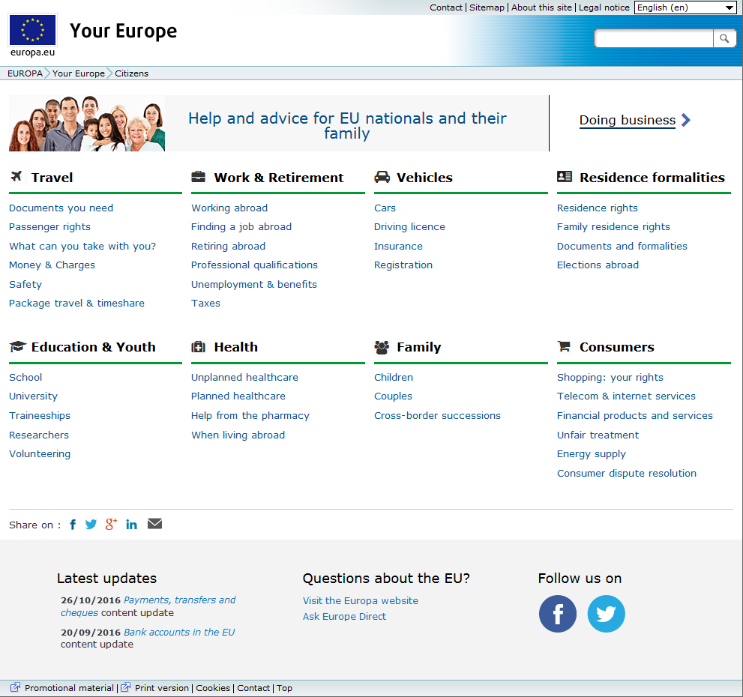

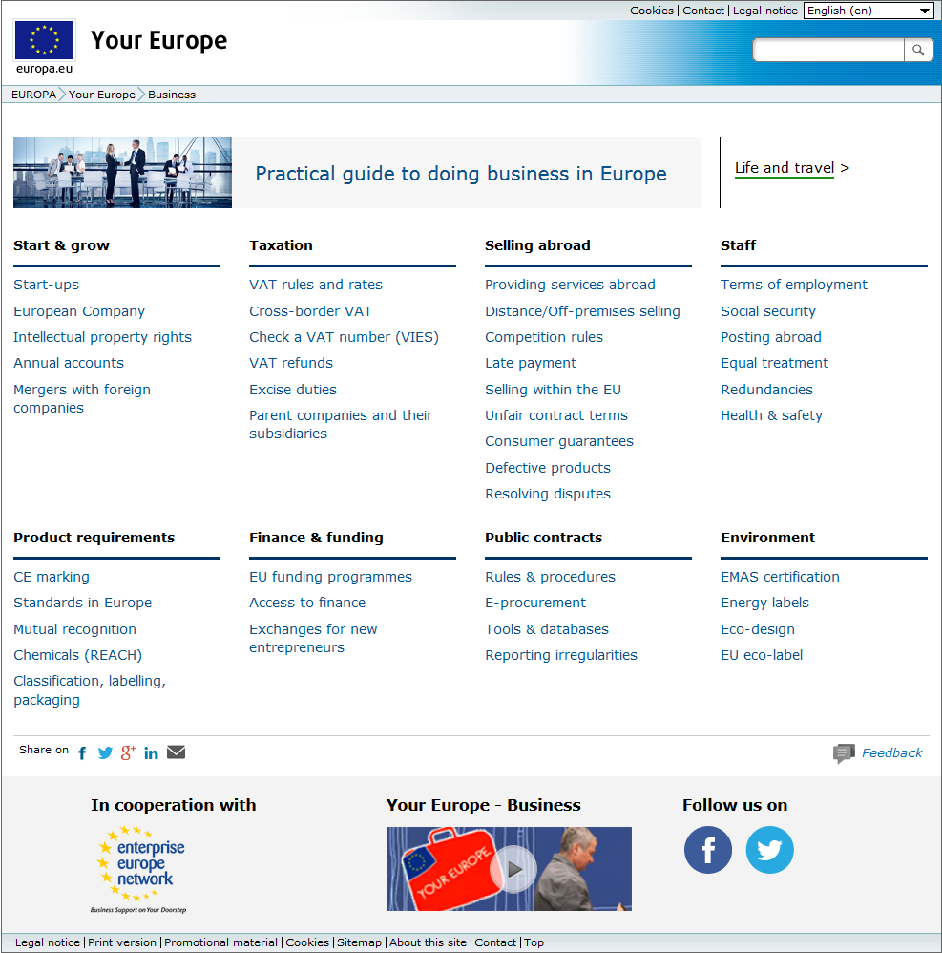

# Example of product requirements

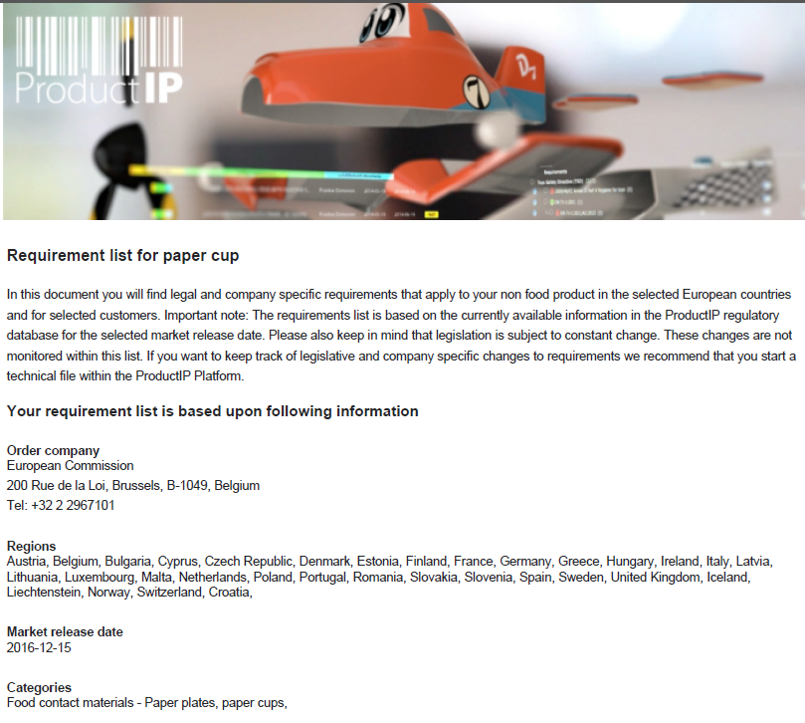

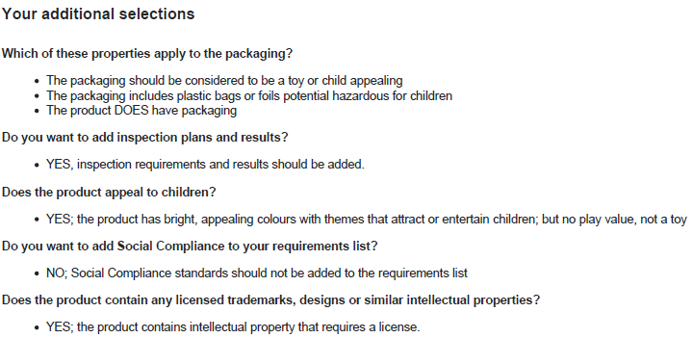

Table 15.1

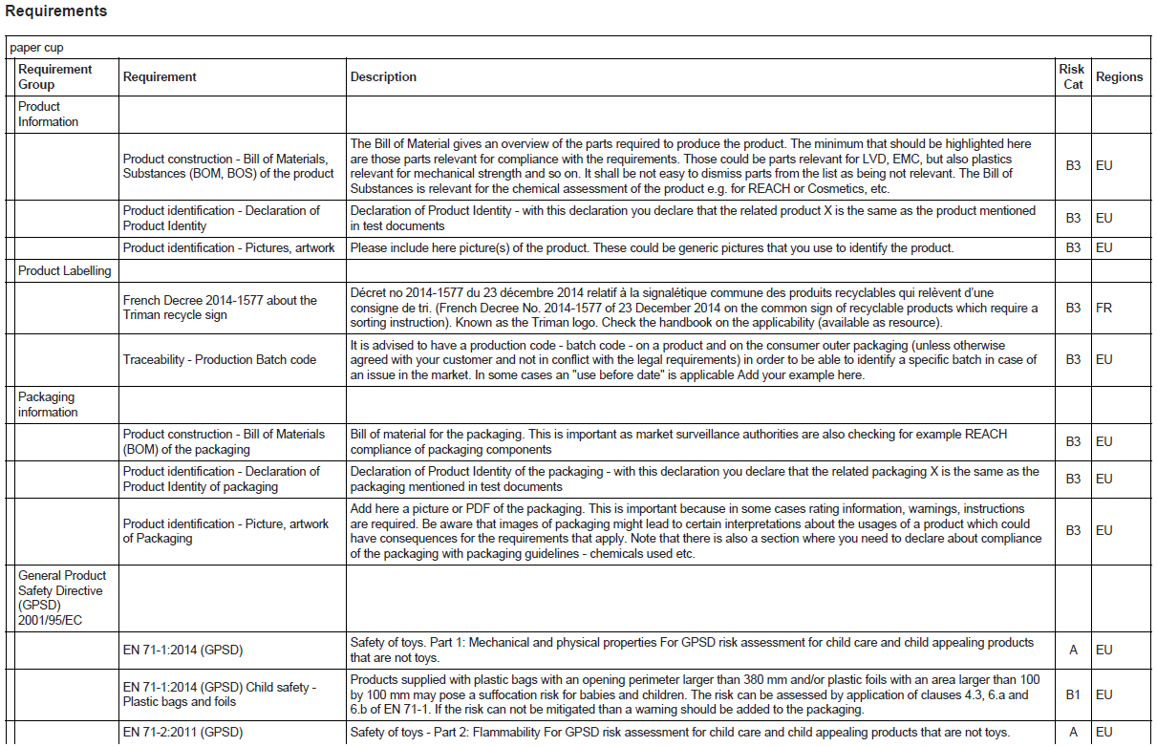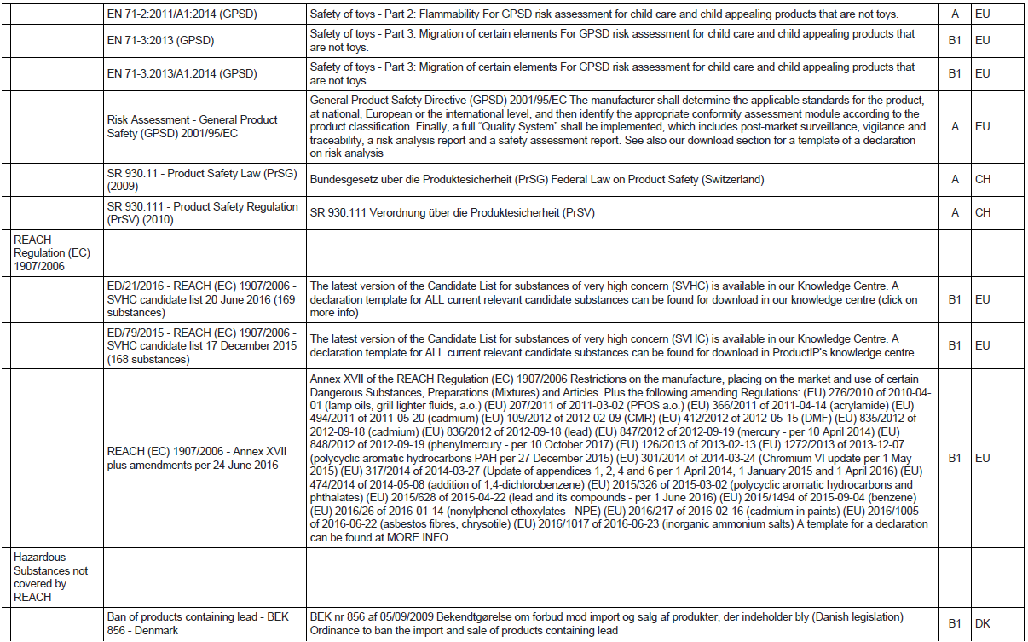

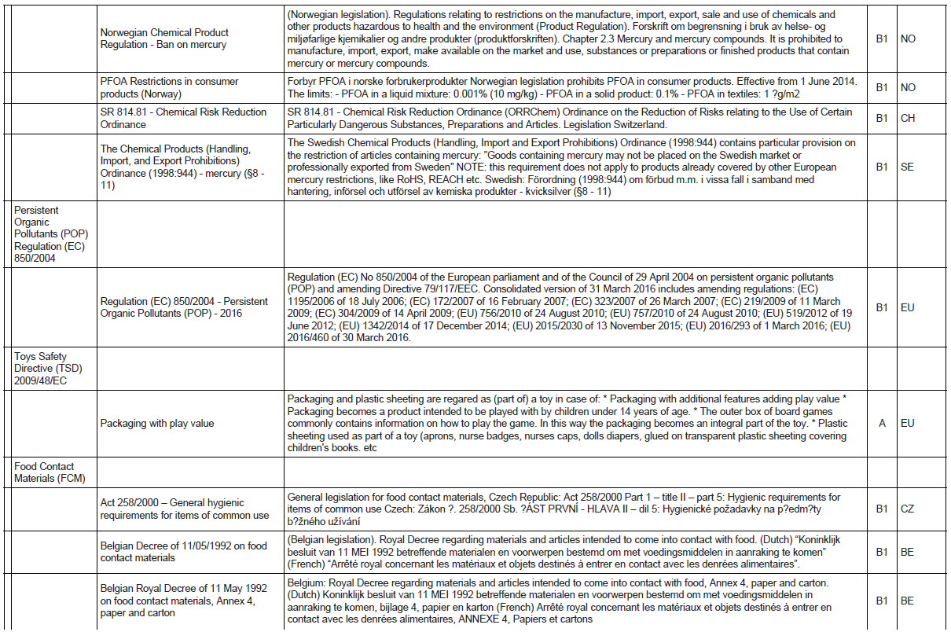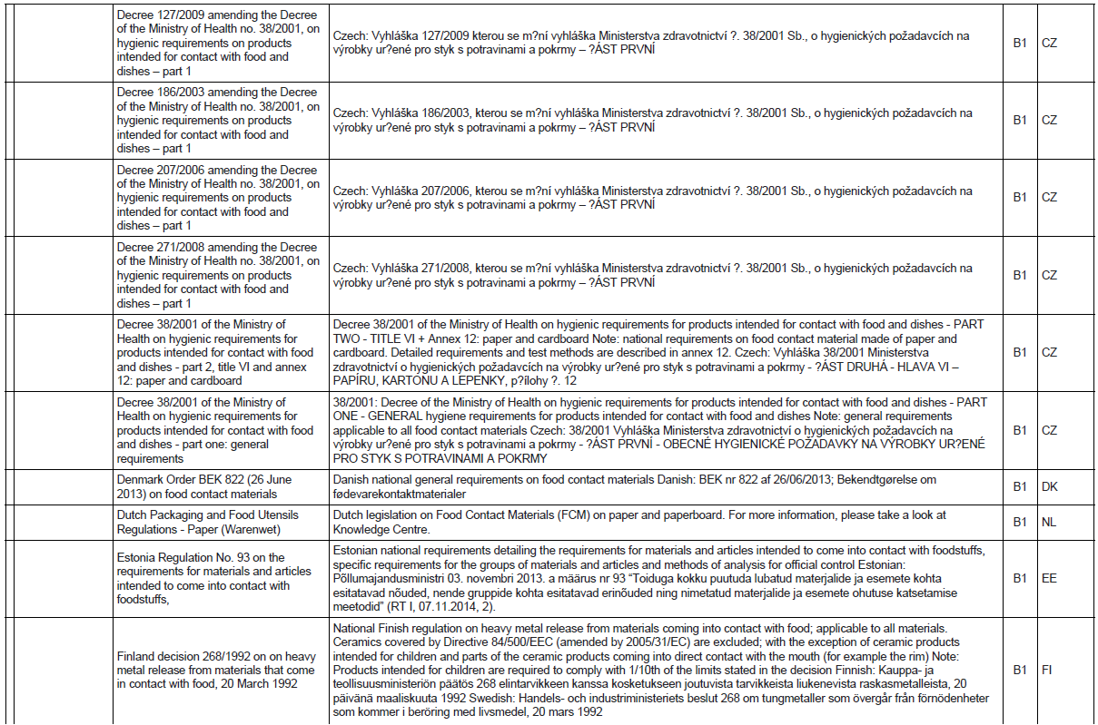

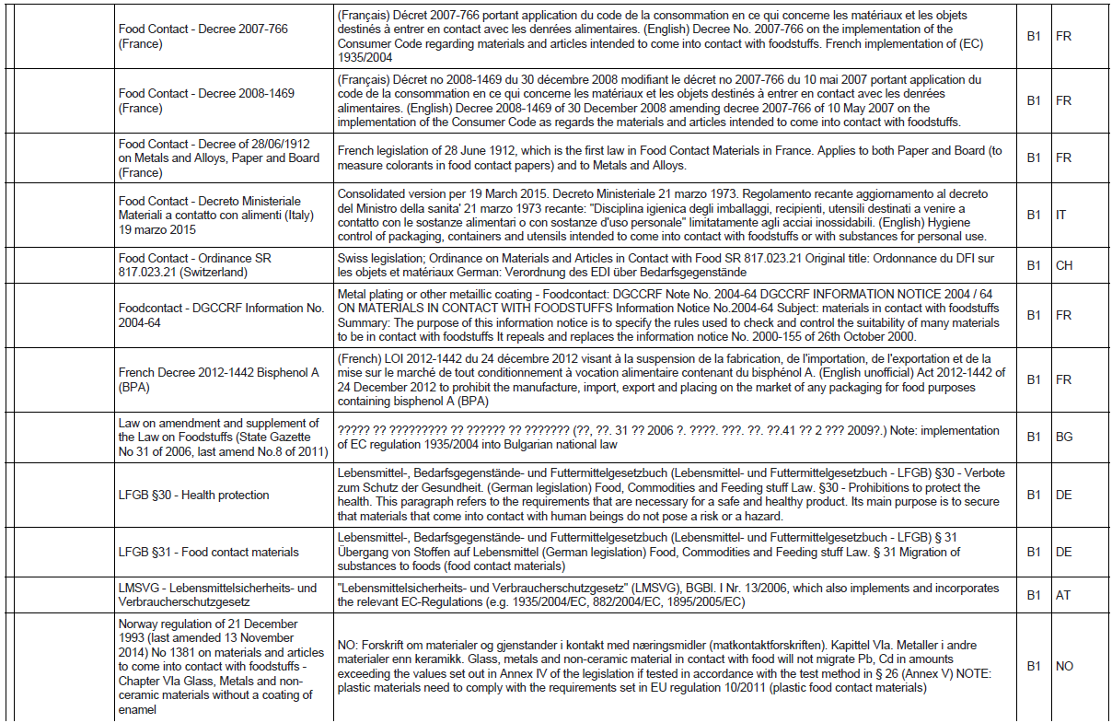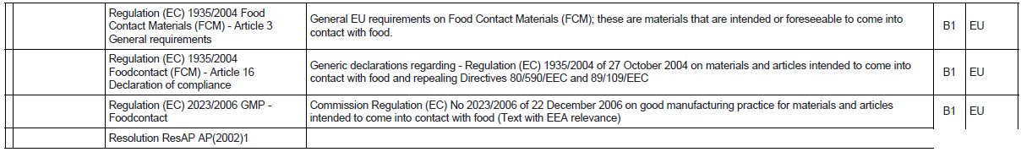

# Report on the online public consultation

## Executive summary

The public consultation has highlighted a strong consensus among business and citizens around the main pillars in terms of content of the Single digital gateway, notably:

* The need for online information about rules and procedures in other EU countries: 93% of business respondents and of citizens 92% respondents consider it very important or important;
* Access to e-procedures: 94% of business respondents and 92 % of citizens respondents consider it very important or important;
* Access to services providing assistance upon request: 88% of business respondents and 87% of citizen respondents consider it very important or important.

Online information on applicable EU and national rules

Businesses and citizens expressed very similar concerns with regards to online information on applicable EU and national rules. Most respondents in both categories would use the internet as the first source of information on these issues (74% of businesses and 80% of citizens). Most of them have tried to find such information online (78% and 70% respectively) but state that it was difficult (80% and 60.2% respectively). The main difficulties for both groups are the lack of findability (48% and 43% respectively), the quality of the information (40% in both cases) and the language in which the information was presented (24% and 13% respectively).

This is reflected in the opinions of respondents concerning quality criteria for online information. For both categories, the top three elements are that information should be findable (82% and 72% respectively), relevant, practical and up-to-date (77% and 69% respectively) and available in another EU language (72% and 64% respectively). Responding businesses (91%)and of responding citizens (87%) can understand information in a different EU language, the most common one being English (88% and 78% respectively), followed by French and German.

Being up-to-date, being run by an official authority and containing contact details to be considered trustworthy re considered the three most important indicators of trustworthiness for a website by both groups of respondents.

When it comes to improving information provision specifically for cross-border users respondents consider to a great extent that it should be mandatory for authorities to provide minimum information for citizens to carry out cross-border activities (80% and 80% respectively) and that this information should be provided in at least one other EU language (77% and 72% respectively). The most effective means to prevent information gaps is for national authorities in each EU country to provide all (77% of business and 63% of citizens consider it very effective) or at least minimum information necessary for cross-border users (68% of businesses consider it very effective) and in at least one other language (72% and 63% of businesses and citizens respectively consider it very effective). Most public authorities consider that minimum information is already being provided (50%). Most of them consider it challenging but feasible to provide all information needed for cross-border activities (50%), information in a centralised EU database (48%) and information in at least one other EU language challenging but feasible.

As far as existing national sources of information for rules and procedures applying to products and services are concerned, a majority of businesses (81%) would be in favour of merging the contact points for goods and services. This could be a realistic option for respondent public authorities, 70% of which consider it desirable or very desirable, despite considering this integration difficult or somewhat difficult (28% and 48% respectively).

Online procedures to comply with national rules

About half of responding businesses and citizens have tried carrying out an e-procedure in another EU/EEA country. The main problems faced by businesses are the use of too much jargon, the lack of full transactionality and the need to translate or certify documents. For citizens the main problems are the lack of full transactionality, the lack of findability of the procedure and problems with relating to the languages available. Issues relating to languages and documents provision were identified as the most urgent to address by both groups of respondents.

The most important quality elements of e-procedures for both groups are the online transactionality of procedures (69% of businesses and 72% of citizens), the ease of navigation and presence of step-by-step guidance (80% and 72% respectively), the possibility to carry out the procedure in at least another EU language (65% and 67% respectively) and the presence of a helpdesk (51% and 63% respectively).

The three priority procedures to be put online for businesses are 1) registration of business activity, 2) VAT registration and 3)VAT return, while for citizens they are 1) requesting or renewing an ID or passport, 2) requesting the recognition of professional qualifications and 3) registering a change of address.

When asked which actions would help in improving the provision of e-procedures, respondents agree that it should be mandatory to make procedures available in at least another EU language (78% of businesses, 73% of citizens and 55% of public authorities) and that at least the most important (67%, 69% and 70% respectively) or any procedures relevant for cross-border users required under future European law (69%, 67% and 48% respectively) should mandatorily be fully online.

Making the availability of at least one foreign language (77% and 67% respectively) the full transactionality of any relevant procedure required under future EU law (69% of citizens) or at least the most important procedures (65% of businesses) mandatory are considering as the most effective measures in encouraging the transition to e-procedures. Half of the responding public authorities consider these actions as challenging but feasible, the other half being split between those that consider that such procedures are already in place and those that consider them unfeasible or unnecessary.

Most public authorities see their transition to e-government as neutral (50%) or positive (30%). They are evenly split among those that consider making more procedures available online, and in that case they would be fully transactional in 83% of cases and they would be in place over the coming two years, and those that do not.

Services for personalised assistance and advice

Respondents were asked about the most important quality criteria for personalised assistance services and flagged that replies should be quick (70% of businesses and 63% of citizens), answer the specific question/query (75% and 79% respectively), be reliable and legally sound (69% and 60% respectively), clear, simple and in non-legalistic language (64% of businesses), services should be able to receive and process queries in a foreign language (68% and 58% respectively) and users should be able to access the service through different channels (35% of citizens).

Feedback mechanism

A majority of citizens (76%) and businesses (55%) would be willing to give feedback on their experience with the Single Market, so as to orient policy-making.

## Introduction

The single digital gateway intends to provide online "everything that entrepreneurs and citizens need" to do business cross-border and/or to travel to, buy from, work, study or reside in another country in the EU Single Market. The single digital gateway would be based on existing portals, contact points and networks, with the aim to expand, improve and better link them up and to enable users to complete the most frequently used national procedures fully on-line. Agreed quality criteria would apply to all services covered by the single digital gateway.

The Commission launched a public consultation on the single digital gateway in order to gather stakeholders' input for the impact assessment of the initiative.

Stakeholders' responses to this survey will help the Commission to better understand their needs and expectations. In particular the survey focused on respondents' views with regards the availability and quality of:

* **Information on applicable EU and national rules**, on issues such as how to register as a resident in another EU country, have your qualifications recognised, obtain a permit to open a shop, register your business activity, selling or manufacturing your products abroad, rights when shopping abroad, how to register your employees in social security schemes of another EU country or register for VAT;
* **Procedures to comply with national rules** (often via national e-government portals), e.g. national procedures for registering as a resident, registering with employment services, registering for VAT and tax payments, registering with social security services, and on the EU level the European professional card procedure;
* **Services for personalised assistance and advice** when online information is not enough, e.g. an authority or (semi) private online help centre or association citizens and businesses can contact when facing problems with rules and procedures, also including problem solving services.

The consultation ran from 26 July to 28 November 2016. The questionnaire was published in 24 languages. The consultation was publicised on the Commission's websites, social media channels as well as in stakeholder meetings. Responses have been published except where respondents asked for confidentiality.

The questionnaire was subdivided into 3 parts targeted to three main audiences: (1) business, self-employed and business representative organizations, (2) citizens, citizens/consumers representative organisations and academics and (3) public authorities. Respondents indicated to which category they belong. While most questions were common to all three parts of the questionnaire, each part also contained questions specifically targeted to the above respondent groups. For a more detailed analysis of respondent perspectives, the respondent groups are broken down into further categories (see Overview of Respondents section).

In total 367 responses were received. The numbers and percentages used to describe the distribution of the responses to the public consultation derive from the answers provided under the EU-Survey tool. In order to avoid that too many respondents would abandon the survey before submitting it due to the number of questions asked, replies to questions were sometimes optional. Respondents often chose not to answer all questions.

## Overview of respondents

The consultation sought the views of interested parties, hence the sample of respondents cannot be considered to be statistically representative. All percentages have been rounded up.

Views were sought from citizens, citizen/consumer associations, businesses, self-employed and business associations, academics and public authorities. They are presented grouped in 3 categories: (1) business, self-employed and business representative organizations, (2) citizens, citizens/consumers representative organisations and academics and (3) public authorities.

The following overview of respondents details the Commission's classification of all 367 responses to the consultation.

Table 16.1: Distribution of respondents

|  |  |  |
| --- | --- | --- |
| **Type of respondent** | **N° of answers** | **% of answers** |
| Self-employed | 33 | 9% |
| Company | 94 | 26% |
| Of which: |  |  |
| * SMEs | 87 | 93% of respondent companies |
| * Firms with more than 250 employees | 7 | 7% of respondent companies |
| Business representative organisation | 35 | 10% |
| **Total for business category** | **162** | 45% |
| Private individual | 147 | 40% |
| Organisation representing citizens / consumers | 11 | 3% |
| Academic / research institution | 8 | 2% |
| **Total for citizens** | **166** | 45% |
| Public authority (including government) | 39 | 10% |
| **Total for Public authority (including government)** | **39** | 10% |
| **Total number of replies** | **367** |  |

Figure 16.1: Geographical distribution of respondents

## Results of the questionnaire for businesses, self-employed and business representative organizations

Among businesses participating in the consultation, most are micro enterprises with 1-9 employees (43%), followed by SMEs with 10-49 employees (18%) and SMES with 50-249 employees (7%). Most respondents are active in the services sector (50%) or both in the services and goods sector (32%). A majority of respondents are active in more than one European country (48%) or are active in one EU country– but would like to enter other EU markets (35%).

A strong majority of respondents considers very important or important to have access online to information about products and services rules in other EU countries (73% and 20% respectively), e-procedures (68% and 26% respectively) and services providing assistance upon request (56% and 32% respectively) in relation to their cross-border activities.

Figure 16.2: Analysis of needs for businesses: How important would it be for you to have online access to the following services?

***Access to information about products and services rules in other EU countries:***

About 78% of business respondents have tried finding which rules they should be following to comply with national requirements in another EU country and the majority of them thought it was difficult (80%).

The main reasons given to justify why finding information was considered difficult were that it was hard to find the right website (48%), that information was hard to understand, inaccurate, or outdated (40%) and that information was in a language the user could not understand (24%). Some respondents also suggested further reasons, such as the ambiguity in the information presented on different official websites, the need for checklists guiding the user through all the steps they should take to find the relevant information for their case, the lack of specialised human resources and the need to better know the national regulatory context in order to put the information into context.

A large majority of respondents are likely to look for information on the internet (74%) while most of the remaining respondents would directly go to a source they know and trust either online or offline (24%).

Over 91% of the respondents can understand information in a language that is not their mother tongue. 88% of respondents can understand information in English, followed by French (28%) and German (16%). When information is found in a language that users cannot understand, more than half of respondents say they use free online translation services, even if the outcome is not perfectly accurate (56%). The second preferred technique is to ask someone they know to help with the translation (23%). Some respondents declared that they would keep looking for information from other sources.

When asked about the most important elements to define the quality of the information found online, respondents answered that the information they are looking for should be quickly findable, information should be relevant, practical, up to date and is written from their point of view and information should be available in English or another commonly used language.

Table 16.2: Most important quality requirements for online information

|  |  |
| --- | --- |
| **Quality element** | **Ratio** |
| I can find the information I need quickly | 82% |
| Information is relevant, practical, up to date and is written from my point of view | 77% |
| Information is available in English or another commonly used language | 72% |
| I can get in touch with someone (by phone, email, chat) or there is a list of contact details for national authorities | 56% |
| I can easily find out who owns the website, what it’s for and who it’s aimed at | 19% |
| I can send feedback or leave reviews or ratings that are published on the website | 9% |
| Other | 2% |
| Don't know | 2% |
| No Answer | 0% |

Among the elements that make a website trustworthy, it being up to date and being an official government or authority website qualify as the most important elements, as detailed in Table 16.3.

Table 16.3: What makes a website trustworthy?

|  |  |  |  |  |  |  |  |
| --- | --- | --- | --- | --- | --- | --- | --- |
|  | **Very important** | **Important** | **Neutral** | **Rather not important** | **Not important** | **Don't know** | **No answer** |
| **Up to date** | 70% | 25% | 2% | 0% | 0% | 2% | 0% |
| **Official government or authority website** | 57% | 31% | 9% | 1% | 1% | 2% | 0% |
| **Contact details** | 40% | 40% | 16% | 2% | 1% | 2% | 0% |
| **Website of a private organisation I know and trust** | 23% | 53% | 18% | 3% | 2% | 1% | 0% |
| **Quality certification (e.g. ISO 9001, Trusted Shops, s@fer-shopping, Confianza Online, Buy with Confidence)** | 15% | 26% | 31% | 11% | 12% | 6% | 0% |
| **User reviews** | 12% | 35% | 32% | 14% | 6% | 2% | 0% |
| **Other** | 5% | 2% | 6% | 3.% | 1% | 27% | 1% |

*Extract from the open text replies*:

"Built well by today's standards as this demonstrates how seriously the publishing organization takes their website. For example, if a website isn't responsive (meaning that it's fully accessible on different screen sizes and if the user changes the font size because of visual impairments and the like), it seems safe to assume that the organization find it acceptable not to take into account a significant percentage of the population. This in turn suggests that the website is just a "nice to have" rather than the main point of contact and will always be treated second class when it comes to updates and the like." - The Waving Cat GmbH

A consistent majority of business respondents in in favour of integrating existing national portals and contact points for goods and services in one national portal, with 46.3% of them considering it very positively and 35% positively. Only 2% see it negatively or very negatively.

*Extract from the open text replies:*

Increasingly, entrepreneurs market goods with a service component (e.g. for maintenance), or goods and services are related in other ways. For this reason, some business stakeholders have recently called for the creation of online national business portals covering both goods AND services. – Anonymous respondent

When it comes to improving information for cross-border users, respondents consider to a great extent that authorities in each EU country should be obliged to provide a minimum amount of information (80%) or all information (68%) for businesses to help them carry out cross-border activities and that information should be provided in at least another EU language (77%). Table 16.4 below details how these measures are considered by respondents:

|  |  |  |  |  |
| --- | --- | --- | --- | --- |
| Table 16.4: How to prevent gaps in online information | | | | |
|  | **Should be mandatory** | **Should be voluntary (guidance)** | **Not necessary** | **No opinion** | |
| **Authorities in each EU country should provide a minimum amount of information for businesses to help them carry out cross-border activities.** | 80% | 13% | 2% | 4% | |
| **Information should be provided in at least one other language.** | 77% | 20% | 2% | 1% | |
| **Authorities in each EU country should provide all the information necessary for businesses to engage in cross-border business or private activities.** | 68% | 27% | 2% | 2% | |
| **For certain important areas, information on national rules should be collected and made available in a centralised EU database instead of on national websites.** | 63% | 26% | 5% | 6% | |
| **EU countries / national public authorities should provide personal assistance to answer the specific questions from businesses that are not covered by the information online.** | 43% | 48 % | 7% | 2% | |

Most respondents agree that the most effective ways of preventing information gaps is for national authorities in each EU country to provide all the information necessary for businesses (77%) or at least minimum information (68%) and in at least one other language (72%). Table 16.5 below provides further details.

|  |  |  |  |  |  |
| --- | --- | --- | --- | --- | --- |
| Table 16.5: Most effective actions to prevent gaps in online information | | | | | |
|  | **Very effective** | **Somewhat effective** | **Ineffective** | **Unnecessary** | **Do not know** |
| **Authorities in each EU country should provide all the information necessary for businesses to engage in cross-border business or private activities.** | 77% | 18% | 2% | 1% | 2% |
| **Information should be provided in at least one other language.** | 72% | 23% | 2% | 1% | 1% |
| **Authorities in each EU country should provide a minimum amount of information for businesses to help them carry out cross-border activities.** | 68% | 25% | 4% | 1% | 2% |
| **For certain important areas, information on national rules should be collected and made available in a centralised EU database instead of on national websites.** | 66% | 23% | 4% | 3% | 4% |
| **EU countries / national public authorities should provide personal assistance to answer the specific questions from businesses that are not covered by the information online.** | 52% | 38% | 3% | 4% | 4% |

***Cross-border online procedures***

Most respondents have never completed an e-procedure in another EU country (52%). Those who tried faced a variety of issues, the most important of them being that there was too much legal or administrative jargon (14%), there were some offline steps (14%) and documents needed to be translated or certified (13%). In particular, issues relating to languages, notably the explanation of the procedure being available only in the national language (69%), online forms being in national language(s) only (57%) and inexistent help-desk or help-desk only available in the national language(s) (38%) and to documents, notably required documents not existing in the country of origin (29%) and required certified translation for foreign documents (24%).

Businesses considered easy navigation with step-by-step guidance (80%), full cross-border transactionality (69%) the possibility to carry out the procedure in one's own language (65.43%) and the availability of a helpdesk (51%) as the most important quality aspects of online procedures.

The suggested procedures were ranked in terms of priority by respondents in Table 16.6.

|  |  |  |  |  |
| --- | --- | --- | --- | --- |
| Table 16.6: Procedures that should be priority for access online for cross-border users | | | | |
|  | **High priority** | **Medium priority** | **Low priority** | **No priority** |
| **Registration of business activity** | 67% | 25% | 3% | 6% |
| **VAT registration** | 65% | 23% | 6% | 6% |
| **VAT returns** | 62% | 25% | 6% | 7% |
| **Recognition of qualification** | 59% | 26% | 6% | 8% |
| **Corporate/business tax declaration** | 55% | 30% | 9% | 6% |
| **Registration with national insurance scheme as employer** | 54% | 30% | 10% | 6% |
| **Notification of cessation of activity subject to VAT** | 49% | 35% | 8% | 8% |
| **Payment of social contributions for employees and payroll withholding tax** | 48% | 36% | 9% | 7% |
| **Registration for income tax** | 47% | 38% | 10% | 5% |
| **Applying for public procurement** | 47% | 31% | 10% | 12% |
| **Registration of employees with pension schemes** | 44% | 37% | 12% | 7% |
| **Notifications related to data protection** | 39% | 36% | 15% | 10% |
| **Reporting end of contract of employee** | 33% | 44% | 15% | 9% |
| **Apply for building planning permits** | 27% | 38% | 23% | 12% |
| **Apply for environmental permits** | 27% | 41% | 22% | 11% |

*Extract from the open text replies*:

"If it's required to do business, it needs to be doable 100% online." - The Waving Cat GmbH

When considering possible actions aiming at improving the provision of online procedures, most business respondents indicated that all of them should be mandatory, with the provision of procedures in at least one foreign language, the full transactionality of any procedure relevant for cross-border users, and the provision of at least the most important procedures online topping the ranking (see Table 16.7).

Table 16.7: How to improve the provision of e-procedures

|  |  |  |  |  |
| --- | --- | --- | --- | --- |
|  | **Should be mandatory** | **Should be voluntary (guidance)** | **Not necessary** | **No opinion** |
| **Procedures should be available in at least one other foreign language.** | 78% | 17% | 1% | 4% |
| **Any procedures relevant for cross-border users required under future EU laws should be fully online. Offline procedures may exist in parallel.** | 69% | 25% | 0% | 7% |
| **A limited number of the most important procedures for cross-border users should be provided fully online.** | 67% | 23% | 4% | 6% |
| **All procedures relevant for cross-border users should be fully online.** | 60% | 31% | 2% | 6% |

All proposed actions for promoting the switch from paper based to electronic procedures are mostly considered to be very effective or somewhat effective, with a preference for the provision of procedures in at least one foreign language, the provision of at least the most important procedures online and the full transactionality of any procedure relevant for cross-border users required under future EU laws, as shown in Table 16.8.

Table 16.8: Most effective ways of improving the provision of e-procedures

|  |  |  |  |  |  |
| --- | --- | --- | --- | --- | --- |
|  | **Very effective** | **Somewhat effective** | **Ineffective** | **Unnecessary** | **Do not know** |
| **Procedures should be available in at least one other foreign language.** | 77% | 16% | 0% | 1% | 6 % |
| **Any procedures relevant for cross-border users required under future EU laws should be fully online. Offline procedures may exist in parallel.** | 65% | 25% | 2% | 1% | 6% |
| **All procedures relevant for cross-border users should be fully online.** | 65% | 25% | 1% | 2% | 6% |
| **A limited number of the most important procedures for cross-border users should be provided fully online** | 57% | 31% | 5% | 1% | 6% |

About 20% of respondents can recommend a well-functioning site for any type of online information and business procedures. Among the most frequently referred to websites are: gov.uk, e-estonia.com, and bmf.gv.at.

***Assistance services***

When asked about online personalised assistance services, most respondents declare that the 5 most important quality criteria are 1) Quick reply, 2) Reply answers my specific question / query, 3) Reply is reliable and legally sound, 4) Reply is in clear, simple, non-legalistic language, 5) I can use English or another common second language, and will also receive the reply in this language.

Only 10% of respondents can recommend a well-functioning site for online personalised assistance and advice, including advantageaustria.org and gov.uk.

*Extract from the open text replies:*

"There should be a centralised customer care service where to report platforms and services that are not delivering up to standards. There should be an effective enforcement system to protect the citizens and companies from negligence." Anonymous company, Malta

***Feedback mechanism***

Most respondents (55%) would be willing to give feedback on their experience with the Single Market, so as to draw the attention of policy-makers to recurrent problems.

## Results of the questionnaire for citizens, citizen or consumer representative organisations and academics

Among citizens, citizens or consumer associations and academics participating in the consultation, a strong majority of respondents considers very important or important to have access online to information about rules and procedures in other EU countries (82% and 10% respectively), e-procedures (73% and 19% respectively) and services providing assistance upon request (59% and 28%) in relation to their cross-border activities.

Figure 16.3: Analysis of needs for citizens: How important would it be for you to have online access to the following services?

Figure 16.4: Geographical distribution of respondents

Citizens constitute 89% of the respondents in this category, followed by organisations representing citizens/consumers (7%) and academic/research institutions (5%). The geographical distribution of respondents is varied, with respondents from almost all EU/EEA countries, as shown in the figure above.

Access to information about rules in other EU countries:

Almost 70% of respondents in this category have tried finding which rules they should be following to comply with national requirements when moving to another EU country and most of them thought it was difficult or somewhat difficult (27% and 59% respectively). The main reasons given to justify why finding information was considered difficult are that it was hard to find the right website (43%) and that information was hard to understand, inaccurate, or outdated (40%), followed by the fact that information was in a language the user could not understand (13%). Some respondents commented that it was hard to find the right information when planning to move abroad, for instance when it comes to how their pensions will be taxed, others highlighted that it is not always possible to know whether the information on a website is up to date and reliable. Respondents declared having looked for information concerning how to register their legal partnerships in another EU country, information about taxation, health insurance, social security, but also elements linked to their professional activity abroad, such as how to insure a company vehicle in a different EU country.

Over 80% of respondents are likely to look for information on the internet while most of the remaining respondents would directly go to a source they know and trust either online or offline (16%).

Over 87% of the respondents can understand information in a language that is not their mother tongue. 78% of respondents can understand information in English, followed by French (26%) and German (14%). When information is found in a language that users cannot understand, more than half of respondents say they use free online translation services, even if the outcome is not perfectly accurate (69%). The second preferred technique is to ask someone they know to help with the translation (12%). Respondents also declared contacting the competent authority in the hopes of finding someone who can speak another language.

When asked about the most important elements to define the quality of the information found online, respondents answered that information should be quickly findable (72%), information should be relevant, practical up to date and written from the users' point of view (69%), it should be available in English or another commonly used language (64%) and it should be possible to get in touch with someone or there should be a list of contact details for national authorities (53%).

*Extract from the open text replies:*

"A website is trustworthy when it offers the possibility to understand and get familiarized with the issue and quickly identify the right scheme / administrators." Anonymous citizen, Sweden

The ranking of the elements that make a website trustworthy is presented in Table 16.9.

Table 16.9: What makes a website trustworthy?

|  |  |  |  |  |  |  |  |
| --- | --- | --- | --- | --- | --- | --- | --- |
|  | **Very important** | **Important** | **Neutral** | **Rather not important** | **Not important** | **Don't know** | **No answer** |
| **Up to date** | 78 % | 16% | 4% | 0% | 0% | 1% | 0% |
| **Official government or authority website** | 66% | 27% | 5% | 0% | 1% | 1% | 0% |
| **Contact details** | 45% | 31% | 16% | 5% | 2% | 1% | 0% |
| **Website of a private organisation I know and trust** | 21% | 46% | 23% | 4% | 4% | 2% | 0% |
| **Quality certification (e.g. ISO 9001, Trusted Shops, s@fer-shopping, Confianza Online, Buy with Confidence)** | 20% | 30% | 25% | 11% | 8% | 5% | 0% |
| **User reviews** | 13% | 34% | 35% | 13% | 4% | 1% | 0% |
| **Other** | 4% | 4% | 4% | 1% | 1% | 30% | 57% |

When it comes to improving information for cross-border users, respondents consider to a great extent that the authorities should mandatorily provide minimum information for citizens to carry out cross-border activities (81%) and that that information should be provided in at least another EU language (72%). Table 16.10 below details how each proposed measure is considered by respondents.

Table 16.10: How to prevent gaps in online information

|  |  |  |  |  |  |
| --- | --- | --- | --- | --- | --- |
|  | **Should be mandatory** | **Should be voluntary (guidance)** | **Not necessary** | **No opinion** | **No Answer** |
| **Authorities in each EU country should provide a minimum amount of information for citizens to help them carry out cross-border activities.** | 81% | 9% | 3% | 4% | 4% |
| **Information should be provided in at least one other language.** | 72% | 20% | 2% | 2% | 4% |
| **For certain important areas, information on national rules should be collected and made available in a centralised EU database instead of on national websites.** | 67% | 21% | 5% | 4% | 3% |
| **Authorities in each EU country should provide all the information necessary for citizens to engage in cross-border business or private activities.** | 61% | 34% | 1% | 1% | 3% |
| **EU countries / national public authorities should provide personal assistance to answer the specific questions from citizens that are not covered by the information online.** | 55% | 33% | 3% | 6% | 4% |

Providing information in at least another EU language and providing all information necessary to citizens to engage in cross-border business or private activities are considered as the most effective approaches in reducing the time and costs for citizens to find information online.

Table 16.11: Most effective actions to prevent gaps in online information

|  |  |  |  |  |  |  |
| --- | --- | --- | --- | --- | --- | --- |
|  | **Very effective** | **Somewhat effective** | **Ineffective** | **Unnecessary** | **Do not know** | **No answer** |
| **Information should be provided in at least one other language.** | 63% | 26% | 1% | 1% | 4% | 4% |
| **Authorities in each EU country should provide all the information necessary for citizens to engage in cross-border business or private activities.** | 63% | 26% | 2% | 2% | 4% | 4% |
| **For certain important areas, information on national rules should be collected and made available in a centralised EU database instead of on national websites.** | 62% | 22% | 2% | 4% | 4% | 6% |
| **Authorities in each EU country should provide a minimum amount of information for citizens to help them carry out cross-border activities.** | 58% | 29% | 4% | 2% | 4% | 4% |
| **EU countries / national public authorities should provide personal assistance to answer the specific questions from citizens that are not covered by the information online.** | 57% | 27% | 1% | 2% | 8% | 5% |

Cross-border e-procedures:

Respondents in this category are almost equally split between those who have (48%) and those who have never completed (52%) an e-procedure in another EU country. Most of those who tried either found it difficult (49%) or had to give up (25%). They faced a variety of issues, the most important of them being that there were some offline steps (21%), It was not possible to do it online (20%) and users could not find out where to do it online (16%). Also issues relating to languages, notably the fact that documents needed to be translated and / or certified (16%), and procedures being in a language the user didn’t understand. (11%) were signalled as being important.

*Extract from the open text replies:*

"Often online portals are built for the residents of that country and some of the initial requirements cannot be met by people not living in the country. This is a form of discrimination, because it will not be possible for the non-resident to complete the procedure and obtain what they need. " - M.F., Slovakia.

When asked about the aspects of online procedures that citizens find the most problematic and the most urgent to address, respondents identified the presence of forms in national language(s) only (63%), the need for certified translations of foreign documents (45%), the presence of assistance services only in the national language(s) (38%) and the need to certify foreign documents (37.95%) as the most pressing issues, as shown in Table 16.12.

Table 16.12: Problematic aspects of e-procedures that should be addressed as a priority

|  |  |
| --- | --- |
| **Issue** | **Ratio** |
| Online forms in national language(s) only | 63% |
| Foreign supporting documents require certified translations | 45% |
| Personalised assistance service does not exist or exists only in national language(s) | 38% |
| Foreign supporting documents need to be certified | 38% |
| The documents required do not exist in my country | 35% |
| Online forms where it’s not possible to enter non-national addresses and phone numbers | 33% |
| Means of payment only accessible to national users | 25% |
| Foreign e-signature and e-authentication means are not accepted | 23% |
| No Answer | 0% |

Respondents in the citizens' category considered full online transactionality (72%), the easy navigation with step-by-step guidance (72%), the possibility to use a known language (67%) and the availability of a helpdesk in case of questions or problems (63%) as the most important quality aspects of online procedures.

The suggested procedures were ranked in terms of priority by respondents in the following way:

Table 16.13: Procedures that should be prioritised for cross-border online access

|  |  |  |  |  |  |
| --- | --- | --- | --- | --- | --- |
|  | **High** | **Medium** | **Low** | **No priority** | **Do not know** |
| **Requesting / renewing ID card or passport** | 76% | 17% | 3% | 1% | 2% |
| **Request recognition of professional qualifications from a foreign EU national** | 73% | 20% | 4% | 0% | 3% |
| **Registering a change of address** | 72% | 23% | 1% | 1% | 2% |
| **Request recognition of diploma from a foreign EU national** | 72% | 20% | 5% | 1% | 3% |
| **Request a birth certificate** | 70% | 23% | 2% | 2% | 4% |
| **Enrol in university** | 69% | 19% | 5% | 3% | 4% |
| **Declaring income taxes** | 69% | 19% | 4% | 1% | 7% |
| **Register for social security benefits** | 69% | 19% | 5% | 1% | 5% |
| **Apply for a criminal record certificate** | 64% | 22% | 7% | 2% | 4% |
| **Apply for a study grant** | 63% | 27% | 3% | 4% | 4% |
| **Register for child allowances** | 60% | 23% | 7% | 4% | 7% |
| **Register for a pension** | 60% | 27% | 5% | 4% | 5% |
| **Register a car** | 57% | 31% | 4% | 4% | 4% |
| **Registering as unemployed** | 53% | 30% | 7% | 4% | 6% |
| **Registering a marriage** | 45% | 35% | 10% | 5% | 5% |
| **Starting an inheritance procedure** | 42% | 35% | 12% | 7% | 5% |

When considering possible actions aiming at improving the provision of online procedures, most citizen respondents indicated that all of them should be mandatory, with the provision of procedures in at least one other foreign language (73%), the provision of a limited number of important procedures fully online (69%) and the provision of any relevant cross-border procedure fully online (67%) topping the ranking.

Table 16.14: How to improve the provision of e-procedures

|  |  |  |  |  |  |
| --- | --- | --- | --- | --- | --- |
|  | **Should be mandatory** | **Should be voluntary (guidance)** | **Not necessary** | **No opinion** | **No answer** |
| **Procedures should be available in at least one other foreign language.** | 73% | 19% | 2% | 2% | 4% |
| **A limited number of the most important procedures for cross-border users should be provided fully online.** | 69% | 16% | 3% | 7% | 6% |
| **Any procedures relevant for cross-border users required under future EU laws should be fully online. Offline procedures may exist in parallel.** | 67% | 23% | 1% | 4% | 4% |
| **All procedures relevant for cross-border users should be fully online.** | 53% | 36% | 4% | 2% | 5% |

All proposed actions for promoting the switch from paper based to electronic procedures are mostly considered to be very effective or somewhat effective, with a preference for putting any procedures relevant for cross-border users required under future EU laws should be fully online (69%), making procedures available at least in another EU language (67%) and putting all procedures relevant for cross-border users should be fully online (63%).

Table 16.15: Most effective ways of improving the provision of e-procedures

|  |  |  |  |  |  |  |  |  |
| --- | --- | --- | --- | --- | --- | --- | --- | --- |
|  | **Very Effective** | **Partially effective** | **Not effective** | **No need for this action** | | **Don't know** | **No answer** | |
| **Any procedures relevant for cross-border users required under future EU laws should be fully online. Offline procedures may exist in parallel.** | 69% | 14% | 4% | 1% | 4% | | 8% |
| **Procedures should be available in at least one other foreign language.** | 67% | 20% | 3% | 1% | 4% | | 5% |
| **All procedures relevant for cross-border users should be fully online.** | 63% | 21% | 5% | 3% | 4% | | 5% |
| **A limited number of the most important procedures for cross-border users should be provided fully online** | 54% | 27% | 6% | 1% | 5% | | 7% |

About 22% of respondents can recommend a well-functioning site for any type of online procedures. Among the most frequently referred to websites are: gov.uk, ucas.com, www.studielink.nl, and several national tax services (e.g. France, Spain and Belgium).

Assistance services:

When asked about online personalised assistance services, most respondents declare that the 5 most important quality criteria are:

Table 16.16: Quality criteria for assistance services

|  |  |
| --- | --- |
|  | **Ratio** |
| Reply answers my specific question / query | 79% |
| Quick reply | 63% |
| Reply is in clear, simple, non-legalistic language | 61% |
| Reply is reliable and legally sound | 60% |
| I can use English or another common second language, and will also receive the reply in this language | 58% |
| I can access the service in different ways (e.g. email, phone, social media) | 35% |
| It is clear from the start what I can expect from the service, and how long it will take. | 27% |
| I can file a complaint about the service | 17% |
| User feedback visible on the page | 7% |
| Quality certification visible on page | 4% |
| Other | 2% |
| Don't know | 2% |
| No Answer | 0% |

Only about 15% of respondents can recommend a well-functioning site for online personalised assistance and advice, the most quoted ones being: portaldocidadao.pt, YourEurope and Your Europe Advice.

Feedback mechanism:

Most respondents (76%) would be willing to give feedback on their experience with the Single Market, so as to draw the attention of policy-makers to recurrent problems.

## Results of the questionnaire for public authorities

In total 39 public authorities replied to the survey. 21 operate at the national, 8 at the regional, 4 at the local, 1 at the international and 5 at the European level.

Most public authorities consider it desirable (45%) or very desirable (25%) to integrate the services and goods contact points in one national portal, although most of them consider this integration somewhat difficult (48%) or difficult (28%).

In order to improve online information for cross border users, most respondents consider that most of the proposed initiatives should be mandatory. Table 16.17 below details how these measures are considered by respondents:

Table 16.17: How to prevent gaps in online information

|  |  |  |  |  |
| --- | --- | --- | --- | --- |
|  | **Should be mandatory** | **Should be voluntary (guidance)** | **Not necessary** | **No opinion** |
| **Authorities in each EU country should provide a minimum amount of information for citizens to help them carry out cross-border activities.** | 78% | 20% | 3% | 0% |
| **Information should be provided in at least one other language.** | 43% | 45% | 8% | 5% |
| **EU countries / national public authorities should provide personal assistance to answer the specific questions from citizens that are not covered by the information online.** | 38% | 55% | 78% | 0% |
| **Authorities in each EU country should provide all the information necessary for citizens to engage in cross-border business or private activities.** | 40% | 45% | 15% | 0% |
| **For certain important areas, information on national rules should be collected and made available in a centralised EU database instead of on national websites.** | 35% | 30% | 28% | 8% |

Public authorities consider that most of the proposed initiatives in the survey are already being put in place in their administration or would be easy to implement of that they would be challenging to implement, but feasible. Detailed replies are presented in Table 16.18.

Table 16.18: Feasibility of actions to prevent gaps in online information

|  | **Easy to do / Already being done** | **Challenging but feasible** | **Unfeasible** | **Unnecessary** | **Don't know** |
| --- | --- | --- | --- | --- | --- |
| **Authorities in each EU country should provide a minimum amount of information for citizens to help them carry out cross-border activities.** | 50% | 40% | 5% | 3% | 3% |
| **Public authorities should provide personal assistance to answer the specific questions from citizens that are not covered by the information online.** | 33% | 45% | 8% | 8% | 8% |
| **Information should be provided in at least one other language.** | 28% | 48% | 10% | 8% | 8% |
| **Authorities in each EU country should provide all the information necessary for citizens to engage in cross-border business or private activities** | 10% | 50% | 30% | 8% | 3% |
| **For certain important areas, information on national rules should be collected and made available in a centralised EU database instead of on national websites.** | 10% | 48% | 15% | 23% | 5% |

The participating public authorities don't appear to have strong views concerning their administration's switch to e-government, with most of them considering it neutral (50%), and followed by those that consider it as a positive experience (30%). Among the most quoted problems for the transition is the need to coordinate the work of several authorities often across different government levels, the lack of a legal basis and/or political will, as well as the lack of human resources in small administrations. Among the examples of good practices in managing and ensuring the quality of the on-line content on portals, a few examples were quoted, including the Brussels Region Informatics Service one (BE), and the one of the Dutch Ministry of Economic Affairs (NL).

*Extract from the open text replies:*

"We plan to use a standardized procedure description designed by the Walloon region. As a result, procedures described by other government levels in Belgium will be made available by any government. We implemented a form platform called Irisbox that supports virtually any kind of procedure with strong back-office integration and on-line consultation of authentic sources." - Brussels Region Informatics Centre, Belgium.

"In order to ensure the quality of online content it is crucial to engage the various government and non-government bodies that are involved in (online) procedures for services and goods. Processes, procedures, national laws, and EU-regulations change over time, therefore, it is a challenge to ensure the quality and the utility of the online content. Due to this fact, the ministry of economic affairs has set up an editorial team for the PSC (www.ondernemersplein.nl) in which the experts of various bodies and contact points work together to ensure the quality of the online content of the PSC." - Ministry of Economic Affairs, the Netherlands.

All the proposed actions to encourage the transition to on-line procedures are mostly considered by respondent public authorities as actions that should have a mandatory effect (Table 16.19).

|  |  |  |  |  |
| --- | --- | --- | --- | --- |
| Table ***16***.***19:*** How to improve the provision of e-procedures | | | | |
|  | **Should be mandatory** | **Should be voluntary (guidance)** | **Not necessary** | **No opinion** |
| **A limited number of the most important procedures for cross-border users should be provided fully online** | 70% | 18% | 13 % | 0% |
| **Procedures should be available in at least one other foreign language.** | 55% | 33% | 8% | 5% |
| **Any procedures relevant for cross-border users required under future EU laws should be fully online. Offline procedures may exist in parallel.** | 48% | 30 % | 8% | 5% |
| **All procedures relevant for cross-border users should be fully online.** | 30% | 48% | 23% | 0% |

Replies concerning the feasibility of these actions highlight that despite some challenges to their implementation, the actions are considered as being feasible by most respondents (Table 16.20).

Table 16.20: Feasibility of actions to improve the provision of e-procedures

|  |  |  |  |  |  |
| --- | --- | --- | --- | --- | --- |
|  | **Easy to do /Already being done** | **Challenging but feasible** | **Unfeasible** | **Unnecessary** | **Don't know** |
| **A limited number of the most important procedures for cross-border users should be provided fully online.** | 35% | 48% | 0% | 15% | 3% |
| **Procedures should be available in at least one other foreign language.** | 20% | 50% | 5% | 15% | 10% |
| **Any procedures relevant for cross-border users required under future EU laws should be fully online. Offline procedures may exist in parallel.** | 13% | 50% | 10% | 20% | 8% |
| **All procedures relevant for cross-border users should be fully online.** | 8% | 33% | 40% | 15% | 5% |

Most of the responding public authorities accept electronic documents as part of their on-line procedures (25% for all procedures and 58% for some).

The three most used criteria used to decide which administrative procedures to put online are:

1. Presence of a legal requirement (65%),
2. Maximum benefit for users (63%) and
3. Maximising benefit for the authority, in terms of expected savings and increased efficiency (60%).

Some countries, such as Norway, have developed guidelines defining the criteria for the digitalisation of procedures. When carrying out the transition, only half of the authorities specifically take into account the needs of users from other EU countries (50%). Those that do, mostly make an explanation of the procedure available in at least one frequently used foreign language (30%) or have a help desk service that can deal with questions and provide replies in at least one frequently used foreign language (20%). The reasons for not taking users from other EU countries into account seem to be limited demand from foreign users (23%) and the fact that it was never considered by the administration (15%). Some authorities also indicated that the lack of recognition of eIDs or the need for a notary act, which requires the physical presence of the user, limit the possibility to provide services to cross-border users.

*Extract from the open text replies:*

"A prerequisite for this initiative is the recognition of eID across Member States, otherwise efforts to obtain an overview and accessibility across countries could not be realized in addition to the pure information needs." – Local Government Association, Denmark.

Respondents indicated to what extent important procedures for businesses and citizens are online in their administration. Results are presented in Table 16.21 for businesses and Table 16.22 for citizens).

For businesses:

Table 16.21: To what extent are the following business procedures online?

|  | **Fully online** | **Partially online** | **Not at all online** | **Do not know /not applicable** |
| --- | --- | --- | --- | --- |
| **Registration for income tax** | 35% | 8% | 3% | 55% |
| **Corporate/business tax declaration** | 35% | 5% | 3% | 58% |
| **Reporting end of contract of employee** | 35% | 10% | 8% | 48% |
| **Payment of social contributions for employees and payroll withholding tax** | 33% | 10% | 8% | 5% |
| **VAT returns** | 30% | 8% | 3% | 60% |
| **Registration of employees with pension schemes** | 28% | 15% | 5% | 53% |
| **Applying for public procurement** | 28% | 20% | 3% | 50% |
| **VAT registration** | 25% | 13% | 3% | 60% |
| **Registration with national insurance scheme as employer** | 25% | 20% | 5% | 50% |
| **Notification of cessation of activity subject to VAT** | 23% | 8% | 3% | 68% |
| **Registration of business activity** | 20% | 35% | 13% | 33% |
| **Apply for building planning permits** | 15% | 13% | 25% | 48% |
| **Notifications related to data protection** | 15% | 13% | 8% | 65% |
| **Recognition of qualification** | 10% | 28% | 15% | 48% |
| **Apply for environmental permits** | 5% | 28% | 13% | 55% |

*Extract from the open text replies:*

"We feel that establishing a business is one the most important life events in the business lifecycle. A complex, offline-only procedure may be a particular hurdle in fostering entrepreneurship which is what we aim to abolish." Point of Single Contact, Enterprise Lithuania - Lithuania

***For citizens***

|  |  |  |  |  |
| --- | --- | --- | --- | --- |
| Table ***16***.***22***: To what extent are the following citizen procedures online? | | | | |
|  | **Fully online** | **Partially online** | **Not at all online** | **Do not know / not applicable** |
| **Declaring income tax** | 40% | 20% | 5% | 35% |
| **Apply for a criminal record certificate** | 38% | 13% | 10% | 40% |
| **Apply for a study grant** | 28% | 18% | 3% | 52% |
| **Registering a change of address** | 25% | 30% | 10% | 35% |
| **Request a birth certificate** | 25% | 25% | 5% | 45% |
| **Enrol in university** | 23% | 23% | 5% | 50% |
| **Register for child allowances** | 20% | 13% | 15% | 53% |
| **Register for a pension** | 20% | 15% | 10% | 55% |
| **Registering as unemployed** | 18% | 25% | 10% | 48% |
| **Register a car** | 18% | 20% | 23% | 40% |
| **Register for social security benefits** | 15% | 20% | 13% | 53% |
| **Request recognition of professional qualifications from a foreign EU national** | 13% | 8% | 15% | 55% |
| **Requesting / renewing ID card or passport** | 8% | 35.% | 28% | 30% |
| **Request recognition of diploma from a foreign EU national** | 8% | 23% | 18% | 53% |
| **Registering a marriage** | 5% | 23% | 35% | 38% |
| **Starting an inheritance procedure** | 3% | 15% | 28% | 55% |

Public administrations appear to be split concerning their plans to make more procedures available online, as 43% have plans of putting more procedures online, while 40% does not currently have any plans to do so. 83% of the administrations that plan on having new procedures online aim at having fully transactional procedures, while only 17% aim at having them partially transactional. Among the procedures mentioned by some public authorities as possible candidates for the on-line transition are: digital trade tax codes, Application for pupil public transport ticket, and other procedures ordered by specific life events, e.g. "become a farmer". The timeframe for the entry into force of such procedures goes from 2017 to 2019. Among the reasons for further digitisation of procedures are: interest of the users, very good technical implementation possibilities, high number of cases, the presence of an incentive at EU level (e.g. eIDAS) and through national policies that aim to assist citizens and companies faster and better, and to make the government more efficient.

When it comes to the promotion of on-line services, different strategies are employed by public authorities, both online and offline. Some authorities carry out promotional activities as part of their overall E-government strategy.

*Extract from the open text replies:*

"We promote digital self-service via the joint municipal digital strategy for 2016-2020 and the eGovernment strategy, where the focus is on the further development of the digital service and user experience agree." – Local Government Association, Denmark.

# Visual outline of the single digital gateway

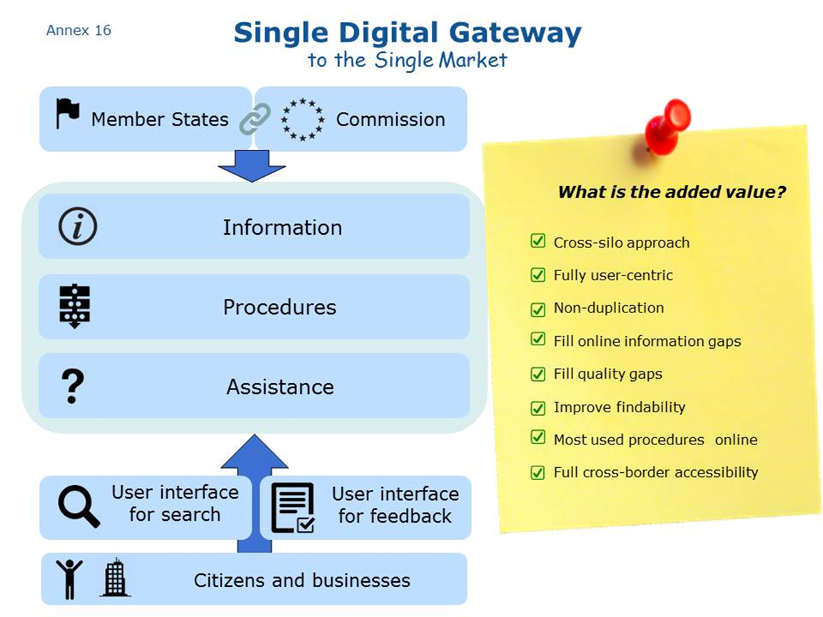

# Financial and human resources of the relevant services

|  | **Financial resources (per year, all sums are in €)** | | | | | | **Human resources (FTEs)** | | | **Size of the network** | **Number of users/visits** |
| --- | --- | --- | --- | --- | --- | --- | --- | --- | --- | --- | --- |
|  | **EU** | | | | **Budget line** | **National** | **EU (FTE)** | **DG/Agency** | **National (FTE) (average per 28 MS)** |  |  |
| **SOLVIT** | 30 000 | Trainings and expert group meetings | Combined with Your Europe | IMI | 02.030400 [Internal Market governance tools] | Not available (difficult to distinguish from other activities) | 4 | GROW.R.4 | From 0.1 to 4 | 31 SOLVIT centres in EEA MS | 2414 eligible complaints |
| **Your Europe Advice** | 1 900 000 |  | Combined with Your Europe |  | 02.030400 [Internal Market governance tools] | None | 1.5 | GROW.R.4 | 0 | 60 legal experts in all EEA MS | 24 454 enquiries |
| **Your Europe citizens** | 500 000 | 2 x year meetings of Editorial Board and 2 x year meetings of interservice group | Internet, Facebook, chats, campaigns for single market tools campaigns financed by other DGs (JUST, SANCO, MOVE) | YE team  YEST online content management tool | 02.030400 [Internal Market governance tools] | None | 5,5 | GROW.R.4 | n/a | Not applicable | 13 600 000 visits on the portal |
| **Your Europe business** | 4 450 000 |  | EU co-ordination (external contractor) |  | 0202 [COSME] | None | 4.5 (EASME) | EASME (Parent unit GROW.R.4) | n/a |  | 3 500 000  visits on the portal |
| **Enterprise Europe Network** | 50 million/year delegated to EASME for grants in EU and COSME participat-ing countries.  15-20% of the resources of each consortium are allocated to single market advisory services.  3 million delegated to EASME for network animation (annual conference, IT cooperation databases, intranet, communication, training) | Grant agreements with about 90 consortia; framework contracts for the animation budget | EU/EASME co-ordination for the partnership agreements/grants. Network partners are expected to provide integrated services to SMEs, incl. promotion and advice on EU finance schemes. to local business | Policy guidance by the Commission; operational support from EASME staff to EEN partner for the various services provided; EASME IT Help Desk for the data-bases | COSME budget delegated to EASME | Maximum EU co-financing is 60% to the eligible costs | 2,5 H2 + 40 EASME | EASME (Parent unit GROW.H.2) | About 4000 staff equivalent to 1 500 FTE.  15-20% of these FTE are working on single market advisory services | 535 Centres in EU and COSME countries; 101 cooperation centres in 29 third countries. | 435 000 SME per year receiving support from EEN |
| **EURES** | 20-23 million |  |  |  | EaSI, 04 03 02 02 | Not available | 12 | EMPL.D1 | n/a | 28 EU MS + EEA + some cooperation with CH | Not available |
| **European Consumer Centres Network** | 6 million € | Grants |  |  | Consumer Programme  Budget line 330401 | 5 million € | 2 | JUST E.3/CHAFEA | From 2 to 8 in each ECC | 28 EU MS+  Norway +Iceland | over 110.000 contacts from consumers, 45.000 complaints  and 4.7 million visits on national websites |
| **Points of Single Contact** | 30 000 | 2 meetings x year of the EUGO Network |  |  | Implementation and development of the internal market  120201 | Not available | 0.5 | GROW.E3 | n/a | 28 MS + EEA | Over 12 000 000 visits on PSCs websites and 200 000 enquiries |
| **Product Contact Points** | 15 000 | 1 meeting per year |  |  | Implementation and development of the internal market  120201 | 405 348 (COM estimate) | 1 | GROW.B1 | 1-2 | 28 MS + EEA | Over 1645 enquiries |
| **Construction Product Contact Points** | 15 000 | 1 meeting per year |  |  | Implementation and development of the internal market  120201 | Not available | 0,2 | GROW.C1 | 2 | 28 MS + EEA | Not available |
| **Professional Qualification Assistance Centres** | 15 000 | 1 meeting per year |  |  | Implementation and development of the internal market  120201 | Not available | 0,5 | GROW.E5 | Not available | 28 MS + EEA | Not available |
| **IPR Helpdesk** | 1 000 000 | - | Main management tasks delegated to EASME + external contractor |  | COSME budget delegated to EASME | None | 0,5 + 0.25 F5 | EASME (Parent unit  GROW.F5) | 0 | Not applicable | 100 000 visits on portal, 10 – 12 000 users registered,  2 000 – 3000 trainings,  1000 requests |
| **Europe Direct** | 14 700 000 | 2 meetings x year | Trainings, grants |  | 16030103 | None | 6 (+ 0,20 – 1 in COM representations in MS) | COMM.C3 | Not relevant | 28 MS | Not available |
| **Online Dispute Resolution** | 1 700 000  (covering: hosting, translation, helpdesk and maintenance) |  |  |  | Consumer Programme  and  Connecting Telecoms Europe Facility (CEF ) | Not available | 3.5 FTE (Unit )  + 9 IT (external contractors) | JUST.E3 | 27 ODR contacts points (at least 2 ODR advisors working full or part-time) | 28 MS (+ EEA to join in 2017)  261 ADR entities from 24 MS to date (07/02/17) | 20 000 complaints submitted (from 15/02/16 to 31/12/16)  1 500 000 visitors during 2016 communication campaign |

# Methodogy of cost and benefit calculation

## Methodology of cost calculation

Where possible, studies that estimated costs for comparable tasks have been used. A recent Deloitte study assessed the costs for the development of an EU VAT web portal. The content-related costs were used as a cost basis for developing content for the information part of the gateway. The IT-related cost estimates of the study were used to assess the costs of a search engine.

Other cost assumptions were made by relevant Commission staff, based on their many years of experience with running portals and assistance services and dealing with IT issues. This is the case with the number of human resources necessary for particular tasks at national and EU level, the necessary promotion budget and for developing the common repository of links, the development of the user feedback tool on Single Market obstacles, translation costs, hosting costs and IT development costs. These assumptions are nevertheless very imprecise and may in practice vary a lot.

Cost figures provided by Member States were used as much as possible. These concerned the costs for setting up a new portal, savings per transaction completed online, and costs for digitalising procedures. However, as table 6.4 shows, costs are not easily comparable and vary very much. Therefore, an estimate was made based on high-end figures that might be lower in reality.

Certain costs turned out to be very difficult to estimate. This was the case for the IT effort necessary for merging the three contact points. Views expressed by some national authorities on this in the framework of a study[4] varied and there was no consensus whether this would be cost-intensive or not. Therefore, the assumption was made that overall, this would be cost-neutral, as the initial costs would be offset by the expected savings.

A further assumption was made with regard to the voluntary roll-out of procedures. Based on Commission experience it was assumed that under a voluntary scenario, Member States would digitalise fewer procedures. Although the extent of this is completely unknown, the figure of 50% of the 20 procedures foreseen under option 2, where this is obligatory, was chosen for demonstration purposes.

The costs for the common user interface for cross-border use of documents and data (option 2) were assessed in a very rough way and as far as possible at the current point in time. This element would depend on a very advanced technical solution, for which an implementing act with a separate impact assessment will be necessary. Thie separate impact assessment will assess all the costs more in detail and with greater precision.

When costs for human resources were calculated, the official Commission annual rate of EUR 138 000 was used whenever Commission resources were concerned, and EUR 120 000 for an IT developer paid for by the Commission. The EUR 120 000 rate comes from a Commission framework contract. EUR 53 000 was used whenever Member State administration resources were foreseen. The rate of EUR 53 000 is based on Eurostat public sector labour cost survey figures[5] covering EU average public sector labour costs and their main components (wages and salaries; direct remuneration, bonuses and allowances; employers' social security contributions and other labour costs) amounting to EUR 40 000, as well as an additional EUR 13 000 in overhead costs.

## Methodology of benefit calculation

### Benefits for administrations from digitalising procedures:

Benefits for national administrations from digitalising procedures proved difficult to assess, as the benefit figures provided by Member States varied a lot (see tables 6.4 and 6.5 for the savings through digitalised procedures). The estimate for the cost savings as a result of digitalisation of nine business procedures was based on one Member State, i.e. Denmark (see also IA table 6.5). The Danish Agency for digitisation has published a comparison of costs between different channels of service provision[6]:

|  |  |
| --- | --- |
| **Channel** | **Cost per transaction** |
| Counter service | €14 |
| Letter (physical) | €11.70 |
| E-mail | €11 |
| Telephone | €7.80 |
| e-Services/Self Services | €4.20 |

The cost savings of ca. EUR 10 for a shift from counter service to e-service and of ca. EUR 7 for a shift from letter to e-service were taken as a basis for calculating the savings for each Member State. The largest part of these savings figures can be attributed to savings in staff costs. But this also means that the cost savings will be much smaller for Member States with smaller average public official salary costs than Denmark. The average calculation of savings will most likely be over-estimated for this reason.

In a next step, the cost saving (in comparison to an online procedure) for value 4 of table 6.3 of the study about administrative formalities was established as EUR 10 (as office visit required), and the cost saving for value 3 (postal letter required) was established as EUR 7. This was multiplied by the number of domestic and cross-border businesses going through each procedure whenever value 4 or 3 was indicated.

|  |
| --- |
| Table ***19***.***1***: Study about administrative formalities: Complexity category of submitting documents |



Table ***19***.***2***: S***tudy about administrative procedures: Number of domestic businesses going through procedures***



Table ***19***.***3***: S***tudy about administrative procedures: Number of cross-border businesses going through procedures***



The result is the following table:

Table ***19***.***4***: ***Savings for public administrations from e-services instead of office services and by post***



This table shows the total savings (covering domestic and cross-border businesses going through each of the nine procedures) from digitalising these 9 procedures for each Member State, with the caveat that the savings are based on Danish figures (high end staff costs), as outlined before. The total EU savings would come up to EUR 111.8 million. The figure per Member State (111.8 / 28) comes up to EUR 4 million – but this average figure hides the large variations in cost savings and differences in public officials' staff costs.



## Benefits from putting information online

The savings for administrations from putting information online were calculated based on the assumption that in the absence of online information, citizens and businesses would need to contact administrations directly, which is a more expensive channel. A cost comparison between Your Europe (online information) and Your Europe Advice (individual assistance) was used to show the difference and potential for savings.

***Benefits for citizens***

According to European Commission own research, a minimum of 1.5 million hours are lost every year by citizens trying to find where information is available on their rights and obligations in order to live, study or retire in another Member State. These 1.5 million hours are an indication of the benefits of the initiative to citizens in the area of information. This figure cannot be converted into a monetary estimate as it does not relate to an actual expenditure but rather to citizens' spare time lost, which is difficult to put into monetary terms. In addition to the time lost, there is also a certain annoyance factor (hassle costs) related to these activities, which cannot be quantified either.

The calculation was made in the following way:

1.3 million people migrate from an EU Member State to another each year. In this process, citizens at least have to:

- register the change of address,

- register for social security benefits,

- register for pension,

- declare income taxes,

- register their car and possibly register for child allowance,

- enrol in university if student, request recognition of their diploma if active worker or register as unemployed.

According to EC own research (see annex 4 for details), just finding information on the above procedures takes on average (simple average across Member States) 1h40min for a citizen speaking at least 3 languages and already being aware of a variety of information sources. The average was calculated as follows: 35 minutes for each of the 15 Member States with the best information offer[7], 1h15 for of the 7 Member States with a medium information offer[8], 5h for each of the 6 Member States with the lowest information offer[9]. This was then adapted to EU migratory flows according to Eurostat data (Eurostat online data code: migr_imm1ctz).

In order to calculate the citizen benefit of a solution where each Member State has made available on its portal high-quality and complete information (option 1), the assumption was made that in this case, the time spent to research the 6 topics would be the 35 minutes currently needed for the Member States with the best information offer. Under this scenario, the aggregate hours will be half of the current situation: 768 367 instead of 1.5 million (saving of 50% as compared to the current situation). For option 2, an additional assumption was made, namely that with the common search tool, citizens would find the information more quickly, i.e. after 28 minutes. The aggregate number of hours under this scenario would be 614 693 instead of 1.5 million (saving of 60%). For option 3, it was assumed that with harmonised information contained in a database, the time to find the information would be 18 minutes. The aggregate number of hours under this scenario would be 395 160 instead of 1.5 million (saving of 75%).

***Benefits for businesses***

The benefits for businesses of very good and accessible online information were assessed through an external study[10]. The methodology used is the following:

In order to estimate the number of EU businesses that are searching for online information, the number of enterprises involved in intra EU exports of goods has been used as proxy variable[11].

Based on EUROSTAT[12] statistics in 2013[13] 1.8 million businesses (8% of the overall active enterprises at EU level) were involved in intra EU exports of goods.

Interviews with business representatives from 15 different EU companies[14] who have experience in cross border operations where used to map behaviours of businesses when they are searching information about another Member State's rules online.

Results from these consultations indicated that businesses:

* Search for online information (on average) on 9 topics and each of them performs from one to nine online searches per year, namely:
  + Minimum one online search per nine topics (i.e. 9 online searches per year)
  + Maximum one online searches per nine topics (i.e. 81 online searches per year)
* are spending from one to eight hours each time they do an online search, namely
  + Minimum one hour per one online search per nine topics (i.e. 9 hours per year)
  + Maximum eight hours per nine online searches per nine topics (648 hours per year)

Combining these data, and considering the hourly average labour cost at Member State[15] level is it possible to draw:

* a “minimum scenario” where each company is speeding nine hours [16] per years searching for online information;
* a “maximum scenario” where each company is speeding 648 hours[17] per years searching for online information.

The annual cost at EU28 is between € 0.42 and €30.2 billion, that means an average annual cost for each company of between € 233 and € 16,813.

|  |  |  |  |  |  |
| --- | --- | --- | --- | --- | --- |
| N. of enterprises Involved in intra EU exports of goods  (2013) | Hours spent doing online searches | | Average hourly Labour Cost  (EUR) | Costs for searching online information (EUR) | |
| Min | Max | Min | Max |
| 1,797,355 | 9  hours | 648  hours | **≈ 26[18]** | 419,718,503 | 30,219,732,248 |

However, this does not take into account the potential “outsourcing cost” (e.g. when businesses require additional external support).

In particular the representatives from the consulted companies declared that

* for six topics (included in the nine for which they were searching online information) they also needed external support
* they paid between less than € 1,000 and € 3,000 to external consultants (per each researched topic).

Also in this case it is possible to identify two scenarios[19]:

|  |  |  |  |  |
| --- | --- | --- | --- | --- |
| N. of enterprises doing cross border operation  (2013) | Costs for searching online information (EUR) | | Costs for External support | |
| Min  € 500 x 6 topics x each company | Max  € 2,500 x 6 topics x each company | Min | Max |
| 1,797,355 | 419,718,503 | 30,219,732,248 | 5,392,064,976 | 26,960,324,878 |

Based on the information presented so far it is possible to conclude that the total costs of finding online essential information about another Member State' rules are between € 3,233 and € 31,813 for one enterprise, that means an aggregate cost between € 5.8 and € 57.2 billion at EU28 if we consider that around 1.8 million EU enterprises are doing or are planning to do cross boarder operations.

## **Potential benefits**

Cost for businesses were computed using the following parameters:

* topics for which they require online information (a)
* number of online search for searched topic (b)
* time spent for each online search (c)
* hourly labour cost (d)
* number of topics for which they require external support (e)
* costs of the external support (f)

|  |  |  |  |  |  |  |  |  |
| --- | --- | --- | --- | --- | --- | --- | --- | --- |
| **(a)** | **(b)** | | **(c)** | | **(d)** | **(e)** | **(f)** | |
| Min | Max | Min | Max | Min | Max |
| 9 | 1 | 9 | 1h | 8h | **≈ 26**[20] | 6 | EUR 500 | EUR 2500 |

The assumption was made that with better online information (e.g. higher quality, higher accessibility) there will be an impact (e.g. reduction) for parameters b, c , e and f. In the case of perfect accessibility of online information we can compute the benefits for businesses as time saved. In particular the maximum time saved might be computed in different scenarios characterised by a radical reduction for parameters b and c, a reduction in the number of topics requiring external support (e), and a 50% reduction for parameter f[21].

|  |  |  |  |  |  |  |  |  |  |
| --- | --- | --- | --- | --- | --- | --- | --- | --- | --- |
| **Scenario** | **(a)** | **(b)** | | **(c)** | | **(d)** | **(e)** | **(f)** | |
| Min | Max | Min | Max | Min | Max |
| Baseline | 9 | 1 | 9 | 1h | 8h | ≈ 26 | 6 | € 500 | € 2,500 |
| 1 | 9 | 1/9 | 1/9 | 1h | 1h | ≈ 26 | 5 | € 250 | € 1,250 |
| 2 | 9 | 1/9 | 1/9 | 40 min | 40 min | ≈ 26 | 4 | € 250 | € 1,250 |
| 3 | 9 | 1/9 | 1/9 | 30 min | 30 min | ≈ 26 | 3 | € 250 | € 1,250 |

|  |  |  |  |  |  |  |
| --- | --- | --- | --- | --- | --- | --- |
| **Scenario** | **Total internal cost (EUR)** | | **Costs for External support** | | **Total Costs** | |
| **Min** | **Max** | **Min** | **Max** | **Min** | **Max** |
| **Baseline** | 419 718 503 | 30 219 732 248 | 5 392 064 975.69 | 26 960 324 878.45 | 5 811 783 479 | 57 180 057 126 |
| 1 | 48 967 159 | 48 967 159 | 2 246 693 740 | 11 233 468 699 | 2 295 660 899 | 11 282 435 858 |
| Diff. with Baseline | -370 751 345 | -30 170 765 089 | -3 145 371 236 | -15 726 856 179 | **-3 516 122 581** | **-45 897 621 268** |
| 2 | 31 090 260 | 31 090 260 | 1 797 354 992 | 8 986 774 959 | 1 828 445 251 | 9 017 865 219 |
| Diff. with Baseline | -388 628 244 | -30 188 641 988 | -3 594 709 984 | -17 973 549 919 | **-3 983 338 228** | **-48 162 191 907** |
| 3 | 23 317 695 | 23 317 695 | 1 348 016 244 | 6 740 081 220 | 1 371 333 939 | 6 763 398 914 |
| Diff. with Baseline | -396 400 809 | -30 196 414 553 | -4 044 048 732 | -20 220 243 659 | **-4 440 449 541** | **-50 416 658 212** |

In the case of the **Scenario 1** the total costs of finding online essential information about another Member State' rules will be between € 1 277 and € 6 267 for one enterprise, that means an aggregate cost at EU28 level between € 2.3 and € 11.3 billion if we consider that around 1.8 million EU enterprises are doing or are planning to do cross boarder operations. This means a saving between 60.5% (minimum scenario) and 80.3% (maximum scenario) that is € 3.5 billion (minimum scenario) and € 45.9 billion (maximum).

Scenario 1 represents option 1, where it is assumed that with complete, high-quality national information, one online search of 1 hour will be sufficient, and the number of topics requiring external support can be reduced by 1.,

In the case of the **Scenario 2** the total costs of finding online essential information about another Member State' rules will be between € 1 017 and € 5 017 for one enterprise, that means an aggregate cost at EU28 level between € 1.8 and € 9 billion. This means a saving between 68.5% (minimum scenario) and 84.2% (maximum scenario) that is € 3.9 billion (minimum scenario) and € 48.1 billion (maximum).

Scenario 2 represents option 2, where it is assumed that the common search engine solution will reduce the time of the search as compared to option 1, namely from 1 hour to 40 minutes. Furthermore, the assumption is made that, in comparison with the baseline, the number of topics requiring external support can be reduced by 2.

In the case of the **Scenario 3** the total costs of finding online essential information about another Member State' rules will be between € 763 and € 5 017 for one enterprise, that means an aggregate cost at EU28 level between € 1.4 and € 6.8 billion. This means a saving between 76.4% (minimum scenario) and 88.1% (maximum scenario) that is € 4.4 billion (minimum scenario) and € 50.4 billion (maximum).

Scenario 3 stands for option 3, where it is assumed that the harmonized database solution will even further reduce the time of the search as compared to option 1 and 2, namely to 30 minutes. The harmonized structure should allow users to understand the information more easily than under the other two options. Furthermore, it is assumed that the number of topics requiring external support can be reduced by 3.

The benefits for businesses of using fully online procedures that are accessible to foreigners were calculated through another external study[22]. The methodology used for this study was:

***Objective and scope***

The objective of the study by Ecorys for the European Commission was to identify the administrative requirements of various important procedures for businesses and to assess the costs of the different steps that are needed to comply with them. The study covers all EU28 Member States.

In total ten procedures in the areas of business registrations and tax returns were examined: (1) general registration of economic activity, (2) VAT registration, (3) VAT returns, (4) request for VAT refund, (5) registration for income tax, (6) corporate/business tax declaration, (7) registration with national social insurance scheme upon establishment, (8) registration of employees with pension and insurance scheme, (9) payment of social contributions and payroll withholding tax for employees, (10) reporting end of contract of employee.

***Methodology – collecting data***

Information about administrative formalities was collected from the competent national authorities of the 28 Member States (inventory). All authorities were asked the same set of questions covering over 80 items for each of the administrative procedures covered by this study for which they are responsible. The information was filled partly in advance with publicly available information, for the authorities to check and complete. In total approximately 100 different authorities have been contacted of which approximately 40 have responded. Most of them fully completing the questionnaires for all procedures. In those cases where items were overlooked or information was not clear, the authorities were contacted for further information. The authorities were asked to complete the information on administrative procedures for limited liability companies, with one overall question per procedure about the most important differences for other legal forms of businesses.

In addition, 61 businesses (limited liability companies and sole traders) operating in 14 selected countries were consulted by means of an online survey from end of November 2016 until early February 2017 (business survey). These countries included both small and large countries and were also spread geographically across the EU. Two different questionnaires were developed, one for domestic firms and one for cross-border firms which covered some additional items such as the cost of translations. The businesses that were consulted included both existing relations and random firms. The businesses were asked to provide information on working time and expenses incurred for each of the ten procedures they had gone through. These data were only filled in by the persons that had gone through the procedures within the last year. Of the responding businesses, 39 were domestic and 18 operated cross-border and responded concerning procedures in another EU country. Each of the 57 businesses responded about one up to six procedures they had gone through.

***Methodology – analysis, cost per occurrence***

Based on the business survey, costs of various activities and expenditures were classified in up to five categories of “complexity” with greater complexity corresponding to higher costs. For each degree of complexity, the characteristics of the administrative formalities causing the costs were examined in order to link costs with types of formalities.

For each country and each of the ten administrative procedures, the same average hours corresponding to that degree of complexity were allocated. This was done to reduce the impact of random differences in for example language proficiency or travel distances. A similar approach was adopted for expenses (after conversion into euros) with one difference. For the relevant degree of complexity, the expenses were calibrated for a reference group of countries with a similar general price level (consisting of the six countries Belgium, France, Germany, Italy, the Netherlands, and Sweden), so that costs in the other eight countries covered by the business survey reflect lower general price levels only. This enabled a separation of differences in costs caused by different administrative requirements and differences caused by general price levels respectively.

This approach not only enabled to reduce the impact of random differences between respondents, but also enabled to estimate the costs involved for countries not covered by the business survey, based on similarities of administrative requirements. One exception is made to costs where differences between firms are not random but structural, namely the translation of company statutes which logically does not apply to sole traders. In this case, costs and numbers of businesses involved (see later) were differentiated by legal form of the business as well.

***Methodology – analysis, frequency***

In some countries, some procedures must be gone through more than once per year. The frequency of the procedure was based primarily on the authorities survey. However, in some countries different businesses must or may go through the procedures at different frequencies. Hence, a relation between reported frequencies in the business survey and the authorities survey was examined, to convert multiple optional frequencies into one average frequency.

***Methodology – analysis, number of businesses***

Lastly, the business population is based on a mix of authorities survey and Eurostat data. From the authorities survey, the number of applications (domestic and from other EU countries) is divided by the frequency estimated in the previous step. For each procedure, the authorities of only a handful of countries reported the number of applications.

To estimate the number of businesses involved for all countries and procedures, Eurostat data on numbers of businesses (old and new, domestic and cross-border, with and without employees) were used. These numbers were related to known numbers of applications (typically for 3 to 5 countries for each procedure), where procedure 1, 2 and 5 apply to all new firms, procedure 7 applies to new employers, procedures 3, 4 and 6 apply to all firms (old and new) and procedures 8, 9 and 10 apply to all employers (old and new). For cross-border firms, an additional assumption needed to be made, namely that 2.5% of the businesses is a new firm. This is confirmed for some countries where Amadeus data is accurate and also for Denmark where all business registrations (including from other EU countries) can be freely accessed.

***Methodology – extrapolation to aggregate costs***

As a last step, aggregate costs were calculated by multiplying the cost per occurrence, the frequency (number of times per year) and the number of businesses involved.

# Glossary

| **Abbreviation/technical term** | **Explanation** |
| --- | --- |
| BRIS | Business Registry Interconnection System |
| CEF | Connecting Europe Facility |
| DG SANTE | European Commission Directorate General for Health and Food Safety |
| Digital-by-default | The principle that public services should be provided through digital channels whenever possible and cost efficient |
| EC | European Commission |
| ECC/ECC-Net | European Consumer Centres. EU co-funded network of centres that promote the understanding of EU consumers' rights and assist in resolving complaints about cross-border purchases. |
| EEN | Enterprise Europe Network. An EU co-funded support network that provides advisory and partnership services to help small and medium sized businesses (SMEs)to strengthen their competitiveness, innovate and do business on European and international markets. |
| eID | electronic identification |
| eIDAS | EU Regulation on electronic identification and trust services for electronic transactions in the internal market |
| EMPSS | European Mobility Portal on Social Security (feasibility under assessment) |
| EN | English |
| EPC | European Professional Card. The first EU-wide fully online procedure for the recognition of qualifications for nurses, pharmacists, physiotherapists, real estate agents and mountain guides. |
| ESIF | European Structural and Investment Funds |
| e-signature | Electronic signature |
| EURES | European Employment Services. A cooperation network designed to facilitate the free movement of workers within the EU |
| EUR-lex | Official website of published EU legislation and EU case law |
| FTE | Full time equivalent |
| ICT | information and communication technology |
| IMI | Internal Market Information System. An IT-based information network that links up national, regional and local authorities across the EU. |
| ISA/ISA2 | Interoperability Solutions for European Public Administrations. An EU funding programme that sets out to improve digital solutions that enable public administrations to become inter-operable across borders. |
| IT | Information technology |
| MS | Member State |
| OOP | Once only principle. The principle that citizens and businesses should supply a piece of information only once to a public administration who should then internally share this data with other public administrations, avoiding burdens on users from providing the same information several times. |
| PCP | Product Contact Points |
| PCPC | Product Contact Points for Construction |
| Points of Single Contact Charter | A charter that encourages EU countries to develop business friendly Points of Single Contact. It establishes criteria about in particular quality and availability of information, completion of electronic procedures, accessibility for cross-border users and usability. |
| PSC | Point of Single Contact |
| REFIT Platform | REFIT stands for regulatory fitness. The platform is a forum that brings together the European Commission, national authorities and other stakeholders in regular meetings to improve existing EU legislation. |
| SDG | Single digital gateway |
| SEPA | Single European Payments Area |
| SME | Small or medium-sized enterprise |
| SOLVIT | A service set up by the EU that assists citizens and businesses to ascertain their EU rights when they experience problems with authorities in another EU member state. |
| SWD | Staff working document of the European Commission |
| TRIS | Technical Regulations Information System |
| VAT | Value added tax |
| YEA | Your Europe Advice. EU funded advice service for citizens and businesses about their EU rights. |

1. <http://ec.europa.eu/isa/ready-to-use-solutions/cpsv-ap_en.htm>
2. Forthcoming study on the main actions, plans and funding priorities of Member States towards the modernisation of Public Administrations, Wavestone for the European Commission, 2016.
3. Data prepared after carefully surveying the NRPs for countries in the study and identifying reforms linked TO2 and TO11, subsequently categorising them between cross-cutting reforms and sector specific reforms
4. <http://ec.europa.eu/DocsRoom/documents/21401/attachments/2/translations>
5. Labour cost, wages and salaries, direct remuneration (excluding apprentices) by NACE Rev. 2 activity ) - LCS surveys 2008 and 2012 [lc_ncost_r2]
6. Digitaliseringsstyrelsen, 2012, as referenced in the Study on Analysis of the Needs for Cross-border Services and Assessment of the Organisational, Legal, Technical and Semantic Barriers, 2013
7. Estonia, Luxembourg, Finland, France, UK, Spain, Denmark, Belgium, Netherlands, Sweden, Malta, Poland, Slovakia, Portugal, Austria
8. Latvia, Greece, Ireland, Germany, Lithuania, Slovenia, Croatia
9. Romania, Bulgaria, Czech Republic, Italy, Cyprus, Hungary
10. Study on information and assistance needs of businesses operating cross-border within the EU, including gap and cost analysis, Ernest & Young for the European Commission, 2017
11. From one side this approach under estimate the number of companies that are potentially interested in searching online information because it does not include companies that are providing services in another EU MS and companies that are planning future cross border operations; on the other side not all companies that are doing or planning cross border activities are searching information online.

    Therefore, we consider this estimation as reasonable while being mindful of the inherent limitations.
12. International trade Statistics (Trade by partner countries and size-class, [DS-058476]) .
13. EUROSTAT provides the number of enterprises involved in intra EU exports in 2013 for 11 countries (AT, BE, CY, CZ, DE,HU, LT, NL, PL, RO, SI). From this data it emerges that on average 8% of active enterprises are involved in intra EU exports for these 11 countries. The same percentage (8%) have been applied to countries for which statistics are not available.
14. Multiple feedbacks from 15 companies based in 5 different MS have been collected. Companies involved had different size and different experience in doing cross border operations. They were asked:

    to select from a list of 29 topics the ones for which they have searched online information while doing business in another MS

    to declare how many online searches they have performed per each searched topic

    to declare the duration of each online search (in hours)

    to declare for how many topics they have required external support and the cost incurred.
15. Labour cost levels by NACE Rev. 2 activity (lc_lci_lev).
16. 1 online search of 1 hour for 9 topics = 9h.
17. 9 online search of 8 hours for 9 topics = 648 h.
18. The exact average value at EU level is ≈ EUR 25.95
19. a “minimum scenario” where each company is speeding the minimum cost (€ 500) for external support for each searched topic (6); a “maximum scenario” where each company is speeding the maximum cost (€ 2,500) for external support for each searched topic (6).
20. The exact average value at EU level is ≈ EUR 25.95
21. This hypothesis is related to a possible reduction of the complexity of the required support.
22. Study about administrative formalities of important procedures and administrative burden for businesses, Ecorys for the European Commission, 2017